

Human resource management –Employee motivation within the workplace.

Level 6 BA Business and Management 2023

BMSP6012/C

Rachel Pickersgill (2004655)

Word count: 11,426

Declaration

- This work has not previously been accepted in substance for any degree and is not being concurrently submitted in candidature for any degree.
- This Dissertation is being submitted in partial fulfilment of the requirements for the degree of BA Business Management.
- This Dissertation is the result of my own independent work/investigation, except where otherwise stated. Other sources are acknowledged by footnotes giving explicit references. A Bibliography is appended.
- I hereby give consent for my Dissertation, if accepted, to be deposited in the School Dissertation Library.
Name: Rachel Pickersgill (2004655)

Date of Submission: 31st March 2023
Signature:

Acknowledgements

I wish to acknowledge and thank all the people involved both directly and indirectly in the development of this investigation.

I would like to thank my supervisor Jessica Shore for the continued support and time throughout the process of the dissertation.

I would like to thank the participants who responded to my questionnaire to provide data for the research study.

Finally, I would like to thank my friends and family for their guidance and support throughout my dissertation.

Abstract

Motivation is the number one issue confronting businesses today. Employers must understand what motivates employees to enhance efficiency and ensure the company's success (Wiley, 1997a). Employee motivation is a well-researched topic; however, most studies do not focus on employee’s individual differences which could affect motivation.

The aim of this dissertation is to investigate employee motivation within the workplace with a focus also on individual differences of employees. To do this the aim is to identify key factors of motivation along with motivational theories. It will also give insight into how individual differences affect motivation.

This study will use a quantitative method. The study is based on a positivist philosophy with a deductive research approach. To answer the research question, primary data is collected through surveys using convenience sampling. This research strategy enables investigations about work motivation.
This research has contributed to an understanding of employee motivation in the workplace by investigating multiple factors that can influence motivation as well as various motivational theories. The study emphasises the importance of intrinsic rewards for motivation and how motivation varies by individual. It also examines the impact of being solely extrinsically motivated on employees and emphasises the significance of motivational theories.

Table of Contents
Chapter 1: Introduction 8
1.1 Background of human resources (HR) and motivation. 9
1.2 The research problem, purpose of the research 9
1.3 Research questions 9
1.4 Research aims and objectives 10
1.5 Dissertation structure 10
Chapter 2 – Literature Review 11
2.1 What is human resource management 11
2.2 Work motivation 11
2.3 Concepts of motivation 12
2.4 Theories 13
2.5 Motivational factors 16
Individual differences in motivation 17
2.6 Summary 18
Chapter 3 – Methodology 19
3.1 Introduction 19
3.2 Philosophy 19
3.3 Research type 20
3.4 Strategy 20
3.5 Time horizon 20
3.6 Techniques and procedures 21
3.7 Barriers and limitations 23
3.8 Ethical considerations 24
3.9 Summary 24
Chapter 4 – Findings 25
Chapter 5 – Data Analysis 33
5.1 Crosstabulations 33
5.2 Summary 38
Chapter 6 – Discussion 39
6.1 Demographic variables (individual differences) 39
6.2 Intrinsic and extrinsic motivation 40
6.3 Motivational theories 40
6.4 Factors of motivation 41
6.5 Summary 42
Chapter 7 – Conclusion 43
6.1 Recommendations/ Contribution to business environment 44
6.2 Recommendations for further study 44
Chapter 8 - Bibliography: 46

Table of figures

Figure 1: Maslow’s hierarchy of needs (Letsoalo, 2017). 14
Figure 2: Saunders research onion (Saunders et al., 2012). 19
Figure 3: Literature review and questions matrix 23
Figure 4: Age of respondents 25
Figure 5: Gender of the respondents 26
Figure 6: Respondents job positions 27
Figure 7: Respondents satisfaction within their jobs 28
Figure 8: Important motivators in the workplace 29
Figure 9: Motivation strategies used in respondent’s workplace 30
Figure 10: Important factors in the workplace 31
Figure 11: Encouraging factors within the workplace 32
Figure 12: Crosstabulation of most important and least important motivating factors and age 33
Figure 13: Crosstabulation of most important and least important motivating factors and job position 34
Figure 14: Crosstabulation of most important and least important factors and age 35
Figure 15: Crosstabulation of most important and least important factors and job position 37

List of abbreviations

HR: Human resources
HRM: Human resource management
SPSS: Statistical Package for the Social Sciences
UWTSD: University of Trinity Saint David

Chapter 1: Introduction

This chapter will introduce the study by discussing the background and context of the selected topic, followed by the research problem, aims and objectives and finally a brief outline of the structure the dissertation will follow.

1.1 Background of human resources (HR) and motivation.

HR emerged as a specific field in the early 20th century and was influenced by Frederick Winslow Taylor and Elton Mayo, who gave concepts to help managers understand their employees and their behaviours. Their concepts are the foundation for contemporary thinking around human resources. Frederick produced ideas on raising productivity through work study and work measurement techniques. Elton Mayo is known for experimenting on workers' behaviour in a study called the Hawthorne effect, which significantly contributes to HR (Prasad, 2012). HR helps an organisation deliver its corporate strategy by recruiting and developing people and managing their performance. Its main objective is to maximise employee productivity and to protect the organisation from issues which may arise within their workforce (Van Aswegen et al, 2006). HR plays a significant role in motivation because motivation is directly linked to employee productivity. A Harvard business review study found that motivation could increase a company's profits by 47% (McGregor & Doshi, 2015). Motivation is a force (intrinsic or extrinsic) that makes people behave the way they do, meaning that internal and external factors can influence motivation. Motivation in the context of HR is essential for organisation performance; done correctly, an organisation can motivate its employees to work more productively. Motivating employees is about understanding what influences employees to become motivated to perform a task at their full potential and boost productivity. HR's role is to understand and implement these factors efficiently (J. Du Plessis et al, 2015).

1.2 The research problem, purpose of the research

Motivation within is critically essential for employee satisfaction and a company's performance. Numerous studies have been undertaken to investigate workplace motivation and the factors that affect motivation. There are also several developed motivational theories, including Maslow's hierarchy of needs and Herzberg two factor theory (Souders, 2023). However, these studies do not focus on what motivates people to work and the concept that people are motivated by different things (individual differences). This study aims to investigate employee motivation within the workplace but also looks to examine motivation from individual differences, such as generational changes. For a company to be successful, employers must understand what drives employees to boost output. Furthermore, workplace demographic changes highlight the need to carry on and identify what drives individuals to perform successfully (Vo et al, 2022).

1.3 Research questions

The focus of the study will be on employee motivation within the workplace; however, there will be other questions which are integral to support this research:

- Are there any patterns of motivation in the workplace and individual differences amongst employees?
- How relevant are motivational theories, and are they essential in motivating employees?

- What are the motivation factors, and how important are these for employees?

- Which form of motivation is most important to employees, intrinsic or extrinsic?

These research questions will be answered in accordance with the secondary data gathered from the literature review and the primary research findings.

1.4 Research aims and objectives

This dissertation aims to investigate human resource management and employee motivation within the workplace and establish motivation patterns in the workplace.

- To analyse academic literature on the rationale of motivation theories and how these apply to what employees deem to motivate them.

- To select an appropriate research approach for the primary research to explore the views of employee motivation within the workplace.

- To evaluate the primary data collected compared to the secondary data to understand the phenomenon of motivation within the workplace.

- To investigate possible approaches for future investigation, with reference to limitations of the primary study, and provide a set of recommendations.

This study will add to the body of knowledge about motivation within the workplace. This will help address the current shortage of research in this area and provide value to those organisations wanting to tailor their motivational strategies around individual employees.

1.5 Dissertation structure

In chapter one, the context and background of the study have been introduced, and the objectives and research questions have been identified.

In chapter two, the literature review will include the definition and theories behind motivation and how these contribute to employee motivation in the workplace. The literature review will form the secondary data for this research project; the primary data will be conducted using a quantitative questionnaire approach.

In chapter three, the theoretical framework will be presented (Saunders’s research onion) and used to outline the selected methodology. The adoption of a quantitative research approach will be justified, along with the discussion of limitations and ethical considerations.

The findings, analysis and discussion chapters will analyse the primary data against the literature review to investigate the importance of intrinsic and extrinsic motivation and what factors affect employee motivation. After analysis and discussions, conclusions will be drawn, and recommendations will be provided.

Chapter 2 – Literature Review

This chapter will investigate human resource management and the use of intrinsic and extrinsic rewards to motivate employees. Human resource management will be analysed, along with the use of extrinsic and intrinsic reward systems, individual differences, and motivational factors, by looking at relevant theories of motivation and how these motivate employees.

2.1 What is human resource management

Human resource management (HRM) is also known as personnel management, and it is constantly changing in response to social, economic, and political changes. It also is constantly adapting to changes in technology. In broad terms, HRM denotes the aspects of recruitment and rewards. It is essentially the human side of the organisation but also adopts a dynamic and adaptive purpose in the organisation’s strategic decisions (Collings et al, 2018). It is made up of two different approaches, soft HRM and hard. In hard HRM, there is a duty to make money and focusing on the needs of the employee is simply a disruption; there is an emphasis on the quantitative aspects of the business. Whereas with soft HRM, there is more focus on the employees being a valuable asset to the organisation, the employees' potential must be developed as employees are a foundation of competitive advantage (Hook & Jenkins, 2019).

2.2 Work motivation

Motivation theory was not developed in the workplace until the middle of the twentieth century. The main idea is that for an organisation to meet its goals, “managers should find a way of taking workers' minds and hearts with them” (Green & Crowther, 2004). Motivation is a complex notion; it can be defined in several ways. One definition of motivation is “how to provide something to a person to drive him/her to do something” (Ruthankoon & Ogunlana, 2003). Work motivation refers to the state of mind of an employee, which drives them to perform their job in a way that achieves a desired outcome (Wietrak et al, 2021). If a manager understands the concepts of work motivation, this will enable them to contribute to their workforce productivity (Pinder, 2014). Mullins (2007) stated three general classifications for motivation within the workplace:

- Economic rewards, which include the individual’s yearly salary, bonuses, company pension and other benefits for working within the company, such as phones and company cars.
- Intrinsic satisfaction, this is the personal motivation to produce work to the best of the employee’s capability. This relates to whether they are passionate about their project in work and whether it can provide value within the company. This differs between employees depending on the conditions also whether they show strong ambition towards strength and development.
- Social relationships, for example, to be happy within the workplace, the employee would have a good relationship with their peers and management. They should also feel respected and valued in the workplace; otherwise, motivation can be decreased or lost.

2.3 Concepts of motivation

To understand motivation two concepts will be looked at these are extrinsic and intrinsic motivation.

Extrinsic motivation: is where there is some form of incentive for completing a task and looking forward to the reward; it is when a task is done to gain a separable outcome (Studer & Knecht, 2016). Extrinsic motivation refers to behaviour which is contingent on the attainment of a result that is separate from the action itself; for instance, a task is undertaken to gain some other outcome, such as a reward. People who are extrinsically motivated do not get motivated by their work; they expect rewards upon task completion otherwise they will not feel satisfied (Legault, 2016). When a job is not inherently satisfying, and the incentives rely on performance or results, such incentives could include prepaid holidays, bonuses, and promotions; employees are more likely to view money as the main reason to complete the work (Kuvaas et al, 2017a). The ideology is that by offering an incentive, one will work harder to achieve their goal. When awarded with this incentive, they will feel their importance and value to the company, which in return helps keep employees happy within the workplace.

Intrinsic motivation: is the theory that a person is working hard to please themselves, thus meaning the main reward is personal satisfaction for completing the task. It is also imperative for task quality and completion (Russ, 2011). It is the natural tendency of people to strive towards doing the activities they consider to be interesting or enjoyable. If the job being undertaken is inherently satisfying for the individual and the incentives to complete it are indirectly associated with performance, employees will mainly think about the task they are completing as they work (Kuvaas et al, 2017b).

Kenneth Thomas (2021a) defined four steps to intrinsic motivation:
- Committing to a worthwhile goal.
- Choosing the best method for achieving that goal.
- Ensuring that work activities are performed competently.
- Ensuring that one is making progress towards the goal.

The first step is to show that the employee believes the task is meaningful and shows true significance to the organisation. Step two requires the employee to choose how they want to complete the task using their investigative methods. The third step is to ensure that the person feels that they are performing to the best of their ability and exceeding their expectations for the task and are proud of the work they produce. The fourth step is for them to start seeing the project results, “achieving the purpose” (Thomas, 2010b). This should give them a boost of morale for future projects.

Impact of extrinsic rewards on intrinsic motivation

Offering extrinsic rewards can increase motivation among employees however research has revealed that offering excessive rewards can decrease motivation. Daniel Pink discovered that extrinsically motivating employees can lead to a narrowed focus and lack of ability to see other solutions hindering creativity of employees. The drive to complete a task to gain a reward can make employees choose decisions that in other circumstances would never be considered. By using only extrinsic reward systems it can lead to the erosion of intrinsic enjoyment which comes from undertaking tasks, by offering rewards for task completion this moves the employee’s mindset from completing the task to achieve a sense of accomplishment to completing the task because they will receive an extrinsic reward for it. This results in the enjoyment being taken away from a task which once was intrinsically pleasing (Pink, 2011).

Researchers have concluded that there are three principal conclusions which concern extrinsic incentives and their impact on intrinsic motivation. (Cherry, 2022).

- Intrinsic motivation will fall after external rewards are given for achieving a small specific task. During a study in the 70s, Deci found that under certain circumstances, extrinsic rewards decreased intrinsic motivation (Deci et al, 1971). For example, if someone is rewarded for completing a simple task, they are less likely to want to complete it in the future for no reward.
- Commendation can increase intrinsic motivation; a study was undertaken to investigate how voiced commendation affects intrinsic motivation. The overall finding was that verbal commendation produces an increase in intrinsic motivation (Cameron & Pierce, 1994a).
- Unexpected extrinsic incentives do not reduce intrinsic motivation. The study above also concluded that extrinsic rewards and their effects on intrinsic motivation are negligible; they neither increase nor decrease a person’s intrinsic motivation (Cameron & Pierce, 1994b).

2.4 Theories

There are two main types of theories used to explain motivation these are process theories and need theories. Need theories concentrate on the emotional characteristic of motivation, process theories concentrate more on the cognitive side of motivation (Lundberg, et al, 2009).

Maslow’s hierarchy of needs

Maslow’s hierarchy of needs is a need theory and outlines five basic needs that can be applied to an organisation and the performance of its employees. According to this theory, until the demands of the first need have been satisfied, one does not feel the needs of the next one (Upadhyaya, 2014). Maslow categorised his five basic needs into three categories: basic, psychological, and self-fulfilment.

Basic needs are physiological needs which are also known as physiological drives. If basic physiological needs are unfulfilled, these will dominate, all other needs will be non-existent, and progression will be restricted to the next stage of the hierarchy. Once the lower needs on the hierarchy have been satisfied, they no longer act as motivators, so there is no longer a need to strive towards satisfying them (Maslow, 1981a). Another basic need is safety needs which includes protection against theft. Maslow believes that due to the safety need, humans are led to prefer the known rather than the unknown (Pichère et al, 2015).

Once physiological needs have been satisfied, as well as safety needs, new needs are developed, which are psychological needs. These include belongingness, love, and esteem needs; these factor in the social nature and the needs relating to status or employment, which defines us in society. Esteem needs can be split into two groups. In the first group, things like achievement and strength are included; in the second is the desire for reputation and dominance (Maslow, 1970).

Finally, at the top of the pyramid are self-fulfilment needs, which include the need for self – actualisation; the needs for this are based on the development of the individual (Maslow, 1981b). The pyramid of needs was designed as a model to define some of the most basic human needs to the more rewarding factors.
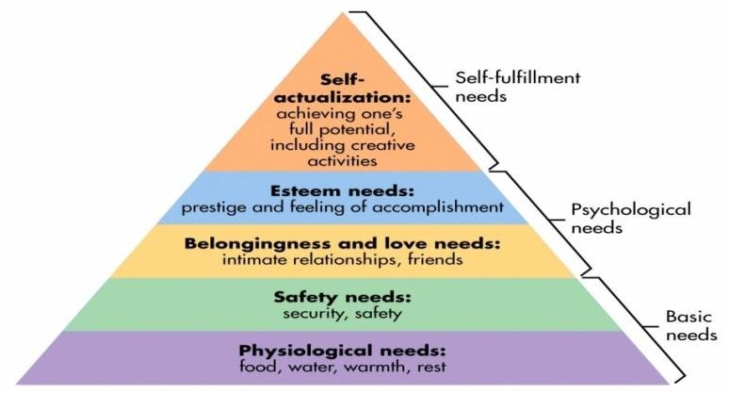

Figure 1: Maslow’s hierarchy of needs (Letsoalo, 2017).

Herzberg’s two-factor theory

Herzberg’s two-factor theory is directly related to the motivation to work. His theory states that there are two aspects of motivation, the first aspect is hygiene which include extrinsic needs such as pay, status and security. The second aspect is motivators which include intrinsic needs such as challenging work and meaningful work. These factors contribute to employees being content within their workplace and having an opportunity for growth (Kurt, 2022). Herzberg did not define the opposite of satisfaction as dissatisfaction; he defined it as no satisfaction, the same concept for the opposite. Dissatisfaction was not defined as satisfaction, but it was defined as no dissatisfaction.

Herzberg’s theory suggests that satisfaction and dissatisfaction are not on the same continuum (DeShields et al, 2005). Motivators increase and improve job satisfaction, whereas hygiene factors reduce job dissatisfaction. When the factors which are contained within the hygiene section are below a level which an employee deems to be acceptable, then job dissatisfaction occurs. However, when these levels are optimal, dissatisfaction will not occur, but neither will a positive attitude; this is due to motivators being the only factors which bring satisfaction. If motivational factors are present, this will produce job satisfaction, and when they are not, it causes no job satisfaction. Similarly, when hygiene factors are poor, this causes dissatisfaction however, when they are good, this will cause no job dissatisfaction but cannot produce satisfaction (Alshmemri et al, 2017).

McGregor theory X and theory Y

McGregor’s theory X and Y came about in the 1960s; it is based on the assumption that a leader’s personal beliefs about employees will influence leadership methodologies selected within the organisation (Larsson et al, 2007). Theory X and Theory Y were proposed as McGregor believed that there were two different assumptions which managers held against their employees. McGregor believed that “behind every managerial decision or action are assumptions about human nature and human behaviour” (McGregor & Cutcher-Gershenfeld, 2006a).

Theory X is based on three assumptions these are 1) the average human has a dislike for work and avoids it if possible. 2) the next one is that people must be directed or threatened with a form of punishment to ensure an acceptable level of effort is put in to achieve the organisation's objectives. 3) finally, the average human seeks to avoid responsibility, seeks direction, and wants security above all else (McGregor & Cutcher-Gershenfeld, 2006b). This approach to managerial motivation suggests that people are naturally unmotivated to work; an organisation which adopts this approach tend to have several levels of management to oversee the work of its employees, and the control tends to remain centralised. It assumes that employees need more ambition, incentives, and rewards to ensure they achieve the necessary goals. Finally, it assumes that employees have no interest in their work except for their pay check (Lawter et al, 2015).

Theory Y is based on six assumptions these are 1) effort in work is natural, and work is not inherently disliked. 2) threat of punishment is not the only way to produce the effort; if committed to the objectives of the organisation, self-direction will be exercised. 3) reward is produced when objectives are achieved due to the commitment to achieving them. 4) responsibility is a learnt behaviour; lack of ambition is not inherited but is usually the consequence of a previous experience. 5) the ability to solve issues using imagination is not a narrowly distributed ability but is widely distributed throughout the population. 6) due to the industrial lifestyle, intellectual abilities still need to be fully utilised (McGregor & Cutcher-Gershenfeld, 2006c). This approach is a more positive approach to management, and a decentralised management style is used. There is trust between managers and employees, and employees are given more responsibilities and are encouraged to develop. Appraisals are used in different ways than in theory X; they are used to encourage a good level of communication rather than to control the employees. Theory Y produces meaning within the workplace and provides employees with more than money.

Vroom’s expectancy theory

Vroom’s theory was developed in 1964 and suggested that we are motivated by three factors: expectancy, instrumentality, and valence. Expectancy is the action, which is undertaken to achieve the desired outcome, the belief that more effort will result in success. Instrumentality is the outcome result produced by the action, the connection between the goal and the activity. Valence is the satisfaction which comes from the outcome and represents the degree of value the reward holds or the result of the success. Vroom’s equation is motivation = expectancy * instrumentality * valence (Chopra, 2019). A positively valent outcome is when the person prefers to achieve it over not achieving it; an outcome that a person would prefer to avoid is negatively valent. If it is believed that high performance is instrumental for the gain of other outcomes that are expected to be rewarding (pay increase) or if high performance will be instrumental to avoidance of outcomes which should be avoided (being fired), then high valence will be placed on performing better. When it is perceived that the value of a reward follows the level of performance, then instrumentality is low (Estes & Polnick, 2012).

Vroom’s theory gives a set of guidelines which managers can use to help motivate their employees. It allows them to provide rewards that employees value rather than running the risk of providing rewards which are not valued (Boone & Kurtz, 2009). A positively valent outcome is when the person prefers attaining it to not; an outcome which a person would prefer to avoid is negatively valent.

2.5 Motivational factors

One of the first studies into motivation was undertaken in 1946, in which industrial workers were asked to rank ten reward factors according to their preference; the survey was performed over four years. Employees ranked "appreciation" as the most crucial factor in 1946 and "discipline" as the least important. In 1980, "interesting work" was at the top of the rankings, while "discipline" was at the bottom. By comparing these factor rankings over several years, it is evident that motivational factors can vary. In more recent studies, the importance of good wages is highlighted (Wiley, 1997b). In the article "What motivates employees Wiley (1997c) also mentions the importance of analysing subgroups which may appear, this helps to determine any variations. For instance, individuals at various levels of an organisation with different income levels may have different motivational values. The following section will outline some of the factors which have different importance.

Challenging work

Multiple studies have been done on creating a challenging work environment to motivate employees and make employees feel like their work is meaningful to the company and society. Challenging employees gives them a sense of value (Fatima, 2011). Attractive job design can increase the employee's internal motivation; it also helps them to engage in the task positively (Asheq et al, 2022). Giving employees challenging assignments allows them to develop new skills, extend their knowledge and gain insight into their workplace. To make this effective, employers should consult their employees about the types of assignments they would value; this means that employees can choose tasks which will engage them, resulting in them being more motivated to complete the tasks efficiently. Without challenges within the workplace, employees have no reason to feel motivated to complete tasks as they are not engaging or stimulating (Bawa, 2017).

Pay/rewards

A study found that rewards significantly affect job satisfaction and productive employee behaviour. Reward systems help to inspire and motivate employees to work more efficiently on tasks, as rewards are related to productivity (Edirisooriya, 2014). Several studies have been done on the impact of pay on motivation. Employees will be motivated if they are paid; this means that if a salary is increased, performance will increase as motivation increases. Salary is a benchmark for employees and motivates them to go to work. When employees' salaries are low, performance will be low because employees are unsatisfied and therefore are not motivated to perform well (Asaari et al, 2019). Another study by Shafiq et al, (2011) with a sample of 167 people supports this. The results found that salary and pay were the most important motivators for employees compared to other factors such as job security, appreciation, and other benefits.

Relationships within the workplace

Healthy employee relationships lead to increased satisfaction and motivation, which leads to higher productivity. Engagement within the workplace is the key to happiness; relationships within the workplace significantly impact engagement levels. When employees are happy in the workplace, they become more motivated, making relationships important for motivation (Brigham, 2022). Previous literature has also found that friendships and relationships within the workplace involve positive feelings towards one another, resulting in employees feeling more fulfilled within their workplace. If employees feel fulfilled, this results in satisfaction and motivation as their feelings towards work are positive, suggesting that friendships and relationships within the workplace are essential factors in workplace motivation (Mao et al, 2012).

Individual differences in motivation

Studies have found that having an understanding of employees’ individual differences can help to improve motivational strategies that are put in place.

Generational differences

Extensive data and research has been done on generational differences and motivation. One study found that 85% of millennials (generation Y) want work which makes a difference and is rewarding for themselves and the world, and 71% want to work for companies that promote global and social responsibility. Both statistics are higher than other age cohorts studied (Strauss, 2013). Studies have also been done on generation Z’s workplace preferences; in 2014, a study found that the three most important motivating factors were advancement, money and meaningful work (Kirchmayer & Fratričová, 2018). Another study done by Kubátová (2016) replicated this study two years later and found similar results; however, the motivators were placed in a different order (money, meaningful work and advancement). Generation Z is the most materialistic of the generations; 45% of the generation is motivated to achieve financial success because they want to be able to afford material goods. This resulting in money being an important motivator for this generation (Berger, 2022). A survey conducted where a sample of generation X had to rank motivating factors found that respect was the most important factor for this generation, followed by good pay (Montana & Petit, 2011). The baby boomers’ generation is motivated both by monetary rewards and non-monetary; studies suggest that this generation does not require as much feedback. The generation is goal-orientated and motivated by promotion and the desire to be valued (Gurchiek, 2019). Other studies have revealed that this generation is driven and willing to go the extra mile for a company; they want to please and are self-centred (Novotny, 2019).

Job position differences

Studies have suggested that employees at lower levels within an organisation are more motivated when the companies invest in the employee’s future and a sense of purpose. Managers become more motivated by their purpose and the challenges that their work provides for them, and the monetary benefits which come with this. Motivation amongst managers is highest when they are fulfilling their true potential; a study by Clark University revealed that managers value intrinsic rewards. The results showed that those who were motivated internally were more productive, which showed managers are motivated by challenging work and the development of their personal goals; monetary aspects were also highlighted as a motivator for this job position (Dang, 2018). There is limited research on what motivates entry-level employees; however, researchers have suggested ways in which organisations could motivate them; some of these include recognition of performance and commendation for good performance, coaching to provide development and feedback and giving more responsibility to these employees to help them recognise their value within the organisation (Saunderson, 2009).

2.6 Summary

This chapter achieved the first objective:

“To analyse academic literature on the rationale of motivation theories and how these apply to what employees deem motivates them.”

The literature review has provided a comprehensive review of motivation theories relevant to the research topic. The main concepts related to motivation and the intrinsic and extrinsic factors related to this have been discussed.

The next chapter will discuss the appropriate research methods and methodology to address the elements highlighted in this chapter.

Chapter 3 – Methodology

3.1 Introduction

This chapter outlines the purpose of the selected methodology, which concerns the topic of the study, which is to understand motivation within the workplace. The purpose of the methodology is to develop the process used to generate a framework in which research is conducted (Mohajan, 2017). The methodology contains information on the research methods selected for the study and the methods used to obtain results and analyse the primary and secondary data. It also states the limitations and ethical considerations of the chosen method. The Saunders research onion will be adopted within this chapter to help guide the chosen methodology.

The research onion provides a framework consisting of six different layers; this allows for decisions to be made, enabling systematic research to be undertaken. Furthermore, the framework helps guide a researcher through each step needed to enable a research method to be developed (Melnikovas, 2018a). The framework’s step-by-step structure allows research development through a selection of philosophies, approaches, methodological choices, strategies, time horizons, techniques, and procedures. Figure 2 highlights the chosen research process.

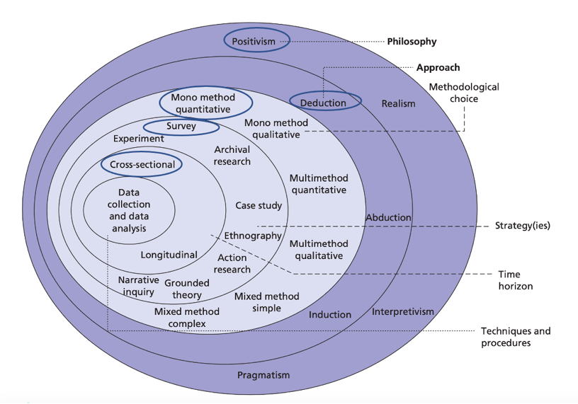
Figure 2: Saunders research onion (Saunders et al., 2012).

3.2 Philosophy

Research philosophy shows the researcher's views of a topic and contains assumptions on which a researcher bases their work (Alturki, 2021). There are two main philosophical fields, ontology which refers to the study of existence and the nature of reality and epistemology, which is how knowledge is gained and how we know what we know. (Killam, 2013). This research study uses an ontological approach.

An interpretive approach looks at historically situated interpretations of the world. Whereas a positivist approach follows the methods of natural sciences, the researcher can observe reality objectively; positivists tend to look for relationships and correlations a comparative method is used. Due to this, a positivist approach usually uses quantitative research methods because the research must be valid and representative. However interpretive approach uses qualitative research methods because there is greater validity even at the sacrifice of representativeness; it assumes that the researcher has a role in observing the world and that reality is unique to the observer, and reality is observed subjectively (Al-Ababneh, 2020). For this research study, positivism will be the philosophy which underpins the research and its goal to understand the motivation within the workplace, and the patterns within motivation which aligns with the positivism approach.

3.3 Research type

The deductive research approach typically tests ideas and examines existing theories; it is generally used within quantitative studies. It involves starting with a theory and then deducing this to a hypothesis to determine whether there is a relationship (Woiceshyn & Daellenbach, 2018). The inductive research approach begins with observations to find patterns and develops conclusions or theories; this approach is typically used within qualitative research (Thomas, 2006). A deductive approach will be used as the research starts with existing theories, which are outlined within the literature review; a question has been formed based on these theories meaning a deductive approach was used (Melnikovas, 2018b).

There are two types of research qualitative and quantitative. Qualitative research is designed to help researchers to understand people. It is designed to understand social contexts in which people live, and one of its benefits is that it allows an understanding of the context in which actions take place (Myers, 2019). Quantitative research is a way of explaining phenomena by collecting and analysing numerical data using mathematical methods (Muijs, 2011). A benefit to quantitative research is it is less time-consuming than qualitative, and the results are more accurate as the researcher does not interpret them.

For this research, a mono method was used where quantitative research was selected, as it involves the collection of data which can then be quantified to explain a phenomenon (Apuke, 2017). This method allows ease of analysing data, although a limitation to this method is that there could be difficulty understanding any complex issues. However, quantitative research allows access to a broader range of people and a larger sample size in a shorter period.

3.4 Strategy

An assessment of existing literature relating to the phenomenon being researched will be conducted; this will be achieved through a literature review and will make up the secondary data. For the primary research, this study uses questionnaires to gather data on the public’s views on motivation within their workplace. A questionnaire was the most appropriate data collection method because it allows the researcher to collect standardised data, which can be easily compared and distributed to a larger audience compared to other methods (Saunders et al, 2007a).

3.5 Time horizon

A cross-sectional study is the most appropriate for this study as it looks at a certain point in time, and it allows a researcher to look at multiple characteristics, for example, age, gender etc. It provides insight into correlations occurring at one given time, although it cannot determine a cause and effect. This type of study allows data to be collected quickly and can access multiple different variables and outcomes to see how they affect a particular condition (Levin, 2006). A longitudinal study could not be adopted as this would need a much longer time frame.

3.6 Techniques and procedures

Data collection method

Primary research will be conducted; this allows data to be gathered with the direct objectives in mind allowing the researcher to gain data specific to the study (Ghauri et al, 2020). The primary research will gather data by use of a questionnaire which will be targeted at the general public. The advantage of using a questionnaire is that it is inexpensive and is not time-consuming. In addition, a questionnaire provides real-world data as the information is collected directly from individuals. However, a disadvantage to this method is a lack of depth and detail on the topic being investigated; this is sacrificed at the gain of scope as a more extensive data set can be achieved in a small amount of time (Denscombe, 2014).

This questionnaire consists of nine questions to gain data on employee motivation within the workplace. The questionnaire contains a variety of questions, including nominal and ordinal. Nominal questions were used to collect participants' demographics, including age and gender, which can be categorised. Ordinal questions provided data that could be ranked or include open-ended questions (Nykiel, 2007). The survey used a variety of different response methods, including multiple choice and rating scales. This provided a range of statistical data to be collected. The questionnaire mainly consisted of closed-ended questions; this allows the researcher to gain clear responses which are measurable and efficiently coded; it also helps to eliminate any irrelevant answers that may be given when using open-ended questions (Hyman & Sierra, 2016).

Survey design

The questionnaire was created using Forms, as it provides a variety of different question types. A link was provided to allow the participants to access the form, which was then distributed online on social media platforms. The questionnaire was anonymous; participants followed the link where a short brief of the questionnaire was provided, which explained that their participation was voluntary and would remain anonymous, explaining that they could withdraw if they wished to. Along with this were the researcher’s contact details should they want to ask questions.

Question | Relation to literature review
Q1. How old are you?  Q2. What is your gender?  Q3. What is your position at your job?  Q4. How satisfied are you within your job? | Question 1-4 are demographic questions to provide background.
Q5. Rank what motivates you most in the workplace.  Security  Money  Health and well-being  Value and respect  Friendship  Rewards | This question can be linked to Vroom’s expectancy theory and Maslow’s hierarchy of needs. The question was selected to help draw on the factors of motivation.
Q6. What strategies are used within your workplace to motivate employees?  Share scheme  Bonus structure  Verbal commendation  Employee development  None | This question was used to draw on whether people value intrinsic or extrinsic rewards more.
Q7. Rank what is most important to you in the workplace.  Pay  Status  Work is meaningful and contributes to a greater cause.  Feel your work is challenging.  Competent at your work  They will be rewarded for their efforts. | This question was used to draw on Herzberg’s two factor theory, Maslow’s hierarchy of needs, the factors of motivation and intrinsic and extrinsic motivation.
Q8. What encourages you to do well at your job?  Authority  Rewards  Supervision  Threat of punishment  Satisfaction  Appraisal  Responsibility  None of the above | This question was used to draw on McGregor’s theory X and theory Y.
Q9. Suggestions to improve motivation within your workplace. | This question provided respondents with the opportunity to give their suggestions.
Figure 3: Literature review and questions matrix

Data analysis

The data will be analysed using a Statistical Package for the Social Sciences (SPSS) and excel. The research study will make use of both descriptive and inferential statistics. Descriptive statistics describe patterns within the dataset, gives a general make-up of the study and outlines the participants' demographics. This type of statistic uses measures of central tendency to give an idea of the nature of the participants (Ellis, 2018). Inferential statistics are used to draw conclusions from a population. The main goal is to make generalisations about the population; the accuracy depends on the sample taken (Asadoorian & Kantarelis, 2005).

Sampling strategy

The entire population is too large to sample, so a smaller sample group representative of the whole sample was used to increase the reliability and validity. A smaller sample of the general public was used within this study as the target population was the general public. The sample size required to ensure that the results are valid is a minimum of 100 respondents this ensures that the data is representative (Pearson & Mundform, 2010). The number of respondents gained from this study was 88 causing some limitations.

A convenience sampling method was used to gain participants due to the time restraints of the study and using the general public as a target population. Convenience sampling is a form of non-probabilistic sampling; it is a method that uses a conveniently located sample for the researcher; there is no pattern to acquiring the participants; therefore, time and costs can be reduced (Edgar & Manz, 2017). Non- probabilistic sampling is a method of selecting participants from a target population using a subjective method; it uses a non-random way of selection (Saunders et al, 2007b).

3.7 Barriers and limitations

A convenience sample was used within the study as it was the best suited for the time constraints involved. However, the limitation is that it may not have reached a diversified population which other methods, such as a systematic sampling method, would have been able to achieve. In addition, this meant that inferential statistics could be inaccurate as the sampling method chosen was convenience (Emerson, 2021). Therefore, the results may only be generalisable to some of the target population.

Another limitation of this study was that the survey only gained 88 participants due to time constraints and the use of convenience sampling. This number of participants is lower than the suggested minimum number of respondents meaning that the sample size may be representative of only some of the population.

A limitation was that the participants predominately fell into the age brackets of 18-24 and 25-34, with 55 of the 88 participants falling into these age categories; therefore, the results and analysis of the other age ranges may not be representative meaning the findings may not be generalisable to a broader population.

A limitation of this study was that participants were predominantly female; 65 participants were female, and 23 were male. This meant that the analysis of gender was discarded as the results would not have been generalisable.

3.8 Ethical considerations

This research was undertaken in line with the ethical standards of UWTSD, with the approval of a supervisor obtained by an ethics approval form. Ethical considerations were met as the questionnaire was anonymous, and the data was stored on one device with password protection to ensure it was not misused. The questionnaire was voluntary, and participants were over the age of 18. An ethical disclaimer was published at the beginning of the questionnaire, informing the participants that it was voluntary and that they could withdraw at any time. It also stated that they would be anonymous and gave a method of contact if there were any further questions.

3.9 Summary

This chapter achieved objective 2:

“To select an appropriate research approach for the primary research to explore the views of employee motivation within the workplace.”

This chapter has explained, using Saunders’s research onion, the research methods to be considered and those adopted in this study. It has justified the choices made by the researcher to undertake a positivist quantitative approach in the form of a questionnaire. It has also outlined limitations and ethical considerations which were taken.

Chapter 4 – Findings

This chapter presents the findings of the primary research undertaken for the investigation of Human resource management – employee motivation within the workplace. A total of 88 responses were gained this was achieved using convenience sampling. All respondents were aged 18 years or over and participated voluntarily.

Q1- How old are you?

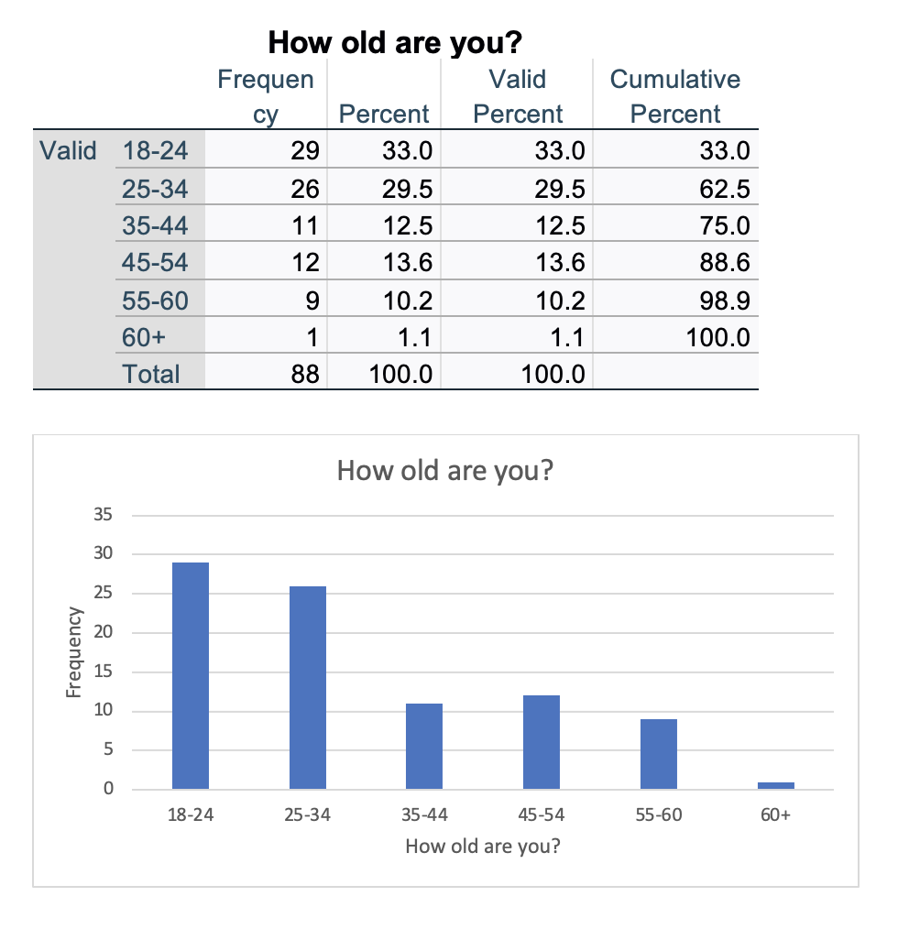
Figure 4: Age of respondents

Figure 4 identifies the age groups which completed the questionnaire, with the largest completion rate being 33% in the age category 18-24, the category with the lowest completion rate was 60+ with only one participant falling into this category.

Q2- What is your gender

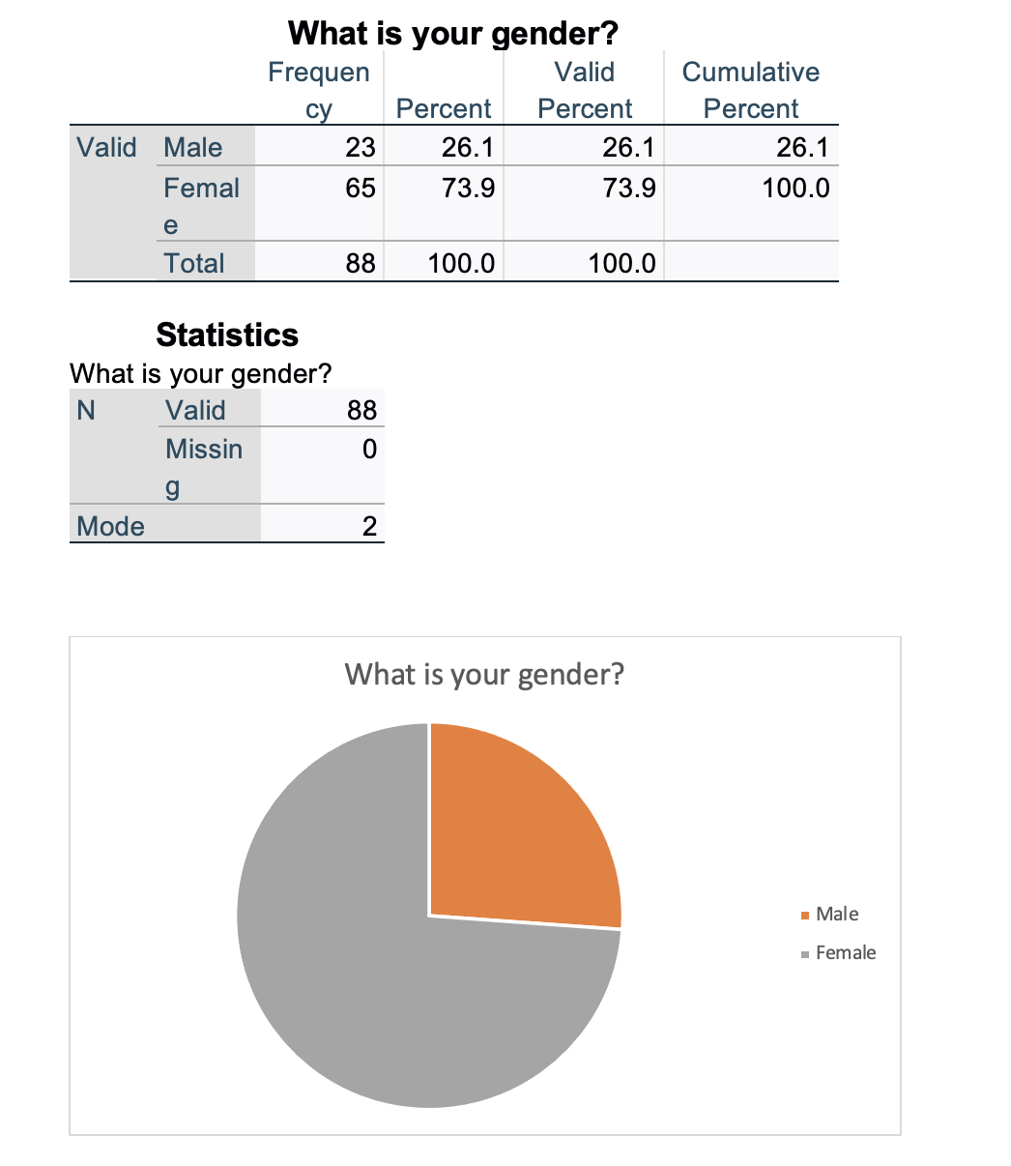
Figure 5: Gender of the respondents

Figure 5 shows that there were a higher number of female participants, the valid percentage of females was 73.9%, the percentage of male participants was 26.1%. Therefore, the mode is 2 which is coded to female. Other and prefer not to say were not included in the data as no participants identified within these categories.

Q3- What is your position at your job?
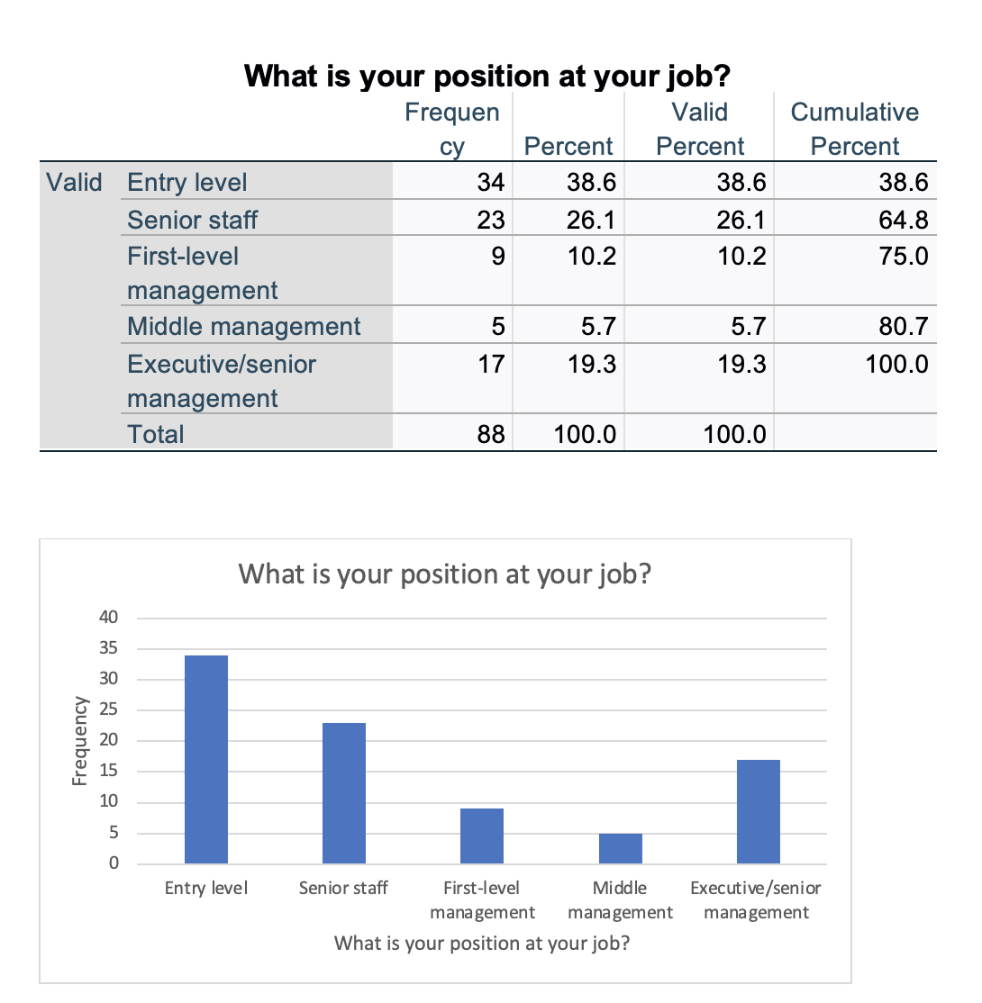
Figure 6: Respondents job positions

Figure 6 shows the participants position within their job; from the bar chart it is evident that most participants were at entry level within their job with 38.6% of participants falling into this category. Only 5.7% of participants fell into the middle management category making this the category with the least number of participants.

Q4- How satisfied are you within your job?

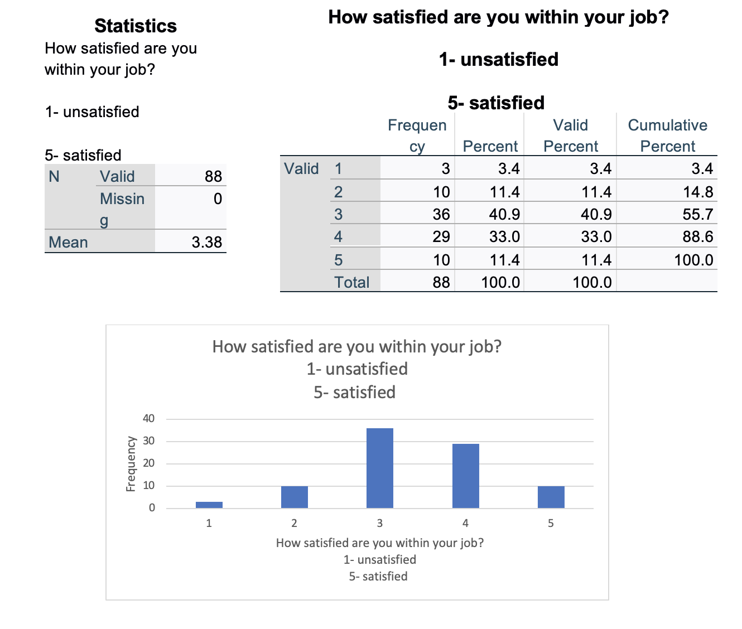
Figure 7: Respondents satisfaction within their jobs
Figure 7 illustrates the participants satisfaction within their jobs the most common rating was 3 with 36 of 88 participants rating their satisfaction as 3, 10 participants rated their satisfaction as 5- satisfied and 3 participants rated their satisfaction as 1-unsatisfied. The statistics table shows a measure of central tendency the measure used in this case is the mean, the table shows the mean average satisfaction was 3.38.

Q5- Rank what motivates you most in the workplace.
1- most important
6- least important
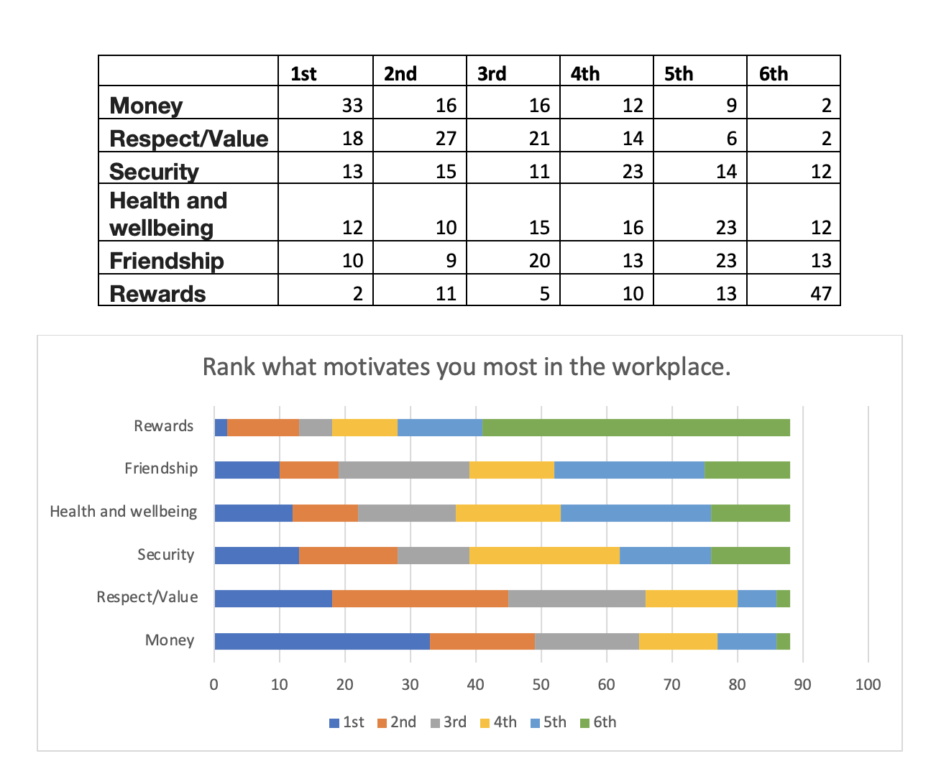
Figure 8: Important motivators in the workplace
Figure 8 shows how the participants ranked factors which motivated them in the workplace from most important to least important. From the stacked bar chart, it is evident that rewards were ranked least important by the largest number of participants 47 out 88 participants ranking this factor as their 6th choice- least important. The factor which got ranked as most important the highest number of times was money with 33 participants placing it as their 1st choice- most important.

Q6- What strategies are used within your workplace to motivate employees?

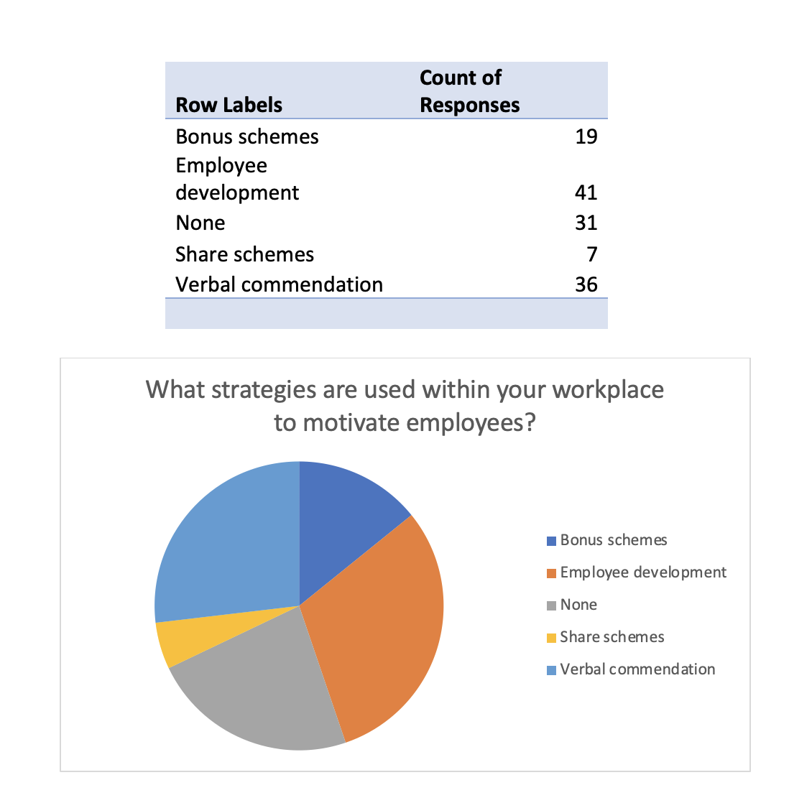
Figure 9: Motivation strategies used in respondent’s workplace
Figure 9 shows what strategies are in place to motivate employees in the respondent’s workplace. The pie chart shows that:
- 41 participants selected employee development as one of the strategies in place to help motivate employees.
- 36 participants answered that verbal commendation is used as a way of motivating employees.
- 31 claimed there were no strategies in place.
- 19 said there were bonus schemes in place.
- 7 claimed there are share schemes being used as a strategy to motivate employees.

Q7- Rank what is most important to you in the workplace.
1- most important
6- least important

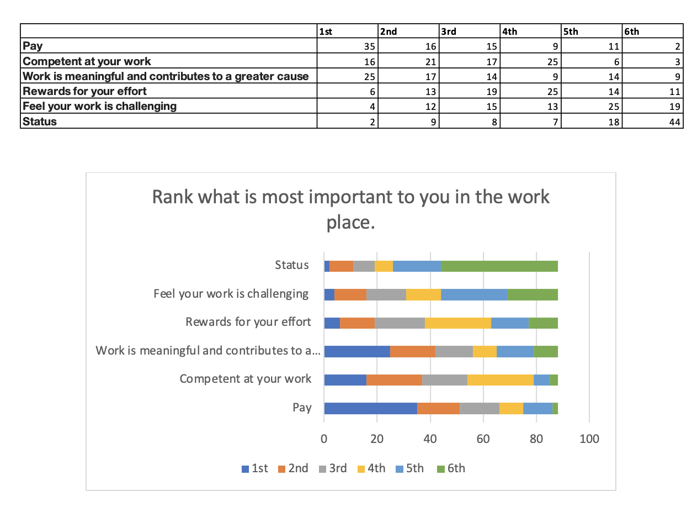
Figure 10: Important factors in the workplace

Figure 10 is a stacked bar chart which depicts how participants ranked factors within the workplace 1st being most important and 6th being least important. It is evident from the data that pay was selected as a first choice most frequently with 35 participants selecting it as their first choice. In contrast to this, 2 participants chose status as their most important factor within the workplace and 44 participants selected it as their 6th choice, making it the most frequent 6th choice response.

Q8- What encourages you to do well at your job?

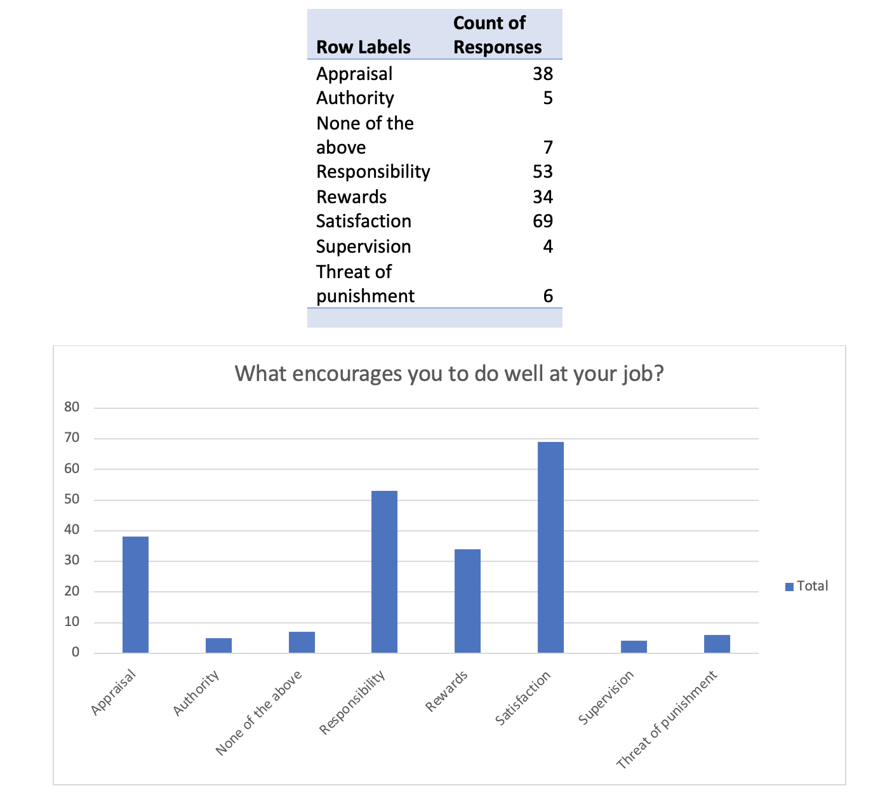
Figure 11: Encouraging factors within the workplace
Figure 11 is a bar chart showing what participants considered to be encouraging factors within the workplace. The graph shows that satisfaction was clearly the most encouraging factor as 69 participants chose it as a factor which encourages them to perform well. 53 participants selected responsibility, 38 selected appraisals, 34 chose rewards, 6 chose threat of punishment, 5 chose authority and 4 chose supervision.

Q9- Required respondents to state some suggestions to improve motivation within their workplace. Below are some of the responses:
- 14% of the respondents gave the suggestion of rewards systems being implemented.
- 5% answered better pay.
- 6% answered praise and encouragement.
- 6% answered better communication.
- One participant wrote “weekly targets to help work towards a goal”.
- Multiple respondents mentioned more bonuses.
- One respondent suggested performance-based pay.
- 6% suggested bonus schemes.

Chapter 5 – Data Analysis

This chapter will analyse the data collected using crosstabulations. Data analysis is the process of converting data into information. This procedure entails identifying patterns and trends in data. The purpose of data analysis is to comprehend the meaning of the data and then apply that comprehension to make judgements or predictions (Coghlan & Brydon-Miller, 2014).

5.1 Crosstabulations

Q5
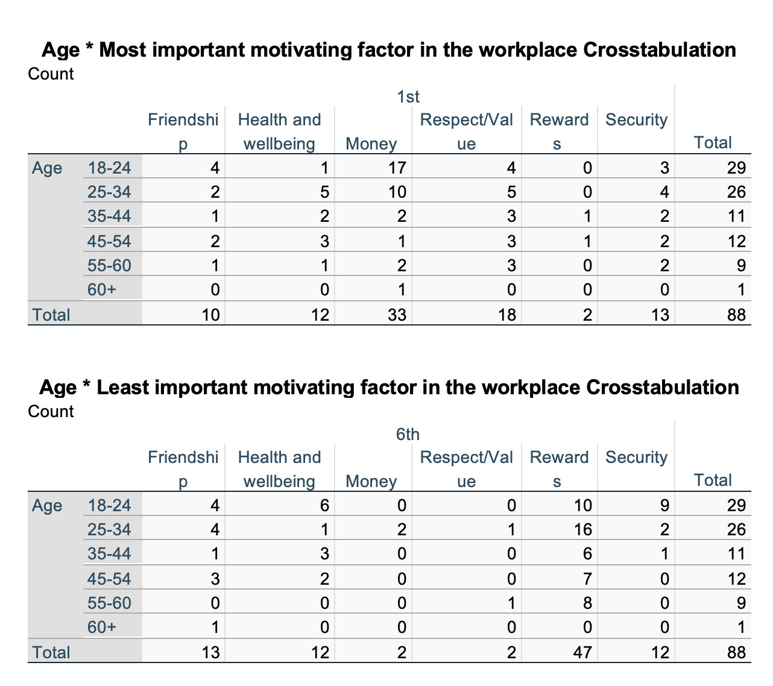
Figure 12: Crosstabulation of most important and least important motivating factors and age
Analysis

These crosstabulations of what participants rated as their most important motivating factor and least important in the workplace and the participant's age, show that it was predominately 18-24-year-olds that rated money as their most motivating factor. It also shows that this age range rated rewards as their least motivating factor. In the 25–34-year-old category, money was rated most important and rewards least important. However, in the 35–44-year-old category, respect/value was rated most important, with rewards being least important. In the 45–54-year-old category most important were health and well-being and respect/value. For 55–60-year-olds, it was also respect/value. These results show that there could be a generational difference in what participants consider most motivating in the workplace as the results differ between the different age ranges. However, for the least important factor, each age category had rewards as the most common factor placed as least important for motivation except for 60+ who selected friendship as least important.

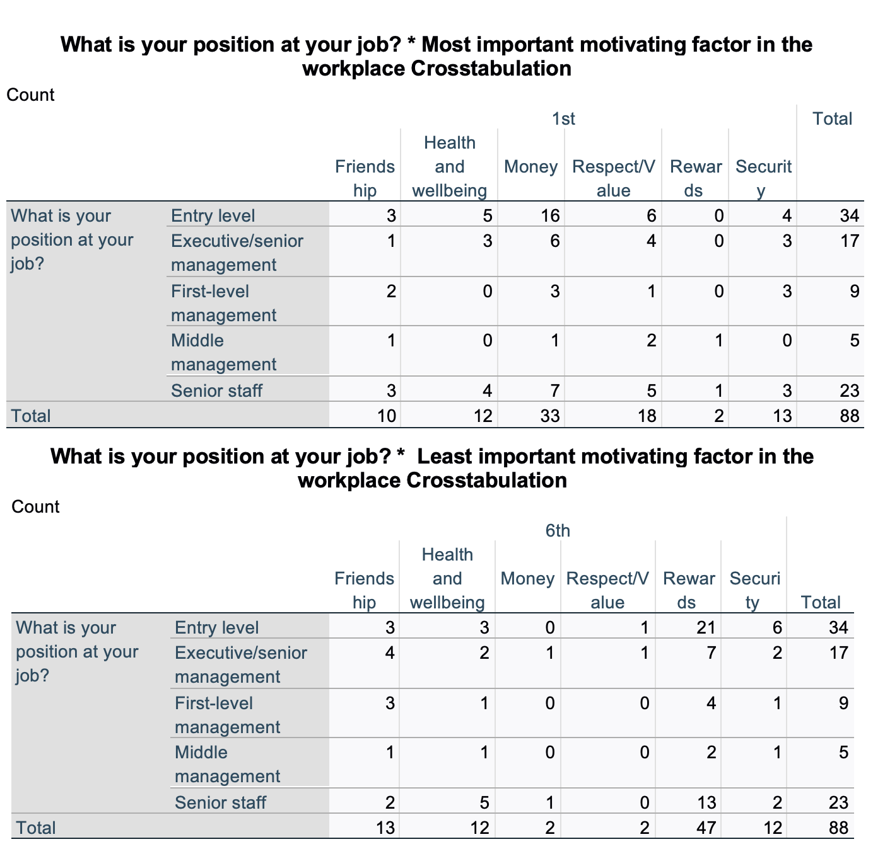
Figure 13: Crosstabulation of most important and least important motivating factors and job position
Analysis

These crosstabulations show what participants rated as their most important motivating factor and least important in the workplace and job position. For the respondents at entry-level, money was selected as the most important motivating factor for the highest number of participants, with 16 out of 34 ranking it most important. Rewards were the most popular for the least important motivating factor, with 21 out of 35 ranking it least important. For first-level management, money and security were most frequently chosen as the most important motivating factor, with 3 out of nine choosing them as their first rank. Rewards were also selected as their least important motivating factor, with four respondents choosing it as the least important. Middle management respondents selected respect/value as their most important motivating factor the highest number of times, with 2 out of 5 selecting this category. Rewards were voted the most for their least motivating factor, with two respondents selecting it. Senior staff chose money most frequently as their most important motivating factor, with 7 out of 23 selecting it. Rewards were most commonly ranked as the least important factor for senior staff, with 13 out of the 23 respondents ranking it last. Finally, for executive/senior management, 6 out of 17 respondents chose money as their most important motivating factor making this the most frequent choice for this job position, and 7 out of 17 chose rewards as their least important motivating factor. These results show little pattern between job position and factors which are important for motivation, as all except middle management participants selected money as their most important motivating factor most frequently. Rewards were most frequently chosen as the least important factor by all the groups of participants.

Q7
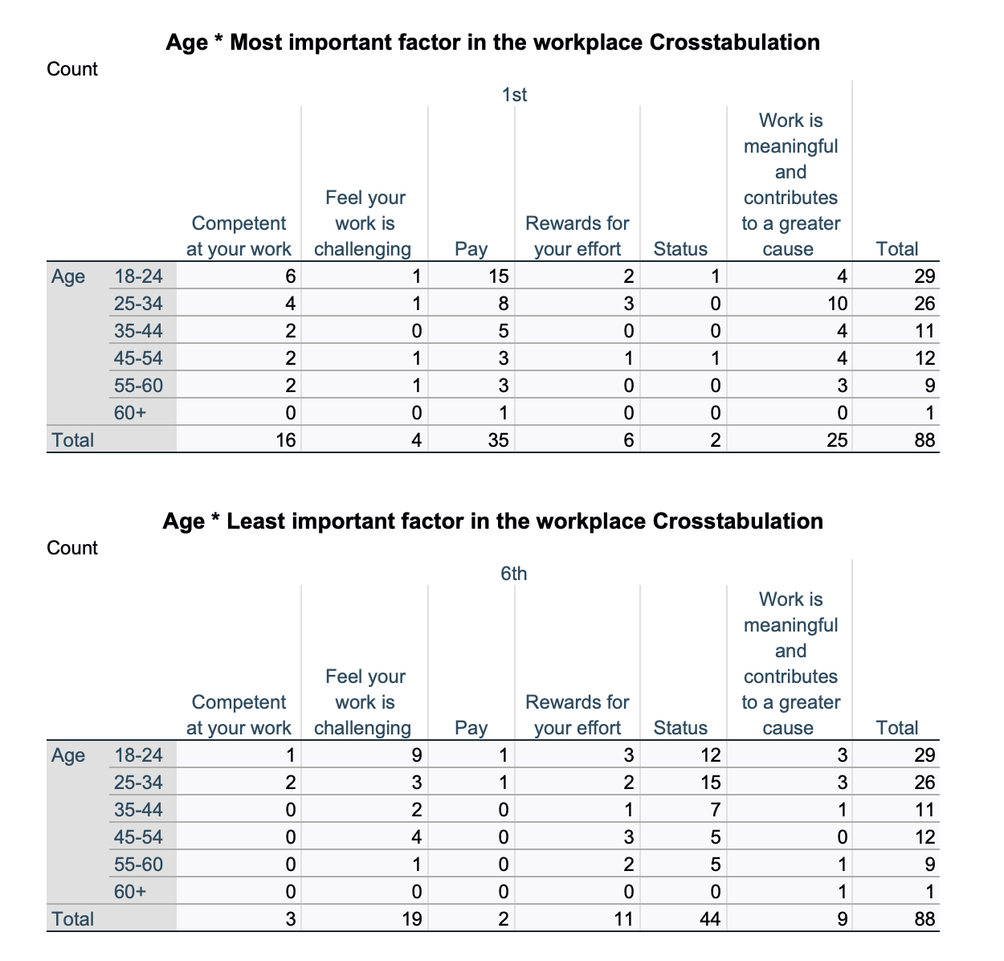
Figure 14: Crosstabulation of most important and least important factors and age

Analysis

These crosstabulations show the respondent's least and most important factors within the workplace and the participant's age. For respondents aged 18-24, pay was most frequently chosen as the most important factor in the workplace, with 15 out of 29 ranking it first, status was most frequently selected as the least important factor, 12 out of the 29 selected it as their last choice. Aged 25-34 selected ‘work is meaningful and contributes to a greater cause' as their most important factor within the workplace the highest number of times, with 10 out of the 26 selecting it as their first choice; status was also selected the most for least important factor with 15 out of 26 choosing it as their last rank. Respondents aged 35-44 selected pay as their most important factor the highest number of times, with 5 out of 11 selecting it as their first choice. For the least important factor, status was also chosen the most. Ages 45-54 ranked 'work is meaningful and contributes to a greater cause' as most important most frequently, with 4 out of 12 ranking it as the first choice. Status was also selected as least important for this age bracket, with 5 selecting it as the last choice. For respondents aged 55-60, pay and 'work is meaningful and contributes to a greater cause' were selected as most important by 3 participants making these the most frequently ranked as most important; 5 participants of the nine also selected status as least important, making it the most popular factor ranked last. Finally, for those aged 60+, pay was chosen as most important, and 'work is meaningful and contributes to a greater cause' was selected as least important. These results show that there could be some pattern between generations and the most important factors within the workplace, as there are different results for the different age brackets. The younger participants mainly chose pay as their most important factor; however, 25-34, 45-54, and 55-60 mainly chose 'work is meaningful and contributes to a greater cause'. A greater number of participants could have enabled a more evident pattern to develop.

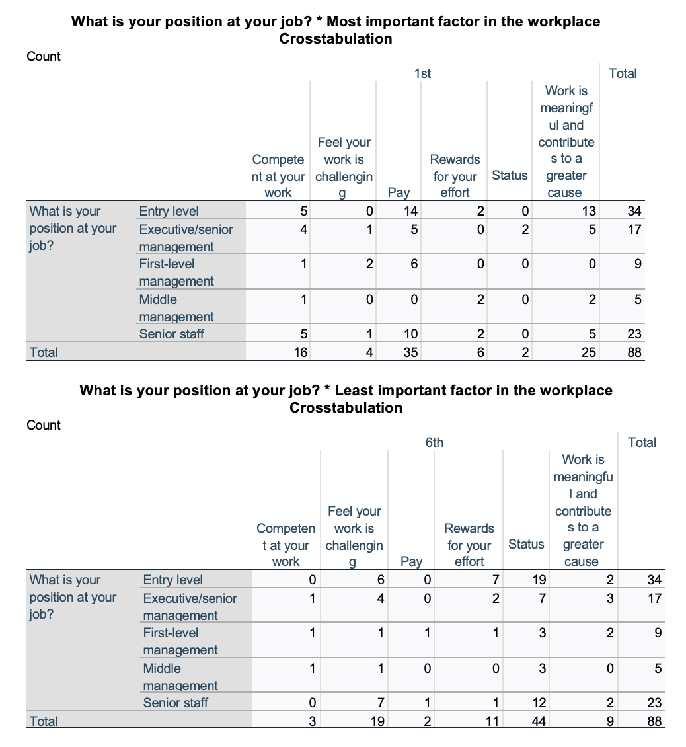
Figure 15: Crosstabulation of most important and least important factors and job position

Analysis

These crosstabulations show the respondent's least and most important factors within the workplace and the participant's job position. Entry-level respondents most commonly chose pay as their most important factor, with 14 out of 34 selecting it as their top rank. The majority selected status as the least important factor; 19 participants ranked this factor as least important. First-level management mainly selected pay as the most important, with 6 out of nine ranking it as most important; for least important, status was also most selected, with 3 participants selecting it. Middle management selected 'rewards for your efforts' and 'work is meaningful and contributes to a greater cause' as their most important factor most frequently, with both factors being ranked as first choice by 3 participants. For least important, status was ranked most regularly, with 3 out of 5 choosing it as their last choice. Senior staff also chose pay most frequently, with 10 out of 23 participants in this category ranking it most important. The most popular and least important factor was status, with 12 participants ranking it last. Executive/senior management participants ranked both pay and 'work is meaningful and contributes to a greater cause' most frequently as most important, both having 5 participants ranking it as most important. For the least important, status was also the most selected. These results show little pattern between job positions and important factors within the workplace. The only result that differed was participants that fell into the middle management category.

5.2 Summary

The crosstabulations have revealed patterns which have occurred within the study, these results will be discussed further in the following chapter.

Chapter 6 – Discussion

This chapter will discuss the findings and analysis in relation to the literature review. The discussion is divided into four parts which will answer the research questions: analysis of demographic variables (individual differences), analysis of extrinsic and intrinsic rewards, analysis of motivation theories, and analysis of motivational factors.

6.1 Demographic variables (individual differences)

“Are there any patterns that arise of motivation in the workplace and the individual differences amongst employees?”

This section aims to analyse the survey respondents' demographic variables, including age, and job position. Previous studies have revealed the importance of analysing demographic variables and motivation. This section will look at how age and job position affect motivation.

The majority of participants within the study fell into the age brackets of 18-24 and 25-34, with 55 out of the 88 participants falling into this age bracket. The primary research supports the theory that motivation is different depending on the employee's age; an interpretation of the results suggests that the primary findings support parts of the literature; however, some parts have been rejected. Generation Z, which includes the age brackets of 18-24, were motivated mainly by money. Generation Y (millennials), including the age bracket of 25-34 and 35-44, were mostly motivated by money and respect/value. Generation X ages include the age brackets of 45-54 and 55-64, mainly motivated by health, well-being, and respect/value. Baby boomers, which cover the age bracket of 60+, were primarily motivated by money. The literature review states that generation Y is more motivated by making a difference than money. However, primary findings have found that money is still a significant motivator for this age bracket as well as respect/value. Within the secondary data, generation Z was found to be motivated by money, meaningful work, and advancements. The primary findings have shown that money is a strong motivator for this generation, with 17 out of the 29 participants choosing it as their most important motivator. Generation X has been found to rank respect and pay as their most important motivators, as discovered in previous research. The primary research findings partly relate to this as it was found that generation X ranked health and well-being and respect/value as top motivating factors; however, only three respondents out of the 21 who fall into this generation ranked money as their most motivating factor. There was only one participant who fell into the baby boomers, which includes the 60+ category, results are specific to this participant and are not generalisable. However, money was ranked as most important for this participant and friendship was ranked least important. This supports some of the elements discussed in the literature review as previous studies have found this generation to be self-centred, which would be the reason this participant chose friendship as their least important motivating factor. They also selected money as their most important factor, which coincides with previous research as it suggests this generation is money motivated.

The primary research shows that entry-level employees are motivated mainly through their pay and that their work is "meaningful and contributes to a greater cause". However, there was no substantial research on what motivated entry-level employees'; pay was not considered an important suggestion on how organisations could attempt to motivate their entry-level employees. The findings show that having a purpose, however, also motivates them, which is relevant to the literature found as a suggestion was given of coaching to ensure that entry-level employees know their value. The literature on what motivates managers suggests that they are motivated by challenges and intrinsic rewards but are also motivated by money. The primary research partially supports this as executive/senior management were motivated mainly by pay and contributing to a greater cause; however, one of their least important factors was challenging work, with 4 out of 17 participants ranking it least important, and one participant ranking it most important rejecting part of the previous research findings.

6.2 Intrinsic and extrinsic motivation

“Which form of motivation is most important to employees intrinsic or extrinsic?”

The primary research has shown that generations Z and Y are more extrinsically motivated, and generation X are more intrinsically motivated. As discussed in the literature review, there could be issues with being motivated solely by extrinsic rewards. From the research, it is evident that the younger generation is driven mainly by extrinsic rewards, which could be troubling as this could lead to a generation being formed with a lack of creativity and the ability to think outside the box for solutions. Furthermore, having a generation motivated by money means there will be less empathy and consideration for other essential factors, as money is the only thing that matters.

The research has shown that employees value both extrinsic and intrinsic rewards. Though, money came out on top, with 33 choosing it as their most important factor in question 7; only 35 participants chose the extrinsic factors: money and rewards. However, intrinsic factors were also important, if not more important, for a lot of the employees, with 53 out of the 88 choosing various different intrinsic factors as their first ranked choice (friendship, health and wellbeing, respect/value and security).

The results from question 6 show that there are currently more intrinsic forms of motivation used within the workplace by way of employee development and verbal commendation than there are extrinsic forms, which is positive; as discussed in the literature review, there are adverse effects from the use of only extrinsic rewards.

6.3 Motivational theories

“How relevant are motivational theories and are they important in motivating employees?”

This next part aims to analyse the motivational theories with the findings from the research. First, Maslow's hierarchy of needs will be analysed against the study's findings. The results from one of the ranking questions (Q7), which required participants to rank what was most important to them in the workplace, revealed that participants do not feel as though status is important. Suggesting that there is a lack of motivation to reach self-actualisation and gain management roles within the workplace, there is more of an ambition to earn money. Half of the participants ranked status as their least important factor, and money was ranked as most important by 35 participants; this shows that people are not motivated by their status within their job, and money is a primary driver in motivation. However, Maslow's hierarchy of needs states that self-actualisation is when the full potential has been achieved; it is the top rewarding factor. This suggests that Maslow's hierarchy of needs only goes so far, and people do not want to fulfil all their needs, just their basic needs, which can be fulfilled by pay. Out of the 17 participants who are already at the executive/senior management level, the highest job position (self-actualisation) only two ranked status as their most important factor, with 7 ranking it their least important factor suggesting that self-actualisation does not act as a motivator. Participants were more motivated by the money that comes with self-actualisation and the fact that they are contributing to a greater cause not by the status itself, suggesting that the need for self-actualisation is not important.

The other ranking question included in the survey (Q5) asked participants to rank the most important motivating factors in the workplace; this revealed some support for the theory. Maslow's hierarchy of needs places friendship third, above security and physiological needs; from the results, participants ranked security and health and wellbeing as most important (basic needs), with 13 ranking security as most important and 12 choosing health and wellbeing, showing that these needs may have a higher importance meaning these needs must be met before the needs of belongingness (friendship) showing the accuracy of Maslow's theory.

The next theory is Herzberg's two-factor theory which identifies motivators and hygiene factors. The primary results did show a relationship with Herzberg's two-factor theory. The results from question 7 show that 35 out of 88 participants chose pay as their most important motivating factor, which is part of the hygiene element. Twenty-five participants ranked 'work is meaningful and contributes to a greater cause' as their first choice, which is part of the motivator's element, suggesting that a mixture of hygiene and motivators is seen as necessary within motivation.

Out of the 88 participants, 47 participants ranked rewards as the least motivating factor in question 5 within their job position. Vroom suggested that expectancy is a crucial element in motivation proposing that employees will perform well to receive an outcome such as a reward. However, the results show that participants did not feel that rewards were an important factor in motivation, suggesting that Vroom's theory may only be partially fit for purpose.

McGregor's theory X claims that management should implement authority to motivate employees; it also suggests that people tend to avoid responsibility. Theory Y suggests that appraisal should be given, and responsibility should be given to employees. The results from question 8 support theory Y within McGregor's theory as more participants chose elements within theory Y as encouraging/motivating factors. In contrast, only 5 participants stated that authority motivates them, and only six felt that the threat of punishment motivated them, rejecting the elements from theory X.

6.4 Factors of motivation

“What are the factors of motivation and how important these are for employees?”

The primary results show that in question 7, four respondents selected work is challenging as the most important factor, and 19 ranked it as the least important factor. This conflicts with the secondary findings within the literature review, where (Asheq et al, 2022) undertook a study and found that challenging work played a significant role in increasing internal motivation. The results within the primary study clearly show it is not as important to motivation as other factors.

The most common factor ranked as most important within question 7 was pay; this coincides with research undertaken by (Shafiq et al, 2011), who found pay was most important over factors such as job security. In the primary research, 33 respondents selected pay as their most important motivating factor, whereas 13 chose security. Additionally, 2 ranked money as the least important factor, whereas 12 ranked security as the least important. These results back up the previous study as pay is more important than security factors and is clearly important for motivation.

Out of the 88 participants, only ten ranked friendships as their most important motivating factor in question 5, which contradicts a study explored within the literature review by (Mao et al, 2012), which stated that friendships within the workplace are crucial for happiness and motivation, making it an essential factor in overall employee motivation.

6.5 Summary

This chapter has achieved objective 3:

“To evaluate the primary data collected in comparison to the secondary data to understand the phenomenon of motivation within the workplace”.

This chapter has provided an understanding of the different motivating factors within the workplace, with discussions relating to the literature provided in chapter 2. The present study is in accordance with parts of the previous literature but rejects some elements.

This chapter has successfully discussed the data and explored intrinsic and extrinsic rewards as motivation to establish patterns of individual differences and factors of motivation in the workplace. The next chapter will conclude the research study and discuss further possibilities for future research.

Chapter 7 – Conclusion

This conclusion will encapsulate the findings from the literature review and empirical investigation. Using the structure of the four research objectives, this investigation has provided an understanding of employee motivation in human resource management and identified patterns of motivation at work. Objective one was achieved in the literature review, objective two was achieved in the methodology, objective three was achieved in the discussion.

The final objective will be achieved within this chapter “To investigate possible approaches for future investigation, with reference to limitations of the primary study, and provide a set of recommendations”.

By using crosstabulations to analyse the survey data, this study has answered the four research questions:

1: Are there any patterns that arise of motivation in the workplace and the individual differences amongst employees?

2: How relevant are motivational theories and are they important in motivating employees?

3: What are the factors of motivation and how important these are for employees?

4: Which form of motivation is most important to employees intrinsic or extrinsic?

When reflecting on the first research question it is evident that there were some generational patterns which were highlighted. Generations Z and Y appeared to be more extrinsically motivated than generation X which could be a cause for concern, as a generation solely motivated by money means other important factors will be neglected. Due to the limited time and resources of this study the generalisability of the research is hindered as the sample predominantly fell into two age brackets 18-24 and 25-34. This makes it difficult to draw conclusions across the other age groups which lacked participants. The age bracket 60+ only had one participant meaning that conclusions could not be generalised on any patterns which may have occurred within this age group, as the sample size within this age group is not representative.

The second research question is explored within this study gaining an understanding of the relevance of motivational theories. The primary research mostly supported previous studies and theories however did reject some characteristics. Vroom’s theory of expectancy was rejected by the primary findings as participants did not feel as though rewards were an important motivating factor. The primary research also rejected the theory X element of McGregor’s theory as more participants selected elements from theory Y to be motivating only supporting part of the theory.

When analysing motivational factors in light of the third research question, secondary data was both rejected and accepted. The primary findings show that the most motivating overall factor was pay which supports parts of the previous literature. However, friendship and challenging work were not significant factors in motivating the participants, resulting in pay being of more importance than other factors.

The last research question focusses on the form of motivation which is most important. The primary research shows that although money and pay was ranked most important by the highest number of participants, collectively intrinsic factors appeared to be more important to them. The findings also show that companies predominantly use intrinsic factors to help motivate employees.

This study has developed an understanding of employee motivation within the workplace, exploring multiple aspects which can affect motivation and different theories related to motivation. The study highlights the importance of intrinsic rewards for motivation and how motivation can vary depending on an individual. It also explores the affects that being solely extrinsically motivated can have on employees and draws on the importance of the motivational theories.

6.1 Recommendations/ Contribution to business environment

Businesses must understand what motivates people. Companies can use this understanding to implement motivational methods that can lead to a competitive advantage and success. Managers can learn about employee motivation by reading and analysing surveys on the subject. This study contributes to a better understanding of what motivates individuals to work, which can then help managers motivate their employees more effectively. Following the study, some recommendations can be made:

Firstly, it would be beneficial for organisations to focus on tailoring motivational methods to individuals rather than using a general approach. This would help maximise motivation, in turn improving productivity.

Another recommendation to increase employee motivation within the workplace is to pay attention to what factors employees feel are essential and adopt these factors through motivational schemes.

Finally, organisations need to address both extrinsic and intrinsic motivation, as using only extrinsic motivation can lead to adverse effects on intrinsic motivation, so a balance of the two would be beneficial in keeping employees motivated within the workplace.

6.2 Recommendations for further study

Since there was limited time with this dissertation, further research would be of interest to gain a deeper understanding. Therefore, recommendations for further studies are provided.

One of the main limitations of the research is that further scope is needed for the investigation of the concept of motivation in the workplace. The research is limited to the literature available and is confined to the views of the employees who participated in the surveys. A further study combining qualitative and quantitative research methods could be beneficial to gain deeper insights into the questions asked in the survey and a broader age range of participants, resulting in the findings being more generalisable.

Future research could also be done into researching what employees consider as contributing to a greater good, as views on this question could vary among respondents, meaning the accuracy of this question could be improved. The data collection showed that younger generations were more motivated by money than anything else. Further research into whether this is due to younger generations being money-mad and materialistic or just trying to get by could provide insight into why employees are motivated by certain factors.

Another scope for further research would be to survey participants again in a year to see if there are changes in what motivates them. The surveys in the present study were performed cross-sectional, giving only insight into participants' views at one time. A longitudinal study could be advantageous as changes in motivation could be explored, and factors which have caused these changes could also be looked at, giving a more in-depth picture of what affects employee motivation.

Chapter 8 - Bibliography:

Al-Ababneh. M. M. (2020). Linking Ontology, Epistemology and Research Methodology. Science & Philosophy, 8(1), 75–91. Retrieved February 28, 2023, from: https://doi.org/10.23756/sp.v8i1.500.

Alshmemri. M., Shahwan-Akl. L., & Maude. P. (2017). Herzberg’s two-factor theory. Life Science Journal, 14(5), (pp.12-16). Retrieved December 1, 2022, from: https://www.lifesciencesite.com/lsj/life140517/03_32120lsj140517_12_16.pdf.

Alturki. R. (2021). Research Onion for Smart IoT-Enabled Mobile Applications. Scientific Programming, 2021. Retrieved February 27, 2023, from: https://doi.org/10.1155/2021/4270998.

Apuke. O. D. (2017). Quantitative Research Methods: A Synopsis Approach. Kuwait Chapter of Arabian Journal of Business and Management Review, 6(11), 40–47. Retrieved February 14, 2023, from: https://doi.org/10.12816/0040336.

Asaari. M. H. a. H., Desa. N. M., & Subramaniam. L. (2019). Influence of Salary, Promotion, and Recognition toward Work Motivation among Government Trade Agency Employees. International Journal of Business and Management, 14(4), 48. Retrieved 10, 2023, from: https://doi.org/10.5539/ijbm.v14n4p48.

Asadoorian. M. O., & Kantarelis. D. (2005). Essentials of Inferential Statistics. United States: University Press of America. Retrieved February 28, 2023, from: https://www.google.co.uk/books/edition/Essentials_of_Inferential_Statistics/MUyrEx2ATwkC?hl=en&gbpv=1&dq=inferential+statistics&printsec=frontcover.

Asheq. A. A., Islam. R., & Akhtar. R. (2022). Analysis of Employee Motivation in the Service and Manufacturing Organizations: The Case of a Developing Economy. International Journal of Business and Systems Research, 1(1), 1. Retrieved March 10, 2023, from: https://doi.org/10.1504/ijbsr.2022.10039933.

Bawa. M. A. (2017). Employee motivation and productivity: a review of literature and implications for management practice. International Journal of Economics, Commerce and Management, 12, 662-673. Retrieved March 12, 2023, from: https://www.academia.edu/download/60832003/5123920191008-6701-uj50eo.pdf

Berger. C. (2022). Gen Z is the most materialistic living generation. Fortune. Retrieved March 20, 2023, from: https://fortune.com/2022/09/14/how-does-gen-z-define-financial-success-materialism-peace/.

Boone. L. E. & Kurtz. D. L. (2009). Contemporary Business 2010 Update. United Kingdom: Wiley. (pp. 306). Retrieved December 12, 2022, from: https://www.google.co.uk/books/edition/Contemporary_Business_2010_Update/B03ZwmnvkXQC?hl=en&gbpv=0.

Brigham. T. (2022). Research Shows Having A Friend At Work Can Boost Happiness For Young People. Forbes. Retrieved March 12, 2023, from: https://www.forbes.com/sites/tessbrigham/2022/03/03/research-shows-having-a-friend-at-work-can-boost-happiness-for-young-people/?sh=7731b311b129.

Cameron. J., & Pierce. W. D. (1994a). Reinforcement, Reward, and Intrinsic Motivation: A Meta-Analysis. Review of Educational Research, 64(3), (pp. 363–423). https://doi.org/10.3102/00346543064003363.

Cameron. J., & Pierce. W. D. (1994b). Reinforcement, Reward, and Intrinsic Motivation: A Meta-Analysis. Review of Educational Research, 64(3), (pp. 363–423). https://doi.org/10.3102/00346543064003363.

Cherry. K. (2022). Extrinsic vs. Intrinsic Motivation: What’s the Difference? Verywell Mind. Retrieved December 13, 2022, from: https://www.verywellmind.com/differences-between-extrinsic-and-intrinsic-motivation-2795384.

Chopra. K. (2019). Vroom’s expectancy theory to motivate academic library users in India using grounded theory approach. Global Knowledge, Memory and Communication, 68(4/5), (pp. 300–322). Retrieved December 12, 2022, from: https://doi.org/10.1108/GKMC-09-2018-0079.

Coghlan, D., & Brydon-Miller, M. (2014). Data Analysis. The SAGE Encyclopaedia of Action Research. Retrieved March 9, 2023, from: https://doi.org/10.4135/9781446294406.

Collings. D. G., Wood. G. T., & Szamosi. L. T. (Eds.). (2018). Human Resource Management. Retrieved November 29, 2022, from: https://doi.org/10.4324/9781315299556.

Dang. N. (2018). What motivates managers? Money, yes, but so much more - Clark Now | Clark University. Clark Now | Clark University. Retrieved March 15, 2023, from: https://clarknow.clarku.edu/2016/03/20/what-motivates-managers-money-yes-but-so-much-more/.

Deci. E. L., Koestner, R., & Ryan, R. M. (2001). Extrinsic Rewards and Intrinsic Motivation in Education: Reconsidered Once Again. Review of Educational Research, 71(1), (pp. 1–27). Retrieved December 14, 2022, from: https://doi.org/10.3102/00346543071001001.

Denscombe. M. (2014). Good Research Guide For Small-Scale Social Research Projects (5th ed.). McGraw-Hill Education. Retrieved February 16, 2023, from: https://r2.vlereader.com/Reader?ean=9780335264711.

DeShields. Kara. A., & Kaynak. E. (2005). Determinants of business student satisfaction and retention in higher education: applying Herzberg’s two-factor theory. International Journal of Educational Management, 19(2), (pp. 128–139). Retrieved December 1, 2022, from: https://doi.org/10.1108/0951354051058242.

Edgar. T. W., & Manz. D. O. (2017). Exploratory Study. Research Methods for Cyber Security, (pp. 95–130). Retrieved February 22, 2023, from: https://doi.org/10.1016/b978-0-12-805349-2.00004-2.

Edirisooriya. W. A. (2014). Impact of Rewards on Employee Performance: With Special Reference to ElectriCo. Faculty of Management and Finance, University of Ruhuna, Sri Lan. Retrieved March 10, 2023, from: https://citeseerx.ist.psu.edu/document?repid=rep1&type=pdf&doi=d9f239550102e9722cfcddb64d82f895b341095e.

Ellis. P. (2018). Understanding Research for Nursing Students. Learning Matters. (pp. 126-127).

Emerson. R. W. (2021). Convenience Sampling Revisited: Embracing Its Limitations Through Thoughtful Study Design. Journal of Visual Impairment & Blindness, 115(1), 76–77. Retrieved February 28, 2023, from: https://doi.org/10.1177/0145482x20987707.

Estes. B., & Polnick. B. (2012). Examining motivation theory in higher education: An expectancy theory analysis of tenured faculty productivity. International Journal of MBA, (1), (pp.13-19). Retrieved December 12, 2022, from: http://www.nationalforum.com/Electronic%20Journal%20Volumes/Estes,%20Brent%20Examining%20Motivation%20Theory%20IJMBA%2015%201%202012.pdf.

Fatima. H. (2011). Does Employee retention affect Organizational Competence. Industrial Engineering Letters, 1(1), 24–39. Retrieved March 10, 2023, from: https://www.iiste.org/Journals/index.php/IEL/article/download/638/531.

Ghauri. P., Grønhaug. K., & Strange. R. (2020). Research Methods in Business Studies. Cambridge University Press. (pp. 160). Retrieved February 16, 2023, from: https://books.google.co.uk/books?hl=en&lr=&id=1gvUDwAAQBAJ&oi=fnd&pg=PR14&ots=xO4Q_ggnUD&sig=n3TgUbSuS_RUsA1nx80IcG5tA9I&redir_esc=y#v=onepage&q&f=false.

Green. M. & Crowther. D. (2004). Organisational Theory. Kiribati: Chartered Institute of Personnel and Development. (p. 38). Retrieved December 4, 2022, from: https://www.google.co.uk/books/edition/Organisational_Theory/SHzeKFIuAGQC?hl=en&gbpv=1.

Gurchiek. K. (2019). What Motivates Your Workers? It Depends on Their Generation. SHRM. Retrieved March 15, 2023, from: https://www.shrm.org/resourcesandtools/hr-topics/behavioral-competencies/global-and-cultural-effectiveness/pages/what-motivates-your-workers-it-depends-on-their-generation.aspx.

Hook. C. & Jenkins. A. K. (2019). Introducing Human Resource Management. United Kingdom: Pearson Education Limited. Retrieved November 29, 2022, from https://www.google.co.uk/books/edition/Introducing_Human_Resource_Management/_e2hDwAAQBAJ?hl=en&gbpv=0.

Hyman. M., & Sierra. J. (2016). Open- versus close-ended survey questions. NMSU Business Outlook. 14. Retrieved February 22, 2023, from: https://www.researchgate.net/publication/282249876_Open-_versus_close-ended_survey_questions.

J. Du Plessis. A., Douangphichit. N., & Dodd. P. (2015). HRM in Relation To Employee Motivation and Job Performance in the Hospitality Industry. Journal of International Business Research and Marketing, 1(4), 12–21. Retrieved March 6, 2023, from: https://doi.org/10.18775/jibrm.1849-8558.2015.14.3002.

Killam. L. (2013). Research terminology simplified. Retrieved February 27, 2023, from: https://www.google.co.uk/books/edition/Research_terminology_simplified/nKMnAgAAQBAJ?hl=en&gbpv=0.

Kirchmayer. Z., & Fratričová. J. (2018). What Motivates Generation Z at Work? Insights into Motivation Drivers of Business Students in Slovakia. ResearchGate. Retrieved March 15, 2023, from: https://www.researchgate.net/publication/324797364_What_Motivates_Generation_Z_at_Work_Insights_into_Motivation_Drivers_of_Business_Students_in_Slovakia.

Kubátová. J. (2016). Work-Related Attitudes of Czech Generation Z: International Comparison. Central European Business Review, 5(4), 61–70. Retrieved March 15, 2023, from: https://doi.org/10.18267/j.cebr.167.

Kurt. S. (2022). Herzberg’s Motivation-Hygiene Theory: Two-factor. Education Library. Retrieved November 30, 2022, from: https://educationlibrary.org/herzbergs-motivation-hygiene-theory-two-factor/.

Kuvaas et al. (2017a). Do intrinsic and extrinsic motivation relate differently to employee outcomes? Journal of Economic Psychology, 61, (pp. 244–258). https://doi.org/10.1016/j.joep.2017.05.004.

Kuvaas et al. (2017b). Do intrinsic and extrinsic motivation relate differently to employee outcomes? Journal of Economic Psychology, 61, (pp. 244–258). https://doi.org/10.1016/j.joep.2017.05.004.

Larsson. J., Vinberg. S., & Wiklund. H. (2007). Leadership, Quality and Health: Using McGregor’s X and Y Theory for Analyzing Values in Relation to Methodologies and Outcomes. Total Quality Management & Business Excellence, 18(10), (pp. 1147–1168). Retrieved December 6, 2022, from: https://web-p-ebscohost-com.ezproxy.uwtsd.ac.uk/ehost/pdfviewer/pdfviewer?vid=0&sid=e66d424f-cdb2-4991-be8f-6d4fab20c8eb%40redis.

Lawter, Kopelman. R. E., & Prottas. D. J. (2015). McGregor’s Theory X/Y and Job Performance: A Multilevel, Multi-source Analysis. Journal of Managerial Issues, 27(1/4), (pp, 84–101). Retrieved December 6, 2022, from: https://web-p-ebscohost-com.ezproxy.uwtsd.ac.uk/ehost/pdfviewer/pdfviewer?vid=0&sid=cb5aaf83-8486-4323-9a12-b93f792212f4%40redis.

Legault. L. (2016). Intrinsic and Extrinsic Motivation. Encyclopaedia of Personality and Individual Differences, 1–4. Retrieved March 8, 2023, from: https://doi.org/10.1007/978-3-319-28099-8_1139-1.

Letsoalo. M. E. (2017). Maslow’s hierarchy of needs. Researchgate. Retrieved November 29, 2022, from: https://www.researchgate.net/figure/Maslows-hierarchy-of-needs_fig1_320090228.

Levin. K. A. (2006). Study design III: Cross-sectional studies. Evidence-Based Dentistry, 7(1), 24–25. Retrieved February 16, 2023, from: https://doi.org/10.1038/sj.ebd.6400375.

Lundberg. C., Gudmundson. A., & Andersson. T. D. (2009). Herzberg’s Two-Factor Theory of work motivation tested empirically on seasonal workers in hospitality and tourism. Tourism Management (1982), 30(6), 890–899. Retrieved November 30, 2022, from: https://doi.org/10.1016/j.tourman.2008.12.

Mao. H., Hsieh. A., & Chen. C. (2012). The relationship between workplace friendship and perceived job significance. Journal of Management & Organization, 18(2), 247–262. Retrieved March 12, 2023, from: https://doi.org/10.5172/jmo.2012.18.2.247.

Maslow. A. H. (1970). Motivation and personality. (pp. 43-46). Harper & Row Publishers. Retrieved November 30, 2022, from: https://www.holybooks.com/wp-content/uploads/Motivation-and-Personality-Maslow.pdf.

Maslow. A. H. (1981a). Motivation And Personality. United States: Harper & Row. Retrieved November 29, 2022, from: https://www.google.co.uk/books/edition/Motivation_And_Personality/DVmxDwAAQBAJ?hl=en&gbpv=0.

Maslow. A. H. (1981b). Motivation And Personality. United States: Harper & Row. Retrieved November 29, 2022, from: https://www.google.co.uk/books/edition/Motivation_And_Personality/DVmxDwAAQBAJ?hl=en&gbpv=0.

Mc.Gregor. L., & Doshi. M. (2015). How Company Culture Shapes Employee Motivation. Retrieved March 6, 2023, from: https://hbr.org/2015/11/how-company-culture-shapes-employee-motivation.

McGregor. D. & Cutcher-Gershenfeld. J. (2006a). The human side of enterprise (Annotated ed.). McGraw-Hill. (p. 45). Retrieved December 6, 2022, from: https://web-p-ebscohost-com.ezproxy.uwtsd.ac.uk/ehost/ebookviewer/ebook/bmxlYmtfXzI2ODc4NTdfX0FO0?sid=4cc40cc4-8848-4fb2-802c-eedd0d49ce90%40redis&vid=0&format=EB&lpid=lp_1&rid=0.

McGregor. D. & Cutcher-Gershenfeld. J. (2006b). The human side of enterprise (Annotated ed.). McGraw-Hill. (pp. 44-47). Retrieved December 6, 2022, from: https://web-p-ebscohost-com.ezproxy.uwtsd.ac.uk/ehost/ebookviewer/ebook/bmxlYmtfXzI2ODc4NTdfX0FO0?sid=4cc40cc4-8848-4fb2-802c-eedd0d49ce90%40redis&vid=0&format=EB&lpid=lp_1&rid=0.

McGregor. & Cutcher-Gershenfeld. J. (2006c). The human side of enterprise (Annotated ed.). McGraw-Hill. (pp. 65- 66). Retrieved December 6, 2022, from: https://web-p-ebscohost-com.ezproxy.uwtsd.ac.uk/ehost/ebookviewer/ebook/bmxlYmtfXzI2ODc4NTdfX0FO0?sid=4cc40cc4-8848-4fb2-802c-eedd0d49ce90%40redis&vid=0&format=EB&lpid=lp_1&rid=0.

Melnikovas. A. (2018a). Towards an Explicit Research Methodology: Adapting Research Onion Model for Futures Studies. Journal of Futures Studies, 23(2). Retrieved February 27, 2023, from: https://doi.org/10.6531/jfs.201812_23(2).0003.

Melnikovas. A. (2018b). Towards an Explicit Research Methodology: Adapting Research Onion Model for Futures Studies. Journal of Futures Studies, 23(2). Retrieved February 27, 2023, from: https://doi.org/10.6531/jfs.201812_23(2).0003.

Mohajan. H. (2017). Research Methodology. Retrieved February 28, 2023, from: https://www.researchgate.net/publication/321964409_Research_Methodology.

Montana. P. J., & Petit. F. (2011). Motivating And Managing Generation X And Y On The Job While Preparing For Z: A Market Oriented Approach. Journal of Business & Economics Research, 6(8). Retrieved March 15, 2023, from: https://doi.org/10.19030/jber.v6i8.2459.

Muijs. D. (2011). Doing quantitative research in education with SPSS (2nd ed.). Sage Publications. Retrieved February 14, 2023, from: https://web-s-ebscohost-com.ezproxy.uwtsd.ac.uk/ehost/ebookviewer/ebook/bmxlYmtfXzUwOTM2Ml9fQU41?sid=392a363a-3024-443b-a0b5-3d2754de91ce@redis&vid=0&format=EB&lpid=lp_1&rid=0.

Mullins. L. J. (2007). Management and Organisational Behaviour. Pearson Education. Retrieved March 10, 2023, from: http://www.mim.ac.mw/books/Laurie%20Mullins%27s%20Management%20&%20Organizational%20Behaviour,%207th%20edition.pdf.

Myers. M. D. (2019). Qualitative Research in Business and Management. United Kingdom: SAGE Publications. Retrieved February 14, 2023, from: https://www.google.co.uk/books/edition/Qualitative_Research_in_Business_and_Man/KcuYDwAAQBAJ?hl=en&gbpv=1&dq=what+is+qualitative+research+myers&printsec=frontcover.

Novotny. A. N. (2019). The Relationship of Management Level Leadership Style, and Generational Employee Retention. Retrieved March15, 2023, from: ProQuest Central; ProQuest Dissertations & Theses Global. (2509698900). https://www.proquest.com/dissertations-theses/relationship-management-level-leadership-style/docview/2509698900/se-2.

Nykiel. R. A. (2007). Handbook of Marketing Research Methodologies for Hospitality and Tourism. United Kingdom: Haworth Hospitality & Tourism Press. Retrieved February 22, 2023, from: https://www.google.co.uk/books/edition/Handbook_of_Marketing_Research_Methodolo/05LjPDRSSGkC?hl=en&gbpv=1&dq=data+types+nominal+ordinal&pg=PA60&printsec=frontcover.

Pearson. R. H., & Mundform. D. J. (2010). Recommended Sample Size for Conducting Exploratory Factor Analysis on Dichotomous Data. Journal of Modern Applied Statistical Methods, 9(2), 359–368. Retrieved February 27, 2023, from: https://doi.org/10.22237/jmasm/1288584240.

Pichère. P., Cadiat. A.-C., & Probert. C. (2015). Maslow’s hierarchy of needs (Probert, Trans.). (pp. 4-6) Lemaitre Publishing. Retrieved November 29, 2022, from: https://www-vlebooks-com.ezproxy.uwtsd.ac.uk/Product/Index/744508?page=0.

Pinder. C. C. (2014). Work Motivation in Organizational Behaviour (2nd ed.). Psychology Press. Retrieved March 7, 2023, from: https://www.google.co.uk/books/edition/Work_Motivation_in_Organizational_Behavi/9RoKBAAAQBAJ?hl=en&gbpv=1&dq=what+is+work+motivation&printsec=frontcover.

Pink. D. H. (2011). Drive: The Surprising Truth about what Motivates Us. Canongate Books.

Prasad. K. (2012). Strategic Human Resource Development: Concepts and Practices. PHI Learning. (pp. 350). Retrieved March 6, 2023, from: https://www.google.co.uk/books/edition/Strategic_Human_Resource_Development_Con/uP5egx_zDvgC?hl=en&gbpv=1&dq=frederick+winslow+human+resource&pg=PA349&printsec=frontcover.

Russ. S. (2011). Emotion/Affect. Encyclopedia of Creativity, (pp, 449–455). Retrieved November 30, 2022, from: https://doi.org/10.1016/b978-0-12-375038-9.00089-3.

Ruthankoon. R. & Ogunlana. S. (2003), "Testing Herzberg’s two‐factor theory in the Thai construction industry", Engineering, Construction and Architectural Management, Vol. 10 No. 5, (pp. 333-341). Retrieved December 1, 2022, from: https://doi.org/10.1108/09699980310502946.

S. Van Aswegen., L. Markham., W. Meyer., & R. Kleynhans. (2006). Fresh Perspectives: Human Resource Management. Prentice Hall. Retrieved March 6, 2023, from: https://www.google.co.uk/books/edition/Fresh_Perspectives_Human_Resource_Manage/8_acBYy_77oC?hl=en&gbpv=1&dq=the+main+purpose+of+hr%C2%A0&pg=PR18&printsec=frontcover.

Saunders. M., Lewis. P., & Thornhill. A. (2007a). Research Methods for Business Students. Prentice Hall. Retrieved February 21, 2023, from: https://www.google.com/url?sa=t&rct=j&q=&esrc=s&source=web&cd=&ved=2ahUKEwis_cPi9Kb9AhUWjVwKHdg6CSMQFnoECA4QAQ&url=https%3A%2F%2Fsfa2142120804c535.jimcontent.com%2Fdownload%2Fversion%2F1436278548%2Fmodule%2F10058477483%2Fname%2FResearch_Methods_for_Business_Students.pdf&usg=AOvVaw0fbFrLGUYkBdEeYeAnfK2h

Saunders. M., Lewis. P., & Thornhill. A. (2007b). Research Methods for Business Students. Prentice Hall. (pp. 226). Retrieved February 21, 2023, from: https://www.google.com/url?sa=t&rct=j&q=&esrc=s&source=web&cd=&ved=2ahUKEwis_cPi9Kb9AhUWjVwKHdg6CSMQFnoECA4QAQ&url=https%3A%2F%2Fsfa2142120804c535.jimcontent.com%2Fdownload%2Fversion%2F1436278548%2Fmodule%2F10058477483%2Fname%2FResearch_Methods_for_Business_Students.pdf&usg=AOvVaw0fbFrLGUYkBdEeYeAnfK2h

Saunders. M., Lewis. P., & Thornhill. A. (2012). Research Methods for Business Students. Pearson. Retrieved February 27, 2023, from: https://gibsoncollege.edu.et/wp-content/uploads/2022/01/Research-Methods-for-Business-Students-by-Mark-Saunders-Philip-Lewis-Adrian-Thornhill-z-lib.org-1.pdf.

Saunderson. (2009). Can’t Motivate with a BMW? Successful Meetings, 58(8), 18–. Retrieved March 15, 2023, from: https://web-s-ebscohost-com.ezproxy.uwtsd.ac.uk/ehost/detail/detail?vid=0&sid=d93bcf5d-1606-4ca8-b66d-89e11d27cb9f%40redis&bdata=JnNpdGU9ZWhvc3QtbGl2ZQ%3d%3d#AN=43623072&db=hjh.

Shafiq. M. M., Mariam. M., & Ali. S. (2011). Association between Reward and Employee Motivation: A Case Study Banking Sector of Pakistan. Social Science Research Network. Retrieved March 10, 2023, from: https://doi.org/10.2139/ssrn.1857663.

Souders. B. M. (2023). The Science of Improving Motivation at Work. PositivePsychology.com. Retrieved March 7, 2023, from: https://positivepsychology.com/improving-motivation-at-work/.

Strauss. K. (2013). Do Millennials Think Differently About Money And Career? Forbes. Retrieved March 15, 2023, from: https://www.forbes.com/sites/karstenstrauss/2013/09/17/do-millennials-think-differently-about-money-and-career/?sh=509685c6b89b.

Studer, B., & Knecht, S. (2016). Chapter 2 - A benefit–cost framework of motivation for a specific activity (B. Studer & S. Knecht, Eds.). ScienceDirect; Elsevier. Retrieved December 13, 2022, from: https://www.sciencedirect.com/science/article/abs/pii/S0079612316301005.

Thomas. D. R. (2006). A General Inductive Approach for Analyzing Qualitative Evaluation Data. American Journal of Evaluation, 27(2). Retrieved February 27, 2023, from: https://doi.org/10.1177/1098214005283748.

Thomas. K. W. (2010a). Intrinsic Motivation at Work: What Really Drives Employee Engagement. ReadHowYouWant.com, Limited. Retrieved November 30, 2022, from: https://www.bkconnection.com/static/Intrinsic_Motivation_at_Work_2nd_EXCERPT.pdf.

Thomas. K. W. (2010b). Intrinsic Motivation at Work: What Really Drives Employee Engagement. ReadHowYouWant.com, Limited. Retrieved November 30, 2022, from: https://www.bkconnection.com/static/Intrinsic_Motivation_at_Work_2nd_EXCERPT.pdf.

Upadhyaya. (2014). Application of the Maslow’s hierarchy of need theory; impacts and implications on organizational culture, human resource and employee’s performance. International Journal of Education and Management Studies, 4(4), (pp. 353– 356). Retrieved November 25, 2022, from: https://www.proquest.com/docview/1680503888?accountid=130472&parentSessionId=fdSm3jSh5FVro3Qi3lL32JdPigS8tZwHa4HbXY6aGSU%3D&pq-origsite=primo.

Vo. T. T. B., Tuliao. K. V., & Chen. C. (2022). Work Motivation: The Roles of Individual Needs and Social Conditions. Behavioural Sciences, 12(2), 49. Retrieved March 15, 2023, from: https://doi.org/10.3390/bs12020049.

Wietrak. E., Rousseau. D. and Barends. E. (2021) Work motivation: an evidence review. Scientific summary. London: Chartered Institute of Personnel and Development. Retrieved November 25, 2022, from: https://www.cipd.co.uk/Images/work-motivation-scientific-summary_tcm18-89562.pdf.

Wiley. C. (1997a). What motivates employees according to over 40 years of motivation surveys. International Journal of Manpower, 18(3), 263–280. Retrieved March 10, 2023: https://doi.org/10.1108/01437729710169373.

Wiley. C. (1997b). What motivates employees according to over 40 years of motivation surveys. International Journal of Manpower, 18(3), 263–280. Retrieved March 10, 2023: https://doi.org/10.1108/01437729710169373.

Wiley. C. (1997c). What motivates employees according to over 40 years of motivation surveys. International Journal of Manpower, 18(3), 263–280. Retrieved March 10, 2023: https://doi.org/10.1108/01437729710169373.

Woiceshyn. J., & Daellenbach. U. (2018). Evaluating inductive vs deductive research in management studies. Qualitative Research in Organizations and Management: An International Journal, 13(2). Retrieved February 27, 2023, from: https://doi.org/10.1108/qrom-06-2017-1538.

