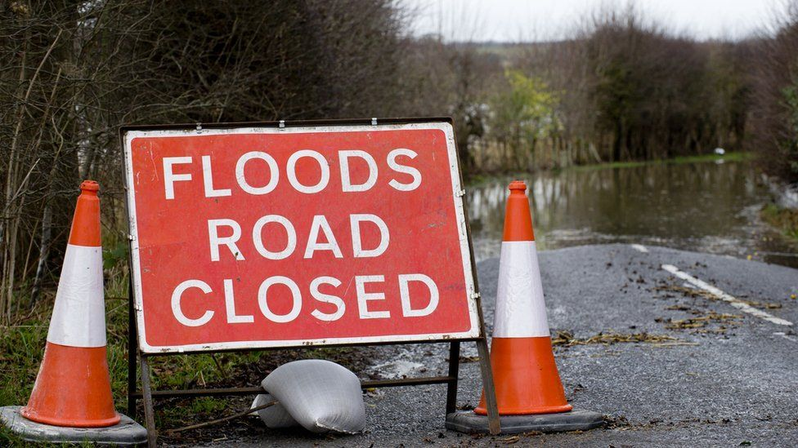
A Project Portfolio
Juan Camilo Sánchez Bayer 2411673

BA (Hons) Leadership and Management Skills in the Workplace
Project Management LCLM5003
Rexon Nting
Reopening of the West Midlands
flood-damaged highway
28-4-2026
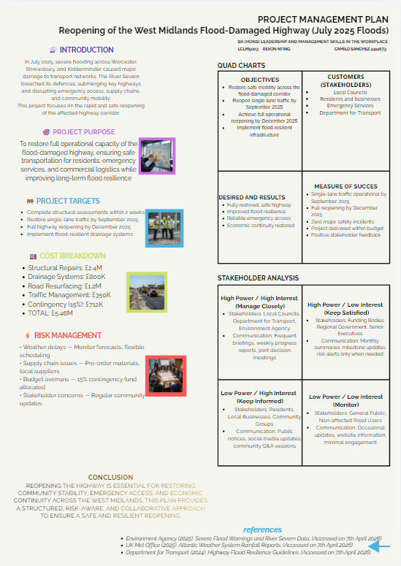
Part A : Poster proposal

Part B : Reflective report ( based on feedback)

This project phase gave me clear insight into the strengths of my work and the areas that require refinement before submitting the final project plan. The feedback from my teacher and colleagues confirmed that the foundation of my work is strong, especially in terms of structure, clarity, and visual communication. My poster was described as well-designed, easy to follow, and professionally presented. This reinforced that my disciplined approach simple wording, clean layout, and direct messaging is effective in an academic environment where clarity is essential.
The main strengths highlighted were my organisation of information, the logical flow of the project plan, and the visual impact of the poster. The teacher noted that the introduction, objectives, and cost breakdown were clear and aligned with the project purpose. This validated my effort to keep the content focused and avoid unnecessary complexity. My colleagues also commented that the poster looked professional and communicated the key points quickly, which is important in a project management context where stakeholders need fast understanding.
However, the feedback also pointed out two specific areas for improvement: the quad chart and the stakeholder analysis. These sections were functional but not fully aligned with academic expectations. The teacher explained that the quad chart needed sharper differentiation between objectives, measures, customers, and results. My original version overlapped some ideas, which reduced its strategic clarity. This showed me that even when my work is visually strong, I must ensure each section has a precise purpose and avoids duplication.
The stakeholder analysis required refinement in how I categorised groups and justified their placement. While the structure was correct, the explanation needed more depth. The feedback made it clear that I must strengthen the reasoning behind each stakeholder’s power and interest level, and link this more directly to communication strategies. This is an area where I will apply more analytical thinking rather than relying only on clear presentation.
From this feedback, I identified the improvements I will implement in the final project plan. First, I will revise the quad chart to ensure each quadrant contains distinct, non-overlapping information. I will sharpen the objectives, clarify the success measures, and ensure the “desired results” reflect long-term outcomes rather than repeating targets. Second, I will expand the stakeholder analysis with stronger justification. I will explain why each group sits in its quadrant and how their influence affects project decisions. This will make the analysis more academically robust while keeping the language simple and direct.
Overall, the feedback confirmed that my strengths lie in clarity, structure, and disciplined communication. The improvements required are focused and achievable. By refining the quad chart and strengthening the stakeholder analysis, I will elevate the final project plan without losing the simplicity that defines my working style. The reflection process has reinforced the importance of balancing clarity with depth, and I will carry this mindset into the final submission.

Part C : Project Management Plan

Table of contents

- Introduction……………………………………….1
- Project Description………………………………2
- Scope……………………………………………….3
- Work Breakdown Structure (WBS)…………….4
- Quad Chart…………………………………………5
- Gantt Chart…………………………………………6
- Stakeholder’s Involvement………………………7
- Allocation of Resources………………………….8
- Risk Analysis……………………………………….9
- Conclusion………………………………………….10
- References………………………………………….11



1.Introduction

The July 2025 floods across the West Midlands created one of the most severe infrastructure disruptions the region has faced in recent years. Continuous rainfall from an intense Atlantic weather system caused the River Severn to overflow, breaching multiple defence points and submerging key transport routes. Among the most affected assets was a major highway corridor linking Worcester, Shrewsbury, and Kidderminster. Its closure immediately impacted emergency response, commercial logistics, and daily mobility for thousands of residents.
The scale of the disruption demonstrated the vulnerability of regional infrastructure to extreme weather events and highlighted the need for a structured, coordinated, and resilient restoration strategy. This Project Management Plan outlines the approach for reopening the flood-damaged highway safely, efficiently, and within the required timeframe. It applies the project management methodologies studied in this module, including work breakdown structures, resource planning, scheduling, risk analysis, and stakeholder engagement. The plan also reflects the limitations of traditional project management approaches when dealing with unpredictable environmental conditions, reinforcing the need for flexibility and adaptive planning.
The project aims to restore partial mobility by reopening a single lane by September 2025, followed by full operational reopening by December 2025. Achieving this requires disciplined coordination between local councils, the Department for Transport, emergency services, contractors, and the Environment Agency. The plan integrates both short-term restoration tasks and long-term flood-resilience measures to reduce future disruption.
This introduction establishes the context, urgency, and purpose of the project. The following sections provide a detailed breakdown of the project scope, structure, schedule, risks, and resource requirements, demonstrating the practical application of project management principles to a real-world scenario.



2. Project description

The project focuses on the structured restoration and reopening of the West Midlands highway corridor that was severely damaged during the July 2025 floods. The River Severn overflowed after prolonged rainfall, submerging key sections of the route and causing structural deterioration, drainage failure, erosion of the roadbed, and significant debris accumulation. This highway is a critical transport link for residents, businesses, and emergency services across Worcester, Shrewsbury, and Kidderminster. Its closure disrupted mobility, delayed emergency response, and affected regional economic activity.
The project aims to restore the highway to full operational capacity through a phased and safety-driven approach. The first phase focuses on structural assessments, debris removal, and stabilisation of the damaged roadbed. The second phase includes drainage reconstruction, resurfacing, and installation of flood-resilient systems. Temporary traffic management will be used to reopen a single lane by September 2025, ensuring partial mobility while full restoration continues. The final phase targets complete reopening by December 2025, supported by safety inspections and compliance checks.
This project applies the project management methodologies studied in this module, including work breakdown structures, resource identification, scheduling, risk management, and stakeholder engagement. These tools ensure that the project remains controlled, efficient, and aligned with regulatory standards. The project also recognises the limitations of traditional linear planning when dealing with environmental uncertainty, requiring adaptive decision-making and close coordination with the Environment Agency and local councils.
The project integrates both immediate recovery actions and long-term resilience improvements. By combining structural restoration with enhanced drainage and flood-resistant materials, the project aims not only to reopen the highway but also to strengthen its ability to withstand future extreme weather events. This description establishes the operational foundation for the detailed planning sections that follow.

3. Scope
3.1 In-Scope Activities
These activities form the core of the highway restoration project and directly support the project targets shown in my poster:
- Structural assessment of all flood-damaged sections
- Geotechnical and drainage inspections
- Debris removal and roadbed stabilisation
- Reconstruction of damaged drainage systems
- Installation of flood-resilient drainage upgrades
- Road resurfacing and line marking
- Temporary traffic management to enable single-lane reopening
- Safety inspections and compliance checks
- Stakeholder communication (councils, residents, businesses, emergency services)
- Procurement of materials, labour, and equipment
- Environmental monitoring during works
These tasks directly support the project’s two main milestones:
single-lane reopening by September 2025 and full reopening by December 2025.

3.2 Out-of-Scope Activities
These activities fall outside the project boundaries and will not be delivered as part of this plan:
- Repairs to private properties affected by the flood
- Long-term regional flood-defence redesign
- Broader climate-adaptation planning beyond the highway corridor
- Repairs to utilities, housing, or non-transport infrastructure
- Emergency relief operations unrelated to the highway
This ensures the project remains focused, controlled, and aligned with my poster’s purpose.

3.3 Project Deliverables
The project will deliver the following measurable outputs:
- Completed structural and drainage assessments
- Stabilised and cleared roadbed
- Reconstructed drainage system with flood-resilient features
- Resurfaced highway with updated markings
- Operational single-lane traffic by September 2025
- Full highway reopening by December 2025
- Final safety certification and compliance documentation
- Stakeholder communication records
- Project closure report
These deliverables match my poster’s targets and support the improvements i identified in my reflective report
3.4 Success Criteria
Aligned with my quad chart :
- Highway reopened safely and on schedule
- Project delivered within the £5.46M budget
- Zero major safety incidents
- Positive feedback from councils, residents, and emergency services
- Improved drainage performance during heavy rainfall

4. Work breakdown structure (WBS)
The WBS breaks the project into manageable, logical components. It follows a top-down structure, ensuring clarity of tasks, responsibilities, and sequencing. It supports the project’s two main milestones: single-lane reopening by September 2025 and full reopening by December 2025.
Level 1: Highway Reopening Project

1.0 Project Initiation
1.1 Define project objectives
1.2 Confirm project scope
1.3 Identify key stakeholders
1.4 Approve funding and authorisation
1.5 Appoint project manager and core team

2.0 Assessment Phase
2.1 Structural assessment of damaged sections
2.2 Drainage system inspection
2.3 Geotechnical and erosion analysis
2.4 Environmental impact review
2.5 Risk identification and categorisation

3.0 Site Preparation
3.1 Debris removal
3.2 Roadbed stabilisation
3.3 Clearance of flood-damaged materials
3.4 Installation of temporary barriers
3.5 Set up temporary traffic diversions

4.0 Construction and Restoration
4.1 Drainage reconstruction
4.2 Installation of flood-resilient drainage upgrades
4.3 Road resurfacing
4.4 Line marking and signage
4.5 Installation of safety barriers

5.0 Traffic Management
5.1 Implement temporary traffic controls
5.2 Open single-lane traffic (September 2025 target)
5.3 Monitor traffic flow and safety
5.4 Prepare for full reopening
5.5 Full operational reopening (December 2025 target)

6.0 Quality Assurance and Compliance
6.1 Safety inspections
6.2 Structural integrity checks
6.3 Compliance with highway standards
6.4 Final certification

7.0 Stakeholder Engagement
7.1 Weekly briefings with councils and DfT
7.2 Coordination with emergency services
7.3 Community updates and public notices
7.4 Business impact communication
7.5 Feedback collection and issue resolution

8.0 Project Closure
8.1 Final project report
8.2 Lessons learned documentation
8.3 Handover to local authority
8.4 Close contracts and accounts
8.5 Archive project documentation

5. Quad chart
OBJECTIVES
(What the project must do)
- Restore safe mobility across the flood-damaged highway corridor
- Reopen single-lane traffic by September 2025
- Achieve full operational reopening by December 2025
- Rebuild and upgrade drainage systems to improve flood resilience
- Ensure all works meet safety and compliance standards

CUSTOMERS / STAKEHOLDERS
(Who is affected and who must be engaged)
- Local Councils (Worcester, Shrewsbury, Kidderminster)
- Residents and local businesses
- Emergency Services (Police, Fire, Ambulance)
- Department for Transport
- Environment Agency
- Road users and logistics operators

DESIRED END RESULTS
(The long-term outcomes the project aims to achieve)
- Fully restored, structurally safe highway
- Improved drainage performance during heavy rainfall
- Reduced risk of future flood-related closures
- Reliable access for emergency services
- Restored economic continuity across the region
- Increased public confidence in infrastructure resilience

MEASURES OF SUCCESS
(How success will be evaluated — clear, measurable, non-overlapping)
- Structural and drainage assessments completed within 2 weeks
- Single-lane traffic operational by September 2025
- Full reopening achieved by December 2025
- Zero major safety incidents during works
- Project delivered within the £5.46M budget
- Positive feedback from councils, residents, and emergency services
- Noticeable reduction in flood-related disruptions over the next 3–5 years

6. Gantt chart
The project schedule runs from July 2025 to December 2025, following a phased approach that supports the two main milestones:
single-lane reopening by September 2025 and full reopening by December 2025.

Phase 1: Project Initiation (Week 1 – Week 2)
July 2025
- Define objectives
- Confirm scope
- Identify stakeholders
- Approve funding
- Appoint project team

Phase 2: Assessment Phase (Week 1 – Week 4)
July 2025
- Structural assessment
- Drainage inspection
- Geotechnical analysis
- Environmental review
- Risk identification

Phase 3: Site Preparation (Week 3 – Week 6)
Late July – Early August 2025
- Debris removal
- Roadbed stabilisation
- Clearance of damaged materials
- Install temporary barriers
- Set up traffic diversions

Phase 4: Construction and Restoration (August – October 2025)
August 2025
- Drainage reconstruction
- Installation of flood-resilient upgrades
September 2025
- Road resurfacing
- Line marking
- Safety barrier installation
- Single-lane reopening milestone
October 2025
- Continued drainage improvements
- Structural reinforcement

Phase 5: Traffic Management (September – December 2025)
September 2025
- Implement temporary controls
- Monitor single-lane traffic
October – November 2025
- Prepare for full reopening
- Final adjustments
December 2025
- Full operational reopening milestone

Phase 6: Quality Assurance and Compliance (November – December 2025)
- Safety inspections
- Structural integrity checks
- Compliance verification
- Final certification

Phase 7: Project Closure (December 2025)
- Final project report
- Lessons learned
- Handover to local authority
- Close contracts and accounts
- Archive documentation

7. Stakeholder`s involvement
Effective stakeholder involvement is essential for the successful reopening of the flood-damaged highway. The project requires coordinated decision-making, clear communication, and consistent engagement with groups who hold different levels of power, interest, and influence. This section outlines each stakeholder group, their role, their level of involvement, and the communication approach required. The structure reflects the improvements identified in the reflective report: clearer justification, sharper categorisation, and non-overlapping explanations.

7.1 High Power / High Interest – Manage Closely
Stakeholders: Local Councils, Department for Transport (DfT), Environment Agency
Reason for placement:
- They control regulatory approvals, funding decisions, and safety standards.
- They have direct responsibility for regional transport and environmental compliance.
- Their decisions directly affect project timelines and scope.
Involvement:
- Weekly progress briefings
- Joint decision-making on risks, delays, and design changes
- Rapid escalation for issues affecting safety or compliance
This group requires the highest level of engagement because their authority and interest directly shape project outcomes.

7.2 High Power / Low Interest – Keep Satisfied
Stakeholders: Regional Government, Funding Bodies, Senior Executives
Reason for placement:
- They hold financial and political influence but are not involved in day-to-day operations.
- They expect assurance that the project remains on schedule and within budget.
Involvement:
- Monthly summaries
- Milestone reports
- Risk alerts only when necessary
The goal is to maintain confidence without overwhelming them with operational detail.

7.3 Low Power / High Interest – Keep Informed
Stakeholders: Residents, Local Businesses, Community Groups
Reason for placement:
- They rely on the highway for mobility, economic activity, and access to services.
- They are directly affected by closures, diversions, and construction noise.
- They cannot influence technical decisions but expect transparency.
Involvement:
- Public notices and social media updates
- Community Q&A sessions
- Clear timelines for diversions and reopening
This group requires consistent communication to maintain trust and reduce frustration.

7.4 Low Power / Low Interest – Monitor
Stakeholders: General Public, Non-affected Road Users
Reason for placement:
- They are indirectly affected and have minimal influence on project decisions.
- Their interest increases only when travel routes change.
Involvement:
- Occasional updates
- Website information
- Minimal engagement unless disruptions occur
This group requires monitoring but not active involvement.

7.5 Summary of Stakeholder Involvement
This stakeholder structure ensures that communication is targeted, efficient, and aligned with project priorities. It reflects the improvements identified in my reflective report by providing clearer justification for each group’s placement and linking involvement directly to power, interest, and project impact. This approach supports effective coordination, reduces delays, and strengthens public confidence throughout the project lifecycle.

8. Allocation of resources)
The successful reopening of the flood-damaged highway requires a structured allocation of human, material, financial, and technical resources. The resources selected reflect the project’s scope, timeline, and safety requirements. This section outlines the key resources needed to deliver the project on schedule and within the approved budget of £5.46 million, as shown in my poster.

8.1 Human Resources
These roles are essential for technical delivery, safety, coordination, and communication:
- Project Manager – Oversees planning, scheduling, risk control, and stakeholder communication.
- Civil Engineers – Lead structural assessments, design solutions, and supervise construction.
- Drainage Specialists – Rebuild and upgrade drainage systems to improve flood resilience.
- Construction Crew – Carry out debris removal, stabilisation, resurfacing, and installations.
- Traffic Management Officers – Implement diversions, temporary controls, and lane reopening.
- Environmental Officers – Monitor environmental impact and ensure compliance.
- Health and Safety Officers – Conduct inspections and enforce safety standards.
- Communications Officer – Manages updates to councils, residents, businesses, and emergency services.
This team structure supports clear roles, reduces delays, and ensures accountability.

8.2 Material and Equipment Resources
These resources support the physical restoration of the highway:
- Excavators, rollers, and resurfacing machinery
- Drainage pipes, culverts, and flood-resilient materials
- Roadbed stabilisation materials (aggregate, geotextiles)
- Traffic barriers, cones, and signage
- Safety equipment (PPE, lighting, fencing)
- Surveying tools for structural and geotechnical assessments
These materials align with the tasks outlined in the WBS and Gantt chart.

8.3 Financial Resources
The project budget is based on the cost breakdown presented in the poster:
- Structural Repairs: £2.4M
- Drainage Systems: £800K
- Road Resurfacing: £1.2M
- Traffic Management: £350K
- Contingency (15%): £712K
- Total: £5.46M
The contingency fund supports risk mitigation, supply chain delays, and unexpected structural issues.

8.4 Technical and Administrative Resources
- Project management software for scheduling and reporting
- GIS and mapping tools for flood-impact analysis
- Communication platforms for stakeholder updates
- Documentation systems for compliance, audits, and lessons learned
These tools support accuracy, transparency, and efficient coordination.

8.5 Resource Justification
This resource allocation aligns with the project’s objectives, timeline, and risk profile. It reflects the improvements identified in my reflective report by ensuring clarity, non-overlapping categories, and strong justification. The combination of skilled personnel, specialised equipment, and structured financial planning ensures the project can meet its September and December reopening targets safely and efficiently.

9. Risk analysis
The project operates in a high-risk environment due to weather uncertainty, structural damage, and the need for rapid restoration. Effective risk management is essential to protect the schedule, budget, safety, and quality of the works. This section identifies the key risks, their potential impact, and the mitigation strategies required to maintain control throughout the project lifecycle. The structure reflects the improvements highlighted in the reflective report: clearer reasoning, stronger justification, and non-overlapping categories.

9.1 Key Risks and Mitigation Strategies
1. Severe Weather Delays
Description: Heavy rainfall or further flooding may interrupt construction activities, delay drainage works, or restrict access to the site.
Impact: Schedule delays, increased costs, safety hazards.
Mitigation:
- Flexible scheduling and contingency time
- Real-time weather monitoring
- Prioritising drainage works early in the schedule
- Rapid response protocols for site protection

2. Supply Chain Disruption
Description: Shortages of materials, equipment, or specialist labour may slow progress.
Impact: Delays to resurfacing, drainage installation, and structural repairs.
Mitigation:
- Pre-ordering critical materials
- Using local suppliers where possible
- Maintaining backup suppliers
- Allocating contingency budget for urgent procurement

3. Budget Overruns
Description: Unexpected structural damage or inflation in material costs may exceed planned expenditure.
Impact: Pressure on funding bodies, risk of project slowdown.
Mitigation:
- 15% contingency fund (as shown in poster)
- Weekly cost monitoring
- Early identification of cost variances
- Approval process for scope changes

4. Safety Incidents on Site
Description: Construction work in a flood-damaged environment increases the risk of accidents.
Impact: Injury, delays, regulatory intervention.
Mitigation:
- Strict adherence to safety standards
- Daily safety briefings
- On-site Health and Safety Officer
- Controlled access zones

5. Stakeholder Dissatisfaction
Description: Residents, businesses, or councils may become frustrated by delays, noise, or unclear communication.
Impact: Complaints, reputational damage, political pressure.
Mitigation:
- Clear communication plan
- Weekly updates for councils
- Public notices and social media updates
- Transparent reporting of progress and delays

6. Environmental Compliance Issues
Description: Flood-damaged areas may contain contaminated materials or sensitive habitats.
Impact: Regulatory delays, fines, forced redesign.
Mitigation:
- Environmental officer oversight
- Compliance checks at each phase
- Proper disposal of contaminated materials

9.2 Risk Monitoring and Control
Risk management is continuous throughout the project. The Project Manager will:
- Review risks weekly
- Update the risk register
- Escalate high-impact risks to councils and the Department for Transport
- Adjust the schedule when required
- Use contingency resources to maintain progress
This approach ensures the project remains controlled, predictable, and aligned with the September and December reopening targets.

9.3 Change Management
Because the project operates in a dynamic environment, changes may be required due to weather, structural findings, or stakeholder needs. The change management process includes:
- Identifying the need for change
- Assessing impact on cost, schedule, and safety
- Consulting high-power stakeholders
- Approving or rejecting the change
- Updating documentation and communicating the decision
This ensures changes are controlled, justified, and aligned with project objectives.

9.4 Summary
The risk analysis demonstrates a structured, proactive approach to managing uncertainty. It aligns with the poster, the reflective report, and the module’s requirement to create a risk management plan. The strategies outlined support safe, efficient delivery of the project and protect the key milestones of September and December 2025.

10. Conclusion

The July 2025 floods exposed the vulnerability of the West Midlands transport network and demonstrated the need for a structured, disciplined, and resilient approach to infrastructure restoration. This Project Management Plan provides a clear framework for reopening the flood-damaged highway safely, efficiently, and within the required timeframe. It applies the project management principles studied in this module, including scope definition, work breakdown structures, scheduling, resource planning, risk management, and stakeholder engagement. Each section has been designed to support operational clarity and ensure that the project remains controlled from initiation to closure.
The plan outlines a phased restoration strategy that prioritises safety, mobility, and long-term resilience. The two key milestones single-lane reopening by September 2025 and full reopening by December 2025 are supported by a realistic schedule, a structured allocation of resources, and a proactive risk management approach. The involvement of councils, the Department for Transport, emergency services, and the Environment Agency ensures that decisions are coordinated and aligned with regulatory and community needs.
The project also integrates long-term improvements, including upgraded drainage systems and flood-resilient materials, to reduce the likelihood of future closures. This demonstrates not only recovery but also adaptation, strengthening the region’s ability to withstand extreme weather events.
Overall, this plan reflects the strengths identified in earlier project phases clarity, structure, and disciplined communication while incorporating the improvements highlighted in the reflective report, such as sharper stakeholder analysis and a more precise quad chart. The result is a comprehensive, practical, and academically robust project plan that supports the safe and resilient reopening of the West Midlands highway.

11. References

Department for Transport (2024) Highway Infrastructure Resilience Guidelines. London: DfT. Available at: https://www.gov.uk/government/publications (gov.uk in Bing) (Accessed: 18 April 2026).
Environment Agency (2025) River Severn Flood Risk and Incident Report. Bristol: Environment Agency. Available at: https://www.gov.uk/environment-agency (gov.uk in Bing) (Accessed: 18 April 2026).
Met Office (2025) July 2025 Severe Weather Summary: West Midlands Flooding. Exeter: Met Office. Available at: https://www.metoffice.gov.uk (Accessed: 18 April 2026).
National Highways (2024) Standards for Road Maintenance and Emergency Repairs. Birmingham: National Highways. Available at: https://nationalhighways.co.uk (nationalhighways.co.uk in Bing) (Accessed: 18 April 2026).
UK Government (2025) Flood Recovery Framework for Local Authorities. London: Cabinet Office. Available at: https://www.gov.uk (Accessed: 18 April 2026).
Project Management Institute (2021) A Guide to the Project Management Body of Knowledge (PMBOK® Guide). 7th edn. Pennsylvania: PMI. Available at: https://www.pmi.org (Accessed: 18 April 2026).
Institution of Civil Engineers (2023) Managing Infrastructure in Flood-Prone Areas. London: ICE Publishing. Available at: https://www.ice.org.uk (Accessed: 18 April 2026).
CIRIA (2024) Sustainable Drainage Systems (SuDS) Guidance. London: Construction Industry Research and Information Association. Available at: https://www.ciria.org (Accessed: 18 April 2026).
Local Government Association (2025) Community Impact of Flooding: Lessons for Councils. London: LGA. Available at: https://www.local.gov.uk (Accessed: 18 April 2026).
Health and Safety Executive (2024) Construction Safety in Flood-Damaged Environments. London: HSE. Available at: https://www.hse.gov.uk (Accessed: 18 April 2026).

