Innovation Opportunity and New Venture Concept for IKEA UK

Name: Dragos-Ionut Ionita
Student Number: 2329603
Module: LCLM6002
Lecturer name: Seyed Nasirpourosgoei

Task 1: Identifying Innovation Opportunities for IKEA UK 3
1.1 Introduction 3
1.2 Understanding User Needs 3
1.3 Opportunity Analysis 5
1.4 Technological Enablers 6
1.5 Scalability and Sustainability of the Proposed Innovation 8
1.6 Justification of the Proposed Innovation Opportunity 9
Task 2: Applying Design Thinking to Develop the Proposed Innovation 10
2.1 Empathise 10
2.2 Define 12
Problem Statement 13
How Might We…? 13
2.3 Ideate 13
2.4 Prototype 15
2.5 Test 16
2.6 Reflection and Critical Analysis 17
Conclusion 18
References 19

Task 1: Identifying Innovation Opportunities for IKEA UK

1.1 Introduction
The UK home furnishing industry is undergoing rapid transformation, driven by changing consumer lifestyles, digital innovation and rising expectations for sustainable, personalised shopping. Customers increasingly seek integrated solutions that simplify home planning, rather than buying furniture as standalone items (Brown, 2009; Norman, 2013). IKEA UK has built a strong market position through affordable Scandinavian design, omnichannel retailing and sustainability commitment; in FY24, over 40% of IKEA UK sales were made online, rising to 47% in London (IKEA UK, 2024). Despite this progress, existing tools support only isolated stages of the purchasing journey rather than the complete planning experience customers now expect. This task applies Design Thinking to identify an innovation opportunity for IKEA UK by examining user needs, market gaps, technological enablers and scalability. An AI-powered Home Planning Ecosystem is proposed as an integrated innovation capable of strengthening customer experience while supporting IKEA UK's digital and sustainability ambitions (Liedtka, 2018). IKEA UK represents a particularly suitable case for this innovation because its mature omnichannel strategy, sustainability commitments and digital capabilities create favourable conditions for AI-enabled service innovation (Ingka Group, 2025). The approach also reflects a debate within the literature: Brown (2009) positions empathy as the essential first step from which decisions should flow, whereas Norman (2013) contends understanding user behaviour alone is insufficient without continual validation through usability testing. Applied to IKEA UK, this means empathy should be a starting point refined throughout development, a principle carried through this portfolio to the Prototype and Test stages in Task 2.

1.2 Understanding User Needs
The Empathise stage of Design Thinking encourages organisations to explore the practical and emotional challenges customers encounter, ensuring innovation reflects genuine insight rather than assumption (Brown, 2009). Furniture purchasing is a high-involvement decision balancing functionality, aesthetics, affordability and sustainability. First-time buyers, renters and residents of compact urban homes in particular struggle to visualise how furniture will fit their space or complement existing interiors before committing to a purchase (Norman, 2013). This uncertainty is intensified by a fragmented planning journey: customers move between inspiration browsing, product comparison, budgeting tools, room measurement and physical store visits before deciding, which raises cognitive effort and contributes to abandoned baskets and avoidable returns. UK furniture and home returns already sit at around 19% of online orders, among the highest of any non-clothing category — a category estimate consistent with Retail Economics' finding of around 19.5% for UK non-food online returns overall (Eightx, 2026; Retail Economics, 2025). From a Design Thinking perspective, this points to a systemic journey problem rather than isolated usability issues (Norman, 2013; Brown, 2009). Expectations are also evolving: customers want guidance that reflects their lifestyle, household composition, space and sustainability preferences, rather than generic recommendations based on past browsing alone (Liedtka, 2018). Consequently, IKEA UK's opportunity lies not in another digital tool but in an integrated experience combining planning, personalisation and decision support — the foundation of the proposed AI-powered Home Planning Ecosystem. This insight should nonetheless be evaluated critically: Liedtka (2018) suggests human-centred insight can reliably surface genuine opportunities, whereas Buchanan (1992) cautions that organisational problems are inherently 'wicked' and resist complete definition through user research alone. Buchanan's caution is the more convincing in the IKEA UK context, because AI-driven personalisation depends on complex, evolving customer data that cannot be fully understood through a single empathy exercise; this justifies treating the persona and empathy map as a starting hypothesis rather than a final conclusion.
User Insight | Evidence from Customer Journey | Innovation Opportunity
Difficulty visualising furniture in real homes | Low purchasing confidence; furniture return rate around 19% (Eightx, 2026) | AI-powered room planning with AR visualisation
Fragmented home-planning process | Customers switch between multiple tools and channels | Integrated digital Home Planning Ecosystem
Limited personalised guidance | Generic recommendations ignore individual needs | AI-driven recommendations based on room, lifestyle and budget
Demand for sustainable purchasing support | Customers lack clear decision guidance | Personalised sustainability recommendations within planning
Table 1. Summary of User Needs and Innovation Opportunities
Source: Author's analysis based on Brown (2009), Norman (2013), Liedtka (2018), IKEA UK (2024), Eightx (2026) and Retail Economics (2025).

1.3 Opportunity Analysis
Turning insight into opportunity requires evaluating whether existing solutions meet unmet needs. The UK online home-furnishing market is valued at approximately £2.6 billion (IBISWorld, 2025), within a wider furniture retail sector worth around £19.5 billion (Mintel, 2025), and remains largely product-focused, creating space to differentiate through service innovation rather than further product development (Verganti, 2009; Liedtka, 2018). IKEA UK, John Lewis, Dunelm and Wayfair have each invested in omnichannel capability, digital catalogues and room-visualisation tools, yet these services typically support isolated stages of the journey rather than a single, continuous experience from inspiration to post-purchase support. A further gap exists in AI application: most retail AI targets product recommendation from browsing history, overlooking contextual variables such as room dimensions and household composition, optimising product selection rather than holistic planning (Davenport and Ronanki, 2018). Growing consumer awareness of sustainable consumption compounds this gap; UK consumers increasingly weigh durability and environmental impact, yet receive little decision support during planning. Rather than developing another standalone feature, IKEA UK's opportunity is to create an integrated ecosystem that combines planning, personalisation and sustainability within one platform. This reflects Design Thinking's emphasis on solving interconnected customer needs instead of isolated technological problems. This opportunity should also be evaluated critically: Verganti (2009) argues meaning-driven innovation often outperforms purely technology-led change, yet such repositioning still depends on IKEA UK possessing the operational capability to deliver it consistently. The gap analysis below therefore assesses not only whether a genuine market gap exists, but whether IKEA UK's digital infrastructure realistically supports closing it. Verganti's view is the more convincing here, because IKEA UK already possesses the omnichannel and sustainability infrastructure needed; the execution-capability risk Verganti overlooks is precisely what the technological enablers and scalability sections below are designed to test.

Current Market Practice | Remaining Market Gap | Opportunity for IKEA UK
Digital room-planning tools | Limited personalisation and decision support | AI-powered personalised home planning
Product-based AI recommendations | Lack of contextual understanding | AI recommendations based on room, lifestyle and household needs
Omnichannel retail services | Fragmented customer journey | Integrated end-to-end Home Planning Ecosystem
Sustainability information | Limited guidance during decision-making | Personalised sustainability recommendations throughout planning
Table 2. Opportunity Gap Analysis
Source: Author's analysis based on Verganti (2009), Davenport and Ronanki (2018), Liedtka (2018), IBISWorld (2025) and Mintel (2025).

1.4 Technological Enablers
Selecting appropriate technologies ensures innovation responds to genuine need rather than becoming technology-led. The proposed ecosystem combines complementary technologies addressing the purchase uncertainty, fragmentation and limited personalisation identified above, working together rather than independently (Brown, 2009; Liedtka, 2018). Consumer appetite supports this direction: roughly one in two UK shoppers is willing to use augmented reality (AR) for shopping, and 59% would use it specifically for furniture (GetApp, 2020), consistent with academic evidence that AR enhances decision-making and reduces purchase uncertainty in retail (Lavoye, Mero and Tarkiainen, 2021).

Technology | Customer Problem Addressed | Application within IKEA UK | Limitation
Artificial Intelligence (AI) | Customers lack confidence selecting furniture and layouts | Generates personalised layouts, recommendations and budget-conscious suggestions from room data and preferences | Recommendation quality depends on accurate customer data
Augmented Reality (AR) | Customers cannot confidently visualise products at home | Places virtual IKEA furniture in real spaces before purchase, reducing uncertainty and returns | Depends on compatible devices and image quality
Cloud Computing | Planning information is fragmented across platforms | Synchronises room plans, wish lists and recommendations across web, app and store | Requires reliable infrastructure and maintenance
Data Analytics | Recommendations are generic and static | Continuously analyses interactions to refine accuracy and detect changing preferences | Must comply with GDPR and customer privacy expectations
Table 3. Evaluation of Technological Enablers for the Proposed Innovation
Source: Author's analysis based on Brown (2009), Davenport and Ronanki (2018), Westerman, Bonnet and McAfee (2014), GetApp (2020), Lavoye, Mero and Tarkiainen (2021) and IKEA UK (2024).
Rather than relying on a single technology, value is created through the integration of AI, AR, cloud computing and data analytics, allowing IKEA UK to move beyond product recommendations towards a personalised, end-to-end planning experience (Liedtka, 2018). This matters strategically because no single technology could resolve the fragmented planning journey identified in Empathise; the table supports investing in an integrated ecosystem, since isolated adoption of AR or AI alone would leave at least one core pain point unaddressed. This integration should not be assumed unproblematic. Davenport and Ronanki (2018) argue AI improves decision quality within a wider digital ecosystem, whereas Westerman, Bonnet and McAfee (2014) caution that transformation initiatives often fail because organisations underestimate the operational change required. Their caution is the more decisive for IKEA UK, since its technical capability is not in doubt, whereas its capacity to retrain staff and manage data governance at scale is far less proven — implementation risk, not technology choice, is the likelier determinant of success. Beyond organisational readiness, further risks require active management. Customers may resist AI-driven recommendations if they perceive reduced human interaction or opaque data use, undermining trust built over decades of in-store service (Davenport and Ronanki, 2018). Algorithmic bias is a related concern, as models trained on historical data risk under-serving customers whose needs differ from the majority unless outputs are regularly audited. Integration costs typically extend beyond initial development, since connecting the ecosystem to existing systems requires ongoing investment, while cybersecurity is a further exposure given the sensitivity of room, budget and preference data, requiring safeguards alongside GDPR compliance. Employee training and long-term maintenance are also non-trivial, as staff need sufficient understanding to support customers and AI models require continuous retraining. Feasibility therefore depends as much on sustained organisational commitment as on the initial technology investment.

1.5 Scalability and Sustainability of the Proposed Innovation
The proposed ecosystem was selected not only because it meets identified needs but because it offers strong long-term scalability. Within Design Thinking, successful innovation must generate user value while remaining operationally feasible (Brown, 2009). Compared with standalone tools, a unified platform offers greater strategic flexibility, since new functions can be added without redesigning the core experience. Building AI, AR and cloud synchronisation onto IKEA UK's existing infrastructure allows incremental expansion rather than investment in multiple separate platforms, reducing operational risk (Liedtka, 2018). This incremental approach nonetheless carries its own risk. Rogers (2003) suggests that innovations adopted gradually can lose momentum if early users do not perceive a sufficiently strong relative advantage over existing tools, meaning IKEA UK must ensure that even an early, limited version of the ecosystem delivers a noticeably improved experience rather than a marginal one. This reinforces why the first release should prioritise the functions most directly linked to the uncertainty identified above, rather than attempting to launch every feature simultaneously. Sustainability further justifies the choice. Where alternative digital tools primarily aim to increase sales, the proposed ecosystem supports more responsible purchasing by helping customers select suitable products before transacting. Accurate planning and personalised recommendations can reduce unnecessary purchases and returns — currently costing UK retailers an estimated £27 billion a year across non-food categories (ZigZag and Retail Economics, 2024) — while encouraging durable or circular alternatives, supporting IKEA UK's ambition for affordable, sustainable living alongside improved operational efficiency (Ingka Group, 2025).
Evaluation Criterion | Justification
Scalability | Can be implemented gradually across IKEA UK's existing digital platforms, reducing implementation risk and supporting continuous improvement.
Economic viability | Lower product returns and improved purchasing confidence may reduce operational costs while increasing customer loyalty.
Environmental sustainability | More accurate purchasing decisions reduce waste, unnecessary transportation and product returns.
Social sustainability | Personalised planning improves accessibility for customers with different household sizes, budgets and living environments.
Why this solution? | Unlike isolated digital tools, the integrated ecosystem addresses multiple customer pain points simultaneously, creating greater long-term value for both customers and IKEA UK.
Table 4. Critical Evaluation of the Proposed Innovation
Source: Author's analysis based on Brown (2009), Liedtka (2018) and Ingka Group (2025).
Overall, compared with alternative standalone technologies, the proposed innovation offers a stronger balance of customer value, organisational feasibility and long-term sustainability, making it more adaptable to future consumer expectations and better aligned with IKEA UK's strategic commitment to responsible retailing.

1.6 Justification of the Proposed Innovation Opportunity
Task 1 demonstrates that the AI-powered Home Planning Ecosystem is the most appropriate opportunity for IKEA UK because it addresses an interconnected set of needs rather than a single operational problem. Design Thinking holds that innovation should be evaluated on desirability, feasibility and viability (Liedtka, 2018); the proposed solution satisfies all three by combining customer insight with technologies that integrate into IKEA UK's existing ecosystem. Compared with narrower alternatives — standalone AR tools, AI chatbots or additional apps — the ecosystem delivers greater value by supporting the complete planning journey, reducing cognitive effort and strengthening purchasing confidence. The innovation is consistent with IKEA UK's strategic direction: because the organisation has already invested in digital transformation and circular practices, the ecosystem extends existing capability rather than requiring a new business model (Ingka Group, 2025). More explicitly, it supports four objectives: increasing customer lifetime value by retaining customers within IKEA UK's ecosystem; strengthening differentiation against John Lewis, Dunelm and Wayfair; supporting omnichannel growth by synchronising plans across channels; and contributing to Ingka Group's circular economy goals by reducing unnecessary consumption and returns (Ingka Group, 2025).

Task 2: Applying Design Thinking to Develop the Proposed Innovation

2.1 Empathise
The Empathise stage seeks to understand users' experiences, motivations and frustrations before proposing solutions, uncovering genuine insight rather than organisational assumption (Brown, 2009). For IKEA UK, this matters because home-furnishing decisions carry emotional, financial and practical weight beyond individual product choices. A customer persona was developed from the Task 1 findings: a typical IKEA UK customer who values affordability, sustainability and convenience but experiences uncertainty throughout planning. Using a persona keeps the process focused on representative needs rather than every possible segment, and — compared with broad market segmentation — provides richer behavioural insight from the customer's, not the organisation's, perspective (Norman, 2013). This starting point is itself debated: Brown (2009) treats empathy as the essential first step from which subsequent decisions should flow, whereas Norman (2013) argues understanding user behaviour is insufficient unless supported by iterative usability testing. In practice, this means empathy should be a continuously validated activity rather than a one-off exercise — reflected later through the Prototype and Test stages. Norman's argument is more applicable to IKEA UK's digital innovation, because iterative testing reduces the risk of implementing AI and AR features that look insightful on paper but fail to reflect how customers actually behave.
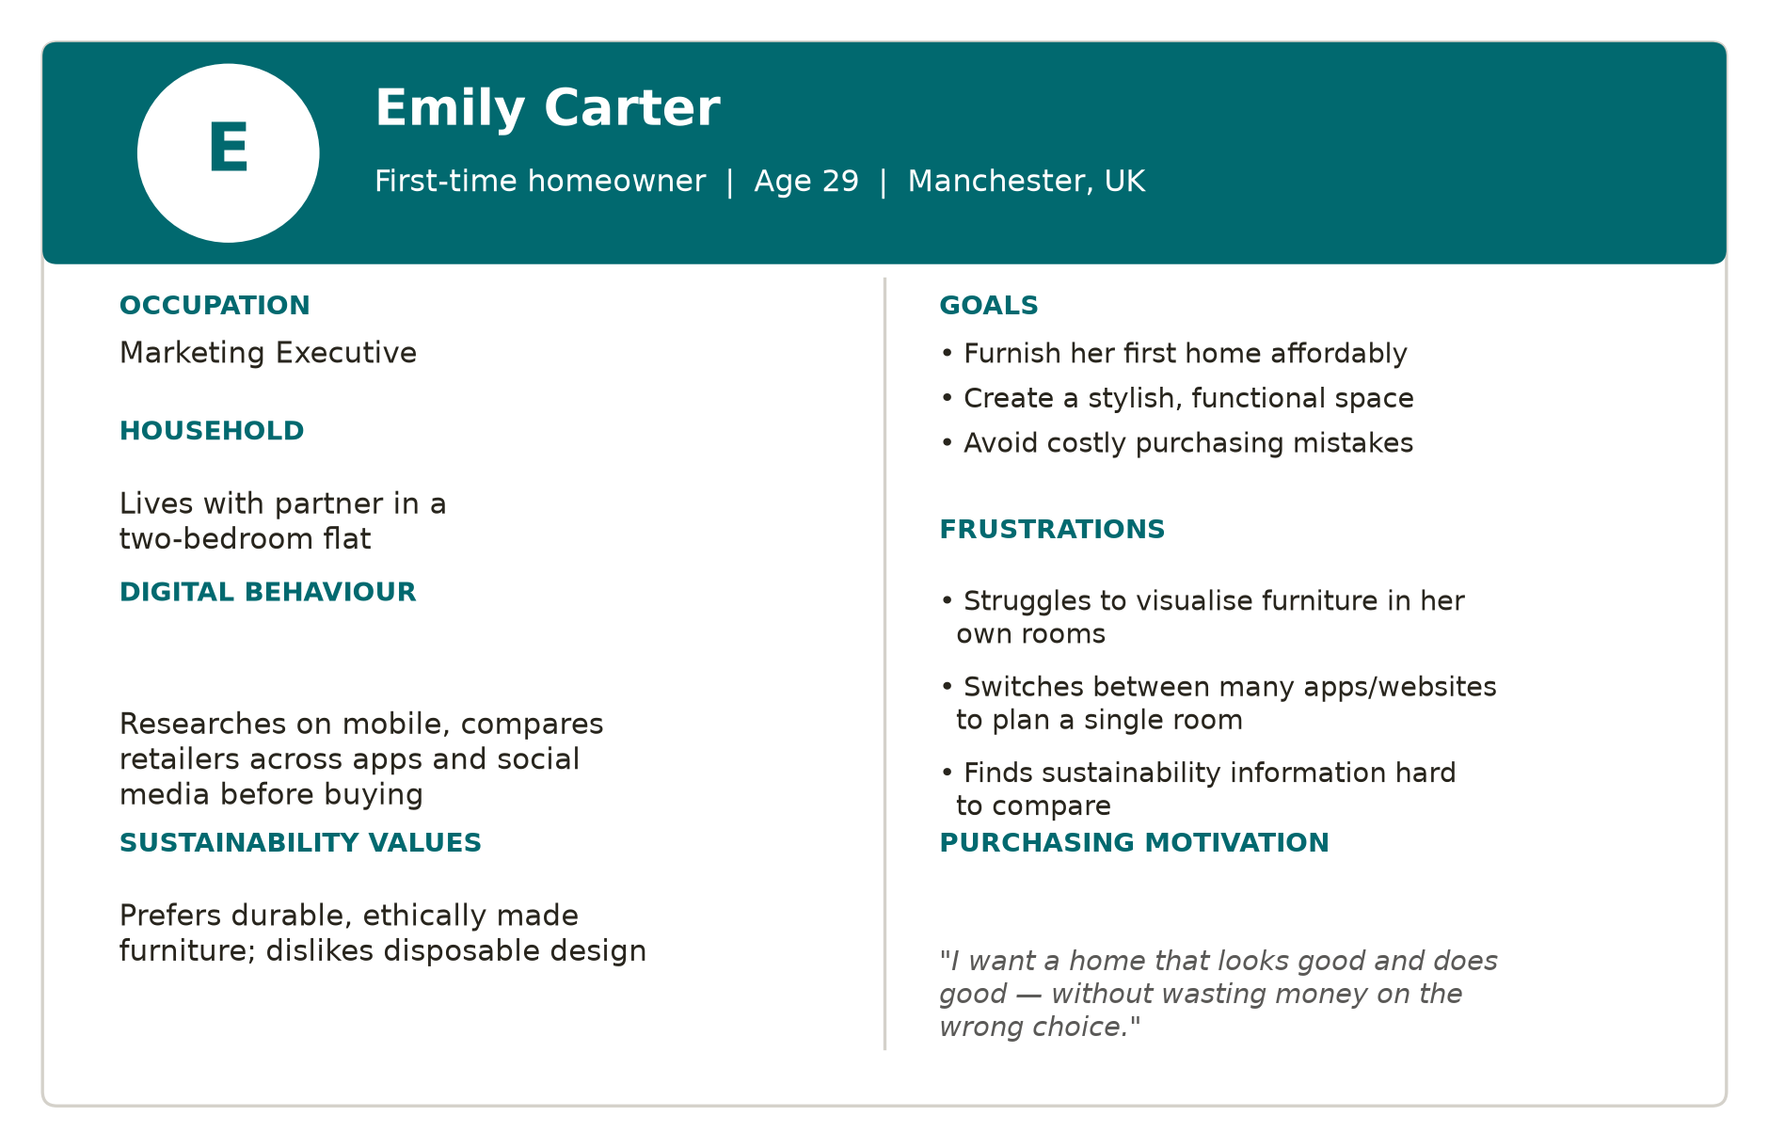
Figure 1. Customer persona — “Emily”, 29-year-old first-time homeowner, Manchester.
Source: Author's own persona, developed using the Task 1 user-needs analysis and Norman's (2013) human-centred design principles.
The persona highlights recurring challenges: difficulty visualising furniture within limited space, difficulty coordinating products across rooms, and low confidence balancing design against affordability. She values responsible purchasing but finds sustainability information hard to interpret when deciding — evidence that the problem extends beyond product selection to the complexity of planning an entire living environment. Although personas simplify complex customer groups into a single representative profile, this simplification risks overlooking the needs of less typical customers, such as older shoppers or those with limited digital confidence; this limitation is complemented by the empathy map below and addressed further in the Reflection section. An Empathy Map was then developed to examine what the user thinks, feels, says and does across the purchasing journey, capturing functional and emotional dimensions that demographic analysis alone would miss (Dam and Siang, 2020).
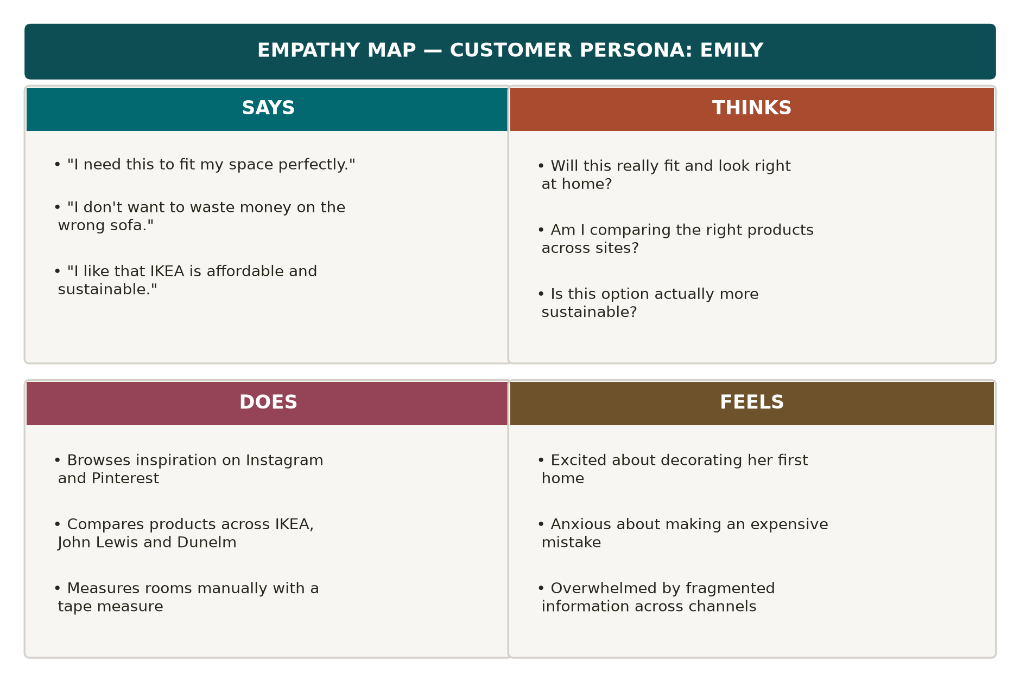
Figure 2. Empathy map: Says, Thinks, Does and Feels, linked to the customer persona.
Source: Author's own diagram, based on Dam and Siang's (2020) empathy-mapping framework.
The map shows customers motivated by creating attractive, functional homes while fearing costly mistakes. Digital tools inspire but do not remove uncertainty, because information stays fragmented across channels — customers want reassurance more than additional choice, directly supporting an ecosystem that integrates planning, personalisation and decision support in one platform. Collectively, this confirms the opportunity is fundamentally human-centred rather than technology-led, providing a stronger foundation for the Define stage.

2.2 Define
Define converts Empathise insights into a clearly bounded design challenge, focusing effort on the problem that creates the greatest user value (Brown, 2009). The persona and empathy map indicate the core challenge is not furniture or service availability but the complexity of planning an entire living space: customers move across multiple platforms to seek inspiration, compare products, measure rooms and estimate cost, raising cognitive effort and delaying decisions. This challenge carries greater influence than operational issues such as delivery speed because it touches every stage of the decision journey.

Problem Statement
Customers furnishing their homes need a personalised, integrated planning experience, because existing tools do not adequately support visualising products, comparing alternatives or deciding confidently within their space, budget and sustainability preferences. To keep exploration open, this was reframed using the “How Might We” (HMW) technique, which avoids prescribing a solution and instead creates room for multiple concepts during Ideate (IDEO, 2015), reducing the risk of choosing technology before evaluating alternatives. This framing itself requires justification. While a narrowly defined problem statement can accelerate decision-making, Ulrich and Eppinger (2020) note that over-specifying a problem risks constraining the solution space before alternatives have been properly explored. The problem statement above therefore intentionally emphasises the outcome customers require — confident, end-to-end planning support — rather than prescribing a specific technology, preserving flexibility for the comparison of concepts undertaken in Ideate.

How Might We…?
How might IKEA UK enable customers to confidently plan, personalise and furnish their homes through one connected digital experience integrating room visualisation, budgeting and sustainability guidance before purchase? This statement sets a clear direction while remaining broad enough for creativity, without assuming the AI-powered ecosystem is the only possible answer — it instead provides an objective benchmark against which alternatives are assessed in Ideate. While the HMW technique encourages creative exploration, an overly broad problem statement can dilute innovation priorities and make evaluation difficult. The statement adopted here therefore balances flexibility with a clear strategic direction, anchoring subsequent ideation in the specific uncertainty identified during Empathise rather than allowing it to drift toward unrelated opportunities.

2.3 Ideate
Ideate generates multiple possible solutions before selecting the concept that best resolves the design challenge, since Design Thinking holds that innovation should emerge through exploration and comparison rather than the first workable idea (Brown, 2009). Several alternatives were therefore considered for IKEA UK, each assessed on its ability to solve the Define-stage problem, its fit with IKEA UK's existing business model, and its potential for long-term customer value — rather than technological novelty alone — reducing the risk of a technology-led solution that misses genuine need.
This comparative approach reflects an ongoing debate: Verganti (2009) argues breakthrough innovation comes from radically reinterpreting what a product means to customers, whereas Tidd and Bessant (2021) emphasise that most successful innovation is incremental. For IKEA UK, Tidd and Bessant's incremental view is more persuasive, since the business already has the infrastructure and customer base to extend rather than reinvent its offer; Verganti's radical repositioning would carry greater risk without a corresponding rise in customer value at this stage.
Proposed Idea | Advantages | Limitations | Overall Assessment
AI Home Planning Ecosystem | Integrates planning, budgeting, personalisation and sustainability in one platform | Requires investment in AI integration and data management | Selected
AI Virtual Interior Designer | Personalised design advice and styling inspiration | Focused on aesthetics; limited budgeting or planning support | Moderate potential
Smart Shopping Assistant Chatbot | Real-time support and product information | Solves information problems, not planning challenges | Limited potential
AR Room Visualiser | Lets customers visualise products before buying | Improves visualisation only; no budgeting, sustainability or personalisation | High value but insufficient alone
Table 5. Comparative Evaluation of Alternative Innovation Concepts
Source: Author's analysis based on Brown (2009), IDEO (2015), Liedtka (2018) and Ingka Group (2025).
This comparison shows each concept addresses only part of the customer journey; only the ecosystem answers the full challenge identified in Empathise and Define. Unlike the chatbot and AR visualiser, which focus on isolated interactions, the ecosystem combines planning, visualisation, budgeting and sustainability guidance while remaining adaptable for future features. The rejected concepts are not without merit: a chatbot would demand far lower investment, making it a more realistic first step for a smaller retailer without IKEA UK's scale. For IKEA UK, the comparison supports the ecosystem precisely because the business already has the resources to absorb the higher cost.

2.4 Prototype
Prototype turns the selected concept into a tangible form for early evaluation before significant resources are committed; prototyping tests assumptions and surfaces usability issues rather than producing a finished product (Brown, 2009; IDEO, 2015). Low-fidelity prototyping lowers financial risk while allowing refinement against the needs identified in Empathise and Define (Liedtka, 2018). The AI-powered Home Planning Ecosystem was carried forward because it addresses a broader range of needs than the alternatives — unlike the Virtual Interior Designer (aesthetics-led) or AR Visualiser (visualisation-only), it integrates planning, budgeting, sustainability guidance and personalised recommendations within one journey (Norman, 2013). Low-fidelity prototypes reduce financial and technical risk by enabling early feedback before full development. However, they cannot fully evaluate technical feasibility, AI performance or data accuracy under real operating conditions, meaning further development and technical testing would be required before commercial implementation (IDEO, 2015).
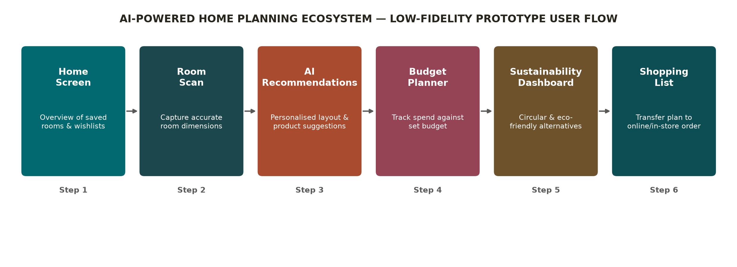
Figure 3. Low-fidelity prototype user flow for the AI-powered Home Planning Ecosystem.
Source: Author's own prototype concept, informed by IDEO's (2015) human-centred design process.
The prototype is built around six functions, each answering a pain point from Empathise. Room Scan captures accurate dimensions; AI Personalised Recommendations generate solutions from room layout, preference and budget rather than browsing history; the Budget Planner supports informed financial decisions; the Sustainability Dashboard presents circular alternatives; and the integrated Shopping List transfers the plan directly into IKEA UK's online or in-store channels (Ingka Group, 2025). Compared with several independent tools, this connected platform reduces cognitive effort and can be refined through successive iterations, lowering development risk (IDEO, 2015).

2.5 Test
Test evaluates whether the innovation genuinely meets the needs identified in Empathise and Define; testing exists to surface weaknesses and generate evidence for refinement rather than to confirm a solution is already correct (Liedtka, 2018). The prototype would be tested with representative customers — first-time homeowners, renters and residents of smaller urban properties — who experience the greatest planning uncertainty and represent the primary target audience from Task 1. This targeted approach nonetheless has limitations: focusing predominantly on first-time buyers may understate the needs of loyal, high-frequency IKEA UK customers who could also benefit from more personalised planning support; a broader testing sample, incorporating both groups, would therefore strengthen confidence in the ecosystem's applicability across IKEA UK's full customer base.
Testing Objective | Evaluation Method | Expected Insight
Assess ease of navigation | Observation during task completion | Where users hesitate or need assistance
Evaluate AI recommendations | User interviews and satisfaction ratings | Whether recommendations reflect real preferences
Assess room-planning accuracy | Practical room-planning exercise | User confidence before and after prototype use
Evaluate budgeting feature | Scenario-based purchasing task | Whether users stay within their intended budget
Assess sustainability guidance | Post-task interview | Whether sustainability information affects purchasing decisions
Table 6. Testing Strategy for the AI-powered Home Planning Ecosystem
Source: Author's analysis based on Brown (2009), IDEO (2015) and Liedtka (2018).
Testing should combine behaviour and perception, since a participant may report ease of use while still making repeated navigation errors; combining observation with interviews produces more reliable findings (Norman, 2013). Results should refine the prototype before wider rollout: where uncertainty persists, the interface or recommendation logic should be redesigned, while successful features are prioritised. This generates diagnostic evidence at each functional layer — navigation, recommendation accuracy, budgeting and sustainability guidance — ensuring any decision to proceed rests on specific evidence rather than an average rating that could mask weaker features.

2.6 Reflection and Critical Analysis
Applying Design Thinking provided a structured route to an innovation grounded in genuine customer need rather than organisational assumption: each stage — research, definition, ideation, prototyping and testing — contributed distinct insight, reducing the risk of a technically interesting solution that fails to create real customer value (Brown, 2009; Liedtka, 2018). The process's greatest strength was its human-centred starting point. Beginning with customer needs rather than available technology shifted focus from improving individual digital services to redesigning the entire planning experience, producing a solution that integrates planning, budgeting, visualisation and sustainability guidance around the root causes of uncertainty identified in Empathise. Compared with a technology-led approach, this is more likely to improve satisfaction because decisions rest on user insight rather than organisational preference (Norman, 2013). This human-centred approach can be contrasted with more traditional, linear methods. A stage-gate process moves sequentially from screening to launch, with limited opportunity to revisit earlier decisions (Ulrich and Eppinger, 2020). Design Thinking instead allows continuous learning through iteration, testing assumptions throughout rather than only at fixed checkpoints. However, this flexibility carries a cost: repeated testing cycles can increase development time where budgets or deadlines are tightly constrained (Tidd and Bessant, 2021). For IKEA UK this trade-off is justified given the scale of investment required, though a faster stage-gate approach may suit smaller, time-critical initiatives better. However, limitations should be acknowledged. The persona and empathy map were built from representative rather than primary research, so the solution may not fully capture the needs of older or less digitally confident consumers; future research should validate the persona and empathy map through semi-structured interviews and observational studies with IKEA UK customers, thereby improving the reliability and transferability of the findings (Norman, 2013). The ecosystem's effectiveness also depends on data quality: recommendations only improve decisions when data is accurate and responsibly managed, requiring regulatory compliance and customer trust (Davenport and Ronanki, 2018). The ecosystem was selected because, compared with standalone options such as a chatbot, it achieved the strongest balance of desirability, feasibility and viability consistent with IKEA UK's objectives (Liedtka, 2018). Overall, Design Thinking enabled evidence-based rather than assumption-led development, aligned with IKEA UK's long-term strategic direction. Comparing Design Thinking with Lean Startup clarifies why the former was more appropriate here. Lean Startup prioritises rapid, low-cost testing of a minimum viable product to validate demand (Ries, 2011), suiting ventures with high market uncertainty but limited insight into user motivation. For IKEA UK, the challenge was not whether demand exists but how customers experience a complex, emotionally weighted planning journey, making Design Thinking's emphasis on empathy more suitable. A Stage-Gate approach would offer clearer governance checkpoints, but its sequential structure risks locking in assumptions before they can be tested through prototyping. Undertaking this project clarified practical lessons about applying Design Thinking rather than describing it. The clearest assumption to prove wrong was the initial framing during Empathise: Task 1 assumed the central barrier was customers' inability to visualise furniture, pointing toward an AR-led solution. Revisiting this through the persona and empathy map in Task 2 showed visualisation was only one symptom of a broader issue — fragmented reassurance across channels — meaning a standalone AR tool would have addressed a secondary problem rather than the root cause. This directly shaped the decision to design an integrated ecosystem rather than a single feature. If repeated, Prototype would need redesigning: testing all six functions as one connected concept risks masking which feature drives confidence. A second iteration would instead prototype AI room-planning alone, using short interviews with recent purchasers rather than a constructed persona, before expanding to the full ecosystem.

Conclusion
This portfolio applied Design Thinking to identify and develop an innovation opportunity for IKEA UK. Analysis of user needs, market gaps and technological capability showed that customers need a more integrated, personalised approach to home planning, justifying the AI-powered Home Planning Ecosystem. The framework ensured the solution evolved through a structured, evidence-based process: Empathise and Define identified the causes of customer uncertainty; Ideate compared alternative concepts; and Prototype and Test demonstrated how iterative development reduces implementation risk (Liedtka, 2018). The proposed innovation creates value on both sides. For customers, it strengthens purchasing confidence by integrating room planning, personalised recommendations, budgeting and sustainability guidance into one experience; for IKEA UK, it supports digital transformation, deepens customer engagement and advances long-term sustainability ambitions (Ingka Group, 2025). Further user testing and technical development would be required before commercial implementation, but the project demonstrates that Design Thinking offers an effective, evidence-led methodology for developing customer-centred innovation within UK retail, balancing desirability, feasibility and viability to create meaningful value for customers while supporting IKEA UK's long-term competitive position. Beyond supporting IKEA UK's strategic objectives, the project demonstrates how Design Thinking enables organisations to transform fragmented customer journeys into integrated service innovations capable of delivering long-term competitive advantage.

References
Brown, T. (2009) Change by Design: How Design Thinking Creates New Alternatives for Business and Society. New York: Harper Business.
Buchanan, R. (1992) ‘Wicked problems in design thinking’, Design Issues, 8(2), pp. 5–21.
Dam, R. and Siang, T. (2020) ‘Empathy Map — Why and How to Use It’, Interaction Design Foundation. Available at: https://www.interaction-design.org/literature/article/empathy-map-why-and-how-to-use-it (Accessed: 11 July 2026).
Davenport, T.H. and Ronanki, R. (2018) ‘Artificial intelligence for the real world’, Harvard Business Review, 96(1), pp. 108–116.
Eightx (2026) UK Ecommerce Return Rate Benchmark. Available at: https://eightx.co/blog/uk-ecommerce-return-rate-benchmark (Accessed: 12 July 2026).
GetApp (2020) 1 in 2 Consumers in the UK Are Willing to Use AR Technology for Shopping. Available at: https://www.getapp.co.uk/blog/1713/1-in-2-consumers-uk-willing-to-use-ar-technology-shopping (Accessed: 13 July 2026).
IBISWorld (2025) Online Home Furnishing Retailing in the UK – Market Size. Available at: https://www.ibisworld.com/united-kingdom/market-size/online-home-furnishing-retailing/6056/ (Accessed: 14 July 2026).
IDEO (2015) The Field Guide to Human-Centered Design. San Francisco: IDEO.
IKEA UK (2024) 2024 UK Report. Available at: https://www.ikea.com/gb/en/files/pdf/2c/76/2c764340/ikea-2024-uk-report-final-1.pdf (Accessed: 15 July 2026).
Ingka Group (2025) Annual Summary and Sustainability Report FY25. Available at: https://www.ingka.com/reports/ (Accessed: 16 July 2026).
Inter IKEA Group (2024) Inter IKEA Holding B.V. Annual Report FY24. Available at: https://www.inter.ikea.com (Accessed: 17 July 2026).
Lavoye, V., Mero, J. and Tarkiainen, A. (2021) ‘Consumer behavior with augmented reality in retail: a review and research agenda’, The International Review of Retail, Distribution and Consumer Research, 31(3), pp. 299–329.
Liedtka, J. (2018) ‘Why Design Thinking Works’, Harvard Business Review, 96(5), pp. 72–79.
Mintel (2025) UK Furniture Retailing Market Report. Available at: https://store.mintel.com/report/uk-furniture-retailing-market-report (Accessed: 18 July 2026).
Norman, D.A. (2013) The Design of Everyday Things. Revised and Expanded edn. New York: Basic Books.
Retail Economics (2025) ZigZag Returns Benchmark 2025. Available at: https://www.retaileconomics.co.uk/retail-insights/thought-leadership-reports/zigzag-uk-returns-benchmark-2025 (Accessed: 19 July 2026).
Ries, E. (2011) The Lean Startup: How Today's Entrepreneurs Use Continuous Innovation to Create Radically Successful Businesses. New York: Crown Business.
Rogers, E.M. (2003) Diffusion of Innovations. 5th edn. New York: Free Press.
Tidd, J. and Bessant, J. (2021) Managing Innovation: Integrating Technological, Market and Organisational Change. 7th edn. Chichester: Wiley.
Ulrich, K.T. and Eppinger, S.D. (2020) Product Design and Development. 7th edn. New York: McGraw-Hill.
Verganti, R. (2009) Design-Driven Innovation: Changing the Rules of Competition by Radically Innovating What Things Mean. Boston: Harvard Business Press.
Westerman, G., Bonnet, D. and McAfee, A. (2014) Leading Digital: Turning Technology into Business Transformation. Boston: Harvard Business Review Press.
ZigZag and Retail Economics (2024) The Cost of Serial Returners in 2024. Available at: https://www.retaileconomics.co.uk/retail-insights/thought-leadership-reports/the-cost-of-serial-returners-in-2024-zigzag-retail-economics (Accessed: 10 July 2026).

