
ENTREPRENEURSHIP
LCBB5001


ASSESMENT 2
STUDENT NAME: AMNA MASAUD
STUDENT ID: 2113737
LECTURER: NADEEM MIRZA
UNIVERSITY OF WALES TRINITY SAINT DAVID

TABLE OF CONTENTS

BUSINESS DESCRIPTION 2
MISSION STATEMENT 2
PRODUCT 2
INTELLECTUAL PROPERTY 3
OWNERSHIP&LEGAL STTRUCTURE 3
INDUSTRY ANALYSIS 3
VRIO ANALYSIS 3
PORTER’S FIVE FORCES ANALYSIS 4
OPERATIONS AND MANAGEMENT TEAM 5
MARKETING PLAN 6
FINANCIAL PLAN 8
MARKET RESEARCH 9
REFERENCES 10


AMY’S CHALETS
PHONE NUMBER: 07397528305
INSTAGRAM: AMY’S CHALETS
FACEBOOK: AMY’S CHALETS
WEBSITE: www.amyschalets.co.uk
ADDRESS: Caversham Lake, Reading

BUSINESS DESCRIPTION
Reading achieved fame in the industrial era for its beer, biscuits, and bulbs. Nonetheless, at present, it has evolved into a lively, modernized town situated besides the rivers Thames and Kennet & Avon Canal. The arts and culture community have been expanding and the town is now known for its exceptional entertainment in the country. The hospitality industry in Reading and its surrounding area is diverse and opulent, capturing the unique cultures and customs of the local global community. However, it is not entirely exploit, hence why Amy’s Chalets has been developed in order to tackle the market gap.

MISSION STATEMENT
Create exceptional experiences for guests through our capabilities, enthusiasm, and engagement.

PRODUCT
Providing accommodation in floating chalets on Caversham Lakes, a very well-known area in Reading.

INTELLECTUAL PROPERTY
Knowing the importance of intellectual property in the chosen industry, Amy’s Chalets will be covered by business patents rights. It will be feasible for a patent as it is an unique business idea within the designated environmental conditions.

OWNERSHIP&LEGAL STTRUCTURE
Amy’s Chalets is a general partnership, jointly owned business that is operated by two individuals (myself and my partner) who assume joint responsibility.

INDUSTRY ANALYSIS
After establishing the feasibility of a new venture in a specific industry and target market, a thorough analysis is necessary to understand the potential of the chosen field. A detailed analysis aids a business in determining the accessibility of its identified niche or target markets, as well as which ones would be the optimal point of entry for the new company. (Barringer, 2019)

VRIO ANALYSIS
According to Gutierrez et al. (2015), VRIO Analysis can been conducted taking in consideration several factors that create competitive advantage:
VALUE
Resources should be able to add value to the company. To benefit the company, they must increase their worth by helping the company identify opportunities and overcome challenges. The competitiveness of a company revolves around valuable internal resources. Resources must enable value creation.
RARENESS
For company resources to provide a competitive edge, they must be uncommon. Multiple companies should not have easy access to them, which would make them widely available. Valuable and varied resources may provide a firm with a limited competitive advantage.
IMITABILITY
To remain competitive, the resources held by a firm must be challenging to replicate. Resources may be hard to replicate for two reasons: they were obtained or made in unique circumstances, they may be skill-based, and they might require substantial investment. Making small decisions is crucial for developing, nurturing, and exploiting resources.
ORGANIZATION
A company needs to have policies and procedures that focus on maximizing resources in order to have a competitive edge. Rare and valuable firm resources, which are difficult to copy and organized in the right way, can significantly enhance the competitive advantage of a company. Ensuring that appropriate formal structures, control systems, and HR policies and practices are in place is crucial.

PORTER’S FIVE FORCES ANALYSIS
The Five Forces Model helps entrepreneurs to comprehend the industry's structure. Each force influences the industry profitability by putting pressure on the average rate of return of the firms operating in the same sector. (Barringer, 2019) The analysis below aims to understand the dynamic changes in the industry and improve them having an adjusting ability and utilizing resources to attract investors and generate increased profits. (Bezla, 2021)
THREAT OF NEW ENTRANTS
This force relies on the new businesses’ capability of joining the industry. Starting a new hotel business is challenging due to the numerous risks present in the industry and launching it in a location with intense competition will make it even more challenging to gain an upper hand. But it's not uncommon. New competition can be a threat to existing businesses, particularly when they have a unique way of differentiating themselves from others in the market.
THREAT OF SUBSTITUTES
Low threat of substitutes makes industries more appealing. The focal firm's industry cannot be easily replaced by products or services from other industries. In the past, there were not many threats to the leisure industry. But with the advancement of technology, new and creative disruptions have become a significant challenge for hoteliers. The COVID pandemic has led to teleconference being introduced as a novel alternative product. Many individuals and companies are now opting for virtual meetings instead of in-person gatherings, as it simplifies the hassle of travel and booking rooms.
BARGAINING POWER OF CUSTOMERS
Customers have the ability, also known as the power, to negotiate lower prices. Large-scale purchases or reservations of hotel rooms are frequently made by groups like tour operators, which is a prime example of this practice. Hotels might lower their rates as consumers gain more confidence in the industry. If the suppliers have strong bargaining power, it may be difficult for them to raise prices, or they may even suffer losses. If they have little leverage in negotiations, suppliers can boost their profits by raising prices.
BARGAINING POWER OF SUPPLIERS
Although customers have more negotiating power, this force can still impose some pressure on the industry. A more appealing hospitality industry with the potential for higher profits results from reduced supplier power. As their numbers decline, suppliers have more influence. This could raise input costs and put financial strain on companies that depend on the available goods and services. Hotel managers are in a difficult situation as they need to secure a cost-effective partnership with their suppliers in order to stay competitive.
INDUSTRY RIVALRY
Hospitality industry is highly competitive. Several factors play a role in deciding how competitive an industry is. If there are many hotels that offer almost the same products and services nearby, the company's competitiveness becomes weaker. New competition arriving in the market increases the necessity to distinguish oneself.

OPERATIONS AND MANAGEMENT TEAM
Amy’s Chaletes operational plan outlines the main goals and how it intends to accomplish them. A clearly defined plan can improve daily operations and guarantee project success. Understanding the concept and production of operational plans is essential for success in the business or operations management fields.
The business will adopt a general partnership, where the members will be myself, Amna Masaud and my partner Andrew Moses. Both of us will share equal financial and legal responsibility without favouritism towards any individual shareholder. Both parties will share the profits and losses equally. Amy’s Chalets will compound staff members functioning at different hierarchical levels under them. There are several department withing the organisation: CEO’s (Amna Masaud and Andrew Moses), General Manager (Nancy Stewart), Administrator (John Edmonds), Marketing (Georgia Hobbs) and Accounting (Stephanie Summer). An extended chart of all the employees and their skills and experience can be found in Appendix B.
According to IMB (2023), to create a successful business process management system, the stages of the workflow involved should be clearly defined. This aids in pinpointing areas that require improvement and indicators that will measure advancement. Amy’s Chalets will enhance its performance and achieve superior results through the utilization of business process management. There are the five stages of the lifecycle:
- Process design: for each team member of Amy’s business will be
assigned individual tasks for each step in their workflow. It's important to have defined steps so the team can identify areas for process improvement and measure progress.
- Model: the team needs to make a visual model of the process during
this stage: installation time (one week), rooms decoration and furnishing (one week), signing contracts (1 day), setting up social media channels and developing website (one week while the installation takes time), suppliers (chalets and room amenities made by a local supplier), furniture will be bought from a local charity shop and some donated by friends.
- Execute: test the new system with a small group by carrying out a proof
of concept. The team can advance in implementing the process on a wider scale upon integrating feedback.
- Monitor: the team needs to keep an eye on the process, track its
efficiency gains and identify any new bottlenecks that may arise.
- Optimize: at the end, the team fine-tunes the process for better
business performance.

MARKETING PLAN
Marketing involves creating and employing tactics to make a product or service known to potential customers and sparking interest in it. Marketing is the function of a business that recognizes the customers and their necessities and expectations. Marketing can shape your business name into a strong brand, creating a distinct and tangible impression in the minds of your customers. A brand sets apart a company's products or services from others using creative differentiators such as a logo, name, design, or terminology. Prioritizing your present and potential customers is crucial in entrepreneurship. (Mariotti, 2016)
According to Bojanic (2008), the marketing’s mix elements can be analysed as follow:
PRODUCT
The marketing mix's product element comprises both the physical item and the accompanying services needed to create the end product. A product refers to a complete offering of various goods and services bundled together in a package.
Amy’s Chalets provides accommodation in floating chalets in one of the most well-known area of Reading, Caversham. People can enjoy the beauty of the nature while being close to the main attraction points of the town. The business has been developed in order to fill in the market gap that Reading is having and exploit its water resources (surrounded by several rivers and lakes).
PRICE
Price denotes the worth of a product or service, encompassing both monetary and non-monetary aspects. Amy’s Chalets is promoting an affordable price for its customers, taking in consideration the resources and opportunities available in the area. The main idea when developing the business, was to create attractive, unique, and budget friendly accommodation for people that want to explore one of the most picturesque towns from Berkshire. Below are the packages and promotions:
- Single occupancy: £80/night
- Double occupancy: £100/night
- One night accommodation and 2 hours boat trip for one person: £120
- One night accommodation and 2 hours boat trip for two people: £140
- Boat trip price for children:
0-6 years: no additional cost
7-17 years: £10/ child
- Student discount/ NHS discount/group discount (at least three chalets booked): 10% off
- Children rates:
0-6 years: no additional cost (maximum 2 adults and 2 children/ chalet)
7-17 years: adult rate for each child (maximum 2 adults and 2 children/ chalet)
- Referral discount from previous guests: 10% off
PROMOTION
As a component of the overall marketing mix, promotion in marketing entails the use of various communication channels to advertise a good or service. Publicity is unpaid mass communication without sponsorship, whereas advertising is paid mass communication with an established sponsor.
As Amy’s Chalets is new on the market, promoting is extremely important in order to reach customers. Hence why, the promotion will consist of bringing awareness and customer interaction via social media platforms (Instagram, Facebook and own website), collaboration with the local newspaper and news website. By collaborating with local suppliers, there will be as well an advantage in promoting the venture. However, it needs to be taken in consideration that being a new firm, resources are limited, and more ways of promotion will be taken in consideration at a later time.
PLACE
The marketing mix place element encompasses the delivery and supply chain management that facilitate the production and accessibility of a product or service to the end user. Services prioritize locating convenient retail spots for consumers and utilize shorter distribution channels. Amy’s Chalets will benefit of a floating chalet at the entrance, which will serve as an office for all the administrational activities and customers’ information point throughout their stay. There will be put in place self-check-in and check-out stations in the main chalet.
PEOPLE
People are recognized as an integral component of service production and delivery in this element. The presence of both employees and consumers is required for the service encounter to occur. Training staff, educating customers, and setting realistic expectations are essential for service-oriented companies. Employees of service firms play a vital role in enhancing the value of the product by contributing to the service experience.
PROCESS
This element refers to the provision of services to clients and manages process design aspects, including supply cycle management, franchising directives, payment protocols, and employee training regimens.
Amy’s Chalets had developed its own website, where customers can book/cancel their stays, check availability, research main attraction points and get in touch with the hosts. However, the bookings can be done as well over the phone.
PHYSICAL EVIDENCE
The element comprises both the service environment and any physical evidence that aids in promoting the product.
Amy’s Chalets is collaborating with local providers in order to promote sustainability and focus on small businesses improvement for procuring the wood for the construction of the chalets, rooms amenities, boat rides, cleaning personnel. Business’ concept is to promote nature and spending more time enjoying and protecting it, hence why all the marketing materials refer to it.

FINANCIAL PLAN
Due to the pandemic, businesses are no longer simply reminded to expect the unexpected; it has become a requirement. Business owners need to protect themselves against financial losses due to various factors such as inconsistent revenue, sudden increase in insurances, changes in regulations, and other unpredictable events that can occur in a rapidly transforming business environment. Because of this uncertainty, Amy’s Chalets will put implement several practices to avoid revenue loss (Forbes, 2021):
- Periodically check and update financial plans for both budget and cash flow.
- Having emergency funds readily available.
- Keep building and fostering relationships.
A statement of cash flows is produced to analyse what caused the changes in
company's financial state between two balance sheets. It shows the inflow and outflow of money. Funding options and submissions for a particular timeframe. The statement regarding sources and uses of funds clarifies where a company acquired their money from and how they utilized it in the past and plan to in the future. This is a key component of the business plan. (Marketline, 2023)
Financing involves providing funds for various purposes such as business activities, purchases, or investments. Banks and other financial institutions offer funding to assist businesses, consumers and investors achieve their objectives. Financing is crucial in economic systems because it enables companies to acquire goods beyond their immediate capacity.
Initial investment required: The amount of money required to set up the business for its first sale is known as the startup cost:
- £100,000 chalets price and installation ->10 chalets including the office chalet: £10,000 each.
- Furniture and rooms amenities: £20,000
- Land rent: £3000/month
- Marketing: £2,000
- Miscellaneous: £5,000
Source of funds:
- savings: £60,000 Amna +£60,000 Andrew
- bank loan: £15,000

MARKET RESEARCH
The UK hotels and motels industry has had a varied performance in the past and in 2020, it experienced a significant decline due to COVID-19 pandemic restrictions. The industry saw substantial growth in 2021 and is anticipated to maintain its strong impulse in 2022. Growth is expected to slow down for the rest of the forecast. UK is a top destination for visitors due to its diverse cultural and arts sector, captivating landscapes, heritage sites, and renowned museums. Good transport infrastructure promotes tourism and boosts the hotel and motel industry in the country. The country is skilled in coordinating different types of professional events like trade shows, expos, meetings, and conferences. It also organizes sporting events that entice many domestic and international visitors. (Marketline, 2023)
In 2021, the room revenue segment was the biggest contributor to the industry, generating $14.8 billion which was 62.9% of the total value. Non-room revenue made up 37.1% of the total value, amounting to $8.7 billion in 2021. Taking in consideration these figures, UK’s government is focused on creating a sustainable tourism industry and boosting economic growth in all regions of the country. In 2022, the country has seen significant tourism projects aimed at enticing domestic and foreign visitors, boosting investment, and promoting cultural, business, and sporting activities. Hotels and motels players in the country have great growth opportunities due to various events taking place. (Marketline, 2023)

REFERENCES

Alcaraz, J.M. & Susaeta, Lourdes & Colon, C. & Gutiérrez-Martínez, Isis & Suurez, E. & Pin, Jose. (2015). Managing Sustainability for Competitive Advantage: Evidence from the Hospitality Industry. SSRN Electronic Journal. 10.2139/ssrn.2598500.
Barringer, B.R. (2019) Entrepreneurship : successfully launching new ventures . Sixth edition, global edition. Harlow, England;: Pearson.
Bezla (2021). Bezla. [Online] Available at: https://bezla.com/bezla-com-llc [Accessed 15 4 2023].
Blackwell, E. (2011) How to prepare a business plan. 5th ed. London;: Kogan Page.
Bojanic, D. (2008) Hospitality marketing mix and service marketing principles from: Handbook of Hospitality Marketing Management Routledge. [Online] Available at:
https://www.routledgehandbooks.com/doi/10.4324/9780080569437.ch3
[Accessed 16 4 2023].
Forbes (2021). 12 Ways Business Can Guard Against ‘Unexpected’ Financial Losses. [Online] Available at: https://www.forbes.com/sites/forbesfinancecouncil/2021/02/02/12-ways-business-can-guard-against-unexpected-financial-losses/?sh=576c81da58a8 [Accessed 21 4 2023].
IMB (2023). What is business process management?. [Online]
Available at: https://www.ibm.com/topics/business-process-management [Accessed 20 4 2023].
Mariotti, S. (2016) Entrepreneurship: starting & operating a small business. Fourth edition, Global edition. Boston:, Pearson.
Marketline (2023). Hotels & Motels in the United Kingdom. [Online] Available at: https://advantage-marketline-com.ezproxy.uwtsd.ac.uk/Analysis/ViewasPDF/united-kingdom-hotels-motels-169286 [Accessed 20 4 2023].

Appendix A

VRIO ANALYSIS

Figure 1: VRIO Analysis (Created by student)

PORTER’S FIVE FORCES-COMPETITORS

THE NAME OF COMPETITOR | DIFFERENTIATION
Caversham Lakes | Provides only water activities and boat rides, not accommodation
Rolling Fields Glamping | 15 min walk from Thames river (not closer to water)
California Chalet and Touring Park | 10 min drive from the city centre, no floating, positioned in the forest
Table 1: COMPETITORS (Created by student)
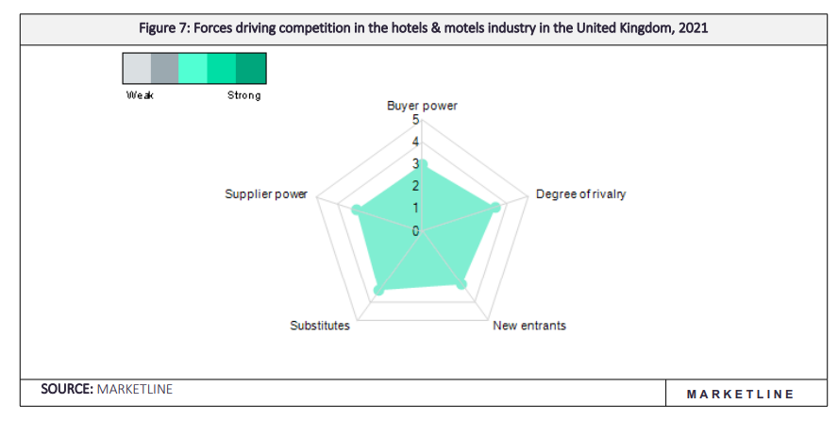
Figure 2: Porter’s five forces (Marketline, 2023)

APPENDIX B

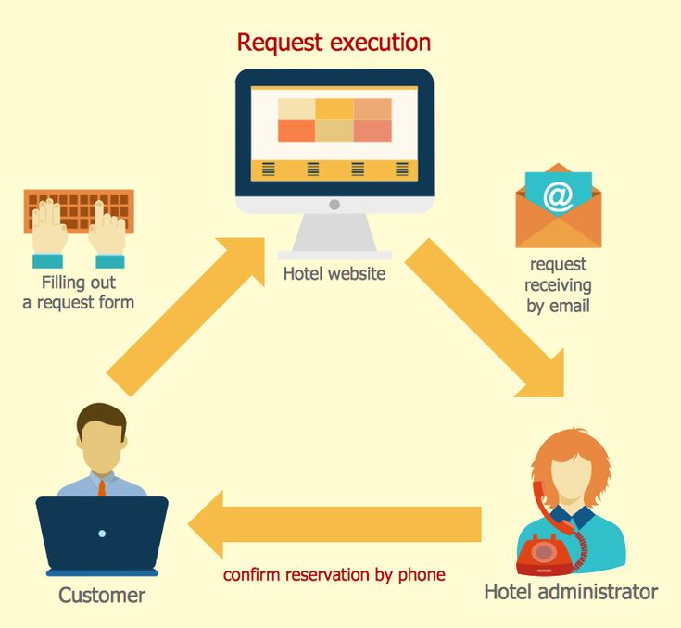

Figure 3: Amy’s Chalets reservation process (Marketline, 2023)

Figure 4: Amy’s Chalets organisational chart (Created by student)

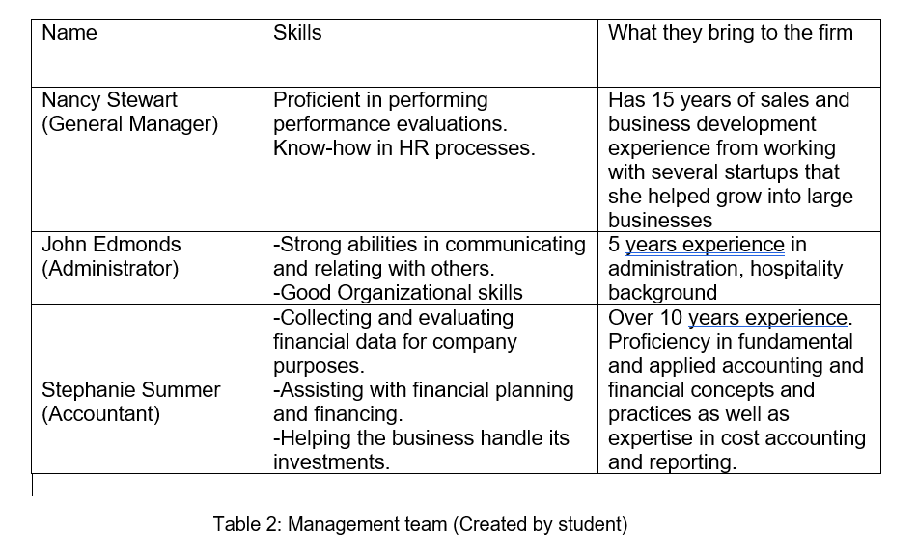
APPENDIX C
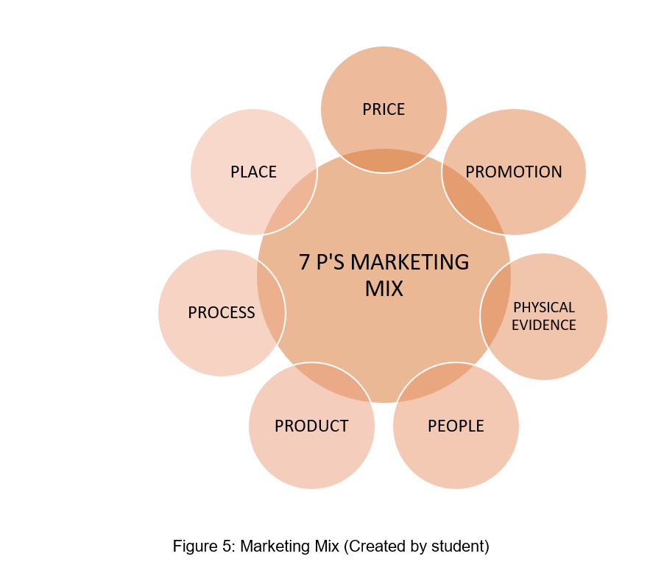

APPENDIX D

FINANCIALS

 | Month 1 | Month 2 | Month 3 | Month 4 | Month 5 | Month 6
Revenue (from your operations and marketing section)
Fixed Costs
(List out your fixed costs)

Variable Costs
(List out your variable costs)

Profit

APPENDIX E

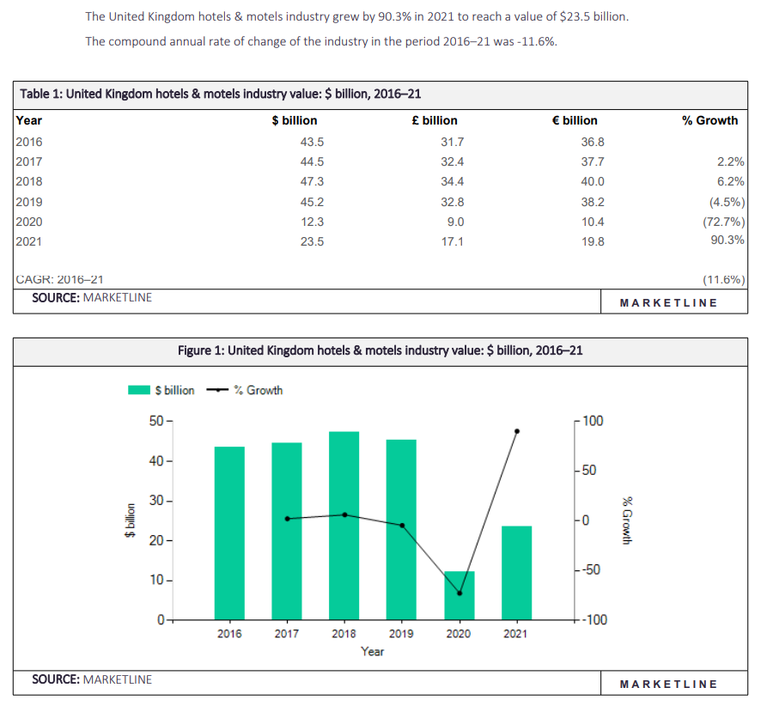
MARKET RESEARCH

Figure 6: UK’s hotels &motels value 2016-2021 (Marketline, 2023)
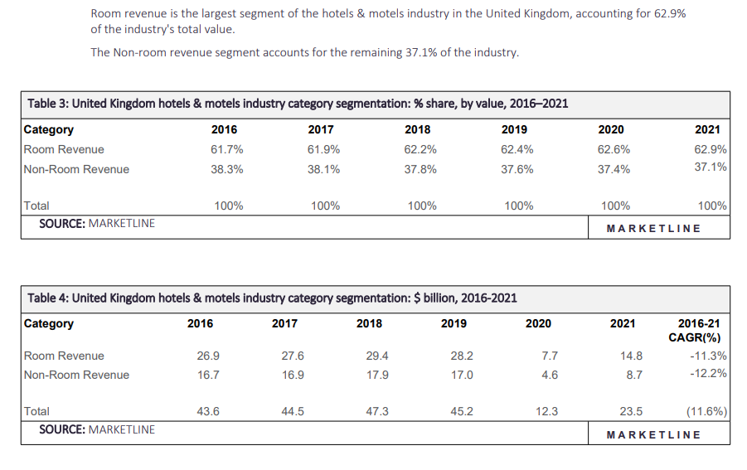
Figure 7: UK’s hotels & motels segmentation 2016-2021 (Marketline, 2023)

