  - Name: Josh Archer Student No: 2011907 Module No: ACCA4025

Assignment 2: Personal Development Plan (PDP)

Name: Josh Archer Student No: 2011907 Module No: ACCA4025

Contents
Introduction 2
Self-Evaluation 3
PDP 4
Development Plan 4
References 7

Introduction

Within the course work I will be assessing and providing an overview of my personality. This will include things such as my strengths, weaknesses and traits. I have taken numerous personality tests to help me with these including, Belbin Team Role test, Myers-Briggs Type Indicator (MBTI) and the Multiple Intelligence test. There will also be a Professional Development Plan (PDP) detailing my developments for the future and developments I have achieved.

Self-Evaluation

One of the first tests I took was the Belbin Team Role test. Dr Belbin believed that for a team to be successful, they must have a diverse group of people with certain personality traits and behaviours to become successful. They believe that each individual has several of these behaviours making up their team roles (1). My top 3 team roles based on my personality traits are
- Executive – This allows me to bring discipline and a drive to finish the job to the team. It also shows I am diligent and listen to my team (2). I would say this is fairly accurate as I believe I have developed some of these traits during my team in the Army. However, some of my weaknesses that come with this are that I sometimes grow aggravated and agitated when I am trying to complete tasks at hand. This can lead to me sometimes offending people.

- Innovator – This behaviour will bring creativity and imagination to my team. I enjoy being innovative with my ideas and solutions to problems. I would tend to agree with this, I am really keen on bringing new ideas to my company (2). I also learn new innovative ways of working especially when it comes to my role in my company. However, one of the weaknesses that comes with this is that I get preoccupied with these ideas rather than actually solving the problems. This can also mean that my communication skills are sometimes lacking when trying to converse to my team effectively (1).

- Explorer - This team role will bring curiosity to the team. This could go hand in hand with the innovator role as my curiosity will lead to investigations which will then lead to innovation. (2) This role also allows me to do well at presenting my ideas which will become key in getting my ideas across to my team. In my workplace I enjoy presenting newfound innovations to my team especially innovations in sustainability. One of the weaknesses I have found with this is that I tend to lose interest and enthusiasm once the initial stages of investigating new ideas has passed (1)
I also took the Myers-Briggs Type Indicator which lead me to find that I prefer thinking to feeling. I prefer to think logically which sometimes leads to my team members feeling that I am unemotional. I also find it hard to recognise people’s feelings (3). I also enjoy being competitive, this may also be a trait that I developed in the armed forces.

PDP

Development Plan

NAME: | Josh Archer | STUDENT NUMBER: | 2011907
COVERING THE PERIOD FROM: | 01/01/2021 | TO: | 01/01/2022

What do I want/need to learn or develop?  (Specific & Relevant) | What will I do to achieve this?  (Specific) | What resources or support will I need?  (Achievable) | What will my success criteria be?  (Measurable) | Target dates for review and completion  (Timebound)
After I completed the Myers-Briggs Type Indicator test, I found that I can be unemotional and unable to recognise how people are feeling (3). I would like to learn how to become more sensitive to people’s feelings. | On the Life Hacks website, I have learned to in order for me to accomplish this, I must first understand how I portray myself in regard to my body language and confidence. Pausing when feeling certain emotions and seeing the way my body is portraying these (6). | To be able to do this I will need time in order to complete this exercise. It would be something that I would have to learn organically in order to properly understand my body language. | My success will be measured when I can fully understand the way I am portraying myself to other people. I can then properly understand how I am making others feel. | I would like to have this completed by June/July 2021.
After I completed the colour personality test, I found that can procrastinate (7). I would like to learn to be more productive. | The Forbes website, explains that I should develop a system where I can remove distractions such as phones, and organise a time of the day in which I can check these distractions (8). | To be able to do this I will need software’s such as outlook in which I can set times within my calendar and organise my time properly. | Success will be measured when I can be productive without being distracted. | I would like to have this completed by Feb/March 2021
I conducted the Belbin Team Role test and found that one of the things I may be lacking is communication skills (2). I would like to learn how to communicate to my team effectively. | Upon reading how to communicate effectively on the Small business website, I found that being receptive to my team is a great way to communicate effectively (9). It will allow me to respond correctly to what they are saying. | I would need time and patience from my team in order to complete this. | I will measure this success by finding that my message I am trying to communicate has been received effectively and correctly. | I would like to have this completed by April/May 2021

Video

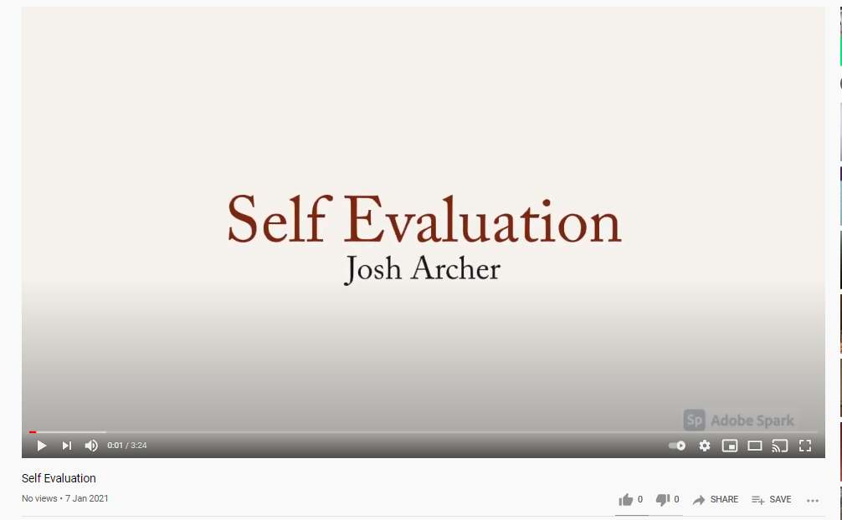
Line to Video: https://www.youtube.com/watch?v=I_ZLTcfH8lM&feature=youtu.be

References

[1] | Belbin Associates, “The Nine Belbin Team Roles,” Belbin Associates, 2021. [Online]. Available: https://www.belbin.com/about/belbin-team-roles/. [Accessed 02 01 2021].
[2] | 123 Test, “Your team roles,” 123 Test, 2021. [Online]. Available: https://www.123test.com/team-roles-test/id=KEN20VL2VHMA&version=. [Accessed 02 01 2021].
[3] | Truity, “The TypeFinder Personality Test,” Truity, 2021. [Online]. Available: https://www.truity.com/personality-test/17621/test-results/31346526. [Accessed 02 01 2021].
[4] | MindTools, “Personal Goal Setting,” Mindtools, 2020. [Online]. Available: https://www.mindtools.com/page6.html. [Accessed 02 01 2021].
[5] | University of Edinburgh, “Gibbs' Reflective Cycle,” University of Edinburgh, 11 11 2020. [Online]. Available: https://www.ed.ac.uk/reflection/reflectors-toolkit/reflecting-on-experience/gibbs-reflective-cycle. [Accessed 02 01 2021].
[6] | E. Baller, “How to Be More Sensitive for an Emotionally Insensitive Person,” Life Hack, 2020. [Online]. Available: https://www.lifehack.org/627055/how-to-be-more-sensitive-for-an-emotionally-insensitive-person. [Accessed 02 01 2021].
[7] | 365tests, 365 Tests, 2021. [Online]. Available: https://365tests.com/personality-tests/free-color-personality-test/. [Accessed 02 01 2021].
[8] | I. Pozin, “9 Habits of Productive People,” Forbes, 2020. [Online]. Available: https://www.forbes.com/sites/ilyapozin/2013/08/14/9-habits-of-productive-people/?sh=364bf3772d3f. [Accessed 02 01 2021].
[9] | V. Belonwu, “20 Ways to Communicate Effectively With Your Team,” Small Business Trends, 30 04 2020. [Online]. Available: https://smallbiztrends.com/2013/11/20-ways-to-communicate-effectively-in-the-workplace.html. [Accessed 02 01 2021].

