Lab 7 & 8
Step 1 – TCP ports
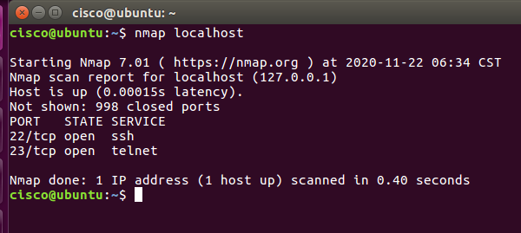
Step 2
Use ifconfig to find host ip etc
Host ip = 10.0.2.15
Scan = nmap 10.0.2.15
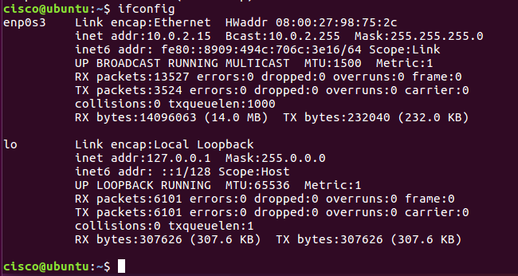
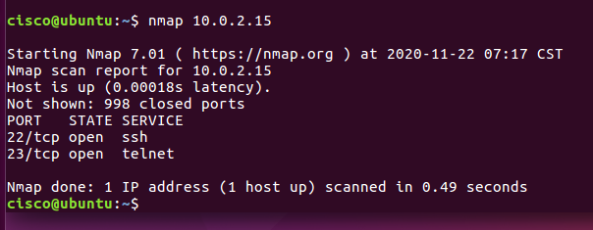
Step 3
No Differences found
Step 4
Why only 1000 scanned?
Some are reserved (approx. 1st 2400+)
Generally, nmap only scans the 1st 1000 that are available, but you can scan the others, up to a maximum of 65535
Nmap -p1234-3456 localhost or nmap -p1000-3000 10.0.2.15
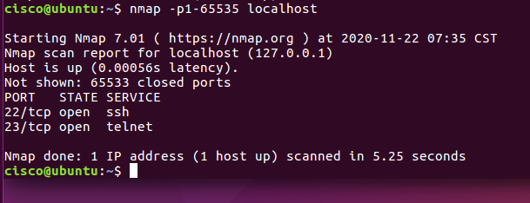
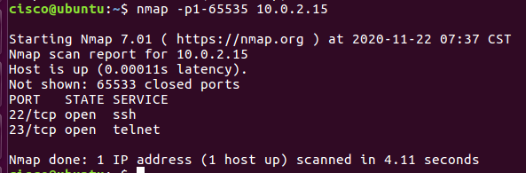
Step 5 – now scanning UDP ports
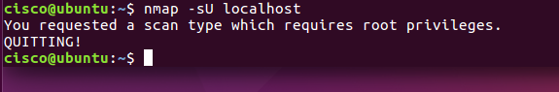
No access allowed, so need to request as a super user.
Sudo nmap -sU localhost and will require PW = password
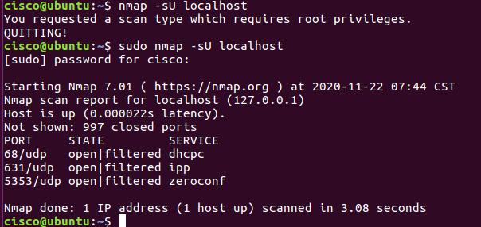
Sudo nmap -sU 10.0.2.15
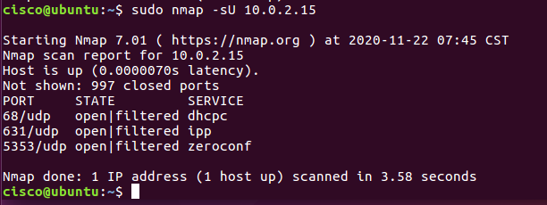
Step 6
Port 68 open in UDP but closed in TCP
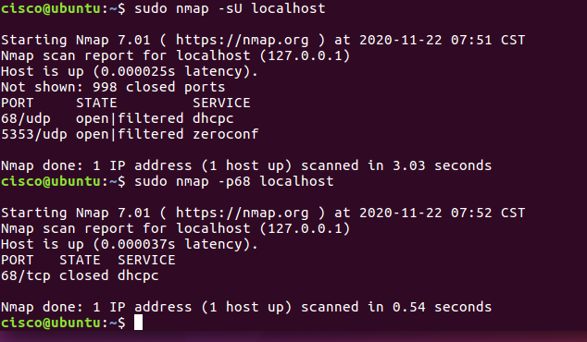
Step 7
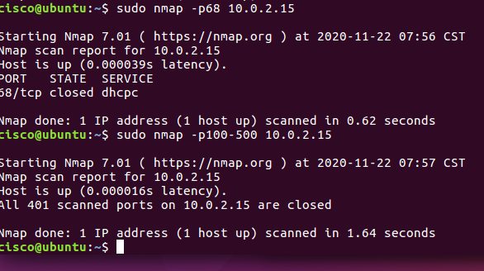
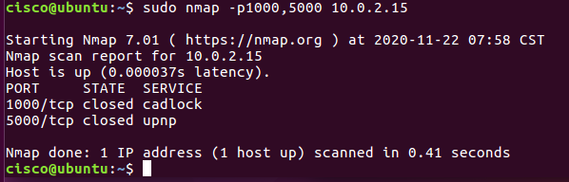
Google search for nmap.org commands
????????

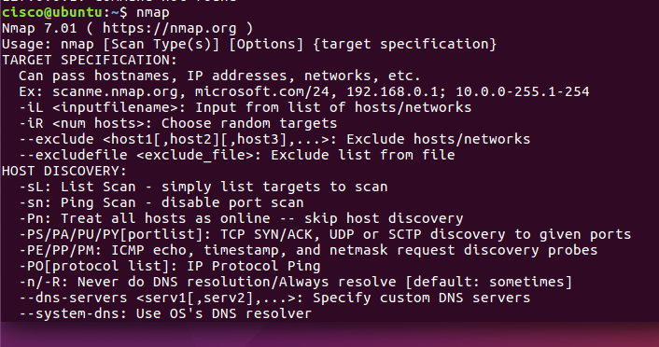
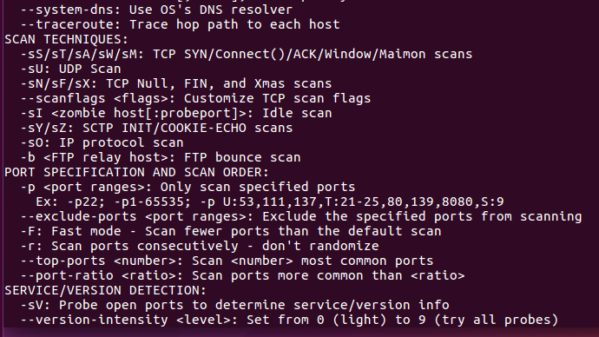
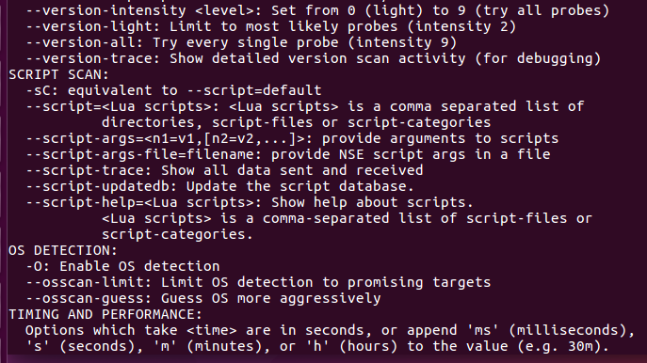
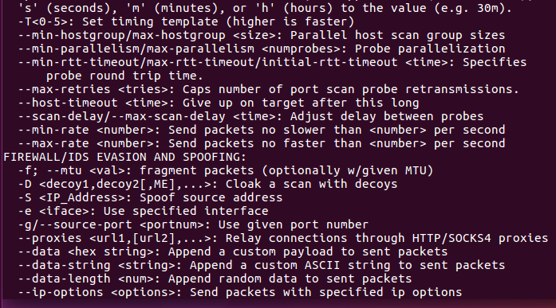
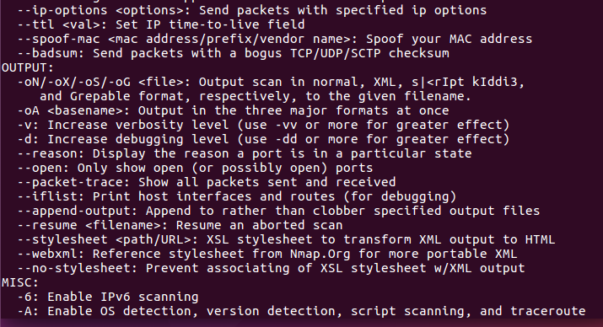
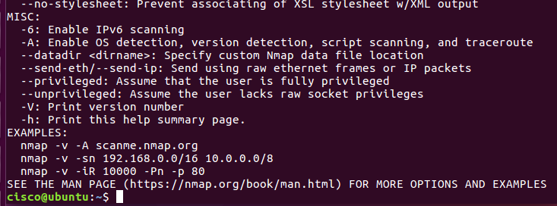

Step 8
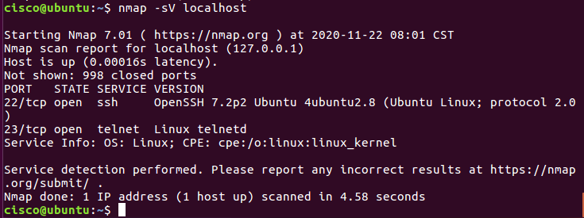
Version = OpenSSH 7.2p2
Linux telnetd
Linux OS


