University of Wales Trinity Saint David
School of Engineering



Design for Manufacture and Assembly: Component Optimisation
Joe Shankland
2317772
BEng Mechanical Engineering
16/06/2025

Manufacturing Design & Technology (PT)

Contents
Introduction 3
Literature Review 5
Design Principles 5
Manufacturing Techniques 5
Analysis Tools 6
Define Customer Requirements 7
Manufacturability 7
Defect Mitigation 9
Material and Cost Efficiency 10
Sustainability 11
Design and Development 11
Simulation and Validation 23
Cost Calculation Analysis 26
Sustainability Considerations 29
Recyclability 29
Energy Efficiency 29
Waste Reduction 29
Discussion and Recommendations 30
Conclusion 31
References 33

Introduction

The purpose of this report is to design and develop a mobile phone case, along with the mould required for its mass production. In recent years, rapid technological advancement has made smartphones an essential part of daily life, with the majority of the global population now carrying a highly capable device in their pocket. These smartphones, while powerful, are also delicate and susceptible to damage from drops, impacts, and environmental exposure. To protect these valuable devices, phone cases have become an essential accessory, helping to preserve functionality, appearance, and overall lifespan. Early mobile phones were much larger and more durable by design, with less emphasis placed on user-friendly design or portability. As mobile phones evolved to become sleeker, thinner, and more fragile, the need for protective accessories such as phone cases became more apparent. This growing reliance on smartphones in both personal and professional settings has led to a sharp increase in the demand for protective solutions. As a result, the production of phone cases has had to scale up significantly, requiring efficient and cost-effective manufacturing methods like injection moulding to meet global demand while ensuring consistent quality and performance.
This report will follow the stages of a phone case through initial design from specification, to final manufacture. Initial Specification of the phone case requires a lightweight polymer housing with integrated mounting points, ventilation slots, and snap fit fasteners, which is optimised for high-volume polymer injection moulding. To ensure this specification is met, the product must be subject to multi-stage design and analysis, using tools such as Quality Function Deployment (QFD), Design for Assembly (DFA) and Design for Manufacturing (DFM). Quality Function Deployment is a process which help to consider customer requirements in a product, with the emphasis on the customer needs and requirements, Quality Function Deployment helps manufacturers translate these into engineering specifications for further development. Design for Manufacturing/Assembly analysis ensures that the product can be efficiently manufactured and assembled. In conjunction, the following tools will also be used, Failure Mode and Effects Analysis (FMEA), Design of Experiments (DOE), and SolidWorks Plastics analysis. The combination of all of these tools will ensure the products is suitable for manufacture, and will be functional with minimal failures.
Due to the nature of mass manufacturing, the material selection and manufacturing method used will also have to be properly analysed to ensure suitability, efficiency, and cost efficiency. Using tools such as the Cambridge Engineering Selector (CES), the materials available will be analysed to ensure the chosen material will have the correct properties, to avoid failures. Manufacturing Costs will also be considered, analysing the machine time, tooling costs, and labour expenses.

Literature Review

Design Principles
When designing a phone case for mass production, two key design methodologies play a vital role: Design for Manufacture (DFM) and Design for Assembly (DFA).
DFM focuses on simplifying the design to make the manufacturing process more cost-effective and reliable. In the context of a phone case, this involves considering material selection, wall thickness uniformity, draft angles for mould release, and minimizing complex geometries that increase tooling or machining time. According to Bralla (1999), effective DFM ensures that the product can be manufactured with minimal waste and tooling costs.
DFA concentrates on reducing the number of components and simplifying assembly processes. Since phone cases are often a single piece product, DFA principles help ensure that snap-fit features or clip mechanisms are integrated in a way that allows for quick and repeatable assembly. Boothroyd et al. (2010) emphasized that integrating DFA early in the design phase results in reduced production time and labour costs.
Together, DFM and DFA support a streamlined production process, from concept to final product, ensuring high-quality, cost-efficient, and scalable manufacture of phone cases.

Manufacturing Techniques
A number of manufacturing processes are available for producing plastic phone cases, but injection moulding is the most common due to its repeatability, speed, and suitability for mass production. Injection Moulding involves injecting molten polymer into a mould cavity, then cooling and ejecting the solidified component. This technique is well-suited to the tight tolerances and aesthetic requirements of phone cases. Common thermoplastics used include polycarbonate (PC), thermoplastic polyurethane (TPU), and acrylonitrile butadiene styrene (ABS). These materials offer impact resistance, flexibility, and dimensional stability (Rosato & Rosato, 2000).
Other manufacturing techniques such as casting or 3D printing may be used for prototyping but are unsuitable for high-volume production due to longer cycle times and higher unit costs. Therefore, injection moulding offers the best balance of cost, cycle time, surface finish, and dimensional accuracy for phone case production.

Analysis Tools
A range of tools are used in the design and development phase to optimise the phone case design:
- Quality Function Deployment (QFD): This method translates customer requirements into engineering specifications. To improve product quality and reduce development time and cost, QFD provides a structured approach to addressing customer needs (Launchnotes.com, 2025).
- Failure Modes and Effects Analysis (FMEA): A risk assessment tool used to identify potential failure points in the design or manufacturing process. Applying FMEA to phone case production ensures that issues such as weak snap-fits or poor material properties are mitigated early.
- SolidWorks Plastics: A simulation tool that analyses the flow of plastic in mould cavities, helping designers predict and correct issues like weld lines, air traps, or incomplete filling before tooling is manufactured.
- Finite Element Analysis (FEA): Used to assess the structural performance of the phone case under stress conditions (e.g., drops or pressure). FEA simulations ensure the case can protect the phone from mechanical shock and bending forces.
These tools collectively reduce development time, improve product performance, and lower manufacturing risk, making them essential to design and production stages of an injection moulded phone case.

Define Customer Requirements

In the development and manufacture of a product, understanding and addressing customer requirements is essential for ensuring functionality, quality, and market competitiveness. The brief given from the Customer mentioned four main requirements to consider, which are, Manufacturability, Defect Mitigation, Material and Cost Efficiency, and Sustainability. Analysis must be done all of these requirements early in the process to ensure that the research, design, and manufacturing stages can continue smoothly, and compromises are not made which impact requirement and functionality.

Manufacturability
To meet this requirement, the design must incorporate features that allow for consistent and repeatable manufacturing processes. This can be done by simplifying complex geometries, reducing the number of parts, and choosing manufacturing methods with low cycle times, such as injection moulding or die casting, can enhance output. Additionally, ensuring compatibility with standardised tooling and fixings can further reduce setup times and improve scalability.
A method to improve manufacturability of a product is to use Design for Manufacture and Design for Assembly analysis, which ensures all variables which may affect these processes have been considered in the early stage. Figure 1 below, shows a component appraisal chart which allows us to decipher what makes a part essential. The chart shows that an essential part must satisfy one of the following criteria:
- The part must be separate to provide essential movement, relative to all other parts.
- The part is made of a separate material to the other parts, which is essential to function.
- The part must be separate to allow for essential replacement or repair.

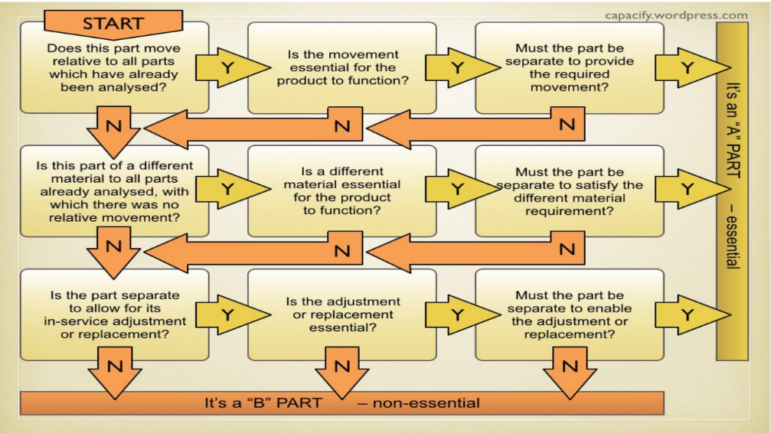
Figure 1 - DFM essential component chart (Lucas, 1991)

Employing these considerations before the design stage ensures that only essential parts are created, and functionality is maintained. Design for Assembly considerations can also be used to ensure the production process is efficient.
The following step-by-step plan outlines the complete process for manufacturing the phone case using injection moulding, from initial material preparation through to final quality inspection:
Step 1: Material Preparation
- Material Selection: Choose a suitable thermoplastic polymer based on the required mechanical, thermal, and aesthetic properties of the final product.
- Drying: Depending on the polymer's moisture sensitivity, drying may be necessary to prevent defects. Granules should be dried under manufacturer-recommended conditions to ensure optimal processing performance.
Step 2: Machine Setup
- Mould Installation: Secure and align the mould into the injection moulding machine, ensuring proper clamping and safety checks.
- Parameter Configuration: Set machine parameters including barrel temperature, injection pressure, screw speed, cooling time, and mould temperature in accordance with the chosen material’s processing guidelines.
Step 3: Injection Moulding Cycle
- Plasticisation: The plastic granules are fed into the hopper, conveyed through the heated barrel, and melted.
- Injection: Molten polymer is injected into the closed mould cavity at controlled pressure and speed to ensure complete fill.
- Packing & Holding: Additional pressure is maintained after the cavity is filled to compensate for material shrinkage during cooling.
- Cooling: The part is allowed to cool and solidify inside the mould, with cycle time dependent on part geometry and material properties.
- Ejection: Once solidified, the mould opens and the part is ejected using pins or air assistance.
Step 4: Trimming and Finishing
- Sprue Removal: Any excess material from sprues are removed either manually or automatically.
- Flash Removal: Any minor flash or imperfections around edges are trimmed or polished to meet visual and functional standards.

Step 6: Quality Inspection
- Visual Inspection: Parts are checked for surface defects such as warping, incomplete fill, sink marks, or flow lines.
- Dimensional Inspection: Key features and tolerances are verified using measuring instruments such as callipers, gauges, or coordinate measuring machines (CMM).
- Functional Testing: Compatibility and usability with the intended phone model are tested to confirm proper fit and functionality.
- Documentation and Sorting: Quality results are recorded. Parts that fail to meet specifications are rejected and directed to rework or recycling as appropriate.
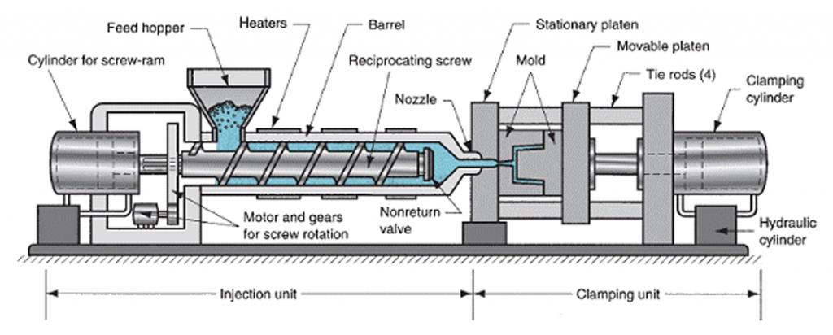
This general process ensures that the component can be reliably manufactured at high volume, regardless of the specific thermoplastic used, while maintaining consistent quality and efficiency throughout production. The overview of this process can be seen in Figure 2.

Figure 2 - Overview of Injection Moulding Process

Defect Mitigation
Defect mitigation is critical for maintaining product integrity and customer satisfaction. Finite Element Analysis (FEA) via SolidWorks simulation tools can be used to assure this. Optimising operating conditions, and ensuring variables such as gate location, wall thickness uniformity, and proper draft angles also help mitigate Defects. Common defects that occur during injection moulding are, Warping, Sink marks, Flash, Short shots, and Air Bubbles, these defects can all be minimised by ensuring the operating variables are correct. Ensuring that the correct amount of material is injected into the mould at the correct temperature is a method which helps to mitigate flash and short shots, where as controlling the cooling rate is an effective method for avoiding Warping, Sink marks, and flash. Combining this with a correctly designed gating system and incorporating a vacuum into the system, ensures that there are no air bubbles in the product.

Material and Cost Efficiency
This requirement demands an informed choice of material to offer the best balance between mechanical properties and cost. Utilising the Cambridge Engineering Selector Database to analyse material properties, allows for materials to be compared accurately. Material properties such as tensile strength, impact and fatigue resistance, as well as thermal properties need to be considered. Material Strength is extremely important, the possible impact forces that affect the phone case must be considered, as well as the large number of cycles that the product will experience. For manufacturing, thermal properties are also important in material selection, as they affect the process, most notably, how much energy is required to melt the material, and the Melt Flow Index, which indicates how easily the material flows during the moulding process. Other considerations such as cost and flammability are also extremely important, the former for increasing savings, and the latter for ensuring safety and that the product is UL 94 V-0 classified, to abide by legislation (protolabs, 2019).

Sustainability
Sustainability is a growing customer priority and often a regulatory requirement. Sustainability can be improved by selecting recyclable or biodegradable materials and adopting low-energy manufacturing methods. Polymer as a material is very well suited for recycled use, as thermoplastics are simple to reprocess. Most suitably, secondary recycling, which involves, sorting, shredding, washing, melting, and re-shaping into pellets, these pellets can then be used for injection moulding. This method of recycling is widely used due to the cost effectiveness and simplicity of the process, with improvements making it commercially viable. The largest variation in this process, is the sorting method, of which many are available, such as Manual Sorting, Density Separation, Raman Spectroscopy, Electrostatic Separation. One of the most common method in polymer recycling is Spectroscopy, which utilises x-rays to determine the elements which are present in a material, this method has been shown to yield a sorting efficiency of 57-89% for common plastics in Europe (Faraca and Astrup, 2019). Another favoured method is Electrostatic Separation, which is often applied to more complex mixtures, which may include metallic parts as well as multiple polymers. This method utilises the triboelectric effect, where materials become electrically charged after contact, this static charge is then used to measure and sort them.

Design and Development

As previously mentioned, for the design stage, analytical tools must be used to ensure that the design fulfils the requirements, while still maintaining full functionality. The first analytical tool used in this process was Quality Function Design, which is a method used to translate customer wants and needs into an engineering specification. As shown below in Table 1, a QFD for this product analyses the correlation between the needs from the customer to the engineering variables of the design process. After a long evaluation process, the customers needs were decided as the following:
- Drop Protection
- Scratch Resistance
- Slim and Lightweight
- Stylish Design
- Comfortable Grip
- Easy Button and Port Access
- Affordable Price
While the engineering variables, were decided as the following:
- Material Type
- Wall Thickness
- Surface Finish/Texture
- Corner Reinforcement
- Precision of button cut-outs
- Manufacturing Cost per Unit
- Weight
Using QFD analysis, it was observed that, the variable which would have the greatest effect on customer requirements, was Material Type, which had an importance weight of 385.7. This was followed by Surface Finish with an importance weight of 353.6 and Wall Thickness with an importance weight of 257.1. Analysing these numbers, it’s noticed that there are two standout values for Material Type and Surface Finish, at 385.7 and 353.6 respectively. When compared to the lowest value of 110.7, these vales have an difference of 248% and 219% respectively from the lowest value, compared to an increase of only 132% for the next greatest value. This shows, that proportionately, these two variables, Material Type and Surface Finish, are the most important, and further analysis should be completed to help inform further decisions.
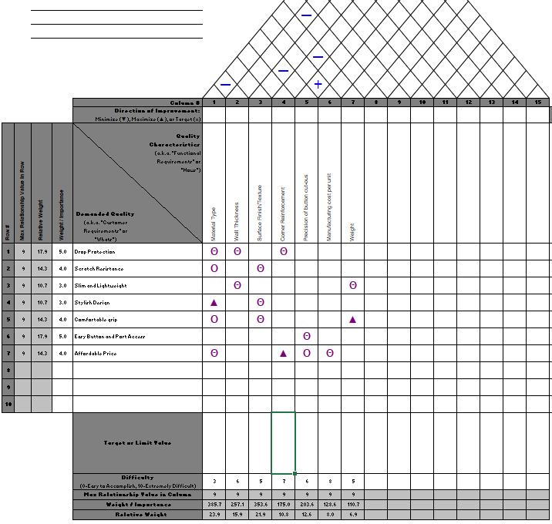
Table 1 - QFD House of Quality
The next stage, was to consider Design for Manufacture, which is a method previously discussed to analyse essential and non-essential parts. As previously analysed, with the help of Figure 1, it can be decided that an essential part must abide by the following conditions:
- The component must only be separate to provide essential movement, relative to all other parts.
- The part is must be made of a separate material to the other parts, which is essential to function.
- The part must be separate to allow for essential replacement or repair.
To analyse these conditions, it can be seen that, a phone case does not require any moving parts, as it is more efficient to use snap-fit fasteners instead of external ones. It is also observed, that, while possible, it is not essential to make the phone case out of multiple materials, as the incorporation of cut-outs for the buttons ensure full functionality. Finally, these considerations suggest that the phone case should be manufactured as one piece, meaning the ability to replace or repair components isn’t possible, and the whole part would need to be replaced.
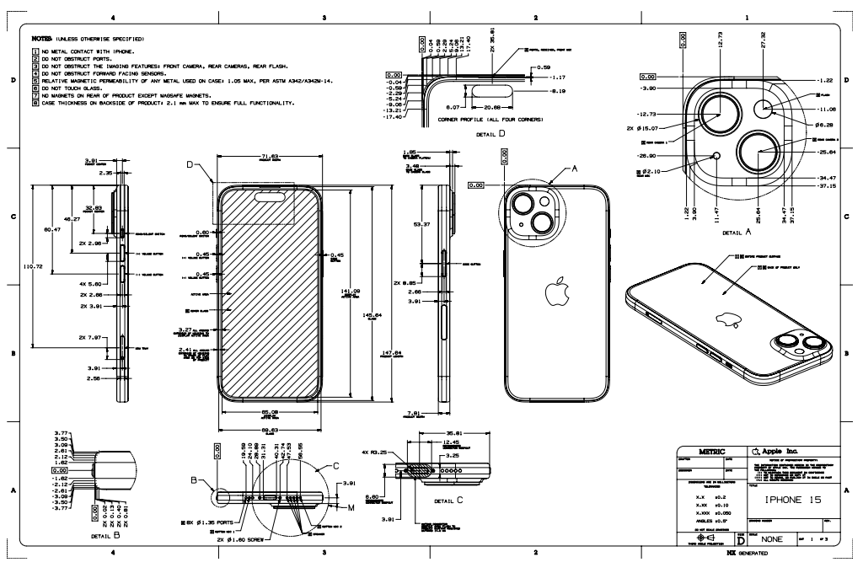
When designing, to ensure proportions and measurements are correct, engineering drawings from apple, shown below in figure 3, 4, and 5, were used. These drawings ensures that the internal cavity of the phone case is able to hold the phone, and incorporate a snap-fit to retain the phone.

Figure 3 - Engineering Design Specification from Apple (Apple, 2024)
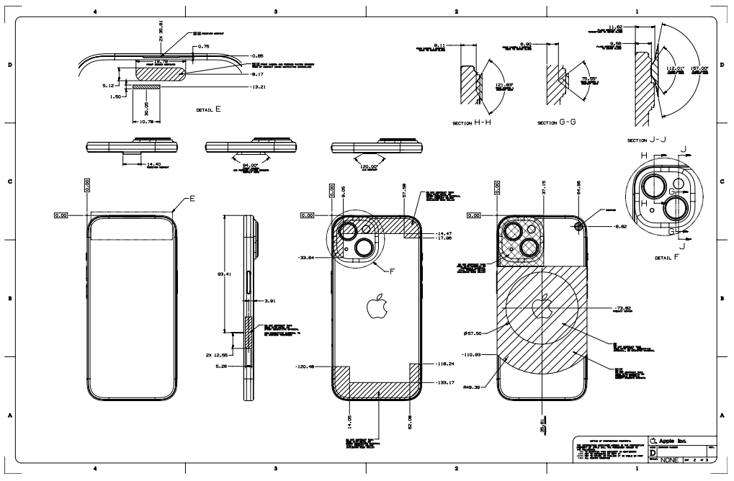

Figure 4 – Engineering Design Specification from Apple (Apple, 2024)
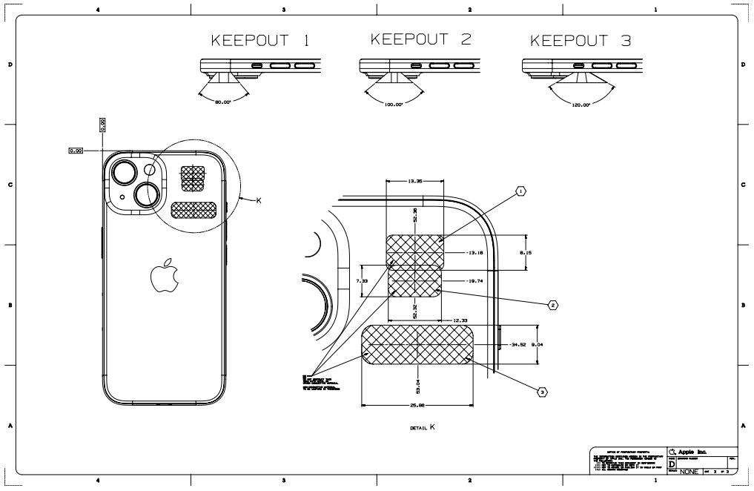

Figure 5 - Engineering Design Specification from Apple (Apple, 2024)
Once these drawings have been analysed, the phone case can be designed, utilising the analysis methods already completed. After multiple design stages, the final design can be seen in Figure 6 and 7.
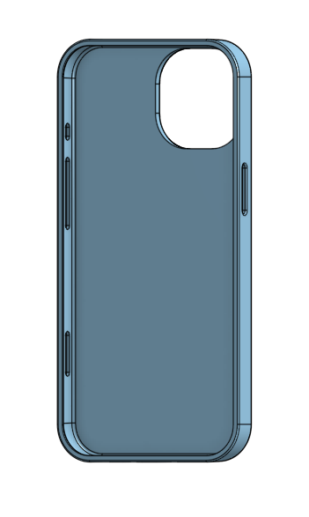
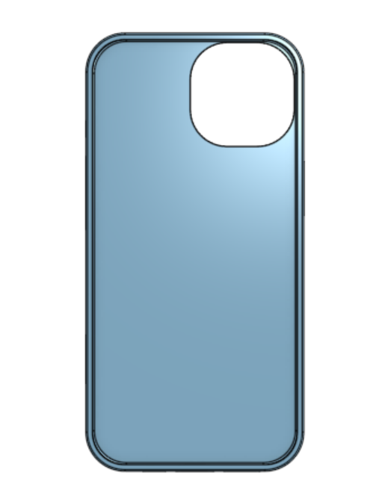
Figure 6 - 3D Render of Phone Case Design Figure 7 - 3D Render of Phone Case Design

Shown below in Figure 8 and Figure 9, some of the features can be seen, for example, the rounded edges on the outside of the case ensure that the case has a comfortable grip, as requested by the customer, some more features of the design are:
- Increased Clearance and Rounded edges around button/port holes to ensure functionality is optimal.
- Lipped edge around screen to provide increased protection from drops.
- Lipped edge around camera to provide increased protection from drops.
- Internal Edges are rounded to increase structural rigidity and hold strength on phone.
- Lipped edge around screen to provide snap fit fastener for phone retention.
Figure 12 also shows an Engineering Drawing of the phone case, providing important dimensions and information.

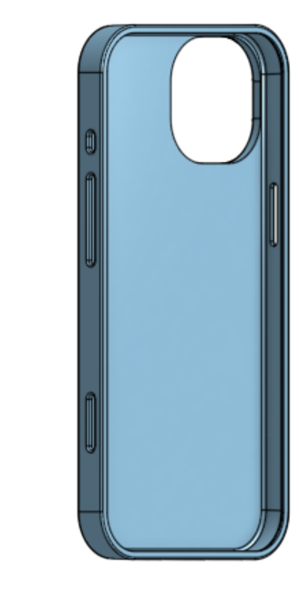

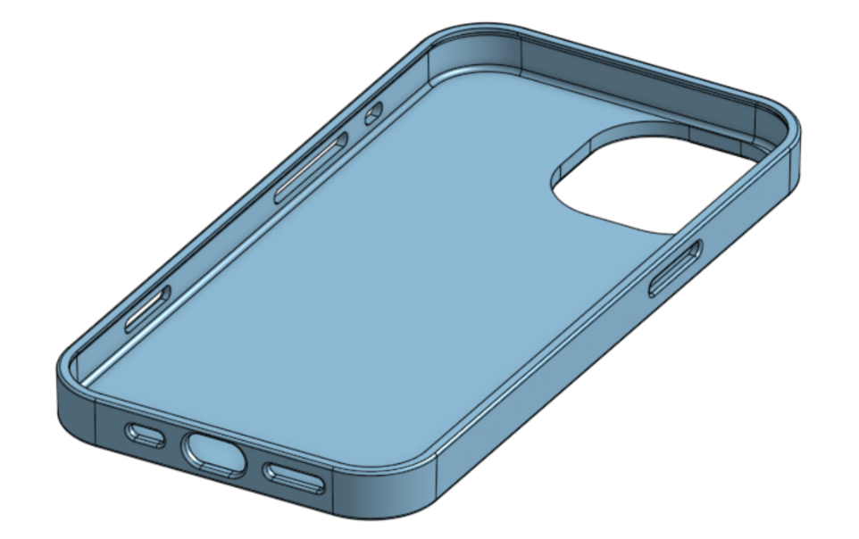

Figure 8 - 3D Render of Phone Case Design Figure 9 - 3D Render of Phone Case Design
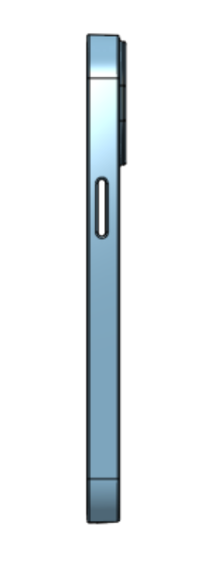

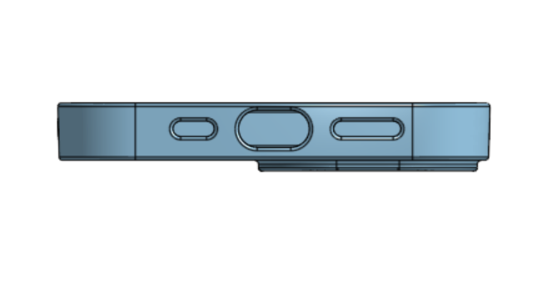

Figure 10 - 3D Render of Phone Case Design Figure 11 - 3D Render of Phone Case Design

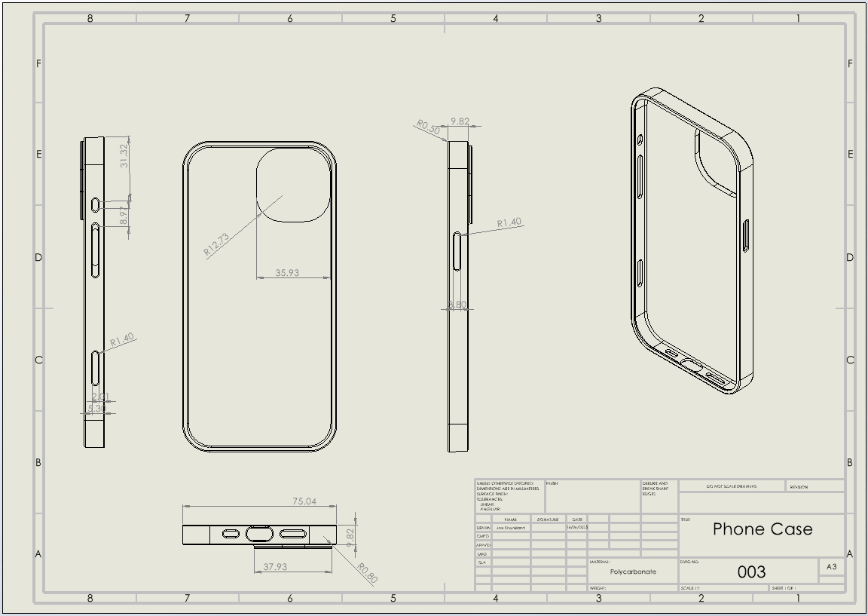
Figure 12 - Engineering Drawing for Phone Case Design

In conjunction with the product design, the mould can also be created, using the dimensions of the phones case, possibly leading to adjustments to aid the efficient use of an injection moulding machine. Shown below in Figure 13 and 14 are annotated 3D renders of the mould, the mould uses previously mentioned considerations to ensure an efficient manufacturing process, as well as ensuring functionality. The components in the mould are:
- Alignment Pins and Holes to ensure precision
- Filling Sprue
- Ejection System to accommodate quick cycles and front lip
- Draft angles on all sides to ensure smooth ejection
- Curved Edges to avoid increased stresses when cooling
- Hydraulic Side Pins to accommodate Cut Outs

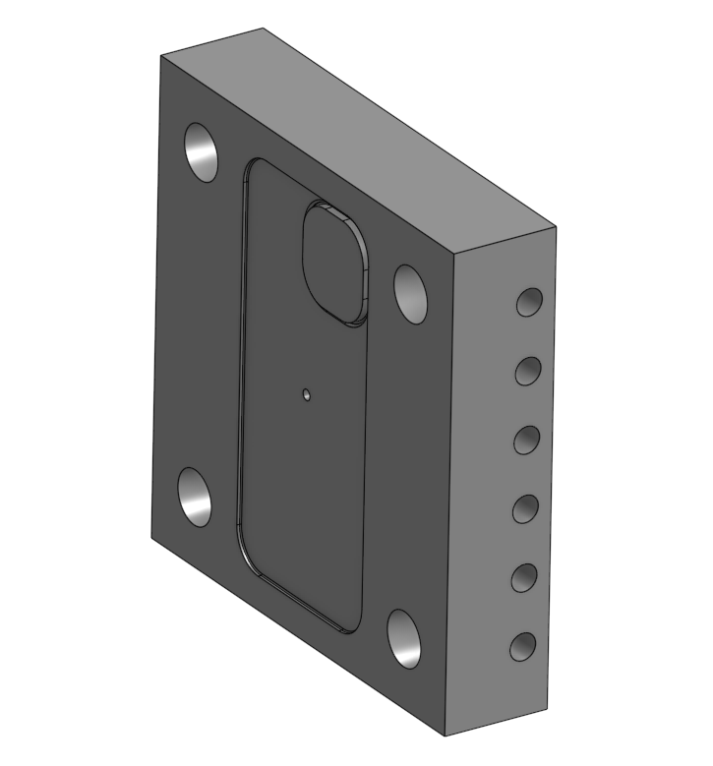
Alignment Holes
Cooling Channels
Filling Sprue
Mould Cavity

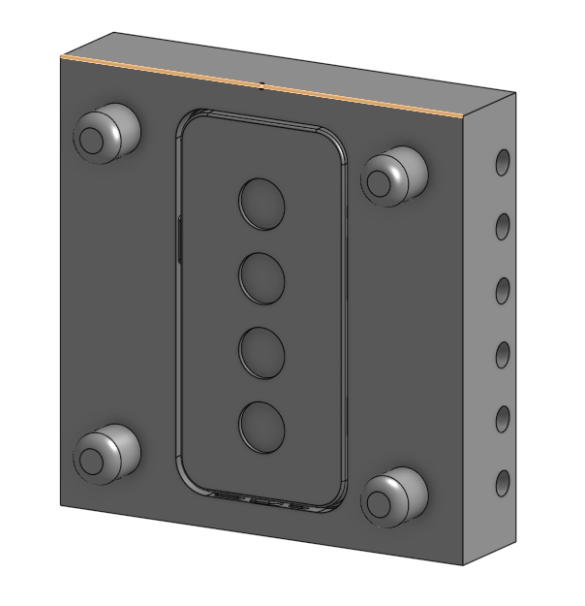
Figure 13 - Annotated 3D Render of Mould Design
Alignment Pins
Ejection System
Mould Cavity
Cooling Channels
Hydraulic pins for cut outs

Figure 14 - Annotated 3D Render of Mould Design
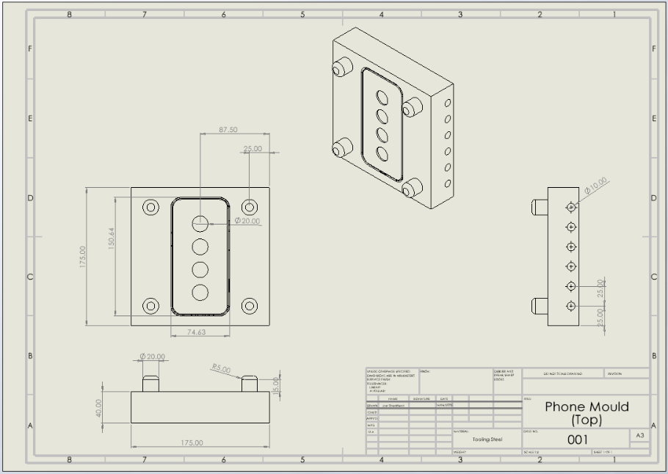
Also shown below are Engineering Drawings of the Mould Sections, giving more detail of the dimensions of the piece.
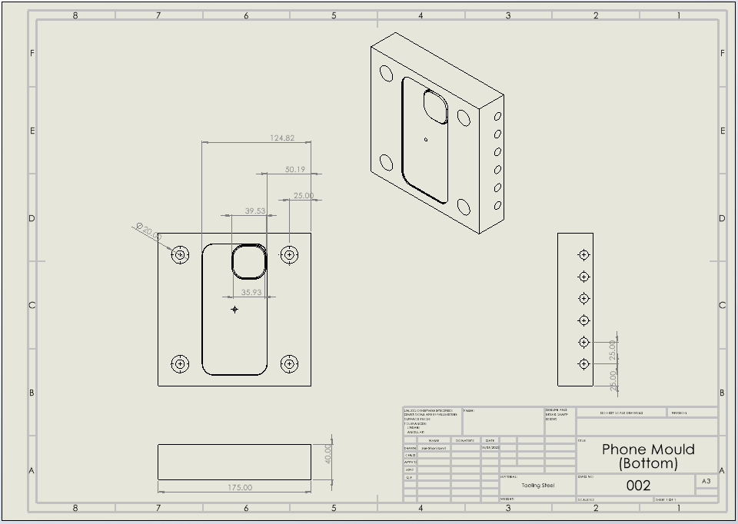
Figure 15 - Engineering Drawing of Mould Design
Figure 16 - Engineering Drawing of Mould Design
The next stage of design was deciding on a material, in the domestic marketplace, phone cases are available in lots of different materials, all suitable, and offering different qualities. For this product, the customer requirements and brief must be adhered to, therefore, the material must have high impact and fracture strength, as well as low price, and a suitable melting point for injection moulding.
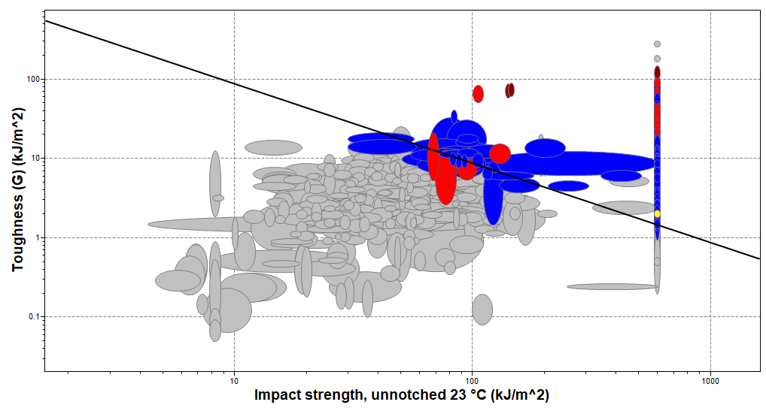
With the use of the Cambridge Engineering Selection Database, the available polymers can be assessed based on their properties. Shown below in Figure 17, the material Toughness is compared to the material Impact Strength, to ensure that the chosen material has a high value for both properties, ensuring neither is sacrificed. Figure 17 also shows that Polycarbonate, highlighted in yellow, is above the selected threshold to be suitable for this application. Polycarbonate is shown to have a reasonably high Toughness of 1.85=2.23 kJ/m² as well as having a good Unnotched Impact Strength of 590-600 kJ/m².
Figure 17 - Graph of Impact Strength against Toughness (Granta, 2022)
Figure 18 is also taken from the Cambridge Engineering Selection Database, and shows material Fracture Toughness compared to material Price per Unit Volume. This comparison ensures that the chosen material is able to satisfy the requirement of providing drop protection, while also having a low Price per Unit Volume to ensure the product still remains affordable. Again highlighted in yellow is Polycarbonate, which also satisfies the chosen requirements for these variables, having a satisfactory Fracture Toughness of 2.1-2.3 Mpam^{0.5} and a low Price per Unit Volume of 2210-2287 GBP/m³.
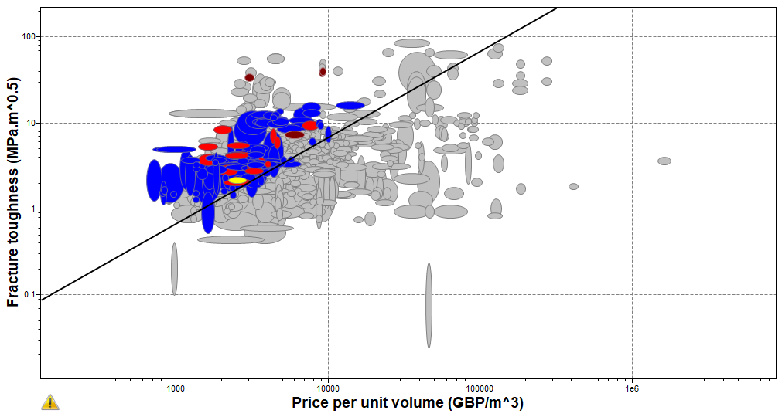
Figure 18 - Graph of Price per Unit Volume against Fracture Toughness (Granta, 2022)
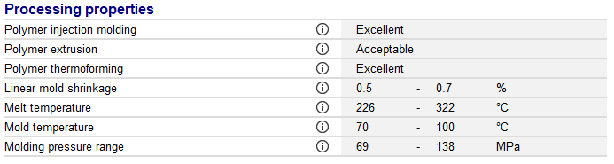
After finding that Polycarbonate satisfies the relevant variables for the phone case, Cambridge Engineering Selection Database can also be used to analyse the material’s processing properties. Shown in Figure 19 below, it can be seen that Polycarbonate has an Excellent Rating for compatability with Polymer Injection Moulding, making it an extremely well suited option for this product. It can also be seen that Polycarbonate has a melt temperature of 226-322°C and requires a mold temperature of 70-100°C, these values can be used when considering the production costs, as this may impact the machine that has to be used. Another factor that may affect the manufacturing costs, is the molding pressure required, which for Polycarbonate, can be seen as 69-138 Mpa, these factors should be considered moving forward in the process, when considering manufacturing.

Figure 19 - Polycarbonate Processing Properties (Granta, 2022)

Simulation and Validation

SolidWorks provides simulation tools which allow the product to be analysed through each process stage without having to spend the time or money doing so in the real world. These tools provide key information for the design and manufacturing stages, while also saving money and research and development. The first simulation tool which aids the design of the phone case is the mould fill tool, which simulates the filling of the mould cavity, providing essential values, such as mould fill time, polymer volume required, mould cooling time, and overall cycle time. As shown below in Figure 20 and 21, it can be seen how the mould is filled, with the colours representing different time periods, shown by the legend, allowing for the machine properties to be correctly set.

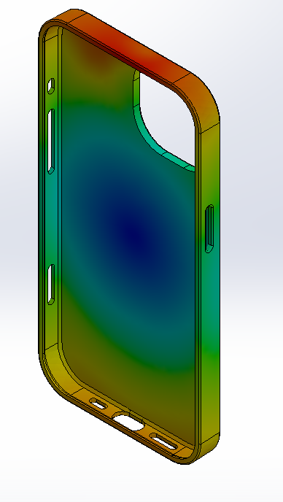
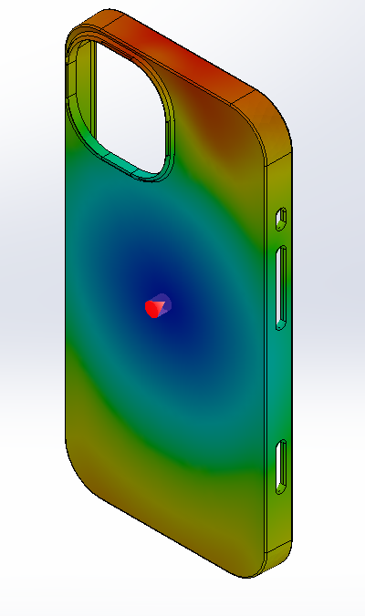

Figure 20 - Mould Fill Analysis Figure 21 - Mould Fill Analysis

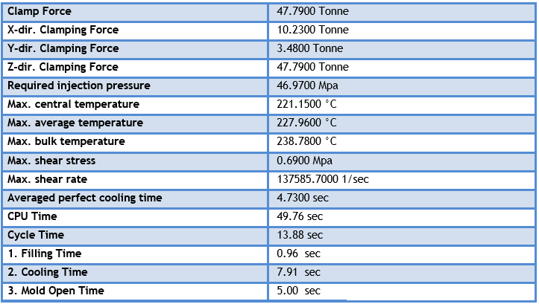
Solidworks also generates a report which allows the values to be analysed, this can be seen below in Figure 22, which shows a required clamp force of 47.79 Tonne and an injection pressure of 46.97MPa, these values can also be used to decide on a suitable injection moulding machine. Further, figure 22 shows that the process has a cycle time of 13.88 seconds, which can be broken down into a filling time of 0.96 seconds, a cooling time of 7.91 seconds, and a mould open time of 5.00 seconds. These values should be used to accurately set the operating parameters for the machine, ensuring that the product is correct.
Figure 22 - Mould Fill Analysis Results
Additional Simulation tools that are providing on Solidworks, are impact and stress simulations, the most applicable of which is drop testing, which is something that the product would often experience, and should be able to protect a phone against. This simulation would provide essential information on how the phone case would react to an impact, and where the largest stresses are applied, if needed, allowing for further design development. Figure 23 shows the von Mises stress caused through the product as a result of being dropped from 1000mm. The Figure shows, that the largest stress force acting on the phone case, as a result of a drop from 1000mm is 7.552x10⁻⁷ Pa, which is far smaller than the minimum fracture toughness of Polycarbonate, which is 69MPa. This result shows that the product will be able to stand up to regular drops.

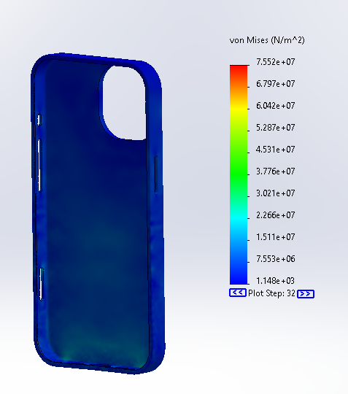

Figure 23 - Drop Test Analysis

Cost Calculation Analysis

For a typical medium 100 – 160 tonne injection-moulding machine in the UK, new machines cost approximately £20,000 and up, with prices rising into the low hundreds of thousands for larger or electric models
- Initial purchase price: £100,000
- Expected service life: 10 years
Depreciation can be modelled on a straight-line basis:
$$Annual Depreciation= \frac{£100,000}{10}=£10,000 per year$$
2. Annual Operating Hours
Injection-moulding machines in regular production environments may run two shifts a day, five days a week. Assuming three weeks of downtime annually:
- Operational weeks: $49$
- Hours/week: $5 days × 16 hours = 80 hours$
- Annual machine hours: $49 × 80 = 3,920 hours per year$

3. Machine Hourly Cost
We must include depreciation, energy, maintenance, and tooling amortisation.
- Depreciation: $\frac{£10,000 }{3920h} = £2.55/h$
- Energy & maintenance: £100/h
- Thus:
$$Machine\frac{cost}{hour}=£2.55+£100=£102.55$$

4. Labour Cost Rate in the UK
Official UK data for average labour compensation in manufacturing is around £25 per hour.
5. Labour Overhead Allocation
Overhead costs must be apportioned to machine hours. Therefore;
- Indirect costs estimate: £50,000/year
$$Labour overhead rate=\frac{£50,000}{3920}=£12.60/h$$
6. Combined Hourly Cost
Summing all direct and allocated costs per operating hour:
Cost Component | Rate (£/h)
Machine Depreciation | 2.55
Machine Energy & Maintenance | 100.00
Direct Labour | 25.00
Labour Overhead | 12.76
Total | 140.31

7. Per-Cycle & Per-Part Cost
Assuming that each part requires a handling time of 30 seconds, to trim and finish, we can calculate the total cycle time per part as
$$Total Cycle Time=Machine Cycle Time+30 \\ =13.88+30 \\ =43.88s \\ =0.01219hours$$Therefore,
$$Hourly Production Rate=\frac{1}{0.01219} \\ =82parts/h$$

This makes the cost per part;

$$Cost per part= \frac{£140.31}{82}=£1.71$$

Sustainability Considerations

Recyclability

One of the key sustainability benefits of polycarbonate is its recyclability. As a thermoplastic, PC can be re-melted and remoulded multiple times without significant degradation in its mechanical properties, allowing for effective reuse in manufacturing processes. Furthermore, polycarbonate waste from injection moulding can be collected, shredded, and reintegrated into new production cycles, reducing dependency on virgin materials. The adoption of post-industrial recycled polycarbonate and the possibility of incorporating post-consumer recycled PC into phone case production enhances the overall material circularity of the project.

Energy Efficiency

Energy efficiency has been considered in both the material and the mould design. Polycarbonate has a relatively high processing temperature of 226-322°C which may increase energy demand. However, to mitigate this, the mould design includes optimised conformal cooling channels, which significantly reduce cooling time and thereby lower cycle time and overall energy consumption. These channels are strategically shaped to closely follow the contour of the mould, ensuring uniform cooling and efficient heat dissipation. Additionally, the use of servo-driven injection moulding machines, rather than hydraulic models, can reduce energy consumption by up to 50%, making the process more sustainable in the long term.

Waste Reduction

The design of the phone case has been optimised to minimise material use without compromising structural integrity, reducing the overall volume of plastic required. In addition, design features such as uniform wall thickness, filleted edges, and minimal undercuts help prevent common moulding defects such as warping or sink marks, therefore lowering the rate of rejected parts and rework.. These design considerations collectively support a lean manufacturing approach with minimal scrap generation.

Discussion and Recommendations
Simulation and testing results were in alignment with customer requirements concerning durability, form fit, and aesthetic quality. The use of simulation software allowed early identification of potential defect zones such as warping and sink marks, which were mitigated through modifications like uniform wall thickness and filleted corners. Validation tests confirmed that the final product met impact resistance expectations and maintained dimensional accuracy within acceptable tolerance limits, ensuring proper fit
Several trade-offs were made during the design process to meet cost and manufacturing constraints while maintaining product quality.
- Tight tolerances were limited, reducing machining and inspection costs elsewhere.
- A material selection process was used to weigh polycarbonate’s performance benefits against its higher cost compared to other plastics; the decision to proceed with PC was based on its superior impact resistance and aesthetic finish.
- In terms of environmental considerations, polycarbonate was chosen in its recyclable form.
To improve the design and production process further, the following recommendations are proposed:
- Explore mould designs, allowing for multiple phones cases to be produced from one mould using a gating system.
- Consider renewable energy-powered manufacturing processes to lower the carbon footprint of production.
- Conduct further simulations on heat distribution during moulding to optimise cooling times and improve cycle efficiency.
Overall, by continuously aligning design practices with customer needs, manufacturing realities, and sustainability goals, the phone case project demonstrates strong potential for scalable, responsible production.

Conclusion
This report has detailed the complete design and development process of a mobile phone case produced using injection moulding with polycarbonate as the base material. The project has met its core objectives relating to performance, manufacturability, and sustainability, and has demonstrated its suitability for high-volume industrial production.
The design phase was underpinned by performance targets such as impact resistance, fit tolerance, and surface quality, all critical for user satisfaction and functional reliability. Through finite element analysis and simulation, the case was optimised to ensure structural integrity under common stress scenarios such as drops. The results showed that the phone case would only experience stresses of 7.552x10⁻⁷ Pa when dropped from a height of 1000mm, which is much less than the Fracture Toughness of Polycarbonate, which has a minimum value of 69MPa. This confirms the product meets the durability expectations typical of modern phone accessories.
On the manufacturing front, the project incorporated Design for Manufacturing (DFM) principles early in the development process. Simplified geometry, elimination of unnecessary undercuts, and the use of uniform wall thickness not only made the mould easier and more cost-effective to manufacture but also reduced the potential for injection moulding defects. The inclusion of cooling channels in the mould tooling was instrumental in reducing the cycle time, increasing output without sacrificing quality.
Sustainability considerations were embedded throughout the project. Polycarbonate was chosen for its recyclability and mechanical properties, and the design was carefully optimised to minimise excess material use while retaining functionality. The lean design approach led to a material usage reduction, directly lowering both production cost and environmental impact. The use of renewable energy in the injection moulding process, where feasible, would further contributed to reducing the product’s lifecycle carbon footprint.
Importantly, the project demonstrates a strong alignment between product design and the requirements of high-volume manufacturing. By prioritising manufacturability from the outset, the production process is capable of maintaining consistent part quality over large quantities, with reduced labour input and energy usage per unit. This makes the product highly suitable for rapid production in competitive markets where cost-efficiency and sustainability are increasingly critical.
In conclusion, the phone case design satisfies all major project objectives. It delivers on performance expectations, supports lean and efficient manufacturing, and upholds sustainability commitments in line with current industry standards. With further refinement, such as integrating recycled content more extensively, creating modular mould designs, or implementing advanced surface finishing techniques, the product could be improved even further.

References
Boothroyd G, Dewhurst, P. and Knight, W.A. (2002). Product design for manufacture and assembly. Boca Raton, Fl: Crc Press.
Bralla, J.G. (1998). Design for Manufacturability Handbook. McGraw Hill Professional.
Faraca, G. and Astrup, T. (2019). Plastic waste from recycling centres: Characterisation and evaluation of plastic recyclability. Waste Management, 95, pp.388–398. doi:https://doi.org/10.1016/j.wasman.2019.06.038.
Granta (2022) Granta Edupack (22.2.2) Available at: https://www.ansys.com/en-gb/products/materials/granta-edupack
Launchnotes.com. (2025). Quality Function Deployment (QFD): Definition, Examples, and Applications | LaunchNotes. [online] Available at: https://www.launchnotes.com/glossary/quality-function-deployment-qfd-in-product-management-and-operations?utm_source=chatgpt.com [Accessed 14 Jun. 2025].
Lucas (1991) Mini-Guide: The Lucas Manufacturing Systems Handbook, Solihull: Lucas Engineering & Systems Ltd
Montgomery, D.C. (2017). Design and Analysis of Experiments. 9th ed. Hoboken, Nj: John Wiley & Sons, Inc.
Moultrie, J. (2016). Quality function deployment - QFD. [online] Cam.ac.uk. Available at: https://www.ifm.eng.cam.ac.uk/research/dmg/tools-and-techniques/quality-function-deployment-qfd/.
Protolabs (2019). UL 94 Classification and Flame-Retardant Plastic Materials. [online] Available at: https://www.protolabs.com/en-gb/resources/blog/flame-retardant-thermoplastics-and-ul-classifications/.
Rosato, D.V. and Rosato, M.G. (2012). Injection Molding Handbook. Springer Science & Business Media.
Wolniak, Radosław. (2017). The history of the QFD method. Scientific Papers of Silesian University of Technology. Organization and Management Series. 2017. 553-564. 10.29119/1641-3466.2017.100.42.

