

Student name: sandra cristina orozco carvajal
Student ID: 2416899
Module name: PSICOLOGY
Module code:BMHP 5023
Lecturer name: D r. soban sadiq
Assessment: task 1 diabetes.

1. Introduction:
Diabetes is a chronic metabolic disease characterised by high levels of glucose in the blood, being a very common disease in our current society, which over time leads to serious damage every day especially people with obesity this produces serious damage to the heart, blood vessels, eyes, kidneys, and nerves the most harmful is type 2 diabetes that usually occurs in adults and occurs when the body becomes resistant to insulin or does not produce enough insulin. Recently in developing countries diabetes has increased dramatically, type 1 diabetes, also known as juvenile diabetes or insulin-dependent diabetes is a chronic condition in which the pancreas produces little or no insulin on its own. Currently type 1 diabetes cannot be prevented, there are effective approaches available to prevent type 2 diabetes and prevent the complications and premature death that can result from all types of diabetes, physical activity is essential and a healthy lifestyle.
Real case: 48-year-old female patient
Reason for consultation: she goes to the doctor because she has constant fatigue, dry mouth, and a voluntary weight loss of approximately 8 kilos in the last 2 months.
Family history: Your mother has high blood pressure and died of type 2 diabetes mellitus
Lifestyle: sedentary, with eating habits extremely rich in carbohydrates predominating the exaggerated consumption of processed industrial foods.
Reported symptoms; Polydipsia: excessive and uncontrolled thirst
Polyuria: need to urinate she reports that her sleep is scarce and she wakes up several times a night to go to the bathroom to urinate, she also manifests excessive tiredness and weakness in general.
Physical examination:
Vital Signs: Blood pressure 135 divided by 85 mmHg
Anthropometry: current weight 98 kg , height 152 m
All this information is telling us that we have type 2 diabetes.
The diagnostic tests requested show fasting glucose 126.
Glycosylated hemoblobin (hbA1c) 6.5% This test indicates a blood sugar index within the past 3 months.
Blood glucose > of 200 mg that is accompanied by clinical symptoms.
All these data show us an initial approach that the patient has type 2 diabetes
1a. What is diabetes? Briefly describe what it is and distinguish between Type 1 and Type 2.

Diabetes is a chronic disease in which the body doesn't regulate a level of sugar or glucose within the bloodstream, this occurs when the pancreas doesn't produce enough insulin. Type 1 diabetes is when the body doesn't produce enough insulin because the immune system attacks the pancreas and type 2 diabetes is when the body doesn't use well the insulin or doesn't produce enough.

1b. What are the main risk factors for Type 2 diabetes?

The main risk factors for type diabetes are overweight or obesity, lack of physical exercise, a sedentary lifestyle is very important as it favors fat accumulation and insulin resistance, poor diet, such as exaggerated consumption of sugary drinks and ultra-processed foods, having parents or siblings with diabetes is also very important in England the OFFICE FOR HEALTH IMPROVEMENT AND DISPARITIES (OHID), published the Diabetes Profile update in March 2025, where the clinical management of type 2 diabetes in the UK follows the recommendations of the NICE NG28 guideline, which promotes individualized treatment based on glycemic control, in order to prevent the risk of vascula, focusing on healthy eating and physical activity, Although the guide was published in 2015, it continued to be an official reference during 2025 until the subsequent update in 2026.

1c. Why is patient education important in a GP surgery setting (as described in the casstudy)? Patient education is very important from the GP, where we encourage and teach early self-care, teaching the patient the possible subsequent complications due to not having adequate treatment, in the same way, teaching them the appropriate practices for the management of the disease, such as healthy habits, risk prevention,

2: The body keeps the blood sugar level at a safe level through a process called glucose homeostasis through which it is a process directed mainly by the pancreas this system uses hormones that act as buttons to raise and lower the energy levels that are necessary, the function of glucagon is signaling the liver to transform the glycogen stored into glucose.

2a. What is homeostasis and why does the body need to keep blood glucose within a normal range?

Homeostasis is the body's ability to maintain a stable internal balance, regulating conditions such as temperature, PH, blood sugar levels and hydration especially in patients with diabetes, this allows our cells to function properly in the face of any external changes, hyperglycemia occurs when there is a high blood sugar level usually 180 > mg /dl, And hypoglycemia occurs when this level is low, usually 70 mg> dl. And for the question around 4-6 mmol is a normal glucose level.

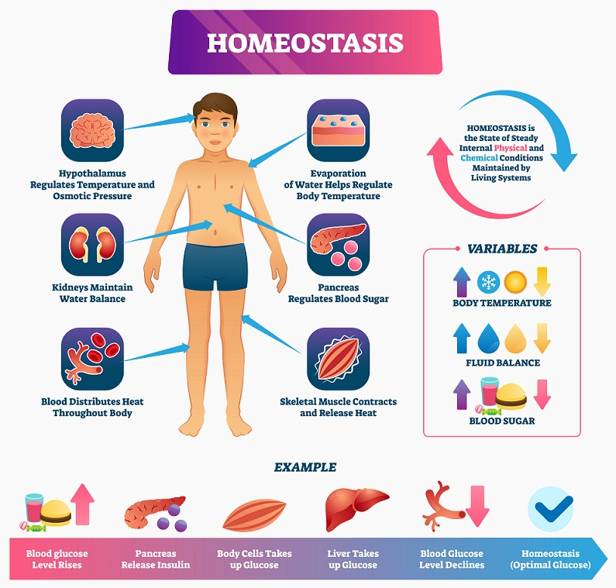

2b. What happens in the body when blood glucose rises.

(1) blood glucose rises, (2) beta cells in the pancreas detect this, (3) insulin is released, (4) insulin signals cells to absorb glucose (via GLUT4 doors), (5) the liver stores extra glucose as glycogen. Blood sugar returns to normal. When you eat, carbohydrates are broken down into glucose, raising blood sugar in response, the pancreas releases insulin and this allows sugar to enter your cells to be used for energy

2c. What happens in the body when blood glucose falls.
(1) blood glucose falls, (2) alpha cells detect this, (3) glucagon is released, (4) the liver breaks down stored glycogen and releases glucose into the blood. Blood sugar returns to normal. When glucose drops due to fasting or exercise, the body changes its metabolism to obtain energy, alternatively during fasting, the drop in insulin and the rise in glucagon, by not entering food, insulin levels drop, and the pancreas secrete glucagon.

2d. How does this system fail in a person with Type 2 diabetes?
The cells stop responding properly to insulin. Blood sugar remains high because glucose cannot enter cells efficiently. Over time, the beta cells may become exhausted from overworking. Link this back to the patient in the case study. Insulin resistance occurs when the body is exposed to too much sugar, by the intake of high doses of sugar a lot of sugar enters the bloodstream the pancreas releases high levels of insulin which is known as resistance, these sugar levels remain high and this causes the pancreas to continue releasing more insulin for the cells to respond, Over time the pancreas cannot keep up with that rhythm and blood sugar levels continue to rise, the liver sends the remaining sugar to the body which stores it as fat which causes weight gain and this is what produces type 2 diabetes, which is what happens with our 48-year-old patient, diet based on refined products, due to this we see the exaggerated weight gain in the last 3 months.

3a. What is cellular respiration.
Aerobic respiration is a biological process break down food molecules, like glucose in the presence of oxygen to release usable chemical energy and produce carbon dioxide and water as by products this highly efficient process power almost all living organisms, the chemical process during aerobic respiration the cells transfer energy from glucose in to molecules of adenosine triphosphate (ATP), which act as the cells energy the overall balance chemical equation is C6H12O6 + 6CO2PLUS 6H2O + ENERGY (ATP).

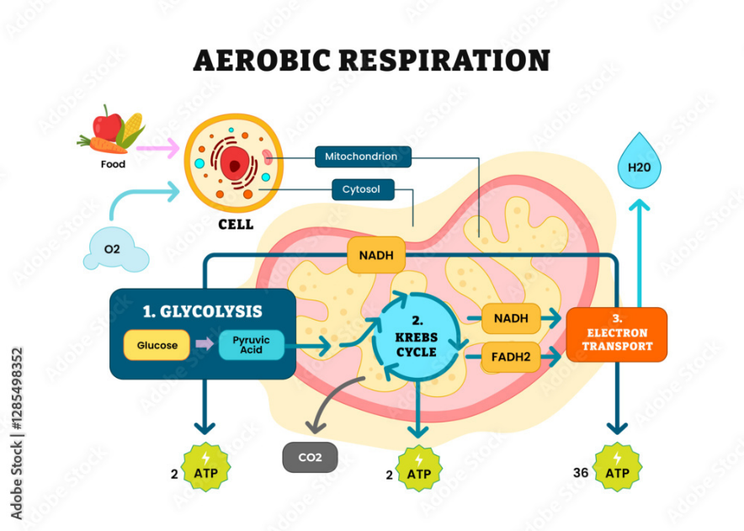
(infoupdate.org and infoupdate.org, 2016)

3b. Briefly describe the main stages of aerobic respiration:
You do not need to give every biochemical detail — focus on inputs, outputs, and where in the cell each stage occurs (cytoplasm vs. mitochondria). How much ATP is produced overall? This metabolic process occurs where cells use oxygen to break down glucose creating energy in the form of ATP, (adenosine triphosphate), they release carbon dioxide and water as waste this mechanism develops in the motochondria of the eukaryotic cell, this process is broken down into 3 parts: glycolysis occurs in the cytoplasm of the cell, where one molecule of glucose splits into two of pyruvic acid generating a small amount of energy 2 of (ATP), in the Krebs cycle this takes place in the mitochondrial matrix, and the respiratory chain of oxidative phosphorylation develops in the inner membrane of the mitochondria,

3c. What (anaerobic respiration).
Briefly cover lactic acid production. Link to complications of poorly controlled diabetes such as diabetic ketoacidosis (DKA) if appropriate. When oxygen is not available in sufficient quantity, the cells change from aerobic to anaerobic respiration to continue producing energy, this mechanism is especially relevant in patients with diabetes mellitus: when glucose levels are so high, blood vessel damage occurs and the oxygen supply to the tissues decreases.

4a. What methods are used to monitor.
Describe at least two monitoring methods, including how they work and what information they provide to the patient and clinician.: to measure blood glucose is done through the glucometer, which is the most common and portable method and the other method is (CGM), it consists of a small sensor that is usually placed on the arm, o abdomen measures the sugar in the interstitial fluid 24 hours a day sends the data to a reader or mobile phone, the information that we are going to give to the patient and the doctor are the results of some of these two monitors, so that they evaluate the case.

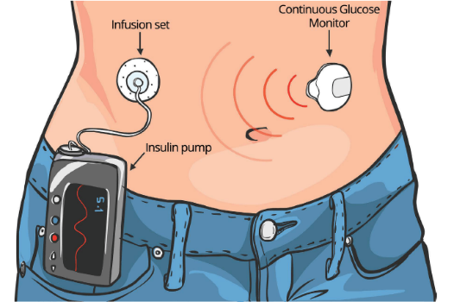

4b. Why is consistent tracking important.
Consider: hypoglycaemia risk, medication adjustments, identifying patterns related to diet/exercise, patient empowerment. Relate back to the case study scenario. The 2 are important and fundamental in Our scenario the patient has type 2 diabetes, constant monitoring feeds and makes the care plan effective, the care plan is the roadmap that is designed by the medical team that aims to keep the disease under control is very important because it defines the glycosylated hemoblobin (HbA1c) goals, It is very necessary for our patient the doses of medication, or insulin, the nutritional plan, the exercise routine.

5a. evidence Type 2 diabetes?
Discuss: low-GI foods, reducing refined carbohydrates/sugars, Mediterranean diet evidence, portion control. Use at least one guideline source (e.g. NICE, Diabetes UK, WHO). Scientific evidence acts and supports glucose control in type 2 diabetes, this control must be individualized and prioritizing a healthy lifestyle, evidence shows that the standard objective is to prevent mycovascular complications, and it must be done and should be done by personalizing each patient, weight loss is fundamental, nutrition strongly supports low-carbohydrate diets and the Mediterranean diet, To achieve a significant reduction we estimate tha almost 6 million people in the UK are living with diabetes the risk factors of type 2 diabetes are multiple and complex they include age, family history and ethnicity , as well as living with overweight or obesity

5b. physical exercise?
Consider: how exercise improves insulin sensitivity, recommended activity levels (e.g. 150 mins/week moderate activity), aerobics vs. resistance training. Scientific evidence says that staying active and exercising regularly helps maintain blood glucose levels 150 minutes of aerobic activity a week such as walking, swimming, or cycling, it is also recommended to maintain a moderate and vigorous intensity when exercising helps reduce the percentage of fat in the body and at the same time increases the quality and quantity of muscle.


5c. impact smoking.
Smoking increases the risk of developing type 2 diabetes by up to 40%, in people already diagnosed smoke and nicotine greatly trigger insulin resistance in this way they raise blood sugar and accelerate the appearance of serious kidney and cardiovascular complications, the increase in insulin resistance present in cigarettes and vapes raise hormones such as cortisol, These hormones have an opposite effect to insulin prevent the body from processing sugar well and signal the liver to release more glucose into the blood, as a nurse practitioner I would offer advice to quit smoking explaining to the patient the benefits in the short and long term, my intervention would be empathetic and understandable focusing on the patient.

6. Conclusion

Type 1 diabetes, and type 2, are diseases that affect the way the body uses glucose, in both cases the exaggerated consumption of carbohydrates is essential for its development, blood sugar levels are fundamental and are the key indicators of this disease, for this reason we must maintain extreme vigilance of these indices, glycolysis is a process by which glucose is transformed into ATP, which is the main source of energy for cells when diabetes is not well controlled, this important process can be altered, for this reason maintaining healthy lifestyle habits are important within these habits are a balanced diet avoiding consumption of refined foods rich in sugar, sugary and carbonated drinks, and industrial pastries, in the same way that smoking is one of the modifiable risk factors for the progressive development of type 2 diabetes (DM2), in the United Kingdom, the National Health Service (NHS), and the National Institute for and Care Excellence (NICE), recognize that quitting smoking is a priority intervention to reduce cardiovascular risk and improve clinical outcomes in people with diabetes. Smoking increases insulin resistance.

6. regulation metabolism.
The key points are, homeostasis which is the conversion of energy to ensure a constant supply to cells especially the brain, and red blood cells, glucagon produced by alpha cells are released during fasting to raise blood sugar stimulating the liver to break down stored glycogen (glycogenolysis)

6 b. monitors.
Monitoring is related, in a positive and constant way, keeping the patient controlled with adequate levels with a healthy lifestyle, daily and constant physical exercise, balanced diet, predominance of vegetables and fruits, always avoiding the consumption of tobacco, and vapes of any kind, all this together with constant and periodic surveillance of your case.

6c. What is your overall message to the patient/reader a diabetes

The control and periodic evaluation of sugar levels are essential for a treatment of this disease, and we must analyze maintaining constant exercise at least 30 minutes a day, a diet based on fruits and vegetables, and lean fat-free meats, avoiding processed products, and sugary drinks,

6. Reference List

American Diabetes Association (2023). American diabetes association. [online] diabetes.org. American Diabetes Association. Available at: https://diabetes.org/ [Accessed 28 July 2026].
American Diabetes Association (2025). Standards of care in diabetes. [online] professional.diabetes.org. Available at: https://professional.diabetes.org/standards-of-care [Accessed 28 July 2026].
CDC (2019). Division of diabetes translation. [online] Center for Disease Control and Prevention. Available at: https://www.cdc.gov/diabetes/index.html [Accessed 28 July 2026].
Diabetes UK (2023). Diabetes UK - know diabetes. fight diabetes. [online] Diabetes UK. Available at: https://www.diabetes.org.uk/ [Accessed 28 July 2026].
infoupdate.org and infoupdate.org (2016). What structure in bacterial cells is the site of Aerobic respiration - infoupdate.org. [online] Infoupdate.org. Available at: https://infoupdate.org/what-structure-in-bacterial-cells-is-the-site-of-aerobic-respiration/ [Accessed 28 July 2026].
NHS (2023). Diabetes. [online] NHS. NHS. Available at: https://www.nhs.uk/conditions/diabetes/ [Accessed 28 July 2026].
NICE (2022). Type 2 diabetes in adults: Management. [online] Nice.org.uk. NICE. Available at: https://www.nice.org.uk/guidance/ng28 [Accessed 28 July 2026].
Office for Health Improvement & Disparities (2025). Diabetes profile: Statistical commentary, march 2025. [online] GOV.UK. Available at: https://www.gov.uk/government/statistics/diabetes-profile-update-march-2025/diabetes-profile-statistical-commentary-march-2025 [Accessed 28 July 2026].
PAHO (2021). Diabetes - PAHO/WHO | Pan American Health Organization. [online] www.paho.org. Available at: https://www.paho.org/es/temas/diabetes [Accessed 28 July 2026].
The Editors of Encyclopedia Britannica (2018). Diabetes mellitus | definition, types, symptoms, & treatment. [online] Encyclopædia Britannica. Available at: https://www.britannica.com/science/diabetes-mellitus [Accessed 28 July 2026].

