ADVANCED INDUSTRY 4.0

Assignment 2: Essay (4500 words)

Module Code: ACPA 7000

Supervisor: Jaymie Phillips

Critical evaluation of manufacturing systems at a strategic level to identify opportunities for new and emerging Industry 4.0 technology enablers, whilst identifying the cultural and workforce factors that may contribute to delivering authentic economic and societal benefit.

28th May 2022

Steve West

Student ID: 2030244

Contents
Introduction 3
Background 3
The Opportunity 4
Main Report 5
The Business Case 5
Applications of Industry 4.0 in Food Production environments 7
Data capture 9
‘Real-Life’ Example 9
Sensors 10
Process Efficiencies 11
Obvious Benefits 16
Less Obvious Benefits 17
Opportunities for Employees 17
Less Obvious Outcomes – Customer 19
Conclusions and Recommendations 19
Business benefits 20
Employee benefits 21
Societal benefits 21
References 21

Introduction

Background

May 2022
Businesses around the world are currently operating in extremely challenging circumstances – a vicious circle caused by many factors, but especially the impacts of very high inflation and, at the same time, severe shortages of staff and skills.

This is reported to be an existential challenge for many businesses, especially SMEs that do not have the financial war chest of much larger businesses. Within the food and drink sector hospitality businesses are particularly concerned, and this will feed through to their supply chain. BigHospitality, a UK trade magazine for the hospitality sector, reported in April 2022 that inflation in Food Service was around double the Consumer Price Index and was extremely volatile with the result that many hospitality businesses could go out of business (McAllister, 2022).

Adding to the difficulties is a breakdown of global supply chain resilience, caused by the coronavirus pandemic and exacerbated by the uncertain geopolitical environment following Russia’s invasion of Ukraine. This is resulting in seismic shifts within the business operating environment, where supply chain efficiencies created by strategies such as ‘just in time’ supply are being replaced by less efficient ‘just in case’ stockpiling strategies.

This case has been building since the Covid pandemic. An article in Forbes in January 2022 – prior to the invasion of Ukraine – discussed that the problems caused by global shipping bottlenecks was already having a significant impact on supply chains and causing disruption to many different types of businesses globally (Shih, 2022).

The recent war in Ukraine is expected to accelerate this shift significantly and cause additional specific supply issues – especially with food products as Ukraine is a major supplier of many agricultural products such as edible oils and grains. For example, it supplied around 12% of wheat, which when added to Russia’s wheat production amount to almost 30% of global wheat production’
This, coupled with the rise in both deglobalisation and interest rates are expected to result in an economic slowdown in many countries.
These changes are having a tremendous impact on business and society confidence as they each grapple with strategies to overcome the challenges.
However, for businesses that are currently ‘low-tech’ (i.e., that have not adopted technology), adopting Industry 4.0 could be a strategy for survival – and be a launching pad for long-term sustainability and prosperity once supply chain normality is restored.

The Opportunity

‘Can the adoption of Industry 4.0 contribute towards solving the challenges facing businesses in 2022 and turn the problems on their head – replacing a vicious circle with a virtuous circle for companies and their workforce?’
This question will be examined in the context of Food businesses based in Wales (Food and Drink is the largest sector within Welsh manufacturing).
Elements to be considered will be sustainability, strengthening business financial foundations and engaging the workforce.

Main Report

The Business Case

In the current climate described above it is clear that low-tech businesses (of all sizes) need to consider ways in which they can improve productivity to overcome labour shortages and the various inflationary challenges they are facing. Improving productivity usually translates into increased capacity, allowing for a degree of future business growth with the same available resources. This increases the business’s financial position generally, but also relative to competitors who are not adopting technology. On the other hand, if competitors are ahead in adopting technology, then there is also a risk of existential threats if low-tech businesses do not adopt technology.
Improving a business’s financial performance improves resilience and therefore aids long-term sustainability, but it could also support alternative business strategies that are perhaps less obvious.
There continues to be a reluctance for SMEs to adopt Industry 4.0 technology, and this does not appear to have significantly changed yet since a study was published in September 2007 in the International Journal of Production Research:
‘Despite the growing number of new tools and technologies, most of them are under-exploited, if not ignored by SMEs.’ (Meouf, et al., 2017)

Traditional thinking usually links improving productivity to lowering costs by reducing staff numbers to realise cost benefits – at least in the short term. This may not always be beneficial in the long term, however, so alternative strategies should be considered when implementing technology.

This report will look at the following alternative strategy:

- Upskill the existing workforce to prepare for new technology introductions (helpful for staff retention).
- Invest in Industry 4.0 technology to increase capacity and efficiency (for example, by replacing inefficient repetitive labour-intensive tasks with automation) – this will free up knowledgeable staff that are currently spending a lot of (unrewarding/boring) time performing the repetitive tasks.
- Utilise the freed-up resources to do more interesting, challenging and rewarding tasks that are currently not being done effectively. (This will also be helpful for both financial performance and staff retention). This can include:
- Continuous Improvement of processes and/or Products
- Product Development
- Training
- ‘Blue-sky thinking’ (think 3M)
- Society/charity/community interventions
- Support the team to implement the ideas they are generating.
- ‘Sell’ the extra production capacity created by both the technology implementation and the implementation of the continuous improvement ideas. (This will improve the company’s financial situation by offsetting the inflationary pressures and will also aid with team retention.)
- Repeat the above – a virtual circle.

Applications of Industry 4.0 in Food Production environments

Within the context of Welsh Food manufacturers, a lot of the processes are generic, so, by means of an example for illustration purposes, the production of baked goods (cakes and traybakes) will be considered to demonstrate the different stages of production/processing.

The following flow chart demonstrates the manufacturing process:
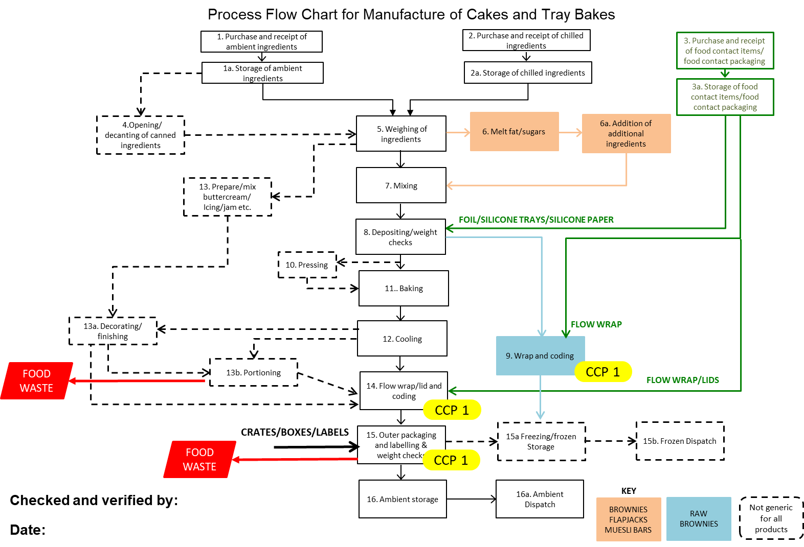
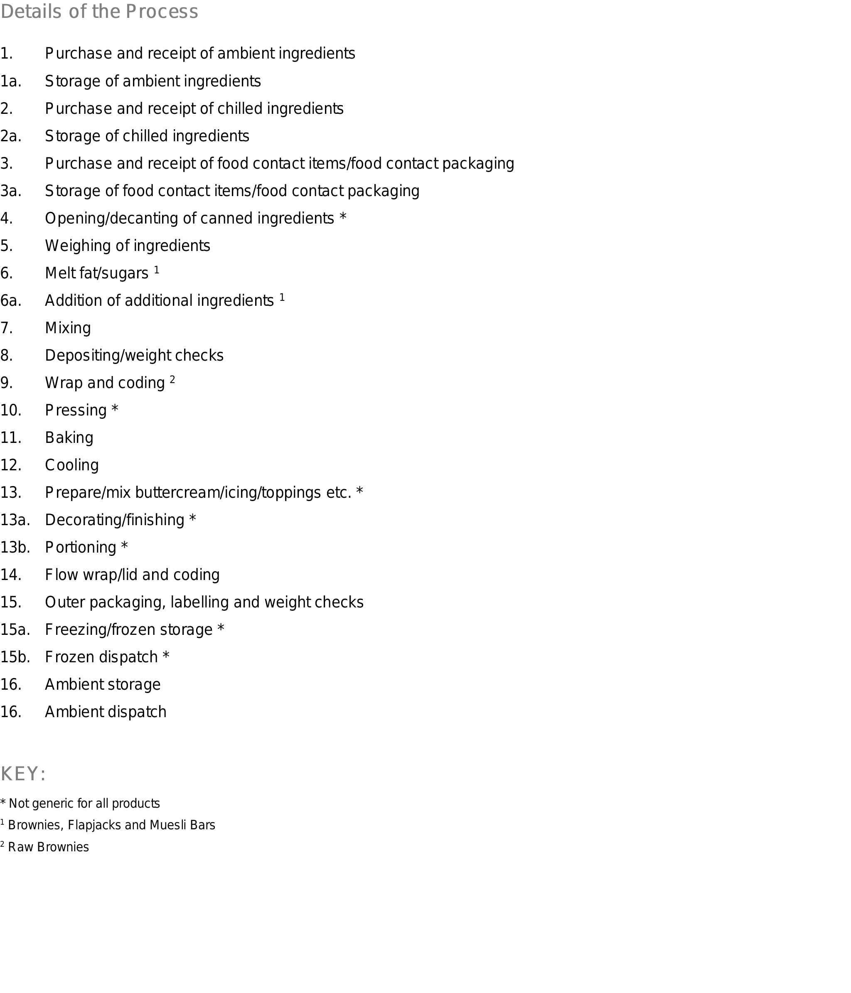

Data capture

The foundation of Industry 4.0 is the collection, analysis and interpretation of real-time data to aid decision making, and ideally make automatic process adjustments in real time to improve process outcomes.
Industry 4.0 technologies can be used to collect data from many types of equipment and conditions and then analyse the data as a whole system to stop or reduce ‘out-of-control’ processes, raise alarms via mobile devices such as smartphones, make small adjustments to optimise processes, provide information to support local and remote decision-making.
It can also be used to understand how input changes are affecting outputs. Many useful articles and guides have been published about the benefits of implementing Industry 4 including being abo to use data to make better informed decisions, and that the advent of cloud computing and smart devices such as smart phones, means it can be accessed remotely from anywhere there is an internet connection (GenPact, 2022).

‘Real-Life’ Example
In the bakery process chart above, step 2a is the storage of chilled ingredients, and one of the daily tasks for these chilled ingredients is to monitor fridge temperatures. These are often monitored manually by having a team member record a temperature reading at regular intervals (every 2 hours would be typical) to ensure the fridge is working correctly and that the stored ingredients are safe to use in food production. This manual process can be replaced by implementing a relatively cheap device for continuously monitoring a fridge temperature and sending an alert via a smart phone if the temperature is out of specification. This significantly improves the effectiveness of the monitoring process as it monitors temperatures 24 hours a day, 365 days a year with zero human intervention when the fridges are operating within specification (as determined by the desired set points – upper and lower limits). If the fridge does become out of specification an alert is raised instantly, which allows the necessary remedial action to take place immediately (this could be adjustment, a reset, or a repair of the fridge. The contents of the fridge could be moved to another fridge (or used in production by changing the production schedule), before the out-of-specification temperature causes them to be scrapped due to food safety concerns.
Automating this data collection and monitoring process frees up the team member’s time, which can be used to work on higher value (usually more interesting) work. For example, some of the freed-up time could be used to analyse the new (significantly more comprehensive) data, and in this actual example it was found that the upper set points on the fridges could be changed from 2 degrees Celsius to 4 degrees Celsius (The specification range is 1 degree to 5 degrees, but the upper limit was set to 2 degrees ‘to be safe’ as the temperatures were only monitored every 2 hours.) This change to the set points resulted in a reduction of electricity consumption, especially during warmer ambient conditions, and a resultant cost saving. In this real example, the SME company concerned has 2 x walk-in fridges and 2 x walk-in freezers, all of which are running 24 hours per day, 365 days per year, so this small change to the set points resulted in an annual saving of £4420 for an investment of approximately £800:

- Time saving: 5 readings per fridge/freezer per day x 312 days per year (the factory runs 6 days per week) x 4 units x 2 minutes = 12,480 minutes per year = 208 hours per year x £15/hr = £3,120 of freed-up labour per year
- Electricity saving by adjusting temperatures estimated at: £200 per fridge/freezer x 4 = £800/year
- Wastage saving (one incident per 2 years, approx. £1000 per incident) £500 of waste ingredient per year. (The company concerned had a freezer fault occur on a Sunday on one occasion. By the time this was realised on the Monday morning £17,000 worth of products had to be disposed of, so £500 per year is a very conservative estimate.)
- Total saving £4,420 per year equates to a 552% annual return on investment (ROI).

If the 208 hours per year that is freed up is used on other continuous improvement ideas, this return could be significantly higher in the long term. This example demonstrates that this type of approach can be extremely effective and it can be used to assess and improve every single process step in a business to achieve very significant financial improvements for the business, and at the same time free up the team members for more interesting and rewarding tasks that will aid employee retention.

Sensors
Many types of sensors are available to collect data, many at low cost. These include sensors for monitoring ambient conditions such as temperatures and humidity, process conditions such as speeds, flow rates, temperatures, vibrations, and system outputs such as quality rates, yield, stoppage times, etc.
Sensors can be added to existing equipment, or data can be collected by connecting to control systems that are already incorporated into equipment where they exist.
Once sensors have been installed and data is being collected, then the data can be analysed and used to identify possible process improvements. When a process change is made, the data will be able to assist in determining whether the change had had a desirable effect on the process outcomes, and if so, to what extent. This will increase the understanding of the relationships between process inputs and outputs and enable a more targeted approach to continuous improvement.

Process Efficiencies

If we consider the bakery process steps in the table referred to earlier, there are lots of opportunities where data could be captured and used to initiate Industry 4.0 continuous improvement ideas and/or improved process control. This would improve efficiencies, quality rates, process times etc and therefore improve both the financial performance of the business and create the time necessary to work on other tasks and/or projects, thereby creating a virtuous circle mentioned earlier.
Each of the separate processes could be improved independently but the data will also enable less obvious relationships between linked processes to be understood and improved.
Here are some potential opportunities in the bakery process steps to indicate some different areas that could be addressed in this way:

1. Purchase and receipt of ambient ingredients
Real-time monitoring of stock control levels using vision systems and/or ultrasonic detectors
Software comparison of actual stock levels to planned production data from an Enterprise Resource Planning (ERP) system
Automatically place purchase orders for required stock
Barcode reading of incoming goods to automatically adjust actual stock levels on system and assist with traceability

1a. Storage of ambient ingredients
Ambient temperature monitoring (and possibly control) to ensure optimal storage conditions
Ambient humidity monitoring (and possibly control) to ensure optimal storage conditions
Automatic ‘first in, first out’ monitoring system to ensure correct stock rotation
Automatic traceability system linked to purchase orders and production schedule

2. Purchase and receipt of chilled ingredients
Real-time monitoring of stock control levels using vision systems and/or ultrasonic detectors
Software comparison of actual stock levels to planned production data from ERP system
Automatically place purchase orders for required stock
Barcode reading of incoming goods to automatically adjust actual stock levels on system and assist with traceability.

2a. Storage of chilled ingredients
Chiller temperature monitoring (and possibly automatic adjustment / control) to ensure optimal storage conditions
Chiller humidity monitoring (and possibly automatic control) to ensure optimal storage conditions
Automatic ‘First In - First Out’ monitoring system to ensure correct stock rotation
Automatic traceability system linked to purchase orders and production schedule

3. Purchase and receipt of food contact items/food contact packaging
Real-time monitoring of stock control levels using vision systems and/or ultrasonic detectors
Software comparison of actual stock levels to planned production data from ERP system
Automatically place purchase orders for required stock
Barcode reading of incoming goods to automatically adjust actual stock levels on system and assist with traceability.

3a. Storage of food contact items/food contact packaging
Ambient temperature monitoring (and possibly control) to ensure optimal storage conditions
Ambient humidity monitoring (and possibly control) to ensure optimal storage conditions
Automatic ‘First in - First out’ monitoring system to ensure correct stock rotation
Automatic traceability system linked to purchase orders and production schedule

4. Opening/decanting of canned ingredients *
n/a

5. Weighing of ingredients
Ingredient barcode readers for traceability of batches
‘Smart scales’ that include a Human Machine Interface, which displays recipes and weighing instructions.
Ingredient weight tolerances before the system allows the next ingredient to be processed.
Data capture of actual ingredient weights for every batch
Eliminate the risk of weighing errors
Eliminate incorrect ingredient selection (e.g. if the wrong grade of flour were selected, the system would highlight this and alarm before it was added to the mix)
Remote throughput measuring
Process time variation capture

6. Melt fat/sugars 1
Automatic temperature monitoring and data capture
Automatic temperature control of melted product to avoid excessive heat
Remote throughput measuring
Process time variation capture
Fault code collection / diagnosis

6a. Addition of additional ingredients 1
Automatic dosing
Remote throughput measuring
Process time variation capture

7. Mixing
Programmable controllers for consistent mixing process
Vibration monitoring for early warning of bearing failure
Bowl level monitoring to indicate correct mixing process is completed
Remote throughput measuring
Process time variation capture
Waiting time capture
Fault code collection / diagnosis

8. Depositing/weight checks
Automatic depositing
Shot weight monitoring
Viscosity measuring
Temperature monitoring and control
Remote throughput measuring
Vibration monitoring for early warning of bearing failure
Process time variation capture
Fault code collection / diagnosis

9. Wrap and coding 2
Automatic temperature monitoring and control
Remote throughput measuring
Vibration monitoring for early warning of bearing failure
Fault code collection / diagnosis
Process time variation capture
Fault code collection / diagnosis

10. Pressing *
Automatic pressing process
Remote throughput measuring
Vibration monitoring for early warning of bearing failure
Process time variation capture
Fault code collection / diagnosis

11. Baking
Automatic temperature monitoring and control
Remote throughput measuring
Vision system to confirm correct bake colour
Process time variation capture
Fault code collection / diagnosis

12. Cooling
Automatic temperature monitoring and control
Remote throughput measuring
Process time variation capture

13. Prepare/mix buttercream/icing/toppings etc. *
Automatic temperature monitoring and control
Remote throughput measuring
Vibration monitoring for early warning of bearing failure
Process time variation capture

13a. Decorating/finishing *
Automatic temperature monitoring and control
Remote throughput measuring
Process time variation capture
Vision system to confirm accuracy
Automated application
Fault code collection / diagnosis

13b. Portioning *
Automatic portioning
Vibration monitoring for early warning of bearing failure
Process time variation capture
Vision system to confirm accuracy
Automated application
Remote throughput measuring
Fault code collection / diagnosis

14. Flow wrap/lid and coding
Automatic temperature monitoring and control
Vibration monitoring for early warning of bearing failure
Process time variation capture
Vision system to confirm accuracy
Automated application

15. Outer packaging, labelling and weight checks

15a. Freezing/frozen storage *
Automatic temperature monitoring and control

15b. Frozen dispatch *
Automatic temperature monitoring and control

16. Ambient storage
Automatic temperature monitoring and control

16a. Ambient dispatch
Automatic temperature monitoring and control

It can be seen that the potential application of Industry 4.0 technology is very significant and could have a remarkable impact on the business. A lot of the methodologies are low cost so the se can be adopted initially, and then the cost benefits derived from them can be used to ward capital investment applications over a period. The assessment of the benefits and the use of data also allows business cases to be derived where external investment could be utilised top speed up the implementation of Industry 4.0 technology.

Obvious Benefits

As outlined earlier, several benefits of this approach are quite obvious, and these are usually used as the basis of the justification for such approaches (and would normally be used as the key performance indicators (KPIs) to measure the success or otherwise of these types of projects):

- Capacity Increases
- Productivity
- Quality Improvement/Consistency
- ROI Improvements

These benefits combine to improve the financial performance of the business and therefore overall competitiveness and long-term sustainability, so are very useful and widely used KPIs.

Mamad Mohamad, in an article published in the International Journal of supply and Operations Management in August 2018 concluded that:
‘some clear benefits can be identified from the implementation of Industry 4.0 as flexibility, quality standards, efficiency, and so on. Hence, this will allow companies to meet customers’ demands, creating values. Nevertheless, the majority of companies are hesitant to begin their digital transformation processes due to serious implementation barriers that include uncertainties about financial benefits and a lack of specialist knowledge.’ (Mohamed, 2018)

This further reinforces that the benefits are definitely real, but that businesses are in many cases still holding back implementing so must be encouraged to learn more about the opportunities to create the confidence to invest and implement Industry 4.0.

Less Obvious Benefits

However, some less obvious benefits will be considered below, as these also have a very significant impact on the long-term success of the business and are very often overlooked. The typical response to improving efficiency is to reduce the cost, by reducing the work force and improving profitability.

This approach will not ‘unlock’ the maximum benefits to the business, however, and can be self-defeating in the first place – if the workforce believes the outcome of implementing improvements is that they will lose their jobs, they will hardly be incentivised to ‘buy-in’ to the changes and are more likely to resist them. It will therefore be a lot more difficult to engage them in implementing the improvements and very likely that the expected ROI will not be achieved, or at the very best it will take significantly longer to achieve and be a long and painful process. During this time competitors who have a different (more effective) approach could strengthen their position.

If the emphasis of the project is actually to free up valuable human resources from low-skill, repetitive tasks to allow them to work on other tasks such as those below, then the efficiencies gained by implementing Industry 4.0 can be compounded over time to achieve a significantly more advantageous outcome.

Opportunities for Employees

Improved financial performance and stability, coupled with the freeing up of time could enable the company to offer improved terms and conditions to staff that would enable them to retain, recruit and develop team members. This will further enhance the performance of the business. The following list is an indication of the sort of opportunities that could be offered to new and existing team members:

- ‘Better’/more interesting and rewarding jobs
- Fulfilment - MASLOW
- Training
- For work-related tasks, but also for other skills, the employee may wish to develop that are not obviously or directly associated with their work.
- Continuous Improvement
- Empowering and involving employees in process design and development will enable the business to harness the skills and knowledge of the work force in a positive way to improve existing processes, products, procedures.
- Product Development
- Innovation time – 3M
- Employees could be allocated several days per year as a reward and recognition programme for innovation time. This would intellectually stimulate employees and lead to new ideas being generated for products and processes.
- Social Responsibility opportunities – helping the community
- Employees could be allocated several days per year as a reward and recognition programme for offsite community days that would enhance their wellbeing. This would also enhance the business’s reputation. This could include volunteering at local charities or community events.
- Offsite days
- Employees could be allocated several days per year as a reward and recognition programme for offsite days that would enhance their knowledge and loyalty. This could include trade shows, customer visits, factory tours, etc.
- Improved Conditions
- Improved financial performance and stability may also allow for an increase in pay and/or a shorter working week or more holidays.

The benefits to employees can be understood by looking at Maslow’s hierarchy of needs. The lower 2 levels are basic needs and being employed helps to support theses needs by providing the resources (money) necessary for food, shelter, warmth, and safety. Any means of income would provide for this as long as the level of income is sufficient. The first of the psychological needs are met by family and friends, and friendships are often accomplished in a work environment at least to some extent. The top two layers of the pyramid are what makes life fulfilling (rather than just bearable or survivable). A lot of the benefits outlined above will help with meeting these needs, so if we concentrate on ways in which the workplace can support these needs it will lead to a fulfilled and happier workforce that will be more stable and will attract high calibre people in the future.

MASLOW’S HIERARCHY OF NEEDS (Wikipedia, 2022)
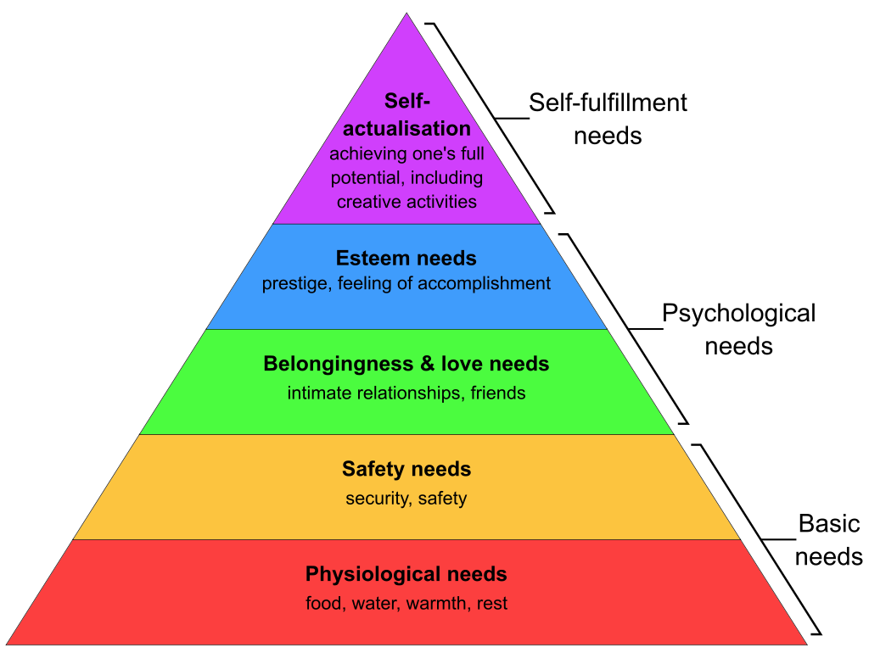

Less Obvious Outcomes – Customer

The business and the employees will gain benefits from the above approach as outlined above. However, this culture change will also have an impact on existing and potential customers as well – gaining customer confidence will make it easier to open up new markets, develop new products, and deliver the products on time in full, because the engaged workforce will have a much better understanding of their processes and the limitations, and have the time to be more effective at onboarding new customers, ‘looking after’ customers, problem solving etc.
Customers will value the company ethos and values, so this also makes good business sense. People like to be associated with companies that demonstrate stronger social responsibility.

Conclusions and Recommendations

The successful and effective implementation of techniques and technologies such as Industry 4.0 is already proven to support significant business improvements in all typical KPIs. Efficiencies will improve, waste will be reduced, capacity will improve, costs will reduce. In many cases this does not require huge investment, so it is recommended that a small pilot project is implemented initially – mainly to introduce the workforce to the techniques but also to share the vision that it is not all about reducing labour. The following steps are recommended:

- Develop and communicate the vision.
- Lead by example.
- Create a small cross functional team for the pilot introduction.
- Train the team with an emphasis on identifying low-cost solutions (such as the fridge temperature monitoring mentioned earlier).
- Do a Gemba process walk, observe, and ask questions.
- Implement cost effective ways to collect and analyse the data.
- Identify potential pilot areas/projects.
- Use the data to decide which project should be the pilot area.
- The pilot project/area does not have to be the one that has the biggest financial impact – it should be something that will be very visible to the whole organisation and provide visible ‘wins’ to the team.
- Support the team to implement the pilot project.
- Share and celebrate the successes.
- At the earliest opportunity, ‘invest’ the time that has been freed up in tasks that will motivate the whole team.
- Form teams to roll out the process gradually across the business.
- Gradually implement higher value investments as the roll out progresses.
- Remember that this is a culture change, so it will take time, and not everything will work first time.

Business benefits

The business will benefit in many ways. It will benefit indirectly from the benefits that are enjoyed by employees, customers, and the local communities/society.

Direct benefits to the business that can be directly measured include increased profit potential due to improved margins created by increased productivity and efficiency. Process variation will reduce which will in turn reduce waste/scrap. As product consistency improves, there will be less time required to be spent on ‘firefighting’ as there will be fewer problems to manage on a day-to-day basis. Any problems that do require firefighting will be seen as being opportunities to apply continuous improvement and make further improvements.

Additional time spent on product development and blue-sky thinking will result in improved products and help keep ahead of the competition in relation to trends.

Employee benefits

Employees will have more interesting and fulfilling work and the opportunity to learn new skills. They will have more connection and pride in their workplace, which will improve morale. They will be able to contribute to the local community, which will help with personal wellbeing and satisfaction. The business will be able to improve conditions for the workforce through a combination of reduced working hours and/or increased pay.

Societal benefits

It is good business practice and part of the responsibility of business to provide a contribution to society beyond employing people and providing goods and services. Allocating resources for societal benefits makes good business sense as it enhances the company’s reputation and strengthens the brand.

References

GenPact, 2022. Your guide to Industry 4.0: How data anaytics and cloud technologies are enabling the factory of the future. [Online]
Available at: https://www.genpact.com/insight/point-of-view/your-guide-to-industry-4-0-how-data-analytics-and-cloud-technologies-are-enabling-the-factory-of-the-future
[Accessed 24 May 2022].
McAllister, J., 2022. Big Hospitality. [Online]
Available at: https://www.bighospitality.co.uk/Article/2022/04/12/Cost-pressures-intensify-after-foodservice-price-inflation-hits-double-digits-in-February#:~:text=Hospitality%20businesses%20face%20'existential%20threat,price%20inflation%20hits%20double%20digits&text=Y
[Accessed 26 May 2022].
Meouf, A. et al., 2017. The industrial managment of SMEs in the era of Industry 4.0. International Journal of Production Research, 56(3), pp. 1118-1136.
Mohamed, M., 2018. Challenges and Benefits of Industry 4.0: an overview. International Journal of Supply and Operations Management, 5(3), pp. 256-265.
Shih, W., 2022. Forbes. [Online]
Available at: https://www.forbes.com/sites/willyshih/2022/01/30/from-just-in-time-to-just-in-case-is-excess-and-obsolete-next/?sh=73fb47ff4daf
[Accessed 26 May 2022].
Wikipedia, 2022. Maslow's hierarchy of needs. [Online]
Available at: https://en.wikipedia.org/wiki/Maslow's_hierarchy_of_needs
[Accessed 25 May 2022].

