Changemakers
Assignment 2: E-Portfolio
Jacob Smelt (2215291) – Beng2-PT embedded electronics systems

Contents
E-Portfolio for assignment 2 2
Link 2
Home Page 2
Task 1 - Q1 2
Task 1 - Q2 3
Task 2 3
Task 3 4
References 5
Screenshots of unit completion 5

E-Portfolio for assignment 2

Link
https://sites.google.com/view/changemakers-assignment-2-js/home

Home Page
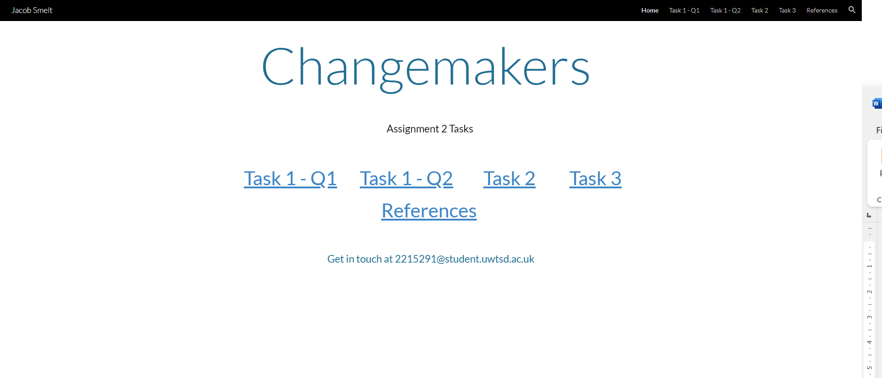

Task 1 - Q1
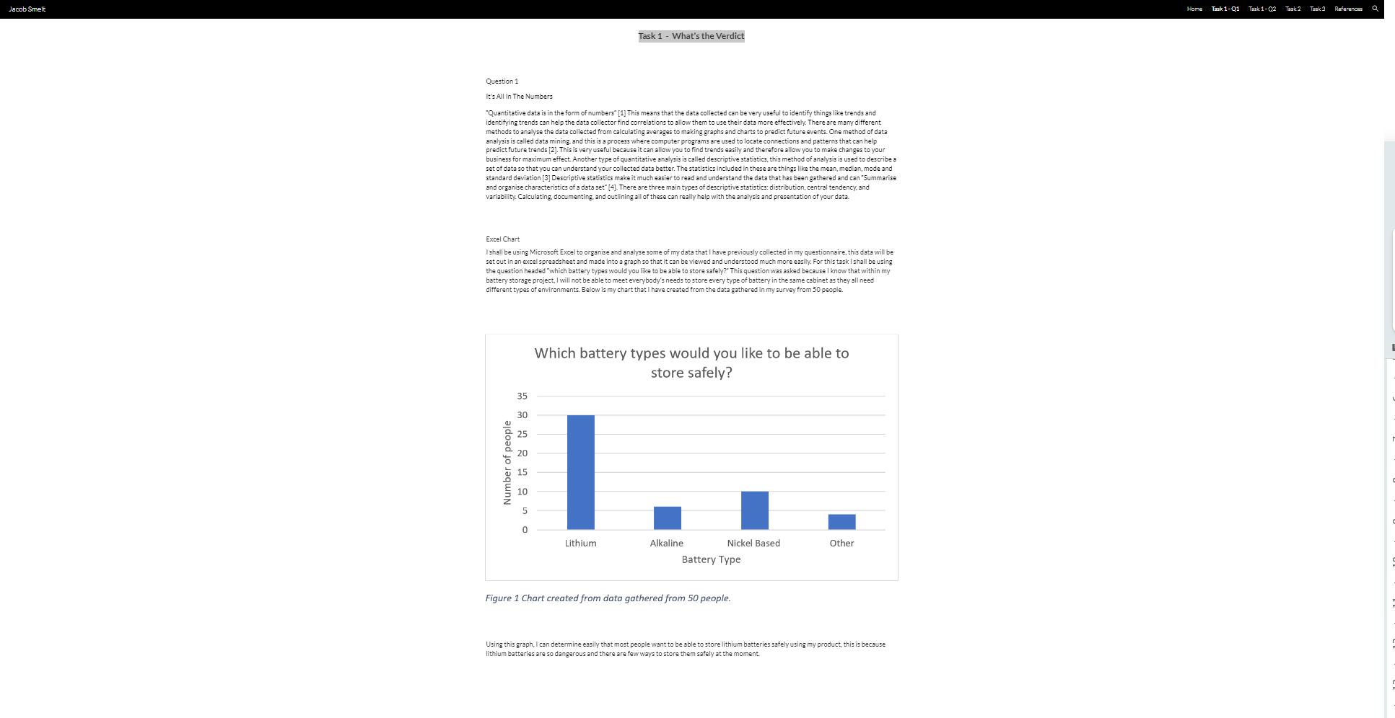

Task 1 - Q2
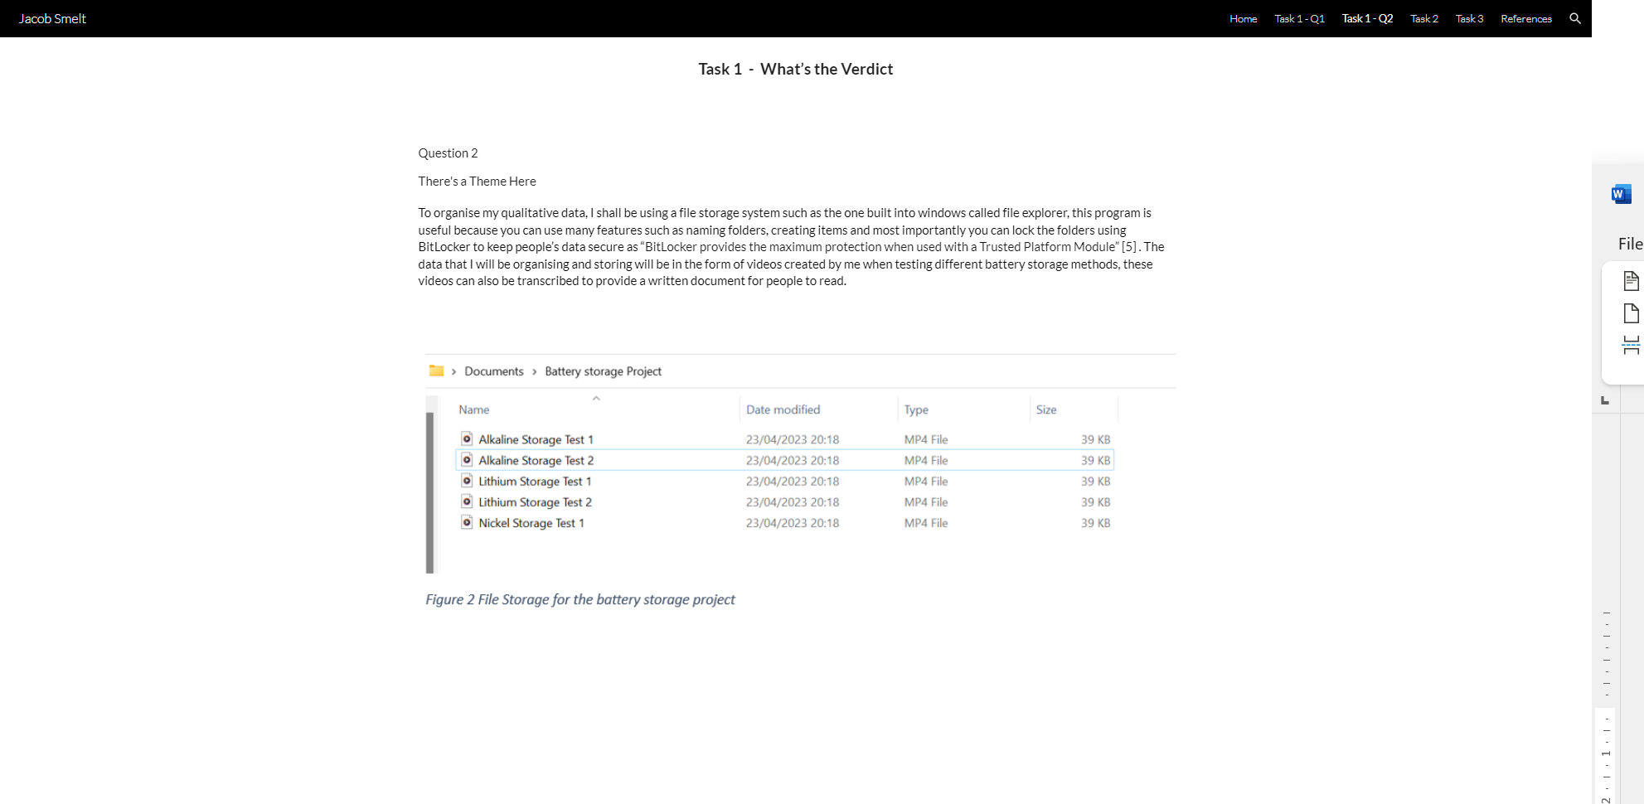

Task 2
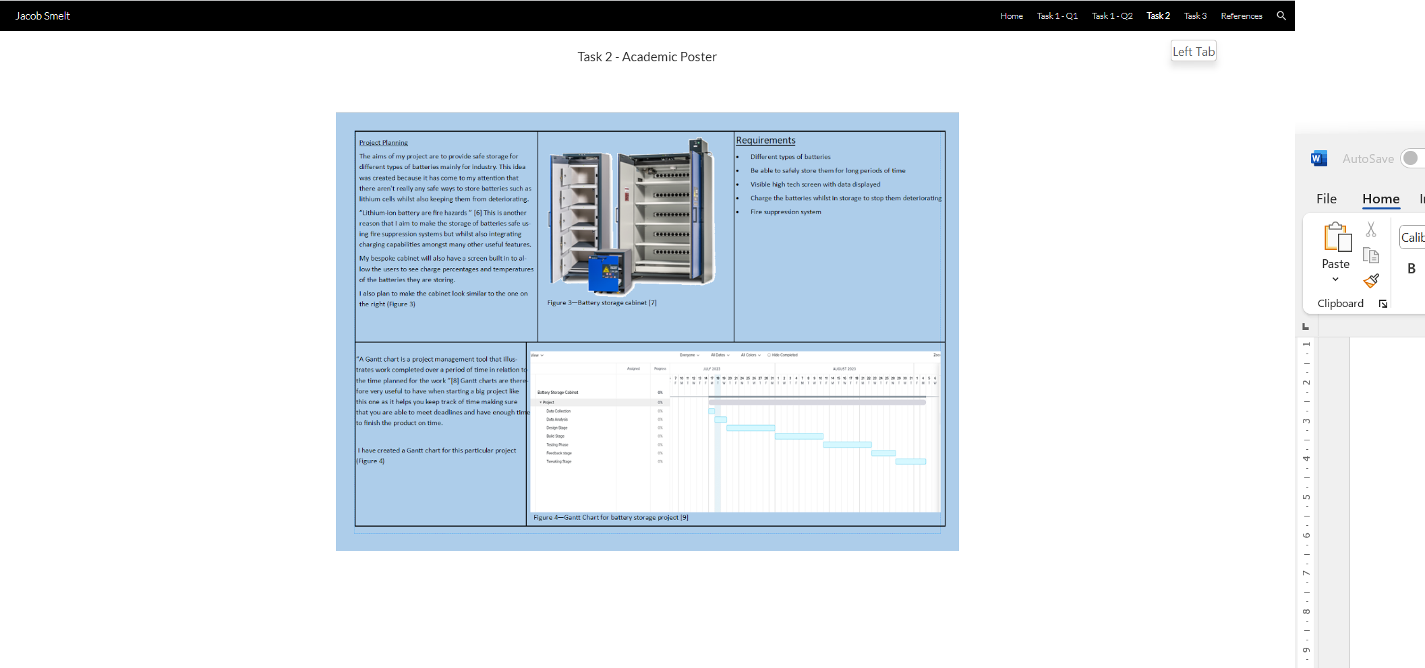

Task 3
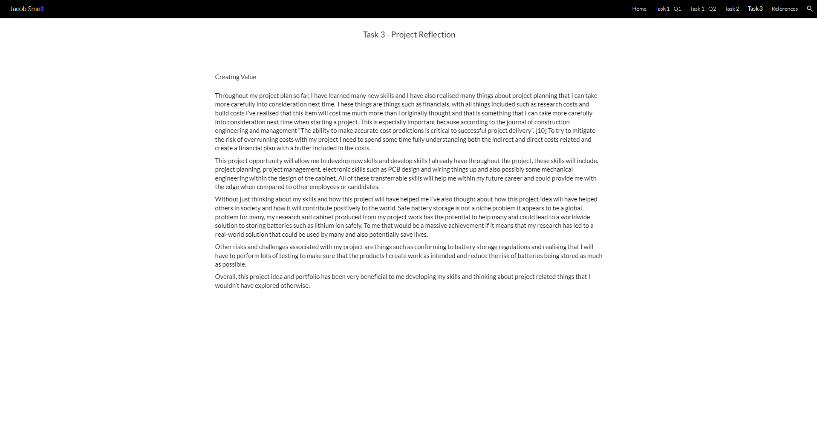

References
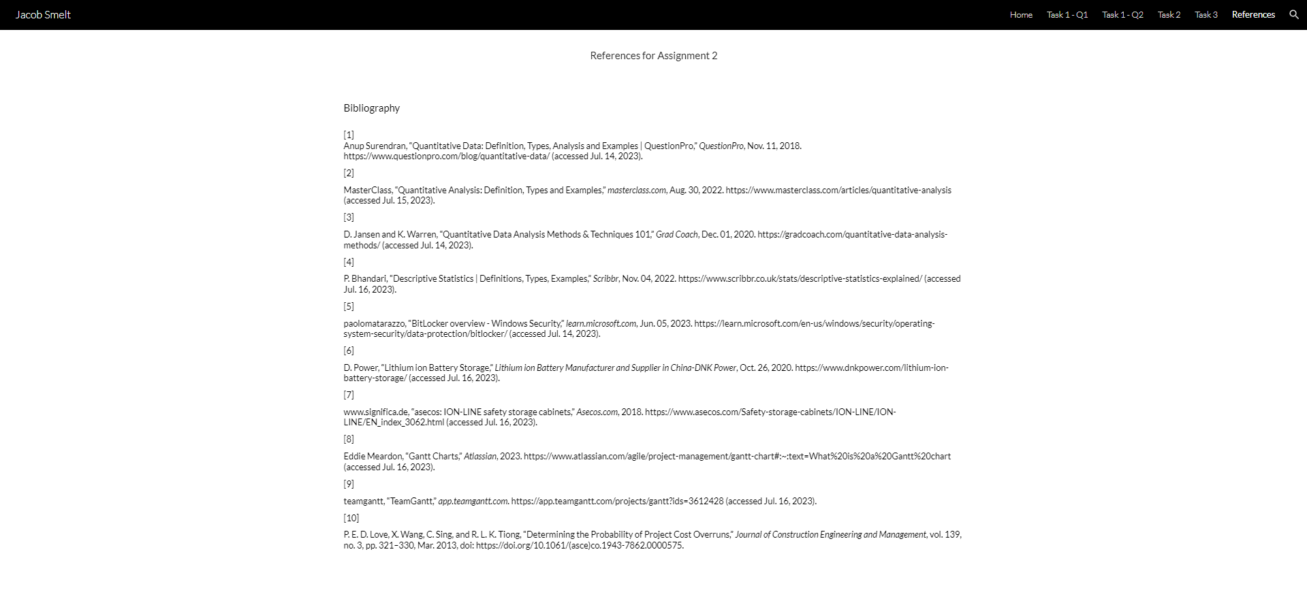

Screenshots of unit completion



