

Assessment 1 – Reading Task Template
PART 1: Upload your photo of your A3
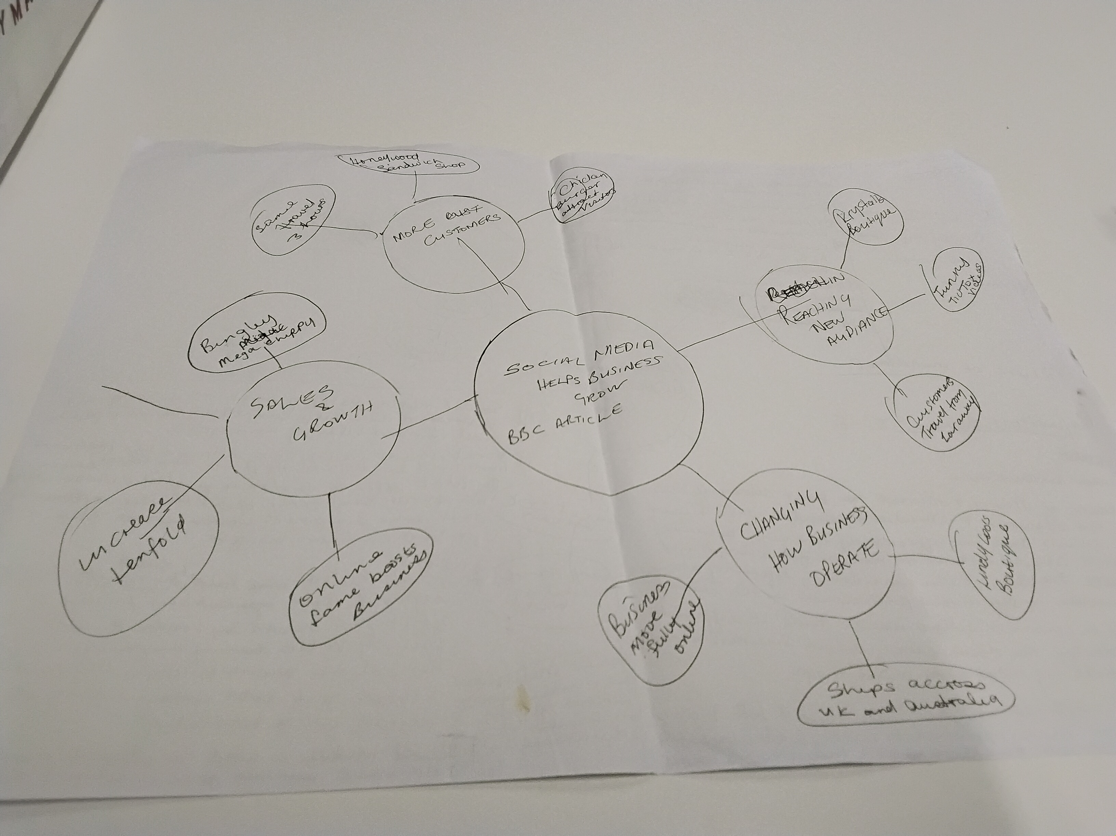
PART 2:
- Answer every question below in 1-3 full sentences.
- Use your own words. Do not use generative AI to answer these questions.
- Include a specific detail from the text when asked.
REMINDER
- The main idea is the overall message of the whole text.
- A key point helps to explain the main idea.
- A specific detail or example from the text shows that the key point is true.

- What is the main idea of the whole text?
The main text is about how social media platforms such as tic tok and instragram can help bunsiness grow and become popular

- What is one key point that supports the main idea, and which specific example from the text shows this?
One of the key point that supports the main idea is that viral social media can attract customers. Specifically Honywood Sandwich shop in Basildon became popular after a customer posted a video about the shop. The owner Mutrat Mutlu said some customers travelled up to 3 hours for his chicken burger.

- What is a different key point that supports the main idea, and which specific example from the text shows this?
A different key point that supports the main idea is how social media helped small businesses change and expand their operation and also the way they operate. Specific example is Lindy Loo Boutique owned by Linda Hunter started posting video during the pandemic growing her online business when her market stall closed down. She sold clothes online to customers across the UK and Australia.

- Which part of the text do you think is most important, and why?
The part of the text which I think is most important is how social media is used as a marketing tool without relying on traditional advertising. Businesses use Social Media help them grow and increasing their sales.

Reflection:
- What did you find difficult in this task (including in-class components), and why was it difficult?
What I found difficult about this task is managing the learning portal due to the fact that I missed the first week and in week 2 class I was so unwell. I tried to work with a peer but I could neither concentrate or focus on anything and come week 3 I was still trying to figure out how to complete and submit this assessment.

- What helped you with this difficulty, and how did it help you?
What has helped me with this difficulty is going to see student success. I got assistance with getting me really started with how manage my learning space and good support managing my lack of laptop. I was taken to the IT department got my device set up and was shown how to loan computers.

