Image Classification Using Artificial Neural Networks
Student Name- Teja Vamsi Devalla
Student ID- 2505092
Module- Application of Machine Learning
Module Code-ACCA7025
Lecturer- Mark Huntly

Abstract
This study is about image classification by CNN in CIFAR-10 dataset. Preprocess data, build the CNN model, evaluate the performance by using TensorFlow and scikit-learn. Classification accuracy and lower overfitting by tuning hyperparameters and results indicate that CNN efficiently captured spatial features and obtained strong performance showing its suitability for image classification.

1.Introduction
Artificial Neural Networks are the deep learning models build to learn from data and recognise patterns. The functioning and structure were inspired from human brains just like neurons transfer signals, the network transfer the data from one layer to another layer to learn patterns. An ANN contains an input layer which receives data, hidden layer to learn pattern, relation from data and output layer for final predictions. The neural network adjusts weights during training to improve the prediction accuracy. By using neural networks in deep learning can solve image recognition, language processing and many complex problems. Image classification is a technique with computer vision which allows to recognise and label shapes, people or any structures in the images. By analysing visual features like colours, size, shape and textures to categorise the images into predefined labels. These techniques significant because it recognises visuals automatically with high accuracy. Self-driving cars use the same technique to classify the pedestrians, roads, traffic signs and lines. In medical imaging, it helps to detect diseases from scans and X-rays, used for smart farming in agriculture to detect plant diseases, monitoring crop and counting fruits and in image recognition neural networks tag photos in social media, detects dogs, cats and car from the image. Convolutional Neural Networks (CNN) use convolution layers to detect features like edges, shapes, size and texture of image[1]. A layer called pooling will reduce the data size without compromising important features and completely connected layer generate the final prediction. Recurrent Neural Network (RNN) is used to process the sequential data, and it contains memory capabilities that enables previous information to effect present output. These are widely used in natural language processing and time- series predictions[2]. RNN is not for classification of images because it requires analysing spatial feature over sequential processing. The main aim of this study is to develop an image classifier using neural networks on CIFAR-10 dataset. To achieve the aim, review the literature in artificial neural networks and clearly state the use cases of convolutional and recurrent neural networks and analyse the image classification techniques. Then build a CNN model and tune the hyperparameters. Finaly evaluate the image classification neural network performance. In this study, section 2 is literature review of neural networks and use case of CNN and RNN, section 3 is methodology of the building CNN classifier for CIFAR-10, then results are discussed in section 4 followed by discussion and conclusion section.

2.Literature Review

2.1 Artificial Neural Networks
Artificial Neural Networks are made up of nodes in different layers are connected to form a network which looks like human brain. The main components of ANN architecture are nodes, input layer, hidden layers and output layer. Each layer contains nodes, and every node receives input and applied weighted sum and add bias then passes the result through activation function which gives non-linear nature to the network. The input layer just receives the data and passes it forward to hidden layer where the learning happens and it has many layers. Then final layer produces the output, if the classification is binary then the network has 1 neuron in output layer, or if it is multiclass then each class have each node in output layer. In the neural network, every connection between nodes contains weight which tell how much effect it carries to next node, and each neuron has its bias value which effects the activation threshold. By using loss function, network adjust weights in training through backpropagation[3].

2.2 Convolutional Neural Networks
Convolutional Neural Networks are a special purpose networks particularly designed to process image and spatial data. In convolutional operation key patterns like edges, textures and shapes are detected in image by using filters. These filters generate feature maps that highlights where the network find patterns in multiple parts of the images. To reduce the spatial dimensions of these maps, pooling layers are used to reduce computational complexity without loosing important information. Then flattening changes, the obtained feature maps into one dimensional vector. These vectors are fed into deep layers to get the prediction output. CNN can automatically retrieve the spatial features without any feature engineering. They use a smaller number of parameters due to weight sharing in convolutional layers, making them computationally fast and less likely to overfit. Moreover, CNN can learn spatial hierarchies efficiently, allows better capturing of image patterns and structures. Several CNN architectures like LeNet for handwritten digit recognition, VGG with smaller filters, AlexNet for classifying wide scale images are performed well in spatial data[4].

2.3 Recurrent Neural Networks
Recurrent Neural Networks are a special purpose networks particularly designed for sequential learning, where the data is computed in a sequential order but not independently. In the contrast of traditional neural networks, RNN use hidden state to store information from previous state, it allows a memory mechanism that captures sequential dependencies. This memory architecture enables network to capture relations over time, making RNN particularly strong for time-based and sequential data. Applications which use ordered data like speech recognition that uses audio sequences to analyse and to identify spoken words RNN achieves better results. In Natural language processing, RNN supports in operations like language translation, sentiment analysis and text prediction by recognising contextual patterns between words. And commonly used in time series forecasting like whether analysis and stock market predictions where past data effects present predictions[5]. Still, RNN is not ideal for CIFAR-10 image classification because images mainly involve spatial feature extraction but not sequential processing. CNN is better for learning spatial hierarchies, texture and edges though convolutional process. Furthermore, RNN faces high computational cost and vanishing gradient problems while dealing with large image data. So, CNN is a suitable neural network for image classification task.

2.4 Hyperparameter Optimisation
Hyperparameter optimisation is crucial for enhancing the performance and stability of neural networks. The learning rate determines how fast the model updates it weights while training. High learning rate may cause inconsistent training, whereas a low value will reduce convergence speed. Batch size controls the number of samples processed before updating weights of the model and it influence on memory size and stability of training. To deactivate neurons during training dropout is used it helps to minimise overfitting and enhance generalisation. Different optimisers like Adam, SGD and RMSProp also affect the performance that Adam supports quicker convergence, adaptive learning rate, SGD allows consistent learning with improved generalisation and RMSProp is effective for sequential and time series data[6].

2.5 Evaluation Metrics
Evaluation metrics are used to analyse the performance of the deep learning models. Accuracy calculates the overall percentage of correct predictions made by the model, how many predicted positive values are actually correct tells by precision, where recall calculates the model’s capability to detect actual positive cases. F1-score is the hormonic mean of precision and recall, it gives a balanced evaluation when handling imbalanced datasets. A confusion matrix provides an overview of predictions by representing correct and incorrect classification among different classes. Loss curves show how training and validation loss vary over epochs, supports to identify model learning performance, overfitting, underfitting and convergence. By using these metrics, can evaluate performance of the neural network.

3.Methodology

3.1 Development Environment
Python is used to build neural network because it allows model development, visualisation. TensorFlow and Keras are used to build and train deep learning models such as CNN, RNN as they enable effective neural network development and better GPU usage. Scikit-learn is used for pre-processing, data splitting and evaluation metrics. NumPy allows fast numerical calculations and matrix functions required for training network. Matplotlib is used for visualising the performance of the classifier and Google Colab is selected as it allows to use free GPU which is major requirement for neural networks.

3.2 Dataset Description (CIFAR-10)
In this research, to classify images CIFAR-10 dataset is used and it contains 60,000 colour images divided into 10 different classes. This dataset is balanced with 6000 images in each class. The size of each image is 32*32 pixels with three colour layers (RGB). The dataset is divided into train and test datasets where training dataset has 50,000 images and test dataset has 10,000 images. The training set is used to train the neural network and test dataset is used to predict the classification on unseen data. CIFAR-10 is most used dataset in deep learning and spatial vision research. The class labels in CIFAR-10 are Airplane, Automobile, Bird, Cat, Deer, Dog, Frog, Horse, Ship, Truck.

3.3 Data Preprocessing
CIFAR-10 image dataset is pre-processed by using keras’s image data generator and make sure all the images are in 32*32 pixels and in RGB colour mode to maintain same consistency though out the dataset. Normalisation is done by rescaling pixel values from [0,255] to [0,1] by dividing by 255 so stabling gradient updates and speed up model convergence. Data augmentation was applied exclusively to training set to improve generalisation and reduce overfitting. The augmentation techniques included random rotation up to 15’ width and height shift up to 10% of image dimensions and horizontal flipping. The training data was further split using a 90/10 training validation split that is validation_split=0.1 yielding 45,000 training images and 5,000 validation images across 10 classes. Training batches were shuffled, and validation batches were kept for consistent evaluation.

3.4 proposed CNN Architecture
Convolutional Neural Network architecture is designed to classify images in CIFAR-10 dataset. The model is designed to automatically extract important features and predict category of the image. The architecture begins with an input layer of size 32*32*3, it will accept RGB colour image from the dataset, this is the layer though which the images are pass to into the neural networks for extracting features. The model contains multiple Convolutional Layers with 32, 64 and 128 filters to detect important visual patterns like objects, shapes, edges and texture. 3*3 filters are used to capture detailed local features effectively while reducing computational complexity. After each convolution operation, the activation function called Rectified Linear Unit is applied to bring nonlinearity to the model and allow CNN to capture complex image patterns effectively and to reduce the vanishing gradient problem. The architecture also includes batch normalisation layers that stabilise and speed up training by normalising feature values between layers. Max pooling layers down sample the spatial dimensions of feature maps, it improves computational efficiency and allows model to focus on important features while reducing overfitting[7]. Throughout the network, multiple dropout layers with values between 0.25 and 0.50 are used, dropout randomly disables neurons during training. A global average pooling layer changes feature maps into o compact representation before classification. Then a dense layer with 128 neurons learning high-level image representation. At last, the SoftMax output layer contains 10 neurons corresponding to the ten classes, SoftMax converts output into probability values by enabling the model to predict the probable class[8].
Architecture-
Input layer -> conv2D (32) + ReLU -> batch normalisation -> conv2D (32) + ReLU -> max pooling -> dropout (0.25) -> conv2D (64) + ReLU -> max pooling -> dropout (0.03) -> conv2D (128) + ReLU -> max pooling -> dropout (0.40) -> global average pooling -> dense layer (128) + ReLU -> dropout (0.50) -> SoftMax output layer .

3.5 Training Process
The CNN model was trained using multiple epochs, batch processing and optimisation techniques to enhance image classification performance on the dataset. An epoch indicates one complete pass of the training dataset through the model. Multiple epochs were used to the network could gradually learn image feature and improve prediction accuracy over time. During training, dataset was divided into smaller groups by batch size, this reduces memory utilisation and speed up computation while maintaining stable learning. The Adam optimiser was used to combine fast convergence and adaptive learning, making it highly effective for CNN training the learning rate controls how much model wights are updated after each cycle. A small learning rate was chosen to support stable learning and avoid instability in performance[9]. The model used categorical cross entropy loss function which is appropriate for multiple class classification problems. A validation split was also applied to evaluate model performance in training and prevent overfitting.

3.6 Hyperparameter Tuning
Various hyperparameter trails are executed on the data using different learning rates, batch sizes and dropout values. High learning rates led to unstable training whereas smaller learning rates increased accuracy and stability. Smaller batch sizes enhanced generalisation but increased training time, while larger batches trained faster but low accuracy. Multiple dropout values were evaluated to reduce overfitting. High value dropout improved validation performance by limiting the model from depending on individual neurons[10].

3.7 Evaluation methods
Accuracy was used to calculate the percentage of correctly classified images where higher accuracy showed better model performance. A confusion matrix analysed correct and incorrect predications for each class, helping to identify difficult categories. Across epochs, loss graph and validation accuracy controls overfitting, generalisation to new data and training stability[4].

4.Results
The CNN model produced high performing results in image classification on CIFAR-10. Training and validation accuracy graphs showed consistent improvement during epochs and loss graph shows stable learning along with reduced overfitting. Final evaluation metrics contains accuracy, precision, recall and F!-score ensured consistent model performance for all class labels. Confusion matrix tells that model got little bit confused between cats and dogs but overall, it classified correctly. And 0.001 learning rate generated highest accuracy than 0.01 and 0.0001.
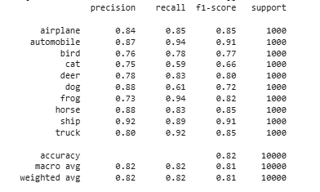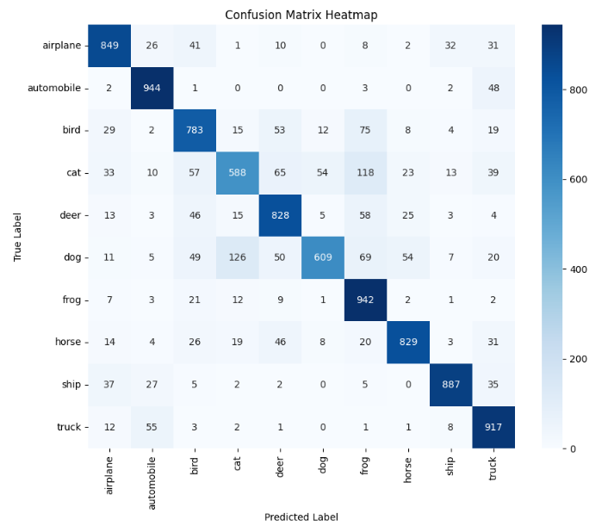

5.Discussion
CNN achieved better results because convolutional layers effectively extracted spatial features and learned patterns from the dataset. Sharing model parameters minimised computational complexity and improved generalisation. Dropout and regularisation helped to minimise overfitting and validation accuracy achieved consistent learning. In further studies, focus on transfer learning and better GPU optimisation.

6.Conclusion
So, CNN is suitable for classification of images from CIFAR-10 by obtaining high accuracy and performance metrics. Preprocessing, model training, evaluation and optimisation were successfully achieved. Performance is increased by hyperparameter tuning. In future work transfer learning and advanced architectures can improve prediction performance.
Screen Recording 2026-05-17 at 23.49.48.mov

References
[1] X. Zhao et al, "A review of convolutional neural networks in computer vision," Artif. Intell. Rev., vol. 57, (4), pp. 99, 2024. . DOI: 10.1007/s10462-024-10721-6.
[2] I. D. Mienye, T. G. Swart and G. Obaido, "Recurrent Neural Networks: A Comprehensive Review of Architectures, Variants, and Applications," Information (Basel), vol. 15, (9), pp. 517, 2024. . DOI: 10.3390/info15090517.
[3] H. Abdel-Jaber et al, "A Review of Deep Learning Algorithms and Their Applications in Healthcare," Algorithms, vol. 15, (2), pp. 71, 2022. . DOI: 10.3390/a15020071.
[4] K. Urazoe et al, "Combination of Convolutional Neural Network Architecture and its Learning Method for Rotation‐Invariant Handwritten Digit Recognition," IEEJ Transactions on Electrical and Electronic Engineering, vol. 16, (1), pp. 161–163, 2021. . DOI: 10.1002/tee.23278.
[5] S. Capobianco et al, "Deep Learning Methods for Vessel Trajectory Prediction Based on Recurrent Neural Networks," T-AES, vol. 57, (6), pp. 4329–4346, 2021. . DOI: 10.1109/TAES.2021.3096873.
[6] W. Cheng, R. Pu and B. Wang, "AMC: Adaptive Learning Rate Adjustment Based on Model Complexity," Mathematics (Basel), vol. 13, (4), pp. 650, 2025. . DOI: 10.3390/math13040650.
[7] F. Saeedan et al, "Detail-preserving pooling in deep networks," in 2018, . DOI: 10.1109/CVPR.2018.00949.
[8] M. Aamir et al, "An Optimized Architecture of Image Classification Using Convolutional Neural Network," International Journal of Image, Graphics and Signal Processing, vol. 11, (10), pp. 30–39, 2019. . DOI: 10.5815/ijigsp.2019.10.05.
[9] K. Wang et al, "An automatic learning rate decay strategy for stochastic gradient descent optimization methods in neural networks," Int J Intell Syst, vol. 37, (10), pp. 7334–7355, 2022. . DOI: 10.1002/int.22883.
[10] Y. Çapkan and A. Yeşildirek, "An Efficient Dropout for Robust Deep Neural Networks," Applied Sciences, vol. 15, (15), pp. 8301, 2025. . DOI: 10.3390/app15158301.

