Portfolio

BMIH5003
Foreign Languages & Cultural Awareness

Lecturer: Giulia Chifari, Antoinette Milne
Student Name: Marin Marius Enache
Student ID: 2241513

Table of Contents
Introduction 3
Component 1- Analysing a situation with a cultural misunderstanding and developing skills 3
Component 3- Self-Reflection 5
Component- 4 Training Presentation 6
Slide 1- Welcome 6
Slide 2- Content 6
Slide 3- Benefits of Multilingualism 7
Slide 4- The importance of Language Awareness 8
Slide 5- Language Awareness in Action 9
Slide 6- Reference 10
Slide 7- Thank you 10
Conclusion 10
Reference 11

List of Figure
Figure 1: Gibbs’ Reflective Cycle 5

Introduction
In the ever-changing and complex field of international hospitality, cultural awareness is gaining prominence. In a field as varied and international as hospitality, the ability to effectively communicate across cultural boundaries is among the most important qualities someone can have. It is common for employees to unconsciously bring their own cultural norms, communication styles, and practices to work. Interpersonal difficulties arising from these cultural qualities' perceived or actual disparities lead to misunderstandings. Now, this report focuses on a scenario and its reflection, skills to develop, training plan, Gibbs reflection, and training presentation.

Component 1- Analysing a situation with a cultural misunderstanding and developing skills
As I was eating my breakfast, I overheard a dispute between a restaurant worker and a Hindu family from South Asia. When he gave them morning foods like bacon and sausage, he did it largely because he was under the impression that they liked eating common breakfast foods. Perhaps assuming the father's rejection for reluctance, he continued presenting a range of sausages regardless of the father's gentle rejection. The mother finally spoke out, explaining that they were religious people and so could not eat pigs. It looked as if everyone at the table was experiencing some kind of uneasiness. The affection of the family remained unwavering even after the servant experienced an overpowering sense of shame. As a consequence of cultural and language barriers, this story serves as an illustration of how misconceptions occur. To avoid cross-cultural miscommunication, more education and awareness are needed. Cultural awareness training plays an essential role in modern workplaces for many reasons, such as fostering better communication and a more welcoming atmosphere where employees feel comfortable discussing and learning about cultural norms around cuisine, greetings, and rituals (Leavitt, 2019). Guests can determine if participants are disinterested or uncomfortable by paying careful attention to non-verbal cues during the conversation. One technique to learn active listening is to pay close attention to the guests and their verbal and nonverbal clues (Taylor, 2020I hope that by doing so, I may show that I'm interested in the conversation and have a better grasp of their meaning and emotions. Innovative and alternative options should be made available to guests with dietary constraints. There should be alternatives for vegetarians, vegans, and those who are gluten-free since people's nutritional demands might vary greatly. Making sure there are gluten-free, vegetarian, and vegan options is crucial when dealing with a wide variety of dietary restrictions. Now, I can ensure that my visitors with dietary restrictions still have a memorable dining experience by offering creative and tasty alternatives. To overcome language hurdles and create a sense of welcomingness, one of the most successful ways is to employ pleasant smiles and considerate body language (Vasilieva, 2021). Before serving, make sure to take care of the guest's dietary limitations. Through the completion of this last stage, I can ensure the pleasure and safety of the visitor, as well as avoid any mishaps that may occur.
Component 2- Strategy for Training
In today's diverse culture, it is essential to provide a service that makes every client feel comfortable, welcomed, and appreciated. Catering to different cultures helps them reach a wider audience, which in turn brings in more consumers and helps eliminate bias in the workplace. With the use of examples from various regions of the globe, they will discuss the normal cultural sensitivity that is associated with greetings, food (including religious dietary restrictions), and personal space (Meitner, 2021). In this exercise, participants will rehearse potential interactions with visitors by dividing up into smaller groups and discussing scenarios that are similar to those that they might face in real life. Utilizing a non-verbal indication that has a unique significance in a different country is something that an outsider does (Islam & Kirillova, 2020). Through the use of principles associated with cultural intelligence (CQ), participants can improve their communication and service delivery abilities. These concepts include paying careful attention while others are speaking, using language that is straightforward and straightforward, and demonstrating suitable body language. Concerning the topic of cultural awareness in the workplace, anybody is permitted to express their thoughts and concerns during a public conversation. One specialized website will serve as a repository for a variety of resources, including online cultural sensitivity classes that are tailored to the geographical area, translation and phrasebooks, and reference guides for particular dietary needs. The hotel staff has handled each case of cultural misunderstanding on an individual basis. Therefore, it is important to bring to people's attention the relevance of having empathy, patience, and a willingness to learn as they lead a group discussion on how to navigate these obstacles by leveraging their cognitive capacities. The purpose of the feedback forms is to gather the experiences and suggestions of users to make changes in the future. Through the use of pre-training surveys, they have the opportunity to gather data that may be used to drive the design, delivery, and content of the training (Salini & Kenett, 2022). Surveys conducted before training might be beneficial in a variety of different ways. Through participation in this advanced training program, staff members will acquire a more profound comprehension of cultural awareness and how they may use it in their day-to-day interactions with visitors. They may improve their standing as a welcoming hotel to people of all backgrounds and cultures by encouraging cultural intelligence (CQ), which will likely lead to happier customers.

Component 3- Self-Reflection
Gibbs' Reflective Cycle is a popular reflection model for taking inventory of the past, good and bad, to learn from it and prepare for the future because of its cyclical nature.
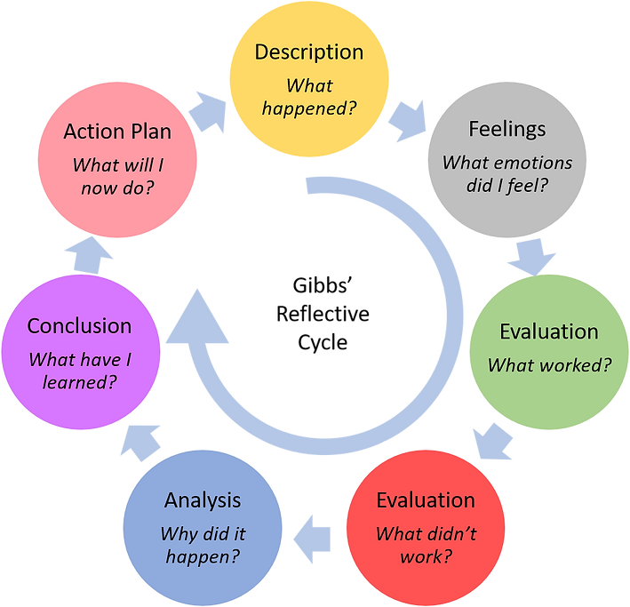
Figure 1: Gibbs’ Reflective Cycle
Source: (Williams et al., 2023)
Description- Ever since I began working in the hotel industry, my view on cultural understanding has undergone a considerable transformation. My knowledge of travel jargon and standard operating procedure was limited to the absolute minimum at the beginning of my journey. Feelings- When it comes to providing exceptional hospitality, having exposure to many cultures is not a desirable trait; rather, it is an essential qualification. Those who come to visit regard even the most modest act of carelessness to be rather offensive (Williams et al., 2023). Traditional diets vary greatly from one culture to the next. Evaluation- At first, I thought cultural understanding was more of a nice-to-have than an absolute must when it came to being a great host. It is important to be aware of the frequent dietary limitations associated with religious beliefs; for instance, Hindus do not consume pork. When guests feel disrespected, it ruins their experience and the hotel's image, regardless of whether it's intentional or not. Analysis- Being culturally sensitive results in the creation of an atmosphere that is welcoming and helpful to people of different backgrounds (Montalcini, 2023). Various cultural variations should be taken into consideration, such as limits on food, nonverbal cues, and beliefs. In the incident the worker had been aware that nonverbal cues may vary from culture to culture, they could have modified their approach. The fact that the waiter continues to provide sausage options after the first refusal suggests that he is not paying attention to what is being said. Conclusion- As a direct consequence of this event, I am very dedicated to working for the promotion of cultural understanding. I am always seeking out new experiences and perspectives because I am fascinated with the many cultures that exist all around the globe. Action plan- By learning more about cultural sensitivity training, those working in the hospitality industry may better meet the dietary restrictions, nonverbal cues, and preferred expressions of their customers (Holden, 2019). My vast cultural understanding enables me to provide first-rate service that gains the trust of tourists, even when they communicate in a different language. By making an effort to be inclusive and respectful of my visitors' cultural origins, I want to improve their experiences.

Component- 4 Training Presentation

Slide 1- Welcome


Slide 2- Content

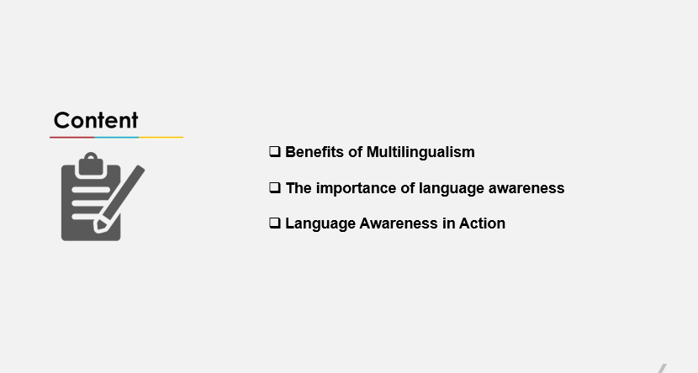

Slide 3- Benefits of Multilingualism
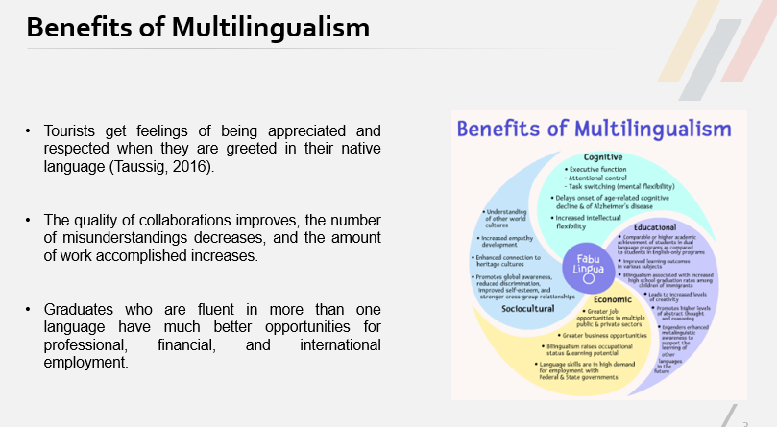
There are many personal and professional benefits to being multilingual. The capacity to interact with people from a wide range of cultural and language backgrounds is an undeniable asset (Diamond, 2019). In our increasingly interconnected world, the ability to communicate fluently in more than one language is invaluable. Tourists get feelings of being appreciated and respected when they are greeted in their native language (Taussig, 2016). Multilingual staff members are better able to communicate with customers from a variety of cultural and linguistic backgrounds. Consequently, the quality of collaborations improves, the number of misunderstandings decreases, and the amount of work accomplished increases. Multilingualism is a huge asset in today's competitive job environment. Graduates who are fluent in more than one language have much better opportunities for professional, financial, and international employment.

Slide 4- The importance of Language Awareness
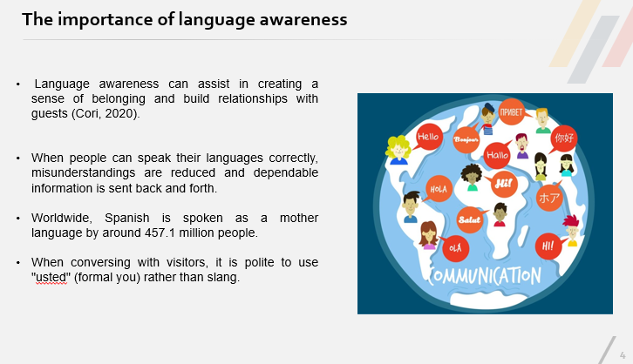
Language awareness can assist in creating a sense of belonging and build relationships with guests (Cori, 2020). When people can speak their languages correctly, misunderstandings are reduced and dependable information is sent back and forth. Although there are many other languages spoken in Spain, the great majority of the people speak Spanish as their first language and as the official language of the nation. Approximately 457.1 million individuals throughout the globe speak Spanish as their native tongue. When compared to German and other Germanic languages, Spanish grammar might seem more accessible to native English speakers due to the shared vocabulary and sentence structure. Formality is highly valued in Spanish business contexts, much as it is done in German corporate environments. When conversing with visitors, it is polite to use "usted" (formal) rather than slang.

Slide 5- Language Awareness in Action
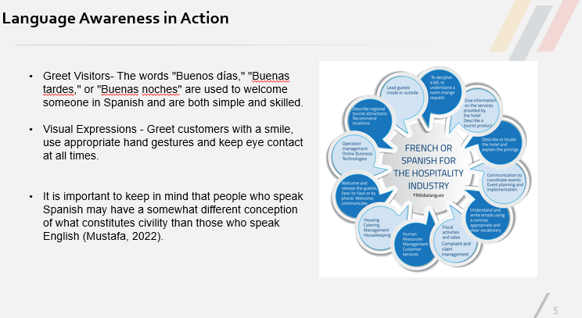
Greet Visitors- The words "Buenos días," "Buenas tardes," or "Buenas noches" are used to welcome someone in Spanish and are both simple and skilled. Visual Expressions - Greet customers with a smile, use appropriate hand gestures and keep eye contact at all times. Even while speaking a different language, nonverbal clues may help people relax and open up to them. (Roque & Ramos, 2019). Implementing Technology -It is essential to use a reliable translation tool or application if there is a linguistic issue. It is important to keep in mind that people who speak Spanish may have a somewhat different conception of what constitutes civility than those who speak English (Mustafa, 2022). For example, in certain Latin American countries, it can be rude to just give someone a thumbs up.

Slide 6- Reference
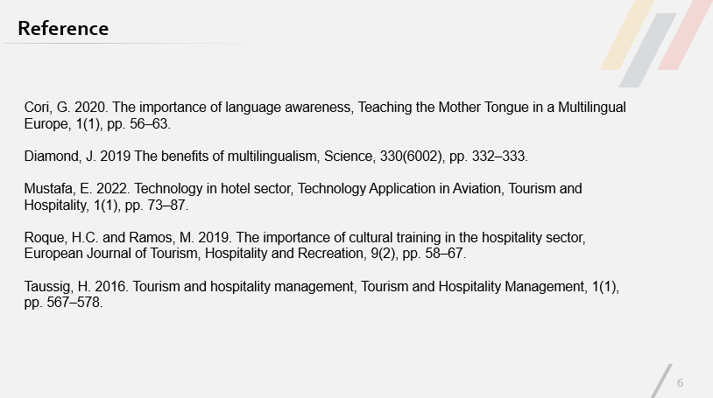

Slide 7- Thank you
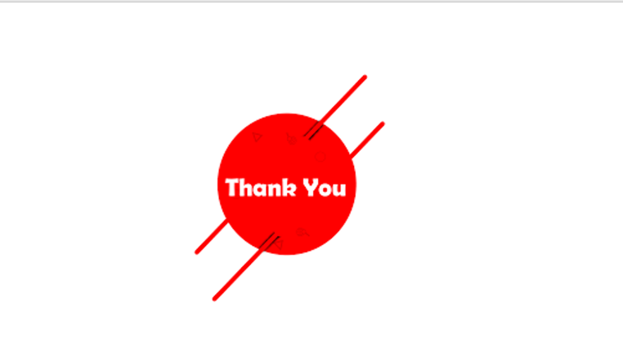

Conclusion
The ability to understand and respect other cultures is now a must for those working in the hospitality and tourist industries if they want to provide their customers with memorable experiences (Yue, 2022). There are some skills like cultural awareness training, paying close attention to guests' verbal and nonverbal cues, presenting a wider menu selection, inquiring about dietary restrictions, and bridging language barriers can help to bridge the gap and prevent cultural misunderstanding. They will learn to effectively navigate cultural differences via the training curriculum including exploring typical cultural sensitivities, using non-verbal cues, practicing successful communication skills in real-life situations, using Online Resources, conduct pre- and post-training quizzes. Now, this encounter restored my passion for cultural awareness. My comprehension is reflected in a Gibbs reflective cycle. Some benefits of being able to speak more than one language include better teamwork, happier customers, and clearer expression of ideas.

Reference
Cori, G. 2020. The importance of language awareness, Teaching the Mother Tongue in a Multilingual Europe, 1(1), pp. 56–63.
Diamond, J. 2019 The benefits of multilingualism, Science, 330(6002), pp. 332–333.
Holden, N. 2019 Knowledge management: Raising the spectre of the cross‐cultural dimension, Knowledge and Process Management, 8(3), pp. 155–163.
Islam, M.S. and Kirillova, K. 2020 Non-verbal communication in hospitality: At the intersection of religion and gender, International Journal of Hospitality Management, 84(2), pp. 10–23.
Leavitt, H. 2019. Intercultural Awareness: Cultural and relational effects on awareness information gathering behavior, iConference 2014 Proceedings, 1(1), pp. 32–41.
Meitner, L. 2021. Cultural sensitivity, SpringerReference, 1(1), pp. 1–5.
Montalcini, R. 2023. International Journal of Tourism and Hotel Management, 1(1), pp. 7–16.
Mustafa, E. 2022. Technology in hotel sector, Technology Application in Aviation, Tourism and Hospitality, 1(1), pp. 73–87.
Roque, H.C. and Ramos, M. 2019. The importance of cultural training in the hospitality sector, European Journal of Tourism, Hospitality and Recreation, 9(2), pp. 58–67.
Salini, S. and Kenett, R.S. 2022. Standards and classical techniques in data analysis of Customer Satisfaction Surveys, Modern Analysis of Customer Surveys, 1(1), pp. 1–18.
Taussig, H. 2016. Tourism and hospitality management, Tourism and Hospitality Management, 1(1), pp. 567–578.
Taylor, J. 2020. Developing cross-cultural communication skills, Cross-Cultural Communication, 2(1), pp. 23–24.
Vasilieva, E.Yu. 2021. Barriers to communication skills assessment and ways to overcome them, Virtual Technologies in Medicine, 1(3), pp. 122–123.
Williams, K., Woolliams, M. and Spiro, J. 2023. Using a framework for Reflection: Gibbs’ reflective cycle, Reflective Writing, 1(1), pp. 90–102.
Yue, D. 2022. Cultural difference and cultural misunderstanding, China Academic Library, 2(1), pp. 275–278.

