Reflective portfolio

Module Title: Professional Career development
Module Number: BMSW4005_BIRM
Student Name: Daniela Milkova
Student Number: 2018263
Lecturer’s Name: Vasilios Tavlaridis

Table of contents:
1.Introduction 2
2.SWOT Analysis and Personal Development Plan (PDP) 2
3.Analysis the skills required to be an ‘effective’ Manager 4
4.Assess the concepts we have learned from this module 7
4.1 Setting Goals & Objectives (SMART)
4.2 UK Employment Law
4.3 Self Awareness Method
5.Conclusion 9
6.References 10

Introduction
The purpose of this Reflective portfolio is to evaluate my progress throughout the course and determinate which of my skills need improvement. It is based on my personal skills development and theories learned during the group work and lectures. I will do a SWOT analysis, Personal Development Planning (PDP) and analyse the skills are required to be an effective manager. During this module I have learned how to set goals and objectives, applicable UK Employment Law, different learning theories and Self Awareness methods. I will describe my understanding of why these are useful and how they have developed me as a professional.
SWOT Analysis
“Keep the reins of your career firmly in your hands" Marie Herman
SWOT Analysis (Strengths, Weaknesses, Opportunities, Threats) is a framework for identifying and analysing internal and external factors that can have an impact on the viability of a project, product, place, or person. Many of us are familiar with the concept of a SWOT analysis for our companies, but many of us have never applied this process to our own personal and professional development. This is extremely useful exercise. (Herman,2017)
For this report I have chosen the skills that I think are the ones I have improved the most and the ones in which I need to work more, there are:
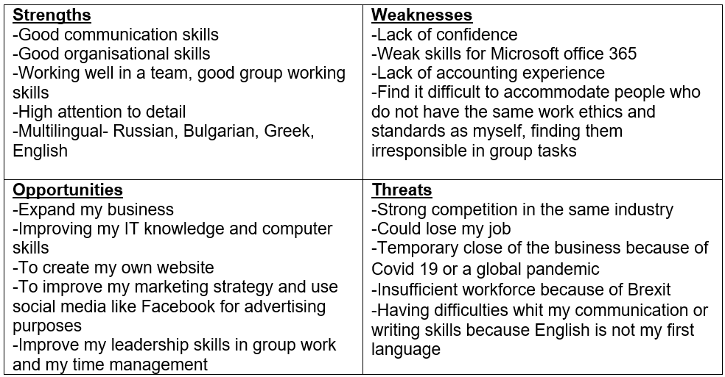
Personal Development Planning (PDP)
Personal Development Planning is defined as ‘a structured and supported process undertaken by an individual to reflect upon their own learning, performance or achievement and to plan for their personal, educational and career development’ (Jackson,2001). This process is flexible and involves five stages:
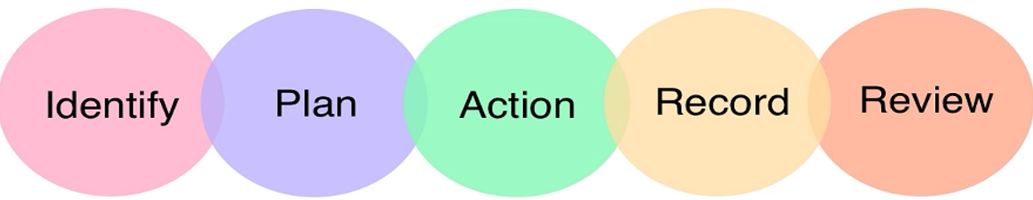

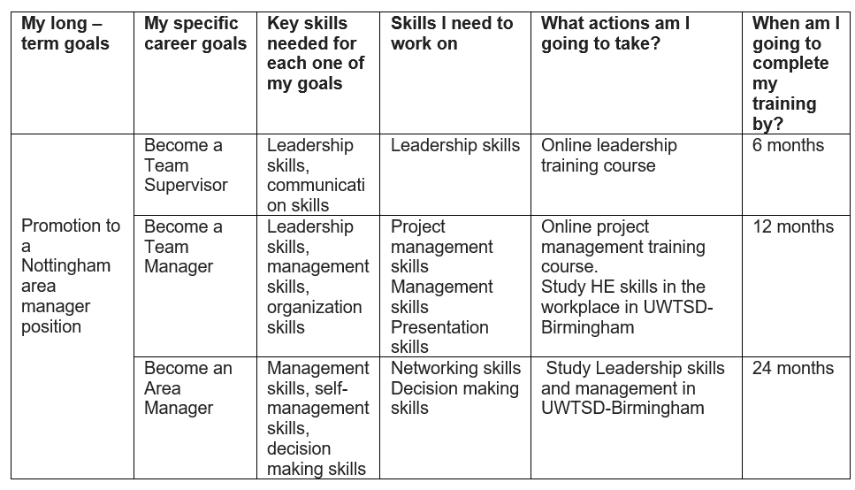

Analysis the skills required to be an ‘effective’ Manager
I have chosen the UK Cleaning Industry; it is a Top ten UK Employment Industry and according to the British Cleaning Council (BCC) contributes £55.5 billion to the UK economy each year (ONC, 2019).
Effective management has always been a key part of working life. It is simple for teams to lose motivation and productivity if proper management is not in place, which can lead to professionals looking for new jobs. The relationship between a manager and their employees has a direct impact on the team’s morale and success.
It is often said that people do not leave businesses, they leave managers, which is why it is so important to get this connection right. If a person does not feel supported or is unable to have open and constructive dialogues with their manager, they are likely to become unmotivated to perform and be dissatisfied.
Here are the top tips of an effective manager:

Communication skills
Everybody is different, so we should be aiming to constantly develop our communication skills, adapting to the ways you are motivating people, and improving the working relationships within our team, and externally. When leaders are good communicators, they are better able to manage their teams and to convince their customers. Effective communication is not just the ability to speak to people, but to empower them to speak to each other. Effective communication helps to increase services or sales by conveying a professional image and reducing misunderstanding between a business and his clients. (Sannia et al.,2017).
This skill is one of the most important skills that a person needs to have in today’s employability market, because this is the principal method, using to “exchange of facts, ideas, opinion or emotions by two or more persons.” (Newman and Summer). We have learned the different models of effective communication such as Shannon –Weaver, Schramm’s model and Lendel –Daft model of Channels Richness.” For effective management, the idea of richness of a communication channel important in areas such as management information systems and organisational behaviour” (Daft & Lendel,1986).
I have improved these skills throughout the term by doing presentations at different course modules, for example the Power Point presentation for “Effective Communication when launching a new service.” and through group work which I will describe below.
Group working skills
This skill means the ability to work effectively with other people-both as an individual and as a member of a group. These are required to win the co-operation of others and build effective work teams. A key part of the role of being an effective manager is to provide support to employees working within a team and to show trust in them. The ability to listen and understand the wants, needs, and concerns of your team and the individuals who report to you form an important part of manager responsibilities. Throughout the course I have had the chance to improve my group working skills in all modules, this skill is considered as one of the most crucial factors for business development. This skill was developed in all modules throughout different activities. We had the opportunity to improve our group-work skills, for example the group presentation and written business plan was done in groups to collaboratively decide how to invest £25 000, chosen a Business, make a business plan, analyse the internal, external factors & main competitors, to discuss a financial plan and to achieve least 80k-90k profit in the first year.

Make decisions & Organisational skills

Decision-making is a main function of a manager. Chartered Management Institute (CMI) defined Decision making as “the process of choosing between alternative courses of action.” Employees will look to their manager to make decisions on how to progress projects, solve issues, and steer the team towards its goals. “Decision making skills enable a manager to consider alternatives and use judgement to choose an appropriate and timely course of action.”
As a manager in my own cleaning company, I have always planned my week's work in advance. Good Administrative skills are essential to be organised.

Leadership skills
Employees are looking for a leader that they can look up to and, aspire to. However, for employees to buy into the direction of their manager, they need to respect them professionally. By setting a good example, proving skills and knowledge, and being a high achiever, a manager can gain the professional respect of their employees and ensure that they have the backing of the team.
As a leader, it falls on you to take responsibility for the success and failures of their team. However, a good leader shares the successes and absorbs the failures. Empowering the team to drive for success and sharing any wins is an important trait. More importantly, is taking responsibility when mistakes are made. Leading from the front. Showing the team that you are willing to step in for them when things get tough is all part of effective management.
For me, being a leader in two groups in the first and second term as well as my Business is not only making other people do what I say but earning their respect to accept my ideas and value my input.
IT skills
Good IT Skills are becoming more essential for managers as technology advances, we must know how to use Microsoft Office, social media, email communication, marketing automation, data visualisation etc as well as industry specific software. These technologies are used for strategic planning, assessment, product evaluation and project coordination (Adams & Galanes,2009) as well as for people to easily communicate directly with one another across time and space (Nohria & Eccles,1998). For me, this is one of the skills I need to concentrate on the most because in this century, everyone needs to know how to use and work with technology, and a large amount of work places these days requires you to have IT knowledge for qualifying for the job this was not necessary for much of my professional life.

Assessment of Concepts Learnt
Setting Goals & Objectives
The main concept we learnt was SMART
The SMART acronym stands for:
- S-Specific. This means that objectives must be clear, for example it must state that a business needs to make more profit, reduce waste, reduce environmental impact, increase sales
- M-Measurable. A business must be able to measure whether they have met an objective. A business needs to specify an amount. For example, a business may want a £10 000 increase or a 25% decrease
- A-Agreed. Stakeholders in a business must agree about their objectives, this will give objectives a much better chance of succeeding
- R-realistic. Objectives must be realistic for the size and scale of the business. For example, a small café would not have an objective to make £ 1 million profit
- T- Time-bound. Objectives must have a time limit, for example 6 months or 1 year
Drucker (2006)
This is a useful method as it is recognised across many different sectors internationally and can be used throughout my professional life. It helps provide focus by giving limited set criteria to evaluate and progress. This method enabled me to see improving communication is my top priority.
UK Employment Law is not a concept and must be followed to ensure not only legality of the business but the relevant safeguarding it looks to ensue.it is relevant throughout the whole Employment process from recruitment to retirement/end of contract. Using Recruitment as an example this must adhere to Equality Act (2010) to ensure that people are not discriminated against due to a protected characteristic for example having a British Sign Language (BSL) interpreter for someone who uses sign language to ensure they can still be understood/understand the interview questions as to not put them to a disadvantage to someone without hearing loss.
In my professional development this has helped me understand the need for foreign workers to understand their rights in relation to pay and working conditions to prevent employers taking advantage of them.
The Self-Awareness concept we learned about was the Johari Window, this is used to help identity. The Johari Window is a useful leadership tool for elucidating and improving self-awareness and understanding between leaders and followers, and interpersonal relationships between groups (Hersey, Blanchard, & Johnson,2008). It is one of the few tools out there that has an emphasis on “soft skills "such as behaviour, empathy, co-operation, inter group development and interpersonal development, it is a great model to use because of it is simplicity and because it can be applied in a variety of situations and environments (self-awareness.org.uk/news/understanding-the-Johari-window-model)
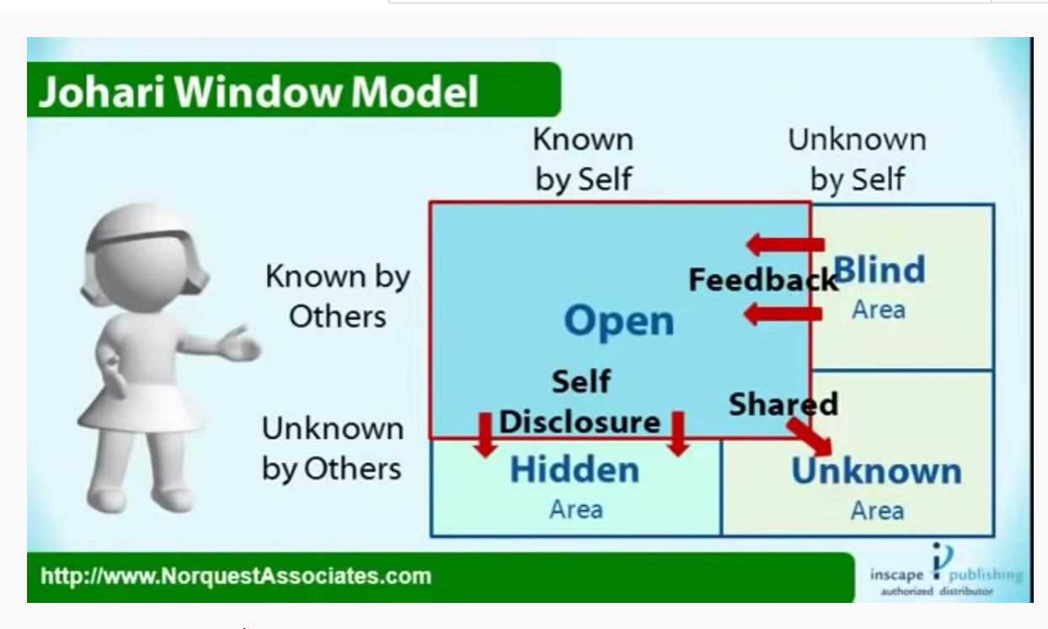
Elements of the Johari Window Model:
There are two factors at work within the Johari Window. The first is what you know about yourself. The second factor relates to what other people know about you (Shapiro, Heil and Lager,1983).
Quadrant one is open area is all information that a person is aware of him or herself, and which is also known to others such as your behaviour, knowledge, skills, attitudes, and “public” history. The open area is the most important quadrant, speaking, the more people know about each other, the more productive and effective they will be when working together. The open area can be expanded horizontally into the blind space through a process known as ‘feedback solicitation’ which is engaging and listening to other team members’ feedback about him (The Johari Window,2018). As the leader receives feedback from followers the open area then expand horizontally and the blind area gets smaller, as information is shared by the leader, the open area expands vertically, and the hidden area becomes smaller (Self Discovery,2016).
Quadrant two is a blind area; hence, quadrant two represents the things a leader may not be aware of that are known by others (Hersey et al., 2008). Quadrant three is the hidden area, thus, these are the things the leader knows about his or herself that others do not know (Hersey et al., 2008). Lastly, quadrant four is the unknown and represents the things that are unknown by the leader and his or her followers (Hersey et al., 2008).
The Johari Window model is often used by many organizations for understanding and training in self–awareness, personal development, improving communications, interpersonal communications, group dynamics, team development and inter-group relationships (“Johari Window,”2016).
The Johari Window has allowed me to better understand what others think about me, both positive and negative, and I can now use this information to help me become a better manager in the future.
Conclusion
During my time at the University of Wales Trinity Saint David I have had the chance to develop and improve my interpersonal skills, knowing that nowadays these skills are what employers are looking for when they are planning to hire someone makes me think about the importance of develop, learn, and practice those skills more. This has been achieved through Group work as it gave hands on experience and through individual assignments where I honed my skills such as writing a Covering Letter and CV which helped show any gaps in my experience from the required skillset.

References:
Adam, K. & Galanes, G. (2009). Communicating in groups: Application and skills (6th Ed.). McGraw Hill: New York
Daft, R. L., & Lengel, R. H. (1986). Organizational Information Requirements, Media Richness, and Structural Design. Management Science
Drucker, P. (2006) The Practice of Management
gov.uk/guidance/equality-act-2010-guidance
Herman, M. (2017). Creating a Personal SWOT Analysis. MRH Enterprises LLC. Fecha de consulta, 20
Hersey, B., Blanchard, K. H., & Dewey, E. Johnson. (2008). Management of Organization of onal Behavior: Leading Human Resources, p190
Jackson, N. (2001). Personal development planning: what does it mean. Higher Education Academy from http://www. heacademy. ac. Uk/ourwork/teachingandlearning.
Nohria, N. & Eccles, R. (1998). Network and organisations: Structure, form and action. Harvard Business School Press: United States of America
Office for National Statistics (2019) https://www.ons.gov.uk/
Sannia A Balashav, A., Rubtcova, M. & Satinsky, D.M. (2017) .The effectiveness of communication channels in government and business communication
selfawareness.org.uk/news/understanding-the-johari-window-model
Shapiro, D., Heil, J. and Lager, F. (1983). Validation of the Johari Window Test as a Measure of Self-Disclosure: The Journal of Social Psychology
The e-learning net: The Johari Window

