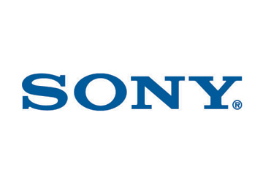
A Critical Assessment of the Music Industry and the wider market conditions in the light of Digital Disruption.

Assignement 1 – Part A

Youtube URL: https://youtu.be/-IPdtbDfe-4

MBA - Digital Entrepreneurship Module UWTSD
Craig Blackstone
Student No 1910263
References – Assignment 1, Part A
Chaffey D, Smith PR, (2013) Emarketing Excellence Planning and optimizing your digital marketing Fourth edition, Routlidge, London and New York
Christensen CM (1997) The innovators dilemma: when new technologies cause great firms to fail. Harvard Business School Press, Boston
Christensen CM (2006) The ongoing process of building a theory of disruption. J Prod Innov Manag 23(1):39–55
Christensen CM, Raynor M, McDonald R (2015) What Is disruptive innovation? In: Harvard business review. https://hbr.org/2015/12/what-is-disruptive-innovation. Accessed 26 /06/ 2018.
Bloombergtax.com (2018) Available at https://news.bloombergtax.com/daily-tax-report-state/sony-settles-netflix-tax-debt-ending-chicago-legal-battle. Accessed 20/11/2019
Global Music Report (2018), Available at https://www.ifpi.org/downloads/GMR2018.pdf. Accessed 20/11/2019
Guides (2019), Availabe at https://guides.yoosecurity.com/ Access 20/11/2019.
Frater P, (2019) Yahoo Entertainment https://www.yahoo.com/entertainment/clockenflap-hong-kong-music-festival-145143120.html
Vella, R. (2016) Industry faces digitisation challenges, but all is not lost Mndustry faces digitisation challenges, but all is not lost. Available at https://www.abc.net.au/news/2016-11-28/why-music-is-not-lost/8055044 Accessed 21/11/2019.
Porter M.E. (1985) Competitive Advantage. Creating and Sustaining Superior Performance, New York, NY: Free Press 1985
Wikstrom P. (2012) typology of music distribution models, Available in the International Journal of Music Business Research, available at https://eprints.qut.edu.au/67836/. Accessed 21/11/2019
Ferrier C, (2019,) Copyright Infringement Liability In The Music Business . Available at https://www.hypebot.com/hypebot/2019/10/copyright-infringement-liability-in-the-music-business.html, Accessed 21/11/19
IG.FT (2019) Available at https://ig.ft.com/sites/numbers/economies/us/, Accessed 21/11/2019
Mindtools (2019) Available at https://www.mindtools.com/pages/article/newTMC_08.htm, Accessed 21/11/2019
Chapellpo J, Porters five forces, available at https://www.investopedia.com/terms/p/porter.asp. Accessed 20/11/2019
Riesewik, M (2019), The Future of Spotify: Assessing Spotify’s Position by Analysing the Competition, University of Twente P.O. Box 217, 7500AE Enschede The Netherlands. Available at https://pdfs.semanticscholar.org/6345/da165ce1e3b6330f46f350ed4b544bc505e5.pdf. Accessed 21/11/2019
(Reisewijk 2019) https://pdfs.semanticscholar.org/6345/da165ce1e3b6330f46f350ed4b544bc505e5.pdf
IFPI (2019) Gliobal Music Report 2019 available at https://www.ifpi.org/news/IFPI-GLOBAL-MUSIC-REPORT-2019 Accessed 20/11/2019
RIAA (2019) Mid Year Report Available at https://www.riaa.com/riaa-releases-2019-mid-year-music-industry-revenue-report/ Accessed 20/11/2019
1985

A Systematic Analysis of Sony Music Entertainment Organisation in light of digital disruption.
Assignement 1 – Part B

MBA - Digital Entrepreneurship Module UWTSD
Craig Blackstone
Student No 1910263
CONTENTS
- Executive Summary 3
- Introduction 3
- Digital Disruption 4
- Business Model Canvas 8
- Customer Analysis (& Marketing Strategy) 9
- Competitive Analysis 15
- Porters Value Chain 15
- SWOT Analysis 20
- Conclusions and Recommendations 21
- References 22

Executive Summary
This report undertakes a systematic situational analysis of SONY Music Entertainment (SME). By analyzing SME’s strategies in relation to customer motivation, value proposition, marketing, CRM, and the organizations value chain we able the report shows that SME is well placed for continued growth but highlights a key risk associated with online streaming distribution. PR Smith’s SOSTAC Model is useful in assessing a business. This model includes Situational Analysis (which is further elaborated on in (Chaffey and Smith 2013) as well as objectives, Strategies, Tactics, Actions and Control.

Introduction
This report applies accepted industry marketing and business theory as well as models to undertake a situational analyses of the organization, SONY Music Entertainment (SME).

Sony Music Entertainment (SME) is a subsidiary of SONY Corporate Group. SONY corporate group operates diverse businesses, including games, motion pictures, animation and other content intellectual property (IP); electronics businesses; and direct to consumer (DTC) services businesses including PlayStation Network (PSN) and financial services. This diversity presents advantages to Sony Music Entertainment as it facilitates growth through “Synching” with alternate media thereby tapping into new growth markets. (Sony, 2019)

Disruption

While the music industry is still recovering from significant digital disruption, the last few years have seen excellent global music revenue growth due primarily to new business models and innovation such as Streaming . (RIAA, 2019)

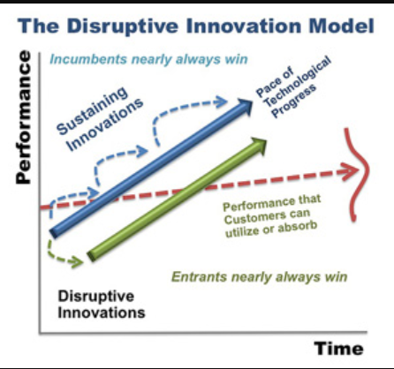
Digital disruption theory is part of a wider field of disruptive innovation theory. In disruptive innovation theory, disruption refers to a very specific process that explains how entrants (such as Spotify) can successfully compete with incumbents (such as SME) (Christensen et al. 2015). “Disruption theory argues that a consistent pattern repeats itself from industry to industry. New entrants to a field establish a foothold at the low end and move up the value network—eating away at the customer base of incumbents—by using a scalable advantage and typically entering the market with a lower-margin profit formula.” (Christensen, et al 2012). These new entrants aren’t burdened by the extensive overheads of legacy incumbent organisations…Instead they invest in only the resources most vital to their own sustainability.
Source: Mcinsey & Company
Skog, Wimelius and Sandburg (2018), in reference to digital platforms, describe how Digital disruption can be framed as a type of digital technology-induced environmental turbulence capable of producing industry-level upheaval.
Wenzel, et al (2015) similarly have attributed the origination of digital disruption to specific actors, digital disruptors, that leverage digital technologies to undermine established industry models of consumption, competition and resourcing. “Digitization is capable of destabilizing the key mechanisms that drive the successful reproduction of strategic paths and, consequently, induce their eventual demise”
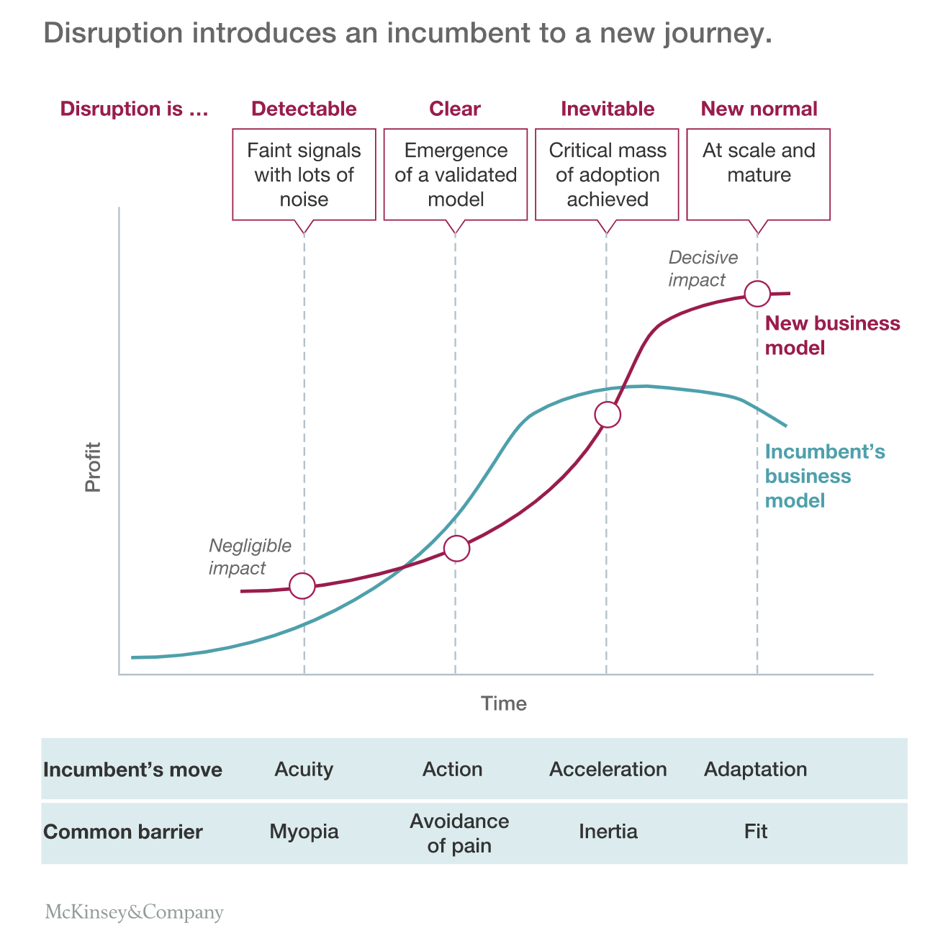
However, if an Incumbent is able to pivot and adapt to the change, as shown in the figure below, the disruptive innovation can create opportunity for new business models, such as online music streaming services partnerships in the case of EMI. “Digital platforms carry unprecedented possibilities for innovation and rapid growth. As demonstrated by firms such as Apple, Google and Facebook, digital platforms enable platform-owners to cultivate masses of external contributions from distributed and diverse actors, and ultimately to dominate whole industries.” (Skog et al, 2018)
Christensen 2006; Christensen et al. 2012 and Christensen et al. 2015, state that disruption theory is concerned with business-model innovation that enables entrants to enter markets with cheap, easy to use, but low-performing products and in doing so created new market demand by engaging new audiences. This is not entirely correct in the case of , online music streaming services. While organisations like Spotify did introduce a cheap, easy to use alternative to music physical music acquision, the product (music) and platform are not low performing.
Source: Mcinsey & Company

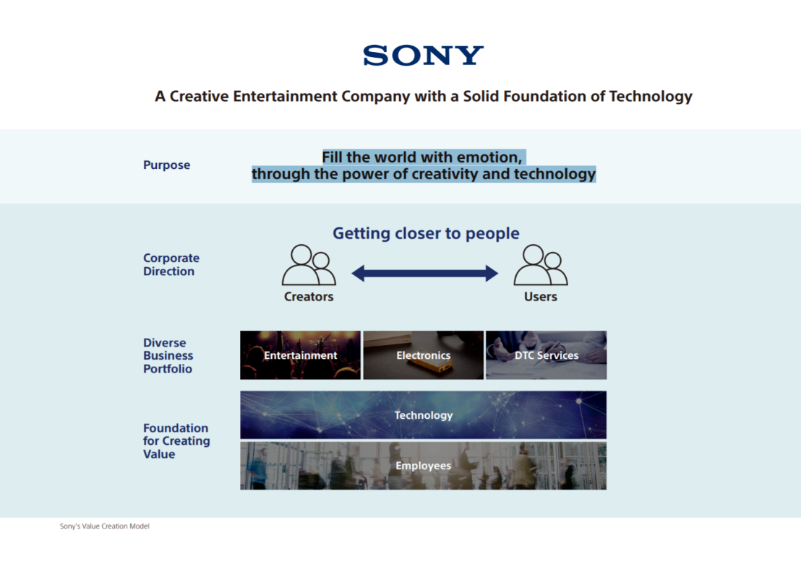
Sony, as an incumbent has undergone significant digital disruption but, through its foundations in technology and extensive music content IP portfolio, has managed to restructure and adapt in time to create a new business model and is beginning to reap the rewards. From Sony’s Online Value Proposition (OVP) depicted on the right we note that they are implementing the Chaffey’s 5 S’s as objectives which is feeding into their strategy.

Sony Value Proposition - (Source: Sony, 2019)

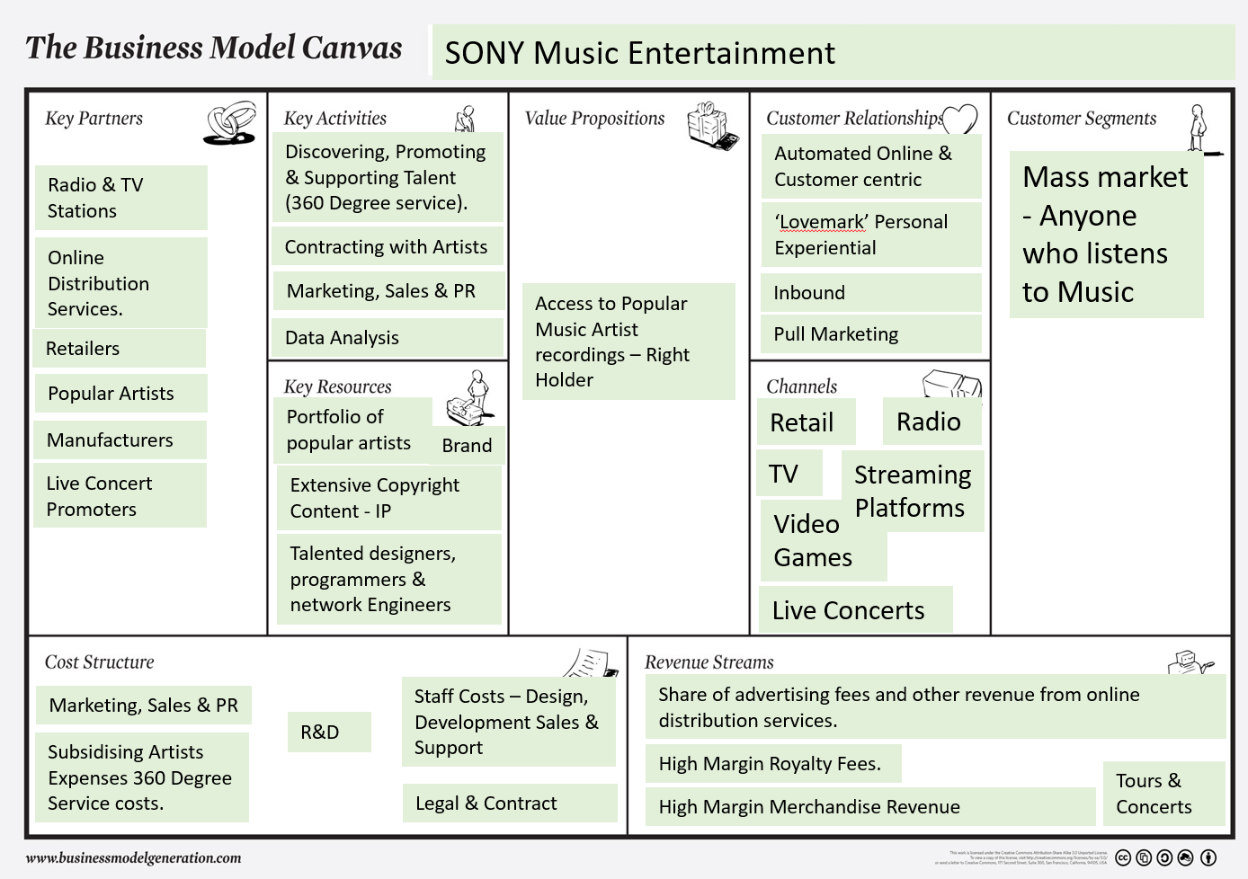
The Business Model
By analyzing SME through the Business Model Canvass (Osterwalder and Pignier, 2010) we are able to break the organization up into nine defined categories, which will assist with analysis of the organization’s product's value proposition, infrastructure, customers, and finances. to better .
From the above model we see that Sony’s current strategy on generating and maintaining a large library of music content IP is well founded as this is not only the main resource (on a smaller scale, live music concert tickets could be included) but also the main value proposition and more recently online value proposition (OVP). To ensure that Sony remains attractive to artists, distributors and customers, Sony needs to have as much quality content as possible. “By making EMI Music Publishing a wholly-owned subsidiary, Sony has become the largest music publishing company in the world. To further reinforce our music content portfolio, we are working to attract and nurture artists in popular streaming genres, and we will cultivate local artists and songwriters in regions where we foresee opportunities for market growth, including China. “ (Sony, 2019)

Customer Analysis & Marketing Strategy

By utilising Philip Kotler’s ‘Three Product Levels’ model (which takes into account customer Need, Want and Demand) we can better understand the different levels of need an SME customer has for its music product.

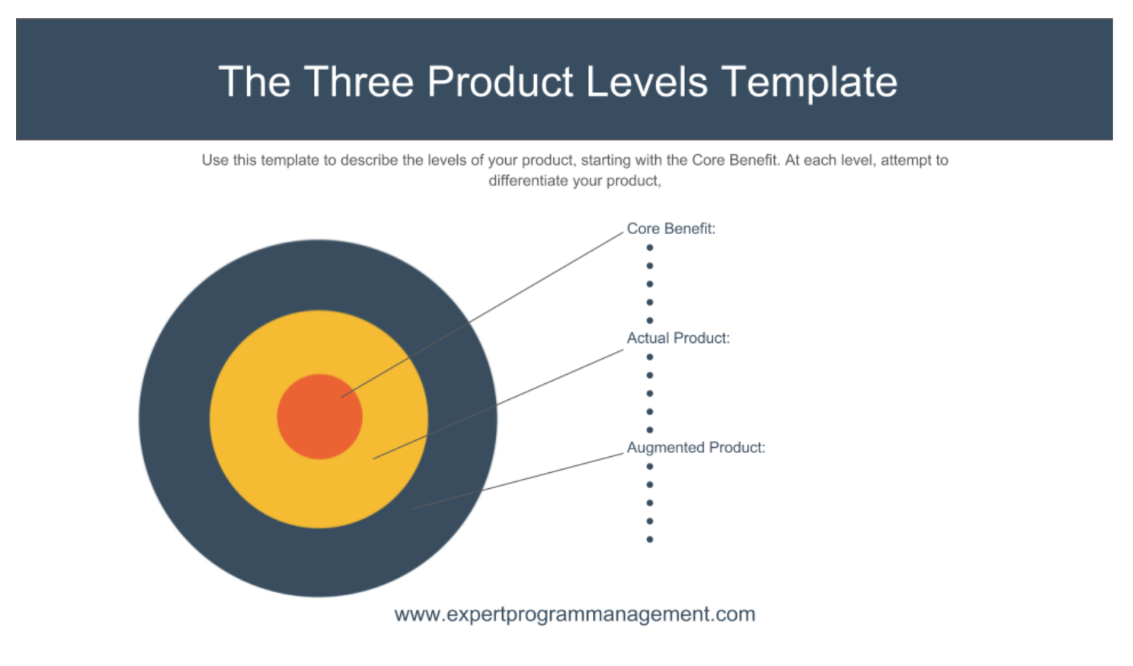
The model requires the breakup of the product (SME’s digital music product) into three section; Core benefit, Actual Product and Augmented Product.
Source: expertprojectmanagement.com
Core Benefit
- Need to conveniently Listen to (and use) Music
Augmented Product
- The company’s reputation for post-sales support.
- CRM and DTC
- Partner freemium (with ads) and paid subscriptions model
- Brand recognition
- 360 degree service
- Customer-centricity and retention and collaboration strategy.(User and Customer)
- Compatible with all audio digital technology.
- Choice/customizable
- Association with popular artists
Actual Product
- Digital format download or live streamed audio file form third part distributor.
- Compatible with all audio digital technology (desktop and mobile).
- Choice

Sony’s digital marketing strategy is and must be robust. David Chaffeys’s Six C's assist with understanding customer motivation. Sony’s ‘Getting closer to people’ strategy aligns with these 6 C’s (Content, Community, Convenience, Cost reduction, Choice) which has resulted in increased customer motivation to engage with the online value proposition which in this case is subscribing and choosing to share SME music via streaming platforms. Sony has invested heavily in its online presence ensuring that it provides high quality, value add content that engages and delights the customer. By delighting the customer and offering value add functionality and features to the online experience, Sony has strengthened its brand loyalty with the customer and created an online community. This community is further strengthened through live concert experience opportunities which has become a growth part of the business. Sony’s strong focus on social media platform integration and pop icon and influencer endorsements, further supports this community growth and retention.

Sony prides itself on technological innovation to solve consumers problems seeking more convenient and exciting ways for the customer to engage with its product and brand. By partnering with Streaming services distributors like Spotify, Sony is able to offer its extensive content to a mass subscription market, through a platform that provides utmost convenience and seamless engagement.

Sony is perceived as a premium brand. On large streaming services, music content form smaller lesser known labels sit beside SME’s content and can be downloaded at the same cost (or free with adverts) as the deemed more premium SME product so there is an informed perception of Value when sharing an SME music track. The greatest advantage that SME has however is its extensive content IP. This provides the customer with choice. Consumer choice is a key strategy for Sony, investing heavily in diverse product offering in order to retain customer loyalty.

Sony’s direct to customer (DTC) and customer-centric strategy is of paramount importance. Sony recognizes the power shift form publisher to customer and is eager to engage with and get closer to the customer. Sony utilizes Inbound marketing techniques to pull customers to products and services via content marketing generating (video, blogs, edm, and the like), social media marketing, search engine optimization (SEO), website and branding. The intent is to attract new customers, engage with them, close the deal, and then delight them in to staying, loving the brand and buying more music product through retail channels. (Chaffey and Ellis-Chadwick, 2012). Chaffey’s 5 S’s of e-commerce marketing are entrenched in Sony’s culture by Selling solutions for customers and artists (users), Serving by adding value, Speaking and getting closer to customers and artists, Saving through technology, and Sizzling by delighting the customer by extending the brand on-line. Sony’s President and CEO Kenichiro Yoshida has stated “People are at the core .... Based on our Purpose to “fill the world with emotion, through the power of creativity and technology,” we at Sony will continue our efforts to grow and deliver even greater value by “getting closer to people.” (Sony 2019)
With technological innovation at its core, and its links to other Sony Media organization’s such as play station, Sony Music Entertainment is well placed to continue to provide new and innovative technological solutions to everyday problems. Sony is employing the Jobs-to-be-done theory whereby SME recognizes that consumers are continually looking for solutions to their everyday problems and at that point they will hire a service or buy a product. Christensen et al. 2012. SME’s strategy is to get closer to the customer through technology and form strong relationships so that SME can more quickly and more accurately identify jobs-to-be done for the customer and provide the solution product without being asked to do so. From our 3 product level model, we know that the need is to conveniently listen and use music. By doing this, Christensen et al. explains that customers will instinctively ‘pull’ the product into their lives. Christensen et al 2012

The 7p’s Marketing Mix Framework
McCarthy’s 7’ps Marketing framework helps to assess whether SME’s marketing mix and customer relation strategy is still on track in this rapidly changing digitized market. Chaffey and Smith (2013) further extend this, adding the eighth P, Partnership, to the digital marketing mix, which is applicable to SME as it relies heavily on partnerships with Streaming distributors as well as extending the product through Artist endorsements, customer awards, Customer reviews and engaging with fans or followers on social networks.
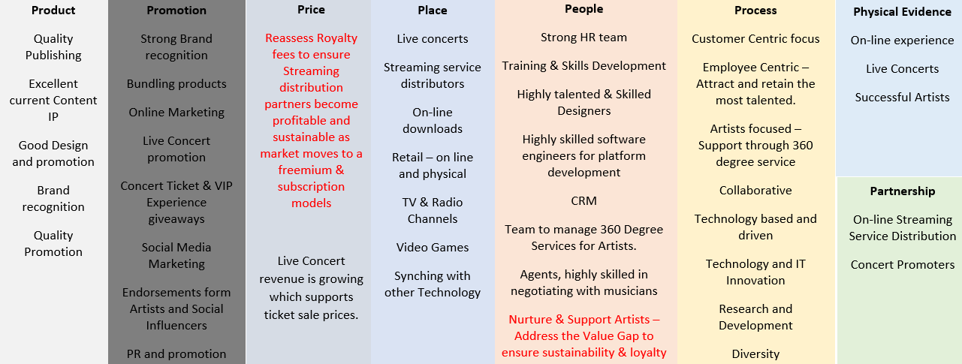

Competitive Analysis
SME competes directly with the other two large record Labels being Universal Music Group and Warner Music Group . (RIAA , 2019)

As SME is one of only three large record labels with the largest content IP library of the three, (Sony, 2019) there is little threat of direct competition. However, because the cost of self-publishing has decreased so dramatically, lowering the barrier to enter, smaller, independent labels are entering the industry, (RIAA, 2019) but not to a scale where they can compete with SME particularly due to the amount of content and financial backing SME have.
Value Chain
The Porters Value Chain will show how SME creates value.

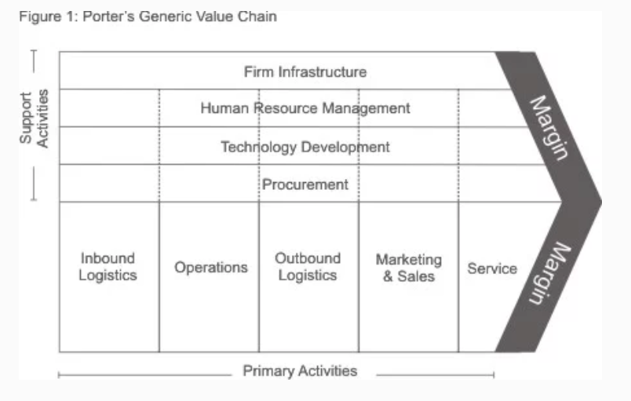(Source: Sony, 2019)

Porters Value chain is typically segmented as shown above. The ‘primary activities’ are shown on the bottom line and the. ‘Secondary/ activities (support activities) sit above these. SME’s Inbound Logistics relate to sourcing and attracting music talent to contract with the Organization Sony has implemented. Sony recognizes the importance of IP content stating in the Sony Corporate report for 2019 “The first focus area is to reinforce our user-oriented DTC (Direct to Customer) services and creator-oriented content IP. We aim to strengthen ties with users and enhance DTC services that generate recurring revenue as we acquire and revitalize content IP and maximize its value.” (Sony, 2019)

The Operations relate to production, design, talent management (360 degree services), online platform development and legal contracting. SME’s Outbound Logistics, primarily include online streaming services like Spotify, download platforms like iTunes and radio, TV and live concerts. Apart form live concerts, distribution logistics and costs are low. The direct activities here relate to negotiating and contracting with the distributor.

Marketing and Sales for SME involves ongoing recognition that SME is a premium music Brand. By contracting exclusive content IP rights with popular and successful artists, SME removes the competition for that specific content and can market that that artists is exclusively a Sony artist. SME’s massive content IP portfolio, puts them in a very strong position to bargain with online streaming distributors, achieving high royalty fees as a result. SME engage with the customer by extending the brand and product through a strong digital marketing strategy, including Social media and other media platforms aligning and extending their brand with their own popular artist’s brands.

Ongoing commitment to excellent Service is key to SME’s strategy of retention of customer. SME sees the importance of understanding the customer, engaging with them and delivering solutions to their day to day problems. SME employs big data, and deep learning analytics to better understand the customers’ needs to ensure that the customer is delighted with the brand and remains loyal. SME invests heavily in design and functionality of the customer touchpoints and looks to innovate technology in order to maintain these connections with the customer.

Support activities include Procurement, HR, Technology development and infrastructure. SME actively pursues talented artists to Procure content IP by offering big record label support, industry connections, brand and funding in order to attract and convince talent artists to contract with SME.

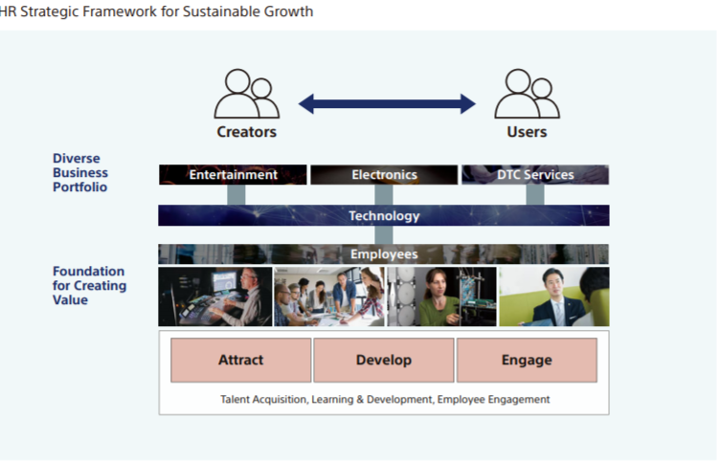
Employees are a key component of SME’s value creation model and growth strategy. SME invests heavily in talented staff recognizing that through positive Human Relations strategy to attract, develop and engage with employees the company retains top talent and will continue to grow together with the employees. Talented staff is required to achieve efficiency in each Primary activity. “It (SME) strives to be the most artist- and employee-friendly company. SMEʼs people strategy, which is at the center of its overall global business strategy, focuses on differentiating SME as an exceptional place to work. This is accomplished through promoting excellence throughout all creative and commercial service capabilities” (Sony, 2019)
(Source: Sony, 2019)

SME’s core is rooted in Technology. As such, technology is utilized throughout the business to ensure efficiencies (including in each Primary activity) and due to the global size of SME, the company employs a high level of technological infrastructure support for the day to day operations of the business.

SWOT Analysis

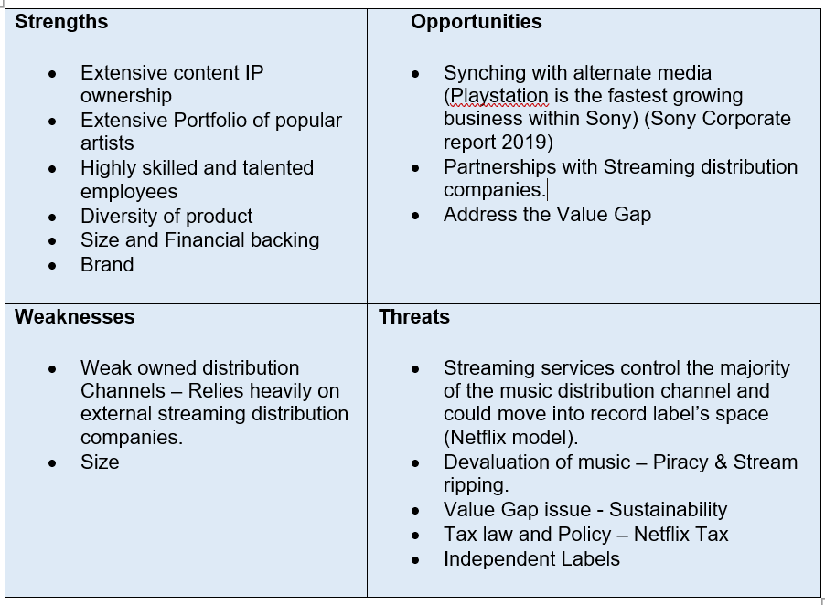
In order understand SME’s key Strengths, Weaknesses, Opportunities, and Threats a SWOT analysis will be undertaken.

The SWOT analysis highlights a key overlap in Weakness and threat being the lack of any direct control of the online streaming distribution process. This highlights a key risk for SME however, this given SME’s significant strengths, there is an opportunity for them to either partner with a large streaming distributor or use their highly skilled staff and technical nouse to move into the streaming distribution space themselves.

Conclusions and Recommendations
SME has experienced excellent growth on the back of growing global music revenue. SME’s focus on people and technology suite the disruptive digital environment and their strong digital marketing strategy is important to extend their product into the marketplace. Streaming services have delivered incredible opportunity and growth to SME however, the analysis highlights that these same organizations pose the greatest threat to SME. If streaming services created and owned content as well as controlled the online distribution channel (including big data and deep learning) SME’s ability to demand high royalty fees for it IP content will diminish along with its profit. Based on the Situation Analysis undertaken, we note good growth in Brand perception and note that SME’s Objectives and Strategy’s are well placed and forward looking.

References – Assignment 1, Part B
Chaffey D & Ellis-Chadwick, (2016), Digital Marketing, Pearson.
Chaffey D, Smith PR, (2013) Emarketing Excellence Planning and optimizing your digital marketing Fourth edition, Routlidge, London and New York.
Christensen CM, Skok D, Allworth J. (2012) Breaking News, Mastering the art of disruptive innovation in journalism in Nieman Report, Available at: https://niemanreports.org/wp-content/uploads/2014/03/Fall2012.pdf. Accessed 19/11/2019.
Christensen CM, (2006) The Ongoing Process of Building a Theory of Disruption, Available at: file:///E:/CAB/MBA/Ongoing%20Process%20of%20Building%20a%20Theory%20of%20disruption.pdf (Accessed 20/11/2019)
Google Trends (2019) Available at: https://trends.google.com/trends/explore?date=all&q=storage%20near%20me Accessed 22/11/2019
Kotler, P, Wong, V, Saunders, J. and Armstrong, G. (2008), Principles of Marketing, 5th ed. Harlow: FT Prentice Hall.
Hanlon A. (2016) Digital Marketing Models: 6Cs of online customer motivation available at: https://www.smartinsights.com/marketing-planning/marketing-models/digital-marketing-models-6cs-online-customer-motivation/ Accessed 22/11/2019
Osterwalder A, Pigneur Y (2010) Business Model Generation. Available at: https://s3.amazonaws.com/academia.edu.documents/32253198/businessmodelgenerationpreview.pdf?response-content-disposition=inline%3B%20filename%3DYoure_holding_a_handbook_for_visionaries.pdf&X-Amz-Algorithm=AWS4-HMAC-SHA256&X-Amz-Credential=AKIAIWOWYYGZ2Y53UL3A%2F20191121%2Fus-east-1%2Fs3%2Faws4_request&X-Amz-Date=20191121T130041Z&X-Amz-Expires=3600&X-Amz-SignedHeaders=host&X-Amz-Signature=aee1d621c6c21a8b4e3bb0c2c04755d46e1bad2a7696d4ff466a005ab134e920 Accessed 21/11/2019
M3Property National Self Storage Market Update Winter 2019 (2019) Available at: https://m3property.com.au/wp-content/uploads/2019/07/Self-Storage-White-Paper-July-2019.pdf Accessed 23/11/2019
Porter, M.E. (1985) Competitive Advantage: Creating and Sustaining Superior Performance, New York, NY: Free Press 1985

