

VIDEO LINK-
MWBA4000 video (1).mp4

LEVEL 4 ASSESSMENT SPECIFICATION

Student name: | - Eswaran A/L Sanker  - Muhammad Afiq Hasran bin Mohd Fadzly Shah  - Muhammad Husaini Bin Suhaini  - Muhammad Muqri Bin Zainal | Student ID number: | 1. 2538271  2. 2538269  3. 2527789  4. 2538272
Module: | Contemporary Challenges: Making a Difference
Module code: | MWBA4000 | Contribution to Overall Module  Assessment (%): | 100%
Lecturer: | Emma Roberts | Internal  Verifier: | Vic Saunders
Assignment Title: | The Significance of Global Teams in Solving Shortened Attention Spans and Deteriorating Academic Performance | Word count (or equivalent): | 6000

Submission deadline: | Monday 24th August 2026 (23.55/11.55 pm British Summer Time BST) | Return date of provisional  marks & written  feedback: | 21st September 2026
Submission method: | All written assessments, where practical and possible, must be submitted via Turnitin unless otherwise instructed by the Lecturer. (Please DO NOT put this assessment specification into Turnitin, or it will match many similarities with other students’ submissions.)  Alternative submission method (if applicable):  Late submission of the assessment will result in a late penalty mark:  Work which is submitted up to 1 week late will be capped at 40% for the first attempt and will be awarded a mark of 0% for re-assessment. Late submission penalties may be lifted only if there is an approved extenuating circumstances claim.  Work submitted more than 1 week late will be considered as a non-submission and will not be marked. The work may be considered as a submission for reassessment if offered by an Examining Board or if there is an approved extenuating circumstances claim.
Academic  honesty/refer encing: | Academic honesty is required. In the main body of your submission, you must give credit to authors on whose research and ideas your work is based. Append to your submission a reference list that indicates the books, articles, etc. that you  have used, cited or quoted to complete this assessment.

Module Learning Outcomes (from module syllabus)
- Identify and evaluate historical and contemporary issues and their impact on today's global society.
- Apply appropriate collaborative working practices to manage conflict and support effective decision-making.
- Implement Design Thinking techniques to investigate problems and generate and evaluate

solutions.

USE OF GENERATIVE AI IN ASSESSMENT

(Lecturer to indicate Yes or No against each element)

RESEARCH | For this assessment, you can use Generative AI to support you in research, including searching for bibliography, using  tools to summarise, compare and interrogate materials. | Yes ☒  No ☐
STRUCTURE | For this assessment, you can use Generative AI to support you in structuring your submission, including creating a  draft argument structure, identifying parts and headings, etc. | Yes ☒  No ☐
PROOFREADING | For this assessment, you can use Generative AI to check your own text/creation for grammatical and syntactical mistakes, including rephrasing of your own work within  specific standards. | Yes ☒  No ☐
WRITING | For this assessment, you can use Generative AI to create text for submission. | Yes ☐  No ☒
CREATIVE | For this assessment, you can use Generative AI to create creative materials, such as images. | Yes ☒  No ☐
PROGRAMING | For this assessment, you can use Generative AI to create and check code. | Yes ☐  No ☒
NONE | For this assessment, you are not allowed to use any type of Generative AI support. This includes research support,  structure support, writing/proofreading support and creative  support. | Yes ☐  No ☒

TABLE OF CONTENTS

VIDEO LINK- MWBA4000 video (1).mp4 1
LEVEL 4 ASSESSMENT SPECIFICATION 1
USE OF GENERATIVE AI IN ASSESSMENT 4
TABLE OF CONTENTS 5
- INTRODUCTION (Husaini) 8
- CONTEMPORARY CHALLENGES AND THE IMPORTANCE OF GLOBAL TEAMS (Husaini) 12
  - Shortened Attention Span 12
  - Deteriorating Academic Performance 13
  - Global Trends and Statistics 15
  - Why It Is a Wicked Problem 16
  - Why Global Teams Are Needed 17
- DESIGN THINKING IN EFFECTIVE PROBLEM SOLVING (Eswaran) 18
  - Digital Technology and Social Media 18
  - Educational System Challenges 18
  - Psychological and Behavioural Factors 19
  - Societal and Cultural Influences 20
- DESIGN THINKING AS A PROBLEM-SOLVING APPROACH (Eswaran) 21
  - Empathise and Wicked Problem 21
  - Define 21
  - Ideate 22
  - Prototype 22
  - Test 23
The pilot testing for our prototypes will be done across classrooms in diverse school environments (i.e. city vs village Malaysian schools), to measure focus retention via
short quiz scores as well as student feedback on how engaging the classes were. 23
  - Proposed Solutions 23
- THE ROLE OF GLOBAL TEAMS IN SOLVING THE PROBLEM (Muqri) 24
  - Importance of Global Collaboration 24
  - Interdisciplinary Thinking 25
  - Leadership in Global Teams 26
  - Emotional Intelligence in Team Collaboration 26
  - Managing Conflict and Decision-Making 27
- CRITICAL EVALUATION OF THE PROPOSED SOLUTIONS (Muqri) 28
  - Advantages of Global Team Collaboration 28
  - Challenges and Limitations 28
  - Real-World Examples and Best Practices 29
- ETHICAL CONSIDERATIONS (Afiq) 30
  - Ethical Use of AI and technology in Education (Current Situation) 30
  - Privacy and Data Protection 31
  - Digital Inequality 32
- RECOMMENDATIONS (Afiq) 33
  - Recommendations for Governments 33
  - Recommendations for Educational Institutions 33
  - Recommendations for Parents and Students 34
  - Recommendations for Technology Companies 34
  - Future Directions 35
- CONCLUSION (Afiq) 36
- INDIVIDUAL REFLECTIONS 37
  - Reflection (Husaini) 37
  - Reflection (Eswaran) 39
  - Reflection (Muqri) 40
  - Reflection (Afiq) 43
REFERENCES 45
APPENDIX 50
STUDENT FEEDBACK FORM 51
GENERIC ASSESSMENT CRITERIA 53

INTRODUCTION (Husaini)

  - Background of the Study

Our environment shapes us. Today’s teenagers have been exposed to digital technology since infancy, nurturing technology-literate generations. However, this digital environment caused shortened attention span issues.

People’s thinking is shaped by media consumption. Modern media consumption is instant and infinite (Liao, 2023). This rapid shifting of concentration contributes to the problem. Teenagers require sustained attention span in the stage of developing skills and personality.

Concerns on Malaysia’s education system were present with the students’ academic performance. The system needs to address the Programme for International Student Assessment (PISA), a global study run by Organisation for Economic Co-operation and Development (OECD) worldwide. Malaysia never surpassed the average OECD PISA scores for the subjects; Mathematics, Reading and Science since 2010 (Malik, 2026).

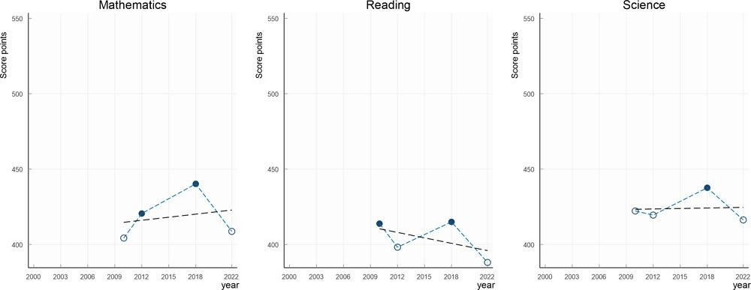

Figure 1.1.1, Malaysian PISA scores from 2010 to 2022

The question is, are our students getting smarter or are we sacrificing their foundational skills? These two issues are interconnected issues, caused by multiple factors.

This report proposes a solution, by examining how global teams contribute to addressing and solving these challenges.

Problem Statement

There are 2 problems listed in this report:

    - Shortened attention span of Malaysian Teenagers

    - Deteriorating Academic Performance of Malaysian Teenagers.

Attention span has correlation with academic performance. A study was conducted to examine the influence of short form videos on attention span and academic performance. The study found that heavy social media users have difficulty concentrating while also scoring
worse on their tests (Asif & Kazi, 2024).

Additionally, Malaysian global secondary education quality has been declining per the PISA statistics (OECD, 2023).

The problem faced by the global team in this situation is how can Malaysian teenagers sustain attention during the learning process while achieving stronger academic results per international standards?

The factors of these problems are curriculum, socioeconomic differences, availability of facilities and manpower, technology and upbringing (Malik, 2026). Malaysian secondary curriculum has always emphasised more on examination. The biggest test a Malaysian student faces, called the Malaysian Certificate of Education (SPM), is purely examination based. Richer individuals can provide quality education to their offsprings while poorer
students only have access to government education (Malik, 2026). Additionally, Malaysian

government schools are crowded. In a Parliamentary Session during January 2026, 18 schools in the state of Selangor were identified as critically congested (Harian Metro, 2026).

Today’s generation of teenagers are exposed to contents that negatively impact their attention span. The upbringing of parents also plays a role in a student's foundational skills and attention span.

Objectives of the Report

There are three objectives of this report:

    - To examine correlation of shortened attention span in Malaysian youths with the deterioration of their academic performance.
    - To examine how global teams develop a response plan to this challenge based on the context of Malaysian youths.
    - To evaluate the roles of different organizations in improving student engagement and academic performance

Scope of the Discussion

This report focuses on Malaysian teenagers in secondary school, from 13 year olds to 17 year olds that are affected by shortened attention spans and deteriorating academic performance. Although there is a correlation between the two issues, academic problems are complex and this report discusses the factors of academic problems beyond shortened attention span. The proposed solution will be presented through perspectives of global teams.

2.0 CONTEMPORARY CHALLENGES AND THE IMPORTANCE OF GLOBAL
TEAMS (Husaini)

Shortened Attention Span

Attention span is the amount of time someone can focus on an activity. There’s no clear way to quantify attention span, but there was a study in Munich on the effects of short form videos towards the ability to retain attention span. 60 participants were tasked to perform Prospective Memory tasks in specific intervals, where they are exposed to different digital media during breaks. The researchers found that TikTok exposed participants have the poorest performance on the tasks which concluded that rapid context switching causes impairment on prospective memory (Chiossi et al., 2023).

Historically, media consumption evolved from traditional media to digital media.

Traditional media needs sustained attention, but digital media provide rapid content switching which requires little engagement (Nhedzi, 2018).

However, attention spans are influenced by other factors such as motivation and task difficulty. The statements show the interaction between the modern media and shortening attention span.

Deteriorating Academic Performance

Malaysia scored below the OECD average in PISA, while also degrading in

performance compared to 2018. For reference, the OECD averages for three core subjects tested in PISA are (OECD, 2023):

PISA 2022 | Malaysia Score | OECD 2022 Score
Mathematics | 409 | 472
Reading | 388 | 476
Science | 416 | 485

Figure 2.2.1, Trends in Mathematics, Reading and Science OECD Test Performance in Malaysia

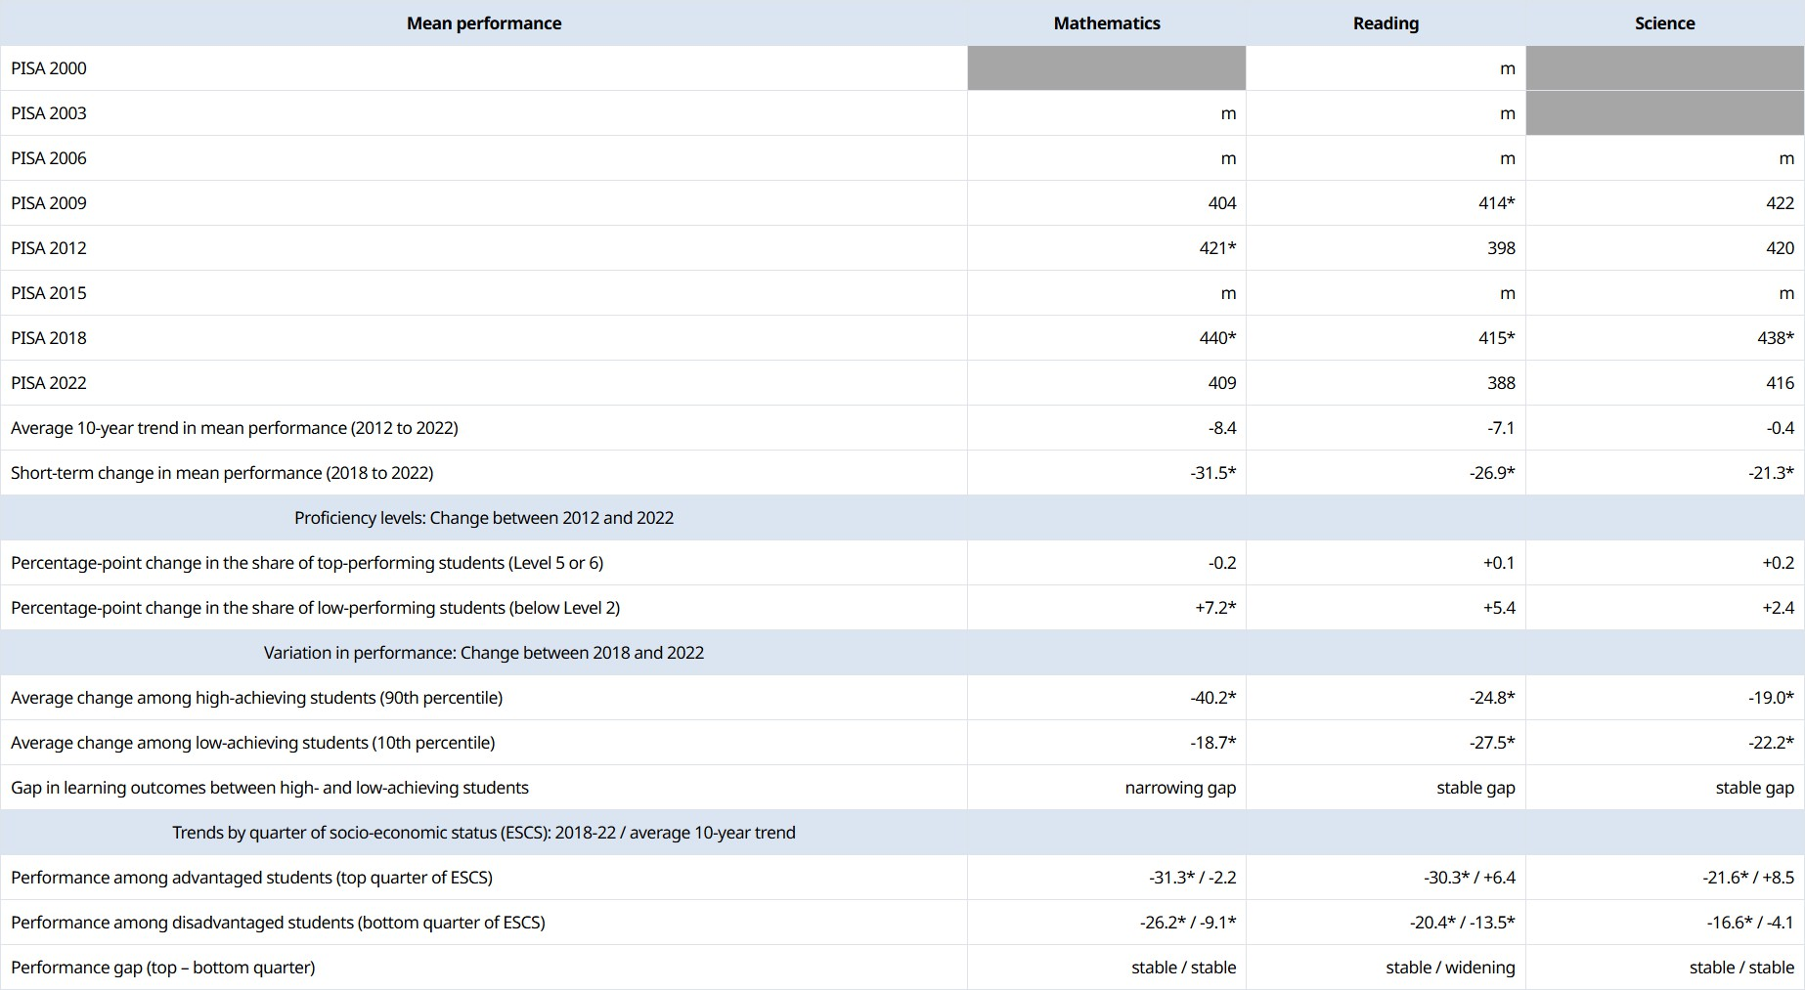

Figure 2.2.2, Snapshot of Mathematics, Reading and Science results for Malaysia

Less than half Malaysian teenagers (42% out of all 2022 Malaysian PISA takers) reached reading level 2 and above, the basic proficiency to interpret information. 24% of Malaysian students were in schools that had a lack of teaching staff and 22% were in schools reporting inadequately qualified teaching staff (OECD, 2023).

Global Trends and Statistics

Alternatively, Singapore, a company geographically close to Malaysia performed better in the 2022 PISA test. The distinctions between Singapore and Malaysia’s results are as follows (OECD, 2023):

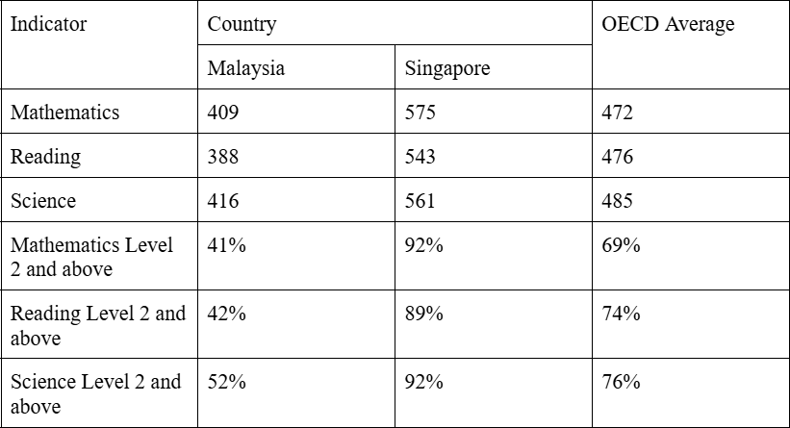

So why did this distinction happen?

Firstly, the socioeconomic status of average Singaporeans to average Malaysians as

the median monthly household income in 2024 for Singapore and Malaysia are US$8,400 and US$1,500 respectively which allow Singaporean families to access better educational
services (Department of Statistics Malaysia [DOSM], 2025)(Singapore Department of Statistics, 2024). Additionally, Singapore provides a professional-development roadmap for Singapore educators which makes educator skills more holistic (Academy of Singapore Teachers, 2026). Singapore has also integrated hybrid learning effectively via the Singapore Student Learning Space (SLS) (Government Technology Agency of Singapore, 2025).

Why It Is a Wicked Problem

Wicked problems are problems with no direct remedy, and solving them is constrained by real world challenges (Stony Brook University, 2023), in this case finding a solution to eradicate deteriorating academic performances and attention span in Malaysian youths.

The solutions for this issue is hurdled by constraints such as:

    - Costs

Adapting a smart learning system, 21st century learning would require a lot of costs.

    - Availability of Labour

Employment of Malaysian Educators has shown a trend of high turnover rate, with an average of 5,594 educators choosing to retire early between 2022 to 2024 (Radio Televisyen Malaysia [RTM], 2025) .
    - Availability of Facilities

In 2023, the Ministry of Education (MOE) reported 42.6% of government schools had a functioning ICT device-to-student ratio of 1:10. 42.6% of government schools are
incapable of conducting hybrid-learning models

    - Economic condition of Malaysians

Higher tax is needed for new changes. Malaysians tend to oppose higher taxes when it affects their cost of living. In 2025 out of 1,605 Malaysians 53% considered cost of living as their biggest concern (The Star, 2025) .
    - Current education quality and capabilities of Malaysian students

Malaysia’s education system mainly focuses on test based assessment. Parents'

upbringing and primary school education does not prepare students for an education that places greater emphasis on critical thinking.

Why Global Teams Are Needed

This issue can be traced back to the Malaysian education system. Assigning an international team can help by getting a perspective on the problem from the lenses of non-Malaysians, while also finding out how other countries manage the issue of shortened attention span among their youths.

DESIGN THINKING IN EFFECTIVE PROBLEM SOLVING (Eswaran)

Digital Technology and Social Media

With regards to short attention span and deteriorating academic performance, digital technology, especially social media, is a root cause via dopaminergic feedback loops.
Fast-paced micro-content and short-form videos such as TikTok and instagram reels and youtube shorts, have been continuously conditioning youth to expect continuous visual
simulation. Over time, continuous exposure to these videos shrink the cognitive stamina and focus required for long-form reading and problem solving. This overload of the ventral striatum, the brain’s primary reward center, weakens prefrontal executive functioning
(Volkow et al.; Twenge et al.,2018).

Continuous partial focus is prevalent among Malaysian youth who engage in

mutli-screening (i.e. studying while scrolling social media), leading to cognitive overload and fragmented focus (Shanmugasundaram & Tamilarasu, 2023). Also, the “infinite scroll”
feature of social media apps have kept students scrolling social media endlessly throughout the night, hindering their sleep (Kee et al., 2025).

Educational System Challenges

The Malaysian educational system is another root cause of the above issues. The Malaysian National Education system which is heavily exam-centric has failed in captivating modern screen-raised learners used to lively interactive media.

Due to budget constraints, the Malaysian educational system’s performance is also bottlenecked. Unlike high spending Organisation for Economic Co-operation and Development (OECD) education systems like that of Finland and Norway, where the overall educational budget where a minimum of USD 126,000 per student is allotted, the Malaysian public schools face resource constraints, leading to overcrowded classrooms (often 35–40 students per class) as well as uneven digital infrastructure across urban and rural schools (OECD, 2023).
Also, the Malaysian education system, unlike the European Education model, lacks the emphasis on formative assessments and flexible learning pathways that have been known to effectively facilitate and encourage varying cognitive paces, ultimately boosting the education performance of young students.

Psychological and Behavioural Factors

Furthermore, prolonged social media usage has also resulted in several psychological and behavioral factors. For instance, adolescents, known to possess an underdeveloped prefrontal cortex, have been left vulnerable towards impulsive social media checking and procrastination.
Such compulsive “doom-scrolling”behaviour leads to excessive late night screen exposure, suppressing melatonin production and disrupting REM sleep; vital for cognitive recovery and long-term memory consolidation. Without adequate rest and memory consolidation, high schooler’s performance has a higher chance of deteriorating over time.

Societal and Cultural Influences

Despite the above root causes, one cannot dismiss the societal and cultural effects of Malaysian parenting on the educational development and education performance of young adults. In most modern Malaysian dual-income households, work stress and high work demands have frequently driven parents to resort to the usage of smartphones and tablets as “digital pacifiers” from early childhood. Such un-supervised screen time has unintentionally fostered a habitual reliance on smartphones, as well as embedding screen addiction into the lives of young students.

DESIGN THINKING AS A PROBLEM-SOLVING APPROACH (Eswaran)

Empathise and Wicked Problem

Our wicked problem stems from refusing to frame the issue as inherent student laziness, but instead as an issue stemming from the environment of digital saturation colliding with outdated instructional methods. This issue is truly a wicked problem, as there are a variety of roots to this issue as stated earlier and there isn't a single fixed solution to this issue.

In order to empathise with the Malaysian community and our sample; the Malaysian high school students, we have centered our research and data retrieval to be based on conducting qualitative interviews with high school students. Digital habit tracking of our sample’s smartphone usage will also be implemented, ethically by securing parental consent for minors. Such data collection will also comply strictly with the Malaysian PDPA 2010, collecting only fully anonymized screen-time metrics without personal data or private messages.

Define

Allow me to redefine the core problem statement; ”How do redesign the high school education delivery in Malaysia to ensure that digital-native students retain complex concepts and improve overall academic performance despite shortened attention spans?”

Ideate

Using our current global teams, we have collected regional educational philosophies of their distinct regions to be incorporated into the current Malaysian syllabus. For example, the Western / European perspective, we learnt to incorporate more high formative assessment, which allow individual cognitive spacing as well as holistic competence frameworks to assess the academic performance of the high schooler, rather than only focusing 100% on written
exams (OECD, 2020; Finnish National Agency for Education, 2016).

Our eastern/asian team members placed importance on rigorous foundational skill building and collaborative group accountability models (Tan, 2017), to ensure consistent academic progress and performance.
Next, upon gathering the above info, team members will conduct the relevant
cross-national comparative analysis. This will be able to generate nuanced insights on how cultural norms shape technology adoption and learning habits (Hofstede et al., 2010; UNESCO, 2021).

Prototype

Our Prototype is a hybrid learning module which also combines usage of a dedicated smartphone app for smartphone integrated learning. A low-fidelity prototype of this hybrid curriculum will be developed and will contain short asynchronous video lessons, interactive quizzes, and synchronous in-person team challenges. The app will also have gamified
immediate visual feedback, and progress tracking to mimic social media reward mechanisms for educational goals to keep students engaged. This app can also lock social media apps, ensuring students only use the smartphone for learning permissions.

Test

The pilot testing for our prototypes will be done across classrooms in diverse school environments (i.e. city vs village Malaysian schools), to measure focus retention via short quiz scores as well as student feedback on how engaging the classes were.

The Beta version of the Smartphone app will also be released for nationwide testing and promoted in all Malaysian high schools. The usage and installation of this smartphone app is to be facilitated by the high schooler’s parents.

Proposed Solutions

Other than the proposed solution of the hybrid-teaching curriculum and smartphone application, we intend to emulate the recent policy shift in Finland, where Bring Your Own Device (BYOD) is encouraged for structured, teacher-guided learning tasks all while restricting social media usage.
Another proposed solution is to guide parents to install third-party automated app-blocking applications in their children’s smartphones , which block social media use during at home studying hours, to manage "doom-scrolling" tendencies constructively.
With all the above efforts, we are confident to arrive at an amicable set of practical solutions to address our wicked problems.

THE ROLE OF GLOBAL TEAMS IN SOLVING THE PROBLEM (Muqri)

Importance of Global Collaboration

A single educational system cannot adequately address the complex problem of shortened attention spans and declining academic performance. Solutions should be considered internationally because digital technology, educational practices, cultural norms, and socioeconomic conditions differ across countries. This is particularly relevant to Malaysia, where PISA 2022 results showed declines in reading, science, and mathematics
performance compared with 2018 (OECD, 2023a). International comparison therefore allows Malaysian educators and policymakers to examine strategies used elsewhere and identify
approaches that can be adapted to local conditions.

International cooperation also enables countries to evaluate both successful and unsuccessful practices. Finland, for example, reconsidered its use of digital devices after
teachers identified them as contributing to distraction and reduced concentration, leading one school district to increase the use of traditional books in 2024 (Reuters, 2024). This
demonstrates why global teams should not simply copy another country's education system.
Instead, they can compare evidence, identify contextual differences, and select suitable
elements for a hybrid education model. Similarly, UNESCO (2023) argues that technology should support human interaction in education rather than replace it.

Interdisciplinary Thinking

The effectiveness of global collaboration can be strengthened through interdisciplinary thinking. Shortened attention spans are influenced by psychological, technological, social, and cultural factors, making it more than an educational issue. Therefore, an effective international team could involve educators, psychologists, technology specialists, policymakers, and social scientists.
Each discipline provides a different perspective. Psychologists can examine attention and motivation, while educators can evaluate curriculum and teaching strategies. Technology specialists can assess how digital tools can support learning without increasing distraction,
while policymakers can consider costs, regulations, and practical implementation. Social
scientists can examine how socioeconomic inequalities and cultural norms influence students' behaviour.
This approach reduces the risk of solving one aspect of the problem while creating another. UNESCO (2023), for example, emphasises that educational technology should be evaluated according to its relevance, equity, sustainability, and effectiveness. Therefore, interdisciplinary global teams can help develop a hybrid model that combines technological innovation with evidence-based teaching and human interaction.

Leadership in Global Teams

Effective leadership is essential because diversity within global teams can produce both creativity and conflict. Leaders must manage members with different cultural and professional backgrounds while ensuring that no single country's educational philosophy dominates the discussion. Instead, leaders should establish shared goals and create an environment where different perspectives can be evaluated fairly.
Effective leadership should involve communication, delegation, negotiation, and evidence-based decision-making. Leaders must also consider whether solutions developed in wealthier countries are financially and culturally suitable for Malaysia. Therefore, a successful global leader should act as a facilitator who combines different perspectives
towards a common objective. This supports UNESCO's (2023) recommendation that educational decisions consider learners' needs, teacher and student experiences, and national and local contexts.

Emotional Intelligence in Team Collaboration

Emotional intelligence (EI) is particularly important when individuals from different cultural and professional backgrounds work together. Differences in communication styles and cultural expectations can cause disagreements to become personal if they are not managed effectively.
Team members with strong EI can recognise and regulate their emotions, empathise with others, and maintain positive relationships. This allows disagreement to be treated as a difference in perspective rather than personal rejection. Davaei et al. (2022) found that emotional and cultural intelligence reduced interpersonal, task, and process conflict in 232 global virtual teams involving students from 38 countries.

Therefore, EI can help international teams maintain psychological safety while encouraging members to challenge ideas constructively. This is particularly important when developing a hybrid education model, where members may disagree about the balance between traditional classroom teaching and digital learning.

Managing Conflict and Decision-Making

Global teams offer diverse perspectives, but differences in language, culture, communication styles, and professional priorities can create conflict. Effective conflict management is therefore necessary for productive decision-making.
Teams should establish shared objectives and evaluate suggestions according to agreed criteria such as effectiveness, cost, inclusiveness, and cultural suitability. Active listening and clarification can also reduce misunderstandings. Cultural intelligence is particularly useful because it can reduce conflict and differences in conflict perceptions within international virtual teams (Johnson et al., 2024).
The objective should therefore not be to eliminate disagreement. Constructive task disagreement can improve ideas, whereas poorly managed interpersonal and process conflict can reduce team performance. Effective global collaboration requires the ability to manage differences constructively.

CRITICAL EVALUATION OF THE PROPOSED SOLUTIONS (Muqri)

Advantages of Global Team Collaboration

The main advantage of global teamwork is access to a wider range of knowledge and experiences. International teams can examine educational strategies used in different
countries and assess their suitability for addressing shortened attention spans and declining academic performance. This encourages innovation while reducing dependence on the
assumptions of one country.

Global collaboration also promotes cultural adaptability. Rather than creating a universal solution, team members can identify which elements of a hybrid education model can be transferred and which require modification. This is important for Malaysia because educational strategies must consider local infrastructure, cultural expectations, and
socioeconomic differences.

Furthermore, international comparison supports evidence-based decision-making. The OECD's PISA programme provides comparative data on educational performance across
countries (OECD, 2023a). Global teams can therefore combine international evidence with local knowledge when developing and evaluating educational interventions.

Challenges and Limitations

Despite these advantages, global collaboration has limitations. An intervention that succeeds in one education system may not produce the same results elsewhere because of differences in culture, infrastructure, resources, and educational priorities. UNESCO (2023) therefore stresses that technology-based solutions must be appropriate to national and local contexts.

International teams may also experience language barriers, cultural misunderstandings, unequal participation, time-zone differences, and conflicting professional priorities. Members from wealthier countries may additionally have greater influence because of their access to more advanced technologies and resources.
Consequently, the proposed hybrid model should not be viewed as a simple combination of international education systems. Instead, global teams should identify evidence-based practices, assess their suitability for Malaysia, and test them before wider implementation.

Real-World Examples and Best Practices

International experience demonstrates the importance of balance when using educational technology. Finland provides an example of reassessing digitalisation after
teachers observed that digital devices could negatively affect students' concentration. In 2024, schools in Riihimäki increased their use of traditional books in response to concerns about distraction (Reuters, 2024). Although this does not mean technology is inherently harmful, it highlights the importance of evaluating how technology is used within specific learning environments.
UNESCO (2023) similarly argues that technology should be learner-centred, evidence-based, equitable, and sustainable while strengthening rather than replacing human interaction. Therefore, the most appropriate approach is not to choose completely between traditional and digital education. Instead, global teams should identify where technology genuinely improves learning while retaining teaching practices that support concentration, social interaction, and deeper learning.

ETHICAL CONSIDERATIONS (Afiq)

Ethical Use of AI and technology in Education (Current Situation)

Artificial Intelligence (A.I.) must be a tool to enhance learning by generating a new pathway for students to obtain information, and not to simplify tasks till their real
responsibilities are forgotten. According to D.K (2026), Malaysia is facing a digital focus

crisis as the country ranks among the most AI-enthusiastic nations globally, which attracts the attention of educators and academicians of this severe decline.
Taylor’s College (2025), once highlighted that Malaysian youth are heavily experiencing "cognitive overload" due to hyper-fast, algorithmically driven content, leading 8
- seconds of attention span lost on average. Short span entertainment such as reels, short videos, micro-dramas and vertical series are commonly engaged with, drastically diminishing academic classroom focus. Duration being spent can clearly be determined through the capability for them in paying attention during class. It displaces the cognitive investments in slow-paced, beneficial activities like reading or sports.

This decline often begins in early childhood. A Universiti Kebangsaan Malaysia (UKM) study reported by Malay Mail (2026) revealed that 80% of children aged 9 to 12 failed basic mathematical reasoning. Instead of solving it mentally, they relied on calculators and ChatGPT.

Combating this crisis demands global collaboration. It is because modern education requires a diverse cognitive framework that a single nation cannot solve these digital
challenges alone.

Privacy and Data Protection

Data privacy and protection are deeply connected to the attention span because AI companies use data collection to manipulate user behavior. AI platforms may track every interaction, such as homework queries to predict physiological triggers, delivering a
hyper-personalized answer. This intense engagement interrupts focus as answers are easily accessible at home, then disengaged the students during class. Amburgey (2025), notes that young users may share too much information, enabling AI to understand and hook their attention.
This excessive usage of AI causes a cognitive decline known as “cognitive offloading”, reducing one’s critical thinking and problem solving capability. Students are heavily impacted with these consequences. Instead of trying to answer the question, students would just copy and paste them into ChatGPT. Barcaui (2025) had also stated a research which says, students using AI tools to assist their learning scored 57.5% on long-term retention tests 45 days later, compared to 68.5% for non-AI users. Consequently, the younger generation faces severe interpersonal skills, including professional communication, writing and decision-making. In overall, this attention drops not from a lack of student intelligence, but from the unethical use of AI tools.

Digital Inequality

Digital accessibility is ensuring all learners, including those with permanent or temporary disabilities can engage with educational technology and course materials. In Malaysia, access is divided across B40, M40 and T20 income groups. B40s are commonly found in rural villages with certain technology limitations.
The Ministry of Education Malaysia (MOE) conducted a survey in March 2020, revealing that only 9% of students from 900, 000 pupils had a personal computer and tablet, while 36.9% didn't have any. This digital divide shows the nation was unprepared to shift into a digital education environment. It caused the students to lose their academic focus, fall behind and finally disengage from education.
However, for those who had device, they were engineered as a fast-paced information giver that causes mental fatigue, making long form textbook reading feel intolerable. Students tend to lose focus during class, due to “cognitive offloading” induced by AI, including chatbots. Taylor’s College (2025), stated that platforms that serve sped-up content, influence
the viewer’s focus ability, dropping student attention spans to an average of eight seconds. To support this, McQuiston (2025) highlighted that USC report revealing that AI is used by
college students for quick answers, instead of conceptual learning.

RECOMMENDATIONS (Afiq)

Recommendations for Governments

Governments must shift from merely distributing devices to constructing a regulated, human-centered digital education policies. By collaborating proactively with global bodies
like (UNESCO), the Malaysian government can leverage frameworks such as the Global Education Monitoring Report and Guidelines on AI. It highly focuses on a rights-based approach to GenAI in classrooms, while preventing the “AI divide”, to protect student data rights.
This attention span issue is directly aligned with Sustainable Development Goal 4

(SDG 4) which promotes equitable and education quality by 2030. A research highlights that concentration and attentiveness has gained increasing attention from most of the educators and academic people, (Rajeswari et al., 2025, p.2), proving that education quality is attached towards students attention span.

Recommendations for Educational Institutions

Local educational institutions must shoulder their responsibility by responding to the national policies such as Digital Education Policy (DEP) 2023 - 2030. Specifically,
institutions must enforce Strategic Thrust 1 (digital literate students), focuses ethical digital citizenship, and Thrust 4 (infrastructure enablement) addresses devices and Internet equity. These efforts navigate students toward deep learning rather than passive scrolling.

Furthermore, institutions should implement global frameworks, such as the OECD Digital Education Outlook. As excessive AI usage could decrease critical thinking, the OECD offers a model to co-design AI as an augmenting partner rather than a task replacement. As
Paule (2026) notes, “Offloading cognitive work to chatbots can lead to “metacognitive laziness”, reducing engagement and long-term skill development.

Recommendations for Parents and Students

For parents, they could integrate AI into their children's world without compromising their academic performances. Firstly, practice “Think First, Ask Second, Verify Third” at home, shifting from a strict surveillance to a shared exploration. For instance, attempt a problem independently first, then reconfirm it with AI.
Next, set a “Never-share Rules’, as a data protection initiative at family level. Parents must teach the children to not take any photo, or sensitive information on any AI platform.
Simultaneously, this would cut off the level of engagement between the AI with them. According to EdCircuit (2026), family rules must stay short, such as using AI to explore ideas, not to finish the school homework.

Recommendations for Technology Companies

Beyond education institutions, technology companies must also comply with

regulations established by higher authorities to ensure youth have safe digital access along with their actual needs.
For instance, the United Kingdom’s Information Commissioner's Office (ICO) has designed a standard that contains 15 statutory standards for software that is likely to be accessed by a person under 18. Crucially, Standard 13 forbids companies from using harmful “nudge techniques”, preventing data manipulation and exploitation.

Additionally, organizations including Center for Humane Technology (CHT), focuses on shifting tech company business models from engagement driven profit into prioritizing human well-being. Ultimately, these global frameworks prove that protecting students
requires accountability from both ends. Tech companies provide an ethical platform, while educational institutions ensure AI serves as a partner learner, not a shortcut.

Future Directions

In future, AI platforms should be able to customize courses and lesson plans by aligning with a student’s specific tone and suitable answer format. This allows it to deliver friendly and engaging answers tailored to individual needs. Furthermore, AI must be a tool to protect students from dropping out, as the risk is frequently driven by fragmented attention span and digital inequality. Besides that, governments may implement AI-powered early warning systems to monitor learning patterns, identify any student at risk, and deploy time
interventions before they are completely disengaged.

CONCLUSION (Afiq)

In conclusion, addressing the digital focus requires a systemic accountability across all sectors. While global bodies such as UNESCO and the OECD structure frameworks,
Malaysia relies on successful implementation of DEP 2023 - 2030 and active cooperation between governments, educational institutions, tech companies and families. Then, turning AI from a shortcut into a human centered learning partner is paramount. By prioritizing strict data protections and utilizing proactive, stakeholders may safeguard student attention spans, and continuously cultivate the minds of future generations

INDIVIDUAL REFLECTIONS

Reflection (Husaini)

Descriptions

My task was to conduct research on the issue of shortened attention span and deteriorating academic performance of Malaysian teenagers (aged 13-17). I was struggling due to the complexity of quantifying the severity of the issues, but I applied OECD PISA and used research on prospective memory, to get a proper indicator for the problems.

Feelings

I initially felt overwhelmed because the topic is too broad. However, after discussing with my group members, I managed to limit my findings to a relevant scope.

Evaluation

I helped the team by providing a clearer understanding of our report. Using PISA helps to evaluate Malaysian education internationally and the research helps provide
perspective on how technology affects attention span. However, I spent too much time on attention span.

Analysis

This happened due to the inherent nature of wicked problems and the broadness of the topic of education, which causes too much time for research.

Conclusion

In the end, I learned that for a team to be able to commit to a work effectively, a proper scope and definition of problem are needed to ensure a proper workflow is maintained.

Action Plan

In future projects, I will create a proper workflow plan for brainstorming to reduce time waste on finding non-relevant information. Additionally, I will create a proper time allocation chart for myself so I can complete my part faster, allowing better quality control of my work.

Reflection (Eswaran)

Description
At the start of this module, my primary task was to analyze the root cause of shortened attention spans and the declining academic performance of Malaysian High School Students and to apply the 5 stages of design thinking to design practical actionable hybrid learning solutions for Malaysian high school.

Feelings

Initially, I was overwhelmed by the complexity of the issue presented to me. Indeed reconciling the current rigid Malaysian educational structure with the current rapidly evolving digital behaviour felt like an insurmountable task. Luckily, applying design thinking and team brainstorming meetings provided the necessary clarity and structure for me to complete my tasks.
Evaluation + Analysis

What worked well for my team were the weekly meetings, used to ensure consistent progress and enable group members to voice out difficulties and seek support. At times
there were disagreements as to the ideas that should be implemented in the report, but with active listening and constructive peer feedback, we managed to synergise our ideas towards the intended solutions. Not to mention, we have been team members in almost all modules offered this semester, hence we have a base level of synergy we have built over time. This synergy has been the primary reason we managed to execute this project very well, despite delays in keeping up with our initial deadline.

Conclusion

The design thinking process demonstrated that complex educational challenges, which is a wicked problem in our case, cannot be solved with a single solution. The best approach is using Design Thinking to deconstruct multifaceted (“wicked”) problems into practical, manageable - user-centred solution stages.

Action Plan

In future collaborative projects, I’d like to ensure that we stick to our initial

deadlines more strictly to prevent any unwarranted last minute complications with the assignment prep. Also, I’ll prefer to implement the prototyping and testing phases earlier in the group planning process to gauge solution feasibility quickly before finalizing written report proposals.

Reflection (Muqri)

Description

Our group collaborated through Google Meet and WhatsApp. I contributed by helping with task delegation, identifying relevant countries and examples, and monitoring deadlines. Contributions were generally balanced, with frequent discussions about ideas. We had minor disagreements about the use of Kamus Dewan language and AI integration, but these were resolved through discussion.

Feelings

Initially, I felt that organisation would be important because members were managing assignments from different subjects. I therefore felt responsible for helping establish clear tasks and deadlines. I was also comfortable sharing my opinions because
members were generally receptive. Although disagreements occurred, they did not become personal.

Evaluation

A major strength was the group's willingness to support one another. Members generally responded positively to suggestions, making delegation and decision-making easier. My involvement in task delegation and deadline management also helped maintain structure. However, our meetings could have been more frequent, as conflicting academic responsibilities sometimes made progress discussions difficult.

Analysis

This experience demonstrated the importance of respectful communication and emotional intelligence in teamwork. The disagreement regarding AI integration showed that different opinions do not necessarily create conflict; when members listen to one another, disagreement can contribute to better decisions. I also learned that effective delegation
requires consideration of members' abilities, availability, and workload rather than simply assigning tasks.

Conclusion

Overall, our team functioned effectively because members communicated openly, respected different opinions, and contributed fairly. However, more regular progress
meetings could have improved our organisation. I learned that successful collaboration requires both individual effort and continued accountability towards the group.

Action Plan

In future group projects, I would organise shorter but more frequent meetings and establish intermediate deadlines rather than relying mainly on the final submission date. I would continue using platforms such as Google Meet and WhatsApp while regularly reviewing task progress. I would also maintain the group's respectful communication style while taking earlier action when delays or lack of engagement occur.

Reflection (Afiq)

Descriptions

Two months were given to complete the assignment. Everything went smooth, all
tasks delegated equally among the 4 team members including me. We agreed to schedule a 1 month earlier submission deadline, giving us plenty of time to recheck and improve our writing afterwards. As everyone came from different courses and commitment, we missed it.

Feelings

At first, a bit of disappointment surrounded myself because things could be done way earlier and this had burdened all the team members. It badly impacts everyone to rush and particular at the same time toward completing their own part.

Evaluation

However, we tackled this matter swiftly by conducting an online discussion via

Google Meet. We realigned our objective, working flow and set up a new deadline which is 10 days earlier. The meeting was a buffer for everyone to visualize the things that must be done to complete the assignment.

Analysis

This taught us that time management is paramount in an assignment. It showed that inefficient time management would affect the whole group. It would create pressure, miscommunication and interrupt the overall progress.

Conclusion

Finally, everyone got their part settled right on time. I believe that every challenge that happens indicates a room of improvement personally to all the members. It is because this lesson could be applied for other assignments in future. Additionally, every team member must be on the same page and encouraged to obtain achievement together.

Action Plan

As part of the team, I should have taken my responsibilities more seriously. For example, I must schedule a timely work check for every assignment, so that I am able to see the one that needs my attention more. Besides, I would inform my leader regarding every
progress completed, then only he or she will know when to follow up with me if I fall behind the process.

REFERENCES

-Academy of Singapore Teachers. (2026, July 28). Teacher Growth Model. https://academyofsingaporeteachers.moe.edu.sg/professional-excellence/teacher-gro wth-model/
Australian School of Abu Dhabi. (2026). Navigating AI as a family: AI guide for parents. https://australianschool.ae/ai-guide-for-parents/
Davaei, M., Gunkel, M., Veglio, V., & Taras, V. (2022). The influence of cultural

intelligence and emotional intelligence on conflict occurrence and performance in global virtual teams. Journal of International Management, 28(4), 100969. https://doi.org/10.1016/j.intman.2022.100969
Department of Statistics Malaysia. (2025). Household income survey report, Malaysia & states, 2024.
https://www.dosm.gov.my/portal-main/release-content/household-income-survey-re port--malaysia--states-2024
EdCircuit Staff. (2026, August 5). AI for students: A parent's guide by age. edCircuit. https://edcircuit.com/ai-for-students-a-parents-guide-by-age/
Finnish National Agency for Education. (2016). National core curriculum for basic education 2014.
Government Technology Agency of Singapore. (2025, September 26). Student Learning Space (SLS).
https://www.tech.gov.sg/products-and-services/for-citizens/education/student-learni ng-space/

Harian Metro. (2026, January 24). Isu sekolah padat: KPM lulus segera bina bilik darjah tambahan di Selangor.
https://www.hmetro.com.my/mutakhir/2026/01/1314965/isu-sekolah-padat-kpm-lul us-segera-bina-bilik-darjah-tambahan-di-selangor
Hofstede, G., Hofstede, G. J., & Minkov, M. (2010). Cultures and organizations: Software of the mind (3rd ed.). McGraw-Hill Education.
Johnson, W. H. A., Dong, L., Li, M. L., & Taras, V. (2024). Transcending conflict in global virtual teams: Multi-level effects of cultural intelligence and perceptions of conflict on subjective and objective outcomes. Journal of International Management. https://doi.org/10.1016/j.intman.2024.101219
Kee, D. M. H., Tai, J. C. Q., Ng, I. S. Q., & Parameswaran, K. (2025). From scroll to struggle: Social media usage and its impact on Malaysian youth attention and academic focus. Asia Pacific Journal of Management and Education, 8(3), 390–406. https://doi.org/10.32535/apjme.v8i3.4266
Liao, C.-H. (2023). Exploring the influence of public perception of mass media usage and attitudes towards mass media news on altruistic behavior. Behavioral Sciences, 13(8), 621. https://doi.org/10.3390/bs13080621
Malik, M. (2026, June 16). In Malaysia's education system, the problem is more than examinations. Sinar Daily.
https://www.sinardaily.my/article/737018/opinions/letters/in-malaysias-education-sy stem-the-problem-is-more-than-examinations

McQuiston, P. (2025, September 18). AI is changing how students learn — or avoid learning. USC Today.
https://today.usc.edu/ai-is-changing-how-students-learn-or-avoid-learning/

Nhedzi, A. (2018). The relationship between traditional and digital media as an influence on generational consumer preference. Communitas, 23, 18–38. https://doi.org/10.38140/com.v23i0.3718
OECD. (2020). Education Policy Outlook: Competence frameworks and formative assessment in Europe. OECD Publishing.
OECD. (2023a). PISA 2022 results (Volume I): The state of learning and equity in education. OECD Publishing. https://doi.org/10.1787/53f23881-en
OECD. (2023b). PISA 2022 results (Volume II): Learning during—and from—disruption.
OECD Publishing.

OECD. (2023c). PISA 2022 results (Volume I and II): Country notes—Malaysia. OECD.
https://www.oecd.org/en/publications/pisa-2022-results-volume-i-and-ii-country-not es_ed6fbcc5-en/malaysia_1dbe2061-en.html
OECD. (2023d). PISA 2022 results (Volume I and II): Country notes—Singapore. OECD.
https://www.oecd.org/en/publications/pisa-2022-results-volume-i-and-ii-country-not es_ed6fbcc5-en/singapore_2f72624e-en.html
Paule, L. G. (2026, February 3). OECD Digital Education Outlook 2026: How generative AI can support learning when used with purpose. Digital Skills and Jobs Platform. https://digital-skills-jobs.europa.eu/en/latest/news/oecd-digital-education-outlook-2 026-how-generative-ai-can-support-learning-when-used

Radio Televisyen Malaysia. (2025). KPM laksana pelbagai inisiatif tangani isu kekurangan guru. RTM.
https://berita.rtm.gov.my/nasional/senarai-berita-nasional/senarai-artikel/kpm-laksan a-pelbagai-inisiatif-tangani-isu-kekurangan-guru/
Ravi, I. (2025, October 3). The 8-second attention span generation: Childhood in digital overload. Taylor's College.
https://college.taylors.edu.my/en/student-life/news/2025/the-8-second-attention-spa n-generation-childhood-in-digital-overload.html
Reuters. (2024, September 11). Books, screens out: Some Finnish pupils go back to paper after tech push.
Shanmugasundaram, M., & Tamilarasu, A. (2023). The impact of multi-screening and social media usage on cognitive overload and academic focus among youth. Journal of Educational Psychology and Pedagogy, 15(2), 112–128.
Singapore Department of Statistics. (2024). [SingStat Table Builder table M810361].
Singapore Department of Statistics. https://tablebuilder.singstat.gov.sg/table/TS/M810361
Stony Brook University. (2023). What's a wicked problem? Stony Brook University.
https://www.stonybrook.edu/commcms/wicked-problem/about/What-is-a-wicked-pr oblem
Tan, C. (2017). Instructional leadership and Asian educational models: Rigorous skill-building and collaborative accountability. Springer.

The Star. (2025, July 26). Only 40% of Malaysians believe country is on the right track, says survey. The Star.
https://www.thestar.com.my/news/nation/2025/07/26/only-40-of-malaysians-believe
-country-is-on-the-right-track-says-survey

Twenge, J. M., Martin, G. N., & Campbell, W. K. (2018). Decreases in psychological well-being among American adolescents after 2012 and links to screen time: Analysis of monitoring the future data. Emotion, 18(6), 765–780. https://doi.org/10.1037/emo0000403
UNESCO. (2021). Technology in education: A global comparison of digital learning, cultural norms, and student habits. UNESCO Publishing.
UNESCO. (2023). Global education monitoring report 2023: Technology in education: A tool on whose terms? UNESCO.
United Nations Educational, Scientific and Cultural Organization. (2025, September 4). AI and education: Protecting the rights of learners. UNESCO.
https://www.unesco.org/en/articles/ai-and-education-protecting-rights-learners

Volkow, N. D., Wise, R. A., & Baler, R. (2017). The dopamine motive system: Implications for drug and food addiction. Nature Reviews Neuroscience, 18(12), 741–752. https://doi.org/10.1038/nrn.2017.130

APPENDIX

STUDENT FEEDBACK FORM
This section details the extent to which the assessment criteria are demonstrated by you, which in turn determines your mark. The marks available for each category of skill are shown. Lecturers will use the space provided to comment on the achievement of the task(s), including those areas in which you have performed well and areas that would benefit from development/improvement.

Generic Assessment Criteria | Marks available | Marks awarded
1. Engagement with Literature Skills | 10
2. Knowledge and Understanding Skills | 30
3. Cognitive and Intellectual Skills | 15

4. Practical Application Skills | 15
5. Transferable Skills for Life and Professional Practice | 30

Assessment Mark (Assessment marks are  subject to ratification by the Exam Board. | Late Submission Penalties (tick if  appropriate) |  | %
These comments and marks are intended to provide feedback on module work and are  for guidance only until they are confirmed.) | Up to 1 week late (40% Max) |  | %
 | Over 1 week late (0%) |  | %

52

GENERIC ASSESSMENT CRITERIA

Level 4
In accordance with the Framework for Higher Education Qualifications, at the end of Level 4, students will be expected to have demonstrated knowledge of the basic underlying concepts and principles of a subject, and an ability to evaluate and interpret these within the context of that area of study. They should be able to present, evaluate and interpret qualitative and quantitative data to develop lines of argument and make sound judgments in accordance with basic theories and concepts of their subject(s) of study. They will have learned how to evaluate different approaches to solving problems, and will be able to communicate the results of their study/work accurately and reliably, and with structured and coherent arguments. They will be able to undertake further training and develop new skills within a structured and managed environment,
and will have the qualities and transferable skills necessary for employment requiring the exercise of some personal responsibility.

Level 4 | FAIL | MARGINAL FAIL | SATISFACTORY  (3rd / Pass) | GOOD  (2.2 / Pass) | VERY GOOD  (2.1 / Merit) | EXCELLENT  (1st / Distinction) | EXCEPTIONAL  (1st / Distinction)
Category | 0-29% | 30-39% | 40-49% | 50-59% | 60-69% | 70-84% | 85-100%
Engagement with literature (including reading, referencing,  academic  conventions and | Little or no evidence of reading and/or  reliance on  inappropriate sources.  Views and findings mostly | Poor engagement with essential reading. No  evidence of wider reading.  Reliance on  inappropriate sources, and/or indiscriminate | Engagement with a limited range of mostly relevant and credible sources, but with  some reliance on information gained through class contact. Some | Engagemen t with an  appropriate range of literature, including  sources retrieved independen tly. Some | Engagement with a wide range of literature, including  sources retrieved independently.  Selection of relevant and | Engagement with an extensive  range of relevant and credible literature.  Consistently accurate application of referencing. | Exceptional engagement with an extensive range of relevant and  credible literature. High-level referencing skills consistently applied.

Level 4 | FAIL | MARGINAL FAIL | SATISFACTORY  (3rd / Pass) | GOOD  (2.2 / Pass) | VERY GOOD  (2.1 / Merit) | EXCELLENT  (1st / Distinction) | EXCEPTIONAL  (1st / Distinction)
Category | 0-29% | 30-39% | 40-49% | 50-59% | 60-69% | 70-84% | 85-100%
academic honesty) | unsupported and  non-authorita tive.  Referencing conventions are used incoherently or are largely absent. | use of sources. Heavily reliant on information gained through class contact. Inconsistent and weak use of referencing. | omissions and minor errors.  Referencing  conventions are evident, though not always applied accurately or consistently. | over-relian ce on texts rather than other sources.  Referencin g may  show minor inaccuracie s or inconsisten  cies. | credible sources. Generally sound referencing, with no/very few  inaccuracies or inconsistencies.

Level 4 | FAIL | MARGINAL FAIL | SATISFACTORY  (3rd / Pass) | GOOD  (2.2 / Pass) | VERY GOOD  (2.1 / Merit) | EXCELLENT  (1st / Distinction) | EXCEPTIONAL  (1st / Distinction)
Category | 0-29% | 30-39% | 40-49% | 50-59% | 60-69% | 70-84% | 85-100%
Knowledge and understandin g (Knowledge of the basic underlying  concepts and principles of a subject.) | Major gaps in knowledge and understandin g of the basic underlying  concepts and principles of the subject matter.  Inclusion of  irrelevant | Gaps in  knowledge of the basic underlying  concepts and principles, with a flawed or superficial understanding.  Some significant inaccuracies | Limited knowledge and understanding of the basic underlying  concepts and  principles within the subject area. Some elements may be missing. | Knowledge of the basic underlying concepts and  principles  is accurate, with a good understandi ng of the field of study, but | Competent  knowledge of the basic underlying  concepts and principles.  Exhibits a very good understanding. | Excellent  knowledge and understanding of the basic underlying  concepts and  principles of the subject. | Exceptional, detailed knowledge and understanding of the basic underlying concepts and principles

Level 4 | FAIL | MARGINAL FAIL | SATISFACTORY  (3rd / Pass) | GOOD  (2.2 / Pass) | VERY GOOD  (2.1 / Merit) | EXCELLENT  (1st / Distinction) | EXCEPTIONAL  (1st / Distinction)
Category | 0-29% | 30-39% | 40-49% | 50-59% | 60-69% | 70-84% | 85-100%
 | material. Substantial  inaccuracies. | and/or irrelevant material. |  | lacks depth and/or  breadth.
Cognitive and intellectual  skills  (Evaluate underlying  concepts and principles of a subject and | Wholly or almost wholly  descriptive work. Little or no evaluation of the  underlying | Largely  descriptive work, with superficial evaluation of the underlying  concepts and principles. Weak  interpretation of | Limited attempt at evaluation of the underlying  concepts and principles, tending towards description. | Good evaluation of the underlying concepts and principles. Can  interpret | Sound evaluation of  the underlying concepts and principles. Can interpret  qualitative and quantitative  data accurately. | Excellent evaluation of the underlying  concepts and principles. Can interpret  qualitative and quantitative data  accurately and | Exceptional evaluation of the underlying concepts and principles based on evidence.  Outstanding interpretation of

Level 4 | FAIL | MARGINAL FAIL | SATISFACTORY  (3rd / Pass) | GOOD  (2.2 / Pass) | VERY GOOD  (2.1 / Merit) | EXCELLENT  (1st / Distinction) | EXCEPTIONAL  (1st / Distinction)
Category | 0-29% | 30-39% | 40-49% | 50-59% | 60-69% | 70-84% | 85-100%
interpret  qualitative and quantitative  data to develop lines of argument and make sound judgements.) | concepts and principles.  Failure to develop arguments, leading to illogical or invalid judgements. Minimal or no use of | data, flawed development of arguments and judgements.  Information is accepted uncritically, uses generalised  statements made with scant  evidence and  unsubstantiated | Can interpret qualitative and  quantitative data, but with some errors. Some  evidence to support emerging arguments and judgements, but  these may be underdeveloped or  with a little | qualitative and  quantitative data, with minor errors.  An emerging ability to use  evidence to | Ability to devise  arguments using evidence to make mostly appropriate and valid judgements. | with some insight. Excellent ability to devise arguments using evidence and  make appropriate and valid judgements. | qualitative and  quantitative data.  Exceptional ability to devise arguments using evidence and make wholly  appropriate and valid judgements.

Level 4 | FAIL | MARGINAL FAIL | SATISFACTORY  (3rd / Pass) | GOOD  (2.2 / Pass) | VERY GOOD  (2.1 / Merit) | EXCELLENT  (1st / Distinction) | EXCEPTIONAL  (1st / Distinction)
Category | 0-29% | 30-39% | 40-49% | 50-59% | 60-69% | 70-84% | 85-100%
 | evidence to back up views. | opinions. Ideas are sometimes illogical and contradictory. | inconsistency/misi nterpretation. | support the argument.  Mostly valid  arguments and logical judgements  .
Practical skills | Limited or no use of taught,  basic | Rudimentary application of  taught, basic | An adequate  awareness and mostly appropriate | A good and appropriate  application | A very good application of a  range of basic | An advanced application of a  range of taught, | Exceptional levels of application and  deployment skills in

Level 4 | FAIL | MARGINAL FAIL | SATISFACTORY  (3rd / Pass) | GOOD  (2.2 / Pass) | VERY GOOD  (2.1 / Merit) | EXCELLENT  (1st / Distinction) | EXCEPTIONAL  (1st / Distinction)
Category | 0-29% | 30-39% | 40-49% | 50-59% | 60-69% | 70-84% | 85-100%
(Different  approaches to solving  problems in particular contexts.) | methods, materials,  tools and/or techniques.  Little or no appreciation of the context of the application.  Very weak evidence of | methods, materials, tools and/or techniques, but without consideration and competence. Flawed appreciation of  the context of  the application. | application of basic methods, materials, tools  and/or techniques.  Basic appreciation of the context of  the application.  Can identify problems in  particular contexts  and propose basic | of basic methods, materials,  tools and/or techniques.  Clear appreciatio n of the context of the  application. | methods, materials, tools and/or techniques.  Very good consideration of the context of the application.  Very good evidence of | basic methods, materials, tools and/or techniques.  The context of  the application is well considered and insightful.  Excellent  evidence of different | particular practical contexts.  Outstanding identification of problems in  particular contexts and formulation of wholly appropriate, thoughtful solutions  / different approaches.

Level 4 | FAIL | MARGINAL FAIL | SATISFACTORY  (3rd / Pass) | GOOD  (2.2 / Pass) | VERY GOOD  (2.1 / Merit) | EXCELLENT  (1st / Distinction) | EXCEPTIONAL  (1st / Distinction)
Category | 0-29% | 30-39% | 40-49% | 50-59% | 60-69% | 70-84% | 85-100%
 | different  approaches to  problem-solv ing in particular contexts. | Weak evidence of different  approaches to problem-solving in particular contexts. | alternative  approaches or solutions, though there may be errors. | Good  evidence of different  approaches to  problem-so lving in particular contexts, and  proposes  mostly | different  approaches to problem-solvin g in particular contexts, and  proposes  appropriate solutions. | approaches to problem-solving in particular contexts, and  proposes  appropriate solutions.

Level 4 | FAIL | MARGINAL FAIL | SATISFACTORY  (3rd / Pass) | GOOD  (2.2 / Pass) | VERY GOOD  (2.1 / Merit) | EXCELLENT  (1st / Distinction) | EXCEPTIONAL  (1st / Distinction)
Category | 0-29% | 30-39% | 40-49% | 50-59% | 60-69% | 70-84% | 85-100%
appropriate
solutions.
Transferable skills for life and  professional practice  (Communicate the results of their study/work | Work is poorly structured, disorganised, inaccurate and/or confusingly expressed.  Very weak  use of | Work is poorly presented in a disjointed manner. It is loosely, and at times incoherently,  structured, with  information and ideas often | Mostly ordered presentation and  structure in which relevant  ideas/concepts are reasonably expressed. Work may lack  coherence and/or  accuracy in places. | Mostly coherent, organised and  accurate work, in a suitable  structure  and is for the most | Work is accurate, coherent, fluent,  well-structured and organised.  Can work effectively independently | Work is coherent, very fluent and is presented professionally.  Can work effectively independently and/or as part of a team, with an  excellent | Work is accurate, exceptionally coherent, very fluent and presented well. Can work effectively independently and/or as part of a team, with an  exceptional

Level 4 | FAIL | MARGINAL FAIL | SATISFACTORY  (3rd / Pass) | GOOD  (2.2 / Pass) | VERY GOOD  (2.1 / Merit) | EXCELLENT  (1st / Distinction) | EXCEPTIONAL  (1st / Distinction)
Category | 0-29% | 30-39% | 40-49% | 50-59% | 60-69% | 70-84% | 85-100%
accurately and reliably, and with structured and coherent arguments; the qualities needed for employment requiring the  exercise of  some personal responsibility | language and/or very  inappropriate style. Failure to work effectively individually or as part of a group. Little or no  evidence of  the skills for | poorly expressed. Weak use of language and/or  inappropriate style. Flawed approach to individual or group work, meeting only partial  obligations to | Can work as part of a group, meeting most  obligations to others, but perhaps with limited involvement in group activities.  Demonstrates the basic skills for employment | part clearly expressed. Can work effectively independen tly and/or  as part of a team, with clear contributio | and/or as part of a team, with a very good contribution to group activities.  Demonstrates very good  skills for employment requiring the  exercise of | contribution to group activities. Demonstrates excellent skills for employment requiring the  exercise of some personal responsibility with an appetite | contribution to group activities. Demonstrates exceptional skills for employment requiring the  exercise of some personal responsibility with an appetite for further  development.

Level 4 | FAIL | MARGINAL FAIL | SATISFACTORY  (3rd / Pass) | GOOD  (2.2 / Pass) | VERY GOOD  (2.1 / Merit) | EXCELLENT  (1st / Distinction) | EXCEPTIONAL  (1st / Distinction)
Category | 0-29% | 30-39% | 40-49% | 50-59% | 60-69% | 70-84% | 85-100%
within a structured and managed environment.) | employment requiring the exercise of  some personal responsibility  . | others. Limited evidence of the skills for employment requiring the  exercise of some personal responsibility. | requiring the  exercise of some personal responsibility, with some areas of minor weakness. | n to group activities.  Demonstrat es the skills for employmen t requiring  the exercise of some personal  responsibili | some personal responsibility, with just occasional minor weakness. | for further development.

Level 4 | FAIL | MARGINAL FAIL | SATISFACTORY  (3rd / Pass) | GOOD  (2.2 / Pass) | VERY GOOD  (2.1 / Merit) | EXCELLENT  (1st / Distinction) | EXCEPTIONAL  (1st / Distinction)
Category | 0-29% | 30-39% | 40-49% | 50-59% | 60-69% | 70-84% | 85-100%
ty, with
some areas of strength and some of minor weakness.

Digital Receipt
This receipt acknowledges that Turnitin received your paper. Below you will find the receipt information regarding your submission.
The first page of your submissions is displayed below.

Submission author: Assignment title: Submission title:
File name: File size:
Page count: Word count:
Character count: Submission date: Submission ID:
Muhammad Afiq Hasran Bin Mohd Fadzly Shah Submit your assignment here Part 1 (Moodle TT)
The Significance of Global Teams in Solving Shortened Attenti… 72413_Muhammad_Afiq_Hasran_Bin_Mohd_Fadzly_Shah_The_… 2.08M
37
5,929
36,122
23-Aug-2026 03:53PM (UTC+0100)
288004046


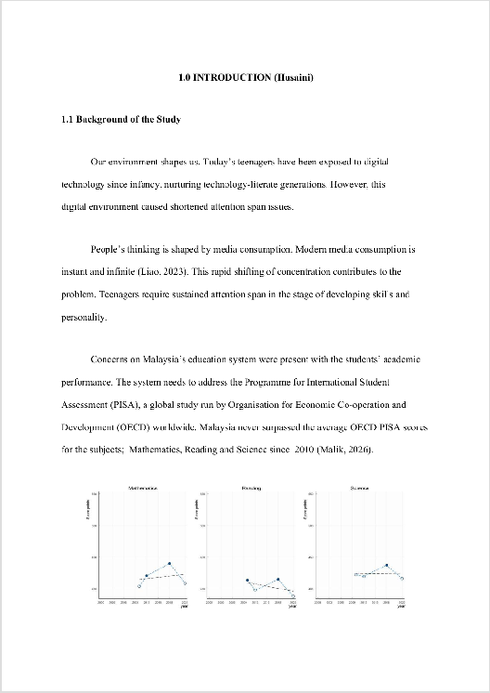

Copyright 2026 Turnitin. All rights reserved.

The Significance of Global Teams in Solving Shortened Attention Spans and Deteriorating
Academic Performance
by Muhammad Afiq Hasran Bin Mohd Fadzly Shah

Submission date: 23-Aug-2026 03:53PM (UTC+0100)
Submission ID: 288004046
File name: 72413_Muhammad_Afiq_Hasran_Bin_Mohd_Fadzly_Shah_The_Significance_of_Global_Teams_in_Solving_Shortened_Attention_Spans
Word count: 5929
Character count: 36122

1382453418.docx (2.08M)

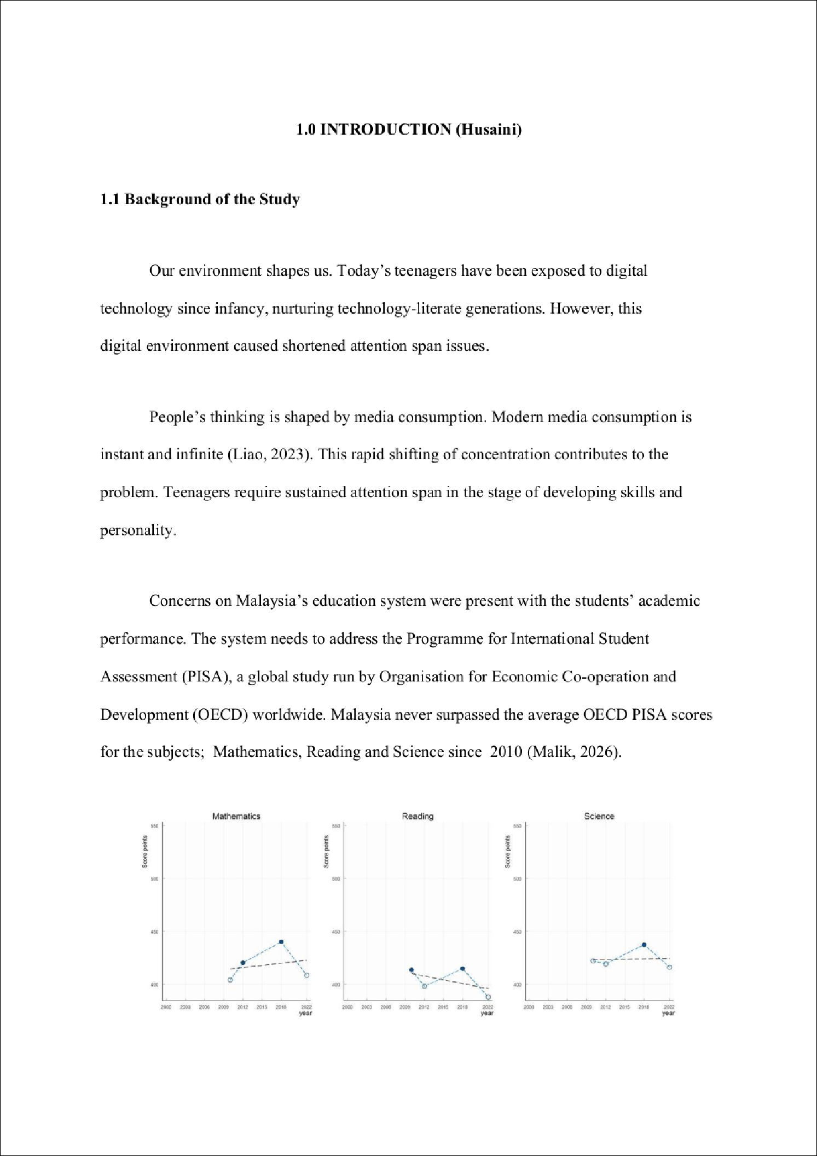

3



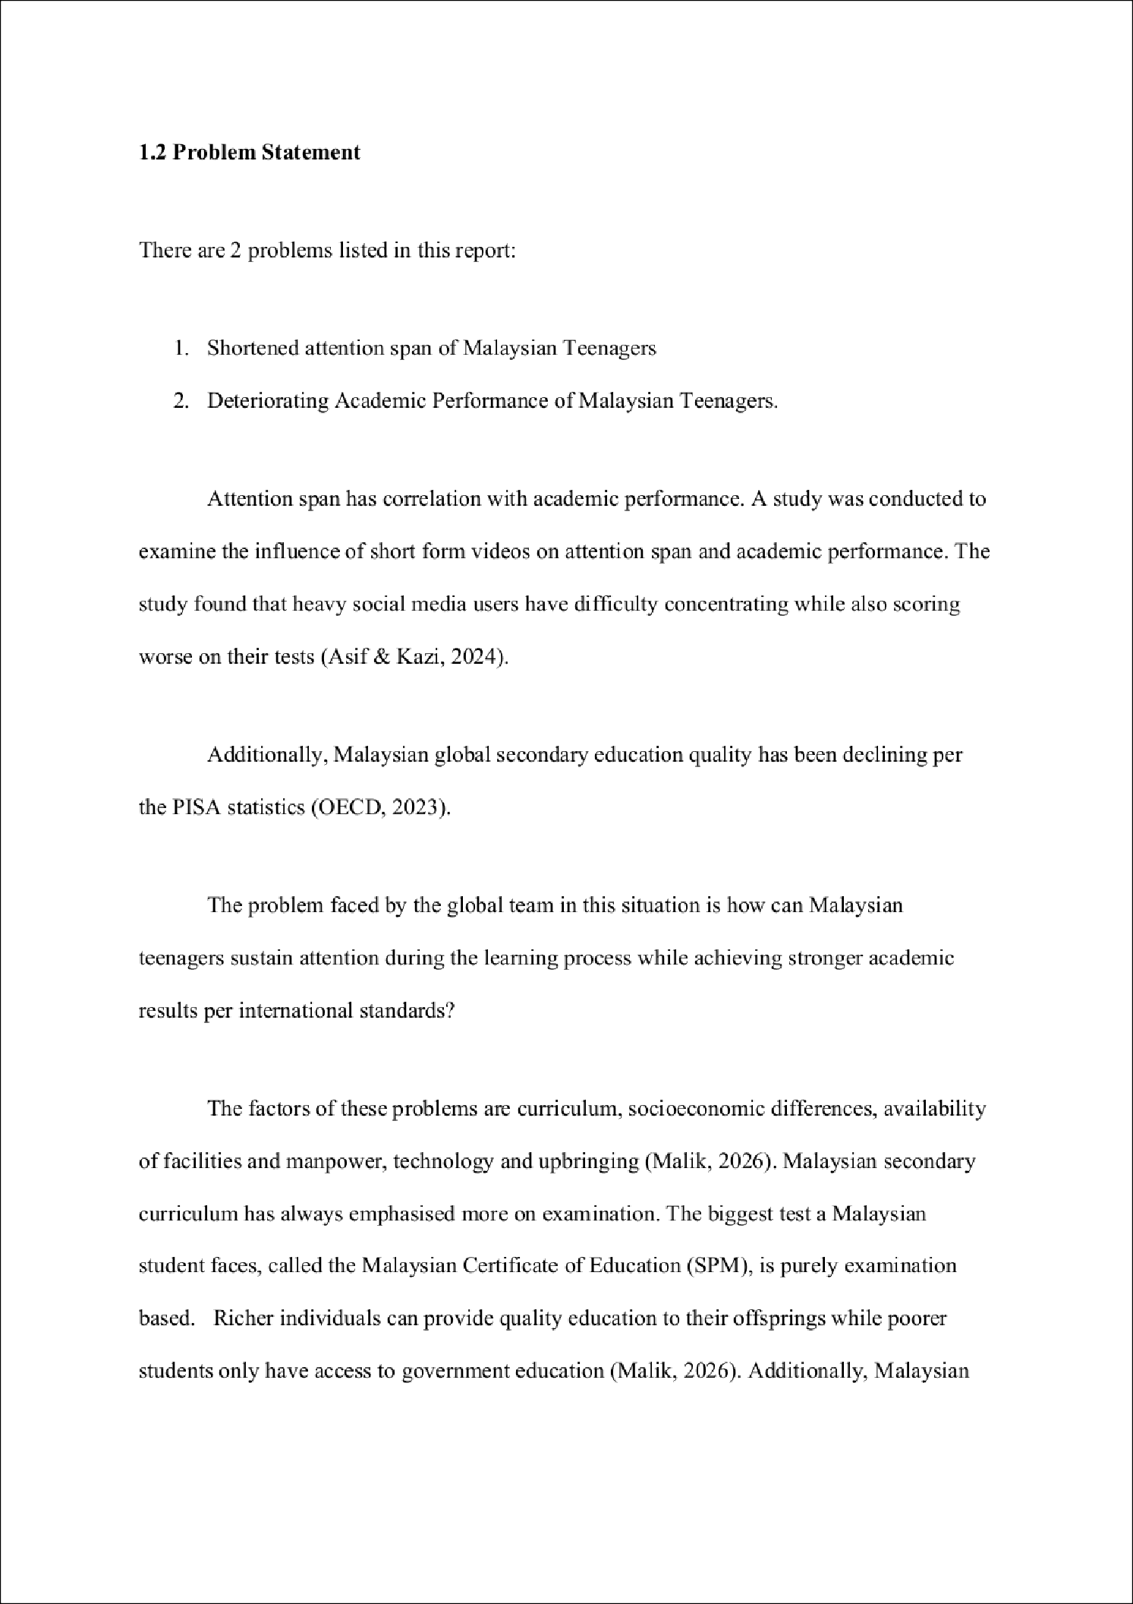

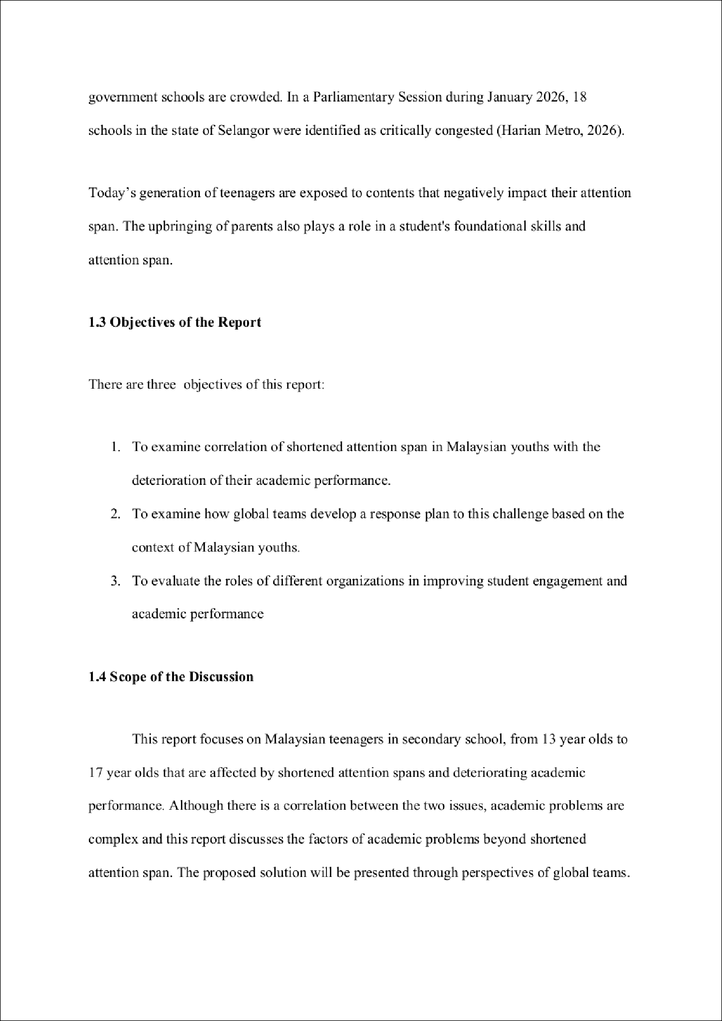

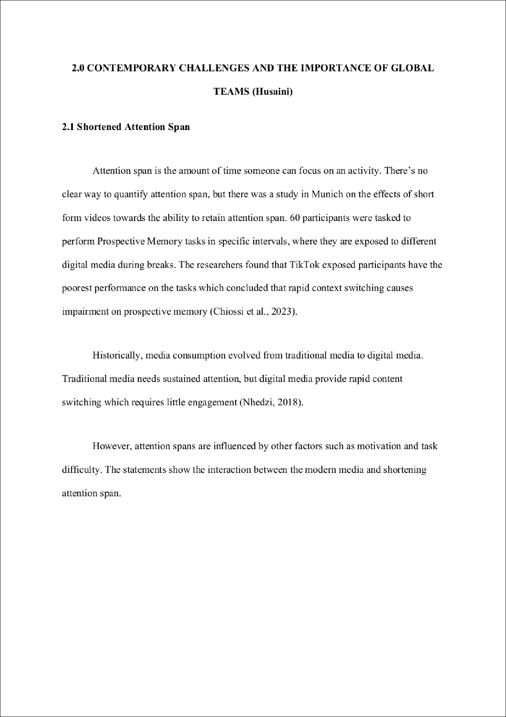

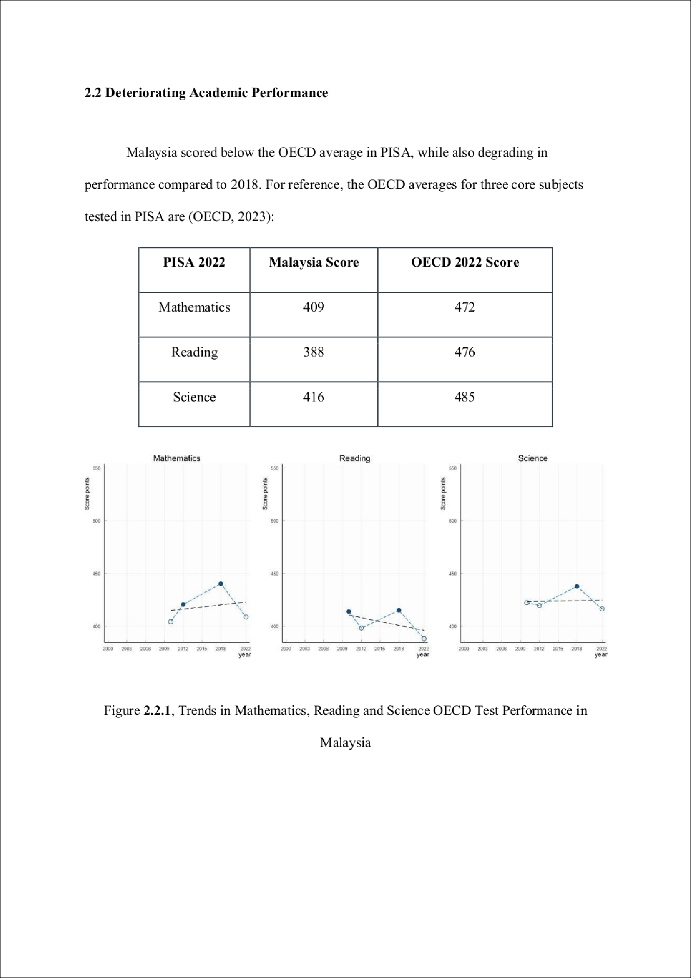



5

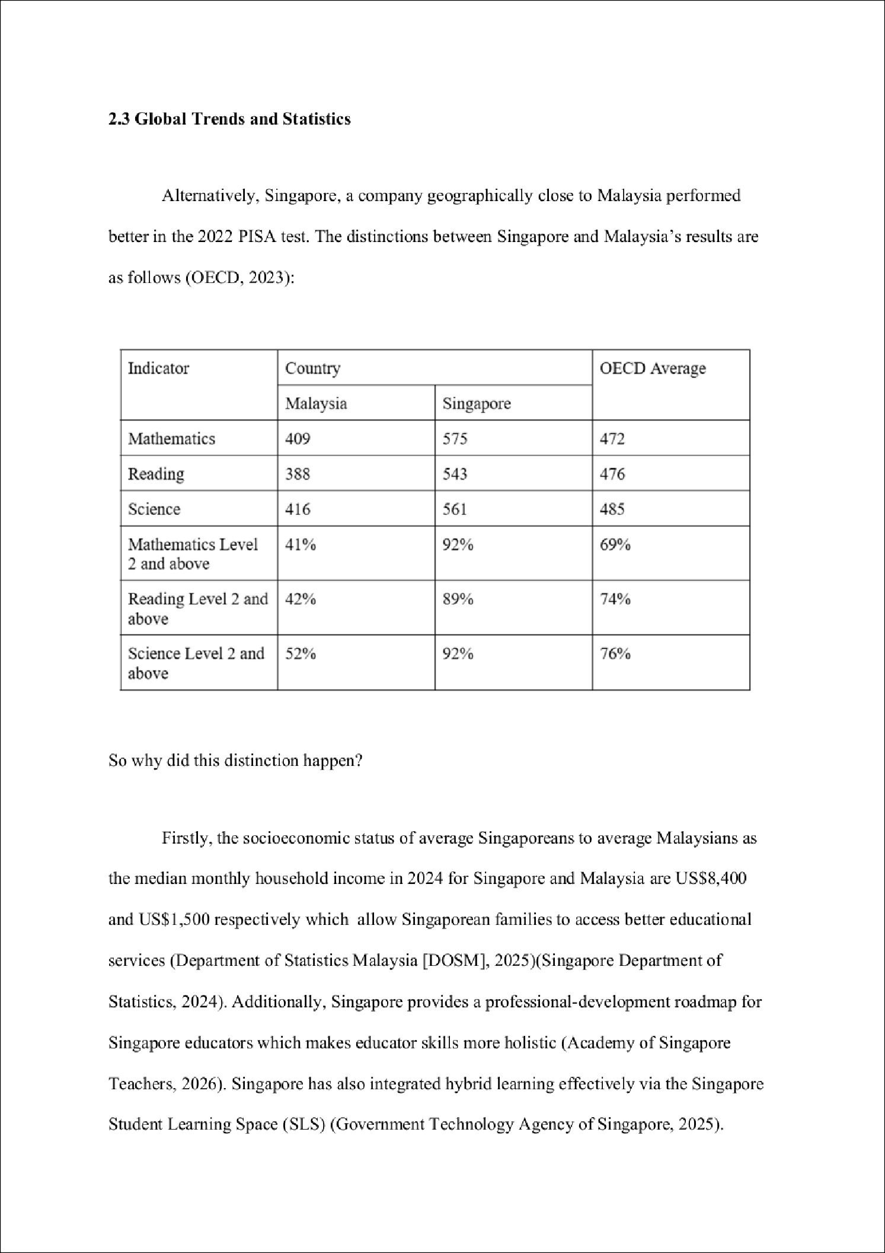

9

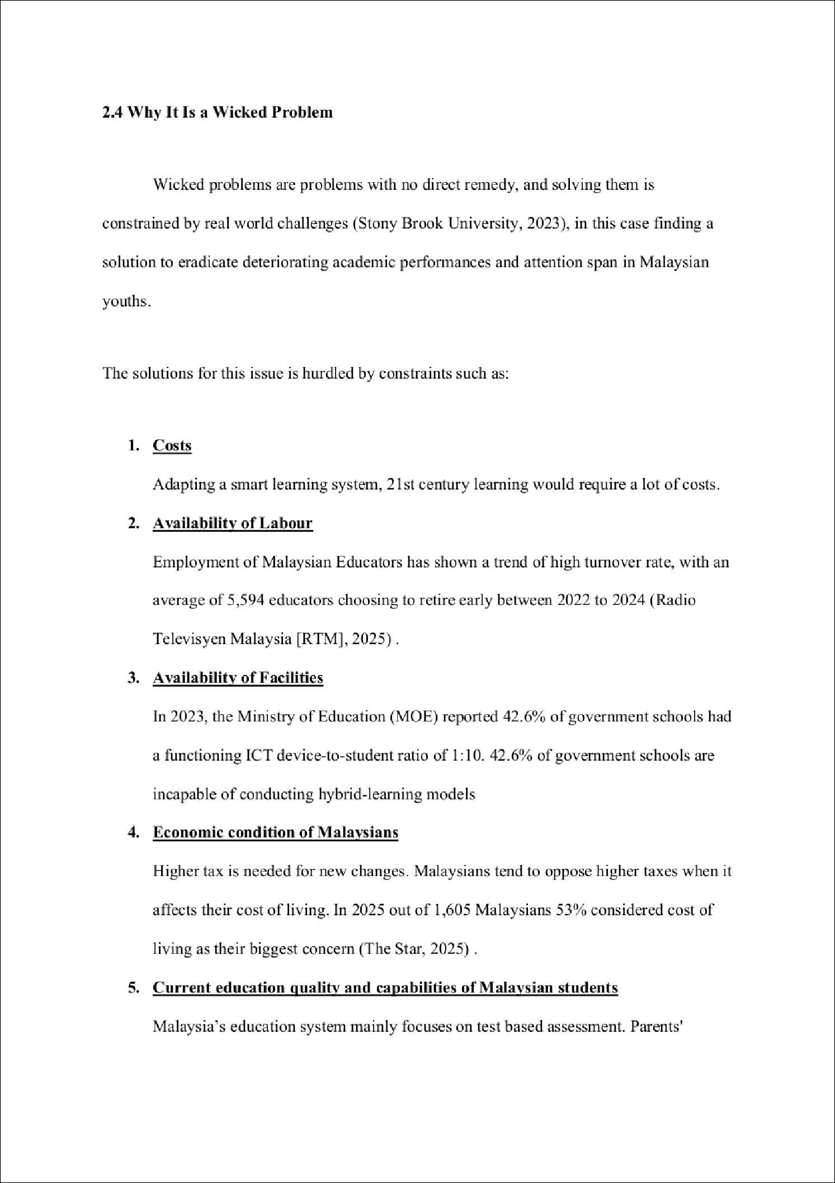

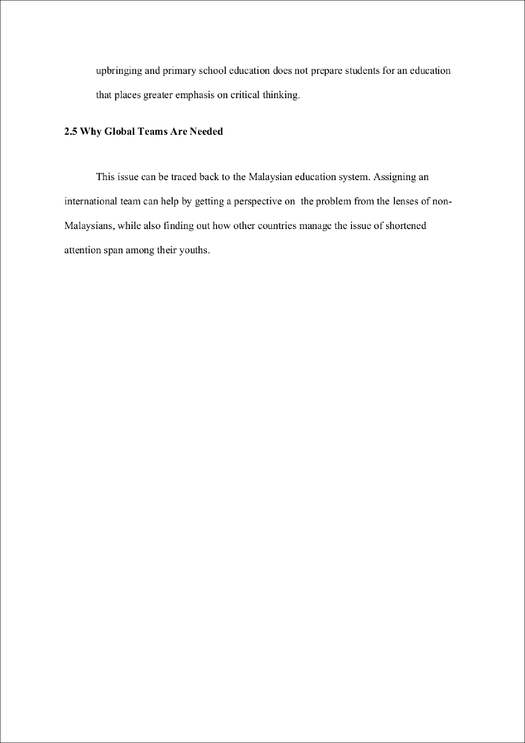

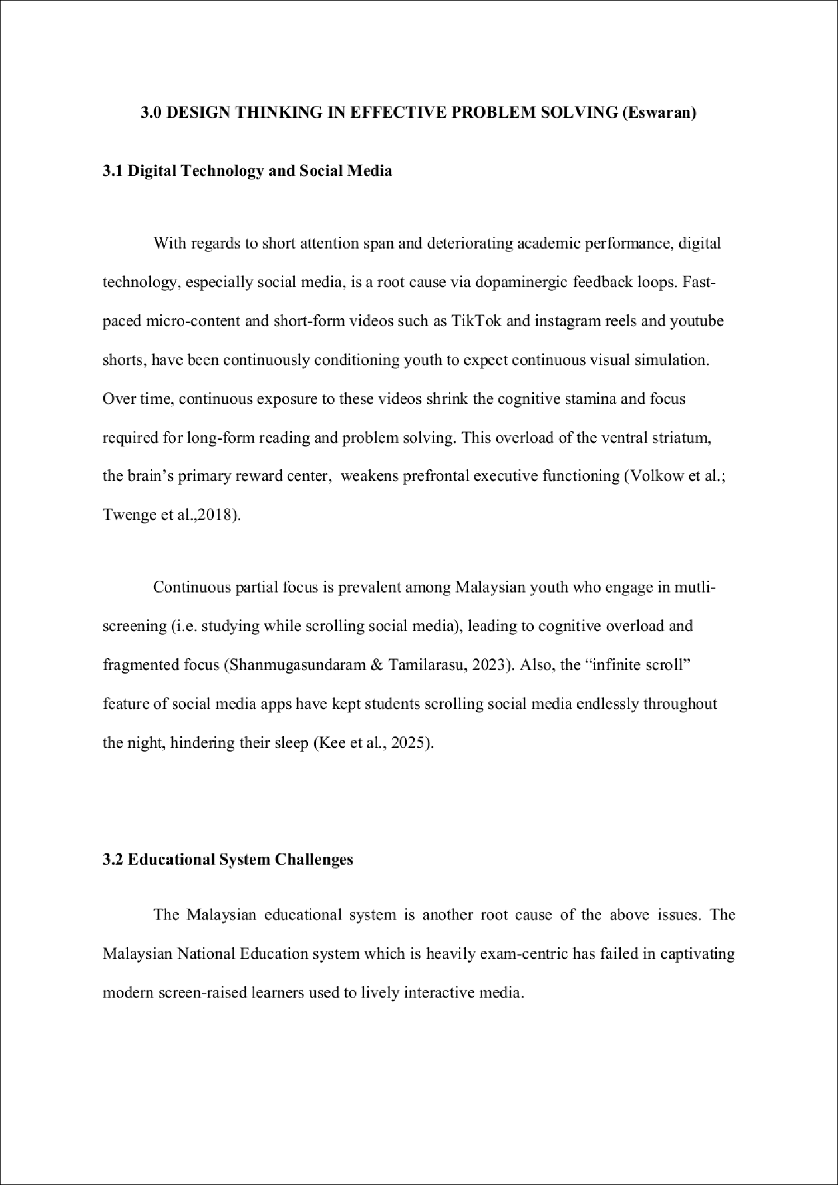

6

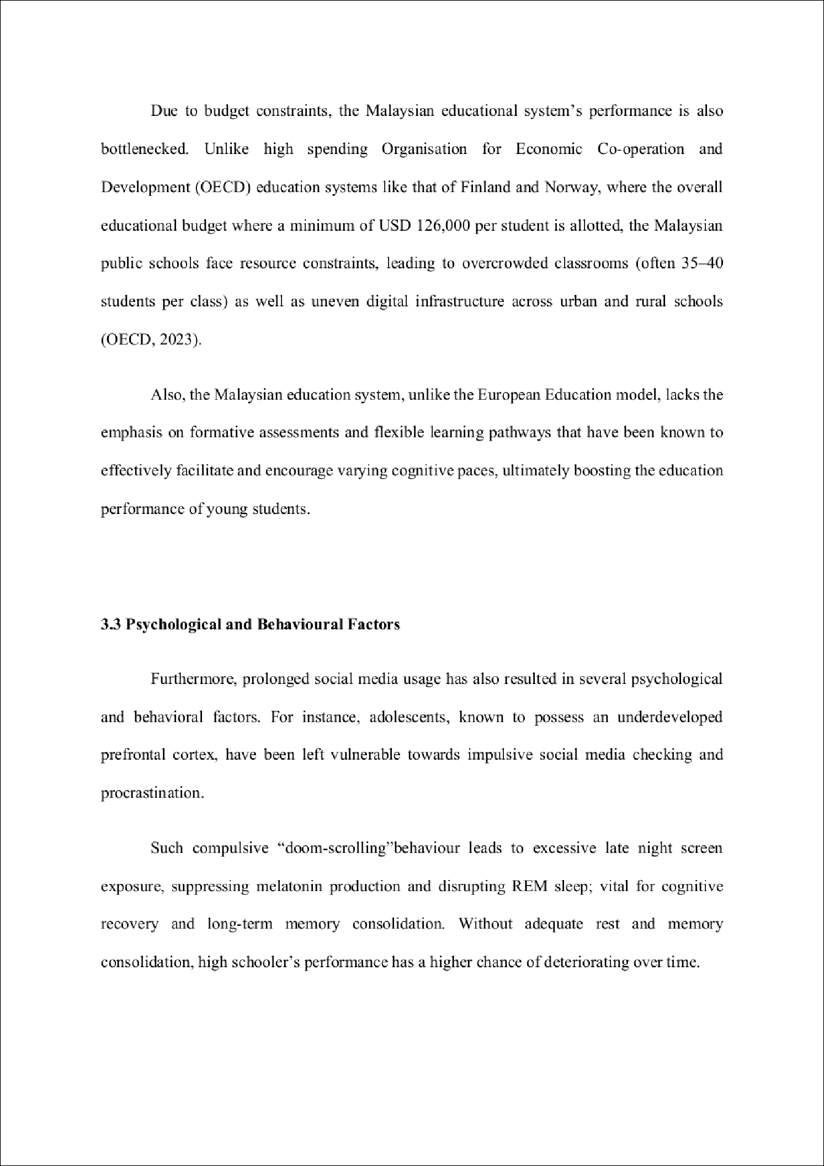
3

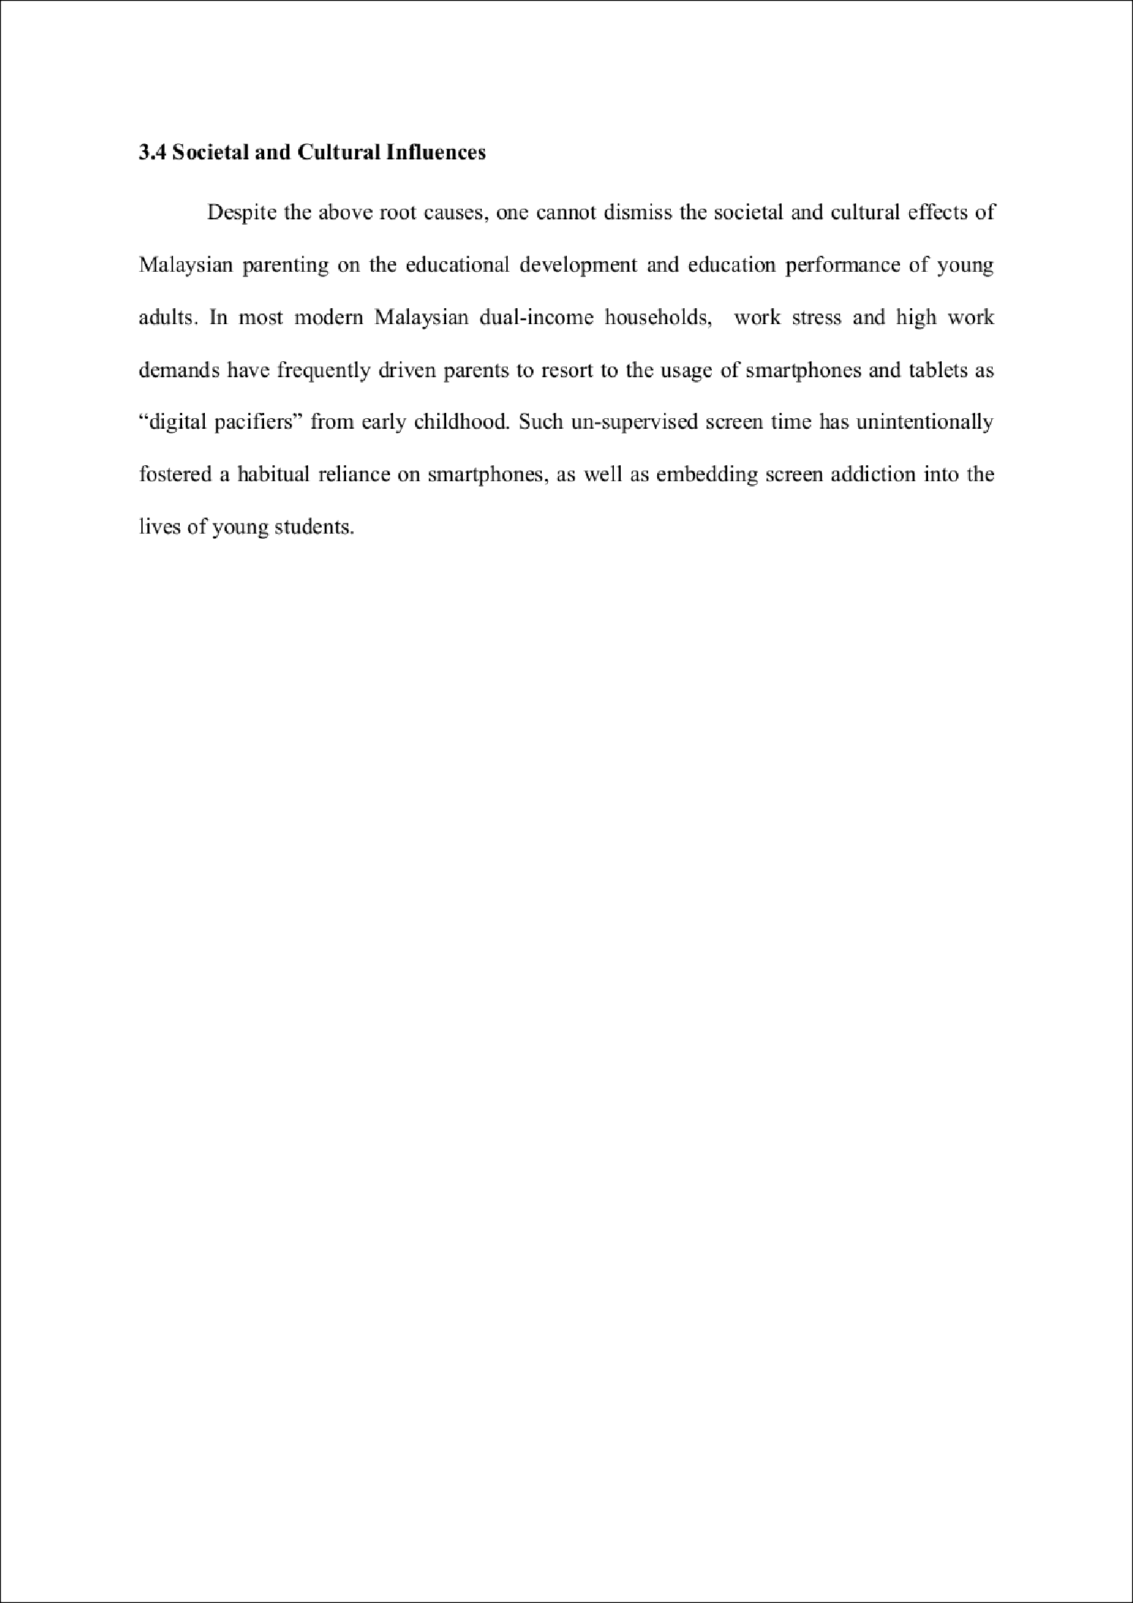

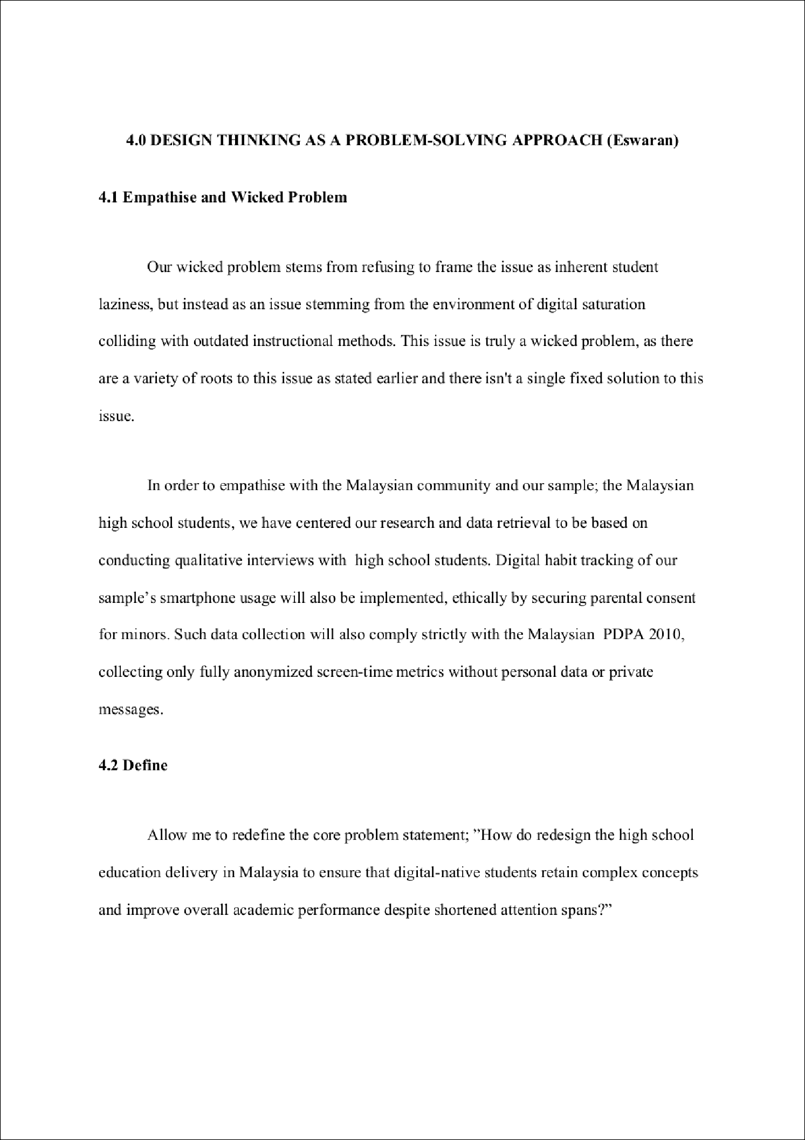

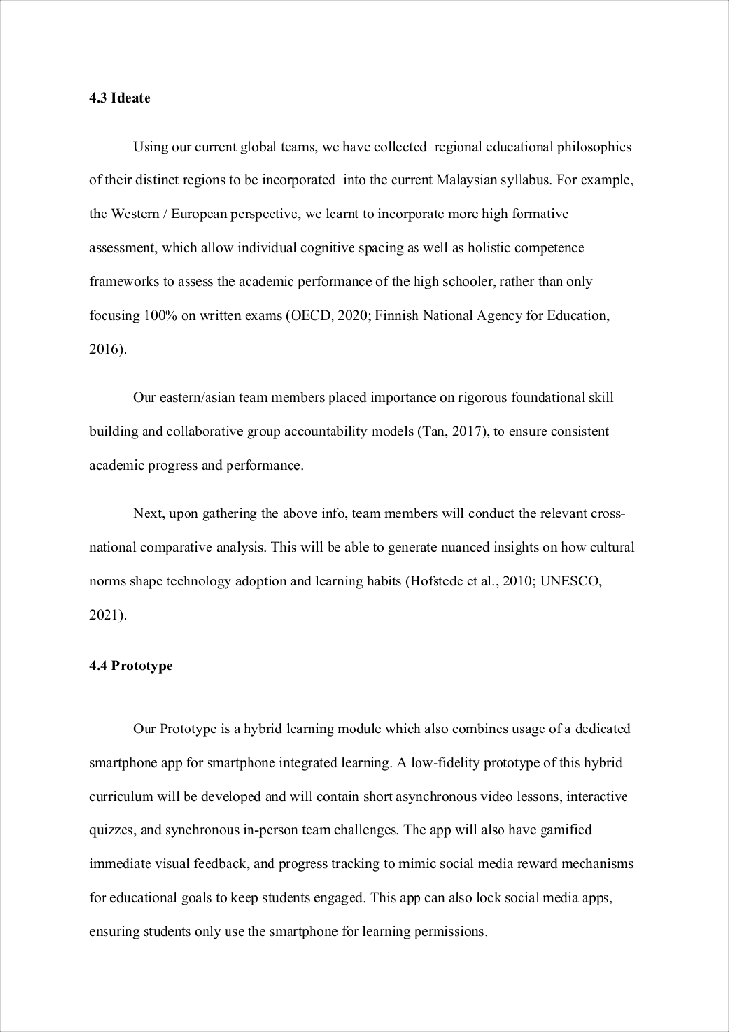

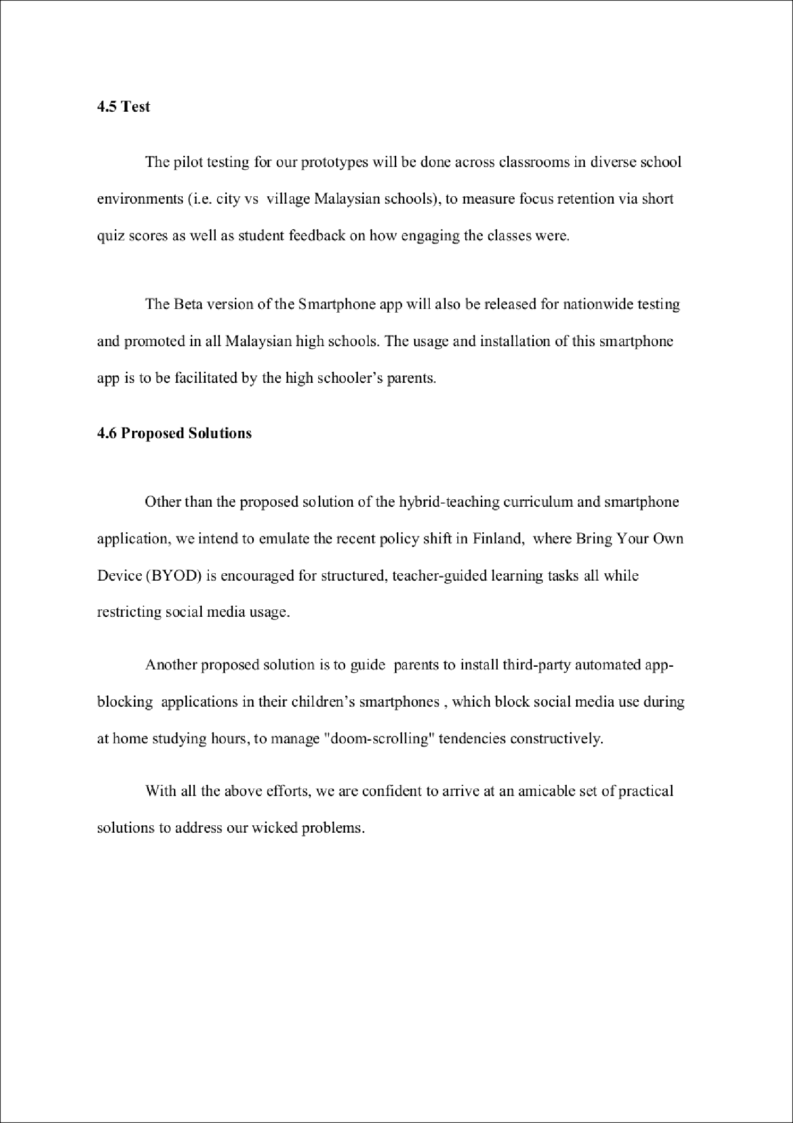

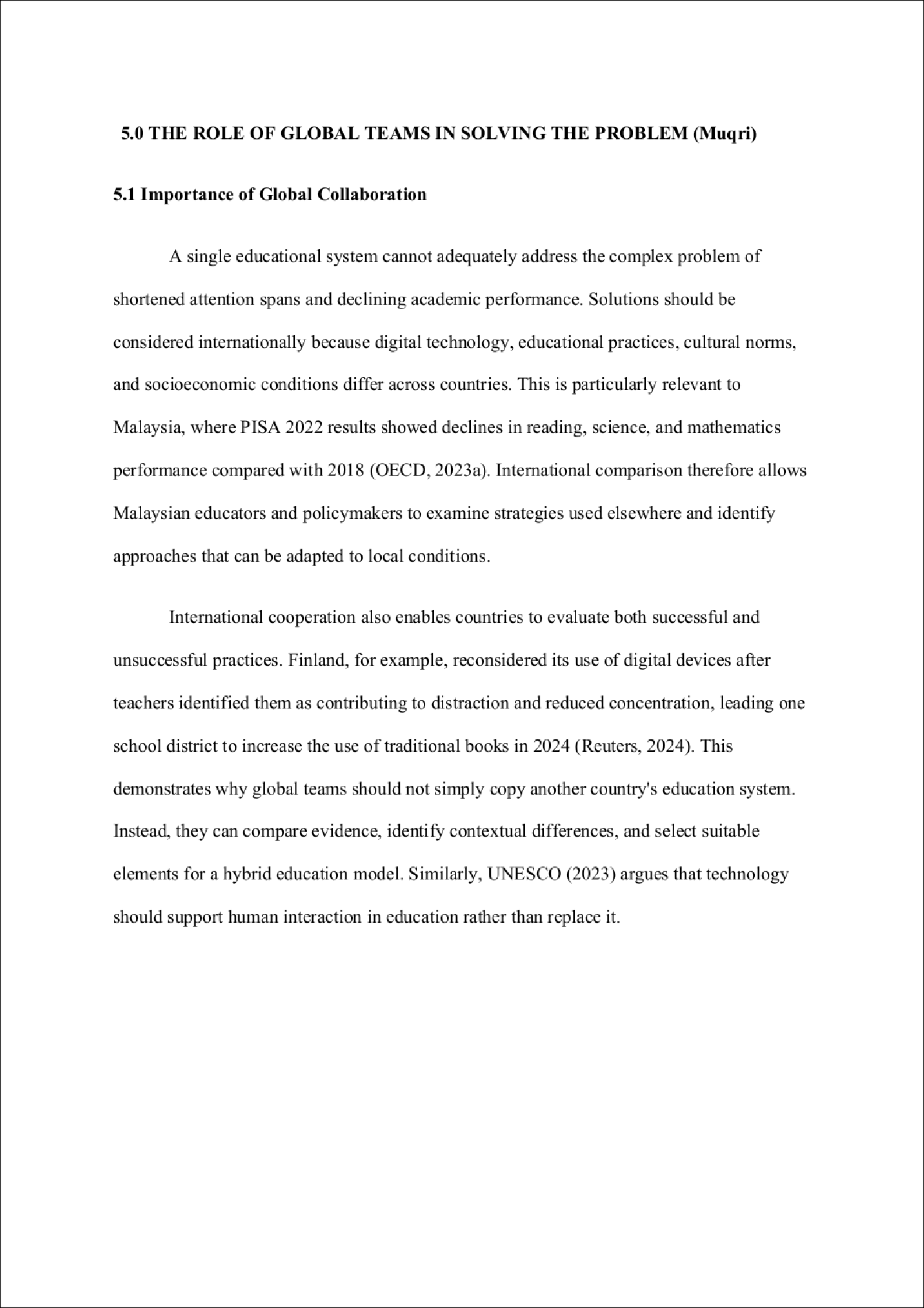

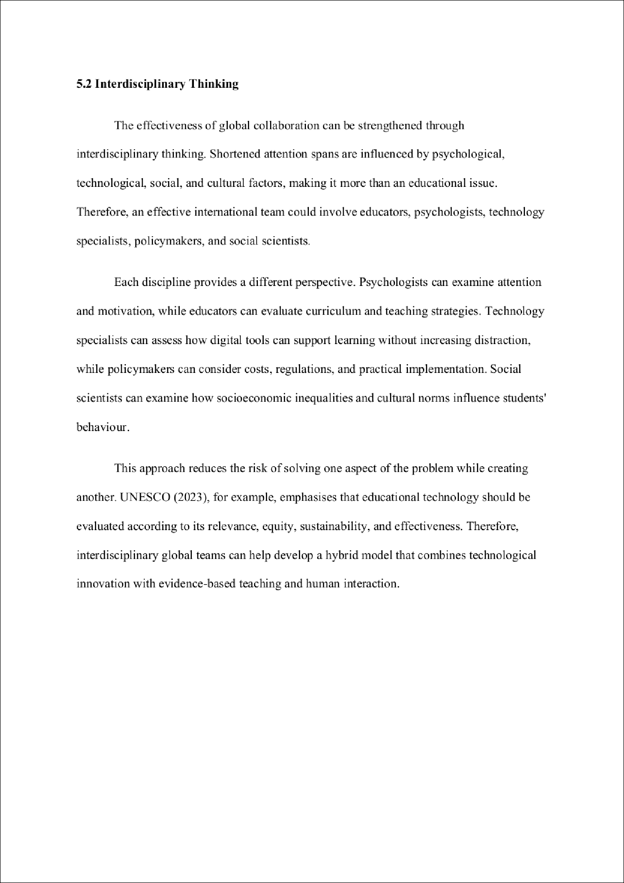

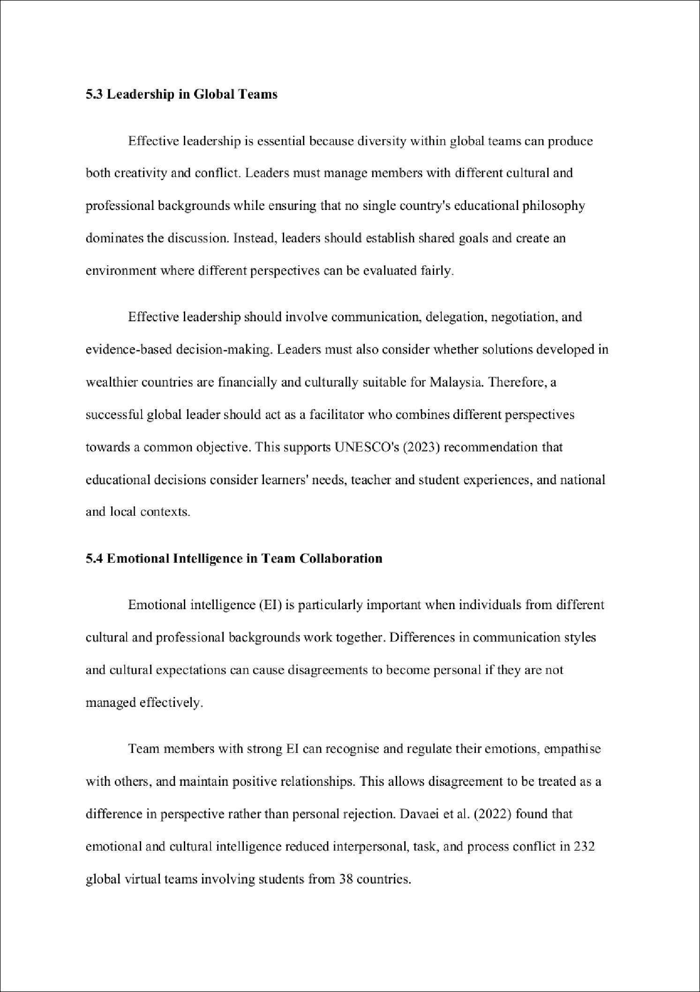

1

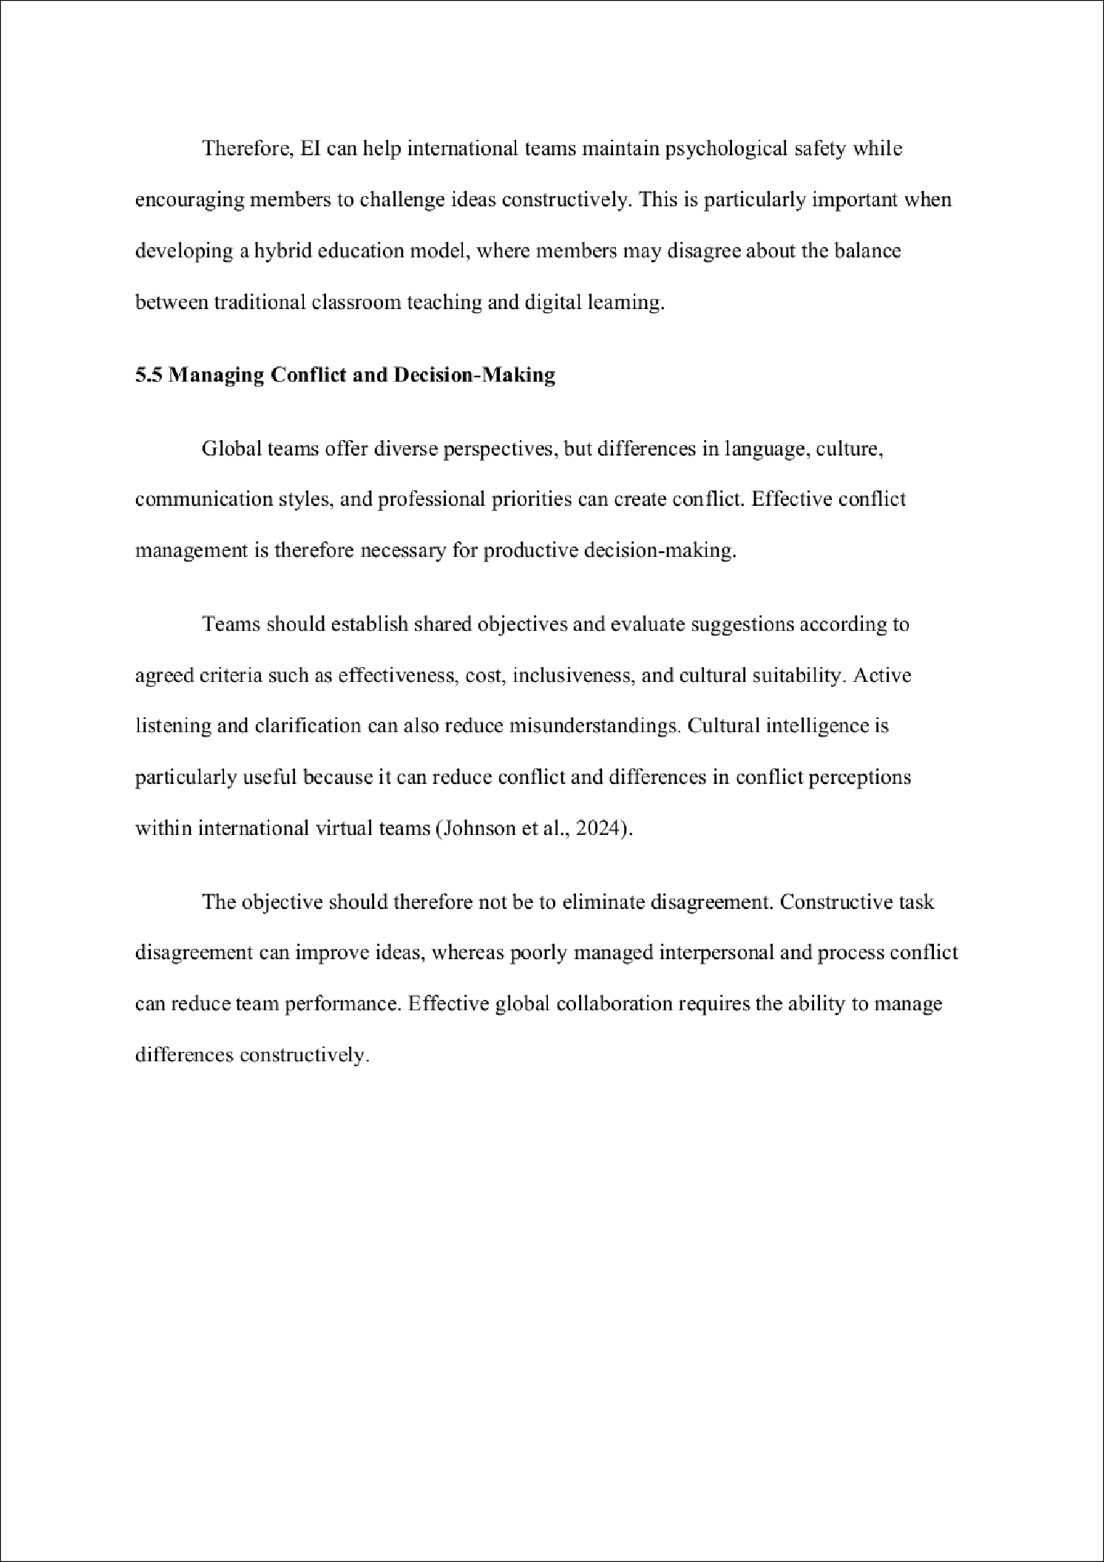

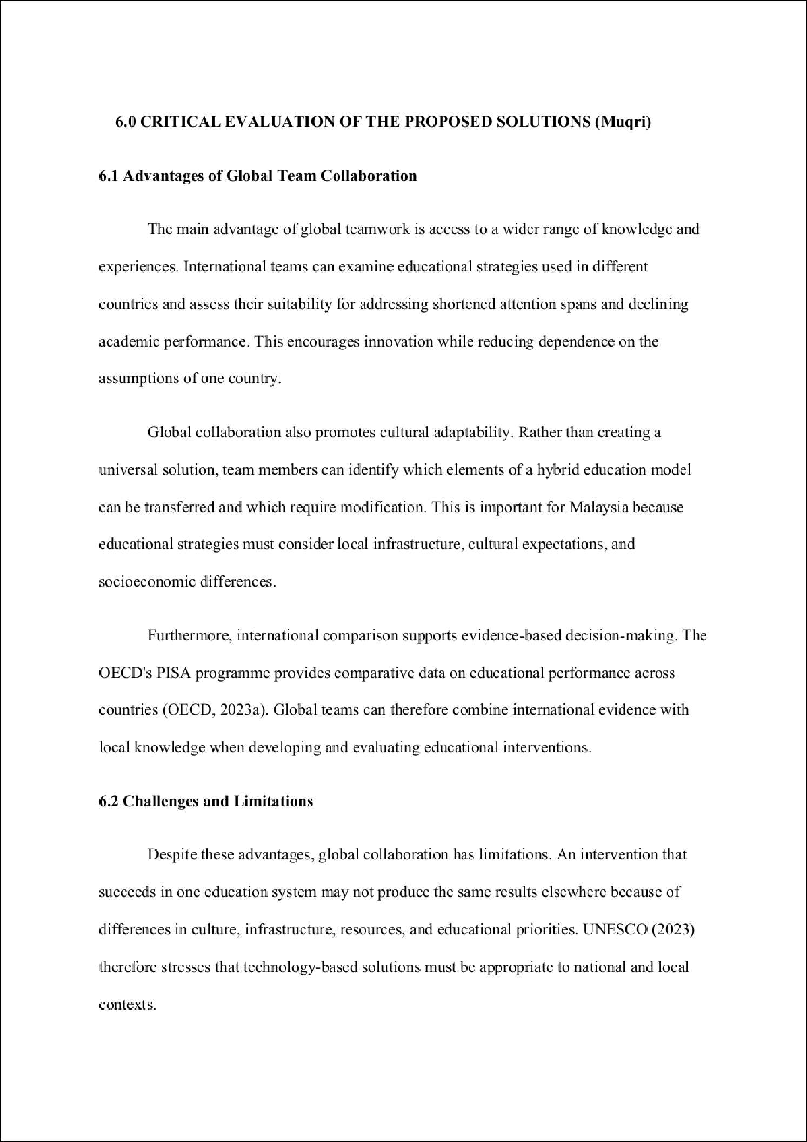

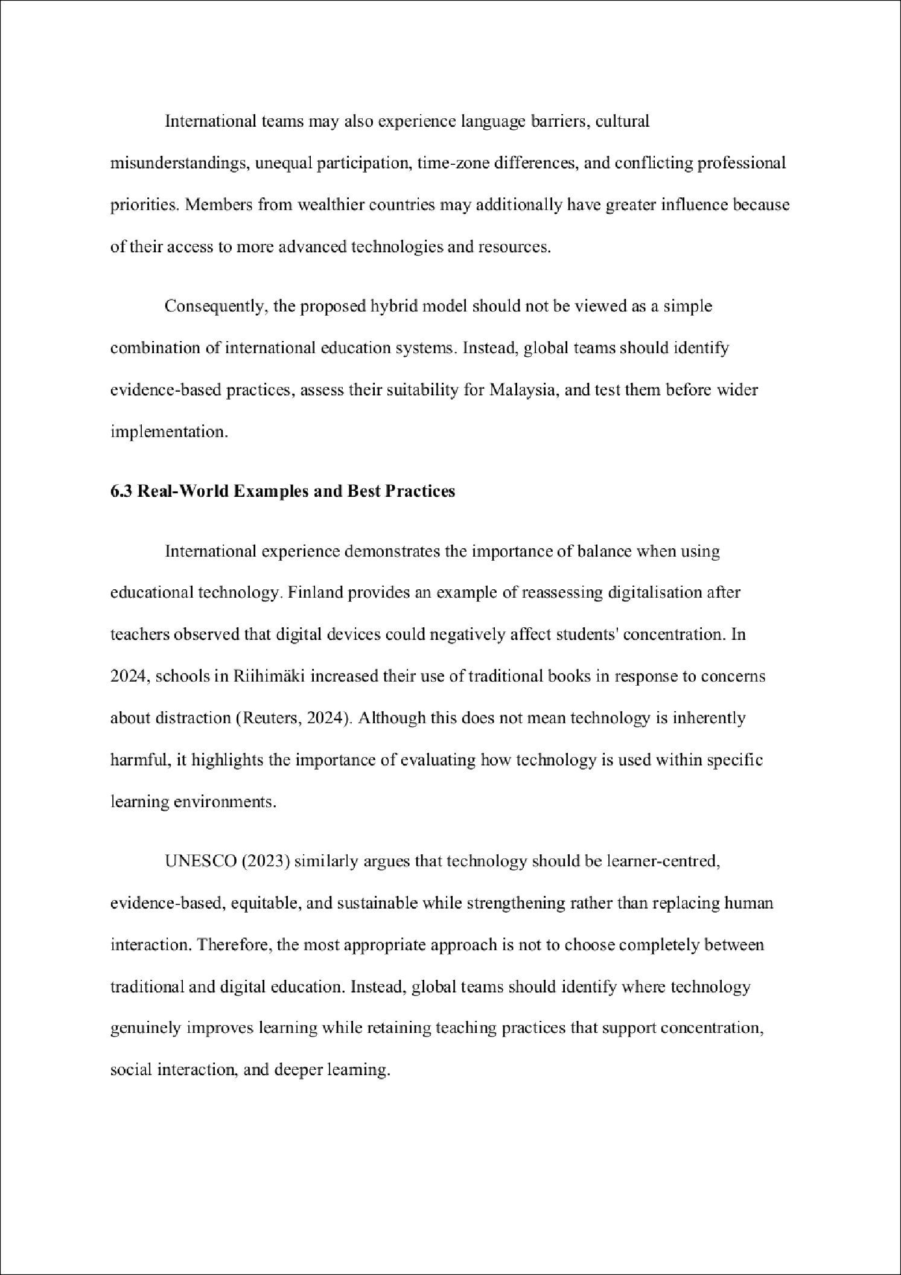

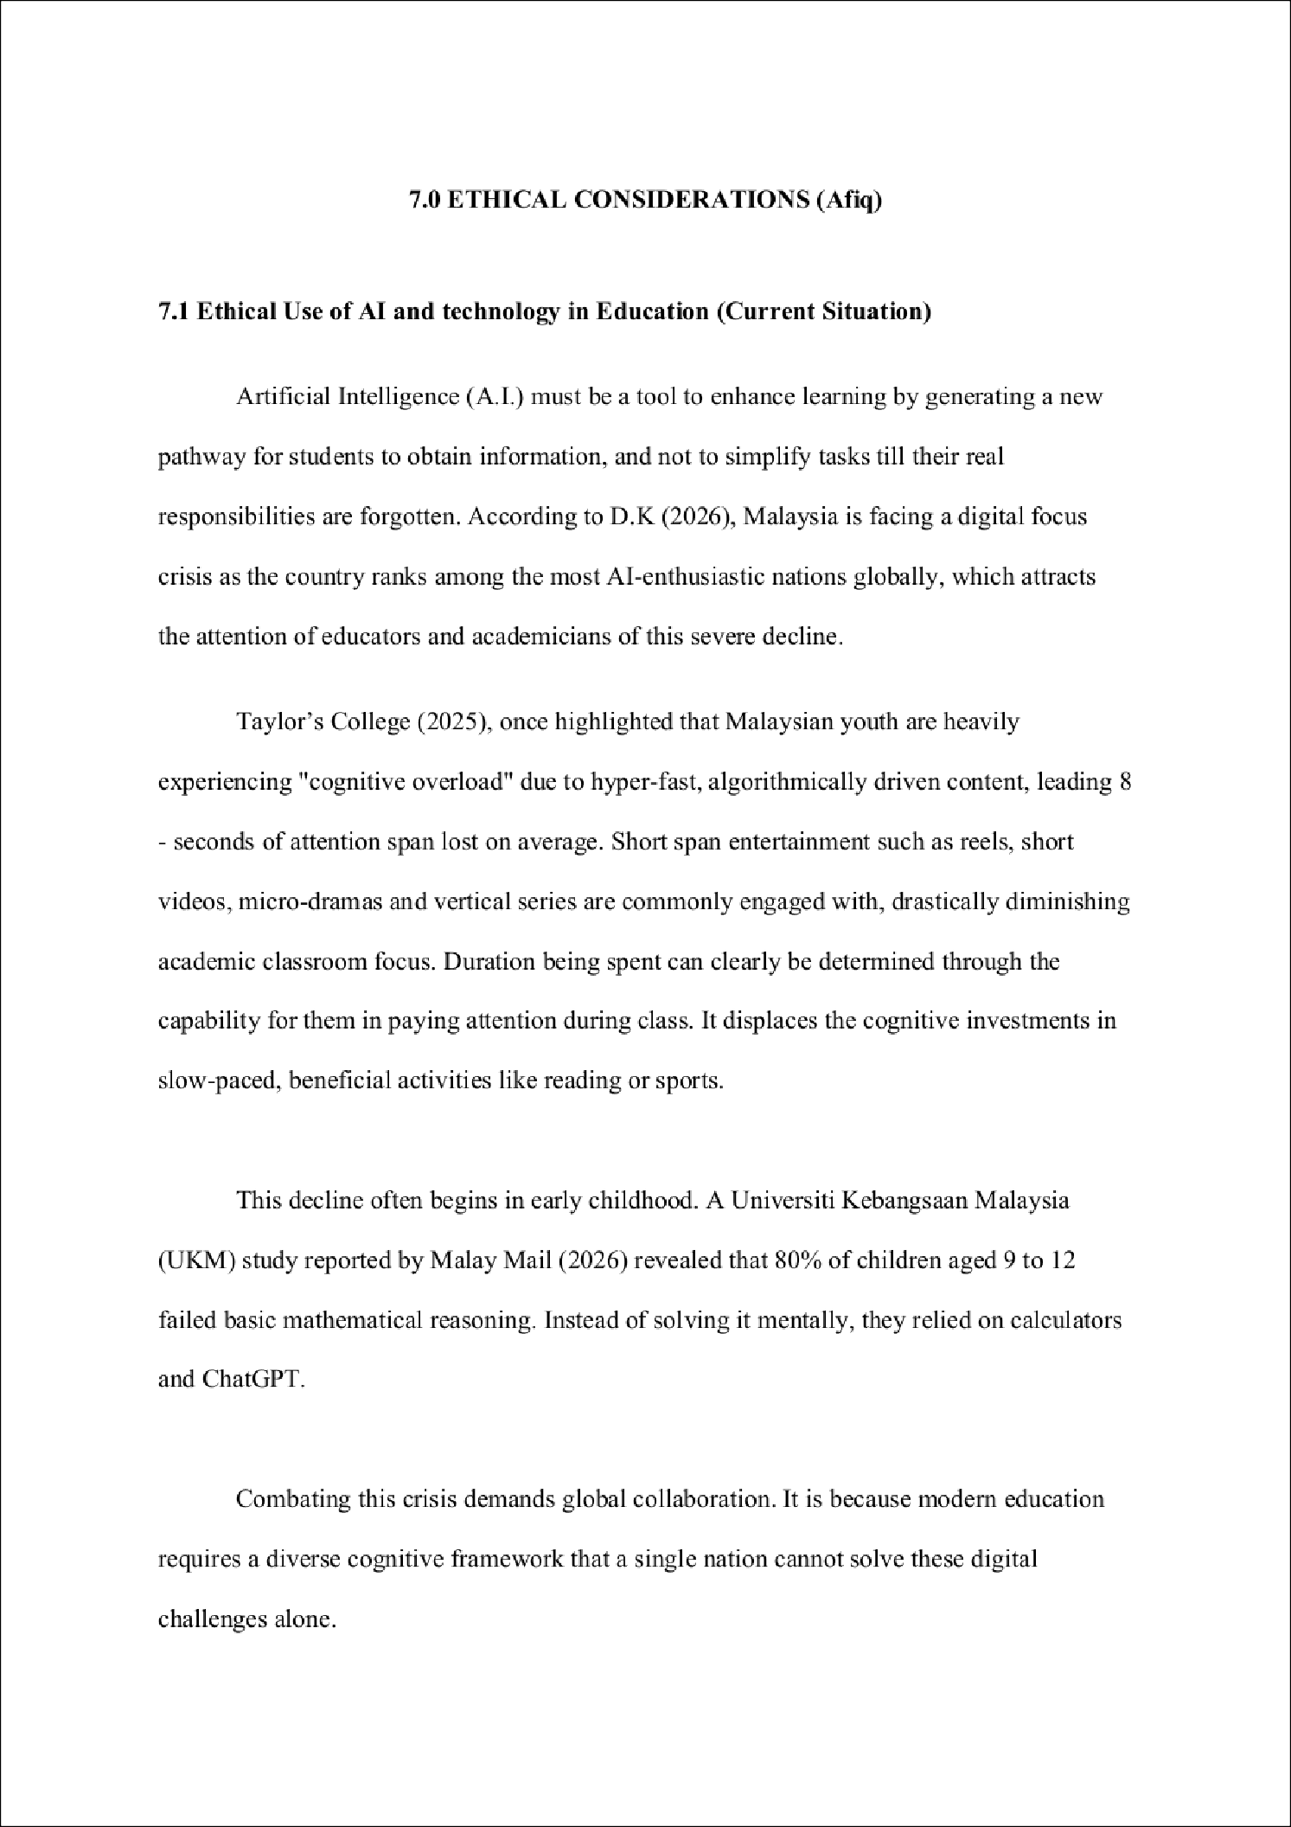

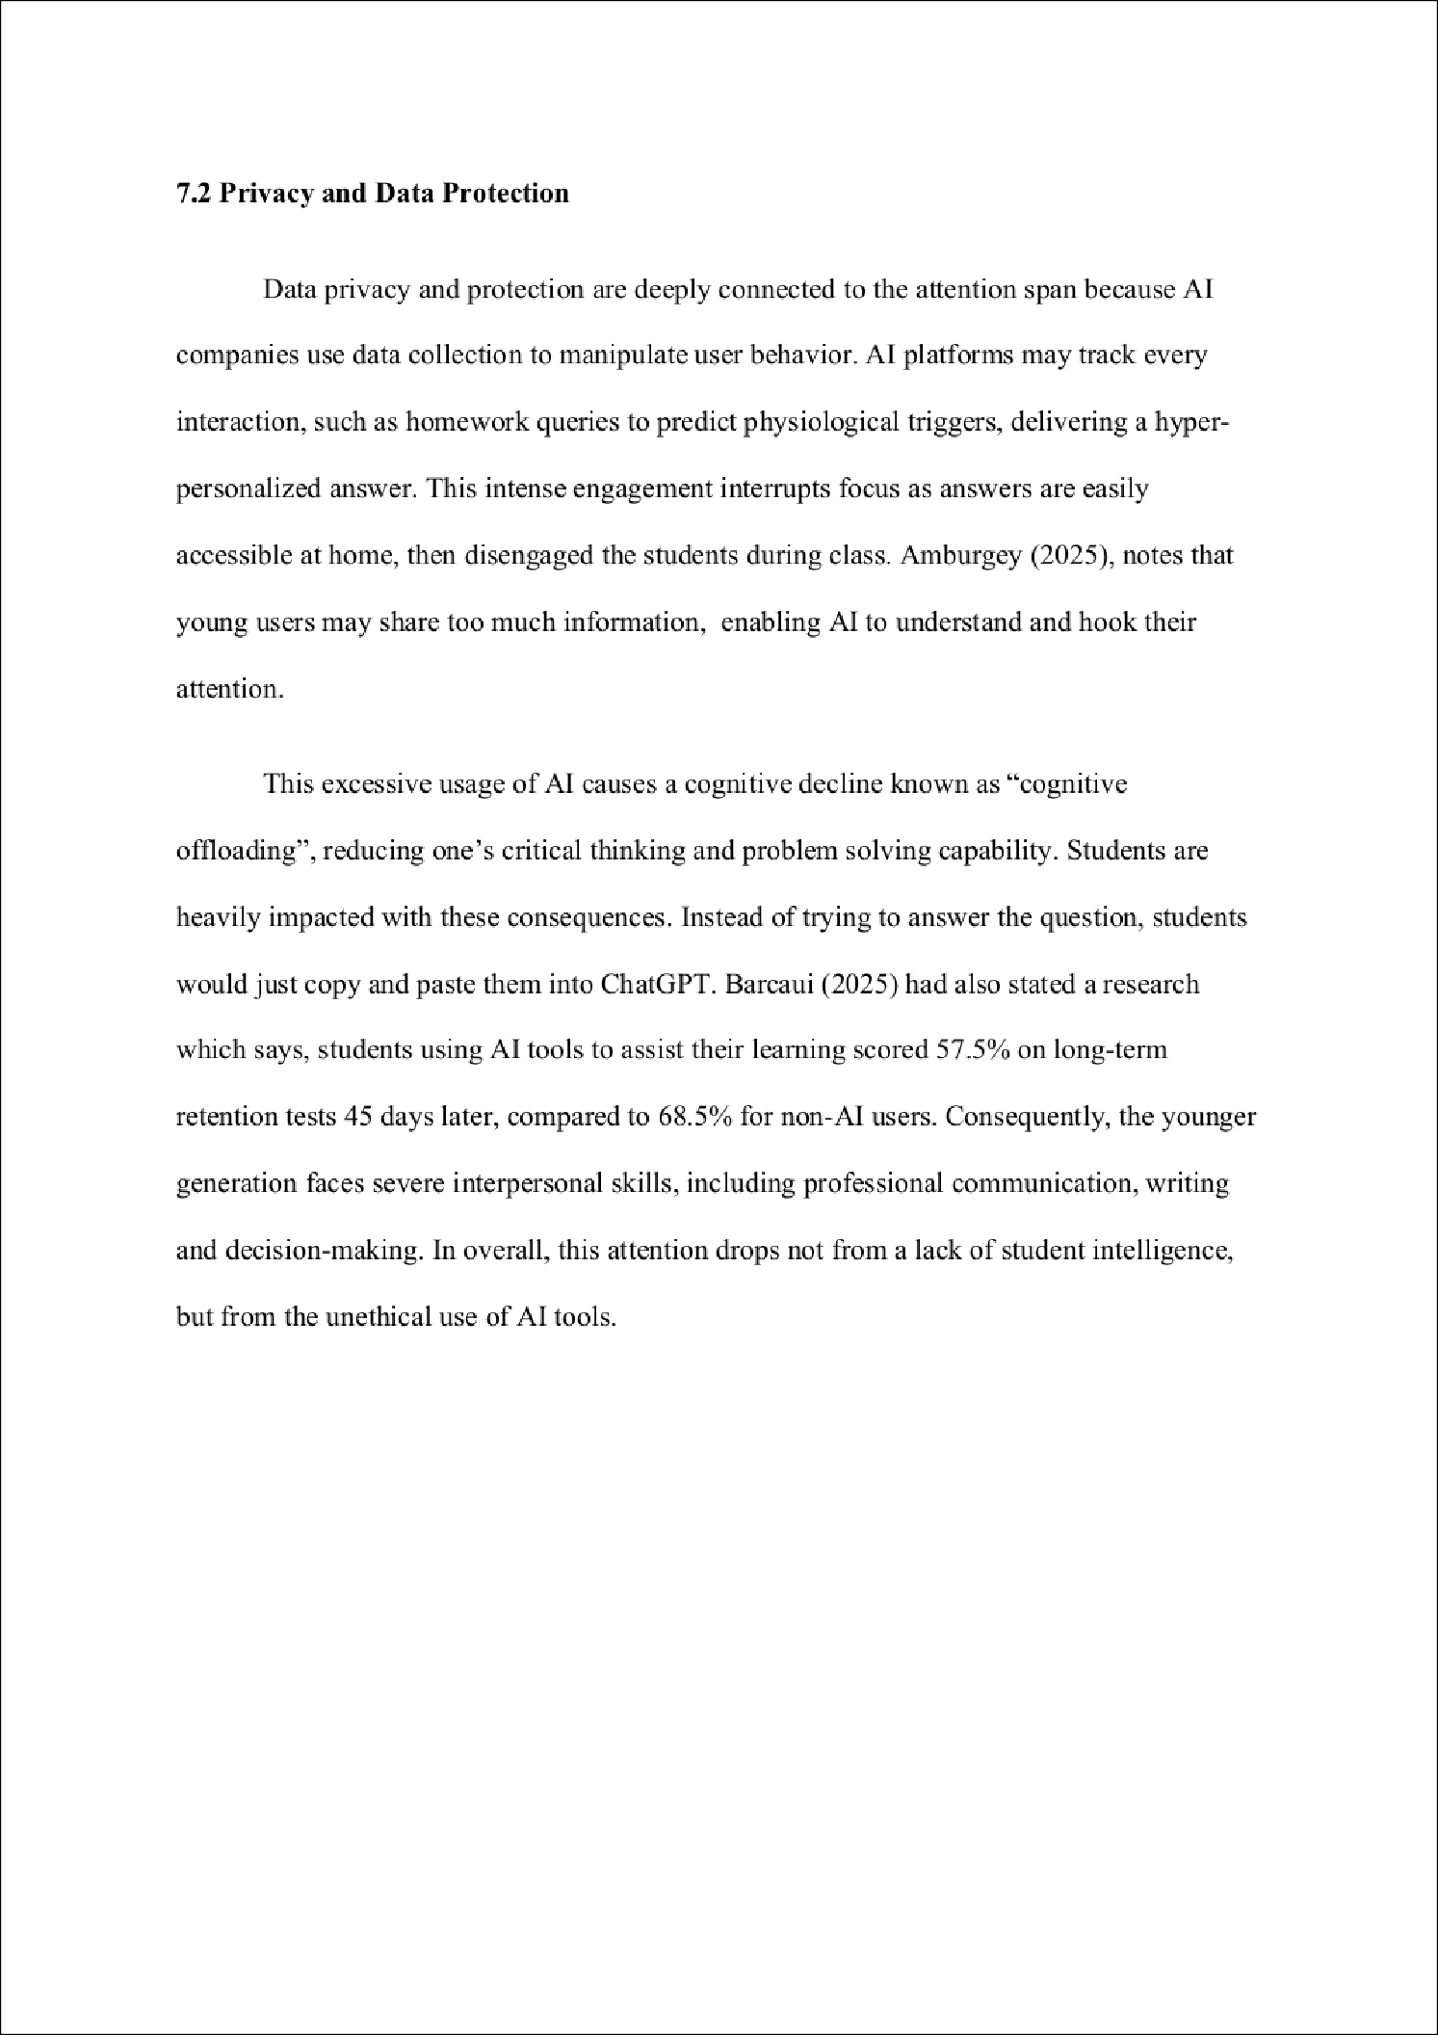

4

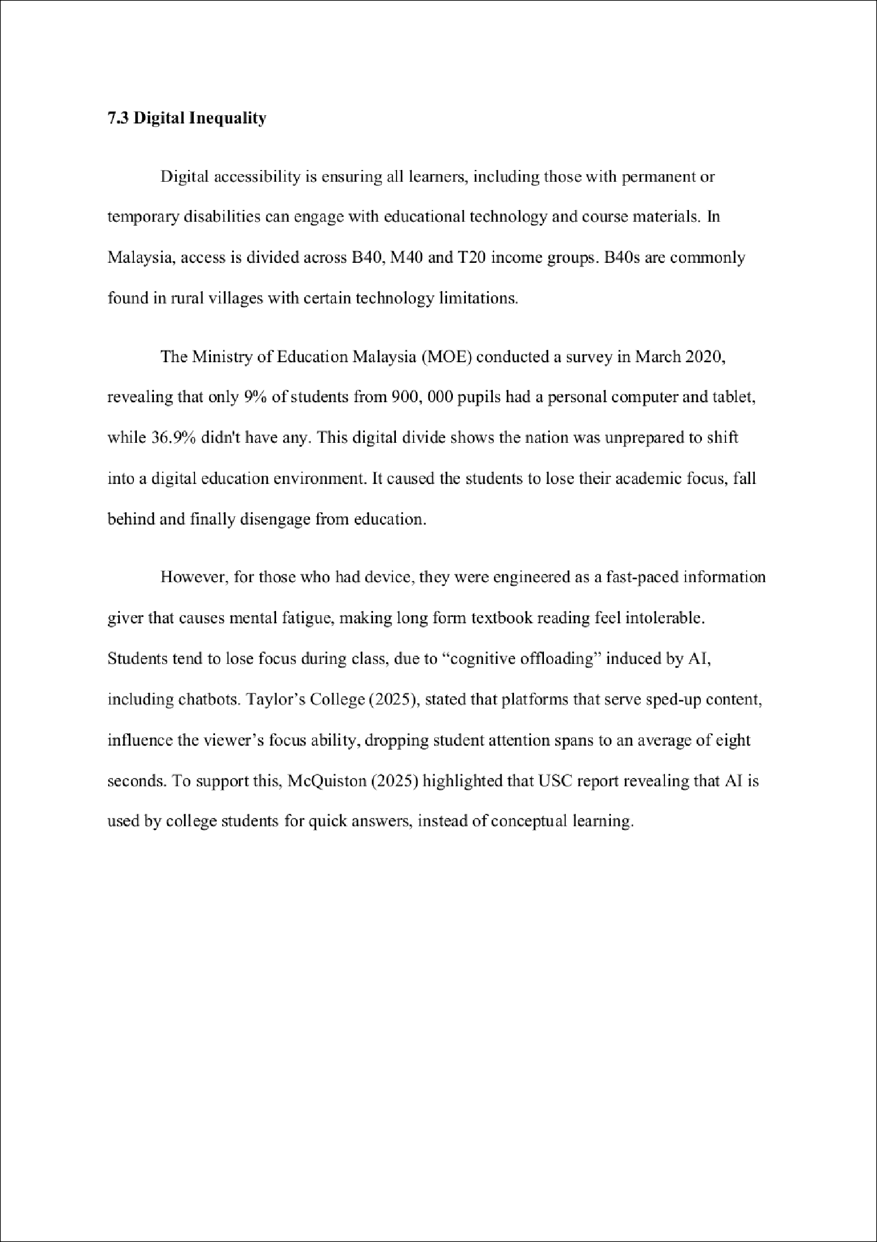

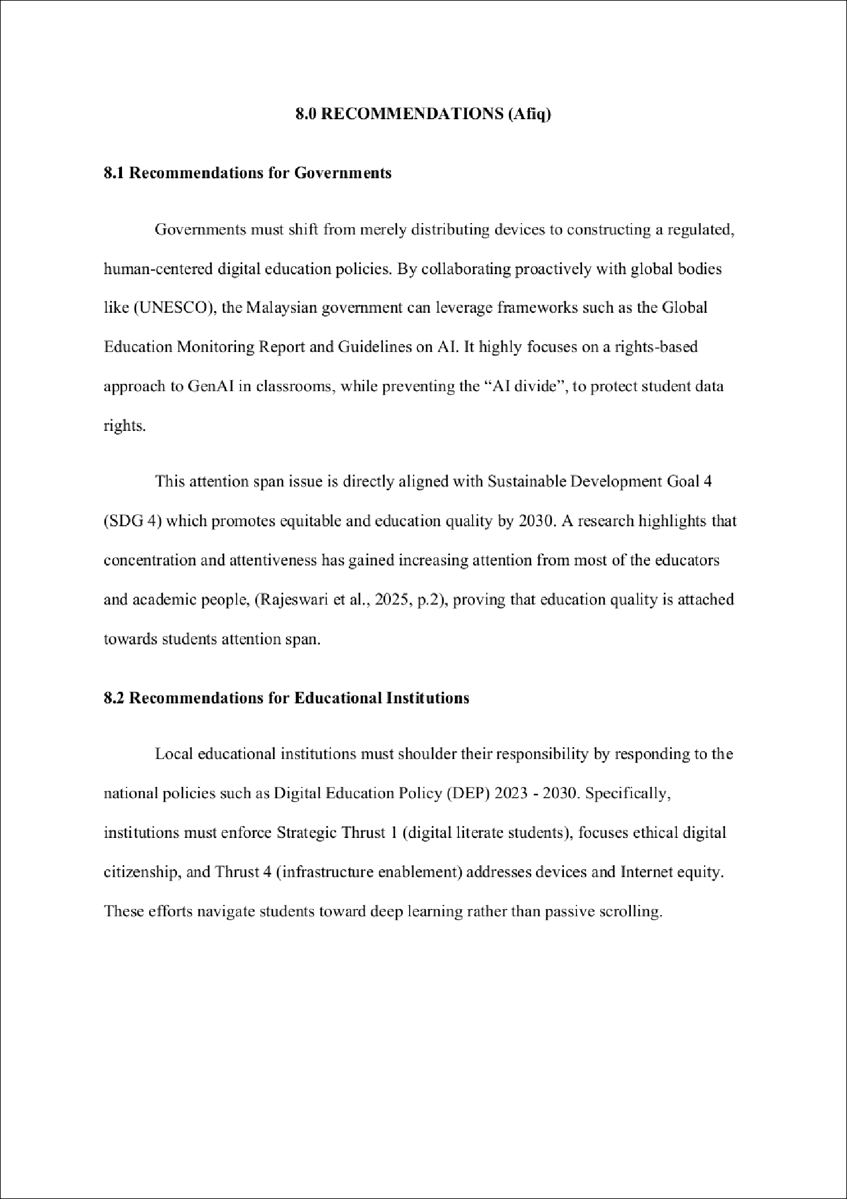

8

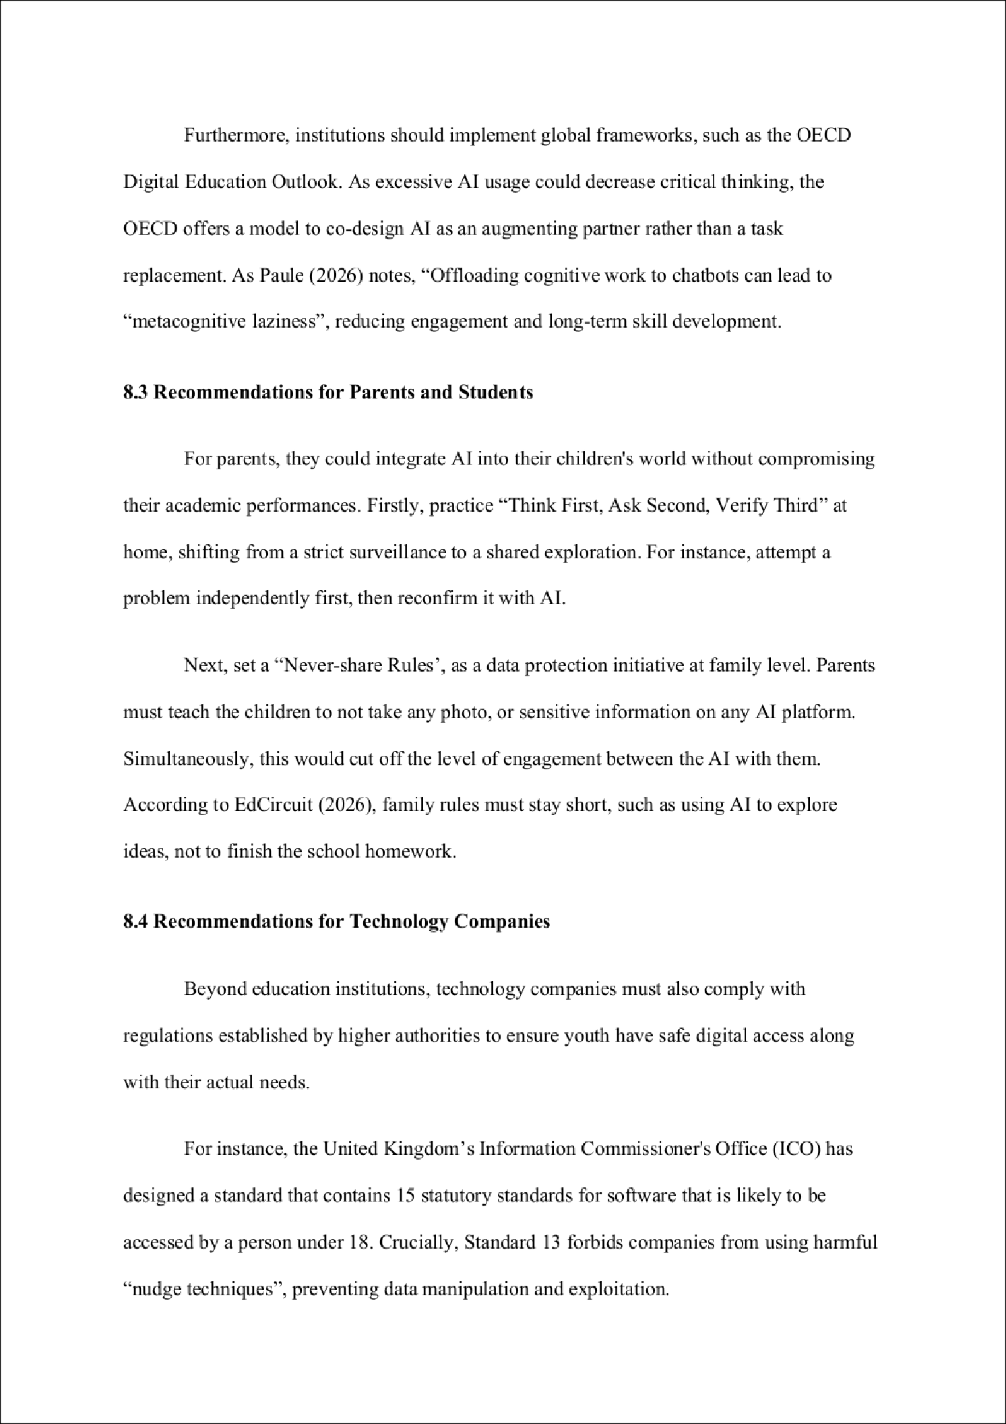

2

7

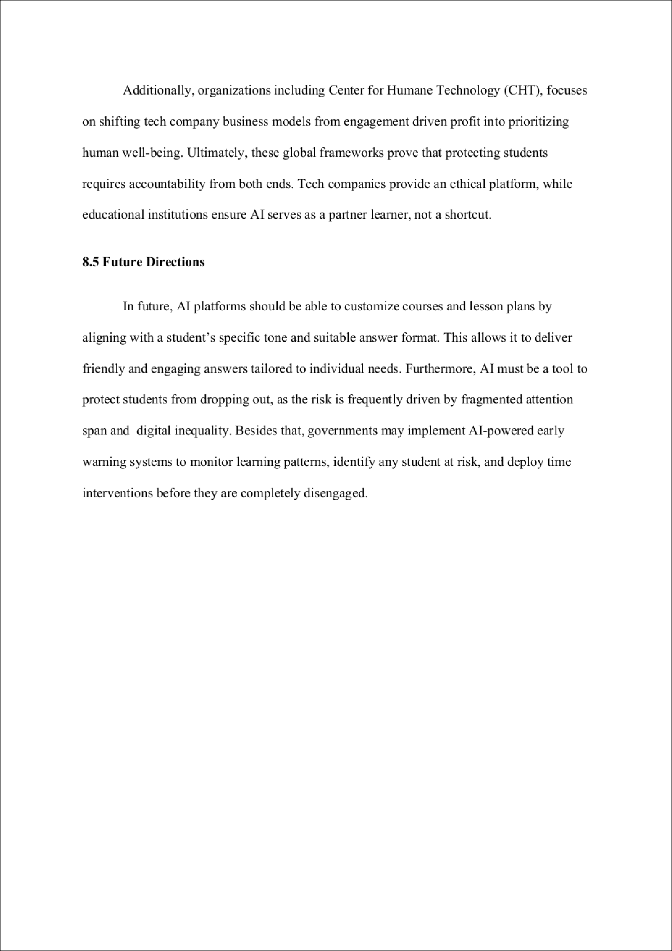

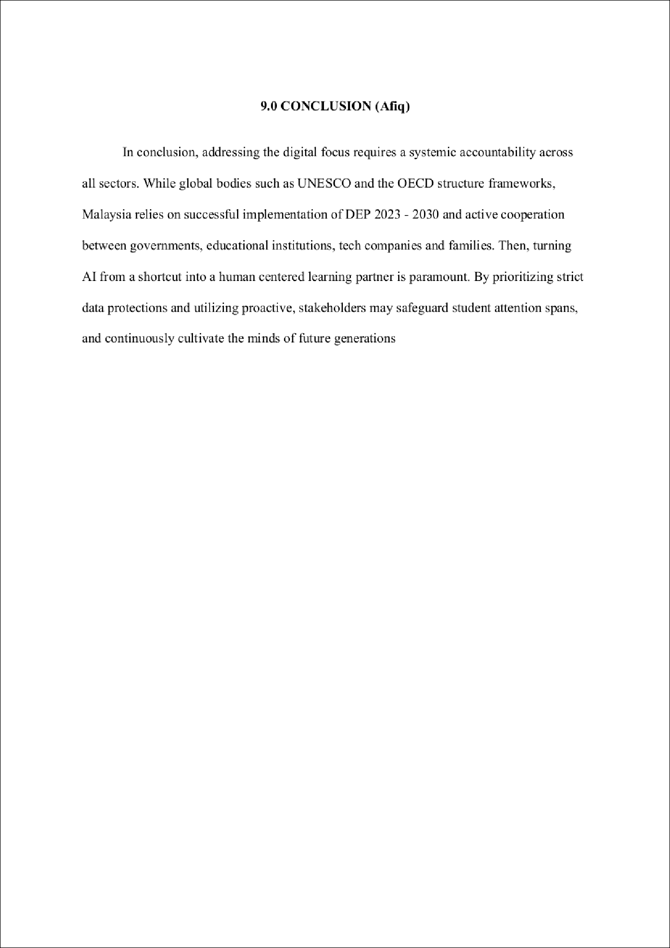

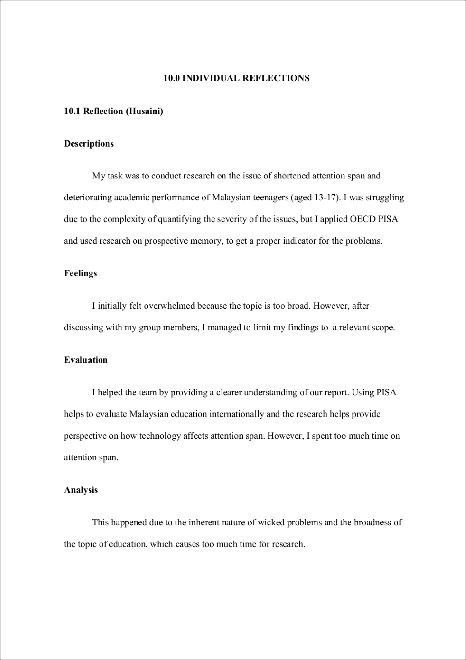



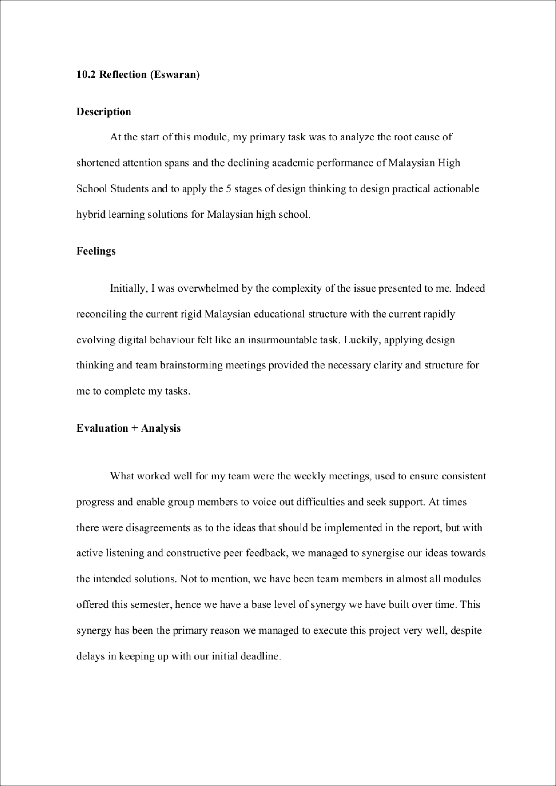

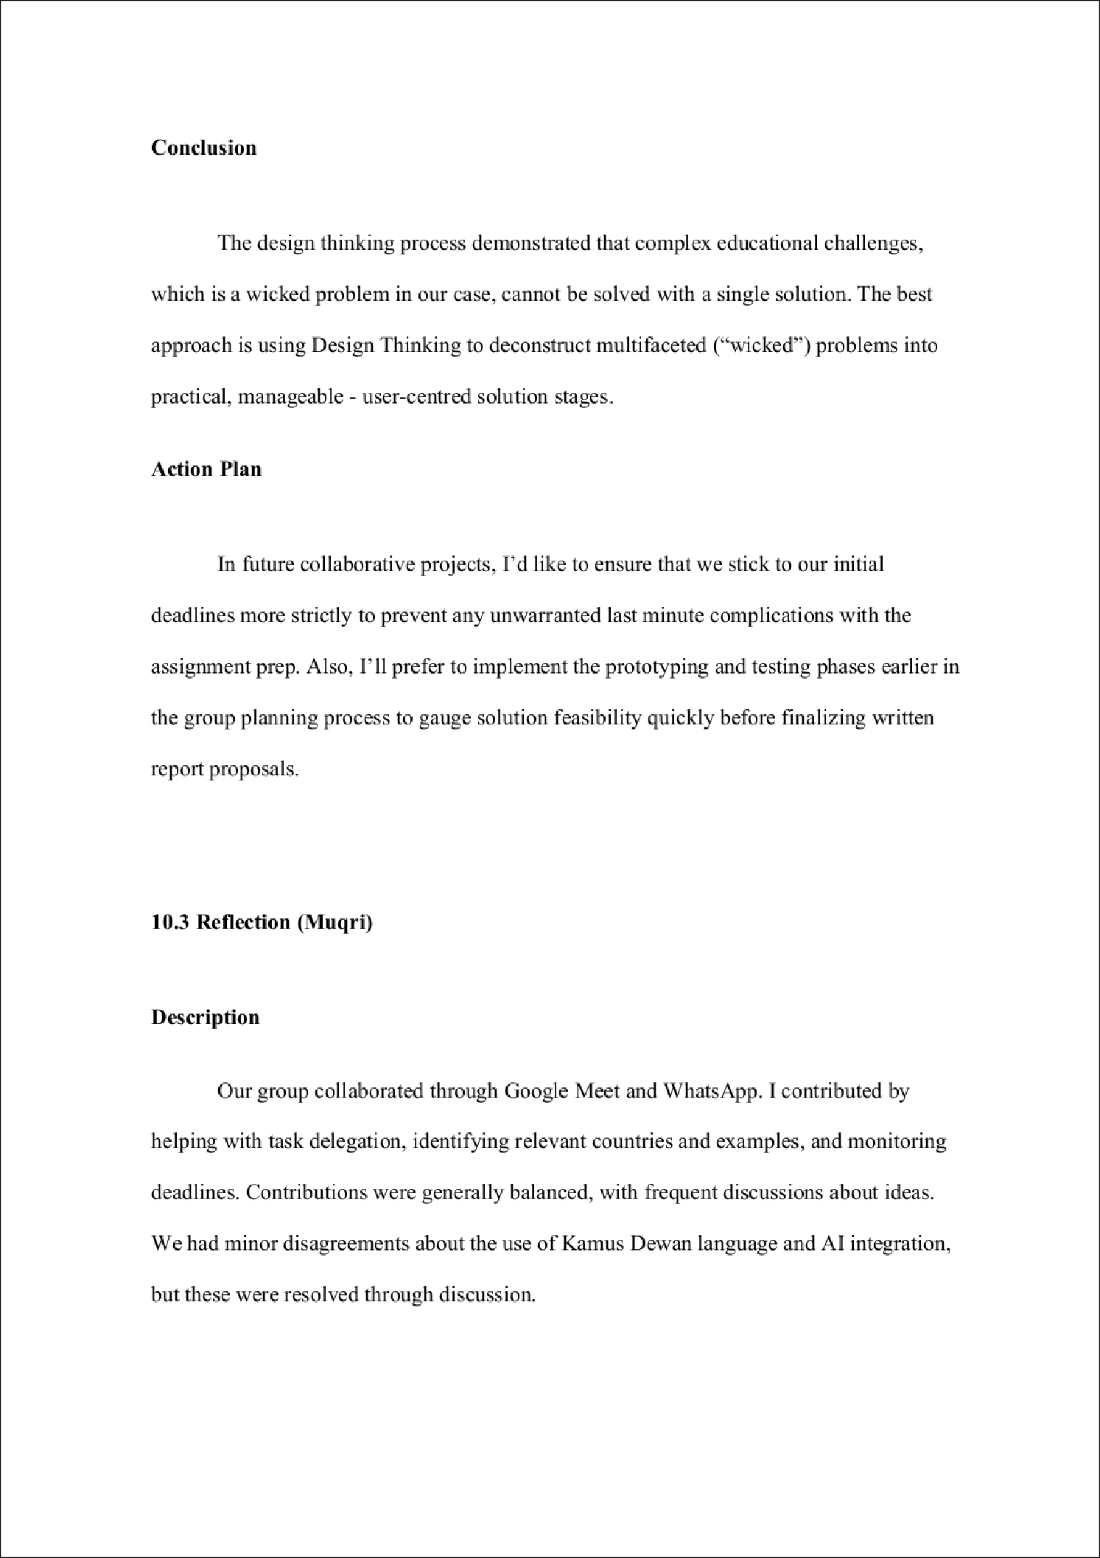

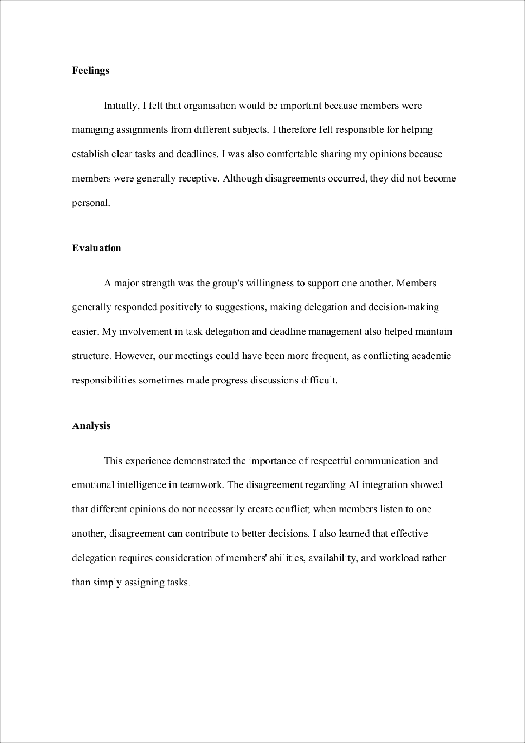

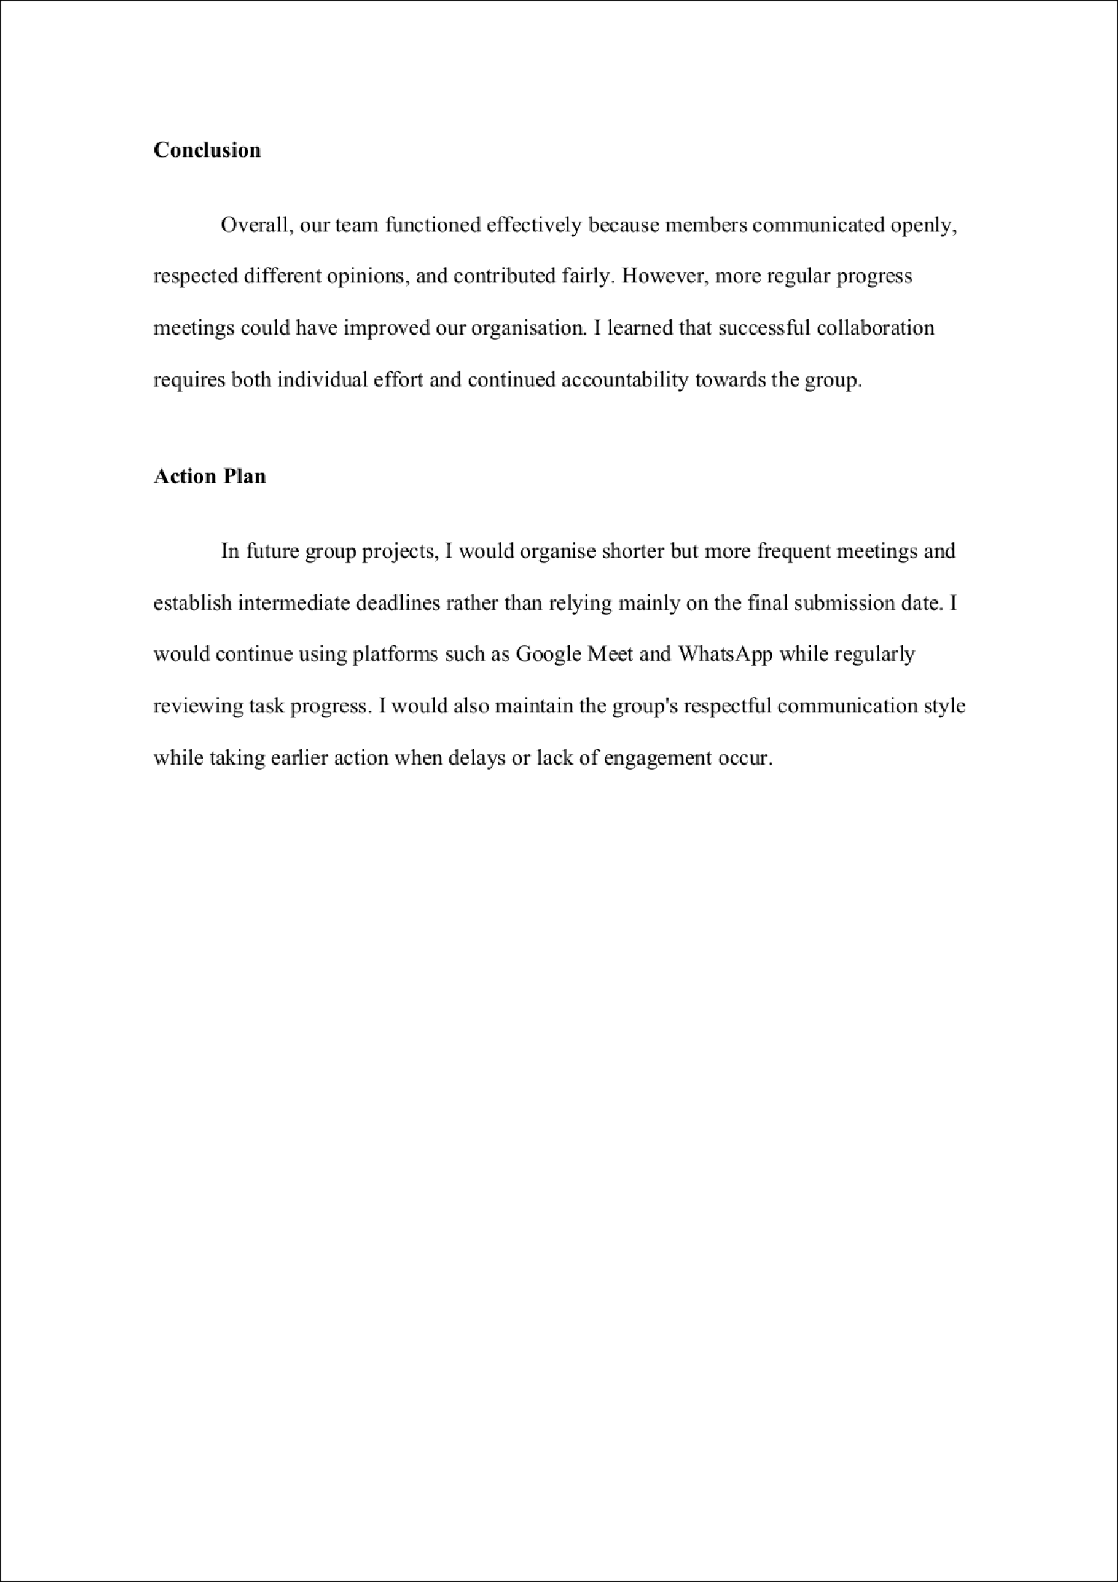

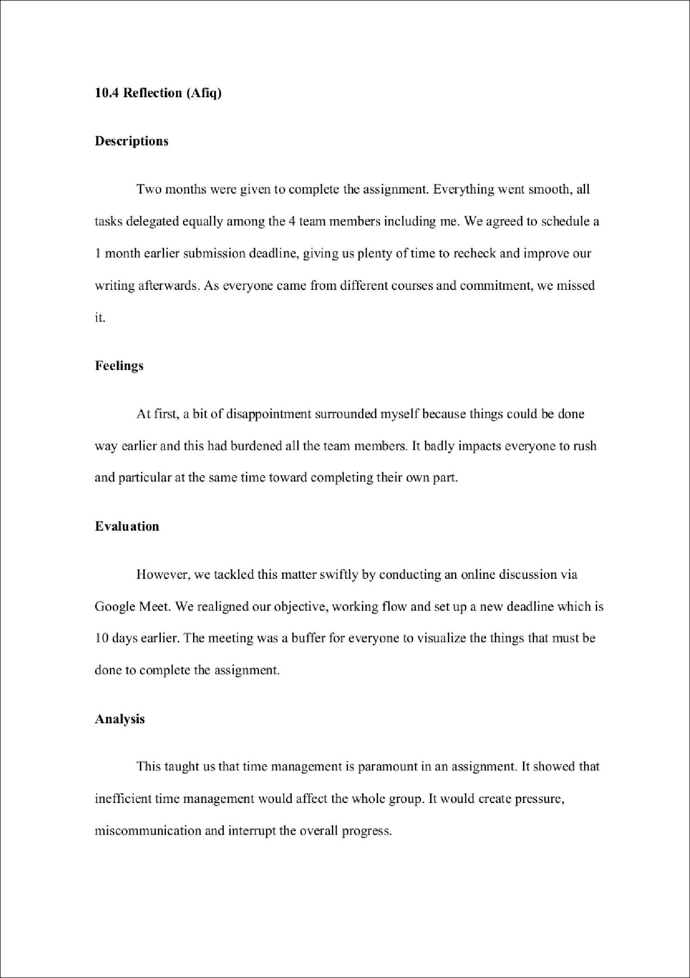

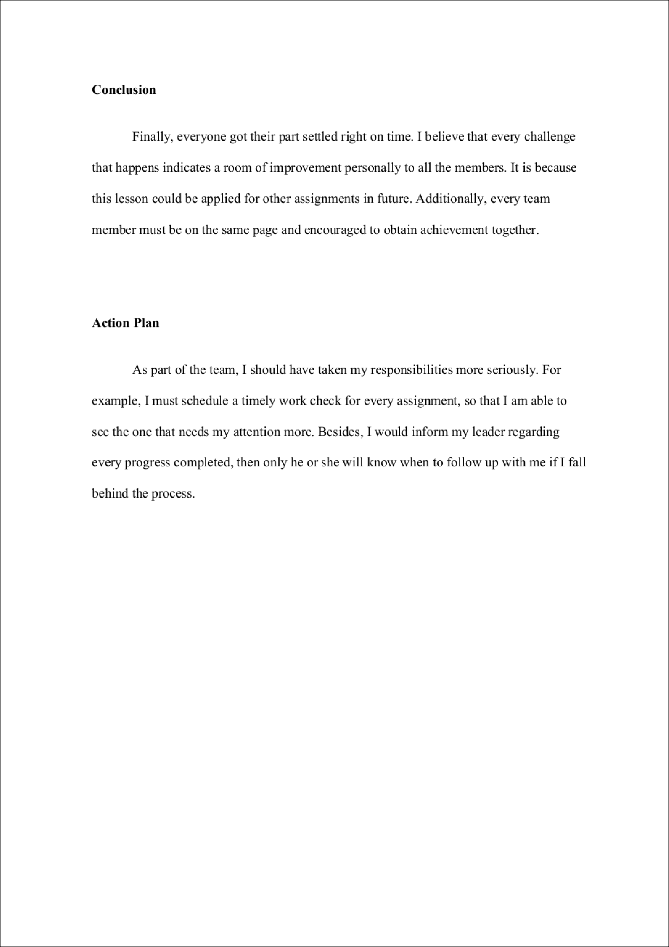

The Significance of Global Teams in Solving Shortened Attention Spans and Deteriorating Academic Performance
2
ORIGINALITY REPORT

%
SIMILARITY INDEX
1%
INTERNET SOURCES
0%
PUBLICATIONS
1%
STUDENT PAPERS

PRIMARY SOURCES
1 Submitted to Saint Leo University |  | <1%
2 digital-skills-jobs.europa.eu |  | <1%
3 www.youthpolicy.org |  | <1%
4 Submitted to Cesine University |  | <1%
5 Submitted to Taylor’s Education Group |  | <1%
6 kocerroxy.com |  | <1%
7 www.annualreports.co.uk |  | <1%
8 giki.edu.pk |  | <1%
9 www.tech.gov.sg |  | <1%

Student Paper

Internet Source

Internet Source

Student Paper

Student Paper

Internet Source

Internet Source

Internet Source

Internet Source

Exclude quotes Off
Exclude bibliography Off
Exclude matches Off

