Coaching portfolio - management of the coaching process

Chelsea Jenkins - 1910104

(M4X02087)

Table of Contents
1. Introduction 3
2. A Scheme of Work (Itinerary Coaching Plan) 7
3. Rugby Coaching Plan 10
4. Netball Game Sense Coaching Plan 21
5. Bounce Pass Netball Coaching Plan 33
6. Observational Coaching Competence Assessment 43
7. Coaching Session and Personal Practice 44
8. Workbook for Coaching Process 49
9. Academic Journal Reviews 71
9.1 An Integrative Definition of Coaching Effectiveness and Expertise 71
9.2 An Australian Perspective on the Development of Youth Football Players 73
9.3 Tennis Coaching: Applying the Game Sense Approach 75
9.4 A Review on the Effect of Small-Sided and Modified Games in Sport Teaching & Coaching 77
9.5 Supplements: Sport, Health & Education 79
10. Conclusion 81
11. Reference List 82

- Introduction
Talent and Coaching
- Talent:
The definition of talent is “whether talent is innate or dynamic due to the environment the individual engages in,” linking to the nature and nurture debate. (Durrand-Bush and Salmela, 2001). In recent sports psychology research, they state there is a consensus that talent is both innate and dynamic, and that is the key point how to maximise and develop the highest potential of an athlete. (Abbott and Collins, 2004).
- Coaching:
Coaching can be defined in many ways, for example, “supports a person at every level in becoming who they want to be and unlocks a person’s potential to maximise their performance.” (International Coaching Community, 2020).
A coach does not just try to get their athletes to their maximum potential they also have many other roles. For example, mentoring, counseling and teaching. These all focus on the well-being of athletes and passing on knowledge from their experiences. (International Coaching Community, 2020).
Long –tern Athlete Development and Four Pillars of Development
When considering an athlete, it is important to highlight the five stages of Long-term Athlete Development (LTAD). These stages are, the FUNdemantal stage, training to train stage, training to compete stage, training to win stage and the retirement/retraining stage. (Bayli, 2005). This is key because as a coach you need time to improve on different elements of training before becoming a professional athlete or compete and win. This links to the four pillars of development which are, Physical, Technical, Tactical and Psychological. (Ricard Pruna, 2018, p. 43-46).
Every person has had different coaching experiences from a child to a professional athlete. Most early year coaching will involve coaches making sessions fun, friend orientated and mix gender sports, this as a result keeps children in sport due to, they are participating with friends and it is not about winning but enjoying learning new skills and sports between the ages of 3-7 normally do not involve impact activities e.g. tackling. (Children, sport and exercise, 2019).

Sports England Talent Plan – Creating the World’s Best Talent System
In 2018, Sport England realised their findings on talent, it was called “The Talent Plan – Creating the World’s Best Talent System. They stated more than 80% of Team GB and Paralympic GB were made up of English athletes. (Sport England, 2018, p.4). They highlight that “the world’s best talent system is one that keeps on winning, so producing more and better athletes and performances remains a prime objective. In addition, they state that “athletes and coaches also known that there’s always room for improvement.” (Sport England, 2018, p.4).
In the research, they discuss how best to define talent and how to correctly identify and develop it. Sport England have defined talent has “it can be thought of as a multidimensional package of characteristics and abilities.” (Sport England, 2018, p.11). From a practical perspective Sport England have said within the talent system is the most useful for them when considering how we can, within the training and competition pathway e.g. developing the characteristics and abilities deemed to be necessary for the achieving future senior international success in sport and within each sport. (Sport England, 2018, p.11). For example, we may not see evidence of some of these characteristics and abilities until the athlete reaches full maturity, a coach meets their development needs, or they could train in an appropriate environment unique to their needs. Another example is, performance e.g. competition results, do not show a true reflection on an athlete's talent. This is a risk of missing out on potential talent athletes and therefore Sport England have stated they need to get a long-term view as their approach to avoid missing out. (Sport England, 2018, p.11).
In addition, Sport England talk about talent inclusion. They state they are “creating an environment in which is inclusive and where prohibitive barriers have been identified and actively removed.” (Sports England, 2018, p. 12).
Talent development is “a complex and often non-linear process, it is the practice of developing athletes to perform to their potential”. (Sport England, 2018, p.16).
At each stage of the talent pathway, pathway leaders, coaches e.g. both England Talent Pathway and/or club. The workforce more mainly focused with “encouraging and advancing sport-specific skillsets and behaviours in the athletes they are engaged with”. For example, developing talent in an athlete so that they can therefore reach their full potential, requires a keen awareness of the individual, their stage of development and a working knowledge of the factors that impact talent development in general alongside those specific to their sport. (Sport England, 2018, p.16).
Sport England’s plan for talent development identification is focused on three main elements which are, the individual, environment and the task. The individual is taking into consideration e.g. chronological age, training experience and characteristics. The environment focuses on the coaching quality, support, cultural importance, sport policy and availability of facilities. The last element the task looks at speed, power, balance, endurance, decision making and coordination. All the elements link with the progression, inclusion and positive experiences to aid in identifying talent development. (Sport England, 2018, p.17).
This is shown in figure 1 and 2.

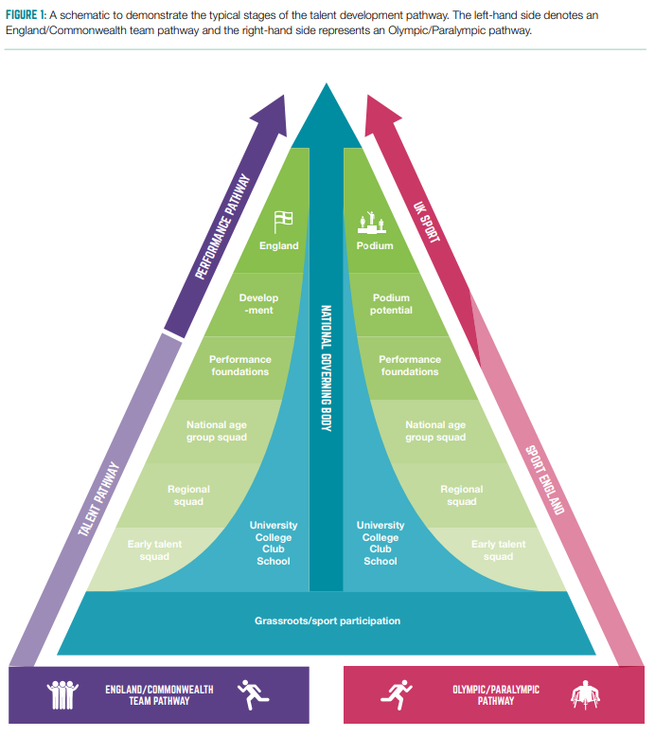

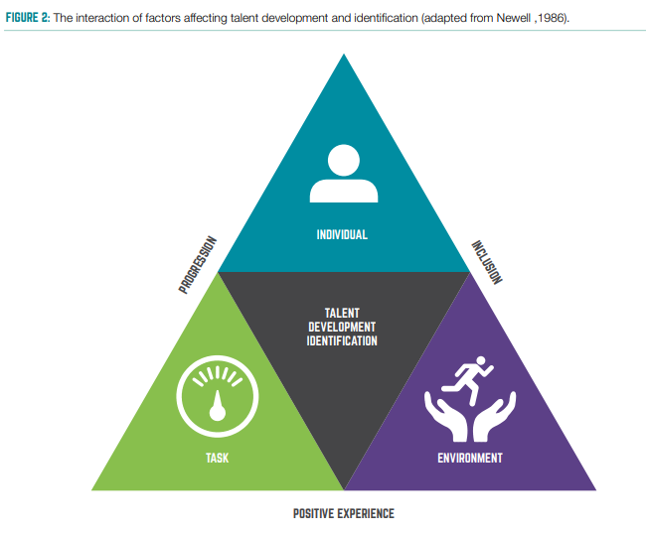

- A Scheme of Work (Itinerary Coaching Plan)

DATE: | SCHOOL: | YEAR: | NUMBER OF PUPILS: | ACTIVITY: | GOALS FOR THE SESSION: | PERSONAL ACTION PLAN FOR FUTURE SESSIONS:
21/10/2019 | Brynmill | 3/4 | 56 | Catching and Passing. | *Warm-up = Stuck in the mud.  *Activities = basic catching and passing then into a game. | *Session plan needs to be more in depth e.g. more than one activity.  *Session itself needs to be more enjoyable for the pupils.  *Do not be afraid to change or adapt session plan if the session is not working.
18/11/2019 | Trallwn | 3/4 | 65 | Netball | *Warm-up = stuck in the mud.  *Activities = chest and bounce pass e.g. how many chest/bounce passes can you successfully complete in 20 seconds. | *When planning to ensure if we are told to plan for 10 pupils per group make sure to plan for between 7-15 pupils just in case.  *Before session starts ensuring all equipment is suitable to use due to some netballs being flat and unsuitable for use.
25/11/2019 | Lonlas | 2 | 68 | Rugby | *Warm-up = bonds and tag with rugby ball to increase heart rate.  *Activity 1 = catching ball from height then passing back to coach.  *Activity 2 = passing ball down the line.  *Encourage teamwork, effective communication and use of Welsh.  *APES. | *Ensure all members of the coaching group know what they are supposed to be doing throughout the session to make sure the session flows smoothly.  *Try to have pupils think more on their own e.g. what are the key parts we are focusing on and what could you have done instead of that pass to be more successful and score?
24/02/2020 | Llanrhydian | 3-5 | 30 | Netball | *Warm-up = split group into 3 mini groups for technique of chest pass.  *Activity 1 = split group into 4 mini groups (3v3) game.  *Activity 2 = Stop game to focus on the areas of technique that groups can improve on e.g. passing or finding free space.  *Whole-Part –Whole.  *Ask pupils more questions and APES. | *Need to be louder throughout session to get pupils attention e.g. 3,2,1 or shout freeze.  *Do not be afraid to adapt the plan for the session to make it fit the pupils you are teaching e.g. making activities easier or more challenging due to pupils having a range of abilities.
09/03/2020 | Lonlas | 5/6 | 54 | Rugby | *Warm-up = tag with rugby ball.  *Activity 1 = Passing down the line focusing on teamwork and finding space.  *Activity 2 = Catching ball from height and passing back to coach.  *Throughout session third coach who is not taking the lead on the activity will be taking pupils to the sit for one to ones to improve pupil's basic technique. | *Ensure when we are planning for the session, we take into consideration that some pupils may not enjoy the activity, so we need to know how to help them enjoy the activity.  * Time management e.g. dedicating specific times to each of the sections of the session.

*Pen Y Bryn and Penllegaer were Cancelled due to COVID-19. *

- Rugby Coaching Plan
Rugby Passing - Session Planner
Venue: LC2 |  |  | Age group: Year 2  Number Attending: 68 pupils
Date: 25/11/19 |  |  | Start time: 11am  Finish time: 2pm
Equipment:
Rugby balls x5, Bibs x5, Cones x16

Nearest Telephone:  Reception. | 1st Aid bag:  Reception.
Risk Assessment completed:  Yes. | Additional Hazards and actions taken:  Yes.
Learning from previous session:  - I learnt how important it is for the warm- up to be fun and active, otherwise pupils especially of a young age get bored very easily and therefore are not enjoying the activities.  - It is key that every member of the coaching group know exactly what they are doing throughout the session. This links to previous difficulties with time management supporting the improvements needing in communication throughout the group. |  | Personal action points from previous session:  - I need to work on time management throughout the coaching session, by dedicating specific times to each of the sections of the session.  - Try to have pupils think more on their own instead of me correcting them or giving them the answers.
Goals for the session:

- Fun Warm-up game e.g. bonds and tag with rugby ball, increase heart rate.
- Activity 1: half the group – practicing catching the ball from height then pass back to the coach.
- Activity 2: other half the group – passing ball down the line.
- After first activity the groups will switch.
- Key components = correctly positioning when catching and receiving ball, catching the ball correctly with right technique from height.
- Throughout session encourage teamwork, effective communication and the use of Welsh.
- Ensure that the session is active, purposeful, enjoyable and safe.

Introduction and warm-up:

The group starts by bringing all the pupils close so they can all hear and see us. Once all pupils are paying attention introduce all members of the coaching individually. The warm-up will be bonds and tag with the rugby ball. Bonds is when you have all the pupils run around then shout out a number and they have to get into a group of that number. If there is an odd number and therefore leaves one pupil out that pupil becomes the person to be on in tag therefore ensuring no one is left out. This is also a perfect opportunity for members of the group who do not speak a lot of Welsh to get involved. For example, “grwpiau o dri,” groups of three, “pasio o’r glun” pass from the hip, “dilynwnch gyda’ch byseed” follow through with your fingers and “edrych ar y targed cyn taflu” look at target before throwing. Tag is being played with a rugby ball because it gives the pupils easier experience getting to know the correct way to hold the rugby ball and linking to the activities following. Both if these activities encourage communication and teamwork skills. This will take part within a corned off area for safety. After the warm-ups the coaching group will half the pupils into two groups for the first activity.

Main Content/Game  Activity 1:  This activity is focusing on the correct technique of catching a high ball in rugby.  This includes:  - Anticipate where the ball will land and move towards the target area.  - Keep eyes on the ball.  - Extend arms above eyes in the direction of the ball, elbows together with soft hands and fingers spread and little fingers almost touching.  As shown in Figure 1.  The pupils will the line up one behind the other and a coach will throw the rugby ball into the air for them to catch. Once, they have caught the ball the pupils will then pass the ball back to the coach and join the back of the line.  Ross Rugby. 2020. High Ball Catching | Ross Rugby. [online] Available at: <https://rossrugby.co.za/technical-zone/skills/position-specific-skills/wing-skills-and-drills/> [Accessed 25 March 2020].  Activity 2:  The focal point of this activity is to learn how to correctly pass a rugby ball.  The steps include:  - Hold the ball in two hands with your fingers spread across the seam (middle) of the ball, with your chest facing forward.  - Look at target (team member), draw the ball off your hip as you swing your hands through an arc, keeping elbows close to your body.  - Release the ball with a flick off the wrist and fingers. Follow through with your fingers pointing to the target (team member) - chest high in front of the receiver.  News.bbc.co.uk. 2020. BBC SPORT | Rugby Union | Skills | The Basic Pass. [online] Available at: <http://news.bbc.co.uk/sport1/hi/rugby_union/skills/4198382.stm> [Accessed 25 March 2020].  Pupils will then line up in groups and pass the ball down the line, taking the technique learnt from above. This is shown in Figure 2.  Game:  There are two groups which on averages has between 5-7 pupils in each group.  The aim of the game is to score from one side of the coned area to the other. To do this all members of the team must touch the rugby ball before the team can score. In addition, if anyone of the team members drops the rugby ball the game is frozen and the rugby ball is given to the other team. This encourages the pupils do not drop the ball and increase successful passes.  This is shown in Figure 3. |  | Organisation/diagram  - All activity will take place within a coned off area, which will promote safety.  Activity 1:  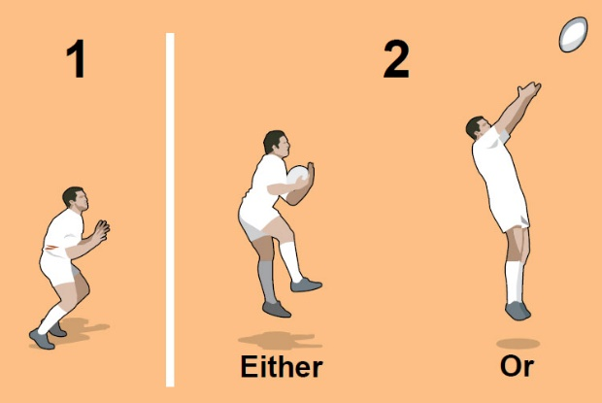  Figure 1:  Cottrell, D. (2020). Catching the kick off - Rugby Coach Weekly. [online] Rugby Coach Weekly. https://www.rugbycoachweekly.net/practice-plans/catching-kick-off/ [Accessed 5 Feb. 2020].  Activity 2:  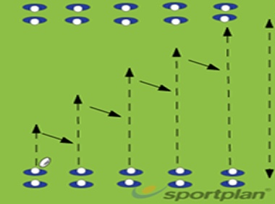  Figure 2  Sportplan.net. (2020). Sportplan - Sports Coaching Made Easy. [online] https://www.sportplan.net/app/#drills/Rugby/Passing [Accessed 5 Feb. 2020].  Game:  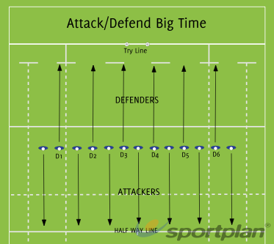  Figure 3  Sportplan. 2020. Attack/Defend Big Time Sevens - Rugby Drills, Rugby | Sportplan. [online] Available at: <https://www.sportplan.net/drills/Rugby/Sevens/AttackDefend-Big-Time-pd120.jsp> [Accessed 26 March 2020]
Ideas for Development (progression / regression):  Game:  - There are 3 attackers and 2 defenders.  - The 3 attackers must get past the two defenders without being touched or intercepted.  - The defenders will start back in the box and can move anywhere inside the box.  - The attackers must remain inside the box and all attackers must touch the rugby ball before scoring. |  | Diagram for activity:  Game:  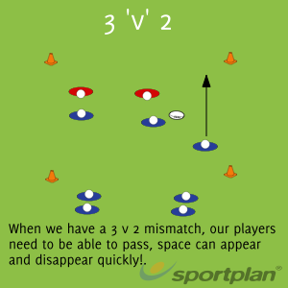  Sportplan. 2020. 3 'V' 2 Passing - Rugby Drills, Rugby | Sportplan. [online] Available at: <https://www.sportplan.net/drills/Rugby/Passing/3-v-2-pd79.jsp> [Accessed 26 March 2020].

5Cs to be included in this session | Select 2 of the 5 and apply to session  HOW?
Competence

Confidence: | It was essential for us to keep telling the pupils throughout the session they are doing well and keeping confidence up. For example, great pass and good teamwork. If one pupil is executing a pass well e.g. showing great technique linking to successful pass have them show the group a demonstration. Thus, this gives that pupil a huge amount of confidence because they know they are executing the technique correctly and other pupils in the group get to see the them demonstrate the skill and this could possibly help other pupils pick up on it easier. Furthermore, if pupils are struggling with the skill and technique have one of the coaches take the pupil or pupils aside and focus on the area, they need to improve on then re-introduce them into drill or game. This will allow pupils to have one to one lesson with coaches and hopefully this will increase the chances of them enjoying the session.
Connection: | An important part of the coaching session is communication, which was encouraged throughout the whole session to all the pupils. For example, call their fellow pupils names before they pass the ball, this therefore reduces the chance of pupils reducing the ball and increasing the number of successful passes. In addition, the drill concentrates on communication allowing pupils to be the passer and receiver of the ball. Moreover, all coaches made sure we were asking pupils questions throughout the session. For example, what the key techniques we are focusing on and what you could do to improve to make your passes etc more successful, giving pupils the opportunity to think for themselves and more of an independent learner.
Character and caring:

Creativity:

Cool-down:

Light stretching. For example, call all pupils in and have them sit down and tell the pupils if you can touch someone you are too close, this reduces the chance of pupils hitting each other whilst completing the cool-down. After this, ask them to stretch their arms to the sky then stand up and try and touch their toes without bending their knees. This is to be repeated three times and pupils should take deep breathes in and out throughout the cool-down.

Comments on session:

The team did not communicate very well throughout the coaching session and as a result created some problems for the group. For example, due to it being a welsh speaking school some members of the group struggled due to the lack of knowledge and understanding of the language and confidence. This could have been easily solved by members of the group teaching other members of the group that were less confident a few phrases before the session e.g. “grwpiau o dri,” groups of three, for the warm- up.

Another problem due to the lack of communication some members of the group were standing on the side not knowing their role in the group, this therefore links to how we planned as a group. This could be solved by asking everyone before the session begins if they know what the plan is and ensure everyone in the group takes part in the planning of the session.

The pupils informed us that they really enjoyed the warm-up especially because they have never played it before. Thus, they mentioned that they enjoyed playing the game at the end however the activities we gave them to do were a bit repetitive for the pupils who already knew how to throw a basic pass in rugby. This is something the group can work on in the future taking into consideration that some pupils will need to be challenged more than others.

Review of your Coaching Session and Personal Action Plan
For each session you deliver you need to complete a Coaching Session Review and Evaluation plus a Personal Coaching Action Plan.

Practical: Coaching Session Review and Evaluation (Individual Reflection)
Were the aims of the session achieved?  Identify which ones were achieved and which if any, were not. | I think that most of the aims of the session were achieved. For example, all pupils communicated very well and by the end of the session most of the pupils knew how to correctly pass a rugby ball and knew the key techniques/parts we have coaches were looking for.  Moreover, we asked the pupils loads of questions to check for understanding, this also reinforced the key parts we were focusing on e.g. hold two hands on the rugby ball and draw ball from the hip.  However, due to some of the pupils already knowing how to pass a rugby ball they got bored earlier on in the session. This highlights that we need to make sure we are planning for all abilities.
What factors helped ensure that your aims were achieved?  (Reflect upon organisation, appropriateness of activities, coaching styles.) | Throughout the session we asked pupils what we were focusing on and ensured it was not the same pupils answering all the time. This helped us check for understanding of the whole class and therefore gives the pupils the opportunity to ask further questions and demonstrations to be shown again if needed.  Furthermore, we encouraged communication between teammates from the start to end of the session and why communication is so important for the game at the end of the session and rugby in general.
What were the reasons for you not achieving your aims? (Reflect upon organisation, appropriateness of activities, coaching styles. | As a group we did not communicate very well and that lead to us losing time during the session linking to the lack of confusion of who had what role. Also, we could of supported each other more by different people taking the lead and if members of the coaching group were not taking the lead on an activity they could of taken pupils to the side to work on drills or technique one to one. This would of allowed the session to flow a lot more smoothly and for us to improve our time management skills.
What changes (if any) did you make to your session that were not in your plan and why? | We decided after the first group we had that we would try and split the welsh speakers into different groups to try our best to support others who don’t speak welsh. Also, this allowed us to have more people coaches to help the pupils when needed.
Would you do anything differently if you were to deliver the session again? | We had one big game at the end of the session which was some points very hectic. This was due to pupils bunching up together and there not being enough space to pass. So, I would next time have two smaller groups e.g. 3v3 or 3v2, giving pupils more opportunity to pass and score.
What have you learnt about your coaching from this session? | I have learnt that it is important to not only encourage teamwork and communication for the pupils but within the coaching group as well. This is due to most of the group's problems linking o the fact we did not work as well as we should of together e.g. lack of communication and planning as a group. So next time I would like to encourage more participation of everyone in the group and ensure everyone knows their role for the session.  In addition, it is foremost that whilst we are planning that we consider that there will always be a range of abilities in every coaching session and this is why we need to focus more on APES throughout the session e.g. Active, Purposeful, Enjoyable and Safe.  Finally, to be a good coach you must be able to encourage and inspire pupils especially when they do not like the activity you are presenting. This is something I need to improve on especially with girls as they do not always like rugby or football.
Personal Action Plan
Using the information above, what changes will you make to your planning, coaching delivery and organisation in future sessions?

In future sessions, I am going to try and get more involved in the planning and organisation of the coaching plan so I can bring up conversations such as, have we considered an option for different abilities and is what we doing have a purpose. Thus, ensure that I leave enough time during the session to achieve the objectives as a group have set and consider that time will be spent on demonstrating activities, drills and answering pupils' questions working towards improving my time management skills.

Furthermore, I need to work on being louder when leading an activity or drill. This is because the hall gets loud and pupils’ sometimes struggle to understand everything I have said in the demonstration and during a game. This can be improved by shouting 3,2,1 or freeze during a game to get all pupils attention. Also, whilst planning do not forget to leave room in the area for coaches to take pupils to the side to improve their technique before being reintroduced to the activity.

Name of Coach: Chelsea Jenkins |  | Venue: LC2 | Date: 25/11/2019

Risk Assessment

Ref | Hazard / Task / Activity  Area of Concern | Persons at Risk | Existing Controls | Describe Any Further Controls / Actions Needed | Actions By Whom | Action By When
1 | Knowing the location of the emergency exits. | All users. | There are signs around the facility that has instructions where everyone can safely exit the facility. Thus, there are fire tests. | All the coaches have a responsibility to explain to all pupils where the emergency exits are and the precautions in place and note to them there are no fire drills planned. | Members of staff and coaches. | Before session.
2 | Pupils leaving jackets and jumpers on the edge of the coned area | Pupils. | In the introduction ask all pupils if they want to take off their jackets and jumpers because they are going to get warm and if they could please put them to the side out of the way. | If pupils proceed to take their jackets and jumpers off during the drills and games, ask them to put the jackets to the side or quickly move them out of the way. | Coaches and pupils. | N/A
3 | Knowing the location of the first aid kit | All users. | There are first aiders in the facility and in addition coaching staff or teachers cannot find anyone walking around there is always a member of staff at reception and that is where the first kit is located. | If unsure ask member of staff at reception and they should be able to tell you exactly where they are located. Also, know find out who are the first aiders at the facility. | Members of staff and coaches. | Before session.
4 | Rugby hitting pupils and members of the coaching group. | Pupils. | Inform pupils of the correct and safe way to pass and receive the rugby ball. State that it is better to call the teammates name before you pass to reduce the chances of someone getting hurt. | If they by the ball after you have put cautions in place, make sure pupil is ok and if needed take them to a member of the teaching staff. | Coaches. | N/A
5 | Slipping on the cones. | Pupils and coaches. | Warn pupils to be cautious of the environment they are going to be using and what could happen if they accidently slip. | Instead of cones use flat disc plates. This will reduce the chances of the pupils hurting themselves. | Coaches. | By the next session.

- Netball Game Sense Coaching Plan
“Game Sense” Approach – Netball Planner
Venue: LC2 |  | Age group: Year 2/3  Number Attending: 62 pupils
Date: 24/02/2020 |  | Start time: 11:30am  Finish time: 2:30pm
Equipment:

Netballs x6, bibs x8 and flat disc markers x16.

Nearest Telephone:  Reception. | 1st Aid bag:  Reception.
Risk Assessment completed:  Yes |  |  | Additional Hazards and actions taken:  Yes
Learning from previous session:  - It is important to plan in-depth for all different situations so therefore you know what you are delivering.  - I learnt from the previous session that it is ok to change what you planned when it comes to delivering the session because sometimes what you plan does not fit the audience you are coaching to or it may not be active, purposeful or enjoyable enough. As a result, you need to adapt to the situation. |  |  | Personal action points from previous session:  - I need to be louder and do not be afraid to tell pupils they are doing something wrong. For example, what are the three things we are focusing on in today’s session? and should we try the pass again whilst thinking about the technique we just talked about.  - Try and get the pupils to ask and answer more questions.
Goals for the session:

- Warm-up = Split the group into 3 mini groups on technique of chest pass.
- Activity 1 = Split group into 4 mini groups (3V3) game.
- Activity 2 = Stop game to focus on the areas of technique that the group can improve on.
For example, passing or finding space in a game.
- Whole – Part – Whole
- Encourage communication with teams to increase chances of successful passes.
- Ask pupils questions instead of coaches given them the answers. Let pupils work out what they can improve in themselves.
.

Introduction and warm-up:

At the start, call all pupils, make sure everyone can see and hear you (coaches). Once all pupils are paying attention, introduce individual members of the coaches that will be taking them for the session. Then, ask if anyone has played netball before and if anyone can chest pass. If pupils put their hand up, ask them to come to the front to demonstrate, whilst pointing out key techniques and what we are going to focus on today. After demonstration, split group into 3 mini groups to focus on chest pass technique. For example, passing in a circle, calling the name of the person who is receiving the ball next.
Furthermore, encourage pupils to pass to each other by finding space and successful passes. Plus, the warm-up will last around 5 minutes in a section that is corned off for safety. After the warm-up the coaching group will put pupils into 4 mini groups for a game.

Main Content/Game:  “Part”:  This is focusing on techniques that pupils may be struggling with, for example, finding space or successful passing.  What the pupils learn and improve during “Part” they then take and use it in the “Whole/Game” to be more successful.  They main technique is how to chest pass correctly and successfully. The components that will be our focal point is:  - Make a W with fingers, bring thumbs together in the centre.  - Step forward with one foot, this will aid with energy passing the ball.  - Keep elbows close to your body and push through with the ball. When you realise the ball make sure your arms and fingers are straight.  - Keep an eye on the receiver.  As shown in figure 1.  News.bbc.co.uk. (2015). BBC SPORT | Other Sport... | Netball | Netball: chest pass. [online]: http://news.bbc.co.uk/sport1/hi/other_sports/netball/4188162.stm [Accessed 27 Feb. 2020].  “Whole/Game”:  Start with a 2 games of netball 4V4, instructing that all members of the team have to touch the ball before they can score.  This gives the coaches the opportunity to see what they may need to focus on during the “Part”.  In addition, this is where coaches can stop the game and ask pupils questions, such as, what was a better option instead of passing there or what should you have done instead of that.  Moreover, after doing the “Part” drill it is important that we see everything the pupils have learnt in the game and therefore a more skilful game. |  |  | Organisation/diagram:  - Coned off areas where games and drills will take place, this will ensure safety and  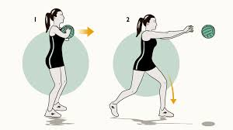  Figure 1:  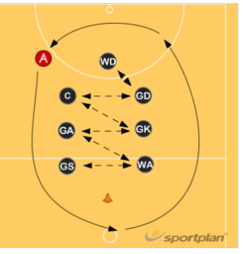  “Part”: Figure 2  Sportplan.net. (2017). Sportplan - Sports Coaching Made Easy. [online]:https://www.sportplan.net/app/#drills/Netball/sessionPlans/Attacking-Principle-Driving-onto-the-Ball-15167362.jsp [Accessed 26 Feb. 2020].  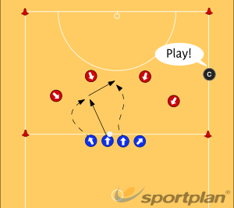  “Whole”/Game: Figure 3  Sportplan. (2020). Attacking Third Game - Offence v Defence Small games Sportplan. [online]:https://www.sportplan.net/drills/Netball/Small-games/Attacking-Third-Game-Offence-v-Defence-NA0000003.jsp [Accessed 26 Feb. 2020].
Ideas for Development (progression / regression):  “Part”:  One person starts with the ball. The ball is passed to someone across the circle, each pupil can only receive once until it is back to the start. Once all pupils are confident add another ball in, carry this on until they get to 3/4 ball going in the circle. Thus, when ball is dropped stop the activity and restart. This add pressure to the drill therefore making the pupils focus on the skill.  “Whole/Game”:  During the game instead of everyone being able to go anywhere in the coned off area split pupils into areas where they are allowed to go and not go. This creates an environment that challenges all of them and focuses on attacking during the game.  For example, 2v1, making it easier for the team attacking to score and as a result increasing confidence due to scoring. |  |  | Diagram for activity  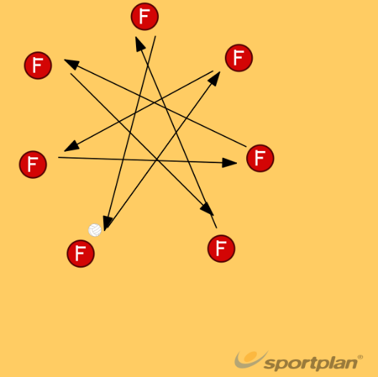  “Part”: Figure 4  Sportplan.net. (2020). Sportplan - Sports Coaching Made Easy. [online]: https://www.sportplan.net/app/#public/Netball/open/5067591 [Accessed 27 Feb. 2020]  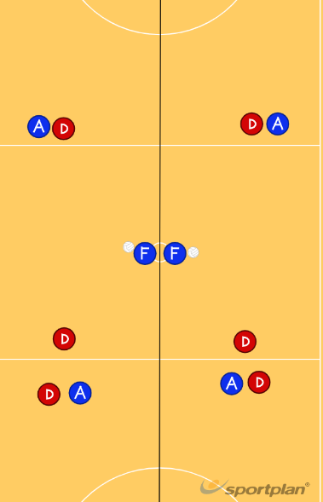  “Whole/Game”: Figure 5  Sportplan.net. (2020). Sportplan - Sports Coaching Made Easy. [online]: https://www.sportplan.net/app/#public/Netball [Accessed 27 Feb. 2020].

5Cs to be included in this session | Select 2 of the 5 and apply to session  HOW?
Competence

Confidence: | Throughout the session tell pupils they are doing really well. For example, great pass, good use of space. If someone within the group is executing the techniques we are focusing on really well stop the game and have them demonstrate for the class, this will reassure the pupil or pupils are doing the correct technique. Plus, giving the rest of the pupils another looks at the demonstration therefore making them more confident in what them need to do next to improve. If a member of the group is finding the activity hard have one of the coaches take them to the side to explain in further detail and have on to one practice, as a result improving confidence. Overall, try best to encourage and praise all pupil as much as possible throughout the session.
Connection: | One of the key parts of the session is communication. We encouraged all pupils to call their team mates name before they pass or when they are in free space. Moreover, all pupils have the opportunity to play against different teams as we split them into four mini groups, testing their communication. Thus, the drill concentrates on communication allowing pupils the chance to be the passer, receiver and marking the ball improving overall technique and skill. In addition, throughout the session we ask pupil questions such as, what are the main points we are focusing on, what could you improve on and how could we make that pass more successful. This gives the pupils the chance to work things out for themselves and as a result become a better learner.
Character and caring:

Creativity:

Cool-down:

Light stretching, for example, have pupils sit down in a circle and ask them to stretch to the sky and then stand up and touch your toes or floor without bending knees. Repeat these three times whilst taking deep breaths in and out.

Comments on session:

The planning for the session was not in-depth enough and therefore created a lot of problems. For example, the warm-up was too static and majority of pupils were standing there doing nothing and was not enjoyable for them. In addition, the aim of the warm-up was for the pupils to get used to chest passing the netball yet most of them touched the ball on average twice which is not meeting the goals of the session and due to them being static their heart rates did not raise. Another problem the group encountered was we did not give the pupils the opportunity to score, this was because throughout the session we kept it has even teams and anyone could go anywhere within the coned area. However, the “Part” activities did help the pupils in the game as we seen the techniques learnt in the activities being used in the game (“Whole”) and all coaches were encouraging communication throughout each session and this increased the number of successful passes between teams.
I believe that the group could have been more effective with the time we were given for the session and this links to the problems with time management and communication within the group. This links to us not planning in-depth enough due to the coaching group not being 100% sure what we were going to move onto next, we need to make sure our sessions flow more and enough we are meeting the goals we have set.

Review of your Coaching Session and Personal Action Plan
For each session you deliver you need to complete a Coaching Session Review and Evaluation plus a Personal Coaching Action Plan.

Practical: Coaching Session Review and Evaluation (Individual Reflection)
Were the aims of the session achieved?  Identify which ones were achieved and which if any, were not. | I think some of the aims were achieved in the session. For example, everyone communicated really well and everyone knew have to correctly chest pass and majority of pupils found space. Also, pupils answered all of the questions we asked and some of the pupils were realising what mistakes they were making and improved on them. However, the warm-up was static and as a result was not fun for the pupils and we did not develop the “Whole/Game” as much as we could. Thus, we did not always follow the Whole-Part-Whole approach.
What factors helped ensure that your aims were achieved?  (Reflect upon organisation, appropriateness of activities, coaching styles.) | At the start and end of every activity we asked the pupils what were the main things they we focusing on, this checked the understanding of the pupils and gave them the opportunity to answer questions. Moreover, we encouraged communication constantly throughout the session and ensured that pupils understood why communication and working as a team was so important. This is important because, the players know when they are going to pass and receive the netball and when team mate is in space.
What were the reasons for you not achieving your aims? (Reflect upon organisation, appropriateness of activities, coaching styles. | As a group we did not get the chance to develop our activities due to the lack of time management and communication to each other. As well I believe we could have supported each other a lot more when one of us was taking the leading making it easier for each other.
What changes (if any) did you make to your session that were not in your plan and why? | We had two games going on at once instead of one to ensure that all pupils we active as much as possible and we added a netball into the games to ensure that every was having a chance to pass the ball.
Would you do anything differently if you were to deliver the session again? | Firstly, I would make sure that we planned more in-depth and ensured that we focused more on APES. For example, making sure that the warm-up was active and purposeful and as a result more dynamic.
What have you learnt about your coaching from this session? | I’ve learnt how important it is to plan in-depth and how key it is for everyone to know exactly step by step you are doing and that way everything will flow a lot easier. In addition, to be a good coach you must have the ability to inspire and motivate the pupils you are working with due to it being very easier for children to lose interest if you do not make it enjoyable for them. Furthermore, a good coach always has to be positive. For example, have patience and praise players instead of criticising them, always find something good to say. Finally, you need to be clear and constant with all the instructions you give, this may lead to you taking more time sometimes because you needing to break down techniques into parts for the pupils to understand better.
Personal Action Plan
Using the information above, what changes will you make to your planning, coaching delivery and organisation in future sessions?

In future sessions, I am going to try and be louder in my explanations and during the activities. For example, shouting 3,2,1 to get pupils attention to come in for discussion or freeze giving myself a better chance to be heard and therefore the more opportunity to ask pupils questions, such as, “what could you have done instead of passing there and that’s go back to that pass, what was a better option”. In addition, I need to ensure that I make sure I am leaving enough time to reach all of the goals and objectives I have set for the session. This links to the improvement I need to make when it comes to planning a successful session. For example, making sure I stick to the approach e.g. game sense approach, making the most of the area I have, game adaptations and modifications. As well as, I need to make sure I leave a space in the area for someone to be taken out of the game or activity to improve on pass or technique for five minutes and then go back into game more confident. Furthermore, centre around the idea of involving connection with the session. For example, 4v2 to increase the chance of the teams scoring.

Name of Coach: Chelsea Jenkins |  | Venue: LC2 | Date: 24/02/2020

Risk Assessment (Complete Individually)

Ref | Hazard / Task / Activity  Area of Concern | Persons at Risk | Existing Controls | Describe Any Further Controls / Actions Needed | Actions By Whom | Action By When
1 | Knowing location of first aid kit. | All users. | There are first aiders walking around the facility and thus in case coaching staff or teacher cannot find a member of staff walking around there will always be a member of staff at reception and that is the location of the first aid kit. | If unsure ask at reception of the facility and they should be able to tell you exactly where they are. Also, know who the first aiders are at the facility are. | Members of staff and coaches. | Before session.
2 | Netball hitting pupils or members of group. | Pupils. | Teach pupils the correct and safe way to catch and pass the ball. Highlight that it is better to pass short and be successful then to pass long and not score or lose the netball. | If they get hit by the netball after you put but cautions in place make sure the pupil is ok and may need to take them to a member of teaching staff. | Coaches | N/A
3 | Knowing the location of emergency exits. | All users. | There are signs around the facility instructing where emergency exits are. In addition, there are fire drill test. | We have a reasonability to explain to the pupils where the emergency exits are and the precautions in place and note to them there are no fire drills planned. | Members of staff and coaches. | Before session.
4 | Pupils winding up or hitting each other or members of the coaching team. | Pupils and coaches. | Make sure that all pupils are warned to behave during session before activities beginning. Also, that it does not matter if you don’t win any games it’s about taking part and having fun. | First time it happens tell them that it is nit ok to hit or upset people and if they continue they will have to sit out of the activity/game and speak to their teacher. | Coaches and teachers. | N/A
5 | Pupils leaving jackets and jumpers on the edge of the coned area. | Pupils. | In the introduction ask all pupils if they want to take off their jackets and jumpers now because they are going to get warm and they can up them to the side. | If pupils take off jackets and jumpers during activities ask them to put them to the side or pick them up quickly and move them out of the way. | Coach and pupils. | N/A

- Bounce Pass Netball Coaching Plan

Chest and Bounce Pass - Session Planner
Venue: LC2 |  |  | Age group:  9-11-year olds.  Number Attending:  80 pupils in total (in groups of 8 – 14 pupils).
Date: 21/10/19 |  |  | Start time: 11:30am  Finish time: 2:30pm
Equipment:
6 basketballs and 8 cones.
Nearest Telephone:  Reception. | 1st Aid bag:  Reception.
Risk Assessment completed:  Yes | Additional Hazards and actions taken:  Yes
Learning from previous session:  N/A |  | Personal action points from previous session:  N/A
Goals for the session:

- Fun warm up game e.g. Stuck in the mud.
- Activities on chest and bounce passing e.g. how many chest passes can you complete in 20 seconds without dropping the basketball.
- Next game continuing from the chest pass onto how many bounce passes can you complete in 30 seconds as a team.
- Use key components of passing and catching the basketball by chest and bounce pass.
- During the session expand on areas to determine certain pupils may need some extra support. For example, one to one demonstration on how to complete a chest pass. This maybe because they did not see the first demonstration clearly.
Introduction and warm-up:
Firstly, have all pupils stand on a clear line of the court e.g. please can you stand on the red line. Once all pupils are paying attention introduce individual members of the group that will be coaching them for the session. The warm-up activity will be stuck in the mud. This is a game when one or more people are picked to tag the other members of the group. Once someone has been tagged (stuck in the mud) they have to stand with their legs and arms out and they cannot move until someone who has not been tagged releases them, this is done by someone running or passing under person that is stuck to free them. Also, this will get the pupils to work as a team to release as many people as possible before team runs out and get their heart rates up. If one person is finding it hard to tag everyone, we will introduce someone else to help them. Furthermore, each warm- up will last around 2 minutes and you are not allowed to run out of the coned area. After the warm- up or introduction we will put them into groups e.g. line them up and say group 1 and 2 alternatively down the line.

Main Content/Game:  Passer for chest pass:  - Hold the ball close to the chest with elbows pointing out.  - Have each hand on either side of the ball ensuring that hands and fingers are making a “W-shape”.  - Ensure that pupils follow through with chest pass and step forward into the pass.  - Make sure pupils are looking where they want to pass.  - Call the person that will be catching the ball to make sure they are ready to receive the ball.  Catcher for chest pass:  - Step forward to receive the ball.  - When receiving the ball catch it with both hands on either side of the ball.  - Be ready for the person passing the ball to call you saying the ball is about the be thrown.  Game for chest passes:  - How many chest passes can you successfully complete in 20 seconds?  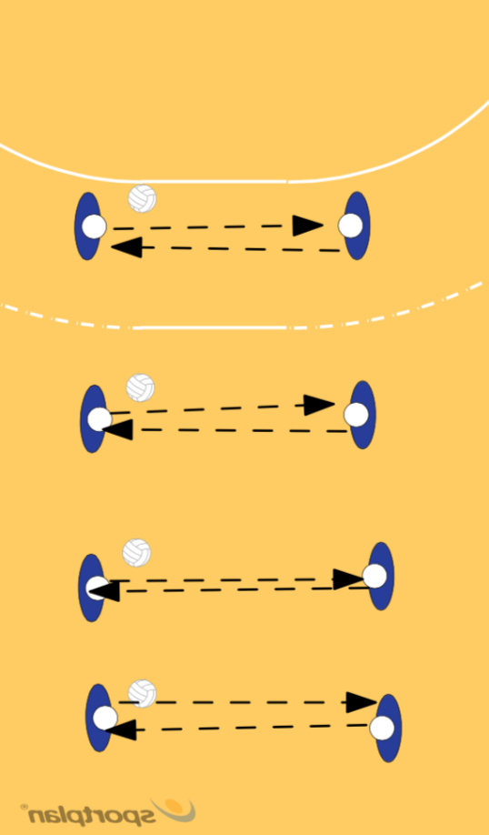  - If the ball is dropped, they start from zero again.  Passer for bounce pass:  - Step forward into the pass that the ball follows through.  - As they are passing ensure the ball is being pushed into the ground and only bounces once before reaching the other member of the group.  - Flick wrists so thumbs are pointed towards the floor.  - Look where you are passing and call team mate to make sure they are ready.  Catcher for bounce pass:  - Step forward to receive the ball.  - Catch the ball with both hands on either side of the ball.  - Communicate with team mate to ensure ball is not dropped.  Game for bounce pass:  - How many bounce passes can you successfully complete in 30 seconds?  - Same rules as chest pass.  - NO losers in both games due to there being no points being awarded. |  | Organisation/diagram:  - Coned off area that they had to stay in and use the cones to explain where they should be standing for each activity.  - Only use basketballs, more per group.  - Ask them which pass they found the hardest and why.  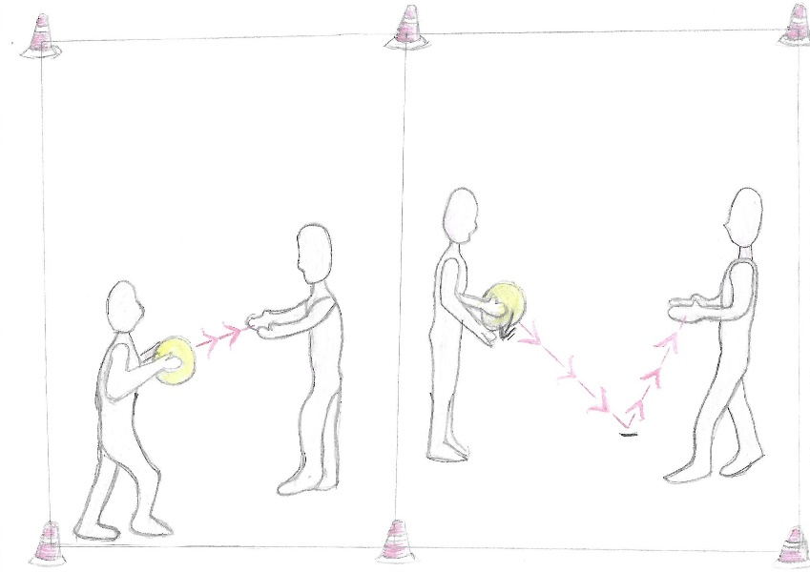  Sportplan.net. (2018). Sportplan - Sports Coaching Made Easy. [online]: https://www.sportplan.net/app/#search/Handball/chest%20pass [Accessed 6 Nov. 2019].
Ideas for Development (progression / regression):  We observed that a number of pupils struggled to pass the ball as long as others, so we brought them closer together it makes it easier and enjoy more due to the distance being slower to pass. This could be a note to us as coaches we may need to make the distance between pairs/groups shorter, so everyone is at the same distance. Moreover, we had a few pupils ask for a re demonstration of the passes. This could be an area to work on next time and improve. For example, take more time to explain and talk through each pass or have every pair/group complete one pass before we start to ensure everyone is ok with the technique. This therefore gives us as coaches the opportunity to see which groups need more attention and guidance than others. |  | Diagram for activity:  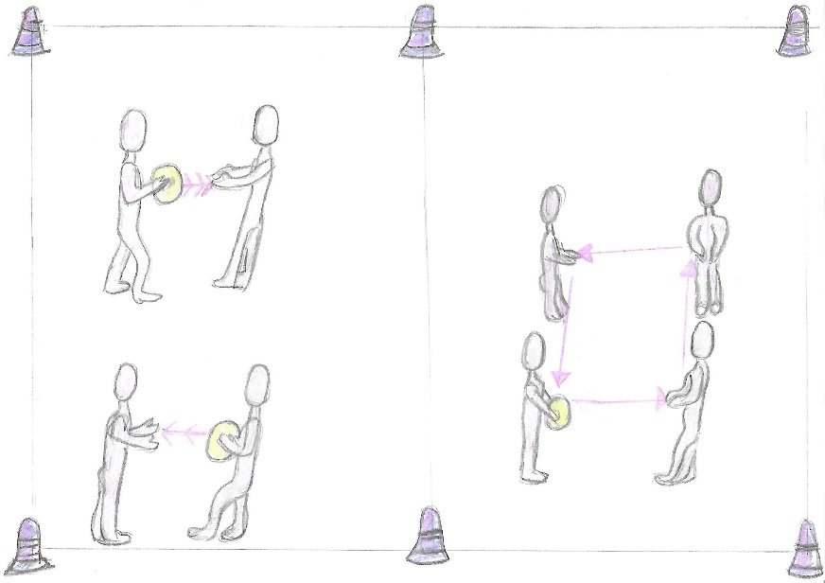

5Cs to be included in this session | Select 2 of the 5 and apply to session  HOW?
Competence

Confidence: | Tell pupils that they are doing well and are improving. If someone is executing the technique, we’ll have them demonstrate to the group, this will improve their confidence and may help others in the group if they see someone the same age performing the skill. Thus, if a pupil is struggling with the activity tell them try again and they are getting better. Overall, encourage and praise the pupils throughout the session.
Connection: | Throughout the session pupils will be working as a team and will need to have good communication skills to correctly completed the activities. Also, we try our best throughout the activities to mix the groups up so people work with someone out of their friendship groups and hopefully make new friends. Have pairs or groups tell their partner something their partner has improved on throughout the session, this encourages confidence within the group having peers praise too.
Character and caring:

Creativity:

Cool-down:

Light stretching e.g. have pupils stretch as high as they can to the sky and stretch the floor as low as they can without bending their knees this will be repeated three times whilst they are instructed to take deep breathes in and out.

Comments on session:

Organisation for adapting our session plan needs to be improved e.g. if we plan for 10 pupils make sure the activity you are doing is suitable for 7 or 15 pupils. This links to the amount of equipment we need such as, amount of basketballs. Due to us not planning for a group of 14 pupils we did not have enough basketballs so we had to adapt on the spot and have groups of 3 and 4. Also, one of our basketball was flat that made it hard for the group that was using it when it came to the bounce pass. This is a note for next time to ensure all balls are fully inflated before pupils arrive. All of the pupils that took part in the warm- up said they enjoyed it and most of the pupils liked the two passing activities especially the games where they had 20 or 30 seconds to pass the ball as many times as possible without dropping the ball. The pair/group work overall went really well with the exception of some people messing around with the balls in between activities. Some pupils more than other struggled with the distance of passing the ball so we move them closer together to make it easier and seen improvement. In the first game we did have a points award for 1st, 2nd and 3rd place for the most passes for the games however we quickly realised that pupils that did not get any points looked disappointed so for the rest of the groups we had everyone at the end of each game put their hands up and asked who had more than 5,10,15 etc successful passes, so they were no los or winners. Everyone was happy when they were praised by us and peers.

Review of your Coaching Session and Personal Action Plan
For each session you deliver you need to complete a Coaching Session Review and Evaluation plus a Personal Coaching Action Plan.

Practical: Coaching Session Review and Evaluation (Individual Reflection)
Were the aims of the session achieved?  Identify which ones were achieved and which if any, were not. | I think most of the aims of the session were achieved such as, everyone completed a successful chest and bounce pass. However, I believe that as a group we could have been clearer with the instructions.
What factors helped ensure that your aims were achieved?  (Reflect upon organisation, appropriateness of activities, coaching styles.) | When a pupil was finding it difficult to complete a chest or bounce pass one of the members of the group would demonstrate the pass again and watch the pupil passing to see where they were going wrong so we could address it and correct it. This was done by either bringing the pair closer together or ensuring the pupil had the correct technique.
What were the reasons for you not achieving your aims? (Reflect upon organisation, appropriateness of activities, coaching styles. | A few of the pupils asked for us to re show the passes again, this highlights that we did not explain the activities as well as we should. To ensure this is improved next time it would be beneficial if one member of the group explained the same section for every group of students. This means each member would know exactly what to say correctly.
What changes (if any) did you make to your session that were not in your plan and why? | Due to the group not having enough basketballs for 14 pupils we had to adapt the passes being passed between pairs to groups of fours. Thus, we had to change the activity for some of the pupils due to it being too easy or hard.
Would you do anything differently if you were to deliver the session again? | I would change the warm-up because pupils got over excited and started slipping on the cones in the area, this could of lead to one of them hurting themselves. Also, some of the pupils were a bit rough playing stuck in the mud and some of the pupils did not like it.
What have you learnt about your coaching from this session? | I’ve learnt that to be a good coach you need to plan effectively and have the ability to adapt when your plan doesn’t go as planned. For example, having the correct number of equipment, equipment that is useable and having a plan b if there are more pupils than you anticipated. Furthermore, you need to be constant and clear with all instructions you give, this may lead to you breaking down a simple technique into components for pupils to understand effectively. Finally, to be a good coach you need to have the ability to be understand that there is always going to be mixed abilities in every group, and you must cater for all abilities without making others feel less confident in their selves.
Personal Action Plan
Using the information above, what changes will you make to your planning, coaching delivery and organisation in future sessions?

In the future, I would make sure that when I am deciding what activity to coach that it is not too basic and take into consideration that there maybe more or less pupils in each group that I have planned for. This means choosing an activity that is easily adapted and make sure we plan for most adaptions, such as, if one pupil has a disability or impairment. This ensures that no pupil is being left out of the activity on the day.
Moreover, it is important to make sure that all equipment you can planning on using for the coaching activity is at an appropriate standard to use. This time we did not have enough equipment for larger groups and also one of the basketballs was not pumped up properly and therefore unusable. This made the coaching session harder because we did not check the equipment before the session started.
In the next coaching session, I hope to be more constant and clearer when giving demonstrations and instructions. In addition, I would suggest that instead of changing each member of the group to cover every role just have the same member recite the same part of the session for every group of pupils. This ensures that everyone is clear and knows exactly what they should be doing instead of one person taking charge or the group looking at each other not knowing what to do next. This point would also improve when the planning for the session is better.
Furthermore, the warmup the group chose could be changed due to stuck in the mud causing pupils to not behave and listen and they got wind up pretty easy. It was also if other pupils were fasting than others it made the game unfair and therefore some pupils did not enjoy the warmup. Next time, I hope to choose a warmup that encourages teamwork and communication which is a bit calmer.

Name of Coach: Chelsea Jenkins |  | Venue: LC2 | Date: 21/10/19

Risk Assessment (Complete Individually)
Ref | Hazard / Task / Activity  Area of Concern | Persons at Risk | Existing Controls | Describe Any Further Controls / Actions Needed | Actions By Whom | Action By When
1 | Knowing where the emergency exits are in the location. | All users | Signs around the building instructing where the emergency exits are. Also, having frequent fire drill practices. | We have a responsibility to tell the children where the emergency exits are and the precautions we will take. Thus, if a fire drill is planned or not. | Member of staff and coaches. | Before the session starts, just in case anything has changed.
2 | Slipping on the cones | Pupils and coaches | Warn pupils to be cautious of their surroundings and what could happen if they accidently slip. | Use plate mats, this will reduce the chance of pupils hurting themselves. | Coaches. | By the next session.
3 | Knowing where the first aid kit is located. | All users | There are always first aiders walking around the facility and also most leisure centres have a first aid kit behind the main desk. | If unsure ask at main desk of the facility and they should be able to tell you exactly where they are. Thus, know who the first aiders are in the facility. | Member of staff and coaches. | Before the session starts.
4 | Ball hitting pupils. | Pupils. | Teach them the correct technique to catch and pass the ball, so they are ready to receive the ball and not passing the ball too high causing injuries. | If they do get hit with the ball after taking caution, make sure they are ok and take them to see their teacher. | Coaches. | N/A
5 | Pupils hitting each other or the coaches. | Pupils and coaches. | Pupils are warned to behave doing coaches sessions by teachers before session starts. | The first time tell them that its not ok to hit people if this continues have them sit out of the activity and speak to the teacher. | Coaches and teachers | N/A

- Observational Coaching Competence Assessment

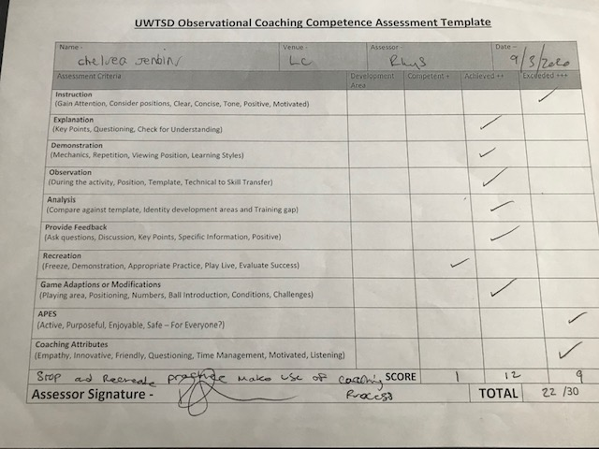

- Coaching Session and Personal Practice

Name: Chelsea Jenkins. Student no: 1910104.

Task: Describe the values or codes of practice relevant to be an effective coach. Outline what your core values are.

- What are the codes of practice for a sports coach/instructor?

- “Be incorporated into governing body of sport and employer's constitution and governance documents”.
- “Be incorporated into coach education and development processes”.
- “Be assessed as part of the coach reaccreditation process”.
- “Be part of policy and procedure for dealing with allegations and complaints”.
- “Be used as the benchmark for good practice in determining the need for sanctions”.
- “Be supported by the appropriate training and resources”.
(Coaching UK, 2020).

- Personal Core Values

- Always treat all individuals with respect.
- Communicate with and provide feedback to participants in a way that reflects respect and care.
- Communicate clear and effectively with all participants.
- Create an environment where everyone can participate in, no matter the sport or activity.
- Ensure that no matter the ability of the participates they can still join in the sport or activity and still enjoy the session.

- Describe the role of the coach/instructor in attempting to improve participants’ performance.

  - Goal Setting:
This type of technique can be used to increase an athlete's (participant) commitment towards achieving a personal goal e.g. developing the skills require careful planning and this can be achieved by setting shirt and specific targets. For example, SMART targeting, Specific, Measurable, Achievable, Realistic and Timely.
The benefits of goal setting are that it one increases motivation and determination e.g. if an athlete (participant) reaches a short – term target this will motivate them to continue. Thus, it reinforces self – confidence and want to keep on working. Furthermore, to achieve the goals set coaches may did to develop new strategies along the way. (Ferdinand Agyeman,2020).

  - Observational Analysis:
This technique provides the athlete (participant) and coaches with the information that aids them understand their performance. This technique is reliable and detailed information linking to performance and to achieve continual success coaches and athletes (participant) must understand what they have done them successful or unsuccessful.
The benefits of observational analysis are enhanced technical and tactical knowledge, improve decision making and confidence of the athlete (participant). The benefits of the coach using observational analysis are assists in the understanding of athletes (participant) strengths and weaknesses and enables an in – depth review of performance. This is shown in figure 1 below. (Ferdinand Agyeman, 2020).

- Explain the importance of evaluation & continuing professional development to the coaching process.

It is important for coaches, athletes and participates to develop constantly this is due to society and views are always evolving. An element of this is technology. Technology has development rapidly over the last decade (cite). There are different types of technology that are used in sports, for example, self – technology. This involves testing for banned performance – enhancing drugs and surgical procedures including, prosthetics/bionic limbs. (Phillip Omoregic, 2016, p.900). Another type of technology used in sport is rehabilitative. This is substances and procedures used to treat moderate to severe injury. This is typically found in sport clinics and training facilities. (Phillip Omoregic, 2016, p.901). Thus, it includes medicine used by healthy athletes. Movement technology is a type of technology used in sport, this is designed to assess the form and efficiency of an athlete’s body. Most common element of this technology is video technology. (Phillip Omoregic, 2016, p.902). This is technology that allows coaches to video athletes and look back at the skill or game they’ve executed and see how they can develop and improve in certain areas or see if they have achieved a goal and push the athlete further with a new set of goals.
Furthermore, the way coaches now teach and train athletes to participates has changed over the years. This is because of the way children respond to coaching has changed. For example, children used to do exactly what a teacher said without questions, now children do not like to be shouted at and they like to ask why they are doing an activity. As coach you must be able to adapt your planning and delivery to your target audience e.g. pupils or athletes.

- Outline the importance of discussing the outcomes of your evaluation with a colleague

It is key to communicate with you colleagues especially when discussing the outcomes of your evaluation, this is for many reasons. For example, it is important to note everything that went well and everything the participants found enjoyable, however it is more vital to recognise where we can improve e.g. warm – up was too static or one of the activities was not specific the objectives of the coaching session. It gives coaches the opportunity to improve on skills or development ideas for future sessions and ensure they are not repeating the same mistakes.

Developing personal coaching practice

Review your competency sheets and summarise the following in relation to your role as a coach/instructor

- Areas of Strength…

- Communicate clearly and effectively when demonstrating an activity or drill.
- Empathic with participants.
- Positively encourage participants throughout session.

- Areas for development.........

- Improvement in being louder when trying to get participants attention during activity or game e.g. shout 3,2,1 or freeze.
- Work on adaptions and modifications of activities and games e.g. 3v2 instead of 3v3.
- Make sure I plan for all abilities.

- How do you access information on developments in your sport /activity & current coaching practice?
I am in regular contact with the Chairman of Aberavon Wizards, who lets me know if there are any opportunities available. These have included working with the management and medical team. Before gaining my experience, the teams brief me in anything that has been updated and why they have decided to change it, this allows me to know I am up to date with rules and regulations.
Furthermore, I have signed up to sports magazines and websites that email me weekly informing me if anything in the sporting world has happened along with following BBC sport who give you automatically update you has the information is unfolding.

- Outline your views on the importance of having a personal action plan for your development and also the importance of regularly reviewing and updating your personal action plan

It is key to have personal action plans in place for you as a coach and for an athlete. This is because it helps you as a coach identify what you need to improve on e.g. knowledge of sport or communication between you and the athlete. In addition, you can see what the athlete needs to improve on and put a plan together to achieve that and once the athlete has complete most of the plan you as a coach and sit back and look if they have achieved or improved on anything. If they have there is no need to continue focusing on it, if the athlete has not fully achieved the objective you need to look for another way which is more efficient than the previous one to meet the objectives. Also, whilst creating a new action plan you as a coach may have observed other techniques that need to be improved, this would be added into the plan as well. This is updating the plan in place to suit the athlete at the present due to the athlete constantly developing.

Construct a Personal Action Plan

- Outline types of development activities that are available to you and how you may access these?

I have worked with Aberavon Wizards R.F.C, which has allowed me first hand to see how they train, develop and plan their sessions and therefore take what I have learnt and adapt it to fit the participants I coach.
In addition, I have worked with a water polo team at Aberavon Leisure and Fitness Centre, where I have had the opportunity to see how coaches plan and adapt sessions on a weekly basis. Also, how important the relationship is between coach and athlete. These are skills and details I hope to carry through into my coaching sessions.
I hope to continue to improve on my professional development throughout my sports management degree in and outside of the classroom.

- Workbook for Coaching Process

8.1 Attributes of a good coach.
Please complete as many attributes of a good coach as possible.

Knowledge:
- Specific rules and regulations.
- Training techniques.
- Anatomy and Physiology.
- Learning styles and stages.
- Motivational strategies.
- Legislation and ethnics.

Skills:
- Communication.
- Teamwork.
- Time management.
- Organisation.
- Patience.
- Listening.
- Questioning.
- Reflecting.
- Provides feedback e.g.
- Goal setting e.g. SMART targeting.

Qualities and Attitudes:
- Empathy
- Trustworthy.
- Positive.
- Approachable.
- Supportive

8.2 Roles of a Coach.
A coach in a club may have to play many different roles and each one of these roles may need different skills.
Name the roles that a club coach may have perform:

- First aider.
- Peacekeeper.
- Applies for grants.
- Online social Ambassador.
- Secretary.
- Taxi – driver.
- Leader
- Counsellor
- Innovator
- Motivator
- Teacher
- Planner and organiser
- Role model.

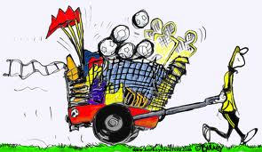

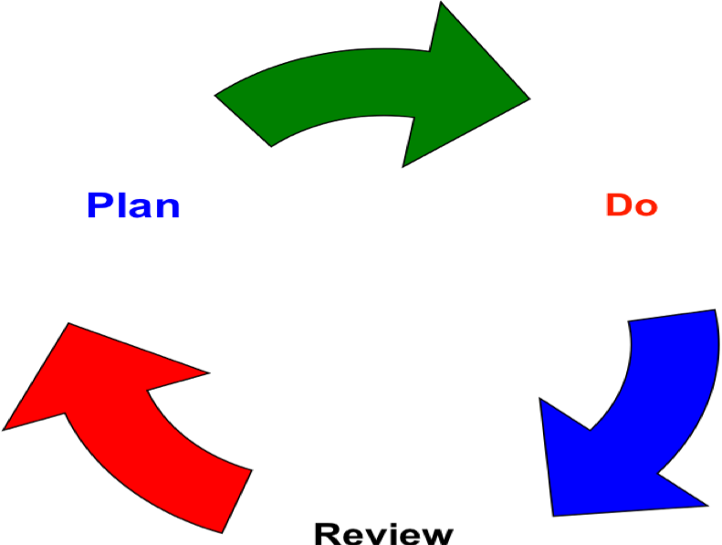

8.3. What does a coach need to do?

Fill in as many examples of best practice in the following:

Planning: e.g. Safe working area.
- Focus on 1-2 key points.
- Ensure the activity is for all abilities.
- Equipment e.g. amount and ensure it is safe to use.
- Make sure you know where fire exits are located.
- Check area/environment you are using is safe and clean.
- Variety.

Doing:
e.g. Use of voice to slow activities down (quiet)or speed things up (loud and sharp).
- Talk clearly.
- Repeat demonstration when needed.
- Stand somewhere all participants can hear and see you.
- Tone of voice.
- Observing participants body language.
- Shout freeze or 3,2,1 to get participants attention.
- Had a new ball into an activity to develop activity.
- Ask participants what the key points we are focusing on?
- Have participants do one of the demonstrations.
- Take participants to the side to improve technique.
- Time management.
- Encouraging participants.
- Bring pupils in to talk to them to ensure everyone can hear you
- Move around the area to see pupil's technique from different angles.

Reviewing:
e.g. Did I hit the outcome of the session for the players?

- Did I meet all of the objectives I set?
- Was the session Active, Purposeful, Enjoyable and safe?
- Did I meet my personal action goals?
- How could I develop my activities?
- Did I plan in-depth enough?
- What were the reasons I did not achieve my objectives?
- What did I learn from this session?
- Have I improved from the previous session?

8.4. Principles of a good coaching session – ‘APES’


All good coaching sessions should contain all of the following elements.

- A = Active.

- P = Purposeful.

- E = Enjoyable.

- S = Safe.

All of the above, together = SUCCESS

8.5. Principles of Learning – ‘PRICELESS’

Fill in the missing words (the words represented by the letters in PRICELESS) and complete the empty boxes.

PRICELESS LEARNING PRINCIPLES
Principle  Athletes learn better when: |  | This means as coaches we need to start/do more: | This means as coaches we need to stop/do less:
P | they have time to Practice. | Coach needs to focus on time management and ensure time is being used effectively and practically. | Stop wasting time in sessions and plan in depth before session to prevent this from happening e.g. have time allocated to each activity or part of the session to fit everything in.
R | it is made Relevant to their own playing situation. | Needs to plan sessions out that fit the individuals wants and needs and therefore are specific to the athlete. For example, a coach would not plan a session for passing a ball if the athlete needed to improve on finding space and decision making. For example, have SMART targets/objectives. | Coach needs to stop or put less drills/activities into sessions that the athlete does not need to improve or has not got anything to do with the overall goals. for example, update targets and objectives on a regular basis.
I | they are Involve in their own learning and can learn from each  other. | Promote individual learning e.g. asking questions to the athlete. For example, what do you think you could have done to make that pass more successful? | Giving the athlete the answers to the questions they are asking.
C | in a supportive and non-threatening  Climate where mistakes are seen as an essential part of learning. | A coach needs to create a supportive and positive environment for athletes where they can be comfortable to communicate with coaches and other members that are participating. For example, “that’s ok try again you will get it next time.” There can never be enough positive and supportive comments from a coach. | If athlete makes a mistake or is struggling with a technique not put them or allow other participates to make fun of them.
E | you build on their existing skills, knowledge and Experiences. | A coach needs to know existing skills, knowledge and experiences to ensure that they do not repeat anything unnecessary e.g. communication is key. In addition, coaches can pass on more knowledge and create more meaning experiences to benefit the individual. | The coach needs to try less to repeat drills and activities and focus in developing the athlete in other ways.
L | the coaching is Learner centred. | To check for understanding and allow participates to take responsibility for their own learning e.g. do not focus on one part of the athlete take everything into consideration and benefit the whole individual. | The coach needs to stop focusing on one thing at a time.
E | the players are Enjoyable the session. | Needs to communicate with the athlete each session to find out if the athlete enjoyed the session or not. If not take that part of the session out or adapted or develop it. | Coach needs to make less decisions on their own to ensure that the athlete is happy with future sessions.
S | they are helped to examine and Self – reflection on their current behaviour. | Coaches need to make time in the session for athletes to self-reflect and see where they are in terms of their goals and objectives. For example, have they meet them or do more objectives need to be put in place to achieve them. | Allow athletes to say what they feel they have improved on or how they think they can achieve their goals in the future e.g. independent learning.
S | they gain some success and their self-esteem is raised. | Coach needs to ensure that they are constantly praising the athlete increasing self-esteem and confidence. Thus, adding to the success of the athlete. | Coach needs to stop any shouting or negativity in the session.

8.6. Providing Instruction and Explanation
Complete the 4 stages of Providing Instruction and explanation in the correct sequence.

- Plan What To Do Before You Speak

2. Gain Their Attention Before You Start The Session

3. Keep The Message Clear And Simple
……………………………………………….

4. Check For Understanding And Ask If There Are Any Questions
………………………………………………

8.7. Providing Demonstrations
Complete the 4 stages of Providing Demonstrations in the correct sequence.

1. Stand Where All Pupils Can Hear And See You

2. Focus On One To Two Key Points This Is To Ensure Pupils Do Not Get Confused
…………………………………………………

3. Repeat Demonstration More Than Once When Appropraite

4. Check For Understanding E.g. Asking What The Key Points Were And If They Have Any Questions
………………………………………………

8.8. Observation and Analysis
Complete the 4 stages of the process for Observation and Analysis in the correct sequence.

- Make Sure To Focus On One Of The Key Points At A Time

2. Move Around The Space To Get Different View Of The Activity, This Is To Ensure You Are Observing Everything From All Angles
…………………………………………………

3. Compare The Observations With The Correct Template And See If There Are Any Similarities Or Differences
……………………………………………….

4. This Is Where We Would Build On The Correct Skill/Technique And Correct Errors To Improve
………………………………………………

8.9. Providing Feedback
Complete the 4 stages of Providing Feedback in the correct sequence.

- Ask Questions To Pupils To Start Feedback Of The Session And See If There Is Anything You As A Coach Can Improve On In Future Sessions
……………………………………………….

2. It Is Important To Limit Information To One To Two Key Points
…………………………………………………

3. Simple, Clear And Specific Information To Reduce The Chance Of Confusion
……………………………………………….

4. Try And Be Positive Throughout. For Example, Good Pass And Good Use Of Free Space
………………………………………………

8.10. The Good Coach (The Art of coaching)

Complete the following statements: -

The good coach:

Sees what is – needs to be improved or developed.
Sees what is – what is right and praises the participates.
Recognises why - things why it needs to be improved or developed
Knows how – to correct it.

8.11. Physical Development in Children
In every group of young athletes/children, coaches will find that there are great differences in ability, weight and size.

When designing physical practices for children, coaches should be mindful of:

- Age.
- Injury.
- Ensuring you do not overload.
- Puberty.
- Mature physically and emotionally.

When selecting teams or groups during a coaching session, coaches should be mindful of:
- Fair environment.
- Puberty.
- Different abilities.
- Age.

15. Children and Exercise

Children are not little adults and their bodies are still developing, therefore coaches should have a basic knowledge of child development.

Name some criteria that coaches should be aware of when planning/designing physical activities for children:

- Overloading e.g. watching for signs of distress.
- Use own body as resistance foe strength training.
- Do not except girls to develop more aerobic power after puberty.
- Reduce training especially weight bearing exercise during the growth spurt.

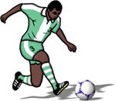

8.12. Long Term Athlete Development (Balyi)

Name the 5 Stages of Balyi’s LTAD Model:

1st Stage = The FUNdamental stage.

2nd Stage = Training to train stage.

3rd Stage = Training to compete stage.

4th Stage = Training to win.

5th Stage = The retirement/ retraining stage.

8.13. Fundamentals of Movement Stage.

At this stage of a player’s development a coach should concentrate on: -

- Physical Development.

- Skill Development.

- Social Development.

- Mental Development.

8.14. ABC’s of Athleticism

What are the ABC’s of Athleticism?

A = Agility.

B = Balance.

C = Co – ordination.

s = Speed.

8.15. Communication – Listening and Questioning.

‘Communication Skills’ are essential for a any coach.
Knowing what helps the athletes/players to listen to a coach is of primary importance to a coach who wishes to develop his/her communication skills.

Listening Skills
Name five things that help players listen to a coach:

- Observing body language, voice and changes.

- 100 percent attention on speaker e.g. eye contact.

- Using supportive body language.

- Do not mess around with activity equipment e.g. place it on the floor when the coach is talking.

- Try their best to get involved in the conservations and questions throughout the session.

Name five things that a coach may do that could distract the players from listening:

- Focusing only on content not intent.

- Attention switching internally to what you want to say next.

- Assuming you know what, they are going to say.

- Ask them to put all equipment down before explaining or demonstrating.

- Ask them to put their fingers on lips if they are listening.

8.16. Questioning Skills
Being a good coach is not just about having excellent sports-specific and technical knowledge. The skill of effective coaching lies in asking the right questions
Coaches use questions to ‘empower’ the players. Empowerment is giving authority to the players to help them become more confident and assertive.

Coaches ask their players questions to encourage them to think and solve problems for themselves

Name five other ways in which questions can be used to promote learning.

- Establish goals.

- Raise awareness.

- Challenge current thinking or practice.

- Encourage communication.

- Check and awareness.

What is an open question?

- Elicit large number if possible, answers.

- Require more than a one-word answer.

Give an example of an open question that may be used in a sporting context.

- Remind me …...

- Could you expand on …......

Open questions often start with:

- What, where and how.

What is a closed question?

- Small number of possible answers e.g. yes or no.

- Narrowly focused answers.

Give an example of a closed question that may be used in a sporting context.

- Does everyone understand the demonstration?

- Any questions?

Closed questions often start with:

- Can, Did, Have and Will.

8.17. In research undertaken with children, 5 -11-year old were asked what they would like in a coaching environment.

The most popular answers were:

- Fun.

- Friend orientated.

- The opportunity to make new friends.

- A range of different ability.

- Gender mix groups.

- A range of activities because children can get bored of the same thing, so you have to be creative.

8.18. Name some of the core needs of young children 7-12 years), when playing sport.

- Focus on 2-3 key points.

- Specific.

- Team orientated.

- Building on confidence.

- Mostly aerobic activities.

Developing the ‘whole’ child.

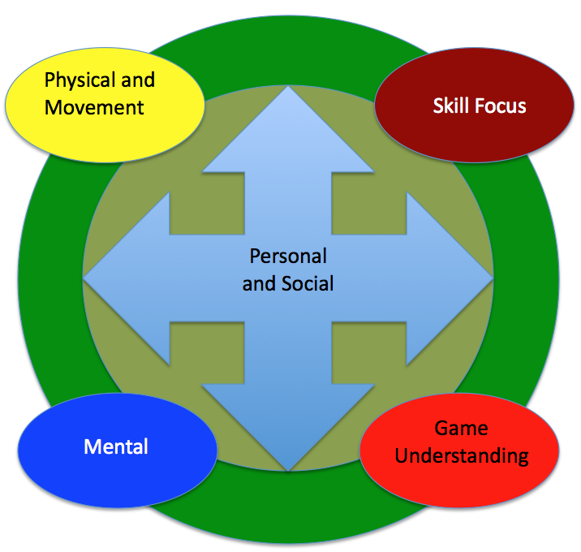

8.19. The core capabilities for developing social and personal skills have been identified as the 5Cs

What are the 5Cs for developing the social skills of children?

- Competence.

- Confidence.

- Connection.

- Character and Caring.

- Creativity.

8.20. Practical Session Health and Safety Checklist
Name 10 things you could expect to see on a check list for a ‘Risk Assessment’

- Check environment is safe for use.

- Is the equipment suitable for use?

- Know the location of all fire exits.

- Know the location of First Aid Kit.

- How can you prevent the risk from happening?

- Who does the risk affect?

- Existing precautions in place.

- Is there any further action that we need to put in place to reduce the risk?

- Use flat disc instead of cones to reduce the chances of pupils slipping.

- Make sure you explain pupils if there is a planned fire alarm test or not.

- Reviews
9.1 An Integrative Definition of Coaching Effectiveness and Expertise

Student Name: Chelsea Jenkins
Title of Work: An Integrative definition of coaching effectiveness and expertise.
Author: Jean Cote and Wade Gilbert
Reference: Cote, J. and Gilbert, W., 2009. An Integrative definition of coaching effectiveness and expertise. Internal Journal of Sport Science and Coaching, 4(3), pp.307-319.

Date of Article: 2009.
PERSONAL REVIEW
Review Suggestions
- Give an overview of the article.
- What are the key points in this article?
- Who is intended audience – academics/ practitioners – why do you come to that conclusion?
- Does the author define any terms? Are the definitions specific, useful, circular?
- What are the key findings?
- What did I find striking or interesting about these key points?
- How has this article influenced me in thinking deeply about my values, beliefs and assumptions?
- Does the author suggest areas for further research or discussion?
Personal Review (300 words)

Introduction:

In this article, it states that the International Journal of Sports Science and Coaching recently issued five separate research articles in relation to “good coaching”. The articles all contained words such as, “elite, expert, successful and great”, and two studies used the same criteria to identify their participants e.g. age between 14-18. The authors of this journal highlight that they too used a similar approach to describing participants in their research. E.g. age between 19-22.

The first section is used to build to proposed definition in the conceptual models of coaching. The second, third and fourth sections is detailed discussion about the each if the three components of the definition of coaching effectiveness. For example, coach's knowledge, athletes' outcomes and coaching contexts. The final section includes the importance of practice and research.

Foundation of the definition: Conceptual models of coaching:

In this section, it states that there are many different models of coaching that have been developed over the last 30 years based on research with a vast range of coaches e.g. 12,13,19,24-27. These models have come from different theoretical perspectives. For example, leadership, expertise, coach – athlete relationship, motivation and education.

Throughout this section it is made clear that the research is important due to the purpose of it is to understand the complexity of coaches’ work but at the same time focuses on the conceptual frameworks. One specific aspect of coaching limits the overall understanding that a coach can have narrow views and that can affect the participants (athletes).

Definitions:

The definition is key for understanding the article.
“Coaching expertise or effectiveness by athletes’ level of achievement (win-loss percentage), or athletes’ personal attributes (satisfaction, enjoyment), while other authors define coaching expertise by a coach’s years of experience (10 years of experience).”

9.2 An Australian Perspective on the Development of Youth Football Players

Student Name: Chelsea Jenkins
Title of Work: An Australian perspective in the development of youth football players
Author: D. O’Connor and P. Larkin
Reference:
International Research in Science and Soccer II, Chapter: 20, Publisher: Routledge, Editors: Terence Favero, Barry Drust, Brian Dawson, pp.204 - 214.
Date of Article: January 21st 2008.
PERSONAL REVIEW
Review Suggestions
- Give an overview of the article.
- What are the key points in this article?
- Who is intended audience – academics/ practitioners – why do you come to that conclusion?
- Does the author define any terms? Are the definitions specific, useful, circular?
- What are the key findings?
- What did I find striking or interesting about these key points?
- How has this article influenced me in thinking deeply about my values, beliefs and assumptions?
- Does the author suggest areas for further research or discussion?
Personal Review (300 words)

Overview and findings of the article:

National Curriculum:

Football training sessions more at youth level have typically been delivered by a coach -centred approach. The author highlights that a disadvantage of traditional coach-centred style of coaching is emphasised on memorising and copying with instructions and feedback given by the coach. However, it is stated in the article that this is “limited opportunity for the players to learn e.g. problem solving.” (Kidman and Lombardo,2010).

It states that during a traditional session, players are normally exposed to an introduction activity, a skill phased activity which is repetitive or isolated and then followed by a game. (Hodges and Franks, 2002; O'Connor, 2012; Williams and Hodges, 2005).
In the report the author says that 60-72% of the time is dedicated to skill – based training. For example, physical, technical and skill practices. (Ford, Yates and Williams, 2010).
In addition ,28-40% of the time is to focus on ‘playing form’ activities.

The Football Federation Australia has tried to move away from the traditional style of coaching and therefore including more playing form activities and thus developing a National Curriculum. The National Curriculum gives coaches the understanding of the national football philosophy, but also highlighting the specific coaching strategies to enhance and improve the technical and decision-making ability of the players. In addition, this strategy includes four activities within a training session. For example, instructional skill-based activity to frame the session, then continued by two or three game-based activities e.g. playing form. It stated in the journal that increasing amounts of the play approach may improve both technical and decision making, as the activities provides an opportunity to create bridges between the skills being performed and decisions and actions required within a game context. (Ford et al, 2010).

Definitions:

There were many definitions throughout the journal I’ve choosen the two below due to them supporting the information and research above.

- A coach-centred approach, whereby the coach is in control and there is little input from the player (O’Connor, 2012).

- ‘Playing form’ activities, which have a game-related focus, including small-sided and conditioning games, which are believed to promote perceptual-cognitive and technical skills (Cushion, Ford, & Williams, 2012; Ford et al., 2010).

9.3 Tennis Coaching: Applying the Game Sense Approach

Student Name: Chelsea Jenkins
Title of Work: Tennis Coaching: Applying the Game Sense Approach.
Author: S.Pill and M.Hewitt.
Reference:
Pill, S.Hewitt,M.(2017).Tennis Coaching: Applying the Game Sense Approach.Strategies:A Journal for Physical and Sport Educators,30(2)10-16.
Date of Article: 2017.
PERSONAL REVIEW
Review Suggestions
- Give an overview of the article.
- What are the key points in this article?
- Who is intended audience – academics/ practitioners – why do you come to that conclusion?
- Does the author define any terms? Are the definitions specific, useful, circular?
- What are the key findings?
- What did I find striking or interesting about these key points?
- How has this article influenced me in thinking deeply about my values, beliefs and assumptions?
- Does the author suggest areas for further research or discussion?
Personal Review (300 words)

The Game Sense Approach – Athlete Centred Coaching:

The Game Sense Approach was developed from the field of sport coaching pedagogy and therefore adopts similar characteristics of the ‘Teaching Games for Understanding’ (TGFU) model that emerges as a pedagogical response to issue associated with the educational rigour of the games curriculum engagement of students in secondary physical education. (Bunker and Thorpe, 1982).
Although, unlike traditional pedagogical framing of sport teaching as a technical-to-tactical progression, and the 6-step TGFU model describing a tactical-to-technical progression. (Bunker and Thorpe, 1982). In the journal it highlights that Game Sense Approach supports tactical and technical components of skilled performance at all levels of game development.
The original Game Sense Approach equation was:

Technique + game context = skill

The game context is referring to elements like, pressure, decision-making, timing, used of space and risk. (den Dyn, 1997).

The main elements of Game Sense Approach are making sure that you have successful implementation of tennis. The activities attempt to encourage the main feature of the game of tennis – the rally. For example, projection and reception. In link with the technical skills and relevant tactical components. This way all players ‘play purpose’ and develop their skills by:

- Knowing what to do in the context of play e.g. decision making.
- Knowing how to do it e.g. movement knowledge.
- Being able to execute the ‘how’ and ‘what’ successful e.g. movement capability.
(Pill, 2013).

It is key to highlight that the Game Sense Approach does not ‘rule in or out’ of any instructional strategy, however it suggests in the journal that a focus on an inquiry – guided discovery styles and a game –based practice environment.

Game Modification:

CHANGE IT:

C = Coaching Styles.
H = How scoring occurs or the scoring system.
A = Area or dimension.
N = Number of players.
G = Games rules.
E = Equipment.
I = Inclusion by modifying activities for learning needs.
T = Time of the games or time allowed in possession.

9.4 A Review on the Effect of Small-Sided and Modified Games in Sport Teaching and Coaching

Student Name: Chelsea Jenkins
Title of Work: A Review on the Effect of Small- Sided and Modified Games in Sport Teaching and Coaching: Informing TGFU
Author: S. Graupensperger and A. Turner, S. Pill, M. Neutzling, K. Pagnano-Richardson, and D. Sheehy, U. Schnyder and E.-J. Hossner,
Reference: (2016) Full Issue PDF, Volume 87, Supplement 1, Research Quarterly for Exercise and Sport, 87:sup1, Si-S120, DOI: 10.1080/02701367.2016.1213610
Date of Article: 19th July 2016
PERSONAL REVIEW
Review Suggestions
- Give an overview of the article.
- What are the key points in this article?
- Who is intended audience – academics/ practitioners – why do you come to that conclusion?
- Does the author define any terms? Are the definitions specific, useful, circular?
- What are the key findings?
- What did I find striking or interesting about these key points?
- How has this article influenced me in thinking deeply about my values, beliefs and assumptions?
- Does the author suggest areas for further research or discussion?
Personal Review (300 words)

In this article, they compare to a technique approach and control groups. The research is based on 99 students with 33 participants in each group, this is to focus on skill instruction and to develop tactical awareness and decision making in small sided games.

One of the coaches is using the above approach for twelve weeks including 80-minute lessons each week. The other group that did not receive any instruction. In the 12th week, the participants were checked for knowledge, skill and game performance. Separate analysis was conducted to examine group difference in cognitive and skill outcome.

The results of the research were that the TGFU group scored significantly higher on passing decision making and significantly higher than the control groups for knowledge. In addition, the TGFU group scored higher on control and passing execution than other groups. Moreover, there was no difference in the three groups for accuracy, but the technique group recorded faster than the control groups.

The conclusion of the research was that TGFU approach provides a more viable way of teaching strategic decision making for korfball players.

TGFU and Psychosocial factors:

The skills that the participants will have learnt and developed over the course of twelve weeks can be transferred very easily into key life skills. The outcomes have yet to be tested to a great extent but TGFU is becoming popular.

The present study is ten weeks including youth football players. For example, three youth teams, two boys and one girl teams between the ages of nine to twelve. Furthermore, each team will undertake two practice sessions each week for an average of 1.25 hours beginning two weeks prior to the season.

The teams coached with the TGFU model have experience coaches of 25 years and examine potential changes and outcomes. A review on the effect of small-sided and modified game in sport, teaching and coaching.

Overall, TGFU have focused on the principle of “play” and this has given the participants learning experiences, however SSG has been shown as less effective and less clear in comparison.

  - Supplements: Sport, Health & Education
Student Name: Chelsea Jenkins
Title of Work: Supplements: Sport, Health and Education.
Author: Thomas Heinen, Pia M Vinken and Roman Farana.
Reference:
Heinen, T., Vinken, P. and Farana, R., 2013. Supplements:Sport, Health and Education. 7(3), pp.128-153.

Date of Article: 2013
PERSONAL REVIEW
Review Suggestions
- Give an overview of the article.
- What are the key points in this article?
- Who is intended audience – academics/ practitioners – why do you come to that conclusion?
- Does the author define any terms? Are the definitions specific, useful, circular?
- What are the key findings?
- What did I find striking or interesting about these key points?
- How has this article influenced me in thinking deeply about my values, beliefs and assumptions?
- Does the author suggest areas for further research or discussion?
Personal Review (300 words)

The Role of Visual Perception in the Control and Acquisition of Gymnastics Skills - Thomas Heinen:

In this section of the article is written by Thomas Heinen who studies at the Institute of Sport Science at the University of Hildesheim, Germany. He talks about how professional gymnasts can perform complex skills e.g. a double somersault with double twist with ease. He states that when you first look at skills which are complex it seems to be unclear how they are regulated. This is broken down into theoretical positions, this is when the gymnast moves in a way and at the same time uses the dynamic environment where he/she gain information from the environment. Thus, which results is used to regulate action to achieve a specific movement goal.
Heinen continues by saying there is a link between perception and action that it is influenced by the task demand and mental representation of the gymnast possesses. The most key source of information is perception-action which is visual information and researchers argue that skilled gymnasts optimise their visual information by picking up the best serve the task demands in the complex skills. This therefore allows the gymnast to optimise their gaze behaviour as well as the information that they gain from the environment. Heinen states that gymnasts seem to regulate complex skills linking to the visually perceived environmental cues.

Performance – Enhancing Methods in Gymnastics Training, Competition and Recovery; A Special Emphasis on Elastic Taping – Pia M Vinken:

In this section they highlight there are several methods and techniques such as, active and passive warm-up and cool-down that includes technique, massage, water immersion and myofascial release as taping and bracing are mostly applied to support in athlete's performance and recovery.

Effect to Technique Selection on Below Loading and Movement Variability During the Round-Off in Gymnastics – Roman Farana:

Roman Farana is part of the Department of Human Movement Studies at the Pedagogical Faculty, University of Ostrava, Czech Republic. Farana focuses on chronic elbow injury linking to tumbling in female gymnastics showed serious problems for the performers. The research looks at “how the biomechanical characteristics of impact loading and elbow kinematics and kinetics, changes as a function of technique selections”. In addition, “based on a gymnast analysis the study has the objective of variability in the elbow joint kinematics and kinetics of professional in the execution of the round-off with different hand position.”

- Conclusion
Throughout this module I have learnt that a coach is not all about teaching it is about so much more such as, being a role model, a motivator and innovator, organiser and decision maker. I have also developed many skills that include time management, critical thinking, the ability to adapt on the spot and how to communicate with a range of pupils e.g. welsh speaking and children with learning disabilities. I have done this by using principles such as ‘APES’ and ‘PRICELESS’ which allow me to see if the session is active, purposeful, enjoyable, safe, learner centred along with many more. Thus, good coaching is about getting the best out of all players and making sure all pupils can participate no matter their ability.
In addition, this module has allowed me to learn that the way we say things has a greater impact than the words we use. For example, children do not react well to negativity and shouting instead as coaches we should always be positive, encouraging and praise all pupils throughout all sessions, ensuring their confidence and self-esteem has improved before they leave the session. This has allowed me to better myself as coach.

- Reference List

- Balyi, I., 2001. Long - term Athlete Development - the sysytem and solutions. [online] 8, p.2. Available at: <https://www.activeoxfordshire.org/uploads/long-term-athlete-development-article.pdf> [Accessed 25 March 2020].

- Cote, J. and Gilbert, W., 2009. An Integrative definition of coaching effectiveness and expertise. Internal Journal of Sport Science and Coaching, 4(3), pp.307-319.

- Cottrell, D. (2020). Catching the kick off - Rugby Coach Weekly. [online] Rugby Coach Weekly. https://www.rugbycoachweekly.net/practice-plans/catching-kick-off/ [Accessed 5 Feb. 2020].

- Durand - Bush, N. and Samela, J., 2001. The Development of Talent in Sport. [online] 2, pp.269-289. Available at: <https://www.researchgate.net/publication/270901959_The_development_of_talent_in_sport> [Accessed 27 March 2020].

- (2016) Full Issue PDF, Volume 817, Supplement 1, Research Quarterly for Exercise and Sport, 87:sup1, Si-S120, DOI: 10.1080/02701367.2016.1213610

- Heinen, T., Vinken, P. and Farana, R., 2013. Supplements:Sport, Health and Education. 7(3), pp.128-15.

- Internationalcoachingcommunity.com. 2020. What Is Coaching? - International Coaching Community. [online] Available at: <https://internationalcoachingcommunity.com/what-is-coaching/> [Accessed 30 March 2020].

- MacNaughton, D., 2015. The Coaching Edge: Building Your Pillars Of Performance - UK College Of Personal Development. [online] UK College of Personal Development. Available at: <https://ukcpd.net/the-coaching-edge-building-your-pillars-of-performance-2/7> [Accessed 29 March 2020].

- Mayo Clinic. 2020. Children, Sports and Exercise: Choices for All Ages. [online] Available at: <https://www.mayoclinic.org/healthy-lifestyle/childrens-health/in-depth/fitness/art-20048027> [Accessed 29 April 2020].

- News.bbc.co.uk. 2015. BBC SPORT | Other Sport ...| Netball| Netball:chest pass. [online] Available at: <http://news.bbc.co.uk/sport1/hi/other_sports/netball/.4188162.stm > [Accessed 27 Feb. 2020]

- News.bbc.co.uk. 2020. BBC SPORT | Rugby Union | Skills | The Basic Pass. [online] Available at: <http://news.bbc.co.uk/sport1/hi/rugby_union/skills/4198382.stm> [Accessed 25 March 2020].

- Pill, S.Hewitt,M.(2017).Tennis Coaching: Applying the Game Sense Approach.Strategies:A Journal for Physical and Sport Educators,30(2)10-16.

- Omoregic, P., 2016. The Impact of Technology on Sport Performance. [online] pp.900,901,902. Available at: <http://333808384_THE_IMPACT_OF_TECHNOLOGY_ON_SPORT_PERFORMANCE> [Accessed 1 April 2020].

- Pruna, R., Miñarro Tribaldos, L. and Bahdur, K., 2018. Player talent identification and development in football. Apunts. Medicina de l'Esport, 53(198), pp.43-46.

- Ross Rugby. 2020. High Ball Catching | Ross Rugby. [online] Available at: <https://rossrugby.co.za/technical-zone/skills/position-specific-skills/wing-skills-and-drills/> [Accessed 25 March 2020].

- Sportengland-production-files.s3.eu-west-2.amazonaws.com. 2018. The Talent Plan For England - Creating The World's Best Talent Plan. [online] Available at: <https://sportengland-production-files.s3.eu-west-2.amazonaws.com/s3fs-public/the-talent-plan-for-england.pdf?FMAAxsmgrkyJ0hXlJQl2aB7s9uIpV.uN> [Accessed 24 March 2020].

- Sportplan. 2020. Attack/Defend Big Time Sevens - Rugby Drills, Rugby | Sportplan. [online] Available at: <https://www.sportplan.net/drills/Rugby/Sevens/AttackDefend-Big-Time-pd120.jsp> [Accessed 26 March 2020]

- Sportplan.(2020).Attacking Third Game Offense / Defence Small games |Sportplan. [online]: https//www.sportplan.net/drills/Netball/Small-games/Attacking - Third-Game-Offence-v-Defence-NA0000003.JSP. [Accessed 26. Feb.2020].

- Sportplan.(2020). Sportplan – Sports Coaching Made Easy. [online]: https://www.sportplan.net/app/#public/Netball/open/5067591{Acessed 27 Feb. 2020].

- Sportplan.net. (2017).Sportplan - Sports Coaching Made Easy.[online]:https://www.sportsplan.net /app/#drills/Netball/sessionPlans/A tackling-Principle –Driving –onto-the Ball-15167362.jsp[Accessed 26.Feb.2020].

- Sportplan.net. (2020). Sportplan - Sports Coaching Made Easy. [online] https://www.sportplan.net/app/#search/Handball/chest%20pass [Accessed 6 Nov. 2019].

- Sportplan.net. (2020). Sportplan - Sports Coaching Made Easy. [online] https://www.sportplan.net/app/#drills/Rugby/Passing [Accessed 5 Feb. 2020].

- Sportplan. 2020. 3 'V' 2 Passing - Rugby Drills, Rugby | Sportplan. [online] Available at: <https://www.sportplan.net/drills/Rugby/Passing/3-v-2-pd79.jsp> [Accessed 26 March 2020].

