University of Wales Trinity Saint David School of Applied Computing

Assignment
M4X01508 Introduction to Programming
Ryan Williams
1708310
20/4/2018

Contents
Assignment i
3. Introduction 1
4. Requirements (Must, Should, May) 1
5. Flowchart 2
6. Why use a loop? 4
7. Testing 5
8. User documentation 6
9. Technical documentation (this doubles as a Code Listing) 7
10. Conclusion 8
11. References 9
1 Bibliography 10

3. Introduction

The objective of the assignment is to create a lottery number program using the c programming language. The program will need to be designed with clear instructions so that a user with no previous programming knowledge is able to open and run the program. The program will be created and run using the XCODE integrated development environment(IDE).

In order to complete the task, 6 random lottery numbers need to be displayed in ascending order. The numbers for the program must range from 1-59 and will be generated automatically. For this to be successful, the program will need to ensure that no duplicates are produced or displayed on the screen. A message will be used to welcome the user and to wish them good luck before present the numbers to the user.

The random aspect of generating each number will be achieved using the SRAND function. The Srand function uses the computers real time clock to generate each number. Further calculations are then made on the random numbers. The Srand function is not completely random. It works by acting as a starting point for a pseudo-random number. By using this function, each time the program runs the results may result in similar but not the same numbers.

This assignment can help develop and enhance skills already gained from previous tasks on this module (M4X015080). The programming used on this task will also help for future study by enhancing knowledge of analysing, creating, running and testing programs.

4. Requirements (Must, Should, May)

Before creating the program, a requirements list using the Moscow requirements format has been created below. The table lists the must have, should have and may have requirements that the program should have.

Must Have | Should Have | May have
Start Button | loops | Lucky number
Stop Button | Game History | strings
Generate random numbers |  | breaks
List the numbers in Ascending order |  | strings
Generate 6 numbers |  | arrays
Store the numbers |  | Display “Run program again?”
Display “good luck” |  | History of previous results
Display a “welcome message”
Numbers 1-49
No Duplicates

5. Flowchart
The flowchart below displays an algorithm showing the logical steps taken to design the lottery program. Algorithms are widely used in programming to break problems down into smaller steps. Algorithms can be used to manage and simplify larger and more complex problems. The flowchart below has been designed to not only show the program to be created but to also summarise repetitive tasks used such as loops and if statements to save time and space so that the program can be easier to visualise.

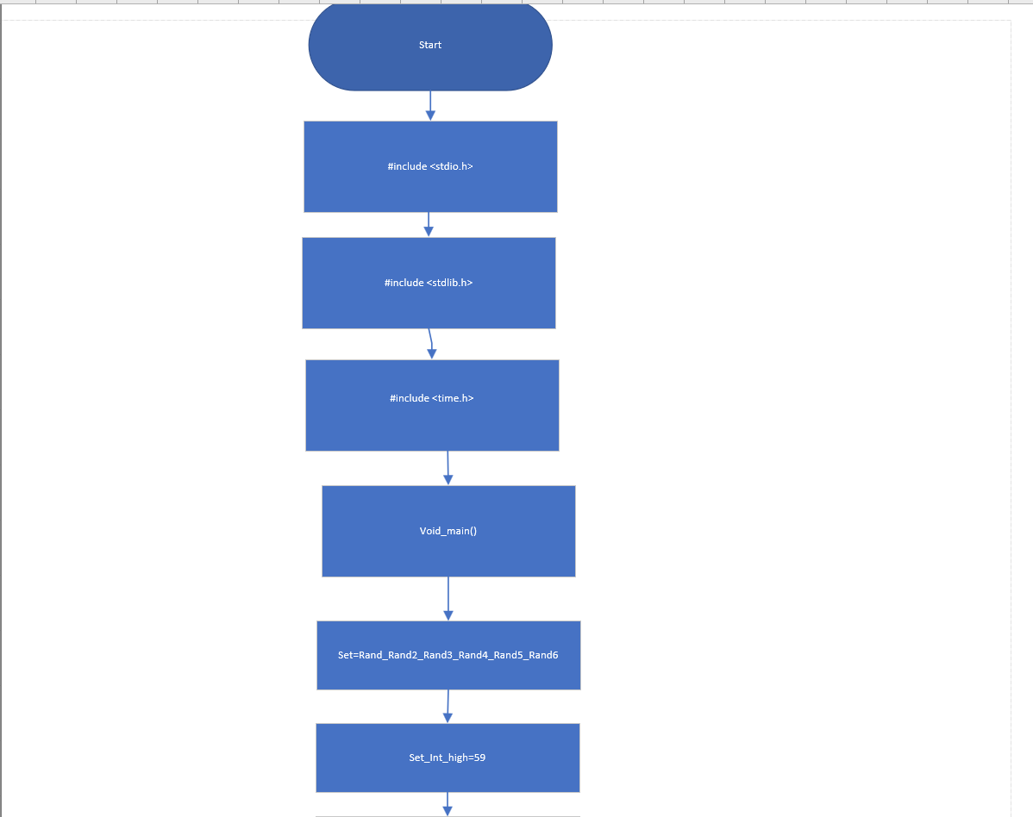

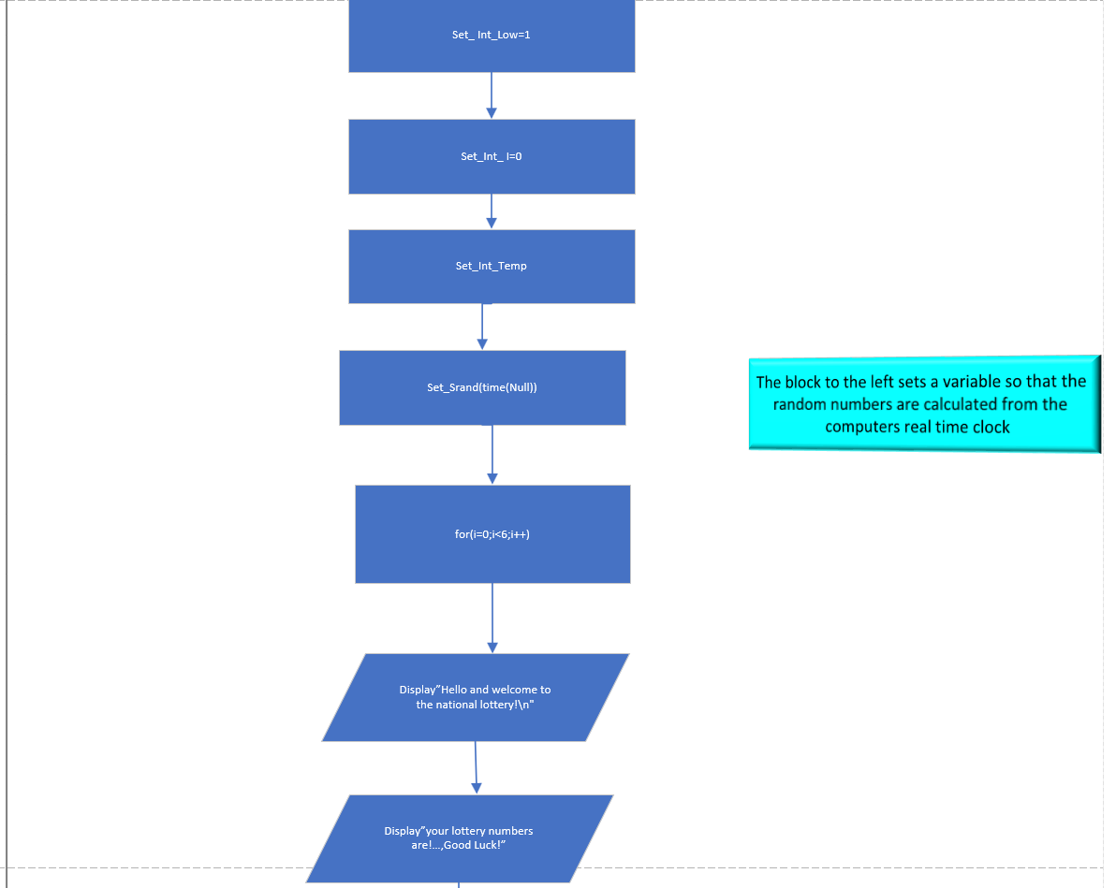

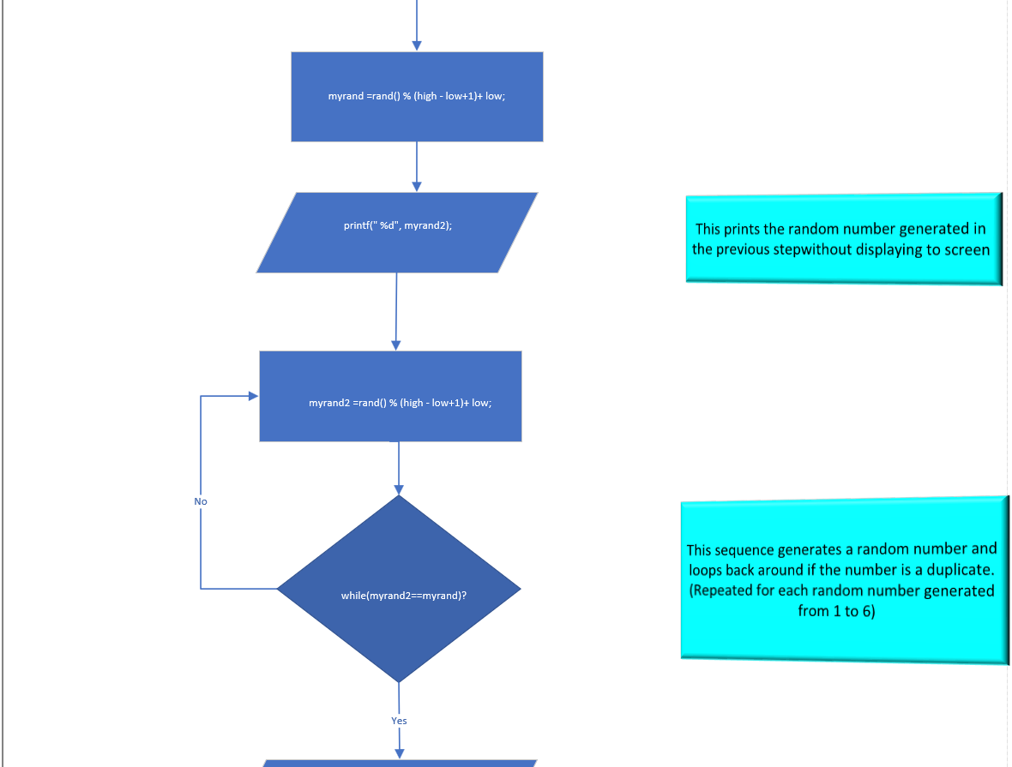

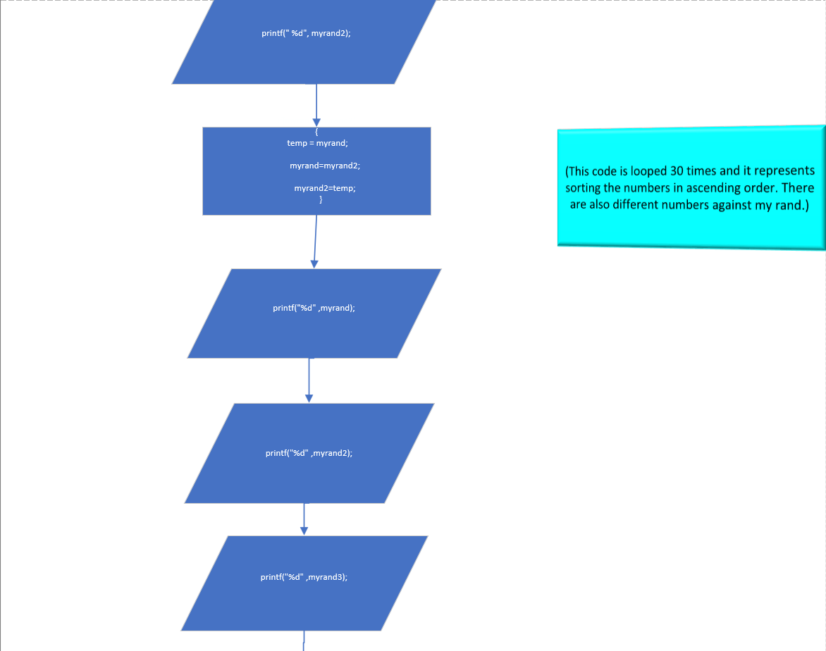

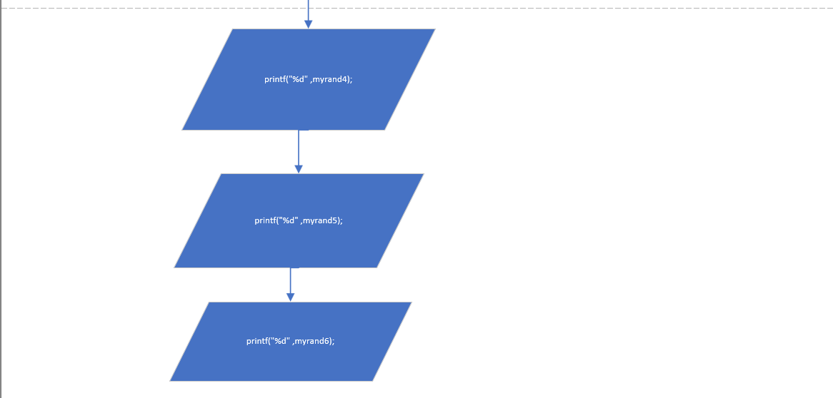

6. Why use a loop?

A software program can often require code that is duplicated or used repeatedly. Large programs using the same code could take considerable or impossible amounts of time to create, or even to complete a section of a program. Using a loop enables a program to keep running until it satisfies a required condition, or until another instruction is executed, or the program ends.

A loop structure could be suitable to use in the lottery program to set the amount of times a number should be generated. A for loop could be set to incrementally add another random number each time the loop is completed. A for loop is used when the number of loops required is known. Another loop, (a while loop used when the number of loops is unknown), would be suitable to compare the random numbers generated each time so that if the random number is a duplicate of the previous number then the program would loop again until an unused number is generated and displayed.

[1]

7. Testing

The program was tested for errors and reliability using two different methods. The methods below were carried out:

Normal testing
The normal testing for the program produced 6 numbers ranging from 1-59 on multiple runs of the program. The below screenshots show the program being run successfully on two occasions.

Test 1

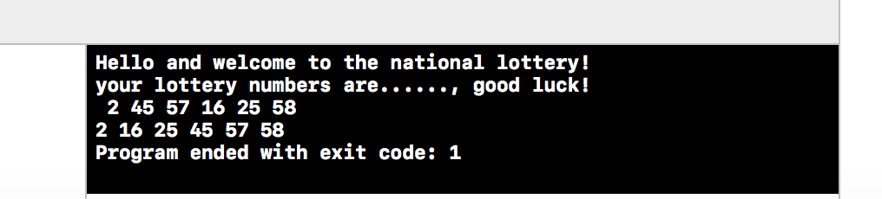

Test 2
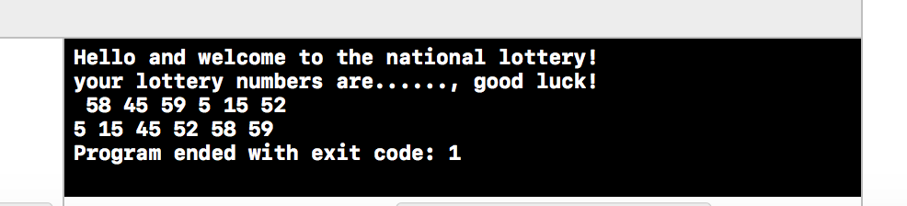

Boundary Testing

The boundary testing for the program was run until numbers 1 and 59 were displayed to ensure both numbers were able to be used. The below screenshot shows both numbers in the same draw:

Boundary test
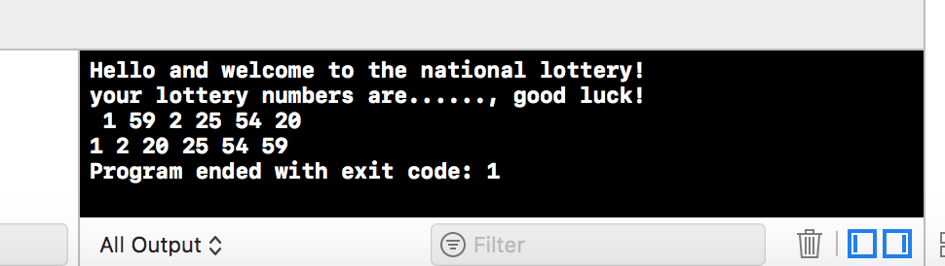

8. User documentation

Welcome to the lottery program!

The lottery program is designed to generate 6 random numbers between 1-59, and to display the random numbers selected to the screen in ascending order. The program is designed to contain no duplicate numbers and will provide a welcome message as well as a good luck message before the balls are displayed.

Xcode

The program used to create and run this program is called Xcode. Xcode is an integrated development environment(IDE). Xcode is used to create programs on the mac osx operating system. The code created can also be used on windows systems by copying the source code (main.c) on this computer and opening it with other IDEs such as visual studio 2017.

To run the program, you simply click the start button located to the top left of the screen as shown below:



Once the start button is pressed, two messages will display on the screen as shown below:

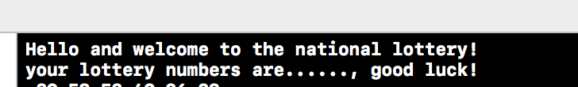

The lottery numbers are then generated and displayed at the bottom of the screen as shown below;

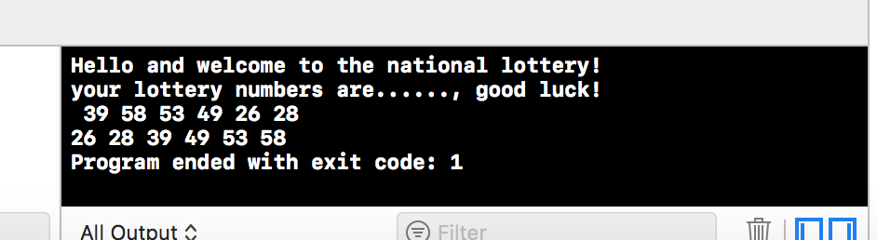

The above picture shows the lottery numbers generated in two different ways. The top row displays the numbers in the order they were first generated. The second line displays the generated numbers in ascending order. Displaying the numbers in ascending order can make it easier when checking the numbers.

The program can be stopped at any time using the button shown below which is located on the top left-hand corner of the screen. The program will also automatically end once the numbers are displayed.



9. Technical documentation

Below is a code listing with comments added to better understand the lottery program created.
#include <stdio.h> // library needed
#include <stdlib.h> // library needed
#include <time.h> // library needed

void main() // parent function needed

// Variables needed:
int myrand,myrand2,myrand3,myrand4,myrand5,myrand6;
int low = 1;
int high = 59;
int i =0;
int temp;

srand(time(NULL)); // Sets the seed of the random number algorithm generator function rand()

for(i=0;i<6;i++) // for loop used to generate 6 random numbers

myrand =rand() % (high - low+1)+ low; //calculates the first number
printf("Hello and welcome to the national lottery!\n"); // prints the message to screen
printf("your lottery numbers are......, good luck!\n"); //prints the message to screen
printf(" %d", myrand); // Prints the random number generated

myrand2 =rand() % (high - low+1)+ low; //calculates the 2nd number. This pattern will continue for each number generated
while(myrand2==myrand ) //Compares myrand2 with myrand. (This pattern will continue for each of the 6 numbers generated). If a duplicate is found the code will loop to generate a new number. This will continue until no duplicates are found.
printf(" %d", myrand2); // Prints out the 2nd number

if(myrand>myrand2) // checks for a condition.
temp = myrand; // stores myrand in temp location.
myrand=myrand2; // sorts myrand2 as it’s the lowest number.
//This pattern will continue for each number that has been generated.
printf("%d" ,myrand);

printf("%d" ,myrand2); // prints the sorted number
printf("%d" ,myrand3); // prints the sorted number
printf("%d" ,myrand4); // prints the sorted number
printf("%d" ,myrand5); // prints the sorted number
printf("%d" ,myrand6); // prints the sorted number

10. Conclusion

An early creation of the program was able to display the 6 random numbers. Further tests to this program then discovered duplicate numbers were still being produced. The program was then redesigned to make further calculations to the random numbers. These calculations allowed the program to run without duplicates.

Arranging the numbers in ascending order brought further issues before it was understood that the computer could not compare and swap the numbers directly. To solve this problem, it was learned that one of the random numbers would first need to be stored in a temporary location. Once this number was stored it was then able to be compared and swapped for the lower number. This sequence continued to sort each number from lowest to highest.

A better algorithm during the design phase could have prevented these issues from occurring at the implementation stage. Further knowledge, understanding and experience of programming may make it possible to improve and develop more complex programs with more efficiency.

The programming concepts developed on this assignment have helped to reinforce previous work that has been completed on this programming module (M4X015080). The assignment has given a better understanding on how and when to use tools such as loops, if statements and functions. The knowledge gained from this assignment will be applied in the future to help solve other problems when creating programs.

11. References
James, Mike The Essence of Loops, (2014)

Bibliography

[1] | M. James, “The Essence of Loops,” Thursday November 2014. [Online]. Available: http://www.i-programmer.info/programming/theory/8003-the-essence-of-loops.html. [Accessed Wednesday April 2018].

