Task 2: Reflective report
Student Name: Aisha Bibi
Student ID:2122694
Lecturer: Isiah Oino
Module: BMSW4001_BIRM
Table of Contents
Table of Contents
Experience of writing Task 1 3
Experience of working as a group on the week 8 activity 9
Conclusion 13
Peer feedback ……………………………………………………………………………..14
Personal development plan or PDP 16
Reference list 20

Experience of writing Task 1
Task 1 has enabled me to learn and explore the subject of employee motivation. I have been able to learn a lot about the different factors that have made great changes in the levels of motivation and how different organisations bring positive motivational rise among the employees via the use of motivational changes as well as via the addressing of the different motivating factors. Motivation has been found to be a key player for the organisation in order to get their job done by their employees. This makes the organisations make use of motivational methods and strategies. There have been several strategies of motivation. However, the most effective ones are mainly payment, recognition and awards, additional holidays and great working conditions. These have been making great influences on the motivational levels of the employees of the organisation which is why the application of these methods have been wide (Graves and Sakris, 2018). Hence, for this, I am making the use of Gibb’s reflective cycle of reflection for better evaluation:

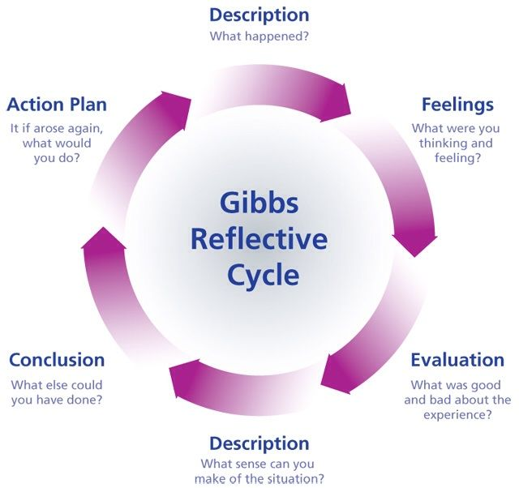
Figure 1: Gibb’s Reflective Cycle
(Source: Adeani et al., 2020)
Description: | Description is the first stage of the reflective cycle of Gibbs and revolves around the explanation of the situation that has been experienced by an individual in detail (Adeani et al., 2020). During the course of the study, I planned that I must develop my academic skills further and this module has been found to be great means for me to develop my skills widely. I targeted that I need to especially focus on my skills of writing, interpreting and referencing properly. While I was performing task 1, I encountered a number of study materials that have been found to be of great use to my study. I had been able to utilise them in a great manner which is why I think that I have been able to conclude task 1 with good points regarding the factors of employee motivation.
Feelings: | The second stage of Gibb’s reflective cycle is feelings. This phase is comprised of the different feelings that have been gained or experienced during the course of study or any situation. This has been also an important stage as it shows might be the situation while the work is being performed (Markkanen et al., 2020). There were a number of feelings that have been involved during the module. At first, I was highly excited to explore the subject of employee motivation. I was also curious because I wanted to make sure that I am able to present a great study so that I am able to develop my skills further. I always wanted to investigate literature sources of other authors as well along with the study material which I was provided. This has been important in order to increase the effectiveness of the study.
Evaluation: | Evaluation has been the third stage of Gibb’s reflective cycle. This phase of the cycle is comprised of the things that have been approached in the study and the things that have not been. Hence, a proper evaluation of the different learning is expressed in this stage of the cycle (Tanaka et al., 2018). Furthermore, during this study, I was not just able to learn and explore the subject of motivation rather I have been able to advance my academic skills as well. My abilities to interpret and understand the subject and how I can have a better approach to record what is being discussed have been sharpened. I am now able to understand things clearly via the use of this module. Moreover, my research skills have been my strengths and hence I have been able to perform these research skills effectively, however, I need to focus on my writing skills.
Analysis: | In the fourth stage of Gibb’s reflective cycle, analysis of the situation is performed in order to make sense of the things that have happened. Questions such as “Why things do went good or bad? or “How does experience can be compared to the literature?” etc., are performed (Soundiraraj and Babu, 2022). The study went well due to the reasons that a number of literature have been explored on the subject of employee motivation. I had been able to learn of the different factors that have been discussed as well as my interpreting skills have been sharpened. I have been able to analyse in the study that my interpreting skills have been great while my skills to reference the resources that have been utilised have been a weak factor.
Conclusion: | Conclusion is the fifth stage of the reflective cycle of Gibb. The conclusion has been the summarisation of the whole of every stage of the cycle. This stage has been crucial as it shows the different strengths and weaknesses that have been encountered in the task. Hence, further, improvements can be made (Reljić et al., 2019). During the course study, I gathered a lot of information regarding employee motivation. I had been able to learn the benefits and losses of each method of motivation. This has been due to my interpreting skills and my researching skills which have been my strengths. However, I need to develop my writing and referencing skills to become more effective in my academic work.
Action plan: | The action plan has been the last stage or the sixth phase of Gibb’s reflective cycle. This is phase is also one of the significant phases as it focuses on how improvements can be made for similar situations that one may encounter in future. This is useful to bring more effective work for the next time (Dhaliwal et al., 2018). I am required to take help from different literature sources that are focused on the development of writing and referencing skills which will help me to present a more and highly authentic academic work.
Table 1: Gibb’s Reflective Cycle for evaluation of the experience of writing Task 1

Experience of working as a group on the week 8 activity
For the evaluation of the experience that has been gained by me during the week 8 activity. I am using a reflective cycle of Gibb which is comprised of six stages or phases. Description, feelings, evaluation, analysis, conclusion and action plan have been the different stages of the cycle. The reflective cycle of Gibb has been found to be structuring the reflective report in a great manner as it has been used for the addressing of every point when it comes to writing a reflective report. A brief explanation of the week 8 group activity has been performed below:
Description: | In week 8, we had to perform a group presentation that was based on a job application poster. We split the information amongst each other and the people that had more strength in areas did those parts of the presentation. Everyone took part by doing some of the presentation and then we added it all together and saw what we could improve. 5 of us played the role of senior authorities while the remaining played the role of employees. We did our presentation in the classroom face to face. I had to demonstrate my motivational skills in order to bring motivational development to the individuals that were playing the role of employees to be more confident to apply for jobs.
Feelings: | During the presentation of the group in week 8 of the module there were lots of emotions that I expressed. For example, I was feeling excited and anxious at the same time about what the teachers and my peers would say and how we would present our work. I was very pleased with communication skills that was shared between us all. I felt very confident and at ease while I was working with my group.
Evaluation: | In the week 8 activity, when we presented our presentation, I acknowledged that our poster was not in the best format compared to other groups because other groups poster was very easy to understand and was very appealing. On the other hand, our poster has locations for where to apply to the jobs unlike other groups. In the future, I would like to include more skills to help the team. This will lead to the development of my practical knowledge, while the development of my writing and referencing skills will enable development in my theoretical knowledge and information as well as the teams.
Analysis: | I have been able to demonstrate my leadership skills with great effectiveness. Particularly, collaborating with others via the use of my communication skills that brought great development in my role in the group of the week 8 activity. This has enabled me to gain a lot of information on how I can make a positive motivational impact on my employees if I am employed in an organisation as a leader. These have been my strengths which have enabled my development. On the other hand, I need to improve my research skills in order to provide the team with more relevant information.
Conclusion: | The second last phase of the reflective cycle of Gibb over the subject of employee motivation can be concluded as I have been able to fulfil the role of a team member effectively due to the proper demonstration of the communication and teamwork skills that have been possessed by me. However, there have been some things that have been lacking and it is important to bring more effectiveness in my role. I am needed to enhance my skills so that I am able to demonstrate my roles effectively if I am provided with such roles in future. Furthermore, I feel that we could have divided the presentation between us to present and this will enable us to develop our communication and presentation skills further.
Action plan:  Table 2: Gibb’s Reflective Cycle for evaluation of the experience of working in a group | The action plan has been the last phase of Gibb’s reflective cycle. As I have been able to understand my strengths and weaknesses hence, I will be able to work on them to develop them widely. As for the weakness I have been able to devise a personal development plan for this which has addressed the various activities that can be performed in order to bring huge personal development and increase the effectiveness of my theoretical and practical knowledge. For example, in the future If I experience a similar situation, I will need to improve my communication skills so I will be more confident and be more comfortable to present or talk to a large group of people.
Evaluation of the experience of working in a group
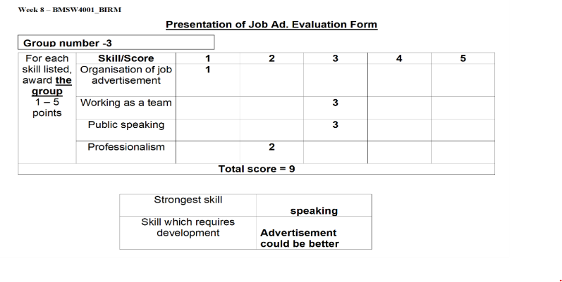

According to group 3, our strongest skill was our speaking and communication skills as well as working as a team. Skills which require development is that the advertisement could be better. We could improve this by bringing awareness by inserting more pictures and improve the format of the work.

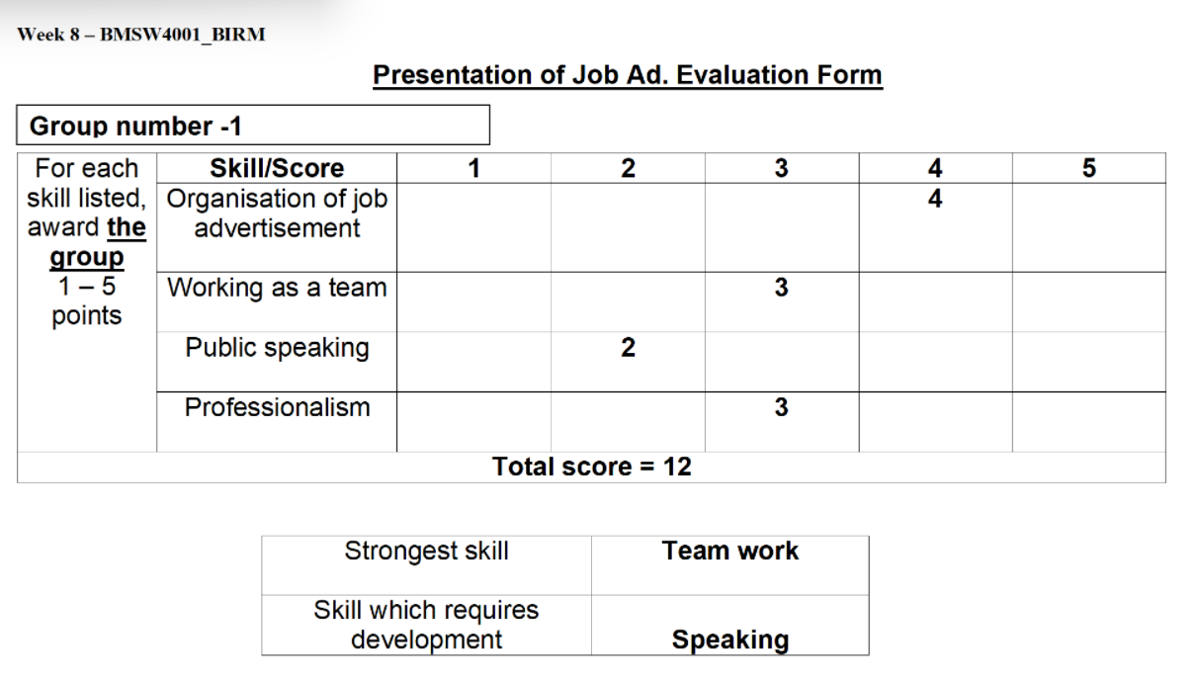
The feedback we received from Group 1, states that organising and advertising the poster was one of our strongest skills. The skill which required development is presenting, therefore, we can express our ideas and further developing our communication skills.

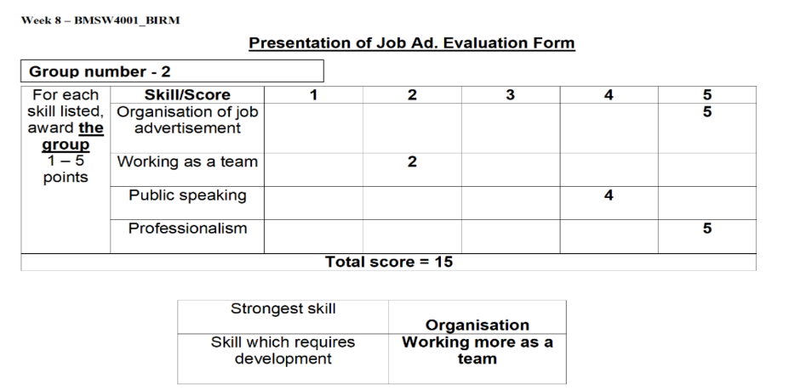
According to Group 2, our best skills were organisation and professionalism.
A skill which could be developed is teamwork. We could improve this by pre-planning
And deciding which member will participate in certain parts.

Personal development plan or PDP
Personal targets | How will I achieve this? | How will this improve my academic or employability prospects? | How will I know that I have achieved this? | When will I achieve this by?
- Writing skills | The writing skills can be improved further via the help of my assessors. They can educate me learn how I can write with fewer grammatical errors and make sense of the things that I will be writing in my studies. | Better writing skills will allow me to have devised better academic works and I will also be able to generate reports and present reports in my employment duties. | This will be evaluated by me when I am able to have good feedback from my assessors regarding my skills of writing. | This should be developed in around 2 weeks.
- Referencing skills | There have been a number of literatures that are focused on making learners understand how they can reference in an effective manner. The utilisation of such resources will be highly useful for me and will make me learn more about referencing skills. | By improving my referencing skills, I will be able to improve my academic works. I will be able to avoid plagiarism with the use of proper skills of referencing. | Again, feedback from my teachers will allow me to understand the development that I have made in terms of referencing skills. | The development of referencing skills should be done within a week.
- Problem-solving skills | I can develop my problem-solving skills via the method of getting to the root cause of the problem. This will grant me an insight of the issue and hence I will be able to find various solutions to such problems at a low level. This will increase my understanding of how I can make an approach to problems | This will allow me to solve various problems that are faced in academics as well as employment. I will be able to solve the issues in both fields properly. | This will be evaluated personally as I will be able to evaluate the development myself which can be seen in my day-to-day tasks. | The skills of problem-solving can be developed in a time period of 3 weeks.
Table 3: Personal Development Plan

Reference list
Adeani, I.S., Febriani, R.B. and Syafryadin, S., 2020. USING GIBBS’REFLECTIVE CYCLE IN MAKING REFLECTIONS OF LITERARY ANALYSIS. Indonesian EFL Journal, 6(2), pp.139-148.
Dhaliwal, U., Singh, S. and Singh, N., 2018. Reflective student narratives: honing professionalism and empathy. Indian J Med Ethics, 3(1), pp.9-15.

Graves, L.M. and Sarkis, J., 2018. The role of employees' leadership perceptions, values, and motivation in employees' provenvironmental behaviors. Journal of cleaner production, 196, pp.576-587.
Markkanen, P., Välimäki, M., Anttila, M. and Kuuskorpi, M., 2020. A reflective cycle: Understanding challenging situations in a school setting. Educational Research, 62(1), pp.46-62.
Reljić, N.M., Pajnkihar, M. and Fekonja, Z., 2019. Self-reflection during first clinical practice: The experiences of nursing students. Nurse education today, 72, pp.61-66.
Soundiraraj, S. and Babu, B.A., 2022. Reflective Practice for Teachers in the Post-Method Era. Contemporary ELT Strategies in Engineering Pedagogy: Theory and Practice.
Tanaka, M., Okamoto, R. and Koide, K., 2018. Relationship between Reflective Practice Skills and Volume of Writing in a Reflective Journal. Health, 10(3), pp.283-288.

