

Program: MSc Data and AI
Name: Vaidya Dharmik Kanaiyalal
Student ID: 2433624

Module: Data Security, Governance and Compliance
Code: ACCA7028

Developing a Security, Governance and Compliance Framework for NatureGreen

1. Abstract

NatureGreen is a global organisation that relies heavily on cloud services and an almost entirely wireless network. While this setup supports flexibility and operational efficiency, it also exposes the company to a wide range of security, governance and compliance risks. NG is also considering a Bring Your Own Device (BYOD) approach, which could increase the number of unmanaged devices accessing sensitive systems. This report reviews several recognised security and governance frameworks, including ISO/IEC 27001, ISO/IEC 27002, COBIT 2019 and the NIST Cybersecurity Framework, to understand how they can help NG establish a more structured and reliable security environment. Based on insights from these frameworks, a practical model is proposed that covers governance roles, policy development, risk assessment, technical controls and operational processes. The report also discusses why organisations need to keep up with updated standards and regulatory requirements, especially given the rapid changes in cyber threats and technology. Overall, the aim is to provide NG with a clearer, more organised approach to improving its security posture without disrupting daily operations.

Introduction

Technology plays a central role in how most modern organisations operate, and this brings both opportunities and risks [1]. NatureGreen (NG), a global company working across the health and wellness sector, relies heavily on cloud platforms and a network that is almost entirely wireless. Although this allows the company to operate flexibly across different regions, it also increases its exposure to cyber threats [2]. The situation becomes more challenging when combined with the growing expectation that NG should support Bring Your Own Device (BYOD) access for staff and customers. BYOD can improve convenience, but it introduces new security concerns[3], especially when personal devices are not managed or protected to the same standard as corporate equipment.
The scenario suggests that NG currently lacks a clear governance structure and does not have formal policies to guide security decisions[4]. Without these foundations, it becomes difficult to manage risks, protect sensitive information or meet legal requirements in different regions. To address these issues, this report examines several recognised security and governance frameworks. These include ISO/IEC 27001, ISO/IEC 27002, COBIT 2019, ITIL 4 and the NIST Cybersecurity Framework. Each offers a different perspective on how organisations should approach security, governance and compliance. By reviewing these frameworks and considering NG’s specific situation, the report develops a practical security model that can help NG improve its overall security posture in a structured and manageable way [5].

Research on Security Frameworks and Models

3.1 Overview of Security Frameworks Relevant to NatureGreen
To develop a structured and reliable security environment, NatureGreen (NG) requires guidance from established frameworks that are widely used across the industry. These frameworks offer different strengths: some help organisations design policies, others guide governance decisions, and some assist in improving operational consistency. Reviewing these models is essential because NG currently lacks formal processes, documented controls and a clear security structure. Understanding what each framework provides allows NG to adopt a balanced, practical approach suited to its cloudbased and wireless operations [6].

3.2 ISO/IEC 27001 and ISO/IEC 27002
ISO/IEC 27001 is an international standard that sets the foundation for building an Information Security Management System. It emphasises risk assessment and continuous improvement, making it highly adaptable to changing environments such as cloudbased systems. ISO/IEC 27002 supports this by providing detailed guidance on specific controls, including access management, network protection, encryption, monitoring, and supplier relationships. The newer 2022 updates also address modern requirements such as cloud configuration [7], threat intelligence and secure authentication. These elements make ISO highly suitable for NG, which currently operates with minimal structure and depends heavily on cloud and wireless technologies.
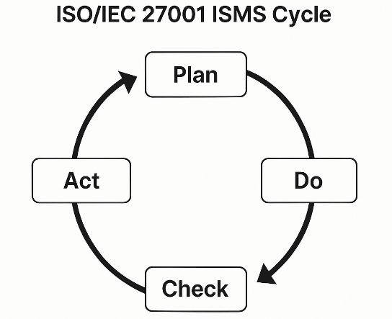
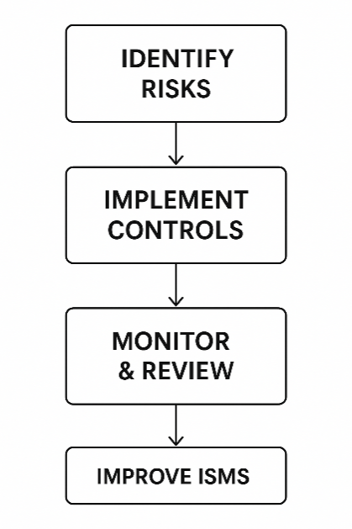

3.3 COBIT 2019
COBIT 2019 focuses on governance rather than technical controls. It defines how organisations should oversee IT activities, who holds decisionmaking responsibilities, and how performance is monitored. Since NG lacks a governance model and does not have clearly assigned security responsibilities, COBIT offers a strong foundation for establishing accountability[8]. By defining roles, oversight mechanisms and links between business goals and technology decisions, COBIT provides NG with the strategic direction it currently lacks. This governance layer would also help ensure that the policies and controls introduced through ISO are properly managed and maintained.

3.4 NIST Cybersecurity Framework (CSF)
The NIST CSF provides a structured view of the security lifecycle using its five core functions: Identify, Protect, Detect, Respond and Recover. These functions help organisations understand their current level of security maturity and highlight areas requiring improvement. This is particularly useful for NG, which has several operational weaknesses, such as limited monitoring, no formal incident response process and unclear risk ownership[9]. NIST CSF allows NG to prioritise improvements rather than attempting to develop controls in an unstructured manner. Its flexibility also makes it suitable for both cloud environments and traditional IT operations.

3.5 ITIL 4
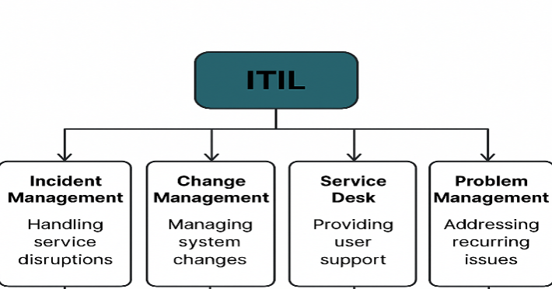
ITIL 4 contributes to security by improving IT service management practices. It does not define security controls directly, but it strengthens operational processes that support security activities. Practices such as incident management, change control, supplier management and service continuity are essential for an organisation like NG, which is heavily dependent on cloud services[10]. Without strong operational processes, even welldesigned security controls can fail. ITIL helps ensure that the organisation responds effectively to incidents, avoids unnecessary risks during system changes and maintains stable operations across its global services.

3.6 Comparison of Frameworks and Their Relevance to NG
Although these frameworks focus on different aspects of security, they complement one another when applied together[11]. ISO provides the structure for policies and technical controls, COBIT establishes governance and oversight, NIST supports maturity assessments and prioritisation, and ITIL ensures that daily operations run smoothly. The table below outlines how each framework contributes to NG’s needs.

3.7 Combined View of How Frameworks Work Together
These frameworks can be viewed as different layers of a single, integrated security approach. COBIT provides governance at the top, ensuring decisions are consistent and aligned with the business. ISO delivers practical controls and policies that NG needs urgently[12]. NIST helps NG understand its weaknesses and set a realistic improvement roadmap. ITIL strengthens daytoday operations, ensuring that security is not just designed but actually maintained. The diagram below illustrates this relationship.
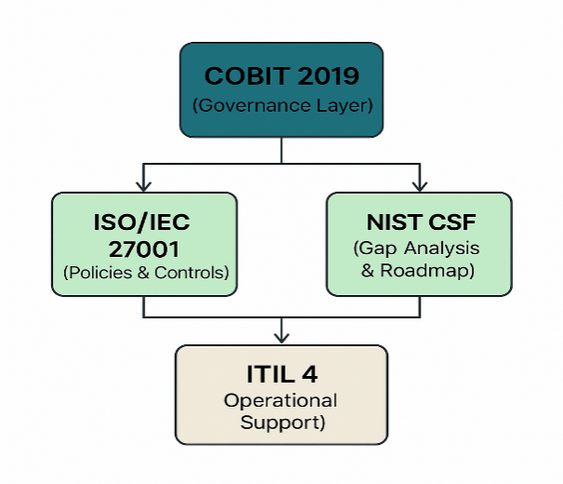
Diagram 1. Relationship Between the Frameworks

3.8 Conclusion of the Framework Review
Overall, the reviewed frameworks collectively provide NG with a comprehensive approach to addressing its current weaknesses. By integrating governance, controls, maturity assessment and operational processes, NG can create a sustainable and adaptable security environment. This combination is far more effective than relying on a single framework and aligns closely with NG’s reliance on cloud services, wireless networks and expanding digital services.

Table 1. Comparison of Selected Frameworks
Framework | Primary Focus | Relevance to NatureGreen
ISO/IEC 27001 & 27002 | Riskbased security, controls and policies | Helps NG establish formal policies and structured controls suited to cloud and wireless systems
COBIT 2019 | Governance, roles and oversight | Clarifies responsibilities and decisionmaking, something NG currently lacks
NIST CSF | Security lifecycle and maturity | Helps NG assess weaknesses and prioritise improvements in a practical order
ITIL 4 | IT service management and operational processes | Supports incident response, continuity and supplier management for cloudbased operations

These frameworks can also be viewed together to show how they complement one another rather than compete. COBIT provides governance and direction, ISO offers detailed controls, NIST helps identify areas that require improvement, and ITIL supports stable operational practices.Overall, these frameworks provide NG with a structured and balanced foundation for improving security. ISO helps develop solid policies and controls, COBIT strengthens governance, NIST supports practical prioritisation, and ITIL ensures operational processes run reliably. Using them together gives NG a comprehensive starting point for building its security, governance and compliance capabilities[13].

Section 4: Proposed Security, Governance and Compliance Framework for NatureGreen

4.1 Overview of the Proposed Framework
This section presents a practical security, governance and compliance framework tailored to NatureGreen’s (NG) needs. The framework combines ideas from the reviewed models ISO/IEC 27001 and 27002, COBIT 2019, ITIL 4 and the NIST CSF to create a structured approach that matches NG’s cloudbased and wireless environment. The framework focuses on five key areas: governance, policies, risk management, security controls and operational processes.

4.2 Governance Structure for NG
One of NG’s biggest weaknesses is the absence of a clear governance model. A simple structure would help create accountability and reduce confusion over who approves policies, who monitors risks and who responds during incidents. The recommended structure includes an Executive Sponsor, a Security Manager, a Data Protection Lead [14].

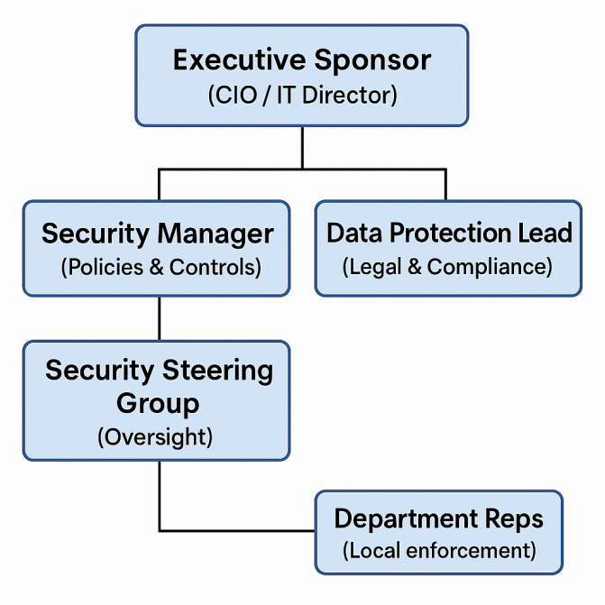
4.3 Development of Security Policies
Policies are essential because they set the rules for how staff, customers and systems behave. Since NG currently has no formal policies, the first step is establishing a core set of documents covering areas like information security, BYOD, wireless networks, access control, cloud usage and incident handling[13].

Table 1. Key Policies Required for NG
Policy Name | Purpose / Coverage
Information Security Policy | Defines overall security expectations and responsibilities
BYOD Policy | Rules for personal device access and security controls
Wireless Network Policy | Encryption standards, segmentation and wireless access
Cloud Security Policy | Identity management, logging, shared responsibility
Access Control Policy | Rolebased access, approval workflows, periodic reviews
Data Protection Policy | Personal data handling, retention, minimisation
Incident Response Policy | Reporting channels, response steps and communication

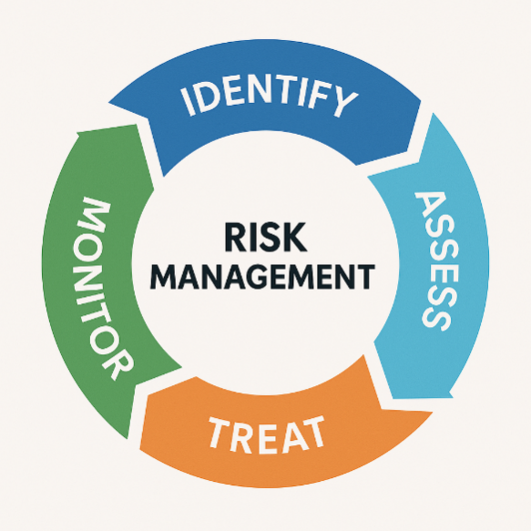
4.4 Risk and Asset Management Process

A structured risk management approach is essential for NG because the organisation handles sensitive personal data and valuable intellectual property. Using ISO 27001’s risk assessment method, NG should identify its assets, assess the threats against them and decide which controls to implement first. This approach helps NG focus on the most serious risks rather than spreading resources too thinly[15].

Table 2. Example Risk Register for NG
Risk Description | Likelihood | Impact | Recommended Treatment
Weak WiFi security | Medium | High | Implement WPA3, segmentation and monitoring
Personal devices accessing corporate data | High | Medium | Enforce BYOD controls, MFA and MDM
Cloud misconfiguration | Medium | High | Regular reviews and cloud configuration scanning
IP data leakage | Low | High | Use DLP tools and restrict access permissions

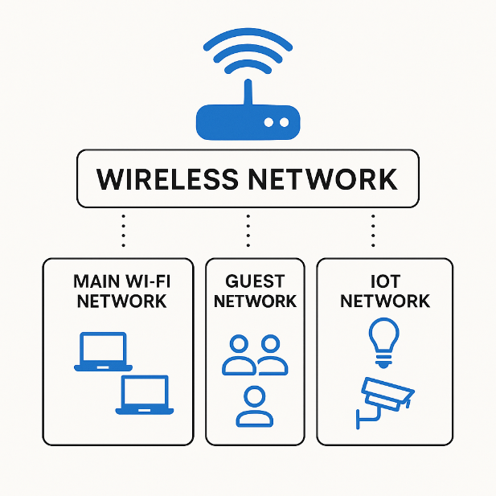
4.5 Security Controls for NG

Security controls should be chosen based on risks. ISO/IEC 27002 offers a wide range of controls that NG can apply, but these must be adapted to fit NG’s cloudbased and wireless environment. Key control areas include identity and access management, wireless protection, cloud security and endpoint safeguards. These controls strengthen confidentiality, integrity and availability across NG’s systems.
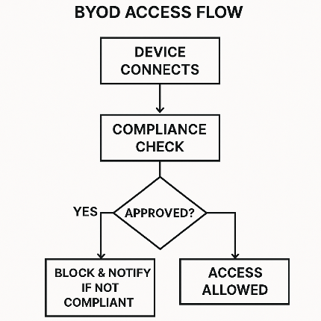
Diagram 2. BYOD Access Control Flow (TextBased)

4.6 Operational Processes Using ITIL
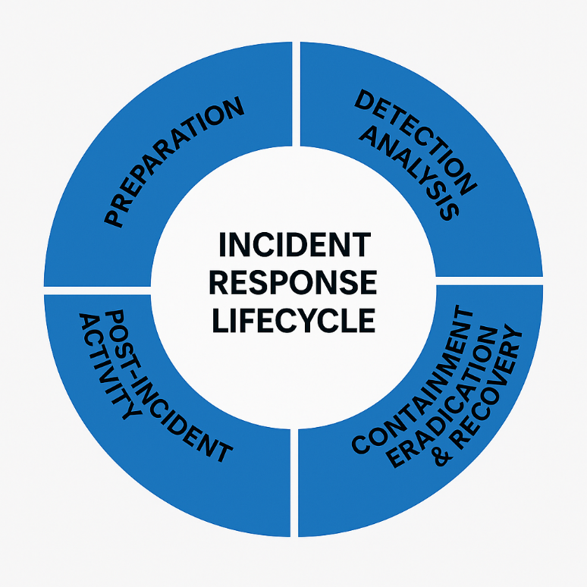
Operational processes ensure that security is supported daytoday rather than only on paper. ITIL 4 offers practical guidance for managing incidents, controlling changes to systems and recovering from disruptions. For NG, this is important because cloud services and wireless networks can fail or be misconfigured unexpectedly. A stable operational structure allows NG to respond quickly and consistently.

Table 3. ITIL Practices Relevant to NG
ITIL Practice | Importance for NG
Incident Management | Ensures clear steps during security incidents
Change Control | Prevents risky changes to cloud or network setups
Supplier Management | Helps monitor cloud providers’ performance
Service Continuity | Supports recovery after outages or cyber events

4.7 Summary of the Proposed Framework
Overall, the recommended framework gives NG a structured path for improving its security posture. Governance provides direction, policies create consistency, risk management helps prioritise, controls strengthen protection and ITIL processes support reliable daily operations. Together, these areas address NG’s current weaknesses and give the organisation a clear starting point for longterm improvement.

5. Critical Discussion: Why Updated Regulations and Standards Are Necessary

5.1 Relevance of Updated Standards in a Rapidly Changing Environment
The need for updated security regulations and standards has become increasingly important as technologies evolve at a fast pace. For an organisation like NatureGreen (NG), which operates primarily through cloud services and wireless networks, relying on outdated guidance would create significant gaps in protection. Cyber threats today are far more sophisticated than they were a few years ago, which means organisations must align their security practices with the most recent industry expectations[16]. Updated standards often reflect lessons learned from major incidents and new vulnerabilities, ensuring that organisations are not relying on controls that may now be ineffective.

5.2 Impact on Cloud Security and Shared Responsibility
Cloud environments change frequently, with service providers introducing new features, tools and configurations several times a year. Updated security frameworks help organisations understand how to manage these changes responsibly. Many earlier standards did not fully address cloudspecific risks or the shared responsibility model used by providers. More recent guidance, such as newer versions of ISO/IEC 27002 and updates to the NIST CSF, include clearer expectations on identity management, logging, data protection and configuration security within cloud platforms [17]. For NG, keeping policies aligned with these new expectations reduces the chance of misconfigurations, which are one of the leading causes of cloud breaches.

5.3 Importance for Data Protection and Legal Compliance
Regulations related to data protection are also continuously being updated, particularly in regions where NG operates globally. Laws such as the GDPR set strict requirements around consent, access rights, breach reporting and crossborder data transfers. As technology changes, these regulations are frequently revised or interpreted differently by courts and regulators. If NG does not keep pace with these changes, it risks legal penalties, reputational damage and loss of customer trust. Updated standards provide clearer interpretations of how organisations should handle personal information, making compliance more manageable[16].

Table 1. Examples of Impact from Updated Regulations
Area Affected | Type of Update | Effect on NG’s Operations
Data retention rules | New retention limits | Requires policy changes and deletion processes
Breach reporting | Tighter reporting deadlines | Needs faster detection and incident response processes
Crossborder transfers | Updated international transfer rules | Affects how NG stores cloud data across regions

5.4 Influence on Wireless and Mobile Security Practices
As NG relies heavily on wireless networks and BYOD access, updates to wireless and mobile security standards directly affect the organisation [17]. For example, earlier wireless standards such as WPA and WPA2 are no longer sufficient against modern attacks, and updated standards like WPA3 offer stronger protections. Similarly, mobile device security expectations now require encryption, regular updates and stronger authentication. Updated international and industry standards help ensure that NG’s wireless and mobile controls keep pace with new threats, reducing the risk of unauthorised access or data interception.

5.5 Supporting Continuous Improvement and Organisational Maturity
Updated standards and regulations also encourage organisations to adopt a continuous improvement mindset. Frameworks such as ISO/IEC 27001 emphasise ongoing review and adjustment, recognising that security is not a onetime exercise. For NG, staying aligned with updated guidance helps the organisation mature gradually, rather than remaining reactive[18]. This approach is especially important for a growing organisation with expanding digital services, as maintaining outdated controls can slow development and increase exposure to risk.

5.6 Summary of the Importance of Updates
In summary, updated security standards and regulations are essential for maintaining strong protection in a changing digital landscape. They help NG remain compliant with legal expectations, reduce cloud and wireless risks, address modern threat behaviours and strengthen operational resilience. For an organisation at NG’s maturity level, keeping up with updates is not optionalit is a necessary part of building a reliable and secure environment.

Assumptions

6.1 NatureGreen’s Technology Environment
This report is based on the assumption that NatureGreen (NG) primarily operates using cloudbased platforms rather than onpremises infrastructure. The scenario indicates that NG uses an almost entirely wireless network, so it is assumed that traditional wired networks play only a minor role in daily operations. It is also assumed that NG relies on several thirdparty cloud service providers, which is common for organisations that need high flexibility and global accessibility[19].

6.2 Devices and User Access
It is assumed that NG is considering a Bring Your Own Device (BYOD) model for staff and customers, even though this has not yet been formally introduced. This means that personal devices such as laptops, phones and tablets may potentially access NG’s systems in the future. It is also assumed that there are currently no device management or access control mechanisms in place for personal devices. These assumptions are based directly on the scenario, which highlights the lack of policies and the increasing expectation for BYOD access[20].

6.3 Organisational Structure and Roles
The scenario suggests that NG does not have a clearly defined governance structure, so it is assumed that no dedicated security leadership roles currently exist [21]. It is also assumed that responsibilities for risk management, incident response and compliance are not formally assigned. This lack of structure forms part of the reasoning for proposing a governance model in the earlier section.

6.4 Data and Compliance Requirements
It is assumed that NG handles personal data from customers across different regions, which means the organisation must comply with various data protection regulations such as the GDPR. It is also assumed that NG processes some form of intellectual property, since the scenario emphasises the need to protect sensitive research and development information. These assumptions help justify the need for strong data protection controls and governance practices [22].

6.5 Security Maturity and Resources
Based on the scenario, it is assumed that NG is at an early stage of security maturity, with limited formal processes or documented controls. At the same time, it is assumed that NG is willing to invest some resources financial and operational to improve its security posture, otherwise implementing the proposed framework would not be feasible. The report assumes NG has access to both internal staff and external support if required.

Conclusion

7.1 Summary of the Key Findings
NatureGreen (NG) currently operates without a structured security, governance or compliance framework, which creates significant risks given its reliance on cloud platforms, wireless networks and potential BYOD usage. The research on established frameworks shows that no single model can fully address NG’s situation on its own. However, combining elements from ISO/IEC 27001 and 27002, COBIT 2019, the NIST Cybersecurity Framework and ITIL 4 provides a strong and practical foundation for improving NG’s security posture.

7.2 Effectiveness of the Proposed Framework
The proposed framework in this report offers NG a balanced and realistic way to strengthen its security environment. Governance recommendations help clarify responsibilities, while the introduction of policies ensures consistent expectations across the organisation. The risk management approach supports prioritised decisionmaking, and the security controls address the specific challenges NG faces in cloud and wireless environments. Additionally, ITILbased operational processes help embed security into daily activities rather than treating it as a separate function.

7.3 Importance of Keeping Standards Updated
An important theme throughout the report is that security standards and regulations evolve rapidly. NG must keep pace with these changes in order to remain compliant with data protection laws, avoid cloud misconfigurations and protect sensitive intellectual property. Updated standards also reflect emerging threats, meaning NG’s longterm security depends on reviewing and updating its controls regularly.

7.4 Final Reflection on NG’s Security Direction
Overall, the recommendations provided in this report give NG a structured, modern and flexible approach to security. Implementing the proposed framework will not eliminate all risks, but it will significantly reduce the most serious vulnerabilities and bring NG’s practices in line with current industry expectations. With continued monitoring and periodic updates, NG can build a security environment that supports its operations while protecting the organisation’s data, customers and reputation.

8. reference

- Zhang, M., Hou, J. and Liu, Y., 2025. Achieving development goals via digital government strategies for a sustainable digital economy that integrate natural resource governance and energy security. Resources Policy, 101, p.105330.

- Fedorov, R., Kuklina, V., Sizov, O., Soromotin, A., Prihodko, N., Pechkin, A., Krasnenko, A., Lobanov, A. and Esau, I., 2021. Zooming in on Arctic urban nature: green and blue space in Nadym, Siberia. Environmental research letters, 16(7), p.075009.
- Chauhan, M. and Shiaeles, S., 2023. An analysis of cloud security frameworks, problems, and proposed solutions. Network, 3(3), pp.422-450.

- Pardo, C., 2016. Towards an integrated management system (IMS), harmonizing the ISO/IEC 27001 and ISO/IEC 20000-2 standards. International Journal of Software Engineering and Its Applications.

- Calder, A., 2020. Information Security based on ISO 27001/ISO 27002. Van Haren.

- Di Giulio, C., Sprabery, R., Kamhoua, C., Kwiat, K., Campbell, R.H. and Bashir, M.N., 2017, June. Cloud standards in comparison: Are new security frameworks improving cloud security?. In 2017 IEEE 10th International Conference on Cloud Computing (CLOUD) (pp. 50-57). IEEE.

- Nachrowi, E., Nurhadryani, Y. and Sukoco, H., 2020. Evaluation of governance and management of information technology services using Cobit 2019 and ITIL 4. Jurnal RESTI (Rekayasa Sistem Dan Teknologi Informasi), 4(4), pp.764-774.

- Sun, Y., Safford, D., Zohar, M., Pendarakis, D., Gu, Z. and Jaeger, T., 2018. Security namespace: making linux security frameworks available to containers. In 27th USENIX Security Symposium (USENIX Security 18) (pp. 1423-1439).

- Utomo, D., Wijaya, M., Suzanna, S., Efendi, E., and Sagala, N.T.M., 2022. Leveraging COBIT 2019 to Implement IT Governance in SME Context: A Case Study of Higher Education in Campus A. CommIT (Communication and Information Technology) Journal, 16(2), pp.129-141.

- Warih, H., Adrian, M., and Suroso, J.S., Information System Audit using COBIT 2019 on Multi Finance Company. Buletin Poltanesa, 26(1), p.620337.

- Bahri, R.S. and Putra, Y.H., 2023. Optimizing Information System Management in Micro, Small, and Medium Enterprises: A COBIT 5 Framework Approach for Enhanced Quality. @ is The Best: Accounting Information Systems and Information Technology Business Enterprise, 8(2), pp.166-180.

- Burke, J., Gasti, P., Nathan, N. and Tsudik, G., 2013, April. Securing instrumented environments over contentcentric networking: The case of lighting control and NDN. In 2013 IEEE Conference on Computer Communications Workshops (INFOCOM WKSHPS) (pp. 394398). IEEE.

- Park, P., Ergen, S.C., Fischione, C., Lu, C. and Johansson, K.H., 2017. Wireless network design for control systems: A survey. IEEE Communications Surveys & Tutorials, 20(2), pp.9781013.

- Huber, B., Schmid, O. and Kilcher, L., 2010. Standards and regulations. In the World of organic agriculture (pp. 5970). Routledge.

- Almorsy, M., Grundy, J. and Müller, I., 2016. An analysis of the cloud computing security problem. arXiv preprint arXiv:1609.01107.

- Nurmela, P., Etto, J. and Häkkilä, J., 2024, November. Exploring VR as a Method to Study User Perceptions of Challenges in Green Transition Technology in Nature. In International Conference on Design, Learning, and Innovation (pp. 5168). Cham: Springer Nature Switzerland.

- AlHaj, A., 2025, March. Enhancing IoT Security Schemes Through Governance, Risk, and Compliance (GRC). In International Conference on Information Management (pp. 217226). Cham: Springer Nature Switzerland.

- Haque, A., 2024. Building With NatureGreen Thru BioBased MaterialsProduction Footprint, Raw Material Sourcing and Its Impact, Applications and Fit for a Sustainable Future With Its Outstanding Environmental Performance. Raw Material Sourcing and Its Impact, Applications and Fit for a Sustainable Future With Its Outstanding Environmental Performance (June 22, 2024).

- Hettne, B., 2010. Development and security: Origins and future. Security Dialogue, 41(1), pp.3152.

- Mell, P. and Grance, T., 2011. The NIST definition of cloud computing.

- Hogan, M., Liu, F., Sokol, A. and Tong, J., 2011. Nist cloud computing standards roadmap. NIST Special Publication, 35(6), p.11.

- Veiga, A.D. and Eloff, J.H., 2007. An information security governance framework. Information systems management, 24(4), pp.361372.

