Lab Report – Titration

- Aim:
The aim of the experiment was to determine the concentration of a solution of hydrochloric acid (HCL) using a standard solution of sodium hydroxide (NaOH).
The main tasks of this experiment were to:
- Identify the volume of 0.1002 mol/L of NaOH is required to titrate (neutralise) 25mL of and unknown mol/L of HCL.
- calculate the concentration of the solution of HCL used in the titration.
- calculate the moles of NaOH solution.
- calculate the moles of HCL solution.

- Theory:
Titration is defined as the neutralisation of a substance by the addition of one solution of a known concentration to another solution of an unknown concentration but of a known volume [1]. The neutralisation process is usually indicated by a colour change by adding an indicator to the solution which is to be neutralised.
In titration the solution of known concentration is known as the titrant, and the solution of unknown concentration is called the analyte. Titration itself is a chemical reaction between these two solutions, whereby the analyte is neutralised by the titrant. This state of neutralisation is called the equivalence point. By adding an indicator to the analyte this equivalence point will be presented by a change in colour of the titrate, showing that the end point has been reached, whereby the pH is neutral. Titration can be applied to
In acid-base titrations, a strong acid (e.g., HCL) will be mixed with a strong base solution (e.g., NaOH) to form a neutral solution (e.g., NaCl and H2O), where the pH of this titrate will equal seven (i.e., pH = 7).
Titration is used in quantitative chemical analysis and can be used to establish the molarity of the analyte.
At the equivalence point in the neutralisation process the moles of acid are equal to the moles of base.
At the point of neutralisation, the Moles of solute and equal to the molarity of a solution, multiplied by its volume.
To Calculate the Molarity (Mol/L) of the solution, the following equation is used:
Molarity (M) = | Moles of Solute (Mol) | = | n
Molarity (M) = | Litres of Solution (L) | = | V

To calculate the unknown molarity of titrant, the following equation can be used, provided that the molarity of either acid or base are known.

Molarity of Acid | x | Volume of Acid | = | Molarity of Base | x | Volume of Base
MA | x | VA | = | MB | x | VB

At the equivalence point the Molarity of Acid and the Molarity of Base will have reached neutralisation. At this point the Moles of both titrant and analyte will be the same. The equation can be rearranged accordingly to calculate the molarity of the analyte.
2.1 Application:
Titration has numerous applications across industry including, but not limited to, food industry, and the production of wine & beverages; manufacture of cosmetics; waste-water management processes; and medical industries. The Pharmaceutical industry utilises different types of titrations in volumetric analysis under four different processes which are Purity Analysis of Pharmaceutically Active Ingredients; Content Analysis by Redox Titrations; Precipitation Titrations; and in pH-Stat Titrations [2].
Titration has been used in the agricultural industries in production of fertilisers in the form of Ammonium Nitrate (NH4NO3). Ammonium Nitrate is produced when Nitric acid is neutralised using ammonia [3].
NH3 | + | HNO3 | = | NH4NO3

The product of this titration is used in the production of explosives in the Ordnance, Munitions and Explosives industry, and therefore understanding the concept of titration and its relevance to OME is essential.
Ammonium Nitrate has been mixed with trinitrotoluene (TNT) to produce Amatol. When mixed in the ratio of 85% Ammonium Nitrate and 15% TNT provides optimum values of pressure and velocity, in relation to detonation and explosion [4]. The benefits of mixing Ammonium Nitrate and TNT provided a stable explosive mixture, employed by both the allied forces during the second world war, and was also employed in the warhead of the German V2 rocket from 1944 to 1952 [5]. Whilst these are historic examples, the capabilities associated with Amatol remain relevant to this day.

- Chemicals and Equipment:
3.1 Chemicals used in the procedure:
- 100 mL of standard NaOH solution (M = 0.1002 mol/L)
- 100 mL of HCL solution (M = Unknown mol/L)
- Phenolphthalein indicator
3.2 Equipment:
- Burette – 50 mL attached to a burette stand with clamp.
- Pipette – 10 mL with pipette filler.
- Small funnel used to fill the burette.
- 250 mL beaker for waste chemicals and product.
- Erlenmeyer (conical) flask (x3).
- White tile to go under the titration flask.
Personal Protective Equipment must be worn throughout, due to the nature and corrosive properties of HCL and NaOH. PPE included safety goggles, lab coat, and nitrile (or latex) gloves.

- Procedure:
Step 1:
- Clean the calibrated equipment as follows-
  - Burette – cleaned with NaOH, rinsed, run through the tap mechanism, and placed into the waste beaker.
  - Pipette – cleaned with HCL, rinsed, and placed into the waste beaker.
  - Erlenmeyer flasks were rinsed and cleaned with distilled water and poured into waste beaker.
Step 2:
- Place the small funnel in the top of the Burette and fill with Sodium Hydroxide solution. The starting level must be recorded from the bottom of the meniscus to allow accurate readings to be taken.
Step 3:
- Using the Pipette filler put 25 mL of HCL solution in the clean Erlenmeyer flask.
Step 4:
- Add 3x drops of Phenolphthalein indicator into the flask containing HCL and agitate gently to allow throughout mixture.
Step 5:
- Use the tap of the burette, run the NaOH solution into the conical flask gradually, whilst mixing thoroughly. Continue until the solution changes to a pink colour. Stop at the point the solution changes colour and can sustain a pink hue. The lighter the shade of pink the more accurate the calculation will be.
Step 6:
- Clean the equipment as per previous steps 2, 3, 4.
Step 7:
- Run the NaOH until the reading on the burette is within 2 mL of the first reading.
- At this point slow the NaOH flow to 1x drip at a time (0.05 mL). Continue to add NaOH to the HCL until the point of colour change & record the results to within 0.05 mL (2x) or 0.10 mL (3x).

- Observations/Data:
The following results were recorded from the titration:

FLASK | 1  Rough Titration | 2 | 3
V HCL (mL)  From Pipette | 25.00 mL | 25.00 mL | 25.00 mL
Initial Burette Reading | 45.00 mL | 22.25 mL | 26.55 mL
Final Burette Reading | 22.00 mL | 38.95 mL | 43.60 mL
V NaOH (mL) | 17.00 mL | 16.70 mL | 17.05 mL
Moles of NaOH | 0.001703 moles | 0.001673 moles | 0.001708 moles
Moles of HCL | 0.001703 moles | 0.001673 moles | 0.001708 moles
Molarity of HCL | 0.06813 Mol/L | 0.06693 Mol/L | 0.06833 Mol/L
Molarity of NaOH | 0.1002 Mol/L | 0.1002 Mol/L | 0.1002 Mol/L

The original recordings and results can be seen in Appendix 1.
- Calculations:
The molarity of the HCL solution can be derived from the original equation:
Molarity of Acid | x | Volume of Acid | = | Molarity of Base | x | Volume of Base
MA | x | VA | = | MB | x | VB

By rearranging the equation, and in making the molarity of the HCL the subject, the equation becomes:
Molarity of Acid | = | Molarity of Base | x | Volume of Base
 |  | Volume of Acid

MA | = | MB | x | VB
 |  | VA

An example using the results can be seen here:

MA | = | 0.1002 Mol/L | x | 0.017 L
 |  | 0.025 L

0.06813 Mol/L | = | 0.1002 Mol/L | x | 0.017 L
 |  | 0.025 L

The original calculations for calculating the Molarity of the HCL solution can be seen in Appendix 2.

To calculate the moles of the titrant and analyte we use the following equation:
Moles | = | Molarity | x | Volume
N | = | M | x | V

An example calculation relating to mols of NaOH can be seen below:
Moles | = | Molarity | x | Volume
0.001703 Mol | = | 0.1002 Mol/L | x | 0.017 L

- Results and Discussion:
When at the point of equilibrium, the results indicated that 25mL of HCL was neutralised by approximately 17mL of NaOH (respectively 17.00 ml, 16.70 ml, and 17.05 ml – averaging 16.9166 ml).
It was observed that the volume of NaOH solute used to neutralise the acid was less than the 25 mL of HCl the Erlenmeyer flask. From the results, it is suggested that whilst the volume of NaOH is lower, less is needed to reach equilibrium between the solutions. This suggests that the molarity of the solution is higher than that of the analyte.
It is shown that the Moles of NaOH and moles of HCL were in equilibrium at the equivalence point, but the recorded volumes were different. This suggests that that analyte was of a weaker concentration, due to volumetric differences.
It was observed during the experiment that the burette continued to drip at its own rate when the tap was turned to the off position. Whilst close attention was paid during the process and the volumes recorded accurately, the Erlenmeyer flask must be removed from under the burette at the point of colour change so that the results are not affected. It is possible that the readings taken from the burette could have been affected by this by up to 0.10 mL.
The titration was conducted in pairs, meaning that observations were subjective to the individuals taking part. Whilst phenolphthalein indicator had been added to the HCL solution, the lighter shades were more difficult to observe. Should this experiment be repeated, it should be advised that using a white background would assist in identifying the colour change at the point of equilibrium, alongside a colour chart for comparison.
The process of adding the titrant (NaOH) to the analyte (HCL) could also be improved. Tighter control of the burette tap would have increased accuracy in recording the results. In reducing the volume of sodium hydroxide added per drop (approx. 0.05 mL) at a time, a greater level of accuracy would have been achieved. In reducing the measure of NaOH to 0.01 mL it is likely that the exact point of equilibrium could be established.
During the second set of results the tap was turned the wrong direction, allowing more NaOH into the Erlenmeyer flask than was necessary, rapidly turning the titrate from a very slight pink hue to a vibrant bright pink hue. Human error resulted in a variance of 0.30 mL between results.
These variables could be removed by replacing equipment with alternatives with tighter tolerances, or by additional control measures, such as removal of the human factor.

- Conclusion:
The purpose of the titration experiment was to determine the concentration of a solution of 25ml hydrochloric acid (HCL) using a standard solution of 0.1002 Mol/L sodium hydroxide (NaOH).
At the equivalence point the Molarity of Acid and the Molarity of Base reached a neutral state, indicted by the Phenolphthalein indicator.
Results show that there was a difference in volume between the titrant and analyte. This suggested that there was a difference in the molarity of the two liquids, and the results and calculations show that the molarity of the sodium hydroxide as being of higher than the hydrochloric acid, as a lower volume of NaOH was used to neutralise the 25Ml HCL.
Whilst there are areas which require improvement, results support that titration was successfully achieved within acceptable parameters.

Bibliography

[1] | LibreTexts Chemistry, "Acid-Base Titrations," NICE, 30 August 2022. [Online]. Available: https://chem.libretexts.org/Ancillary_Materials/Demos_Techniques_and_Experiments/General_Lab_Techniques/Titration/Acid-Base_Titrations. [Accessed 13 March 2023].
[2] | Master Chemistry, "Uses of Titration in Industries," The Master Chemistry, Publication Date Not Specified 2021. [Online]. Available: https://themasterchemistry.com/uses-of-titration-in-industries/. [Accessed 15 March 2023].
[3] | Vaisala, "Ammonium Nitrate Production Process," Vailsala, Publication Month not specified 2023. [Online]. Available: https://www.vaisala.com/en/industries-applications/chemicals-allied-products/ammonium-nitrate-production-process#:~:text=Ammonium%20nitrate%20is%20produced%20by,fed%20to%20a%20slurry%20tank. [Accessed 15 March 2023].
[4] | A. Alipoor and K. Mazaheri, "The Optimization of Detonation Properties in Gaseous Mixtures and Mixed Explosive Materials," Journal of Energetic Materials, vol. 31, no. 2, pp. 115-126, 2012.
[5] | T. Dungan, "V-2 Rocket," Brothers Designs, Original Date no published on Website 1999-2021. [Online]. Available: http://www.v2rocket.com/. [Accessed 16 March 2023].
[6] | LibreTexts Chemistry, "Titration," NICE, 21 06 2019. [Online]. Available: https://chem.libretexts.org/Ancillary_Materials/Demos_Techniques_and_Experiments/General_Lab_Techniques/Titration. [Accessed 13 03 2023].
[7] | Khan Academy, "Acid-Base Titration Curves," Khan Academy, 2023. [Online]. Available: https://www.khanacademy.org/test-prep/mcat/chemical-processes/titrations-and-solubility-equilibria/a/acid-base-titration-curves. [Accessed 14 March 2023].
[8] | R. Sleeman and J. F. Carter, "Forensic Sciences | Explosives," in Ecyclopedia of Analytical Science, Elsevier, 2005, pp. 400-406.
[9] | Cool Periodic Table, "Titration," Cool Periodic Table, Publication Year Not Given. [Online]. Available: https://coolperiodictable.com/resources/acids-and-bases/titration.php. [Accessed 14 March 2023].
[10] | Merck, "What is Titration?," Merck KGaA, Publication Date Not Specified 2023. [Online]. Available: https://www.sigmaaldrich.com/GB/en/technical-documents/technical-article/analytical-chemistry/titration-and-karl-fischer/learning-center-titration. [Accessed 14 March 2023].

References

[1] | LibreTexts Chemistry, "Acid-Base Titrations," NICE, 30 August 2022. [Online]. Available: https://chem.libretexts.org/Ancillary_Materials/Demos_Techniques_and_Experiments/General_Lab_Techniques/Titration/Acid-Base_Titrations. [Accessed 13 March 2023].
[2] | Master Chemistry, "Uses of Titration in Industries," The Master Chemistry, Publication Date Not Specified 2021. [Online]. Available: https://themasterchemistry.com/uses-of-titration-in-industries/. [Accessed 15 March 2023].
[3] | Vaisala, "Ammonium Nitrate Production Process," Vailsala, Publication Month not specified 2023. [Online]. Available: https://www.vaisala.com/en/industries-applications/chemicals-allied-products/ammonium-nitrate-production-process#:~:text=Ammonium%20nitrate%20is%20produced%20by,fed%20to%20a%20slurry%20tank. [Accessed 15 March 2023].
[4] | A. Alipoor and K. Mazaheri, "The Optimization of Detonation Properties in Gaseous Mixtures and Mixed Explosive Materials," Journal of Energetic Materials, vol. 31, no. 2, pp. 115-126, 2012.
[5] | T. Dungan, "V-2 Rocket," Brothers Designs, Original Date no published on Website 1999-2021. [Online]. Available: http://www.v2rocket.com/. [Accessed 16 March 2023].
[6] | LibreTexts Chemistry, "Titration," NICE, 21 06 2019. [Online]. Available: https://chem.libretexts.org/Ancillary_Materials/Demos_Techniques_and_Experiments/General_Lab_Techniques/Titration. [Accessed 13 03 2023].
[7] | Khan Academy, "Acid-Base Titration Curves," Khan Academy, 2023. [Online]. Available: https://www.khanacademy.org/test-prep/mcat/chemical-processes/titrations-and-solubility-equilibria/a/acid-base-titration-curves. [Accessed 14 March 2023].
[8] | R. Sleeman and J. F. Carter, "Forensic Sciences | Explosives," in Ecyclopedia of Analytical Science, Elsevier, 2005, pp. 400-406.
[9] | Cool Periodic Table, "Titration," Cool Periodic Table, Publication Year Not Given. [Online]. Available: https://coolperiodictable.com/resources/acids-and-bases/titration.php. [Accessed 14 March 2023].
[10] | Merck, "What is Titration?," Merck KGaA, Publication Date Not Specified 2023. [Online]. Available: https://www.sigmaaldrich.com/GB/en/technical-documents/technical-article/analytical-chemistry/titration-and-karl-fischer/learning-center-titration. [Accessed 14 March 2023].

Appendices:

Appendix 1:
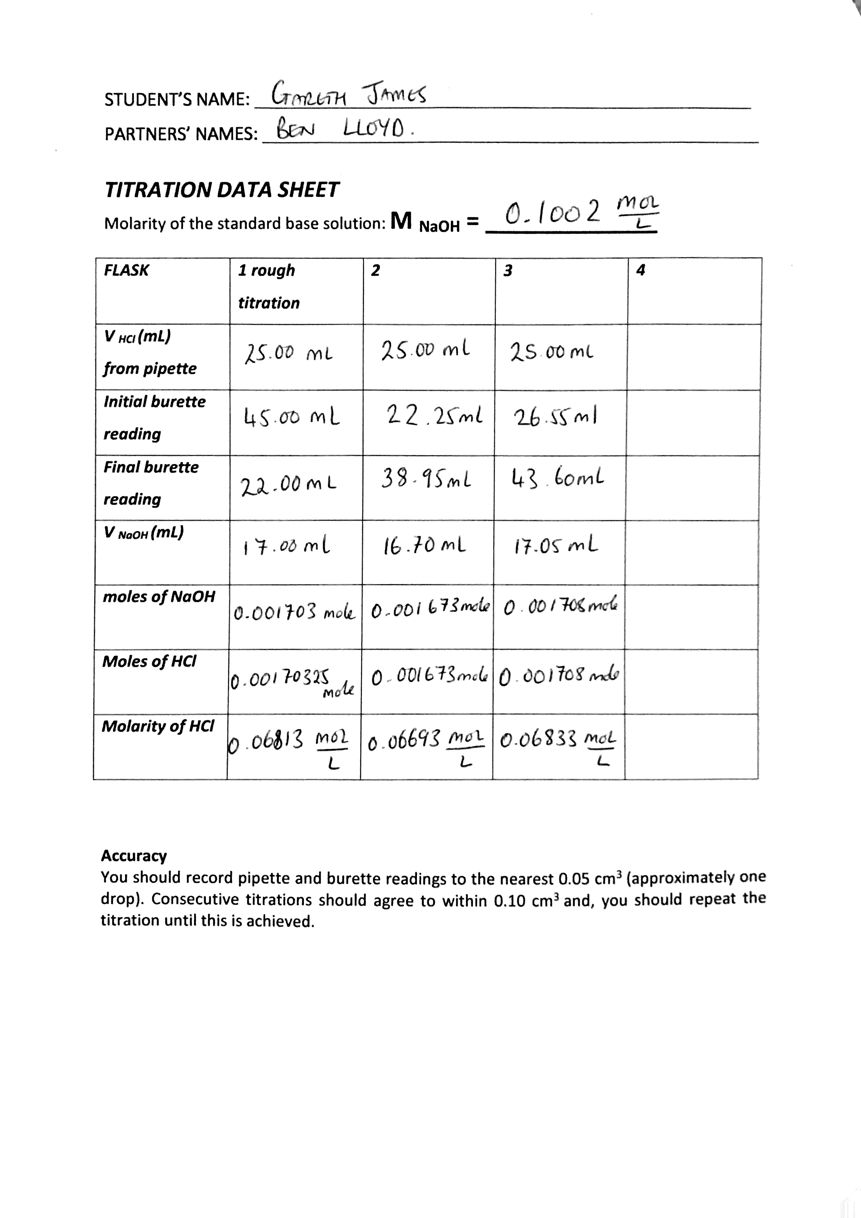

Appendix 2:


