Daniel Grasu
1805703
4-05-2019

A report on communication within the workplace
Effective Team-Working and Communication
BMSK 4002

Executive summary

Based on a case study, the author will analyze the importance of effective communication in the workplace, by following models to illustrate his points of view. The author will conduct researches regarding the teamwork theories and how those theories can support the organization to improve its services.
The author will consult a no. of books, newspapers, websites to support his work and draw a conclusion at the end.

Contents list

1. Executive summary 1
2. Contents list 2
3. Introduction 3
4. Findings 4
4.1. Theories 4
4.1.1. Communication 4
4.1.2. Team Working 4
4.1.3. Conflicts 5
4.1.4 Belbin theory 5
4.1.5 Tuckman theory 6
4.2 Michelle Sullivan business analysis 6
4.2.1 Communication issues 6
4.2.2 Teamwork issues 8
4.2.3 Conflict issues 9
5. Conclusion 10
6. Recommendation 11
7. Action plan 12
8. Appendices 13
9. Reference list 14
10. Bibliography 15

Introduction

The case study analyzed by the author is Michelle Sullivan toy store from Swansea how have registered a rapidly grown in the last year. In his report, the author, who is a business consultant, will analyze Michelle’s business, and he will advise her about the possible team structures and how the communication channels can be improved to prevent small issues to become big problems.
See appendices Michelle’s business for the full business description.

Findings

Further on, in his report, the author will analyze and explain the main three factors which should not be missing from a successful business.

4.1. Theories

A successful business is based on three main factors and tow important theory such as:

4.1.1. Communication

Based on his research, the author has identified communication as the process by which a sender sends a message to a receiver through a channel. (Means and Rankin, 2010)

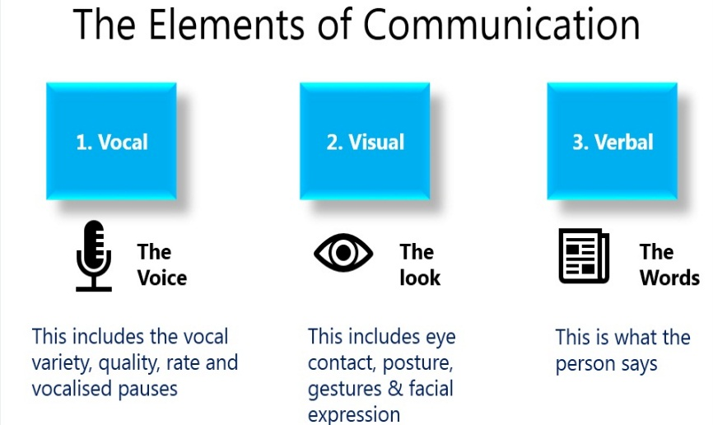
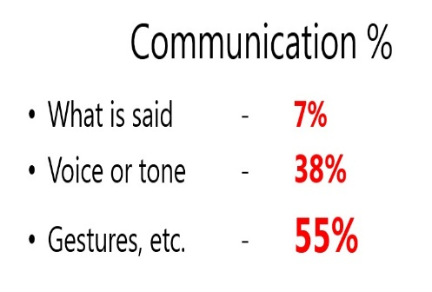

Further, in his report, the author will analyze the communication process and the communication barriers that occurred or can occur in the Michelle business case.

4.1.2. Team Working

Based on his research, the author has identified teamwork as team's joined efforts to achieve a common objective or to perform a job in the most efficient and effective way possible. (West, 2012)
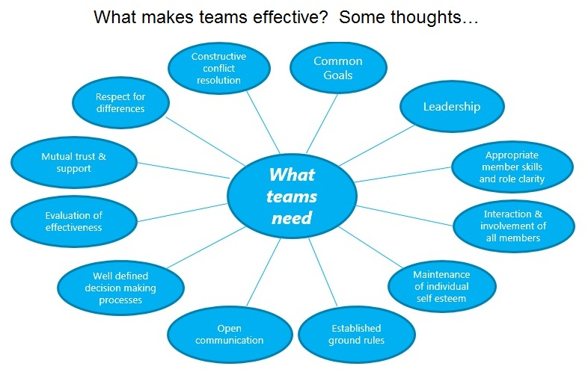

4.1.3. Conflicts

Based on his research, the author has identified conflict as a process which starts when a part realizes that another part has started to affect something that the first party cares about. (Sweetman, 2011)
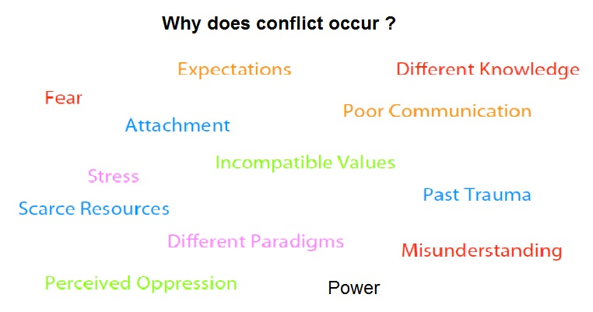

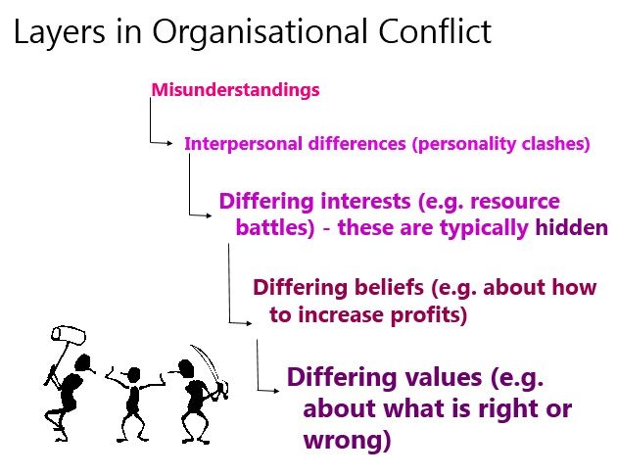

Further, in his report, the author will analyze why do conflicts occur in Michelle Sullivan business and the signs that there is a conflict.

4.1.4 Belbin theory

Another theory used by the author to analyses Michelle Sullivan business is known as ‘Belbin theory’. Dr. Meredith Belbin and his team found out nine behavioral clusters which can help a team to become a high performing team. (Belbin, 2010)

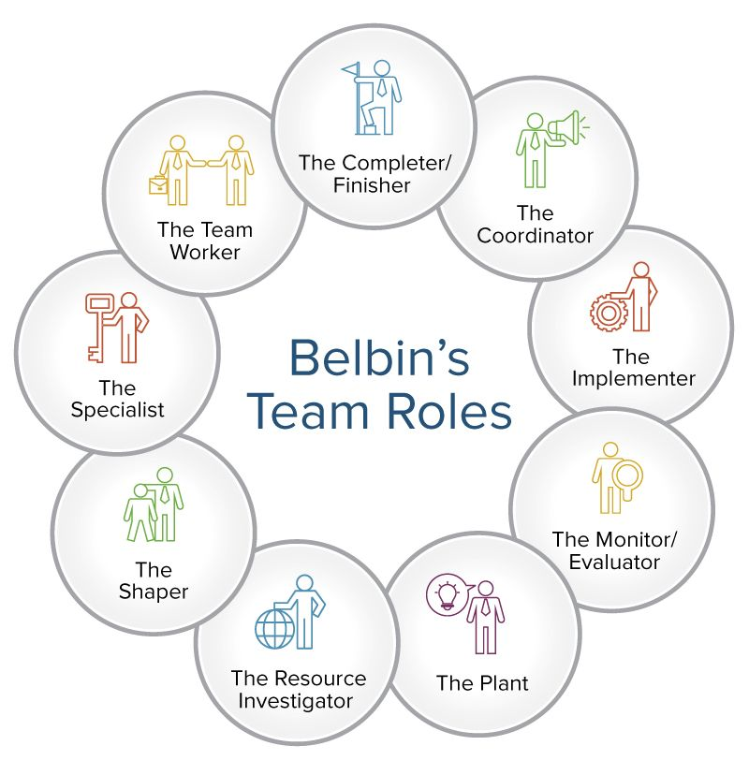

Further, in his report, the author will demonstrate how this theory will help Michelle Sullivan to improve her business.

4.1.5 Tuckman theory

Another theory used by the author to analyses Michelle Sullivan business is known as ‘Tuckman theory’. Bruce Tuckman has discovered that every group who want to become a team need to cross four stages or phases of forming, named forming, storming, norming and performing. (Egolf, 2013)

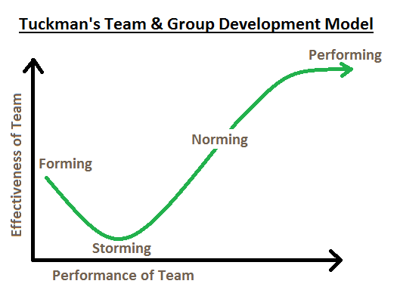
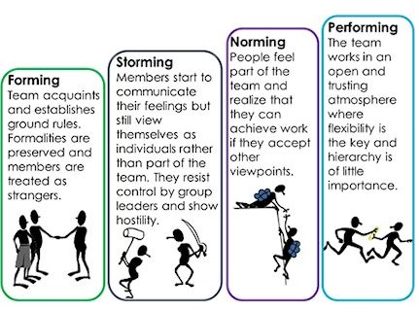

4.2 Michelle Sullivan business analysis

In this chapter, the author will conduct an analysis regarding communication issues, teamwork issues, conflict issues which occurred or can occur in Michelle Sullivan business by applying Belbin theory and Tuckman theory.
Based on company description and on activity description the author has identified many issues regarding communication, teamwork, and management on M. Sullivan business.
Base on Tuckman theory, the author has identified that many from her employees are in the storming stage. This means that they act as a group, by coordinating their individual efforts, not like a team, by share a common team purpose. This issue can generate conflicts between employees because the expectation, different skills, misunderstanding, poor communication, and stress will be occurring.
Base on Belbin theory the author has noticed that the M. Sullivan organization has a few important positions missing like the monitor, the shaper, the specialist, the coordinator and all this can lead to big problems in business expansion.
Further, in his report, the author has split this issue into three categories, and he has conducted an analysis to find the source and the reason for what it has appeared.

4.2.1 Communication issues

This issue can appear because the message can’t penetrate the communication barriers and the receiver will not understand the sender. In many cases, this issue can generate big conflicts.
A few communication barriers identified by the author in M. Sullivan organization are:
- Environmental Barrier because a few employees are doing only night shift with no manager on duty and this can lead to having non-inform employees in its organization.
- Psychological Barriers because one employee is off on long term sickness and this mean he will not be informed regarding the business expansion.
- Perceptual Barriers because the employees don’t have an official meeting with a manager, and they will be badly informed or not informed regarding the company changes or regarding the company policies
- Content Barriers because the employees are not receiving the message in a clear way and they will face up with misunderstanding
For improving team communication, the company management team need to reduce or to eliminate all the communication barriers. In this way, they can increase the chance that their employees will receive the right information and eliminate misunderstandings. (Chong et al., 2012)
In his brochure, Guy Harris is talking about the five steps to achieve remarkable communication results. The easy way to remember these steps is to connect them to the SOLAR word where:
S is coming from Stop and it's looking more like a non-action. This step is aimed at slowing down, gaining time to respond and not reacting immediately to avoid misunderstandings.
O is coming from Observe and the objective is to gather more information before the reaction.
L is coming from Listen and it’s mean to listen fully to what the other person is saying, to notice the spoken and the unspoken messages because over 55% from the message is coming from the gesture, body language, etc.
A is coming from Adjust/reframe and this step creates the foundation for the response. The response is based on what the other persons have used so far (words, tone, and body language).
R is coming from Respond and the object is to provide a respond thoughtfully and carefully taking in consideration the words, body language and tone used to send the message.
Another way to eliminate the barriers is related to the canal used for sending the message. The author in his report is encouraged to use the face-to-face method for reducing and to eliminate the communication barriers. All the information regarding the conditions of employment, about organization, task description should be transmitted through regular meetings before or after the start of shift and the author is recommending avoiding any writing methods because the message can be lost. (Schweiger, 2006)
For effective communication (Morgan, 2017), the author is recommending to:
- Check any assumption before starting any conversation because sometimes the emotion can cloud an individual’s judgment.
- Reframe the purpose of the conversation because sometimes is better to see the conversation as a chance to solve a problem and to change someone’s behavior, rather than getting tough and make an example for someone.
- Use passive and active voice appropriately by keeping the negative feedback in the passive voice and avoid the active voice.
- Use a ‘Praise sandwich’ by putting the negative conversation between two good news.
- Watch the language and try to avoid the first person and use the third person
- Be clear about consequences and to not be afraid of informing someone of the consequences
- Assume good intentions because in this way is easier to change the point of view later after gathering all the information.
- Avoid emotion during a conversation and focus on the evidence.
- Ensure that there are no surprises further on
- Leave the conversation on a positive note
- Use language which allows for some doubt and gives the other person a way out without making them feel embarrassed.
- Listen well and do not interrupt and on the end of conversation check if the message was delivered without misunderstandings.
- Encourage self-reflection because sometimes is better to comment on what happened rather than telling what to think.
- Do not be afraid of silence because sometimes is the better way to give or to receive time to think.
- Do not match someone else’s mood because of having two people in tears will not help. They need to focus on the issue not to have the same mood.
- Do not focus on what can’t change because sometimes is very hard to change someone personality or behavior.
- Apologies because can be very powerful for healing friendships and workplace relationship.
- Always thanks even if the conversation was hard or not achieved any objectives.

4.2.2 Teamwork issues

This issue will appear when the employees will act as a group, not like a team. The relationship between social interdependence theory and teamwork and the effect on business success is a relatively new concept, but successful teamwork and its influence on success are not forgotten. (Smith and Katzenbach, 2015)
Effective teamwork is one of the fundamental elements of a high-performing business. The establishment of an efficient teamwork environment depends on organizational management, management styles, and flexibility. It is expected that employees who are working in a team to assume more responsibilities, make informed decisions within a team structure and use their intellectual and creative skills to reach a team goal. (Tarricone and Luca, 2002)
Before to become a team, the employees need to cross four important stages.
- Formation (Forming) – In this stage the employees will start to know each other, to ensure that the roles and contributions are clear, and they are ready to start the task.
- Disagreeing (Storming) – In this stage, the employees will start to find out that other members will not contribute enough to the task, will not respect properly the other team members. Is the stage when the conflict will appear.
- Developing ways of working (Norming) – In this stage, the employees will develop rules and procedures to reach their objectives. Is the stage when the members will start to develop rules to ensure that the goal could be accomplished.
- Performing – Is the stage when the team members have developed some rules regarding the mod how they work, have started to develop their personalities and roles within the team, and they start to feel comfortable when they disagree.

4.2.3 Conflict issues

This issue will appear when the employees don’t know their role in the organization. There is a need for different team roles at different stages, and teams should have the flexibility to do this. (R. M. Belbin, 2010)
In Michelle Sullivan organization case, the author has identified a few factors who can generate conflicts between employees such as different knowledge, expectation, poor communication, stress, misunderstanding. The conflicts are not only destructive but also offer many possibilities for change, development, and innovation. (Proksch, 2016)
The author has identified a few positive aspects of conflict such as:
- Constructive conflict can lay problems on the table and opens discussion;
- Can lead to solutions and happier outcomes for all members;
- Can increases communication between people and leads to a greater mutual understanding;
- Can gives an opportunity to explore problems and find creative solutions;
- Can releases emotions that have been hidden away;

Conclusion

After he has analyzed the Michell Sullivan business, the author has discovered a few issues regarding the organization activity such as:
- Communication issues – because the employees how are working in night shift are doing their job without being monitored by a team lead or a manager. This issue can lead to a bad informing regarding their duty, company changes, company news or new employers’ rules.
- Teamwork issues – because the employers are acting like a group not like a team. The ad hoc meetings which can lead to a breakdown in communication is not meant to connect employers and to define the team objectives. Without having a formal team, the company is face to chaos.
- Conflict issues – who are generated because the employers don't know how to work in a team, and they didn't manage to know each other skills. Most of them are working part-time during the stores opening hours.
- Management issues – because the new starters will not receive proper training. The business fast expansion has revealed big issues regarding the management team because this was unable to provide a development strategy.

Recommendation

To ensure the Michelle Sullivan business is running smoothly, the author will recommend:
- To create a well-established working schedule;
- To improve communication channels and eliminate communication barriers between managers and employees by having a regular meeting on the start of the day or on the start of the shift where managers can brief the new targets, objectives, news, or any concerns regarding business activity;
- To improve communication channels and eliminate communication barriers between co-workers by involving them in common activities, make them work together to reach a common goal, make them part of the business;
- To define the objectives and targets for every team in every day to have a better idea regarding the company objectives, to encourage teamwork and to eliminate conflicts;
- To implement a new strategy regarding the new starts training schedule, actual employers personal development plan and a good strategy regarding business expansion.
For more details see the action plan.

Action plan

Store opening time:
Monday to Friday from 7.00 am to 11.00 pm
Saturday and Sunday from 9.00 am to 7.00 pm

2 shifts for sales assistance, security guards, cleaners.
3 shifts for employees who are working in stockroom and managers.

Every shift will be rotate from a week to another.

 |  | Store opening time
 |  | 7:00 – 23:00 |  |  |  |  | 9:00 – 19:00 | 9:00 – 19:00
 |  | Monday | Tuesday | Wednesday | Thursday | Friday | Saturday | Sunday
Shift 1 | Schedule | 6:30 – 15:00 | 6:30 – 15:00 | 6:30 – 15:00 | 6:30 – 15:00 | 6:30 – 15:00 |  | 8:30 – 19:00
Shift 1 | Employees on duty | 1 – manager  7 – sellers  1 – cleaner  1 – security  1 – stock man | 1 – manager  7 – sellers  1 – cleaner  1 – security  1 – stock man | 1 – manager  7 – sellers  1 – cleaner  1 – security  1 – stock man | 1 – manager  7 – sellers  1 – cleaner  1 – security  1 – stock man | 1 – manager  7 – sellers  1 – cleaner  1 – security  1 – stock man |  | 1 – manager  7 – sellers  1 – cleaner  1 – security  1 – stock man
Shift 2 | Schedule | 14:30 – 23:00 | 14:30 – 23:00 | 14:30 – 23:00 | 14:30 – 23:00 | 14:30 – 23:00 | 8:30 – 19:00
Shift 2 | Employees on duty | 1 – manager  7 – sellers  1 – cleaner  1 – security  1 – stock man | 1 – manager  7 – sellers  1 – cleaner  1 – security  1 – stock man | 1 – manager  7 – sellers  1 – cleaner  1 – security  1 – stock man | 1 – manager  7 – sellers  1 – cleaner  1 – security  1 – stock man | 1 – manager  7 – sellers  1 – cleaner  1 – security  1 – stock man | 1 – manager  7 – sellers  1 – cleaner  1 – security  1 – stock man
Shift 3 | Schedule | 22:30 – 7:00 | 22:30 – 7:00 | 22:30 – 7:00 | 22:30 – 7:00 | 22:30 – 7:00 | 18:30 – 5:00
Shift 3 | Employees on duty | 1 – manager  4 – stock mans | 1 – manager  4 – stock mans | 1 – manager  4 – stock mans | 1 – manager  4 – stock mans | 1 – manager  4 – stock mans | 1 – manager  4 – stock mans
Total Employees used |  | 27  3 – managers  14 – sellers  2 – cleaners  2 – security  6 – stock mans | 27  3 – managers  14 – sellers  2 – cleaners  2 – security  6 – stock mans | 27  3 – managers  14 – sellers  2 – cleaners  2 – security  6 – stock mans | 27  3 – managers  14 – sellers  2 – cleaners  2 – security  6 – stock mans | 27  3 – managers  14 – sellers  2 – cleaners  2 – security  6 – stock mans | 16  2 – managers  7 – sellers  1 – cleaner  1 – security  5 – stock mans | 11  1 – manager  7 – sellers  1 – cleaner  1 – security  1 – stock man

Rotation schedule
 | Week 1 | Week 2 | Week 3
manager | Shift 1 | Shift 3 | Shift 2
sellers | Shift 1 | Shift 2
cleaners | Shift 1 | Shift 2
security | Shift 1 | Shift 2
Stock mans | Shift 1 (only 1 person) | Shift 3 (only 1 person) | Shift 3 (only 1 person)

- Every manager will be in charge with the new starters’ induction and shop supervising. Every shift will start with a brief regarding the day activity, objectives, news, etc.
- Each team will choose one team leader to lead them and to train the new starters.

Appendices

Michelle’s business
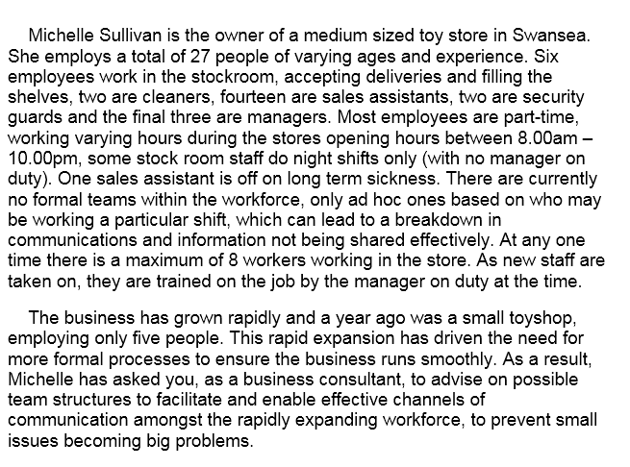

Reference list

- Means, T. and Rankin, D. (2010). Business communication. 2nd ed. Australia: South-Western Cengage Learning, p.4.

- West, M. (2012). Effective Teamwork: Practical Lessons from Organisational Research. 3rd ed. Chichester: BPS Blackwell.

- Sweetman, D. (2011). Business, Conflict Resolution and Peacebuilding: Contributions from the private sector to address violent conflict. London: Routledge.

- Belbin, R.M. (2010). Management Teams: Why They Succeed Or Fail. 3rd ed. London: Routledge.

- Egolf, D. (2013). Forming Storming Norming Performing: Successful Communication in Groups and Teams. 3rd ed. New York: IUnverse.

- Chong, D., Eerde, W., Rutte, C. and Chai, K. (2012). Bringing Employees Closer: The Effect of Proximity on Communication When Teams Function under Time Pressure. Journal of Product Innovation Management, 29(2), pp.205-215.

- Schweiger, C. (2006). Volume 68 of TCRP synthesis: Methods of rider communication. Washington, D.C: Transportation Research Board.

- Morgan, P. (2017). The business student's guide to study and employability. London: SAGE Publications, p.261.

- Smith, D. and Katzenbach, J. (2015). The Wisdom of Teams: Creating the High-Performance Organization. Boston: Harvard Business Review Press.

- Tarricone, P. and Luca, J. (2002). Employees, teamwork and social interdependence – a formula for successful business?. Team Performance Management: An International Journal, 8(3/4), pp.54-59.

- R. M. Belbin. (2010). Team roles at work. 2nd ed. Oxford: Routledge Ltd, pp.97-106.

- Proksch, S. (2016). Conflict Management. Switzerland: Springer.

10. Bibliography

- Belbin, R.M. (2010). Management Teams: Why They Succeed Or Fail. 3rd ed. London: Routledge.

- Chong, D., Eerde, W., Rutte, C. and Chai, K. (2012). Bringing Employees Closer: The Effect of Proximity on Communication When Teams Function under Time Pressure. Journal of Product Innovation Management, 29(2), pp.205-215.

- Egolf, D. (2013). Forming Storming Norming Performing: Successful Communication in Groups and Teams. 3rd ed. New York: IUnverse.

- Krogerus, M. and Tschäppeler, R. (2018). The Communication Book: 44 Ideas for Better Conversations Every Day. Uk: Penguin.

- Means, T. and Rankin, D. (2010). Business communication. 2nd ed. Australia: South-Western Cengage Learning, p.4.

- Mehrabian, A. (2009). Nonverbal communication. 3rd ed. New Jersey: Routledge.

- Morgan, P. (2017). The business student's guide to study and employability. London: SAGE Publications, p.261.

- Parker, G. (2008). Team Players and Teamwork: New Strategies for Developing Successful Collaboration. 2nd ed. San Francisco, Calif.: John Wiley & Sons.

- Proksch, S. (2016). Conflict Management. Switzerland: Springer.

- R. M. Belbin. (2010). Team roles at work. 2nd ed. Oxford: Routledge Ltd, pp.97-106.

- Schweiger, C. (2006). Volume 68 of TCRP synthesis: Methods of rider communication. Washington, D.C: Transportation Research Board.

- Smith, D. and Katzenbach, J. (2015). The Wisdom of Teams: Creating the High-Performance Organization. Boston: Harvard Business Review Press.

- Sweetman, D. (2011). Business, Conflict Resolution and Peacebuilding: Contributions from the private sector to address violent conflict. London: Routledge.

- Tarricone, P. and Luca, J. (2002). Employees, teamwork and social interdependence – a formula for successful business?. Team Performance Management: An International Journal, 8(3/4), pp.54-59.

- West, M. (2012). Effective Teamwork: Practical Lessons from Organisational Research. 3rd ed. Chichester: BPS Blackwell.

