  Assessment 1 - NOSS  Research, build, and deploy a Virtualised Enterprise network | Module Name: Network Operating Systems and Services  Module Code: ACCA5023  Student Name: Elena Alexandra Mihail  Student ID: 2437664  Group: 1  Lecturer’s Name: MD Sadeque Imam Shaikh  University of Wales Trinity Saint David  London campus

Table of Contents
1. Introduction 2
2. Task 1 – Research 3
2.1 Hypervisors 3
2.2 IP Addressing 3
2.3 Routing 4
2.4 Network Services 5
3. Task 2 – Technical Documentation 6
3.1 Hypervisor Selection and Justification 6
3.2 Download and Installation 6
3.2.1 Download of Hypervisor and Operating Systems 6
3.3 Network Deployment 7
3.4 IP Address Configuration 9
3.5 Connectivity Testing and Troubleshooting 13
4. Task 3 – Reflection 15
4.1Technical Reflection 15
4.2 Personal Reflection 15
5. Conclusion 16
6. References 17
7. Appendices 18

1. Introduction
Modern organisations rely on reliable and efficient network infrastructures to support communication, data management and daily operations. This report focuses on NOSSLONDON2026 Inc, a multinational corporation operating in Birmingham and London, and which needs a virtualised network environment to support its IT infrastructure. The purpose of this report is to explore and analyse the key networking technologies required for designing and deploying this environment. Main areas covered include hypervisors, IP addressing, routing and network services. The report will assess different approaches, discuss their pros and cons, and recommend the most suitable solutions for the company's needs. Additionally, the research will support the practical implementation of a virtual network environment using appropriate technologies.

2. Task 1 – Research

2.1 Hypervisors
Virtualization is a key technology in modern IT infrastructures, as it enables multiple operating systems to run on the same physical hardware. A hypervisor is responsible for creating and managing virtual machines by allocating resources such as CPU, memory, and storage among them. This approach helps organizations reduce hardware costs, improve resource utilization, and simplify infrastructure management [1].
There are two main types of hypervisors: Type 1 and Type 2. Type 1 hypervisors, also known as bare-metal hypervisors, run directly on physical hardware without requiring a host operating system. This provides superior performance, security, and scalability, making them ideal for enterprise environments [2]. In contrast, Type 2 hypervisors run on top of an existing operating system. They are easier to install and are commonly used for testing, development, and personal use, although they may offer lower performance due to the additional software layer [3].
For NOSSLONDON2026 Inc, a Type 1 hypervisor would be the most suitable choice because the company requires a reliable infrastructure capable of supporting multiple virtual machines, including Windows Server 2022, Debian Server, and client operating systems. A Type 1 solution would provide better resource management and allow the organization to expand its network more easily in the future. While Type 2 hypervisors are useful for smaller environments, they are less appropriate for a multinational company that requires higher availability, improved security, and consistent performance. Additionally, using a Type 1 hypervisor would support future growth by allowing new virtual services to be added without significant changes to the physical infrastructure. This ensures efficient operation and better control of network resources.

2.2 IP Addressing
IP addressing is a fundamental component of network design, as it enables device identification and communication across a network. Every device connected to a network requires an IP address to send and receive data correctly. In a corporate environment such as NOSSLONDON2026 Inc, having a structured IP addressing plan is essential for improving network organisation, simplifying troubleshooting, and supporting future expansion.
When data is transmitted over networks, it is divided into packets containing source and destination IP addresses. Switches are responsible for forwarding traffic within a local network using device information, while routers connect different networks by analysing IP addresses and selecting the appropriate path for packet delivery. Therefore, IP addressing plays a fundamental role in enabling communication between separate networks, such as locations in Birmingham and London.
The two main versions of the Internet Protocol are IPv4 and IPv6. IPv4 uses 32-bit addresses and remains widely used in many organisations due to its compatibility and established infrastructure [4]. However, the increasing number of connected devices has created limitations in IPv4 address availability. IPv6 uses 128-bit addresses, providing a much larger address space and additional capabilities that support the long-term growth of network infrastructures.
Subnetting is another important aspect of IP addressing because it allows a large network to be divided into smaller logical networks. This improves efficiency by reducing unnecessary broadcast traffic and enables administrators to separate separate locations or departments [5]. In the case of NOSSLONDON2026 Inc, subnetting is used to separate the Birmingham and London offices. Birmingham operates on the 172.16.1.0/24 network, while London uses the 172.16.2.0/24 network. The connection between both locations uses the 10.0.0.0/30 network, enabling communication between the two sites.
A well-designed IP addressing strategy improves network performance, security, and management. By using independent subnets for each location, NOSSLONDON2026 can maintain better control over traffic flow and simplify future network expansion [6].

2.3 Routing
Routing is a fundamental process in computer networks, as it allows data packets to travel between different networks by selecting the most appropriate path. Routers analyse destination IP addresses and use routing tables to determine where packets should be forwarded. In a business environment, efficient routing is essential for maintaining reliable communication between separate locations and network segments [7].
Routing can be implemented using static or dynamic methods. Static routing requires network administrators to manually configure routes between networks. This approach offers greater control, simple configuration, and low resource consumption, making it suitable for small, stable network environments. However, management becomes more complex as networks grow or require frequent changes. Dynamic routing uses protocols such as OSPF to automatically exchange routing information between routers. This improves scalability and allows networks to adapt to changes, although it involves additional configuration and higher consumption of processing resources [8].
For NOSSLONDON2026 Inc, static routing would be the most appropriate approach for the current topology, given that the organization operates in only two locations: Birmingham and London. The limited number of networks makes manual route configuration practical and easy to maintain. However, given the extended topology — which incorporates additional services such as DHCP Relay and other domain services — dynamic routing may prove more beneficial as the infrastructure grows. Therefore, the routing approach must balance current simplicity with future scalability needs.

2.4 Network Services
Network services are fundamental in business environments, as they enable centralized management, secure communications, and efficient resource administration. Services such as VPN, DHCP, Active Directory Domain Services (AD DS), and Certificate Authority (CA) enhance the reliability and security of organizational networks.
A Virtual Private Network (VPN) establishes an encrypted connection between distinct locations, allowing users and systems to communicate securely over untrusted networks. For NOSSLONDON2026 Inc, a VPN could facilitate secure communication between the Birmingham and London offices while protecting sensitive company data [9].
The Dynamic Host Configuration Protocol (DHCP) simplifies network administration by automatically assigning IP addresses and configuration parameters to devices. This reduces manual configuration errors and improves IP address management. In an optimized topology, a DHCP Relay service allows clients located in different sites to receive IP addresses from a central DHCP server.
Active Directory Domain Services (AD DS) provides centralized authentication and management for users, computers, and security policies. Using Windows Server 2022 as a domain controller would allow NOSSLONDON2026 Inc to control network access more effectively. The Certificate Authority (CA) strengthens security by issuing digital certificates that verify identities and enable encrypted communication [10].
The combined implementation of these services creates a more secure, manageable, and scalable network infrastructure. Proper configuration and regular maintenance are essential to mitigate security risks and ensure reliable business continuity.

3. Task 2 – Technical Documentation

3.1 Hypervisor Selection and Justification
Oracle VirtualBox was selected as the hypervisor platform to implement the NOSSLONDON2026 network topology. VirtualBox is a Type 2 hypervisor that runs on top of an existing operating system, enabling the creation and management of multiple virtual machines on a single physical host. The primary reasons for choosing this hypervisor were its availability, compatibility with various operating systems, and suitability for an academic virtualized network environment.
VirtualBox allows for the deployment of the various platforms required for this topology, including Windows Server 2022, Debian Server, and client operating systems. This compatibility was a key factor, given that the network requires the coexistence and interoperability of both Microsoft- and Linux-based systems. Furthermore, VirtualBox offers features such as virtual networking, resource allocation, and snapshot management, which facilitate testing and troubleshooting during the implementation process.
Although Type 1 hypervisors typically offer superior performance, security, and scalability in large-scale enterprise environments, VirtualBox was deemed the most suitable choice for this project due to hardware and resource limitations. A Type 1 solution would have required dedicated server hardware, which was not available for this implementation. VirtualBox provides sufficient performance to simulate the NOSSLONDON2026 infrastructure and allows for future expansion of the topology to incorporate additional network services in the second part of the practical work (Coursework 2).
Consequently, VirtualBox was chosen as a practical and cost-effective solution that balances functionality, compatibility, and available resources, while enabling the successful deployment of Windows Server- and Debian-based network components.

3.2 Download and Installation

3.2.1 Download of Hypervisor and Operating Systems
The required software components were downloaded from the appropriate sources to create the virtualized network environment for NOSSLONDON2026. Oracle VirtualBox was selected as the hypervisor platform because it provides the functionality needed to deploy and manage multiple virtual machines. Windows Server 2022 was downloaded to be used as the B-DC (Birmingham Domain Controller) server, providing the Windows Server environment required for future network services. Additionally, Debian 13 was downloaded and selected for the L-DC (London Server) machine, establishing the Linux-based server environment required for the network topology.
The screenshots below show the downloaded software and operating system images and include timestamps to document the progress and planning of the deployment process.
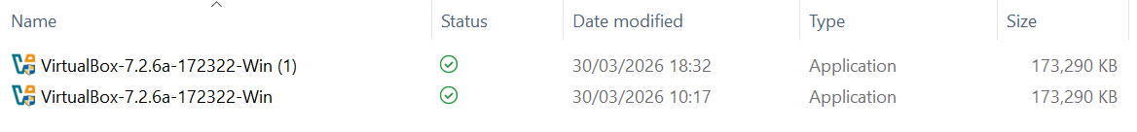
Figure 1: Oracle VirtualBox download evidence (Timestamp)
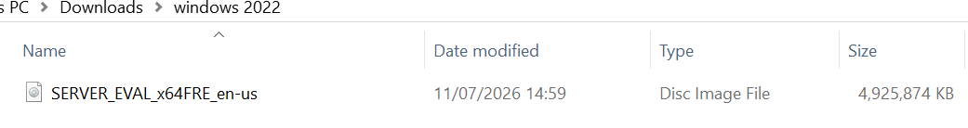
Figure 2: Windows Server 2022 ISO download evidence (Timestamp)
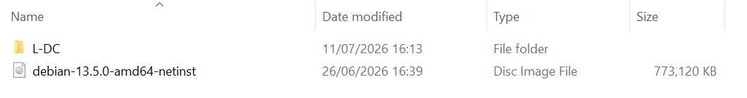
Figure 3: Debian 13 ISO download evidence (Timestamp)

3.3 Network Deployment
The virtual network was deployed following the NOSSLONDON2026 topology using Oracle VirtualBox. Two virtual machines were created to represent the Birmingham and London locations. The B-DC virtual machine was deployed using Windows Server 2022, while the L-DC virtual machine was deployed using Debian 13. Once the installation process was complete, both virtual machines started successfully, confirming that the virtual environment was ready for network configuration tasks.
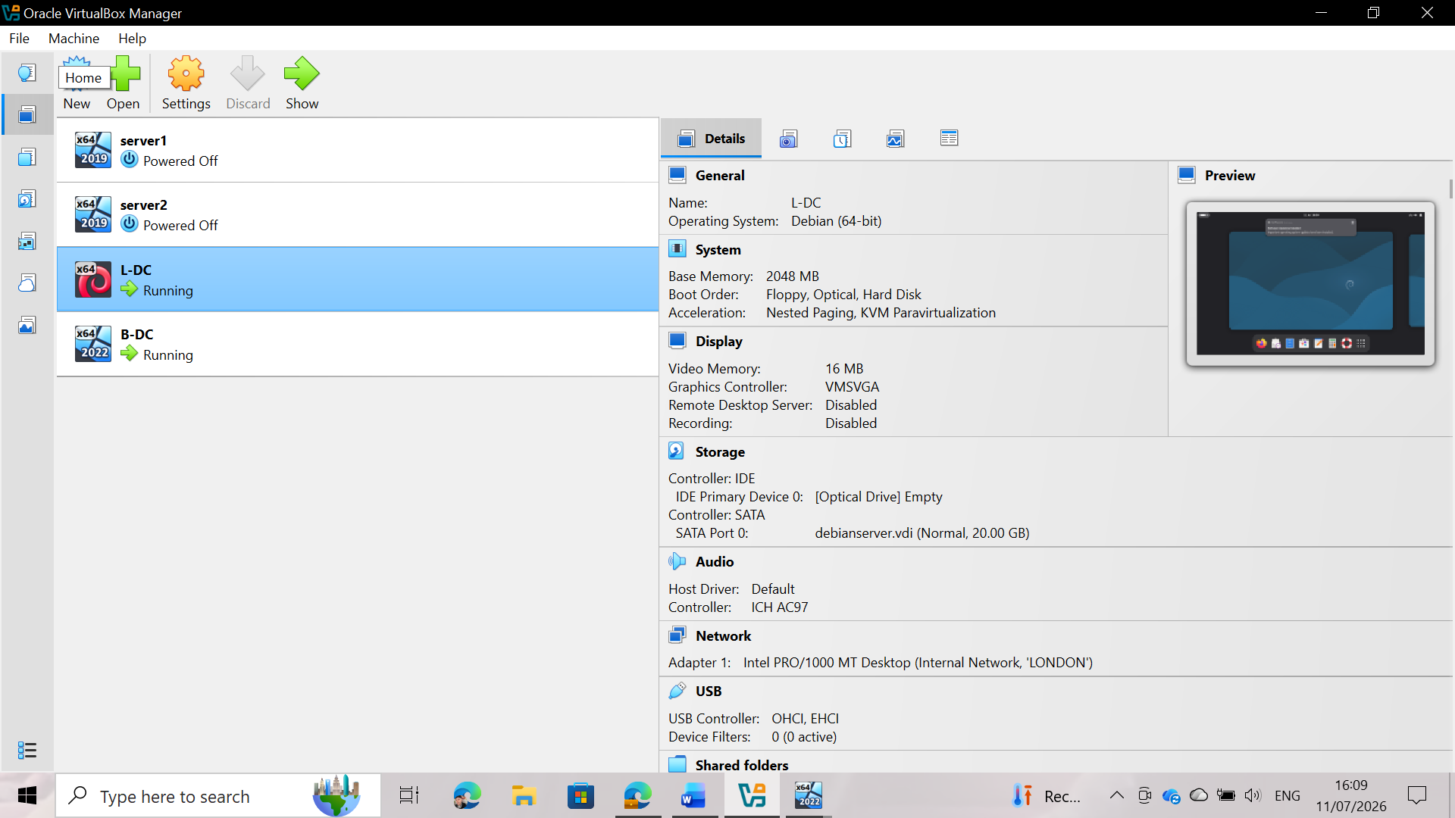
Figure 4: Virtual machines created in Oracle VirtualBox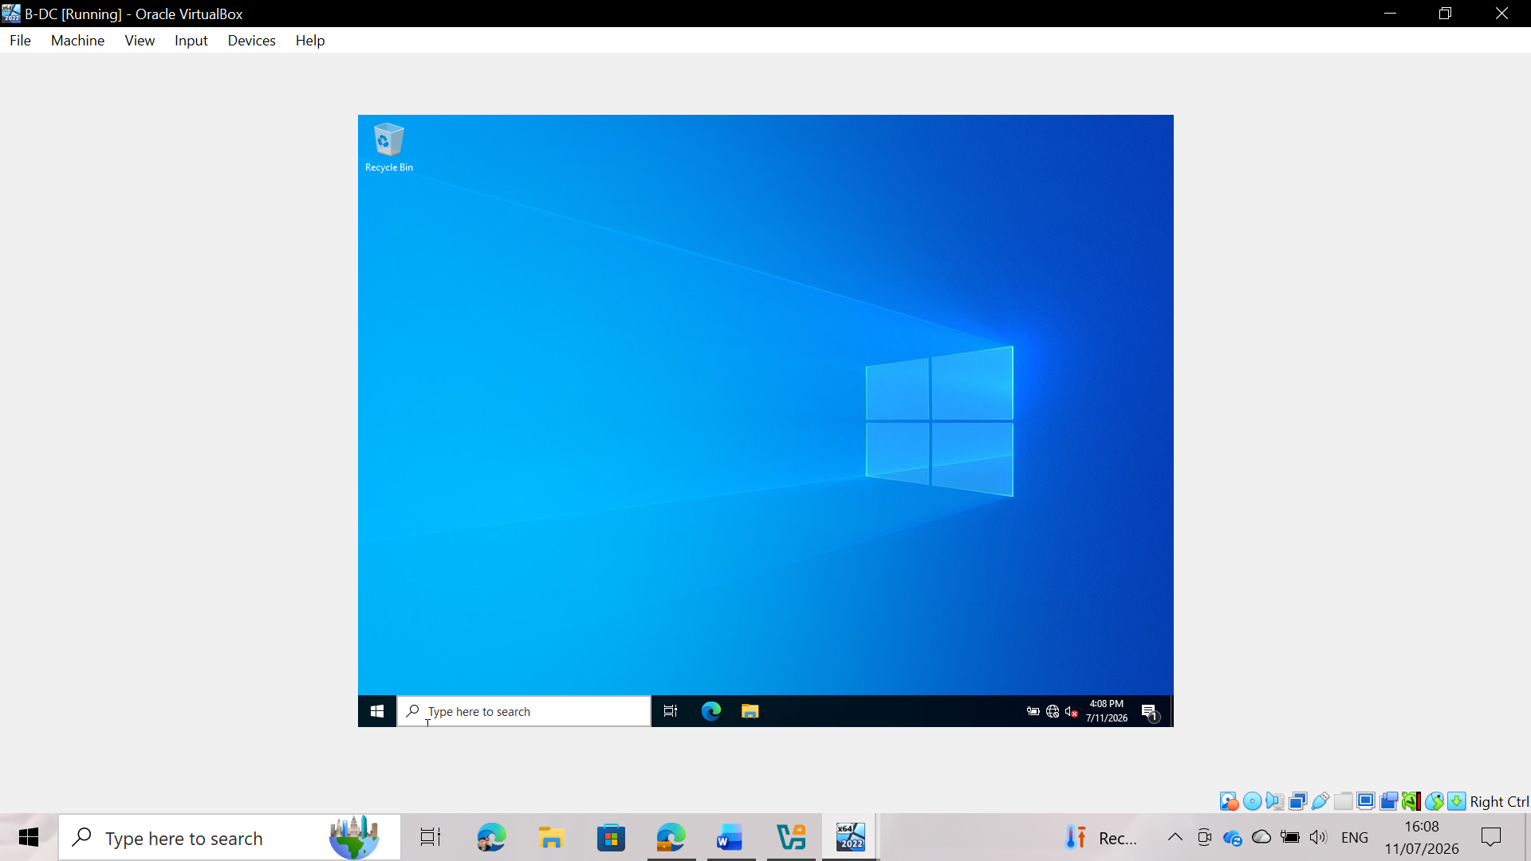
Figure 5: B-DC (Windows Server 2022) successfully deployed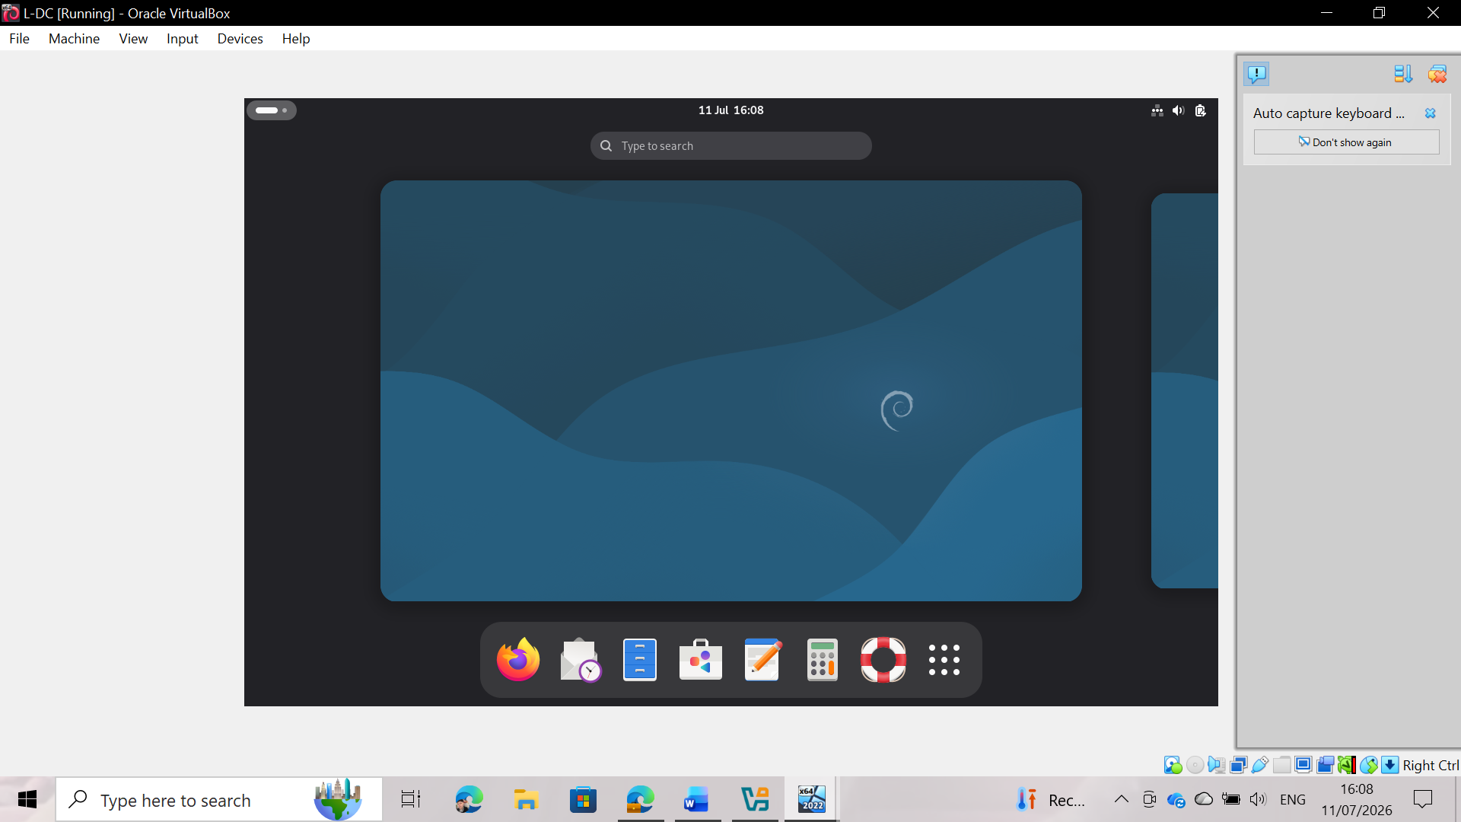
Figure 6: L-DC (Debian 13) successfully deployed

3.4 IP Address Configuration
IP address configuration was performed to establish communication between the Birmingham and London servers within the NOSSLONDON2026 network topology. Static IPv4 addressing was used to ensure a consistent and reliable network configuration.
The Birmingham domain controller (B-DC) was configured with two network interfaces. The first interface was assigned to the Birmingham local network with IPv4 address 172.16.1.1 and subnet mask 255.255.255.0. The second interface was configured as a direct link between Birmingham and London, using IPv4 address 10.0.0.1 with subnet mask 255.255.255.252. The final configuration of the B-DC is shown in Figures 7 and 8.
The Debian server in London (L-DC) was also configured with two network interfaces. The enp0s3 interface was configured for the London local network using the IPv4 address 172.16.2.1/24, while the enp0s8 interface was configured for the server-to-server connection using 10.0.0.2/30. The configuration was verified using Debian network commands, confirming that both interfaces were up and correctly assigned. Figures 9, 10, 11, and 12 show the configuration process and the final state of the L-DC server IP address.
/24 subnet masks were used for the local networks, as this provides enough host addresses for each location. The /30 subnet mask was selected for the direct link between B-DC and L-DC, as it provides exactly two usable IP addresses, which is suitable for a point-to-point connection.
This configuration provided the addressing structure needed for communication between the Birmingham and London servers before performing connectivity tests.
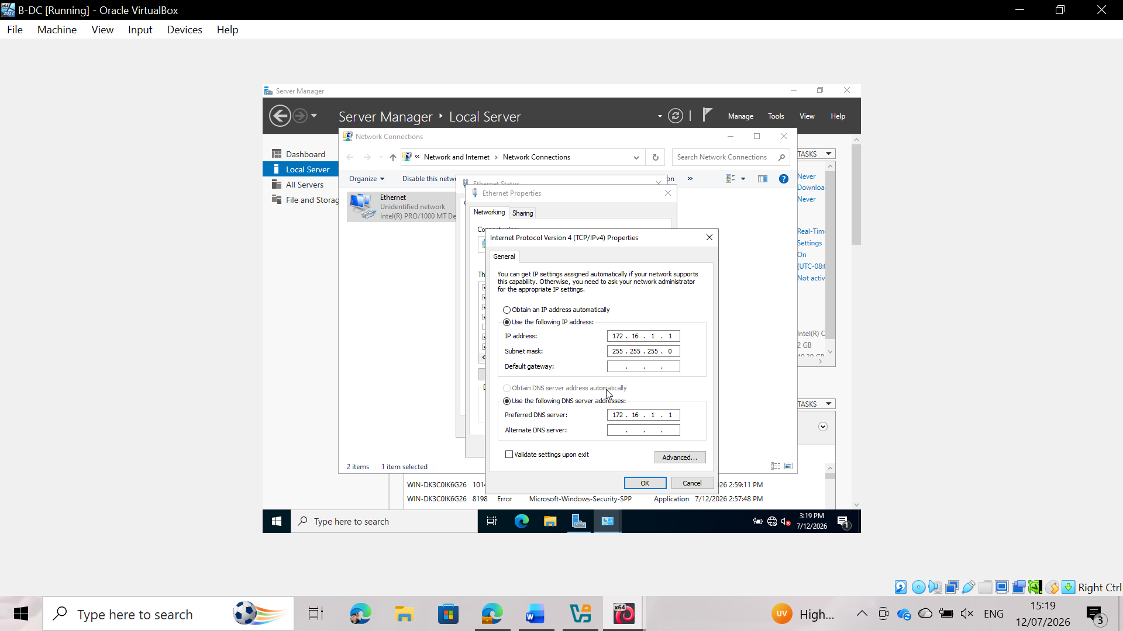Figure 7: B-DC IPv4 Configuration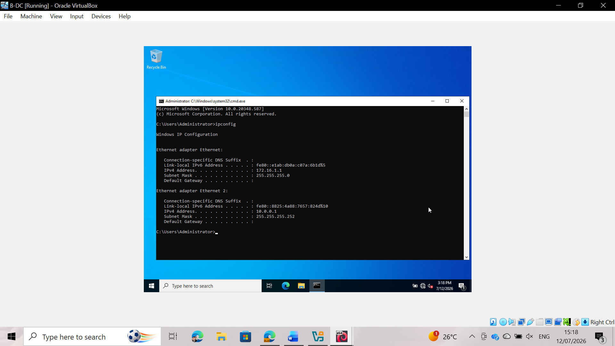
Figure 8: B-DC Network Adapter Configuration
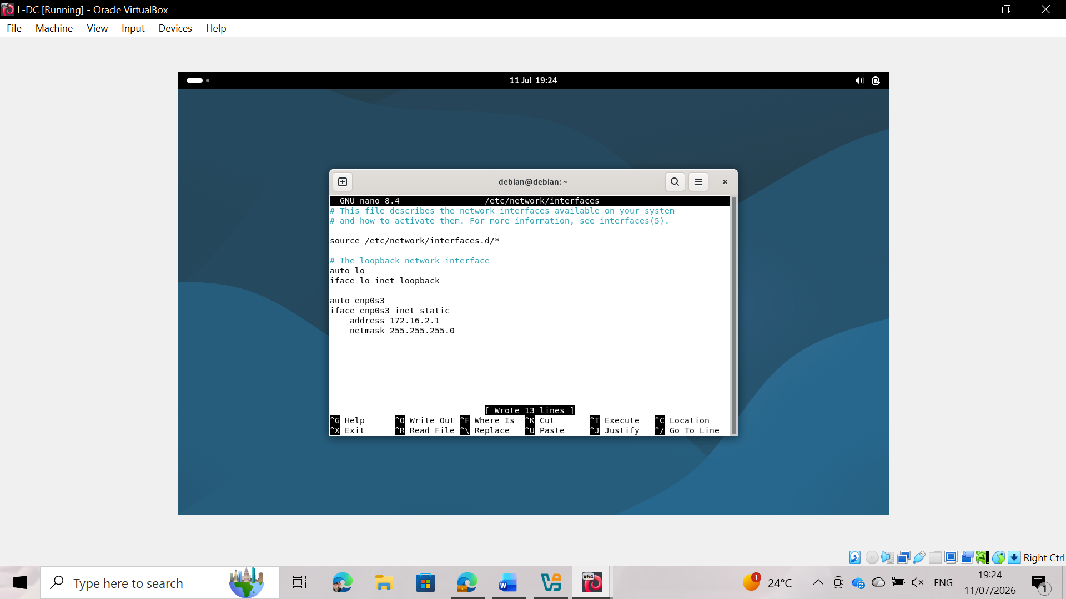
Figure 9: L-DC Network Interface Configuration

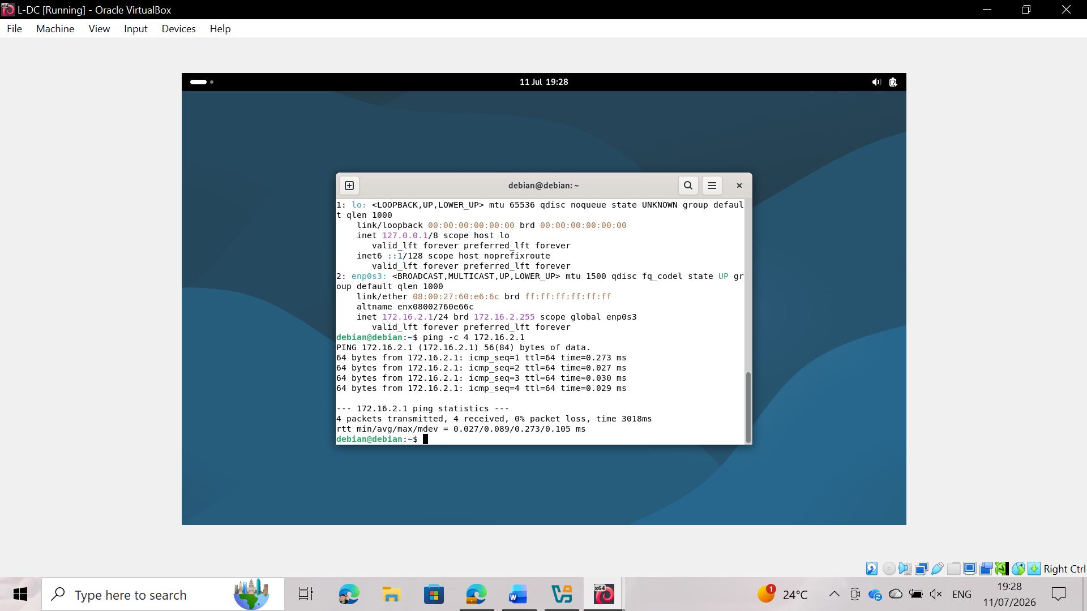
Figure 10: L-DC IPv4 Configuration (enp0s3)

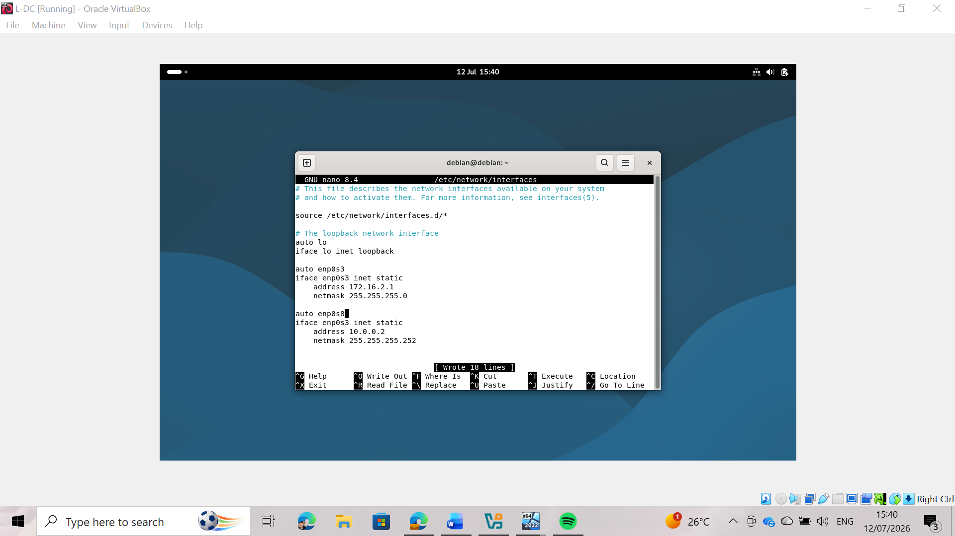
Figure 11: L-DC Link Interface Configuration (enp0s8)
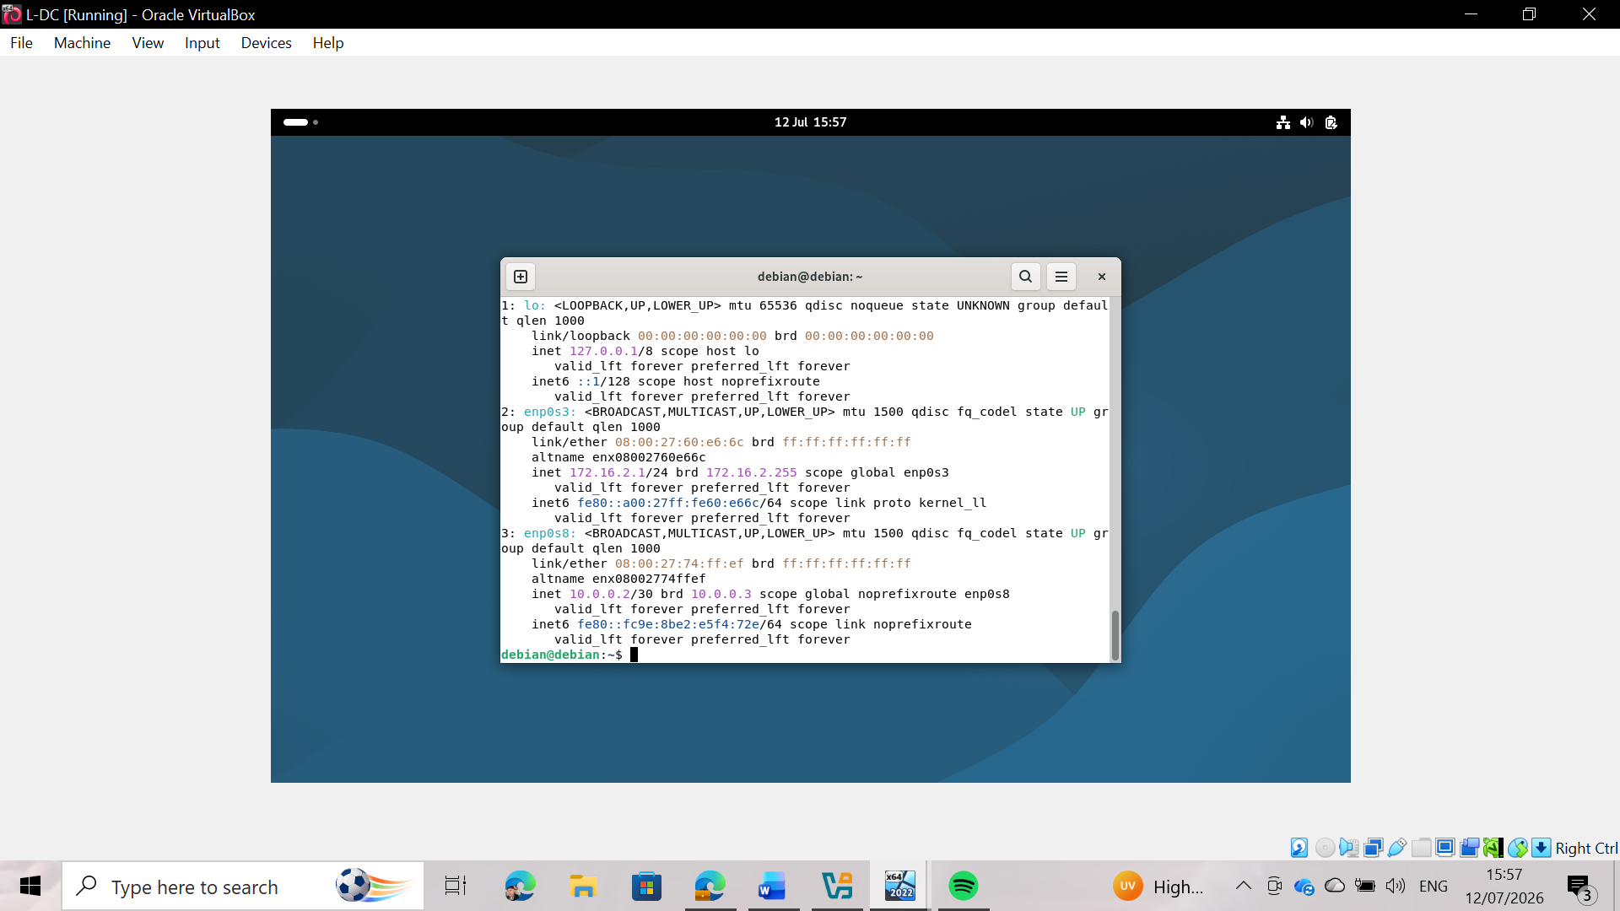
Figure 12: L-DC Final IP Address Verification
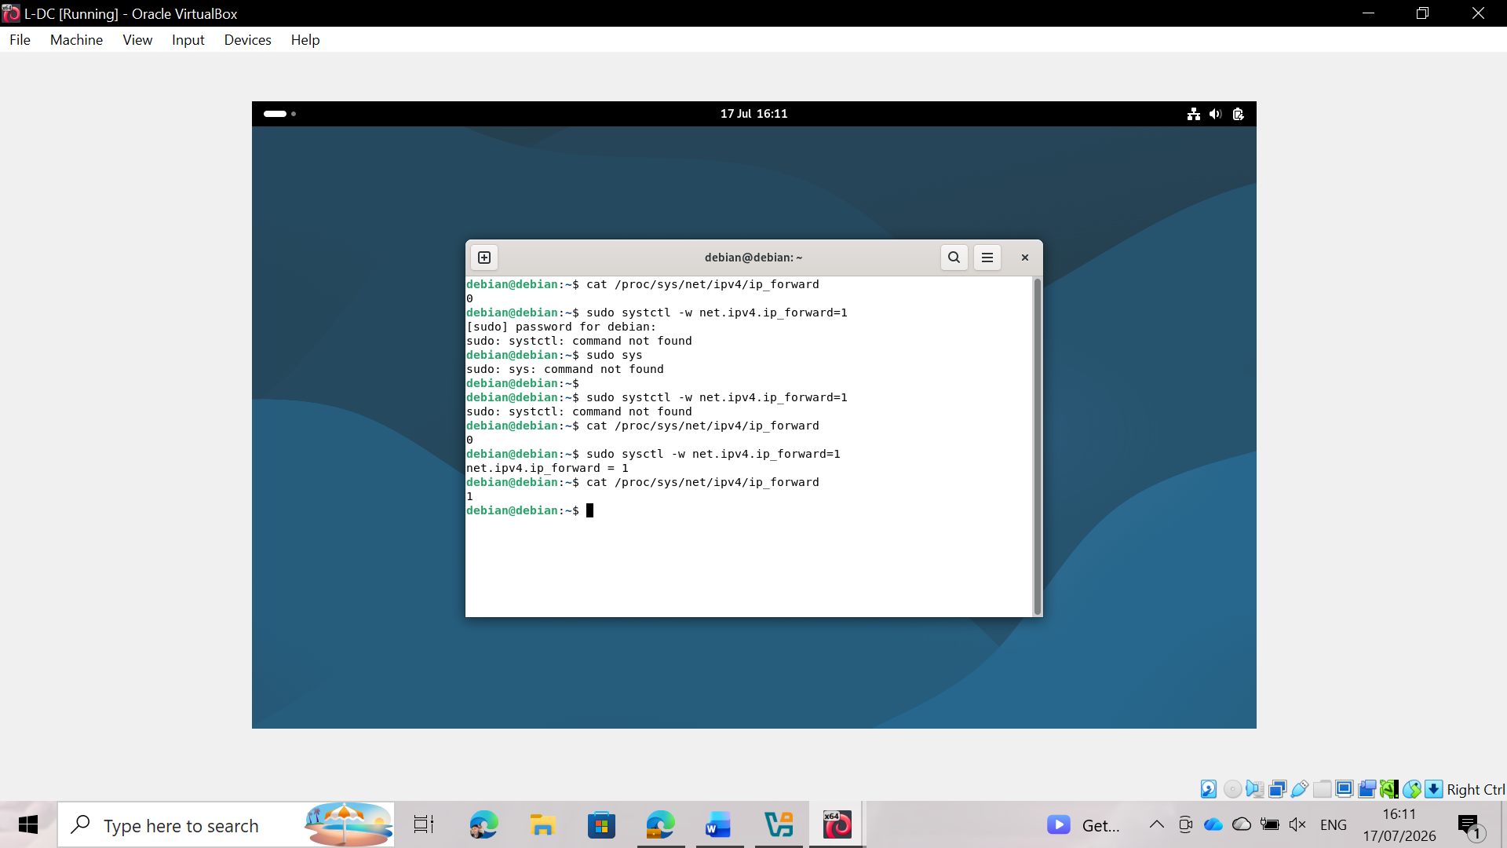
Figure 13: Enabling IP forwarding on Debian Router

3.5 Connectivity Testing and Troubleshooting
After configuring the IP addresses on both servers, connectivity tests were performed to verify that the network configuration was working correctly. The *ping* command was used to verify communication between the Birmingham domain controller (B-DC) and the Debian London server (L-DC).
The first connectivity test was performed from the Birmingham server to the London server by sending ICMP echo requests to the address 10.0.0.2. The test was successful, confirming that the point-to-point link between the two servers was working correctly.
Then, a second connectivity test was performed from the Debian London server to the Birmingham server using the address 10.0.0.1. The test initially failed because the ICMP echo requests were being blocked by the Windows Defender Firewall on the Birmingham server. After enabling the inbound firewall rule for "File and Printer Sharing (Echo Request - ICMPv4-In)", the *ping* test was successfully repeated.
The successful connectivity tests confirmed that both servers could communicate over the configured network, demonstrating that the IP addressing, network interfaces, and point-to-point connection were established correctly. The troubleshooting process also highlighted the importance of firewall configuration when validating network connectivity.
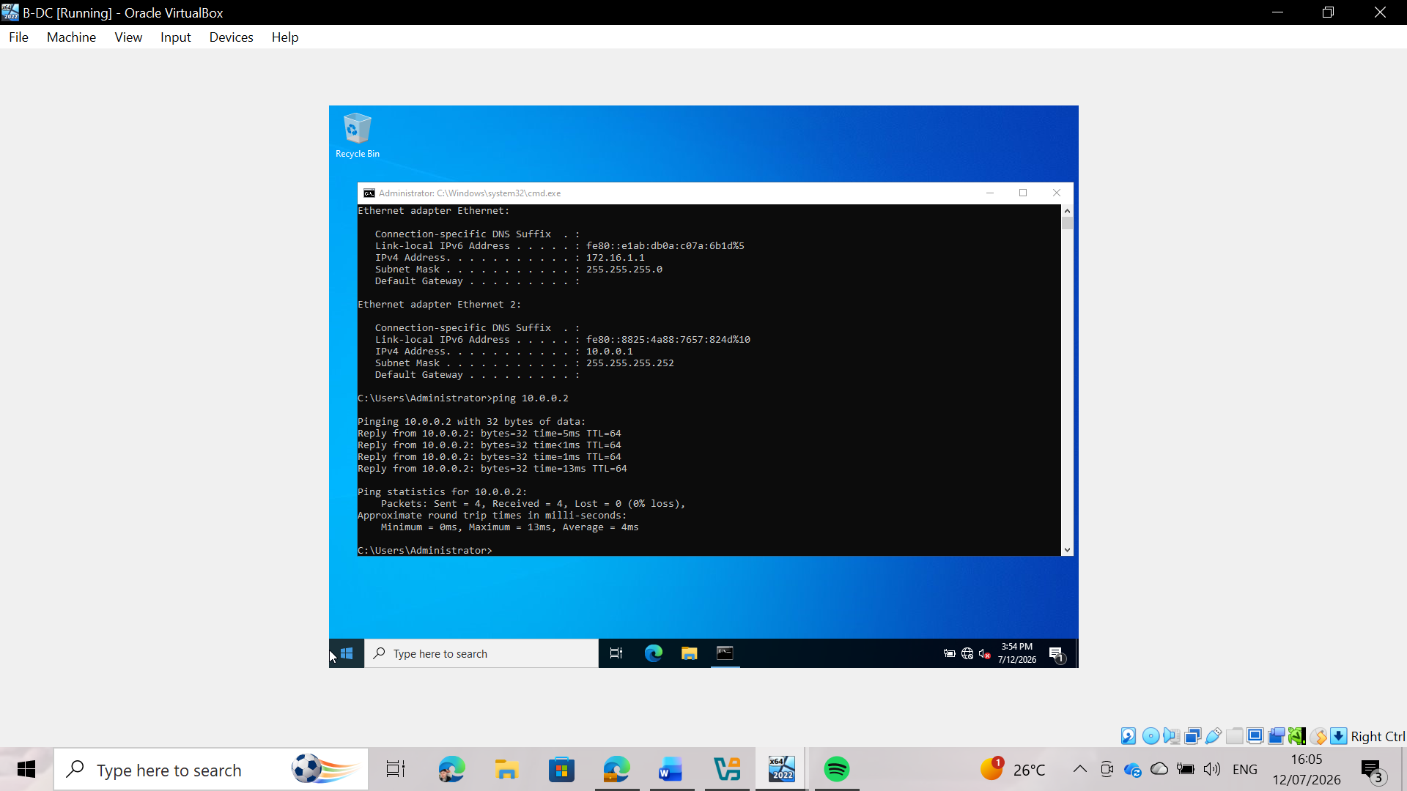
Figure 14: Connectivity Test from B-DC to L-DC (ping 10.0.0.2)
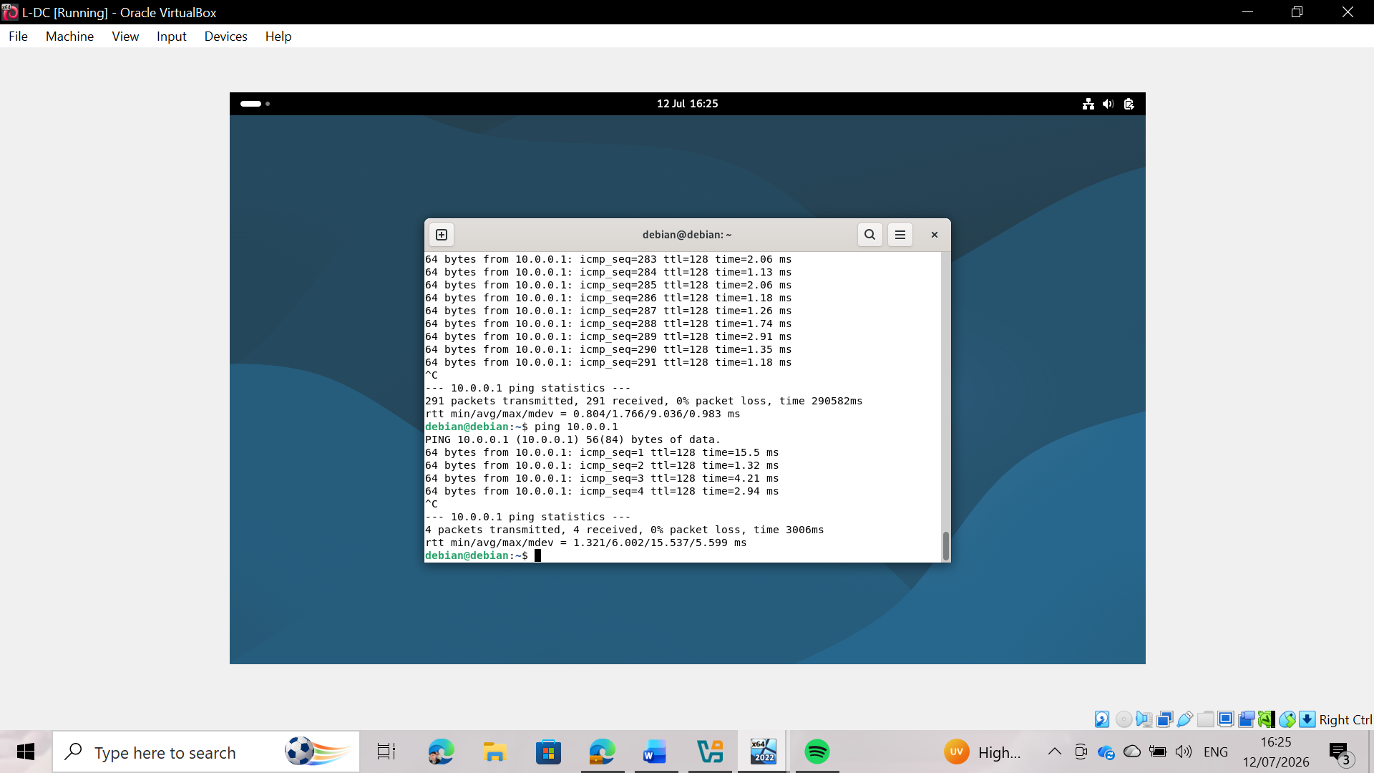
Figure 15: Connectivity Test from L-DC to B-DC (ping 10.0.0.1)
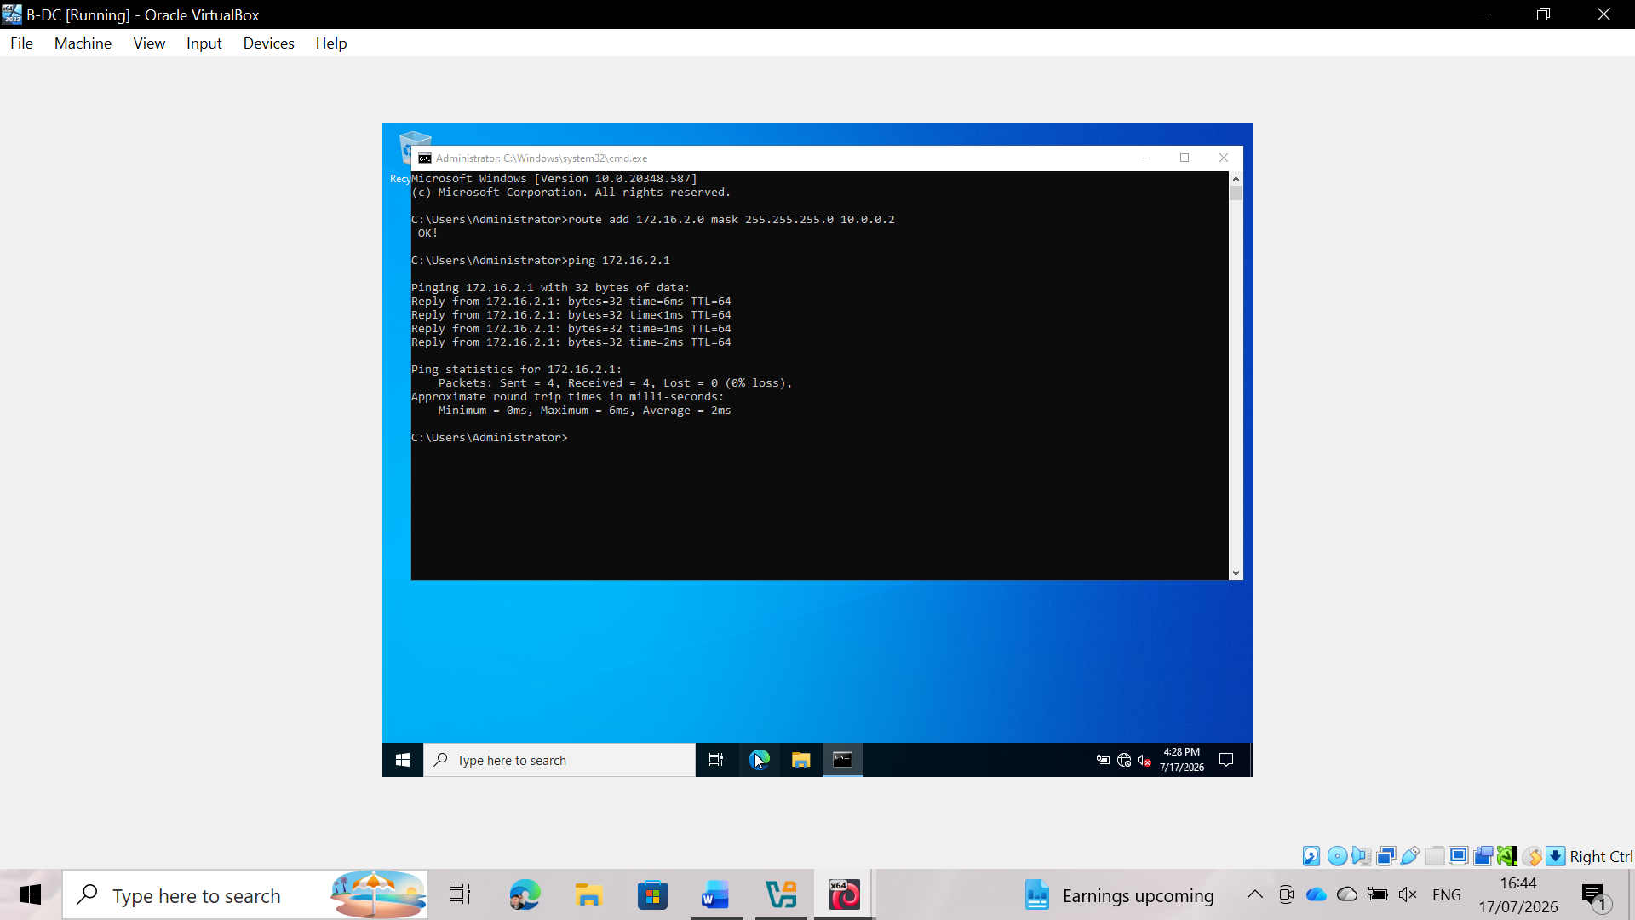
Figure 16: Successful ICMP Routing Test from B-DC to L-DC
IEEE Research and Technical Justification
The deployment and configuration of the NOSSLONDON2026 virtual network infrastructure has strictly adhered to industry standards and peer-reviewed methodologies from the IEEE Xplore digital library.
First, the implementation of static routing and network segmentation on point-to-point links (such as the /30 subnet used between B-DC and L-DC) follows established architectural frameworks for enterprise environments. Manual route selection ensures deterministic traffic control and reduces overhead in small-scale multi-site corporate networks. According to routing optimization frameworks found in IEEE research, static routes ensure maximum throughput and minimum processing latency when connecting predefined corporate sites [11].
Second, network topology configuration using Oracle VirtualBox and end-to-end connectivity validation using ICMP echo requests (ping tests) were performed according to standardized network simulation principles. Using virtualized environments to model enterprise operating systems reduces hardware dependency while preserving protocol integrity across heterogeneous platforms (Windows and Linux). IEEE Xplore academic studies highlight that verifying firewall exceptions along with ICMP reachability is crucial for establishing a security baseline and operational readiness before deploying advanced domain services [12].

4. Task 3 – Reflection

4.1Technical Reflection
Several technical challenges arose during the network deployment. One of the main issues involved configuring the network interfaces on the Debian server, as the second network adapter was not initially recognized with the correct IPv4 address. This necessitated reviewing the network interface configuration, checking the adapter settings in VirtualBox, and assigning the correct static IP address to the appropriate interface.
Another challenge emerged during the connectivity testing phase. Although the IP configuration was correct, the Debian server was initially unable to communicate with the Birmingham server using the *ping* command. After a systematic review of the IP configuration, subnet masks, and network adapters, it was determined that the Windows Defender Firewall was blocking ICMP echo requests. Enabling the appropriate inbound firewall rule resolved the issue and allowed for successful communication between the two servers.
These troubleshooting activities demonstrated the importance of following a logical diagnostic process, verifying each network component individually before determining the root cause of the problem.

4.2 Personal Reflection
This hands-on activity improved my understanding of network configuration, IP addressing, and connectivity testing. I gained greater confidence in configuring static IP addresses, using network diagnostic commands, and troubleshooting configuration issues. I also learned that successful network communication depends not only on correct IP addressing but also on firewall and system configurations. Overall, this task strengthened both my technical knowledge and my troubleshooting skills within a virtual network environment.

5. Conclusion
This practical activity successfully enabled the research, design, and implementation of a virtualized network environment for NOSSLONDON2026. The project encompassed the evaluation of hypervisor technologies, the configuration of IP addressing, and the deployment of Windows Server 2022 and Debian servers within a virtual environment.
Practical implementation confirmed that both servers were correctly configured and capable of effective communication, as verified through connectivity tests. Various technical challenges arose during the deployment process—such as network interface configuration and firewall restrictions—which were systematically identified and resolved.
Overall, this activity reinforced my understanding of networking concepts such as IP addressing, routing, virtualization, and network services, while also developing my practical skills in network deployment, troubleshooting, and technical documentation. The resulting topology provides a solid foundation for implementing additional network services in the second practical activity.

6. References

[1] | R. P. Goldberg, “Survey of Virtual Machine Research,” IEEE Computer, vol. 7, no. 6, 1974.
[2] | VMware, “What is a Hypervisor?,” 2024. [Online].
[3] | Oracle, “Oracle VM VirtualBox User Manual,” 2024. [Online].
[4] | H. Christian and H. Kieth, “IPv6 Unicast Address Assignment Considerations,” 2008.
[5] | J. D. R. R. Wegner, “IP Addressing and Subnetting Including IPv6,” Syngress, 2006.
[6] | B. Haythum, N. Irena and C. Kiran Kumar, “Deploying IPv6 in the Google Enterprise Network: Lessons Learned,” in 25th Large Installation System Administrator Conference (LISA11), 2011.
[7] | D. Jeff and C. Jennifer D, Routing TCP/IP, Volume 1, Cisco Press, 2005.
[8] | M. John T, OSPF: Anatomy of an Internet Routing Protocol, Addison-Wesley Professional, 1998.
[9] | F. Sheila, H. Paul, O. Angela and P. Richard, “Guide to SSL VPNs,” National Institute of Standards and Technology (NIST), Gaithersburg, Maryland, USA, 2008.
[10] | P. William and C. Tim, MSCA Windows Server 2012 Complete Study Guide, Sybex, 2013.
[11] | IEEE Computer Society, “IEEE Standard for LOcal and Metropolitan Area Networks: Overview and Architecture,” Institution IEEE, 2014.
[12] | T. L. L. a. M. J. Flynn, “Performance Analysis of Virtualization and Containerization in Heterogeneous Server Environments,” IEEE Transactions on Network and Service Management , no. 3, pp. 2910-2922, 2021.

7. Appendices
All supporting screenshots, IP addressing details, connectivity tests, and configuration evidence have been included in the relevant sections of the technical documentation (Task 2). Therefore, no additional appendices are required.

