TITLE PAGE

NAME: NDEY YASSIN LOWE

STUDENT NUMBER: 1815270

PROGRAMME: CERTIFICATE IN HIGHER EDUCATION SKILLS FOR THE WORKPLACE

MODULE: EFFECTIVE TEAM WORKING AND COMMUNICATION

BMSW: 4002

LECTURER’S NAME: ERIC OSEI

ASSIGNMENT TITLE: BUSINESS REPORT

TABLE OF CONTENTS

- Title Page................................................................................................... Page 1

- Table of Contents........................................................................................Page 2

- Introduction.................................................................................................Page 3

- Functions communication...........................................................................Page 4

- Communication in Sarah’s business......................................................... Page 5
a) Importance of effective communication....................................... Page 6
b) Importance of two-way communication ........................................Page 7
c) Effective methods of communication............................................Page 8
d) Significance of verbal and non- verbal communication................Page 9

- Conclusion/ Recommendation.................................................................Page 10

- References...............................................................................................Page 11

INTRODUCTION
Communication is an Act of transmitting information. It is the exchange of information, ideas or thoughts that result in understanding between people. Communication is from the Latin word Communicare.
For any organisation to success, there should be an effective communication system as a means of sending or receiving information.
Communication situation exist when:
- There is a person ( sender/ transmitter) who wants to pass some information.
- There is another person ( receiver ) to whom the information is to be passed on.
- The receiver partly or wholly understands the message or information passed on to him.
- The receiver responds to the message or give feedback.
Effective communication can be achieve through hearing, ability to see, reading skills, understanding the language use, ability to recognise and use information memory to recall and understand information. Good communication skills is also very important in anyone to success and be able to work well with others.
Sarah being the owner of the company, delegate the running of her business to two managers who are both responsible for all communication within the business. These two managers have to have an effective means of communication and channels of relaying information to their employees and have to work hand in hand for the continuous success of the business. It is also important to have a proper work environment in order for any business to success.

FUNCTIONS OF COMMUNICATION
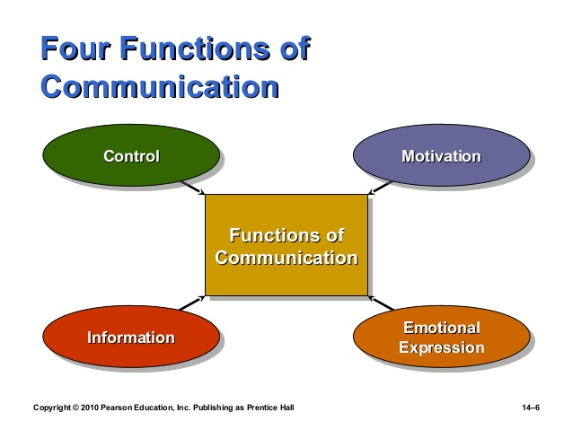
The purpose of communication is to Control, Motivate, Express Emotional and Provide Information.

CONTROL: Through communication, you can control the behaviour of your employees by putting down rules, regulations, job description and guidelines for the employees to follow.
MOTIVATE: By setting goals, employees can be motivated to do what is right to achieve those goals.
EMOTIONAL EXPRESSION: Communication create a room for people to express their feelings and frustrations.
PROVIDE INFORMATION: Any organisation that wants to success should provides effective communication within them. Information should always reach the targeted audience.

IMPORTANCE OF EFFECTIVE COMMUNICATION TO THE BUSINESS
For any organisation or business to success, effective communication should be an important tool. Communication play an important role for the success of any business. As the business consultant, my first advice will be to build a good communication relationships with staffs, suppliers and customers for continued success. Effective communication within the work place encourage employees to open up to new ideas, feel value and build trusts. As much as creating team building whereby all employees are given a voice and listen to, leading to increases in output. Communication is very significant for Sarah’s company to maintain the growth of the business and the fact that the business have grown rapidly in only a year means that the business is doing something right and the method of communication the business is using is reaching the targeted people. However, since the business is expanding, efficient communication is require. Employees will feel more secure with their roles if they are well informed.
There are many advantages of effective communication in a business;
- Effective communication build a stronger team and also create a positive atmosphere at the workplace.
- Good communication between employees and managers increase productivity
- Proper communication from managers to their employees through the right channels makes the business run smoothly.
- When information is transmitted properly, it minimise conflict.
For these reasons, it is important to maintain effective communication both internally and externally to avoid the collapse of any business.

There are two different types of communication: VERBAL and NON-VERBAL communication.
Verbal communication is the most common way that people use to communicate with each other. Verbal communication can be in words, speeches, presentations, meetings. It is important that the message is clear. The sharing of information is very vital in a any business
Non-Verbal communication is more of a written form of communication like drawing, writing, painting and different types of body movements like facial expressions, gestures, eye contacts, touching. I will advice Sarah to make use of both verbal and non- verbal methods of communication in her business.

IMPORTANCES OF TWO WAY COMMUNICATION
Two way communication is very important in any organisation especially now that Sarah’s business is rapidly expanding. Communication is essential in any work environment to allow employees to give their best performance. In any two way communication, there is a sender and a receiver. Two way communication occurs when the receiver sends response or feedback to the sender’s message. When the receiver receives the message, then the receiver decodes it and send back his or her reaction to the sender. Both the sender and recipient do not need to be in the same place or near each other. Communication is completed when the receiver is able to decode the message of the sender. Two way communication can be done horizontally or vertically. When a superior exchanges information with his subordinates it is vertical two way communication and on the other hand, when communication is between the same rank of individuals it called horizontal two way communication. The diagram below show how two way communication is transmitter.
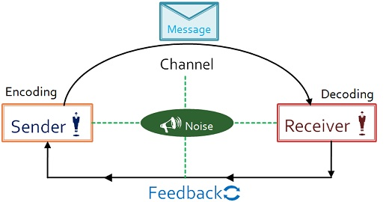

There are many advantages to a two way communication. Two way communication enable people to share information, ideas, thoughts and opinions. Two way communication promote democracy and improve relationship between staffs. Telephone and face-to-face conversation are examples of two way communication. As a business consultant, I will advice Sarah’s business managers to maintain effective two way communication for the continued success of the business.

MODELS OF COMMUNICATION
There are 3 different models of communication;
Shannon and Weaver Model, Aristotle Model and Berlo Model. However, I want Sarah Davis

to concentrate on the best model of communication.

Berlo’s model however, have no feedback, no room for noise and did not mention barriers to communication which is important in a business. When you send a message, you want to know the reaction of the receiver.

METHODS OF COMMUNICATION STRUCTURE OF THE BUSINESS
For Sarah’s business to continue flourishing, the business have to adapt both formal and informal ways of communication.

Formal Communication
Communication designed by management through official channels in an organisation is formal communication. They are normally from top leaders of the business down to the lower level of employees. Sarah being the owner of the discount store employing two managers who are responsible for the success of her business. The managers have to set up a structure through channels to communication with their lower subordinates. It is more reliable and since it is written, documentary evidence is present. Since it is only through predefined channels, the flow of information is slow and information might be lost because of the long chain of communication it have to follow.
Informal Communication
As informal method of communication can be written or spoken through body language or even gestures. It flows in every direction and very fast. But rumors could spread quickly in this method of communication and therefore, not very reliable.

Active listening is very important for any communication to be effective. Active listening creates a better understanding and relationship between a Receiver and a Sender. Only 25% contents of communication is actually listened to. We remember very little like one word in eight and our attention span last between 4 to 5 minutes. It is therefore important to keep communication brief and interesting. Barriers to communication have to be consider when choosing the method of communication to use in the business.

BARRIER TO COMMUNICATION
- Poor internet signal
- Attitudes
- Language barrier
- Poor eye sign
- Information Overload
- Filtering
- Poor structure design
- Lack of credible source
- Gender Differences
You can overcome the barriers by
- Keeping it short
- Getting an interpreter
- True to the facts
- Use feedback
- Simplify the language
- Listen actively
- Watch non-verbal cues
- Constrain emotions

CONCLUSION/ RECOMMENDATION
Sarah Davis need to focus more on what she is doing as well as creating more effective communication methods for her expanding business. My first issue with Sarah’s business is the need for two managers because it did not said in which department they are managers. I will advice Sarah’s to have one manager for the overall business and an assistant manager who will be directly answerable to the manager and thus, be the acting manager when the manager is away. My reason for this is to promote ethical communication and avoid ethical lapses. The two managers could face an ethical dilemma where both of them have a conflict of interest. They might have the same goal but reaching a decision will be very hard then and will affect the business. Whereas, if there it only one manager and a deputy manager, reaching a decision will be much easier and communication will flow smoothly. Every business needs a chain of command from the superior to his or her subordinates. Having predefined channels of communication will avoid confusion.
Modern technology is advancing and if Sarah wants her business to be more successful, she have to invest a lot in technology. Sending emails will an excellent way of communication for the business because its cheap and you can send many at once which I will recommend. The problem with emails are that most of the time, you do not have immediate feedbacks. Important messages could go to their spam message and not read or they might not have internet access.
Telephone calls are also an effective ways of communication because you receiver immediate feedback. I will recommend the business to be using phone calls when they need an immediate reaction depending on the targeted audience and what time of the day it is because of the time differences in other countries and having staffs that works night shift, they might spend the day sleeping.
Video calls will be good for the business as well. It save cost and having to travel from one place to another. This method might be inconvenient depending on the time and what they are doing. My advice is to schedule a time to call in order for them to be ready.
As for the staff on maternity leave, I will advice Sarah to employ a temporary staff until she is back. Since the business it growing, the business cannot be short of manpower. The sale assistant on leave should be updated of all the changes in the business through emails, phone calls ,letters, etc.
I will advice the business to be sending letters out even though they are an expensive and a slow form of communication, many people values letters coming to their doors than having them online which can disappear anytime the system crashed. Beside, many old people are computer illiterate and cannot read mails online.
For the success of every business, effective team work is very important. The business needs to build an effective team work. Where there is good leadership, there is effective team work. Leaders who engage with their employees and build relationship tend to success. Once your employees trust your judgement and feel included in decision makings, they will perform better and work towards the common goal for the betterment of the business.
Communicate well and build a good relationship both internally and externally for continuous success in your business.

REFERENCES
- Cardinal (2015) ‘5 steps in building effective team work’. Available at: http://www.huffpost.com ( Accessed: 9 August 2019).
- Alessandra, T. (1993) Communicating at work. New York: Fireside.
- Reddy (2016) ‘Importance of two way communication in a workplace’. Available at: http://www.wisestep.com (Accessed: 7 August 2019).
- Surhi (2019) ‘Difference between internal and external communication’. Available at: http://www.keydifferences.com ( Accessed: 7 August 2019).
- Robbin, S.P.,Stuart-Kotze, R., & Coulter, M. (2000) Management. Scarborough, Ont: Prentice Hall Canada
- Berlo, D (1960) The process of communication. New York., New York: Rinehart, & Winston.
- Mckay, Davis, & Fanning, (1995) ‘Active Listening’, In Certificate of Higher Education, Griffiths, B. A. And Dunham, E. B. London: Sage, p52
- Maud, A., Schriek M, Tinkler P. K. (2015) ‘Encoding and Decoding Messages’ in Certificate Of Higher Education. London: Sage, p47
- Surhi (2018) ‘ Differences between formal and informal communication’. Available at: http://www.keydifferences.com ( Accessed: 8 August 2019).

