
APPENDIX GA36c

LEVEL 6 ASSESSMENT SPECIFICATION

Student name: | James Craddock-Jones | Student ID number: | 256515
Programme: | BSc Applied Computing
Module: | Usability Engineering
Module code: | ACCB6017 | Contribution to Overall Module Assessment (%): | 50%
Lecturer: | Dr Nik Whitehead | Internal Verifier: | Bev Holland
Assignment Title: | Prototyping & Testing | Word count (or equivalent): | 3000
Submission deadline: | 25/3/22 | Return date of provisional marks & written feedback:
Submission method: | All written assessments, where practical and possible, must be submitted via Turnitin unless otherwise instructed by the Lecturer. (Please DO NOT put this assessment specification into Turnitin or it will match many similarities with other students’ submissions.)  Alternative submission method (if applicable):  Late submission of the assessment will result in a late penalty mark. Penalties for late submission: Up to one week late, maximum mark of 40%. Over one week late, 0%. Only the Extenuating Circumstances Panel may approve a change to submission dates.
Academic honesty / referencing: | Academic honesty is required. In the main body of your submission you must give credit to authors on whose research and ideas your work is based. Append to your submission a reference list that indicates the books, articles, etc. that you have used, cited or quoted in order to complete this assessment.
Module Learning Outcomes
(from module syllabus)
Upon the successful completion of this module, the student should be able to:
- Research and evaluate cognitive and social information processing
- Select, apply and analyse critically techniques of interface evaluation
- Synthesize a solution to a complex design problem from the concepts and principles of usability engineering and software development
- Critically analyse, individually and as part of a team exercise, input and output hardware appropriate for specialised applications, for example for use by disabled people, and for three-dimensional modelling applications

TASK DESCRIPTION

You will develop a prototype interface design for an online Welsh Government Covid Pass. Your prototype may include a Web or Mobile application and is to be developed as a paper prototype and a software prototype. You should select a user task such as accessing your Covid pass, uploading the results of a recent Covid test, or providing information about the local levels of Covid and any related restriction that apply. You agree your chosen topic with your lecturer either in class or by email before starting work. You will also evaluate a paper prototype produced by another student in the group.

You are required to apply the theory covered in human factors and to use the process of task analysis for your prototype design.

Your task is as follows (each numbered point should correspond to a section in your report):

- To provide a brief introduction to your chosen task and present any existing facility on NHS, NHS Wales, or Welsh Government web pages or apps. Appropriate references are important here and please include academic sources.

- Identify your target user group and investigate their requirements via an appropriate method such as task analysis. Evidence of input from real user(s) should be provided.

- To present a paper prototype design using the outcomes of the design. This should be a hand drawn walkthrough of a transaction for the chosen area for the device.

- To analyse the application of human factors theory in your paper prototype designs. This should include an explanation of your application of theory of visual perception, human memory and human reasoning, interface metaphors and affordance. This is another section where referencing is important and as well as a brief explanation it is important to specify how human factors have been applied to specific elements of your design.

- To complete and document a walkthrough of your paper prototype with a member of the class as user. You should review aspects of the interface that worked and did not work and provide a copy of their written feedback.

- To participate as user for a class member’s design and to write up your evaluation of their design. You will need to provide a copy of their design to help your explanation.

- To produce a software prototype of your web or mobile design using the appropriate software tool of your choice (eg. XD, Balsamiq, Dreamweaver, Visual Studio, Photoshop) and to give a written analysis of this prototype and the features included. This should be explained using screen prints and narrative and an evaluation of the software tool selected for rapid prototyping.

- Give an evaluation of the usability engineering techniques used in producing your Welsh Government Covid Pass interface prototype and their effectiveness. Did applying a usability technique such as task analysis, applying human factors and the walkthrough of a paper prototype result in a better design? Give some specific examples of changes you made to your design as a result.

- To use and reference appropriate resources throughout. References should be provided for task analysis, human factors, usability in web design and any other topic as required.

Suggested word count: 3,000 words.

GUIDANCE FOR Students IN THE COMPLETION OF TASKS

NOTE: The guidance offered below is linked to the five generic assessment criteria overleaf.

- Engagement with Literature Skills
Your work must be informed and supported by scholarly material that is relevant to and focused on the task(s) set; you should make use of scholarly reviews and primary sources, where appropriate (for example, refereed research articles and/or original materials appropriate to the discipline). You should provide evidence that you have accessed a wide range of sources, which may be academic, governmental and industrial; these sources may include academic journal articles, textbooks, current news articles, organisational documents, and websites. You should consider the credibility of your sources; academic journals are normally highly credible sources while websites require careful consideration/selection and should be used sparingly. Any sources you use should be current and up-to-date, mostly published within the last five years or so, though seminal/important works in the field may be older. You must provide evidence of your research/own reading throughout your work, using a suitable referencing system, including in-text citations in the main body of your work and a reference list at the end of your work.

Guidance specific to this assessment: You should be able to provide examples of existing systems to support your choice of functionality, and should justify your design and evaluation decisions with relevant references to the literature.

- Knowledge and Understanding Skills
At level 6, you should be able to demonstrate coherent and detailed knowledge and a systematic understanding of the subject area, at least some of which is informed by the latest research and/or advanced scholarship within the discipline. You should be aware of the uncertainty, ambiguity and limits of knowledge. Your work must demonstrate the growing extent of your knowledge and systematic understanding of concepts and underlying principles associated with the subject area. Knowledge relates to the facts, information and skills you have acquired through your learning. You demonstrate your understanding by interpreting the meaning of the facts and information (knowledge). This means that you need to select and include in your work the concepts, techniques, models, theories, etc. appropriate to the task(s) set. You should be able to explain the theories, concepts, etc. meaningfully to show your understanding. Your mark/grade will also depend upon the extent to which you demonstrate your knowledge and understanding; ideally each should be complete and detailed, with comprehensive coverage.

Guidance specific to this assessment: N/A.

- Cognitive and Intellectual Skills
You should be able to: critically evaluate evidence, arguments, assumptions, abstract concepts and data some of which are at the forefront of a discipline (and that may be incomplete) to devise and sustain arguments, to make judgements and/or solve problems; describe and comment upon particular aspects of current research, or equivalent advanced scholarship, in the discipline Your work must contain evidence of logical, analytical thinking, evaluation and synthesis. For example, to examine and break information down into parts, make inferences, compile, compare and contrast information. This means not just describing what! But also justifying: Why? How? When? Who? Where? At what cost? At all times, you must provide justification for your arguments and judgements. Evidence that you have reflected upon the ideas of others within the subject area is crucial to you providing a reasoned and informed debate within your work. Furthermore, you should provide evidence that you are able to make sound judgements and convincing arguments using data and concepts. Sound, valid conclusions are necessary and must be derived from the content of your work. Where relevant, alternative solutions and recommendations may be proposed.

Guidance specific to this assessment: N/A

- Practical Skills
At level 6, you should be able to apply the methods and techniques that you have learned to review, consolidate, extend and apply your knowledge and understanding, and to initiate and carry out projects. You will deploy accurately established techniques of analysis and enquiry relevant to the discipline, and apply them in complex and unpredictable contexts, to devise and sustain arguments and/or to solve problems. You should be able to frame appropriate questions to achieve a solution - or identify a range of solutions. You should be able to demonstrate how the subject-related concepts and ideas relate to real world situations and/or a particular context. How do they work in practice? You will deploy models, methods, techniques, and/or theories, in that context or circumstances, to assess current situations, perhaps to formulate plans or solutions to solve problems, or to create artefacts, some of which may be innovative and creative. This is likely to involve, for instance, the use of real world artefacts, examples and cases, the application of a model within an organisation and/or benchmarking one theory or organisation against others based on stated criteria. You should show awareness of the limitations of concepts and theories when applied in particular contexts.

Guidance specific to this assessment: You’re building a practical interface system. Talk to your users about what they’d like to see in this, then implement those requirements in a usable interface. Show that it is usable through your testing. When you evaluate someone else’s interface remember to be objective rather than subjective.

- Transferable Skills for Life and Professional Practice
Your work must provide evidence of the qualities and transferable skills necessary for graduate-level employment requiring the exercise of initiative and personal responsibility and decision-making in complex and unpredictable circumstances. This includes demonstrating: the learning ability for professional development to advance existing skills and acquire new competences of a professional nature that will enable you to assume significant responsibility within organisations; that you can initiate and complete tasks and procedures, whether individually and/or collaboratively; that you can use appropriate media to effectively communicate information, arguments and analysis in a variety of forms to specialist and non-specialist audiences; fluency of expression; clarity and effectiveness in presentation and organisation. Work should be coherent and well-structured in presentation and organisation.

Guidance specific to this assessment: You should show how you’re using common professional techniques like task analysis effectively. Remember to write the report in an academic manner with numerical referencing, correct captioning of illustrations, appropriate technical English.

Student FEEDBACK FORM

This section details the extent to which the assessment criteria are demonstrated by you, which in turn determines your mark. The marks available for each category of skill are shown. Lecturers will use the space provided to comment on the achievement of the task(s), including those areas in which you have performed well and areas that would benefit from development/improvement.

Generic Assessment Criteria | Marks available | Marks  awarded
1. Engagement with Literature Skills
.
Research and application as shown in your Introduction and human factors sections  Sound overview of current NHS Covid Pass system, with some annotated screenshots and comparison to the EU system currently in place with Vancouver referencing applied. Human factors theory briefly discussed in relation to visual perception, memory, human reasoning, metaphors and affordances. Diagrammatic illustrations provided to support discussion, together with citations from suitable sources. Some attempts made at comparison, with some reference to potential consideration in the design and development of the prototypes. However, this would have been better applied through annotation of specific screens as it is quite general. Some reference made to Human Factors theory in evaluation. |  | 19
 | 30 | 19
2. Knowledge and Understanding Skills

 | 0
3. Cognitive and Intellectual Skills

 | 0
4. Practical Application Skills

Effective paper and software Prototypes with good explanation. A constructive review of another student’s paper prototype with thoughtful suggestions.  Observation of walkthrough of current system organised in order to obtain feedback and establish user requirements. Key findings are summarised but no additional evidence submitted eg observation records to support this.  Paper prototype screens have been referenced to the HTA but there are many that are missing. Constructive feedback from the participant of the paper prototype walkthrough and response to this has been provided. Constructive feedback also returned with key findings briefly discussed. All feedback provided and received is included in the Appendix.  Professionally produced software prototype using Adobe Xd based on task analysis and HTA. You have taken on board feedback provided and applied changes in the development of your software prototype. Some inconsistencies in navigation between screens. Limited annotation of software prototype screens explaining consideration of human factors theory, although this should have been applied to the paper prototype designs. Most of the navigation within your software prototype is fully functional. However, more use could have been made of error/success/loading screens. Also, details were unable to be typed where required.  Evaluation of software prototype considers both positive and negative aspects with suggested improvements. Some reference made to Human Factors theory in your evaluation. No evaluation provided of Adobe XD as suitable software for this project nor of any other usability engineering techniques eg task analysis |  | 34
 | 50 | 34
5. Transferable Skills for Life and Professional Practice

Effectively apply an appropriate usability engineering technique such as task analysis and evaluate the techniques used in your conclusion. Good technical writing and referencing.  Target use group selected and briefly justified. Task analysis completed and HTA produced. However, decomposition of tasks could have been more comprehensive in nature.  Expression is generally appropriate throughout with familiarity of terminology relevant to this topic being evident. Vancouver referencing conventions have been accurately applied. |  | 11
 | 20 | 11

Assessment Mark (Assessment marks are subject to ratification at the Exam Board. These comments and marks are to give feedback on module work and are for guidance only until they are confirmed. ) | Late Submission Penalties (tick if appropriate) |  | 64%
 | Up to 1 week late (40% Max) |  | 64%
 | Over 1 week late (0%) |  | 64%

GENERIC ASSESSMENT CRITERIA

Level 6
In accordance with the Framework for Higher Education Qualifications, at the end of Level 6 students should have coherent and detailed knowledge and a systematic understanding of their subject area, at least some of which is informed by the latest research and/or advanced scholarship within the discipline. They will be able to accurately deploy established techniques of analysis and enquiry within a discipline, using their conceptual understanding to devise and sustain arguments and/or to solve problems. They should be aware of the uncertainty, ambiguity and limits of knowledge. They should be able to critically evaluate evidence, arguments, assumptions, abstract concepts and data (that may be incomplete), to make judgements, and to frame appropriate questions to achieve a solution - or identify a range of solutions. They will apply the methods and techniques that they have learned to review, consolidate, extend and apply their knowledge and understanding, and to initiate and carry out projects. They will have the ability to manage their own learning, and to make use of scholarly reviews and primary sources (for example, refereed research articles and/or original materials appropriate to the discipline). They will demonstrate the qualities and transferable skills necessary for employment requiring: the exercise of initiative and personal responsibility; decision-making in complex and unpredictable contexts; the learning ability needed to undertake appropriate further training of a professional or equivalent nature.

Level 6 | FAIL | MARGINAL FAIL | SATISFACTORY  (3rd / Pass) | GOOD  (2.2 / Pass) | VERY GOOD  (2.1 / Merit) | EXCELLENT  (1st / Distinction) | EXCEPTIONAL  (1st / Distinction)
Category | 0-29% | 30-39% | 40-49% | 50-59% | 60-69% | 70-84% | 85-100%
Engagement with literature (including reading, referencing,  academic conventions and  academic honesty) | Little or no evidence of reading and/or reliance on inappropriate sources.  Views and findings mostly unsupported and non-authoritative.  Referencing conventions used incoherently or largely absent. | Poor engagement with essential reading. No evidence of wider reading. Reliance on inappropriate sources, and/or indiscriminate use of sources. Heavily reliant on information gained through class contact. Inconsistent and weak use of referencing. | Engagement with a limited range of mostly relevant and credible sources. Some omissions and minor errors.  Referencing conventions evident though not always applied accurately or consistently. | Engagement with an appropriate range of research-informed literature, including sources retrieved independently. Some over-reliance on texts. Referencing may show minor inaccuracies or inconsistencies. | Engagement with a wide range of research-informed literature, including sources retrieved independently.  Selection of relevant and credible sources. Very good use of referencing, with no/very few inaccuracies or inconsistencies. | Engagement with an extensive range of relevant and credible literature, informed by the latest research. Consistently accurate application of referencing. | Exceptional engagement with an extensive range of relevant and credible literature, informed by the latest research. High-level referencing skills consistently and professionally applied.
Knowledge and understanding (Coherent and detailed knowledge and systematic understanding of the subject area, at least some of which is informed by the latest research and/or advanced scholarship within the discipline.) | Major gaps in knowledge and systematic understanding of the subject matter. Substantial inaccuracies. No awareness of knowledge of the latest research and/or advanced scholarship within the discipline. | Gaps in knowledge, with only superficial systematic understanding. Some significant inaccuracies and/or irrelevant material. No awareness of knowledge of the latest research and/or advanced scholarship within the discipline. | Limited knowledge and systematic understanding of the relevant concepts and principles within the subject area which to some limited extent, is informed by current research and scholarship. | Knowledge is reasonably detailed, accurate with a good systematic understanding of the field of study and to some extent, current research and scholarship. | Knowledge is reasonably extensive coherent and detailed. Exhibits very good understanding of the breadth and depth of established views, and the work is, at least in part, well-informed by current research and scholarship. | Excellent coherent and detailed knowledge and systematic understanding of the principles and theories of current research and scholarship. Clear awareness of challenges to established views and the limitations of the knowledge base. | Exceptionally coherent and detailed knowledge and systematic understanding of the principles and theories of the subject, well-informed by current research and scholarship. A critical, sophisticated and nuanced awareness of the ambiguities and limitations of knowledge.
Cognitive and intellectual skills  (Conceptual and critical thinking, analysis, synthesis and evaluation of research, assumptions, abstract concepts and data (that may be incomplete); logic, argument and judgement.) | Wholly or almost wholly descriptive work. Little or no analysis, synthesis or evaluation.  Failure to develop arguments, leading to illogical or invalid judgements. Unsubstantiated generalisations, made without use of any credible evidence. | Largely descriptive work, with superficial use of critical evaluation. Weak development of arguments and judgements. Information accepted uncritically, uses generalised statements made with scant evidence and unsubstantiated opinions. Ideas sometimes illogical and contradictory. | Limited attempt at critical thinking, analysis, synthesis and evaluation, tending towards description.  Some evidence to support emerging arguments and judgements but these may be underdeveloped or with a little inconsistency / mis-interpretation.  Asserts rather than argues a case. | Some critical thinking, analysis, synthesis and evaluation. Can analyse new and/or abstract concepts and data without guidance.  An emerging awareness of different stances and ability to use evidence (that may be incomplete) to support the argument.  Mostly valid arguments and logical judgements. Some tendency to assert/state opinion rather than argue on the basis of reason and evidence. | Sound critical thinking, analysis, synthesis and evaluation demonstrating critical thinking. Ability to devise and sustain persuasive arguments, and to review the reliability, validity and significance of evidence (that may be incomplete) to make mostly appropriate and valid judgements. | Excellent critical thinking, analysis, synthesis and evaluation. Ability to investigate contradictory or incomplete information and make strong, persuasive, arguments and sophisticated judgements. Some evidence of independent thought and ability to ‘see beyond the question’, suggesting a grasp of the broader field and wider concepts. | Exceptional critical thinking, analysis, synthesis and evaluation based on judiciously selected evidence.  Ability to investigate contradictory or incomplete information and make strong, persuasive, arguments and sophisticated, nuanced, judgements. Evidence of independent thought and ability to ‘see beyond the question’, suggesting an outstanding grasp of the broader field and wider concepts.
Practical skills  (Apply/deploy accurately established tools and techniques; initiate and carry out projects; formulate solutions to solve problems in complex and unpredictable contexts.) | Limited or no use of methods, materials, tools and/or techniques.  Little or no appreciation of the context of the application.  Limited understanding of the application of theory to practice or making appropriate links between the two.  Very weak problem-solving skills in complex and unpredictable contexts. | Rudimentary application of methods, materials, tools and/or techniques but without consideration and competence. Flawed appreciation of the context of the application.  Weak understanding of the application of theory to practice, with only occasional evidence of making appropriate links between the two. Weak problem-solving skills in complex and unpredictable contexts. | An adequate awareness and mostly appropriate application of well-established methods, materials, tools and/or techniques.  Basic appreciation of the context of the application. Theoretical knowledge and understanding applied in practice, but not always making logical links between the two.  Can identify problems and propose basic solutions in complex and unpredictable contexts without fully appreciating the complexity. | A good and appropriate application of standard methods, materials, tools and/or techniques.  Clear appreciation of the context of the application. Mainly consistent, accurate and logical application of theory to practice, making appropriate links between the two  Can identify problems and propose mostly appropriate solutions in complex and unpredictable contexts. | A very good application of a range of methods, materials, tools and/or techniques.  Very good consideration of the context of the application, with perceptive insights. Can identify problems and propose appropriate solutions in complex and unpredictable contexts.  Evidence of some innovation and creativity. | An advanced application of a range of methods, materials, tools and/or techniques.  The context of the application is well considered, and insightful.  Application and deployment extend beyond established conventions. Can identify complex problems and propose excellent solutions. Innovation and creativity evident. | Exceptional levels of application and deployment skills in unpredictable, practical contexts, drawing skilfully on the latest research within the discipline. Can identify complex problems and propose sophisticated solutions. Assimilation and development of cutting edge processes and techniques.
Transferable skills for life and professional practice  (Exercise of initiative and personal responsibility; professional development; initiate and complete tasks and procedures: individually and/or collaboratively; use appropriate media to communicate effectively; fluency of expression; clarity and effectiveness in presentation and organisation.) | Communication medium is inappropriate or misapplied.  Work is poorly structured, disorganised and/or confusingly expressed. Very weak use of language and/or very inappropriate style. Little or no evidence of autonomy (or collaboration, where relevant) in the completion of tasks. Little or no evidence of the skills required in graduate employment. | Communication medium is poorly designed and/or not suitable for the audience.  Work is poorly presented in a disjointed manner. It is loosely, and at times incoherently, structured, with information and ideas often poorly expressed. Weak use of language and/or inappropriate style. Weak independent initiative (or collaboration, if relevant). Limited evidence of the skills required in graduate employment. | Can communicate in a suitable medium but with some room for improvement.  Mostly ordered presentation and structure in which relevant ideas / concepts are reasonably expressed. Work may lack coherence in places. Can work as part of a team, but with limited involvement in group activities.  Demonstrates the basic skills required in graduate employment, with some areas of minor weakness. | Can communicate effectively in a suitable format, but may have minor errors.  Mostly coherent, organised work, in a suitable structure and is for the most part clearly expressed. Can work effectively independently and/or as part of a team, with clear contribution to group activities.  Demonstrates the skills required in graduate employment, with some areas of strength and some of minor weakness. | Can communicate well, confidently and consistently in a suitable format.  Work is coherent, fluent, well-structured and organised. Can work very well autonomously and/or as part of a team, with very good contribution to group activities.  Demonstrates very good graduate employment skills, with just occasional minor weakness. | Can communicate professionally confidently and consistently in a suitable format.  Work is coherent, very fluent and is presented professionally. Can work autonomously with initiative. Where relevant can work professionally within a team, showing leadership skills as appropriate, managing conflict and meeting obligations. Demonstrates excellent graduate employment skills and an appetite for further development. | Can communicate with an exceptionally high level of professionalism.  Work is exceptionally coherent, very fluent and is presented professionally. Can work exceptionally well and professionally within a team, showing advanced leadership skills. Demonstrates exceptional graduate employment skills and an appetite for further development.

THIS DOCUMENT IS ALSO AVAILABLE IN WELSH

Assignment 1
-
Usability Engineering

James Craddock-Jones
256515
25/03/2022
Contents
Introduction 4
What is The Task at Hand? 4
What are The Current Systems in Place? 4
Other Systems Around the World 7
New System Design 9
Target User Group 9
Who are the target user group? 9
What are the requirements of the target user group? 9
Human Factors within Design 10
Visual Perception 10
Human Memory 11
Human Reasoning 11
Interface Metaphors 12
Affordance 12
Walkthrough and Review of Paper Prototype 14
Paper Prototype 14
Results from Prototype Review 24
New System Development System HTA 24
System Design 25
Main Menu 25
Register an Account 26
Login 27
Forgot Password 28
Home Menu 29
Book Booster Dose 30
Record Test Results 31
Local Restrictions 32
Vaccine Records 34
Processing Menu 34
Evaluation of System Design 36
References 37
Appendix 37
A: Feedback of Design From Aaron 37
Visibility of system status 37
Match between system and real world 38
User control and freedom 38
Consistency and standards 38
Error prevention 38
Recognition rather than recall 38
Flexibility and efficiency of use 38
Aesthetic and minimalist design 39
Help users recognise, diagnose, and recover from errors 39
Help and documentation 39
Recommendations: 39
B: Aaron’s Design 39
C: Feedback for Aaron 43
Visibility of system status – Score: 3 43
Match between system and real world – Score: 2 43
User control and freedom – Score: 2 43
Consistency and standards – Score: 1 43
Error prevention – Score: 2 43
Recognition rather than recall – Score: 1 43
Flexibility rather than recall – Score: 2 43
Aesthetic and minimalist design – Score: 1 43
Recommendations: 44

Introduction

What is The Task at Hand?
The task is to create a new design and build the COVID passes system for the Welsh Government. This new system will require a prototype design built for either a website or mobile application that users can interact with to get the details they need to go to public venues.
The prototype must also be able to upload COVID test results to the Welsh Government as well as provide information about local restrictions in different areas of Wales and provide the Welsh Government information on where the user has been, for example, venues so that effective track and trace can be applied when needed.

What are The Current Systems in Place?
The current system in place is the NHS online website that provides the user with their COVID pass in a bar code for domestic use such as pubs and clubs and international travel to provide proof of vaccination COVID-19. The website has these two pass categories separated on a home screen where the user can choose the one they need.
The NHS online website also provides the user with more information about each of their vaccinations, such as the manufacturer, date of vaccination, the vaccination number, if it was their first, second, or third dose, and more the batch numbers.
The website gives the user the choice of how they can obtain their COID pass, for example, whether they would like to have a PDF version of their COVID pass to print off or just use the one provided. Every pass has an expiration date that is roughly one month from when you requested the COVID pass. (2)
To register to NHS online to gain access to a COVID pass, the user must set up an account providing either identification, passport, full UK driving licence, or full European driving licence. Users must also be over 12. (2)
Below are a few examples of the current NHS COVID pass system used across most of the UK. You can view your COVID pass and COVID records and get a COVID pass for travelling worldwide.
The first image is the main menu, allowing you to select a COVID pass for domestic use or travel. Personally, looking at the user design, this should have been done with noticeable buttons rather than hyperlinks. I state this as it would be easier for the user to interpret that they are clickable and would have allowed for a much larger clickable zone helping with usability.
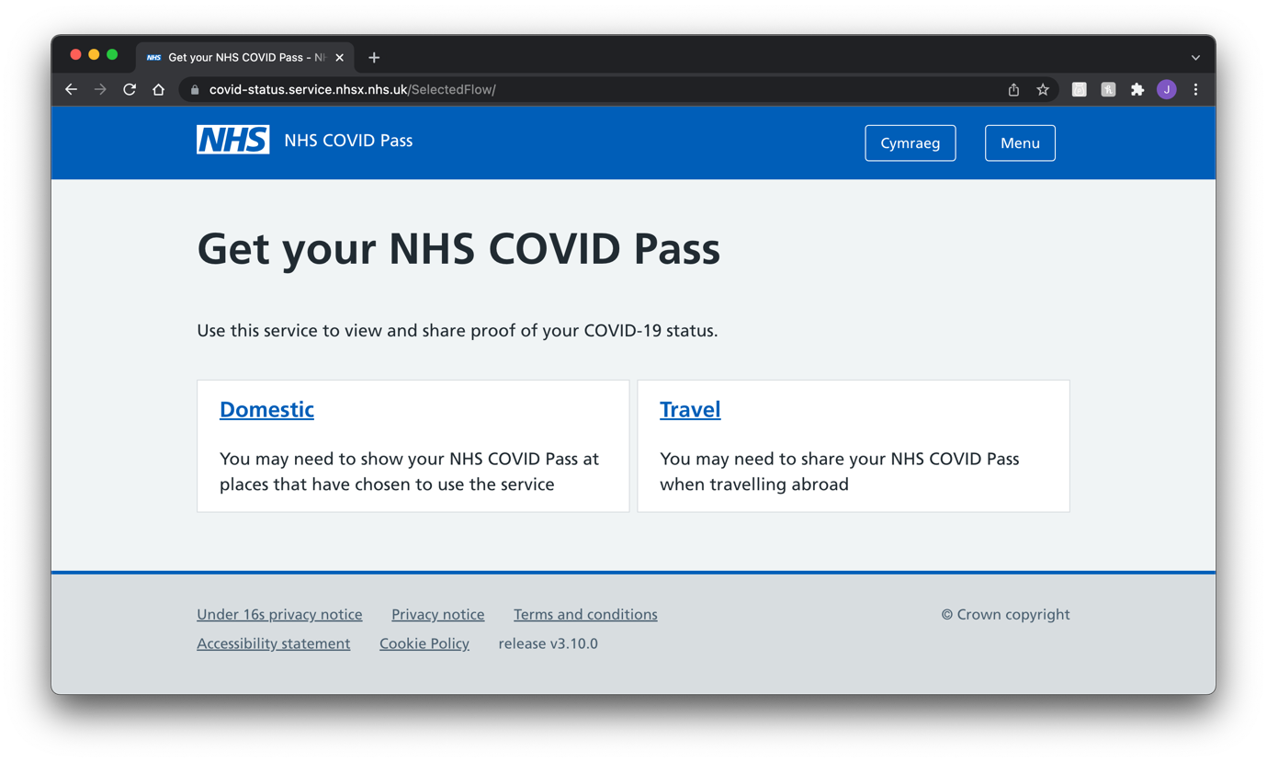
The next page shown below is the COVID pass menu for domestic use. The design for this page is simple and easy to understand and interpret, though it does have its issues regarding wasting space and relying too much on black space to fill the page.
For example, the bottom buttons could have been placed on the left-hand side, while the COVID pass could have been placed on the right, taking up more space.
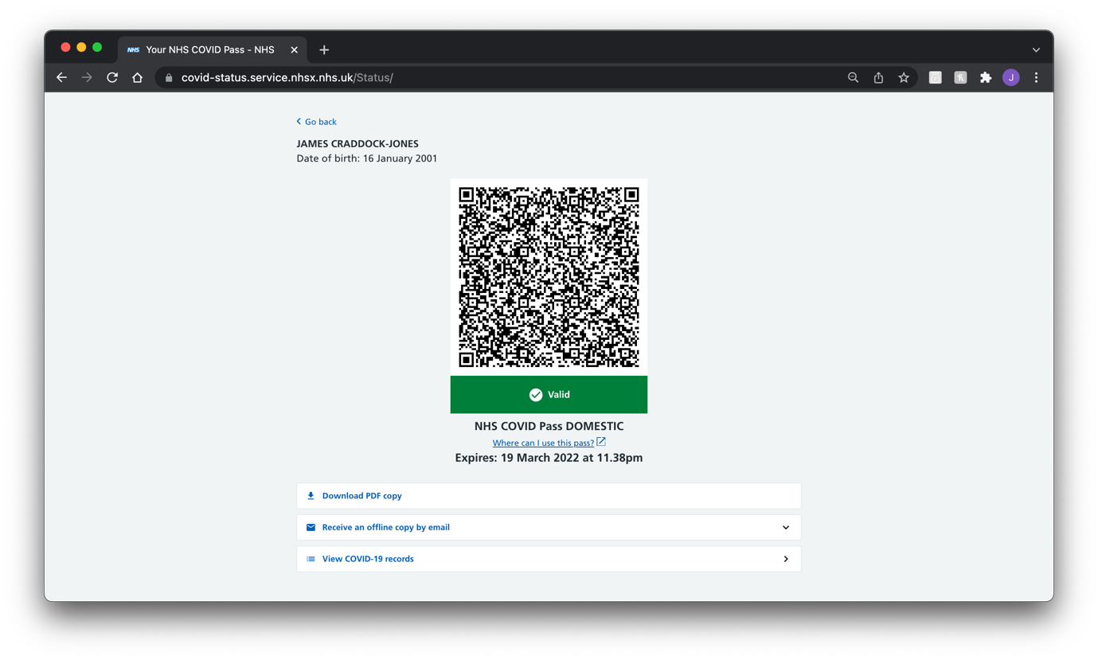
The following menu provides the user with their COVID-19 records. For example, vaccinations that they have been administered. This menu uses a simple design that can come across as simple to the user and hides the data that could overwhelm them by default, such as batch numbers.
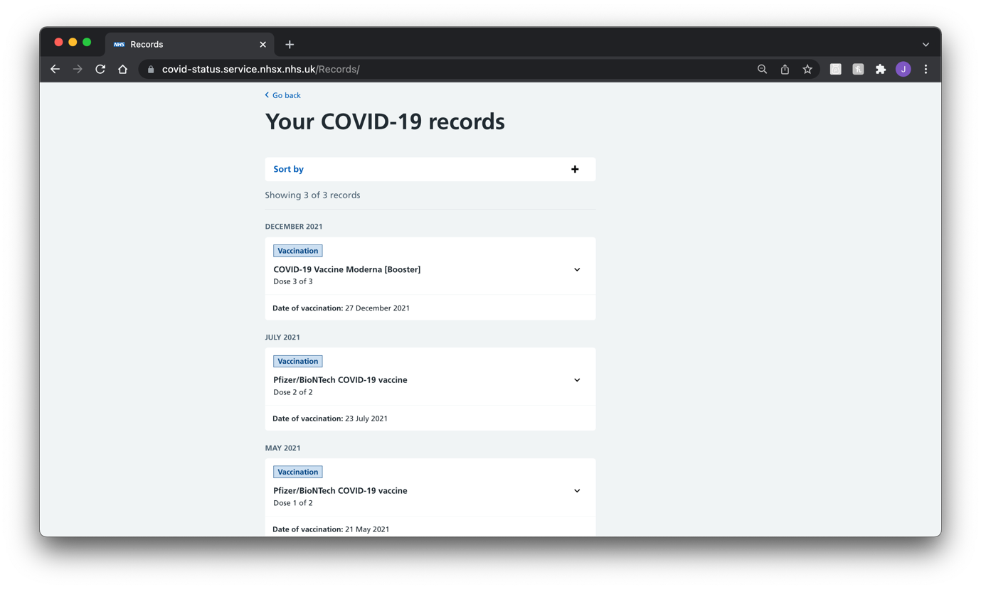
The following two menus are related to international travel. This could have been designed significantly better by having one QR code that can bring up the records of all COVID vaccinations. This could have been done rather than having to have one QR code for each vaccination, thus drastically simplifying the process for the user.
Doing it this way would have also allowed for the same design as the domestic pass, allowing for better usability through the user remembering design cues, simplifying the learning curve.
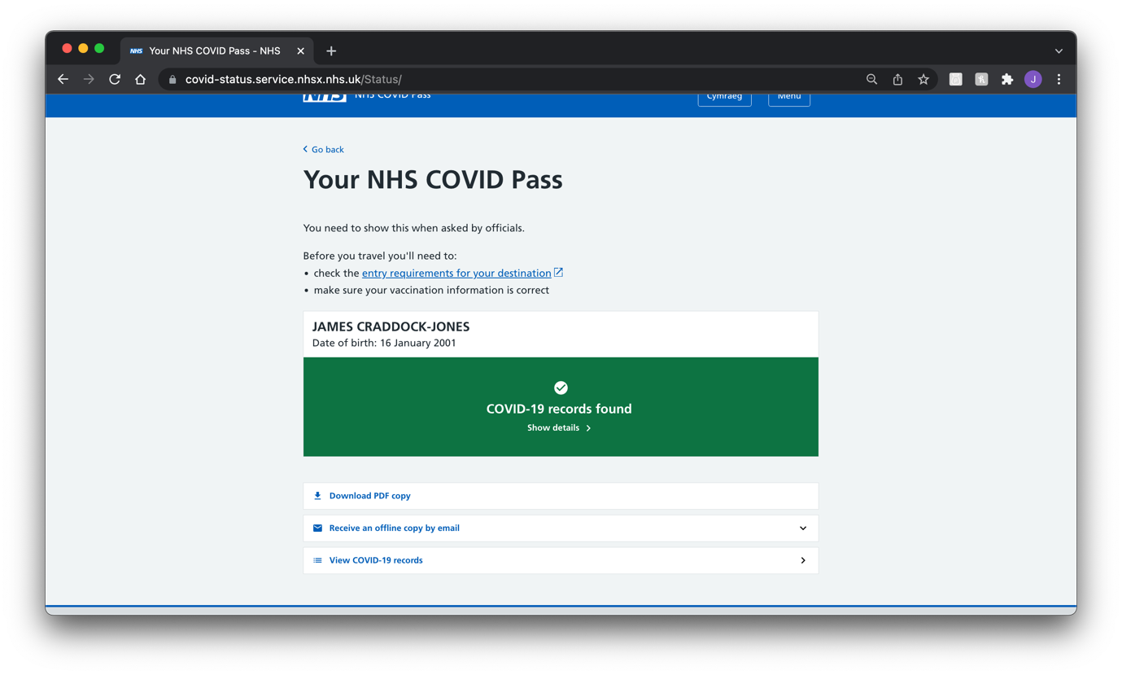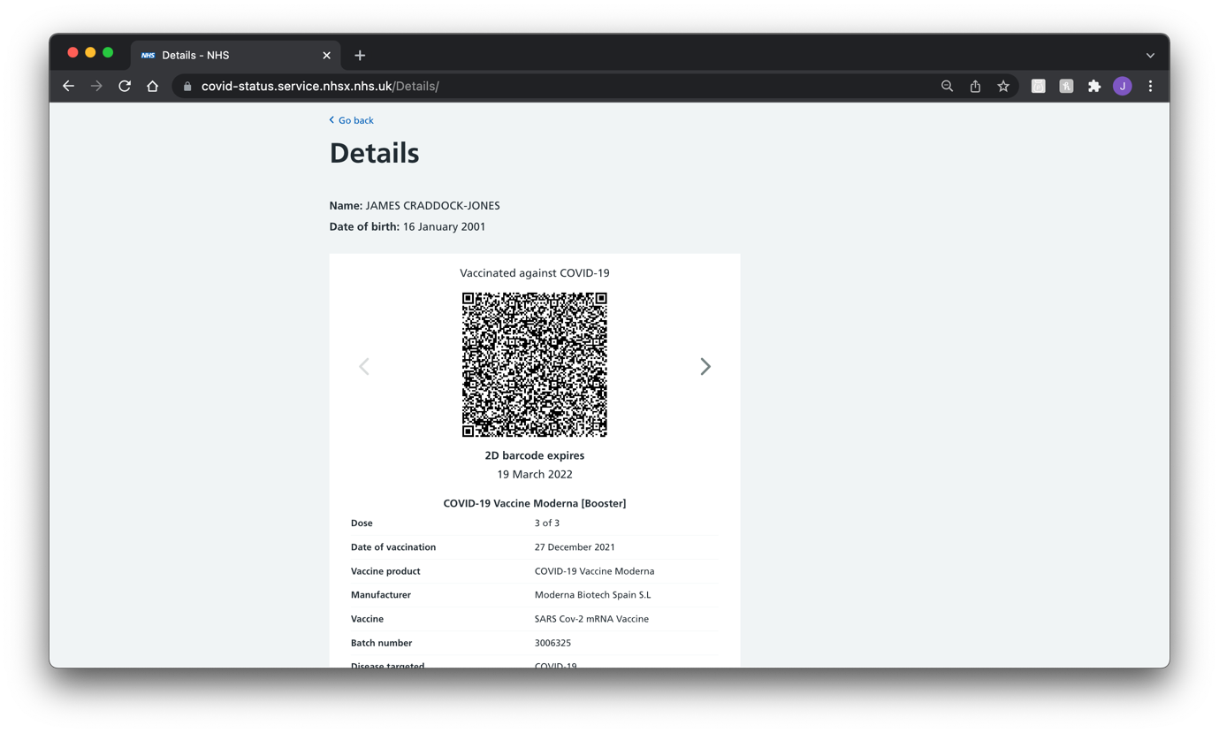

Other Systems Around the World
One system is the EU Digital COVID Certificate. This can be found across all European countries. The advantage of this system is that it is recognised as valid across the whole EU while also providing services in English and other languages that nationals may also use. (1)

Like the UK COVID pass system, this system also provides a QR code as the primary verification method. In addition, this system is also recognised around the world like the UK system making it easy to use around the world when travelling. (1)

This pass also covers people who recently had COVID or have recently had a negative test. This pass is given out free of charge to anyone within the EU whose country supports the system. (1)
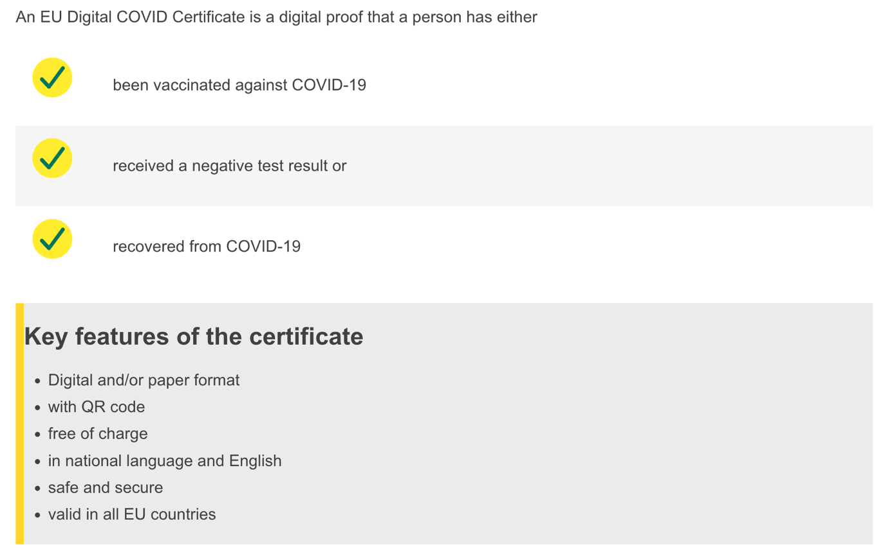
(1)
Everyone who is an EU national or is living within a member state is entitled to a COVID pass through this system. Like the UK system, only children over the age of 12 can apply for a pass. (1)

Below is how the system’s QR codes work and validate the QR code against the different signatures that venues have been provided.
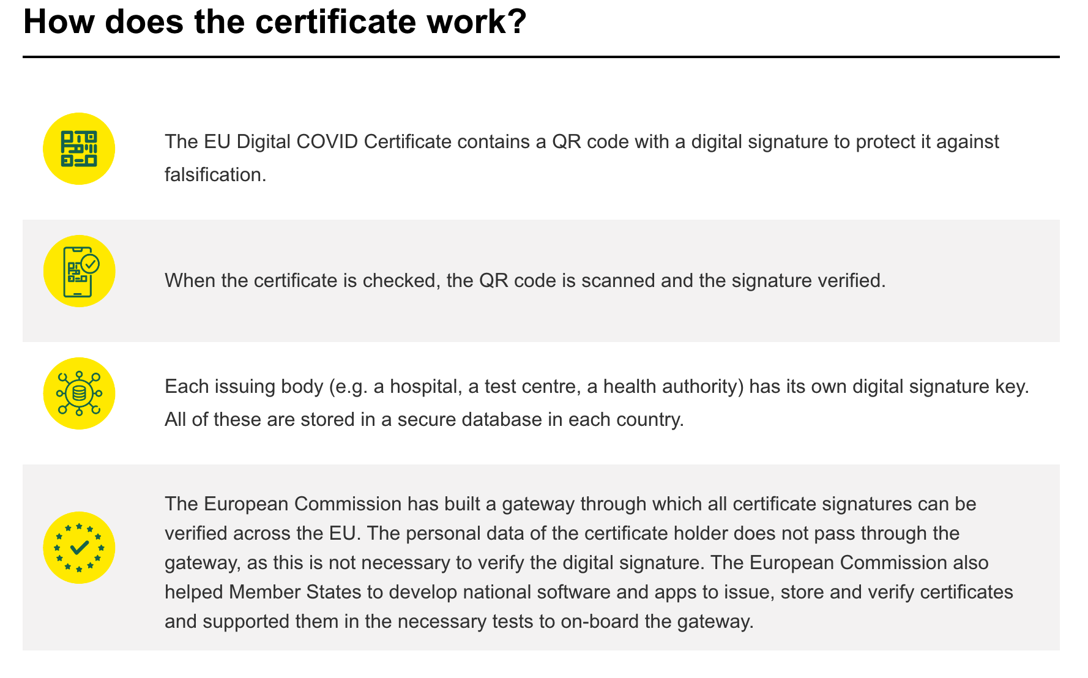
(1)

New System Design

Target User Group

Who are the target user group?
Due to COVID passes being used in pubs, clubs, theatres and other public venues in Wales. It is safe to assume that the target audience for the system would be young adults (16-21) to adults of an age range from 22 up to mid to late 30. These tend to be the age ranges that use venues listed, such as theatres, pubs, and clubs.

What are the requirements of the target user group?
From the observation that has taken place, I have found that the user would like a more streamlined experience when using the system. For example, a more basic design is clear to understand with all the required information on demand.
In addition, I have found that they would like the new design to be more polished in that all menus follow the same design principles to allow for the design to be easier to learn. The current design does not do this well enough and is confusing due to its rushed appearance.

Human Factors within Design

Visual Perception
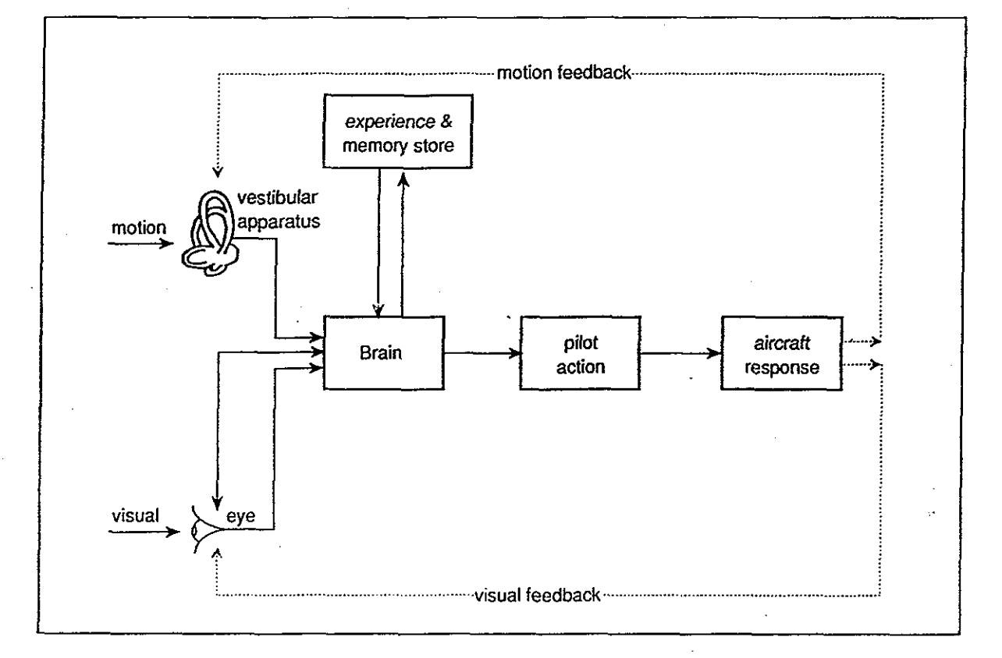
(3)
Visual perception involves gathering information from the eyes, for example, motion and light. The eyes have three processes that are involved with adaptation, one being the adjustment of light via the pupil expanding and contracting in different lighting conditions, another being the intensity of light, and the third being two mechanisms that occur with the rod and cones within the retina of the eyes to preserve light and the many different colours. (3)

Visual perception also includes calling from memory past experiences with the combination of learning and expectation, and this is “well reflected in the popular saying that one sees what one expects to see.” (3)

The following stages, pilot action and aircraft response, deal with the response to the stimulus, for example, twisting a door handle and pulling the door towards you to open it or pushing a door. (3)

The intended design of the new system will make sure that elements of the GUI are recognisable to the user from the real world and or other GUI designs to help the user quickly learn how the new system works. This would mean, for example, making the buttons look like different button GUI designs and the same for input forms so that the user recalls what to do from memory and past experiences.
Human Memory 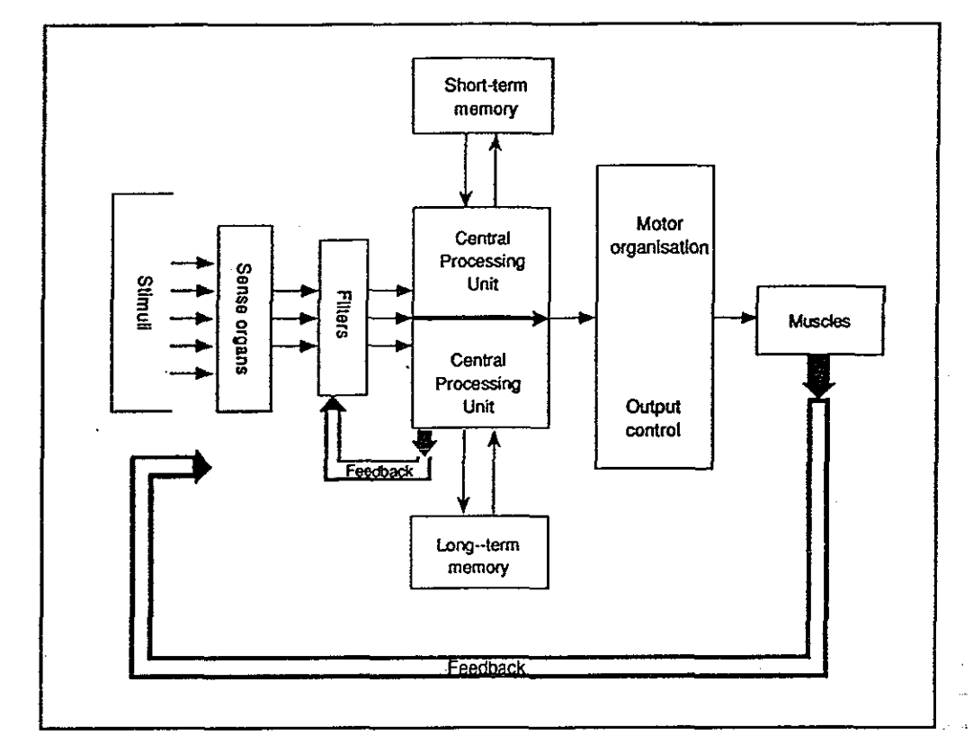
(3)
Memory is the most vital key to any human information system, with no system being able to process without it. The downside to human memory is that it is a limited resource and must be treated like that when designing a user interface. An overly complex system can easily overwhelm the memory system within the human brain. (3)

There are two types of human memory, which can be trained to be further improved. One is long term memory which is the retention of information over a long period, for example, a few weeks, months or even years. While on the other hand, short term memory only lasts if needed and fades away over a short period when no longer needed. (3)

This ties somewhat into visual perception, so the same will be done to combat this in the design like that, so making sure that elements of the GUI are recognisable to the user from the real world and or other GUI designs to help the user quickly learn how the new system works.

Human Reasoning
Human reasoning allows individuals who are characterised by their ability to think instinctively, without any constraints, and in a manner that any critical piece of information might be analysed by using logic to obtain a more comprehensive understanding. (4)

People can get information by accumulating facts or figures, comprehending them, and then determining whether they are right or wrong through their ability to reason. In a nutshell, reasoning is any procedure that encompasses reaching a judgment based on a combination of facts. (4)

Throughout the design, this will be incorporated in many ways. For example, taking design cues from other designs allows the user to recall from existing knowledge gained elsewhere and repurpose that with minimal learning curves.

This could be taking design cues with how elements such as buttons or menus are laid out or placed on the GUI and colours schemes for such elements.

Interface Metaphors
Interface metaphors are a collection of GUI actions, images, and procedures that take advantage of the users' prior understanding of similar interface designs they may have used. (5)

The goal of interface metaphors is to give the user immediate knowledge about interacting with the user interface. They are made to look like tangible things, but they also get their characteristics. A computer desktop or a web gateway are examples of this. (5)

Interface metaphors can be based on an action, an item, or a mix. They can communicate with the users existing experience to help them grasp the unknown. (5)

Examples are the floppy disk representing save in applications and the graphical icons for files and folders that help symbolise a computer’s file system. (5)

Like human reasoning, the same can be applied to the design by incorporating design cues from other GUI designs. For example, taking design cues from different designs allows the user to recall existing knowledge gained elsewhere and repurpose that with minimal learning curves.

Affordance
Affordance refers to the relationship between someone’s understanding with a physical or electronic entity. Affordances in a graphical interface are perceivable, actionable possibilities. (6)

Users see a graphical interface and conclude which activities are available based on expectations and prior experiences using other GUIs. (6)
Throughout his publication, The Design Of Everyday Things, Don Norman, an expert within human-computer interaction research, Don wonderfully outlines the significance of affordances within graphical interfaces. “When affordances are taken advantage of, the user knows what to do just by looking: no picture, label, or instruction needed.” (6)

To make the design comply with this design factor, the new system’s design will make elements such as buttons stick out to look obvious that they are clickable like real-life buttons.

This will be hard to do with the current modern styling of flat objects/colours, unlike almost a decade ago when skeuomorphic GUI design was still a trend before changes to design were made in operating systems like iOS 7 and Windows 8.
The below image shows this shift in GUI design with iOS 7 (left) vs iOS 6 (right).
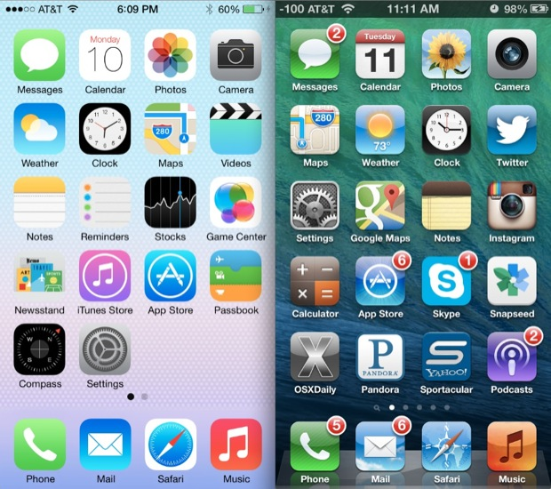
(7)
In addition, the Windows 8 start menu vs Windows 7 start menu shown below.
Windows 8:

(8)

Windows 7:

(9)

Walkthrough and Review of Paper Prototype

Paper Prototype
Below is the paper prototype that was shown to Aaron for feedback on how it could be improved. Where helpful, a page number has been placed next to clickable objects such as buttons that correlate with the page number on the top left-hand side.

Main Menu
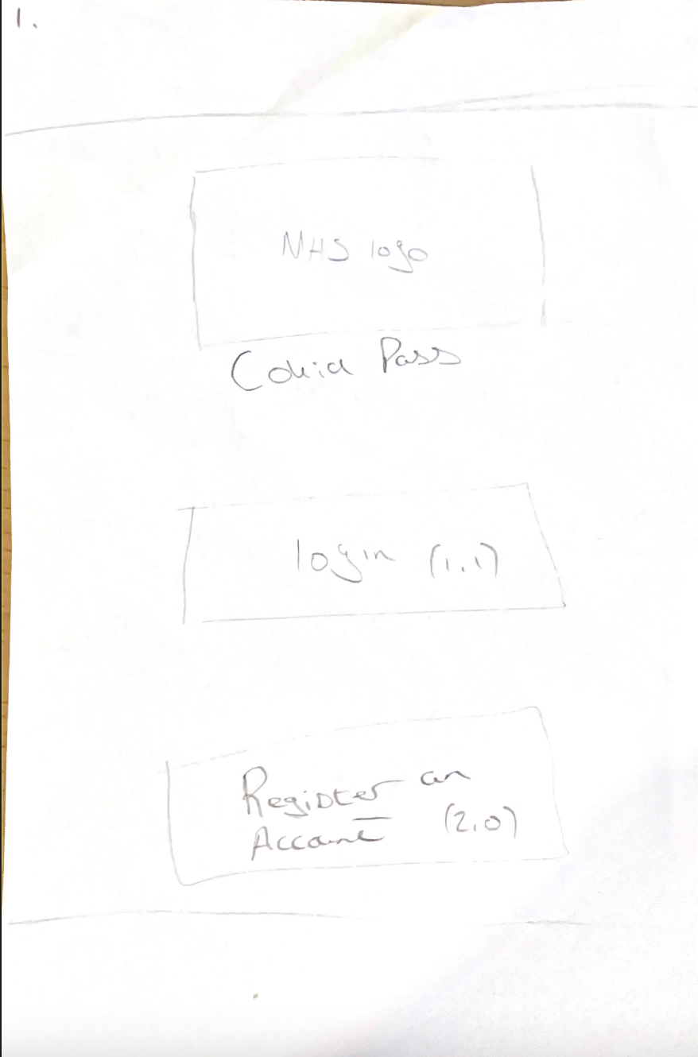

Login
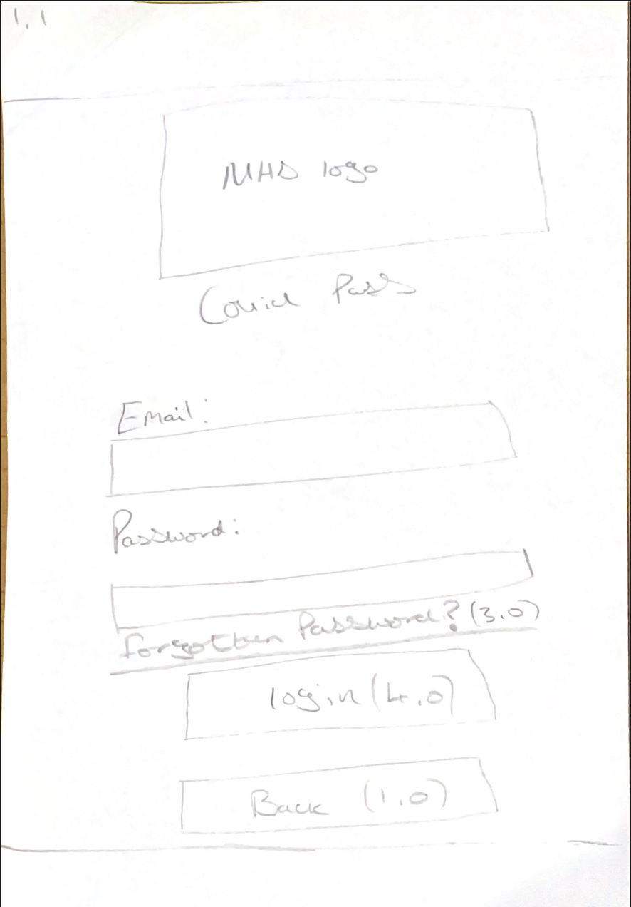

Register an Account
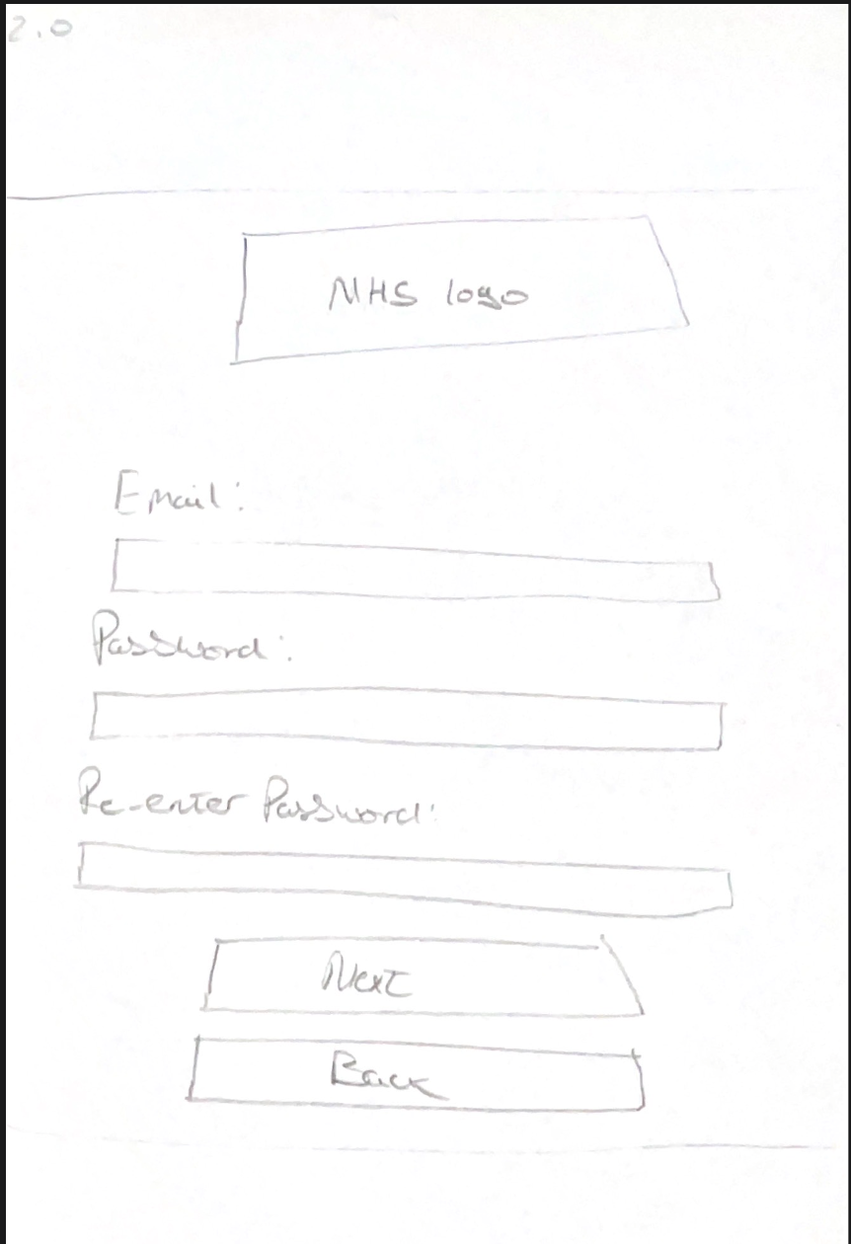

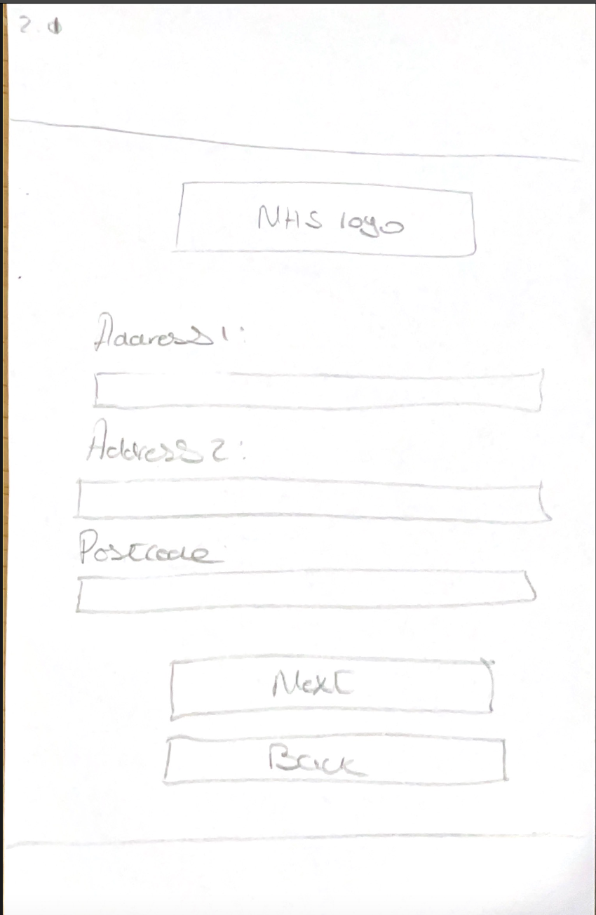
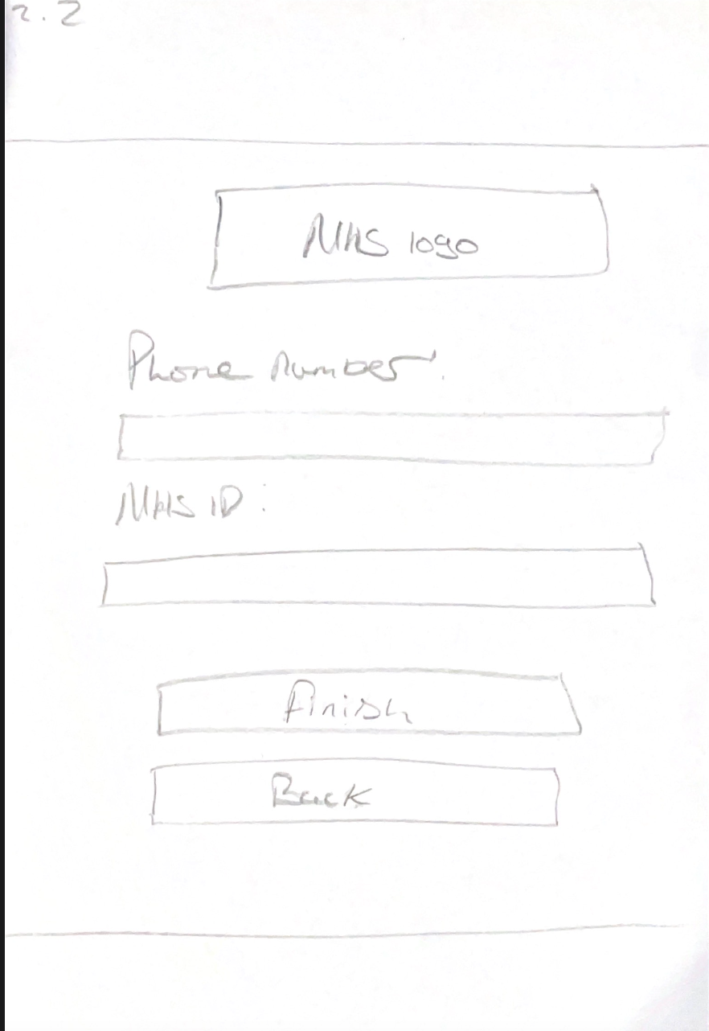

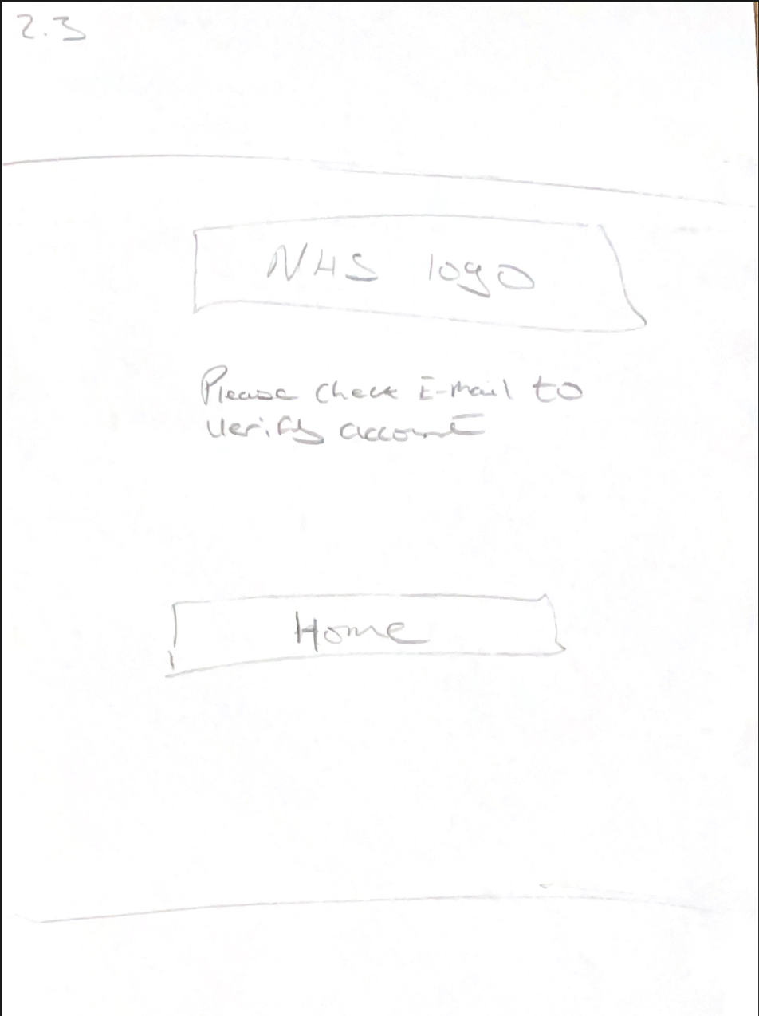

Forgot Password
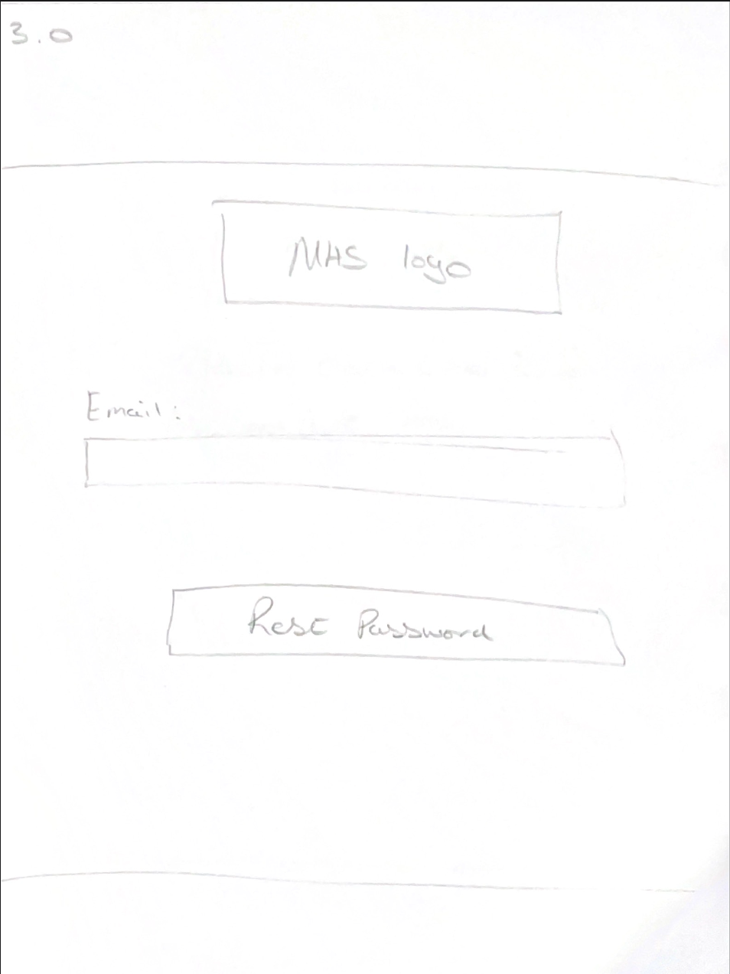
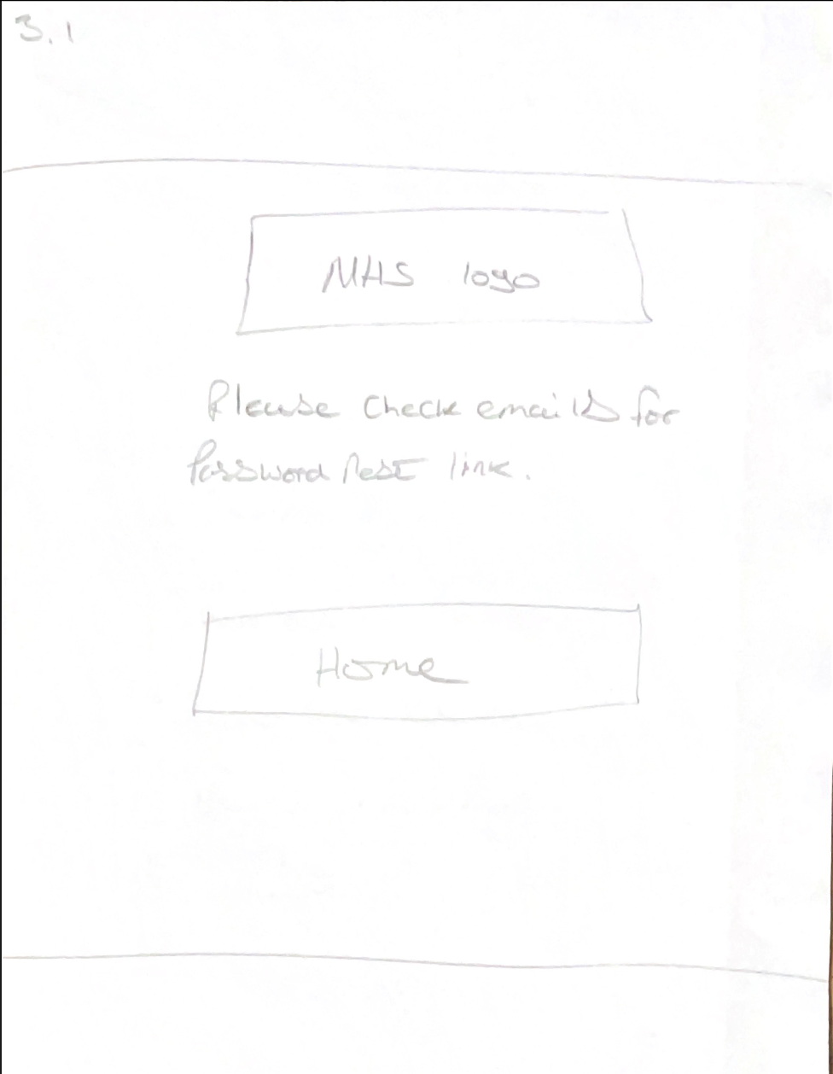

Home Menu
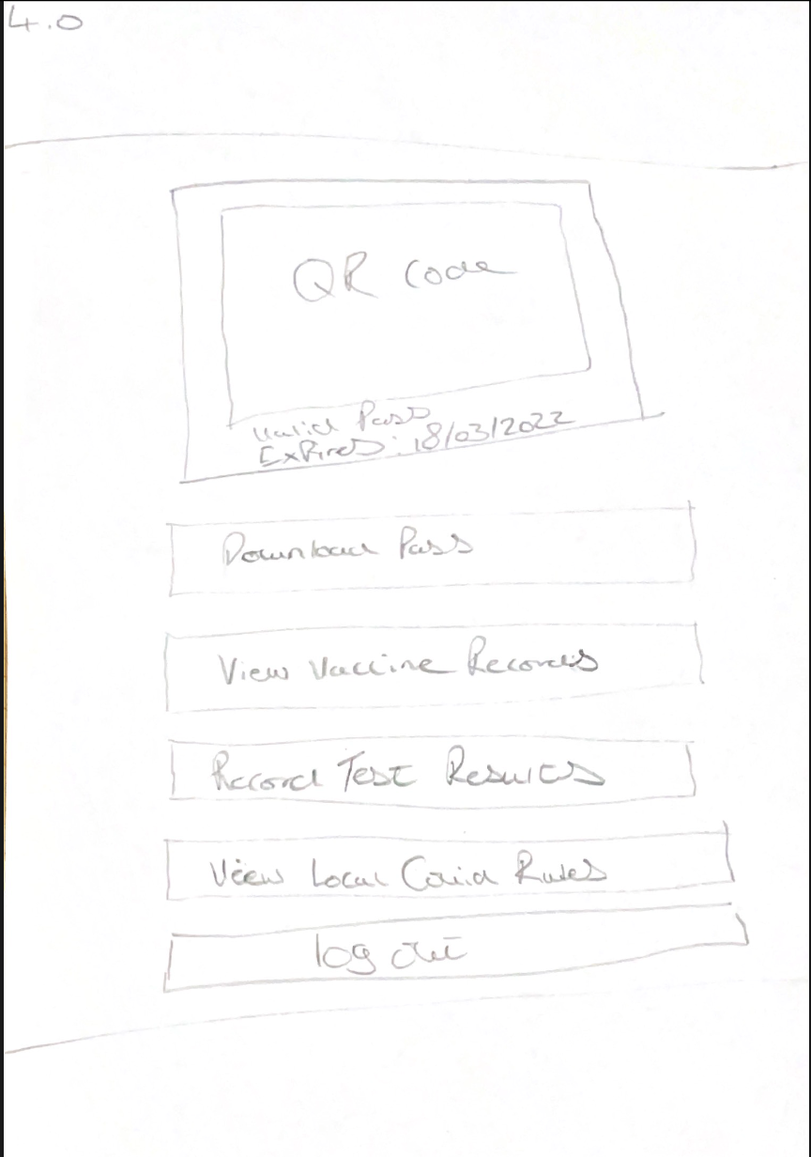

Results from Prototype Review

Results
See Appendix A for feedback.

Feedback To Aaron
I provided the whole feedback to Aaron can be seen in Appendix C. The summary of the feedback that I provided to Aaron is that the design applies many human factors—for example, taking design cues from other systems.
In addition, he has kept the design minimal and consistent throughout, so it does not overwhelm the user when they are using the system.
The design fell apart with the location of the back buttons not being in an ideal place (top right side of the menu), making error prevention for the user a little cumbersome.
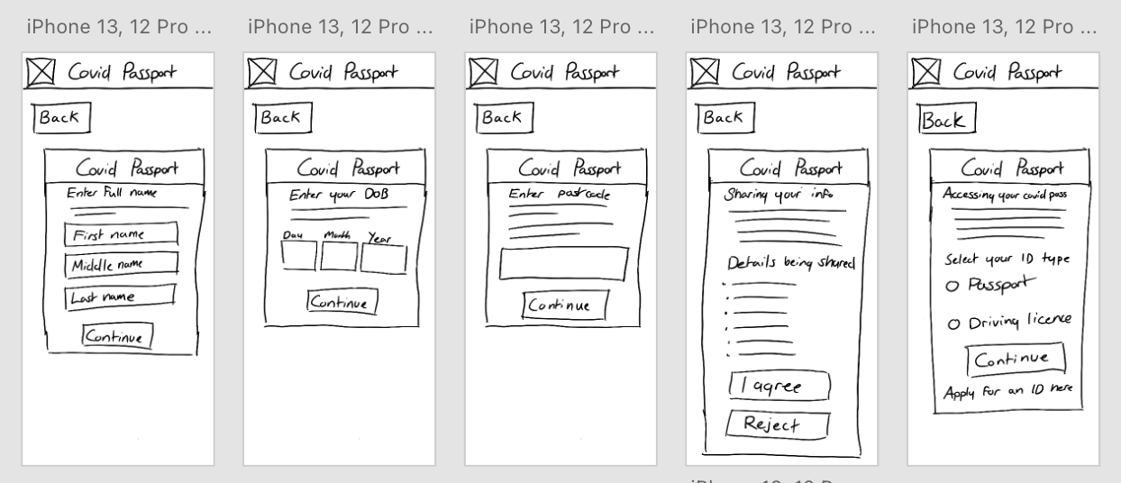

Furthermore, there was no processing menu within the design, meaning the user would not be notified of system status when loading or processing data.

Changes made to design
The design will now show a little message under the NHS logo telling the user what process they are going through to know where they are and what they are required to do.

A processing message will be displayed as and when needed. For example, when completing the registration steps, providing COVID test data, booking a booster dose, and loading vaccine data from the NHS database.

One area in which is disagree with Aaron on is the main menu. I believe that designing it in the way Aaron has recommended might cause confusion and make the login menu much more complex than it needs to be.

New System Development
System HTA
Below is the system HTA, which serves as a task analysis for what the system will do once complete. This includes the processes and temps on handling logins and registers, booking boosters, uploading tests results, viewing local restrictions, viewing vaccine records, and providing test results.

Due to its size, the HTA diagram will be included with this document.
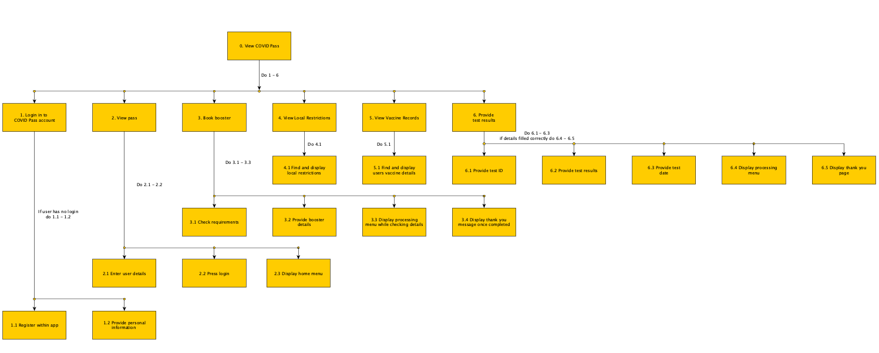

System Design

Main Menu
Below is the main menu that greets the user when they open the app for the first time. Here the user can choose to set up an account, login into an existing account, and change language between English and Welsh.
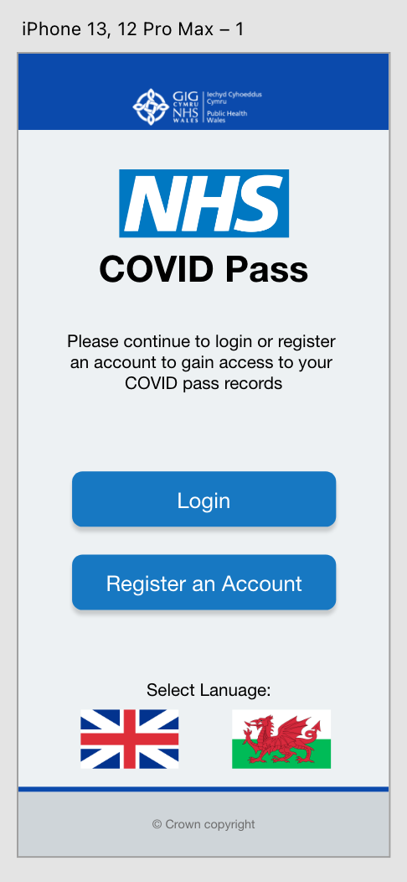

Register an Account
Below is the process that the user will go through when creating an account. The user will provide their complete address details, email, password, phone number, and NHS ID to verify the account against existing NHS records.

A processing menu will be shown when the user presses the finish button to display the system is processing the data they have provided.
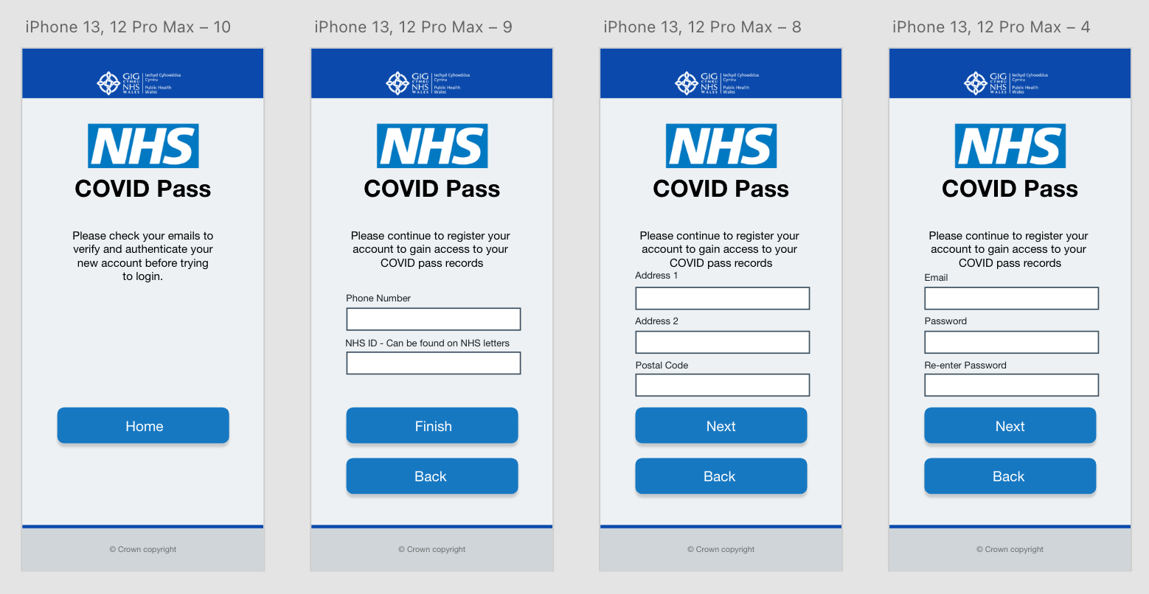

Login
Below is the design for the login menu. The menu requires the user to input the correct account details to progress onto their account’s home menu. This menu also provides a little link that takes the user to a menu to reset their accounts password.
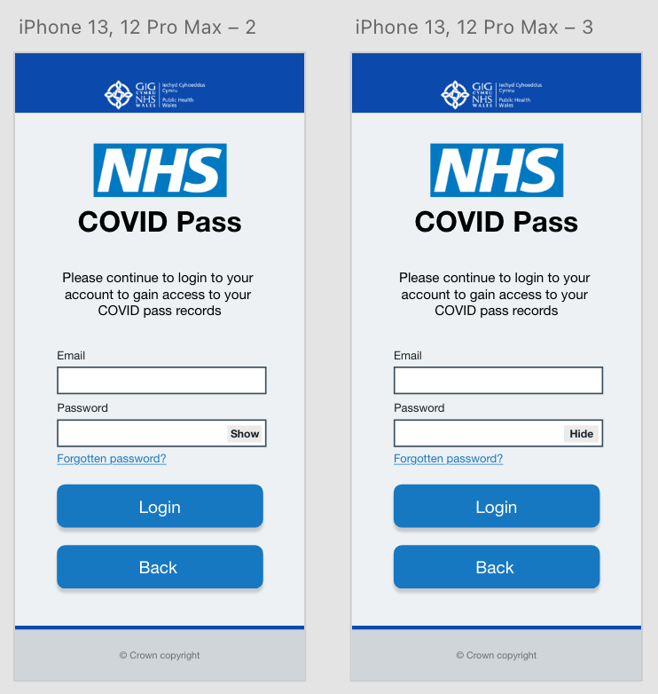

Forgot Password
Below is the menu that has been designed for requesting a password reset. The user must provide their account’s email. The processing menu will be shown here when pressing the “Send Rest Request” to show the system is processing the request.
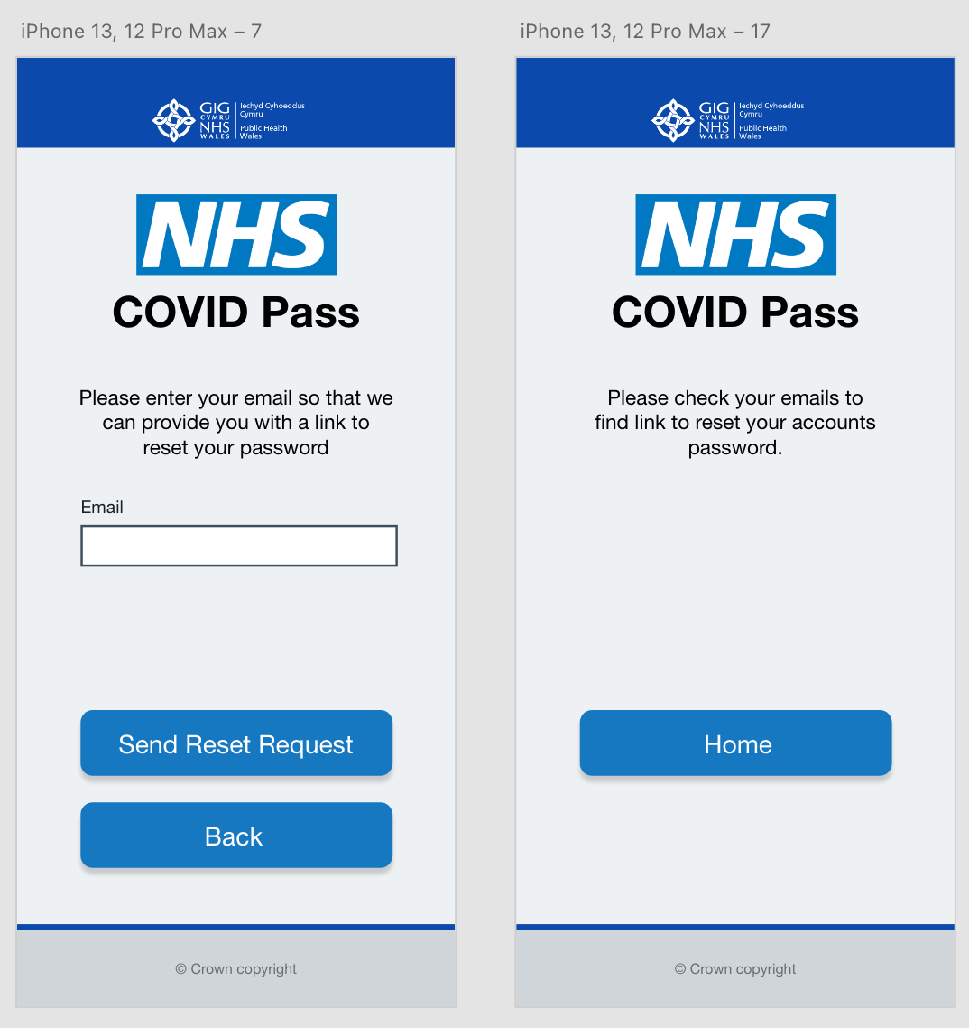

Home Menu
Below are the various home menus that can be shown to the user depending on certain variables. For example, if the user has not received their booster, they will be shown the interface on the far-right. If they are fully vaccinated, the middle menu will be shown, and the far-left menu will be shown if they have downloaded their pass.

This menu also provides access to the rest of the system regarding vaccine records, local restrictions, and recording COVID test results.
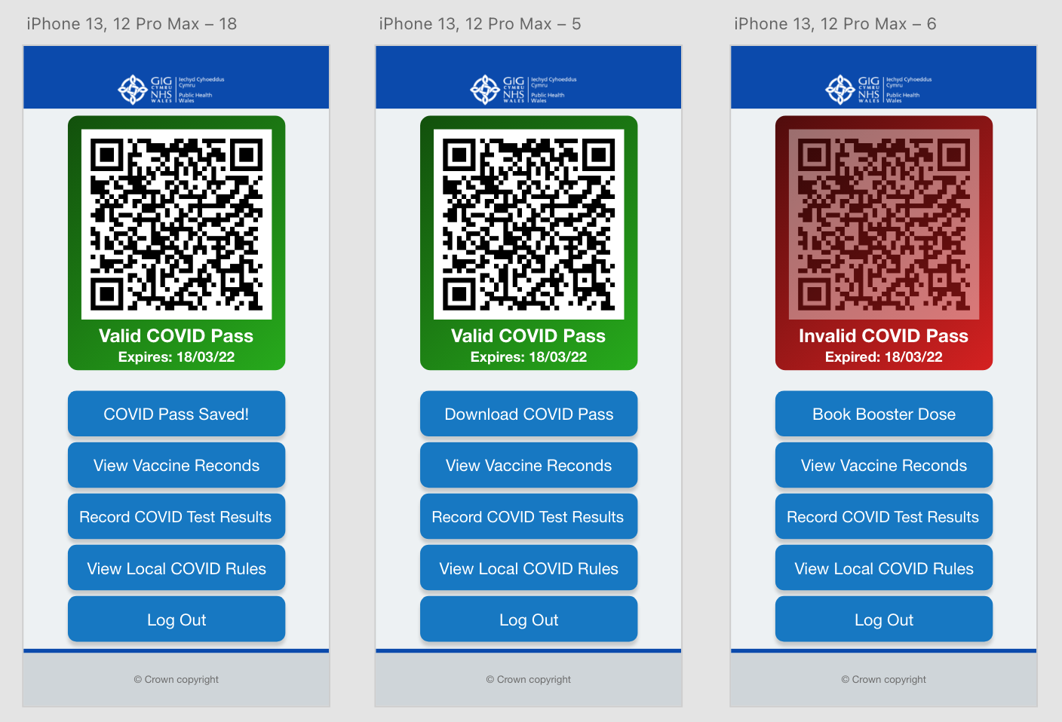

Book Booster Dose
Below is the menu which will be used to book booster doses if the user has not received any. The user will be required to enter a date, region and venue for the booster. The processing menu will be shown between the booking and thank you pages.
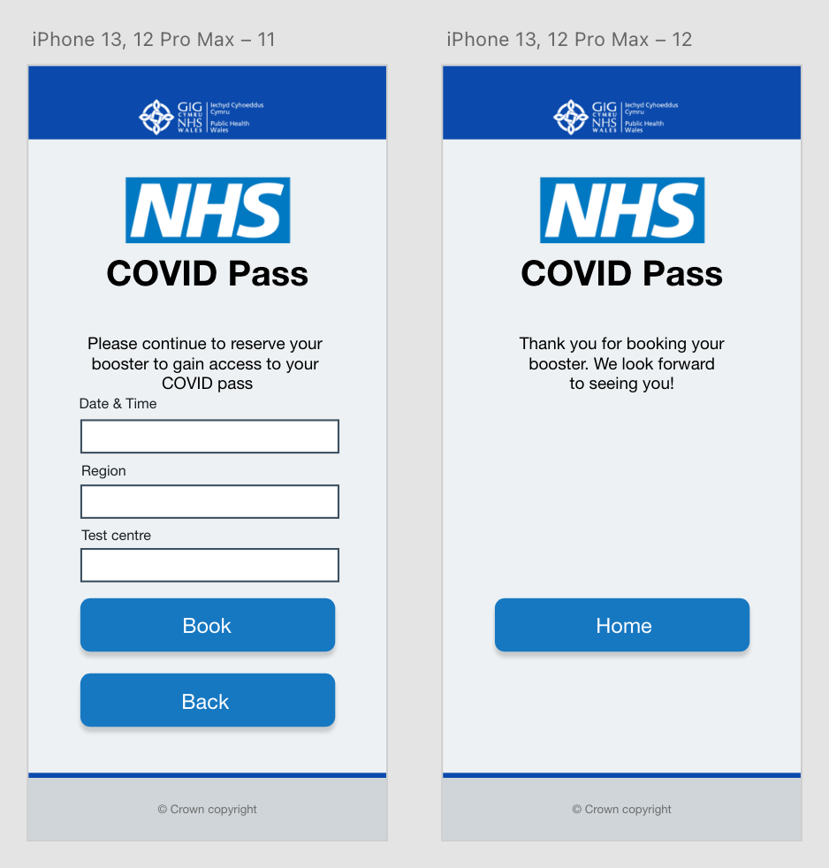

Record Test Results
Below is the menu which will be used to record COVID results. The user will be required to enter the test result, test ID, and the date the test was done. The processing menu will be shown between the recording and thank you pages.

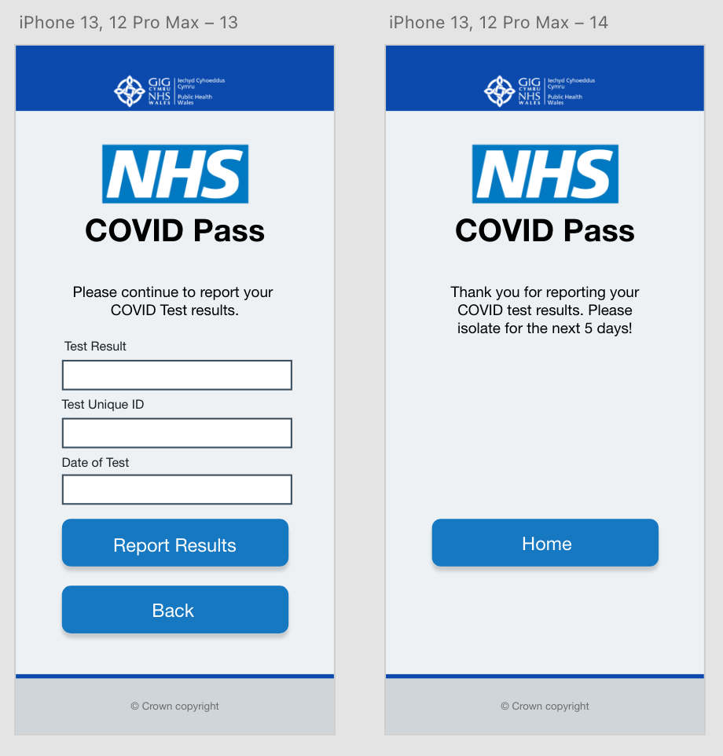

Local Restrictions
Below is the menu that handles the local restrictions. The user does not have to do anything here as the system handles that for the user.
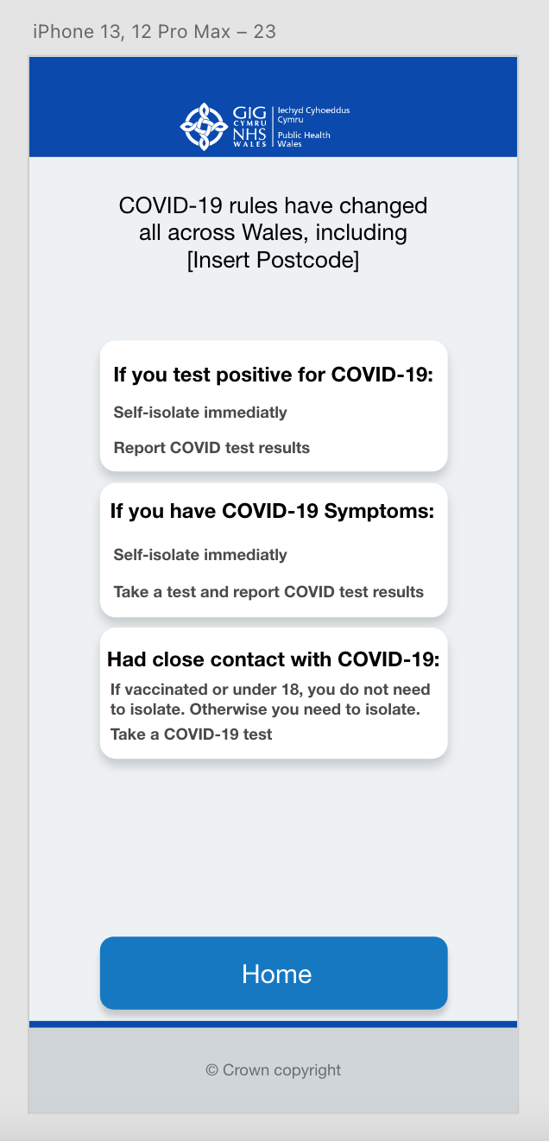

Vaccine Records
Below is the vaccine records menu. This menu provides the user with information regarding how many doses they have received, the date they received them, and the vaccine manufacturer.
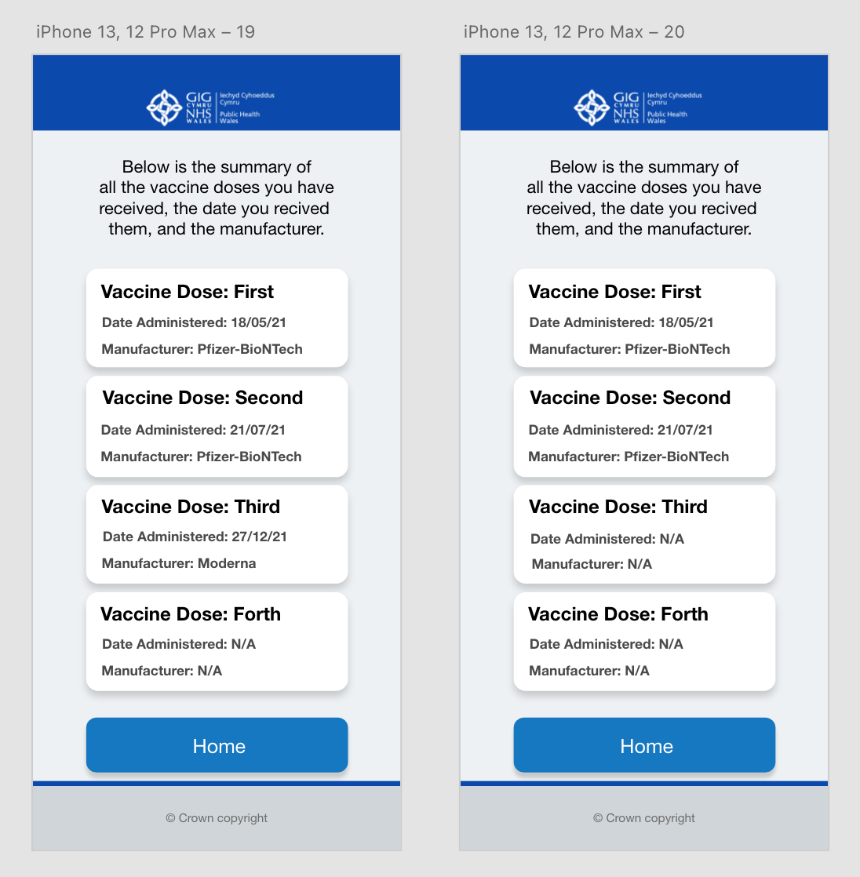

Processing Menu
This is the processing menu shown to the user when the system is processing data.
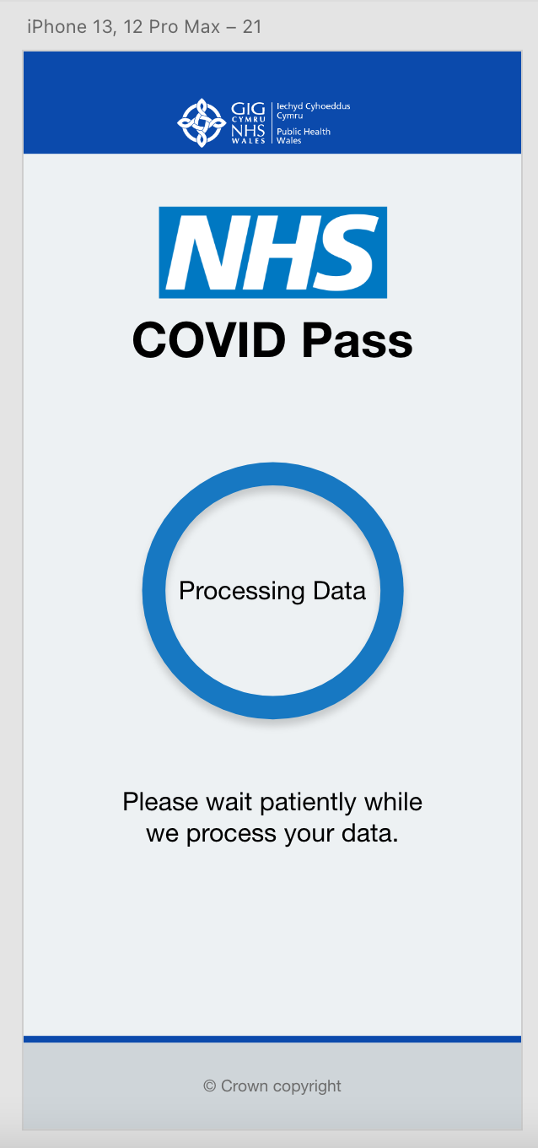

Evaluation of System Design
I have relied on the user’s recall throughout the design by using a similar design to the standard NHS website. This allows the user to use human reasoning and interface metaphors to recall their experience using the NHS website and apply it to this application.
One change was made to this with the buttons. This was done so that the colour pallet could be simplified by different shades of blue, rather than making the buttons an entirely different colour as the NHS website does with buttons being green.

The downside to doing the buttons like so was that recall could not be used here from the NHS website, but to help the user know they are clickable and to bring in some affordance, a drop shadow was applied to all the blue buttons to distinguish them from the rest of the GUI. This also helped the button look more like a real-life button as the drop shadow applied depth.

One area which can be improved is the local restrictions menu. I say this because the design is not best suited to the amount of information needed to be displayed to the user. The design is very cramped and restricted in the amount of detail provided to the user.

I designed the local restrictions menu this way so that recall could be used from the vaccine records menu, but instead, it has caused an issue with the amount of information that could be provided at a given time.

There are advantages and disadvantages to registering an account with this system. The advantage and disadvantage are that the system uses people’s unique NHS ID to register an account. While doing it this way simplifies the process, it makes it harder for those who do not know their NHS ID to sign up and use the application.

When viewing vaccine records, the design is simple and straight to the point as all the information that the user requires is displayed clearly in an understandable format. The information provided has been simplified compared to the current system so that the user does not get overwhelmed by all the information.

This menu and the local restrictions menu will require some human reasoning to use, given that the design is somewhat different from the rest. Although, it is not different enough that the user will struggle to adapt and use the GUI.
The message shown at the top of most menus allows the user to know the system’s status, allowing the user to know where they are at a given time and what is required from them. The processing menu also provides them with the crucial information that the system is loading and has not crashed.

References
- European Commission, EU Digital COVID Certificate, https://ec.europa.eu/info/live-work-travel-eu/coronavirus-response/safe-covid-19-vaccines-europeans/eu-digital-covid-certificate_en Date of Access: 03/02/2022

- Welsh Government, Get your NHS COVID Pass, https://gov.wales/get-your-nhs-covid-pass Date of Access: 03/02/2022

- ATC Training, Human Factors Training Manual, https://www.globalairtraining.com/resources/DOC-9683.pdf Date of Access: 10/02/2022

- Brice Foundation, Human Reasoning and Ethics, https://www.bricefoundation.org/single-post/2019/03/25/human-reasoning-and-ethics Date of Access: 17/02/2022

- The Audiopedia, What is INTERFACE METAPHOR? What does INTERFACE METAPHOR mean? INTERFACE METAPHOR meaning, https://www.youtube.com/watch?v=L5n3CDnyk5o Date of Access: 17/02/2022

- N. Babich, What Is Affordance and How Does it Impact Design?, https://xd.adobe.com/ideas/principles/web-design/what-is-affordance-design/ Date of Access: 24/02/2022

- OSXDaily, iOS 7 vs iOS 6 Side-by-Side Visual Comparisons, https://osxdaily.com/2013/06/11/ios-7-vs-ios-6-visual-comparison/ Date of Access: 24/02/2022

- M. Stanojevic, Windows 7 vs. Windows 8 comparison: Old meets new, https://windowsreport.com/windows-7-vs-windows-8/ Date of Access: 24/02/2022

- L. Hoàng, Windows 7: Disable Highlighting New Programs in the Start menu, https://www.tech-recipes.com/rx/21773/windows-7-disable-highlighting-new-programs-in-the-start-menu/ Date of Access: 24/02/2022

Appendix

A: Feedback of Design From Aaron

Visibility of system status
Severity score out of 5:
1 | 2 | 3 | 4 | 5
Reasons why: The buttons which are labelled with appropriate text help towards telling the user what the system may do, for example ‘LOGIN’ or ‘RESET PASSWORD’ other than that there are no indications of what the system is doing or processing.

Match between system and real world
Severity score out of 5:
1 | 2 | 3 | 4 | 5
Reasons why: The phrases and concepts used are very common practice which should provide enough for the design.

User control and freedom
Severity score out of 5:
1 | 2 | 3 | 4 | 5
Reasons why: Overall the control given to the user is clear and concise although, on the reset password page there is no way to navigate back a page, only reset the password button is present.

Consistency and standards
Severity score out of 5:
1 | 2 | 3 | 4 | 5
Reasons why: The design seems pretty consistent all the way through with a very vertical design that does fit the requirements of a phone screen well.

Error prevention
Severity score out of 5:
1 | 2 | 3 | 4 | 5
Reasons why: Although there are controls for going back a page which could help with error prevention, there are no warning screens present or windows present to notify a user if they would have entered some information wrong. Retyping the password for the account creation process is a good example of error prevention and is applied here.

Recognition rather than recall
Severity score out of 5:
1 | 2 | 3 | 4 | 5
Reasons why: Although the design minimises what the user needs to do on each page, it is important to remind the user what process they are going through, for example if they are creating an account, put a title or text suggesting what stage of the process they are at to help users not get confused.

Flexibility and efficiency of use
Severity score out of 5:
1 | 2 | 3 | 4 | 5
Reasons why: The design provides navigation tools which are consistently in the same position, all users would use this navigation easily. Possibly provide more ways of interacting with navigation for example swiping right on the phone would go back also.

Aesthetic and minimalist design
Severity score out of 5:
1 | 2 | 3 | 4 | 5
Reasons why: The design is very minimalistic and does well in not distracting the user will unnecessary elements.

Help users recognise, diagnose, and recover from errors
Severity score out of 5:
1 | 2 | 3 | 4 | 5
Reasons why: There are no error messages present in the current design, users can however use the back button to go back a step if need be.

Help and documentation
Severity score out of 5:
1 | 2 | 3 | 4 | 5
Reasons why: Additional documentation is not present but could be assumed that the process is so common and streamlined that the text on screen is enough for 99% of users.

Recommendations:
I feel that the first page in the prototype could be removed and a registration button be added to the login page which should remove one extra step in the process but may be beneficial to keep as this software is to be used by the general public which will have a wide range of skillsets and making the process simple to understand will help In the design.

B: Aaron’s Design
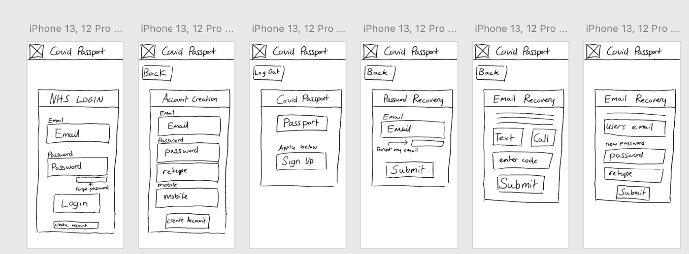

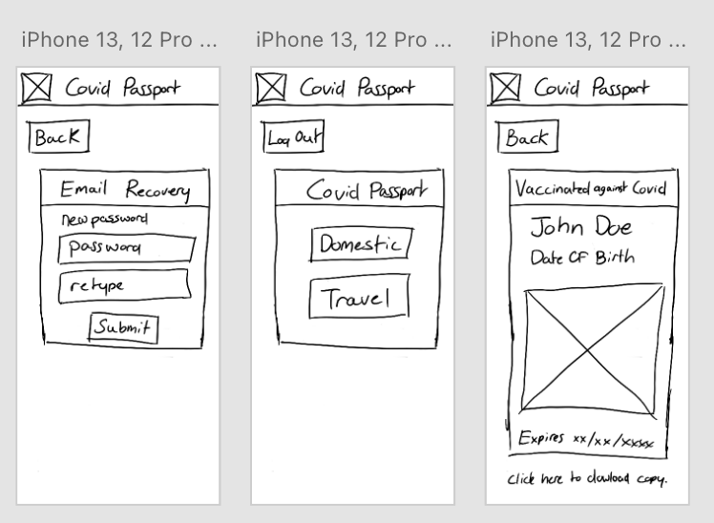

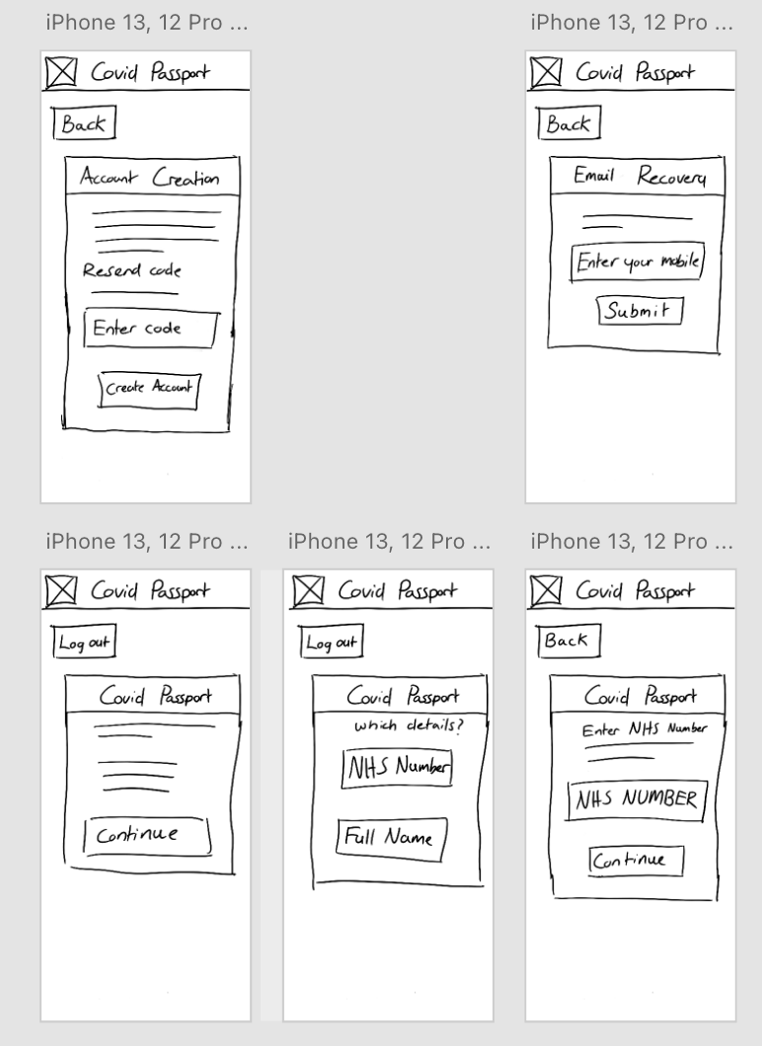

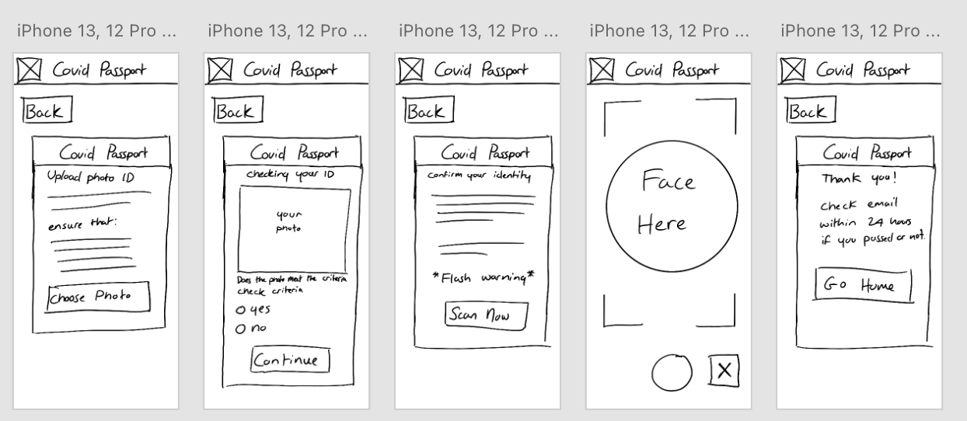

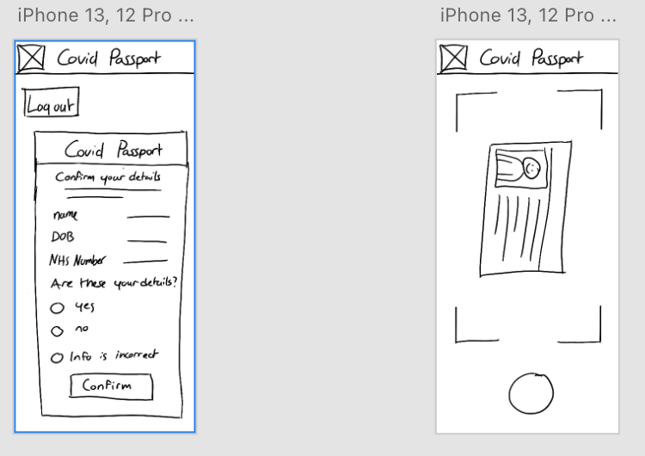

C: Feedback for Aaron

Visibility of system status – Score: 3
There are no loading screens to inform the user that the system is processing something in the background. the system on the other hand does provide the user with their location status through the many different menus.

Match between system and real world – Score: 2
The design makes use of buttons with a similar design to buttons in the real world.

User control and freedom – Score: 2
Back buttons need repositioning as they are not displayed in the most noticeable of areas at the first few glances

Consistency and standards – Score: 1
Design is consistent throughout the system.

Error prevention – Score: 2
As stated before, the back buttons are positioned in an area that would go unnoticed when for example, registering an account.

Recognition rather than recall – Score: 1
Design is consistent throughout the system and takes design cues from other GUI designs making it easier to use.

Flexibility rather than recall – Score: 2
The design provides shortcuts back to the home menu but does not provide back buttons in a suitable position when needed.

Aesthetic and minimalist design – Score: 1
Design is consistent throughout the system and takes design cues from other GUI designs making it easier to use. While also being minimalistic by showing the user only the required information.

Recommendations:
relocate back buttons to a more suitable location and add loading screens to show the user the system is processing something.

