DS 1 Assignment

My Screenshots/Photos

Screenshot/GOOGLE MAPS
[MAPS AND NAVIGATION]
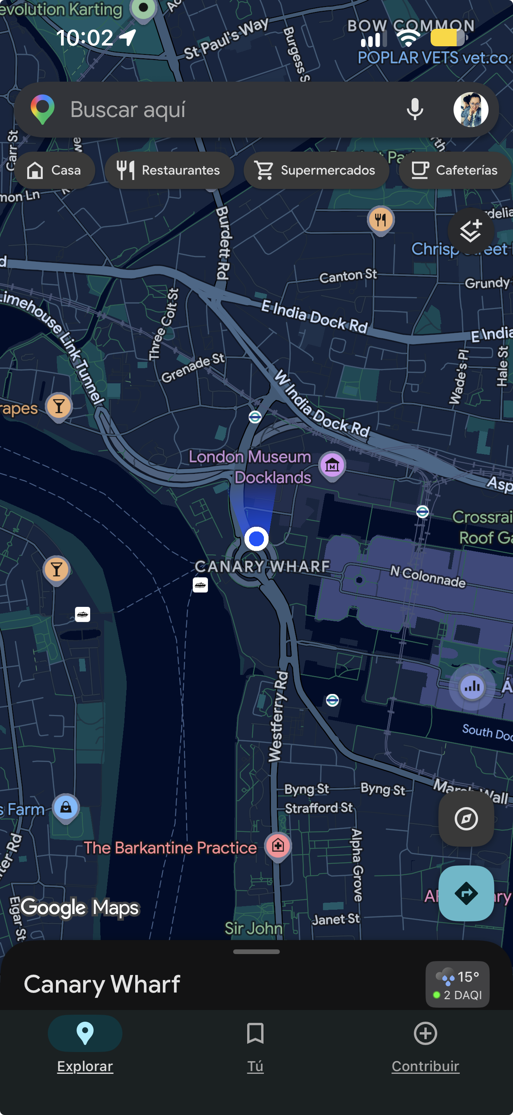
Google Maps helps us find our way in unfamiliar places and reach our destination safely and efficiently.
When I first arrived in this country, I relied on this app every day to avoid getting lost. It helped me travel from place to place with confidence.

Screenshot/TEAMS
[VIDEO CONFERENCING]
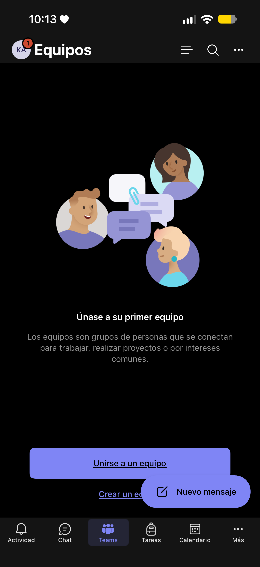
Video calls let us talk, study and work together from anywhere. We can share files and stay in touch while saving time and money on travel.
I learnt to use this app during the COVID-19 pandemic. As we couldn’t meet in person for safety reasons, I attended my work meetings by video call.

Screenshot/AMAZON
[ONLINE SHOPPING]
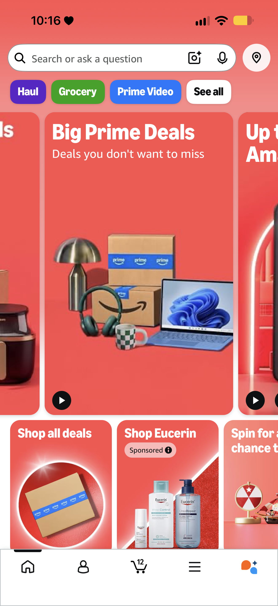
Online shopping lets us buy things from anywhere, at any time. We can compare prices and find what we need without going to a shop.
I started using Amazon when I moved to this country. I love it because I can shop online and have everything delivered to my door, without spending money on transport.

Screenshot/ICLOUD
[CLOUD STORAGE]
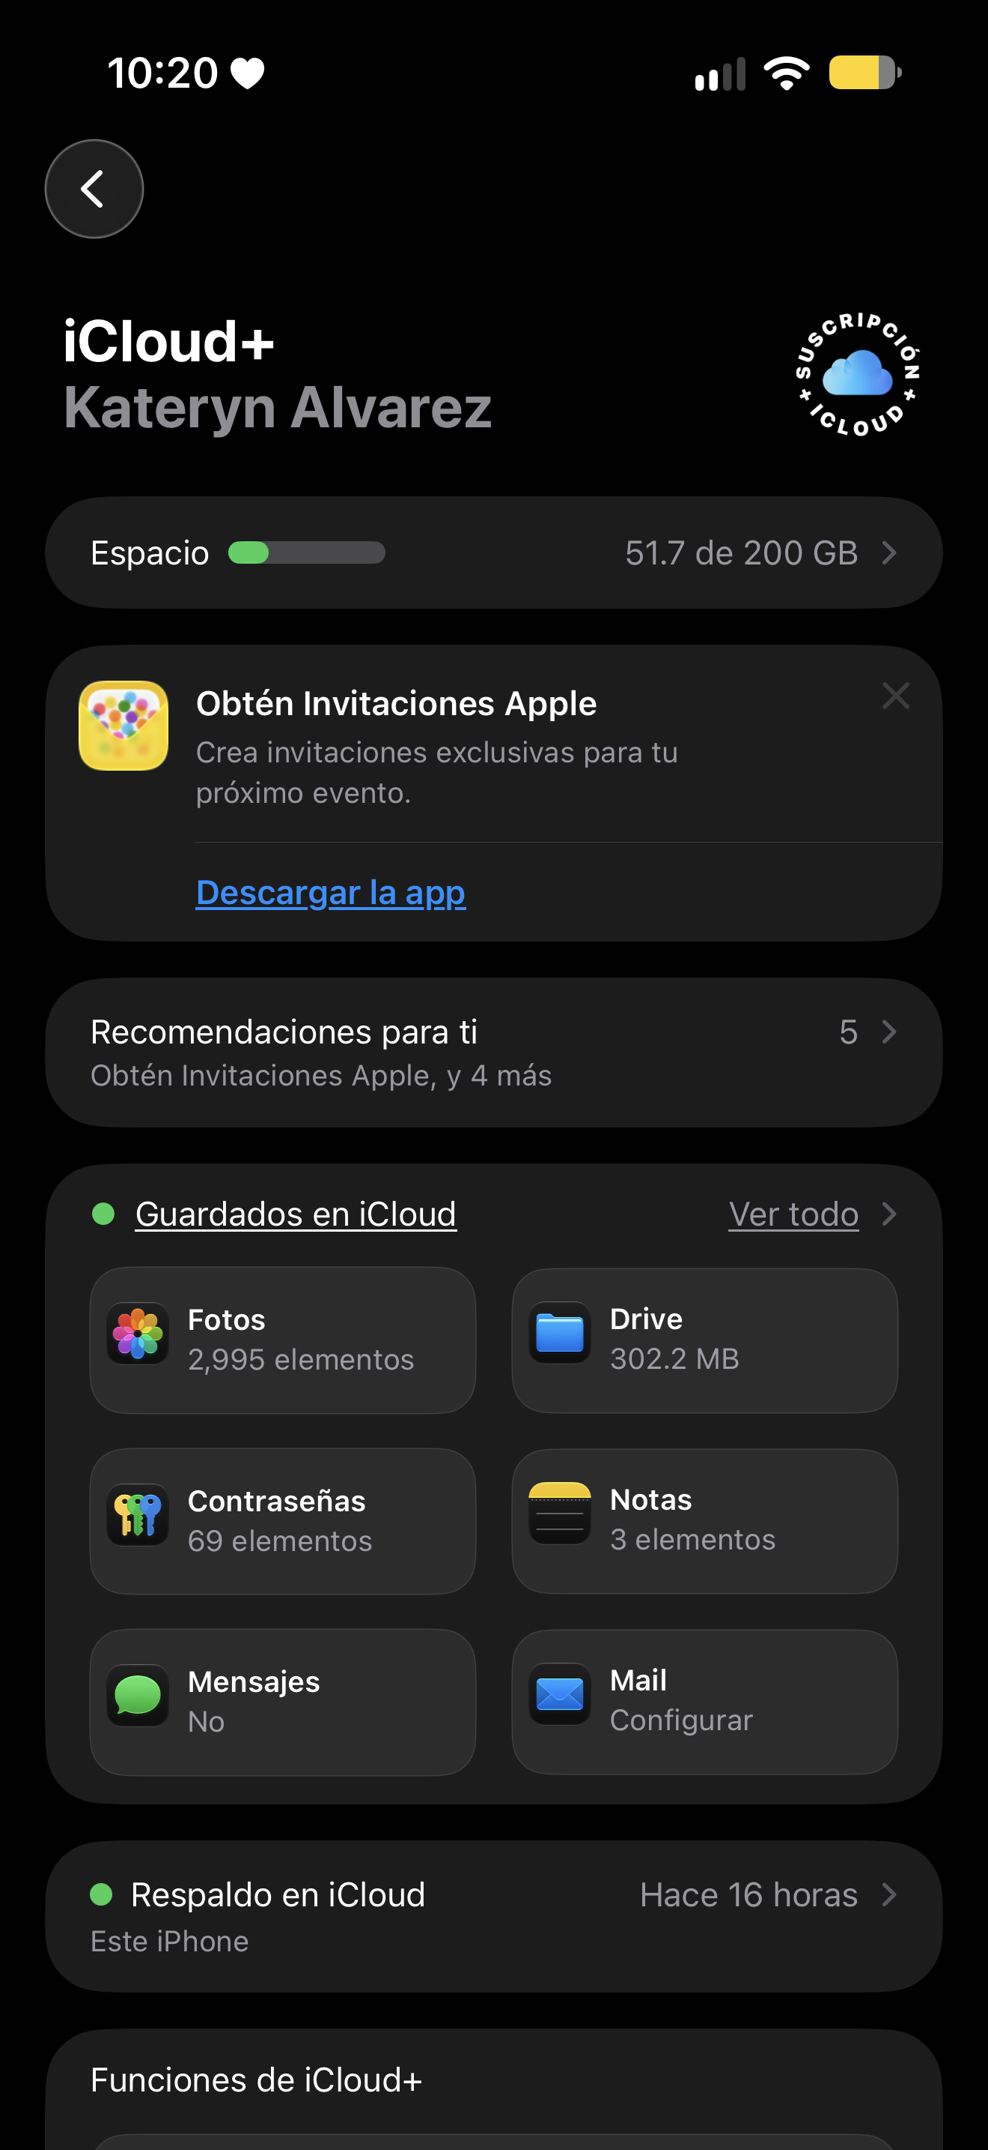
iCloud lets us save photos, videos and files online and access them from different Apple devices. It also keeps a backup so we can recover our data if we lose or replace our device.
Although I pay for iCloud, I find it really useful when I change my phone because I can recover all my information. It used to be harder, and we often lost our files.

Screenshot/YOUTUBE
[STREAMING SERVICE]
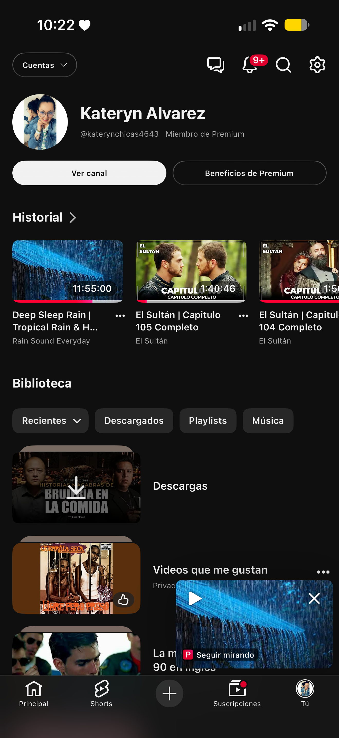
Streaming services let us watch films and TV shows or listen to music online without downloading them first.
YouTube is my favourite app and I use it every day. I can watch what I like from the comfort of my home at any time.

Screenshot/WALLET
[ONLINE BANKING]
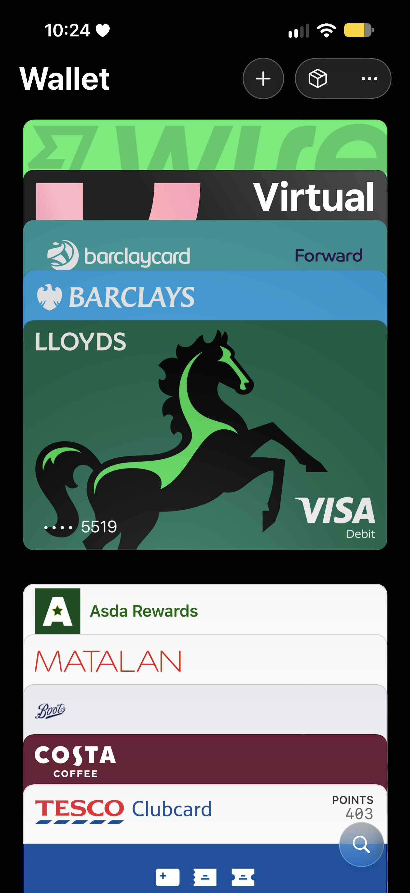
A digital wallet lets us store our payment cards on our phone and pay without carrying cash. It makes shopping quicker and easier.
I also started using this app when I moved to this country, and I love it. I can pay without carrying cash: with just a double click on my phone, I can do my shopping.

My Short Reflection

Digital tools are apps and devices that help us with everyday tasks. I use Google Maps to find my way, online banking to manage my money, and online shopping to save time. iCloud stores my photos and files, while video calls help me stay in touch and attend classes. I also use streaming apps to watch films and listen to music. These tools make my daily life easier.
“Technology has made life much easier for everyone in this generation.”
- I use digital tools to study and communicate with people from different places.
- I feel confident when I use Google Maps because I know I won’t get lost.
- I want to improve my digital skills.
- I often use Google Maps and online banking.
- I sometimes feel nervous about using new technology.
- I hope this module will help me learn new digital skills so I can keep up with technology.
- Digital skills are important for me because they make my life easier.

