
Front cover
BSc (Hons.)/BEng (Hons.) Ordnance, Munitions and Explosives

ACDA 5011 – Level 5 Instrumentation and Control
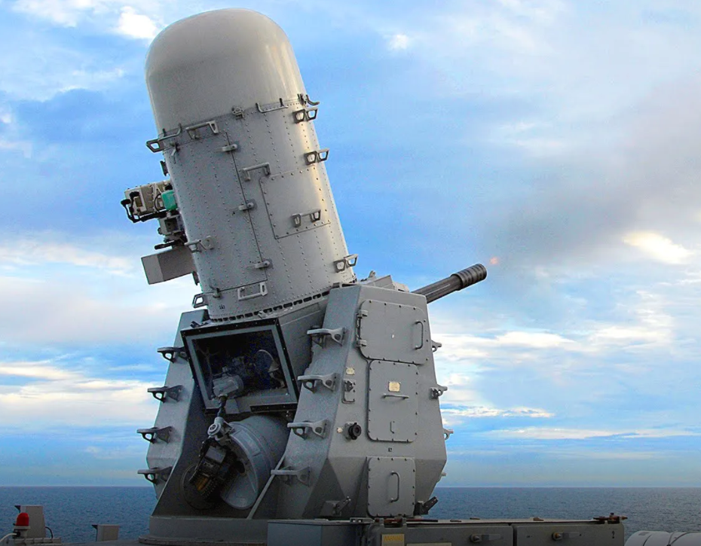
[1]

Authored by: Mike Peck
Student number: 1907404
Date: November 2021
Figure 1 – Phalanx CIWS

Abstract

MATLAB and Simulink, were used to design a closed loop control system capable of controlling a Close-In Weapon System (CIWS) such as on the front page, which is represented by the process carried out in the report. The resulting control system was shown to be able to bring the process under control within two seconds, with overshoot of less than 5%. This was achieved by finding the closed loop transfer function of the system as a whole, i.e. the positioning system and the control system you have designed. Results were then validated by comparing the results of simulations of the single transfer function and the simulation results obtained from the whole modular system. The stability of the system was also confirmed by use of Pole-Zero, Nyquist and Bode plots

Contents
Contents

Front cover 1
Abstract 2
Contents 3
Table of Figures 4
Table of Equations 4
1. Introduction 5
1.1. Background 5
2. Method 7
2. Simulation setups 13
2.1. Initial controller and Process closed loop simulation and Single whole system transform function 13
3. Results 14
3.1. Initial controller and Process closed loop simulation and Single whole system transform function simulation oscilloscope results 14
3.2. Pole-Zero Map to show roots (s) from System Transfer Function 15
3.3. Nyquist Plot of Forward TF, Pole-Zero plots of closed loop and plant and Bode diagram 16
3.4. Nyquist Plot of Plant, Controller and System 17
4. Discussion 18
5. Conclusions 19
6. References 20

Table of Figures

Figure 1 – Phalanx CIWS 1
Figure 2 – Block diagram of closed loop control system for the system [4] 7
Figure 3 – Outputs from the MATLAB PID Tuner 7
Figure 4 – Above the MATLAB PID Tuner software can be seen (Created by author) 8
Figure 5 – Whole system + single function from MATLAB Simulink (Created by author) 13
Figure 6 - Whole system + single function simulation results from MATLAB Simulink (Created by author) 14
Figure 7 - Pole-Zero Map to show roots (s) from System Transfer Function 15
Figure 8 - Nyquist Plot of Forward TF, Pole-Zero plots of closed loop and plant and Bode diagram 16
Figure 9 - Nyquist Plot of Plant, Controller and System 17

Table of Equations

Equation 1 - Transform equation from MATLAB 2019 Help section 7
Equation 2 – PID Controller Transform given by MATLAB 2019 Help section 8
Equation 3 - Whole system transfer function as given by MATLAB 2019 Help section 11

1. Introduction

Background

Control systems can be used to bring a system into control within the ranges required by the set point of the system. Control can be obtained by either an open-loop control system or a closed-loop control system.

The closed-loop control system uses data from one or more feed back loops to feed data about the systems condition back in, to compare with the setpoint and enable ajustment. Where as in an open loop control system there is no feedback from the system which reports the systems current or changing condition. [2]
Typical expamples of such control systems are as follows:

Open loop control: A toaster which has no feedback as to the amount the bread has toasted and therefore would continue to toast even though the toast may be on fire.

Closed loop control: There are toasters which can use optics which feedback into the browning controller to compare with the desired setting and thus stop toasting.

This report utilises the latter, the closed loop control system, which is required for the angular positioning system attached to an automatic Close-In Weapon System (CIWS) turret, such as pictured in the Phalanx weapons system on the front cover (Figure 1.).

The task for this assignment is to:
“Using MATLAB and Simulink, design a closed loop control system capable of controlling this process. Following a unit step input, your control system should be able to bring the process under control within two seconds, with overshoot of less than 5%.

Using your control system, find the closed loop transfer function of the system as a whole, i.e. the positioning system and the control system you have designed. Validate your results by comparing the results of simulations of the single transfer function and the simulation results obtained above.” [3]

The rest of this report will set out how to achieve this task, as follows:
  - Firstly – the assigned values will be utilised to give the transfer function for the process and the MATLAB PID tuner used to generate Proportional, Integral and Differential (PID) values for a PID controller, capable of positioning the CIWS turret within 2 seconds and with an overshoot of less than 5%

  - Secondly - steps will be used to calculate the system and PID controller transfer function coefficients and therefore transfer equations

  - Thirdly – simulations will be built in MATLAB Simulink for both the controller, process and feedback loop (i.e. the whole closed loop control system output) and will be compared to the whole system single transfer function simulation output to show that the single system function calculated is correct

  - Fourthly – the roots (s - values) of the single whole system function can then be calculated to give poles and zeros in a Pole-Zero plot, used to generate a Nyquist Plot and a Bode plot, all of which will be used to comment on the stability of the system

2. Method

As described in the previous section the assigned values were taken from the assignment brief and inserted into the transfer function for the turret (below):
$$G\left(s\right)=\frac{1}{as^{2}+bs+c}$$
Equation 1 - Transform equation from MATLAB 2019 Help section

Taking the assigned values: a = 2, b = 3, c = 2 the transfer function now becomes:
$$G\left(s\right)=\frac{1}{2s^{2}+3s+2}$$

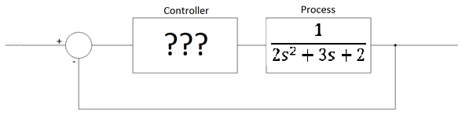
When drawn as a block diagram, the system now looks like this:
Figure 2 – Block diagram of closed loop control system for the system [4]

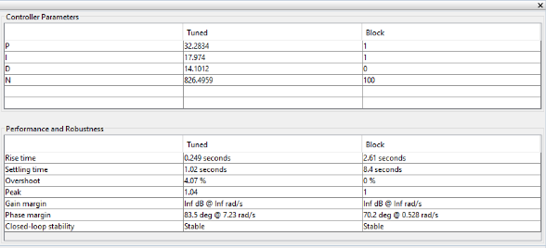
MATLAB 2019 PID Tuner was then used and adjusted to achieve the response or settling time of less than 2 seconds (1.02s) and an overshoot of less than 5% (4.07%) and the subsequent PID and N values were generated, as can be seen in figures 3 and 4 (below and following page).
Figure 3 – Outputs from the MATLAB PID Tuner
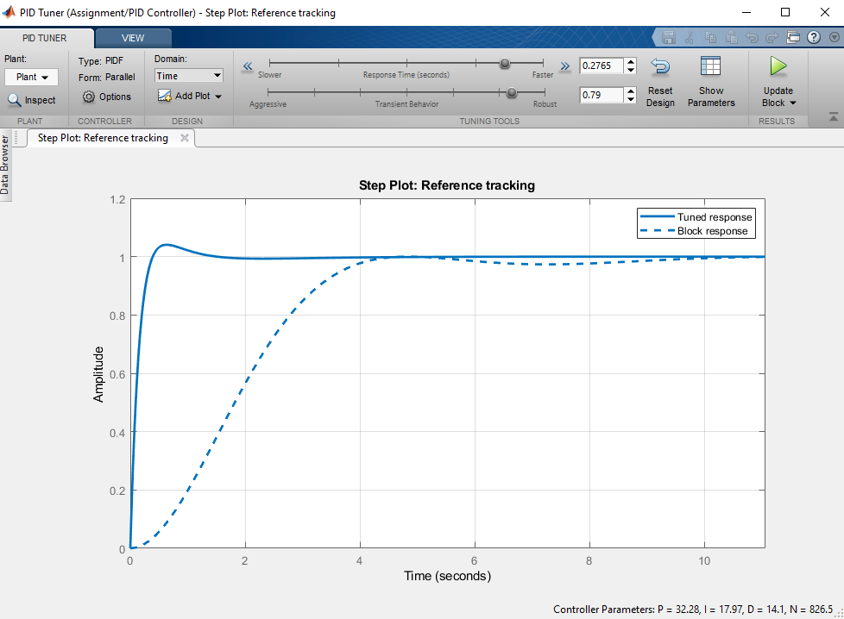
Figure 4 – Above the MATLAB PID Tuner software can be seen (Created by author)

Using the PID tuner in MATLAB, the following values were obtained:

Kp: 32.2834
Ki: 17.9740
Kd: 14.1012

So the transfer function, $G_{c}\left(s\right)$, of the PID controller from the La Place transform will be:

$$G_{c}\left(s\right)=K_{p}+k_{i}\frac{1}{s}+k_{d}\frac{s}{\frac{1}{N}s+1}$$ |  | (1)

Equation 2 – PID Controller Transform given by MATLAB 2019 Help section
For the values above would become:
$$G_{c}\left(s\right)=32.2834+17.9740\frac{1}{s}+14.1012 \frac{s}{\frac{1}{826.4959}s+1}$$ | (2)
To calculate the forward path transfer function of the system, the controller’s transfer function,$G_{c}\left(s\right)$, must be multiplied by the transfer function of the process, $G\left(s\right)$.
.
$$G_{c}\left(s\right)G\left(s\right)=\left[K_{p}+K_{i}\frac{1}{s}+K_{d} \frac{s}{\frac{1}{N}s+1}\right]\left[\frac{1}{2s^{2}+3s+2}\right]$$ |  | (3)

The controller’s transfer function needs to be converted a single fraction in order to multiply it by the process transfer function. This can be done as follows:

Firstly the $k_{d}$ term in the controller transfer function must be transposed into a single fraction as below:

$$K_{d} \frac{s}{\frac{1}{N}s+1}= \frac{K_{d}s}{\frac{s}{N}+1}=\frac{K_{d}s}{\frac{s}{N}+\frac{N}{N}}=\frac{K_{d}s}{\frac{s+N}{N}}=\frac{K_{d}sN}{s+N}$$

Substitution of the new $k_{d}$ term into equation (3) gives:

$$G_{c}\left(s\right)G\left(s\right)=\left[K_{p}+\frac{K_{i}}{s}+\frac{K_{d}sN}{s+N} \right]\left[\frac{1}{2s^{2}+3s+2}\right]$$ | (4)

The controller transfer function now needs to be turned into a single fraction with a common denominator of s(s+N) to give:

$G_{c}\left(s\right)=\frac{K_{p}s\left(s+N\right)+K_{i}\left(s+N\right)+K_{d}s^{2}N}{s(s+N)}=\frac{{(K}_{p}+k_{d}N)s^{2}+\left(K_{p}N+K_{i}\right)s+K_{i}N }{s^{2}+Ns}$ | (5)
The output of equation (5) can now be substituted into equation (3) for $G_{c}(s)$, to give:

$$G_{c}\left(s\right)G\left(s\right)=\left[\frac{{(K}_{p}+k_{d}N)s^{2}+\left(K_{p}N+K_{i}\right)s+K_{i}N }{s^{2}+Ns}\right]\left[\frac{1}{as^{2}+bs+c}\right]$$ |  | (6)
The numerator remains the same as it is multiplied by 1, however the denominators can be multiplied as follows:

× | $$as^{2}$$ | $$bs$$ | $$c$$
$$s^{2}$$ | $$as^{4}$$ | $$bs^{3}$$ | $$cs^{2}$$
$$Ns$$ | $$aNs^{3}$$ | $$bNs^{2}$$ | $$cNs$$

Which gives:
$as^{4}+bs^{3}+aNs^{3}+cs^{2}+bNs^{2}+cNs$and can be factorised as: a$s^{4}+\left(b+aN\right)s^{3}+\left(c+bN\right)s^{2}+cNs$

Giving the final Controller and process transfer function, $G_{c}(s)G(s)$, as:

$$G_{c}\left(s\right)G\left(s\right)=\frac{{(K}_{p}+k_{d}N)s^{2}+\left(K_{p}N+K_{i}\right)s+K_{i}N}{as^{4}+\left(b+aN\right)s^{3}+\left(c+bN\right)s^{2}+cNs}$$

The block diagram can now be redrawn as:

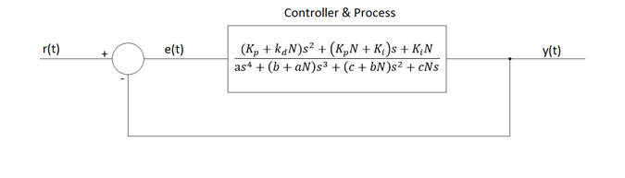

Now we remove the feedback loop and calculate the transfer function of the system as a whole.
Using:
$$TF=\frac{G}{1+GH}$$
Equation 3 - Whole system transfer function as given by MATLAB 2019 Help section

Where TF is the transfer function of the whole system, G is the forward path transfer function, and H is the transfer function of the feedback loop, in this case $H=1$

$$TF=\frac{\frac{{(K}_{p}+k_{d}N)s^{2}+\left(K_{p}N+K_{i}\right)s+K_{i}N}{as^{4}+\left(b+aN\right)s^{3}+\left(c+bN\right)s^{2}+cNs}}{1+\left(\frac{{(K}_{p}+k_{d}N)s^{2}+\left(K_{p}N+K_{i}\right)s+K_{i}N}{as^{4}+\left(b+aN\right)s^{3}+\left(c+bN\right)s^{2}+cNs}\right)×1}$$
The 1 in the denominator can become equivalent in terms of the denominator of the fraction next to it, giving:
$$TF=\frac{\frac{{(K}_{p}+k_{d}N)s^{2}+\left(K_{p}N+K_{i}\right)s+K_{i}N}{as^{4}+\left(b+aN\right)s^{3}+\left(c+bN\right)s^{2}+cNs}}{\left(\frac{as^{4}+\left(b+aN\right)s^{3}+\left(c+bN\right)s^{2}+cNs}{as^{4}+\left(b+aN\right)s^{3}+\left(c+bN\right)s^{2}+cNs}\right)+\frac{{(K}_{p}+k_{d}N)s^{2}+\left(K_{p}N+K_{i}\right)s+K_{i}N}{as^{4}+\left(b+aN\right)s^{3}+\left(c+bN\right)s^{2}+cNs}}$$

The denominator fractions numerator can also now be added to give:

$$TF=\frac{\frac{{(K}_{p}+k_{d}N)s^{2}+\left(K_{p}N+K_{i}\right)s+K_{i}N}{as^{4}+\left(b+aN\right)s^{3}+\left(c+bN\right)s^{2}+cNs}}{\frac{as^{4}+(b+aN)s^{3}+\left(c+bN\right)s^{2}+cNs+{(K}_{p}+k_{d}N)s^{2}+\left(K_{p}N+K_{i}\right)s+K_{i}N}{as^{4}+\left(b+aN\right)s^{3}+\left(c+bN\right)s^{2}+cNs}}$$

Which using the rules of multiplication of fractions becomes:

$$TF=\frac{{(K}_{p}+k_{d}N)s^{2}+\left(K_{p}N+K_{i}\right)s+K_{i}N}{as^{4}+\left(b+aN\right)s^{3}+\left(c+bN\right)s^{2}+cNs}×\frac{as^{4}+\left(b+aN\right)s^{3}+\left(c+bN\right)s^{2}+cNs }{as^{4}+(b+aN)s^{3}+\left(c+bN\right)s^{2}+cNs+{(K}_{p}+k_{d}N)s^{2}+\left(K_{p}N+K_{i}\right)s+K_{i}N}$$

Resulting in the single fraction as below:

$$TF=\frac{{(K}_{p}+k_{d}N)s^{2}+\left(K_{p}N+K_{i}\right)s+K_{i}N}{as^{4}+(b+aN)s^{3}+\left(c+bN\right)s^{2}+cNs+{(K}_{p}+k_{d}N)s^{2}+\left(K_{p}N+K_{i}\right)s+K_{i}N}$$

Collecting like terms gives:
$$TF=\frac{{(K}_{p}+k_{d}N)s^{2}+\left(K_{p}N+K_{i}\right)s+K_{i}N}{as^{4}+(b+aN)s^{3}+\left(c+bN{+K}_{p}+k_{d}N\right)s^{2}+\left(cN+K_{p}N+K_{i}\right)s+K_{i}N}$$
The assigned values for the process function and acquired PID values are as below:

a = 2 | b = 3 | c = 2
$k_{p}=$ 32.2834 | $k_{i}=$ 17.9740 | $k_{d}=$ 14.1012 | $N=$ 826.4959

Substitution of the values above gives:

$$TF=\frac{\left(32.2834+\left(14.1012 ×826.4959\right)\right)s^{2}+ \left(\left(32.2834 × 826.4959\right)+17.9740\right)s+\left(17.9740 ×826.4959\right) }{2s^{4}+\left(3+(2 × 826.4959) \right)s^{3}+\left(2+\left(3 ×826.4959\right) \right)s^{2}+\left(2 × 826.4959\right)s+(32.2834+ \left(14.1012 × 32.2834)\right)s^{2}+\left(\left(32.2834 × 826.4959\right)+17.9740\right)s+\left(17.9740 ×826.4959\right) }$$

Collecting like terms gives:

$$TF=\frac{\left(11686.86738508\right)s^{2}+ (26700.07173806)s+\left(14855.4373066\right) }{2s^{4}+\left(3+(2 × 826.4959) \right)s^{3}+\left(2+\left(3 ×826.4959\right) \right)s^{2}+\left(2 × 826.4959\right)s+(32.2834+ \left(14.1012 × 32.2834)\right)s^{2}+\left(\left(32.2834 × 826.4959\right)+17.9740\right)s+\left(17.9740 ×826.4959\right) }$$

The block diagram can now be redrawn again as a single block, as below:

$$\frac{324.3576s^{5}+718.015s^{4}+1016.3125s^{3}+842.4072s^{2}+260.574s}{16s^{6}+348.3576s^{5}+775.015s^{4}+1052.3125s^{3}+914.4072s^{2}+260.574s}$$
y(t)

Simulation setups

Initial controller and Process closed loop simulation and Single whole system transform function

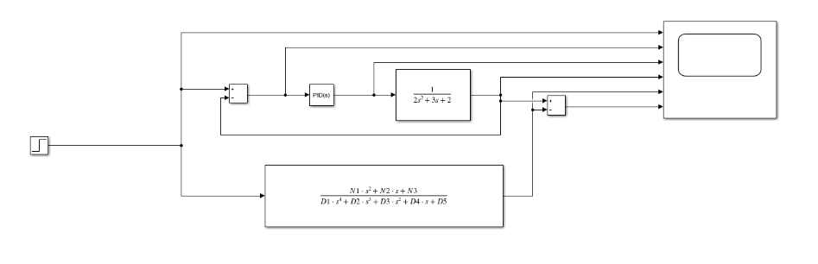
Now that a single equivalent transform function has been calculated for the whole system it is necessary to simulate both the original system and the whole system function together to be able to ascertain they give the same result or output and therefore show that the single whole system transform can be used instead of the individual components of the system.
Figure 5 – Whole system + single function from MATLAB Simulink (Created by author)

It should be noted that the original system can be seen as the components going from the source to the subtracter box (which adds the feedback data to the input data) to the PID controller and then on to the process function and the out put sent to the 4th terminal (from the top) on the oscillorscope. The single calculated equivlent function simply goes from source to 5th oscilloscope terminal from the top. Both outputs also go to another subtractor box which feeds to the last terminal on the oscillorscope to show the comparative differences between the two outputs, these will be shown in the results section and discussed in the discussion section.

3. Results

Initial controller and Process closed loop simulation and Single whole system transform function simulation oscilloscope results

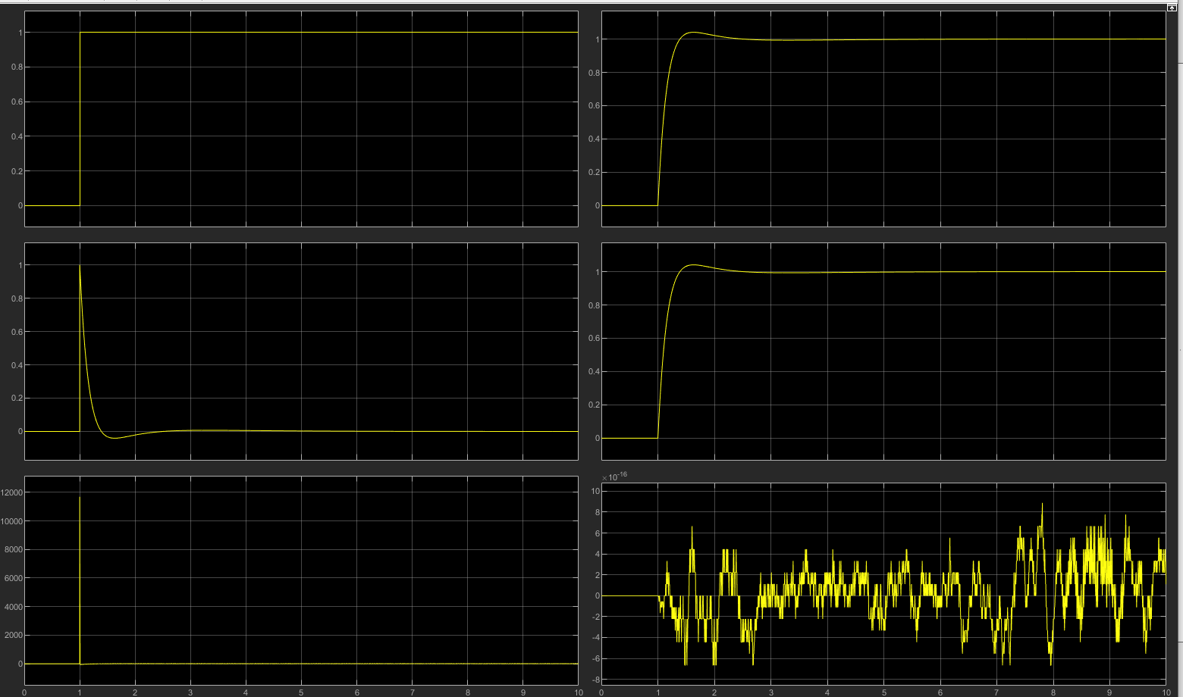
Figure 6 - Whole system + single function simulation results from MATLAB Simulink (Created by author)
It should be noted that the Y-axis represents signal voltage (in Volts) and the X-axis represents time. The top left graph indicates the input or source signal, 0 represents off and 1 power on. 2nd from top left indicates the signal as a result of the input signal and feedback. 3rd left graph indicates the output from the PID controller (note the spike in voltage to nearly 12000 and then resolution in signal). Top right indicates the Initial controller and Process closed loop simulation output. 2nd right indicates the Single whole system transform function simulation output and finally the bottom right shows the difference between the two signal outputs, note the voltage scale is in x10⁻¹⁶ i.e. a very small difference.

Pole-Zero Map to show roots (s) from System Transfer Function
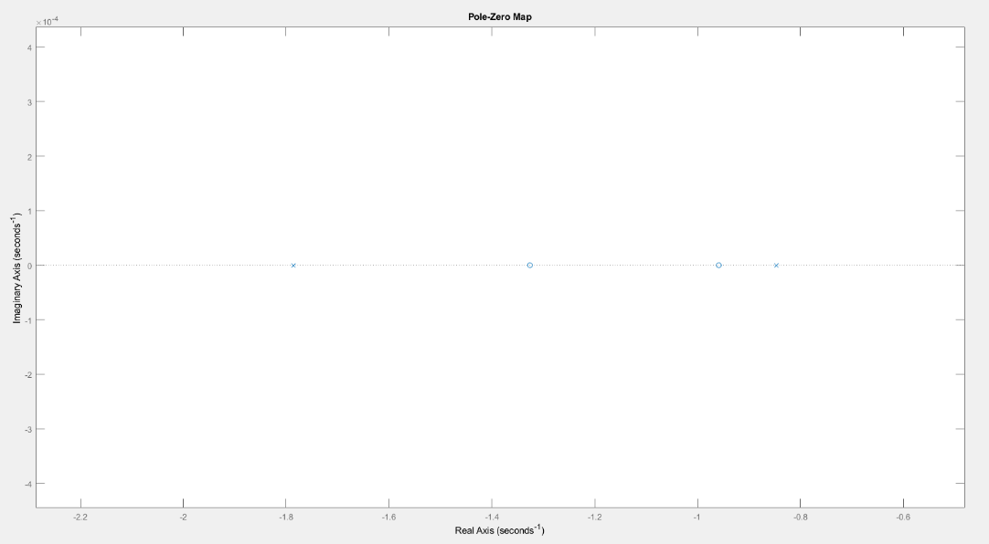
It should be noted that there are poles at: -819.3711 (but can’t be seen as the scale does not allow high resolution of the roots to the right as the same time, can be seen in next figure), -5.9914, -1.7864 and -0.8470 and zeroes at: -1.3260 and -0.9586, these will be discussed in the next section.

Figure 7 - 3.1. Pole-Zero Map to show roots (s) from System Transfer Function

Nyquist Plot of Forward TF, Pole-Zero plots of closed loop and plant and Bode diagram

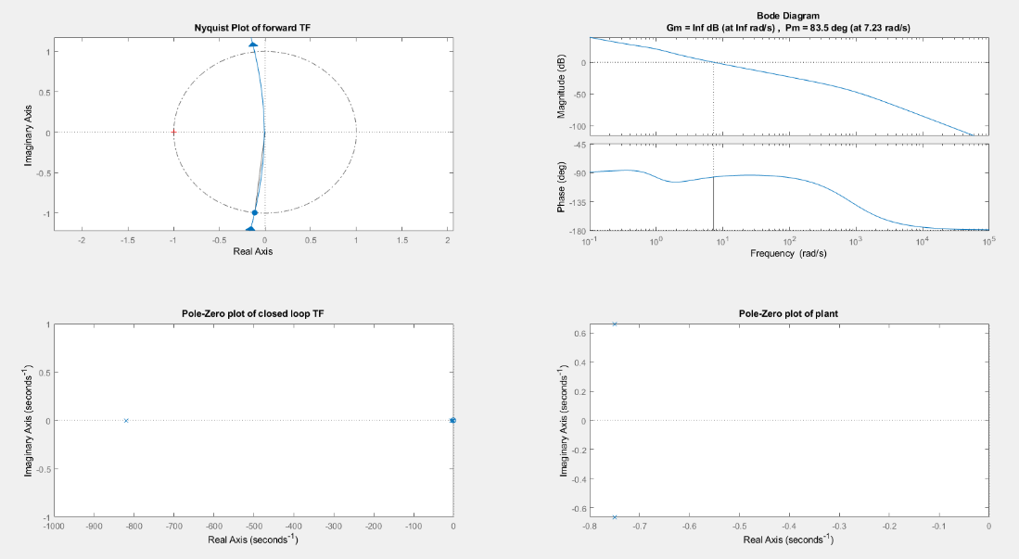

Figure 8 - 3.1. Nyquist Plot of Forward TF, Pole-Zero plots of closed loop and plant and Bode diagram

Nyquist Plot of Plant, Controller and System
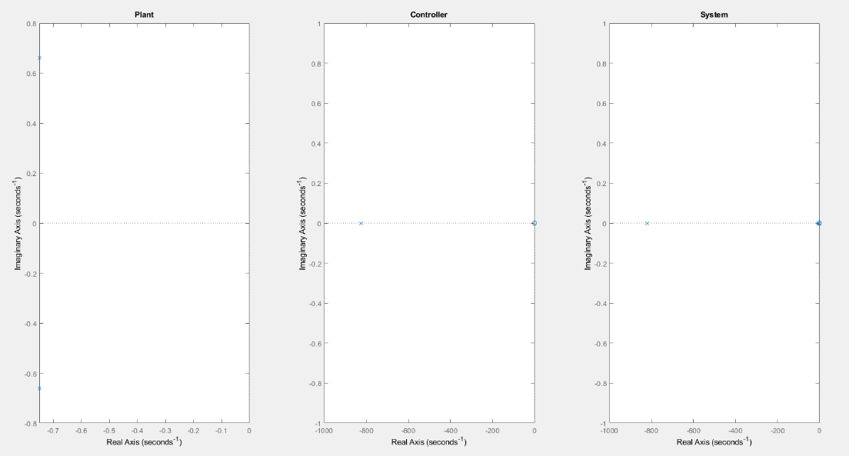

Figure 9 - Nyquist Plot of Plant, Controller and System

4. Discussion

As can be seen from the bottom right graph in section 3.1., there is a very small difference between the calculated whole system transfer function and the output from the indervidual components with feedback loop. This means that the single function is a good and highly accurate representation of the whole system, therefore both the denminator and numerator can be solved to give the roots for both poles and zeroes respectifully. These poles and zeroes can be seen in 3.2. and 3.3. in the form of Pole-Zero plots. The posistion of the poles and zeroes of the whole system function shows that all are to the left of the Y-axis, this indicates that the system is stable and will act in a damping or attentuating manner rather than a diverging one in which the oscillations of the system will ultimately lead to destruction of the system. The Bode diagram in section 3.3. indcates that the Gain margin (Gm) = infinite dB and the Phase margin (Pm) = 83.5 degrees indicate good damping and frequency ability, showing further evidence of a resilient and stable system.

5. Conclusions

This report determined PID values for a proposed controller as part of a closed loop control system of a CIWS positioning system. The values proposed were proven to generate a stable and reliable result from simulated data, showing that is used in a weapon positioning system it would be capable of doing so within 2 seconds and with less than 5% overshoot.

6. References

[1] | G. Allison, “Raytheon awarded contract for Phalanx upgrades and overhauls,” 20 08 2019. [Online]. Available: https://ukdefencejournal.org.uk/raytheon-awarded-contract-for-phalanx-upgrades-and-overhauls/. [Accessed 08 12 2021].
[2] | D. S. Mosey, “L5 - Instrumentation and Control (OME) (ACDA5011) - 3. Control Mechanisms powerpoint,” [Online]. Available: https://moodle.uwtsd.ac.uk/course/view.php?id=2258. [Accessed 30 11 2021].
[3] | D. S. Mosey, “L5 - Instrumentation and Control (OME) (ACDA5011) - ACDA5011 sem1 CW1 2021 22,” 28 10 2021. [Online]. Available: https://moodle.uwtsd.ac.uk/course/view.php?id=2258.
[4] | D. S. Mosey, “L5 - Instrumentation and Control (OME) (ACDA5011) - Assignment Task 2 Worked Example,” [Online]. Available: https://moodle.uwtsd.ac.uk/course/view.php?id=2258. [Accessed 01 12 2021].

