LEGISLATIVE RISK IN HOTEL INDUSTRY
BUSINESS SKILLS FOR THE INTERNATIONL HOTEL INDUTRY
(M4X01917_BIRM)
ALEXANDRA LAURA BULAI /1815176
UNIVERSITY OF WALES TRINITY SAINT
LECTURER :DALE CLARKE

EXECUTIVE SUMMARY
Risk management in the hotel industry is uncertain and it includes to find out different ways to guarantee necessities of security and health as well as an explanative way to manage and deal with the liabilities. The majority of the functions and activities must be provident by the administrators, ignoring can have a negative impact on the business as well as damage to the employees, staff or visitors. It is very important for organizations to perform risk management activities successfully because neglecting can have negative results such as monetary loss and end of the operations and activities. It is very essential for the owner of the hotel to have knowledge about different authoritative acts and legal frameworks in order to perform business activities smoothly.

Table of Contents
EXECUTIVE SUMMARY 2
INTRODUCTION 4
DISCUSSION 5
LIABILITY RISK 7
DATA PROTECTION 8
HEALTH AND SAFETY 8
FOOD HYGIENE 8
RISK MANAGEMENT 9
LICENSING 9
KEY PROVISIONS WITHIN HOTEL PROPRIETORS ACT 1956 10
CONCLUSION 11
REFERENCES 12

INTRODUCTION

Potential for losses due to the change in the legal and regulatory actions termed as legal risk. The risk that arises due to a change in law or tax law that have an adverse effect on investment return. This can effect investment positively or negatively (Mišćenić and Raccah, 2016). This risk deals with different changes such as the need to provide more benefits and advantages to employees and free trade agreement that reduce competition in a particular industry. This report is all about the legislative risk that has to be taken into consideration by the management and employees of the hotel. The report includes different areas such as food and safety, food hygiene, liability, data protection, licensing and also includes key provisions as per the hotel proprietors act 1956.

DISCUSSION

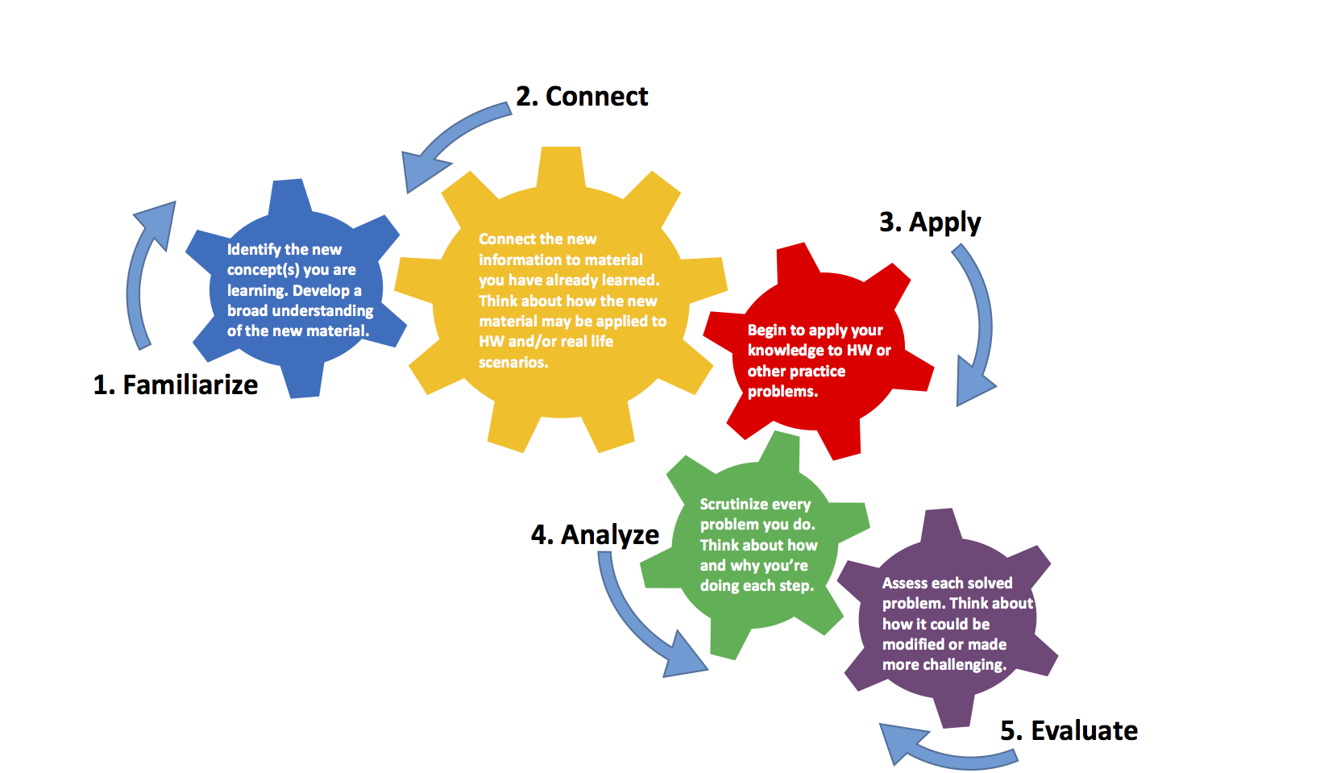
I have learned that problem solving is very important for the organization because it helps the organization to observe what is happening in the environment as well as identifying factors that can be improved or change. Developing strategies and approaches that can be helpful at the time of legal changes and implementing those changes.

To manage legal risk effectively is one of the crucial task for the management of the hotel and it is very essential to make a sound decision that also helps to establish plan and policy that could be very effective to manage and deal with risk.


This is very important for individuals to focus on their overall growth and development while making a plan for the future. The primary aim of the PDP is to encourage and direct an individual to achieve a short-term and long-term goal. This is very helpful tom assess own potential.


SWOT Analysis is very important to analyze strength, weakness, threat, and opportunities that can help to formulate strategies in order to prepare for the future course of action. A SWOT analysis takes into consideration both internal and external factors that can affect success and failure.


LIABILITY RISK
Every hotel must have to use the concept of making or developing as well as signing the agreements at least once. Basically, there are many types of contracts and agreement but specifically in this type of the industry, mainly use contracts and agreements are legal contracts, agreements that are related to the business and the organization (Waikar, at al. 2016). For the manager, it is very basic to use reports that are evident and real to the subject to the law contract and agreement. An agreement must contain mass and bulk of the companion segments in order to be substantial and allowed as per the legal rules or laws. For instances, purpose to enter into a lawful relationship, an acknowledgment, and offer, acceptable limit for those who are actively participating in the business (Adam, et al. 2017).

DATA PROTECTION
Data protection is very important in every business those have stored information about client and customers like contact number, credit card information for a long-term purpose. In order to build and maintain long term relationship with the customer most of the hotel take feedback for services provided by the staff and the feedback also include information like contact number, name, email id, date of birth and anniversary date, etc. of the customer. This information is used by the management of the hotel to maintain contact with the customer such as wishing them on their birthday and anniversary, customer fell delighted by this type of efforts made by hotel management (Voigt and Von dem Bussche, 2017). In the hotel industry, customer information is of great importance and it is the responsibility of the manager to keep information of guest confidential and ensure then that their important information provided by them will not be misused. The organization tells the customer how the information is going to utilize in order to improve the degree of trust of customers. The management of hotel should keep eye on staff that how they manage the data of the customer and maintain consistency with data protection (Bieker, et al.2016).

HEALTH AND SAFETY
Several capacities and divisions in the management of the hotel and each of the division filling an alternate need and comprises of different factors and individual. This is very important for the hotel to guarantee the security and safety of everyone on the premises and it is also the lawful necessity of hotel (Caccamo, et al.2018). To ensure management of health and safety at the workplace it is the necessity of the hotel that according to the rules and laws hotel should investigate risk to deal with various dangers that could influence staff as well as visitors of the hotel. Food standards act 1999 and Food safety act 1990 is the main act for the safety of food (Food Standards Agency, 2109).

FOOD HYGIENE
Various food laws are applicable to the hotel industry and the management of the hotel is responsible and can say that it is important for the management of the hotel to provide hygienic food to their customers that is fit for them and healthier to eat. The hotel industry is the industry that deals with the health of the customer and it is a very important and very big responsibility for the management of the hotel to be very careful about the food that they are going to serve to the customer. If there is any mistake happen in this then it will be very dangerous for the health of the customer as well as it will destroy image and reputation of the hotel (Lelieveld, et al.2016). There are special authorities who are appointed to examine the hygiene of food of the hotel and visit the hotel premises to check the consistency with legitimate prerequisites. Several nations have food administrative frameworks that are Centre around the requirement of laws. Food hygiene legislation and food safety and hygiene regulations 2013 are there for food hygiene (Food Standards Agency, 2109).

RISK MANAGEMENT
Risk management refers to identify, analyze and take steps to minimize or eliminate loss faced by the business. Every business has to face risk, some of the risks are predictable and can say that under the control of the management of the organization while some of the risks are unpredictable and not in the control of the management (Hopkin, 2018). The hospitality industry has to face a large amount of risk and risk faced by the hotel industry is unpredictable most of the time. Management of risk is crucial to make sure that the business will run smoothly. There are many types of risk that are faced by the hotel industry it can include property risk, premises risk, data privacy, etc. Businesses operated in the hotel industry face a level of property risk. There are various ignition sources present in the hotels and contents that are highly burnable. In order to minimize this risk, the hotel management should ensure that all fire and smoke alarm system working well and meet the requirement of national fire prevention association (Eggenschwiler, et al.2017).

LICENSING
There are huge numbers of enlistments and license that are necessary to start the hotel business and working in the hotel industry. License required by the hotel to meet anonymous criteria’s and principles for looking after legitimacy. In order to work effectively and for the smooth functioning of the hotel it is very important for the hotel manager having knowledge of these enlistments and licenses. The license consists of a permit for fire safety and building, police license, and trade license for a hotel, business registration, and health trade license, etc. Most of the time necessity of the permits is depends on the location, category, and rating of the hotel. Further, instructions and principles to acquire a permit for the hotel business contrast as represented by the state.

KEY PROVISIONS WITHIN HOTEL PROPRIETORS ACT 1956
This act improves and changes laws relating to the inns and innkeepers.
According to this act, hotel refers to the establishment that operated by the proprietors as providing food, drink and if needed sleeping accommodation to the traveler without any contract and the traveler or customer is willing to pay an affordable sum for the facilities and services provided by the hotel (Legislation.gov.uk, 2019).
The hotel according to the act shall be considered to inn and rights, duties and liabilities that are before the beginning of this act shall be attached to the innkeeper or proprietor of the hotel and not to any other person.
Under this act, the in some circumstances proprietor of the hotel may be liable to make good any damage and loss to the property of guest even if it was not due to the mistake and fault of hotel staff and proprietor.
Conditions under this are that it is only for those guests who have sleeping accommodation in the hotel and this will be limited to £50 (Legislation.gov.uk, 2019).

CONCLUSION

From the study, it can be concluded that it is very important for the hotel owner to understand different legal frameworks and acts for the smooth functioning of the hotel. It is the responsibility of the management of the hotel to keep information confidential that are provided by the customer and manager of the organization should present real and evident reports that are subjected to agreement and contract. Health and safety of customers, employees, and everybody present on the premises must be a priority of the hotel management as well as take care of food hygiene and for this, there are different laws and regulations are there. The supervisory team of the hotel must have satisfactory legitimate culture, manage, regulate, organize and control work in such a manner that threat of happening of mistakes with the customer should be minimized. If there is no proper management of risk and hotel not follow the rules and regulations then it can destroy the reputation and image of the hotel and results to lose the trust of customers.

REFERENCES

- Adam, S.M., Morsy, M.A. and Moawad, E.H., 2017. Food Safety Risk Management System in Three Star Hotels: Barriers, Benefits, and Motivations of Application. International Journal of Heritage, Tourism, and Hospitality, 10(2/2).
- Bieker, F., Friedewald, M., Hansen, M., Obersteller, H. and Rost, M., 2016, September. A process for data protection impact assessment under the european general data protection regulation. In Annual Privacy Forum (pp. 21-37). Springer, Cham.
- Caccamo, A., Taylor, J.Z., Daniel, D. and Bulatovic-Schumer, R., 2018. Measuring and improving food safety culture in a five-star hotel: a case study. Worldwide Hospitality and Tourism Themes, 10(3), pp.345-357.
- Dudeja, P., Gupta, R.K. and Minhas, A.S. eds., 2016. Food Safety in the 21st Century: Public Health Perspective. Academic Press.
- Eggenschwiler, Y., Brunetti, A. and Bandi, M., 2017. Exchange rate risk management in the hotel industry. Proceedings Book, p.307.
- Food Standards Agency, 2109. Key regulations (Online), available at https://www.food.gov.uk/about-us/key-regulations last accessed on 22nd July 2019.
- Hopkin, P., 2018. Fundamentals of risk management: understanding, evaluating and implementing effective risk management. Kogan Page Publishers.
- Legislation.gov.uk, 2019. Hotel Proprietors Act 1956 (Online), available at http://www.legislation.gov.uk/ukpga/Eliz2/4-5/62 last accessed on 22nd July 2019.
- Lelieveld, H.L., Holah, J. and Gabric, D. eds., 2016. Handbook of hygiene control in the food industry. Woodhead Publishing.
- Manning, L., 2018. The value of food safety culture to the hospitality industry. Worldwide Hospitality and Tourism Themes, 10(3), pp.284-296.
- Mišćenić, E. and Raccah, A. eds., 2016. Legal risks in EU Law: Interdisciplinary studies on legal risk management and better regulation in Europe. Springer.
- Voigt, P. and Von dem Bussche, A., 2017. The eu general data protection regulation (gdpr). A Practical Guide, 1st Ed., Cham: Springer International Publishing.
- Waikar, V.G., Hegde Desai, P.G. and Borde, N., 2016. Hotel’s grid group structure and risk management practices. Tourism Review, 71(3), pp.192-204.

