How to choose the best music production software and hardware for you?

So, you might be thinking, I've got the gear to get creative with but what next? Well, here's the ultimate guide for you to find what's best for you to unleash your creative abilities. Many will say it is down to the musician how they decide to be creative in their compositions - we agree to certain extent. There are many factors depending on how you work and how advanced you'd like a piece of music to be. Factors such as; the budget you have for the project and going into the future, whether you'd like to invest in your future projects, the experience you have in the field, do you use Mac or PC and things like if you perform live or not. Choosing the best DAW also has some factors in your creative process.

What is a DAW? (Digital Audio Workstation)

A DAW or Digital Audio Workstation is a blank surface with all the necessary tools ready to be used in order to create and finalize your project of choice. It is a computerised program for recording, editing, mixing and mastering many audio files in which you the musician decide to create. There are many ways to record your own personal instruments, MIDI controllers and vocals. There’s also chances to perfect your sounds by rearrange, cut, adding effects to them and many more!

To anyone who has the intention of creating music; whether that's done in a professional studio or a home - based studio, each one has a DAW and is set with a digital set up to begin their creative process on screen. With every musician being different, many record in real time with actual instruments and others use analog set ups such as using a variety of synthesizers and drum machines on the screen to explore many effects and sounds that can be created by using these. Although, these days many people are equipped with a studio where they can do both, this will come down to experience with many different options of tech to create their own personal sound.

Here are the steps you need to take in order to choose the perfect software for you…

When it comes to choosing your DAW there’s no wrong choice, especially nowadays where technology is pretty much even on all levels of making music. There are three aspects I think you should take into consideration before making the big jump of choosing your personal DAW – it is all preference at the end of the day.

Experience? – If you think you’re a beginner and are just starting out in this field, you might not want to jump straight into a crazy DAW set up such as Pro Tools. You should start with a program that is easily understood and can set you on your way for developing your personal sound and creativity. Check out the best beginner versions of software https://www.wirerealm.com/guides/best-beginners-music-software

This demonstrates the basics which are classed as fundamentals in the industry to get you going to the level of where you’d like to be. Jumping into almost pro versions of software could take a long time to learn and could be scary and potentially put you off wanting to be creative so it’s always best to learn from the beginning and build your knowledge from there.

Your budget? – Buying your first piece of software is like an investment. It’s where you begin your journey, so the budget is pretty important to bare in mind when looking for the piece of equipment. If there are financial issues, then there’s no need to worry! There are many free music software’s available online to create and release your music of any sorts.

Here’s the link to check out free music software available online…
https://www.wirerealm.com/guides/best-free-music-software

Mac or PC? – There have been many debates whether it is Mac or PC musicians should use to place their DAW on. Many musicians have a music computer, but if you don’t it would be wise to invest in one which has the capacity to support the DAW that you decide to choose once finished reading this post. Giving an honest opinion – it really doesn’t matter which one you’d choose, both have the same qualities, the only difference is that one would be Windows based and the other is Apple based. It is all down to personal preference. One thing to look out for is, some software’s are Mac only and others can work on both Mac or PC so do your research wisely.

Future thinking – When starting with a beginner - based software, you could potentially start to get bored once you’ve learned the basics of it and are wanting to use more functions to develop your skill and knowledge. You need to keep in mind that you will be good enough to move on to something more advanced, even if it’s just the slightest too! So, having that in mind- maybe find a middle ground as to it’ll be challenging enough to keep you going for some - time but it’ll continue to have the fundamentals from the beginner level also. There are many different software’s musicians use at this stage but one that comes to mind is the FL Studio. Many professional musicians use this software to produce their music also.

The Top 5 music production software:

Ableton Live –

Recommended Levels
All levels recommended
Compatible With
– Mac or Windows
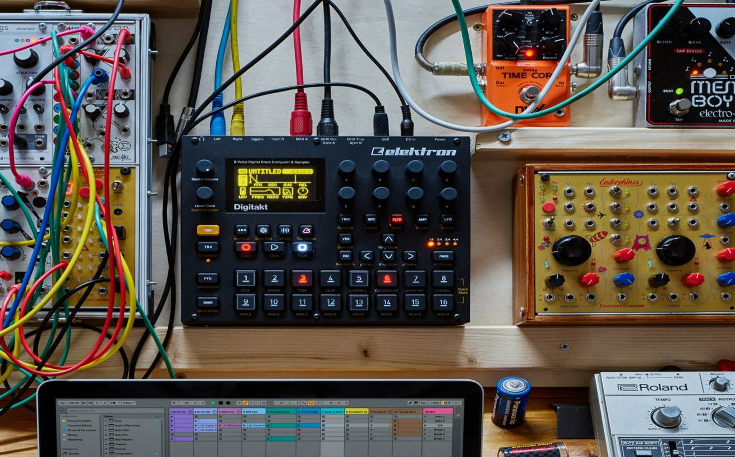

Apple Logic Pro X –
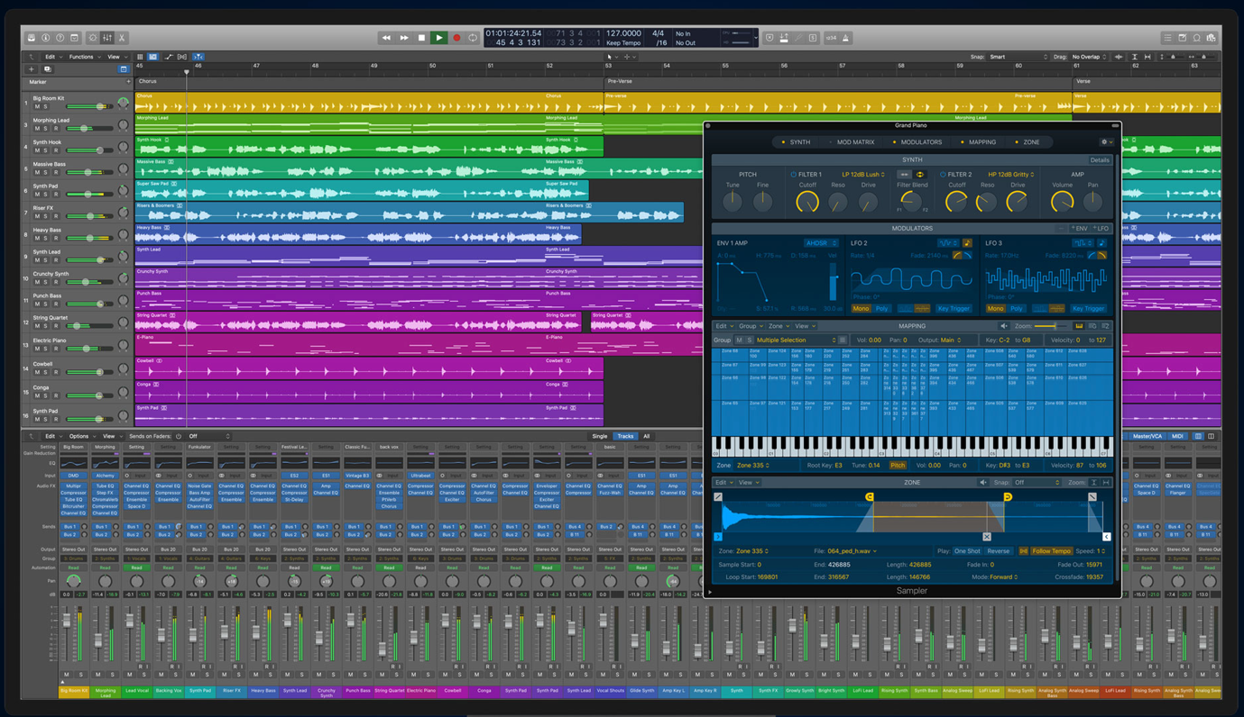
Recommended Levels
Medium to expert
Compatible With
Mac Only

Avid Pro Tool –
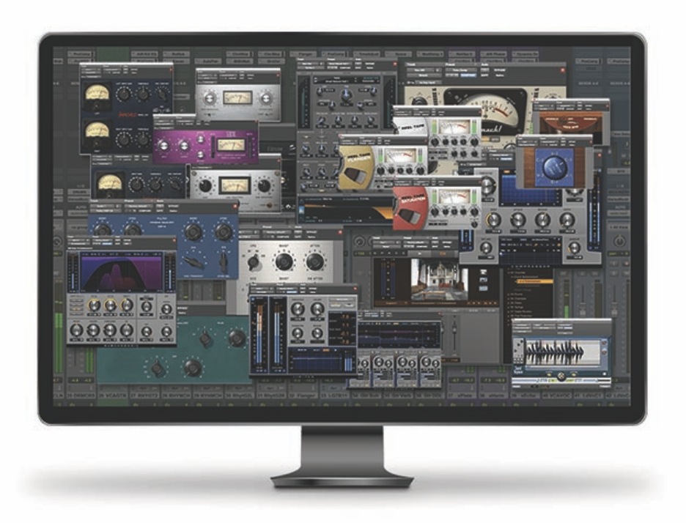
Recommended Levels
Expert/Professional
Compatible With
Mac or Windows

Propellerhead Reason –
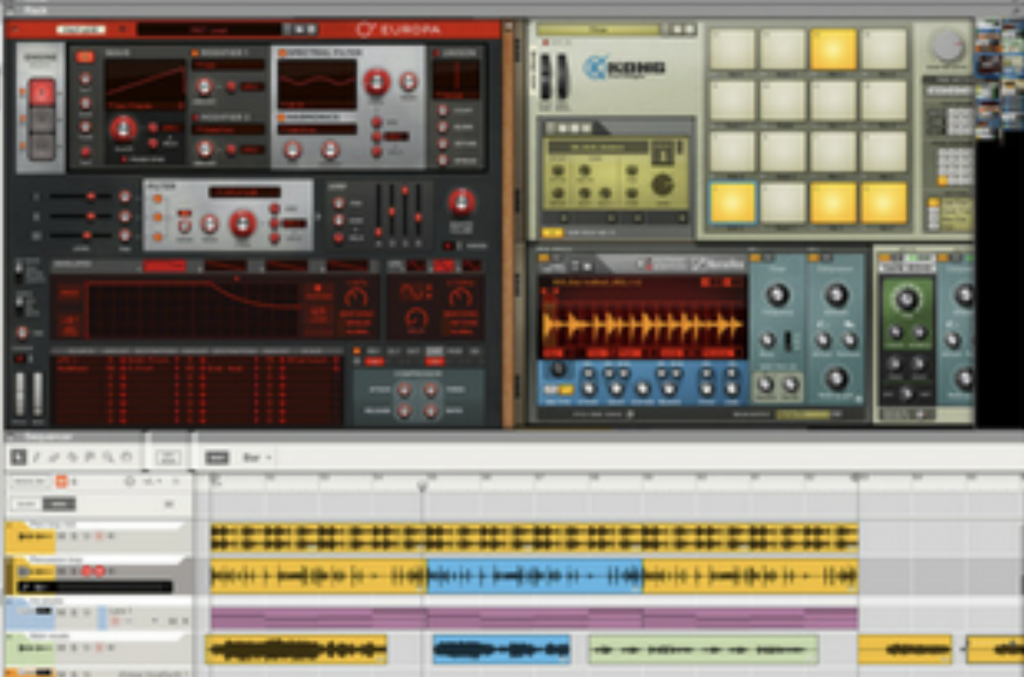
Recommended Levels
Slightly above beginner to semi-pro
Compatible With
Mac or Windows

FL Studio –
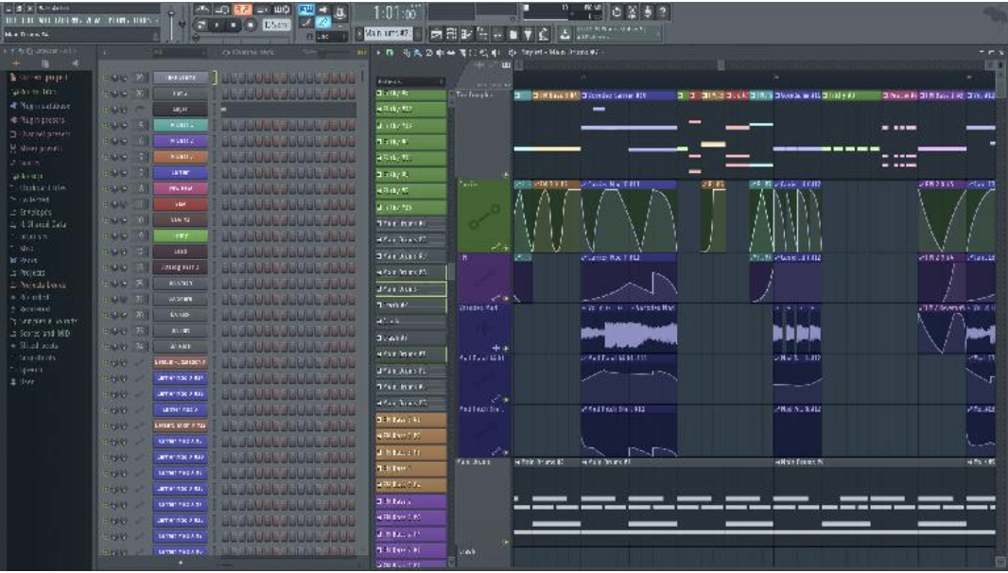
Recommended Levels
Beginner and Up
Compatible With
Windows only

So, as you can see by the images shown above, layout wise there's not many differences but the main difference would be is the level of experience and knowledge required to use the different softwares as they can offer different "extras" to use to finalize each of your projects. These are just some ideas and advice for whoever is looking at purchasing a software of your choice, and it is purposely a guide to see what each of your preferences are as a musician.

What hardware essentials do you need for a studio?

There are many things to take into consideration when looking for different pieces of hardware you’d like or need to incorporate into the studio or space you want to unleash your creativity. There’s a range of microphones, audio interfaces, MIDI keyboard controllers etc. So, let’s have a look at the top 5 items that are essential for creating and recording your ideas.

- The Audio interface

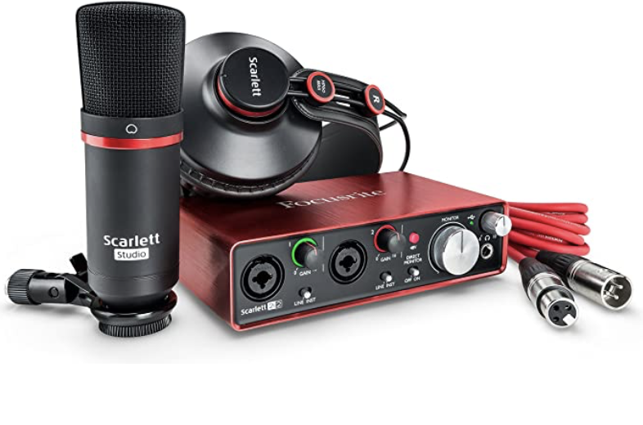
Every studio is essential to have one of these bad boys. Purchasing one of these are important as it’ll be the base of where all of your recordings will be sent digitally through to your computer and software. Choosing which Audio Interface is completely down your personal preference. A highly popular audio interface would be the Focusrite Scarlett 2i2. It’s fully compatible with any device you connect it with, it also comes with a package software. If it’s your first main hardware purchase, it might be helpful to look into the Focusrite Scarlett 2i2 Studio, which contains the audio interface itself but also comes with headphones and a condenser microphone too!

- The Microphone

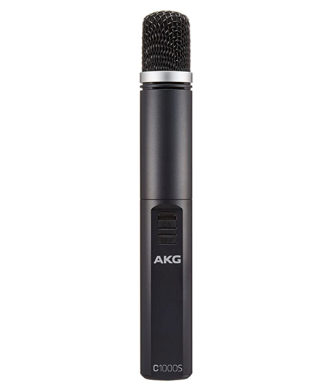

There are many types of microphones, check this out to see the endless list:
https://www.musicrepo.com/recording-microphone-types/

Deciding which microphone is best for what instrument is so crucial to the clarity of the sound it makes. This is pretty much a trial and error process in order to find the right sound for you! People may have different preferences, as some microphones prioritise the higher sounding sounds and others with the low sounding sounds. Hopefully, the link above will give you a more in detail approach as to how to choose the best mics for you. Most of professional and home studio musicians will own a large diaphragm condenser mic. Depending on your budget there will be a range of different mics to suit your needs of recording. Whenever you use a condenser microphone make sure you select an audio interface that includes phantom power in order to power the mic, without it, it simply won’t work.

- The USB Microphone

If you’re looking at a certain budget then maybe buying the audio interface, microphone and all the extra cables needed can be slightly pricy. With a USB mic there’s no extra buying, it is literally as simple as plug in and play. There is a USB mic for every recording situation possible. It can be used for many things such as: voiceovers, vocalists, they’re brilliant for podcasting and even acoustic instruments, the list is endless! Whether you have a full - blown studio set up or not, the USB mic will not disappoint as it can be used for portable recordings also. There are so many varieties of USB mics out there it be worth to check this link out for more: https://www.musicrepo.com/which-usb-microphone/ - it’s really worth checking out the link as there are many options to choose from depending on your preference and knowledge as a musician.

- The USB MIDI Keyboard Controller

If playing the keyboard isn’t a strong point of yours then maybe purchasing one will be handy for a home studio set-up. Is a great place to start with inserting bass lines, a variety of drum - beats, and essentially being in control of the entirety of the project itself through the keyboard. If learning the keyboard is something you want to learn as a musician, then this is a brilliant opportunity for you rather than buying a grand piano as that can be pretty daunting for a beginner in that area. Using the keyboard controller is also a good way of creating and writing your own sheet music by using score writing software – Sibelius is a good option if you want to take that route. The Samson Graphite 49 is a simple make, including a set of full - size keys plus it’s at a reasonable price too! It’s perfect for creating and sculpting your own sounds and it’s fully compatible with any other music software of your choice, it is fully accessible for anyone and everyone who like to give it a try for a recording.

- Heaphones

The most sensible way of hearing out a project would be through a set of studio monitors, but this isn’t very realistic for home - based studios therefore headphones are essential for musicians to have on hand once recording and are beginning to monitor, mix and master the project itself. If the project requires vocals, then the vocalist might want to be able to hear themselves during the recording, again this is an important part of any project that includes vocals as the singer needs to be comfortable whilst performing. There is a slight hiccup with using headphones, as some headphones are perfect for recording and others are best for editing and mixing the pieces. There aren’t many sets oh headphones that are great at both. Check this link as it gives the best advice to which set of headphones are best for you:

https://www.musicrepo.com/best-headphones-for-home-recording-studio/

When looking at your "gear" for the studio whether that's a professional based or home based studio, pricing will always be a massive factor for what product and style you purchase. Going through and reading what's best and what you are looking for as a musician is a key factor always, always do research making sure it's within your knowledge of how to use that product. It's not always about how good it looks but how well it actually works, especially how it works for you!

http://www.theproducersblog.com

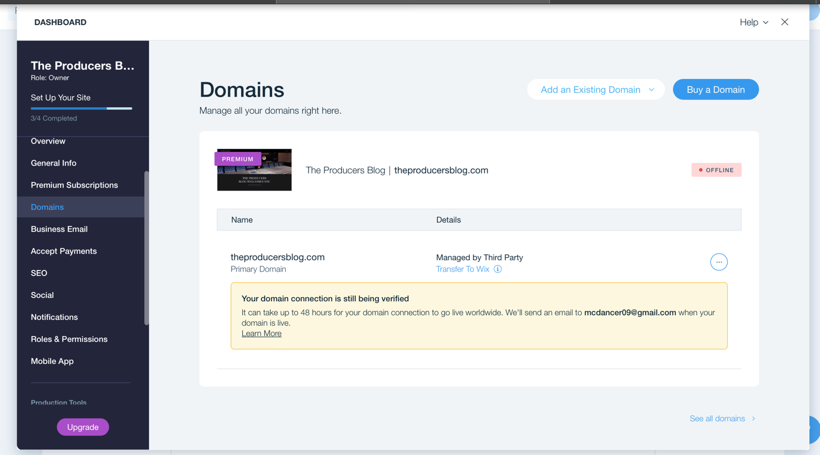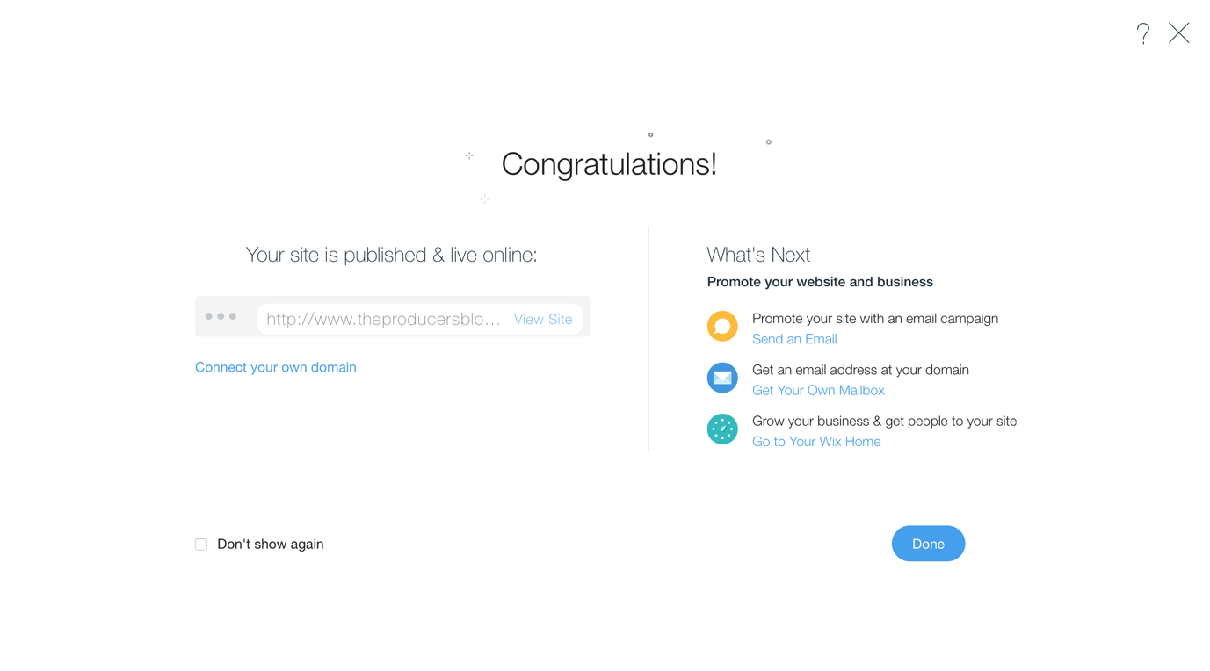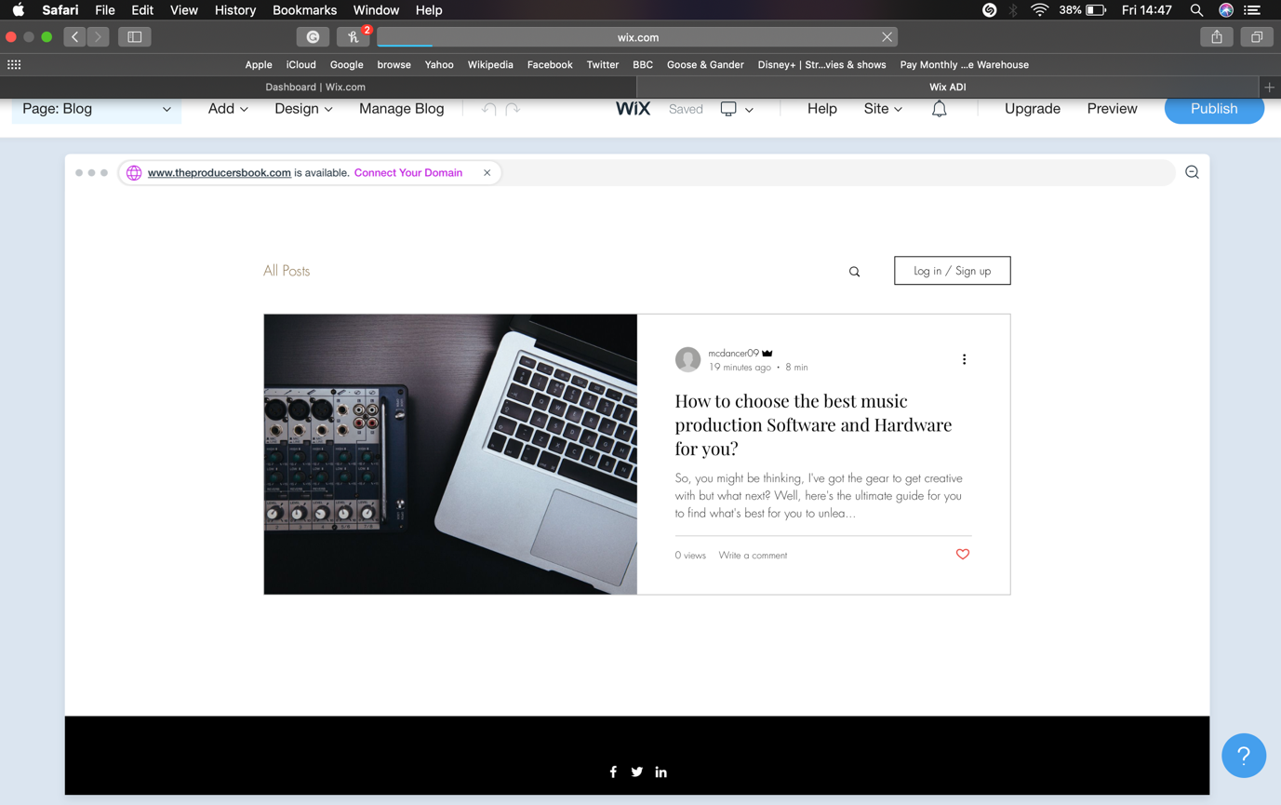
Bibliography

Ask.audio. n.d. [online] Available at: <https://ask.audio/articles/fl-studio-125-pattern-clip-playlist-feature-revealed/ja> [Accessed 26 April 2020].

Apple (CA). n.d. Logic Pro - Apple (CA). [online] Available at: <https://www.apple.com/ca/logic-pro/> [Accessed 26 April 2020].

Ableton.com. n.d. Music Production With Live And Push | Ableton. [online] Available at: <https://www.ableton.com/en/> [Accessed 26 April 2020].

Avid.com. n.d. Pro Tools - Music Software - Avid. [online] Available at: <https://www.avid.com/pro-tools> [Accessed 26 April 2020].
MusicTech. n.d. Reason Intro Offers The Reason Experience For Less Than £100. [online] Available at: <https://www.musictech.net/news/propellerhead-release-reason-intro/> [Accessed 26 April 2020].

The Wire Realm. n.d. The Best Free Music Software. [online] Available at: <https://www.wirerealm.com/guides/best-free-music-software> [Accessed 24 April 2020].

The Wire Realm. n.d. The Best Music Production Software For Beginners. [online] Available at: <https://www.wirerealm.com/guides/best-beginners-music-software> [Accessed 26 April 2020].

The Wire Realm. 2020. Top 10 Best Music Production Software – Digital Audio Workstations. [online] Available at: <https://www.wirerealm.com/guides/best-music-production-software-daw> [Accessed 24 April 2020].

Music Repo. 2020. Music Making Hardware: Our Top 10 Studio Essentials For 2020. [online] Available at: <https://www.musicrepo.com/music-making-hardware/> [Accessed 24 April 2020].

Amazon.com. n.d. [online] Available at: <https://www.amazon.com/Focusrite-Scarlett-Studio-Interface-Recording/dp/B01E6T50BO/ref=as_li_ss_il?ie=UTF8&qid=1548702012&sr=8-1&keywords=B01E6T50BO&linkCode=li2&tag=musrep03-20&linkId=ae5c092fa474cbec27518c8a85a438ea&language=en_US> [Accessed 26 April 2020].

Amazon.com. n.d. [online] Available at: <https://www.amazon.com/AKG-C1000-S-Condenser-Microphone/dp/B00COU1MQ0/ref=as_li_ss_il?ie=UTF8&qid=1548702629&sr=8-1&keywords=AKG+C1000S&linkCode=li2&tag=musrep03-20&linkId=88e8843268823d6b8a80db28dbcb21cf&language=en_US> [Accessed 26 April 2020].

Music Repo. n.d. Best USB Microphones For Recording In 2020: The Ultimate Guide. [online] Available at: <https://www.musicrepo.com/which-usb-microphone/> [Accessed 24 April 2020].

Music Repo. n.d. The Best Studio Headphones For Home Recording Studios In 2020. [online] Available at: <https://www.musicrepo.com/best-headphones-for-home-recording-studio/> [Accessed 24 April 2020].

