

Assessment 2
(Written document)

Student name: RUTH SENE
Student ID: 2029258

Module name: Changemakers: Building your Personal Brand for Sustainable Employment
Module code: BMHP5015
Lecturer name: Bianca Sanfilippo

Part 1.
Reflection on the key learning points which you I gained because of
completing the Changemakers: Building a Personal Brand for Sustainable Employment module.

This module required me to complete online learning activities on Moodle divided into 4 Units: Brand you, it is a Small World, Opportunity Knocks, and The Pursuit of Happiness. Each Unit discussed different topics essential for personal and professional development.
In this task I focus on 4 specific learning points from each unit that supported me to reflect on my employability skills and knowledge and their importance for my career development. The learning points/aspects discussed in this task are Ambition, making connections and networking, resilience, emotional intelligence, autonomy.

Ambition
In unit 1 the concept of ambition was ambition and its significance in advancing one's career were examined. Personal, intellectual, and professional success are all within reach for those who are driven by ambition. The drive to succeed professionally and get praise for our efforts is a key ingredient in building a successful career. When I consider my own attributes, I realise that I am ambitious because I want to make the most of my abilities. My future in the workplace is well-planned.
Ambition is important for career development because…
To be ambitious is to want to succeed or stand out in some way, and to want to keep trying even when things don't go as planned or as well as you'd hoped.
It's the mentality that will get you to the finish line first, no matter how tough the road ahead may very well be.
As a means to go forward in life, aspiration is more valuable than natural ability or financial backing.
Despite possessing every necessary talent for your position, if you lack the will to succeed, you will never get to the top.


Making connections and networking
Networking may be described as the establishment of professional ties and connections among peers/colleagues, professionals, and employers in one's own sector/field. Making relationships is vital in today's professional employment, including photography, teaching, and healthcare. Networking may help us locate the ideal job and career opportunity after graduation from Cornerstone University. Developing professional relationships is one of the most essential abilities necessary for success in any field. When we need guidance or assistance in resolving difficult issues, having contacts with other specialists is crucial. Additionally, contacts may help us locate new employment prospects, advance in our careers, and grow our businesses. According to the data, 85 percent of job openings are filled via networking. Using social media sites, such as Facebook or Instagram, face-to-face meetings, seminars, training sessions, and conferences, academics, peers, and professionals may network.
In contrast to the many superficial connections acquired via networking, the genuine links acquired through connection-building may endure a lifetime. When I make an effort to connect with someone, I do it with the intention of strengthening our connection, not my professional status. This topic was essential to me and gave great information. This is owing to the fact that I do not use LinkedIn or Twitter or any other current social media platform. I lack the motivation to create my own online professional profile with a photo and credentials. Upon reflection, I realise that this is one of the key areas in which I need to improve. I must work up the courage to create my own profile so I may network with other professionals in my industry, learn from them, and contribute to the progress of our disciplines and communities. I feel as if I am missing out on opportunities to create my image and reputation because I lack connections. A robust internet network is essential for me to get employment and grow in my chosen sector. According to Harrison (2021), LinkedIn is a vital resource for recruiters seeking quality candidates. In order to advance in this field, I've chosen to create my individual profile.



Identifying career opportunities
In order to keep up with the ever-changing nature of business, I must be more flexible in how I search for new possibilities. My chosen profession needs to bring us joy, obviously. However, it's not always as simple as it looks to figure out what kind of work makes us happy.
Today's workplaces are becoming more complicated, therefore it's important to be adaptable in your search for new chances. From a young age, my parents instilled in me the confidence that I could achieve any goal I set for myself. Once I graduate, however, the topic of discussion often switches to "how are you going to pay my mortgage" I have no idea how my life will develop, but I do realise that external forces will play a part.
We must include resiliency training into our work routine if we are to survive these challenging times. I have been able to do this by selecting conversations that provide opportunities I can exploit.
The significance of making intelligent career choices. Since most of us spend at least 71% of our waking hours at work, it is crucial to find a profession that provides us joy. There is more to career exploration than merely considering how to get money. Do not hurry into a job merely to have one; doing so might land you in the wrong place doing something you despise. The consequences will affect your personal and professional life.
You want to feel good about coming to work every day because you know your work improves the lives of others. There will be challenging days, but it is crucial that the good days exceed the bad. If you like your work, you will be far more successful at achieving your desired outcomes.
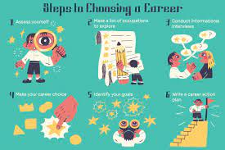

Future me
As a result of this conversation prompt, I have been able to consider the factors that finally prompted me to enrol in college. I will be required to evaluate how the reality of college life compare to my initial expectations and how this may impact my future goals. I consider how my study habits may alter because of these many influences.
Developing an emotional connection with my future self may result in a change in perspective and a strengthened ability to make wise judgements in the present moment. By doing something as simple as role-playing a potential result before to committing to it, i might improve my connection with my future selves. I was introduced to the notion of limiting thoughts and the influence they had over me for the first time. Several strategies for overcoming self-doubt will be presented. The distinction between a growth mindset and a fixed mindset will be clarified to me.
In the end, I will learn about the art of possibility and how adopting a more optimistic perspective might assist me in achieving my goals.
Students' motivations for pursuing postsecondary education varied widely but were mostly driven by the hope of bettering their job and advancing their careers.


Resilience
especially in the midst, the capacity of a material or item to recover its original shape after being deformed.
To be resilient, one must be able to adapt one's thoughts, feelings, and actions to new circumstances, both inside oneself and in the outside world.
It's certain that I have difficulties in my life and at work. Maintaining normal functioning despite stress is essential in many contexts, but it is particularly important in the workplace, where resilience may make all the difference.
The ability to bounce back from adversity is a hallmark of resilience. People who are resilient draw on their inner reserves of strength and talent to go on in the face of adversity.
There are several reasons why the capacity to recover from adversity is vital, including preventing the beginnings of mental health issues and maintaining stability in one's life through difficult times.
Because I am resilient, I can maintain my composure under stress. A person in this circumstance may be a newly promoted manager who is now expected to assume more tasks. Instead of complaining about the difficulty of their task, the person will search for ways to simplify their procedures. Aspects of career resilience include the ability to take command of one's professional life, improve as an individual and as an employee, and adapt to a changing work environment. One concept of career resilience is accepting responsibility for one's own professional growth.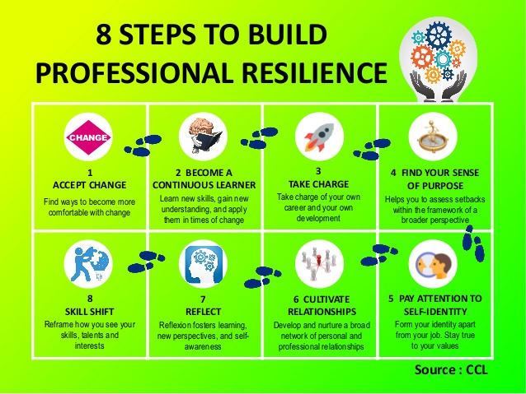

Emotional intelligence
Emotional intelligence means being in control of one's own feelings and using that knowledge to benefit oneself and one's friendships with others, as well as to deal with stressful situations, articulate one's feelings clearly, show empathy, face obstacles, and resolve conflicts.
A graduate with a high level of emotional intelligence is more likely to thrive in their chosen sector, contribute positively to their team, and develop in their chosen career. Emotional intelligence facilitates communication, cooperation, and the formation of interpersonal bonds.
Being emotionally intelligent has helped me in many ways: in making friends, working in teams, resolving conflicts, and enjoying my work more. Possessing a high EI may help boost team output and employee retention.
Emotional intelligence is characterised by an ability to comprehend and manage one's emotions. By demonstrating emotional intelligence at work, you may enhance relationships with colleagues and promote your career.
Emotional intelligence comprises self-awareness, empathy, and the ability to regulate unpleasant emotions. Academic achievement, good judgement, and long-term satisfaction are but a few of the many benefits associated with the development of these skills. also, the ability to manage my own emotions and understand those of people around me.

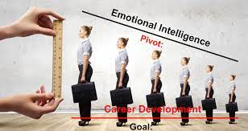

Part 2. Personal Development Plan (PDP) Example
 | SKILLS | CURRENT ABILITY | TARGET ABILITY | DEVELOPMENT OPPORTUNITY | CRITERIA TO ASSESS SUCCESS | TIME-FRAME | EVIDENCE
1st  PRIORITY | Networking skills  Writing communication skills | Require improvement  Good | Good  great | Reading online training, self-learning such as listening to podcast, watching video.  Able to express myself clearly, keep a place to jot down thoughts and ideas, constructive criticism as growth, write and read often, reading about the purpose of my message. | I am creating and updating my own LinkedIn account and increase number of connections.  Thinking through in advance what I want to say, gathering, analysing and arranging my information in logical, developing my argument in a logical way, adapting my writing style for different audiences. | 26/02/2013  1/09/2022 | Certificate,  Online account  Training  Reading books, watching video
2nd  PRIORITY | teamwork Skills  making decision skills | good  require improvement | Excellent  good | Listening to other opinions, accepting and learning from constructive criticism. Giving positive, constructive feedback.  Understand the context, make a plan, set deadlines, evaluate the outcome also get second opinion. | Working confidently within group, working cooperatively towards a common goal, contributing my own ideas effectively in a group.  Taking a positive attitude to failure: persevering when things are not working out, accepting responsibility for mistakes/wrong decisions, being flexible- prepared to adapt goals in the light of changing situations. | 12/02/2021  12/03/2013 | Online training  Online account,  assessment
3rd  PRIORITY | Academic skills  Digital skills | Good  good | Excellent  Excellent | Book an appointment with London library | Higher grades | 20/03/2020 | assignment

Reference List
Monster Career Advice. (n.d.). How Building Resilience Can Help Your Career. [online] Available at: https://www.monster.com/career-advice/article/building-resilience.

‌Community Industry Group. (n.d.). Types of Resilience. [online] Available at: https://communityindustrygroup.org.au/lessons/types-of-resilience/.
‌
Future Self. (n.d.). Future Self. [online] Available at: https://futureselfshop.com/ [Accessed 27 Dec. 2022].
‌
Psychology Today. (2019). Emotional Intelligence | Psychology Today UK. [online] Available at: https://www.psychologytoday.com/gb/basics/emotional-intelligence.
‌
Institute for Health and Human Potential (2019). What Is Emotional Intelligence, Daniel Goleman. [online] IHHP. Available at: https://www.ihhp.com/meaning-of-emotional-intelligence/.
‌
Cherry, K. (2022). 5 key components of emotional intelligence. [online] Very well Mind. Available at: https://www.verywellmind.com/components-of-emotional-intelligence.
‌
Segal, J., Smith, M., Robinson, L. and Shubin, J. (2019). Improving Emotional Intelligence (EQ). [online] HelpGuide.org. Available at: https://www.helpguide.org/articles/mental-health/emotional-intelligence-eq.htm.
‌
www.cococonsulting.ch. (n.d.). Coco Consulting Blog - 3 Reasons Why Building Connections Is Better Than Networking. [online] Available at: https://www.cococonsulting.ch/blog/3-reasons-why-building-connections-is-better-than-networking [Accessed 28 Dec. 2022].
‌
Careertipster.com. (2015). Networking: Making Contact vs. Making Connections – Career Tipster – Career Development & Education. [online] Available at: http://careertipster.com/careerdev/networking/networking-making-contact-vs-making-connections/ [Accessed 14 May 2019].

www.nobledesktop.com. (n.d.). Making Connections Through Networking | Noble Desktop Blog. [online] Available at: https://www.nobledesktop.com/blog/making-connections-through-networking [Accessed 28 Dec. 2022].
‌
‌

