MSc Policing

(Operational and Strategic Leadership)

Strategic Management in Policing

BMPO7004D

Development of a strategic plan for a specialist area of policing

Owen Stafford

Contents

Executive Summary 3
Introduction 4
Main body 6
Strategy statements 7
Level of strategy 9
Strategic development 9
Strategic position 10
Strategic choices 13
Strategy in action 13
Leadership 14
Divergence 17
Strategies to consider – Prescriptive 18
Strategies to consider – Emergent 19
Strategies to consider – Umbrella 19
Implementation and delivery 21
Conclusion 21
Recommendations 22
Appendices 23
References 27

Executive Summary

Missing persons is an emotive subject.
Nationally and locally a missing person investigation can attract significant interest and cost the police service and other partner agencies significant amount of resources.
More importantly there is a person at the centre of this subject, a person who is likely in crisis, whose life may be at risk or are deceased. A family are left behind, leaving many unanswered questions including, are they alive, are they safe, where are they, what are they doing?
This report highlights how the force should consider a missing person strategy and at the heart of its creation how it should be tilted towards the vision of Humberside Police in protecting some of society’s most vulnerable persons.
The report takes a deeper dive into the historical perspective, current theories and techniques which support how to deliver a missing person strategy.
This report considers the legal and ethical obligations of Humberside Police. Balancing those obligations whilst working with stakeholders and partner organisations to locate the missing person and once located go onto deliver outstanding safeguarding and prevention work.
The report aims to set out a structure for how Humberside Police can continue on its path of continuing excellence by building the previous rating of outstanding in the management of missing person.

Introduction

This report will consider the development of a strategic plan for missing persons within Humberside Police (HP).
An inspection of HP’s internal and external strategic documents reveals the force does not have a strategic plan for missing persons (MP). Considering many cases of MPs, large amounts of resource, community interest and often serious crimes begin from the determination of a missing person, an example of this relates to the recent case of BULLEY (CoP, 2023).
At the most basic level, a strategic plan can be a guide to support the forces legal obligations to protect life, work with both internal and external stakeholders / partners to safeguard the welfare of children (Childrens Act 2004).
Clear leadership, that sets a vision, provides a guide as to standards and makes staff feel proud of their contribution to policing. Officers can use these foundations as an anchor to guide decision making and prevent confusion when contributing to the creation of the strategy Johnson et al (2012).
The Code of Ethics provides principles for the Police Service (CoP, 2024). At the local level a missing person strategy (MPS) must be linked to the culture, values and behaviours of the force. A strategy statement would bring these areas together and as suggested by Whittington et al (2020, p.10) “Public-sector organisations need strategy statements not only for themselves, but to reassure clients, funders and regulators that their priorities are the right ones.” Nowhere is the most appropriate than the Police Service.
To begin construction of a MPS following the legal and ethical obligations, it needs to be determined what strategy is. Acts of parliament, academic and professional bodies work are used to support why and how a MPS would be brought from conception to a working strategy.
Strategy has been described as “the determination of the basic long-term goals and objectives of an enterprise, and the adoption of courses of action and the allocation of resources for carrying out these goals” (Chandler,1990,p.13). Most activities within any businesses, public or third sector following this idea.
The reasons for people going missing are complex (Missing People, 2024). The challenge of a MPS is to bring together the separate legal and ethical requirements, intertwin them and produce a strategy that safeguards the public (NPCC 2022). This strategy when completed should sit next to other strategies the force uses and complement them.
The subject of missing persons is not one that can be solved by policing. Rittel and Webber (1973) describe a wicked problem as having ten key areas, property eight is described as the problem been a symptom of another problem; rarely do people go missing without a driver to that behaviour. The work undertaken by the Missing Person Charity (2024) and Gibb and Wollnaugh (2007) in searching for missing persons and the reasons driving active missing persons demonstrates the complexity of the subject. Camillus (2019) describes a wicked problem as having five areas of insight. When these five areas are overlaid onto missing persons, four of the five areas are closely aligned, with the fifth area matching the first known missing episodes. Using this concept, missing is not solvable by conventional processes, but is manageable as a problem.
Demand across most areas of policing is predictable (Humberside Police 2024), within the force area there will be crimes and incidents that require flexibility; having a strategy that caters for emergent and known demand, is one that Humberside Police should strive to achieve.

Main body

Strategy has its origins in military planning, with strategy and strategic planning borrowed from military thinking. Strategy is a word generated from “Strategos”, Greek to mean the art of the army general. Strategy has been around since our distant Homo cousins used strategies that emerged and become directive, creating plans to catch food, stay warm and work in groups to ensure survival. Strategies and plans have assisted humans to achieve a great amount of success over the last 50,000 years.
Public and media interest in missing persons impacts how trust and confidence in policing is seen during missing person investigations. This type of investigation can significantly enhance or damaged police reputation (North Yorkshire Police 2024) and (British Broadcast Corporate 2020).
Legal obligations have remand consistent, since the introduction of the European Charter Human Rights (European Commission, 2024). Cultural attitudes and expectations have changed with an increase in the expectations of the police service both in respect of trust and what is expected of the police service Brown and Hobbs (2023) & (CoP, 2015). Increased demand has driven a reestablishment of policing’s core duties and boundaries which have been blurred (CoP, 2023).
Demand associated with missing persons has grown, relating to children and increased scrutiny by assessing bodies such as the HMICFRS PEEL inspection review including a vulnerability strand (HMICFRCS 2024).
Policing does have uncertainty, but also certainty as described by Wally and Adams (2019). The likely known outcomes are semi predictable and as describe by Whittington et al (2020, p.50) are “probable” within a range of outcomes. There are a range of outcomes that could unfold, with the bulk of missing person investigations and associated risk placed in the middle of those outcomes. To a lesser extent but with no higher risk association is safeguarding against unlikely risks associated with missing children and / or vulnerable adults.
Over the past 50 years there has been debate within academia about strategy, its component parts, tools and the difference between a strategy and a plan. Lynch (2018) notes that strategic management is made complicated by the lack of agreement between researchers about the subject and how its component parts fit together.

Strategy statements

Internally to HP the Plan on a Page is a broad, simplified strategy of direction, with an easily digestible plan of mission, vision and objectives.
A MP strategy needs to set out the below areas:
- Fundamental goals (mission, vision or objectives) – The mission should be to locate missing persons. The vision should be “to locate a missing person, safeguard them and work with partners to contribute to a problem-solving approach”. The objectives are intertwined in the vision statement and scope of activities.
- Scope of activities – To locate MPs using specialist officers who are focused on the subject area only. To work with stakeholders and partners to share joint responsibility (CoP, 2016). To use a problem-solving approach to reducing missing episodes and hold partners to account for their responsibilities (CoP, 2022).
- Advantage – Officers based within a specialist team with specialist oversight. Officers with the correct skills and team behaviours. Officers who can diligently work with partners to safeguard individuals.
The above sets out a notional perspective on how the force can safeguard members of the public and discharge its legal and ethical duties. This message would as the strategy develops into the implementation stage be an area of discussion with stakeholders.
The force has produced a control strategy that details how MP risk has been assessed as low risk. However, homicide has been graded high risk. Murder investigations within the force area such as Nelson and Squires have started as missing person enquiries (British Broadcast Corporation, 2005) and (British Broadcast Corporation, 2019). A misunderstanding of placement and strategy positioning of MP risk is evident within HP.
Mintzberg (1987) has laid out strategy with Five Ps for Strategy. This view provides 5 definitions of strategy, spanning areas of plan, ploy, pattern, position and perspective. The aim of Mintzberg’s view is to provide clarity and understanding of strategy. Mintzberg had previously commented on intended strategies that “…most end up in the rubbish bin”. This is further explored by Bovaird and Loeffler (2016, pg. 70) who point to the dangers of a semi-emergent strategy that has been imposed by a political leader or senior executive.
It is proposed by Khalifa (2023) that previously accepted models that have underpinned strategic thinking from the late 1960’s onwards may need to be reconsider, suggesting that Mintzberg admitted his previously proposed models were known to be false. This claim relies on some specific details within the wording but does not provide an explanation in detail to discount the historic and foundational thinking. Mintzberg and others should not be undermined because of this argument made by Khalifa. Established concepts and tools should be used to create a MPS.

Level of strategy

Considering the levels of strategy model Whittington et al (2020) (figure 1) a MPS would fit within the business-level area (mid-level) and the base level functional strategies area. This is an appropriate place for the MPS to sit within the wider organisational level strategies.
Business level strategy is described as “…how the individual business should compete in their particular market.” Whittington et al (2020, pg.12). It is considered that a wider view of the overall strategies within HP would anchor the MPS underneath of the corporate-level strategy that is inclusive of the forces Plan on a Page and Control Strategies.

Strategic development

Laid out is how HP can get from the conceptual idea of a MPS to a strategy that is embedded within HPs daily business. To do this Whittington et al (2020) applies the use of Strategy’s Three Branches (Figure 2). This layout is one of assessment of the environment internally and externally, developing options and creating processes to drive the formation and delivery of the strategy.

Strategic position

The first of three areas (Strategic Position) which forms part of the Exploring Strategy Framework (Figure 3) gives a greater understanding of five key areas. This baseline assessment of the fundamental position is key to laying the foundations of a new strategy.
Policing has priorities that are directed by central government and the local PCC (Home Office 2023) and (Police and Crime Commissioner 2023). These priorities alongside, legal and ethical requirements shape police thinking, force strategies, resource allocation and preferred outcomes.
An agenda of national priorities has been set for 2023 for the general direction of policing. Although this does not include MPs as a priority, it is well established with previous cases that MPs have a significant amount of risk to the individual and organisation.
HMICFRS most recent inspection of HP included “vulnerability” as an area of inspection. MPs is a key area within vulnerability, with oversight on the force’s strategy, plans and resource allocation of interest to HMICFRCS due to the interwoven nature of MPs and vulnerability.
Locally the PCC has set an agenda that does not include MPs as a priority within the PCC strategy. The PCC (2023) has placed some emphasis on HP “…challenging ourselves to innovate and think outside the box”. There is a misalignment between the national and local political understanding of policing and its obligations that is not aligned to key challenges at force level. A MPS should include thinking more openly and broadly with greater understanding of MPs as a standalone area of policing.
It is known across policing that MP matters are what Mintzberg (1994) would describe as niche and if explored further Mintzberg suggest that “…perhaps even found, through a pattern of behaviour” (1987, pg.15). This is what is happening with MPs within policing. A MPS would formally align behaviours (end product) with HP commitments, senior leader thinking and resource allocation.
Stakeholders are fundamental in policing to the achievement of a strategy. As can be seen in the Plan on Page the force attributes great emphasis on stakeholder connections. The force has reevaluated its obligations across a range of partners over the last 2-3 years, this is evident through the Right Care, Right Person Initiative (2023) alongside Joint Responsibility (2016) is a corner stones of stakeholder engagement working and boundary setting.
The political landscape and factors that affect policing are evident from central government directions and agendas to PCC’s commitments. Bovaird and Loeffler, (2016, pg.71) make the case that public sector strategy is different to that of private strategy, making the point of interactions, clashes on viewpoints and “short-termism”.
A MPS must be aligned with HP polices but have due consideration to external stakeholder needs, wants and commitments relating to MPs and the impact the subject has on their organisations.
Alignment with other organisations that have legal, strategic and practitioner involvement should be part of a plan as suggested by Caputo and McIntyre (2015).
Understanding of the factors that are surrounding HP are key to been able to view the environment. Proposed are two well cited models to scan the environment, these are:
PESTLE Analysis - This tool scans the environment across six areas, these are political, economic, social, technological and legal (Figure 4). When considering political this would include PCC, local MPs, governmental and national agendas. Economic factors include funding and costs. Social influences include the ever-changing views of the public, the basic expectations of the public and any changing demographics in the Humberside area. Technological advancement impacts on how HP operate and how technology can be a main investigatory strand in MP enquiries. Environmental factors are of a lower consideration for policing but are consider in the structural compontants such as buildings and vehicles. Legal constraints dictate broadly what actively HP should undertake. As sited throughout the report, this is a cornerstone of the MPS Johnson et al (2011) (Figure 4).
5P Framework (Porters Five Forces) – Devised by Porter, the five forces framework is structured for industry (Figure 5). This model must be adapted to be useful within the public sector and policing specifically. New entrants into the market in respect of unknown MPs or groups that become a resource demand to HP.
Considering competition, HP does not have a competitor, stakeholders could be considered competitors if the most suitably trained officer is to conduct problem solving or intervention work. Closely aligned stakeholders may be able to compete in this area and as they are best placed via skills, training and legal obligations to undertake this work. HP does have a significant amount of bargaining power with buyers, if buyers are considered to be stakeholders and partners. This is described by Porter as “….suppliers can put pressure on the players in the industry (Karlof and Lovingsson 2005, pg.268). This would amount to strategic influence in the broadest sense and link into local and national policies.

Strategic choices

Overlapping of strategic position is strategic choices. Whittington et al (2020, pg.15) describes strategic choices as “…the direction in which strategy might move and the methods by which strategy might be pursued”. Mintzberg (1984, pg.256) has described strategy as “establishing long range goals and action plans for an organisation”. This view is a clear, logical thought process and one that matches policing culture.
While Magretta (2012, pg.6), speaking of Porters work, states that “No strategy is meaningful unless it makes clear what the organisation will not do”. This cements a view that a strategy needs to be well thought out in its objectives and delivery, whilst having a review mechanism to avoid strategic drift. The implementation of Right Care, Right Person has provided guidance, culture and ethos to curtail drift.

Strategy in action

An overlap to both the strategic choices and strategic position is strategy in action, this area is the engine room of the strategy delivery. As options available to HP become clearer when moving into action considerations. Within HP focus should be given to the development of structure, models, inclusivity of technological development, officer skills and mindset that could reduce risk and harm.

Leadership

Responsible leadership is a required part of the strategy process. When cross referred with the deliberate strategy leaders should strive for core qualities inclusive of transparency, coordination of matters, strong articulation of a strategy making vision and alignment of systems and processes Martiz (2011, pg.107).
It is recognised that difficulties leading through an emergent strategy creates, but it is recognised that having a sound strategy as a benefit outweighs any individual leadership concerns. Leaders and managers need to harness and display clear viewpoints, well-articulated whilst demonstrating visible passion Lynch (2018). Leadership is vital to the development and delivery of an MPS within HP.
Strategic options would crystalise with more directed focus provided to the development of structure, models and innovation including technology, skills and mindset that could reduce risk and harm.
Deeper thinking and a force commitment to how the MPS is resourced and structured is required to bring the MPS to life and drive a strategic plan.
Fundamental to the strategy to drive change is what tools are used to assist with the assessment. Outlined are two tools that are suggested for use:
- Forcefield Analysis Model – This tool is used to analyse change as imbalances between driving forces and restraining forces. The theory created by Lewin (1951) (Figure 6) has three elements to it:
- HP would have to unfreeze the forces which are driving and restraining change.
- When unfreezing the restraints an imbalance has to be created so change can take place (pushing the drivers into the restraint area).
- Once driving forces have successful pushed into the restraint area, a state of rebalance and securing of that rebalance must take place.
Thomas (1985, pg.57) promotes the use of this tool stating “…provide a mechanism for identify and assessing various forces working for and against strategic change”. Thomas describes the “Beautiful Strategic Game”, making a link between change not been seen as threatening but helpful if perceived correctly. A MPS could be seen as a “Beautiful Plan” within HP by those who hold historical views of previous strategies. Key to delivery is engagement with those who are stakeholders to MPs, this will provide a rounded view of the forces involved.
- Eight steps of change model – Devised by Kotter (1996) (Figure 7) this model offers a structured approach to working through change within HP. Kotter (2012, pg.22) provides a viewpoint that “…inwardly focusing cultures, paralysing bureaucracy, parochial politics…a lack of leadership in middle management…must address and address them well”. All of these factors are known within policing and must be considered throughout the development of a strategy. Eight elements should be specifically used as a tick sheet of areas to be covered by middle managers who are responsible for development and using the strategy.
  - Establishing a sense of urgency – Much like Potters work this area suggests an inspection of the market. This would be completed as part of the analysis of the microenvironment.
  - Creating the guiding coalition – A working group would be required to work though the development of a strategy and to continue the oversight once the policy is brought into action.
  - Developing a vision and strategy – This would be covered by using HPs vision with a bolt on as suggested specifically to an MPS. Development of the strategy would be based on a working group with a set agenda / time to be followed.
  - Communicate the change vision – The MPS needs to have lower and middle managers involved so they are live the strategy development with the view of sharing the new vision with practitioners.
  - Empowering broad-based action – Having top cover as by a chief officer who can remove barriers is vital to the creation of an MPS. Allowing officers to think and generate ideas that can open up new ways of doing things is also important.
  - Generating short term wins – the drawing up of a plan to get traction on quick small achievements that can be celebrated.
  - Consolidating gains – Keeping momentum going with small achievements to create longer term goals. Bringing staff into the process who have an interest and can positively influence the policy reaction.
  - Anchoring new approaches – This is a key part of the MPS development. Bringing to life and pushing the strategy into daily business. The behaviours of staff and middle managers are important to ensuring success.
A MPS should align with existing policies, that been to not be overreaching, but focused on achievement with clarity of purpose. Once the environment is understood, to what extent is the organisation willing to provide resources to deliver the strategy.

Divergence

Mintzberg (1994) discusses this topic describing it as “Confication, Elaboration and Converastion”. Mintzberg is a proponent of leaving strategies flexible that does not have to be broken down. This is to allow the managers room to manoeuvre and not to be shackled to the strategy. Elliot at al (2020) makes the case that higher level managers can influence senior executives more readily, leaving middle managers as the doers of strategic deliver. Middle managers are often the doers of strategic delivery with access to resource allocation, which is key to delivery of an MPS. Middle managers need to be included to influence the direction, whilst supporting senior leaders with inputs, suggestions and a finger on the pulse to guide on how and where to place resources.
Mentality and belonging to the process are two areas that need to be intertwined within the development of a strategy. Pappas and Woolridge (2007) make the case that middle managers should be involved in the social renewal of strategy, which is support by Johnson et al (2003) who considered this by “unbundling the deeply embedded social behaviours of middle managers”. Vaz, Raes, Heyden (2022) have developed thinking further considering middle managers to “assess the benefits and risks from their relational exchanges”. The concept been that middle managers conduct reconnaissance before mentally agreeing to strategy. Pappas and Woolridge (2007) suggest that staff members who converse frequently are central to strategy. Middle managers, who do in fact mix and engage should be taken on the journey by invitation of inclusion to generate ideas, access to data (as chief officers have) and idea generation.
The need for middle managers experiences to support strategy development and sell the new strategy to practitioners is important. Using inclusivity in the strategy making process with emphasis on an open and honest relationship with senior leaders who steer the process.
Strategic concepts are key to delivery of a sound strategy. Widely written about, Mintzberg (1984, pg.256) has described strategy as “establishing long range goals and action plans for an organisation”. This view is a clear, logical thought process and one that matches policing culture. While Magretta (2012, pg.6), writing about Porters work, states “No strategy is meaningful unless it makes clear what the organisation will not do”. A strategy needs to be well thought out in its objectives and delivery, whilst having a review mechanism to avoid strategic drift.

Strategies to consider – Prescriptive

It is accepted that prescriptive strategy provides a set of objectives, defined by senior leaders before the strategy has been instigated. Lynch (2018) makes clear prescriptive strategy is where the objectives are defined in advance and the main elements have been developed before the strategy commences. Mintzberg (1985, pg.258) describes prescriptive strategy as “precise intentions in the organisation, articulated in a relatively concrete level of detail”. These two descriptions are broadly aligned with the general view of the framework been set before any framework of strategy has been developed. This is a restrictive strategy that is not suitable as a stand-alone tool.

Strategies to consider – Emergent

Mintzberg (1985) describes emergent strategy as having an unclear final objective, with elements of strategy developed during its life, as the strategy proceeds. Emergent strategy does require intention by HP when setting out a strategy, which is not overly prescriptive to the managers tasked with delivering the strategy. The strategy is affected by the internal and external challenges that may emerge; thus, the strategy will bend to meet them. This requires flexibility, but also a high degree of attention by middle managers.

Strategies to consider – Umbrella

An umbrella strategy is one of relaxed control. Mintzberg (1985, pg.63) describes control as “Leaders who have only partial control other actors in an organisation”. An umbrella strategy should provide guidelines to define the behaviour and allow for middle managers to deliver the strategy. This strategy is closely aligned with both the emergent and prescriptive strategies but allows for independent thinking and managing at the middle manager level.
It is proposed that the use of both prescriptive and emergent models as described by Mintzberg. A further view is taken that the emergent strategy can sit within an umbrella strategy, with the umbrella controls been visible but untethered, whilst the emergent strategy “will correct the organisations route” Souza (2023, pg.2).
Micheal Porter’s writings on competitive strategy offers a structure that industry can use to guide its strategy formation. It is clear that 100% of the framework can not be used by Policing. There are areas of cross over that tie in with the creation of a MPS and can be stitched into the considerations about how to create the MPS.
Cost advantage in the basic term cannot be considered but cost to the force in not having a strategy (unguided work) and cost effectiveness of those police officers when conducting unguided work can be. Through HPs activity in looking for MPs this is where the force can gain a competitive advantage, not in the sense of rivals, but in how it efficiently manages the cost implications, risk to the public and organisation; in practice competitive advantage would mean a well-run area of policing with a sound strategy. Porter (1985, pg.9) states “If the product creates a lot of value, structure becomes crucial.” This could be interpreted as providing a MPS that creates value to the force that is a mainstay to safeguarding the public.
Porter (1985) describes three generic strategies that could be used by an organisation. A theory of competitive advantage is described by Porter, suggesting an organisation needs to determine what advantage it wishes to obtain. This resonates with policing as described by Porter as “all things to all people”. Policing has been guilty of this across areas of business including missing activity. The Right Care Right Person policy and Joint Reasonability guidance has reduced the “all things” element to a more refined list of policing activities.
Differentiation has been suggested by Porter as a requirement of strategy. The concept asks the organisation to be unique and the creation of something what is widely valued by customers. A MPS can harness the resources, coupled with a delivery plan that uses those resources effectively.
Being ‘Stuck in the Middle’, meaning no advantage in the industry will indicate below level performance. Porter (1985, pg.17) highlights the need to “make choices about how to compete”. This is the case with the creation of a MPS and delivery of such a strategy. Choices within this area of business are needed to be seen, answered, and delivered on (Figure 8).

Implementation and delivery

The middle managers roles are likely to be Inspector, Chief Inspector and Superintendent. Karlof and Lovingsson (2005) have suggested that the middle manager should be ‘sense making’ at the local leadership level, provide the leadership and storytelling to those who have to work within the strategy.
A conceptual strategy, as is often the case in real world scenarios requires refinement and adjustment by continuing to keep within the framework of the overall vision and objectives. The middle manager is also a conduit back to senior leaders, it is middle managers that must not shy away from providing a realistic account of the factual state of affairs.
Selective Implementation Programme – The concept supports the idea of compromised delivery programme. This is not to look to rewrite a newly chosen MPS nor is it to make such minor changes that have little effect. This concept would empower the middle managers to make decisions that again follow the broad vision of the MPS but give control to middle managers responsible for delivery.
The deliver of the strategy should aspire to be emergent and flexible to allow movement (like a tree bending in the wind) and not constrained by senior managers or the strategy itself acting as an imaginary forcefield to hindering success.

Conclusion
MP is a complex subject that affects both the missing person, their associates, the wider community and organisations.
MP does not have a strategic plan within HP. Policing and MPs are intertwined with the public often looking to the police as the lead organisation to locate and safeguard those individuals.
Understanding the police services obligations and how to discharge those obligations, working with partners to safeguard is key to the consideration, conception and delivery of an MPS. All levels of management are fundamental to the development and delivery of a MPS that serves the public, whilst reducing demand upon HP.
The subject of missing persons is a not solvable, but a matter that can be managed with partners to minimise risk within a every changing world.
This report has outlined the considerations, tools and those involved in the creation and delivery of a MPS. There are two challenges for the force, 1. Having the determination to construct a MPS and 2. Delivering the MPS to protect the public and safeguard some of society’s most vulnerable members.

Recommendations

- The force should begin the process of development of a missing person strategy.
- The force should look to reassess the placement of MP within existing strategies.
- The strategy should be specific in its objectives and aligned to existing force strategies.
- Practitioners and supervisors should be included in the construction of a new strategy alongside middle managers having ownership and responsibility to deliver of that creation and implementation.

Appendices

Figure 1 – Levels of strategy
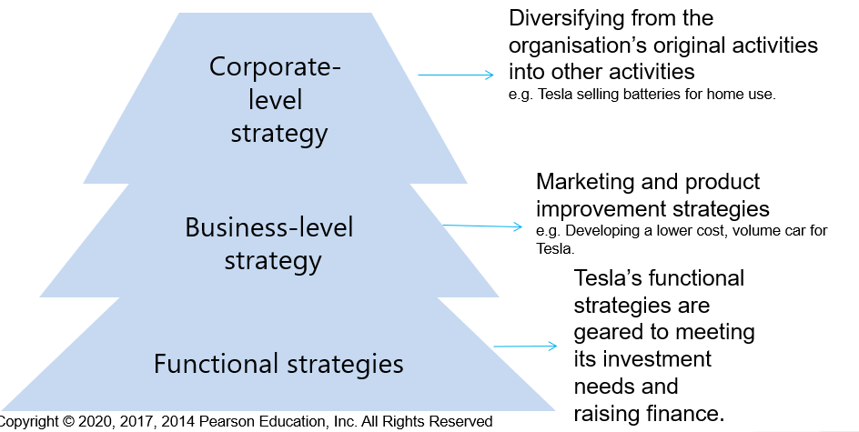

Figure 2 – Strategies three branches
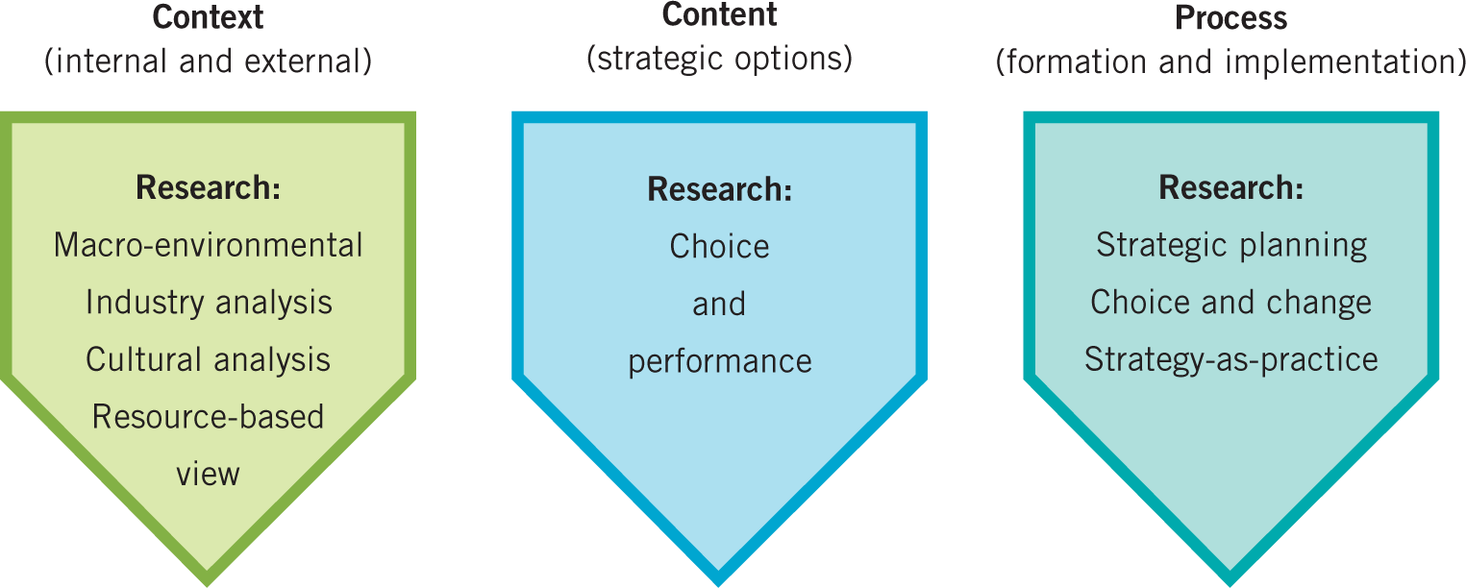

Figure 3 – Exploring strategy framework
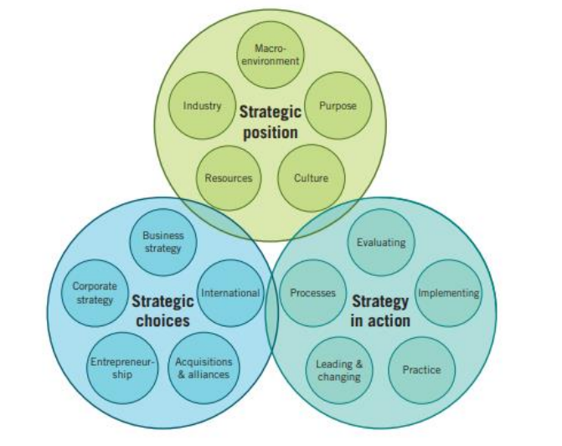

Figure 4 – PESTEL analysis
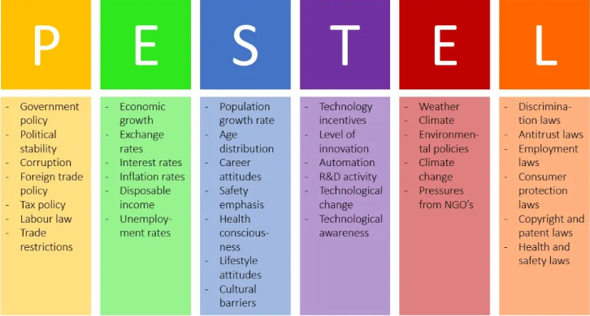

Figure 5 - 5P Framework (Porters Five Forces)

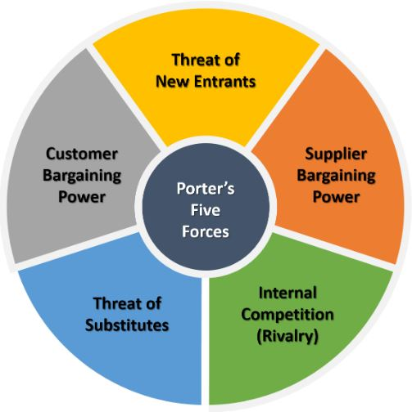

Figure 6 – Force Field Analysis
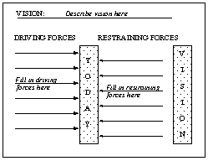

Figure 7 – Eight steps of change model
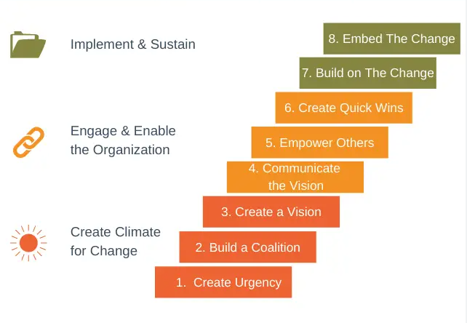

Figure 8 – Mintzberg strategies

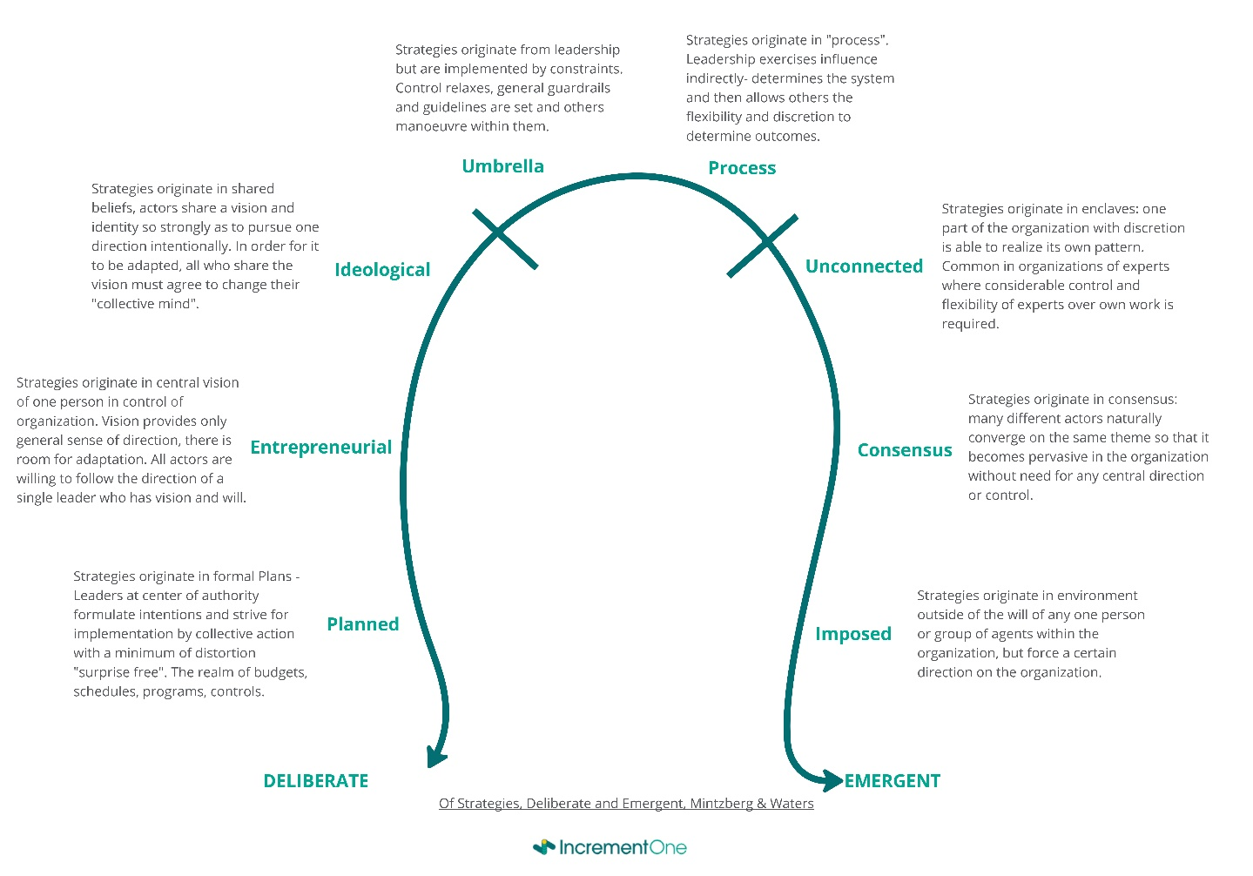

References

British Broadcasting Corporation (2005). Fiancé admits Valentines murder. Available at: http://news.bbc.co.uk/1/hi/england/humber/4414924.stm (Accessed 12 April 2024).
British Broadcasting Corporation (2019). Missing Liby Squire ‘may have come to harm’ police say. Available at: https://www.bbc.co.uk/news/uk-england-humber-47242501 (Accessed: 12 April 2024).
British Broadcasting Corporation (2020). Corrie McKeague: Missing Airmen ‘died after climbing into bin’. Available at: https://www.bbc.co.uk/news/uk-england-suffolk-54931963 (Accessed 12 April 2024).
Brown, R., & Hobbs, A. (2023). ‘Trust in the police’. Available at https://researchbriefings.files.parliament.uk/documents/POST-PN-0693/POST-PN-0693.pdf
(Accessed: 15 April 2024).
Bovaird, T. & Loeffler, E. (2016) Public Management and Governance . Routledge.
Camillus, J. (2019). ‘Strategy as a Wicked Problem’. Harvard Business Review Press, pp. 1-8.
Caputo, T., & McIntyre , M. (2015). 'Addressing role and value in policing: toward a sustainable policing framework'. Policing: An International Journal of Policing Strategies & Management, pp. 265-278.
Chandler, A. D. (1990) Strategy and structure - chapters in the history of the industrial enterprise. In MIT Press.
Childrens Act 2004, Available at: https://www.legislation.gov.uk/ukpga/2004/31/section/11
(Accessed: 12 April 2024)
Children and Social Work Act 2017, Available at: https://www.legislation.gov.uk/ukpga/2017/16/section/16/enacted
(Accessed: 16 March 2024).
Commissioner, H. P. (2022) What Our Priorities Are and How We Are Doing. Available at: https://www.humberside-pcc.gov.uk/Document-Library/Annual-Reports/Humberside-OPCC-Annual-Report-2022-23-final.pdf.
(Accessed: 17 March 2024).
Elnivan Souza, S. F. (2023) 'Revisiting Strategy and Performance Concepts in'. Dutch Journal of Finance and Management, pp. 1-13.
European Commission (2024) European Charter of Fundemental Rights. Available at: https://commission.europa.eu/aid-development-cooperation-fundamental-rights/your-rights-eu/eu-charter-fundamental-rights_en
(Accessed: 16 April 2024).
Fahey, R. J. (2012) 'Joan Magretta: what executives can learn from revisiting Michael Porter'. Strategy and Leadership, pp. 5-10.
Gibb, G. and Woolnough, P. (2007), Missing Persons: Understanding, Planning and Responding. Available at: https://www.missingpersons.gov.au/sites/default/files/PDF%20-%20Publications/Research/International/Missing%20Persons%20Understanding%20Planning%20Respondi.pdf
(Accessed: 11 April 2024).
HMICFRS. (2024) 'PEEL 2021/22 – An inspection of Humberside Police'. Available at: https://assets-hmicfrs.justiceinspectorates.gov.uk/uploads/peel-assessment-2021-22-humberside.pdf.
(Accessed: 17 March 2024).
Human Rights Act 1998, Available at: https://www.legislation.gov.uk/ukpga/1998/42/contents
(Accessed: 16 March 2024).
Johnson, G et al, (2012) Fundamentals of strategy. Financial Times Prentice Hall.
Karlof , B., and Lovingsson, F. (2005) The A-Z of management concepts and models. Thorogood Publishing.
Kotter, J, (2002) Leading change. Harvard Business Review Press.
Lynch, R. (2018) Strategic Management. Pearson Eductation Limited.
Mintzberg, H. (1987) 'The Strategy Concept I: Five Ps For Strategy', California Management Review, pp. 11-24.
https://doi.org/10.2307/41165263
Mintzberg, H. (1994) 'The Fall and Rise of Strategic Planning', pp. 106 - 115. Harvard Business Review, pp. 106-115.
Missing People (2024). Why do people go missing? Available at: https://www.missingpeople.org.uk/for-professionals/policy-and-research/information-and-research/key-information/information-about-missing
(Accessed: 16 April 2024).
National Police Chiefs Council (2022). NPCC Advice on the Legal Duties on the Police to Investigate Missing Persons. Available at: https://www.npcc.police.uk/SysSiteAssets/media/downloads/publications/publications-log/national-crime-coordination-committee/2023/legal-duties-investigate-missing-persons.pdf
(Accessed: 16 April 2024).
North Yorkshire Police (2024). Available at: https://www.northyorkshire.police.uk/news/north-yorkshire/news/news/2024/03-march/claudia-lawrence-case-15th-anniversary/
(Accessed: 12 April 2024).
Office, H. (2023) 'Strategic Policing Requirement 2023'. Available at: www.gov.uk: National priorities - SPR - https://www.gov.uk/government/publications/strategic-policing-requirement-2023
(Accessed: 20 February 2024).
Police, H. (2024) 'Plan on a Page'. Available at: http://nextgen.app.yhrn.police/sites/HumbersideIntranet/DM/PlanOnAPage/web/Home.aspx
(Accessed: 20 February 2024).
Policing, C. (2015) Estimating demand on the police service. Available at: https://assets.production.copweb.aws.college.police.uk/s3fs-public/2021-03/demand-on-policing-report.pdf
(Accessed: 15 April 2024).
Policing, C. (2024) Code of ethics. Available at: https://www.college.police.uk/ethics/code-of-ethics
(Accessed: 11 April 2024).
Policing, C. (2016) Missing persons - Joint responsibility. Available at: https://www.college.police.uk/app/major-investigation-and-public-protection/missing-persons/missing-persons
(Accessed: 19 February 2024).
Policing, C. (2023) Problem-solving policing. Available at: https://www.college.police.uk/article/problem-oriented-policing-pop-guidelines#:~:text=Problem%2Doriented%20policing%20(POP%2C,than%20reacting%20after%20the%20event.
(Accessed: 19 February 2024).
Policing, C. (2023). Independent external review of Lancahsire Constabulary's operational response to reported missing person Nicola Bulley. College of Policing. Available at: https://www.college.police.uk/article/review-nicola-bulley-investigation-published
(Accessed: 20 February 2024).
Policing, C. (2023). Right Care Right Person – Humberside Police. Available at: https://www.college.police.uk/support-forces/practices/smarter-practice/right-care-right-person
(Accessed: 20 February 2024).
Porter, M. (1985). Competitive Advantage. Free Press.
Rittel. W. Horst & Webber M. Melvin. (1973). Dilemmas in a General Theory of Planning. Policy Sciences, Vol.4, pp 155-169.
(Accessed: 11 April 2024).
Thomas, J. (1985). 'Force Field Analysis: A new way to evalute your strategy'. Long Range Planning, pp. 54-59.
(Accessed: 20 February 2024).
Walley, P and Adams, M. (2019) An Evaluation of Demand Management. Centre of Policing Research and Learning.
Waters, M. (1985). 'Of strategies, Deliberate and Emergent'. Strategic Management Journal, pp.257 - 272.
(Accessed: 20 February 2024).
Whittington et al. (2011) Fundementals of Strategy. Pearson Prentice Hall.
Whittington, R. (2020). Exploring strategy:text and cases. Pearson.

