

LOCATION: Swansea | LLEOLIAD: abertawe
LEVEL 7 | LEFEL 7
EXAMINATION PERIOD | CYFNOD ARHOLIADAU
May 2020 | Mai 2020
MODULE CODE: ACCA7018
IP SWITCHED NETWORK PRACTICAL

TIME: 3 HOURS

Name : nabil ouzahra

Student ID : P147535

Date & Time : 12;15 16/06/2020

This is an individual practical lab-test, held under examination conditions. You will be assigned four switches, you should configure these devices based on the following specifications.

This paper is marked out of 100.

You will have 3 hours to complete all the tasks and upload the files on Moodle.

TOPOLOGY
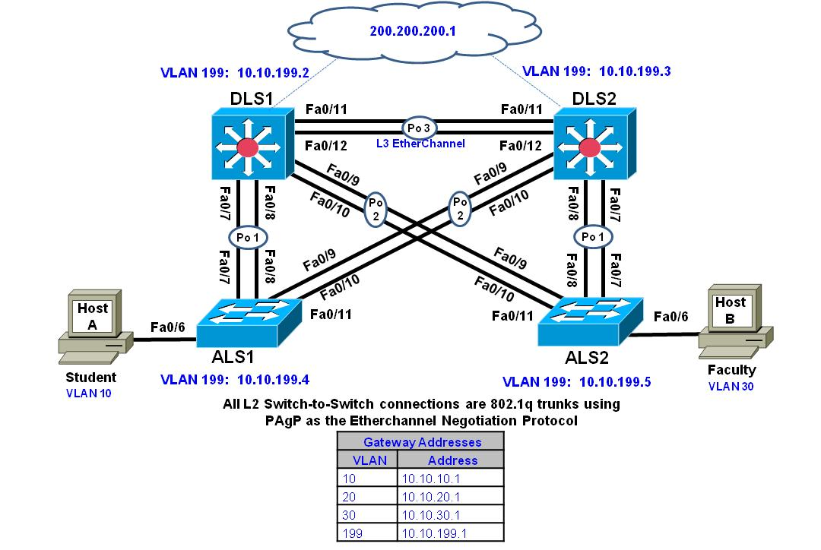

Task 1 – Network Connections

Create the topology using Cisco Packet Tracer and complete the tasks below.

Task 2 – Configure the network according to specification (90 marks)

- Shutdown all ports and only activate ports as required in these instructions.
- Configure each switch with a hostname and the domain name PRACTICAL2.
- Configure each switch with enable secret class.
- Configure the Fa0/11-12 link between DLS1 and DLS2 as a Layer 3 EtherChannel and assign a subnet to it. (See chart in step 6 for subnet information.) Do not use a negotiation protocol.
- Bind all inter-switch links in an EtherChannel using PAgP.
- Statically set all other inter-switch links as 802.1Q trunks. Ensure that the NATIVE VLAN is altered to VLAN 777. Restrict trunks to only allow VLAN traffic from only VLANs used in this scenario. Disable trunk negotiation.
- Place all switches in the VTP domain LAB_TEST with all switches in VTP transparent mode to support local VLANs.
- Use the table below to create local VLANs used in the campus network.
VLAN | VLAN Name | Subnet
10 | STUDENT | 10.10.10.0/24
20 | VOICE | 10.10.20.0/24
30 | FACULTY | 10.10.30.0/24
199 | MANAGEMENT | 10.10.199.0/24
777 | NATIVE_VLAN
900 | PARKING_LOT
L3 Subnet |  | 10.10.12.0/30

- Configure spanning tree mode Rapid PVST. Configure DLS1 as the spanning tree root for VLANs 10, 20 and 199 and as a secondary root for VLANs 30, 777 and 900. Configure DLS2 as the spanning tree root for VLANs 30, 777 and 900 and as a secondary root for VLANs 10, 20 and 199.
- On DLS1 and DLS2, configure SVIs and HSRP to provide gateway redundancy for access layer clients in VLANs 10, 20, 30, and 199. Create an SVI in VLANs 10, 20, 30, and 199, each with an IP address and mask. Reference the chart below for IP address information. Map the HSRP group number to the VLAN number.
 | DLS1 | DLS2 | ALS1 | ALS2 | HSRP VIP
VLAN 10 | 10.10.10.2/24 | 10.10.10.3/24 |  |  | 10.10.10.1
VLAN 20 | 10.10.20.2/24 | 10.10.20.3/24 |  |  | 10.10.20.1
VLAN 30 | 10.10.30.2/24 | 10.10.30.3/24 |  |  | 10.10.30.1
VLAN 199 | 10.10.199.2/24 | 10.10.199.3/24 | 10.10.199.4 | 10.10.10.199.5 | 10.10.199.1/24

- Configure DLS1 as the active HSRP router for VLANs 10 and 20 with a priority value of 120, and configure DLS2 as the backup. Configure DLS2 as the active router for VLANs 30 and 199 with a priority value of 120, and configure DLS1 as the backup.
- On DLS1 and DLS2, configure the loopback address of 200.200.200.1/24. This loopback address will be used in conjunction with HSRP interface tracking.
- Configure a tracked object on DLS1 to check for reachability of the 200.200.200.1 loopback address using an IP SLA. If reachability is lost, DLS1 should relinquish its role to as active router for VLANs 10 and 20. The frequency of the IP SLA test should be set to 15 seconds. Note: Packet Tracer do not support track object command. Please type the command here:
Ip sla 10
Icmp-echo 200.200.200.1
Frequency 15
Ip sla schedule 10 life forever start time now
Track 100 ip sla 10
Interface vlan 10
Standby 10 track 100 decrement 70
Interface vlan 20
Standby 20 track 100 decrement 70

__________________________________________________________
- Configure DLS1 as a DHCP server for VLAN 10 and DLS2 as DHCP server for the VLAN 30. Exclude the first 10 addresses from each pool. Name the pool with VLAN number and name, i.e., VLAN_10_STUDENT. Set the DNS server to the loopback 200.200.200.1 address.
- Configure ALS1 and ALS2 with DHCP snooping on VLAN 10 and 30 to guard against DHCP spoofing and man-in-the-middle attacks and trust the upstream trunks. Configure DLS1 and DLS2 to trust option 82. Note: Packet Tracer do not support track object command. Please type the command here:
DLS1(config)#ip dhcp snooping information option
ALS1(config)#ip dhcp snooping vlan 10,30
DLS2(config)#ip dhcp snooping information option
ALS2(config)#ip dhcp snooping vlan 10,30
__________________________________________________________
- On ALS1 and ALS2, create an SVI for MGMT VLAN 199 with an IP address from the VLAN 199 subnet assigned in Step 10.
- For ALS1 and ALS2, specify the HSRP gateway address of VLAN 199 as the default gateway.
- Enable PortFast on all access layer switch ports.
- On ALS1, configure Fa0/6 as an access port using a MACRO and configure the CLIENT to have access to VLAN 10.
- On ALS1, configure port Fa0/6 with port security. Allow up to two MAC addresses to be learned for IP phone support. Enable sticky learning. Shut down the port if a violation occurs.
- On ALS2, configure port Fa0/6 as an access port in FACULTY VLAN 30. Configure the port to have access to the voice vlan 20.
- Configure IP routing on DLS1 and DLS2, and use OSPF to advertise 10.10.0/16. Ensure that the routing information is only exchanged over the layer 3 EtherChannel. Hard code the router-id on both devices. DLS1 should use 1.1.1.1 and DLS2 should use 2.2.2.2.
- Configure all switching devices to synchronize using NTP with authentication. Use a NTP password of s3cureNTP. DLS1 should be set as the NTP master. Ensure the clocks are accurate on all devices.
- Configure remote login on all switching devices using SSH version 2. Restrict remote login on the VTY lines to only allow the management VLAN using the SSH protocol. Configure the local database so that Network managers can login using the username sshstudent and password cisco123.
- Configure client Host A and Host B to obtain an IP address from the DHCP server.
- Place all unused ports in the Parking_LOT VLAN, statically configure them as access ports, and shut them down.

Task 3 – Test network connectivity (10 marks)
- What is the show command used to verify that the correct VLANs exist on all switches and contain the correct ports? _____________show vlan brief__________________
- What is the show command used to verify that the EtherChannel between switches is configured correctly? _______ _______show etherchannel summary _______________
- What is the show command used to verify the spanning-tree configuration and root bridge (DLS1 or DLS2) for each VLAN?_________________ show spanning-tree active___________________________________
- What is the show command used to verify that the correct SVIs exist and that the correct HRSP routers are primary and standby for each VLAN? ___________show standby brief__ ____________
- What is the command used to verify the IP SLA configuration? _______show ip sla config______________
- What is the command used to verify that Host A can ping Host B? ___________ping 10.10.30.11__________
- What is the command used to verify the traced route from Host A to server Host B.___tracert 10.10.30.11________?
- Test the HSRP configuration by shutting down the loopback interface on DLS1. Initiate a continuous ping from the student VLAN PC. DLS1 should relinquish the HSRP active role. The host on the student VLAN should see minimal disruption. Verify the result
Working fine
- Verify the routing configuration. Are DLS1 and DLS2 only neighboring across the Po3 interface? What is the appropriate show command to verify? _________show ip ospf neighbors___
not supported Port-channel3__________

Submission Requirement

The packet tracer file should be saved as “studentname_id” and uploaded on Moodle. In addition to packet tracer file, you must also submit

• The output of show running-configuration command in a text file for all devices configured.
• This document with task 2 and task 3 completed

All documentation for your solution should be submitted electronically on Moodle.
It is your responsibility that you submit all the outputs and files correctly.

