

Upgrade to HV Switchgear Control & Indication
Independent Project Proposal…..ACCA6020

By
Christian Howells 2215654

BEng Electrical & Electronic Engineering | October 2023
Contents
Introduction 3
Aims & Objectives 3
Background 4
Project Design 7
Main elements of project: 8
Resources Required 8
Overview Pictorial Diagram 9
Planning 10
References 11

Introduction
The proposed project is to upgrade the remote switching method and indication of High Voltage switchgear in Concast South Substation at the Tata Steel site in Port Talbot. The current STC (Standard Telephones & Cables) system from the late 1970’s is inoperable due to cable damage & deterioration between the substation & the main control room, therefore there is currently no remote switching available.

Aims & Objectives
The aims and smart objectives for this project are as follows:
- The aim of the project is to have a remote switching facility on three of the 11KV Vacuum Circuit Breakers (VCB’s) at Concast South Substation. With the intention of continuing on to complete all 13 Energy Department owned VCB’s. I propose utilising and expanding an existing Allen Bradley Compact Logix L30ER PLC at the substation and installing a new HMI to allow for remote operation and monitoring. There is space in an existing control cubicle for the installation.
- The project will take a number of months to complete, measurable milestones along the duration will include having the panel wiring ready for connection onto its designated circuit, programming of the PLC, programming of HMI and testing the operation with the circuit isolated. With the main goal of having remote operation of three 11KV circuit breakers (switchgear).
- Existing skills will need to be developed and new skills gained during the project. Current knowledge of PLCs will have to be advanced to cater for the use of Allen Bradleys. New knowledge will be learnt to enable the programming of the HMI, the Energy Department uses Red Lion HMIs.
- High Voltage switching should ideally be carried out from a remote location, either from a remote control room, a control panel away from the circuit breaker or via an umbilical control device. A remote control function provides a safer environment for the person conducting the switching operation, by physical separation between the operator and switchgear.
- The target date for the project is March 2024. This is to have remote operation of three 11KV circuit breakers via a PLC & HMI. There will be circuit breaker status (open/closed), fault trip, trip circuit supervision (TNH) and Buchholtz alarm indications on the HMI, along with how much current each circuit is taking.

Background
Tata Steel Port Talbot has two main substations: Grange and Cefn Gwrgan. Incoming electrical supplies are provided by the National Grid at 66KV via Super-Grid and Grid transformers. The two Super-Grid (SGT1 & SGT2) feeding Grange S/S are 275KV-66KV and rated at 180MVA each. The two Grid (GT1 & GT2) feeding Cefn Gwrgan S/S are 132KV-66KV and both rated at 45MVA. Two 66KV interconnectors link Grange to Cefn Gwrgan, GT1 & GT2 are usually left on standby.
There are nineteen Supply Transformers, transforming 66KV down to 11KV, this is distributed throughout site to 42 substations via an 11KV interconnected network. There’s an onsite power plant consisting of 7 Turbo Alternators (T/A’s) with an ‘on paper’ generation capacity of 90MW (daily average generation figures are approx. 60-70MW) also feeding into this interconnected network. Generating electricity not only reduces the amount of imported electricity bought in but is safety critical if there is a loss of incoming electricity to the works. A minimum of 47.5MW must be generated by the onsite power plant to support Hot Metal Areas (when all plants running) in case this scenario was to happen.
Voltage levels are reduced further from 11kV to 3.3KV or 415V by distribution transformers. The Energy Department delivers 11KV, 3.3KV and 415V to the various works departments, for them to use and distribute throughout their areas. There are approx. 70 substations in total.
The 11KV network is controlled and monitored by Energy Control Engineers from a central control room (Energy Control Centre, ECC). They should have a means of remotely operating and monitoring the 11KV circuit breakers, ideally this is done from ECC, but mobile authorised electricians can carry out local switching, via instructions from the Control Engineers. Some of the controls & indications used with the circuit breakers are from the 1950’s, over the years newer techniques have been employed. A substation called Concast South used an STC (Standard Telephones & Cables Ltd) system to open, close and monitor the circuit breakers from ECC. Over the years, the underground control cables running from Concast South to ECC have become faulty/deteriorated and a recent basement fire has rendered it totally inoperable.
Energy Controllers operate the STC controlled circuit breakers using switches on a wall sized mimic. Over the years newer systems have been installed, the network has grown, and additional controls are no longer on the mimic. They are operated using ifix & ABB micro Scada systems.

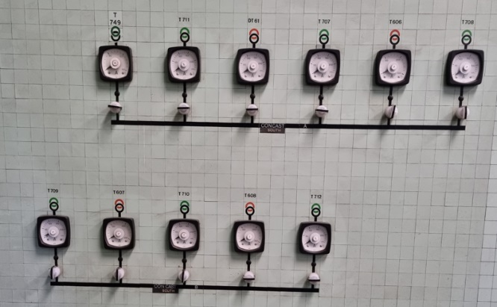
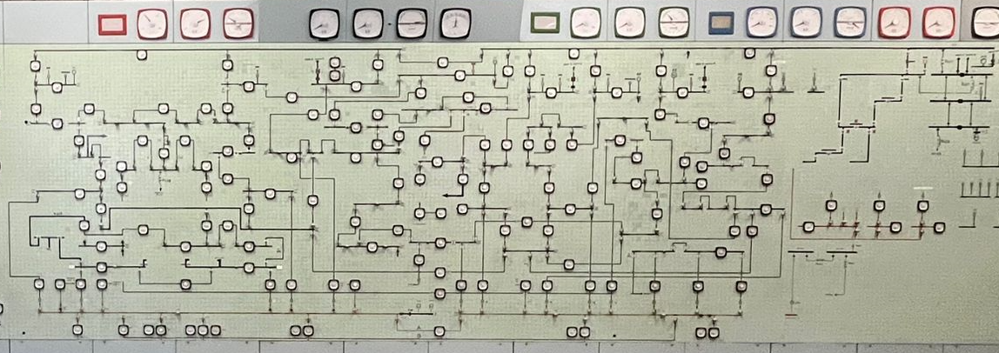
The image above is of the mimic Energy Controllers use to operate and monitor a large portion of the 11KV interconnected network. The close up images below are of the mimic switches and ammeters used by the control engineers for Concast South Substation.

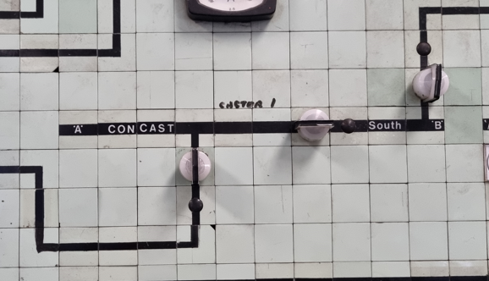

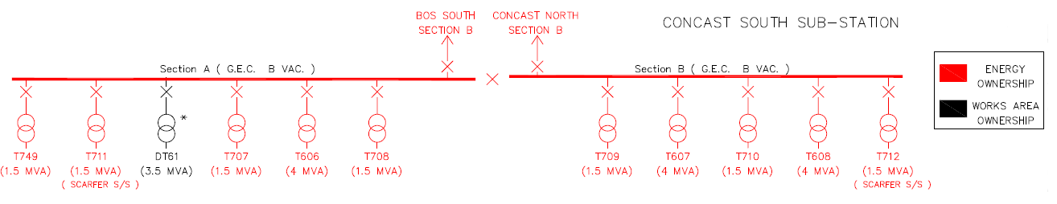
There are 13 Energy and 1 Concast Dept owned 11KV circuits located within the substation (shown below).
The 11KV circuits in Concast South are shared between two Sections, A and B. The Sections are fed via two 11KV interconnectors and can be tied together via a BUS Section VCB. The remaining circuits are 11KV feeds to transformers, the T700 series being 11KV/415V, T600 series being 11KV/415V. The Drive Transformer (DT61) is owned by the Concast department.
On Section A:
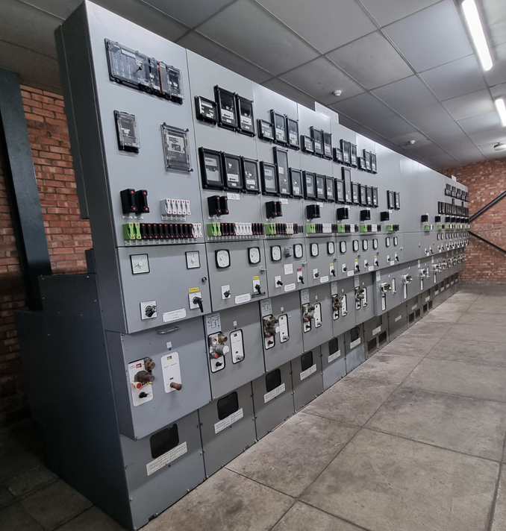
- T749 VCB,
- T711 VCB,
- DT61 (Concast owned),
- T707 VCB,
- T606 VCB,
- T708 VCB,
- Interconnector to BOS South Section B 11KV VCB.
On Section B:
- BUS Section
- Interconnector to Concast North Section B 11KV VCB
- T709 VCB,
- T607 VCB,
- T710 VCB,
- T608 VCB,
- T712 VCB.

Project Design
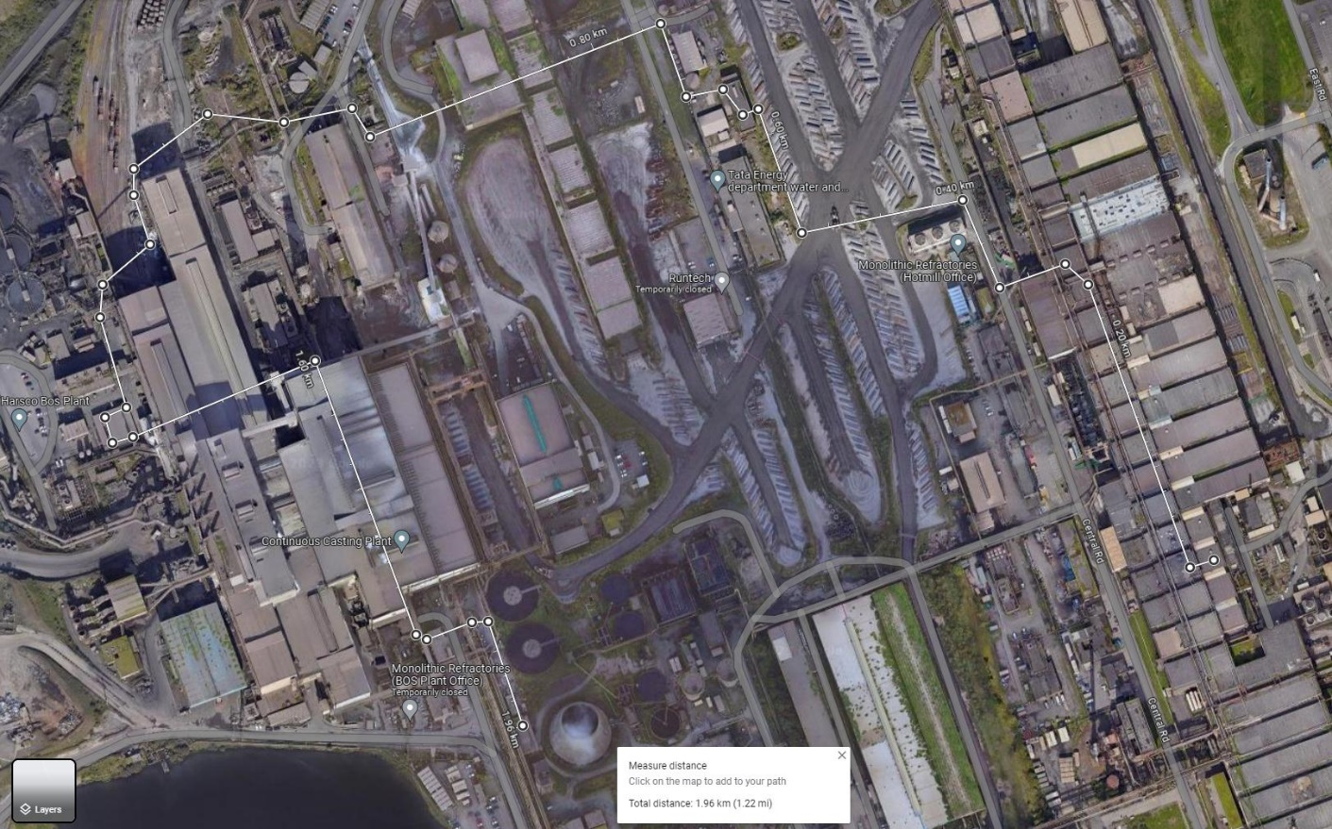
The faulty 100 pair cable between Concast South & ECC is approximately 1.22 miles long. It does not run directly; it goes via two other STC controlled substations. There was a plan 10-15 years ago to replace the whole cable. The Energy Control (ECC) – Abbey Melting Shop Central (AMSC) 200 pair leg was replaced with 2 x 100 pair cables, this partially improved things at the time, but there were still issues with AMSC – BOS North – Concast South legs. A recent basement fire damaging a large portion of the newer 2 x 100 pair cables (ECC – AMSC) has rendered control & indication from Concast South totally inoperable. The costs involved in repairing the newly damaged cables, and running in new cables the remainder of the run would be massive. Below is an aerial image of the cable run.
Energy Control
Cable length approx.. 1.96Km (1.22miles)
Concast South S/S
Abbey Melting Shop Central S/S
BOS North S/S

Discussions have been made with electrical, systems and control engineers, and I have decided to undertake the upgrade of the remote control & indication of HV switchgear at Concast South.
Remote switching is required at the substation, this will initially be done via a panel mounted HMI, utilising an existing PLC & network switch. Existing cabling within the substation from the STC cubicle to Switchgear will still be used. Close, Open & TNH (trip not healthy) relays in STC cubicle will also be re-used. STC outstation card (PCB at substation) and control card (PCB at ECC) will no longer be used.
Further work will be to have remote switching via an iFix SCADA system from Energy Control (this is outside the scope of this project).

Main elements of project:
- Create I/O schedule to identify the additional number and type of PLC cards required,
- Determine a location to house the new installation,
- Identify current wiring schemes and any modifications needed,
- Design the layout of the panel,
- Establish a list of materials & order, e.g.,
  - PLC cards,
  - HMI,
  - Power Supplies,
  - Panel Trunking,
  - Cabling,
  - Crimps,
  - DIN rail,
  - Terminal block, end plate, end bracket
  - Cable ties,
  - Cable sleeves,
  - MCBs,
  - Octal relays,
  - Current transducers
- Install Hardware in cubicle,
- Program PLC,
- Program HMI,
- Isolate and have permit issued on relevant HV circuit,
- Complete wiring & test operations, feedbacks’ while circuit is isolated,
- Re-instate circuit, then use HMI to operate circuit breaker,
- Repeat procedure for the following two circuits,
- Further works beyond the scope of this project will be to complete all 13 circuit breakers and have remote control/monitoring facilities from Energy Control using iFix SCADA system.

Resources Required
Some of the resources required will be:
- The Software RS Logix5000 or Studio5000 for programming Allen Bradley PLC.
- The Software Crimson 3.1 for programming Red Lion HMI.
- Establish new IP address for HMI.
- Inhouse training on HMI programming.

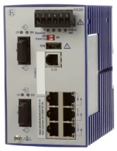
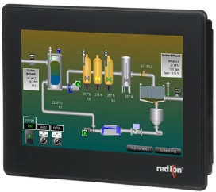

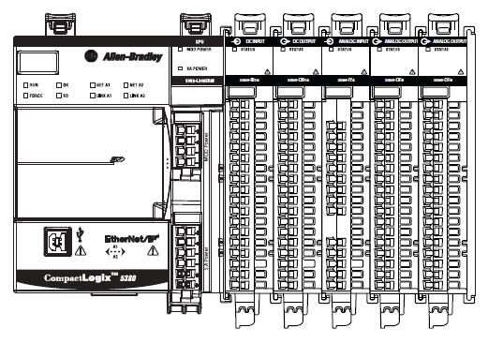
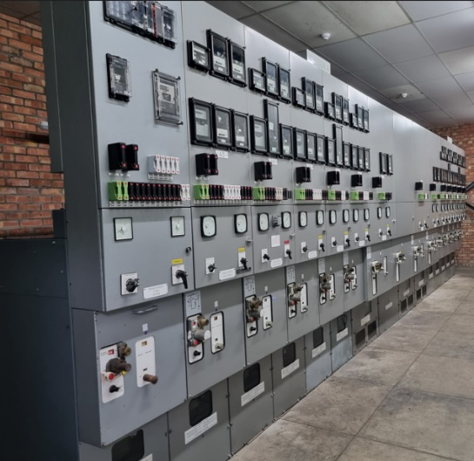
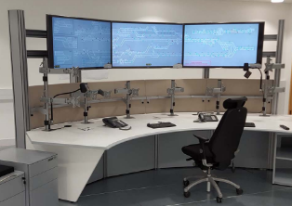
Overview Pictorial Diagram
To Energy Fibre Network
DI– Circuit Breaker position feedback, fault trip, TNH, Buchholtz alarm

DO – Open/Close commands

AI – Circuit Amps

Additional further work beyond project
Network Switch
HMI
PLC
Circuit Breakers

[1] [2] [3] [4] [5]

Planning
A Gantt chart is going to be used to monitor progress of the project. The periods are in weeks i.e., Period 1 was week commencing Monday 5/6/2023. Period 47 is week commencing Monday 22/4/2023, this is the week the Final Report is due.
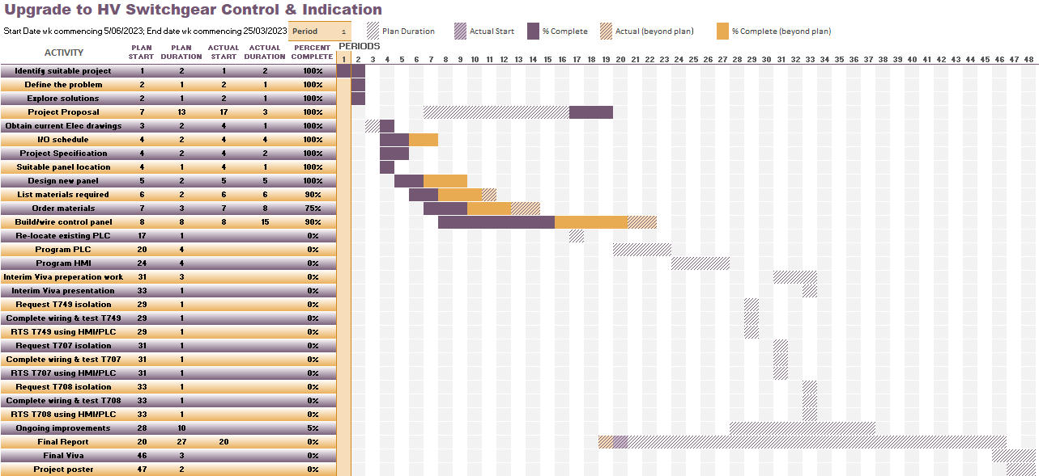
The following Gantt chart has a list of Tasks required to complete the Upgrade to HV switchgear control & Indication at Concast South Substation.
I have some milestones which are stepping stones towards completing the project. Milestones will offer motivation towards getting the tasks completed in a timely manner. My milestones are as follows
- Build/wire control panel ready for final connections – planned completion week 16 (week commencing 18/9/2023).
- Hand in project proposal – planned completion week 20 (week commencing 16/10/2023).
- Program PLC – planned completion week 24 (week commencing 13/11/2023).
- Program HMI – planned completion week 28 (week commencing 11/12/2023).
- Complete wiring, test & return to service T749 - planned completion week 29 (week commencing 18/12/2023).
- Interim Viva presentation – planned completion week 33 (week commencing 15/01/2023).
- Complete wiring, testing & return of third circuit, T708 – planned completion week 33 (week commencing 15/01/2023).
- Submit Final project report – planned completion week 47 (week commencing 22/04/2023).

References

[1] | Hirschmann, “Hirschmann RS20,” [Online]. Available: https://docs.rs-online.com/6ced/A700000008840471.pdf. [Accessed 17 Oct 2023].
[2] | Rockwell Automation, “Compact Logix selection guide,” [Online]. Available: https://literature.rockwellautomation.com/idc/groups/literature/documents/sg/1769-sg003_-en-p.pdf. [Accessed 17 Oct 2023].
[3] | RS online, “Red Lion CR3000 Series TFT Touch-Screen HMI Display - 7 in, TFT Display,” [Online]. Available: https://uk.rs-online.com/web/p/hmi-displays/2337973?gb=s. [Accessed 17 Oct 2023].
[4] | Freeicons 2023, “finger , forward , in front , man , pointing , toward , walking icon,” Freeicons, 2023. [Online]. Available: https://freeicons.io/man-pointing-finger-on-different-directions-icon-set/man-pointing-finger-icon-70926. [Accessed 17 Oct 2023].
[5] | Technology Desking, “Command & Control desks,” Technology desking, [Online]. Available: https://www.technologydeskingtradingdesks.com/products/control-room-desks. [Accessed 19 Oct 2023].

