
Sima Ali
1800624
“Describe a learning event which has happened during your classroom observation. Reflect upon what took place, connecting events to theories of learning and teaching. Make recommendations about how you could improve your own practice in light of this. Produce a poster to illustrate how you would develop the elements of an effective learning environment.”
- Space background for immersive room. Taken from Google Images (assessed 5th October 2018).
- Projectors in immersive room. Taken from Google Images (assessed 5th October 2018).
- Welsh flag for Cornel Cymraeg. Taken from Google Images (assessed 5th October 2018).

M6X01438/C Principles of Pedagogy | University of Wales Trinity Saint David
Wednesday 17th October 2018

Student Number: 1800624
Word Count: 5157
Introduction

The art of successful learning is one which results in positive behaviour change amongst children (Houwer, et al., 2013). This change is often stimulated by experiences, motivation and through play (Pluck & Johnson, 2011). It is unquestionably the case, that effective learning can only be achieved through effective teaching (Kyriacou, 1997) and therefore, the nature of both learning and teaching (especially within primary schools) is indeed everchanging. Bruner (1966), Ausubel (1968) and Gagné (1985) argued that effective teaching occurs through encouraging curiosity (Pluck & Johnson, 2011), whilst effective learning refers to pupil engagement (Kyriacou, 1997). Such aspects continue to underpin the national curriculum in Wales however, structural amendments made by Professor Graham Donaldson (2015) has meant that a greater emphasis is now being placed on the introduction of ‘progression steps’. Donaldson’s ‘Successful Futures’ report suggests that ‘areas of learning and experience’ provide all children in Wales, with a more systematic and coherent foundation for learning (Evans, 2015). Which will ultimately ensure that young learners are equipped with the knowledge and skill set required to be valuable members of society (Figure 1).

Healthy, confident individuals
Ambitious, capable learners
Ethical, informed citizens
Enterprising creative contributors
All children and young people will be…

Figure 1.
The four purposes of the curriculum proposed by Professor Graham Donaldson.
Taken from ‘Successful Futures’ (2015).

In order to ensure the successful implementation of such changes to policy and provision within education, a sound understanding of learning must be attained. Therefore, this essay aims to reflect upon a specific learning event I have observed and provide information on whether such learning techniques fall in line with the existing body of knowledge. In essence, this will allow me to assess learning theory in practice and decipher the best ways to endorse a love for learning in my role as a pedagog.

Observation

A learning event in the primary setting, can be defined as an account or description of the way in which a child reacts or responds to a given activity (Leclercq & Poumay, 2005). The learning event I observed took place in a large, modern, pioneer school situated in a small, rural town in West Wales. For the purpose of this assignment, in accordance with BERA guidance (Appendix A), I have chosen to anonymise the school and thus all references to the school will be removed. According to records held by the Welsh Government (2017), the school is comprised of 620 pupils, which has since increased to over 700 pupils in the last year. This includes the pupils who attend Flying Start (situated on-site) and those with Autism in the Learning Resource Centre. The school is situated in a socio-economically deprived area, with some children attending from catchment areas recognised as the most impoverished in Wales (Devine, 2014). The Free School Meal percentage currently sits at 30.5% and a recent Estyn inspection (2016) reports that the school’s current performance is ‘good’ and its prospects for improvement are ‘excellent’. As a result, the school’s support category is ranked green, emphasising that it is performing well and requires the least amount of support for improvement (Welsh Government, 2017).

Prior to my observation, I was briefed by the Deputy Head Teacher who acquainted me to the school’s key documents. These included the ‘Child Protection Policy’, the ‘Health and Safety Policy’ and the ‘Guidance for Safer Working Practice for Adults who work with Children and Young People’. This provided me with a basic understanding of the school’s structure. During my classroom observation, I was placed in Foundation Phase with 30 children aged between 3 and 5 in reception. In order to be mindful of ethical considerations, I spoke to the class teacher first, explained my reasoning behind the observation and gained written consent, to take photographs and audio recordings of the children (Appendix B). I expressed to the class teacher and the school that any data I collect will be strictly confidential, and all pupils/teachers involved will remain anonymous.

As I was placed with some of the youngest children in the school, it was not uncommon to see that lessons were planned using the carousel cooperative learning strategy whereby the children were split into colour groups (coch, melen, glas, porffor & gwyrdd) all focussing on different tasks relating to shape (Figure 2). This technique is especially beneficial in Foundation Phase as it stimulates pupils’ higher order thinking skills (Yusmanto, et al., 2017). As the classroom setting was exceptionally busy, I found it difficult to focus on one particular aspect and therefore, I chose to pay particular attention to how behaviour was managed in the classroom instead. This is an important area to cover as research indicates that behaviour interventions “receive more attention than many other aspects of schooling.” (Witzel & Mercer, 2003, p. 89). Although there were a number of behaviour strategies I noted during my observation (e.g. counting down from 5-1, moving children to the front of the class etc.), one approach stood out to me in particular. I noticed how behaviour was managed by a rewards and penalty system which took the form of buckets and straws. This idea has become very popular in more recent times as it provides positive reinforcement for good behaviours and negative reinforcement for bad behaviours (Witzel & Mercer, 2003).
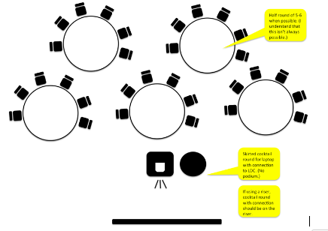
Group coch using lego to build shapes etc
Group melen using iPads to play shape game etc
Group glas using shape cut outs to make a picture etc
Group porffor using chalk on the playground to draw shapes etc
Group gwyrdd working out pattern sequences etc

Figure 2.
Carousel Cooperative Learning Strategy. Helps to split tasks and encourages discussion, reflection and group work. Taken from Gray (2016). Examples of group tasks taken from my observation (2018).

It’s important to note that the ‘bucket wall display’ (Figure 3) was not a specific timetabled task, rather it was something which was used throughout the school day. The aim of this behaviour strategy was to encourage children not only to behave in a manner that is suitable in a classroom environment, but to also work hard and try their best. There were several occasions in which this ‘bucket filling’ behaviour strategy was implemented during my observation. In particular, when the teacher was trying to get the attention of the class during circle time, one child (Child X) was quiet, sat up straight and was facing the front. When the teacher noticed Child X’s positive behaviour, she praised Child X and awarded her with a straw for her bucket. Child X stood up beaming, walked to the front of the class to collect her straw and placed it in her bucket (Figure 4). It’s interesting to note that after the straw was given to Child X, there was an immediate shift in the behaviour of the other children. All the other children, like Child X, stopped talking, sat up straight and faced the front. This emphasises that the children knew the expectations of the classroom and were aware that if they listened, they would also be rewarded.

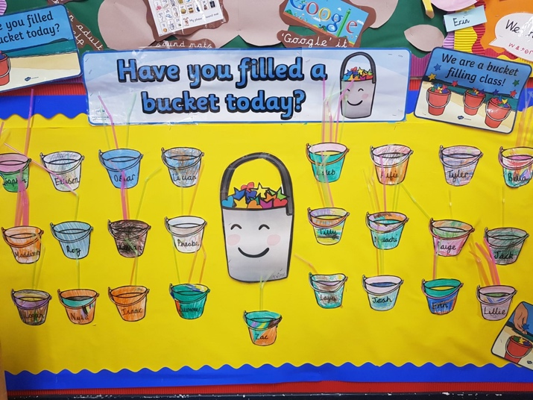
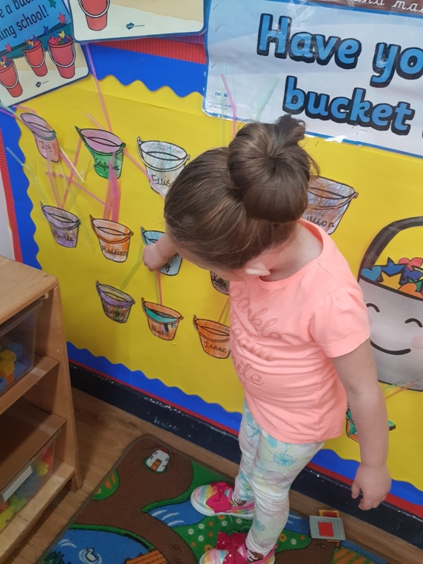
Figure 3. Bucket Wall Display. Photo taken during observation (2018).
Figure 4. Child X placing her straw into her bucket. Photo taken during observation (2018).

As the children had been learning about shapes all week, the circle time activity was used as a way to give the teacher an indication of the levels of understanding amongst the class. Using plastic shapes, the teacher described the properties and pre-empted the children to guess which shape she was holding behind her back. Whilst the teacher was giving out clues (e.g. screaming ‘ouch’ for each point/corner the shape had) I noticed how Child X was still sitting up straight and held her hand up to answer the question. This was unlike other children, who were fidgeting and shouting out in excitement. When Child X was picked on by the teacher, she answered “A square” and proceeded to justify her reasoning. Child X argued that she thought it was a square because “squares have four points”. When asked what other shape has four points, the child paused, thought for a couple minutes and shouted “A rectangle!”. The teacher was so impressed that Child X was awarded with another straw. After circle time had ended, I noticed that Child X went back to the bucket display to count how many straws she now had in total. I took this opportunity to engage in conversation with the child in order to find out her understanding of what the buckets meant to her. I audio recorded this conversation between myself and Child X and transcribed it verbatim as evidence (Appendix C).

After speaking to Child X, it became clear to me that the children associated good behaviour with the straws. They understood that if they listened to the teacher, or were helpful and kind to one another, they would be rewarded with a prize. This falls in line with the discussions put forward by the School of Behaviourism, in that the knowledge of all behaviours are enforced by the external environment (McLeod, 2017). This will be discussed in more detail further down. In this example, the use of straws was particularly beneficial as it provided the children with a visual reminder of what they had achieved already and also, of what they needed to do in order to get a prize. This taught the children of the importance of classroom etiquette and helped them to develop their social and moral skills (Postholm, 2013). As a result, it can be argued that meaningful learning often stems from effective behaviour management (in this case through the use of buckets and straws) within the classroom (Postholm, 2013).

It is the case that similar to good behaviour, bad behaviour is also learnt by children (Allen & Guez, 2000). This was particularly evident during my observation as I noticed that children would misbehave if they saw others misbehaving (Bouton, 2007). One child (Child Y) for example, had isolated himself and began causing disruptions. Despite being told to be quiet numerous times by the teacher, Child Y could not sit still. He began poking his friends in the back to get their attention, which resulted in him getting multiple warnings by the teacher and eventually was moved to the front of the class. This worked initially, but as the task went on, Child Y began fidgeting again. At this point the teacher got frustrated and told Child Y to take a straw out of this bucket for being naughty. Immediately, his behaviour changed and it was clear that he began regretting his actions. Child Y changed his posture, sat up straight and began to engage with the lesson. Again, this action had an impact on the whole class (Figure 6) as the use of a negative reinforcement reminded the children that bad behaviour would not be tolerated.
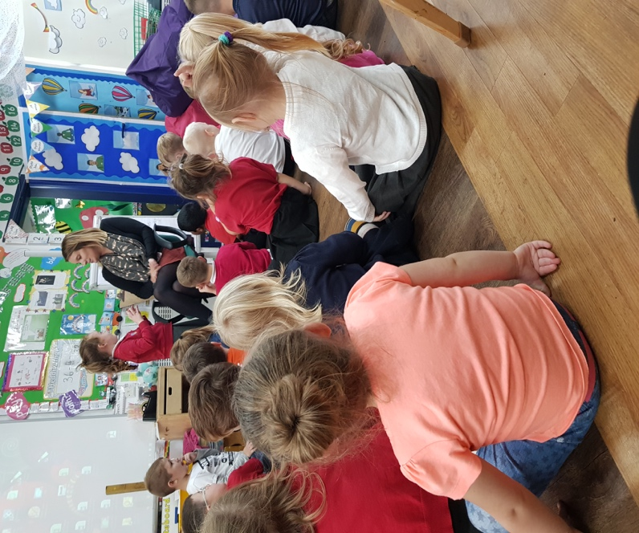
Figure 6.
Children sat up straight and began behaving after Child Y had a straw taken out of his bucket.
Photo taken during observation (2018).

Child Y

I carried out my observation following Rolfe, et al., (2001) Framework for reflective practice (Figure 7). This enabled me to analyse how effective placing straws in a bucket was for behaviour management within the Foundation Phase. Ultimately, this reflection experience has increased my knowledge and taught me lessons which I can impart in my own future practice (Priestley, 2015).
What?
Now what?
So what?
Figure 7.
Framework for reflective practice.
Taken from Rolfe et al (2001).

Learning theories

I chose to focus on this behaviour strategy in particular as I believe it is a good example of learning theory in action. Learning theories are important within education as they are the concepts which translate the reasonings behind certain events (Badyal & Singh, 2017). These theories suggest that the processes in which individuals learn arise from the environment around them (Bigge, 1982) and has a direct impact on the way they react to certain situations. Motivating and encouraging students has always been a key feature of engagement (Hodgman, 2014) and thus, the concept of teaching has always been underpinned with a system of rewards and sanctions (Bigge, 1982).

The School of Behaviourism encourages scientific investigations into individual and animal behaviour (Graham, 2000), rather than cognitive processes (Walinga, 2018). Behaviourism can be defined as an attitude or a set of beliefs (Graham, 2000) which focusses specifically on noticeable stimulus-response behaviours (McLeod, 2017). As behaviour can be modified, Behaviourists believe that the way a person acts can often be forecasted through assumptions and thus controlled or conditioned (Skinner, 1948). Put simply, it is an idea which argues that the way individuals respond to the environment has a direct impact on their actions and therefore, these actions can be trained (Cherry, 2018).

This idea was showcased through the works of Ivan Pavlov (a pioneer of behaviourist psychology), who mistakenly discovered classical conditioning (Figure 8) whilst researching how canines digest food (Walinga, 2018). Classical conditioning refers to learned behaviour through making associations between two stimuli (McLeod, 2017). When looking at the digestive systems of dogs, Pavlov noticed that they began salivating when food was placed in the room by his assistant (Sincero, 2018). Here, the food is known as the unconditioned stimulus and the dogs salivating was the unconditioned response (Gray & Macblain, 2015). It’s interesting to note that such behaviour occurred every time the dogs saw his assistant, regardless of whether he bought food in or not (Pavlov, 1927). Pavlov labelled this ‘associated learning’ as the dogs associated his assistant with being fed (Gray & Macblain, 2015). Interested with what he had discovered, Pavlov uncovered that such behaviours could in fact be trained. He decided to introduce a conditioned stimulus (a bell) which he rang before they were fed (Sincero, 2018). This began conditioning the dogs, teaching them that whenever the bell rang, it was time to eat (Pavlov, 1927). This is similar amongst children in primary schools who have been classically conditioned to line up at the end of break time once the bell has been sounded. Here, children associate the bell with lesson time and are aware that it’s time to learn.

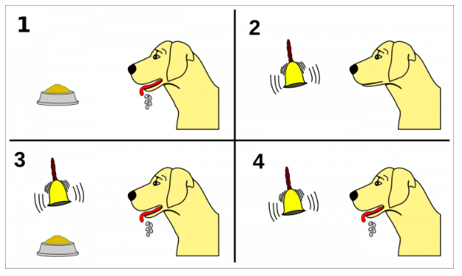

Figure 8.
Diagram explaining Pavlov’s Classical Conditioning.
Taken from Psychestudy.com (2018).

This idea of conditioning behaviours through a stimulus-response system has also been studied by Burrhus Fredric Skinner. Skinner built upon the works of John Watson, who put forward an alternative type of learning which opposed Pavlov’s findings (McLeod, 2018). Rather than classical conditioning, Skinner looks at operant conditioning as an effective method in training behaviour amongst low skilled animals (Bigge, 1982). Operant conditioning refers to behaviour that is restrained by its outcomes (Staddon & Cerutti, 2003), typically through a method of either rewards or sanctions and is something which Skinner argued is effective amongst children and young people (Bigge, 1982). According to this belief, behaviour which has pleasing consequences will be repeated, whereas behaviour which has displeasing consequences will not be repeated (McLeod, 2018). This is because, individuals learn in a manner which is active (Gray & Macblain, 2015) and behaviour change occurs as a result of habit (Staddon & Cerutti, 2003). In order to prove this theory, Skinner placed a rat in a ‘Skinner Box’ (Figure 9) to begin conditioning it’s behaviour (McLeod, 2018). The study looked at the consequences of releasing a pellet of food (positive reinforcement) when the rat pressed the leaver and generating an electric shock (negative reinforcement) when it failed to do so (Bigge, 1982). This idea involves applying reinforcement or punishment after a behaviour (McLeod, 2018) and is something which is commonly used within the classroom setting. This was particularly apparent during my observation as the use of buckets and straws can be seen as a classic illustration of operant conditioning.

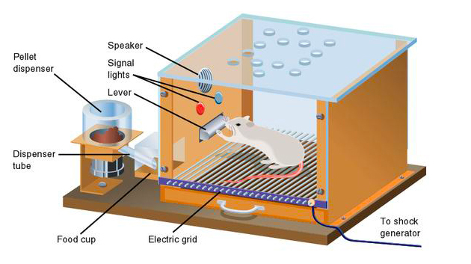
Figure 9.
Diagram explaining Skinner’s Operant Conditioning using a ‘Skinner Box’
Taken from Simply Psychology (McLeod, 2018).

In this example, the children were the operants who were being conditioned to behave a certain way within the classroom. When looking at Child X, she conducted herself in a suitable and sensible manner which was acknowledged by the teacher. Her behaviour earnt her a straw for her bucket as she was aware of the expectations of the classroom and set an example for the rest of the class. The use of positive reinforcement (by awarding her a straw) was beneficial as it encouraged her and the rest of the class to behave well. This falls in line with Skinner’s arguments, that individuals tend to behave in a certain way in order to obtain something which they desire or as a means to steer clear from something unpleasant (Figure 10) (Skinner, 1974). Positive reinforcement in this context requires adding a stimulus (collecting straws to get a prize) in order to increase the chances of the desired response (good behaviour) (Walinga, 2018). It’s important to note that the children’s behaviour was conditioned through associated learning as they built up an association between good behaviour and receiving a reward (Cherry, 2018).

Associated learning also occurred when children changed their behaviour after negative reinforcement (punishment) was applied. For example, during the observation, Child Y was particularly mischievous and began disrupting the class. It was interesting to see that scolding Child Y in front of his peers did not have the same impact as confiscating a straw. This action of taking a straw away reminded Child Y what was at risk (his chances of winning a prize) and also reminded the other children in the class of the repercussions of bad behaviour. This supports Skinner’s argument in that removing something which is desirable (in this case a straw) often stimulates a response and prompts behaviour change (Walinga, 2018). As a result, it can be inferred that through the process of learning, Child Y was less likely to continue misbehaving due to the negative reinforcement (Cherry, 2018). This is because he was made aware of the consequences (McLeod, 2018) and thus, his behaviour was conditioned in order to avoid further punishment.

Positive reinforcement (awarding straws)
Negative reinforcement (removing straws)
Figure 10.
The effects of positive and negative reinforcement as observed on placement (2018).
Strengthens occurrence of good behaviour

Reduces occurrence of bad behaviour

When looking at the literature, it is evident that positive reinforcement is the most effective way to alter behaviour through operant conditioning (Walinga, 2018). This was especially apparent within the classroom as the teacher rewarded well-behaved children (like Child X) as a means to change the attitudes and behaviours of the other children. This increased the likelihood of good behaviour across the class as it allowed both Child X and her peers to focus on the good aspects rather than the bad (Walinga, 2018). However, many psychologists have argued that such techniques to condition behaviour only occur when reinforcement is applied and that children are not intrinsically motivated to behave in a certain way (Grille, 2018). Instead, behavioural improvements transpire for the sole purpose of a reward and cease to exist if there is not an incentive in place (Wiest, 1967). Others claim that this often reduces levels of creativity, as children stop taking risks to challenge themselves and only focus on doing what is required to avoid punishment (Grille, 2018). Furthermore, where either positive or negative reinforcement is overused within the classroom, it can be argued that children become used to it and thus, such behaviour strategies are no longer effective (Grigg, 2014). Despite such criticisms, the use of positive/negative reinforcement (especially within Foundation Phase) was particularly effective during my observation as I believe it motivated the children and reminded them of the expectations of the classroom. As a result, it is a strategy which I intend to implement in my own practice.

My ideal learning environment

An effective learning environment is one which facilitates education and encourages creativity (Richardson & Mishra, 2018). It is a thought provoking space which seeks to inspire and activate excitement whilst keeping children safe (Glazzard, et al., 2010). A good learning environment, which provides children with adequate support, resources and opportunities is paramount for invaluable early years provision (Ministry of Education, 2015). According to Blenkin and Whitehead “the most neglected… dimension of the planned curriculum is the creation of an environment… in which education is to take place” (Blenkin & Whitehead, 1988, p. 35). Therefore, the requirements for such a setting cannot be stressed enough. For this assignment, I designed my own ideal learning environment which includes aspects that I believe are vital for effective practice. Although there are numerous areas and opportunities to learn in the space which I have created, I will only be discussing a few in depth. These are outdoor learning, immersive technology, digital competency, role play and the Growth Mindset. This is because these are some of the key areas which are currently being pushed in the new curriculum in Wales (Donaldson, 2015).

The use of outdoor learning has been particularly influential when designing my own learning environment. This is because outdoor activities are fundamental for a child’s development and thus, should be integrated throughout all areas of the curriculum (Bilton, 2002). In response to this, I have made a fluid connection between the indoors and outdoors using bifold doors, which slide completely open. This combines both areas of learning into one, emphasising that indoor learning and outdoor play are equally as important (Lasenby, 1990). Some have argued that the outdoors itself is a complete leaning experience which promotes physical, intellectual, emotional and social growth and overall wellbeing (Bilton, 2002). One school in West Wales found that outdoor learning notably amplified self-belief and language development within its pupils (ESTYN, 2016). As a result, I have included a number of ways children can explore (e.g. woodland area, through wet play, sand play, mud kitchens, planting flowers and shrubs etc.) in order to enhance their development and exercise their understanding of the world. This includes improving their problem solving skills and encourages them to learn cooperatively (Bento & Dias, 2017). ESTYN reports outline that those educators who utilise the outdoors, fundamentally provide children with rich and positive experiences which permits them to achieve above their expected learning outcomes (ESTYN, 2016).

According to research, outdoor play positively impacts a child’s short and long term physical and mental wellbeing (ONS, 2018). It is a form of learning which stimulates free play and boosts self-esteem and the extent of its effects can rarely be replicated indoors (Bento & Dias, 2017). As a result, a number of campaigns have surfaced, encouraging schools to incorporate outdoor play throughout their timetables. For example in Britain, Forest Schools (Figure 11) have become increasingly popular for holistic development (Knight, 2013). Through such hands on experiences, children can make connections to their learning and develop a real understanding of the natural environment (O'Brien & Murray, 2007). It is also beneficial for children’s fine and gross motor skills (Knight, 2013). From a recent poll, 81% of teachers have voiced a greater demand for lessons to be taken outside (Outdoor Classroom Day, 2018). This is because outdoor play is an organic form of learning, whereby children feel far less pressured to make mistakes (Bilton, 2002). Here, acquiring knowledge through exploration is natural as children are unaware they are learning (Bilton, 2002; Knight, 2013). Furthermore, the outdoors is dynamic, allowing children to investigate in various weather conditions and seasons all throughout the year (Moss, 2012). Therefore, for these reasons, outdoor learning plays a big part in my learning environment.
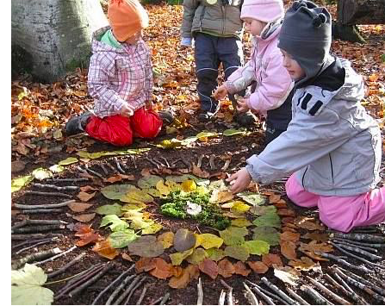
Figure 11.
Forest School. Children using natural resources to enhance their learning.
Taken from Pinterest https://www.pinterest.co.uk/pin/333266441160157426/ (assessed on 14th October 2018).

The use of immersive technology throughout the curriculum is also a large part of my learning environment. This is because in recent years, technology has evolved and is being increasingly used amongst children for gaming and various aspects of social media (Kardefelt-Winther, 2017). As the technological world is continuously advancing, many educational researchers have urged for schools to use digital competency as a means for enhanced learning and provision (Dunleavy, et al., 2009). In response to this, I have included an immersive room which allows children to experience learning in a more interactive way (Figure 12). For example, if children were learning about space, immersive technology allows the solar system to be mapped within the room. Here, situated learning is used to create the illusion that the children are learning about space whilst in space (Dede, 2009). This prompts children to think in different ways and gives them access to visualise and apply meaning to their learning. Being in such environments, elevate levels of sensory development and allow children to explore a topic in different ways (Dede, 2009). Research shows that creating a virtual environment heightens engagement and enables children to bridge the gap between virtual reality and the real world (Dunleavy, et al., 2009). Ultimately, such opportunities facilitate inclusive learning and strengthens creativity (Dunleavy, et al., 2009).

Figure 12.
Example of an immersive room. Taken from Pinterest https://www.pinterest.co.uk/pin/389491067758121261/ (assessed on 15th October 2018).

Digital learning has also been implemented in my classroom through a Digi Den and Audio Space. This is essential because it supports and facilitates both teaching and learning and is something which has proven to intensify attainment and stimulate imagination (Aston, 2016). Technology is also a very useful way to involve parents in their child’s learning as it provides an avenue to oversee progression (ESTYN, 2013). It’s incorporation is vital because the use of technology has become increasingly popular throughout the curriculum e.g. interactive whiteboard, audio books, research, educational games etc. (Aston, 2016). More recently, this area of learning has been given particular attention in the new curriculum, with Digital competence listed as one of three cross-curricular responsibilities next to numeracy and literacy (Learning Wales, 2018). Here, an emphasis is placed on expanding digital efficiency and applying it across all areas of the curriculum and not just in ICT lessons (Welsh Government, 2016). For example, this might include learning shapes through educational games on iPads, or through interactive pictograms etc. This is important because it provides children with the skills set required to thrive in a developing digital age (Welsh Government, 2016) and is something which is particularly stressed in Successful Futures (Donaldson, 2015). ESTYN reports suggest that those schools who have imbedded digital competence throughout their curriculum are showing incredibly positive results (ESTYN, 2018). This includes a far greater understanding of technology, well developed digital skills and higher levels of attainment (ESTYN, 2018).

Role play is another aspect of my classroom as it allows children to stretch their imagination in order to explore real life situations (Meighan, 2011). Just like any other aspect of learning, role play encourages creativity but goes further and promotes a child’s personal, social and emotional development (Roan & Taylor, 2013). As stated in Successful Futures, children should all be given the opportunity to become ‘creative contributors’ (Donaldson, 2015) and therefore, incorporating role play into lesson plans will not only aid this but also increase levels of discipline and widen vocabulary (Homan, 2016). For example, when children role play hospitals, they are aware that the patient and doctor have different roles. Here, children are able to differentiate the difference in behaviour between the characters and are able to use objects accordingly to support their impersonations (TESSA, 2017). Role play is important because it provides children with the ability to be anyone they want to be and through dissecting such behaviour, it becomes clear that important life skills are learnt (Homan, 2016).

I have also incorporated the Growth Mindset (Figure 13) within my learning environment as I believe self-reflection is an invaluable aspect of learning. This is something which will be used throughout the school day, to provide teachers with an indication of how pupils tackled set tasks. Children are able to provide instant feedback and state whether certain tasks, were either easy, difficult or if it challenged their learning (Dweck, 2015). This is beneficial because research suggests that a child’s awareness of their abilities is fundamental for their attainment (Dweck, 2015). Through this, children are prompted to challenge themselves and achieve higher (Muthler, 2015). One Swansea school in particular adopted the Growth Mindset because they believe intelligence blooms over time (ESTYN, 2017). Results showed that children became independent learners and were more likely to have a go at challenging tasks (ESTYN, 2017). This is important because the Growth Mindset teaches children to improve through learning (Dweck, 2015) and is something which is imbedded within Successful Futures (Donaldson, 2015).

Danger zone
Stretch zone
Comfort zone

Figure 13.
Growth Mindset.
Taken from (Dweck, 2015).

Conclusion

As changes to the curriculum has meant a shift towards child-led practice, there is now a far greater influence placed upon areas of learning and experience. According to Successful Futures, learning can occur in numerous ways, (including play) and is unquestionably vital in a child’s development. As a result the way in which children are taught has changed and a more significant emphasis has been placed on progression steps. Such changes were particularly apparent during my observations, which took place in a pioneer school. These observations gave me first-hand knowledge and experience as I noticed how much the children benefited.
During my observations, my task was to focus on a particular learning event. The area which I chose to focus on specifically was a behaviour strategy that involved buckets and straws. Both positive and negative reinforcement was used in this strategy as a means to control behaviour within the classroom using a system of rewards and punishments. I noticed how both aspects of this behaviour strategy were effective, as positive reinforcement (rewarding children with straws for their buckets) motivated the children to do better, whilst negative reinforcement (confiscating straws) refrained them from misbehaving. My observations reinforced Skinner’s idea of Operant Conditioning and accredited his thoughts on associated learning.

It’s important to note that although there are many who criticise Skinner and the School of Behaviourism, I found that the bucket and straw behaviour strategy worked well and thus, I aim to incorporate it into my own future practice. Alongside the recommendations made by Donaldson, I also aim to include aspects of outdoor play, digital competence, role play and the Growth Mindset (amongst others), within my own learning environment which I have illustrated in my poster. Ultimately, this is to make a positive contribution to a child’s learning and promote the importance education.

References

Allen, J. & Guez, W., 2000. Behaviour Modification. France: UNESCO.

Aston, J., 2016. Why are ICT resources for primary schools so important?. [Online]
Available at: https://www.stonegroup.co.uk/ict-resources-in-primary-schools/
[Accessed 15 October 2018].

Ausubel, D. P., 1968. Educational psychology: a cognitive view. New York: Rinehart and Winston.

Badyal, D. K. & Singh, T., 2017. Learning theories: the basics to learn in medical education. International Journal of Applied Basic Medical Research, 7(1), pp. 1-9.

Bento, G. & Dias, G., 2017. The importance of outdoor play for young children's healthy development. Porto Biomedical Journal, 2(5), pp. 157-160.

Bigge, M. L., 1982. Learning theories for children. 4th Edition ed. New York: Harper & Row Publishers Inc.

Bilton, H., 2002. Outdoor play in the early years. 2nd Edition ed. London: David Filton Publishers Ltd.

Blenkin, G. M. & Whitehead, M., 1988. Creating a context for development. In: G. M.

Blenkin & A. V. Kelly, eds. Early Childhood Education. A developmental curiculum. London: Paul Chapman Publishing, pp. 32-60.

Bouton, M. E., 2007. Learning and behaviour: A contemporary synthesis. American Psychological Association, 1(1), pp. 1-9.

Bruner, J. S., 1966. Towards a theory of instruction. Cambridge: Harvard University Press.

Cherry, K., 2018. An overview of behavioural psychology. [Online]
Available at: https://www.verywellmind.com/behavioral-psychology-4157183
[Accessed 7 October 2018].

Dede, C., 2009. Immersive interfaces for engagement and learning. Science, 232(5910), pp. 66-69.

Devine, D., 2014. Why this top 10 of the most deprived areas in Wales should make us all despair. [Online]
Available at: https://www.walesonline.co.uk/news/wales-news/top-10-most-deprived-areas-8177125
[Accessed 28 September 2018].

Donaldson, G., 2015. Successful Futures: Independent review of curriculum and assessment arrangments. [Online]
Available at: http://dera.ioe.ac.uk/22165/2/150225-successful-futures-en_Redacted.pdf
[Accessed 28 September 2018].

Dunleavy, M., Dede, C. & Mitchell, R., 2009. Affordances and Limitations of Immersive Participatory Augmented Reality Simulations for Teaching and Learning. Journal of Science Education and Techology, 18(1), pp. 7-22.

Dweck, C., 2015. Growth Mindset. [Online]
Available at: https://www.stem.org.uk/system/files/community-resources/2016/06/DweckEducationWeek.pdf
[Accessed 15 October 2018].

ESTYN, 2013. Sharing learning through social media. [Online]
Available at: https://www.estyn.gov.wales/effective-practice/sharing-learning-through-social-media
[Accessed 15 October 2018].

ESTYN, 2016. A highly effective outdoor learning environment. [Online]
Available at: https://www.estyn.gov.wales/effective-practice/highly-effective-outdoor-learning-environment
[Accessed 15 October 2018].

ESTYN, 2016. Planning for good quality outdoor learning. [Online]
Available at: https://www.estyn.gov.wales/effective-practice/planning-good-quality-outdoor-learning
[Accessed 15 October 2018].

ESTYN, 2017. Encouraging learners to achieve more than they expect of themselves. [Online]
Available at: https://www.estyn.gov.wales/effective-practice/encouraging-learners-achieve-more-they-expect-themselves
[Accessed 15 October 2018].

ESTYN, 2018. Schools need a clear vision for the new digital competence framework. [Online]
Available at: https://www.estyn.gov.wales/news/schools-need-clear-vision-new-digital-competence-framework
[Accessed 15 October 2018].

Evans, G., 2015. Wales Online. [Online]
Available at: https://www.walesonline.co.uk/news/wales-news/the-donaldson-report-an-at-a-glance-guide-8713671
[Accessed 28 Septemeber 2018].

Gagné, R. M., 1985. The conditions of learning and the theory of instruction. 4th Edition ed. New York: Holt, Rhinehart and Winston.

Glazzard, J., Chadwick, D., Webster, A. & Percival, J., 2010. Assessment for Learning in the Early Years Foundation Stage. London: SAGE Publications.
Google Images, 2018. Digital projector vector sketch icon. [Online]
Available at: https://www.colourbox.com/vector/digital-projector-sketch-icon-vector-19501282
[Accessed 5 October 2018].

Google Images, 2018. Space background stock photos. [Online]
Available at: https://www.shutterstock.com/search/space+background
[Accessed 5 October 2018].

Google Images, 2018. Wales - The Flag Institute. [Online]
Available at: https://www.flaginstitute.org/wp/flags/wales/
[Accessed 5 October 2018].

Graham, G., 2000. Beahviourism. [Online]
Available at: https://plato.stanford.edu/entries/behaviorism/
[Accessed 6 October 2018].

Gray, C. & Macblain, S., 2015. Learning theories in childhood. 2nd Edition ed. London: Sage.

Gray, S., 2016. How to use the cooperative learning "carousel" strategy. [Online]
Available at: http://car.gocompare.com
[Accessed 1 October 2018].

Grigg, R., 2014. Becoming an outstanding primary school teacher. 2nd Edition ed. London: Routledge.

Grille, R., 2018. Rewards and praise: the poisoned carrot. [Online]
Available at: https://www.naturalchild.org/robin_grille/rewards_praise.html
[Accessed 11 October 2018].

Hancock, K. J. & Zubrick, S. R., 2015. Children and young people at risk of disengagement from school, Australia: Commissioner for Children and Young People.

Hodgman, M. R., 2014. Student praise in the modern classroom: the use of praise notes as a productive motivational tool. Journal of Education and Training, 2(1), pp. 41-47.

Homan, E., 2016. Why pretend play is important to child development. [Online]
Available at: https://www.pentagonplay.co.uk/news-and-info/why-pretend-play-is-important-to-child-development
[Accessed 15 October 2018].

Houwer, J. D., Barnes-Holmes, D. & Moors, A., 2013. What is learning? On the nature and merits of a functional definition of learning. Psychonomic Bulletin & Review, 1(1), pp. 1-9.

Kardefelt-Winther, D., 2017. How does the time children spend using digital technology impact their mental well-being, social relationships and physical activity?, London: Unicef.

Knight, S., 2013. Forest School and outdoor learning in early years. 2nd Edition ed. London: SAGE Publications Ltd.

Kyriacou, C., 1997. Effective teaching in schools: theory and practice. 2nd Edition ed. Cheltenham: Stanley Thornes Ltd.

Lasenby, M., 1990. The Early Years. A curriculum for young children. Outdoor play. London: Harcourt Brace Jovanovich.

Learning Wales, 2018. Digital Competence Framework. [Online]
Available at: http://learning.gov.wales/resources/browse-all/digital-competence-framework/?lang=en
[Accessed 15 October 2018].

Leclercq, D. & Poumay, M., 2005. The 8 learning events model and its principles, Belgium: University of Liege.

McLeod, S., 2017. Behaviourist Approach. [Online]
Available at: https://www.simplypsychology.org/behaviorism.html
[Accessed 3 October 2018].

McLeod, S., 2018. Skinner - Operant conditioning. [Online]
Available at: https://www.simplypsychology.org/operant-conditioning.html
[Accessed 7 October 2018].

Meighan, J., 2011. Role play in early years settings. [Online]
Available at: https://teachpreschool.org/2011/06/12/role-play-in-early-years/
[Accessed 15 October 2018].

Ministry of Education, 2015. How to create an effective teaching environment. [Online]
Available at: https://education.gov.gy/web/index.php/teachers/tips-for-teaching/item/1814-how-to-create-an-effective-teaching-environment
[Accessed 12 October 2018].

Moss, S., 2012. Natural Childhood. London: National Trust.

Muthler, S., 2015. Why a Growth Mindset is crucial to learning. [Online]
Available at: http://www.edudemic.com/growth-mindset-way-learn-2/
[Accessed 15 October 2018].

O'Brien, L. & Murray, R., 2007. Forest School and its impacts on young children: Case studies in Britain. Urban Forestry & Urban Greening, 6(4), pp. 249-265.

ONS, 2018. Children’s engagement with the outdoors and sports activities, UK: 2014 to 2015. [Online]
Available at: https://www.ons.gov.uk/peoplepopulationandcommunity/wellbeing/articles/childrensengagementwiththeoutdoorsandsportsactivitiesuk/2014to2015#main-points
[Accessed 14 October 2018].
Outdoor Classroom Day, 2018. The impact of outdoor learning and playtimr at school - and beyond. [Online]
Available at: https://outdoorclassroomday.org.uk/resource/the-impact-of-outdoor-learning-and-playtime-at-school-and-beyond/
[Accessed 14 October 2018].

Pavlov, I. P., 1927. Conditioned Reflexes. New York: Dover.

Pinterest, 2012. Coca-Cola 125th year exhibition at SantralIstanbul. [Online]
Available at: https://www.pinterest.co.uk/pin/389491067758121261/
[Accessed 15 October 2018].

Pinterest, 2018. Forest Schools. [Online]
Available at: https://www.pinterest.co.uk/pin/333266441160157426/
[Accessed 14 October 2018].

Pluck, G. & Johnson, H., 2011. Stimulating curiosity to enhance learning. Educationg, Science and Psychology, 2(19), pp. 24-31.

Postholm, M. B., 2013. Classroom management: what does research tell us?. European Educational Research Journal, 12(3), pp. 389-402.

Priestley, A., 2015. Learning through reflection. [Online]
Available at: http://www.ventureteambuilding.co.uk/learning-through-reflection/
[Accessed 4 October 2018].

Psychestudy, 2018. Pavlov Classical conditioning. [Online]
Available at: https://www.psychestudy.com/behavioral/learning-memory/classical-conditioning/pavlov
[Accessed 7 October 2018].

Richardson, C. & Mishra, P., 2018. Learning environments that support student creativity: developing the scale. Thinking Skills nad Creativity, 27(1), pp. 45-54.

Roan, M. & Taylor, M., 2013. The little book of role play windows. London: Featherstone Education.

Rolfe, G., Freshwater, D. & Jasper, M., 2001. Critical refelction in nursing and the helping professions: as user's guide. Basingstoke: Palgrave Macmillan.

Sincero, S. M., 2018. Classical conditioning. [Online]
Available at: https://explorable.com/classical-conditioning
[Accessed 7 October 2018].

Skinner, B. F., 1948. Superstition in the pigeon. Indianapolis: Hackett Publishing Company.

Skinner, B. F., 1974. About behaviourism. Norfolk: Lowe & Brydone (Printers) Ltd.

Staddon, J. E. R. & Cerutti, D. T., 2003. Operant conditioning. Annual Review of Psychology, 54(1), pp. 115-144.

TESSA, 2017. Why role playing is important for child development. [Online]
Available at: https://tessais.org/why-role-playing-is-important-for-child-development/
[Accessed 15 October 2018].

Walinga, J., 2018. Introduction to Psychology. [Online]
Available at: https://opentextbc.ca/introductiontopsychology/chapter/2-3-behaviourist-psychology/
[Accessed 6 October 2018].

Welsh Government, 2016. Digital Competence Frameowrk guidance. [Online]
Available at: http://learning.gov.wales/docs/learningwales/publications/160831-dcf-guidance-en-v2.pdf
[Accessed 15 October 2018].

Welsh Government, 2017. National School Categorisation System. [Online]
Available at: https://beta.gov.wales/sites/default/files/publications/2018-03/parents-and-carers-guide-national-school-categorisation-system.pdf
[Accessed 28 September 2018].

Wiest, W. M., 1967. Some recent criticisms of behaviorism and learning theory: With special reference to Breger and McGaugh and to Chomsky.. APA PsycNET Direct, 67(3), pp. 214-225.

Witzel, B. S. & Mercer, C. D., 2003. Using rewards to teach students with disabilites: Implications for motivation. Remedial and Special Education, 24(1), pp. 88-96.

Yusmanto, H., Soetjipto, B. E. & Djatmika, E. T., 2017. The application of carousel feeback and round table cooperative learning models to improve student's higher order thinking skills (HOTS) and social studies learning outcomes. International Educational Studies, 10(10), pp. 39-49.

Appendix A.
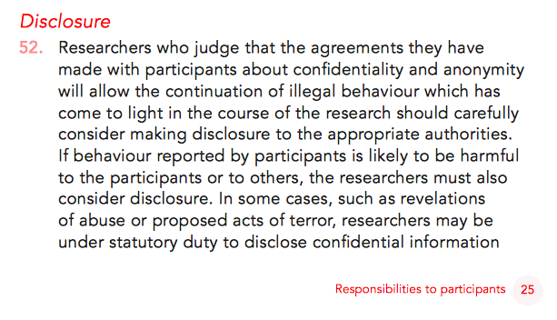
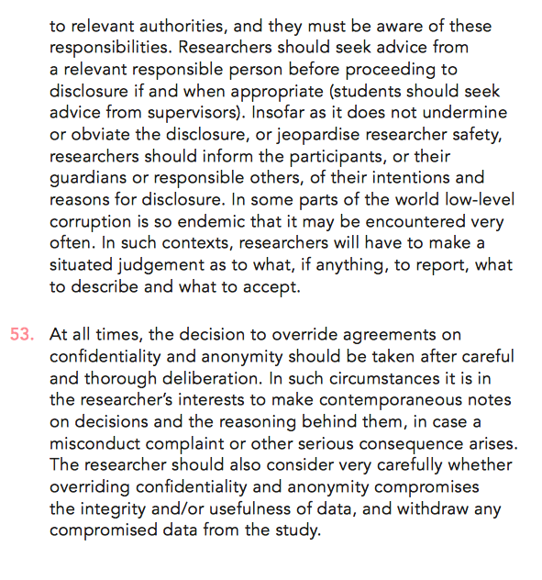
BERA guidance on disclosure (Sections 52 & 53, pages 25-26). Taken from BERA Ethical Guidelines for Educational Research (2018)

Appendix B.
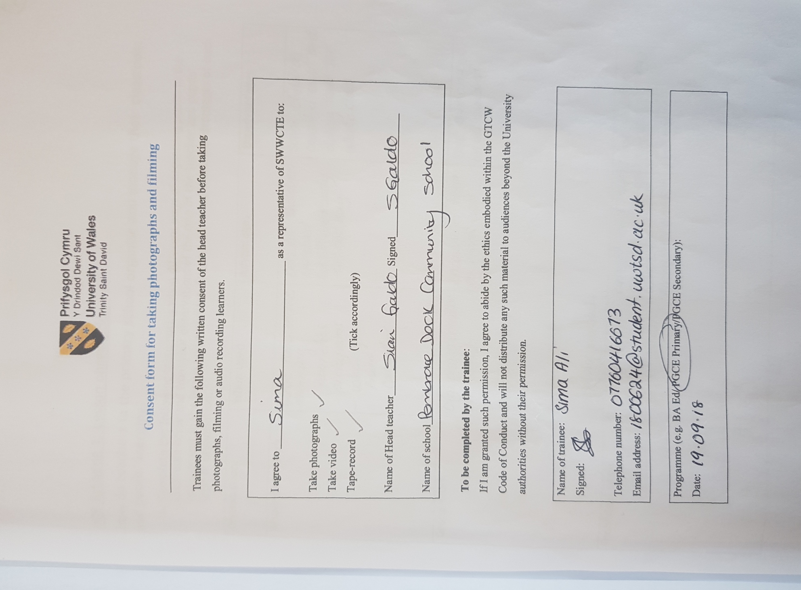
Copy of completed consent form for taking photographs and filming during my observation (2018).

Appendix C.
Transcript of a conversation between myself and Child X during classroom observation (2018).

Child X: [Uses her fingers to count] I’ve got two straws today and I have one more now.

Me: Oh wow. Well done! So how does this work then? *points at bucket wall display*

Child X: Um… [pause]

Me: What do you have to do to get the straws?

Child X: You have to try and put them in there. *points to the bucket on the wall with her name on it* But not that way otherwise it will fall. *shows me how to place the straws in the bucket*

Me: Okay… So how do you get the straws?

Child X: Um… [pause] for good listening with your ears *cups hands around ears*

Me: So… you have to be a good listener?

Child X: Yeah…*stretches arm out and shakes finger up and down* And you need to work hard.

Me: Is that how you got a straw? [pause] By working hard?

Child X: Yeah… I worked brilliant! *proceeds to point at her bucket* Even that’s mine. I done that. All of it.

Me: Oh well done! *pointing at wall* what happens with the straws then?

Child X: Yeah… I got eleven. [pause] If you get ten actually, but I got eleven, you get a prize from the prize box.

Me: Wow! So did you get a prize then?

Child X: Yeah… I choosed a bouncy ball!

Me: That’s amazing! I love bouncy balls! Does it bounce really high?

Child X: Yeah… [pause] but it nearly escaped…

