

Breaking the Silence: Addressing Mental Health Stigma Among Older Women

Elisha Boniwell
Student: 2113032
Module code: ECMH6005
Year of submission: 2025
Word count: 7500
BSc (Hons) Mental Health, University of Wales Trinity Saint David

Declaration/Statements page

DECLARATION
This work has not previously been accepted in substance for any degrees and is not being concurrently submitted in candidature for any degrees.
Signed Elisha Boniwell
Date 22/03/2025

STATEMENT 1
This research project is being submitted in partial fulfilment of the requirements for the degree of
BSc (Hons) Mental Health, University of Wales Trinity Saint David
Signed Elisha Boniwell
Date 22/03/2025

STATEMENT 2
This research project is the result of my own independent work/investigation, except where otherwise stated.
Other sources are acknowledged by giving explicit references. A reference list is appended.
Signed Elisha Boniwell
Date 22/03/2025

STATEMENT 3
I hereby give consent for my independent research project, if accepted, to be available for photocopying and for inter-library loan, and for the title and summary to be made available to outside organisations.
Signed Elisha Boniwell
Date 22/03/2025

Table of Contents
Declaration/Statements page 2
Abstract 4
Chapter 1: Introduction and Literature Review 5
1.1 Introduction 5
1.2 Background and Context 5
1.3 Mental Health Stigma and Ageing 6
1.4 Impact of Mental Health Stigma on seeking help 7
1.5 Critical Evaluation, Theoretical Perspectives, and Research Gaps 9
1.6 Rationale for the Study 11
1.7 Aims and Research Questions 12
Chapter 2: Method 14
2.1 Design 14
2.2 Participants 14
2.3 Materials 15
2.4 Procedure 16
2.5 Ethical Considerations 17
Chapter 3 : Results 18
3.1 Introduction to Analysis 18
3.2 Familiarisation Phase 18
3.3 Table 1 19
3.4 Figure 1 21
3.5 Superordinate Theme 1: Silence and Suppression 22
3.6 Superordinate Theme 2: Emotional Struggles 23
3.7 Superordinate Theme 3: Coping and Support Networks 24
3.8 Conclusion of Results 26
Chapter 4: Discussion 28
4.1 Summary of the Study 28
4.2 Theme 1: Institutional Fear and Historical Stigma 28
4.3 Theme 2: Generational Silence and Cultural Expectations 28
4.4 Theme 3: Support and Hope as Protective Factors 29
4.5 Theme 4: Personal Loss as a Mental Health Trigger 29
4.6 Contribution to Existing Research 29
4.7 Limitations of the Study 30
4.8 Future Research 30
4.9 Conclusion 32
Reference List 33
Appendences 38

Abstract

This study aimed to explore the stigma and perceptions surrounding mental health among older women receiving domiciliary care, with particular attention to how historical experiences and societal attitudes influence their willingness to discuss emotional well-being. A qualitative research approach was used, employing semi-structured interviews with participants. Data were analysed thematically to identify patterns in beliefs, attitudes, and experiences Four female participants aged 60 and over, all receiving domiciliary care support, took part in the study. Thematic analysis revealed four key themes: fear of institutionalisation, generational silence and cultural expectations, the impact of personal loss, and the role of relational support. Participants expressed reluctance to discuss mental health due to past stigma and societal norms but showed openness when trust and empathy were present in care relationships. Understanding older adults' perspectives on mental health stigma is crucial for developing targeted interventions that encourage open discussions and reduce barriers to seeking support.

Chapter 1: Introduction and Literature Review

1.1 Introduction
Mental health in older adults is a critical issue that is often overlooked, particularly in community-based settings such as domiciliary care. Despite an increasing awareness of mental health concerns, many older individuals hesitate to talk about their struggles due to persistent social and generational stigma. As a domiciliary care worker, I have noticed that conversations regarding mental health are frequently avoided or met with discomfort. Stigma plays a significant role in this issue; Cattan et al. (2005) points out that stigma and isolation discourage older adults from seeking support, while Hinshaw (2007) emphasizes how societal attitudes disregard them and obstruct open discussions.
Older adults encounter unique psychosocial stressors, including bereavement, chronic illness, and social isolation, which heighten their vulnerability to mental health difficulties (Laidlaw et al., 2007). However, they are less likely than younger individuals to seek psychological support (Gum et al., 2006). Many seniors grew up at a time when mental illness was heavily stigmatized, fostering a culture of shame and silence (Karel et al., 2012). Even today, these historical influences continue to affect their willingness to seek help, despite broader societal advances (Laidlaw, Thompson, & Coyle, 2010). Goffman’s (1963) theory of stigma provides a valuable perspective for understanding how mental illness can result in a "spoiled identity," particularly among older adults. In his earlier work (1961), he described psychiatric hospitals as "total institutions," where harsh treatments like restraint, electroconvulsive therapy (ECT), and lobotomies stripped individuals of their dignity and independence. These experiences left lasting societal scars, instilling fears that seeking help meant losing one's freedom.
Institutionalization, often involving long-term confinement away from families, fostered distrust of psychiatric services. For many older adults, memories or knowledge of this era evoke fears of being "locked away," making them hesitant to seek support even today. This fear, combined with ongoing stigma, connects mental health treatment to the loss of independence and social rejection. Goffman's concept of "spoiled identity" also explains how older adults internalize stigma, leading to feelings of shame, isolation, and a reluctance to seek help. Addressing the historical trauma of institutionalization is crucial for enhancing mental health support for this society.
Furthermore, gender roles and generational expectations shape perceptions of mental health. Older women, in particular, face pressure to exhibit strength, emotional restraint, and prioritize caregiving, which discourages them from acknowledging psychological distress (Mahalik et al., 2003). Societal pressures, along with internalized stigma and fear of judgment, continue to reinforce silence and avoidance of seeking help (Corrigan, 2004; Vogel et al., 2006). This study focuses on older women receiving domiciliary care, who face distinct vulnerabilities. Through semi-structured interviews and thematic analysis, it aims to explore how stigma is experienced and navigated in everyday care interactions. By amplifying their voices, this research seeks to address gaps in the literature and inform more sensitive, inclusive mental health support for older adults.

1.2 Background and Context
The aging population in the UK is on the rise, leading to an increase in mental health issues such as depression, anxiety, and loneliness . Depression affects around 22% of men and 28% of women aged 65 years and over, yet it is estimated that 85% of older people with depression receive no help at all from the NHS. (Mental Health Foundation, 2023). Older adults face increased risks due to social isolation and declining physical health, yet only about one-third of them seek help for their mental health problems (Royal College of Psychiatrists, 2018). Barriers to accessing support include a lack of awareness, difficulty recognizing symptoms, and stigma.
Mental health services for older adults are limited, particularly in domiciliary care, which further delays access to necessary support (Age UK, 2021). Fear of judgment and concerns about being labelled as 'frail' or 'weak' contribute to reluctance in seeking help, resulting in delayed diagnoses and poorer outcomes (Gulliford et al., 2009). The historical stigma surrounding mental illness, influenced by generational attitudes, continues to affect perceptions today, especially among older women. Social expectations have traditionally encouraged women to prioritize caregiving over self-care, which further establishes internalized stigma (Mental Health Foundation, 2023)
Community-based interventions play a vital role in promoting mental health among older adults. Lee et al. (2021) emphasized the advantages of programs such as befriending schemes and digital engagement however, inconsistent outcome measures limit the ability to draw complete conclusions about their effectiveness. Mackenzie et al. (2019) found that while older adults reported lower perceived stigma, self-stigma remained a barrier to seeking help. This study highlighted the necessity for interventions that address internalized shame, although its reliance on self-reported data may affect the generalizability of the findings.
Historically, research has concentrated on younger populations (Henderson et al., 2013), often overlooking older adults due to the assumption that mental health decline is a natural part of aging (Karel et al., 2012). As a result, older adults are frequently viewed as merely passive welfare recipients, and they may even be accused with burdening younger generations (Hudson, 2012). Ageism may be exacerbated by the belief that senior citizens are less valuable or irrelevant to society. Quantitative studies frequently fail to consider the nuanced personal and cultural factors that can influence an older adult's reluctance to seek help (Conner et al., 2010). This makes qualitative research essential for capturing the complex emotional and historical experiences of older adults, especially those in domiciliary care.

1.3 Mental Health Stigma and Ageing

Stigma refers to the negative beliefs, attitudes, or behaviours directed toward individuals based on certain characteristics, such as mental illness (Goffman, 1963). Corrigan and Watson (2002) differentiate between public stigma, which includes societal attitudes toward mental illness, and self-stigma, where individuals internalize these negative views, leading to feelings of shame and diminished self-esteem. For many older adults, particularly women, acknowledging mental health struggles can feel like an admission of failure, stemming from cultural norms that perceive mental illness as a personal weakness (Gulliford et al., 2009). This internalization may delay the recognition of symptoms and the willingness to seek help. Older adults often downplay their symptoms, attributing them to the natural aging process rather than legitimate health issues (Conner et al., 2010). Additionally, older women experience a dual stigma based on both age and gender, which societal expectations discourage expressions of distress (Hinshaw, 2007).
Goffman’s (1963) foundational work remains influential but is somewhat general, focusing on "total institutions" like psychiatric hospitals rather than the everyday stigma experienced by older adults. His theory could benefit from a more in-depth exploration of self-stigma in the context of seeking treatment. While Corrigan and Watson’s (2002) model enhance our understanding of stigma's impact on help-seeking behaviour, it does not fully address age-related variations, indicating a need for more age-sensitive frameworks. Gulliford et al. (2009) provide valuable insights into how older adults tend to minimize mental health concerns however, their focus is largely on severe mental illnesses, which limits applicability to milder conditions. Moreover, the reliance on self-report measures raises concerns about potential bias. Future longitudinal and mixed-methods research could help strengthen our understanding of these issues.
Conner et al. (2010) emphasizes the importance of culturally sensitive interventions for older African American adults. However, the demographic focus limits the broader applicability of their findings. Similarly, Hinshaw’s (2007) exploration of the intersection of stigma with age and gender provides valuable insights but mainly addresses younger populations, leaving the experiences of older women insufficiently examined. As a result, practical strategies to reduce stigma among older adults are still lacking. Overall, the research reviewed enhances our understanding of the impact of stigma on the mental health of older adults, particularly women. However, significant gaps persist, including a reliance on self-reported data, a narrow demographic focus, and a lack of longitudinal studies. It is essential to address these gaps through more inclusive, diverse, and methodologically varied research to effectively combat stigma

1.4 Impact of Mental Health Stigma on seeking help
Stigma plays a significant role in whether older adults seek help for mental health issues. Mackenzie et al. (2008) identify perceived stigma as a major barrier to accessing services. Many older individuals fear being judged or dismissed, a reluctance that stems from generational beliefs that view mental health struggles as private or shameful (Thornicroft et al., 2007).
Additionally, mistrust of mental health services, fuelled by outdated perceptions of care and fears of institutionalization, discourages open discussions about mental health (Cattan et al., 2005). Many older adults also worry about burdening their family or caregivers, which further increases their hesitation. In home care settings, feelings of isolation can increase when healthcare professionals seem dismissive, leading to disengagement (Sirey et al., 2001). Sirey et al. (2001) found that older adults experiencing depression often avoid seeking professional help due to fears of being perceived as weak or burdensome. Corrigan et al. (2006) highlight how societal stigma and internalized shame deter individuals from seeking care, particularly when services appear to be aimed primarily at younger populations. González et al. (2010) further emphasizes the mistrust felt by minority older adults, but their findings suggest broader implications for older adults in general.
While Mackenzie et al. (2008) provides important insights into the impact of stigma, they do not fully explore the sociocultural factors that shape perceptions of mental health. Future research could investigate how changing cultural norms influence stigma across different generations and backgrounds. Similarly, although Thornicroft et al. (2007) address the fear of being stigmatized by healthcare professionals, they could also examine how improved training might help mitigate this issue. Additional studies could investigate how stigma varies between community-based and institutional care settings.
Cattan et al. (2005) highlights the fears that older adults have about becoming burdens, but their work could delve deeper into how caregiver attitudes influence this reluctance. Investigating the psychological toll on caregivers themselves could also enhance our understanding of the issue. Sirey et al. (2001) points out that dismissal by healthcare providers impairs feelings of isolation, but they primarily focus on individual psychological experiences rather than addressing wider systemic barriers, such as the availability of services.
Collectively, these studies demonstrate that stigma is deeply interconnected with personal history, societal attitudes, and systemic challenges. However, reliance on self-reported data and limited attention to diverse subgroups, such as variations across ethnicity or socioeconomic status, leaves significant gaps. Future research should take a broader perspective, exploring how caregiving dynamics, cultural attitudes, and social isolation interact to shape mental health stigma among older adults.

1.5 Critical Evaluation, Theoretical Perspectives, and Research Gaps

Research indicates that older adults often encounter mental health stigma, primarily due to generational beliefs, fears of institutionalization, and concerns about being a burden. However, many studies on this topic lack depth. Historically, empirical work has focused more on younger populations (Henderson et al., 2013), assuming that mental health struggles are a "normal" part of aging for older adults (Karel et al., 2012). Most quantitative studies rely on standardized scales, which, while useful, often fail to capture the emotional, cultural, and historical factors influencing older adults' reluctance to seek help (Conner et al., 2010). In contrast, qualitative research delves into the complex feelings of shame, silence, and fear that surround mental health issues for older generations (Laidlaw et al., 2010). This focus is particularly important in domiciliary care settings, where support is provided in the home, fostering natural trust-building and meaningful atmosphere.
This study utilizes Link and Phelan’s (2001) model of stigma, which defines stigma as a societal process involving labelling, stereotyping, separation, and discrimination within unequal power structures. This framework is especially relevant for understanding older adults, many of whom grew up in an era when mental illness was heavily stigmatized and often led to institutionalization. Such experiences have reinforced feelings of disregarding, making it challenging for older individuals to openly acknowledge their mental health struggles.
The Life Course Perspective (Elder, 1994) emphasizes how early social contexts leave lasting impressions that shape lifelong attitudes toward mental health. Older women, particularly those raised during times when resilience was expected and emotional needs were often overlooked, are especially vulnerable to internalized stigma. This stigma can prevent them from seeking help even later in life. Many of these women have lived through eras of institutionalization or have witnessed loved ones endure harsh treatment in psychiatric settings, leading to a profound fear of being labelled as "frail" or "weak."
Despite increased awareness of mental health issues in older adults, a significant gap exists in research that connects theoretical insights with the lived experiences of older women in domiciliary care. Most studies generalize older adults or concentrate on institutional environments, neglecting the stigma that operates in home-based care settings, where the risk of isolation and disconnection from formal mental health services is heightened. By centring the voices of older women in domiciliary care, this study seeks to deepen our understanding of their unique experiences. It aims to inform the development of more person-centred, stigma-sensitive training programs for care workers, promoting open discussions about mental health and fostering dignity in later life.

1.6 Rationale for the Study

Despite increasing awareness of mental health challenges among older adults, there remains a significant gap in understanding the unique experiences of older women in domiciliary care. Much of the existing research on mental health stigma has focused primarily on institutional settings or general older populations (e.g., Mackenzie et al., 2008; Thornicroft et al., 2007). Few studies have specifically examined the perceptions and help-seeking behaviours of older women receiving home-based care. This study aims to address that gap by exploring how stigma influences older women’s perspectives, feelings, and willingness to seek support.
By considering the voices of these individuals, the research provides valuable insights for developing more person-centred and stigma-sensitive training for care workers. As a domiciliary care worker, I am uniquely positioned to facilitate open discussions about mental health, fostering environments where older adults feel empowered to express their needs without fear of judgment. This aligns with calls for increased mental health awareness and improved caregiver training in community-based settings (Cattan et al., 2005).
The findings of this study can inform both care practices and policy development, ensuring that mental health support for older women is accessible, compassionate, and responsive. Older women in domiciliary care face unique challenges such as isolation, chronic health issues, and internalized stigma stemming from historical gender roles, which increase their vulnerability (Cattan et al., 2005). These experiences are often overlooked in broader discussions about mental health.

Domiciliary care provides a unique opportunity to engage with individuals in their own environments, offering valuable insights into the real-world barriers to mental health support. However, many older adults receiving home-based care feel that their mental health needs are not adequately addressed and often feel disconnected from formal services. Concentrating on this group ensures that care practices are better tailored to their specific needs, thereby promoting dignity and well-being. Understanding these nuances can lead to more effective interventions, reduce stigma, and improve the overall quality of domiciliary care. This research aims not only to enhance mental health support but also to encourage a more compassionate, person-centred approach to care for older women in the community.

1.7 Aims and Research Questions
Aims:
- To explore the perceptions of mental health among older adult women in domiciliary care.
- To understand the experiences of stigma they face and their attitudes towards seeking mental health support.
Research Questions:
- What are the perceptions and beliefs about mental health among older women receiving domiciliary care?
- How do older women describe their experiences of stigma related to mental health?
- What factors might prevent or encourage older women to discuss their mental health openly?

Chapter 2: Method

2.1 Design
For this study, I chose a non-experimental qualitative design and conducted semi-structured interviews to explore how older women perceive mental health and experience stigma. I opted for a qualitative approach because it allows for a deeper and more personal understanding of participants' lived experiences, particularly regarding sensitive topics like mental health. The flexibility of semi-structured interviews makes them ideal for this kind of research, as they provide a context of questions while giving participants the freedom to express their thoughts in greater detail. This method helped me capture insights shaped by personal, cultural, and generational factors (Braun & Clarke, 2006; Creswell & Poth, 2018).
By using this approach, I aimed to focus on the participants' voices, allowing for a more person-centred understanding of their experiences with mental health. In analysing the data, I looked for key patterns and themes that emerged from the interviews. I employed thematic analysis (Braun & Clarke, 2006) to identify, organize, and interpret significant themes in the data. This method enabled me to delve deeper into how stigma affects help-seeking behaviour and perceptions of mental health among older women. I also adhered to all ethical guidelines, ensuring that participants provided informed consent and that their confidentiality was maintained throughout the process.

2.2 Participants
The study involved four female participants, all aged 60 or over, who were currently receiving domiciliary care services. Purposive sampling was used to select participants who met the criteria: they were over 60, female, and receiving support from a domiciliary care worker. The participants’ ages ranged from 63 to 87 years, with a mean age of 74.5 years (SD = 9.8). All participants identified as White British. This sampling technique was employed to ensure that the sample directly addressed the research questions and that the participants had relevant experiences with mental health stigma. Participation was voluntary, and all individuals provided written informed consent before taking part in the study.

2.3 Materials
The primary material used was a semi-structured interview guide that I developed, drawing from existing literature on mental health stigma and older adults. The guide consisted of open-ended questions designed to explore participants’ understanding of mental health, their attitudes and beliefs, and their comfort level in discussing mental health issues. A printed copy of the interview guide is included in the appendices. To ensure accurate transcription and analysis, the interviews were audio-recorded with verbal consent from participants, using a secure mobile device. The recordings were stored securely, and all data were anonymised during transcription.
The interview was divided into five sections:
- Demographic Questions (to provide context, not used for thematic analysis):
  - How old are you?
  - What did you do for work?
  - How long have you been receiving care?
  - Do you live alone or with family?

- General Perceptions of Mental Health:
  - What does the term “mental health” mean to you?
  - Do you think mental health problems are common among people your age?
  - How do you think mental health differs from physical health?

- Stigma and Attitudes Toward Mental Health:
  - How did people talk about mental health when you were younger?
  - Do you think there is stigma around mental health in older people?
  - Have you ever felt uncomfortable talking about your own mental health? Why or why not?

- Experiences with Mental Health and Help-Seeking:
  - Have you or someone you know ever struggled with mental health? How was it handled?
  - Would you feel comfortable seeking professional help for mental health? Why or why not?
  - What kind of support do you think older adults need for their mental well-being?

- Solutions and Perspectives on Change:
  - What could be done to encourage more open discussions about mental health among older people?
  - Do you think mental health services are accessible for older people?
  - What advice would you give to younger generations about mental health?
The interviews were audio-recorded, and the recordings were transcribed precisely for analysis.

2.4 Procedure

After receiving ethical approval from my university and permission from my manager, I identified four suitable participants based on the established criteria. I approached each participant individually during my regular domiciliary care visits, explaining the purpose of the research and providing them with an information sheet and consent form. All participants signed the consent form prior to participation. Interviews were conducted in the participants' homes during regular care visits and typically lasted between 20–30 minutes. I ensured a quiet and private environment to minimise distractions. During the interviews, I reassured participants that there were no right or wrong answers and that they could withdraw at any time without consequence. Audio recordings were made with verbal consent, ensuring that the data could be transcribed accurately. These recordings were stored securely and anonymised during transcription to protect participants’ confidentiality.
To ensure anonymity, participants were assigned pseudonyms, and all data, including notes and consent forms, were stored securely. The study adhered to ethical guidelines, including obtaining informed consent, maintaining confidentiality, and minimising any potential distress during the interviews. A debrief sheet was provided to participants after the interview, which outlined the study’s aims and answered any questions participants had. All interviews were transcribed verbatim and analysed using a phenomenologically informed thematic analysis approach, focusing on identifying recurring themes related to mental health stigma and help-seeking behaviours.

2.5 Ethical Considerations
Ethical approval was sought from the university’s research ethics committee prior to conducting the study, ensuring that all procedures complied with ethical guidelines. The key ethical considerations for this study included: Informed Consent: Prior to participation, all participants were provided with an information sheet outlining the study’s purpose, the voluntary nature of their involvement, and their right to withdraw at any time. Consent was obtained through a signed form, and participants were given the opportunity to ask questions or seek clarification.
Confidentiality: Participants' privacy was safeguarded by assigning pseudonyms to protect their identities. Data was securely stored electronically on a mobile device with password protection. All audio recordings were encrypted, and the transcriptions were anonymised before analysis to further protect confidentiality. No printed copies of the data were made to ensure that all personal information remained secure. Minimising Distress: Given the sensitive nature of the topic, particular attention was paid to ensuring participants felt comfortable throughout the interview process. The interview questions were designed to be non-invasive, and participants were reassured they could skip any question they were uncomfortable with or withdraw from the study without consequences. Participants were also provided with a debrief sheet after the interview, which included contact information for mental health services should they feel distressed following the interview.
Data Storage and Security: All data, including consent forms, interview notes, and audio recordings, were stored securely in accordance with data protection regulations. Recordings were securely transferred and stored on encrypted devices, and any personal identifying information was excluded from the analysis to maintain confidentiality.

Chapter 3 : Results

3.1 Introduction to Analysis
This chapter presents the findings from four semi-structured interviews with older women receiving domiciliary care. The data were analysed using Braun and Clarke’s (2006) six-phase framework for thematic analysis. The goal was to explore: How do older women perceive and experience stigma surrounding mental health, particularly in relation to historical institutionalisation and societal attitudes? The findings are organised around three superordinate themes, each of which is supported by several subordinate themes. These superordinate themes are: (1) Silence and Suppression, (2) Emotional Struggles, and (3) Coping and Support Networks. Each theme is illustrated with quotes from the participants, with references to specific transcript lines for transparency. A summary table and a diagrammatic representation of the theme structure are included.

3.2 Familiarisation Phase
Following Braun and Clarke’s (2006) six-phase framework for thematic analysis, the familiarisation phase involved an in-depth engagement with the data to develop an initial understanding of the participants' lived experiences. Each interview was transcribed verbatim and carefully reviewed multiple times to immerse myself fully in the content. This process was crucial not only for accuracy but also for capturing the emotional tones and unspoken tensions that emerged during the interviews. During this phase, I took notes on emerging ideas, emotional language, tone, and repeated expressions. Several early observations included a shared reluctance to discuss mental health, references to institutionalization, and expressions of grief, guilt, or shame. These recurring themes provided the foundation for the later development of codes and themes. As I re-read the transcripts, I began to note instances where participants hesitated, became emotional, or used phrases like “you just carry on” or “they’d send you away,” which suggested deep-rooted social norms and fears.
I also maintained a reflective research journal to document my initial thoughts and reactions. As someone working in domiciliary care, I was mindful of the potential influence of my own experiences and biases. Reflexivity was therefore essential to ensure that I remained focused on the participants' meanings rather than imposing my interpretations too early. These insights formed the basis of the initial coding framework, which is summarised in Table 1 below.

3.3 Table 1
Themes Identified in Participants' Interviews
Superordinate Theme | Subordinate Theme | Quote | Line Reference
Silence and Suppression | Fear of Institutionalisation | “You couldn’t tell anyone you were struggling… they’d send you away” | Participant A, Line 2
 | Keeping Quiet to Cope | “I didn’t want anyone knowing how I felt… you just carry on” | Participant B, Line 6
 | Distrust in Services | “They used to treat people like they were mad… I still don’t trust them”
  Participant D, Line 10
Emotional Struggles | Internalised Shame | “I always thought it was my fault, like I was weak” | Participant C, Line 12
 | Loss and Loneliness | “After my husband died, I didn’t know who I was anymore” | Participant B, Line 14
 |  | “I worry all the time now… and I know I shouldn’t, but I do” | Participant A, Line 16
  Anxiety and Worry
Coping & Support Networks | Religion and Faith | “I pray every day; it helps me feel less alone” | Participant D, Line 18
 | Peer Support & Friendship | “Talking to others who understand makes all the difference” | Participant C, Line 21
 | Family Encouragement | “My daughter encouraged me to speak to someone. She said it’s nothing to be ashamed of” | Participant B, Line 23

This table presents the superordinate and subordinate themes that emerged through thematic analysis. The findings suggest that silence and suppression, emotional struggles, and coping mechanisms are central to understanding older women's experiences with mental health and stigma. Each theme is supported by direct quotes from participants, illustrating the nuanced and often hidden emotional experiences of this group. Silence and Suppression was a strong theme, with women recalling how mental health was never talked about. Many were afraid to speak up due to the fear of being institutionalised or labelled as "mad." This led them to keep quiet and deal with their emotions alone, often without trusting support services.
Emotional Struggles shows how deeply these experiences affected them. Feelings of shame, grief, and anxiety were common. For some, losing a partner left them feeling lost and overwhelmed. Others spoke about constant worry and blamed themselves for not being stronger, reflecting how stigma shaped their self-perception.
Coping and Support Networks gave a more hopeful insight. Religion, friendships, and family encouragement played key roles in helping them manage their mental health. In some cases, younger family members helped break the silence by encouraging them to seek support.

3.4 Figure 1
Diagrammatic Representation of Superordinate and Subordinate Themes

This diagram visually captures the key themes that emerged from the women’s stories during the interviews. At the heart of it all are three main areas that seemed to shape how they view and experience mental health: Silence and Suppression, Emotional Struggles, and Coping and Support Networks.
The first theme, Silence and Suppression, reflects how many participants felt they had to hide their struggles often because of fear, past experiences with institutions, or simply because that’s what was expected of them. These silences were not just personal, but part of a wider culture of not speaking up about mental health.
Emotional Struggles brings attention to the difficult feelings many described, like shame, anxiety, or the deep sense of loss after a bereavement. These weren’t always things they shared with others, but they carried them day to day.
On a more hopeful note, Coping and Support Networks shows how, despite everything, the women found ways to manage. Whether through faith, friends, or support from family, they each had someone or something they relied on. The diagram helps bring these themes together in a way that shows their connection, how silence can fuel emotional pain, but also how small acts of support can break that silence and ease the struggle.
The findings reveal a complex picture of stigma, shaped by personal, historical, and societal influences. Although silence and fear dominate much of the discourse, the resilience and support systems described by participants offer hopeful pathways to reduce mental health stigma in older adulthood. These insights are explored further in the discussion chapter, where the findings will be evaluated considering existing literature and psychological theory.

3.5 Superordinate Theme 1: Silence and Suppression
This theme captures the shared experience among participants of keeping mental health struggles hidden, often due to fear, cultural norms, or historical practices. Silence was not just a personal choice but a learned behaviour, shaped by a generational mindset where speaking about mental distress was discouraged or even punished.
Fear of Institutionalisation
Participant A reflected, “You couldn’t tell anyone you were struggling… they’d send you away” (Line 2). This quote illustrates the powerful influence of historical mental health treatment practices, where older generations associated disclosure with being institutionalised or labelled as "mad." For many older adults, memories of asylums and harsh treatments remain vivid, reinforcing a lasting fear of help-seeking. This aligns with Goffman’s (1961) concept of institutional stigma, where individuals internalise the fear of being defined by mental illness due to past systemic practices.
Keeping Quiet to Cope
Participant B shared, “I didn’t want anyone knowing how I felt… you just carry on” (Line 6). This sense of emotional suppression reflects a cultural norm of resilience — the belief that one must endure quietly without seeking help. This behaviour also reflects what Hinchliff and Hirst (2014) describe as a "generation taught to endure," where emotional expression was seen as weakness. The quote also suggests a coping mechanism in itself — silence became a way to maintain dignity in a society that offered little space for vulnerability.
Distrust in Services
Participant D stated, “They used to treat people like they were mad… I still don’t trust them” (Line 10). This quote highlights a continuing mistrust of mental health services, rooted in past experiences or cultural memory of mistreatment. As Read and Dillon (2013) have pointed out, the legacy of institutionalisation continues to impact how older adults perceive mental health services today with many believing that seeking help could still lead to judgment, exclusion, or loss of autonomy.
These findings strongly support previous literature which suggests that older generations are more likely to experience self-stigma and fear of help-seeking due to past social attitudes and mental health systems (Kokanović et al., 2013). Silence is not just an absence of speech; it reflects a protective mechanism, a cultural inheritance, and a legacy of fear.

3.6 Superordinate Theme 2: Emotional Struggles
This theme reflects the deep emotional pain, loss, and internal conflict experienced by the participants when discussing their mental health. While these feelings were often hidden beneath the surface, the interviews revealed a complex emotional setting shaped by years of stigma, silence, and personal hardship.
Internalised Shame
Participant C stated, “I always thought it was my fault, like I was weak” (Line 12). This illustrates the internalisation of stigma where individuals absorb negative societal messages about mental illness and apply them to themselves. As Corrigan and Watson (2002) explain, self-stigma can lead individuals to blame themselves for their struggles, reducing their likelihood of seeking support. For older women, who may have been raised in environments that promoted emotional control and endurance, such beliefs can become deeply imbedded.
Loss and Loneliness
The emotional weight of grief was apparent in Participant B’s words: “After my husband died, I didn’t know who I was anymore” (Line 14). Loss of a partner was a key trigger for emotional decline, often accompanied by a loss of identity and purpose. This supports the work of Victor et al. (2005), who identified bereavement as a major contributor to mental distress in older age, particularly when combined with social isolation. The feeling of being alone not only intensified their struggles but also reinforced the silence around them.
Anxiety and Worry
Participant A noted, “I worry all the time now, about everything. And I know I shouldn't, but I do” (Line 16). This quote reflects a persistent sense of anxiety, even when participants recognised it as irrational. Worry seemed to stem from both present concerns (e.g., health, finances) and lifelong habits of internalised stress. According to Wuthrich and Frei (2015), anxiety is often under-recognised in older adults due to a focus on physical health, yet it can be just as debilitating. In these interviews, it became clear that mental and emotional struggles were often overlooked or misinterpreted as part of “normal ageing.”
Overall, these emotional experiences are closely linked to the earlier theme of silence. The inability to speak openly about mental health over time appears to have intensified feelings of shame, loneliness, and anxiety. These findings support previous research suggesting that older adults not only experience mental health issues but also carry the added weight of stigma and generational attitudes that prevent them from expressing it (Laidlaw et al., 2007).

3.7 Superordinate Theme 3: Coping and Support Networks
Despite the emotional burden and stigma expressed in the previous themes, participants also shared stories of strength, resilience, and the ways in which they managed their mental health. This theme highlights the significance of faith, friendships, and intergenerational support in helping older women cope with psychological distress.
Religion and Faith
Participant D explained, “I pray every day, it helps me feel less alone” (Line 18). For several participants, religion served as a powerful coping mechanism that provided comfort, routine, and a sense of connection to something greater. Faith helped fill the emotional void left by silence and loss. This finding aligns with Koenig (2012), who highlights the positive impact of religious involvement on mental health in later life, particularly in reducing feelings of isolation and depression.
Peer Support and Friendship
Participant C shared, “Talking to others who understand makes all the difference” (Line 21). While formal mental health services were often distrusted, peer support through friendships was viewed as safe and meaningful. These relationships allowed participants to feel heard without judgement. This supports the findings of Cattan et al. (2005), who emphasised the role of peer networks in reducing loneliness and enhancing wellbeing in older adults. The ability to share life experiences with those of a similar age appeared to create a subtle but powerful form of informal support.
Family Encouragement
Support from younger family members was also influential. Participant B reflected, “My daughter encouraged me to speak to someone. She said it’s nothing to be ashamed of” (Line 23). This intergenerational dialogue helped break through the barriers of silence and internalised shame. Research by Vogel et al. (2007) suggests that encouragement from close others, especially younger family members, can reduce stigma and promote help-seeking behaviour. In this study, it was clear that family acted as a bridge between traditional beliefs and more modern, open attitudes towards mental health.

Collectively, these coping strategies represent a shift from isolation to connection. While stigma and fear remained present, participants also demonstrated agency in how they navigated their experiences. This echoes the findings of Keyes (2002), who describes mental health not simply as the absence of illness, but as the presence of positive emotional, social, and psychological functioning. The participants' use of faith, peer support, and family involvement reflects this broader understanding of wellbeing.

3.8 Conclusion of Results
The findings from this study offer a particular understanding of how older women experience and perceive mental health and stigma, particularly in the context of historical institutionalisation and societal expectations. Three central themes emerged: Silence and Suppression, Emotional Struggles, and Coping and Support Networks. Together, these reflect the deep-rooted barriers to mental health expression and support among older generations, as well as their enduring resilience.
The theme of Silence and Suppression highlighted the long-standing cultural taboo around mental illness. Many participants internalised fear of being labelled "mad" or institutionalised, which led to self-silencing and mistrust in services. This corresponds with historical accounts of mental health care that often marginalised or punished individuals for emotional vulnerability (Scull, 2015). These findings reinforce existing literature showing that stigma can have a lasting impact across the life course, particularly for women raised during more conservative eras (Hinshaw, 2007).
Emotional Struggles revealed the heavy psychological toll that this silence created. Participants described feelings of shame, anxiety, and grief—especially surrounding bereavement and identity loss. Their experiences mirror research by Laidlaw et al. (2007), which found that older adults often experience mental distress in more internalised and self-critical ways, particularly when social support is lacking, or stigma remains unaddressed.
However, the theme of Coping and Support Networks brought forward hopeful dimensions. Many participants found comfort through religion, friendships, and encouragement from younger family members. These protective factors helped them manage distress and, in some cases, begin to break the cycle of stigma. This aligns with positive ageing models (e.g., Keyes, 2002), which emphasise the role of social connectedness and purpose in mental wellbeing.
Overall, the results suggest that older women’s perceptions of mental health are deeply shaped by past experiences, societal silence, and shifting cultural narratives. While stigma remains a significant barrier, pathways to healing exist often through relational and spiritual connections. These findings underscore the importance of tailored support approaches that validate older women's lived experiences and build trust within mental health services.

Chapter 4: Discussion

4.1 Summary of the Study
This study explored older women’s perceptions of mental health and stigma within the context of domiciliary care. It focused on how past experiences, societal norms, and personal histories influence their willingness to engage in conversations about mental health. The aim was to highlight the voices of a group often underrepresented in research and to uncover the barriers influencing their mental health discussion. The findings shed light on the legacy of institutional fear, cultural silence, and the value of supportive care relationships.

4.2 Theme 1: Institutional Fear and Historical Stigma
A key finding was the enduring fear linked to historical psychiatric institutions. Participant A recalled being told in childhood that expressing emotional distress could lead to being “locked away” (line 5), illustrating a deep-rooted connection between help-seeking and punishment. This supports Goffman’s (1961) concept of the “total institution,” where psychiatric hospitals acted as sites of exclusion and control. This theme supports existing literature showing that older adults, especially those who lived through the pre-deinstitutionalisation era, have internalised fear and mistrust of psychiatric services (Kydd & Fleming, 2015). The implication is that avoidance of mental health support may stem more from fear of stigma and loss of autonomy than from lack of need. This highlights the persistent impact of historical mental health practices on present-day attitudes.

4.3 Theme 2: Generational Silence and Cultural Expectations
Another key theme was the culturally reinforced silence surrounding emotional struggles. Participants repeatedly mentioned that mental health was “not something you talked about” (Participant C, line 7). This echoes the findings of Laidlaw et al. (2007), who found that older adults often value endurance and perceive emotional expression as a weakness. The idea of “just getting on with it” was frequently mentioned, suggesting that emotional suppression was culturally encouraged, especially for women expected to maintain caregiving roles. Unlike younger generations who may view therapy and openness positively, these older women appear to have absorbed norms that frame mental health issues as shameful or burdensome. This insight aligns with Corrigan’s (2004) model of self-stigma, wherein individuals adopt society’s negative beliefs and internalise them. It suggests a need for targeted education and awareness campaigns that acknowledge and validate generational experiences, rather than adopting a one-size-fits-all approach to stigma reduction.

4.4 Theme 3: Support and Hope as Protective Factors
Despite the barriers, a hopeful theme emerged: the importance of trusted relationships. Several participants, including Participant B (line 10), said having someone who “made me feel like I could talk” encouraged emotional openness. This highlights how consistent, empathetic relationships can begin to undo decades of silence. This supports existing research on the role of relational support in older adults’ mental health (Chow & Ho, 2015). It also suggests that domiciliary carers often excluded from formal mental health interventions play a vital, frontline role in fostering emotional well-being and support. These findings imply that stigma can be challenged through everyday interactions grounded in trust.

4.5 Theme 4: Personal Loss as a Mental Health Trigger
Grief and bereavement emerged as key triggers of emotional distress. Participant D, for example, spoke of losing her husband and feeling empty and hopeless (line 4), though she did not frame these feelings in clinical terms. Many participants described loss in non-diagnostic ways, suggesting a disconnect between experience and mental health language. This supports Bennett et al. (2010), who argue that symptoms in older adults often go unnoticed due to grief being normalised. While grief isn’t pathological, failing to address it may worsen emotional health. These findings highlight the need for proactive bereavement support and services tailored to older adults’ understanding of their emotional states. Most acute grievers naturally transition to integrated grief, when they can resume daily activities and find joy. About 7% of bereaved older adults, however, will develop the mental health condition of Complicated Grief (CG). In CG, the movement from acute to integrated grief is derailed, and grief symptoms remain severe and impairing.

4.6 Contribution to Existing Research
This study contributes to the literature by reaffirming the continued impact of historical stigma and cultural silence while offering new insights into the role of domiciliary carers. Crucially, it uses a qualitative approach to prioritise older women’s narratives which is an underrepresented group in mental health research. While supporting existing theories like Corrigan’s (2004) self-stigma and Goffman’s (1961) institutionalisation, this study also introduces the idea that care relationships can act as opportunities to emotional safety. This has practical implications for improving training for domiciliary carers in recognising and supporting emotional needs.

4.7 Limitations of the Study
While the findings provide valuable insight, several limitations must be acknowledged. The small sample size (n=4) limits the generalisability of the results, and all participants were white British women aged 60 and over, which restricts the diversity of perspectives. A more inclusive sample may have uncovered differences across ethnicity, gender, or socioeconomic status. Additionally, recruitment proved difficult, possibly due to the sensitive nature of the topic and the stigma attached to discussing mental health.
Although interviews were audio recorded allowing for greater accuracy in transcription and the ability to capture tone, pauses, and emotional inflection the interpretation of data remains subject to the researcher's perspective, and some nuance may still be lost in the process of thematic analysis. Furthermore, the interview setting within the context of care may have influenced responses, as participants may have felt cautious about how their disclosures would be perceived by the care system. Finally, as this was an undergraduate study, time constraints limited the depth of analysis and the opportunity for longitudinal insight. A longer-term or repeated-interview approach could yield more comprehensive data on how stigma and perceptions shift over time.

4.8 Future Research
Future research should focus on expanding the opportunity of this study to include a more diverse sample. While this study provided valuable insights into the perceptions of older women in domiciliary care, the findings are limited by the similarity of the sample, which was comprised entirely of white British women aged 60 and over. Exploring the experiences of individuals from different ethnic backgrounds, genders, and socioeconomic statuses could uncover variations in the way stigma and mental health are perceived across different groups. This would contribute to a more comprehensive understanding of the factors influencing mental health attitudes in older adulthood.
Additionally, future studies could investigate the impact of generational shifts on attitudes towards mental health. As younger generations are generally more open to discussing mental health issues, it would be valuable to examine how these attitudes change as they assume caregiving roles for older adults. Longitudinal studies that track the evolution of stigma and mental health perceptions over time would be beneficial in understanding whether and how attitudes towards mental health improve or change as social norms evolve.
Another area for future research is to explore the role of domiciliary carers in mental health support for older adults. While this study highlighted the importance of trusted relationships with carers, there is a need for further investigation into how these caregivers can be better trained to recognise and address mental health issues. Research could focus on developing training programs for carers that include mental health support enabling them to better care their clients and reduce stigma around mental health issues. This could be especially important in contexts where older adults may not have easy access to formal mental health services.
Finally, future studies could consider alternative research methods and settings. Given that the current study took place within the context of domiciliary care, participants may have felt cautious in discussing their mental health due to the potential implications for their care. Exploring the perceptions of older adults in other settings, such as community centres or informal social networks, could offer additional insights into their experiences of stigma and mental health. Additionally, a more longitudinal approach, with repeated interviews over a longer period, could provide a deeper understanding of how stigma and mental health perceptions evolve over time, especially following significant life events such as bereavement or illness.
In summary, future research should continue to build on the findings of this study by expanding the research, exploring generational shifts, investigating the role of carers, and considering alternative research settings and methods. These approaches will provide further insight into the complex dynamics of stigma and mental health in older adulthood, helping to inform policies and practices that better support this population.

4.9 Conclusion
This study has provided valuable insights into the experiences of older women regarding mental health and stigma within the context of domiciliary care. It has highlighted the deeply rooted fears and silence that often surround mental health discussions among this group, shaped by past institutional practices and generational cultural norms. The participants’ stories have emphasised the lasting impact of these factors, illustrating how societal expectations and personal histories influence their willingness to seek help or even acknowledge their mental health struggles. Furthermore, the study has also revealed the importance of supportive relationships in helping older women navigate these challenges. While silence and suppression remain common, the role of trusted carers, friends, and family in providing emotional support and reducing stigma cannot be overstated. These connections serve as crucial lifelines, allowing participants to feel safe enough to discuss their feelings and seek help when needed.
Additionally, the findings highlight both the barriers to mental health engagement and the potential for change, particularly through the development of supportive care relationships. The insights gained through this research call for a more compassionate and culturally sensitive approach to mental health care for older adults, one that recognizes the historical and personal contexts that shape their experiences. Moreover, further research is needed to explore the broader, more diverse experiences of older adults across different ethnic and socioeconomic backgrounds. This would provide a richer understanding of how stigma and mental health are experienced across various groups, helping to develop more targeted interventions. Additionally, longitudinal studies examining the long-term effects of stigma and the role of support networks in mental health outcomes could offer valuable insights for improving care practices.
To conclude, this study underscores the importance of validating the voices of older women in mental health research and practice. By acknowledging their experiences and creating spaces for open dialogue, we can foster an environment where mental health is no longer a forbidden subject, but a part of everyday conversations that are met with understanding and support.

Reference List

Age UK. (2021). The state of older people's mental health. Age UK. https://www.ageuk.org.uk
Braun, V., & Clarke, V. (2006). Using thematic analysis in psychology. Qualitative Research in Psychology, 3(2), 77–101. https://doi.org/10.1191/1478088706qp063oa
Cattan, M., White, M., Bond, J., & Learmouth, A. (2005). Preventing social isolation and loneliness in older people: A systematic review of health promotion interventions. Aging & Mental Health, 9(4), 326-338.
Cattan, M., White, M., Bond, J., & Learmouth, A. (2005). Preventing social isolation and loneliness among older people: A systematic review of health promotion interventions. Ageing & Society, 25(1), 41–67. https://doi.org/10.1017/S0144686X04002594
Conner, K. O., Copeland, V. C., Grote, N. K., Koeske, G., & Shook, M. (2010).
Mental illness stigma and help-seeking in African American older adults. The Journal of the American Geriatrics Society, 58(3), 470–477. https://doi.org/10.1111/j.1532-5415.2010.02757.x
Conner, K. O., Copeland, V. C., Grote, N. K., Koeske, G., Rosen, D., Reynolds, C. F., & Brown, C. (2010). Mental health treatment seeking among older adults with depression: The impact of stigma and race. The American Journal of Geriatric Psychiatry, 18(6), 531–543. https://doi.org/10.1097/JGP.0b013e3181cc0366
Conner, K. O., Copeland, V. C., Grote, N. K., Koeske, G., Rosen, D., Reynolds III, C. F., & Brown, C. (2010). Mental health treatment seeking among older adults with depression: The impact of stigma and race. The American Journal of Geriatric Psychiatry, 18(6), 531–543. https://doi.org/10.1097/JGP.0b013e3181cc0366
Corrigan, P. W. (2004). How stigma interferes with mental health care. American Psychologist, 59(7), 614–625. https://doi.org/10.1037/0003-066X.59.7.614
Corrigan, P. W., & Watson, A. C. (2002). The paradox of self-stigma and mental illness. Clinical Psychology: Science and Practice, 9(1), 35–53. https://doi.org/10.1093/clipsy.9.1.35
Corrigan, P. W., & Watson, A. C. (2002). Understanding the impact of stigma on people with mental illness. World Psychiatry, 1(1), 16–20.

D. C., Dickens, J., & Unützer, J. (2006). Depression treatment preferences in older primary care patients. The Gerontologist, 46(1), 14–22. https://doi.org/10.1093/geront/46.1.14

Elder, G. H. (1994). Time, human agency, and social change: Perspectives on the life course. Social Psychology Quarterly, 57(1), 4-15. https://doi.org/10.2307/2786971
Goffman, E. (1961). Asylums: Essays on the social situation of mental patients and other inmates. Anchor Books.
Goffman, E. (1963). Stigma: Notes on the management of spoiled identity. Prentice-Hall.
Gulliford, M. C., Figueroa-Munoz, J. I., Morgan, M., & Beech, R. (2009). Access to health care and health outcomes in older adults. Journal of the Royal Society of Medicine, 102(12), 511-517. https://doi.org/10.1258/jrsm.2009.090198
Gulliford, M., Karlsen, S., & Muenchberger, H. (2009). Mental health and the older person: The relationship between health service use and psychosocial factors. Journal of Affective Disorders, 117(1-2), 78-85. https://doi.org/10.1016/j.jad.2009.01.007
Gulliford, M., O’Reilly, D., & Edwards, C. (2009). The stigma of mental illness in older adults: Implications for health policy. International Journal of Geriatric Psychiatry, 24(3), 279–286. https://doi.org/10.1002/gps.2330
Gum, A. M., Areán, P. A., Hunkeler, E., Tang, L., Katon, W., Hitchcock, P., Steffens,
Help (SSOSH) scale. Journal of Counseling Psychology, 53(3), 325–337. https://doi.org/10.1037/0022-0167.53.3.325
Hinshaw, S. P. (2007). The mark of shame: Stigma of mental illness and an agenda for change. Oxford University Press.
Hinshaw, S. P. (2007). The mark of shame: Stigma of mental illness and an agenda for change. Oxford University Press.
implications. ISRN Psychiatry, 2012, Article 278730. https://doi.org/10.5402/2012/278730
Karel, M. J., Gatz, M., & Smyer, M. A. (2012). Aging and mental health in the decade ahead: What psychologists need to know. American Psychologist, 67(3), 184–198. https://doi.org/10.1037/a0025393​
Karel, M. J., Gatz, M., & Smyer, M. A. (2012). Aging and mental health. In B. S. Gatz (Ed.), Handbook of aging and mental health: An integrative approach (pp. 3-19). Springer.
Kingstone, T., Burroughs, H., Bartlam, B., Ray, M., Proctor, J., Shepherd, T., Bullock, P., & Chew-Graham, C. A. (2017). Developing a community-based psycho-social intervention with older people and third sector workers for anxiety and depression: A qualitative study. BMC Family Practice, 18, Article 77. https://bmcprimcare.biomedcentral.com/articles/10.1186/s12875-017-0648-7
Koenig, H. G. (2012). Religion, spirituality, and health: The research and clinical
Laidlaw, K., Pachana, N. A., & McLaughlin, D. (2010). The stigma of aging and mental health in older adults. International Journal of Aging & Human Development, 71(1), 1-25. https://doi.org/10.2190/AG.71.1.a
Laidlaw, K., Thompson, L. W., Dick-Siskin, L., & Gallagher-Thompson, D. (2003). Cognitive behaviour therapy with older people. John Wiley & Sons.
Laidlaw, K., Thompson, L. W., Gallagher-Thompson, D., & Dick-Siskin, L. (2007). Cognitive behaviour therapy with older people. Wiley.
Laidlaw, K., Thompson, L., & Coyle, A. (2010). Stigma and the experiences of older people with mental health problems: A critical review of the literature. International Journal of Geriatric Psychiatry, 25(7), 739–746. https://doi.org/10.1002/gps.2382
Lee et al. (2021):
Lee, C., Kuhn, I., McGrath, M., Remes, O., & Cowan, A. (2021). A systematic scoping review of community-based interventions for the prevention of mental ill-health and the promotion of mental health in older adults in the UK. Health & Social Care in the Community, 29(6), 1749–1762. https://doi.org/10.1111/hsc.13413​
Li, F., Luo, S., Mu, W., Li, Y., Ye, L., Zheng, X., Xu, B., & Ding, Y. (2021). Effects of sources of social support and resilience on the mental health of different age groups during the COVID-19 pandemic. BMC Psychiatry, 21(1), Article 16. https://doi.org/10.1186/s12888-020-03012-1

Link, B. G., & Phelan, J. C. (2001). Conceptualizing stigma. Annual Review of Sociology, 27, 363-385. https://doi.org/10.1146/annurev.soc.27.1.363
Mackenzie, C. S., & Gekoski, W. L. (2008). Perceived stigma and mental health help-seeking among older adults. International Journal of Geriatric Psychiatry, 23(6), 667-676.
Mackenzie, C. S., Heath, P. J., Vogel, D. L., & Cheung, J. (2019). Age differences in public stigma, self-stigma, and attitudes toward seeking help: A moderated mediation model. Psychiatric Services, 70(11), 846–853. https://doi.org/10.1176/appi.ps.201800563
Mahalik, J. R., Burns, S. M., & Syzdek, M. (2007). Masculinity and perceived normative health behaviors as predictors of men’s health behaviors. Social Science & Medicine, 64(11), 2201–2209. https://doi.org/10.1016/j.socscimed.2007.02.035
Mental Health Foundation. (2023). Mental health in older adults: Facts and figures. https://www.mentalhealth.org.uk
Mental Health Foundation. (2023). Mental health statistics: Older people. Retrieved from https://www.mentalhealth.org.uk/explore-mental-health/statistics/older-people-statistics
Royal College of Psychiatrists. (2018). Older people’s mental health: The case for change. Retrieved from https://www.rcpsych.ac.uk/docs/default-source/improving-care/nccmh/older-people-mental-health-case-for-change.pdf
Royal College of Psychiatrists. (2018). The mental health of older adults. Royal College of Psychiatrists. https://www.rcpsych.ac.uk
seeking from formal services: The role of stigma and attitudes toward seeking professional help. International Journal of Aging & Human Development, 66(3), 225-245. https://pubmed.ncbi.nlm.nih.gov/15943655/
Sirey, J. A., Bruce, M. L., Alexopoulos, G. S., Perlick, D. A., & Friedman, S. (2001). Stigma as a barrier to recovery in depression. The Journal of Clinical Psychiatry, 62(2), 35-42 https://pubmed.ncbi.nlm.nih.gov/11726752/
Thornicroft, G., Rose, D., & Kassam, A. (2007). Discrimination in health care against people with mental illness. International Review of Psychiatry, 19(2), 113-122. https://doi.org/10.1080/09540260701278937
Victor, C. R., Scambler, S. J., Bowling, A., & Bond, J. (2005). The prevalence of, and risk factors for, loneliness in later life: A survey of older people in Great Britain. Ageing & Society, 25(3), 357–375. https://doi.org/10.1017/S0144686X04003332

Vogel, D. L., Wade, N. G., & Haake, S. (2006). Measuring the self-stigma associated with seeking help for therapy: Psychometric properties of the Self-Stigma of Seeking
Wuthrich, V. M., & Frei, J. (2015). Barriers to treatment of late-life anxiety and depression. Aging & Mental Health, 19(10), 918–
927. https://doi.org/10.1080/13607863.2014.1003280

Braun, V., & Clarke, V. (2006). Using thematic analysis in psychology. Qualitative Research in Psychology, 3(2), 77-101. https://doi.org/10.1191/1478088706qp063oa
Conner, K. O., Copeland, V. C., Grote, N. K., Koeske, G., & Shook, M. (2010). Mental illness stigma and help-seeking in African American older adults. The Journal of the American Geriatrics Society, 58(3), 470–477. https://doi.org/10.1111/j.1532-5415.2010.02757.x
Corrigan, P. W., & Watson, A. C. (2002). The paradox of self-stigma and mental illness. Clinical Psychology: Science and Practice, 9(1), 35–53. https://doi.org/10.1093/clipsy.9.1.35
Creswell, J. W., & Poth, C. N. (2018). Qualitative inquiry and research design: Choosing among five approaches (4th ed.). Sage Publications.
Elder, G. H. (1994). Time, human agency, and social change: Perspectives on the life course. Social Psychology Quarterly, 57(1), 4-15. https://doi.org/10.2307/2786971
Goffman, E. (1963). Stigma: Notes on the management of spoiled identity. Prentice-Hall.
Gulliford, M., O’Reilly, D., & Edwards, C. (2009). The stigma of mental illness in older adults: Implications for health policy. International Journal of Geriatric Psychiatry, 24(3), 279–286. https://doi.org/10.1002/gps.2330
Henderson, C., Robinson, E. J., & Durbach, E. (2013). Addressing the stigma of mental illness in later life: The need for research in older adults. International Journal of Geriatric Psychiatry, 28(9), 979-984. https://doi.org/10.1002/gps.4104
Hinshaw, S. P. (2007). The mark of shame: Stigma of mental illness and an agenda for change. Oxford University Press.
Hinshaw, S. P. (2007). The mark of shame: Stigma of mental illness and an agenda for change. Oxford University Press.
Karel, M. J., Gatz, M., & Smyer, M. A. (2012). Aging and mental health. In Handbook of aging and mental health: An integrative approach (pp. 3-19). Springer. https://psycnet.apa.org/record/2011-21865-001
Laidlaw, K., Pachana, N. A., & McLaughlin, D. (2010). The stigma of aging and mental health in older adults. International Journal of Aging & Human Development, 71(1), 1-25. https://doi.org/10.2190/AG.71.1.a
Link, B. G., & Phelan, J. C. (2001). Conceptualizing stigma. Annual Review of Sociology, 27, 363-385. https://doi.org/10.1146/annurev.soc.27.1.363

Appendences

Appendix A Ethical approval
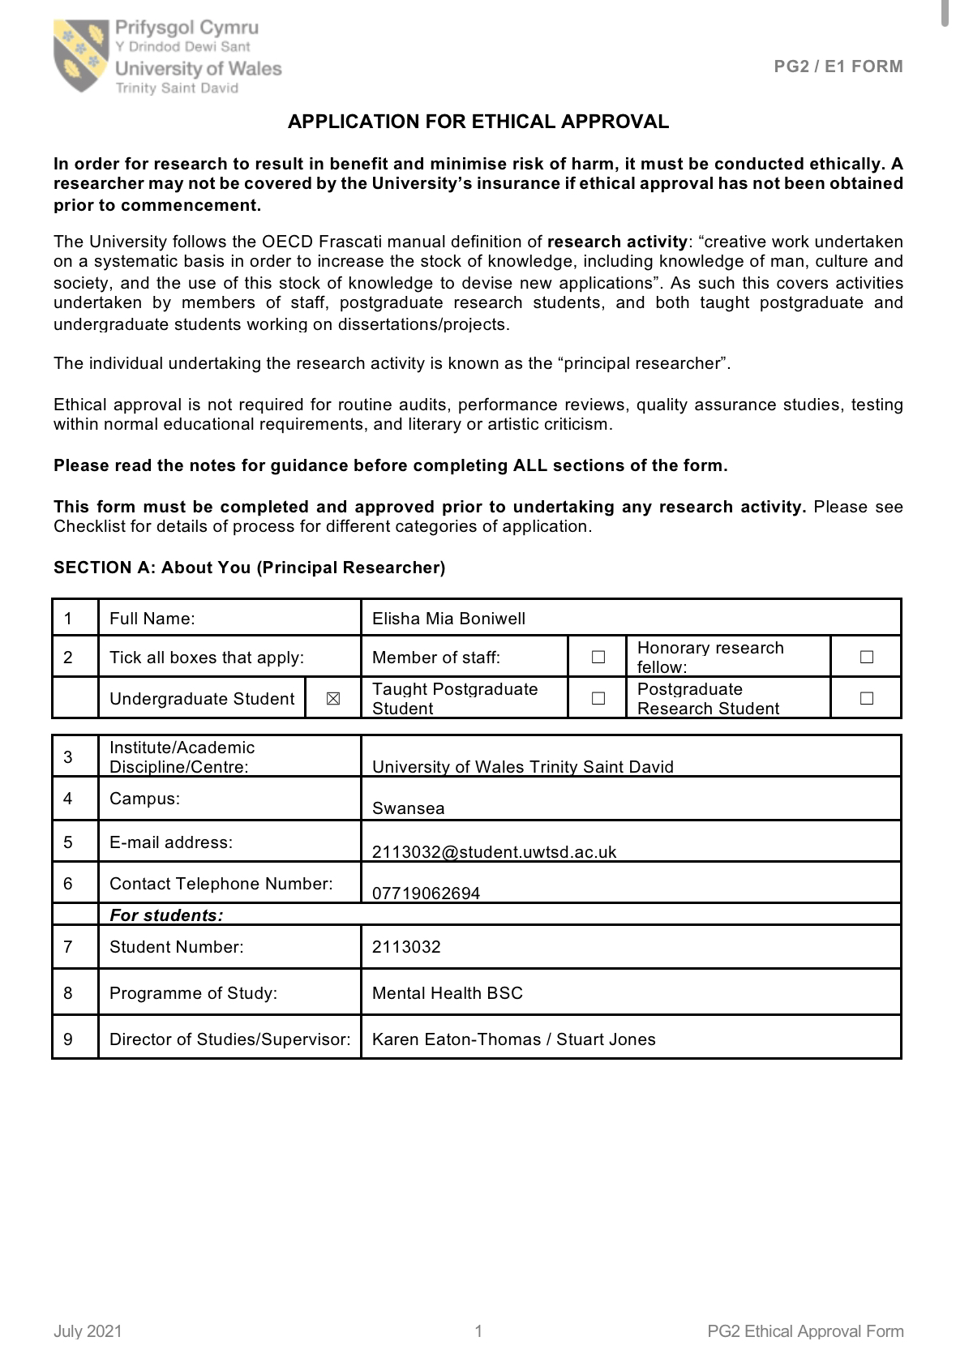

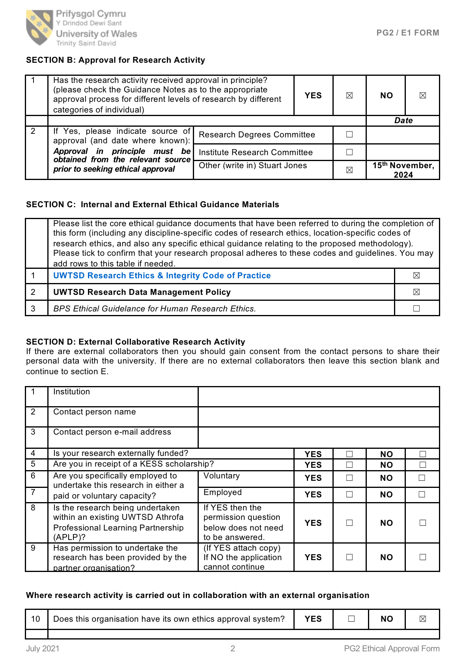

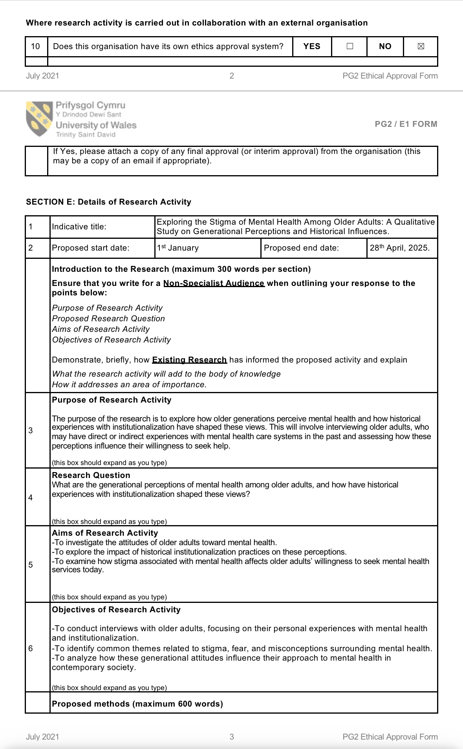

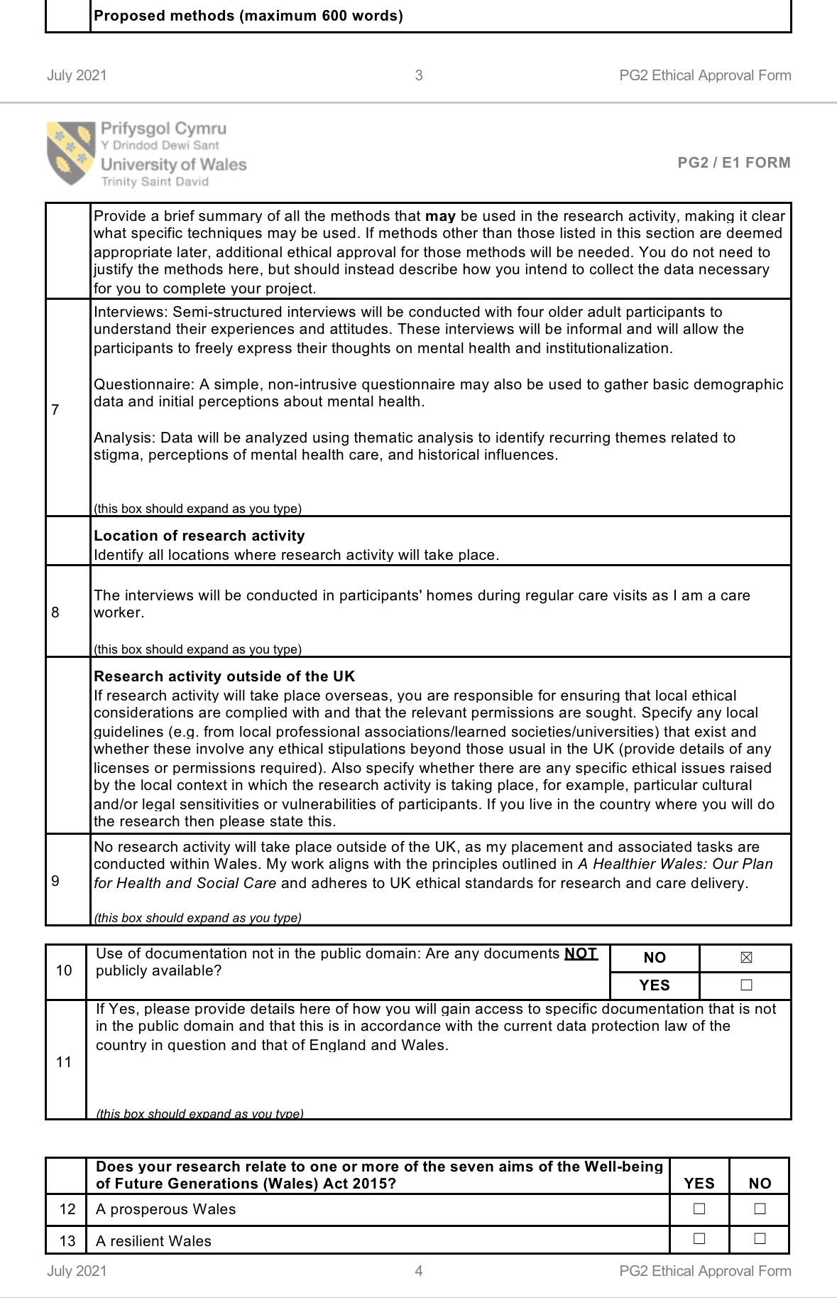
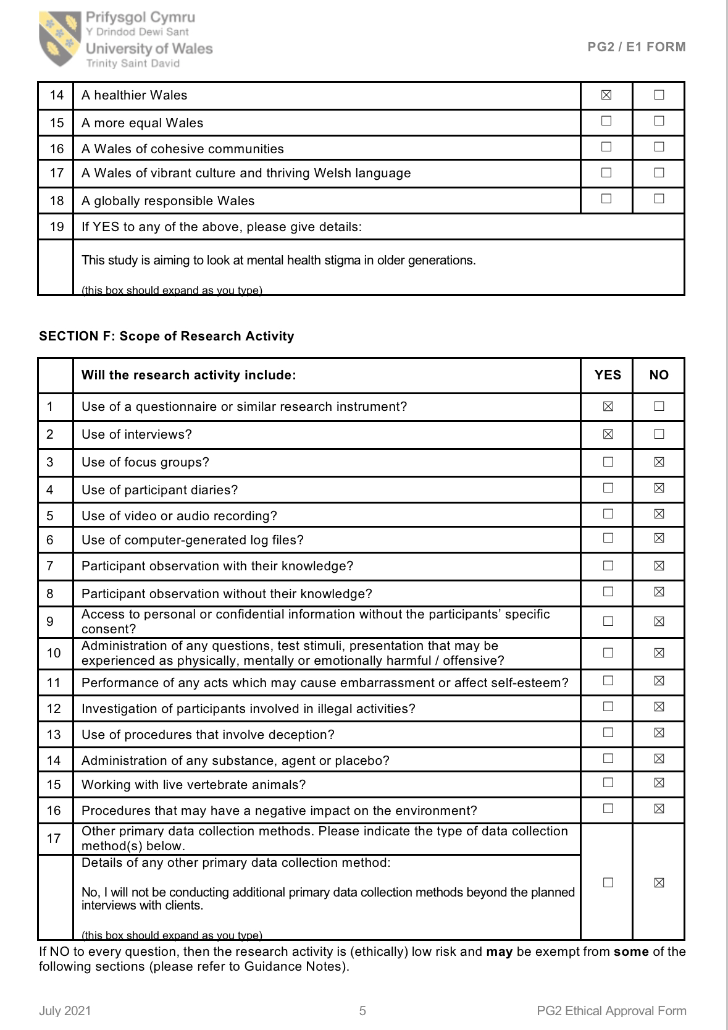

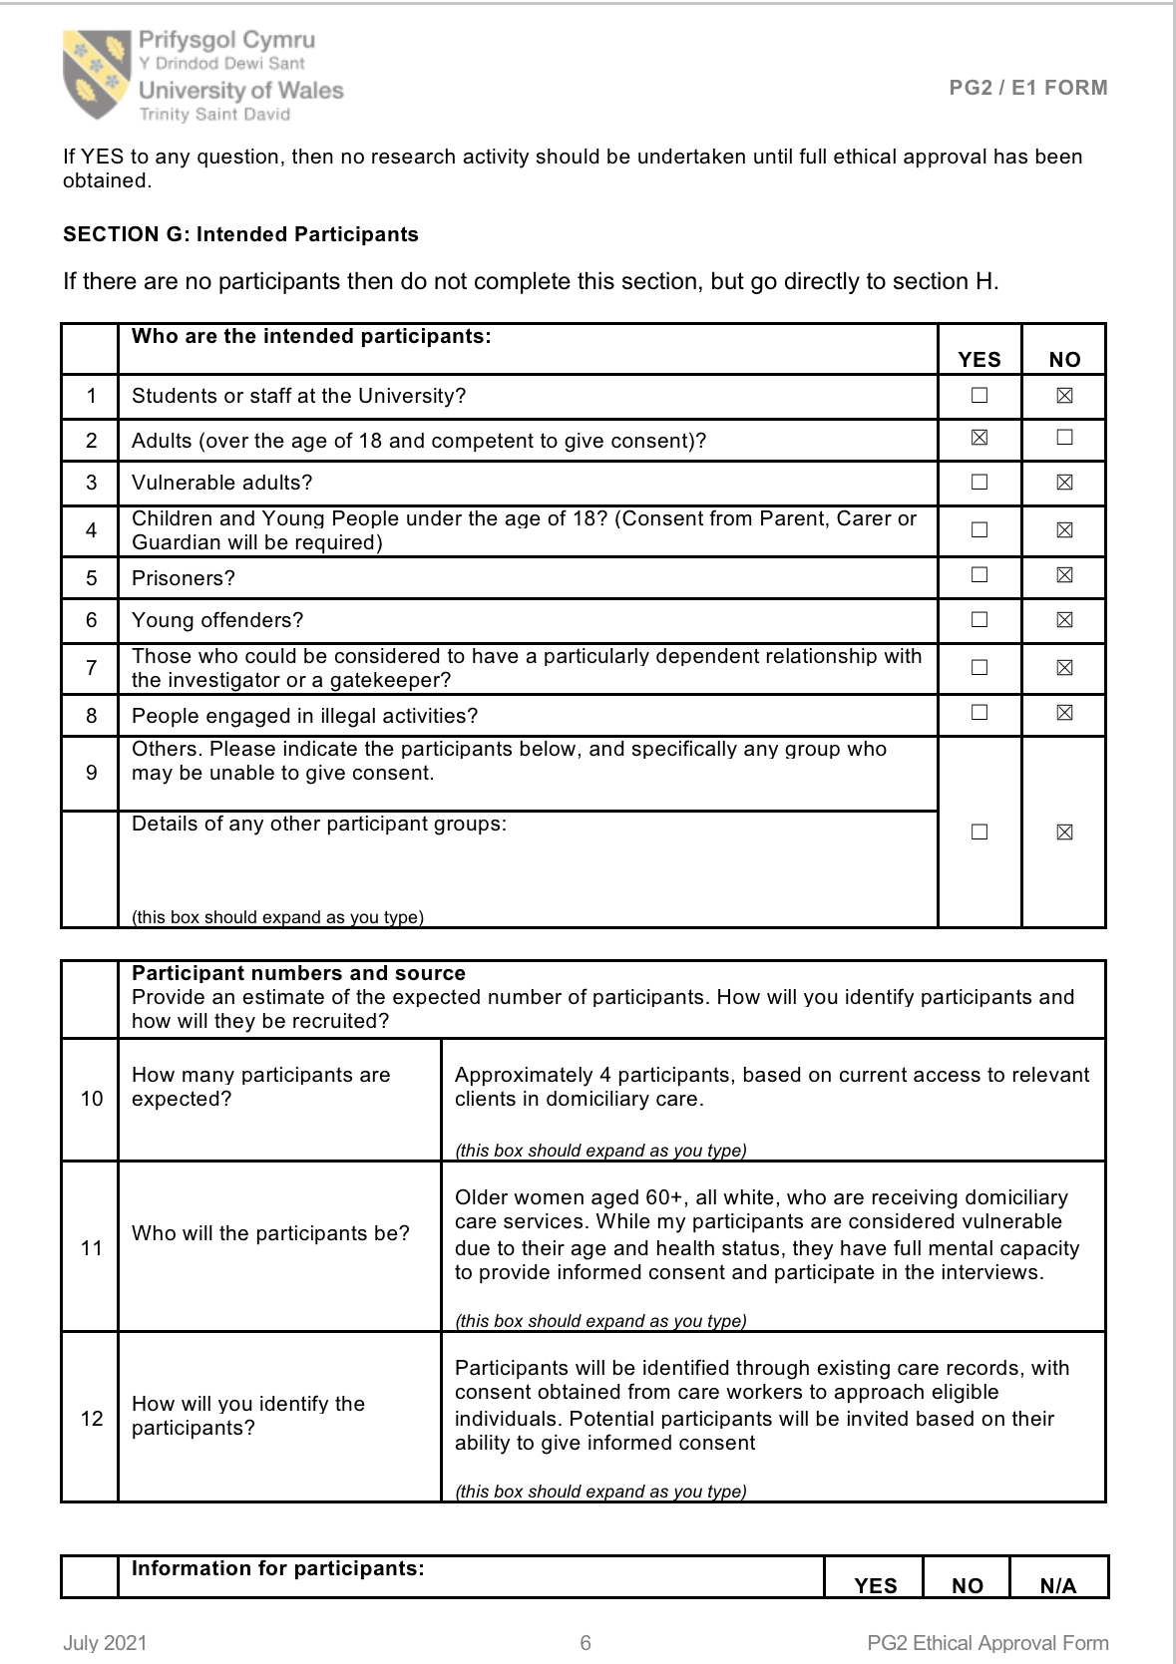

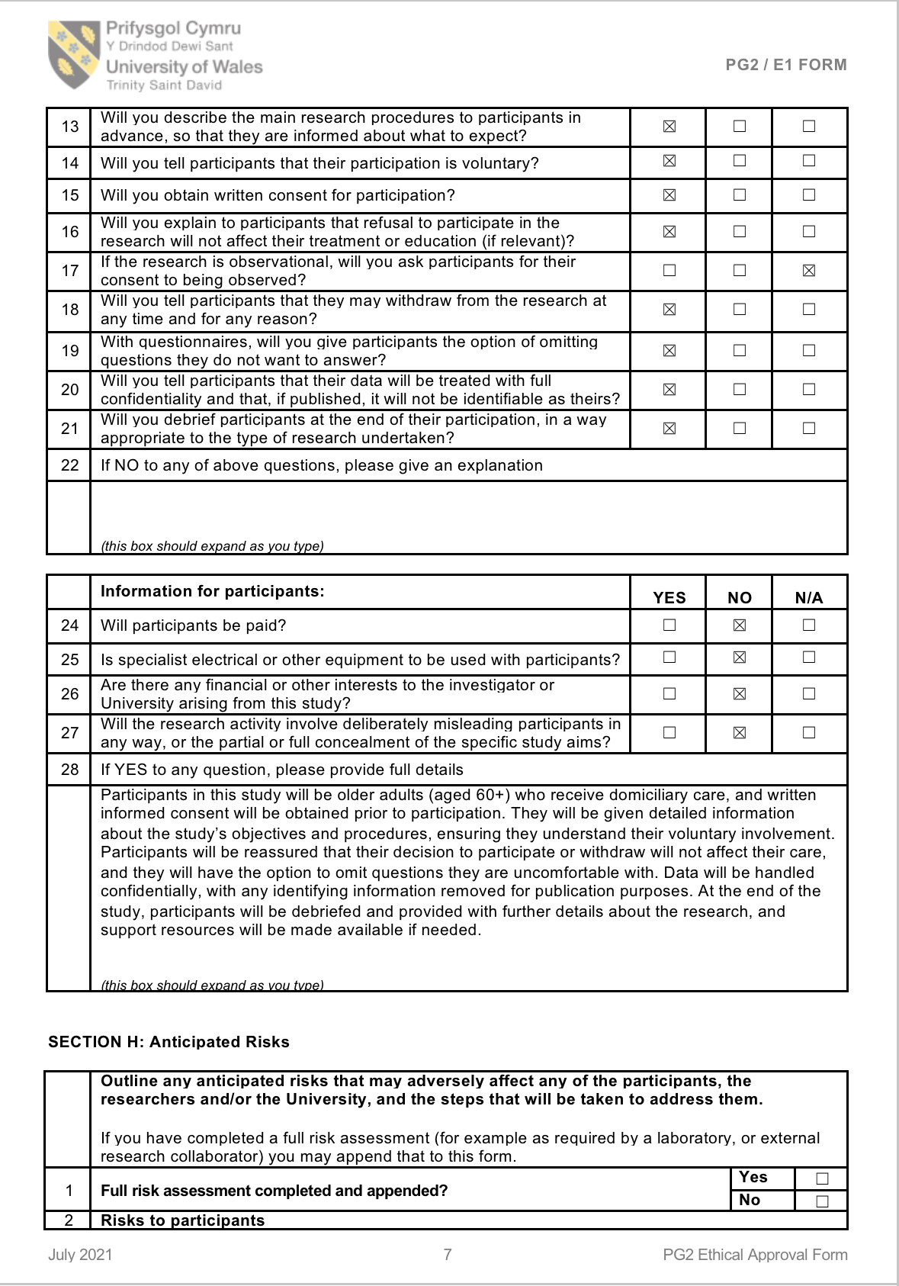

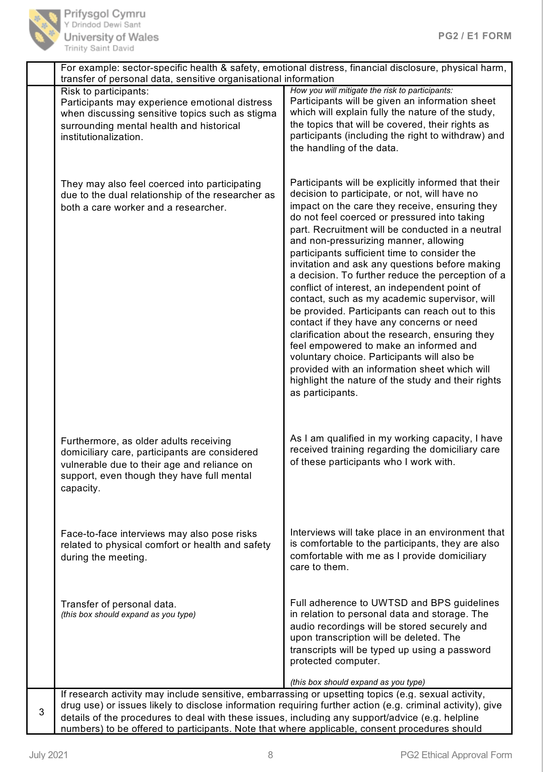
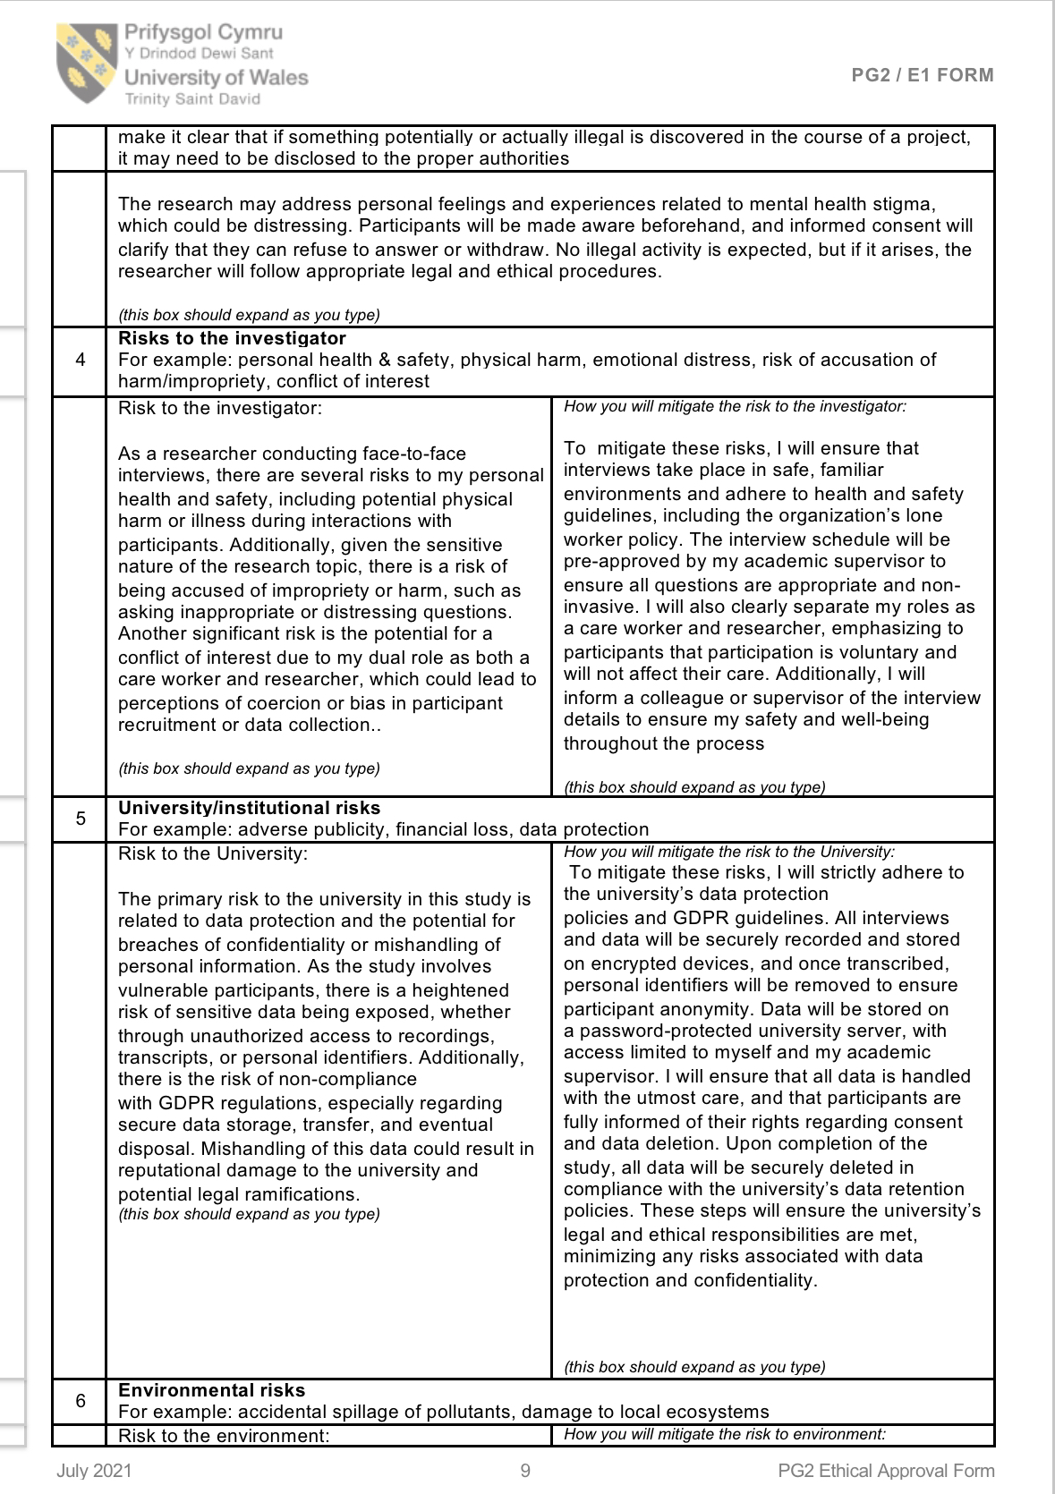

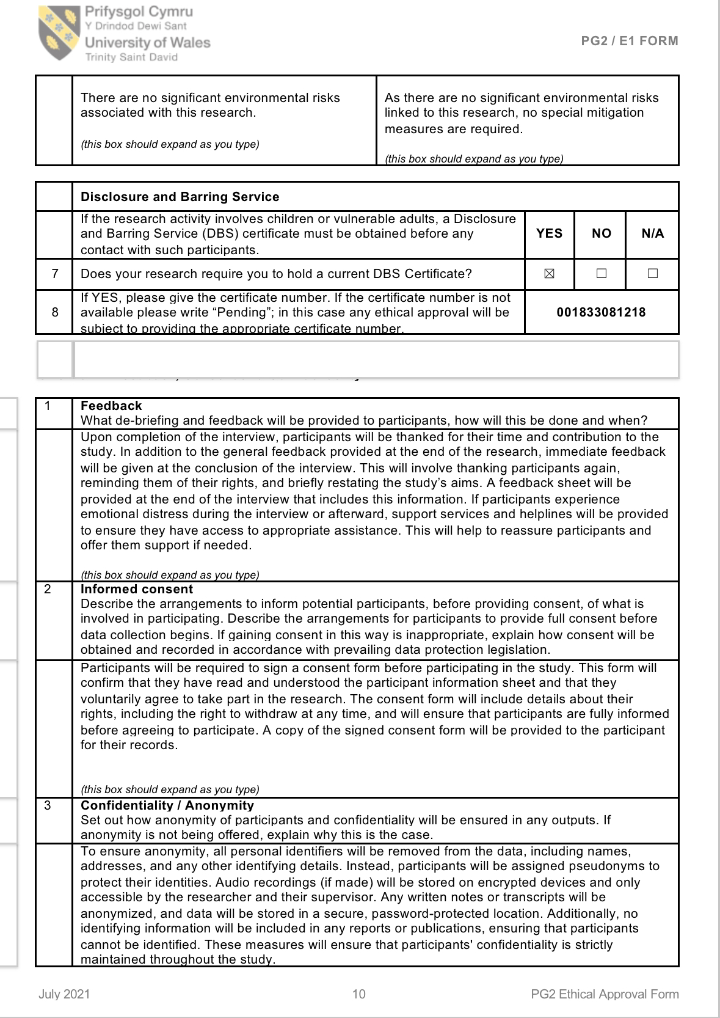

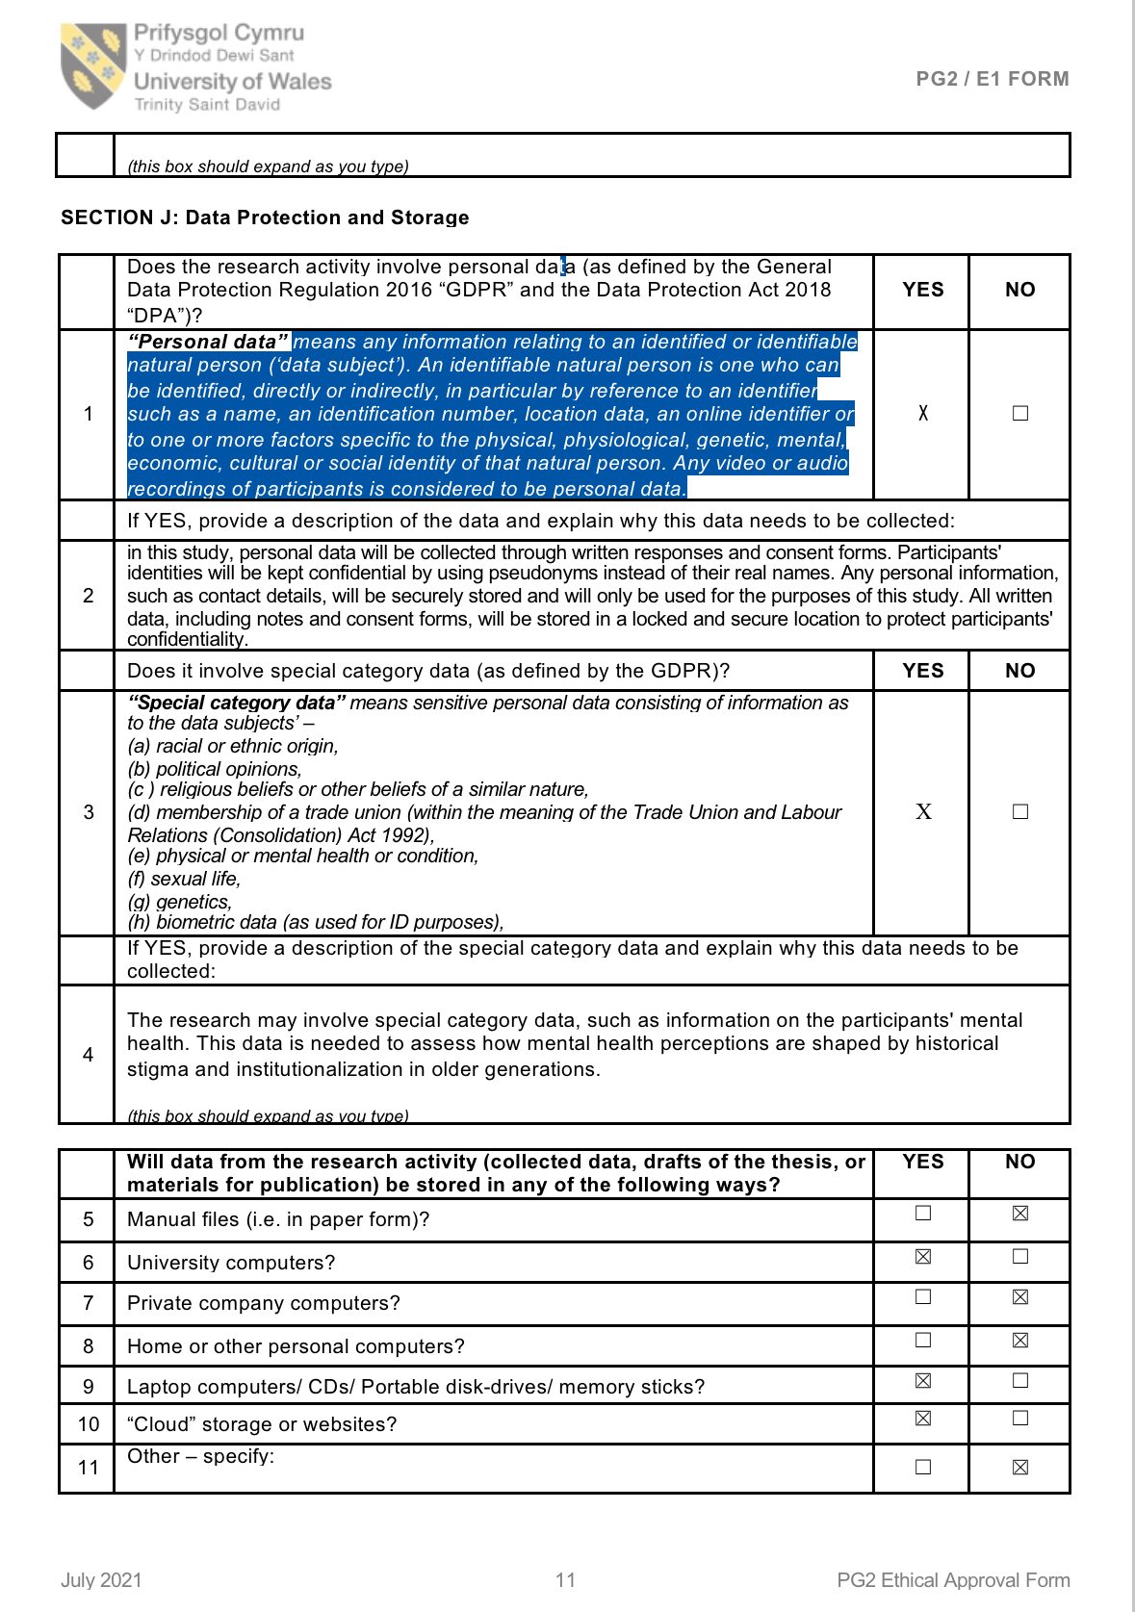

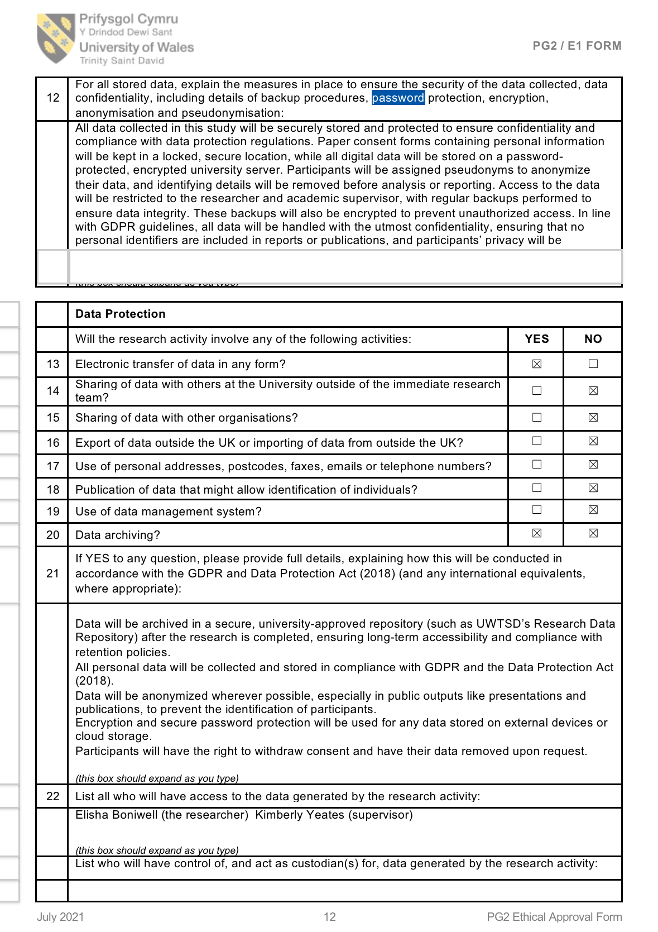
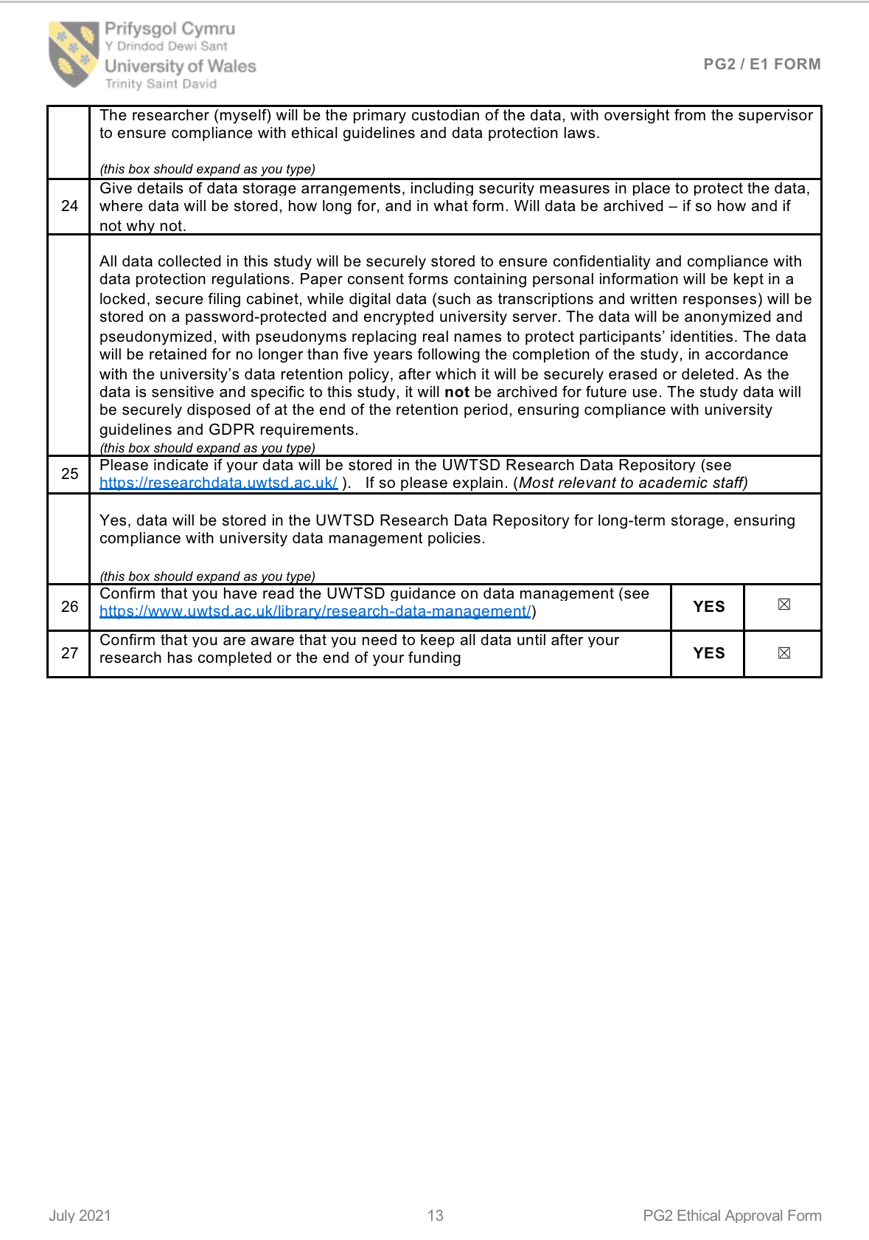

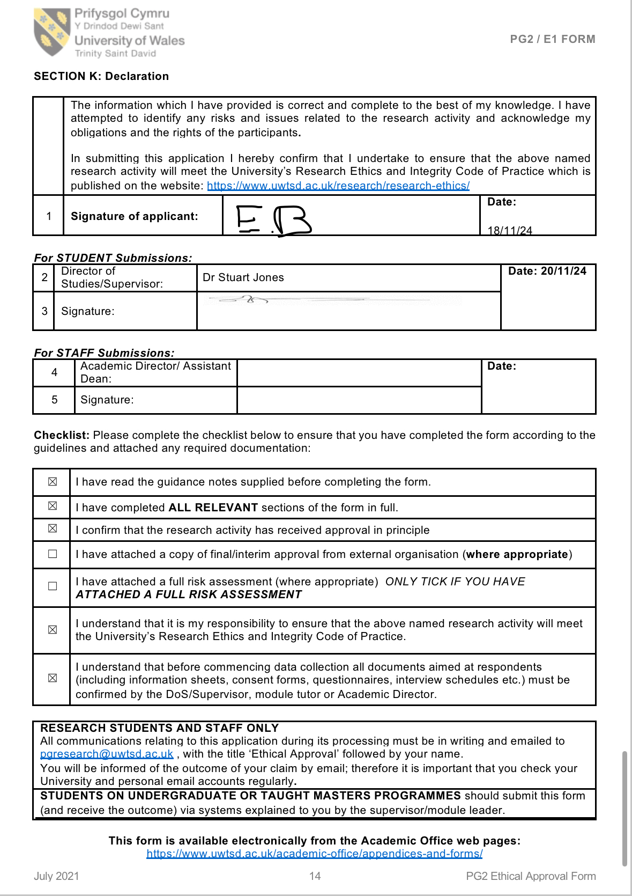

Appendix B: Participant Information Sheet
Study Title
Exploring Mental Health Stigma and Perceptions Among Older Women Receiving Domiciliary Care
Researcher
This study is being conducted by a third-year Psychology undergraduate student at the University of Wales Trinity Saint David as part of their dissertation project.
Purpose of the Study
The aim of this study is to explore how older women perceive mental health and the stigma that may be associated with it. In particular, the study focuses on the experiences and views of older women receiving domiciliary care, and how past societal attitudes may have influenced their willingness to talk about mental health.
Why Have I Been Asked to Take Part?
You have been invited to take part because you are a woman aged 60 or above currently receiving domiciliary care. Your insights and experiences can help improve our understanding of how older adults perceive mental health.
What Will Participation Involve?
If you agree to take part, you will be asked to take part in a one-to-one interview lasting around 20–30 minutes. The interview will involve open-ended questions about your thoughts and experiences related to mental health. With your consent, the interview will be audio-recorded to ensure accurate transcription.
Do I Have to Take Part?
No. Participation is entirely voluntary. If you choose to take part, you can withdraw from the study at any point without giving a reason and without any consequences. You can also withdraw your data up to two weeks after the interview.
Will My Responses Be Kept Confidential?
Yes. All responses will be kept strictly confidential and anonymised. Your name and any identifying details will not appear in the final report. All data will be securely stored and used solely for the purpose of this study.
What Are the Possible Risks or Benefits?
There are no direct risks involved. However, discussing mental health might bring up emotional topics. If you feel upset or need support during or after the interview, information about support services will be provided. While there are no direct personal benefits, your participation may help raise awareness and improve support services for others in similar situations.
What Happens Next?
If you agree to take part, you will be asked to sign a consent form before the interview begins. You will also receive a debrief sheet at the end of the interview with more information and contact details.
Contact Information
If you have any questions or concerns, please feel free to contact the researcher or the dissertation supervisor:
Student Researcher Name
Email: 2113032@student.uwtsd.ac.uk
Dissertation Supervisor Name
Email: s.a.jones@uwtsd.ac.uk

Appendix C
Semi-Structured Interview Schedule for Older Women in Domiciliary Care
1. Demographic Questions (for context, not analysis)
- How old are you?
- What did you do for work?
- How long have you been receiving care?
- Do you live alone or with family?
2. General Perceptions of Mental Health
- What does the term “mental health” mean to you?
- Do you think mental health problems are common among people your age?
- How do you think mental health differs from physical health?
3. Stigma and Attitudes Toward Mental Health
- How did people talk about mental health when you were younger?
- Do you think there is stigma around mental health in older people?
- Have you ever felt uncomfortable talking about your own mental health? Why or why not?
4. Experiences with Mental Health and Help-Seeking
- Have you or someone you know ever struggled with mental health? How was it handled?
- Would you feel comfortable seeking professional help for mental health? Why or why not?
- What kind of support do you think older adults need for their mental well-being?
5. Solutions and Perspectives on Change
- What could be done to encourage more open discussions about mental health among older people?
- Do you think mental health services are accessible for older people?
- What advice would you give to younger generations about mental health?

Appendix D

Centre for Psychology and Counselling
BSc Applied Psychology
BSc Psychology
BSc Psychology and Counselling
BSc Mental Health

Study Consent Form
I understand that this research study is being carried out by a 3rd year Psychology Student for their dissertation, and that taking part in this study will involve This study aims to explore how older women receiving domiciliary care perceive mental health and stigma. Participants will take part in an interview discussing their views and experiences with mental health, stigma, and care. The interview will be recorded for analysis.
This study will take approximately 20 minutes to complete.
I understand that participation in this study is voluntary, and I am free to withdraw participation during or at the end of the study without giving a reason. I understand that once I leave the study, I will not be able to withdraw my data, as it will be anonymized. I am aware that if I have concerns about the study, I can discuss these concerns with the researcher at any time during or after the study. I understand that I will be provided with the contact details of the research supervisor at the end of the study, should I have any concerns.
I understand that the information provided by me will be held confidentially, with a code assigned in place of my name. These data will be stored indefinitely in accordance with the Data Protection Act.
I also understand that at the end of the study I will be provided with a debrief form and the opportunity to discuss any issues with the researcher.

I, ___________________________________(NAME) consent to participate in the study conducted by Elisha Boniwell, Centre for Psychology and Counselling, University of Wales Trinity Saint David, under the supervision of Stuart Jones

Participant Signature:________________________________________________
Date:___________________
Name and signature of researcher taking consent
___________________________________________________________________
Appendix E

Centre for Psychology and Counselling
BSc Applied Psychology
BSc Psychology
BSc Psychology and Counselling
BSc Mental Health

Study Debrief Sheet
Exploring Perceptions and Stigma of Mental Health in Older Women Receiving Domiciliary Care

Thank you for taking part in the study.

The aim of this study was to explore how older women receiving domiciliary care perceive mental health and experience stigma surrounding it.
We specifically wanted to find out whether past experiences, cultural expectations, and historical associations with mental health services influence their willingness to talk about mental health today.

If you wish to withdraw your data from the study, you must tell the researcher now. After this point, all of your data will be anonymised and we will not be able to trace it back to you.

If taking part in this study has raised any questions, please speak to the researcher on 2113032@student.uwtsd.ac.uk or contact the academic supervisor Stuart Jones s.a.jones@uwtsd.ac.uk

Thank you once again for taking time to participate in this study.

Elisha Boniwell

BSC Mental Health
University of Wales Trinity Saint David

Appendix F
Email of approval from Cared Care

Appendix G
Interview Transcripts

Participant A
Interviewer: How old are you?
Participant: I'm 81.
Interviewer: What did you do for work?
Participant: I worked in a factory.
Interviewer: How long have you been receiving care?
Participant: Over 4 years now.
Interviewer: Do you live alone or with family?
Participant: I live on my own.
Interviewer: What does the term "mental health" mean to you?
Participant: It means when someone is struggling in their mind, feeling low or anxious.
Interviewer: Do you think mental health problems are common among people your age?
Participant: Yes, very common. A lot of people are lonely or worried.
Interviewer: Why do you think that is?
Participant: Because of isolation, losing loved ones, and sometimes just not having anyone to talk to.
Interviewer: How do you think mental health differs from physical health?
Participant: Mental health is more about how you're feeling emotionally. Physical health is more visible.
Interviewer: How was the subject of mental health approached when you were younger?
Participant: It wasn’t really. It was ignored mostly. You had to get on with it.
Interviewer: Do you think there's a stigma around mental health in older people?
Participant: Yes, especially in my generation. People don’t want to admit they’re struggling.
Interviewer: Have you ever felt uncomfortable talking about your own mental health?
Participant: Yes, I wouldn’t want people to think I’m weak.
Interviewer: Have you or someone you know ever struggled with mental health?
Participant: Yes, my sister. She had a breakdown after her husband died.
Interviewer: Would you feel comfortable seeking professional help if you needed it?
Participant: I think I would now, yes.
Interviewer: What kind of support do you think older adults need for their mental wellbeing?
Participant: Someone to talk to, company, activities. Just feeling seen and heard.
Interviewer: Have you ever experienced anything in your life that caused you anxiety, like loss of a loved one?
Participant: Losing my husband was the hardest time in my life.
Interviewer: What could be done to encourage more open discussions about mental health among older people?
Participant: More groups, more encouragement, someone taking the time to listen.
Interviewer: Do you think mental health services are accessible for older people?
Participant: Not always, no. It can be hard to know where to go.
Interviewer: What advice would you give to younger generations about mental health?
Participant: Don’t bottle things up. Talk to people and look after your mind as well as your body.

Participant B
Interviewer: How old are you?
Participant: I'm 90 years old.
Interviewer: What did you do for work?
Participant: I worked as a cook in a care home.
Interviewer: How long have you been receiving care?
Participant: Approximately 18 months now.
Interviewer: Do you live alone or with family?
Participant: I live alone.
Interviewer: What does the term "mental health" mean to you?
Participant: It refers to someone who struggles to cope and finds it hard to express their feelings.
Interviewer: Do you think mental health problems are common among people your age?
Participant: Yes, I believe they are.
Interviewer: Why do you think that is?
Participant: Many older people feel lonely and may not be able to care for themselves as they used to.
Interviewer: How do you think mental health differs from physical health?
Participant: Mental health is about what's happening in your mind—your thoughts and emotions. Physical health pertains to your body.
Interviewer: How was the subject of mental health approached when you were younger?
Participant: We didn't really discuss it. It wasn't something people talked about openly.
Interviewer: Do you think there's a stigma around mental health in older people?
Participant: Yes, I do.
Interviewer: Why do you think that is?
Participant: People often fear what others might think if they admit to struggling mentally.
Interviewer: Have you ever felt uncomfortable talking about your own mental health?
Participant: Yes, I have.
Interviewer: Why?
Participant: Because I was afraid of being judged or misunderstood.
Interviewer: Have you or someone you know ever struggled with mental health?
Participant: Not that I'm aware of. I don't know anyone personally who has.
Interviewer: Would you feel comfortable seeking professional help if you needed it?
Participant: Yes, if I felt it was necessary, I would.
Interviewer: What kind of support do you think older adults need for their mental wellbeing?
Participant: Emotional support is crucial.
Interviewer: Have you ever experienced or witnessed anything in your life that caused you anxiety, like the loss of a loved one?
Participant: Yes, losing my parents and my husband were very difficult times.
Interviewer: What could be done to encourage more open discussions about mental health among older people?
Participant: Organizing support groups, attending church, having open conversations, and meeting with others can help.
Interviewer: Do you think mental health services are accessible for older people?
Participant: I believe they are, but it might depend on where you live.
Interviewer: What advice would you give to younger generations about mental health?
Participant: Don't hesitate to reach out, talk to someone, and seek help when you need it.

Participant C
Interviewer: How old are you?
Participant: I'm 76.
Interviewer: What did you do for work?
Participant: I was a cleaner for a long time.
Interviewer: How long have you been receiving care?
Participant: Just over a year now.
Interviewer: Do you live alone or with family?
Participant: I live on my own now. My children visit.
Interviewer: What does the term "mental health" mean to you?
Participant: It’s about how your mind is feeling. Whether you're coping with life.
Interviewer: Do you think mental health problems are common among people your age?
Participant: Yes, more than people think.
Interviewer: Why do you think that is?
Participant: A lot of people feel like they’ve been left behind. They’re isolated.
Interviewer: How do you think mental health differs from physical health?
Participant: Mental health can be harder to spot. People may seem fine on the outside.
Interviewer: How was the subject of mental health approached when you were younger?
Participant: It was hush hush. People were afraid to talk about it.
Interviewer: Do you think there's a stigma around mental health in older people?
Participant: Definitely. We were brought up to keep it to ourselves.
Interviewer: Have you ever felt uncomfortable talking about your own mental health?
Participant: Yes. It doesn’t come naturally to open up.
Interviewer: Have you or someone you know ever struggled with mental health?
Participant: Yes, my brother. He was in a hospital for a time.
Interviewer: Would you feel comfortable seeking professional help if you needed it?
Participant: I’d try. But I wouldn’t find it easy.
Interviewer: What kind of support do you think older adults need for their mental wellbeing?
Participant: More people to talk to, more understanding.
Interviewer: Have you ever experienced anything in your life that caused you anxiety, like loss of a loved one?
Participant: Yes, when I lost my sister, I felt lost for a long time.
Interviewer: What could be done to encourage more open discussions about mental health among older people?
Participant: Maybe community talks, or visits from professionals who are kind.
Interviewer: Do you think mental health services are accessible for older people?
Participant: Not always. Some people don’t even know what’s out there.
Interviewer: What advice would you give to younger generations about mental health?
Participant: Talk about it. Don’t be afraid. You’re not alone.

Participant D
Interviewer: How old are you?
Participant: I'm 84.
Interviewer: What did you do for work?
Participant: I was a housewife and helped my husband run a small family shop.
Interviewer: How long have you been receiving care?
Participant: About 3 years now.
Interviewer: Do you live alone or with family?
Participant: I live alone. My son helps me when he can.
Interviewer: What does the term "mental health" mean to you?
Participant: It's your wellbeing inside—how you're coping with life, emotions, stress.
Interviewer: Do you think mental health problems are common among people your age?
Participant: Yes, especially now. People are more isolated.
Interviewer: Why do you think that is?
Participant: Loneliness, loss of routine, grief—it all adds up.
Interviewer: How do you think mental health differs from physical health?
Participant: Mental health is less visible. But it can be just as painful.
Interviewer: How was the subject of mental health approached when you were younger?
Participant: It wasn’t. People ended up in asylums. That was the fear.
Interviewer: Do you think there's a stigma around mental health in older people?
Participant: Absolutely. It’s still hard to talk about it.
Interviewer: Have you ever felt uncomfortable talking about your own mental health?
Participant: Yes. I didn’t want to seem weak.
Interviewer: Have you or someone you know ever struggled with mental health?
Participant: My cousin did. She was sectioned when I was young. We never saw her again.
Interviewer: Would you feel comfortable seeking professional help if you needed it?
Participant: I would now. But years ago, I wouldn’t have.
Interviewer: What kind of support do you think older adults need for their mental wellbeing?
Participant: Compassion. A friendly ear. Routine.
Interviewer: Have you ever experienced anything in your life that caused you anxiety, like loss of a loved one?
Participant: Yes, my husband passed. It still affects me.
Interviewer: What could be done to encourage more open discussions about mental health among older people?
Participant: Normalise it. Make it okay to talk. Have more discussions.
Interviewer: Do you think mental health services are accessible for older people?
Participant: For some, maybe. For others, they don’t know where to start.
Interviewer: What advice would you give to younger generations about mental health?
Participant: Don’t carry it alone. Speak up. Keep talking.

Appendix H
The study was conducted as part of an undergraduate dissertation project and received ethical approval from the university’s research ethics committee. The aim was to explore older women's perceptions and experiences of mental health and stigma within the context of domiciliary care.

Participants were recruited through convenience sampling during the researcher’s employment as a domiciliary care provider. Four female clients, all aged 60 or over, were invited to take part. Each participant received an information sheet and gave written informed consent before participating.

Semi-structured interviews were conducted individually in the participants’ homes at a time convenient to them. Interviews were audio recorded with permission and followed a consistent interview schedule. The questions were designed to prompt reflection on experiences of mental health, stigma, and support.

The interviews lasted approximately 20-30 minutes each. After the interviews, participants were thanked for their time and given a debrief sheet explaining the study’s purpose and providing relevant mental health support contacts.

The audio recordings were transcribed verbatim by the researcher, and all identifying information was anonymised. The data were then analysed thematically following Braun and Clarke’s (2006) six-step method.

