BUSINESS PLAN
PHOENIX EVENT MANAGEMENT UK

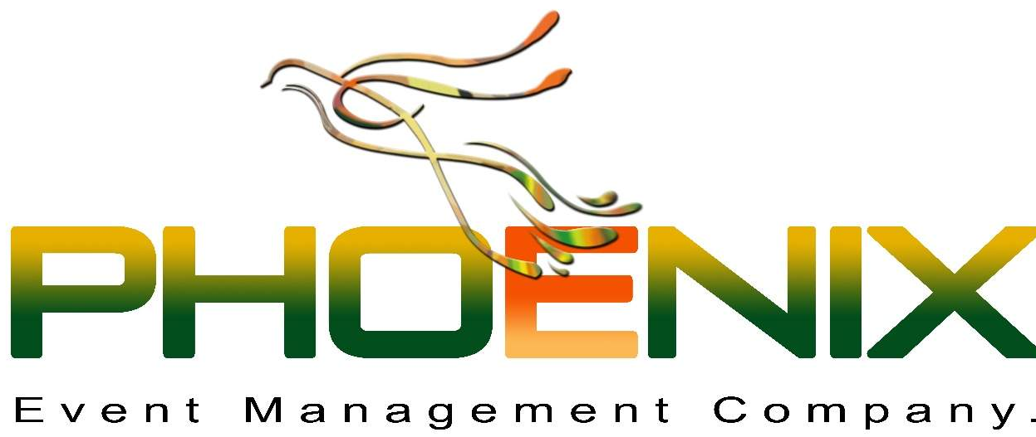

TABLE OF CONTENTS
EXECUTIVE SUMMARY 3
INTRODUCTION 4
DISCUSSION 5
BUSINESS OWNERSHIP 5
NEW PRODUCT AND SERVICES 5
PHYSICAL REQUIREMENTS 7
HUMAN RESOURCES 8
MARKETING ACTIVITIES 10
FINANCIAL RESOURCES 11
SWOT ANALYSIS 13
CONCLUSION 15
REFERENCES 16

EXECUTIVE SUMMARY
This strategic report comprised the influencing data about the procedure to oversee the new business. This marketable strategy included inventive business thought of meetings, wedding function, social and digital media and other promotional activities, all the items utilizing in the association originated from nature and the claim to fame of the bounce is event management. This report incorporates confine examination of physical prerequisite and it contains data of the area of the business, gear required, what is the special selling purpose of the item, and operational capacities. The second phase of investigations the part of HR and what are the activity jobs of working representatives inside the shop or endeavor. Showcasing exercises sick be oversee by the key apparatuses and procedures where the budgetary investigation support making anticipated arranging of the income statement for a year.

INTRODUCTION
Business is referred to the process of selling products and services within the market at equitable prices which can attract more and more customers, but one more thing which is not considered by today's entrepreneurs that product diversification is also necessary to the business. The variance products will support the business by giving a different perception to the customers about the products and its benefits. The main focus of the organization is to generate more sales figures and also provide effective quality products to the customer at their prime stage (Mangla et al. 2015).
This business plan consists of effect information about the process that is required to manage new business formation. This business plan involves the creative business idea of “Phoenix Event Management UK”, all the products using in the organization came from nature and the specialty of the hope of meetings, wedding function, social and digital media and other promotional activities. This report includes detain analysis of physical requirement and it contains information on the location of the business, equipment required, what is the unique selling point of the product, and operational functions. Second stage analyses the aspect of human resources and what are the job roles of working employees within the shop or enterprise. Marketing activities ill be managed by the strategic tools and techniques where the financial analysis support creating projected planning of cash flow for 12 months.

DISCUSSION

BUSINESS OWNERSHIP
Every business has its pattern to frame policies and norms to run the business operations, a productive business group needs to be frame by the effective business venture which have potential sources to manage organizational operations. Numerous phases support the organizational process and also help the organization in managing its activities (Mathooko and Ogutu, 2015). The joint venture partnership is the frame for a defined period and then it breached automatically, which reflects the organizational process and provides financial benefits to the administration.

Source: Reineke, (2020)
But the deed among the financial partners or sleeping partners must be easier to get mutual consent on the profit and loss sharing ratios. Numerous activities can support the organization and process to avail of different activities. This business venture provides financial support by capital generation; equally, risk-bearing, and also share profit (Mieyeville et al. 2015).

NEW PRODUCT AND SERVICES
Event management products like meetings, wedding function, social and digital media and other promotional activities are one of the innovative business ideas which are useful for the proprietors or maker to pick up benefit with noteworthy altruism of the business through effective venture formations. Individuals like event management and more promotional products which is continuously affecting 77% of people in Up and another European country (Reineke, 2020). This business product will help to the individuals who love to promote their brand and managing corporate meetings. There are various sorts of event management products and innovative introduction of the advantages portfolio.
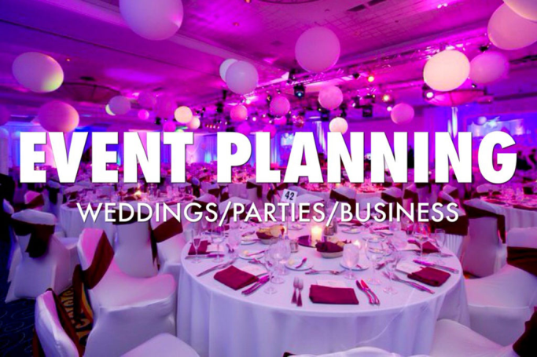

Source: Shi, (2020)
Nowadays the business is quickly differentiated in better places which assist with giving chances to recognize the best business thought which can have the capacity to increase better reaction and market maintainability. Event management and promotions are in the patterns which have aggregate data from statistical surveying say that the age gathering of 45 above is supporting these innovative products in their day by day use which is also creative to make memorable movements (Reineke, 2020). This business thought will be spread jumpers sort of items that are not typically accessible in the market like, meetings, wedding function, social and digital media and other promotional activities. As should be obvious that individuals are going to slope event stations, clan territories of planners, and other characteristic spots to deal with event planning companies. Business is configuration to distinguish its turn of events and development openings, all the business manageability systems, and all the exercises are successfully referenced in it (Shi, 2020).
MISSION
"To expand business operations with collaboration, though delivering meetings, social and digital media and other promotional activities products in the global market."
OBJECTIVES
The core objectives of Phoenix Event Management UK are:
- Expand business operations through establishing event management UK processing products in different superstores or retail shops (Reineke, 2020)
- Effective marketing tools and techniques to make the sustainable formation of business activities
- To establish an anti-competitive position in the event management market

PHYSICAL REQUIREMENTS
The obligation of diverse activities to run the business operations and manage other functioning processes needs to fulfill the requirements which will be mention below. The location of the Phoenix Event Management UK where the efficient amount of space and the crowd came to have products, essential equipment, and technical assistance, valuable unique selling price and more essential how they will be performed within a schedule (Mieyeville et al. 2015).
LOCATION OF THE BUSINESS
The location of the shop quite crows new corporate destinations which can attract more and more tourists. The creative products line Phoenix Event Management UK needs to be set up their maximum marketing process in co5rporate and business areas in London UK. The space of the Event Management is average required 5000 sq. ft. along with parking space (Online Design, 2017). There are few locations that market research helps to identify the location for Event Management Company are mention below:
- 545, Martin Market, Buckingham Palace Road, London WS7B 2AV England (Close to Tourism Destination)
- 211 Goldhawk Road Shepherds Bush, London F07 7DK England (Close to Tourism Destination)
EQUIPMENT REQUIREMENT
There are several types of equipment that are required in the event planning which is mention below, but some machines, man power and directions are specially required to processed events and promotional campaigns like portable projectors, decorative materials, labour union and events hosting space (field space). The basic required equipment is all hardware products, Assorted Miscellaneous, Noise control process tools, and security system (Bellary et al. 2020). Other than event required machinery and skills to perform effectively are skilled workforces and effectual pioneers to direct them. The security System at the event location is helpful to assist crowd that can also supports from unusual incidents. There are different categories of process idem are required in the formation to manage the organizational process and frame events.
UNIQUE SELLING POINT
For the market research, the event management products are slightly less in the market event management which is not providing this kind of product line at one place (Bellary et al. 2020). The best plus point of this creative business idea is proving creative and memorable memories and also effectively work in reducing chaos. This is purely formed from event management activities which are different though using artificial intelligence in selection of right patterns and attracting more crowds to the event. It supports to human bothers to reduce useless effort and gain more energetically support in managing event operations (Reineke, 2020). Products need to be more effective to gain competitive advantages which are the same this ideal will work with an effective unique selling point.
OPERATIONAL FUNCTIONS
The operations related to the activities that employees and other staff will manage in the business. It is necessary for the human resources to uses identical resources for the recruitment and selection of skilled employees. Every employee is the potential to provide impressive customer support and assistance in fulfilling their demand (Rogerson, 2017). The way to organize events on customer demand will be a major requirement for operational activity. The operational process needs more concentration on the activities that support the organizational operations and also become an authentic relationship with the customer.

HUMAN RESOURCES
Human resources management of the company manages recruitment and selection; provides training and learning sessions to the selected employees to choose the right ways to deliver services. There are several roles of HR in the development of the business through planning and forecasting about the future benefits that organizations gain (Pulaj et al. 2015). This functional department recruits potential employees base for establishing a separate entity in the market. It is also required to manage the operational process through establishing monitoring and controlling parameters,
SOURCE OF RECRUITMENT AND SELECTION
There are several kinds of resources which can contribute efforts in recognizing potential and skilled workforce for a new innovative event management plan, which is given below:
Company Website, the portal of the company's website is one of the independent recruitment and selection platforms, where interested candidates are applying for the showcasing job profiles. This process needs a panel to focus on the recruitment and selection stages (Rogerson et al. 2017).
Social Media, is also one of the best ways to attract young people and students though using social media channels. This process helps the organization in founding part-time employees and that is cheaper to the organization (Gorshkov et al. 2018). There are numerous occasions where, people are looking for efficient event planner.
Direct Contact, some contacts can be used by the administration to evaluate them on a referral basis. This process has a potential framework and also benefited from saving time and cost of recruitment.
Recruitment Agencies, numerous agencies are located in the market, where the selected package of the recruitment should be selected and they will offer potential and skilled workforces as per the demand. But the changes and commission of the agencies are very high can be a negative point for HR (Gorshkov et al. 2018).

JOB ROLES OF THE EMPLOYEES
Within the Phoenix Event Management, the requirement of the employees and workers are not that much at ground or initiative level. The framework helps the organization in managing the different organizational process which can affect the organizational streams (Gorshkov et al. 2018). All the information related to the employee’s job profile is mention underneath:
JOB PROFILE | NUMBER OF EMPLOYEES | ROLE & RESPONSIBILITY | SALARY STRUCTURE | WORKING HOURS
Administration and Management | 04 | - Manages the marketing activities  - Research and development  - Implementing strategies and methodologies for development (Henry et al. 2015). | £40,000 PA | 45 hours in a week
Event Manager | 03 | - Manages sales and report to the administration  - Operate daily based event operations  - Handle employee and customer relations | £29,049 PA | 45 hours in a week
Full-time Event Assistant | 08 | - Groundwork of ingredients for use to provide products and services to the customers  - Follow all safety regulations for proper operations handling and managing basic process (Henry et al. 2015). | £10.66 per hour | 40 hours in a week
Part-time Event Assistant | 08 | - Serve customers efficiently with organize hygienic events and creative plans for guests  - Manage cleaning and make hygiene within the event  - Make impressive relations with customers | £6.25 per hour | 25 hours in a week
Security | 02 | - Monitoring surveillance equipment  - Providing information about the inappropriate activities  - Manages access points or permitting entry (Henry et al. 2015). | £6.55 per hour | 40 hours in a week

MARKETING ACTIVITIES
The marketing activities and practices of the organization are effectively aiming at their targeted segments in the market at the initial stage. With the help of big marketing campaigns and social media marketing events, the organization can provide an idea of event planning on affordable prices with diverse product line in one shed (Insureon, 2017). ). The marketing mix is referred to as a marketing framework is focusing on the promotional activities which provide support to the organizational operations.
MARKETING MIX
The marketing mix is reflecting a marketing framework of the products and services through analyzing internal and external dimensions though using its Ps components are Product, Pricing, Place, and Promotion (Gorshkov et al. 2018).
Product, the product and services of the organization is reflecting their significance in the development of the activities. The products of Phoenix Event Management UK are corporate meetings, wedding function, social and digital media campaigns and other promotional practices for third party (Gorshkov et al. 2018).
Pricing, the pricing strategy of the products and services is very affordable and relevant to the high-level quality products and services (Rogerson, 2017). Several formations support business activities and also attract all kinds of the customer base. Inexpensive prices of events can attract more customer base.
Place, the value, and significance of the location on the business activities are more; it helps the organization in managing different identical formations and also being more productive to accomplish desirable activities. Market research initiates some locations which are 545, Martin Market, Buckingham Palace Road, London WS7B 2AV England (Close to Tourism Destination), and 211 Goldhawk Road Shepherds Bush, London F07 7DK England (Gorshkov et al. 2018).
- Promotion, the marketing strategies will be frame according to the define targeted segments which are above 30 age group people, the percentage of the events organized in the country is more than 76% which will be the effective sources of the customer base. Use of diverse marketing strategies to frame the organizational process in an upwards direction ((Shi, 2020).
OTHER STRATEGIES
Social media marketing channels are continuously promoting business operations in these days, this century represents the digital age of generation where the maximum number of people are using a smartphone and have accounts on social media platforms (Henry et al. 2015). With the help of some potential promotional channels like Instagram, Snapchat, Facebook, and others will gather more customer base.

FINANCIAL RESOURCES
FINANCIAL RECOURSES
The financial resources come for different mediums like the arrangement of funds from joint venture partnership while it takes a 50% ratio of each partner. Suppose the business operations are based on the initial investment of £ 10,000,000, the process of collecting funds from the partners on the ratio of 2:2:2:4. £600,000 will be divide into each of three partners where the rest amount £400,000 came in the business in the form of loans, credit, sponsorship, and others. The process of investment in the business is taking formulate processes under the joint venture deed (Accounting Coach, 2017).

PROJECTED CASH FLOW SPREADSHEET FOR 12 MONTHS (PHOENIX EVENT MANAGEMENT UK)
ITEMS | January  £ (million) | February  £ (million) | March  £ (million) | April  £ (million) | May  £ (million) | June  £ (million) | July  £ (million) | August  £ (million) | September  £ (million) | October  £ (million) | November  £ (million) | December  £ (million)
MONEY IN
Loans | 8,000 | 8,000 | 8,000 | 9,000 | 9,000 | 9,000 | 10,000 | 10,000 | 10,000 | 11,000 | 11,000 | 11,000
Sales | 20,000 | 20,000 | 20,000 | 22,000 | 22,000 | 22,000 | 25,000 | 25,000 | 25,000 | 26,000 | 26,000 | 26,000
Sponsorship | 15,000 | 15,000 | 15,000 | 15,000 | 15,000 | 15,000 | 15,000 | 15,000 | 15,000 | 15,000 | 15,000 | 15,000
Promotions | 20,000 | 20,000 | 20,000 | 20,000 | 20,000 | 20,000 | 20,000 | 20,000 | 20,000 | 20,000 | 20,000 | 20,000
TOTAL MONEY IN | 63,000 | 63,000 | 63,000 | 66,000 | 66,000 | 66,000 | 70,000 | 70,000 | 70,000 | 72,000 | 72,000 | 72,000
MONEY OUT
Event Plannning | 1000 | 1000 | 1000 | 1500 | 1500 | 1500 | 2000 | 2000 | 2000 | 2500 | 2500 | 2500
Salary and Remuneration | 10,000 | 10,000 | 10,000 | 11,000 | 11,000 | 11,000 | 12,000 | 12,000 | 12,000 | 13,000 | 13,000 | 13,000
Raw Material | 12,000 | 12,000 | 12,000 | 15,000 | 15,000 | 15,000 | 17,000 | 17,000 | 17,000 | 20,000 | 20,000 | 20,000
Fixed Cost | 5,000 | 5,000 | 5,000 | 7,000 | 7,000 | 7,000 | 9,000 | 9,000 | 9,000 | 11,000 | 11,000 | 11,000
Variable Cost | 3000 | 2500 | 4500 | 2500 | 3300 | 2500 | 2000 | 3000 | 4500 | 4000 | 5000 | 3500
Freight | - | - | - | - | - | - | - | - | - | - | - | -
TOTAL  MONEY OUT | 31,000 | 30,500 | 32,500 | 37,000 | 37,800 | 37,000 | 42,000 | 43,000 | 44,500 | 49,500 | 50,500 | 49,000
TOTAL PROFIT  (variances) | 32,000 | 32,500 | 30,500 | 29,000 | 28,200 | 29,000 | 28,000 | 27,000 | 25,500 | 21,500 | 21,500 | 23,000

FINANCIAL RISKS
- Political and monetary factors likewise worry with the association which can influence the exchange strategy, tax assessment, and other handling of the association.
- The course of action of capital for activities influencing association working strategies and mirror the income creating process (Aileron, 2014). Absence of subsidizing inside the association to deal with all the tasks and influences by the outer condition is crating money related crunches and difficulties to oversee business exercises.
- Quality related issues are consistently the worry of the business authorities so the exercises of the preparing crude material are trained by the authoritative division to deal with the circumstance proficiently.
- Extension of business-arranged exercises is influencing business tasks adequately if the serious procedure over the procedure of business activities (Aven, 2015). Disarray and terrified of descending business diagrams influence the assurance of specialists and the absence of administrative handling.

SWOT ANALYSIS
With the assistance level of internal analysis to identify the current status of the event products and services in the market evaluate by SWOT analysis (Barnet London Borough, 2017).
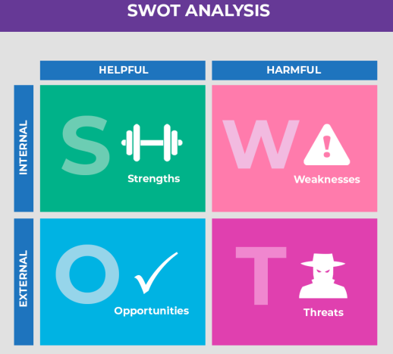
Source: Abdel-Basset et al, (2018)
STRENGTHS
- Efficient event organizing product lines which consist corporate seminars, annual meetings, wedding functions, special occasions, surprise parties and other events on the demand of customers (Abdel-Basset et al. 20178).
- Phoenix Event Management is unadulterated promotional organization having efficient product line with relevant packages for the customers that are amazingly convincing in taste and have a possible quality of providing customer services (Shi, 2020).
WEAKNESS
- The esteeming or valuing methodology of Phoenix Event Management is expensive from its competitors on special occasion events directed by customers
- The initial stage of the business faces challenges from low popularity and less customer base due to lack of awareness.
- The publicizing channels are coordinated to limit different channels and it doesn't give convincing assistance to the customers.
OPPORTUNITIES
- Consumers always demand quality creative and memorable plans for event rather than garbage and common activities, so the huge bit of the pie is one of the odds to develop a monopolistic circumstance in the UK's market to obtain income (Zhao et al. 2016).
- Pull approaches; this process is supportive and contributes assistance in pulling young customers, senior customer base, corporate authorities, and others at the event planning because of the cost and service benefits.
- With the help of joint endeavor and collaborative business process to the concern of establishing various event management outlasts that offers many advantages to their potential customer base (Zhao et al. 2016).
THREATS
- The existing companies like Beyond Certainty, Clear water events and Park Publishing have the greatest competitors of the organization they also provide similar events organizing products but the service of these organizations are not effective and expensive also (Zhao et al. 2016).

CONCLUSION
This report included the statistics and strategic data of the techniques to uses in direct a new business line. This attractive procedure incorporates imaginative business thought of event planning, all the things using in the affiliation started from effective customer assistance in delivering memorable movements to the customers. The specialty of the rebound is providing many event options at one place, people are planning for weeding can contact here, focusing on corporate meetings and other sources. This report consolidates limit assessment of physical essential and it contains information of the region of the business, gear required, what is the unique selling motivation behind things, and operational requirements. The second phase of examinations the piece of HR and what are the action employments of working delegates inside the event management company. Exhibiting practices wiped out is direct by the key automatic assemblies and systems where the cash flow examination supports in making foreseen organizing financial planning by proclamation for a year.

REFERENCES
Abdel-Basset, M., Mohamed, M. and Smarandache, F., 2018. An extension of neutrosophic AHP–SWOT analysis for strategic event planning and decision-making. Symmetry, 10(4), p.116.
Accounting Coach., 2017. Bank Reconciliation. (Online) Available on <https://www.accountingcoach.com/bank-reconciliation/explanation> (Accessed on 18 September 2020).
Aileron., 2014. ‘Top 10 Legal Mistakes Small Businesses Make’ theguardian. (Online) 2 July. Available on < https://www.forbes.com/sites/aileron/2014/07/02/top-10-legal-mistakes-small-businesses-make/#23d54f36242f> (Accessed on 18 September 2020).
Aven, T., 2015. Risk analysis. John Wiley & Sons.
Barnet London Borough., 2017. How to reduce business rates. (Online) available from <https://www.barnet.gov.uk/citizen-home/business/business-rates/reductions-and-reliefs.html> (Accessed on 18 September 2020).
Bellary, S., El-Rifai, M., Andrew, J.A.N.G. and Stubbs, P.E., International Business Machines Corp, 2020. Smarter event planning using cognitive learning. U.S. Patent 10,614,426.
Gorshkov, A.S., Vatin, N.I., Rymkevich, P.P. and Kydrevich, O.O., 2018. Payback period of investments in energy saving. Magazine of Civil Engineering, (2).
GOV.UK., 2017. Set up a private limited company. (Online) available from <https://www.gov.uk/limited-company-formation/set-up-your-company-for-corporation-tax> (Accessed on 18 September 2020).
Henry, K.S., Hunter, H. and Fonte, B., 2015. The Influence of Processing Soil With an Event Management Grinder on Soil Classification. US Air Force Academy Air Force Academy United States.
Insureon., 2017. How Much Is Small Business Insurance? (Online) Available on <http://www.insureon.com/insureonu/costs> (Accessed on 11 September 2019).
Mangla, S.K., Kumar, P. and Barua, M.K., 2015. Risk analysis in the green supply chain using fuzzy AHP approach: A case study. Resources, Conservation and Recycling, 104, pp.375-390.
Mathooko, F.M. and Ogutu, M., 2015. Porter’s five competitive forces framework and other factors that influence the choice of response strategies adopted by public universities in Kenya. International Journal of Educational Management.
Mieyeville, F., Poussielgue, S. and Silberzahn, P., 2015. THE IDEA PROGRAM: INNOVATION USING DESIGN THINKING. 아시아디지털아트앤디자인학회 학술대회 자료집, pp.152-157.
Online Design (2017) CUSTOM WEBSITE DESIGN. (Online) available from < http://www.onlinedesignuk.co.uk/services/custom-website-design> (Accessed on 18 September 2020).
Pulaj, E., Kume, V. and Cipi, A., 2015. The impact of generic competitive strategies on organizational performance. The evidence from Albanian context. European Scientific Journal, 11(28).
Rajasekar, J. and Al Raee, M., 2013. An analysis of the telecommunication industry in the Sultanate of Oman using Michael Porter's competitive strategy model. Competitiveness Review: An International Business Journal.
Reineke, J.C., 2020. The motivations, struggles and behaviours of consumers: a digital consumer insights study of an event planning online community (Doctoral dissertation).
Rogerson, D., 2017. Event plans: practical advice for athletes and exercisers. Journal of the International Society of Event Planners, 14(1), p.36.
Shi, J., 2020. Factors Influencing Customers Satisfaction in Event Planning Industry (Doctoral dissertation, California State Polytechnic University, Pomona).
Zhao, Z.Y., Zuo, J., Wu, P.H., Yan, H. and Zillante, G., 2016. Competitiveness assessment of the biomass power generation industry in China: A five forces model study. Renewable energy, 89, pp.144-153.

