Respiratory Physiology and Safe Asthma Management in Adolescents
Case Study 2: Written assignment report

Table of Contents
1. Introduction 3
2. Respiratory structure and mechanical respiration 3
3. Gas exchange in the lungs 5
4. Irritants and impaired respiration 5
5. Recording and interpreting respiratory data 7
6. Evidence based lifestyle recommendations 8
7. Conclusion 9
References 10

Figure 1: Respiratory System Source: Macmillan Cancer Support 4
Figure 2: Healthy and narrowed airways 6
Figure 3: E-cigarette use and adolescent asthma 7

1. Introduction
Asthma is a heterogeneous airway disease with variable respiratory signs and symptoms and airway obstruction during expiration. Its presentation is a result of the interplay of susceptibility, inflammation and environmental exposure, not a single, uniform disease mechanism (Martin, Townshend and Brodlie, 2022). Of the 11,000 adolescents aged 13–14 years from 117,784 participants in the Global Asthma Network survey, 11.0% had current asthma symptoms in 25 countries. The questionnaire results indicate a significant burden, as they cannot be interpreted as the prevalence of the clinical diagnosis of asthma in this population of GP patients (García-Marcos et al., 2022).
The clinic runs every fortnight for adolescents who are having a deterioration in their childhood asthma as a result of smoking and vaping, and changing social activities. Exacerbations may be triggered by respiratory infections, and risk factors include a family history of susceptibility, allergic disease and environmental exposures. The factors that play a role in the development of asthma should be separated from those that contribute to the worsening of existing asthma (Martin, Townshend and Brodlie, 2022; Kim, 2022). This report combines healthy respiratory anatomy and physiology with airway dysfunction to consider routine monitoring data and to make practical recommendations. The main concept is that education is effective when it is based on physiological information and used to develop an individualised action plan, not just to raise disease awareness.
No individual reading or treatment histories are provided in the scenario. Therefore, recommendations are related to the educational approach of the clinic, and the assessment of the recommendations is necessary prior to applying them to a specific patient. Rather than thinking that every symptom is due to adolescent behaviour, worsening symptoms should prompt review of the diagnosis, exposures and treatment use (Cheng et al., 2022).

2. Respiratory structure and mechanical respiration
The conducting pathway consists of the nose, pharynx, larynx, trachea, bronchi and terminal bronchioles (Figure 1). The inspired air is warmed, humidified, and filtered in the nasal passages, and the larynx is a barrier to the airway. The trachea and larger bronchi are supported by cartilage, while the bronchiolar smooth muscle regulates the calibre of the airways. The ciliated epithelium moves ciliated mucus with trapped particles towards the pharynx. This is the reason for the disruption of airflow and protective clearance caused by airway irritation (Betts et al., 2022).
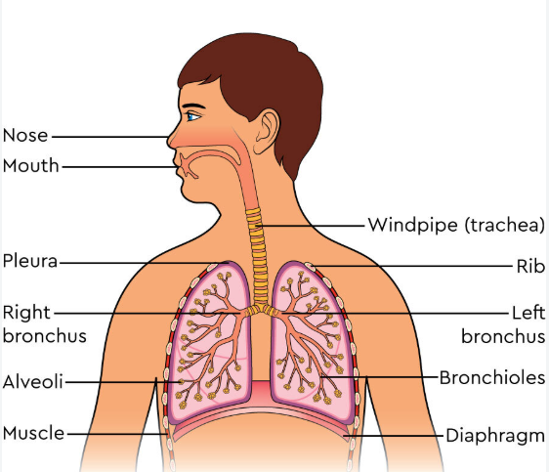
Figure 1: Respiratory System
Source: Macmillan Cancer Support
The respiratory zone consists of respiratory bronchioles, alveolar ducts and alveoli. Thin type I alveolar cells and adjacent capillary endothelium minimise the diffusion distance. Type II cells make surfactant, which decreases surface tension and helps keep alveoli stable. This end-product material is removed by alveolar macrophages. Thus, airways supply air and alveolar architecture allows exchange, and asthma can be understood only in terms of the airways (Betts et al., 2022; Hough et al., 2020).
The thorax increases in size during quiet inspiration by the contraction of the diaphragm and by the activity of the external intercostal muscles. Pleural coupling makes it possible for the lungs to expand, which decreases the pressure in the alveoli below atmospheric pressure and pulls air into the alveoli. Quiet expiration is the result of relaxation of muscles and elastic recoil, increasing alveolar pressure and allowing the air to flow out. Forced expiration involves the use of the abdominal and internal intercostal muscles. The pressure changes illustrate Boyle's inverse relationship between gas volume and pressure (Betts et al., 2022).
There is resistance to airflow, too. Airway patency is not the only factor to consider in effective respiratory maintenance because narrower airways will require a higher pressure difference to move the same amount of air through the airway. For asthma, this is the reason that a teenager can breathe more rapidly and not get enough ventilation, which is why breathing more deeply is not enough to solve the problem (Betts et al., 2022).

3. Gas exchange in the lungs
Oxygen diffuses across the alveolar–capillary membrane down its partial-pressure gradient. The alveolar P o 2 at rest is about 104 mmHg, which is higher than the P o 2 in incoming pulmonary capillary blood of 40 mmHg. Haemoglobin is the protein in plasma which mainly binds oxygen. The pressure of CO2 is the reverse: it is about 45 mmHg in the blood that enters the lungs, and 40 mmHg in the alveolar air. It is more soluble, making it possible to transfer efficiently even though the gradient is smaller (Betts et al., 2022).
In order to exchange, alveolar air must be brought in, and blood must be brought in. If the airways are obstructed, normal ventilation may be inadequate in some areas, even though adequate perfusion may occur, thus leading to poor oxygenation. This relates airway function to alveolar exchange but does not suggest that all symptoms of asthma are associated with hypoxaemia. The thinness and large surface area of the membrane will facilitate diffusion, but will not be sufficient to overcome poor air delivery (Betts et al., 2022).

4. Irritants and impaired respiration
Airway epithelial injury can be caused by smoke and other environmental irritants, which can trigger inflammatory signalling. In sensitive airways, inflammatory reactions cause oedema, mucus production and contraction of smooth muscle, which narrows the airway. The swelling that is relevant here is the swelling of the walls of the airways and not uniform swelling of all lung tissue. Repetitive epithelial damage and healing may result in the development of remodelling, such as smooth-muscle proliferation and extracellular-matrix alterations, and can lead to less reversible obstruction (Hough et al., 2020). These interacting changes can be differentiated from healthy patency in Figure 2.
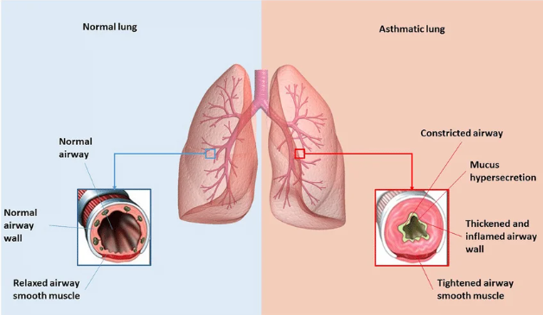
Figure 2: Healthy and narrowed airways
Source: Adapted from Shashtri et al. (2021)
There is another pathway to deterioration, through respiratory viruses. Epithelial defence is disrupted by viral infection, and it affects inflammatory pathways such as type 2 responses. Mechanistic insights, however, are different in other experimental systems and asthma phenotypes and therefore do not provide a uniform response in all adolescents (Kim, 2022). Here, where there are a lot of people around, one would want to discuss the actual smoking exposure, ventilation and infectious contacts and not assume that people who have been present have had an attack.
The same precision is needed for vaping evidence. Ten cross-sectional studies were included in a pooled analysis by Li et al. (2022) with 483,948 adolescents and found that e-cigarette use was associated with increased odds of asthma: OR 1.31 (95% CI 1.22–1.42). The associations reported are shown in Figure 3. Causal inference is restricted by cross-sectional sampling and by possible confounding and unknown timing of exposure. The discovery is related to an association with asthma, not a specific number of exacerbations in this clinic's patients. However, it also acknowledges that there is a need for precautionary exposure reduction in addition to the physiological concern of inhaled irritants.
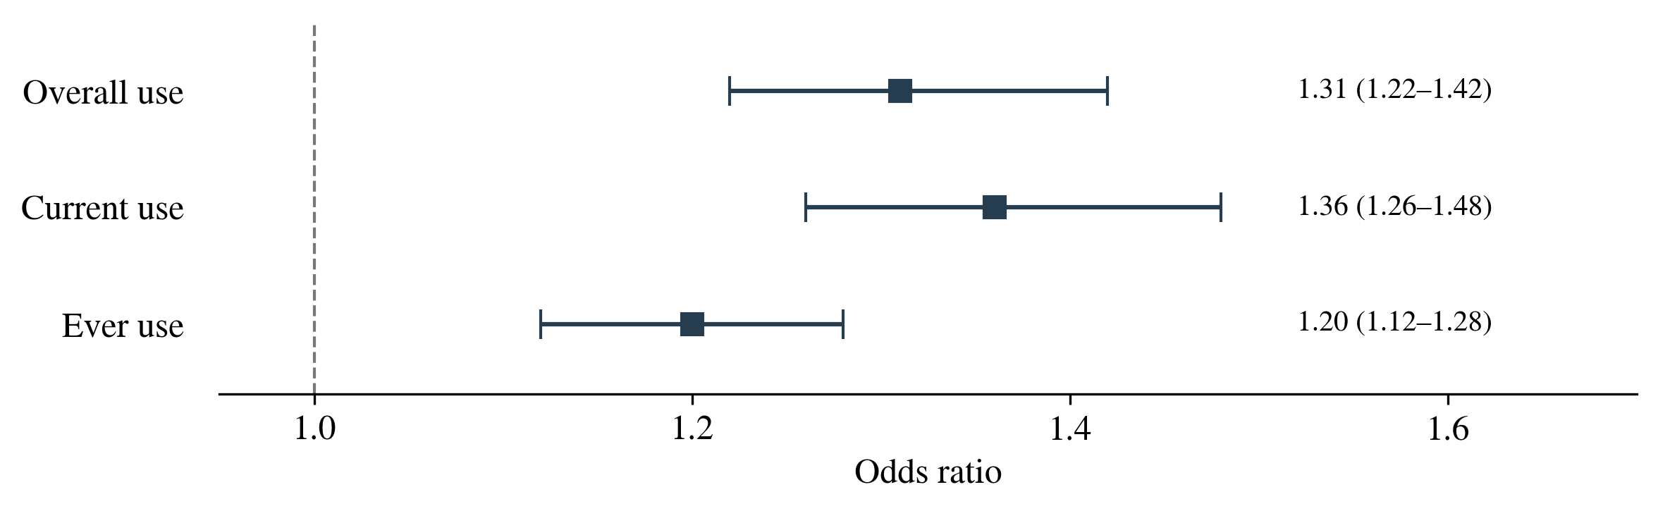
Figure 3: E-cigarette use and adolescent asthma
Reported odds ratios with 95% confidence intervals from Li et al. (2022)

5. Recording and interpreting respiratory data
Peak expiratory flow is the maximum flow on the strongest exhalation and is a readily available indicator of changing airway function. It is only of value if the technique is the same, the measurement conditions are the same, and the interpretation is made against a mutually agreed personal baseline. The nurse should perform the manoeuvre, watch the adolescent perform the manoeuvre, take readings and document symptoms, reliever use and suspected exposures. Rather than viewing a single observation as a diagnosis, repeated observations can support conversations about deterioration and treatment response (Papadopoulos et al., 2024).
Chen et al. (2024) noted a decrease in peak flow in 194 children that occurred about 1.34 days before the onset of exacerbation symptoms. This indicates potential early warning, especially when symptoms are not well perceived. The mean age was 9.51 years; however, selection depended on having consecutive electronic records, which is uncertain for adolescents who do not always record their ages. These observations cannot be used as a basis for automatic medication escalation without the patient's consent and clinical evaluation.
Peak flow is effort-dependent and may be normal in the presence of other abnormalities. The PeARL recommendations prioritise the use of spirometry for routine assessment of lung function, when available, and home peak-flow measurement should be used as a complement (Papadopoulos et al., 2024). The team should review trends and symptom control, inhaler technique and adherence to treatment at fortnightly reviews. If there are gaps in responses, discussion should focus on practical issues, not on intentional non-compliance. For instance, if the previous record for 500 L/min is 350, then that is 70% of the record. This is a representative calculation and not patient information or a standard threshold for treatment.
Records should be followed up with agreed action. Adolescents should be informed of changes that need to be reported to the practice and those for which help should be sought immediately, as they should not wait for a second reading if the symptoms are deteriorating. Personalised action plans link monitoring to safe action (Martin, Townshend & Brodlie, 2022). While digital reminders can help with adherence, there is a lack of heterogeneity and sustained follow-up to assume that the app is sufficient by itself for improving outcomes (Ramsey et al., 2020).
Data quality is also a factor. A fall on the record may be due to poor effort, inconsistent timing or some real obstruction, and omissions may mask a trend. Devoting time to reading the diary together, then, provides an opportunity to make sense of technique and context before making conclusions. Relative change is displayed in the numerical example; thresholds and responses must be tailored (Papadopoulos et al., 2024).

6. Evidence based lifestyle recommendations
The first step is to quit smoking and vaping and minimise exposure to second-hand smoke. Nicotine use/dependence, peer pressures, readiness to quit, and cessation support and follow-up should be determined during consultation. It is best to avoid blame and have an adolescent discussion in private, as they may minimise exposure and not want to be judged. Smoking and vaping, along with psychosocial factors, are noted as critical adolescent-care issues by Cheng et al. (2022). Recommendations should thus be tailored to the particular situations of individuals, not assume they can be changed by information.
The nurse and adolescent should discuss situations associated with symptoms and discuss practical alternatives for social activities, such as avoiding being in smoke-filled areas or limiting time spent with individuals who may be ill with respiratory illness. These measures are based on the pathways of exposure in the case, but not on any mechanisms of infection that quantify the benefits of any specific social restriction (Kim, 2022). It is important to keep supportive friendships and involvement, as this may negatively impact engagement if they are removed completely from social life.
Physical activity should be encouraged, not necessarily discouraged, in an individual plan. Jing et al. (2023) conducted a systematic review of nine trials with a total of 496 children aged between 6 and 18 years. There was evidence of improved exercise capacity and some lung-function measures, although the pooled difference in FEV1 was not significant: 3.17 percentage points (95% CI −2.82 to 9.15). Promising evidence that exercise reverses airway inflammation is limited due to diverse programmes and limited evidence. Activity recommendations should be based upon current control, preferences and an agreed-upon response to exercise-related symptoms.
Treatment should include anti-inflammatory drugs with lifestyle changes. The annual rates of severe exacerbations were 0.04 per year with as-needed budesonide–formoterol versus 0.17 per year with terbutaline in a post hoc analysis of adolescents in SYGMA 1 (Reddel et al., 2021). The relative reduction is about 76%, which shows how important it is to have relief from symptoms; however, the results from these trials of mild asthma do not prove that all adolescents require the same treatment. Treatment suitability should be reviewed by the prescriber, and technique and understanding by the nurse. Evidence-based decisions should be expressed as reasonable, attainable actions, and progress should be measured through symptoms and recorded function.
The adolescent should repeat the agreed actions at follow-up in his/her own words. This is a useful check to ensure that professional language has been translated to knowledge and to uncover misunderstandings before they become decision factors.

7. Conclusion
To ensure safe management of adolescent asthma, it is important to be familiar with the role of airway structure in ensuring adequate ventilation and with how airway obstruction reduces ventilation and gas exchange. Individual causal statements should not be made from observation, but smoking, vaping and respiratory infections should be discussed specifically. When combined with symptoms, technique and clinical assessment, peak-flow trends can aid in early identification. The fortnightly clinic should include individual action plans, reasonable reduction of exposure, and treatment and activity review with support. The effectiveness relies on the extent to which the information is used for timely, informed decision-making by the adolescent.

References
Betts, J.G., Young, K., Wise, J., Johnson, E., Poe, B., Kruse, D., Korol, O., Johnson, J., Womble, M. and DeSaix, P. (2022). Anatomy and physiology 2E. Open Touro Adopted. [online] Available at: https://touroscholar.touro.edu/oto/33/.
Chen, X., Han, P., Kong, Y. and Shen, K. (2024). The relationship between changes in peak expiratory flow and asthma exacerbations in asthmatic children. BMC pediatrics, [online] 24(1), p.284.
Cheng, Z.R., Tan, Y.H., Teoh, O.H. and Lee, J.H. (2022). Keeping pace with adolescent asthma: A practical approach to optimizing care. Pulmonary Therapy, 8(1).
García-Marcos, L., Innes Asher, M., Pearce, N., Ellwood, E., Bissell, K., Chiang, C.-Y., El Sony, A., Ellwood, P., Marks, G.B., Mortimer, K., Elena Martínez-Torres, A., Morales, E., Perez-Fernandez, V., Robertson, S., Rutter, C.E., Silverwood, R.J. and Strachan, D.P. (2022). The burden of asthma, hay fever and eczema in children in 25 countries: GAN phase i study. European Respiratory Journal, 60(3), p.2102866.
Hough, K.P., Curtiss, M.L., Blain, T.J., Liu, R.-M., Trevor, J., Deshane, J.S. and Thannickal, V.J. (2020). Airway remodeling in asthma. Frontiers in Medicine, [online] 7(7), p.191.
Jing, Z., Wang, X., Zhang, P., Huang, J., Jia, Y., Zhang, J., Wu, H. and Sun, X. (2023). Effects of physical activity on lung function and quality of life in asthmatic children: An updated systematic review and meta-analysis. Frontiers in Pediatrics, [online] 11.
Kim, S.R. (2022). Viral infection and airway epithelial immunity in asthma. International Journal of Molecular Sciences, 23(17), p.9914.
Li, X., Zhang, Y., Zhang, R., Chen, F., Shao, L. and Zhang, L. (2022). Association between e-cigarettes and asthma in adolescents: A systematic review and meta-analysis. American Journal of Preventive Medicine, 62(6), pp.953–960.
Martin, J., Townshend, J. and Brodlie, M. (2022). Diagnosis and management of asthma in children. BMJ Paediatrics Open, [online] 6(1), pp.1–12.
Papadopoulos, N.G., Custovic, A., Deschildre, A., Gern, J.E., Nieto Garcia, A., Miligkos, M., Phipatanakul, W., Wong, G., Xepapadaki, P., Agache, I., Arasi, S., Awad El-Sayed, Z., Bacharier, L.B., Bonini, M., Braido, F., Caimmi, D., Castro-Rodriguez, J.A., Chen, Z., Clausen, M., Craig, T., Diamant, Z., Ducharme, F.M., Ebisawa, M., Eigenmann, P., Feleszko, W., Fierro, V., Fiocchi, A., Garcia-Marcos, L., Goh, A., Gómez, R.M., Gotua, M., Hamelmann, E., Hedlin, G., Hossny, E.M., Ispayeva, Z., Jackson, D.J., Jartti, T., Jeseňák, M., Kalayci, O., Kaplan, A., Konradsen, J.R., Kuna, P., Lau, S., Le Souef, P., Lemanske, R.F., Levin, M., Makela, M.J., Mathioudakis, A.G., Mazulov, O., Morais-Almeida, M., Murray, C., Nagaraju, K., Novak, Z., Pawankar, R., Pijnenburg, M.W., Pite, H., Pitrez, P.M., Pohunek, P., Price, D., Priftanji, A., Ramiconi, V., Rivero Yeverino, D., Roberts, G., Sheikh, A., Shen, K.-L., Szepfalusi, Z., Tsiligianni, I., Turkalj, M., Turner, S., Umanets, T., Valiulis, A., Vijveberg, S., Wang, J.-Y., Winders, T., Yon, D.K., Yusuf, O.M., Zar, H.J. and WAO Pediatric Asthma Committee (2024). Recommendations for asthma monitoring in children: A PeARL document endorsed by APAPARI, EAACI, INTERASMA, REG, and WAO. Pediatric allergy and immunology : official publication of the European Society of Pediatric Allergy and Immunology, [online] 35(4), p.e14129.
Ramsey, R.R., Plevinsky, J.M., Kollin, S.R., Gibler, R.C., Guilbert, T.W. and Hommel, K.A. (2020). Systematic review of digital interventions for pediatric asthma management. The Journal of Allergy and Clinical Immunology: In Practice, [online] 8(4).
Reddel, H.K., O’Byrne, P.M., FitzGerald, J.M., Barnes, P.J., Zheng, J., Ivanov, S., Lamarca, R., Puu, M., Alagappan, V.K.T. and Bateman, E.D. (2021). Efficacy and safety of AS-needed budesonide-formoterol in adolescents with mild asthma. The Journal of Allergy and Clinical Immunology: In Practice, 9(8), pp.3069–3077.e6.

