Data Warehousing

Module: Data Warehousing And Data Mining

Module Code: ACCA6026
By: Amy Harrison
Student number: 2133368

Contents
Task 1: Introduction to Data Warehousing 1
1.1 OLTP vs Data Warehouse 2
1.2 Data Warehouse Architecture & Source Systems 2
1.3 Data Marts for Departmental Needs 4
1.4 Normalised vs Dimensional Structures (Star Schema) 5
Task 2: Designing the Data Warehouse 6
2.1 Identification of Internal and External Source Systems 6
Identification of Internal and External Source Systems 6
2.2 Star Schema Design 7
2.3 Data Marts and Extraction Schema 8
2.4 Simplified ETL Plan 8
2.5 Data Quality and Information Governance 9

Task 1: Introduction to Data Warehousing

1.1 OLTP vs Data Warehouse
Rags’n’Riches currently operates an Online Transaction Processing (OLTP) system, which records daily operations such as stock movements, customer orders, deliveries, and invoices. OLTP systems are designed to handle high volumes of real-time transactions, ensuring accuracy and integrity through a normalised database structure that avoids duplication and maintains consistency. This design is particularly effective for operational activities such as updating stock levels, recording returns, or processing client payments quickly and reliably [1][10].
However, OLTP systems are not intended for strategic or long-term analysis. For example, they can confirm that a particular theatre group hired 30 costumes in October, but they cannot easily identify which costume types are most profitable, which warehouses experience seasonal peaks, or which clients generate the highest revenue. Extracting that kind of insight from an OLTP system would be complex, time-consuming, and risk slowing down daily operations.
A data warehouse complements the OLTP environment by consolidating and storing historical data from multiple sources for reporting, forecasting, and decision-making. Unlike OLTP systems, which focus on recording current transactions, a data warehouse is optimised for complex analytical queries and trend analysis [1][5][6]. This enables management to review performance over time, measure profitability by warehouse, and plan future acquisitions with evidence-based confidence.
In summary, while OLTP supports daily business operations, a data warehouse supports strategic insight and long-term growth through:
• Fast, multidimensional reporting.
• Historical trend tracking.
• Reduced load on operational systems.
• Accurate, consolidated data for informed decisions.
A data warehouse would allow Rags’n’Riches to track performance across all locations and time.
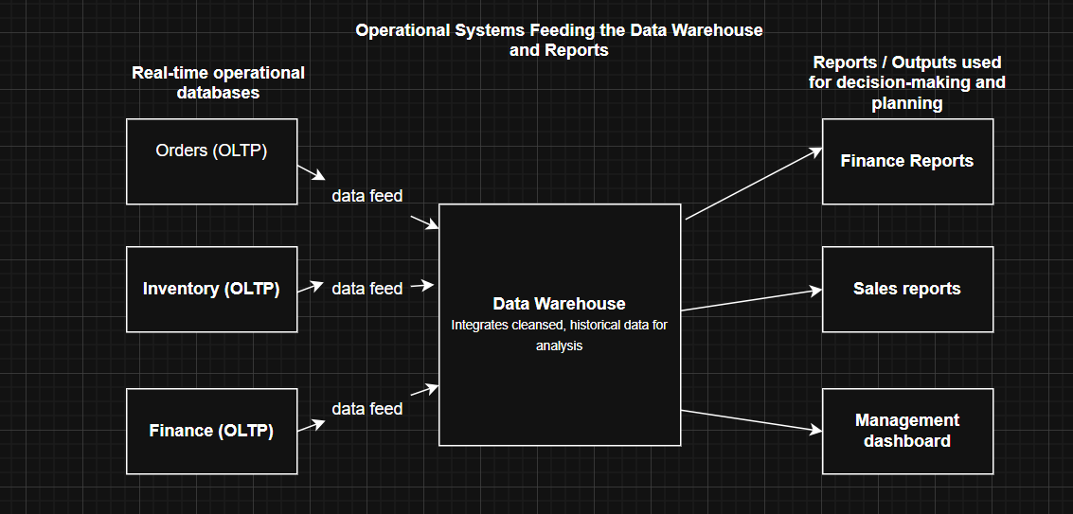
Figure 1: Operational Systems Feeding the Data Warehouse and Reports. This diagram illustrates how Rags’n’Riches’ existing OLTP systems, such as Orders, Inventory, and Finance, feed data into a central Data Warehouse, which then supports Finance Reports, Sales Reports, and Management Dashboards.

1.2 Data Warehouse Architecture & Source Systems
A data warehouse architecture defines how information from multiple systems is collected, cleaned, and combined into one integrated repository to support business reporting and analysis. In practice, it shows the journey of data — from the point it is created in operational systems to the point it becomes meaningful insight for decision-makers.
For Rags’n’Riches, the architecture would consist of four main components: data sources, the ETL process, the data warehouse layer, and the presentation layer [4][5]. Each element performs a distinct role in ensuring information is accurate, consistent, and reliable across all six warehouse locations.
1. Data Sources:
The company generates data from numerous operational areas, all of which feed into the warehouse.
- Internal sources include the orders database (rental records, client details), transport logs (delivery and collection schedules, driver mileage), inventory system (item conditions, warehouse location), finance system (invoices, surcharges, payments), and acquisitions records (new items or write-offs).
- External sources may include government film tax incentives, industry rental benchmarks, and supplier price lists. These allow Rags’n’Riches to compare internal performance with market standards [5][6].
2. ETL (Extract, Transform, Load) Process:
The ETL process is the backbone of the data warehouse.
- Extract pulls data from the various source systems on a scheduled basis, often nightly.
- Transform cleans, validates, and standardises the data — for example, converting all financial values to pounds sterling, aligning date formats, and ensuring warehouse codes match across systems.
- Load inserts the processed data into the warehouse in a structured, historical format, ensuring the company’s live OLTP systems remain unaffected [5].
- 3. Data Warehouse Layer:
This is the central storage area where the cleansed data resides. It keeps historical and summarised data to enable detailed trend analysis — for instance, identifying the most profitable costume types, busiest rental periods, or warehouse efficiency by month. The warehouse also supports complex, multi-year comparisons and allows managers to evaluate performance across all six sites, helping them to plan resource allocation and future acquisitions more effectively.
- 4. Presentation Layer:
This layer delivers information through dashboards and departmental data marts, offering clear, tailored insights to the finance, sales, and operations teams [3][4].
Overall, this layered approach provides a clean separation between operational and analytical systems, ensuring that day-to-day business continues without interruption while management can make confident, evidence-based decisions [6].

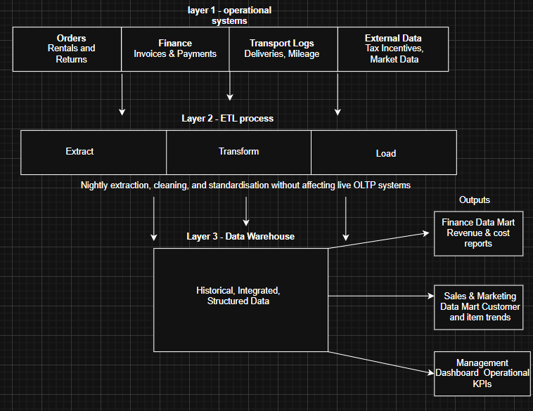
Figure 2: Rags’n’Riches Data Warehouse Architecture. This figure shows how internal and external source systems feed data through the ETL process into the central Data Warehouse. The warehouse then supplies structured, historical data to departmental outputs including Finance, Sales & Marketing, and Management Dashboards.

1.3 Data Marts for Departmental Needs
Data Marts
Data marts are specialised parts of the main Data Warehouse, each designed to meet the unique needs of a specific department [3][6]. Instead of managers having to search through the entire warehouse, they can access only the information relevant to their roles. This targeted approach improves performance, speeds up reporting, and ensures greater data security, since access can be limited to approved users within each team.
For a company like Rags’n’Riches, which operates across multiple warehouses and departments, data marts are especially valuable. They allow each department to make decisions confidently using accurate, up-to-date information drawn from the same single source of truth. This means the finance team can analyse profitability while the sales team studies customer trends — without overlap or confusion.
• Finance Director:
The Finance Data Mart would provide a detailed view of revenues, costs, and overall profits. It would draw data from rental transactions, transport logs, warehouse expenses, and write-offs to calculate accurate profit margins. Reports could include monthly profit by warehouse, cost of damages, and average delivery costs per client. By identifying which sites or product types are most profitable, the Finance Director can make informed budgeting and investment decisions [3].
• Sales & Marketing Director:
This data mart focuses on customer behaviour and rental trends. It would track which costumes or props are most in demand, highlight seasonal patterns, and pinpoint top clients based on rental frequency or value. The Sales & Marketing Director could also assess how discounts or urgent delivery surcharges influence total sales. These insights would guide decisions on marketing campaigns, pricing, and inventory management [2][3].
• Managing Director:
The Managing Director’s Data Mart provides a broader, company-wide view. It integrates data from all departments to monitor warehouse utilisation, operational performance, and stock availability. With this information, leadership can make strategic decisions on expansions, acquisitions, or cost-saving measures [2][6].
Key advantages of using data marts include:
• Faster access to department-specific insights.
• Improved data security through role-based access.
• Reduced reporting complexity and duplication.
• Clearer, data-driven support for strategic planning and forecasting.
By introducing well-structured data marts, Rags’n’Riches can ensure that every department works efficiently with the information most relevant to them. This focused access not only saves time but also empowers each director to make confident, evidence-based decisions that drive the company’s overall success.

1.4 Normalised vs Dimensional Structures (Star Schema)
OLTP databases use normalised structures, meaning data is split across multiple related tables to minimise redundancy and maintain accuracy. Each table focuses on a single topic, such as customers, orders, or inventory, and links to others through keys. This design is ideal for daily operations — for example, processing a new rental or updating stock levels — because it ensures that every change happens quickly and accurately. However, it becomes inefficient for analysis, since data must be pulled together from many tables to form a complete picture. Running complex analytical queries, like comparing profits across all warehouses, can slow down the system and disrupt day-to-day work.
By contrast, a data warehouse uses a dimensional model, such as the star schema, which flattens and organises data specifically for fast reporting and trend analysis [2][3][4]. In a star schema, a single Fact Table sits at the centre, surrounded by several Dimension Tables. This structure makes it easy to summarise and analyse large volumes of information without affecting the operational database.
For Rags’n’Riches, this model would look like:
Fact Table: Rental Transactions — stores measurable data such as rental income, delivery cost, days rented, and profit.
Dimension Tables:
- Item: (Item_ID, Type, Cost, Warehouse) — describes each costume or prop.
- Customer: (Customer_ID, Name, Type) — distinguishes between theatres, film studios, and private clients.
- Warehouse: (Warehouse_ID, Location, Specialisation) — identifies where items are stored or dispatched.
- Date: (Date_ID, Month, Year) — provides a consistent timeline for tracking rentals and returns.
This structure allows the company to analyse sales patterns, customer preferences, and warehouse performance in seconds, supporting confident, data-driven decisions.

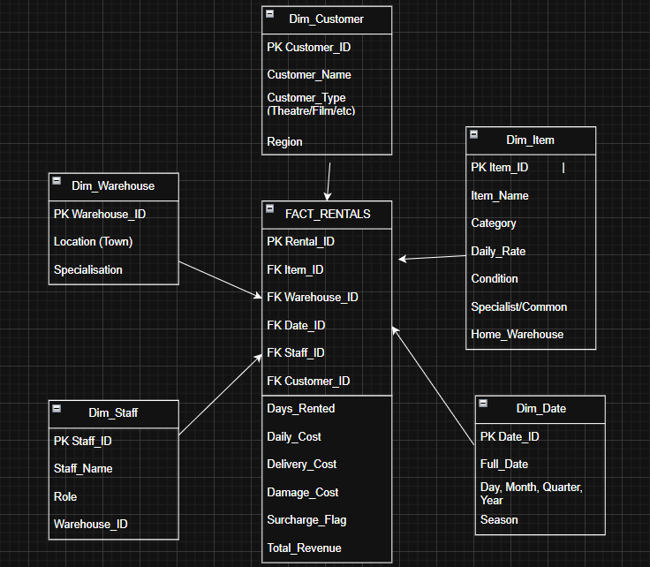
Figure 3: Rags’n’Riches Star Schema (Simplified). The central FACT_RENTALS table stores measures (days, costs, revenue) and links via foreign keys to descriptive Dimension tables (Customer, Item, Warehouse, Date, optional Staff) to enable fast, multi-dimensional analysis [2][3][4]

Task 2: Designing the Data Warehouse
2.1 Identification of Internal and External Source Systems

Identification of Internal and External Source Systems
Rags’n’Riches’ data warehouse will integrate information from a range of internal and external systems to create a single, reliable source for decision-making. This ensures every department—finance, sales, logistics, and management—can access accurate, consistent data rather than working in isolation.
Internal sources include:
- Orders database: Records every rental transaction, including client details, hire dates, and total costs.
- Inventory system: Tracks each item’s location, condition, and whether it’s core or specialist stock.
- Finance system: Stores data on invoices, surcharges, payments, and overall revenue.
- Transport logs: Capture delivery and return data, including distance, vehicle type, and fuel use.
- Acquisitions and write-off records: Record new purchases, damages, and stock disposals.
External sources include:
- Government film tax incentive data.
- Film industry rental benchmarks.
- Fuel and transport cost indexes [5][6].

2.2 Star Schema Design
The star schema forms the foundation of Rags’n’Riches’ new data warehouse, providing a clear and efficient way to store and analyse business information [2][3][4]. Unlike the highly normalised structure of the company’s existing OLTP systems, the star schema is designed for speed and simplicity. It allows management to view key business measures—such as rental income, delivery costs, and profitability—instantly, without slowing down operational systems. The model is easy to understand for non-technical users, making it ideal for managers across departments.
At the centre of the design sits the Fact Table, which stores measurable and numeric data. It is surrounded by several Dimension Tables that describe the context of each transaction, such as the customer, warehouse, item, or date. Each dimension connects to the fact table through a foreign key, forming the star shape. This layout allows complex analytical queries to be completed quickly, as data can be filtered and grouped by any dimension, such as warehouse, time period, or customer type.
Fact Table – Rental Facts:
The Fact_Rentals table records all quantifiable measures relating to the rental process.
- Rental_ID: Primary key identifying each rental transaction.
- Item_ID, Customer_ID, Warehouse_ID, Date_ID: Foreign keys linking to their respective dimension tables.
- Days_Rented, Daily_Cost, Delivery_Cost, Surcharge_Flag, Total_Revenue: Key metrics for financial and operational analysis.
This table will be the main source for performance reporting, enabling the company to analyse profitability by item type, customer, or location.
Dimension Tables:
The dimension tables provide descriptive detail that gives context to the figures in the fact table.
- Item Dimension:
(Item_ID, Name, Type, Specialist/Common, Home_Warehouse, Acquisition_Date, Replacement_Cost)
Holds information about each costume or prop, including whether it is a common-core or specialist item. This allows managers to identify which categories are most profitable or in high demand.
- Customer Dimension:
(Customer_ID, Name, Type (Theatre/Film), Location)
Stores customer details to allow reporting on rental frequency, customer type, and location-based trends.
- Warehouse Dimension:
(Warehouse_ID, Location, Specialisation)
Describes warehouse characteristics, enabling comparisons of performance across sites.
- Date Dimension:
(Date_ID, Day, Month, Year, Quarter)
Provides time-based structure for trend and seasonality analysis, such as busiest rental months or quarterly profits.
- Transport Dimension (optional):
(Driver_ID, Vehicle_Type, Distance, Fuel_Cost)
Allows tracking of delivery efficiency and cost control. Including this dimension helps measure logistical performance, supporting the company’s goal to reduce transport expenses.
Aggregated Tables:
The warehouse will include summary (aggregate) tables to speed up reporting on common queries such as:
- Monthly Revenue per Warehouse
- Most Popular Item Types
- Total Surcharges by Period
These pre-calculated summaries improve performance and allow managers to view high-level insights instantly.
Metadata Table:
To ensure proper data governance and IT transparency, a Metadata Table will document all data definitions, table relationships, data lineage, and refresh frequency [7][8]. This ensures that the warehouse can be maintained efficiently, with clear accountability and consistent updates.
Overall, this star schema design provides Rags’n’Riches with a scalable, easy-to-navigate structure for accurate reporting and strategic decision-making across all departments.
2.3 Data Marts and Extraction Schema
Identification of Data Marts
To provide tailored insights for each department, the following data marts are proposed [3][6]. Data marts extract focused subsets of information from the main warehouse, ensuring each team can access relevant data quickly and securely. This structure reduces the workload on the central warehouse while improving reporting efficiency and decision-making accuracy.
1. Finance Data Mart
Focus: Profitability, revenue trends, and delivery costs.
Tables: Rental Facts, Item Dimension, Warehouse Dimension, Date Dimension.
The Finance Data Mart allows managers to track financial performance across all warehouses. Reports include monthly profits, damaged item costs, and delivery expense summaries. By combining operational and financial data, this mart supports budget forecasting and profit margin analysis, helping the finance team make informed cost-control decisions.
2. Sales & Marketing Data Mart
Focus: Customer rentals, item popularity, and discount effectiveness.
Tables: Rental Facts, Customer Dimension, Item Dimension, Date Dimension.
This mart provides insight into customer behaviour, helping the sales team identify top clients, seasonal rental patterns, and the impact of discounts or promotions on total sales. It also supports forecasting demand to improve stock availability and marketing timing.
3. Management and Operations Data Mart
Focus: Warehouse efficiency and transport performance.
Tables: Rental Facts, Warehouse Dimension, Transport Dimension, Date Dimension.
This mart provides operational insight into warehouse utilisation, delivery performance, and turnaround times, helping management monitor efficiency and plan for growth.
Together, these marts turn the data warehouse into a flexible business tool, supporting both day-to-day decisions and long-term strategy.

2.4 Simplified ETL Plan
  - Simplified ETL Plan
The ETL process (Extract, Transform, Load) ensures that only accurate, consistent, and high-quality data enters the Rags’n’Riches data warehouse [5][9].
Extract: Data is pulled automatically from internal systems, such as orders, inventory, and finance, every night. External data, such as industry benchmarks and transport costs, is extracted weekly to avoid disruption to operational systems.
Transform: During this stage, the data is cleansed to remove duplicates, standardised into consistent formats (e.g., dates, currencies, warehouse codes), and business rules are applied—such as calculating surcharges and total revenues.
Load: The transformed data is then loaded into the fact and dimension tables. Aggregated data, such as monthly profit summaries, is refreshed on a monthly schedule to maintain reporting accuracy.

2.5 Data Quality and Information Governance
  - Data Quality and Information Governance
Rags’n’Riches must maintain strict data quality standards to ensure the reliability of its warehouse. This includes accuracy (validated rental and cost data), consistency (uniform naming and coding), and completeness (no missing rentals or returns). Security should be upheld through department-based access controls, and auditability achieved via logged ETL activities. All data governance policies must be documented, regularly reviewed, and monitored to maintain compliance and integrity [7][8][9].

References
References
[1] Amazon Web Services. “The difference between OLAP and OLTP.”
Available at: https://aws.amazon.com/compare/the-difference-between-olap-and-oltp/ (Accessed: 28 October 2025).
[2] Kimball Group / Holistics. “Kimball’s Dimensional Data Modeling – Guidebook.”
Available at: https://www.holistics.io/books/setup-analytics/kimball-s-dimensional-data-modeling/ (Accessed: 29 October 2025).
[3] Databricks. “What is a Star Schema?”
Available at: https://www.databricks.com/glossary/star-schema (Accessed: 29 October 2025).
[4] Redgate. “OLAP, OLTP, ETL and More: What You Need to Know.”
Available at: https://www.red-gate.com/blog/what-is-data-warehousing (Accessed: 30 October 2025).
[5] IBM. “What is ETL (Extract, Transform, Load)?”
Available at: https://www.ibm.com/topics/etl (Accessed: 30 October 2025).
[6] Stitch Data. “OLTP vs OLAP: Understanding the Differences and Use Cases.”
Available at: https://www.stitchdata.com/resources/oltp-vs-olap/ (Accessed: 31 October 2025).
[7] DataGalaxy. “Implementing Data Governance in a Warehouse: 3 Top Tips.”
Available at: https://www.datagalaxy.com/en/blog/implementing-data-governance-warehouse/ (Accessed: 1 November 2025).
[8] LakeFS. “Data Quality vs Data Governance: How Are They Different?”
Available at: https://lakefs.io/data-quality/data-quality-vs-data-governance/ (Accessed: 2 November 2025).
[9] Collibra. “Why You Need Data Quality and Observability for Your Data Warehouse or Lake.”
Available at: https://www.collibra.com/blog/why-you-need-data-quality-and-observability-for-your-data-warehouse-or-lake (Accessed: 3 November 2025).
[10] Oracle. “What is Online Transaction Processing (OLTP)?”
Available at: https://www.oracle.com/database/what-is-oltp/ (Accessed: 4 November 2025).

