Strategy in The Hospitality Industry: A Case Study on J.D. Wetherspoon
By Laura Jayne Phillips
(P147995)


Dissertation submitted as part of requirements for the award BA (Hons) Business Management

DECLARATION

This work has not previously been accepted in substance for any degree and is not being concurrently submitted in candidature for any degree

Signed……………………………………………

Date………………………………………………

STATEMENT 1

This dissertation is being submitted in partial fulfilment of the requirements for the degree of BA.

Signed…………………………………………….

Date………………………………………………

STATEMENT 2

This dissertation is the result of my own independent work/investigation, except where otherwise stated.

Other sources are acknowledged by footnotes giving explicit references. A bibliography is appended.

Signed……………………………………………

Date………………………………………………

STATEMENT 3

I hereby give consent for my dissertation, if accepted, to be available for photocopying and for interlibrary loan, and for the title and summary to be made available to outside organizations.

Signed………………………………………………

Date…………………………………………………

STATEMENT 4

I hereby give consent for my dissertation, if accepted, to be available on the university’s IT system to those who have consent to use the system.

Signed………………………………………………

Date…………………………………………………

Table of Contents
Table of Figures 6
Acknowledgements 7
Abstract 8
Chapter 1: Introduction 9
1.1 Introduction 9
1.2 Aims and Objectives 9
1.2.2 Research Objectives 9
1.3 Background of Strategy 9
1.4 Background of Wetherspoons 9-10
1.5 Rationale 11-12
1.5 Value of Research 11
1.6 Importance of Research 11
2.0 Chapter 2: Literature Review 12
2.1 Introduction 12
2.2 Definitions of Strategy 12-14
2.2.1 Business Level Strategy 14
2.2.2 Corporate Level Strategy 14
2.2.3 Network Level Strategy 14
2.3 Strategy in the Hospitality Industry 14-16
2.4 The development and evolution of strategies 16-17
2.5 How strategy benefits the Hospitality Industry 17-18
2.6 Wetherspoons 18-19
2.7 Conclusion 19
Chapter 3: Methodology 20
3.0 Introduction 20
3.1 Research Philosophy 20
3.2 The Research Onion 21
3.3 Methods to Collect Data 22
3.3.1 Cross-Sectional Data 22
3.3.2 Deductive Approach 22
3.4 The Research Strategy 22
3.4.1 Primary Data 23
3.4.2 Quantitative Research 23
3.5 The Sample 23-24
3.6 Reliability and Validity 24-25
3.6.1 Reliability 25
3.6.2 Validity 25
3.7 Ethics 25
3.8Strategy and Ethics 25
3.9 Limitations of Research 25
Chapter Four – Data Analysis 26
4.1 Introduction 26
4.2 Generic Questions 26-27
4.3 Occupations 28
4.4 Hospitality organizations and the use of strategies 28-29
4.5 Strategy in an Organization 30-31
4.6 Cost Strategy 31-32
4.7 Corporate business level 33-34
4.8 Strategy Gains more Customers 35-36
4.9 Manager or Teams Decision 36-37
4.10 Differentiation of Wetherspoons Results 37-38
5.0 Chapter 5 – Conclusions and Recommendations 39
5.1 Conclusion 39-40
5.2 Recommendations 41
5.2.1 Recommendations towards a cost-based strategy 41
5.2.2 Recommendations for the use of a Differentiation Strategy 41
5.2.3 Recommendation for including staff members in strategic decisions. 41-42
6.0 Bibliography 43-48
7.0 Appendices 49
7.1 Appendix 1: Image of drinks prices for Wetherspoons in different areas of the UK 49
7.2 Appendix 2: Layout of Questionnaire 50-52
7.3 Appendix 3 – Ethics Form 53-61

Blank Page

Table of Figures

Figure 1 The Research Onion 20
Figure 2 Age category 25
Figure 9 Pie chart show Cost strategy question results 31
Figure 10 Table to show Corporate Business results 32
Figure 11 Pie chart on corporate strategy results 33
Figure 12 Table on 'Does having a strategy gain more customers?’ 34
Figure 13 Pie chart to show does having a strategy make a company gain more customers? 34
Figure 14 Table to show 'Should Strategy be a managers or team decision?' 35
Figure 15 Pie Chart to show should strategy be a managers or teams decision? 35
Figure 16 Table of results from results of Differentiation in Wetherspoons 36
Figure 17 Pie chart of results of Differentiation 37

Acknowledgements

I would like to thank my family and friends for supporting and helping me get through my studies.

I would also like to thank my dissertation supervisor Ian Jackson and Caroline Jawad, the dissertation coordinator and lecturer. Ian and Caroline have both been very helpful this year. Both have been very approachable and supportive of my studies. I would have not been able to have completed this process without the help and encouragement from either of them.
I would also like to say thank you to everyone who took part in answering the online questionnaire, without those participants I would have not be able to have analyzed the results.

Abstract

The aim of this research is to find out how strategy is applied in the hospitality industry with the use of Wetherspoons as a main case study which in chapter 5 will show the recommendations of the outcome to Wetherspoons. This will include elements of research from both primary and secondary fields. The primary research gathered is about strategy, with elements of strategy in the hospitality industry and the evolutions of strategies. The secondary data gathered was based on research of participants thoughts on strategy being implemented into Wetherspoons and what should Wetherspoons should focus on as an organization.
The main source of the literature review has focused on authors such as Porter (1980) who built theory on the generic strategies. Barney and Hesterly (2006) focused on how having a strategy can build competitive advantage for a business. Other authors which have been included are (Wit and Meyer 2004) which have focused on different levels of strategy in an industry. Stacey (2000) was also a focus who wrote about the different structures a strategy can have. (Mullins 1998) also presented theory on how strategy benefits the hospitality industry. Include is also some authors who have correspondingly mentioned Wetherspoons in sections of their books about how the business strategizes and what the business has to offer.
Research carried out will be based on an interpretive approach as, participants answering the questionnaire will be a cluster sample of participants who use the internet, the questionnaire was shared on social media and participants were able to fill it out online. The researcher wanted to gain Quantitative data on the research and find out whether strategic approaches can be adopted in hospitality industries like Wetherspoons which is one of the researcher’s main objectives. The researcher has set the methodology out with the support of the research onion created by (Saunders et al) to support how the research will be carried out.
The analysis of results will be presented through tables and the use of pie charts will show clear results of participants’ answers. Chapter 4 will be questions which are based on the findings gathered from the literature review. The researcher analyzed the findings gathered and compared them to theories produced in the literature review. The questions asked to participants were questions based on strategy and how Wetherspoons as a business can benefit from strategy.
The conclusions and recommendations support the findings that have been gathered on a whole from chapter 4 to support whether the outcome was the correct outcome from what the researcher was trying to achieve from developing this research. The recommendations will suggest what the business can do to either change or maintain the findings that been gathered.

Chapter 1: Introduction

1.1 Introduction
The aim of this dissertation is to evaluate how strategy in the hospitality industry is implemented. Using a large and successful hospitality industry, that will be used as a case study as part of the research process. The chosen industry that will be used as a case study is J.D Wetherspoons. The reason for choosing Wetherspoons is because it is a very successful and popular pub chain, therefore the researcher would like to find out how Wetherspoons strategizes as a business and if consumers are aware of the strategy Wetherspoons uses to draw customer in.

1.2 Aims and Objectives
The purpose of the research is to be able to identify strategies within the hospitality industry, using Wetherspoons as a main case study approach. The main aim of this study is to evaluate the effectiveness of a cost-based strategy within the hospitality industry, using Wetherspoons as a case study.

1.2.2 Research Objectives
To achieve the aim that has been set, the main of this study are
- To assess whether Wetherspoons does implement strategy into its business.
- To identify and asses the strategic approaches adopted within the hospitality industry.
- To make recommendations to Wetherspoons on the adoption of suitable strategic approach.

1.3 Background of Strategy
‘Strategy is not about being the best, but about being unique. Competing to be the best businesses one of the major misconceptions about strategy.’ (Flander 2018) Organizations will possess certain traits to make themselves stand out from the crowd, to gain customers. In principle managers make a strategic decision every time they do something that has long term consequences for the organization. (Waters & Waters 2006, P.9). ‘A good strategy provides a clear road map, consisting of a set of guiding principles of rules, that defines the actions people in the business should take (and not take) and the things they should prioritize (and not to prioritize) to achieve desired goals’ (Watkins 2007)

1.4 Background of Wetherspoons
‘J.D Wetherspoon is Britain’s best-known pub chain. The company, known to almost all as Wetherspoons, operates 900 pubs and employs more than 37,000 people. It has an annual turnover more than £1.6bn. It is responsible for a thousandth of all tax paid in the UK. There are more than 50 Wetherspoons hotels. The company has pubs at eight major airports in England and Scotland, with three outlets at both Gatwick and Heathrow’ (Wilding 2018). The first pub opened in Colney Hatch Lane, Muswell Hill, North London, on 9th December 1979. It was Called Martin’s Free House for the first month, but then changed to Wetherspoons (Perry 2016).
Articles have praised positive outcomes about the company ‘As it nears its 40th birthday, the chain has nearly 1,000 branches, at a time when pubs around the country are closing at a rate of 30 a week – the same time it takes Wetherspoons to sell three million pints. In a week it will serve more than half a million breakfasts, and a million cups of coffee’ (Cumming 2017)
Findings have been reported about the business from Hospitality industry bloggers ‘Wetherspoons policy of restoring ageing building sets it apart from other pub chains. “Wetherspoons can’t be looked on in the same way as O’Neil’s, or a Walkabout, pub; many of them are distinct and individual, often restoring fantastic buildings into thriving businesses”. (Belfast Telegraph 2015)
All business’ who are in the hospitality segment like Wetherspoons have a strategy. This internally consistent set of goals and policies align the firm’s strengths and weaknesses with external (Industry) opportunities and threats. The firm’s strategy must be centrally concerned with the creation and exploitation of its so-called ‘distinctive competencies’ (Smit 2000. P.2003). This is what a clear representation of what strategy is used for in firms like JD Wetherspoons. Businesses are competitive so like all businesses Wetherspoons is a competitor for many. Porter views strategy as ‘building defenses against the competitive forces or as finding positions in the industry’ (Porter 2008)

1.5 Rationale
The findings below state why the researcher wants to expand of further research on the chosen topic.
Strategy has been examined itself and how it is exercised within an organization from managers, In rationalist analysis we include behaviorist and economist approaches in which the object of study is represented as something examinable independently of the social process and practices through which ‘strategy’ and its ‘management’ are accomplished by organizational actors (Baum & Lampel 2010, P.79) Strategy is a big part for any industry as managers will feedback to staff how they can make the business better compared to its competitors. An important theorist who will be discussed in chapter 2 is Michael E. Porter, ‘Porter claims that not all business decisions are strategic. Decisions can only be defined as strategic if they involve doing something ‘differently’ from competitors and if that difference results in a sustainable advantage. To be sustainable it must be difficult to imitate.’ (Mazzucato 2002, P.8) There are different views on finding out how strategy can be implemented in a business whether it is needed or not.
After looking into the elements of strategy and how it is exercised. Olsen and Zhao (2008) did an overview of competitiveness in the hospitality industry and investigated ‘The development of international hotel chains in Europe’ they focused on the economic structure and growth rates of hotels in Europe and how each business strategized and how each work force was differentiated.
Research has been carried out how to strategize in the hotel industry, which falls into the category of hospitality. Findings showed that hotels needed to have a ‘Search friendly Content Strategy’ which means ‘If your hotel website is not optimized, your content won’t amount to much. The need of hour is the adoption of right SEO practices, the content on the website should be keyword optimized, informative and engaging. This is a great way to provide travelers the information they need the most such as local sightseeing places, art and cuisine while also improving organic search results. Hotel Owners who have adopted SEO optimization can see it yielding good conversions’ (Prakash 2017). The researcher wants to investigate how Wetherspoons which also falls under the hospitality industry sector, applies strategy to its business. The researcher wants to know what the focus should be for them and if whether certain strategies applied to that business makes the company stand out from other large competitors. Competitive advantage is key to any business, as all industries have competitors in which ever segmentation they fall under. An article investigated how competitive advantage is exemplified in the hospitality industry showed ‘An important feature of knowledge-based organization which draws the attention of managers in the surveyed hotels is broad-based collaboration with the client, which provides knowledge of them and their needs, while also fostering faster and more efficient work’ (Gierczak 2014 p.182). The use of competitive advantage in hospitality industries is to know what customers are looking for, and to make them want to come to your company instead of other competitors who fall in that segment.

1.5 Value of Research
The value of the research will identify whether consumers are aware of strategy. The researcher wants to gain quantitative statistics on whether consumers do feel strongly about how hospitality industries like Wetherspoons are strategized, and if no strategic approach is being exercised, how or what can Wetherspoons do to strategize more to gain competitive advantage. All research is produced with an audience in mind and that audience will form a judgement about the merits and limitations of the work. (O’Gorman and Macintosh 2015, P.8). The researcher wants to find out from participants does Wetherspoons stand out from the crowd and what strategic approaches should be a focus in a hospitality industry. (Saunders et al 2003, P.5) states ‘results in universal principles relating to the process and its relationship to outcomes’ and ‘findings of significance and value to society in general’. The researcher wants to know if strategic approaches are applied in hospitality environments. Do corporate businesses like Wetherspoons need to focus on strategy to gain a competitive advantage in the hospitality segment.

1.6 Importance of Research
The research that will be carried out will be to, represent the different strategic approaches that can be exemplified in a hospitality industry and to find out how industries such as Wetherspoons do apply any strategic approaches to gain competitive advantage and customer value, and whether participants who take part in the research, do feel that certain strategic approaches should be applied in hospitality segments. Most research is usually based on how organizations on a whole strategize but why do pub chain like Wetherspoons gain the attention of many? The researcher will carry out primary research, to identify whether participants feel strategy on a whole is a useful source in a hospitality industry.

2.0 Chapter 2: Literature Review

2.1 Introduction
The purpose of this section is to critically analyze previous authors who have focused on the area of corporate strategy needs. The aim of a literature review is to compare any similarities within the findings which have been gathered whether the information be positive or negative and to highlight any main key themes that are linked to the topic of discussion within the dissertation. This information has been gathered from chapters of books which contain elements of strategy.
The hospitality industry discussions throughout the literature review will be based on strategy, strategy within the hospitality industry and a focus on Wetherspoons which will be the case study that will be focused on throughout the dissertation.

2.2 Definitions of Strategy
Porter will be a major influence on this literature review as he has researched books based on strategy the main importance of generic strategies this was cited by Kassowski (2007). Porter also argued ‘A good strategy, one that will result in superior performance, is something else’ this was cited by (Magretta 2012, p.93). Porter proposed ‘that a firm’s competitive advantage in an industry is determined by its competitive scope –that is, the breadth of the company’s or business unit’s target market’ cited from (Wheelen et al 2015, P.203). Porters views on strategy has benefited many companies especially in the hospitality industry.
Porter ‘argues that companies only have three strategies to choose from;
- Cost-Leadership
- Differentiation
- Focus
(Kossowski 2007, P.5)
Porter explains how strategy ‘is the creation of a unique and valuable position, involving a different set of activities
- Few needs of many customers
- Broad needs of few customers
- Broad needs of many customers in a narrow market; (Porter 1996)
‘For Porter, strategic competition means choosing a path different from that of others. Instead of competing to be the best, companies can-and should—compete to be unique’ (Magretta 2012, P.29).
This gives an implantation to the reader of what strategy is based on and will know what the author of this dissertation will be focusing on. Another definition to describe strategy in-depth (Nyheim, 2012) ‘Strategy, a word of military origin, refers to a plan of action designed to achieve a particular goal. In Military usage strategy is concerned with new different engagements are linked. How a battle is taught is a matter of tactics: the terms and conditions that it is fought on and whether it should be fought at all is a matter of strategy which is part of the four levels of warfare: political goal or grand strategy, strategy operations and tactics’
Strategy is mainly to gain competitive advantage ‘a good strategy Is a strategy that actively generates such advantages’ (Barnsley & Hesterly 2006 p122-123), the authors show elements to what a strategy is and what it is used for. In addition, (Dalton 2016) implied how ‘strategy is finding out why your business is here and, what it stands for, who it is for and what it aims to achieve next’ which shows why strategy is implemented into businesses and how businesses gain competitive advantage by having a strategy.
Furthermore, on business strategy ‘the business strategy indicates the scope of each unit and how it will compete; what market (s) it will serve; and how unit resources will be allocated and coordinated to create customer value; ’In establishing business strategy; senior managers must determine what portfolio of unit is needed to support the organizations overall goals and what functions should be emphasized or possibly outsourced’ (Burkwood 2004, P.6) this enhances the idea of how managers need to decide what kind of strategy needs to be enforced into the organization so that the business will achieve greatness and more importantly stakeholders.
However, there is also disagreement towards the use of a strategy within the workplace at a corporate level ‘there is some disagreement among strategists on the best way of understanding the determinants of competitive advantage’ (Campbell et al 2011, p.15). In book based on good/bad strategies stated how ‘Bad strategies is not simply the absence of good strategy. It grows out of specific misconceptions and the leadership dysfunctions’. (Rumelt 2011) also went on the describe a bad strategy ‘To detect a bad strategy, look for one or more of its four major hallmarks;
‘Fluff- Fluff is a form of gibberish masquerading as strategic concepts or arguments
Failure to face the challenge- Bad strategy fails to recognize or define the challenge when you cannot define the challenge, you cannot evaluate a strategy or improve it.
Mistaking goals for strategy- Many bad strategies are just statements of desire rather than plans for overcoming obstacles
Bad Strategic Objectives – A strategic object is set by a leader as a means to an end. Strategic objectives are ‘bad’ when they fail to address critical issues or when they are impracticable’ (Rumelt 2011, p.32)
Porters main acknowledgement to strategy is that ‘The purpose of strategy is useful if it’s a secret, if nobody else in the organization knows what the strategy is. The purpose of strategy is to align the behavior of everyone in the organization and to help them make good choices when they’re on their own’ cited by (Magretta 2012, P.208). However (Olsen et al 2008, P.9) Argues ‘Management must view strategic management as a way of thinking and not an annual process. It must be imbedded in every decision, every activity, and every service encounter with the customer’.
The use of strategic formulation has also been implemented within industries, ‘Strategic formulation is the process of determining value-based strategy that considers external opportunities and threats as well as internal capabilities and constraints’ (Pizam 2005, P.603). Whereas (Wheelan et al 2015, p.36) implied the element of strategic management, ‘Strategic management is a set of managerial decisions and actions that help determine the long-term performance of an organization. It includes environmental scanning (both external and internal), strategic formulation (Strategic or long-range planning), strategy implementation and evaluation and control’. Showing in-depth information into how strategic management is carried out within and industry.
Strategic content is important for any industry and can be amplified in a variety of different levels:

2.2.1 Business Level Strategy
As both the business environment and individual firms are dynamic systems, constantly influx, achieving a fit between two is an ongoing challenge. Managers are continuously looking for new ways to align the current, and potential, opportunities and threats in the environment (Wit and Meyer 2004, P.231)

2.2.2 Corporate Level Strategy
Corporate strategy is primarily about the choice of direction for a firm as a whole and management of its business or product portfolio. Corporate strategy therefor includes decisions regarding the flow of financial and other resources to and from a company’s product lines and business units. (Wheelen et al 2015, P.220)

2.2.3 Network Level Strategy
Where two or more firms move beyond a more transactional relationship and work jointly towards a common goal, they form an alliance, partnership or network. Their shared strategy is referred to as network level strategy. In such case, strategy is not only ‘concerned with relating a firm to its environment’, but also with relating a network to its broader environment (Wit and Meyer 2004, P.359)

2.3 Strategy in the Hospitality Industry
In this part of the literature review, the focus on different types of strategy will be looked at to give an indication of the variety of strategies that a hospitality industry can implement.
Porter (1980) Implied how there was 3 main generic strategies; ‘Three potentially successful generic strategic approaches to outperforming other firms in an industry’
- Cost Leadership
- Differentiation
- Focus
‘The generic strategies are approaches to outperforming competitors in the industry’ (Porter 1980, p.35)
Strategy can also be corporate, for example ‘Corporate strategy is the pattern of decisions in a company that determines and reveals its objectives, purposes or goals, produces the principal policies and plans for achieving those goals and defines the range of business the company is to pursue, kind of economic and human organization it is or intends to be, and the nature of the economic and non-economic contribution it intends to make its shareholders, employees, customers and communities’ (Mintzberg et al 1996, p.72)
Another definition to support corporate strategy also links in a business level strategy’ Business level strategies are actions firms take to gain competitive advantages in a single market or industry. Corporate-Level Strategies are actions firms take to gain competitive advantages by operating in multiple markets or industries simultaneously’ (Barney and Hesterly 2006, p.116)
Purchasing strategy is ‘The principles of buyer selection can help a firm in formulating purchasing strategy’ these include
- ‘Stability and competitiveness of the supplier pool;
- Optimal degree of vertical integration
- Allocation of purchases among qualified suppliers
- Creation of maximum techniques with chosen suppliers’ (Porter 1980, p122-123)
The description that Porter describes the generic strategies are as follows;
Cost Leadership- Firms that have a cost leadership strategy strive to become a low-cost producer in the industry. Usually a low-cost producer sells a standardized product on a broad range and tries to exploit all sources of cost advantages (Porter 1980). Prices at or below its rivals are beneficial to the cost leader because it translates into above industry returns (Porter 1980) and provides barriers to enter the market (Miller and Friesen 1983)
Differentiation- Differentiating the product or service offering the firm, creating something that is perceived industry wide as being unique. Differentiation, if achieved, is a viable strategy for earning above-average returns in an industry because it creates a defensible position for coping with the five competitive forces, albeit in a different way than cost leadership (Porter 1980, p.35)
Focus- The entire focus strategy is built around serving a particular target very well, and each functional policy is developed with this in mind (Porter 1980, p.38)
Other forms of different strategies enforced by Stacey (2000) represents how a strategy can be structured;
Simple Structure- The simple structure places emphasis on centralization rather than decentralization. In this structure, staff and workers report directly to a small number of managers- in most cases one person is very much ‘in control’. There is relatively little division of management responsibility and little formal hierarchy. Because it relies heavily on informal personal contact, the simple structure has the flexibility required to deal with rapid change and high levels of uncertainty. (Stacey 2000, p.61)
Functional Structure- This form represents a significant shift from centralization to decentralization. Management is divided by primary and support tasks:
- Getting the work (sales and marketing)
- Carrying out the work (Production, delivery)
- Getting the raw materials (Purchasing, stock control)
- Getting, retaining and developing the labor (personnel)
All these elements link to strategy as it highlights what type of different forms can be undertaken so that the business has built up an organized way of dealing with the business for the future.
The integrating function is performed by a superior manage: the managing director, chief executive or chair person, who acts as the leader of a formally appointed team of managers. The functional form is firmly based on specialization and standardization. (Stacey 2000, p.62)
Strategy can also be formulated. (Tesone 2010, P.45) explained ‘The first step is to audit the mission and vision for the organization. These provide the purpose, philosophy and core reasons for existence of the firm its current form’.
(Mullins and Dossor 2013. P.152) discussed the use of Contingency Approach. ‘The contingency approach which can be viewed as an extension of the systems approach highlights possible means of differentiating between alternative forms of organization structure and systems of management’ which is a strategic approach within an industry especially hospitality.

2.4 The development and evolution of strategies
The evolution of strategies is also a focus of this literature review, it gives indication to the reader how strategic choices have developed over time. Long term strategic plans show how ‘managers can only be said to be planning the future of their organization when a group they share a common intention to achieve a particular future composition and level of performance for the business; that is when they select aims and objectives for the business well in advance of acting’ (Stacey 2000, p.41)
‘Positioning and pricing are relevant to relationships with customers as well as with competitors. Advertising and branding are mechanisms by which firms communicate with their customers, but are also strategic tools governed by competitive interactions’(Kay 1993)Other views show how ‘developing the ability to set goals and the appropriate strategies will encourage individuals to challenge the status quo to take the next step and evolve to a higher level of maturity (Freese 2013)
Evolution of strategies continues as ‘in the last two decades of the century a social change started- often described as post-modernist movement – when society formerly dominated by institutionalized systems and governments and large organizational employers began to be replaced with a more personalized culture-‘the empowerment of the individual’’ (Butler 2012, p.1). A different view on the evolution however stated how ‘companies should challenge two conventional strategy practices. One is the focus on existing customers. The other is two drive for further segmentation to accommodate buyer differences. Typically, to grow their share of market, companies strive to retain and expand existing customers’ (Chan Kim and Mauborgne 2015, p 103). In comparison both points show how a business needs to focus on what is important but for different reasons, others may see strategy as focusing on how an individual form a strategy into a business and the other is concerned about how customers maintain as loyal ones.
The development of strategy has also helped with the term ‘Competitive Advantage’ ‘A company has competitive advantage over its rivals when its profitability is greater than the average profitability of all companies in the industry. It has sustained competitive advantage when it’s able to maintain above-average profitability over a number of years’ (Hill et al 2016, P.80)
There have also been pitfalls in the development of strategy when it comes to companies implementing it ‘In working with senior industry leaders in dozens of organizations implementing sweeping fit for growth transformation progress, we have seen some succeed spectacularly and others stumble. But whatever the circumstances or outcome, certain consistent leadership lessons emerge on how to achieve the promise of a large-scale restricting while avoiding the pitfalls’ (Cauto et al 2017, p.31)
More so on strategy, the use of it being more implemented into organizations was the use of the strategic decision-making process of an 8-step guide of this process stated by (Wheelen et al 2015, p.59)
- Evaluate current performance results in terms of (a) return on investment, profitability, and so forth, and (b) the current mission objectives, strategies and policies.
- Review Corporate Governance –that is, the performance of the firm’s board of directors and top management.
- Scan and assess the external environment to determine that strategic factors that pose Opportunities and Threats.
- Scan and assess the internal corporate environment to determine the strategic factors that are Strengths (especially core competencies) and Weaknesses.
- Analyze strategic factors to (a) pinpoint problem areas and (b) review and revise the corporate mission and objectives as necessary.
- Generate, evaluate and select the best alternative strategy in light of the analysis conducted in step 5.
- Implement selected strategies via programs, budgets and procedure.
- Evaluate implemented strategies via feedback systems, and the control of activities to ensure their minimum deviation from plans.
This can be influenced on how some companies do handle and implement their strategies and that is why certain hospitality industries such as Wetherspoons is a successful business today.

2.5 How strategy benefits the Hospitality Industry
This section of the literature review will be based on findings of how implementing strategy into the hospitality industry can benefit the organization, and how an organization implements their strategies to gain stakeholders and to compare positive and negative elements of how to strategize and how not to strategize. (Mullins 1998, P.11) implied how ‘Managers in hotel and catering tend often to view the industry as unique to regard it as somehow special unlike any other industry’.
A former CEO of a company named Compass Group UK implied ‘I think that shareholders are more demanding and they need to see growth and for that growth to come through in cash. One only has to pick up the financial press and someone is getting hammered for something. It is just more aggressive. Businesses are more transparent today- far more honest than ever before and mistakes cannot be hidden’(Sheppardson and Gibson 2011, p.9) Managers strategically need to up their game in industries in order for them to have positive outcome from present and potential stakeholders.
An industry will always need a strategic application. Tactical Strategies written by (Tesone 2012, p.210). showed how ‘The appropriate strategy will be dictated by the current circumstances that exist within the enterprise’. ‘There are three main categories of tactical studies. A Run Strategy is used to enhance productivity levels within a department that is meeting standards for performance. A growth strategy is implemented when a perceived opportunity for expansion exists. Finally, a fix strategy is a tactic intended to turn around an underperforming department’. As Wetherspoons is the case study the researcher is looking at, does the business use any of these strategies to implement a more positive direction for its future?
How a hospitality industry strategizes more importantly will be the help of, its mission statements ‘In large organizations, these will be provided by the organization, managers need to understand the statement and encourage the team members to understand their contribution to achieving the mission’ (Lee-Ross & Lashley 2010, p.192). However (Mullins 1998, P.99) stated ‘In order to achieve its goals and objectives the work of the establishment has to be divided among its members. The resulting structure should be that which is most appropriate to the objectives of the establishment. Strategy needs to a team decision in an organization.
On the other hand, other authors have examined the idea of a strategic fit in the hospitality industry, ‘the concept of strategic fit, or alignments of the company’s strategy and resources with the external environment, has long been a traditional but a controversial part of the corporate strategy literature. The strength of this concept lies in the insights of business strategists who understand that the resources of the company (e.g. strength, skills, core competencies financial resources and goals) must be aligned (have the right ‘fit’) with its target markets, customer segments, opportunities and external environment (Olsen, West, & Ching-Yick Tese 1998, P183) Cited by Authors Morrit and Weinstein (2012).
From the perspective of (Whelan et al 2015, P.40) ‘Research reveals that organizations that engage in strategic management outperform those that do not. The attainment of an appropriate match, or “fit”, between an organizations environment and its strategy, structure and processes has positive effects on the organizations performance’ if Wetherspoons do implement strategy into its business then it shows a positive outcome for their future and gain the business more stakeholders.

2.6 Wetherspoons
As the chosen case study is Wetherspoons, information gathered from authors about the pub has been stated that ‘JD Wetherspoons pub chain is now one of the UK’s fastest growing businesses. The secret of its success lies in a very clear strategy of differentiation- using service and the marketing mix to set apart from its competition. Like many good business ideas, it is not devastatingly complicated – just a case of serving good beer and good food at reasonable prices, served by friendly and well-trained staff who feel they have stake in success of the company’ (Hill and O’Sullivan 2004, P.405).
Other Authors have also written in more detail about Wetherspoons more in-depth ‘Each Pub has its own name but operates under the overall Wetherspoon brand; the pub name and the company name appear prominently on each of the 640 Wetherspoons pub in Britain. The company was floated out on the London stock exchange in 1992 and continues to expand throughout the UK. (Blythe 2012, P.92) which shows the layout and a bit of history of what Wetherspoons is about.
Wetherspoons’ focus is their stakeholders, ‘Tim Martin has firm views on what his customers want- low prices, food constantly available, no music, normally no television and no smoking’ (Kew and Stredwick 2017, P.367), Furthermore ‘Martin has also criticized the general attitude to staff in the hospitality industry which he regards as ‘Stone age’ (Kew and Stredwick 2017, P.367).
Wetherspoons like all hospitality industries have a strategy, stated by (Hailwood and Toner 2-15, P.144) ‘The JD Wetherspoons design strategy borrows heavily from the history of British pub culture including the archetypal late Victorian pub’ which identifies how the business’ aim comes across to customer. In contrast ‘JD Wetherspoon for example, displays the name of the company on the premises, through under the name of the individuals pub. The pricing strategy and principles of service delivery remain the same across the pubs, through décor and the precise product mix in food and drinks menus vary slightly to meet the local customer needs’ (Wood and Brotherton 2008, P.465) all this information gathered by previous authors show what Wetherspoons has to offer as a business and how the founder Tim martin is also perceived.

2.7 Conclusion
Strategy is how businesses can implement ideas into a business for it to gain competitive advantage for current and future stakeholders. The generic strategies support how porters influence on how strategy can be separated, highlights how a hospitality business can gain competitive advantage from either using cost, differentiation or even a focus strategy.
The main reason why a strategy is used is for managers in the organization to delegate to team members how the company can beat other competitors in the segment they are in and what aims and objectives that organization wants to achieve in the long-run. It is mainly a manager’s decision to influence any strategic decisions in the internal/external environment which can then be passed down to the team.
Positives of using a strategy is that there are objectives and aims set so everyone knows what is expected of them to make the company a success. But negative views of strategy are that managers view strategy as an annual process and not a way of thinking, so it doesn’t benefit the business or gain any stakeholders for the business.
The use of the decision-making process however can benefit a business especially a hospitality business in the long-run as there is a step by step guide to how a business can evaluate its surroundings internally and externally so that element or strategic management is implemented.
The main aim a business needs to focus on is applying strategy is to make sure overall that the consumers (customers) are satisfied overall with how the company is ran and how the consumers benefit from coming to that business.
Having gathered information about Wetherspoons, the businesses aim on a whole is to gain stakeholders and strategically implement a relaxed atmosphere for customers, which gains them competitive advantage. It shows the business does run on a cost strategy basis with aiming to provide low food and drink prices towards its customers.

Chapter 3: Methodology

3.0 Introduction
This chapter is based on the methodology for results to be discussed and analyzed. The research onion will give a representation of the step by step parts that take place in the methodology.
‘The study of research methodology gives the scholar the necessary training in gathering materials and arranging of card-indexing them, participation in the field work when required, and also training in techniques for the collection of data appropriate to particular problems, in the use of statistics, questionnaire and controlled experimentation an in recording evidence, sorting it out and interpreting it’ (Daniel et al 2011, P.17).
The reader will understand step by step how the research was carried out by the researcher and what the researcher found with the findings that had been gathered.

3.1 Research Philosophy
There are two main paradigms which govern the research process. Which are called positivism and interpretivism. Positivism is where more experimental research takes places for example surveys. The reality of positivism is that ‘There is a single reality or truth’ (Patel 2015). The methods used in a positivism approach is ‘Usually quantitative and could include: sampling, measurement and scaling, statistical analysis, questionnaire, focus groups and interviews’ (Patel 2015). Interpretivism on the other hand is where ‘there is no single reality or truth. Reality is created by individuals in groups (less realist)’ (Patel 2015). The methodology used within interpretivism is for example ‘Ethnography, grounded theory, phenomenological research, heuristic inquiry, action research, discourse analysis’ (Patel 2015). The data is usually ‘qualitative and could include: Qualitative interviews, observation, participant, non-participant, case study, life history, narrative’ (Patel 2015).
My research therefore is from a positivist approach as I will be analyzing answers from a questionnaire survey. The findings will therefore be quantitative data. ‘Positivism refers to working with an observable social reality and outcome is always like law generalizations, as is the case with physical and natural scientists’ and ‘Methodology here is highly structured involving hypothesis testing and statistical tools – a quantitative method’ (Datt 2016). The use of a positivist approach will show findings/statistics gathered from the questionnaire providing information about strategy in the hospitality industry: a Wetherspoons case study.
Cited by Mcnabb (2015), Neuman (2000, p.66) implied ‘Positivist researchers emphasize “Precise quantitative data” that are gathered and analyzed using experiments, surveys and statistics; they employ “Rigorous exact measures by carefully analyzing numbers from the measures”. The survey created will gather statistics based on the respondent’s answers.

Positivism ‘Gives validity and objectivity to a research’ and can be ‘Based on precise methods’. However, positivism has been critised for ‘Lack of in-depth understanding of context’ and has a ‘Deterministic view, people are social products’ (Lamb 2013)

3.2 The Research Onion
The research onion is used to outline methodology step by step, which makes the research more clear, in-depth and reliable.

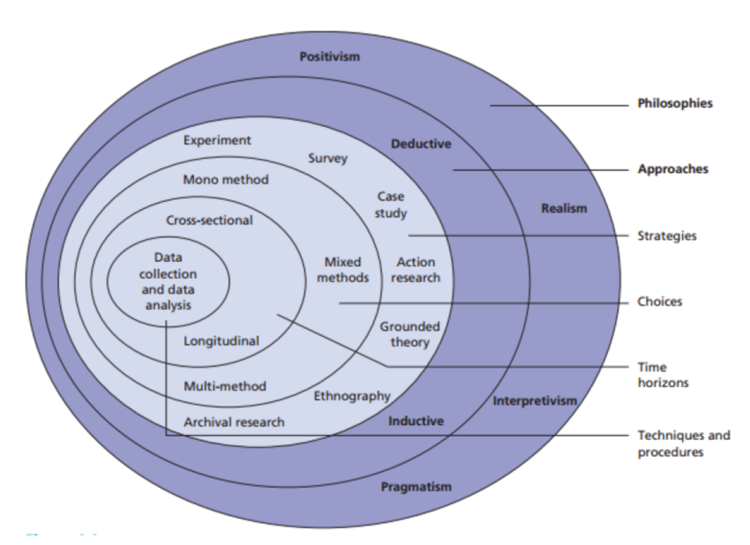
Figure 1 The Research Onion
‘The research onion was developed by Saunders et al (2007) to describe the stages through which the researcher must pass when formulating an effective methodology’ (UK Essays 2017). This outline is an easier and effective way to highlight what research will be carried out in the process, it benefits the researcher to follow step by step ways of research and gives the reader an understanding of what the research will show.

3.3 Methods to Collect Data
The data collected is set in a cross-sectional form. ‘In cross-sectional study, the investigator measures the outcome and the exposures in the study, participants at the same time’ (Setia 2016). The data collected will be answers gathered from questions that have been researched in chapter 2 on strategy/strategy in the hospitality industry and a small section on Wetherspoons.

3.3.1 Cross-Sectional Data
The use of Cross-sectional data is that ‘these types of designs will give us information about the prevalence of outcomes or exposures; this information will be useful for designing cohort study’ (Satia 2016). As the research carried out is questionnaires is a singular form of data, the type of method used in this research is known as ‘Mono Method’. ‘Mono method research must be completely designed and conducted’ (Giddens & Sutton 2010, p.52).

3.3.2 Deductive Approach
The chosen approach for this research is deductive. ‘Deductive approach adopts the researchers own agenda as the point of departure and seeks to prove or disapprove a hypothesis’ (Kitchen 1999, p.478). The researchers aim is to find out about strategy within the workplace to see if gets implemented and noticed. ‘For deductive approaches the emphasis is usually on causality (Gabriel 2013).
The advantages and disadvantages of using this approach is ‘if properly conducted, it will help assure content validity in final scales’ (Swanson & Holton 2005, p.165). On the other hand, ‘it is very time consuming and requires that researchers possess a working knowledge of the phenomena under investigation’ (Swanson & Holton 2005, p.165).

3.4 The Research Strategy
The chosen method of research to be carried out is a survey strategy. ‘The survey strategy aims to produce generalizations about populations by collecting information from samples. Surveys may aim to describe the characteristics of the population or may seek to test explanatory theories by using correlational analysis that follow the same logic as the experiment’ (Thomas 2004, P.21).
The method of survey chosen is questionnaires. This means the respondent answers the questions verbally, hand-written or even electronically. Within a questionnaire, respondents may be asked for example, age, gender, lifestyle or occupation so the researcher can get an idea of who is answering the questions. The questions in survey for this research will be closed meaning a simple ‘yes or no’ or even ‘agree or disagree’ answers. ‘Closed and there-fore, precoded questions, are popular with researchers and interviewers alike because there is a set of answers known before-hand that can be listed on the questionnaire’ (Brace 2008, P.47). With questionnaires the results gathered show quantitative data although some questionnaires can also gather qualitative data.

3.4.1 Primary Data
‘Primary data is information you collect yourself that is directly related to your measures of member satisfaction’ (Gerson 1999, P.120).
For primary data collection, the respondents will be asked to answer an E-Survey (Online Questionnaire) which will be posted onto a social media site. The survey will gather quantitative findings. Once the data is collected, it will then be analyzed numerically. The findings from the data gathered will then be represented into graphs or set out using the excel methods. ‘We use questionnaire as a general term to include all techniques of data collection in which each person is asked to respond to the same set of questions in a predetermined order’ (Devaus 2002) cited by (Saunders et al 2003, P.280).
The reason for choosing surveys to carry out the research is mainly because, the data received from surveys is more like to show validity. The use of a survey allows the sample to be selected or completely random. The cost for creating a survey is low which benefits the researcher to gather many mixed responses from respondents. The respondents also have the benefit of anonymity when answering the survey. The survey will be an E-Survey questionnaire where respondents will answer the questions electronical via computers, laptops, mobile phones etc.
The benefits of using an E-survey is there are a ‘variety of delivery methods: email, intranet web-survey by disc and kiosks’ (Thomas 2002, P.1). The results will be shown by using statistics which will represent answers from the aims about strategy in the hospitality industry. Saunders et al (2003, P.281) explained how ‘Questionnaires can therefore be used for descriptive or explanatory research. Descriptive research such as undertaken using attitude and opinion questionnaires and questionnaires of organizational practices, will enable you to identify and describe the variability in different phenomena.

Quantitative Research
The use of using quantitative research is so that researchers can gather numeric data such as statistics and figures on research with the use of questionnaires. Quantitative studies are defined as: quantifying the problem or research question and establishing the mechanisms through which one or more (quantitative) variable(s) may affect another variable (O’Gorman and Macintosh 2015, P.155)

3.5 The Sample
The sample that will be used in the research is known as a cluster sample. ‘A cluster sample is a random sample of natural groupings (clusters) of individuals in the population. Cluster sampling is very useful when the population is widely dispersed, and it is impractical to list and sample from all its elements’. (Hulley 2007, P.33). This sample is more valid when using questionnaires as the results will be different and varied which can produce valid results from the questions given to the sample based on strategy.
As the sample choice is random, the E-Survey will be posted on social media sites. There will be a variety of mixed responses from the samples and the demographics of the sample will vary. ‘All the other probabilistic methods require frames of all the units, but the cluster method does not require that. Once the clusters are selected, they are compiled into frames. Now, various probabilistic researches and observations are performed on these frames and required conclusions are drawn’ (Lovekar 2016).
There are negative for when using certain samples during research which can cause an element called systematic bias. This means it, affects survey results and reduces data validity, including frame bias (a wrongly chosen population), selection bias (under-representing certain types of population members), non-response bias (data skewed based on who from the chosen sample actually engaged with the study), interviewer bias, questionnaire bias, respondent bias and processing bias (interviewer writes down wrong answers) Devaus 2007: Cited by (O’Gorman and Macintosh 2015, P.160).
To make sure there is no element of systematic bias, the researcher will make sure that the sample is varied so that the researcher will gain a mix of responses from the cluster sample. As the E-survey/Questionnaire will be posted on a social media website the researcher will be able to gain a mix of responses from the samples who use social media daily.

3.6 Reliability and Validity

3.6.1 Reliability
‘In Quantitative research, reliability in data collection is assured in three ways: measuring internal consistency, applying test-retest correlation coefficients, and using equivalent forms of the instrument. If reliability is not assured, then the scientific assumption of accuracy of measurement is violated. The facts are not repeatable.’ (Newman and Benz 1998, P.40).
The questions within the E-survey will be parts which have been taken from chapter 2, and which have also been approved from the dissertation supervisor. The researchers aim is to make sure the research remains un-biased and objective throughout the whole process, the questions asked are straight forward and are completely down to matter of opinion from the sample.

3.6.2 Validity
Saunders et al (2003, p.281) highlights how validity can be maximized in a questionnaire.
This can be by:
- Careful design of individual questions;
- Clear layout of questionnaire form;
- Lucid explanation of the purpose of the questionnaire;
- Pilot testing;
- Carefully planned and executed administration;
The questions chosen as part of the research have been designed carefully and generically, so that the researcher can gather important reliable information that the sample have submitted in the questionnaire.
The Questionnaire has been laid out in a clear format by using an online E-Survey which shows all the questions. The questions are numbered 1-10, and the first three questions are simple
generic questions, which gather demographic information on the sample, which are (age, gender, occupation).
The other 7 questions are either a simple yes/no answer or are based on the format of strongly agree to strongly disagree. There is also a question which gives the sample the option of a multiple-choice answer (more than one answer can be given) which is based on the chosen company used for this case study.

3.7 Ethics
The researcher has stated to participants before answering the questionnaire that all responses are of complete confidentiality which also falls under the data protection act. Being clear about the ethical dimensions of your research is important for three main reasons: navigating sensitive topics, improving research outcomes, and ensuring professional conduct (O’Gorman and Macintosh 2015 P. 197). The primary data that will be collected is completely anonymous and the responses of the research will only be shared with the researcher and researcher’s supervisor which is stated to participants before completing the survey.

3.8Strategy and Ethics
Ethical issues are also supported by strategic approaches. It must provide quality products for its consumers, continued jobs for its employees, and taxes for its government. In the process of formulating and implementing strategies, potential conflicts arise in the goals of the company’s various stakeholders such as stockholders, managers, employees, suppliers, government and society at large. It is while dealing with conflictual-zing goals that managers face ethical dilemmas in prioritizing the demands of various constituents that form the core of the strategy-ethic interface’ (Kolb 2008, p.2014). The researcher needs to take into consideration how strategy may affect individuals taking part in the questionnaire, who may feel strong minded about how strategy is implemented in a work place, especially if a participant works for a hospitality industry.

3.9 Limitations of Research
The limitations of research are the time that was carried out to perform the research. As the researchers chosen method of research was questionnaires the researcher only has a week to gather primary data online from only a small cluster sample. The researcher would only have participants to partake in the research if they only had an online source to access, the research was shared across a social media page which asked participants to take part in the research. The researcher only gathered a total of 69 responses from the whole week it was left for participants to answer and take part in. If the researcher sent out the questionnaires to other participants, the researcher may have had a chance of gaining more respondents.
Had the questionnaires been printed out and given to more participants, the researcher may have had more of a chanced of the reliability and validity of research being higher and would have supported more elements of how strategy should be implemented in Wetherspoons or what certain aspects of strategy should be a focus for a hospitality industry.

Chapter Four – Data Analysis

4.1 Introduction
The aim of this chapter is to reflect on the findings the researcher has discovered from carrying out the research process.
The objective of the research was to identify ‘Strategy in the Hospitality Industry and use Wetherspoons as an example and to find out whether strategy is known in hospitality industries such as Wetherspoons and how the business should strategize.
The data has been collected in a primary data collection form as discussed in chapter 3.
The data will be represented and analyzed with the use of graphs and tables to support all the findings which will be represented on an excel spreadsheet the data was analyzed and presented onto an excel spreadsheet with the use of survey monkey which analyzed all the findings and gave statistics of all the respondents. Chapter Four will be based on the findings gathered from the questionnaire from respondents of the questionnaire, see appendix 1 and 2 for how the questionnaire was laid out to participants who answered.

4.2 Generic Questions

The first three questions of the data gathered were generic questions, based on age, gender and occupation.
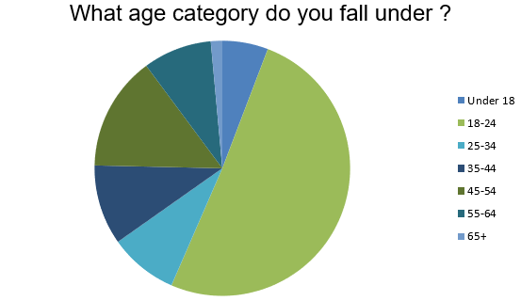
Figure 2 Age category

The demographic range of figure 2 show participants who answered the survey represent, that 50% of participants who took part in this survey were aged between 18-24. The significance of this can identify to the researcher what age range categories enjoy hospitality industries.

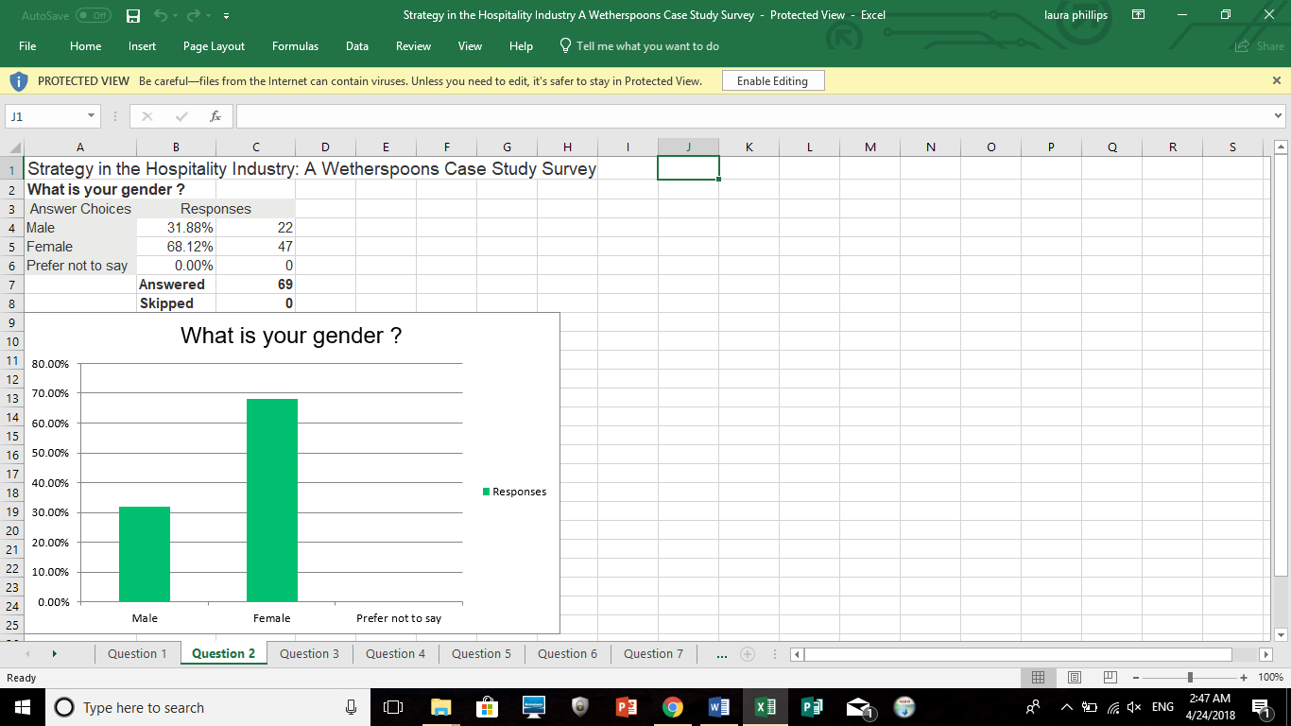
Figure 3 Table to represent gender

Excel can summarize the data and give you figures on your findings in a percentage and can present it in a table, as the data the researcher is gathering Is quantitative, this benefits the researcher’s findings and is able to give a clear answer to findings that have been gathered. The table represents the answers from question 2. The table shows all participants took part and answered the questions. 47 responses came from females, whereas only 22 responses came from males.

4.3 Occupations
Question three asked participants what their current occupation was, there was a variety of mixed respondents who participated in answering the questionnaire. This data was analyzed on survey monkey where respondents could type in the answer of their occupation.
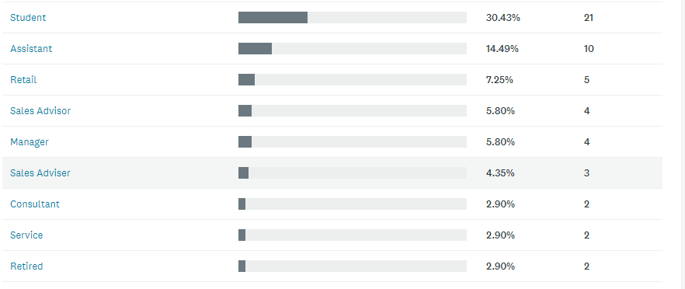
Figure 4 Occupations
Most participants who took part in the survey were student with a result of 30% participation. Then followed by 14% of participants who stated that their occupation was an assistant. Followed by 7% of participants who worked in retail and then followed by 5% of participants who were either a sales advisor or a manager. Then the other 6% of participants were wither a consultant, worked in service or was retired. Which shows a mixed range of, participants who took part in this survey and shows that students are attracted to pubs like Wetherspoons.

4.4 Hospitality organizations and the use of strategies
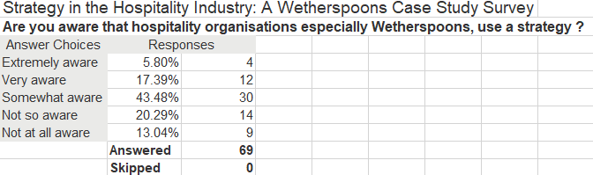
The researcher wanted to find out whether individuals were aware of strategy being enforced within a work place. This was based on a stage of (Strongly aware / aware/ somewhat are/ not so aware/ not at all aware) which can help to see whether participants can point out strategic approaches within a hospitality industry.
Figure 5 Table of results from hospitality industries implementing strategies
To safeguard your company at the level of purpose, you must make strategy the servant rather than the master. Strategies are time-bound and are target specific results. Your purpose, in contrast, is what makes you durably relevant to the world. Strategy is but one of the several important means to operationalize your purpose. Intrinsic human connection to your purpose is even more important (Chevreux et al 2017). Wetherspoons should take into consideration that putting strategy out there may grasp customers attention more, as they will see the effort hard work being done, to keep customer satisfaction high. Figure 5 below represents how many individuals on a whole were aware of strategy being implemented in places like Wetherspoons

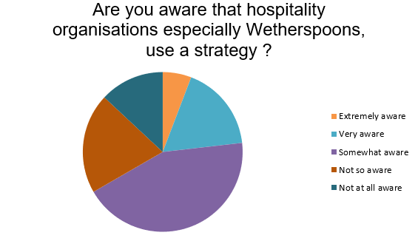
Figure 6 Pie chart to show results of awareness of strategy

On a whole 43% of participants were only ‘somewhat aware’ of strategy being enforced within hospitality industries like Wetherspoons. Showing that industries do need to make it known to customers that they are trying to enforce customer satisfaction. (Chan Kim and Mauborgne 2015)’s statement on ‘focusing on existing customers’ found in section 2.4 of chapter 2. This shows how industries do need to prioritize on customers to gain their attention of strategy benefitting them. However, 17% of participants answered ‘Very aware’ showing that hospitality industries are coming across fairly-positive on people being aware that they are strategizing. Which can be supported by ‘competitive advantage’ from (Hill et al 2016). Emplaning that Wetherspoons does have a competitive advantage in some shape or form. 20% of participants also responded with ‘not so aware’ indicating that there are still customers out there who are know of strategy be exemplified in the work place.

4.5 Strategy in an Organization
The first specific question (4) asked to participants is ‘Should strategy be a main focus in an organization such as Wetherspoons?’ The participants had the options to answer = strongly agree, Agree, neither agree or disagree, disagree or strongly disagree.
Question 4 is a question based on Dalton (2016) theory on what a strategy can do to an industry and what an organization can gain from implementing strategy, this was discussed in chapter 2 section 2.2. Figure 4 below will support the findings of the answers gained from the question.
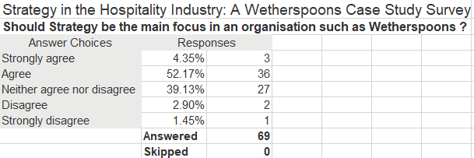
Figure 7 Strategy in the Hospitality Industry

The average number of responses showed how 52% of participants agree with Daltons’ (2016) theory on strategy being a focus in an organization such as Wetherspoons. Compared to 39% of participants who neither agreed or disagreed with the following question, which can give an indication that strategy is not thought of much to certain individuals. This can also support (Hill and O’Sullivan’s 2004, P.405) theory based on how Wetherspoons differentiates from its competitors with the use of service/marketing mix which sets them apart from other competitors, which can support that Wetherspoons strategizing does benefit the business. 3% of participants did strongly agree however on strategy being a focus, so it does go to show that there is some element of importance to use strategy.

Figure 8 Pie chart on strategy results

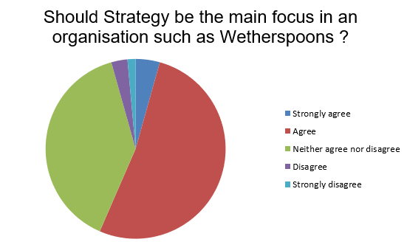

The graphs in these findings are used to show a more-clear in-depth outlook of the answers given from participants during the research process. The line graph represents an outlook of only 1% out of all participants strongly disagreed with strategy being implemented into an industry such as Wetherspoons.

4.6 Cost Strategy
The fifth questioned entailed participants to answer on a scale of strongly agree to strongly disagree again on their attitudes towards cost strategy in an organization. Supporting Porter (1980) theory on cost strategy being implemented in an industry this is based in chapter 2 section 2.3 strategy in the hospitality industry. The summary table below provides evidence of what participants felt about cost strategy. The questionnaire was set out from (Strongly agree/agree/neither agree or disagree/ disagree/strongly disagree).
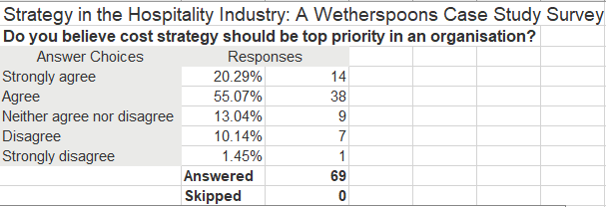
Figure 9 Table to show do you believe strategy should be top priority in an organization?
This question was to find out whether participants felt cost strategy shows importance in an organization like Wetherspoons. The Graph below represents the overall summary of the findings.
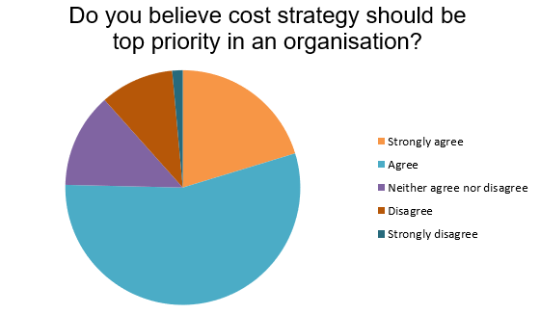
Figure 9 Pie chart show Cost strategy question results

A total of 75% of participants strongly agreed or agreed with cost strategy being a top priority to an organization. This supports Porter (1980) theory on cost strategy being beneficial to a cost leader as consumers will want to go to a hospitality industry more If they are able to strategize cost wise by selling food and drink at affordable prices which is was Wetherspoons do as a business. This result can also support Stacey (2000) theory on a functional structure also which is based on sales and marketing and purchasing and stock control or centralization to decentralization which is like Porters (1980) theory on cost leadership strategy.
Whereas only 11% of participants put disagree or strongly disagree about cost strategy being one of the top priorities in an industry, that maybe due to consumers thinking there should be other issues to focus which is a similar question which is asked in question 9 about what Wetherspoons top priority should be as a corporate business.

4.7 Corporate business level
Question 9 in the questionnaire was a multiple-choice questionnaire, which means allowing participants to answer more than once on the same question. The question asked to participants was based on Wetherspoons being a corporate business. They had a choice between (Customers/Price/Employees/Environmental/Ethical).
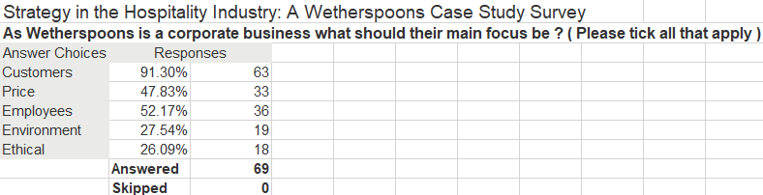
Figure 10 Table to show Corporate Business results
Figure above shows what answers were offered to participants when answering the questionnaire. The options show customers, price, employees, environment and ethical. The question was based on Barney and Hesterley’s (2006) theory on Corporate level strategy and a further in-depth detail about it which was written by Wheelan et al (2015) which can be found in section 2.3 of chapter 2.
The above findings show representation of how 91% of participants felt by Wetherspoons being corporate their focus needs to be on customers, which then followed by 52% of participants feeling that employees should be a focus in a Corporate business-like J.D. Wetherspoon. The findings show how customers and employees are viewed as two of the main important parts to a corporate business as these a people who are internal and external to the business.
This means managers top priority in any hospitality industry including Wetherspoons should be to make sure the customers are satisfied with the service and that the employees are also looked after. This result also supports Mintzberg et al 1996’s theory of corporate businesses showing objectives, purposes and goals and focusing on important things such as employees and customers. See in section 2.3 of chapter2. This can also support (Kew and Stredwick 2017) theory of founder Tim Martin knowing what his customers want, which is ‘cheap food and beers’ which supports these results as most participants believe that customers should be a focus for Wetherspoons, theory can be found in section 2.6 of chapter 2.
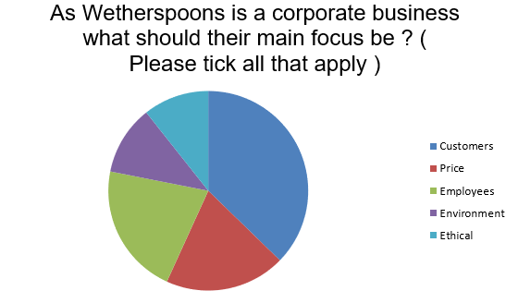

Figure 11 Pie chart on corporate strategy results

Figure 11 shows representation of 91% of participants choosing customers as the main importance to a corporate business, followed by employees at 52%, this result supports Wheelan et al (2015) theory on corporate level strategy as a ‘choice of direction for a firm as a whole’. So, for Wetherspoons a strategy choice they could focus on as a business which they should focus on is the customers and employees who come into the organization internally and externally.

4.8 Strategy Gains more Customers
Question 7 was based on asking participants ‘does strategy make a company gain more customers?’ on a range from strongly agree – strongly disagree, this is able to support whether Wetherspoons needs to focus on gaining more customers for their industry. The question was set out as (Strongly agree/Agree/Neither agree nor disagree/ Disagree/ Strongly Disagree)
This can support (Wheelan et al 2015, P.36) theory on strategic formulation, which can consider the external opportunities. Which can support the results formulated in the table as 60% of participants did agree that strategy does can more customers.
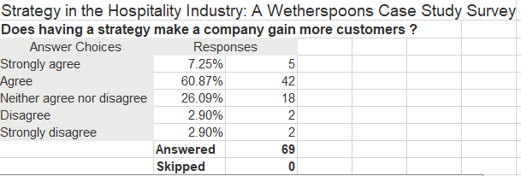
Figure 12 Table on 'Does having a strategy gain more customers?
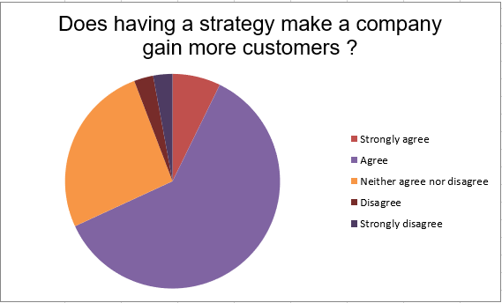

Figure 13 Pie chart to show does having a strategy make a company gain more customers?
Figure 13 represents that, 60% of participants ‘agreed’ that having a strategy does make a company gain more customers compared to 26% of participants who answered, ‘Neither agree or disagree’. Referring back to chapter 2 section 2.2 Porter implied how ‘a firm’s competitive advantage in an industry is determined by its competitive scope- that is the breadth of the company’s or business units target market. If Wetherspoons have looked at its competitive scope or focus on it then, it may enforce them to gaining more loyal customers. 4% of respondents voted either disagree or strongly disagree, but the results show, that most respondents are for strategy being implemented into a business especially Wetherspoons as it is a successful pub chain whose focus should be customers.

4.9 Manager or Teams Decision
Similarly, to question 7, question 6 is focused on whether strategy in the hospitality industry a team’s decision should be or a manager’s decision. The question is one selected answer only of either ‘Managers’ or ‘Team Decision’. This question is based on section 2.3 from chapter 2. The table below represents a summary of the data collected.
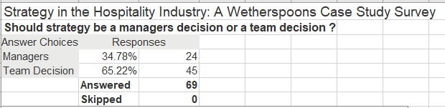
Figure 14 Table to show 'Should Strategy be a managers or team decision?'
This question support (Mullins and Dossor 2013) theory of the contingency approach which on a whole is based on the contingency approach of differentiating between alternative forms of organizational structures, which can support this question as it is based on how a work force in a hospitality industry should work together. But does go against (Stacey 2000) theory on integrating functions of specialization and standardization, see 2.3.
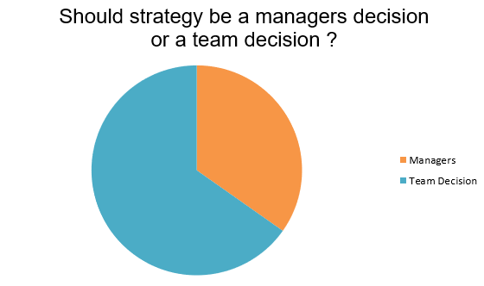

Figure 15 Pie Chart to show should strategy be a managers or teams decision?

The bar graph represents that 65% of participants thought that strategy should be based on a team’s decision, compared to 34% of participants who believe that strategy should be down to a manager’s decision. Showing that participants feel that working as part of a team could strategically benefit an industry. These results support (Lee-Ross & Lashley 2010, P.192) about how ‘managers need to understand the statement and encourage the team members to understand their contribution to achieving the mission’. Findings have shown that ‘Being part of a high-performance team generates ownership and commitment. It is a highly motivating experience. People who work in high-performance teams are more likely to be engaged with their organization ‘(Cook 2009, P.18) highlight evidence that working together as a team will benefit the industry on a whole.
This can also support Stacey (2000) theory section 2.4 in chapter 2, based on ‘managers can only be said to be planning the future of their organization when a group they share a common intention to achieve a particular future composition and level of performance for the business; that is when they select aims and objectives for the business well in advance’ on behalf of managers calling the shots in hospitality industries.

4.10 Differentiation of Wetherspoons Results

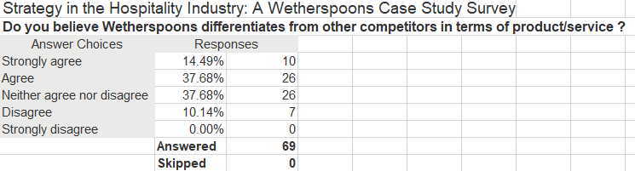
Figure 14 below shows question 10 asked to participations whether they believed does Wetherspoons differentiate from other competitors in terms of product/service? The answers varied from (Strongly agree/ Agree/ Neither agree nor disagree/ Disagree/ Strongly Disagree).
Figure 16 Table of results from results of Differentiation in Wetherspoons

This question was based on Porter (1980)’s differentiation theory. To recap ‘Differentiating the product or service, offering the firm, creating something that is perceived industry wide as being unique’ (Porter 1980, P.35). This part can be found in chapter 2 section 2.3. By asking participants this question the researcher wanted to gain knowledge about if participants really thought that Wetherspoons is a differentiating business to other former competitors in that segment. Findings have shown that ‘Further down the line it is possible that is the larger retailers do franchise out brands, it will be the smaller independently managed multiple licensed retailers, and not individuals, that take them out because of capital needed and operational expertise required. It is proposed that the likelihood of early franchising of brands will come from single brand operators like Yates’ Wine lodge, or Wetherspoons’ (Lashley and Morrison2007, P.216)

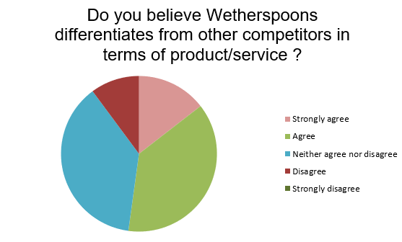
Figure 17 Pie chart of results of differentiation

37% of participants answered agree or neither agree or disagree based on whether Wetherspoons does differentiate from other competitors or services, which does show that Wetherspoons is seen as being different which 37% of participants agreed with. 10% of participants disagreed with the question. Which can support Kay (1993) theory based on positioning and pricing which is in chapter 2 which is aimed at firms communicating with their customers.

5.0 Chapter 5 – Conclusions and Recommendations

This chapter summarizes the overall findings gained from the research carried out of how strategy is implemented in hospitality industries in places like Wetherspoons and if it should be a priority in places like Wetherspoons. This will conclude on a whole the findings the researcher has achieved. Furthermore, there will be a summary of recommendations suggested to Wetherspoons at the end of this conclusion.

5.1 Conclusion
The researcher selects this element to focus on as the researcher is an under-graduate student. The chosen option for using Wetherspoons as a case study was because Wetherspoons is a very sociable and enjoyable pub to go to and enjoy a drink and eat food at reasonable prices, the researcher believed that this would be topic of interest to some readers especially the younger generation as pubs like Wetherspoons are the social scene to attend to when you are eligible to drink. The researcher wanted to know why does Wetherspoons attract many and how do they do it. Hence to use of strategy was used to a core part to this researcher and why Wetherspoons was used as a main case study. The overall research element of finding out how strategy is used and what different kinds of strategies are implemented was a success to the researcher.
The analysis of results in chapter 4 has shown very clear results which has created interesting statistics which has been supported from the help of chapter 3. The sample was small, but the researcher was still able to gather clear and valid results from the graphs and tables presented. The results gathered supported the researchers objective of ‘To analyze the different strategic approaches that can be adopted by organizations in the hospitality sector’, which the researcher was successfully able to achieve. The helpfulness of theories of chapter 2 meant the researcher could ask a variety of different questions based on strategy, what should be focused on and who should decide how a strategy should be implemented into a business.
From the previous theories on strategy discussed in chapter 2, Wetherspoons adapts two of Porter (1980) Generic strategies of cost and differentiation strategy into its industry. Strategy on a whole has been acknowledge from participants from the results gathered in the pie charts in chapter 4, which can support 2.4 the evolution of strategies in chapter 2 of how far it has come. The use of strategy being implemented in an industry shows a positive outcome especially for customers who visit local pub chains similarly to Wetherspoons, most participants in chapter 4 section 4.10 question 10, supported that Wetherspoons does differentiate from other competitors in the hospitality sector. Which supported the generic strategies theory produced by Porter (1980).
The use of primary data carried out in chapter 4, the resource of the online questionnaire was able to help the researcher achieve the outcome of gathering quantitative data and supporting the interpretive approach from chapter 3. The researcher was successful in finding out from chapter 4 if specific strategic approaches are adopted within a hospitality industry which was one of the researcher’s objectives. The researcher wanted to gather information to see if Wetherspoons are applying any of the traits asked and if not can make further recommendations to Wetherspoons for the benefit of its business.
As a result the questions asked about ‘do you think cost strategy should be a top priority in an organization’ and ‘do you believe Wetherspoons differentiates from other competitors in terms of product/service?’ most of the participants who answered replied with ‘agreed’ supporting two of the key factors of generic studies of ‘cost strategy’ and ‘Differentiation strategy’ stated by (Porter 1980) which presented that strategy is a beneficial resource to use as customers will notice the difference in cost and how the whole business is laid out to a customer, showing that people do believe Wetherspoons does stand out as a business. The support of ‘the pricing strategy and principles of service delivery remain the same across the pubs, through décor and the precise product mix in food and drinks menus vary slightly to meet to local customer need’ (Wood and Brotherton 2008, p.464) showing that a cost-based strategy is a good strategy for Wetherspoons which participants agreed should be a focus in that hospitality segment.
The focus on whether strategy should be a managers or teams decision, provided the evidence, that team work should be the key when making decisions for the benefit of the company, this supported Mullin (1998, P.99) theory stating ‘In order to achieve its goals and objectives the work of the establishment has to be divided among its members. The resulting structure should be that which is most appropriate to the objectives of the establishment’ which will benefit Wetherspoons if team decisions are applied.
When asking participants as Wetherspoons being a corporate business, what should their focus be, most participants chose customers and employees which supports the corporate level strategy theory implied from (Wheelan et al 2015). The chosen answer of customers supported (Chan Kim and Mauborgne 2015 p.103) theory on ‘focus on existing customers’ as a strategic practice which identifies with ‘Tim martin has firm views on what his customers want – low prices food constantly available, no music, normally no television and no smoking’ (Kew and Stredwick 2017.P137) which highlights Wetherspoons should maintain focusing on customers a strategic approach for the business as the founder implies that is what its main aim of wanting to gain for customer satisfaction.
When it came to question 7 asking participants ‘Does having a strategy make a company gain more customers?’ majority of participants answered ‘Agree’ highlighting Porters theory on competitive advantage in an industry which is determined by its ‘competitive scope’. Which also supports theory implied from chapter 2 based on Wetherspoons found in section 2.6 of the literature review presented that ‘JD Wetherspoons pub chain is now one of the UK’s fastest growing businesses. The secret of its success lies in a very clear strategy of differentiation- using service and the marketing mix to set apart from its competition. Like many good business ideas, it is not devastatingly complicated- just a case of serving good beer and good food at reasonable prices, served by friendly and well-trained staff who feel they have stake in success of the company’ (Hill and O’Sulliavn 2004, P.405). This gives indication that strategy is a beneficial outcome for a hospitality business like Wetherspoons.
The overall results have supported two of the objectives set which were based on ‘To assess whether Wetherspoons do implement strategy into its business’ and ‘To identify and assess the strategic approaches within the hospitality industry’ which have been met meaning the researcher has achieved the two main overall objectives of the research carried out as part of this dissertation.

5.2 Recommendations
To achieve all three of the objectives set the final objective is ‘To make suitable recommendations to Wetherspoons on the adoption of suitable strategic approach’ which shall be discussed as follows:

5.2.1 Recommendations towards a cost-based strategy
From the findings represented in chapter 4, section 4.6 on the answer asked to participants about a cost-based strategy being a top priority in an organization, the result showed that over 50% of participants agreed that it should be a top priority. And has findings have shown in chapter 2 about Wetherspoons having ‘low prices’ it was able to suffice that a cost-based strategy is beneficial to a hospitality business such as Wetherspoons.
The recommendation for cost strategy is that, the business should maintain using a cost-based strategy for the company as it seems to gain the business competitive advantage and gather more customers. If the business maintains offering food and drink at low prices, its applying a strategy of cost to its business, therefore the business is achieving what is has set out to do in the first place. This approach should be the first main approach Wetherspoons should use as setting food and drink at low cost’s will mean more customers will want to come and purchase from the business compared to other competitors who offer the same services.

5.2.2 Recommendations for the use of a Differentiation Strategy
From the gathering of research produced, a differentiation strategy is what still seems to benefit Wetherspoons’ business. The industry’s uniqueness to just differentiate by selling food and drink at low prices in a relaxed environment is what seems to grab to eye of many from the findings supported in chapter 2.
The Recommendation therefore for Wetherspoons, is to still apply differentiation strategy to the business as the company seems to be performing well by differentiating from other competitors with the services it offers. It is recommended that Wetherspoons do make sure they still focus on the customer needs and wants for their business, as the customers are the important part of making the business a successful one and trying new approaches of how the business can develop its success even more, will help not only maintaining the differentiation strategy, but still having the customer as a priority.

5.2.3 Recommendation for including staff members in strategic decisions.
From the theories gathered in chapter 2, there was very diminutive findings on how teams make strategic decisions for a business, the main decisions are made from management and passed down. Following the results shown in chapter 4 about whether strategic decisions should be a manager or teams decision, the recommendation recommended for Wetherspoons would be to include staff members to have a say in strategic decisions on how the company should approach a certain scenario and how the company can improve on certain products of services it offers.
Instead of one main manager making vast decisions, there should be staff meetings, where staff should be asked what they think can benefit the business, and what they would do to change it, staff would at least have had their voices heard and management will also benefit from this as, more ideas would have been put across which may have never been thought of. Which therefore means the company on a whole can then make strategic decisions, and management are still able to make the final decision, but the teams opinions have at least been put across on what the company can do to out-perform its competitors.

6.0 Bibliography
A., S. M. L. P. &. T., 2015. Research Methods for Business Students. 5th ed. Essex: Pearson
Benz, I. N. a. C. R., 1998. Qualitative-Quantitative Research Methodology. United States of America : Library of Congress .
Brace, I., 2008. Types of Question and Data. In: Questionaire Design: How to Plan, Structure and Write Survey Material For Effective Market Research. London : Kogan Page Limited , p. 47.
A. G. & P. W. S., 2010. Quantitative vs Qualitative . In: Sociology: Introductory Readings . Cambridge : Polity Press , p. 52.
Baum, J. A., 2010. The Globalization of Strategy Research. Volume 27 ed. Bingley: Emerald Group Publishing Limited .
Blythe, J., 2012. CIM Coursebook 08/09 Marketing Essentials. 2nd ed. Oxford : Butterworth -Heinman .
Brace , I., 2008. Types of Questions and Data . In: How to Plan, Structure and Write Survey Material for Effective Market Research . London : Kogan Page Limited , p. 47.
Burkwood, M., 2004. One Organisation, Three levels of strategy . In: Marketing Planning the practice into Principles . Essex: Prentice Hall , p. 6.
Butler, D., 2012. The Social and Economic Context . In: Business Development : A Guide to a Small Business Strategy . Oxford: Routeledge , p. 1.
Charles W. L. Hill, M. A. S. a. G. R. J., 2016. Strategic Management: Theory: An Intergrated Approach. 1st ed. Boston: Cengage Learning.
Cook, S., 2009. Building a high-performance team. 1st ed. Cambridgeshire: IT Governance Publishing .
Cumming, E., 2017. How Britain Fell for Wetherspoons. [Online]
Available at: https://www.theguardian.com/lifeandstyle/2017/aug/06/how-britain-fell-for-wetherspoons
[Accessed 8 May 2018].
Datt, S. a. S., 2016. Choosing an Appropriate Research Philosphy for Your Paper. [Online]
Available at: https://www.projectguru.in/publications/choosing-appropriate-research-philosophy/
[Accessed 11 May 2018].
Dosser, L. J. M. a. P., 2013. Hospitality Management and Organisational Behaviour. 5th ed. Harlow : Pearson Education Limited.
E.Bamford, T. L. J. H. A. N. C., 2015. Strategic Management and Business Policy Globalization, Innovation and Sustainability. 14th ed. Essex: Pearson .
Elizabeth Hill, T. O., 2004. Foundation Marketing. 3rd ed. Essex : Pearson .
Essays, U., 2013. Research Online- Explanation of Concept. [Online]
Available at: https://www.ukessays.com/essays/psychology/explanation-of-the-concept-of-research-onion-psychology-essay.php
[Accessed 10 March 2018].
Flander, J. D., 2018. Business Strategy - Ultimate Guide. [Online]
Available at: https://jeroen-de-flander.com/business-strategy-principles/
[Accessed 11 May 2018].
Freese, I., 2013. The Evolution of Strategic Management. s.l.:In Genius Results LTD .
Gabriel, D., 2013. Inductive and Deductive Approaches to Research. [Online]
Available at: http://deborahgabriel.com/2013/03/17/inductive-and-deductive-approaches-to-research/
[Accessed 4 March 2018].
Gerson , R. F., 1999. Members for Life. 1st ed. United States of America : Human Kinetics .
Ghoshal, H. M. J. L. J. B. Q. S., 1996. The concept of corporate strategy . In: The Strategy Process Concepts Contexts Cases . Essex: Pearson Education Limited , p. 72.
Gibson, C. S. a. H., 2011. Never to be Underestimated. In: Leadership and Entrepreneurship in The Hospitality Industry . Oxford: Goodfellow Publishers Limited , p. 9.
Gierczak, B., 2014. Management Methods And Concepts For Building Competitive Advantage in Hospitality Companies. Polish Journal of Sport and Tourism , 21(3), pp. 178-183.
Hesterly, J. B. B. a. W. S., 2006. Strategic Management and Competitive Advatage. s.l.:Pearson Prentice Hall .
Hulley, S. B., 2007. Designing Clinical Research. 3rd ed. Philadelphia : Lippincott Williams & Wilkins.
Kassowski, A., 2007. Porters Generic Competitive Strategies . In: Strategic Management : Porters Model of generic competitve strategies- theory analysis . s.l.:GRIN Verlag , p. 5.
Kay, J., 1993. Competitive Strategies . In: Foundations of Corporate Success: How Business Stratgies Add Value . New York: Oxford University Press.
Kitchen, P. J., 1999. Overview of the Main Research Design Options - Different Types of Research Designs ?. In: Marketing Communications: Principles and Practice . London : International Thomson Business Press , p. 478.
Kolb, R. W., 2008. Encyclopedia of Business Ethics and Society. 1st ed. Thousand Oaks, California : Sage Publications .
Lamb, J., 2013. Positivism/Interpretive Knowledge. [Online]
Available at: https://prezi.com/hmjbkexvfhvx/positivisminterpretive-knowledge/
[Accessed 8th March 2018].
Lashley, D. L.-r. a. C., 2010. Mission Statements. In: Entrepreneurship and Small Business Management in The Hospitality Industry . Oxford : Elseivier , p. 192.
Laurent Chevreux, J. L. a. X. M., 2017. The Best Companies Know How to Balance Strategy and Purpose. [Online]
Available at: https://hbr.org/2017/11/the-best-companies-know-how-to-balance-strategy-and-purpose
[Accessed 7 May 2018].
Lovekar, V., 2016. The Cluster Sampling Method Has More Advantages Than You Think. [Online]
Available at: https://www.buzzle.com/articles/cluster-sampling-advantages.html
[Accessed 10 March 2018].
Magretta, J., 2012. Understanding Michael Porter: The Essential Guide to Competition and Strategy. 1st ed. Boston: Harvard Business School Publishing .
Mark Hailwood, D. T., 2015. Biographies of Drink : A Case Study Approach to our Historical Relationship With Alcohol. 1st ed. Newcastle Upon Tyne : Cambridge Scholars Publishing .
Mark Saunders, P. L. a. A. T., 2003. Research Methods for Business Students. 3rd ed. Essex: Prentice Hall .
Mauborgne, W. C. K. a. R., 2015. Reach Beyond Existing Demand . In: Blue Ocean Strategy, Expanded Edition: How to Create Uncontested Market Space and Make the Competition Irrelevant . Boston: Harvard Business Review Press , p. 116.
Mazzucato, M., 2002. Strategy for Business : A reader. 1st ed. London: SAGE Publications .
Mcnabb, D. E., 2015. Research Methods for Political Science : Quantitative Qualitative Methods. 2nd ed. New York : Routeledge Publishing .
Meyer, B. D. W. a. R., 2004. Strategy: Process, Content, Context : An International Perspective. 3rd ed. London: Thomson Publising .
Morrison, C. L. a. A., 2007. Franchising Hospitality Services. 2nd ed. Oxford : Butterworth - Heinemann .
Mullins, L. J., 1998. Managing People in the Hospitality Industry. 3rd ed. Essex: Longman Limited .
Newman , I. & Benz, C. R., 1998. Qualitative - Quantitative Research Methodology. 1st ed. United States of America : Board of Trustees .
Nyheim, P., 2012. e-study guide: Technology strategies for the hospitality industry. 2nd ed. s.l.:s.n.
O'Gorman , K. & R. M., 2015. Research Methods for Business and Management. 2nd ed. Oxford: Goodfellow Publishers.
Patel, S., 2015. The Research Paradigm- methodology, epistemolgy and ontology - explained in simple language. [Online]
Available at: http://salmapatel.co.uk/academia/the-research-paradigm-methodology-epistemology-and-ontology-explained-in-simple-language
[Accessed 2nd March 2018].
Perry, F., 2016. 35 Slightly Surpising Facts about Wetherspoons. [Online]
Available at: https://www.buzzfeed.com/floperry/facts-you-probably-didnt-know-about-wetherspoons?utm_term=.mtrkNam4a#.yrV40ayma
[Accessed 8 May 2018].
Pizam, A., 2005. International Encyclopedia of Hospitality Management. 1st ed. Burlington : Elsevier .
Porter, M. E., 1980. Differentiation . In: Competitive Strategy: Techniques for analyzing industries and competitiors . New York : Free Press, p. 35.
Porter, M. E., 1980. Focus . In: Competitive Strategy: Techniques for analyzing industries and competitors . New York : Free Press, p. 38.
Porter, M. E., 1980. Generic Competitve Strategies . In: Competitive Strategy . New York : Free Press , p. 35.
Porter, M. E., 1980. Purchasing Strategy . In: Competitive Strategy . NewYork : Free Press , pp. 122 -123 .
Porter, M. E., 2008. Competitive Strategy: Techniques for Analyzing Industries and Competitors. 3rd ed. New York : The Free Press .
Porter, M. R., 1990. Defining Strategy. s.l.:s.n.
Prakash, S., 2017. Six effective hotel marketing strategies to drive profitability and revenue. [Online]
Available at: https://ehotelier.com/supplier/2017/04/12/hotel-marketing-strategies/
[Accessed 11 May 2018].
Roy C Wood, B. B., 2008. The SAGE Handbook of Hospitality Management. 1st ed. London : SAGE Publications LTD.
Rumelt, R., 2011. Bad Strategy . In: Good Strategy/Bad Strategy: The difference and why is matters . London : Profile Books LTD, p. 32.
S.Hesterly, J. B. a. W., 2006. What is Business- Level Strategy ?. In: Strategic Management and Competitive Advantage . Upper Saddle River New Jersey : Pearson Prentice Hall , p. 116.
Sam, P. S. D. a. A. G., 2011. Research Methodology. 1st ed. s.l.:Kalpaz Publishing.
Setia, M. S., 2016. Methodolody Series Module 3 : Cross- Sectional Studies. [Online]
Available at: https://www.ncbi.nlm.nih.gov/pmc/articles/PMC4885177/
[Accessed 4 March 2018].
Smit, P., 2000. Strategy Implementation: Readings. 1st ed. Landsdowne : Juta & Co LTD .
Stacey, R. D., 2000. Strategic Choice . In: Strategic Management & Organisational Dynamics . Harlow : Pitman Publishing , pp. 61-62.
Stonehouse, D. C. D. E. a. G., 2011. Perspectives on Strategy . In: 3rd, ed. Business Strategy: An Introduction . s.l.:s.n., p. 15.
Stredwick, J. K. a. J., 2017. Business Environment : Managing in a Strategic Context. 2nd ed. London: Chartered Institure of Personnel and Development .
Swanson, R. A. & Holton, E. F., 2005. Advantages and Disadvantages . In: Research in Organizations: Foundations and Methods in Inquiry . San Francisco : Berrett- Koehler Publishers , p. 165.
Team, I.-., 2017. Wetherspoons sets vastly different prices across the UK. [Online]
Available at: https://inews.co.uk/inews-lifestyle/food-and-drink/wetherspoons-sets-vastly-different-prices-across-uk-no-two-pubs-charge/
[Accessed 23 April 2018].
Team, I., 2017. Wetherspoons Sets Vastly Different Prices Across the UK. [Online]
Available at: https://inews.co.uk/inews-lifestyle/food-and-drink/wetherspoons-sets-vastly-different-prices-across-uk-no-two-pubs-charge/
[Accessed 25 April 2018].
Telegraph, B., 2015. JD Wetherspoon: Belfast-Born Tim Martin runs one of Britains Biggest pub chains and is creating 100 new jobs in the City. [Online]
Available at: https://www.belfasttelegraph.co.uk/business/news/jd-wetherspoon-belfastborn-tim-martin-runs-one-of-britains-biggest-pub-chains-and-is-creating-100-new-jobs-in-the-city-30878287.html
[Accessed 8 May 2018].
Tesone, D., 2010. Principles of Management for the Hospitality Industry. 1st ed. Oxford: Elsevier .
Tesone, D. V., 2012. An Overview of Tactical Strategies . In: Principles of Management for the Hospitality Industry . Oxford: Elseivier LTD, p. 210.
Thomas , A. B., 2004. The Survey Strategy . In: Research Skills for Management Studies . London : Routeledge Publishing , p. 21.
Thomas , S., 2002. Electronic Surveys. United States of America : ASTD.
Thornhill, M. S. P. L. a. A., 2015. Research Methods for Business Students. 5th ed. s.l.:Peason Education Limited .
Tse, M. D. O. J. J. W. a. E. C. W., 2008 . Strategic Management in the Hospitality Industry. 3rd ed. Upper Saddle River New Jersey : Pearson Education Limited .
Vinay Cauto, E. W. J. P. a. D. C., 2017. Aligning Costs with Strategy . In: Fit for Growth: A Guide to Strategic Cost Cutting, Restructing and Renewal . New Jersey : John Wiley & Sons , p. 31.
Waters, C. .. J. a. D., 2006. Operations Strategy. 1st ed. London: Thomson Learning.
Watkins, M. D., 2007. Demystifying Strategy: The What, Who, How and Why. [Online]
Available at: https://hbr.org/2007/09/demystifying-strategy-the-what
[Accessed 11 May 2018].
Weinstein, R. M. a. A., 2012. Strategic Fit . In: Segmentation Strategies for Hospitality Managers: Target Marketing for Competitve Advantage . Binghamton : The Haworth Press , p. 183.
Wilding, M., 2018. How Wetherspoons Conquered Britain. [Online]
Available at: https://www.esquire.com/uk/food-drink/a19129642/how-wetherspoons-conquered-britain/
[Accessed 23 April 2018].
Zhao, M. O. J., 2008. Handbook of Hospitality Strategic Management. 1st ed. Oxford : Butter-Worth Heinemann .

7.0 Appendices

7.1 Appendix 1: Image of drinks prices for Wetherspoons in different areas of the UK
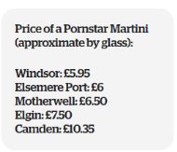

Source: https://inews.co.uk/inews-lifestyle/food-and-drink/wetherspoons-sets-vastly-different-prices-across-uk-no-two-pubs-charge/ (Accessed 25 April 2018)
Figure 1 represents an example of drink prices situated in different Wetherspoons across Britain. ‘Company spokesman Eddie Gershon told it’s because rents and rates vary so much across all parts of the UK. All we can do is be competitive against other pubs in respective areas’ (I-Team 2017). Showing representation of how Wetherspoons strategize the business. This image shown above identifies the cost strategy Wetherspoons has in different sections on England within the UK.

7.2 Appendix 2: Layout of Questionnaire
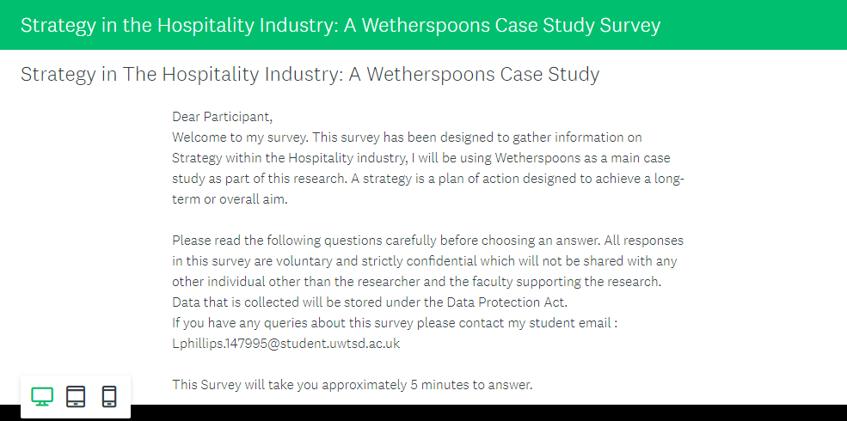

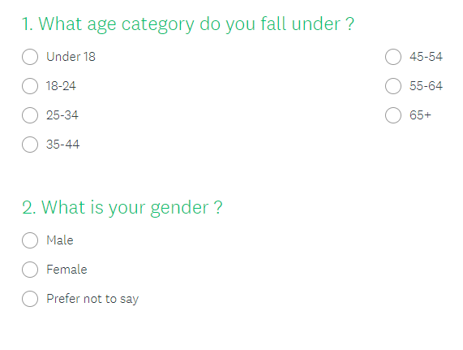

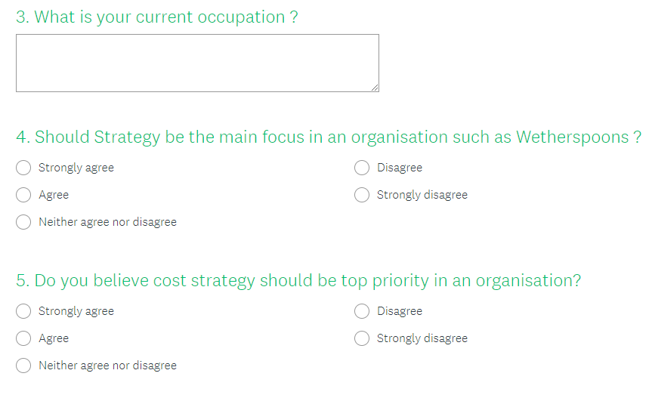
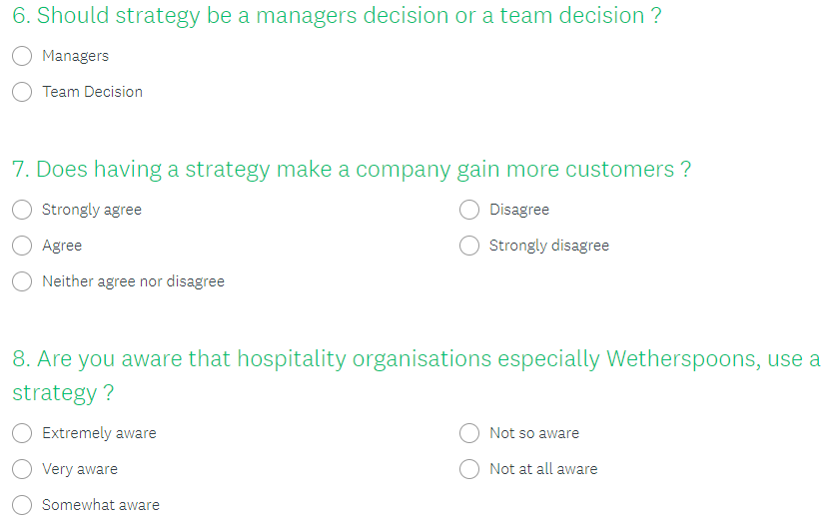

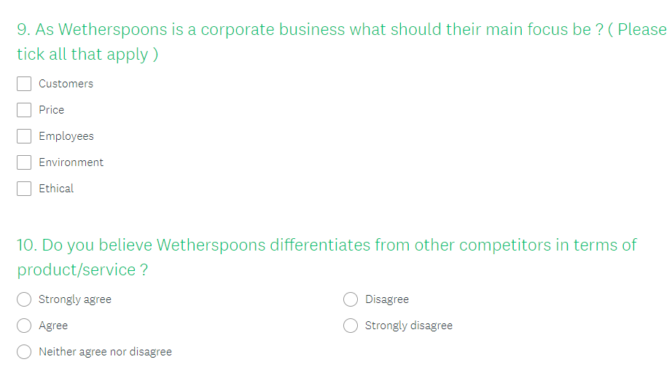

7.3 Appendix 3 – Ethics Form



