

Module Code: LCBB4005
The Global Business Environment – Assessment 2
Assignment Title –New business opportunities and product life cycle
Lecturer: Kenny Tang
Student Name: Robert Alexandru Merghisescu
Student Number: 1907185
Contents
Introduction: 3
Part: A 4
New and emerging business opportunities of electric cars for entrepreneurs 4
Government stakeholders in the EV industry in the Europe 6
Part: B 7
A critical assessment of other businesses linked to the global automobile industry 7
Conclusion: 10
Reference: 11

Introduction:
Electric vehicle, in short EV, is an automobile that uses one or more electric or traction motors for energy. It stores up its electricity in 'Energy Storage Device', for example, Battery. There are mainly three types of EVs and they are Battery Electric Vehicles (BEVs), Plug-in Hybrid Electric Vehicles (PHEVs), and Hybrid Electric Vehicles (HEVs) (Fathabadi, 2018). In Europe and other big countries, electricity is produced from various natural renewable sources that include nuclear, coal, natural gas, etc. Electric Vehicles help lessen this threat of polluting the natural calamities as it only relies on electricity in rechargeable batteries. In this paper, Electric Vehicles in Europe will be discussed.

Part: A

New and emerging business opportunities of electric cars for entrepreneurs
Electric Vehicle is one of the greatest inventions in the history of automobiles in Europe. Among various environmental, mechanical, and other kinds of pros of EVs, the socio-economic part of EV plays a big role in it. It does not only help maintain a good balance between social, economical, or other indicators but also offers many emerging and innovative business opportunities to business executives and entrepreneurs (Romli and Ghani, 2018). Such as- EV Charging Station, Electric car workshop, Customized Insurance Policy Service, Online electric car marketing, Development of various software parts, etc. They are given below:
Electronic Vehicle Charging Station:
The electronic vehicle charging station is one of the most important and popular businesses related to electric car service in Europe. Introducing a charging station is comparatively easy and profitable for an entrepreneur as it has less risk and more demand. As charging time varies from one EV to another so the opportunity in this business is big.
Electric Vehicle Workshop:
Electric Vehicle is still a new idea for the people of Europe. From the sound system of EV to the headlight, everything is designed innovatively. So, the people who are interested in operating EV or those who want to know more about this need to attain specialized skills including auto electrical skills to run this. Thus, EV Workshop could be a big business opportunity for entrepreneurs.
Customized Insurance Policy Service for EV:
Insurance is a big part of any kind of business. By starting an Insurance Policy Sale Service for the Electric Car owners, an entrepreneur can successfully run his business as almost all of the EV owners tend to search for a reliable Insurance Policy Service. It will not only be a successful business for the entrepreneurs but also it will help the EV industry grow more without big risk.
Online Electronic Vehicle Marketing:
Sometimes entrepreneurs don't have enough space to show their EVs. At this moment, starting from advertising to dealing with selling their products online would be a great way to run their business as online business is cheaper and does not require a lot of energy, time, and space. Other spare parts of EVs can be sold online as well.
Developing Software Apps for Electronic Vehicles:
It is known to all that Electronic Vehicles are different from usual vehicles. EVs usually have various software running in them. An entrepreneur who is also interested in developing software apps can easily start making new apps and introduce them to EV (Anderson, 2016). Thus EVs can be expanded and the entrepreneurs and business executives can be fruitful as well.
Product Life Cycle is a process that a specific product goes through from the beginning of the time when it was first introduced until it declines or removed from the market. This process has four stages. They are- Introduction, Growth, Maturity, and Decline.
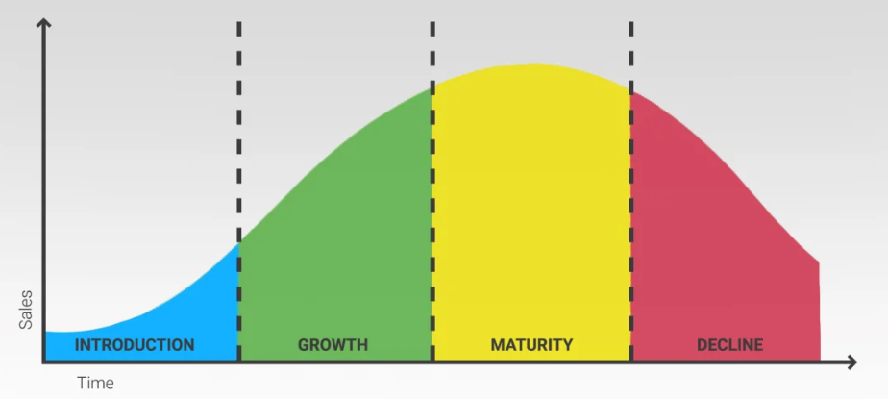
Figure 1: 4 stages of the Product Life Cycle
Electric Vehicle was first introduced in the year 1832. Although it was not that well-known among people at that time later it caught everyone's attention with the advantages it comes with. Electric Vehicle has later introduced again in the 20th century and caught everyone's attention. After letting people know about its advantages and availability, it became famous in no time. After that, it gradually started launching different models and made a place in the automobile industry (Wells, 2010). Consequently, it has become one of the best innovations which are equally advantageous to the economical, environmental, and mechanical situation.

Government stakeholders in the EV industry in Europe
Since the very beginning, Electronic Vehicle has played a big role in the automobile industry of Europe and other different countries including the USA, China, Japan, etc. Electric vehicles are eco-friendly and support the socio-economic factor of the nation. EVs have both opportunities and threats for stakeholders. Given, this industry has less chance of risks compared to other businesses and it has good insurance policy services so, the government becomes more interested in investing and become a part of it.
Different countries of Europe and others including the USA, China, Germany, etc. are supporting the EV industry by subsidizing each year with a good amount of money. For example, The US government is subsidizing electric cars with £7000/year. Germany is currently subsidizing with €4000/year. On the other hand, these countries have declared a rebate to develop this industry more. For example, the British government has declared rebates up to £3,500 for 31 vehicle models (Kulov, 2019). Because of the investment, financial support, and promotion of government in Electric Vehicle, the industry has grown up to 23.5%. Besides that, the UK government has also invested about £100 million in the research of Electric Vehicle.

Part: B

A critical assessment of other businesses linked to the global automobile industry
The automobile industry is a huge industry consisting of many other businesses linked to it. The other businesses may be helpful and profitable for the time being but it cannot always be profitable in the long run to invest in as the social, political, economical, environmental, and other situations can be changed. For example, People can be interested in sharing a ride other than owning one single car of their own. Because people always tend to find the ones that would come of use to them. One of the biggest threats to the Automobile Industry would be self-driving cars. Although it has now become popular among people, researchers are predicting that it would increase the rate of accidents and casualties. On the other hand insurance policy and parking costs are the biggest reasons why people are losing interest in buying their cars, rather they are more into car-sharing services (Doherty and Anderson, 2001). So, investing in this particular sector could be a big risk in the long run. Besides, it is known to all that the current economic situation of the whole world including China is slowing down. Recently, the price of 'USOil' has also decreased at such a rate for the first time in history so, investing in this part could also be a threat in the long run. Experts have reported that in the first half of the year there was a 15% drop in the automobile industry and Ford's sales were slowed down by 27% in the first six months of the year 2018.
Beside all these businesses linked to the automobile industry, there are still some parts that can be describe using Porter's Value Chain Model. In the business world, the value chain model of Porter is one of the most popular models. Porter's Value Chain model has two types of activities. They are- Primary Chain Activities and Support or Secondary Chain Activities. Primary activities have different parts including Inbound Logistics, Operations, Outbound Logistics, Marketing, and sales and Services. And Support or Secondary Value Activities consist of Firm Infrastructure, Human Resource Management, Technology Development, Procurement, etc. These different parts of Primary and Secondary activities make a big impact on the automobile industry and sometimes it becomes uncertain to invest in these sectors as it can become non-profitable in the long run (Al-Shammari and Al-Faqir, 2017). Here, inbound logistics means transportation, delivery, and storage of the products, and outbound means the same for the products that are going out of business. Sometimes, it can be risky in investing in these sectors as the situation does not always stay the same. On the other hand, the parts of Secondary value activity can cause risk in the long run of the automobile industry. For example, one specific technology may not have the same value or effect in the future. It may have a big impact at present but it may lead to a big threat in the future. So, it can be said that a specific step or investment may not have the same value in the upcoming future. For that reason, before investing, one should analyze the whole condition and then invest in the long run.
Now, if the situation of five to ten years of Electric Vehicle Sales in Europe, the US, China, and other countries can be analyzed then it can be seen that:

Figure 2: Electric car sales from 2015 to 2025 in billion-pound
The graph above shows 4 columns and it describes the electric car sales of China, Europe, the United States, and other countries. Here, China is marked with the colour' light blue', Europe is 'red', the United States is 'deep green', and others are 'violet'. The X-Axis represents the ten years (2015-2025) and X-Axis shows the sales in billion pounds. In this graph, the 2015-2019 period is based on historical data and 2020-2025 is the expected sales. It is shown that China had started from a very low sales growth rate. But, later it kept increasing at a higher rate and it is expected that China’s sales rate will increase in the upcoming year. On the other hand, Europe had started a good beginning in the year 2015 but its growth rate could not do well in the last 5 years and it is expected that it will stay the same in the future. The same goes for the United States. And other countries are in the same situation as it started and it is predicted that it is going to stay the same. So, it can be said that China is doing well among the other countries and the growth rate of China is higher than others. Alternatively, Europe, the US, and other countries could not increase as fast as China.

Conclusion:
Electric Vehicles have changed the whole idea of the automobile for the car industry of the world. Before that, the automobile industry did not have the idea of running such cars that would not harm the environment and improve various sides including environmental, mechanical, economic, etc. From the beginning, EVs have played a big role in the socio-economic side of Europe (Naikdessai, capsular, usgaonkar, and salunke, 2019). The cheaper rate to run and maintain, the improvement of safety issues, the energy securities, less risk of running the vehicles, and being good to the environment have made EVs the go-to choice for the car industry. Hence, it is considered to be one of the greatest automobile innovations.

Reference:
Fathabadi, H., 2018. Novel battery/photovoltaic hybrid power source for plug-in hybrid electric vehicles. Solar Energy, 159, pp.243-250.
Romli, L., and Ghani, N., 2018. Innovative Strategies between Work and Life Balance among Female Entrepreneurs in the State of Terengganu, Malaysia. International Journal of Academic Research in Business and Social Sciences, 8(5).
Anderson, K., 2016. Getting acquainted with social networks and apps: Gotta catch them all? Augmented reality gaming apps. Library Hi Tech News, 33(10), pp.6-8.
Wells, P., 2010. Creating new value-added configurations in the electric vehicle industry. World Electric Vehicle Journal, 4(4), pp.823-834.
Kulov, A., 2019. SUBSIDIZING OF INVESTMENTS IN THE DAIRY INDUSTRY OF THE EUROPEAN UNION COUNTRIES. Экономика сельского хозяйства России, (7), pp.82-87.
Doherty, M., and Anderson, J., 2001. People Don'T Keep Their Heads Still When Looking to One Side, and Other People Can Tell. Perception, 30(6), pp.765-767.
Al-Shammari, E., and Al-Faqir, T., 2017. Analysis Support Activities Value Chain Model to the Porter and Impact on the Knowledge Department. Iraqi Administrative Sciences Journal, 1(1), pp.60-86.
Naikdessai, A., capsular, m., usgaonkar, g. and salunke, a., 2019. APPLICATION OF ARAS FOR IDEA SCREENING PHASE OF NPD IN AUTOMOBILE INDUSTRY. Industrial Engineering Journal, 12(6).

