

Student Name: | Vladimir Ivanov
Student Number: | 1816040
Module No: | BMSW4002
Module Title: | Effective team  working and communication
Lecturer: | LLOYD BEHARRY
TASK DESCRIPTION: | Produce a portfolio of evidence, including all in-class exercises, which demonstrates an understanding of the communication skills discussed in class.  Briefly analyse communication in your own or your friend’s workplace -TSB Bank, using your findings from published literature (i.e. refer to theory), suggest how it could be improved.

Executive Summary

The ensuing report studies the various theories and frameworks with regards to communication and establishes the various types and classifications related to it. The aspect of group dynamics has also been discussed in a detailed manner in the context of TSB Bank, one of the most recognizable financial service organisations within the UK. The report further analyses the case of TSB Bank and the challenges it faced due to a distinct lack of communication along with the presentation of a set of recommendations that could have improved their situation.

Table of Contents

Executive Summary 1
Introduction 3
Theories of communication and group dynamics 3
5
Types of communication 6
Case study: TSB Bank 8
Recommendations 9
Conclusion 10
References 11
Appendix: 12

Introduction

To make a successful business, the organisation needs to develop a good team first through an effective communication system. Effective communication helps to build good inter-personal relationship and reduces the chances of conflict. This creates a positive effect on the production and service quality of the company (Maduka et al., 2018). The customers and employees both get benefitted from this and help to make economical profit. There are many ways to build effective communication within a team so that all the team members can act wisely and in a systematic manner to reach the business objectives. This present work will focus on the different theories proposed by different scholar that will help to understand the importance of effective communication for team building. Also, different types of communication systems will be discussed to have wide knowledge on the subject.

Theories of communication and group dynamics
There are certain theories that help to understand d the importance of effective communication to build a successful team to meet the business objectives. They are:
Berlo’s communication model: This model is also known as Sender-Message-Channel-Receiver (SMCR) model of communication. This model discusses the different factors that affect the individual components in the communication system (Petersons and Khalimzoda, 2016). This model says about the encoding and decoding of the sender and receiver of a message.
Sender: it is the source of the message, and good communication skill is required so that he can make good effective communication n with the other team members. He should behave in a calm way and a knowledgeable person. Generally, the leaders of a team are the sender while the workers act as the receiver of a massage.
Message: an important message that is being delivered in an organisational context should have a good content of operation and elements to be carried forward. The language should be simple enough, and the structure should be according to the organisational protocol.
Channel: through a proper channel a message is delivered from a sender to the receiver through hearing, seeing, touching, smelling and tasting.
Receiver: Receivers are the last key person of this process, who receives the message and suppos4ed to act on the information. He also should have good communicational skills, knowledge on the subject of the information and positive attitude towards the issue.
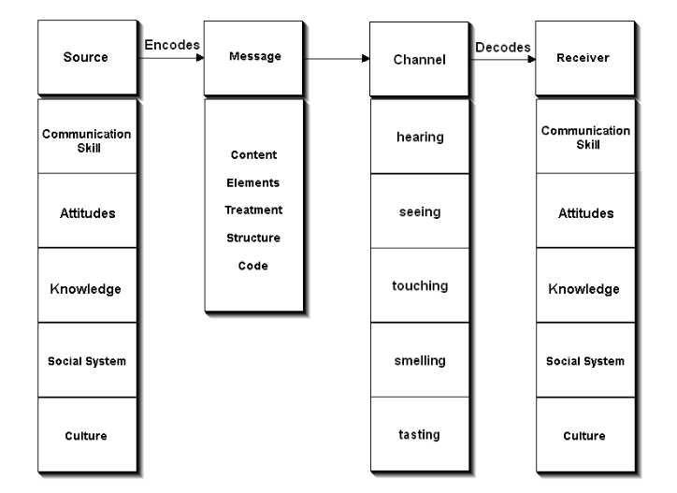

Figure 1: Berlo’s communication model
(Source: Petersons and Khalimzoda, 2016)
Shannon Weaver model of communication: According to this model, the communication system is dependent on the following factors (Rogers and Valente, 2017):
Sender (Information source) – He sends the message
Encoder (Transmitter) –he uses different machines and applications who converts the wo5rds into binary data for confidentiality.
Channel – This medium is used to convey the message
Decoder (Receiver) – He converts the binary data to words.
Receiver (Destination) – He gets the message to work upon.
Noise – These are physical disturbances such as people, an environment that creates problem for message delivery.
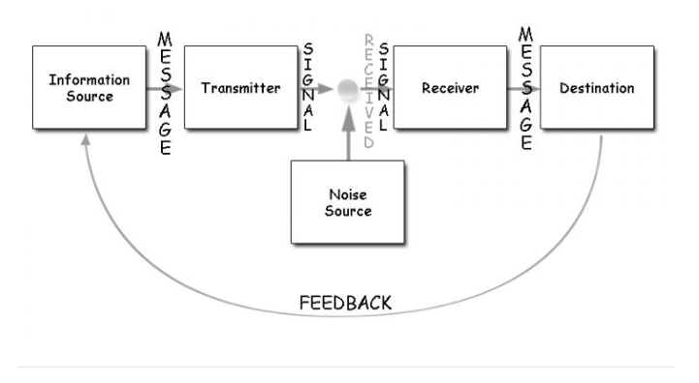

Figure 2: Shannon Weaver model of communication
(Source: Rogers and Valente, 2017)

Tuckman's 1965 Team-Development Model: According to this model, through four simple steps a team could be built (Natvig and Stark, 2016). These are:
- Forming: A team is formed by a selection of potential skilled person for performing a job
- Storming: A lot of discussions occur to get a clear idea about the expected outcome of the work.
- Norming: Agreements on the decisions are made depending on the proposed suggestions for performing the job.
- Performing: The team finally starts to perform to achieve the goal under the direction of the team leader and using effective communication.
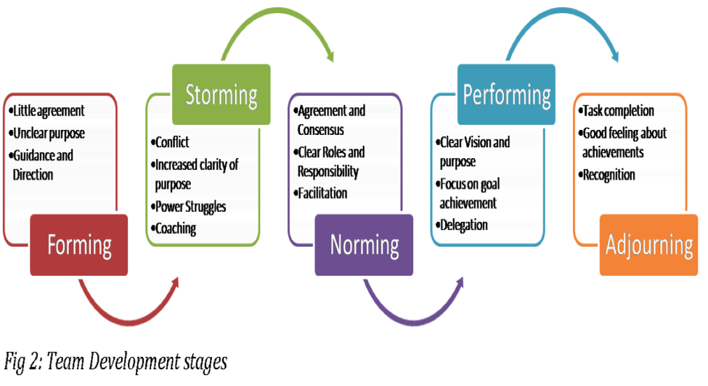
Figure 3: Tuckman's 1965 Team-Development Model
(Source: Natvig and Stark, 2016)

Types of communication
There are mainly four types of communicational ways that people apply in the context of team building as well as personal life. They are:
Verbal communication: In this process, language is the main weapon of communication process. Through the use of speaking, discussing and sometimes with the help of sign language, two or more persons communicate with each other to exchange views, give suggestion or discuss problems. This is one of the most important types of communication system as this takes less time, and makes fewer complications, creates fewer conflicts and is highly impactful. There is one speaker and others act as listener (Chung et al., 2015). The speaking skill of the speaker needs to be excellent to get the proper attention of the listener to make the teamwork effective.
Non-verbal communication: In this category, body languages, gestures and facial expressions have been given importance. Intentionally and unintentionally people use these ways of communication. There is closed type of body languages such as crossed arms or legs, or hunched shoulders, which shows the anxiety of a person. Open body languages such as both feet on the floor and arms by their side or on the table send a positive vibe of communication.
Written communication: Written communication is another effective way of communication and is used thoroughly in official matters. E-mails, notices, circulars, official letters, blogs, memos can create a great impression and the documentation is important. They don’t create a tone and are simple and concise in nature to make a good impression. The advantages of using this type of communication are that they produce the final decision and are effective for all members within a team. Personal official communication can also be done and can keep in a confidential manner. The disadvantage of this communication is that being too formal; it lacks the soft tone of verbal communication and can create misunderstanding or conflict.
Visual communications: This is another way of communication that creates a deep impact on the mind of the viewers. Photographs, videos, sketches, drawings, charts and graphs are some useful tools in this regard. Many people find it interesting to see and remember as this visualisation of data and quickly make them understand the whole story in a short time and is often used by organisation during oral communication. This information can be shared and stored for future uses and can make repeated appearance if required.

Case study: TSB Bank
TSB Bank is among the most recognizable financial services organisations within the UK and houses over 550 branches spanning Scotland, England and Wales (Ertürk, 2016). Launched in the year of 1991, the bank primarily operates as a subsidiary of the Sabadell Group (TSB, 2019). The organisation offers a range of different services including the provision and management of savings accounts, mortgages, current accounts, insurance facilities and so on. TSB Bank also has collaborations with Visa and MasterCard to facilitate their debit and credit card facilities and serves over a million consumers within the UK. The long heritage and the extensive British lineage had led to a bureaucratically motivated management structure and this inherently led to rigidity within their operations (Crowther and Ertürk, 2016). The organisation witnessed one of longest outages with regards to their online banking functionalities in April 2018. Over1.8 million consumers of TSB Bank were unable to access their accounts or their money, and this created a massive outrage within the country. The key finding in accordance to the opinion of the management was distinct lack of communication between the IT department, the contractors and the operations department, which was further aggravated by the absence of proper testing and debugging measures. The problem first came to light when a multitude of customers took to social media complaining about how they could not process their instalment and mortgage payments from their TSB Bank accounts. The contractors hired by the organisation department said there was a massive rushing with regards to the deadline, and the management within TSB Bank failed to provide ample amounts of time for testing and debugging. External analysts further opined that the source codes of the banking software were hastily designed and therefore had a number of crucial error points that led to the system-wide malfunction. TSB Bank, however, declined and apologised to the public with the standing that it was merely a technical error.
The primary limiting factor in this regard may be identified as the distinct lack of communication and correspondence between the management within TSB Bank and the contractors hired for the development of the new banking software. A general sense of direction should have been established whereby the contractors were provided ample amounts of time with regards to fully testing the software. Although the management tried to take curbing measures through the cancellation of interest charges and overdue payments, the error with regards to a clear communicative channel was established to the consensus. Consumer confidence was hurt massively in this context as the bank saw a number of long-term clients shifting to other alternatives. The implementation of Berlo’s model of communication stands to bear a high degree of relevance as the framework distinctly propagates the components required to establish effective channels of communication (Rogers and Valente, 2017). The rushing on the TSB Bank management’s part was a significant aspect that led to the situation in the first place. The assertive attitude shown by the management at TSB Bank had led to a pressure situation for the contractors or the receivers within Berlo’s framework and fundamentally proved to be a noise factor. This further find alignment with Shannon Weaver’s model of communication, whereby noise sources have been established to have a clearly negative influence on the resultant outcomes of the communication process (Turaga, 2016).
In terms of collaboration and group dynamics, Tuckman’s theory of team development stands to bear a substantial degree of relevance with regards to the situation within TSB Bank. The framework categorizes collaborations into four stages including forming, storming, norming and performing (Natvig and Stark, 2016). The forming aspect within TSB Bank and the contractors was flawed, to begin with, as the targets and timeframes set by the TSB management were unrealistic. This led to a clouded mindset within the storming stage, as the contractors and the IT department within TSB Bank failed to schedule tasks in an appropriate manner (Purwanto et al., 2018). The absence of debugging and testing eventually led to the outage and harmed the organisation in a substantial manner. Then norming stage also had its flaws as the decision making and engagement with tasks suffered over time. The performing stage was the most pronounced with regards to the situation, as there was a complete failure within the banking system within four months of implementing the software.

Recommendations
A certain set of recommendations have been formulated with regards to measures that could have been undertaken by the management as TSB Bank to prevent the system-wide outage in 2018. They have been discussed below and are as follows.
- The primary recommendation relates to the provision of a larger amount of time to the contractors for them to test and debug the software. The hurried nature of the management at TSB Bank to ensure that the system goes live as per the announced dates depicted a clear lack of foresight. The improper communication channels also led to a distinct lack of clarity in the context of the correspondence between the contractors and the IT department of TSB Bank.
- Effective channels of communication should have been established between the contractors and the IT department of the banking organisation as the clouded nature of the various directions and reporting measures proved to be substantial noise factors.
- The group dynamics and the degree of collaboration within the project could have been improved to a large extent. The managerial decisions should have been more functional and estimated the negative results that could have taken place due to the poor dynamics.
- Another key factor in this regard relates to the reliance on alternatives. TSB Bank should have thought of a situation whereby the system fails and maintained a secondary hosting service in order to ensure that services remain uninterrupted. The absence to register the risk eventually led to a massive public outrage whereby the confidence within the organisation was significantly hampered.

Conclusion
In conclusion, it may be stated that communication and group dynamics play a key role, especially in the context of collaborative projects and partnerships. As mentioned by McPhee and Poole (2016), the lack of effective channels of communication and improper group functionalities can significantly hamper the achievement of the objectives. As witnessed in the case of TSB Bank, the situation was primarily caused due to a hurried stance and a lack of proper communication cycles. The communication theories of Shannon Weaver and Berlo along with the Tuckman’s model of group dynamics are highly relevant to the overall scenario and could have been relied upon in order to ensure the efficiency within the system.

References
Chung, N., Lee, S. and Han, H., 2015. Understanding communication types on travel information sharing in social media: A transactive memory systems perspective. Telematics and Informatics, 32(4), pp.564-575.
Crowther, I. and Ertürk, I., 2016. Post-crisis bank regulation and financialized bank business models. The Routledge Companion to Banking Regulation and Reform, p.273.
Ertürk, I., 2016. Financialization, bank business models and the limits of post-crisis bank regulation. Journal of Banking Regulation, 17(1-2), pp.60-72.
Maduka, N.S., Edwards, H., Greenwood, D., Osborne, A. and Babatunde, S.O., 2018. Analysis of competencies for effective virtual team leadership in building successful organisations. Benchmarking: An International Journal, 25(2), pp.696-712.
McPhee, R.D. and Poole, M.S., 2016. Models of communication. The international encyclopedia of communication theory and philosophy, pp.1-16.
Natvig, D. and Stark, N.L., 2016. A project team analysis using Tuckman's model of small-group development. Journal of Nursing Education, 55(12), pp.675-681.
Natvig, D. and Stark, N.L., 2016. A project team analysis using Tuckman's model of small-group development. Journal of Nursing Education, 55(12), pp.675-681.
Petersons, A. and Khalimzoda, I., 2016, May. Communication Models and Common Basis for Multicultural Communication in Latvia. In Proceedings of the International Scientific Conference. Volume IV (Vol. 423, p. 433).
Purwanto, A., Zuiderwijk, A. and Janssen, M., 2018, September. Group Development Stages in Open Government Data Engagement Initiatives: A Comparative Case Studies Analysis. In International Conference on Electronic Government (pp. 48-59). Springer, Cham.
Rogers, E.M. and Valente, T.W., 2017. A history of information theory in communication research. In Between communication and information (pp. 35-56). Routledge.
Rogers, E.M. and Valente, T.W., 2017. A history of information theory in communication research. In Between communication and information (pp. 35-56). Routledge.
TSB, 2019. Welcome to TSB | Local Banking for Britain | Personal Banking. Available at: https://www.tsb.co.uk/personal/ [Accessed 17 Aug. 2019].
Turaga, R., 2016. Organizational models of effective communication. IUP Journal of Soft Skills, 10(2), p.56.

Appendix: In this appendix I attached all evidence, including all in-class exercises, which demonstrates an understanding of the communication skills discussed in class.



