Health, Well-being and Sustainable Development
  - Event Critique: Health, Well-being and Sustainable Development Conference: Event Details: Wednesday 27th March 2019, UWTSD SA1 Campus
Introduction
This is a reflective piece of writing that will explore an event that I attended. The topic of the conference was health, well-being and sustainable development. Health is defined by The World Health Organisation, (2019) as not necessary the absence of illness but being in a state of complete physical, mental, social well-being. Well-being is defined by Deci and Ryan (2008) as focus of happiness and the presence of positivity and absence of negativity, the way a person feels has an impact on their well-being. And finally sustainable development is defined by Beckerman (1994) as a way of change to ensure that things last, it should mean that things such as the environment should never deteriorate and be able to last for the future.
An event was attended by myself to explore these topics and learn more about the different ways to keep my health and well-being positive and ensure I do things in a sustainable way and learn about maintaining the planet.

The Event
A health, well-being and sustainable development conference was held within University of Wales Trinity St David SA1 campus, and its purpose was for professionals in the health and social care field to educate and share information on the topic of health, well-being and sustainable development.
The day was structured by three different guest speakers talking about their areas of expertise within the health and social care field relating to the topic of health, well-being and sustainable development.

Aims of the event
The aim of the event was to educate the students of University of Wales Trinity St David about the impact of health, well-being and sustainable development. The different speakers discussed different themes around the topic area and gave plenty of knowledge and understanding in order to ensure the aim of the conference was met.
The insight from professionals meant that the students attending along with myself could get a better understanding of health, well-being and sustainable development and use this within our learning.
The overall aim of the health, well-being and sustainable development event was to allow students and myself to develop an overall understanding of the topic.

Guest speaker 1
The first guest speaker was Felicity Page who spoke about building resilience.
Resilience is defined as the ability to come back from or adapt to change or failure. (Merriam-Webster, 2019)
This talk in my opinion was the most inspirational, as it discussed ways to ensure that whenever you are faced with failure that you have the ability to bounce back and be stronger. The session allowed everyone in the room to get involved in talking about ways that they cope with stresses within their life and comparing resilience and how to measure resilience. Personally, I enjoy talks where everyone can get involved and have discussions therefore this talk was very enjoyable for me. Everyone within the event got involved in telling personal stories and recommending ways for each other to cope in scenarios for example another student attending the event spoke about a book she uses in order to remain positive and resilient when dealing with stress. Felicity told stories of her own ways she has had to remain resilient not only for her but for her family also, this was very inspiring as she explained how she got to where she is today because of failure when her chosen career path didn’t go to plan, it made me realise that in the face of failure, you can still be successful. Felicity taught us ways and steps to take that when everything feels negative, that there is a light at the end of the tunnel and steps can be made in order to ensure that a more positive outcome is possible.
This talk was an hour long with a lot of insight into resilience and how it can have an impact on health and well-being. Negativity and stress has a lasting negative affect on the body and a person’s well-being, therefore coping in an appropriate way can help ensure a person is more positive and healthy to impact positively on their well-being.

Guest speaker 2
The second guest speaker was Rob Blake who is the developmental manager for Hywel Dda University Health Board, he spoke about the Well-being of Future Generations (Wales) Act 2015 and its impact upon health services. This talk was focused on the health care services available in Wales and how the service users will gain a better health care service from the NHS because of better treatment for the staff. Rob spoke about how improvements are being made within the health service for health professionals to ensure that they have a better experience in work and have less time off and feel less stressed and can give their patients the best possible care. More is being done within the health care workplace in order for workers to have different ways to ensure they have ways to deal with stress and have better relationships with managers and team leaders which will enable more of a treat other as you wish to be treated mind set, which will mean that all staff are treated fairly and have a better work life and professional relationships. Staff feeling better at work and having a positive relationship with other workers has shown to have less staff off work for stress and feeling better about working which then has a knock on affect for patients who receive the highest possible standards of care from the professionals.
This talk at the event was interesting in my opinion because Rob made me aware of the different affects that stress has on health care professionals and I found the different sickness statistics shocking. He also reviled the different issues that the health board face and how much demand is put on the staff, which made me realise how much work is put into the health board within Wales, without attending this talk within the conference I would not be aware of the impact of demand the health sector has, and how this is beginning to change for the health care for the people in Wales to improve in accordance to the Well-being of Future Generations (Wales) Act 2015.

Guest speaker 3
Finally, the third guest speaker was Sue Maw who is an award winning FACE lecturer who spoke about her own sustainability journey and recommendations. Sue specialises in computer sciences, the aim of her speech at the event was for everyone attending to leave the event with more awareness of ways for us to be more sustainable. She went on to explain different ways in which we could be more sustainable for example recycling more and using less single use plastic, she explained that the little changes make the biggest difference, and together we can work on making these changes in order to look after the environment and be more sustainable. She also explained the importance of businesses taking on the role and responsibility of recycling and being more green and environmentally friendly by using less single use plastic and this is something that is happening like for example having to pay for carrier bags and less usage of plastic straws within food places. These changes are what makes the difference due to them being easy to adapt to within everyday life.
This talk was very interesting to me because although I know the importance of recycling and looking after the environment I feel that it helped me understand different ways to do this and how easy it is to make changes and how those changes have a bigger impact upon the environment. It has had an impact on me because my aim now moving forward is to ensure I become more sustainable and look after the environment.

Reflection of the event
In order to reflect upon the event as a whole, I am going to use Gibbs model of reflection. This reflective model uses six stages of reflection in order to break down and reflect upon something, in this event it is the health, well-being and sustainable development conference I attended. The Gibbs model of reflection looks as follows and I will use the different sections to break down the conference. (University of Cumbria, 2016)
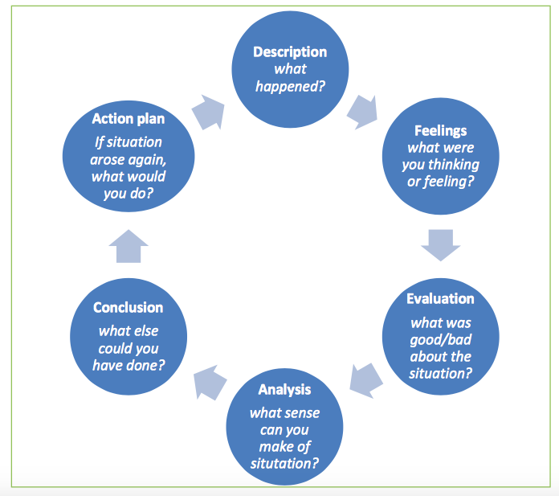

- Description
The event was a health, well-being and sustainable development conference where students attended to learn about the topic area. The event took place within a lecture room where there was plenty of room and the tables were set out in a way where everyone could see the speaker easily and there was a microphone to ensure everyone could hear the speaker clearly.
- Feelings
During the different talks I felt very inspired and felt that the talks were all very informative and I left feeling like I had learnt new things about the topic area and the importance of each talk was clearly portrayed by the speakers.
Mostly the first talk made me have different feelings where we shared a lot of information with each other and I felt like I enjoyed that talk the most.
- Evaluation
The event went very well in my opinion, everyone attending including myself learnt a lot of new things from attending and found out ways to make changes to have an impact upon our health, well-being and sustainable development. As mentioned the environment of the event was good and the length of the talks were enough to gain a lot of information without being too long. There were breaks between each guest speaker for the people attending to get refreshments which I found really useful because it meant I could have something to eat and drink between talks and have some time to reflect on the talk before the next one started.
- Analysis
The event in my opinion went really well, I don’t feel there was any issues within the speakers and how the conference was planned. The speakers were informative and gave plenty of information to myself and everyone that attended and I feel that the speakers were very passionate about the topics in which they discussed and spent a lot of time and effort putting together the presentations that they gave.
- Conclusion
I could have written a lot more notes during the talks but I was too involved in the discussions especially in the first talk to take more notes but I found that I gained plenty of knowledge from the talks regardless. I did find however that Rob during the second talk was going through slides a little quickly making it difficult to get all of the information, and some of which was lengthy therefore was hard to get the notes, however, I did learn a lot from his talk.
- Action plan
In the event that I would have to attend another conference I would try and record some of the talks in order to be able to listen back on them to remind myself of the different topics discussed.

This form of reflecting upon the event has allowed me to break down the event and understand the way in which it was run, it was successful and I found it very informative and interesting.

Comparison to similar event
After attending the event, I wanted to see how different events are similar or differ from the health, well-being and sustainable development conference I attended. I carried out some research and found an event by Impact Engagement, which was called Places and Spaces for Health and Well-being, 2018. It was carried out in Saracen House in Glasgow on February 7th 2018. The event itinerary was much longer than the conference I attended, it ran for six hours with many different talks on health, well-being and sustainable development, the similar thing about the events was that they were in place to spread more information on the topic area and raise awareness of this. The main aim of this event similarly to the event I attended is that they both run in order for the people attending to be more aware of ways to take care of themselves and the environment and changes within health boards to have impacts upon the service users. There was more variety of talks within this event and it was open to the public whereas the conference I attended was only open for university students. More events like this take place which is useful to ensure that the public as well as university students understand the topic issue especially sustainable development as it is important for the future.
The only main differences in the two events is the larger variety of talks, lengthy event time and it being open to the public. With regards to similarities, the events are on the same topic area and have the same purpose and have a few talks that were given in the conference I attended.

Recommendations for future events
As mentioned, the event went very well in my opinion and I found it very enjoyable but I have thought of some ways in which the event could be improved if it were to take place again.
- Firstly the PowerPoint presentations used by the speakers, although they were informative and served their purpose in that sense, it would have been nice to see more pictures and for them to be more visually appealing, they were very word based and it was hard to take notes from them.
- In events I have attended in the past, leaflets and freebies such as pens were given out during or after the event but there was none in this event, I think it would have been a nice addition to the day and a way for the people attending to remember some of the information shared within the talks.
- Like the event I have compared my conference too, having more talks throughout the day with a choice of talks to attend it would have allowed myself and everyone attending to be able to go to a talk that we would personally find interesting and have more of a variety to gain different information from.
- Finally, as I mentioned I enjoyed Felicity’s talk as the audience got to be involved in the discussions, this made the talk more entertaining and I found I learnt more and enjoyed that talk the most. In future within these events it would be useful for the speaker to have activities and audience involvement within the talks and using it as a way to ensure that the audience are focused on the topic being discussed.

Conclusion
To conclude the event was successful in my opinion and the speakers gave very informative talks about their topic areas, they had a lot of knowledge in the field that they passed on to us as an audience and I gained a lot of new knowledge and understanding on the topic area after attending. I learnt new ways to ensure that I become more sustainable for the future and the impact health, well-being and sustainable development has upon us and the changes make have an impact.

Reference List

Beckerman, W. (1994). Sustainable development. Is it a useful concept?. Environmental Values, 3(3), pp.191-209.

Deci, E. and Ryan, R. (2008). Hedonia, eudaemonia and well-being: an introduction. Jounral of Happiness Studies, 9(1), pp.1-11.

Health, Well-being and Sustainability Conference, 27th March 2019, UWTSD SA1 Campus.

Merriam-webster.com. (2019). Definition of RESILIENCE. [online] Available at: https://www.merriam-webster.com/dictionary/resilience [Accessed 1 Apr. 2019].

Impact Engagement. (2018). Places and Spaces for Health and Wellbeing - February 7th, 2018, Glasgow - Impact Engagement. [online] Available at: http://impactengagement.co.uk/places-and-spaces-for-health-and-wellbeing-2018-scotland/ [Accessed 1 Apr. 2019].

University of Cumbria. (2016). Gibbs' reflective cycle. [online] Available at: https://my.cumbria.ac.uk/media/MyCumbria/Documents/ReflectiveCycleGibbs.pdf [Accessed 1 Apr. 2019].

World Health Organisation. (2019). Frequently asked questions. [online] Available at: https://www.who.int/about/who-we-are/frequently-asked-questions [Accessed 1 Apr. 2019].

