University of Wales Trinity Saint David
London Campus
Module Name: Computer Architecture and Operating Systems
Assignment Title: Operating Systems Assignment
Module Code: ACCA 4022
Student Name: Alok Dhariwal
Student ID: 2512876
Group: 2
Lecturer’s Name: Redhwan Al Amiri

Table of Contents
Introduction 3
Key Functions of General Operating Systems 3
Use of Windows OS CLI Commands 6
Use of Command Line Interface in Linux 12
Use of Batch and Bash Scripts 16
Conclusion 18
References 19

Introduction
This article outlines the fundamental functionalities of general purpose operating systems and how command-line interfaces are employed in Windows and Linux. Operating systems such as Windows, MacOS and Linux serve as a bridge between the computer hardware and the user, allowing applications to operate, files to be saved, devices to be controlled and system resources to be managed. The study also contains examples of Windows and Linux CLI commands, simple Batch and Bash scripts and screenshots as proof of practical work. The purpose is to demonstrate theoretical knowledge and practical experience of the usage of operating system tools in a workplace computing environment.

Key Functions of General Operating Systems
The Operating System (OS) is one of the most important components of a computer system since it functions as a bridge between the user and the hardware. Without an operating system, you couldn’t execute apps or adequately manage system resources. Popular general-purpose operating systems such as Microsoft Windows, macOS and Linux may differ in their interface and underlying structure, but they all perform the same basic operations.
One of the key functions of a process management is operating system. This implies you have to deal with numerous processes that are executing at the same time. The OS allocates CPU time for each process so that tasks are done effectively and without conflict. For example , Windows users can open the Task Manager to view processes , CPU usage , and memory usage . Similarly, Linux uses tools such as top or htop to display the current processes. This feature is highly important because modern systems rely heavily on multitasking when a number of apps are launched simultaneously (Stallings, 2018).
Memory management is another important aspect. The operating system regulates the distribution of memory (RAM) to different programs. This manner, each process gets enough RAM to do its job, but one process can’t interfere with another. Techniques such as virtual memory can let systems run bigger programs when physical RAM is limited. This may be examined on Windows with the task manager, whereas Linux includes utilities such as free or vmstat (Silberschatz et al., 2018).
Another fundamental feature of any operating system is file system management. The OS is responsible for the storing, organising and retrieving of data from storage devices such hard drives and SSDs. It provides an ordered way of saving files in directories or folders. For example, Windows has File Explorer, macOS has Finder, and Linux offers directory-based navigation using terminal commands like ls, cd, and mkdir . The users may efficiently maintain and access their data.
Another significant function is the handling of devices. Device driver is a way to operate and interact with hardware devices like printers, keyboards, storage drives etc. via the operating system. These are the drivers that serve as the translators between OS and hardware. When a user connects a USB device, the operating system immediately detects and configures it. This function provides a seamless integration between hardware and software components (Tanenbaum & Bos, 2015).
The OS also provides a user interface so that users may interact with the system. This might be a Graphical User Interface (GUI) such as you see in Windows and macOS or it could be a Command Line Interface (CLI) such as you see in Linux terminals or Windows PowerShell. GUI's are user friendly and aimed towards beginners, however CLI's provide the user more power and are typically used by advanced users and system administrators.
And, finally, operating systems provide security and access control. They manage user accounts, privileges and authentication to ensure only permitted users can access certain files or system resources. Windows utilises user accounts and permissions . Linux uses file permissions and user roles . This is critical to safeguard sensitive data and preserve system integrity.
In brief , operating systems are crucial because they control hardware , execute programs and provide a simple to use environment . But no matter how it’s designed, all operating systems – whether it’s Windows, macOS or Linux – do these important operations to make computing easy and efficient.

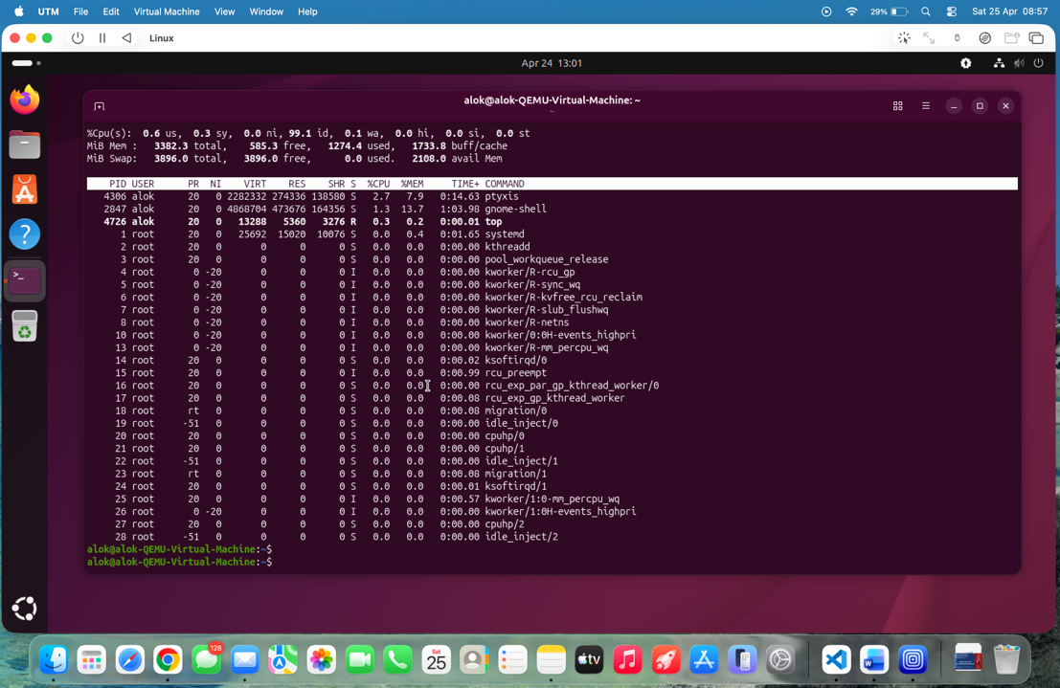
Figure1. This screenshot shows real-time system processes, CPU usage, memory usage, and running tasks. It demonstrates how the operating system manages multiple processes simultaneously and allocates CPU resources efficiently.

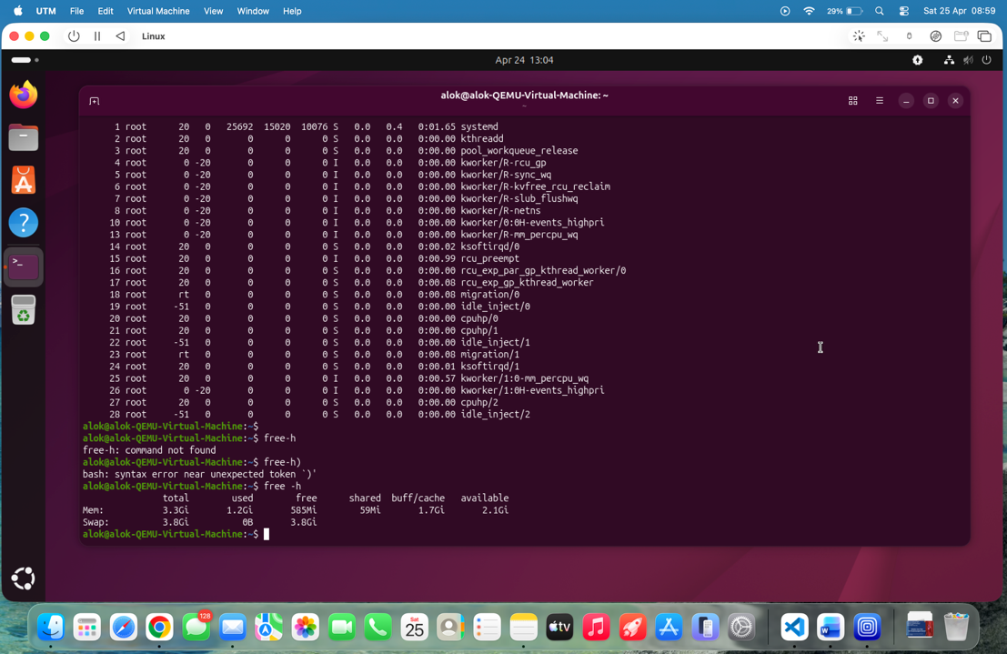
Figure2. This screenshot displays the total, used, and available memory in the system. It demonstrates how the operating system manages RAM and ensures efficient memory allocation for running applications.

Use of Windows OS CLI Commands
File and Directory Management
Windows Command Line Interface – The easiest way to navigate and control the files and folders using simple commands. The command mkdir is used to create a new folder, and dir is used to show the contents of a directory. These commands give a simple way to manage and display files without using the graphical interface.
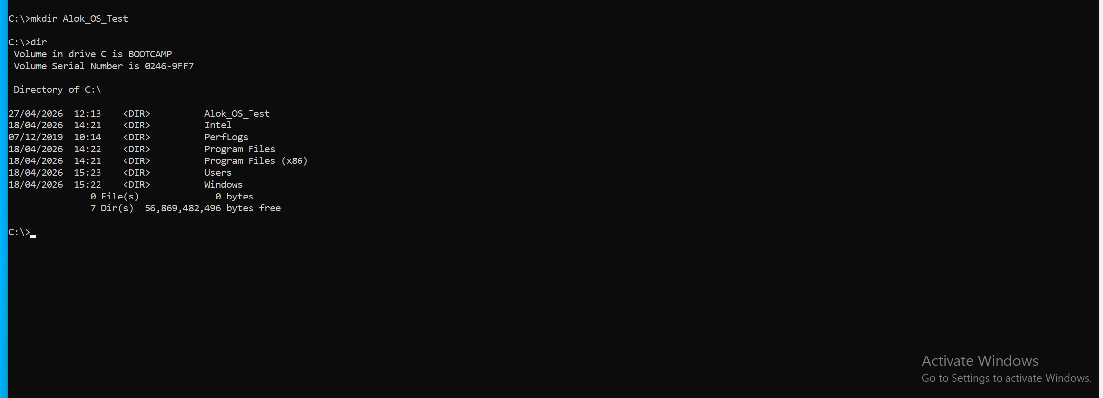
Figure 3: Creating a new folder using mkdir and listing directory contents using dir command in Windows Command Prompt.

Process Management
The tasklist command is used to display all running processes in the system. It provides details such as process name, process ID (PID), and memory usage. This helps in monitoring system performance and identifying active applications.
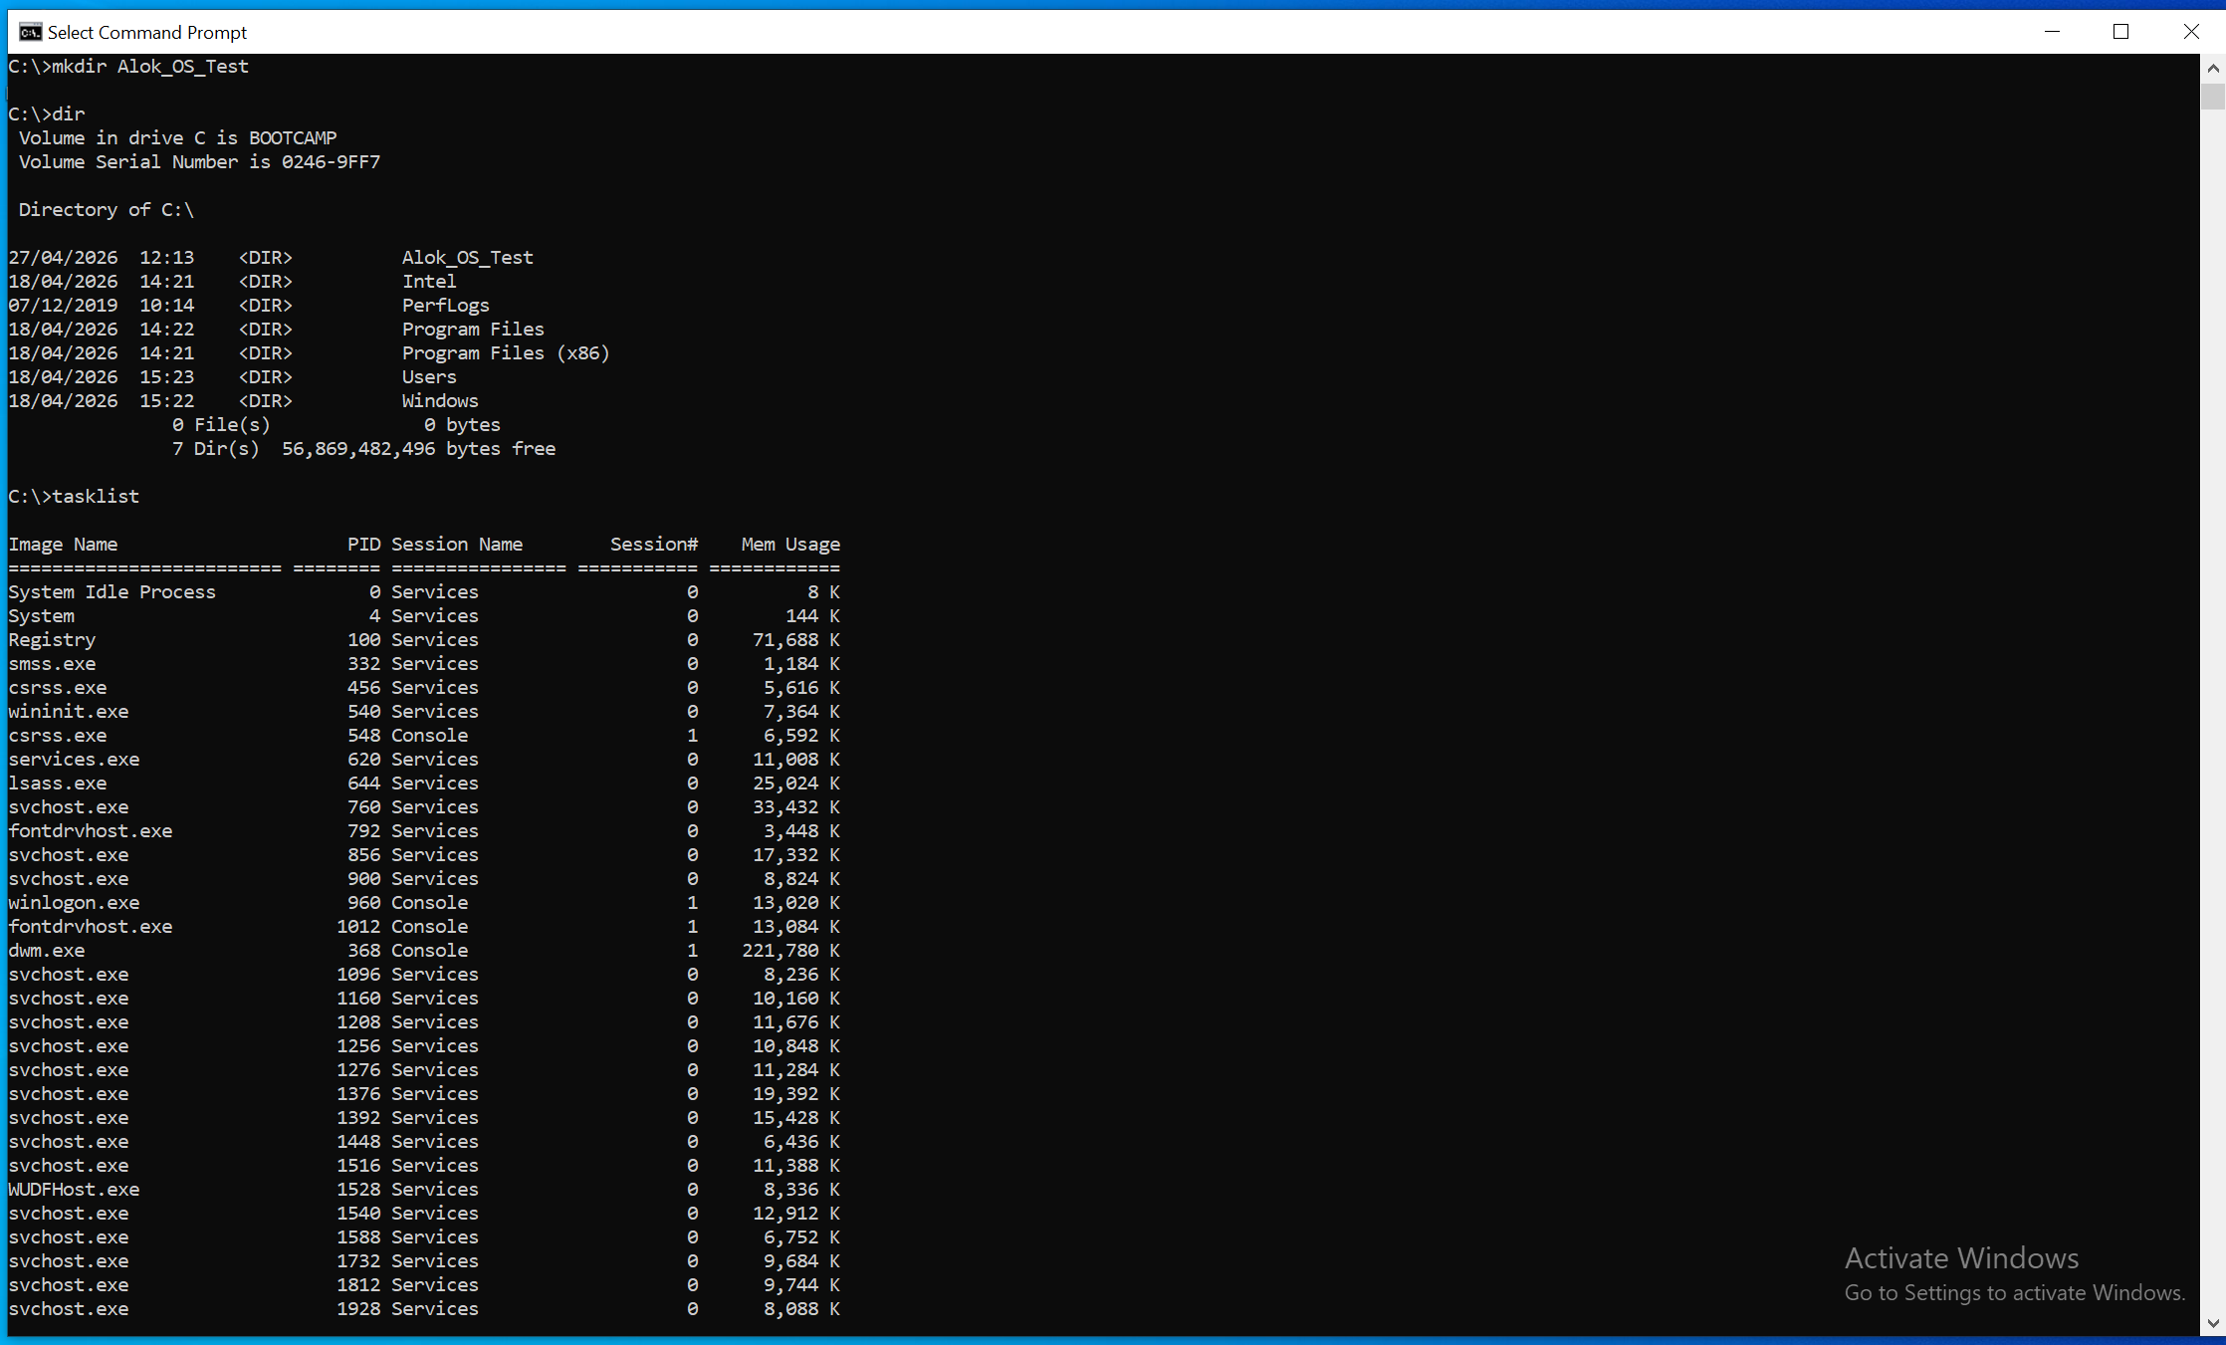
Figure 4: Displaying running processes using tasklist command in Windows Command Prompt.

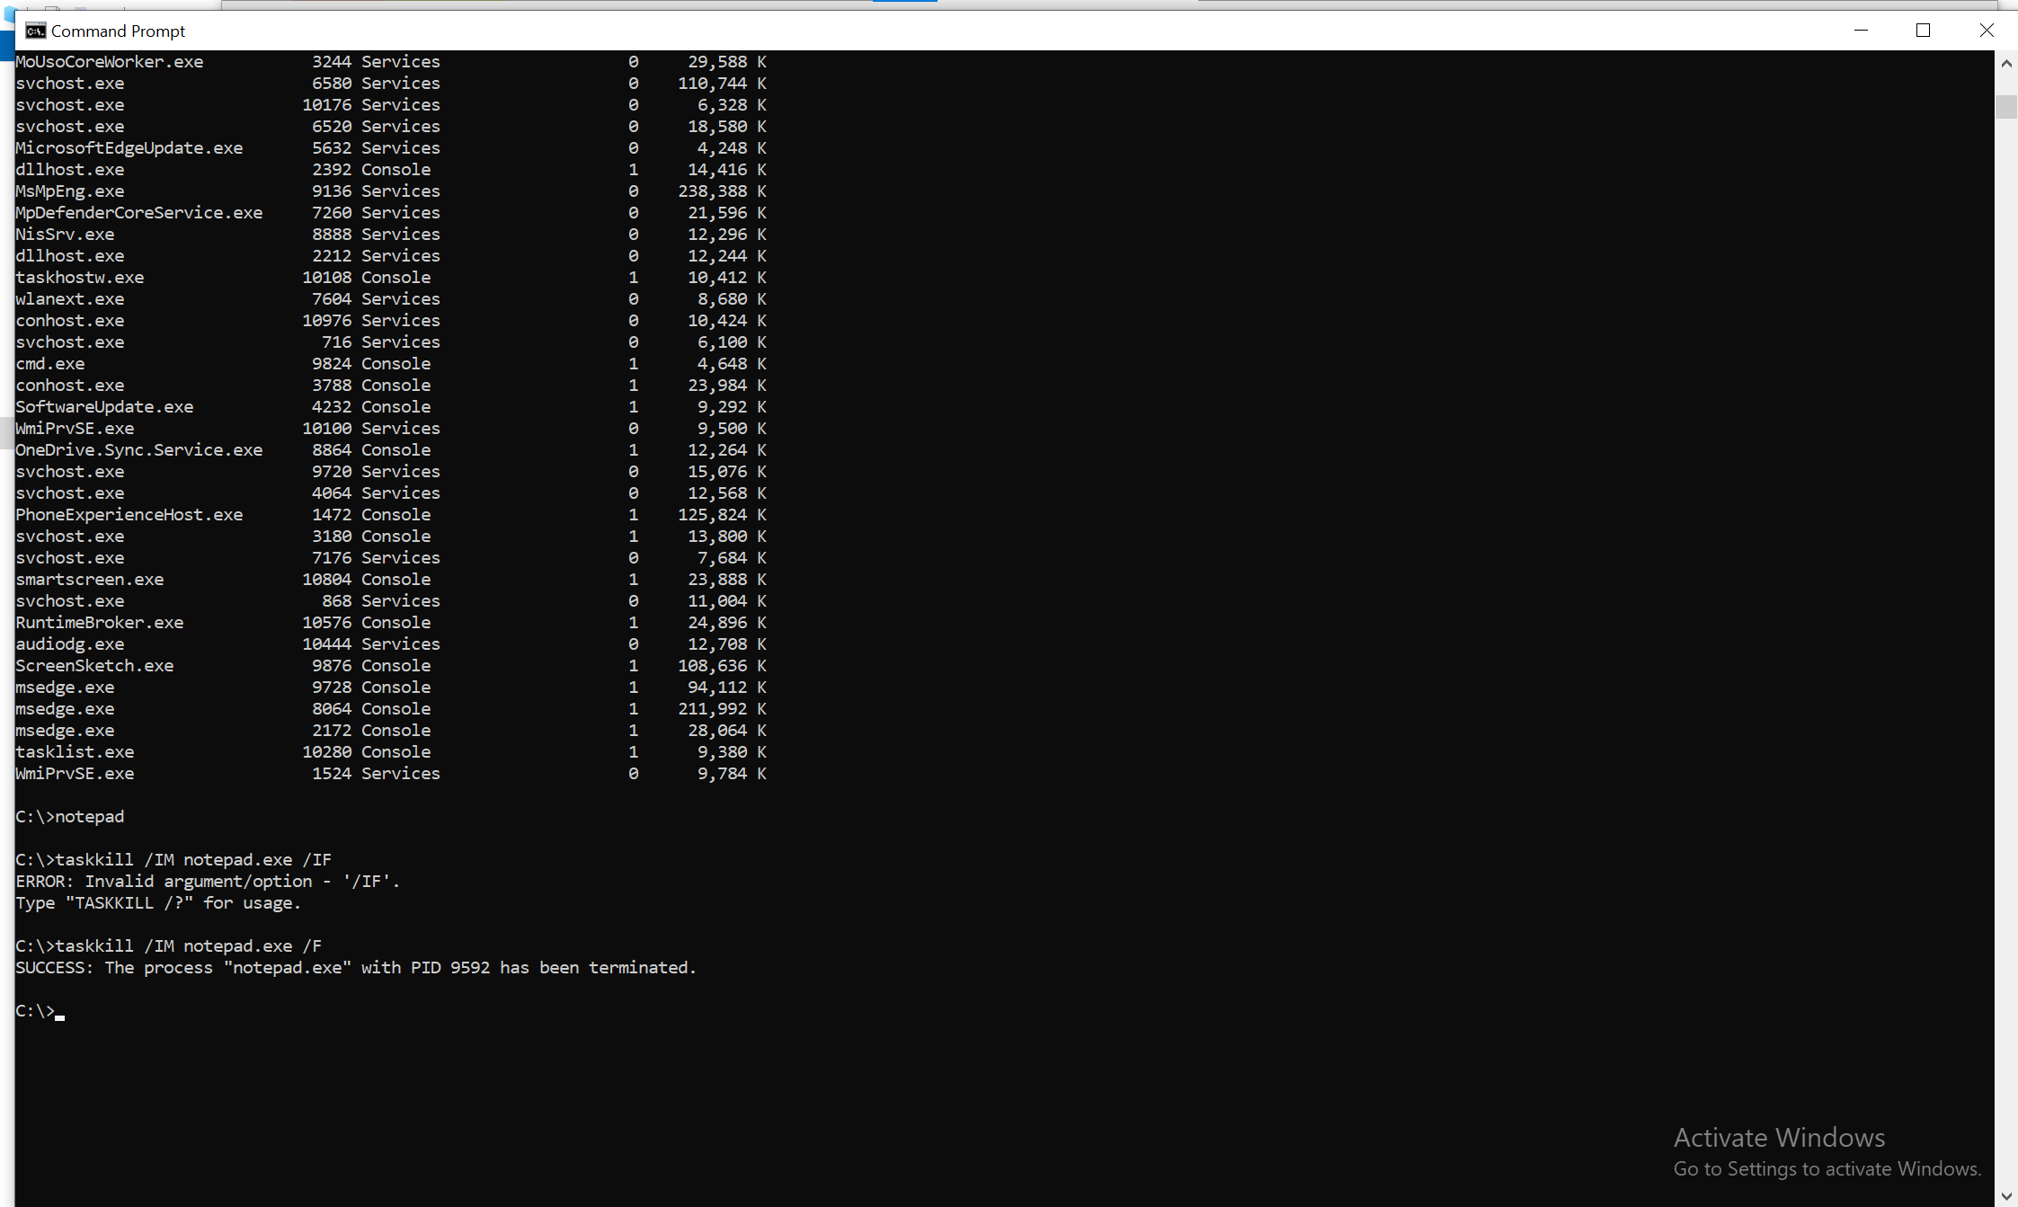
Figure 5: Using taskkill command to terminate a process in Windows. The screenshot shows an incorrect attempt followed by a successful execution of the command.
The taskkill command is used to terminate running processes in Windows. In this example, an incorrect command was first entered, which resulted in an error message. After correcting the syntax, the command successfully terminated the Notepad process. This demonstrates how CLI commands can be used to control system processes and resolve issues.

Network Monitoring and Testing
The ipconfig command is used to display network configuration details of the system, including IP address, subnet mask, and default gateway. This information is useful for diagnosing network issues. In addition, the ping command is used to test connectivity between the local computer and external servers. In this example, the system successfully communicates with google.com, confirming that the network connection is working properly.
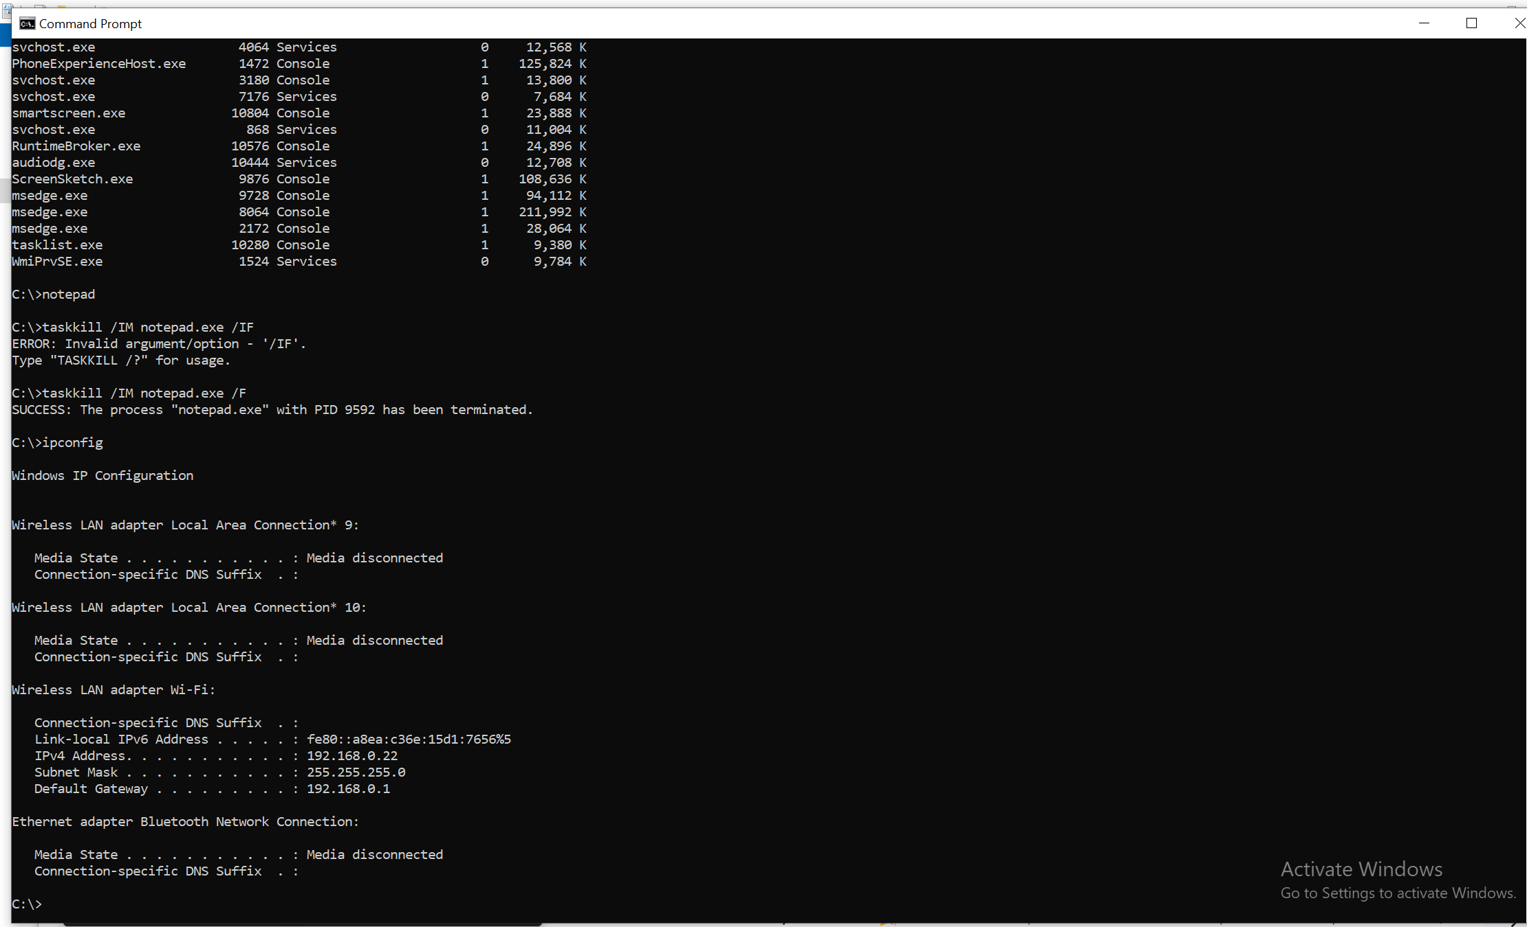
Figure 6: Using the ipconfig command to display network configuration details such as IP address, subnet mask, and default gateway.

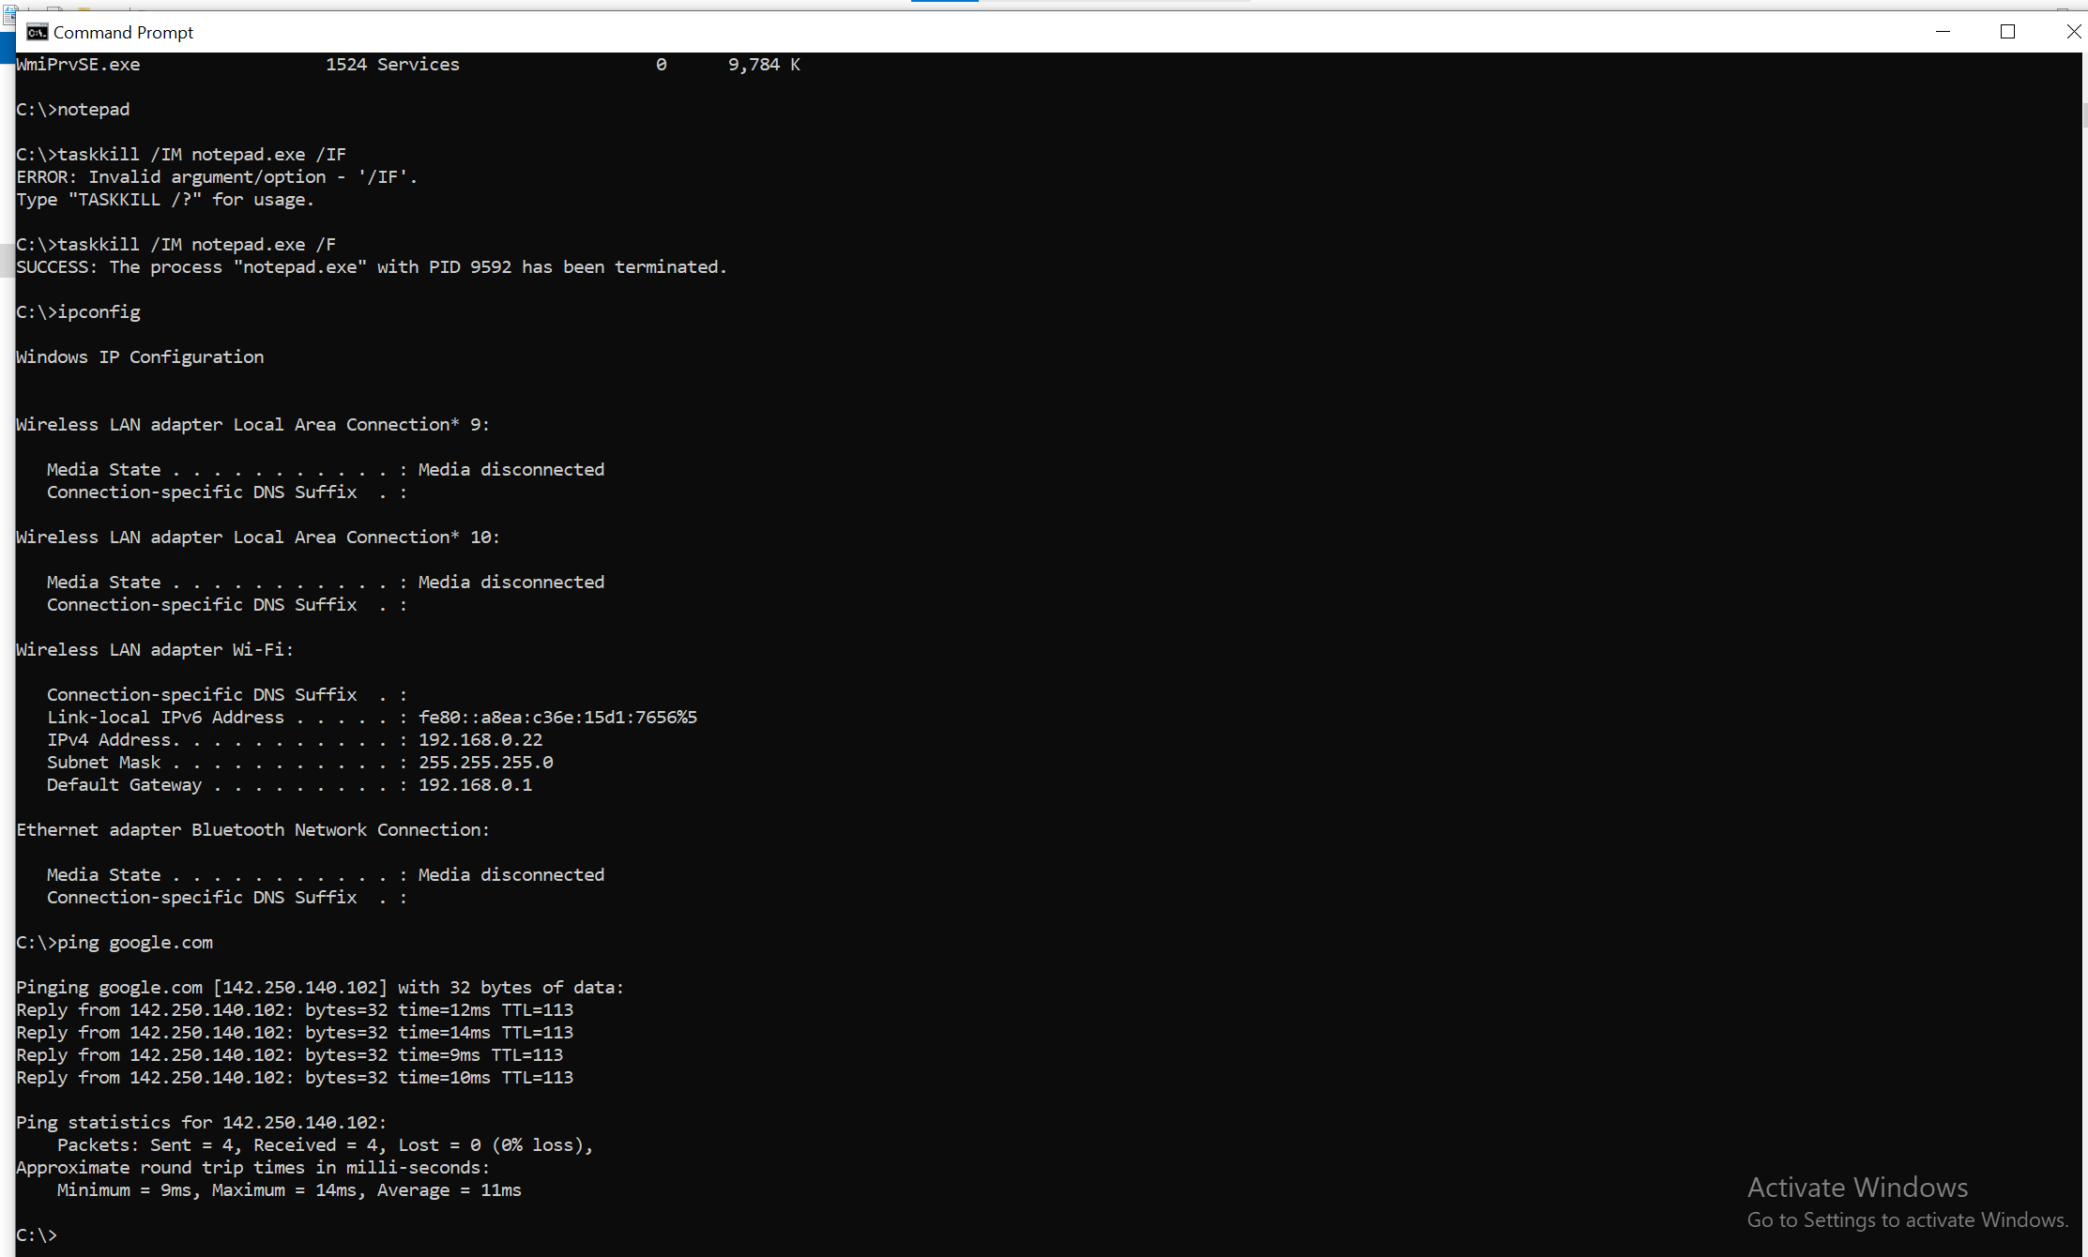
Figure 7: Using the ping command to test network connectivity between the local system and an external server (google.com).
User Management
The net user command is used to manage user accounts on a Windows system. It allows administrators to view existing users, create new accounts, and modify account settings. In this example, the command displays all available user accounts on the system, which helps in managing access and security.
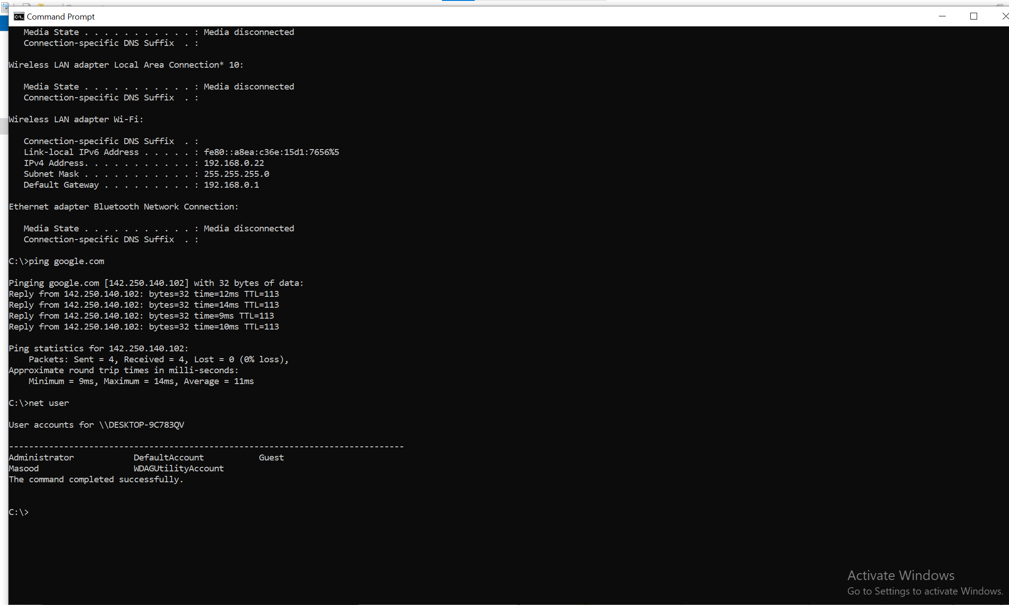
Figure 8: Using the net user command to display all user accounts available on the system.

Task Scheduling
The schtasks command is used to manage and view scheduled tasks in Windows. It allows users to automate system operations such as updates, backups, and maintenance tasks. The screenshot shows a list of scheduled tasks along with their next run time and status, demonstrating how automation is handled within the operating system.
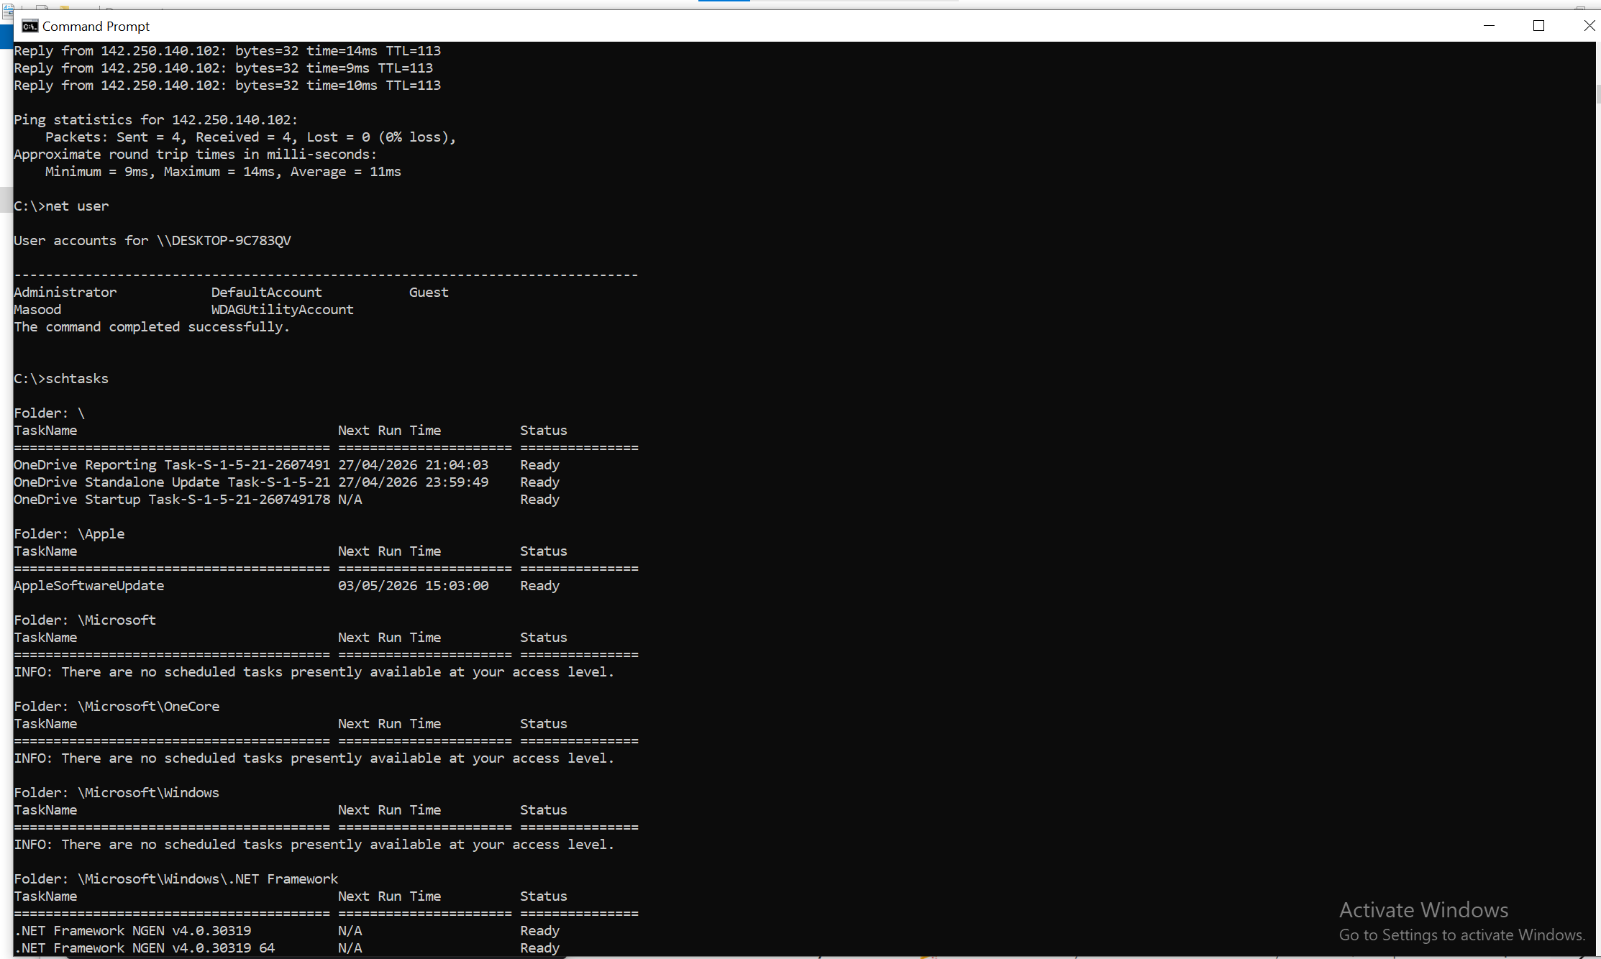
Figure 9: Using the schtasks command to display scheduled tasks and their execution status in Windows.

Windows Batch Scripts

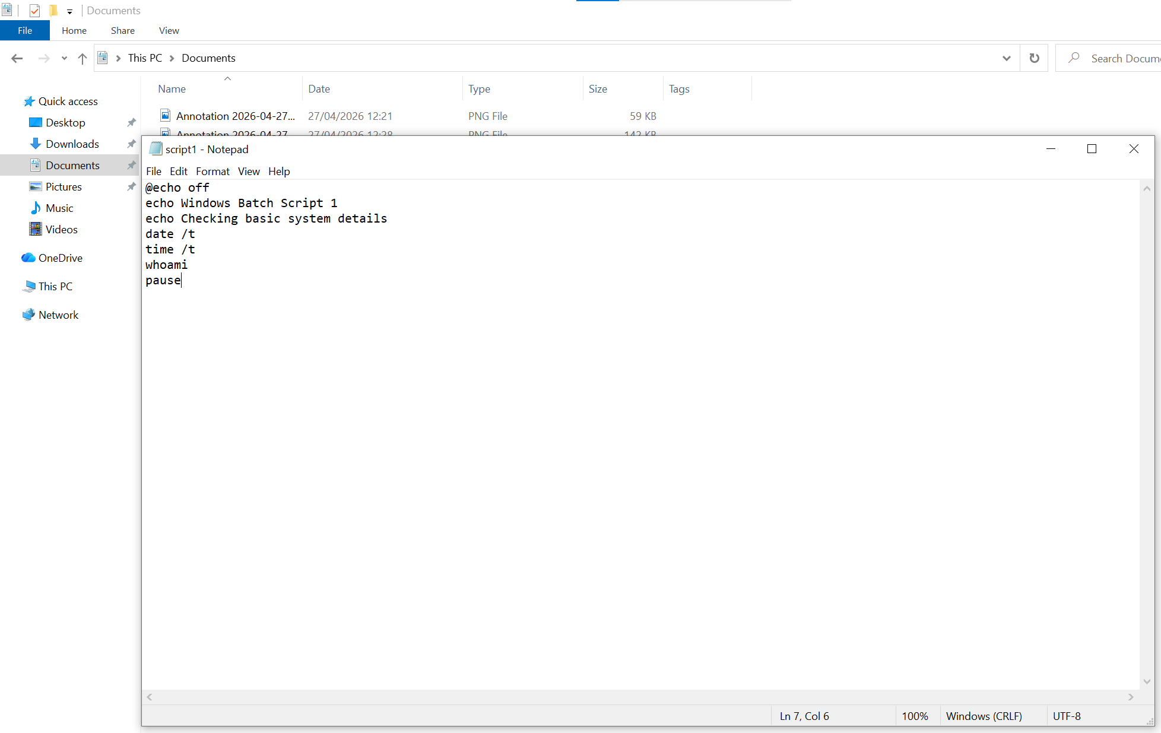
Figure 10: Windows Batch Script 1 code showing date, time, and user information commands.

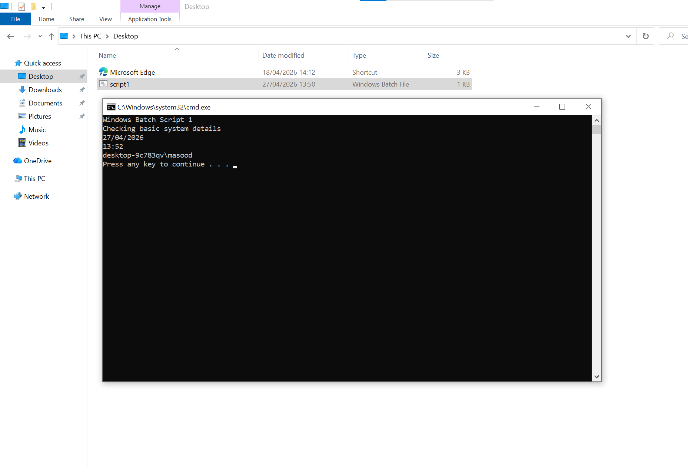
Figure 11: Output of Windows Batch Script 1 displaying date, time, and current user information.

This batch script demonstrates basic automation in Windows using simple commands. It displays the system date, time, and current user. The script uses commands such as date, time, and whoami to retrieve system information. This shows how batch scripting can automate routine system checks.

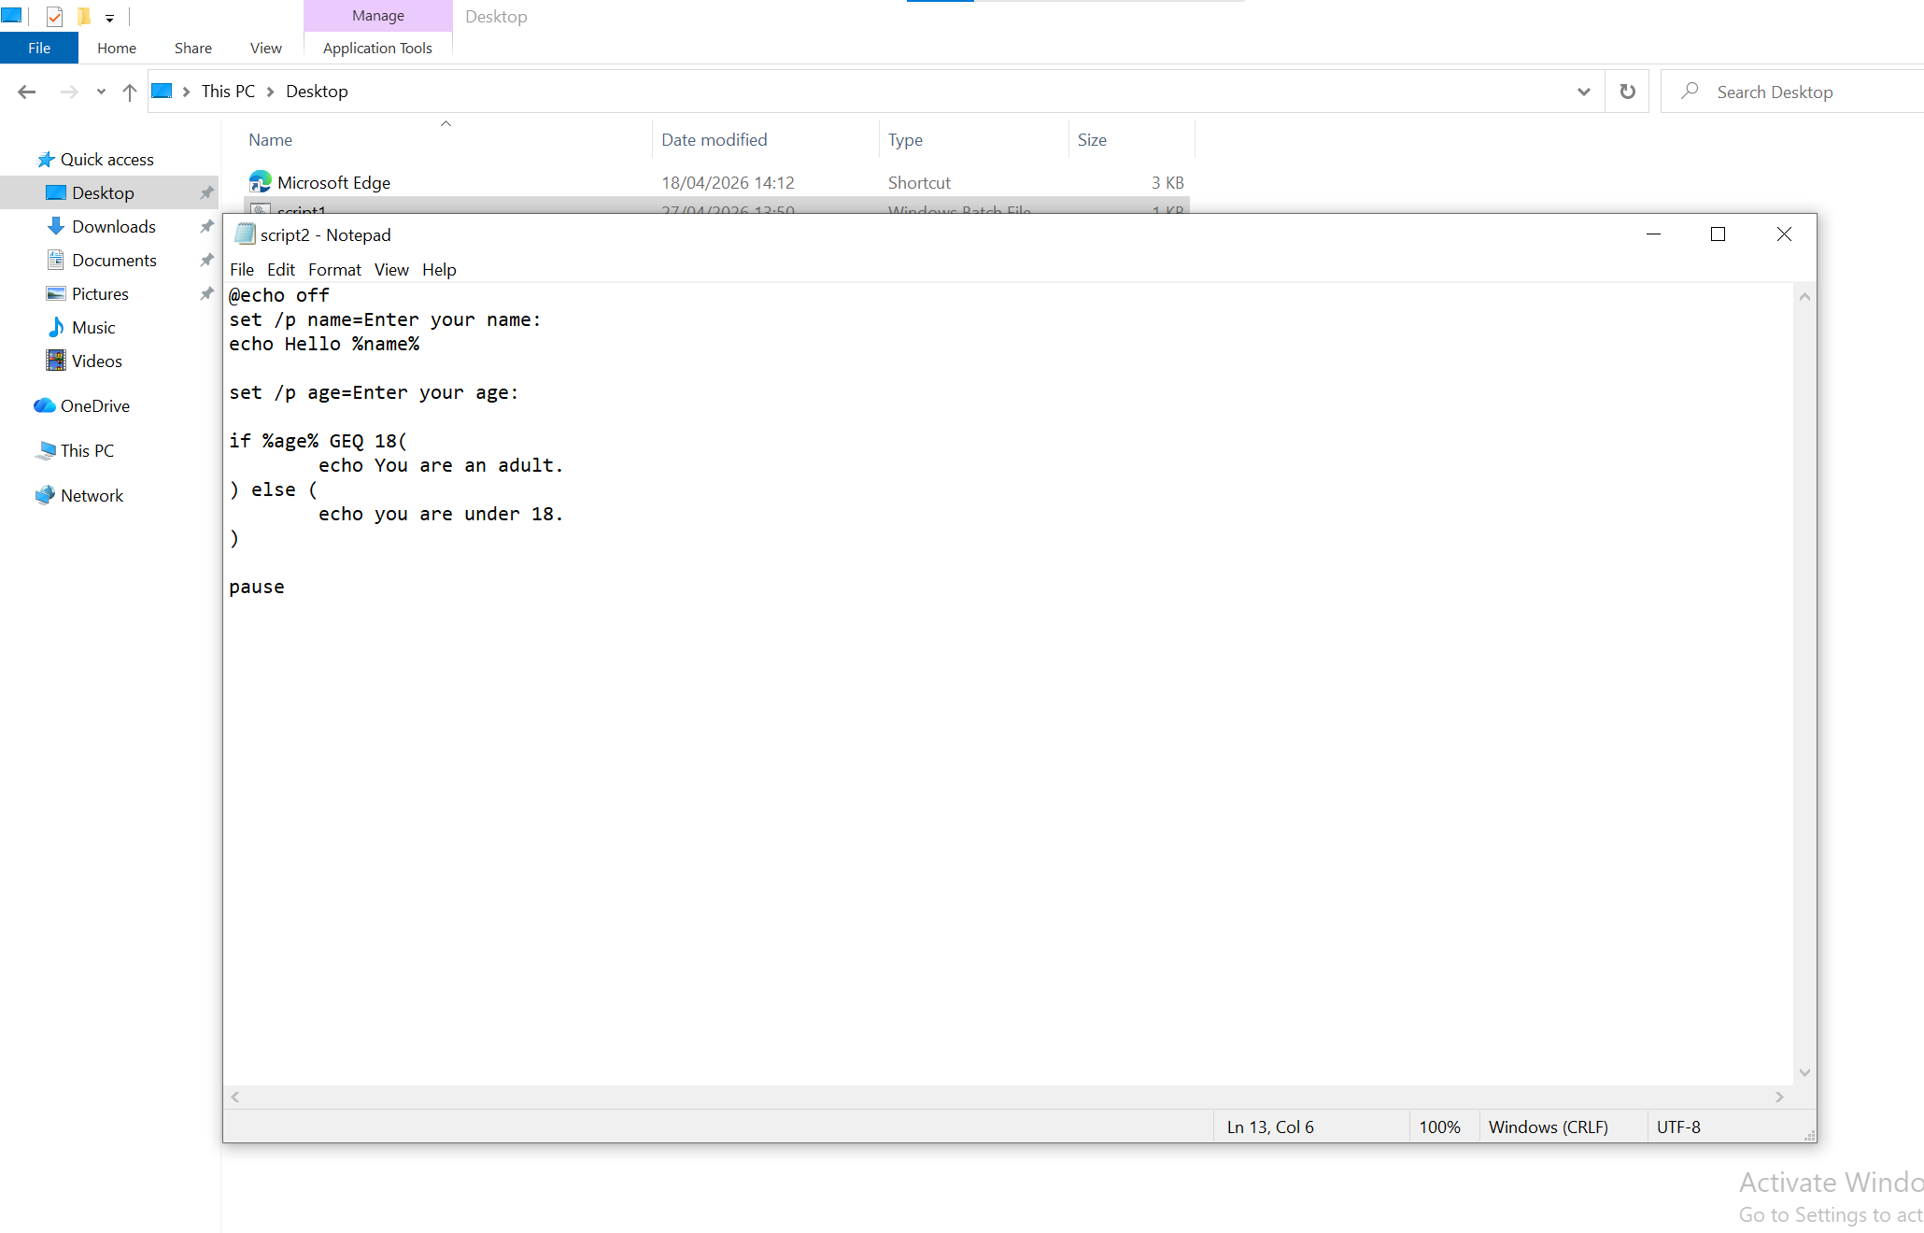
Figure 12: Windows Batch Script 2 code demonstrating user input, variables, and conditional statements.
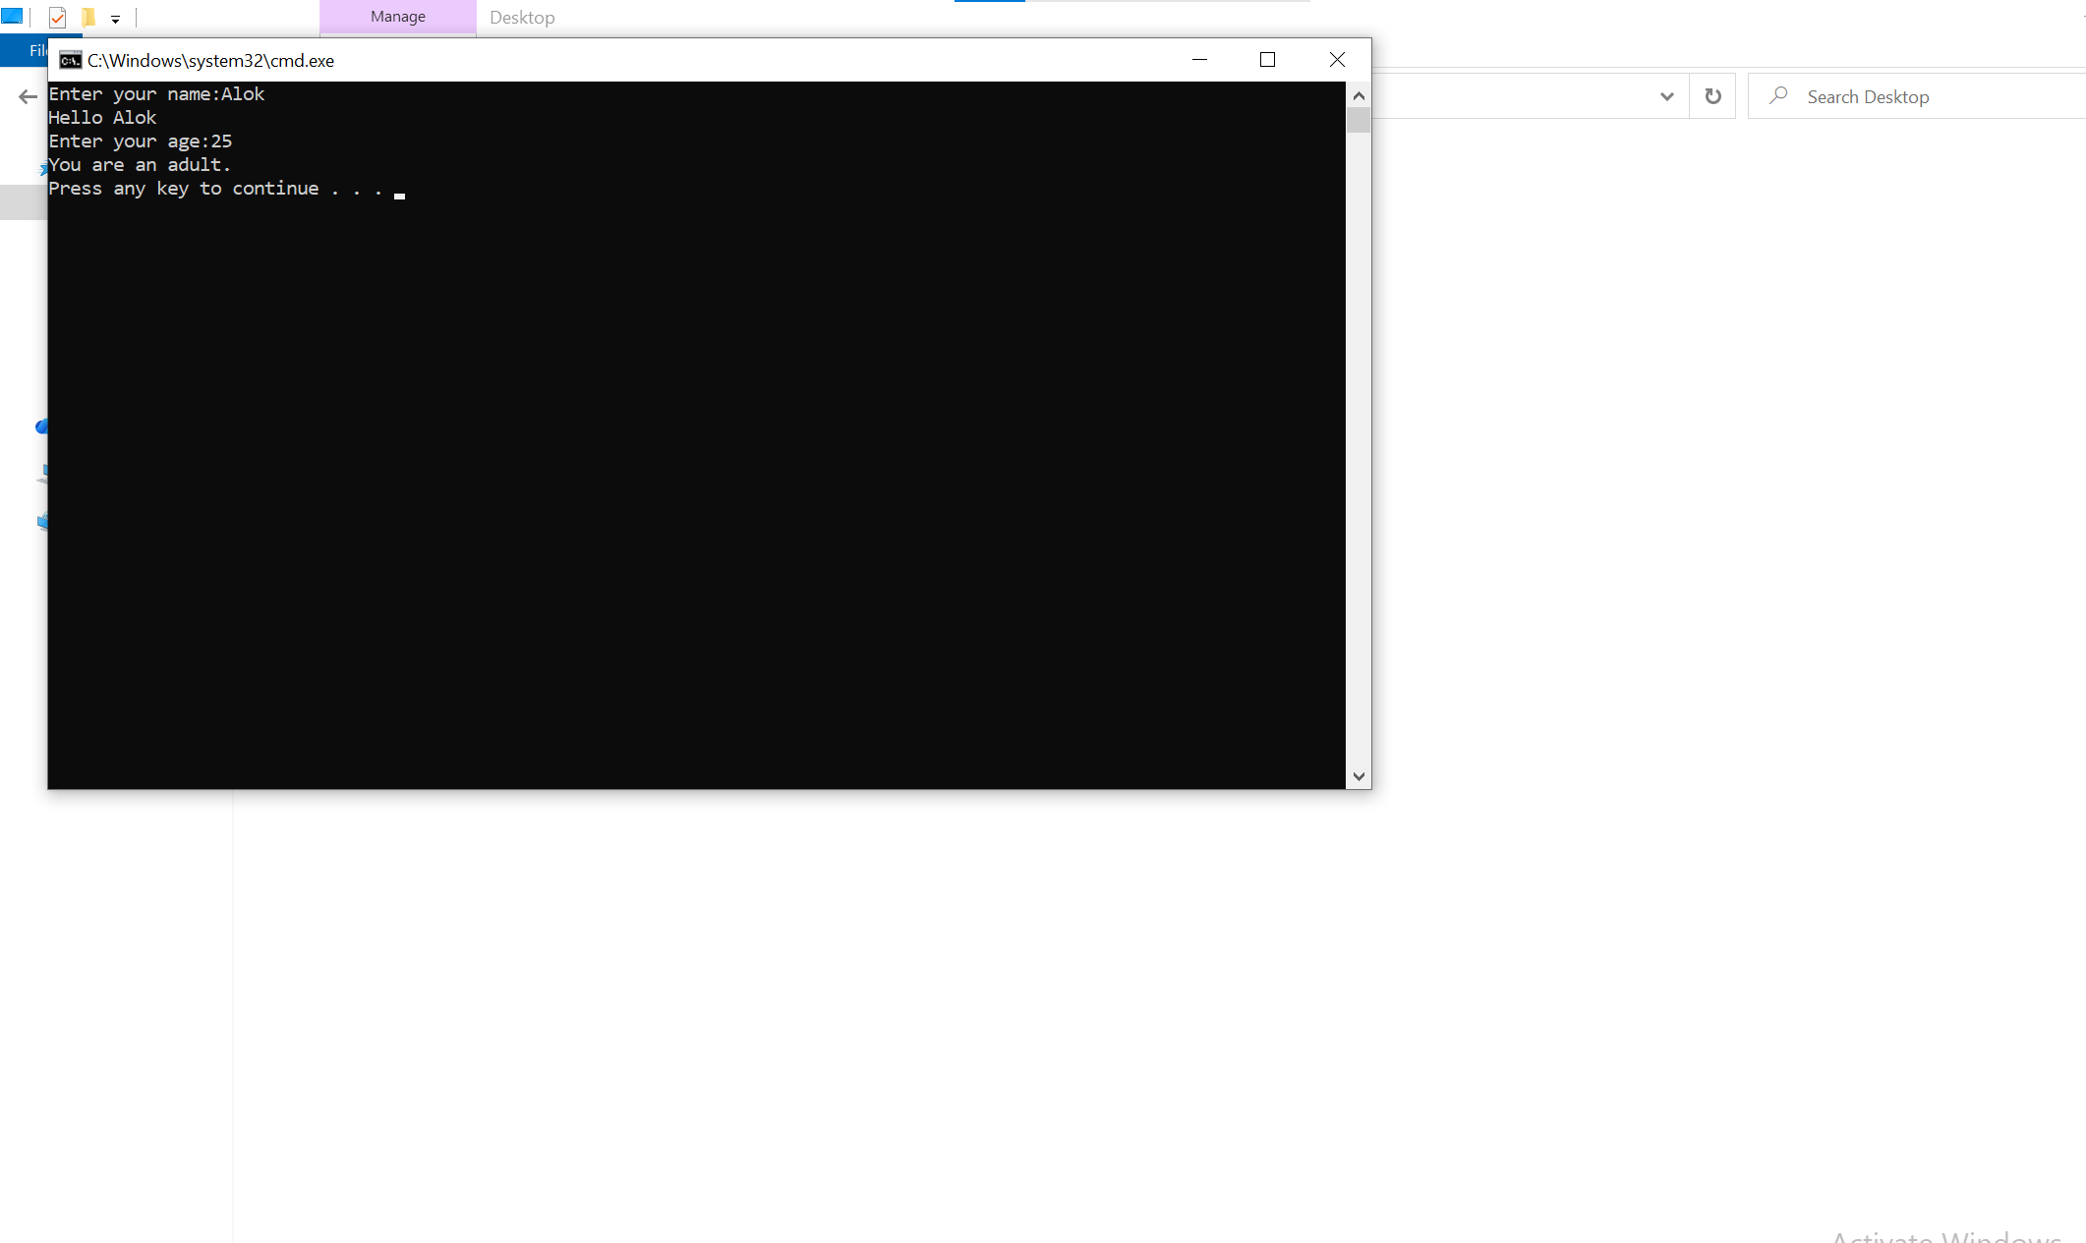
Figure 13: Output of Windows Batch Script 2 showing user input and conditional result.

This batch script demonstrates the use of variables, user input, and conditional statements in Windows. The script asks the user to enter their name and age, stores the values in variables, and uses an if statement to determine whether the user is an adult or under 18. This shows how batch scripting can be used to create interactive and decision-based automation.

Use of Command Line Interface in Linux

In Linux, the CLI (Command Line Interface) is a way for the user to communicate with the OS by typing commands in the terminal. It is used by System Administrators and Developers a lot because of the vast control over the system and the ability to complete the tasks rapidly.

The terminal in Linux is used to run commands for managing files , monitoring the system and for administrative chores . The CLI is quicker and more efficient than GUIs , especially when there are large quantities of files or repetitive activities involved .

ls is a popular command. This will list the files and folders in the current location . cd The cd command allows you to change directories . pwd command for printing current directory path. The user can navigate the file system efficiently using the commands
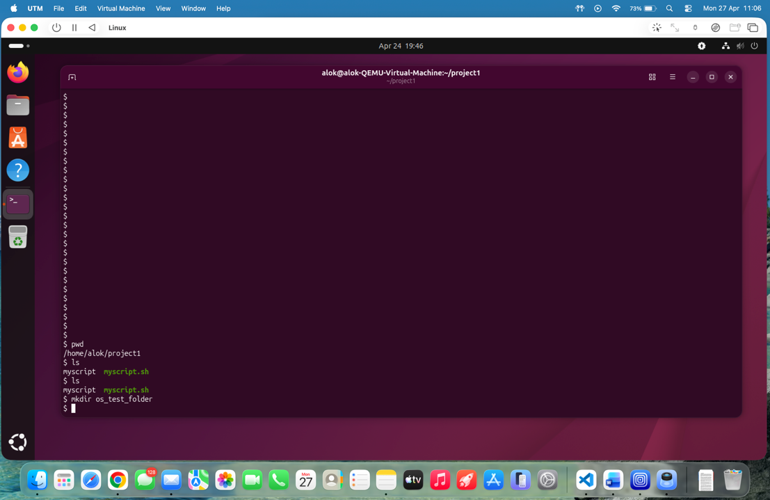
Figure 14: Displaying current directory and listing files using pwd and ls commands

mkdir creates a new directory. rm removes files or directories. For example, you can create a new folder with the command mkdir testfolder and delete a file with rm file.txt. These commands allow you to operate with files directly from the command line.

Free -h shows the memory use in a human-readable manner . System monitoring programs like top show the ongoing processes and CPU utilisation in real-time . These commands are helpful if you want to check the system performance and resource utilisation. The ps aux command was used to display active processes and monitor system performance.
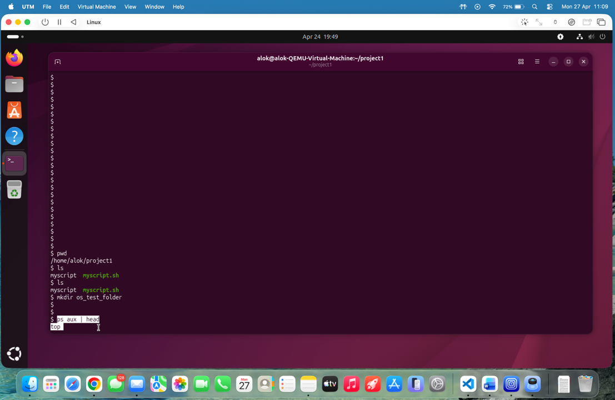
Figure 15. ps aux | head command in Linux.
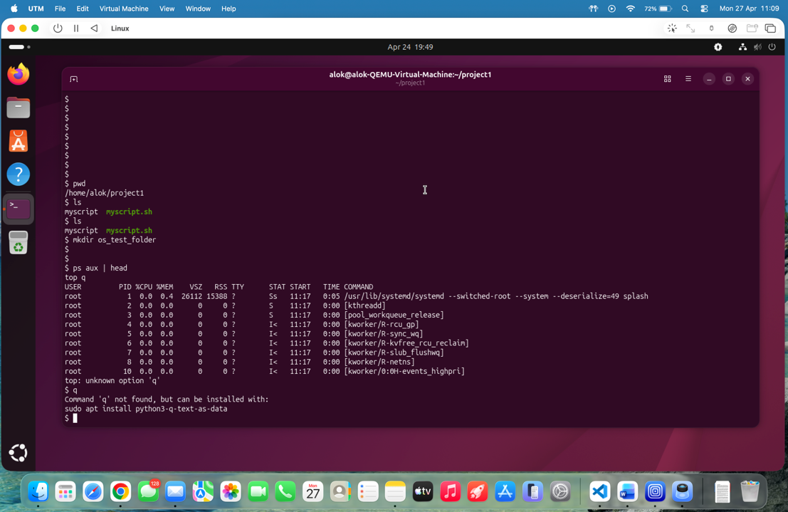
Figure 16: Viewing running processes using ps aux | head command in Linux

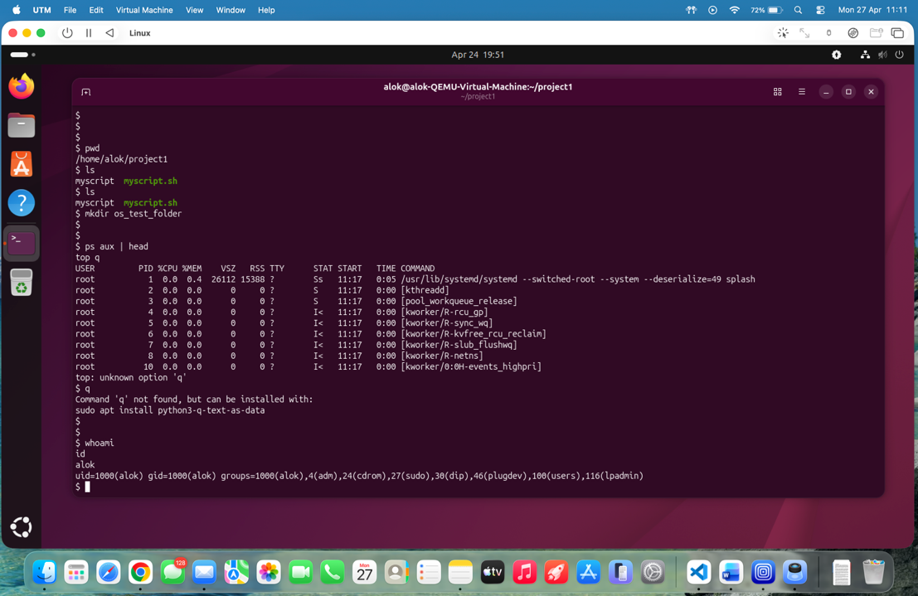
Figure 17: Displaying user identity and group information using whoami and id commands
The commands whoami and id were used to check the current user and group permissions.

Linux CLI is a powerful tool to operate your system efficiently, automate tasks and control components of the operating system in depth.
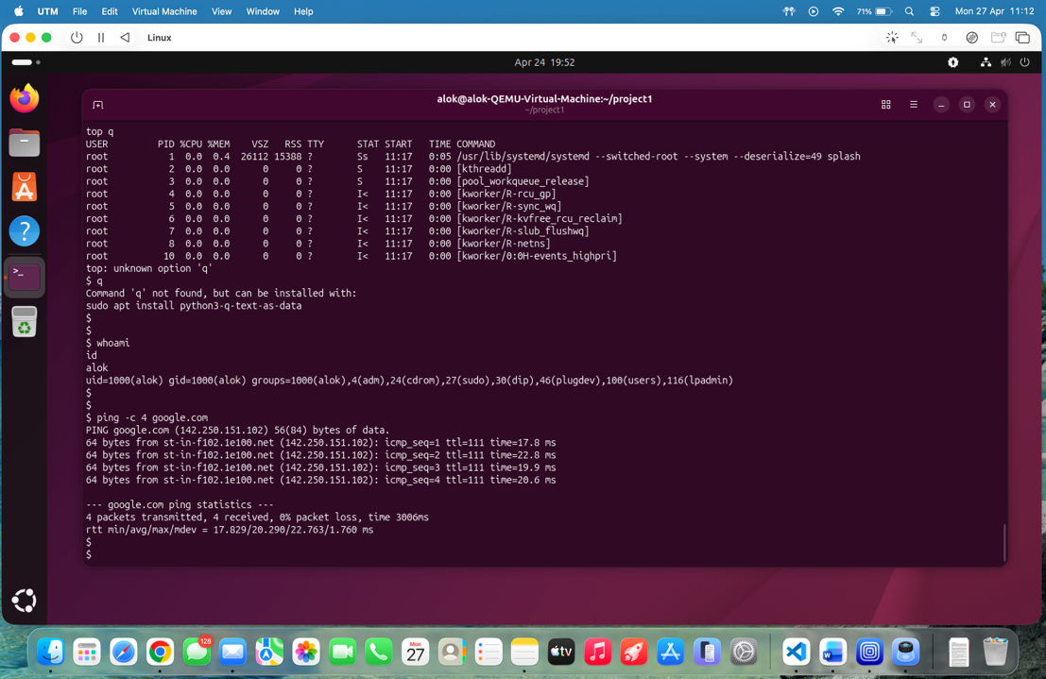
Figure 18: Testing network connectivity using ping command in Linux
The ping command was used to test network connectivity and verify communication with external servers.

Other system management functions are also commonly performed using other Linux CLI commands. You can also move around folders using cd and quickly create files with touch . rm The rm command removes files and folders. The top command is used to monitor the system by displaying the ongoing processes and CPU utilisation in real-time. The free -h command provides the memory usage in a human-readable format and the uptime tells the length of time the system has been running. You can obtain the IP address information with network configuration commands like ip a. These commands further highlight the power and flexibility of the Linux command line interface.

Use of Batch and Bash Scripts

Scripts are little programs that do things automatically inside an operating system. These are really useful to save time and don't have to type the same commands over and over again. Different operating systems employ different scripting types.
Scripts in Windows are commonly written as Batch files (with the suffix .bat).

These are scripts you run from Command Prompt to automate such tasks as creating folders, copying files, or displaying system statistics. Batch scripts employ simple commands like echo, dir and pause. For example, you can write a batch script that displays a message and lists files in a directory.
Scripts are written on linux as bash scripts with shell commands. These scripts are more powerful and more flexible than Batch scripts. Bash scripts are used to automate complex tasks such as system upgrades, file processing and a number of commands in a series. System administrators and programmers frequently use them .
A simple bash script may show a message and show system info. They finish with the .sh suffix and require execution permissions . chmod +x - Makes the script runnable.
Batch and Bash scripts are helpful for automation. Batch scripts are widespread in Windows while Bash scripts are common in Linux. Both of these help to increase efficiency and reduce manual work for recurring processes.

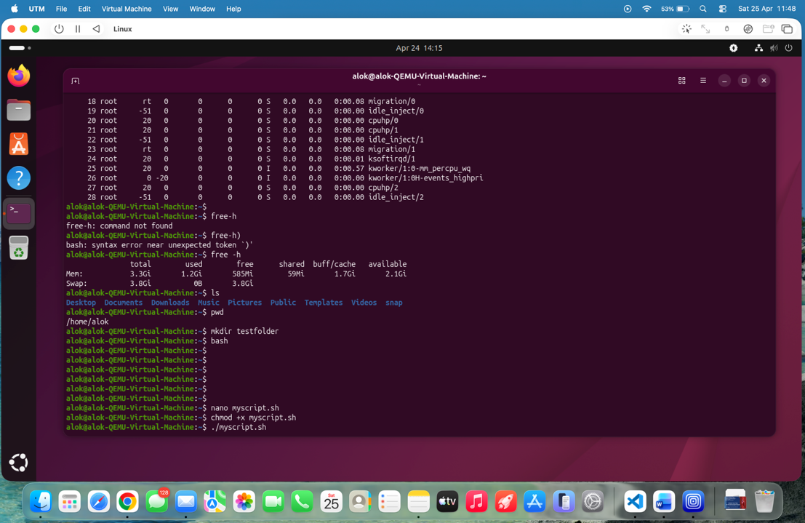
Figure 19. This screenshot shows the Bash script being given execute permission before running it in the Linux terminal.

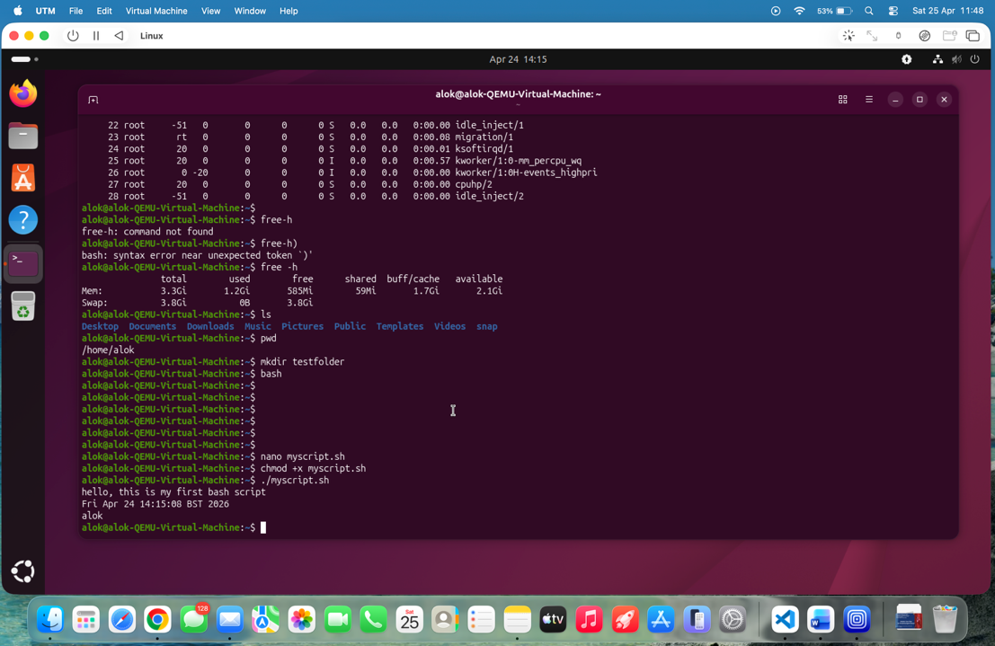
Figure 20. This screenshot shows the Bash script output, including the message, current date, and logged-in user.

Conclusion
This assignment examined the basic roles of general-purpose operating systems and how they are used in real-world computer situations. It explained how operating systems manage processes, memory, files, devices, and security to ensure that the system functions smoothly and efficiently. Features are needed in workplaces, for normal users and pros.
The assignment was also a great introduction to working with command line interfaces in the Linux environment. The assignment explored the file system and monitored the system’s performance using commands like ls, pwd, mkdir, and top. This made it more clear to understand how CLI tools provide greater control and flexibility than graphical interfaces.
Also a simple bash script was written and executed successfully. This was a case of the usage of scripting in operating systems to automate things. This script is an example of how to put numerous commands into one executable file and shows a message, the system date and user information.
This is a very valuable exercise for strengthening theoretical knowledge and practical skills in operating systems. These skills are important in the real world of computer operations, especially in IT or technical positions where you have to administrate systems and work on the command line.

The Windows command line tools were also explored, where commands such as tasklist, ipconfig, and schtasks were used to manage processes, network settings, and scheduled tasks.

References
[1] W. Stallings, Operating Systems: Internals and Design Principles, 9th ed. Pearson, 2018.
[2] A. Silberschatz, P. B. Galvin and G. Gagne, Operating System Concepts, 10th ed. Wiley, 2018.
[3] A. S. Tanenbaum and H. Bos, Modern Operating Systems, 4th ed. Pearson, 2015.
[4] Ubuntu Documentation, “Ubuntu Command Line Basics,” [Online]. Available: https://ubuntu.com/tutorials.

