
Applied Leadership and Management Outreach
Module Assignment Submission
Student Name: | Whitney Davies
Student Number: | 2329046
Module No: | BMSK5012
Module Title: | Understanding and Engaging in the Customer Experience

Statement of Confirmation of Authenticity
By the act of making this submission, the student declares that this is the work of the student named above. The work has not, in whole or in part, been knowingly presented elsewhere for assessment, or where assessment has been built on a previous assessment, this has been identified. Where materials have been used from other sources it has been properly acknowledged. If this statement is untrue, the student acknowledges that an assessment offence has been committed.
Attention is drawn to the plagiarism and unfair practice policies of UWTSD.
Table of Contents
Introduction 3
Customer Value – The Customer’s Perspective 3
Application to organisation 5
Customer Value – The Organisation’s Perspective 6
Application to organisation 7
CRM and Customer Relationship Strategies 7
Application to organisation 9
Quality Systems and Their Impact on Customer Value 10
Application to organisation 11
Customer Needs, Expectations and Experience 12
Application to organisation 13
Conclusion and Recommendations 14
References 16

Introduction
In today’s competitive markets, customers are no longer focused solely on price or product features. They seek experiences that feel personal, relevant and emotionally satisfying. Value is no longer just about function or cost, it now includes how a product or service fits into everyday life, what it represents, and the feelings it creates. As expectations become more complex, organisations are under increasing pressure to understand what matters most to different customers.
At the same time, businesses must also consider customer value from their own perspective. Some customers contribute more over time through loyalty, repeat purchases, recommendations or feedback. This makes it important to evaluate value in both directions: the value delivered to customers and the value received from them.
This report explores customer value from these two perspectives. It examines how value is perceived and experienced by customers, and how organisations assess and manage the value of their customer base. It also investigates the role of tools such as customer relationship management (CRM) systems and quality frameworks in enhancing customer experiences and business outcomes.
The aim is to provide a clearer understanding of how customer value can be embedded into everyday operations, not only to improve satisfaction, but to support long-term success for both customers and organisations.

Customer Value – The Customer’s Perspective
Customer value means different things to different people. While some focus on price or convenience, others care more about how a product or service makes them feel, whether it fits into their lifestyle, or if it reflects their values. Almquist et al. (2016) group value into four main types:
- Functional – how well something works or solves a problem
- Emotional – the feelings it creates, like trust or reassurance
- Life-changing – the confidence or personal growth it supports
- Social impact – whether it contributes to causes the customer cares about
Also highlighted are the 30 elements that sit within these types, showing how layered and personal customer value can be. As per the image below.
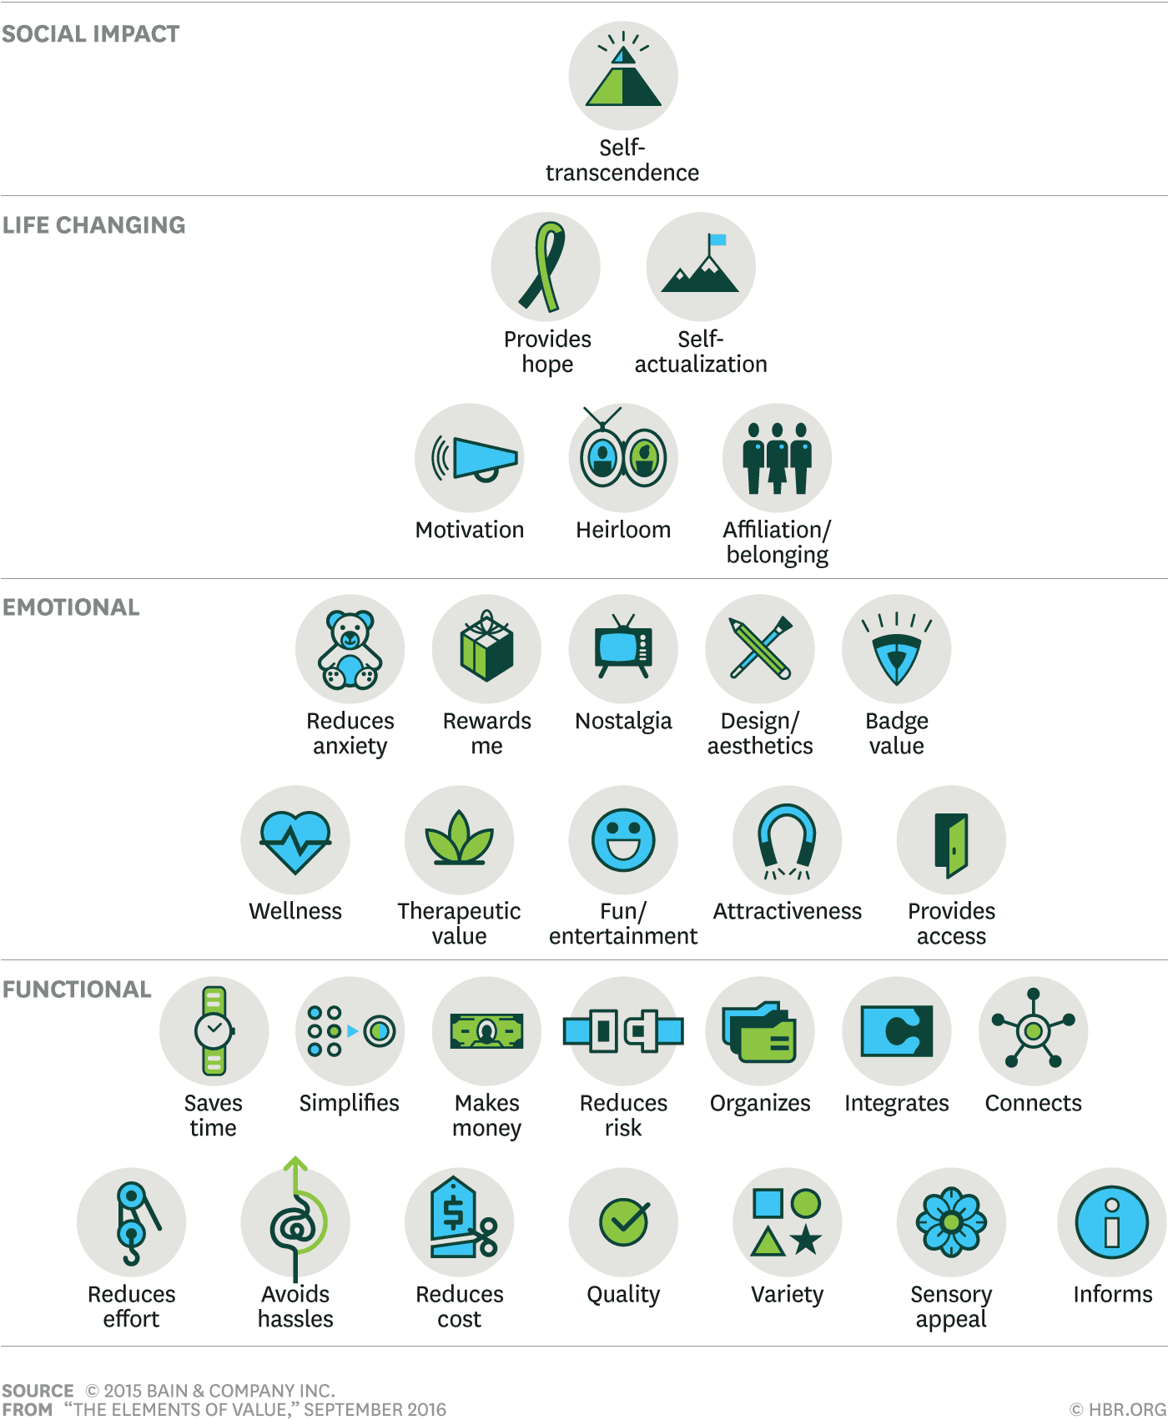
Source: Bain & Company
Functional value is often the easiest to measure. It’s about things like reliability, ease of use and getting the job done. Emotional value comes from how someone feels during and after the experience. Life-changing value is more long-term, and social impact relates to ethical or environmental considerations that influence decisions.
Other models also help explain how value is judged. Zeithaml (1988) describes it as a trade-off between what customers get and what they give up. This could be time, effort or money. The same service might feel like great value to one person and not to another, depending on their expectations. For example, a client who wants a fast turnaround may value speed over detailed reporting, while another may feel short-changed without a more comprehensive deliverable.
Schindler and Holbrook (2003) add to this by making a distinction between two types of value:
- Utilitarian value – practical, task-focused and purposeful
- Hedonic value – emotional, feel-good and based on enjoyment or satisfaction
In professional services, both types come are relevant. Clients expect accuracy, speed and clarity. But they also notice how easy a team is to deal with, how well they are listened to, and whether the experience feels smooth or frustrating. These softer elements often make the biggest difference in how value is perceived, even if they’re hard to measure.
It’s also worth noting that people do not always make decisions logically. Shaw and Hamilton (2016) explain that emotions often drive behaviour more than we think. A service might not be the cheapest or most detailed, but if it feels more “right,” customers will often go with it. This is where tone, trust and small signals matter just as much as facts or features.
Finally, the way a service is delivered can shape how value is experienced. Factors like:
- How quickly someone responds
- How consistent the experience feels across teams
- How well the service can be adapted to fit the client’s style or goals
These moments all play a part in shaping the client’s overall impression. Even small details, like how clear the language is in an email or how easy it is to schedule a call, can influence how valuable the service feels.

Application to organisation
In a professional services environment, functional value often comes from timely delivery, technical accuracy and reliability in meeting deadlines. Emotional value may be created through personal communication, transparency during complex projects or taking the time to explain outcomes clearly. For instance, one project team working with a public sector client focused heavily on proactive communication and co-designed reporting tools. This helped the client feel more in control, leading to improved satisfaction and increased willingness to engage in future work. Different service lines may cater to different value drivers, with audit clients prioritising risk mitigation and regulatory assurance, while advisory clients place more emphasis on insight, innovation and collaboration (Shaw & Hamilton, 2016).

Customer Value – The Organisation’s Perspective
While it is important to understand what customers value, it is just as important for organisations to recognise the value customers bring to them. This goes beyond financial returns. It includes things like loyalty, referrals, influence and even constructive feedback. Understanding these different types of value helps organisations focus their efforts where they will have the most impact. Kumar (2020) outlines several useful measures of customer value to the business.
- Customer Lifetime Value (CLV) – how much a client is likely to contribute over time, not just in revenue, but through ongoing projects and future opportunities
- Customer Referral Value – looks at how much new business a client can help bring in through recommendations or introductions. In professional services, this can be especially important, as referrals often carry more weight than marketing efforts
- Customer Influence Value – applies when a client has a strong presence in their industry or is particularly well-connected. Their relationship with the firm can help build trust with others.
- Customer Knowledge Value – is about the insight a client provides through regular feedback, ideas or constructive input. These clients can help improve the quality of service overall because they are engaged and willing to share what is working and what is not
These different kinds of value do not always show up in financial reports. A client who gives detailed feedback, may help improve the overall quality of delivery for other clients. A well-connected client who brings in one major referral can be worth far more than their own revenue stream alone.
Client retention is a particularly important area in professional services. Winning new work can be time-consuming, expensive and unpredictable, especially in competitive or regulated sectors. Keeping an existing client, on the other hand, means the firm can build on an existing relationship, understand the client better and often deliver more tailored or strategic work over time. Daffy (2001) points out that true customer loyalty is about more than just being satisfied. It is about creating a relationship where the client genuinely wants to stay. He describes this as moving from satisfaction to delight, where the experience is good enough that the client would not even think of going elsewhere.
Client acquisition still matters. New clients bring in fresh perspectives, create opportunities for growth and open the door to new sectors or service lines. In many cases, the ability to attract new business depends on the reputation built with existing clients. Word-of-mouth and referrals still carry more weight than most formal marketing, especially in industries where trust is key.
Organisational value also means knowing that not every client should be managed in the same way. Some clients are high-value and high-potential, while others may be one-off engagements or low-revenue relationships. This is where segmentation becomes useful, not just for marketing but for internal resource planning too.
Client value is not static. It changes as the relationship evolves. A small client today might grow into a major account in the future. Others may shift in importance due to mergers, market changes or internal restructuring. That is why regular review and good data matter.

Application to organisation
In the professional services environment, client value is often assessed using a mix of financial data, project history and relationship strength. Long-term clients, especially those working across multiple service lines, are typically managed more closely. This might include dedicated account teams, regular strategic reviews or access to insights tailored to their sector. One financial services client, for example, has worked with the firm across several transformation projects. What has helped sustain that relationship is not just the quality of the work, but the ongoing communication and the sense that the team understands their business and genuinely cares about the outcome.
Beyond revenue, the client also adds value through feedback, referrals and regular participation in industry roundtables. They are seen not just as a client, but as a partner. This relationship reflects what Daffy describes as “customer delight,” where the service consistently meets expectations and also goes a step further to build trust and long-term loyalty.
Rather than needing to re-pitch for every engagement, the work continues through mutual confidence and a shared understanding of what success looks like for both.

CRM and Customer Relationship Strategies
Customer Relationship Management, or CRM, is more than just a database. It is a business strategy designed to help teams understand customer behaviour, strengthen communication and deliver a more relevant, personalised experience. While CRM tools are important, the real value comes from how organisations use them to build lasting relationships.
Freeland (2002) describes CRM as a long-term investment in client loyalty. He highlights that it is not simply a tech solution, but a philosophy that places the customer at the centre of how decisions are made. In professional services, where relationships evolve over time, this approach can be especially powerful.
One key part of CRM strategy is segmentation; this includes grouping clients based on shared traits so they can be served more effectively. As Davey (2024) explains, segmentation helps firms move beyond basic demographic data and understand what motivates different types of clients. It supports better targeting, more relevant messaging and smarter planning across service lines. Common segmentation types include:
- Demographic (e.g. job role or seniority)
- Geographic (e.g. region or market served)
- Behavioural (e.g. engagement history or service usage)
- Psychographic (e.g. values, goals or risk appetite)
Rather than treating every client the same, segmentation helps teams make decisions about who needs proactive contact, who might respond to new offerings and where more personal attention could drive better outcomes.
CRM systems support this work by bringing together data from different parts of the business. In practice, this means professionals can track project history, contact records, engagement patterns and strategic preferences, all in one place. When used well, CRM helps align teams, reduce duplication and improve communication across the board.
Wailgum and Fruhlinger (2018) note that CRM is particularly valuable when used across sales, service and marketing teams. It allows each area to contribute to and learn from customer data. However, systems only work if the data is current and staff actually use them. Without good internal habits, even the best tools lose impact. Some of the main benefits of CRM include:
- More personalised communication
- Stronger client retention through timely follow-up
- Better visibility of client relationships across service lines
- Increased ability to identify cross-selling or growth opportunities
- Improved consistency in client experience
Davey (2024) also notes that segmentation supports retention and growth. By identifying which clients are most engaged, or which are at risk of leaving, firms can prioritise support where it matters most. CRM insights can also guide marketing campaigns, proposal follow-ups and account planning.

Application to organisation
CRM systems are used across the firm to track engagement, record project outcomes and manage contacts across multiple service lines. This is especially useful when different teams work with the same client on separate engagements. For example, a global client working with both tax and consulting services benefits from a shared CRM record that consolidates communication history and captures strategic preferences. This enables a more joined-up approach to client communication and avoids duplication.
An internal platform, commonly referred to as SWIFT, is used across the business to support client relationship management. This system acts as a central hub for storing client details, managing key contact information, tracking interactions and supporting engagement planning. It brings together data from various teams, allowing professionals to view account histories, upcoming opportunities and active pursuits in one place. By giving different service lines visibility into shared client records, SWIFT supports more consistent communication and helps teams align on relationship strategy.
Segmentation is also built into how SWIFT is used internally. Clients are grouped based on several factors, allowing for more focused support. These typically include:
- Industry sector (e.g. financial services, energy, healthcare, public sector)
- Size of organisation or overall client spend
- Strategic importance or key account status
- Number of service lines involved (single or multi-service)
- Geographic footprint (local, regional or global)
- Level of engagement and responsiveness
- Risk or regulatory complexity
- Openness to innovation and transformation
Overall, SWIFT helps turn client insight into action. Rather than relying on individual memory or siloed spreadsheets, professionals can use CRM to support decisions, tailor their communication and track progress across the full relationship lifecycle.

Quality Systems and Their Impact on Customer Value
Quality systems might not be the most visible part of a business, but they have a huge influence on how value is delivered and perceived by clients. When things go wrong, whether it is delays, errors or inconsistent service, it is often because the underlying processes are not working properly. Quality systems are there to stop that from happening. They help make sure that what is promised to the customer is actually delivered and done so in a reliable, repeatable way.
Approaches such as Total Quality Management (TQM), ISO 9001, Lean Thinking and Six Sigma are commonly used to guide this effort. Each of these methods helps improve consistency, reduce errors and encourage a culture of continuous improvement Garvin (1987). The PDCA cycle, which stands for Plan, Do, Check, Act, is also a simple but practical framework for managing change and refining delivery over time.
Quality assurance is built into most client-facing processes, from audit file reviews to formal engagement checklists. For example, the assurance service line uses pre-engagement planning templates and internal quality control reviews to help ensure work is delivered to a consistent standard. Any findings from quality reviews are shared across the team so lessons can be applied and repeated mistakes avoided. In consulting, project delivery is often reviewed using internal playbooks and peer reviews, which help make sure outputs meet both internal expectations and what the client is looking for. In one case, post-project feedback highlighted a gap in expectations around reporting style. As a result, a new quality check was introduced partway through delivery to clarify reporting formats earlier. These kinds of steps reduce the risk of misunderstanding and help keep the client experience consistent across engagements.
These systems all contribute to building trust. When clients know they can expect a certain level of quality every time, they feel more confident in the firm. Over time, that reliability becomes part of the brand. Garvin (1987) breaks quality down into eight key areas, including performance, reliability, conformance, durability, serviceability, aesthetics, perceived quality and features. These help clarify what good quality looks like from a client perspective — not just whether something works, but how it feels and how consistently it performs.
Oakland (2014) explains that quality should be embedded in the culture of the organisation, not treated as a separate function. When teams take ownership of quality in their own work, rather than leaving it to one person or team, the whole system becomes more effective. In professional services, this means things like:
- Clear project scoping and proposal quality checks
- Regular internal reviews before deliverables are shared
- Client feedback being built into delivery cycles
- Post-project lessons being shared across teams
- Ongoing training and knowledge sharing on best practice
All of these support the kind of experience that clients value, one where the service feels thoughtful, accurate, and adapted to their context. According to Gremler & Gwinner (1998) staff encouraged to take ownership of the client experience help generate relational benefits such as confidence and special treatment, which reinforce loyalty.

Application to organisation
Quality is embedded into most of the client-facing work the firm delivers, though how it is applied can vary between service lines. In audit and assurance, for example, quality processes are heavily standardised. Pre-engagement planning templates, internal checklists and peer reviews are used to ensure every piece of work meets professional and regulatory standards. Engagement leaders are responsible for checking scoping, risk assessment and documentation before any client deliverable is finalised.
In consulting, quality tends to focus more on delivery effectiveness and the client experience. Internal playbooks guide teams through common stages of delivery, while peer reviews and team huddles are used to identify risks and share insight across projects. One consulting team introduced a mid-project check-in after receiving feedback that reporting formats didn’t always meet client expectations. By adding this extra quality step into the project lifecycle, they were able to align earlier and avoid unnecessary rework.
Feedback is used to drive improvements. Clients are invited to share their experiences through close-out conversations or surveys, and any issues raised are addressed and shared internally to avoid repetition. For example, concerns about communication during handovers led to a new process for smoother internal transitions.
Knowledge sharing is also important. When a project goes well, teams are encouraged to share what worked, such as planning approaches or client-friendly templates. These are added to internal playbooks and used in onboarding.
Beyond formal reviews, quality is reinforced by team culture. Staff are encouraged to raise concerns early and take ownership of the client experience. This reflects what Oakland (2014) calls a quality culture, where doing the right thing becomes standard practice.
Together, these efforts build a reputation for consistency. Clients come to trust that their expectations will be met across teams and projects. That trust becomes part of how value is judged, not just through technical accuracy but through smooth delivery and overall confidence in the process.

Customer Needs, Expectations and Experience
Understanding what customers need and expect is one of the most important parts of delivering value, but it is also one of the trickiest. People do not always say exactly what they want, and even when they do, expectations can shift over time. This is why listening carefully, asking the right questions and tracking behaviour all play a part. As Grönroos (2007) explains, value is not just created by the firm but co-created during the interaction between customer and provider. This makes it especially important to get close to the customer experience and pay attention to changes in behaviour or sentiment. In B2B settings like professional services, needs may include both tangible deliverables and more emotional expectations like trust, reliability and communication style.
There are several ways organisations try to uncover what customers want:
- Voice of the Customer tools
- Surveys and interviews
- Client complaints and service issues
- Online reviews and feedback forms
- Observing patterns in behaviour over time
Grouping customers into segments based on behaviour or preferences can also help highlight patterns that might otherwise go unnoticed. For example, customers who always respond quickly to updates may expect more direct communication, while others may prefer structured reports or set-piece meetings.
The Kano Model (Olsen-Landis, 2020) adds another layer to this by showing how customer expectations can be grouped into three categories. Basic needs are expected and go unnoticed unless they fail. Performance features increase satisfaction as they improve. Excitement factors surprise and delight. Understanding these categories helps organisations focus their efforts on what truly matters to different segments of their customer base.
- Basic needs are taken for granted and only noticed when they’re missing
- Performance features increase satisfaction the more they are improved
- Excitement factors go beyond expectations and create memorable experiences
Understanding what sits in each category helps teams prioritise what really matters. Not everything needs to be flashy or exciting but knowing where to put in extra effort can make a big difference.
Berry and Parasuraman (1991) argue that service quality is judged just as much by how something is delivered as by what is delivered. Clients notice things like:
- How responsive the team is
- Whether communication feels joined up and informed
- How easy it is to work with different parts of the business
- Whether the tone feels respectful, flexible and proactive
Technology can help manage the journey more smoothly. Client portals, automated meeting reminders, document sharing platforms and online feedback tools are now widely used to reduce friction and improve consistency. But they should never replace the human experience. A thoughtful email, a follow-up call or an honest conversation still carry more weight than any automated tool.
The key is consistency. Clients don’t expect perfection, but they do expect transparency, structure and a sense that the people they’re working with are on the same page. These details all contribute to the perception of value, and to whether the client wants to continue the relationship or look elsewhere.

Application to organisation
Client needs are usually identified at the proposal stage and then refined throughout the engagement. For example, in a recent public sector transformation project, the client's needs shifted mid-way due to regulatory changes. The delivery team responded by increasing client touchpoints and adjusting outputs based on new priorities. This kind of responsiveness builds trust and shows clients that their goals are being taken seriously. It also helps to reduce frustration and keep momentum when project conditions change. Tools like satisfaction surveys, structured debriefs or check-in meetings help uncover unmet needs, track shifting expectations and identify opportunities for improvement. In some cases, these conversations reveal more than technical gaps. They highlight emotional expectations, like the need for transparency or reassurance. This is especially true in high-stakes or complex engagements, where the client relationship goes beyond transactions and into partnership territory.

Conclusion and Recommendations
This report has explored customer value from two perspectives. On one side is the customer experience, shaped by factors such as emotional connection, trust, quality and responsiveness. On the other is the organisation’s view, which focuses on client retention, revenue potential, referrals and long-term strategic fit. Both perspectives are particularly important in professional services, where relationships are long-term, high-value and built on trust and consistency. The analysis also highlighted the importance of tools like CRM systems, quality frameworks and segmentation in creating joined-up, relevant experiences for different types of clients.
A few practical recommendations can help strengthen customer value further:
- Use segmentation to guide client planning
  - Clients do not all expect the same things. Grouping them based on industry, size, engagement history or strategic fit can help teams tailor communication and service more effectively.
- Standardise where helpful, personalise where possible
  - Shared templates and CRM processes support consistency, but flexibility matters too. Where clients need a more tailored approach, teams should feel confident adjusting how they work.
- Build feedback into the engagement lifecycle
  - Feedback does not need to wait until the end of a project. Regular check-ins and short reviews during delivery can help catch issues early and build trust along the way.
- Make quality part of day-to-day delivery
  - Quality is not just a final check. It should be built into every stage of the work. Encouraging teams to share lessons and reflect on what went well or what could be improved helps raise standards.
- Keep CRM relevant and easy to use
  - If CRM tools feel disconnected from daily work, people will not use them. Making it easier to update, showing the value of insights and embedding it into team routines makes the system more effective.
In a firm like mine, where relationships are central to long-term success, these steps are not just about efficiency. They help build credibility and show clients that their experience is a priority. When internal systems are aligned with client expectations, it becomes easier to deliver consistent service, strengthen trust and create long-term value for both sides.

References
Almquist, E., Senior, J., & Bloch, N. (2016). The elements of value. Harvard Business Review. https://hbr.org/2016/09/the-elements-of-value
Berry, L. L., & Parasuraman, A. (1991). Marketing services: Competing through quality. Free Press.
Davey, L. (2023, August 22). What Is Customer Segmentation? Definition and Guide. Shopify. https://www.shopify.com/uk/blog/what-is-customer-segmentation
Freeland, J. G. (2002). The ultimate CRM handbook: Strategies and concepts for building enduring customer loyalty and profitability. McGraw-Hill.
Garvin, D. (2017). Competing on the Eight Dimensions of Quality - Article - Faculty & Research - Harvard Business School. Hbs.edu. https://www.hbs.edu/faculty/Pages/item.aspx?num=11440&utm
Gwinner, K. P., Gremler, D. D., & Bitner, M. J. (1998). Relational Benefits in Services Industries: The Customer’s Perspective. Journal of the Academy of Marketing Science, 26(2), 101–114. https://doi.org/10.1177/0092070398262002
Kumar, V. (2020). Customer engagement suite. VKCLV.
Oakland, J. S. (2014). Total quality management and operational excellence: Text with cases (4th ed.). Routledge.
Olsen‑Landis, K. (2020). The Kano model: How to delight your customers. Product School.
Schindler, R. M., & Holbrook, M. B. (2003). Nostalgia for early experience as a determinant of consumer preferences. Psychology and Marketing, 20(4), 275–302. https://doi.org/10.1002/mar.10074
Shaw, C., & Hamilton, R. (2016). The intuitive customer: 7 imperatives for moving your customer experience to the next level. Palgrave Macmillan.
Zeithaml, V. A. (1988). Consumer perceptions of price, quality, and value: A means–end model and synthesis of evidence. Journal of Marketing, 52(3), 2–22.

