Internet Technology and Security

Assignment 1

By Ethan Richards

Contents
What is BYOD
The advantages and disadvantages of BYOD
Guidelines on how to implement BYOD
BYOD framework
Configuration demonstration
My choice for a Mobile Device Management Software for my BYOD network
What data is stored on device and the potential for leakage
My strategy to deal with difficult issues

What is BTOD?
BYOD or Bring Your Own Device is when the employees of an organization are allowed to connect personal devices to the company network and use their own computers, smartphones, or other devices for work purposes. Under BYOD, devices used in this manner are supported alongside company owned devices that are owned by the business employee-owned devices are typically part of a system that runs parallel to the main network so as to increase security.
The Pros and Cons of BYOD
Pros of a BYOD Policy
Cost: The cost of buying devices for every employee is very high, if you allow employees to bring their own, it will save the company a large amount of money. You may run into an employee who doesn't own a required device, but this is rare.
Up to date technology: It's a huge expense for any company to keep equipment up to date, but people tend to pay to replace their phone or laptop with the latest available device. This is good for the company as ​ equipment is updated at a reasonable rate.
Increased Productivity: This is one of the biggest reason many companies are adopting BYOD policies. These permit employees to access company data and networks from their personal laptops, smartphones and tablets, this can increase productivity by allowing them to work from anywhere and at any time.
Happier Employees: BYOD policies makes workers happier and more satisfied. This is because employees are allowed to use devices that they like and have chosen to purchase and use. This means that they don’t have to cope with the budget-oriented and often dull devices provided by the company.
Cons of a BYOD Policy
IT support: If every employee has a company provided device, it's easier for the IT department to support and fix the devices as its easier to have a stock of necessary parts. If everyone has their own, it will become difficult to keep the devices working. If the employees device requires specialised/custom software for them to do their job, ensuring it can work on any device will be harder than making it work on a standardised device.
Security/Privacy: Both the company’s and the employee’s privacy are made more vulnerable with BOYD. The company may have rules that require employee device and file system to be open and workable remotely by the system. This will also open up both personal and private data alike, this can then be either disclosed or tampered with.
“One of the most vital aspects of any network is the assurance that data flows remain secure. The following are some methods of implementing necessary security measures. 1) Intrusion Detection and Intrusion Prevention Systems (IDS) and (IPS): IDS and IPS are classified as Monitoring tools.”[1]
The company’s privacy is threatened as well as depending on the employee there might be high-value data stored on their device. Employees will have these data on their machines and once they leave the corporate environment, they stand as potential leaks for the company’s data.
What happens when an employee leaves your employment? It is imperative to remove any confidential information from any employee owned device when they leave the company, while leaving their personal information untouched. You'll need to determine how you'll secure your confidential information before an employee to use their own equipment. This must be stated clearly, what you will do with classified information on the device or you'll have problems when an employee leaves.
Guidelines on how to implement BYOD
If employees want to use their own devices, they must follow some general rules and guideline. Security is an ongoing process that requires vigilance, administration, revision, and flexibility. These policy guidelines, provide ideas for your own BYOD policies.
Jailbroken devices are not allowed: Most, mobile security suites consider jailbroken devices to be “compromised.” These compromised devices are exposed to security vulnerabilities, and are susceptible to malware/virus attacks, and hacks that secured devices are not.
Devices must be protected by screen lock password: A basic security measure that most people forget about is having a screen lock password. Screen locks are easy to setup and yet provide a high level of protection. BYOD security policies must include this powerful deterrent. Mobile device management suites can enforce the use of a screen lock password on any user device.
Devices must be regularly updated with latest OS and patches: To stay ahead of criminals, employees have to keep their devices updated to the latest operating system versions. This includes any and all minor updates that may fix security vulnerabilities between major revisions. The company can enforce update policies from some mobile device management suites to ensure that user’s devices maintain the highest available patch levels.
Corporate data should be encrypted: All data accessed by user devices, should be encrypted so that compromised devices don’t give up their data in readable form. If users are allowed to access data in offline mode, app data is especially sensitive and must be encrypted to ensure security.

Require periodic re-authentication
Periodic re-authentication assures that the user is genuine. Unlimited access without re-authentication is a secure vulnerability for any device that might be stolen or compromised during authenticated use. Management suites can enforce re-authentication after a set time period.
10. Prevent offline access
If you require a very high level of security for particular documents or applications, prevent any offline access to them. Do not allow documents or data to be downloaded or cached on the local device. Only allow access to sensitive information while connected to the corporate network.
Bring your own device is a significant new trend that brings with it an array of security questions, management issues, and policy changes. Users want the freedom to choose and to bring their own devices and you have a commitment to your employees, to your shareholders, and to your customers to maintain a secure environment in which to work and to conduct business. A solid BYOD policy ensures that your employees stay within the guidelines and limitations that you set for them.
BYOD framework
Employee Policy
My suggested user policy is:
We allow our employees to purchase and use smartphones and tablets of their choosing at work for their convenience. We reserve the right to revoke this privilege if users do not abide by the policies and procedures outlined below.
Employees must agree to the terms and conditions set forth in this policy in order to be able to connect their devices to the company network.
Acceptable Use policy
- Employees are blocked from accessing certain websites during work hours or while connected to the corporate network. Such websites include YouTube, Spotify or other recreational websites.
- Devices’ such as cameras and other devices with audio/visual recording capabilities are disabled while on-site, unless permitted by the manager.
- Devices may not be used at any time to:
  - Store or transmit illicit materials
  - Store or transmit proprietary information belonging to another company
  - Harass others
- The following apps are not allowed: (apps not attainable via iTunes, Google Play, or other official means.)
- Employees may use their mobile device to access the following company-owned resources: email, calendars, contacts, documents, etc.
- If an employee is unsure whether they can download an app via a method as listed above, they can request a review to see if they are allowed to download from this source.
Devices and Support
- Devices including apple, Android, Blackberry and Windows phones are allowed.
- Connectivity issues are supported by IT; employees should contact the device manufacturer or their carrier for operating system or hardware-related issues but must alert the company when doing so, as to ensure that security measures are activated.
- Devices must be presented to IT for proper configuration and installation of required apps, such as office productivity software and security tools before access to the network is permitted.
Reimbursement policy
- The company will reimburse the employee for a percentage of the cost of the device of up to 50 % (up to £500).
- The company will not reimburse the employee for the following charges: roaming, plan overages, cost of apps that aren’t work related.
Security policy
- So as to prevent unauthorized access, devices must be password protected using the features of the device and a strong password is required to access the company network.
- The company’s strong password policy is: Passwords must be at least six characters and a combination of upper- and lower-case letters, numbers and symbols. Passwords will be rotated every 90 days and the new password can’t be one of 15 previous passwords.
- Jailbroken/modified devices are strictly forbidden.
- Employees are automatically prevented from downloading, installing and using any app that does not appear on the company’s list of approved apps.
- Smartphones and tablets belonging to employees that are for personal use only are not allowed to connect to the network.
- Employees’ access to company data is limited based on user profiles defined by IT and automatically enforced.
- When leaving our employment, the employee must submit the device to IT so any and all company data, files, software, etc. The device will be returned to the employee after this period.
Risks/Liabilities/Disclaimers
- While IT will take every precaution possible to prevent the employee’s personal data from being lost in the event of a remote wipe a device, however it is the employee’s responsibility to take additional precautions, such as backing up email, contacts, etc.
- The company reserves the right to disconnect devices or disable services without notification.
- Lost or stolen devices must be reported to the company within 24 hours. Employees are responsible for notifying their mobile carrier immediately upon loss of a device.
- We reserve the right to take appropriate disciplinary action up to and including termination for noncompliance with this policy.

By accepting these rules and conditions the employee is accepting full liability for risks including, the partial or complete loss of company and personal data due to an operating system crash, errors, bugs, viruses, malware, or other software or hardware failures, or programming errors that render the device unusable.

Configuration demonstration
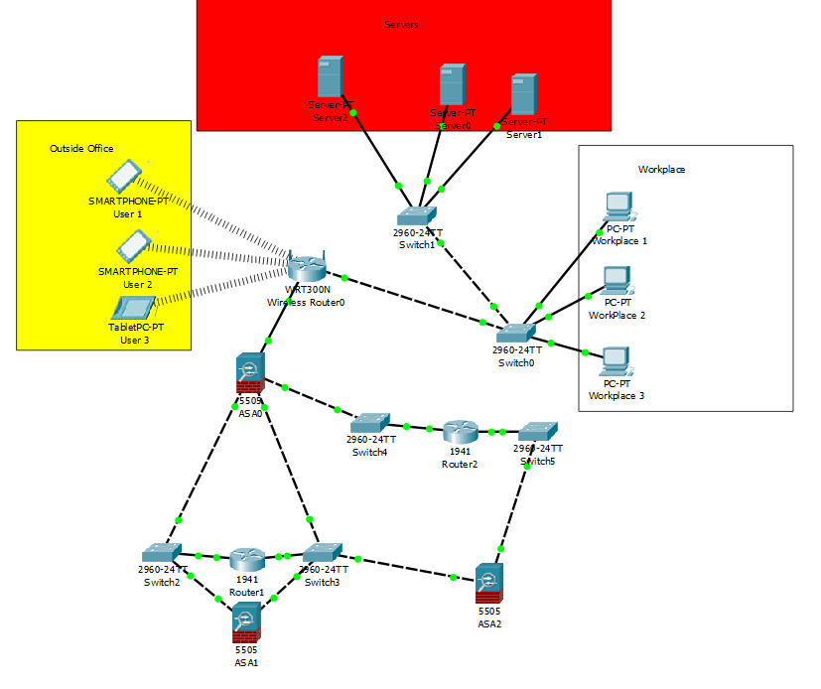

My choice for a Mobile Device Management Software for my BYOD network
When researching mobile device management software found three that would be feasible to use these are:
- “BlackBerry Enterprise Mobility Suite is a complete EMM solution built to protect your business data and increase workforce productivity. Whether on premise or in the cloud or a combination of both, it allows your organization to secure and manage all the intelligent endpoints in your enterprise with its flexible deployment options, mobility uptime, and technical support. You’ll be able to mobilize your critical workflows and business processes and apps including Microsoft Office 365.”[2] This software Suite comes with specialised applications, and supports both third party and custom apps. Its content management suite allows employees to access business files from SharePoint, OneDrive, and Drobox, all with native document editing capabilities.

Features of BlackBerry Enterprise Mobility Suit:
- “End-to-end-security
- Mobile device & app management
- Cross platform support
- Flexible deployment options
- Digital rights management protection
- File synchronization and sharing”[2]

- “Avalanche Mobility Centre by Ivanti is an MDM platform built for supply chain and retail mobility. It is able to manage and control all types of devices used by employees for work whether in the retail floor or in the field such as smartphones, tablets, scanners, barcode scanners, and wearables.”[2] It controls all mobile devices used by the business, keeping them secure, and accessible. It scales up as the business grows and is able to manage 100,000 or more devices. It also updates devices based on a personalised schedule to minimize downtime. Pricing is quote-based.
Features of Avalanche Mobility Centre:
- “Centralized management of all mobile devices
- Supports large-scale deployment
- Manages segmented workgroups
- Designed for supply chain & retail mobility
- Smart device remote control
- Scheduled device updates”[2]

- “Tangoe Managed Mobility Services is a managed technology solution to keep your employees connected and running on the right devices. It aims to improve operational efficiencies and productivity, uncover cost savings, and drive predictable results. Three key features come with the platform – automation, management, and support. You can automate the planning, procurement, and delivery of your devices to get the right technology into the hands of your employees when and where they need them.”[2] This suite allows the company to activate and manage mobile devices, so employee devices are ready out of the box. Tangoe offers a high level of security. Tangoe is offered through custom pricing.

Features of Tangoe Managed Mobility Services:
- “Automatic device recognition
- Remote installation and update
- Deployment and inventory management
- Data management
- Synchronization management
- Wireless network support”[2]
The mobile device management software I have chosen for my BYOD is BlackBerry Enterprise Mobility Suit, this is primarily because it has cross platform support and flexible deployment options as it allows both the company and employees to purchase any device they desire and deploy it both on-premise or in the cloud.
What data is stored on device and the potential for leakage
The data that is stored on a “BYOD device” depends on the staff member utilising it. Some examples of data that may be stored on a “BYOD Device” are financial reports, customer/staff information, reports, etc. The potential for leaks is fairly low but increases exponentially if the member of staff is fired, although this is minimised due to a policy shown in the employee policy which states that employees must be submitted to the IT department so the device to be cleared of all company related files, data, and software at time of firing/quitting, all personal apps, data, etc. will be left alone.
My strategy to deal with difficult issues
I have dealt with the issues of different brand of devices and when the participating device leaves our employment, or the device is lost, stolen, or fails via my chosen mobile device management software and Employee policy respectively, this is because the mobile device management software I chose has cross platform support and my employee policy has a safeguard stating that employees must be submitted to the IT department so the device to be cleared of all company related files, data, and software at time of firing/quitting, all personal apps, data, etc. will be left alone.
References
[1] A. Sedigh, C. Campbell, and K. Radhakrishnan, “BYOT network solutions for enterprise environment,” Proc. - UKSim-AMSS 16th Int. Conf. Comput. Model. Simulation, UKSim 2014, pp. 489–493, 2014.
[2] F. Online, “20 Best Mobile Device Management Software in 2019 - Financesonline.com,” Finance online, 2019. [Online]. Available: https://financesonline.com/mobile-device-management/.

marking criteria and Student FEEDBACK

This section details the assessment criteria. The extent to which these are demonstrated by you determines your mark. The marks available for each criterion are shown. Lecturers will use the space provided to comment on the achievement of the task(s), including those areas in which you have performed well and areas that would benefit from development/improvement.

Common Assessment Criteria Applied (Assignment 1) | Marks available | Marks  awarded
1. Research-informed Literature
Extent of research and/or own reading, selection of credible sources, application of appropriate referencing conventions.
Limited referencing , not consistently applied. (Grade mark: 40.00%) | 15 | 6
2. Knowledge and Understanding of Subject
Extent of knowledge and understanding of concepts and underlying principles associated with the discipline.
Demonstrated basic understanding of the concepts and principles. (Grade mark: 40.00%) | 15 | 6
3. Analysis
Analysis, evaluation and synthesis; logic, argument and judgement; analytical reflection; organisation of ideas and evidence
More of basic definition and explanations. Some evidence to support emerging arguments and judgements. (Grade mark: 47.50%) | 40 | 19
4. Practical Application and Deployment
Deployment of methods, materials, tools and techniques; application of concepts; formulation of innovative and creative solutions to solve problems.
Packet tracer diagram was inserted in the report. Appropriately design but the original file is required to test for security and configuration implementation within the design. (Grade mark: 50.00%) | 20 | 10
5. Skills for Professional Practice
Attributes in professional practice: individual and collaborative working; deployment of appropriate media; presentation and organisation.
Its clearly written, however, some sentences are too long, there are contraction grammar and it could do with formatting and justification. (Grade mark: 55.00%) | 10 | 5.5

Assignment Mark (Assessment marks are subject to ratification at the Exam Board. These comments and marks are to give feedback on module work and are for guidance only until they are confirmed. ) | Late Submission Penalties (tick if appropriate) |  | 46.5%
 | Up to four weeks late |  | 46.5%
 | First Attempt? |  | 46.5%

