
Name: Rajput Kajalsingh
Student Id: 2534452
Programme: MSc Public Health and Social Care in Practice
Module: Community Care and Management of Longer-term Conditions
Module code: LCHS7003
Lecturer: Muhammad Khan
Internal Verifier: Dr. Hamdi Hussain
Assignment Title: Component 1-Information Booklet of Long-term Condition Management


LCHS7003 AND COMMUNITY CARE AND MANAGEMENT OF LONGER-TERM CONDITIONS
INDEX

Introduction 4
Explanation and Evaluation of Type 2 Diabetes as a Focused Long-term Condition 4
Definition of Type 2 Diabetes 4
Burden and Prevalence of Type 2 (Diabetes with UK and Global Statistics) 4
Risk Factors/Aetiology of Type 2 Diabetes 6
A critical evaluation of the impact of the long-term condition with focus on physical, psychological and social implications 6
Physical Implication 6
Psychological Implication 7
Social Implication 7
Evidence-based Treatment in UK through NHS 8
Investigating current theoretical perspectives and models for improved outcomes 9
House of Care Model (UK based Model) 9
WHO Innovative Care for Chronic Conditions Framework (International Model) 10
Critical examination of implementation of local and national political health and social care agendas for type 2 diabetes 12
Local health and social care agenda 12
National health and social care agenda 13
Political agenda and developmental initiatives 14
Recommendations for improvement 15
Recommendation 1: Implementing person-centred care 15
Recommendation 2: Enhancing self-management 16
Recommendation 3: Improving access to Community based palliative care 16
Conclusion 17
References 18

Introduction
Community care is the provision of health and social care services within the community setting. Effective management of community care requires overseeing and coordinating the services to ensure the specific needs of the patients are effectively met. Type 2 Diabetes is one of the most prevalent long-term health conditions in the UK and also globally. This booklet aims to critically evaluate the prevalence, impact, healthcare model and policies around Type 2 diabetes. This informative booklet on Type 2 diabetes intends to support community care professionals in understanding and managing Type 2 diabetes more effectively.

Explanation and Evaluation of Type 2 Diabetes as a Focused Long-term Condition

Definition of Type 2 Diabetes
Type 2 diabetes is a chronic long-term metabolic condition characterised by insulin resistance and a rapid decline in insulin production, which causes persistently high blood sugar levels (WHO, 2024). Type 2 diabetes develops slowly over the years, and it is closely linked with lifestyle factors. Over time, it causes serious damage to the body, specifically to the nerves and blood vessels.

Burden and Prevalence of Type 2 (Diabetes with UK and Global Statistics)
Type 2 diabetes is one of the most prevalent long-term health conditions across the UK and also globally. As of 2024, 589 million people aged between 20 and 79 living with diabetes across the globe have been diagnosed (International Diabetes Federation, 2025). This indicates that 11% of the global population is presently suffering from this chronic health condition. Currently, 1 out of every 9 adults is living with type 2 diabetes, with over 4 out of 10 people unaware of their condition. The prevalence is further projected to increase by 853 million by 2050 (International Diabetes Federation, 2025). Additionally, diabetes was responsible for 3.4 million global deaths in 2024 (International Diabetes Federation, 2025). This reflects the burden and severity of type 2 diabetes at the global scale.
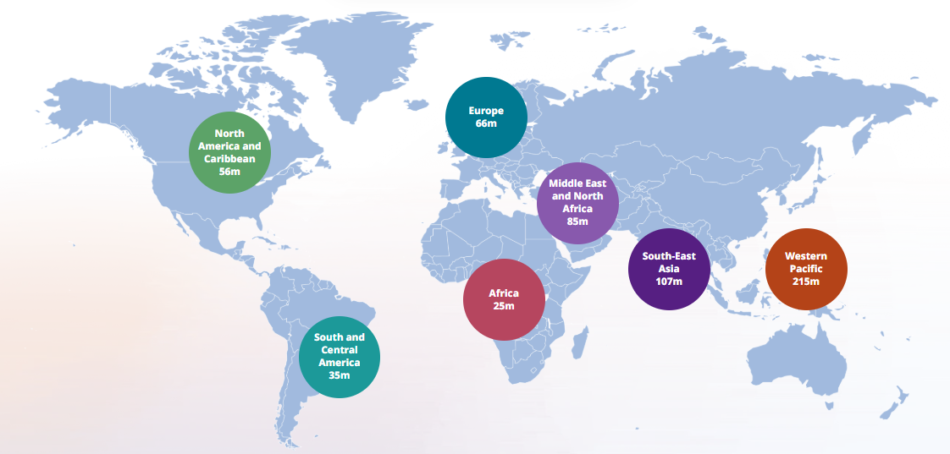
Figure 1: Type 2 Diabetes Prevalence Globally
(Source: International Diabetes Federation, 2025)
The prevalence of type 2 diabetes is further significant in the UK. According to Diabetes UK 2025), as of 2025, over 6 million people in the UK are living with diabetes, and 90% of them are diagnosed with type 2 diabetes. Additionally, 1.3 million people are estimated to be living with undiagnosed type 2 diabetes (Diabetes UK, 2025). The report by Diabetes UK. (2024) further revealed that type 2 diabetes diagnosis among people under 40 has risen to about 40% between 2016 and 2023, projecting a concerning trend towards young onset. Figure 2 reflects the prevalence of diagnosed and undiagnosed cases of type 2 diabetes across the different regions of England. The Midlands region has the highest prevalence with 8.6%, while the South East region has the lowest prevalence of 7% (Gov UK, 2025). Overall, the high prevalence of the long-term condition of type 2 diabetes is a major health concern across the UK and globally.
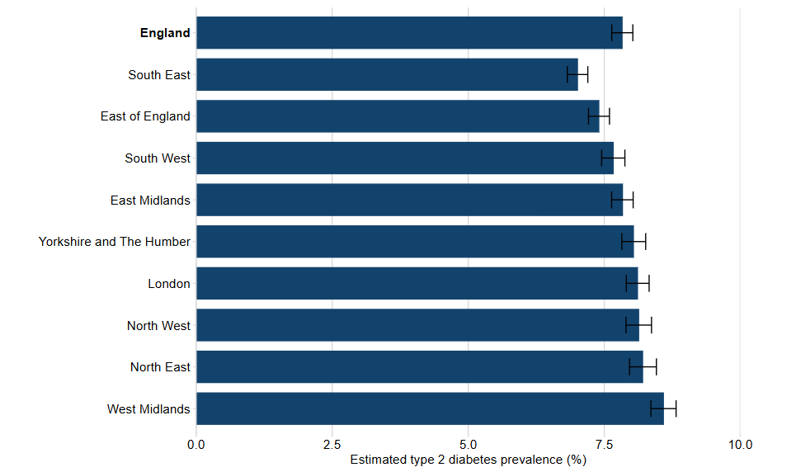
Figure 2: Total Diagnosed and Undiagnosed Type 2 Diabetes Cases in England
(Source: Gov UK, 2025)

Risk Factors/Aetiology of Type 2 Diabetes
The development of the long-term health condition of type 2 diabetes is caused by a critical interaction between genetic and lifestyle factors. Excess body weight is one of the most critical risk factors, as it directly contributes to insulin resistance (Bays, 2023). However, it is not necessary that everyone who is suffering from type 2 diabetes is overweight. Family history and genetic predisposition are other critical risk factors which significantly contribute to the development of type 2 diabetes (Bays, 2023). Additionally, socioeconomic deprivation further increases the risk of the condition, as half of the new diagnoses are occurring in the most deprived areas of the UK (Chan et al., 2025). The additional risk factors of type 2 diabetes include physical inactivity, poor diet, increasing age and so on. Overall, the risk factors of diabetes develop from various physical, social, and psychological dimensions.

A critical evaluation of the impact of the long-term condition with focus on physical, psychological and social implications

Physical Implication
Type 2 diabetes has a significant level of physical impact on the individual who has developed the condition. The high glucose level gradually damages the blood vessels and nerves of the individual, which further enhances the risk of cardiovascular disease, stroke, and kidney failure (Kaze et al. 2022). Additionally, it causes diabetic retinopathy, which damages the blood vessels in the retina and can cause complete or partial eyesight loss. In 2024, diabetes led to around 3.4 million deaths globally (International Diabetes Federation, 2025). Therefore, it can be said that type-2 diabetics have a critical impact on the physical health of individuals, which could lead to developing other health conditions and also cause death.

Psychological Implication
Living with type 2 diabetes has a considerable psychological impact on the patients and their families. As per, people with diabetes are three times more likely to report symptoms of depression than the general population (Zheng et al., 2024). Diabetes distress is the emotional distress resulting from living with diabetes and the burden of relentless daily self-management. Diabetic distress occurred among 1 in every 5 people with non-insulin-treated type 2 diabetes, which is further associated with poorer glycemic control and reduced quality of life (Diabetes UK, 2025). Additionally, feelings of guilt, anxiety, and worry about long-term complications also impacted the individuals and their families.
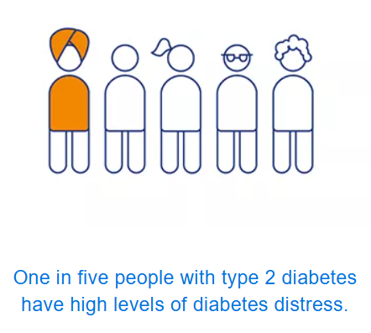

Figure 3: Prevalence of Diabetic Distress
(Source: Diabetes UK, 2025).

Social Implication
Type 2 diabetics have a significant level of social implications for individuals and also their families. As per Diabetes UK (2025), 75% of people with diabetes experience blame or judgement due to their condition. They are also often treated unfairly and viewed as solely responsible for its onset due to life choices. This stigma often leads to secrecy, social withdrawal, and reluctance to seek support, particularly within some minority ethnic communities, where cultural pressures can intensify feelings of shame. For the families who care for members with type 2 diabetics often causes considerable emotional, practical, and financial strain. This often includes management of diet and medication and providing ongoing emotional support. According to Stenberg and Hjelm (2024), the caregiving role performed by family members tends to affect their relationships, employment opportunities, and also their own well-being. This causes family-level stress and an overall reduced quality of time.

Evidence-based Treatment in UK through NHS
The management of type 2 diabetes within the NHS considers evidence-based recommendations developed by the NICE, emphasising on person centred and multidisciplinary care for combining lifestyle interventions. Alliabi et al. (2022) have argued that compliance with evidence-based treatment guidelines is significant for the effective management of T2DM among patients with 56% improvement rate. NHS has embarked on structured tech education as the cornerstone of diabetes management after the accurate diagnosis of T2D for improving individual and community awareness of the issues and its effective management. For instance, DESMOND (Diabetes Education and Self-Management for Ongoing and Newly Diagnosed) assists patients understand diabetes management including monitoring glucose levels and maintaining a healthy lifestyle (Desmond, 2026). DESMOND is an effective evidence-based approach that is offered by the NHS for helping patients with daily management of T2D including monitoring glucose levels, eating healthy, medication adherence and physical activity.
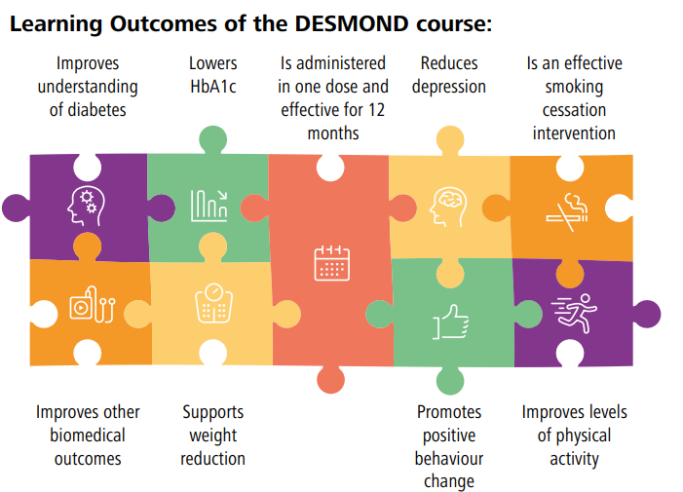
Figure 4: Learning Outcome of DASMOND
(Source: Desmond, 2022)
The NHS has also established pilot tests for initiative to enhance the management of Type 2 Diabetes in the UK. For example, NHS Type 2 Diabetes Path to Remission Programme (T2DR) is established by NHS for offering a 3-month specially formulated diet plan for weight management, consisting of total diet replacement, and improving blood sugar levels (NHS, 2026). NHS. (T2DR) has been established to offer free 12 month behavioural service for weight management among patients through complete diet change and implementing medication adherence strategy (Gergi, 2023). However, mediation and pharmacological treatment is also established and offered by the NHS for addressing the risk of T2D among patients. Pharmacological treatment is provided by the NHS for management of T2D among patients when lifestyle measures and education programs are ineffective and fail to address long-term impact of T2D. Approaches such as modified-release metformin in combination with SGLT-2 inhibitors are recommended by NHS as per NICE guidelines to prioritise cardiovascular and renal protection alongside glycaemic control (NHS, 2026). Thus, NHS programs are being established by the NHS for strengthening their approach to educate patients and improve self-management of diabetes through lifestyle change and medication adherence.

Investigating current theoretical perspectives and models for improved outcomes

House of Care Model (UK based Model)
House of Care Model (HCM) in the UK is widely integrated for long-term conditions management including type 2 diabetes by placing person-centred care planning at the centre of service delivery. The framework comprises four interconnected components including informed and engaged patients, healthcare professionals’ commitment to partnership working, organisational processes and commissioning processes for coordinated services (Sridharan et al., 2025). The HCM framework, unlike clinical-led approaches, recognises the significance of patients’ active participation in daily self-management, leading to medication adherence and patient activation through shared-decision making. Goodrich et al. (2026) argued that HCM for people with long-term conditions emphasise on interdependency of each quality domain to ensure a well-functioning , coordinated and sustainable service delivery model. The HCM focuses on facilitating collaboration between medical teams and their collaboration with the patients and their families for ensuring educational compliance, active patient participation and collective decision making. Thus, the Model is effective for long-term management of T2D and is closely aligned with NHS priorities of personalised care along with integrated services delivery, making it applicable for T2D management.
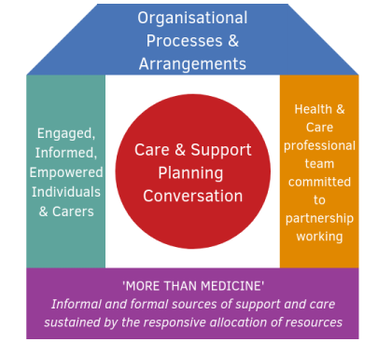
Figure 5: House of Care Model
(Source: Alliance, 2026)

WHO Innovative Care for Chronic Conditions Framework (International Model)
The development of WHO ICCC framework was developed for strengthening the healthcare systems across different countries for the prevention and management of chronic conditions such as Type 2 Diabetes. Lubaki et al. (2024) have outlined that the ICCC framework was established by WHO as a roadmap for the management of chronic conditions in developing countries, facilitating involvement of patients and communities for chronic condition management. The framework comprises fundamental components at the patient (micro), healthcare organisation and community (meso) and policy (macro) levels for emphasising on the management of conditions such as T2D. The framework is effective for the management of long-term conditions such as Diabetes through focusing beyond clinical care and includes healthcare organisations, communities, and policy environments (WHO, 2025). The framework recognises that successful long-term management of T2D requires coordinated action from patients, healthcare providers, communities, and government instead of relying solely on the medical treatment.
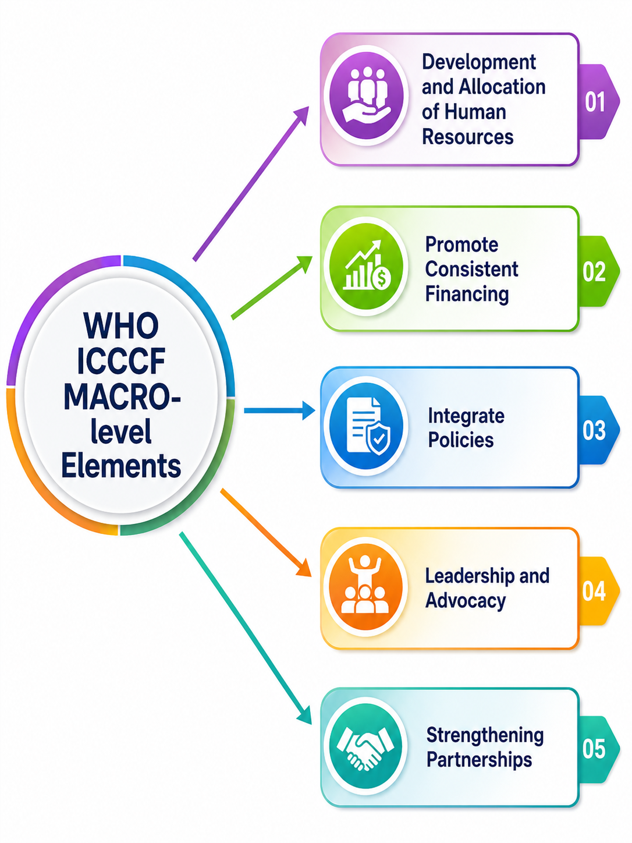
Figure 6: WHO ICCC Framework’ key elements
(Source: Marshall et al., 2025)
The figure outlined the key elements of the framework including development and allocation of human resources, promoting consistent financing, integrated policies, leadership, and partnership. Marshall et al. (2025) outlined that WHO ICCC framework aligns with long-term disease management such as diabetes as it requires lifelong monitoring, behavioural change, and coordinated care across healthcare settings. The existing studies indicate that ICCC elements and principles achieve improved glycaemic control, greater patient engagement, and increased medication adherence through early identification of complications.

Critical examination of implementation of local and national political health and social care agendas for type 2 diabetes

Local health and social care agenda
The type 2 diabetes management in the UK is provided primarily through Integrated Care Systems (ICSs) and neighbourhood health services (NHS England, 2024). This helps bring care closer to the communities by reducing health inequalities as well. Type 2 diabetes is one of the most prevalent in deprived urban areas with the highest rates recorded in some of the UK regions such as the West Midlands (8,6%), Southeast regions (7.0%) (Office for Health Improvement & Disparities, 2025). Additionally, Diabetes UK (2023) reported that the adults living in the most deprived areas are twice as likely to develop type 2 diabetes compared to those in affluent regions. The prevalence among the South Asian and Black communities is significantly higher with onset may occur 10-12 years earlier than in White populations.
Furthermore, Diabetes UK (2026) reported that the local commissioning bodies prioritise community-based screening, culturally tailored dietary interventions and structured education programmes such as ‘Diabetes Education and Self-Management for Ongoing and Newly Diagnosed (DESMOND)’. These initiatives are beneficial for the local people to enhance early diagnosis and empower patients to self-manage their condition. For example, the higher prevalence has been enhanced around 9,1% (2021/22) from 6.6% (2019/20) of the adult populations. Neighbourhood health teams integrate GPs, pharmacists and diabetes specialist nurses to deliver personalised care plans in Birmingham (Birmingham City Council, 2026).
The implementation is supported by the national diabetes audit (NDA) which provides localised data to find gaps in care (Diabetes UK, 2023). However, The Guardian (2023) reported that uptake of structured education remains inconsistent with some of the areas achieving less than 30% participation. The workforce shortage is another concern in the diabetes sector which further constrains care delivery. The local agendas describe a strong commitment to person-centred, culturally sensitive and community-driven approaches identifying that controlling type 2 diabetes needs addressing both medical needs and the wider social determinants of health.

National health and social care agenda
The management of type 2 diabetes is guided by NICE Guideline NG28 which sets out evidenced-based recommendations for diagnosis, lifestyle modification, cardiovascular risk management and pharmacological treatment at the national level (Diabetesonthenet, 2026). Furthermore, Scannell et al. (2025) highlighted that the structured education programmes such as DESMOND are mandated nationally by aiming to empower patients for managing their conditions effectively. The Diabetes UK (2026) provided insights and a comprehensive assessment of implementation. This reported that only 45.2% of people with Type 2 diabetes achieved all three treatment targets (HbA1c, blood pressure and statin use) (GOV UK, 2026). On the other hand, GOV UK, (2026) has also reported that around 58.2% of adults diagnosed before age 40 are a growing subgroup with higher risks of complications and premature mortality. In this regard, NHS England (2022) documented that the national strategies also align with the NHS Long Term Plan targeting to prevent up to 200,000 cases of type 2 diabetes through lifestyle interventions and weight management programmes. Although, the implementation is constrained by workforce shortages and national gaps to underscore the requirements of effective national coordination and equitable resource distribution.

Political agenda and developmental initiatives
The political agenda for type 2 diabetes in the UK is shaped by government commitments to prevent long-term healthcare conditions, enhance workforce and improve digital innovations. The Government's 10-year health plan focuses on the shifting care from hospitals to communities prioritising prevention over the treatment and enhancing access to technologies such as continuous glucose monitors (CGMs) and hybrid closed-loop insulin systems (Diabetes UK, 2025). These initiatives show a positive drive to modernise diabetes care by reducing the long-term economic burdens. The NHS has experienced diabetes costs over £10 billion yearly with type 2 diabetes accounting for the majority (NHS England, 2022).
The charities such as ‘Diabetes UK’ play a responsible role to influence political priorities of the UK. In line with this, Wihlander (2026) asserted that their Manifesto in 2025 calls for cross-government action to transform food environments by reducing obesity and managing the health inequalities effectively. This model can be utilised to monitor routine diabetes checking and providing psychological support into standard care (NHS England, 2023).
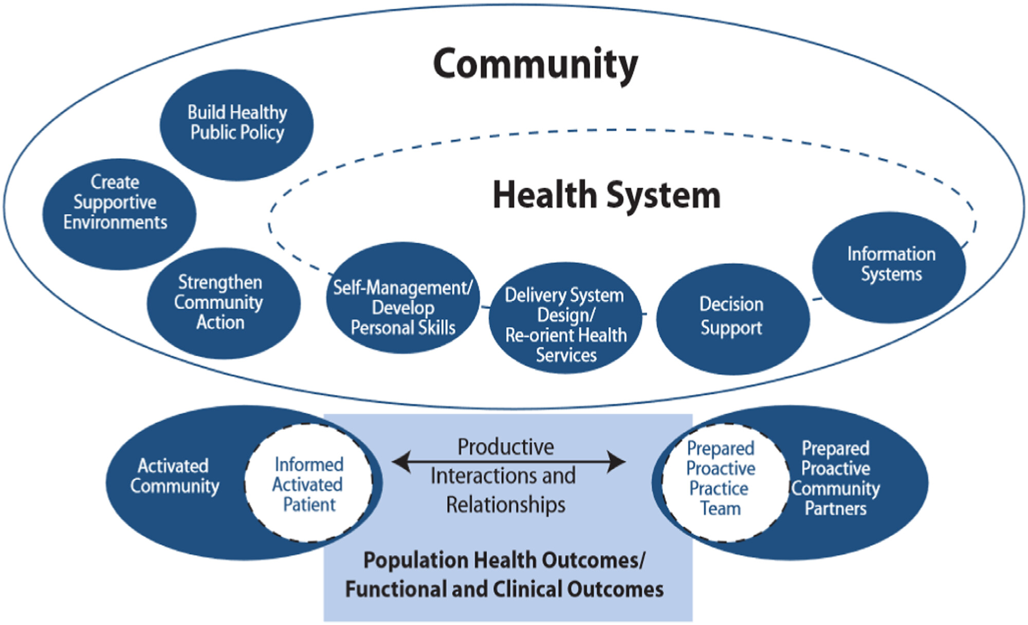
Figure 7: Chronic Care Model
(Source: Pomey et al., 2024)
In alignment with the Chronic Care Model (CCM), Grudniewicz et al. (2023) also mentioned that CCM model focuses on proactive, patient-centred care, integration of community resources and the use of information systems to support decision-making. The political strategies such as digital health expansion and neighbourhood services support this model by intending the empowerment of patients and improving outcomes (GOV UK, 2025). However, the workforce shortages, regional gaps and socio-economic issues persist. In order to mitigate these gaps, sustainable investment and collaborations are required for maintaining political commitments and risk falling to curb rising type 2 diabetes prevalence across the deprived areas of the UK.

Recommendations for improvement

Recommendation 1: Implementing person-centred care
The improvement outcomes for people having type 2 diabetes conditions needs a person-centred approach across all levels of care (Ingul et al., 2025). This provides insights on effective treatment plans for diabetic people’s preferences, cultural needs and social circumstances instead of depending solely on standardised protocols. The House of Care model is widely adopted in the NHS by providing a useful framework for these long-term conditions. Regarding this, Health and Social Care Alliance Scotland (2026) discussed that the application of this model ensures that patients are active participants in their care leading to higher satisfaction, better adherence to treatment and improved long-term outcomes. The person-centred care can be beneficial to enhance accessing community-based services such as dietetic counselling and psychological support to reduce hospital dependence and enhance quality of life.

Recommendation 2: Enhancing self-management
Self-management is highly effective type 2 diabetes control as daily behaviours around diet, exercise, medication and monitoring the potential outcomes. In this similar context, Hanson et al. (2022) opined that self-management can enhance structured educational programmes such as DESMOND empowers patients with knowledge and confidence. Implementing self-management in routine care improves autonomy by reducing complications. This can align with the NHS’s prevention agenda by ensuring resilience and sustainable improvements in diabetes care.

Recommendation 3: Improving access to Community based palliative care
The management of T2D among patients can consist of approaches for end-of-life care through improving access to community-based palliative care to enhance care and living quality of patients. Ndinawe et al. (2026) argued that community-based palliative care expands community nursing, and specialist palliative care for enabling patients to remain in preferred place and improve living quality. The improvement in accessibility to palliative care community nursing services and hospice at home programs can enable patients to receive symptoms management, psychological support, medication review to enhance care quality. Thus, the recommendations of accessibility to palliative care are effective in enhancing end of life care for patients with type 2 diabetes through offering in-home care that also aligns with NHS priorities to deliver care at home.

Conclusion
In conclusion, the management of type 2 diabetes as a long-term condition requires the identification of its risk’s factors and key determinants for early diagnosis and management of the condition. It has been outlined that the prevalence of T2D in the UK and global landscape is high due other health conditions such as obesity along with socioeconomic inequities and widespread reliance on processed foods. Thus, based on the issues, evidence-based recommendations of education programs, self-management, and person-centred care have been offered to enhance care outcomes.

References
Alliabi, F.J.A., Jaber, A.A.S., Jallo, M.K.I. and Baig, M.R., (2022). ‘Adherence of physicians to evidence-based management guidelines for treating type 2 diabetes and atherosclerotic cardiovascular disease in Ajman, United Arab Emirates.’ BMC Primary Care, 23(1), p.70. https://doi.org/10.1186/s12875-022-01672-4
Alliance (2026) The House of Care Model. Available at: https://www.alliance-scotland.org.uk/past-work-and-projects/scotlands-house-of-care/the-house-of-care-model/ (Accessed: 17 July 2026).
Bays, H.E., (2023). ‘Why does type 2 diabetes mellitus impair weight reduction in patients with obesity? A review’. Obesity Pillars, 7, p.100076. https://www.sciencedirect.com/science/article/pii/S2667368123000220
Birmingham City Council (2026) Socioeconomic and ethnic inequalities increase the risk of type 2 diabetes: An analysis of NHS health check attendees in Birmingham. Available at: https://cityobservatory.birmingham.gov.uk/explore/assets/socioeconomic-and-ethnic-inequalities-increase-the-risk-of-type-2-diabetes-an-analysis-of-nhs-health-check-attendees-in-birmingham/ (Accessed: 17 July 2026).
Chan, J., Narayan, P., Law, J.J., Dong, T. and Angelini, G.D., (2025). ‘Socioeconomic deprivation is associated with worse in-hospital survival after isolated coronary artery bypass grafting in the UK’. Interdisciplinary CardioVascular and Thoracic Surgery, 40(6), p.ivaf119. https://academic.oup.com/icvts/article-pdf/40/6/ivaf119/63266395/ivaf119.pdf
Desmond (2022) A Focus on: DESMOND across Nottinghamshire County Part Two. Available at: https://www.desmond.nhs.uk/news-articles/a-focus-on-desmond-across-nottinghamshire-county-part-two (Accessed: 17 July 2026).
Desmond (2026) Our vision. Available at: https://www.desmond.nhs.uk/ (Accessed: 17 July 2026).
Diabetes UK (2023) No One Left Behind. Available at: https://www.diabetes.org.uk/sites/default/files/2025-07/Diabetes%20UK_Tackling%20Inequality%20Brochure_V9_27.06_Digital%20Use%20only.pdf (Accessed: 17 July 2026).
Diabetes UK (2024) Quality Improvement with the National Diabetes Audit (NDA). Available at: https://www.diabetes.org.uk/for-professionals/improving-care/clinical-recommendations-for-professionals/national-diabetes-audit/NDA-Quality-Improvement (Accessed: 17 July 2026).
Diabetes UK (2025) Our response to the government’s 10 Year Health Plan. at: https://www.diabetes.org.uk/about-us/news-and-views/our-response-governments-10-year-health-plan (Accessed: 17 July 2026).
Diabetes UK (2026) National Diabetes Audit. Available at: https://www.diabetes.org.uk/for-professionals/improving-care/clinical-recommendations-for-professionals/national-diabetes-audit (Accessed: 17 July 2026).
Diabetes UK (2026) Supporting people to live well with type 2 diabetes: DESMOND turns 20. Available at: https://www.diabetes.org.uk/about-us/news-and-views/supporting-people-live-well-type-2-diabetes-desmond-turns-20 (Accessed: 17 July 2026).
Diabetes UK. (2025). How many people in the UK have diabetes?. Available at: https://www.diabetes.org.uk/about-us/about-the-charity/our-strategy/statistics (Accessed: 16 July 2026)
Diabetesonthenet (2026) The NICE NG28 type 2 diabetes guideline: Management update – what’s new? Available at: https://diabetesonthenet.com/diabetes-primary-care/factsheet-nice-ng28-feb-2026/ (Accessed: 17 July 2026).
Diabetics UK. (2024). Type 2 Diabetes Prevention Week 2024: Action needed to tackle rising type 2 cases among under-40s. Available at: https://www.diabetes.org.uk/about-us/news-and-views/diabetes-prevention-week-2024-action-needed-tackle-rising-type-2-cases (Accessed: 16 July 2026)
Diabetics UK. (2025). 86% of people with type 1 and 75% of people with type 2 experience judgement for their condition. Available at: https://www.diabetes.org.uk/about-us/news-and-views/86-people-type-1-and-75-people-type-2-experience-judgement-their-condition\ (Accessed: 16 July 2026)
Diabetics UK. (2025). Chapter 3 - Diabetes distress. Available at: https://www.diabetes.org.uk/for-professionals/improving-care/good-practice/psychological-care/emotional-health-professionals-guide/chapter-3-diabetes-distress (Accessed: 16 July 2026)
Gergi, L. (2024) Real-World Type 2 Diabetes Remission Through NHS Diet Programme. Available at: https://www.emjreviews.com/diabetes/news/real-world-type-2-diabetes-remission-through-nhs-diet-programme/ (Accessed: 17 July 2026).
Goodrich, J., Pask, S., Okwuosa, C., Johansson, T., Laidlaw, L., Ghiglieri, C., Chambers, R., Bone, A.E., Barclay, S., Murtagh, F.E. and Sleeman, K.E., (2026). ‘What is the quality of care at the end of life? Qualitative findings from a nationally-representative post-bereavement survey across England and Wales.’ Journal of Health Services Research & Policy, 31(2), pp.85-97. https://doi.org/10.1177/13558196251398678
GOV UK (2025) Fit for the future: 10 Year Health Plan for England (accessible version). Available at: https://www.gov.uk/government/publications/10-year-health-plan-for-england-fit-for-the-future/fit-for-the-future-10-year-health-plan-for-england-accessible-version (Accessed: 17 July 2026).
Gov UK (2025). Diabetes profile: statistical commentary, March 2025. Available at: https://www.gov.uk/government/statistics/diabetes-profile-update-march-2025/diabetes-profile-statistical-commentary-march-2025 (Accessed: 16 July 2026)
GOV UK (2026) Diabetes profile: Statistical commentary, April 2026. Available at: https://www.gov.uk/government/statistics/diabetes-profile-update-april-2026/diabetes-profile-statistical-commentary-april-2026 (Accessed: 17 July 2026).
Grudniewicz, A., Gray, C.S., Boeckxstaens, P., Maeseneer, J. De and Mold, J.W. (2023). ‘Operationalizing the Chronic Care Model with Goal-Oriented Care’. The Patient: Patient-Centered Outcomes Research, 16(6), pp.569–578. Available at: https://doi.org/10.1007/s40271-023-00645-8
Hanson, P., Parmar, D., Deo, P., Whyteoshodi, D., Gotts, C., O’Hare, P.J., Randeva, H. and Barber, T.M. (2022). ‘Insights into optimising education for patients living with diabetes mellitus: A model for the post‐pandemic era, informed by survey data’. Lifestyle Medicine, 3(3). Available at: https://doi.org/10.1002/lim2.64
Health and Social Care Alliance Scotland (2026) The House of Care Model. Available at: https://www.alliance-scotland.org.uk/past-work-and-projects/scotlands-house-of-care/the-house-of-care-model/ (Accessed: 17 July 2026).
Ingul, C.B., Hollekim-Strand, S.M., Sandbakk, M.M., Grønseth, T.I., Rånes, T.I.K., Dyrendahl, L.T., Eilertsen, K., Kristensen, S., Follestad, T. and Løfadli, B. (2025). ‘Empowerment in Type 2 diabetes: A patient-centred approach for lifestyle change’. Diabetes Research and Clinical Practice, 220, p.111998. Available at: https://doi.org/10.1016/j.diabres.2025.111998
International Diabetes Federation (2025). Diabetes facts & figures. Available at: https://idf.org/about-diabetes/diabetes-facts-figures/ (Accessed: 16 July 2026)
International Diabetes Federation (2025). The Diabetes Atlas. Available at: https://diabetesatlas.org/ (Accessed: 16 July 2026)
Kaze, A.D., Jaar, B.G., Fonarow, G.C. and Echouffo-Tcheugui, J.B. (2022). ‘Diabetic kidney disease and risk of incident stroke among adults with type 2 diabetes’. BMC medicine, 20(1), p.127. https://link.springer.com/content/pdf/10.1186/s12916-022-02317-0.pdf
Lubaki, J.P.F., Francis, J.M. and Omole, O.B., (2024). ‘Perspectives of healthcare providers and persons with type 2 diabetes mellitus on improving glycaemic control in Kinshasa, Democratic Republic of the Congo: a qualitative study.’ BMJ Public Health, 2(1). https://doi.org/10.1136/bmjph-2023-000580
Marshall, C., Virdun, C. and Phillips, J.L., (2025). ‘Strengthening care for adults with palliative care needs in high-income rural communities: a global policy environmental scan.’ BMC Palliative Care, 24(1), p.253.https://doi.org/10.1186/s12904-025-01797-0
Ndinawe, J.B., Kabakyenga, J., Namukwaya, E., Mulogo, E.M. and Nagujja, F., (2026). ‘Identification and mapping of mHealth interventions applied in palliative care in Sub Saharan Africa: a scoping review.’ BMC Palliative Care, 25(1), p.76. https://doi.org/10.1186/s12904-026-02034-y
NHS (2026) NHS Type 2 Diabetes Path to Remission Programme. Available at: https://www.england.nhs.uk/diabetes/treatment-care/diabetes-remission/ (Accessed: 17 July 2026).
NHS (2026) What are SGLT2 inhibitors. Available at: https://diabetesmyway.nhs.uk/resources/internal/what-are-sglt2-inhibitors/ (Accessed: 17 July 2026).
NHS England (2022) NHS Prevention Programme cuts chances of Type 2 diabetes for thousands. Available at: https://www.england.nhs.uk/2022/03/nhs-prevention-programme-cuts-chances-of-type-2-diabetes-for-thousands/ (Accessed: 17 July 2026).
NHS England (2023) NHS England. Available at: https://www.england.nhs.uk/ (Accessed: 17 July 2026).
NHS England (2024) NHS England » Diabetes treatment and care programme. Available at: https://www.england.nhs.uk/diabetes/treatment-care/ (Accessed: 17 July 2026).
Office for Health Improvement & Disparities (2025) Diabetes profile: Statistical commentary, March 2025. Available at: https://www.gov.uk/government/statistics/diabetes-profile-update-march-2025/diabetes-profile-statistical-commentary-march-2025 (Accessed: 17 July 2026).
Pomey, M.-P., Schaad, B., Lasserre‐Moutet, A., Böhme, P. and Jackson, M. (2024). ‘Towards a New Integrated Model for Taking Into Account the Experiential Knowledge of People With Chronic Diseases, Integrating Mediation, Therapeutic Education and Partnership: The Expanded Chronic Care Patient–Professional Partnership Model’. Health Expectations, 27(5), p.e70054. Available at: https://doi.org/10.1111/hex.70054
Scannell, C., O’Neill, T. and Griffin, A. (2025). ‘The Effectiveness of a Primary Care Diabetes Education and Self‐Management Program in Ireland: A 6‐Month Follow‐Up Study’. Endocrinology Diabetes & Metabolism, 8(2), p.e70036. Available at: https://doi.org/10.1002/edm2.70036
Sridharan, S., Whynot, J., Antflick, J., Shah, N., Macdougall, I. and Nakaima, A., (2025). ‘Building a House of Care: Movements Toward an Integration of Neuroscience and Community Solutions.’ In A New Blueprint for Brain Health: How Community-Led Evaluations will Construct a Healthier Future (pp. 213-233). Cham: Springer Nature Switzerland. https://doi.org/10.1007/978-3-032-03833-3_11#DOI
Stenberg, J. and Hjelm, K., (2024). ‘Social support as perceived, provided and needed by family-members of migrants with type 2 diabetes–a qualitative study’. BMC Public Health, 24(1), p.1612. https://link.springer.com/content/pdf/10.1186/s12889-024-19101-9.pdf
The Guardian (2023) Census shows stark differences in people’s qualifications across England and Wales. Available at: https://www.theguardian.com/uk-news/2023/jan/10/census-shows-stark-differences-in-peoples-qualifications-across-england-and-wales (Accessed: 17 July 2026).
WHO (2025) Quality of care for chronic conditions. Available at: https://iris.who.int/server/api/core/bitstreams/21147cd6-f068-4f36-b9ad-0ad3a007e84b/content (Accessed: 17 July 2026).
WHO, (2024). Diabetes. Available at: https://www.who.int/news-room/fact-sheets/detail/diabetes (Accessed: 16 July 2026)
Wihlander, B. (2026) Members of UK Parliament urge government to confront food industry amid obesity epidemic. Available at: https://www.nutritioninsight.com/news/uk-parliament-food-industry-obesity-action.html (Accessed: 17 July 2026).
Zheng, C., Yin, J., Wu, L., Hu, Z., Zhang, Y., Cao, L. and Qu, Y. (2024). ‘Association between depression and diabetes among American adults using NHANES data from 2005 to 2020’. Scientific Reports, 14(1), p.27735. https://www.nature.com/articles/s41598-024-78345-y.pdf

