Developing a Stakeholder Management Plan for the New Public Park Project in East Manchester

Student Name: Merecan-Diego Stefan
Student ID: 2325936
Professor Name: Ivan Rodriguez Hernadez

Table of Contents
Element 1: Introduction 2
1.1 Project Overview 2
1.2 Stakeholder Identification 3
1.3 Project Relevance 4
Element 2: Stakeholder Engagement Strategies 5
2.1 Theoretical Framework 5
2.2 Power–Influence–Interest Analysis 6
2.3 Stakeholder Map 7
2.4 Communication Plan 8
2.5 Consultation Strategy 10
Element 3: Ethical Considerations in Consultation, Participation & Feedback 11
3.1 Ethical Framework 11
3.2 Consultation and Data Handling 12
3.3 Managing Bias, Diversity, Equity & Inclusion (DEI) 12
3.4 Feedback Review and Integration 14
Element 4: Conclusion and Reflection 15
4.1 Summary of Key Insights 15
4.2 Reflective Account (Gibbs’ Model, 1988) 16
4.3 Closing Reflection 17
Reference List 18

Element 1: Introduction

1.1 Project Overview
The proposed New Public Park Project in East Manchester forms a major component of Manchester’s Great Outdoors: Green and Blue Infrastructure Strategy and Action Plan 2025–2030 (Manchester City Council, 2025). The project intends to turn a former industrial site into a sustainable, multipurpose public park that promotes biodiversity, climatic resilience, and social well-being. This transition shows the city's commitment to environmental sustainability and inclusive urban renewal, as stated in the Greater Manchester Five-Year Environment Plan 2025–2030 (GMCA, 2025) and Zero Carbon Manchester 2038 Target.
The park is located at Mayfield, immediately south-east of Manchester Piccadilly station, centred on Baring Street(approx. 53.4748° N, −2.2255° W), on a brownfield parcel along the River Medlock (Manchester City Council, 2025). The park’s proposed features include walking and cycling paths, community gardens, eco-friendly play zones, and solar-powered lighting, consistent with Embedding Green Infrastructure Principles (GMCA, 2024), which promotes multifunctional design that integrates environmental and social benefits. The indicative footprint is ~26,300 m² (≈6.5 acres), providing room for continuous riverside paths, play zones, and community planting (Manchester City Council, 2025). The Manchester City Council Environment and Regeneration Department will oversee the £5 million project, which is planned to finish between 2025 and 2028. According to the GrowGreen EU Project (2024), participatory nature-based solutions increase community resilience and promote long-term environmental stewardship. Primary entrances are planned at Baring Street (Boardman Gate) and the former Mayfield Station frontage, improving permeability from Piccadilly and the city centre (GMCA, 2024).
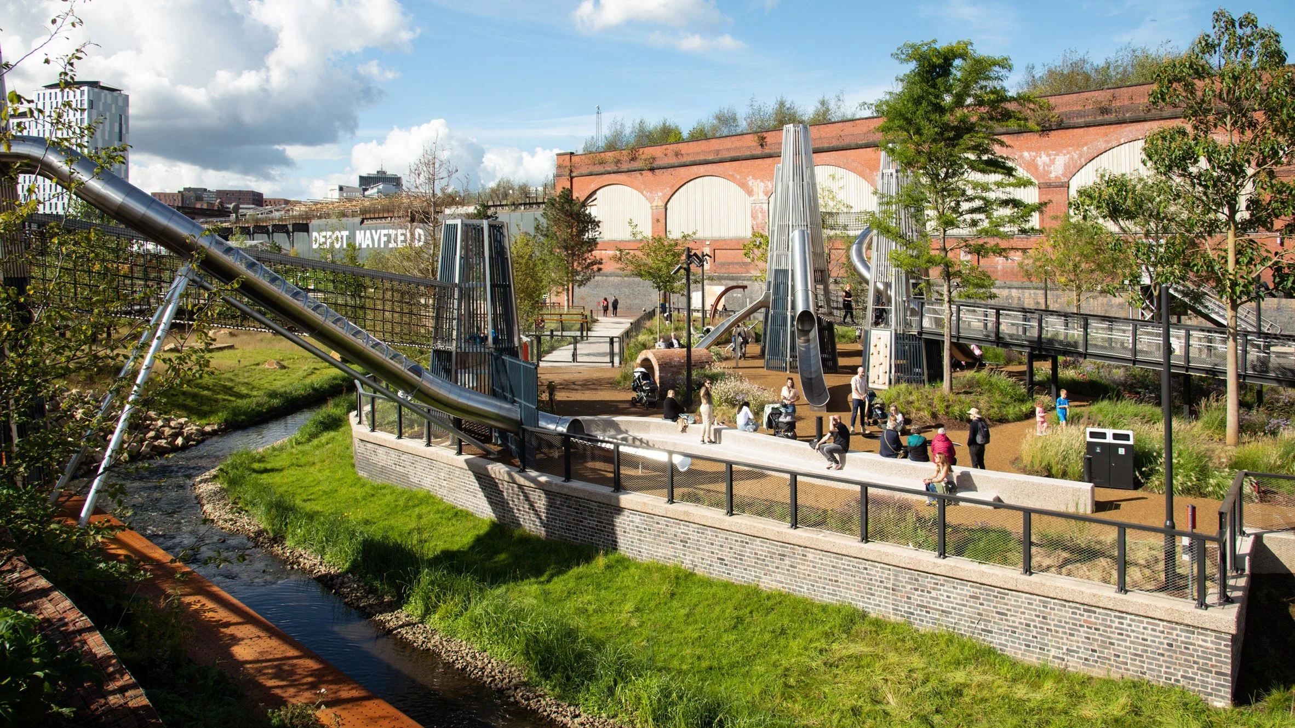
Figure 1. Manchester Mayfield Park (Watson, 2023)

1.2 Stakeholder Identification
As defined by Freeman (1984), stakeholders are individuals or groups who can influence or are influenced by the achievement of an organisation’s objectives. For this project, stakeholders include internal, external, and connectedg roups. Applying Mitchell, Agle and Wood’s (1997) salience model, which evaluates stakeholders based on their power, legitimacy, and urgency, the following table categorises key actors in the New Public Park Project.
Table 1. Identification and Classification of Key Stakeholders for the New Public Park Project in East Manchester
Stakeholder | Type | Interest in Project | Potential Benefit / Impact
Manchester City Council | Internal | Urban regeneration, sustainability | Enhanced image and governance credibility
Local Residents | External | Recreation, safety, well-being | Improved quality of life and property value
Environmental NGOs (e.g., Friends of the Earth Manchester) | Connected | Habitat preservation, advocacy | Biodiversity enhancement and cleaner air
Local Businesses | External | Increased consumer activity | Economic growth and tourism stimulation
Contractors | External | Employment and project delivery | Job creation and economic opportunity
Media (Manchester Evening News) | Connected | Community awareness and transparency | Informed public and civic engagement
Mayfield Development Partnership / Venue Operators (Depot Mayfield; Escape to Freight Island) | Connected | Events programming, access, safety | Placemaking, visitor economy; crowd and traffic management requirements
Direct neighbours include Depot Mayfield (events venue), Escape to Freight Island (food/culture), the former Mayfield Station structure, the River Medlock corridor, and rail/Metrolink assets near Manchester Piccadilly. These adjacencies shape patterns of evening/weekend footfall and noise dispersion and therefore appear in the stakeholder list and risk log (Prebanić & Vukomanović, 2023).

1.3 Project Relevance
Historic industrialisation and intensive urban expansion have left East Manchester without green space. The planned park is needed since the Manchester Green Infrastructure Technical Report (2025) found below-average canopy coverage and few recreational features. Urban greening improves mental health, social inclusion, and air quality (Hislop, Scott and Corbett, 2019). In accordance with the Equality Act (UK Government, 2010), the GMCA Natural Environment Topic Paper (2024) supports inclusive planning procedures. Designed for universal accessibility, the park will provide equal pleasure for all inhabitants. Proximity to major events and hospitality operators increases both social activation potential and management complexity; aligning opening hours, lighting, and stewarding with venue calendars reduces conflict and maximises shared value (Knox, 2024). Universal-design facilities, including accessible toilets and baby-change, are therefore scoped as critical enablers of equitable access (UK Government, 2010).

Element 2: Stakeholder Engagement Strategies

2.1 Theoretical Framework
Effective stakeholder engagement forms the foundation of sustainable project management. Freeman (1984) defines stakeholders as any individual or group that can affect or is affected by the achievement of an organisation’s objectives. In the context of the New Public Park Project in East Manchester, this concept emphasises the need for Manchester City Council and its broad community network to create mutual benefit. Freeman's stakeholder theory promotes cooperation over control, citing legitimacy, trust, and long-term project success.
Based on Freeman's work, Bourne (2015) suggests stakeholder relationship maturity, a process by which firms go from ad hoc communication to systematic, integrated relationship management. In Bourne's Stakeholder Relationship Management (SRM) model, reactive engagement evolves into proactive involvement and message frequency, medium, and subject must meet each group's influence and expectations. This creates targeted communication channels for Manchester park project inhabitants, NGOs, contractors, and media partners. To identify and rank stakeholders, Mendelow's Power–Interest Matrix and Mitchell, Agle, and Wood's (1997) salience model provide structured analytical methods. Mendelow's grid stratifies stakeholders by interest and power (project impact). Mitchell et al. (1997) construct a dynamic stakeholder salience framework by adding power, legitimacy, and urgency. Combining these methods allows variable project design and execution engagement methodologies.
Government initiatives use engagement as a management tool and a democratic accountability tool. Knox (2024) says stakeholder participation legitimizes public-sector innovation by encouraging transparency, inclusivity, and shared ownership. Legitimacy is important for municipal projects like the New Public Park because of financing, local identity, and sustainability. Lastly, digital governance needs online involvement tools. Aaltonen, Di Maddaloni, and Sivunen (2024) show that social media updates, online forums, and feedback surveys promote responsiveness, diversity, and real-time dispute management. These findings shape the park project's stakeholder strategy, which combines traditional consultations with digital means for continuing, inclusive engagement. This stakeholder theory, salience frameworks, and communication maturity basis creates a responsive, ethical, and transparent engagement approach.
Accordingly, venue operators and rail stakeholders are treated as “context setters” whose salience varies by phase, echoing Bourne’s SRM maturity view of dynamic relationships (Bourne, 2015; Mitchell et al., 1997).

2.2 Power–Influence–Interest Analysis
To ensure balanced engagement, stakeholders must be systematically evaluated based on their power, influence, and interest in the project. Table 2 illustrates these relationships for the New Public Park Project.
Table 2. Stakeholder Power–Influence–Interest Analysis for the New Public Park Project
Stakeholder | Power | Influence | Interest | Engagement Priority
Manchester City Council | High | High | High | Manage closely
Local Residents | Medium | High | High | Keep informed
Environmental NGOs | Medium | Medium | High | Consult
Contractors | High | Medium | Medium | Keep satisfied
Local Businesses | Medium | Low | Medium | Monitor
Media | Low | Medium | Medium | Keep informed

Venue operators hold medium power / high influence during events due to crowd flows and reputational spillovers; they are therefore managed as Consult/Keep Satisfied with a joint calendar and incident-response protocol.
Prebanić and Vukomanović (2023) emphasise the importance of mapping traits for infrastructure development, as it simplifies decision-making power and avoids conflict between economic and social aims. Manchester City Council has the most authority in this project owing to its regulatory and financing role, although local citizens have substantial influence via collective action and public opinion. Stakeholder power changes over a project's lifespan, per Dolan (2025). Construction contractors, who were less apparent during consultation, acquire influence on-site, requiring greater control. NGOs and local companies have low impact but great partnership potential in biodiversity monitoring and event sponsorship. The media is crucial to transparency and community feeling. This organised categorisation helps the Council deploy communication resources proportionally, keeping all stakeholders informed, consulted, and empowered.

2.3 Stakeholder Map
A stakeholder map using Mendelow’s Power–Interest grid (Figure 2) clarifies who needs what style of engagement at each phase. Manchester City Council sits in High Power–High Interest (Manage Closely): involve them in all gate decisions and risk reviews. Local Residents and Environmental NGOs plot in Medium Power–High Interest: co-create/keep informed with fortnightly updates, design charrettes, and clear “You Said–We Did” loops. Venue operators (Depot Mayfield / Escape to Freight Island) are Medium Power–High Interest: consult on crowd flows, lighting, and programming via a shared events calendar and incident protocol. Contractors & Designers and Network Rail/TOCsoccupy High Power–Medium Interest (Keep Satisfied), with salience peaking during construction and any interfaces with Piccadilly, manage via weekly look-aheads, permits, and H&S controls. Local Businesses sit around Medium–Medium(Monitor/consult at milestones) for parking, servicing, and event timing. Media remain Low Power–Medium Interest(Keep Informed) through timely, factual briefings. Because positions shift over time (Erkul, Kumral & Çelik, 2016), conduct quarterly stakeholder audits (Bourne, 2015) to capture attitude changes, update coordinates on the grid, and adjust tactics. An interactive map on the Council website will log interaction frequency, key feedback themes, and movements between quadrants from planning through build to operations.
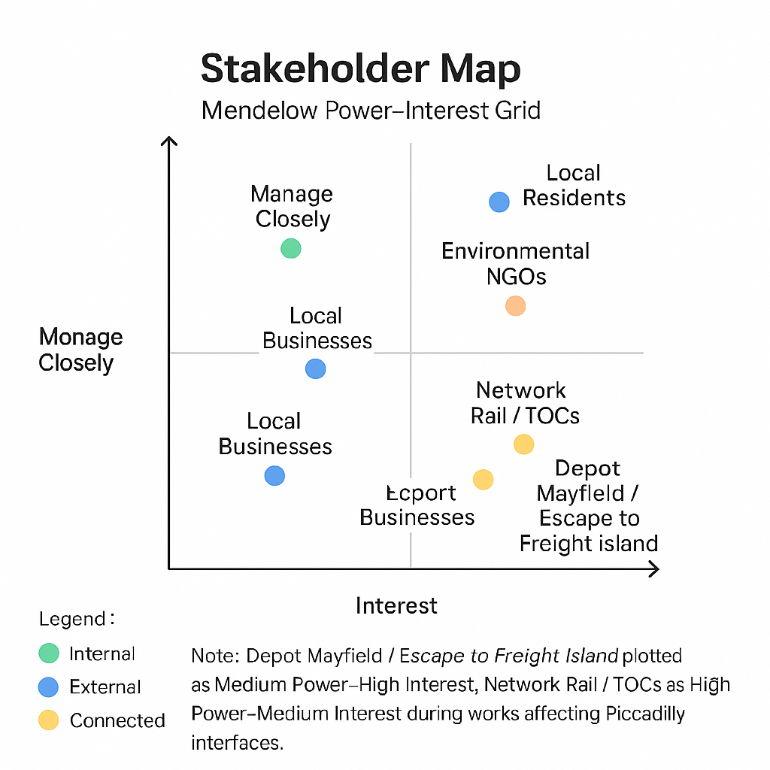
Figure 2. Stakeholder Map

2.4 Communication Plan
Effective communication keeps stakeholders on project objectives. Communication maturity, from reactive to predictive, measures organisational capabilities, according to Bourne (2015). The New Public Park seeks transparency, inclusion, and frequent input via proactive means. This openness is increasingly supported by digital instruments. Aaltonen et al. (2024) show how social media helps public entities handle enquiries and expectations. Knox (2024) claims that addressing demographically diverse individuals via a combination of conventional and digital methods legitimises involvement. The communication strategy below uses digital and physical channels to enable equitable involvement and two-way interaction in accordance with GMCA (2024) green-infrastructure governance requirements.
Table 3. Stakeholder Communication Plan for the New Public Park Project
Stakeholder | Information to Communicate | Frequency | Communication Medium | Responsible Party
Manchester City Council | Project milestones, risk updates | Monthly | Reports, internal meetings | Project Manager
Local Residents | Design plans, community events, construction notices | Bi-weekly | Newsletters, social media, town-hall sessions | Community Liaison Officer
Environmental NGOs | Environmental assessments, biodiversity progress | Quarterly | Email, stakeholder forums | Sustainability Officer
Contractors | Technical requirements, safety standards | Weekly | Briefings, progress dashboards | Site Manager
Local Businesses | Footfall forecasts, commercial opportunities | Monthly | Email circulars, business roundtables | Economic Development Officer
Media | Press releases, human-interest stories | As needed | Press kits, online newsroom | Communications Team
Venue Operators (Depot Mayfield / Freight Island) | Works windows, stewarding, noise, joint events | Monthly (plan) / Weekly (build) / Pre-event | Liaison meeting; shared calendar; SMS ops channel | Community Liaison + Site Manager

A web page will host photo updates, including toilet location photos and wayfinding maps, to reduce information friction for first-time visitors (Aaltonen et al., 2024).
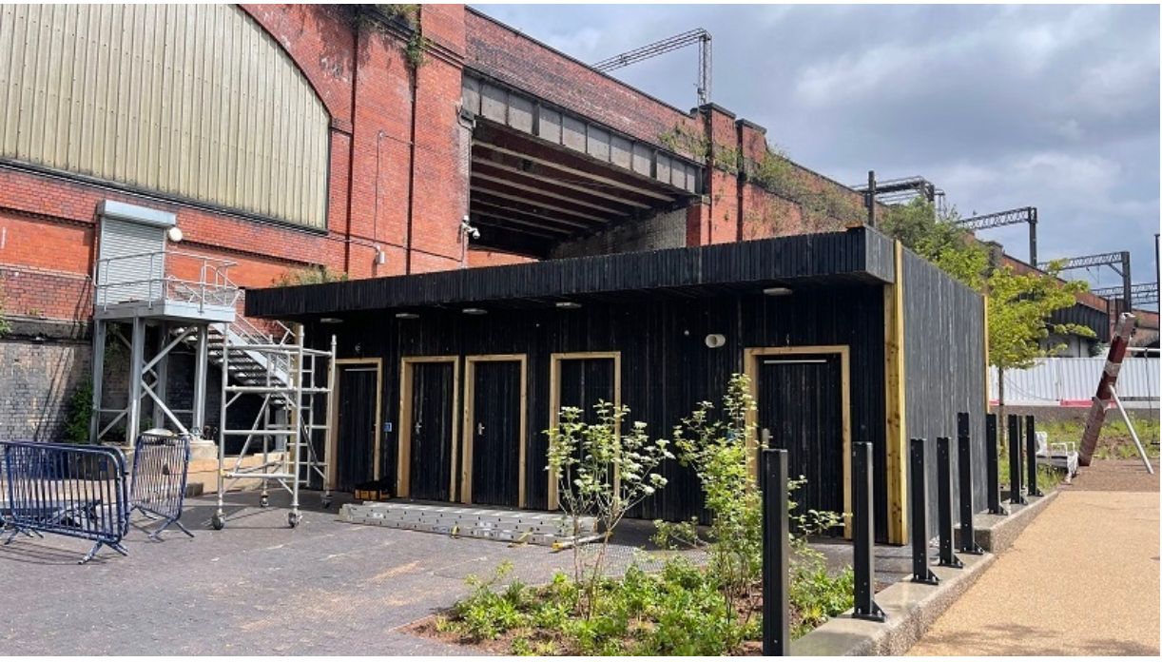
Figure 3. Public toilet of Mayfield Park (Schofield, 2022)
This matrix follows Bourne’s (2015) SRM approach, ensuring each communication type is appropriate for the stakeholder’s influence and information needs. The integration of digital dashboards and social media not only supports transparency but also provides a mechanism for real-time feedback and adaptive communication.

2.5 Consultation Strategy
Public consultation turns inactive stakeholders into active co-creators. Using Manchester's GrowGreen EU initiative (2024) methods, this initiative uses multi-modal consultation:
- Library and community centre exhibits of design concepts for public comment.
- Virtual surveys and seminars for people who cannot attend meetings improve representativeness.
- Youth sustainability education and park stewardship via school collaborations.
In co-design, residents consistently request well-signed toilets near the Play Yard and promenades. Drafts therefore include accessible WCs and baby-change with clear sightlines and lighting; mock-ups and photos will be published for comment during RIBA Stage 3 (“You Said–We Did”).
Inclusivity and early engagement boost legitimacy, whereas iterative consultation enhances decision quality (Stewart et al., 2019). Thus, the park will stress early and continuing interaction and incorporate input into project milestones. In addition, ethical consulting involves openness and response. Brunet (2025) notes that feedback results increase trust and minimise opposition. To do this, the Council will issue quarterly “You Said, We Did” reports summing stakeholder comments and project changes. Anonymous, thoroughly vetted feedback will be gathered via digital forms, public comment boxes, and social-media surveys. Each proposal will be classified by subject (e.g., environmental design, accessibility, safety) to inform technical requirements and social-value aims. The consultation process will be assessed using participation rates, stakeholder satisfaction ratings, and communication-response timeframes, per Bourne (2015) and Knox (2024). This evidence-based strategy promotes ethical and successful involvement throughout the project.

Element 3: Ethical Considerations in Consultation, Participation & Feedback

3.1 Ethical Framework
Credible and sustainable public-sector project execution requires ethical stakeholder involvement. The New Public Park Project in East Manchester uses defined ethical criteria to enable open, inclusive, and trustworthy involvement. Professional integrity and openness must govern all engagement and communication, creating stakeholder and community trust, according to the Chartered Institute of Personnel and Development (CIPD, 2023). According to the British Sociological Association's (BSA, 2021) Statement of Ethical Practice, participant autonomy, informed permission, and confidentiality are important.
These principles provide Manchester City Council three main duties. All consultations must emphasise informed participation, ensuring that participants understand the project's nature, purpose, and scope before giving their opinions. Second, all personally identifiable information must be kept secret and not released without authorisation. Third, publishing findings and adopting input requires honesty and accountability, strengthening the Council's public responsibilities.
Manchester's varied metropolitan population benefits from ethical practise's trust-building. According to BSA (2021), researcher-participant relationships should be fair and reciprocal. Community empowerment is Manchester City Council's overall purpose, so public engagement is not only symbolic but really significant in project results. Systematic ethical standards transform consultation from a procedural duty into a citizen-authority relationship.

3.2 Consultation and Data Handling
Engagement data will be collected through surveys, workshops, and online forums. These sources will include quantitative (satisfaction ratings, participation numbers) and qualitative (comments, interviews, visual feedback). All data will be encrypted on council servers and processed in accordance with the GDPR to ensure the highest data protection standards. Records will be anonymised before analysis and only available to Environment and Regeneration Department employees. Participants will be notified that their participation is optional and they may withdraw at any moment without penalty.
Before collecting data, including community pictures or testimonies, clear consent forms will be given. These forms will state the data's intended purpose, storage length, and participants' Article 17 GDPR rights to deletion or rectification. Only written consent holders will appear in consultation summaries and picture evidence. Demographic data including age, gender, and ethnicity will be gathered confidentially for representativeness evaluation. A secondary officer will peer-review data analysis to reduce human error and prejudice during interpretation. All engagement officers will get data stewardship training in accordance with CIPD (2023) ethics. This keeps data handling methods strong and compliant and promotes accountability throughout the project.

3.3 Managing Bias, Diversity, Equity & Inclusion (DEI)
Stakeholder engagement only matters when it represents community diversity. East Manchester has strong Pakistani, Arab, and Polish populations, making Manchester one of the most ethnically and culturally diverse cities in the UK (Manchester Inclusion Strategy, 2024). The Council will adopt DEI-focused solutions to overcome language, mobility, and representation challenges to promote equal participation.
Table 4. Diversity, Equity, and Inclusion Measures for Stakeholder Consultation
Barrier Identified | Inclusive Strategy | Rationale / Expected Outcome
Language differences | Provide translated consultation materials in Urdu, Arabic, and Polish | Ensures comprehension and representation of minority-language speakers
Physical accessibility | Provide wheelchair access, hearing-assistance devices, and large-print materials | Enables participation of disabled or elderly residents
Gender imbalance | Partner with women’s groups and parent associations for targeted outreach | Encourages female participation and gender equity
Youth underrepresentation | Collaborate with local youth clubs and schools | Builds long-term civic engagement and intergenerational awareness
Digital exclusion | Offer physical feedback forms and phone-based consultations | Prevents exclusion of individuals without internet access

The Equality Act 2010 (UK Government, 2010) requires public engagement programs to accommodate all participants regardless of age, disability, gender, or ethnicity. The consultation events will follow universal design principles to make physical places, digital platforms, and communication tools accessible to everyone. The Manchester Inclusion Strategy (2024) further emphasises “community co-production” and participatory equity in decision-making. This directive requires DEI officers to assess engagement materials before publishing for cultural sensitivity and linguistic neutrality. Proportional demographic monitoring will also address sampling bias: the Council will compare group representation with local census data to find gaps and alter outreach activities. The New Public Park Project shows that urban sustainability includes social justice and inclusion by incorporating DEI ideals into stakeholder engagement.

3.4 Feedback Review and Integration
Feedback integration represents the final stage of ethical stakeholder engagement. The Manchester City Council will implement a four-step feedback loop to ensure transparency and accountability throughout the project cycle:
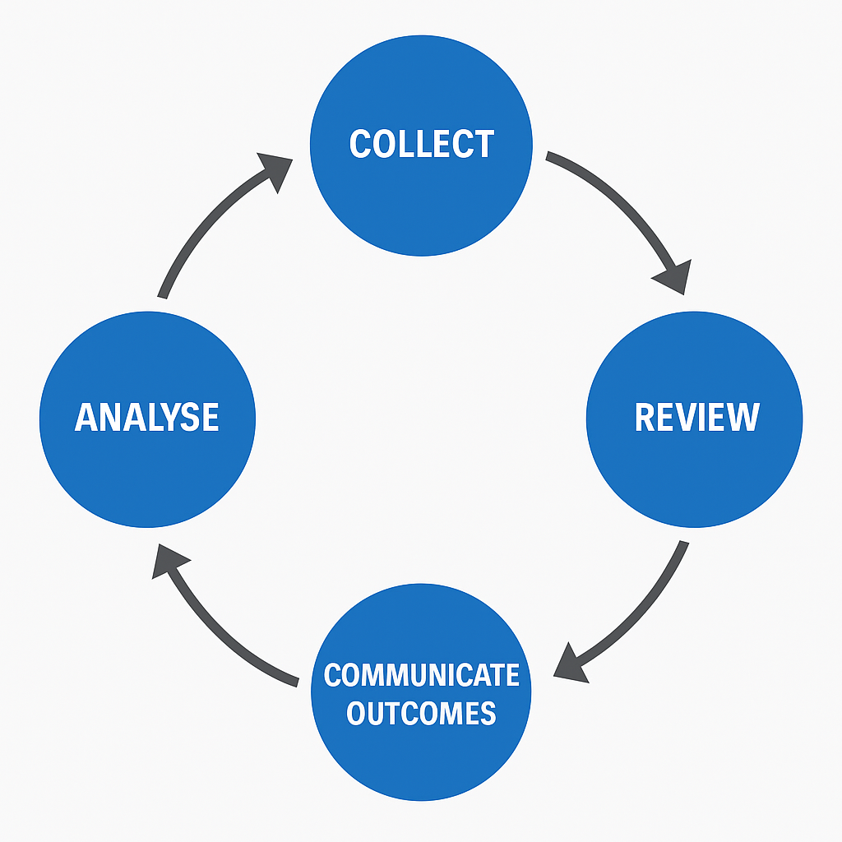
Figure 4. Feedback Loop for Stakeholder Engagement
- Collect: Feedback will be gathered from surveys, public meetings, social media polls, and comment cards placed at community venues.
- Analyse: Responses will be classified by accessibility, design, safety, and environmental considerations.
- Review: Council officials will evaluate proposed improvements alongside architects, contractors, and environmentalists.
- Communicate Outcomes: Manchester City Council will publish a “You Said – We Did” summary on its website and in newsletters to show citizens how their feedback affected them.
Residents worried about park safety at night during early engagement sessions. In response, the Council added solar-powered lights and CCTV surveillance to the plan, showing proactive governance. Brunet (2025) notes that ethical consultation is validated when participants see their comments working, boosting trust and validity. Access to project documents, FAQs, and answer summaries will be maintained by updating the Council's Public Engagement Webpage with progress updates. One year following park completion, the Council will organise an annual post-implementation review meeting for stakeholders to assess results and suggest adjustments to ensure long-term responsibility. Engagement becomes a continuous process of collaborative community governance via this continuing discourse, rather than a discrete event.

Element 4: Conclusion and Reflection

4.1 Summary of Key Insights
The New Public Park Project in East Manchester shows how organised stakeholder engagement can make a local infrastructure project inclusive and sustainable. Project success requires acknowledging stakeholders as active partners whose opinions affect planning, development, and operation. Community groups, the Council, and external partners are held responsible for success via value co-creation, based on Freeman's (1984) stakeholder theory. Mitchell, Agle, and Wood's (1997) stakeholder salience model assessed actors' power, legitimacy, and urgency to define the project's communication hierarchy. This analytical structure encourages safety, biodiversity, and accessibility engagement.
Integrating CIPD's (2023) Code of Professional Conduct ethical communication principles boosts openness and trust. Public infrastructure ethical governance is moral, not procedural, between individuals and authority. Manchester City Council establishes credibility and community support via impartiality, informed consent, and data confidentiality in consultations. Finally, engagement helps regional sustainability frameworks like the GMCA's (2025) Five-Year Environment Plan and Manchester City Council's (2025) Green and Blue Infrastructure strategy. Participatory governance is required for the Zero Carbon 2038 Target, linking environmental resilience to social inclusion. These results demonstrate that stakeholder engagement is crucial to project success and assures environmental, social, and ethical sustainability.

4.2 Reflective Account (Gibbs’ Model, 1988)
Table 5. Reflective Account Using Gibbs’ Reflective Cycle (1988)
Stage of Gibbs’ Reflective Cycle | Reflection Summary (Applied to New Public Park Project)
1. Description | The task involved developing a stakeholder management plan for Manchester’s New Public Park, requiring stakeholder identification, engagement strategy, and ethical framework. Initially, my focus was mainly on technical tools like matrices and maps rather than relational aspects.
2. Feelings | I felt uncertain about balancing efficiency and inclusivity, particularly ensuring underrepresented groups were heard. Over time, I became more confident as I learned that engagement must prioritise empathy, trust, and shared ownership.
3. Evaluation | Evaluating my approach, I realised that structured communication and feedback loops reduced uncertainty and improved accountability. Using stakeholder mapping tools provided clarity in managing expectations.
4. Analysis | Analysis of engagement methods showed that inclusivity directly influenced project legitimacy. I observed that diverse participation increased the project’s acceptance and social relevance.
5. Conclusion | I concluded that ethical, transparent, and inclusive engagement drives project sustainability and strengthens civic trust. Success in stakeholder management depends on both technical planning and moral responsibility.
6. Action Plan | In future practice, I aim to apply participatory tools early, implement DEI strategies systematically, and integrate regular feedback mechanisms. I will also engage in ethical leadership training.

4.3 Closing Reflection
Sustainability requires transparency and broad engagement, which underlies Manchester's Zero Carbon by 2038 goal (GMCA, 2025). This initiative taught me that stakeholder management is a strategic and ethical requirement that helps environmental objectives become community results. The Stewart et al. (2019)-inspired project consultation model shows how participatory methods build legitimacy and lessen opposition. When citizens feel their views count, they support public space upkeep, safety, and social usage as fellow sustainability advocates. Brunet (2025) claims that transparent engagement reduces social conflict and boosts organisational resilience, which is important for long-term municipal planning. This contemplation showed me the importance of self-awareness and critical thought in ethical decision-making. As a future stakeholder professional, I want to promote engagement as a chance to create civic pride and shared responsibility. The New Public Park Project shows that urban infrastructure success goes beyond building. To promote collective well-being, people, location, and policy interact and inform each other. Transparent stakeholder management becomes a democratic governance tool, guaranteeing sustainability and community ownership.

Reference List
Aaltonen, K., Di Maddaloni, F. and Sivunen, A. (2024) ‘Response strategies for community stakeholder engagement on social media: A case study of a large infrastructure project’, International Journal of Project Management, 42(3), pp. 455–468.
Available at: https://discovery.ucl.ac.uk/10201052/1/Di%20Maddaloni_1-s2.0-S0263786324000917-main.pdf(Accessed: 13 October 2025).
Bourne, L. (2015) Stakeholder Relationship Management: A Maturity Model for Organisational Implementation. 2nd edn. Farnham: Gower.
British Sociological Association (BSA) (2021) Statement of Ethical Practice. Durham: BSA. Available at: https://www.britsoc.co.uk/media/24310/bsa_statement_of_ethical_practice.pdf (Accessed: 13 October 2025).
Brunet, M. (2025) ‘Governance, social acceptability and organisational dynamics in public infrastructure projects’, Project Management Journal, 56(4), pp. 312–327.
Available at: https://journals.sagepub.com/doi/full/10.1177/87569728251341288 (Accessed: 13 October 2025).
Chartered Institute of Personnel and Development (CIPD) (2023) Code of Professional Conduct. London: CIPD.
Dolan, K. J. (2025) ‘Stakeholder engagement in large infrastructure projects’, International Journal of Managing Projects in Business, 18(2), pp. 221–242.
Available at: https://www.tandfonline.com/doi/full/10.1080/14488388.2025.2538901 (Accessed: 13 October 2025).
Erkul, R., Kumral, M. and Celik, T. (2016) ‘Stakeholder engagement in mega transport infrastructure projects’, Procedia Engineering, 164, pp. 518–525.
Available at: https://www.sciencedirect.com/science/article/pii/S1877705816329745 (Accessed: 13 October 2025).
Freeman, R. E. (1984) Strategic Management: A Stakeholder Approach. Boston: Pitman.
Greater Manchester Combined Authority (GMCA) (2024) Embedding Green Infrastructure Principles: Guidance for Greater Manchester Local Authorities.
Available at: https://greatermanchester-ca.gov.uk/GMCAFiles/PFE/Supporting%20documents/07%20Greener%20Places/07.01.02%20Guidance%20for%20Greater%20Manchester%20-%20Embedding%20Green%20Infrastructure%20Principles.pdf (Accessed: 13 October 2025).
Greater Manchester Combined Authority (GMCA) (2024) Green Infrastructure Policy Context. Available at: https://greatermanchester-ca.gov.uk/GMCAFiles/PFE/Supporting%20documents/07%20Greener%20Places/07.01.01%20Green%20Infrastructure%20Policy%20Context.pdf (Accessed: 13 October 2025).
Greater Manchester Combined Authority (GMCA) (2024) Natural Environment Topic Paper (Places for Everyone). Available at: https://greatermanchester-ca.gov.uk/GMCAFiles/PFE/Supporting%20documents/07%20Greener%20Places/07.01.26%20Natural%20Environment%20Topic%20Paper.pdf (Accessed: 13 October 2025).
Greater Manchester Combined Authority (GMCA) (2025) Greater Manchester Five-Year Environment Plan 2025–2030. Available at: https://www.greatermanchester-ca.gov.uk/media/alnl0fsy/gmca_5-year-plan_final_digital_v3-ua.pdf(Accessed: 13 October 2025).
GrowGreen EU Project (2024) Manchester Actions and Nature-Based Strategies.
Available at: https://growgreenproject.eu/city-actions/manchester/ (Accessed: 13 October 2025).
Hislop, M., Scott, A.J. and Corbett, A. (2019). What Does Good Green Infrastructure Planning Policy Look Like? Developing and Testing a Policy Assessment Tool Within Central Scotland UK. Planning Theory & Practice, 20(5), pp.633–655. doi:https://doi.org/10.1080/14649357.2019.1678667.
Institution of Civil Engineers (ICE) (2024) Green and Blue Infrastructure: A Transport Sector Perspective. Available at: https://www.ciht.org.uk/media/17093/green-and-blue-infra_single-page-version.pdf (Accessed: 13 October 2025).
Jayasuriya, S. (2024) ‘Towards successful economic infrastructure partnership: Stakeholder management strategies for PPP projects’, International Journal of Project Management, 42(1), pp. 15–28. Available at: https://www.sciencedirect.com/science/article/pii/S2590198224001593 (Accessed: 13 October 2025).
Knox, S. (2024) ‘Stakeholder engagement-as-practice in public sector innovation’, Public Management Review, 26(5), pp. 799–816. Available at: https://strathprints.strath.ac.uk/91231/ (Accessed: 13 October 2025).
Manchester City Council (2025) Manchester Green Infrastructure Technical Report. Available at: https://media.ontheplatform.org.uk/sites/default/files/Manchester%20GI%20Technical%20Report%20FINAL.pdf(Accessed: 13 October 2025).
Manchester City Council (2025) Manchester’s Great Outdoors – A Green & Blue Infrastructure Strategy and Action Plan 2025–2030. Available at: https://www.manchester.gov.uk/downloads/download/6314/manchester_green_and_blue_strategy(Accessed: 13 October 2025).
Manchester City Council (2025) Tree Action Plan 2025. Available at: https://www.manchester.gov.uk/info/500002/council_policies_and_strategies/7061/green_and_blue_infrastructure/3(Accessed: 13 October 2025).
Mitchell, R. K., Agle, B. R. and Wood, D. J. (1997) ‘Toward a theory of stakeholder identification and salience: Defining the principle of who and what really counts’, Academy of Management Review, 22(4), pp. 853–886.
Prebanić, K. R. and Vukomanović, M. (2023) ‘Exploring stakeholder engagement process as the success factor for infrastructure projects’, Buildings, 13(7), 1785.
Available at: https://www.mdpi.com/2075-5309/13/7/1785 (Accessed: 13 October 2025).
Schofield, J. (2022) ‘Exclusive first look at Mayfield Park: looking wonderful, making the city centre better’, Manchester Confidentials, 31 May. Available at: https://confidentials.com/manchester/mayfield-park-city-centre-first-look(Accessed: 2 November 2025).
Stewart, R., Williams, A., Morris, C. and Jenkins, T. (2019) ‘Recruiting and integrating stakeholders in public participation processes: Lessons from urban environmental projects’, Environmental Science & Policy, 101, pp. 20–29.
Available at: https://pmc.ncbi.nlm.nih.gov/articles/PMC6512972/ (Accessed: 13 October 2025).
United Kingdom Government (2010) Equality Act 2010. London: The Stationery Office.
Watson, J. (2023) ‘First new Manchester park in over a century’, Landscape Architecture Aotearoa, 14 June. Available at: https://www.landscapearchitecture.nz/landscape-architecture-aotearoa/2023/3/2/first-new-manchester-park-in-over-a-century (Accessed: 2 November 2025).

