


Phishing Website Detection using Ensemble Approach

Rasithabanu Abdhul Rahim

SUPERVISOR - NITHEESH KALIYAMURTHY
March - 2026

Student No: 2415470
Course: MSc Cybersecurity and Digital Forensics

DECLARATION OF ORIGINALITY
I, Rasithabanu Abdhul Rahim declare that I am the sole author of this Project; that all references cited have been consulted; that I have conducted all work of which this is a record, and that the finished work lies within the prescribed word limits.
This work has not previously been accepted as part of any other degree submission.

Signed: .............................................

Date: ...............................................

FORM OF CONSENT

I, Rasithabanu Abdhul Rahim, hereby consent that my Project, submitted in candidature for the Cybersecurity and Digital Forensics, if successful, may be made available for inter-library loan or photocopying (subject to the law of copyright), and that the title and abstract may be made available to outside organisations.

Signed: .............................................

Date: ...............................................

COPYRIGHT ACKNOWLEDGEMENT
I acknowledge that the copyright of this project report, and any product developed as part of the project, belong to University of Wales Trinity Saint David, Swansea.

ABSTRACT
Phishing attacks remain one of the most significant and widespread threats in cybersecurity, where attackers create fraudulent websites to steal sensitive information such as passwords, financial credentials, and personal data. Although many detection techniques have been proposed, several limitations remain in existing research. These include the use of limited feature sets, reliance on outdated or static datasets, and evaluation methods that focus primarily on accuracy while overlooking other important performance metrics. In addition, traditional machine learning models often struggle to generalise effectively to new and evolving phishing techniques.
This study experimentally evaluates ensemble machine learning approaches for phishing website detection while addressing several research gaps identified in the literature. A systematic literature review (SLR) was conducted following the PRISMA protocol to analyse research published between 2020 and 2025. From an initial set of 30,015 papers, 77 high-quality studies focusing on ensemble learning approaches for phishing detection were selected for detailed analysis. Guided by the Research Onion framework, the study adopted a positivist research philosophy, a deductive research approach, and an experimental quantitative methodology.
The experiments were conducted using the Kaggle Phishing Website Dataset containing 11,055 samples and 32 features describing URL structure, domain characteristics, and website behaviour indicators. Feature selection techniques including Information Gain, Gain Ratio, and Principal Component Analysis (PCA) were applied to identify the most relevant attributes for classification. Two experiments were performed. The first experiment replicated a base study by evaluating nine models across shallow machine learning, ensemble learning, and deep learning categories. The second experiment extended the evaluation by introducing two additional models: LightGBM and a stacking ensemble combining Random Forest, AdaBoost, and LightGBM using logistic regression as the meta-learner. These models were selected based on findings from the literature review, where LightGBM and stacking ensembles were frequently reported as high-performing approaches for phishing detection.
The experimental results demonstrate that ensemble learning models provide the most reliable performance for structured phishing datasets. Random Forest achieved the highest performance with 97.42% accuracy, 97.43% precision, 97.42% recall, and an F1-score of 97.42%, while the stacking ensemble achieved a comparable accuracy of 97.38%. These findings confirm that ensemble-based approaches provide effective and reliable solutions for phishing website classification.
Overall, the study experimentally validates the effectiveness of ensemble learning techniques for phishing detection and addresses several research gaps identified in previous studies. However, the use of a static dataset remains a limitation. Future research should explore the use of real-time phishing datasets, hyperparameter optimisation techniques, and explainable artificial intelligence methods to improve model transparency and real-world deployment in cybersecurity systems.
Keywords: Cybersecurity; Ensemble Learning; Feature Selection; LightGBM; Machine Learning; Phishing Detection; Random Forest; Stacking Ensemble; XGBoost.

Contents
COPYRIGHT ACKNOWLEDGEMENT 3
Chapter 1: Introduction 9
1.1 Introduction 9
1.2 Aim and Objectives 12
1.3 Research Gap 12
1.4 Structure of the Project 13
Chapter 2 - Research & Review of Literature 14
2.1 Methodology 14
2.2 Types of Literature Review 14
2.3 Approach of the Literature Review 15
2.4 Gap Analysis 15
2.5 Query for Phishing Detection Using Ensemble Approaches 16
2.5.1 PRISMA Diagram: 17
2.6 Bibliometric Analysis 18
2.6.1 Literature Performance Benchmarks 22
2.7 Critical Evaluation of Existing Literature 23
2.8 Conclusion of Literature Review 24
Chapter 3 – Research Methodology 25
3.1 Introduction 25
3.2 Research Overview 25
3.2.1 Research Philosophy – Positivism 25
3.2.2 Research Approach – Deductive Approach 26
3.2.3 Research Strategy – Experimental Strategy 26
3.2.4 Methodological Choice – Quantitative Mono-Method 26
3.2.5 Time Horizon – Cross Sectional 26
3.2.6 Techniques and Procedures 26
3.3 Dataset Selection 27
3.4 Risk Assessment and Contingency Plan 27
3.5 Project Timeline (Gantt Chart): 28
3.6 Conclusion 28
Chapter 4 – Design and Implementation 29
4.1 Introduction 29
4.2 Problem Formulation 29
4.2.1 Problem Statement 29
4.2.2 Adopted Experimental Framework 29
4.2.3 Proposed System Architecture 30
4.3 System Design and Justification 31
4.3.1 Design Principles 31
4.3.2 Model Selection Rationale 31
4.4 Dataset Description 32
4.5 Experimental Setup 32
4.5.1 Hardware Environment 32
4.5.2 Software Environment 33
4.6 Implementation Procedure - Experimental 1 33
4.6.1 Dataset Collection 33
4.6.2 Data Validation and Cleaning 34
4.6.3 Feature Selection 35
4.6.4 Train-Test Split 38
4.6.5 Model Training 39
4.6.6 Model Evaluation 44
4.6.7 Originality of Work and Student Contribution 45
4.7 Experimental – 2 46
4.7.1 Dataset Loading 46
4.7.2 Data Validation and Cleaning 46
4.7.3 Feature Selection 47
4.7.4 Train-Test Split 51
4.7.5 Model Training 52
4.7.6 Saving the Trained Models 60
4.7.7 Model Evaluation 61
4.7.8 Originality of Work and Student Contribution 62
4.8 Ethical Considerations 63
4.9 Conclusion 63
Chapter 5 – Results and Analysis 64
5.1 Introduction 64
5.2 Experiment 1 – Base Paper Replication 64
5.2.1 Purpose of Experiment 1 64
5.2.2 Scope of Generative AI Used in Implementation 64
5.2.3 Summarised Outcomes of Experiment 1 65
5.3 Experiment 2 – Extended Model Comparison 65
5.3.1 Purpose of Experiment 2 and Justification for New Models 65
5.3.2 Summarised Outcomes of Experiment 2 66
5.4 Comparative Analysis and Discussion 67
5.4.1 Base Paper Outcomes 67
5.4.2 Three-Way Comparison: Base Paper vs Experiment 1 vs Experiment 2 68
5.4.3 Discussion of Results 68
5.5 Reflection on Aims and Objectives 69
5.5.1 Aim 1 – Systematic Literature Review 69
5.5.2 Aim 2 – Research Methodology Framework 69
5.5.3 Aim 3 – Build and Experiment with an Ensemble-Based Detection Model 69
5.5.4 Aim 4 – Compare Results and Draw Conclusions 69
Chapter 6 - Research Gap Addressing 70
6.1 Gap 1 — Traditional Models Fail in Real-World Deployment 70
6.2 Gap 2 — Limited Feature Sets 70
6.3 Gap 3 — Outdated and Static Datasets 70
6.4 Gap 4 — Accuracy-Only Evaluation 70
6.5 conclusion 70
Chapter 7 – Conclusion 72
7.1 Conclusion 72
7.2 Future Work 72
7.2.1 Use of Updated Datasets 72
7.2.2 Hyperparameter Optimisation 72
7.2.3 Explainability and Interpretability 72
7.2.4 Real-Time Detection Systems 73
Chapter 8 - Reflection 74
8.1 Technical Reflection 74
8.2 Personal Reflection 74
8.3 Conclusion 75
Chapter 9 - References 76

LIST OF FIGURES

Figure 1: Spear Phishing Attack Flow and Data Protection Mechanisms 10
Figure 2: Network Security Layout 11
Figure 3: Types of Literature Review 15
Figure 4: PRISMA Flow Diagram of the Study Selection Process 17
Figure 5: Top Authors by Number of Publications 19
Figure 6: World Map of Article Output by Country 21
Figure 7: Research Onion Method Diagram 26
Figure 8: Project Timeline (Gantt Chart) 29
Figure 9: Experimental Pipeline for Phishing Website Detection 30
Figure 10: System Flow Diagram of the Phishing Website Detection Model Implementation 31
Figure 11: Preview of the Kaggle Phishing Website Dataset 35
Figure 12: Checking the Dataset for Missing Values 36
Figure 13: Feature Selection Using Information Gain 37
Figure 14: Feature Selection Using Gain Ratio 38
Figure 15: Feature Selection Using Principal Component Analysis (PCA) 39
Figure 16: Splitting the Dataset into Training and Testing Sets 40
Figure 17: Implementation of the Support Vector Machine (SVM) classification model. 40
Figure 18: Implementation of the K-Nearest Neighbors (KNN) classification model. 41
Figure 19: Implementation of the Random Forest ensemble learning model. 41
Figure 20: Implementation of the AdaBoost ensemble learning model. 42
Figure 21: Implementation of the XGBoost classification model. 42
Figure 22: Implementation of the LSTM deep learning model. 43
Figure 23: Implementation of the RNN deep learning model. 44
Figure 24: Implementation of the GRU deep learning model 44
Figure 25: Preview of the Kaggle Phishing Website Dataset 47
Figure 26: Missing Value Inspection of the Dataset 48
Figure 27: Information Gain Values for Top Selected Features 49
Figure 28: Ranked Feature Importance Scores Based on Gain Ratio (GR) 51
Figure 29: Ranked Feature Importance Scores Based on Principal Component Analysis (PCA) 52
Figure 30: Train–test split implementation using Scikit-learn 52
Figure 31: Classification models used in the proposed phishing detection system 53
Figure 32: SVM model implementation in Python 53
Figure 33: Implementation of the Decision Tree classifier for training and prediction 54
Figure 34: Implementation of the K-Nearest Neighbours (KNN) classifier for model training and prediction 54
Figure 35: Implementation of the Random Forest classifier for training and prediction 55
Figure 36: Implementation of the AdaBoost classifier for model training and prediction 55
Figure 37: Implementation of the XGBoost classifier for training and prediction 56
Figure 38: Implementation of the LightGBM classifier for training and prediction 57
Figure 39: Implementation of the Stacking Ensemble model 58
Figure 40: Implementation of the Recurrent Neural Network (RNN) model 60
Figure 41: Implementation of the GRU model 61
Figure 42: Saving trained machine learning and deep learning models 61
Figure 43: Summary of Research Gaps Addressed in This Study 72

LIST OF TABLES
Table 1: Criteria Used for Selecting Studies in the Systematic Review 16
Table 2: Number of Publications per Year (2020–2025) 18
Table 3: Publication Distribution 19
Table 4: Most Frequently Used Datasets in Phishing Detection Studies 19
Table 5: Literature Performance Benchmarks 22
Table 6: Research Phases with Cybersecurity Justification 26
Table 7: Risk Assessment Matrix 27
Table 8: Evaluation Results 45
Table 9: Evaluation Results 62
Table 10: Experiment 1 Results Base Paper Replication (9 Models) 65
Table 11: Experiment 2 Results - Extended Model Comparison (11 Models) 66
Table 12: Base Paper Results 67
Table 13: Comparative Results - Base Paper vs Experiment 1 vs Experiment 2 68

Chapter 1: Introduction

1.1 Introduction
Cybersecurity is about keeping computers and information safe so no one can harm or steal them [1]. In today’s world, where we use technology for almost everything like banking, shopping, learning, and communicating keeping information safe is very important. Hackers and cybercriminals try to steal personal information, money, or disrupt services by attacking computers and networks. Cybersecurity acts like a strong shield to stop these attacks and keep our digital lives safe.
The purpose of cybersecurity is to protect information and ensure that it can only be accessed by the people who are allowed to use it [2] [3]. It also aims to ensure that data remains accurate and unaltered by unauthorized individuals, a concept called integrity. Additionally, cybersecurity strives to make sure that systems and data are available and functioning properly whenever they are needed, referred to as availability. Together, these goals help protect information and technology from harm or misuse. There are many types of cybersecurity threats. For example, viruses and malware can damage your computer or steal information. Phishing is when attackers send fake emails to trick you into giving your passwords or money. Hacking happens when someone enters a computer system without permission. Ransomware is a type of harmful software that locks files and asks for payment to unlock them.
To stay safe from these threats, cybersecurity uses different tools. For example, firewalls help stop unwanted access, antivirus software finds and removes harmful programs, and encryption protects data so that only the right people can read it [4]. Using strong passwords and regularly updating software also helps keep systems secure. Everyone from big companies and governments to regular people needs cybersecurity. It helps protect money, personal information, and important services we rely on every day. In short, cybersecurity is about keeping our digital world safe so we can use technology without fear. By understanding and using security measures, we protect ourselves and the information that matters most.
In cybersecurity, understanding the connection between vulnerabilities, threats, and attacks is very important. Vulnerabilities are the weak spots or flaws in a computer system, software, or network like outdated software, weak passwords, or wrong settings that make it easier for bad actors to get in or cause damage [5] [6]. These vulnerabilities attract threats, which are potential dangers that try to exploit these weak points. Threats can come from hackers, malicious software, or even accidental human mistakes. Their goal is usually to steal information, damage systems, or disrupt services. When these threats turn into real actions, they become attacks. Attacks are deliberate efforts by cybercriminals to take advantage of vulnerabilities. For example, an attacker may send a fake email to trick someone into sharing their password or use harmful software to damage a computer system. In short, vulnerabilities are the weaknesses, threats are the possible dangers, and attacks are the harmful actions that exploit those weaknesses. Understanding how these three work together helps us build better defences to protect our digital systems.
Phishing is a cyber-attack where criminals try to trick people into giving sensitive information such as passwords, credit card numbers, or personal details[7][5]. They often send fake emails, messages, or create websites that look like they are from trusted companies like banks, online stores, or social media platforms. These attacks work because people may trust the message or fail to notice small signs that the message or website is not genuine [8][9]. This means even if the technical systems are secure, people can still be fooled. Phishing is dangerous because it can lead to stolen identities, loss of money, or attackers gaining access to personal accounts. Since phishing targets people rather than just software or networks, it’s often harder to defend against than other types of attacks. To stay safe from phishing, people should be careful with suspicious messages, check who sent them, and avoid clicking on links from unknown sources. Training and education can reduce the chance that someone will fall victim to these attacks.
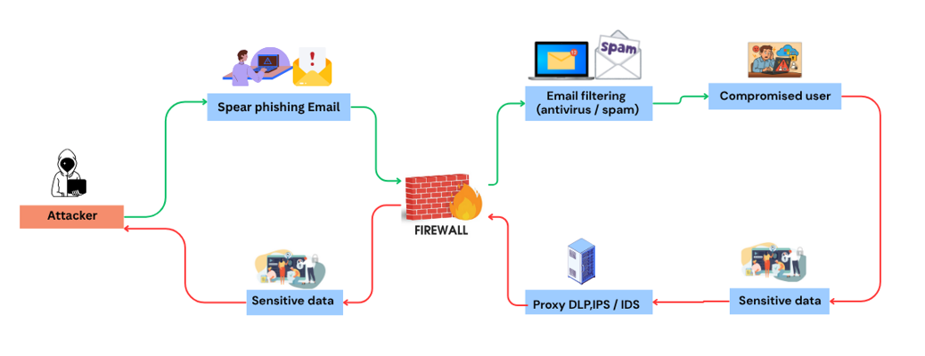
Figure 1: Spear Phishing Attack Flow and Data Protection Mechanisms
Phishing is a method used by attackers to steal private information such as passwords, bank details, or credit card numbers. They usually pretend to be someone trustworthy, like a bank, a well-known website, or even a friend. These attackers send fake emails, messages, or create fake websites that look very real. When you trust them and share your information, the attackers use it to steal money or cause problems. Phishing is dangerous because it tricks people, and even careful users can sometimes fall for it. It is one of the most common ways criminals attack people online.
There are different types of phishing attacks, each working in a slightly different way:
Email phishing is the most common type of phishing attack. In this method, attackers send emails that appear to come from real companies, banks, or online services. These emails often ask you to click a link or download a file, which might cause you to give your personal information without knowing it [10]. Spear Phishing is a more targeted attack, focusing on one person or company. Attackers use information about that person to make the email look very real and personal, making it easier to trick the victim [11]. Smishing is a type of phishing that happens through text messages. In this attack, criminals send fake messages to a phone and ask the person to click a link or share personal information. Vishing happens over the phone, with the attacker calling you pretending to be someone you trust, like a bank worker, to ask for your sensitive information. Website Phishing involves attackers creating fake websites that look like real ones, and when you enter your details on these fake sites, the attackers steal your information.
Stopping phishing is not easy because phishing emails and messages are designed to look very convincing, often using logos, names, and language that mimic real companies, making it hard to tell if they are fake. Attackers continuously develop new tricks to fool people, changing their methods whenever security improves. Even careful users can make mistakes, accidentally clicking on bad links or sharing information, especially when tired or busy. Many people don’t know what phishing is or how to recognize it, making them easy targets. Additionally, technology cannot catch every phishing attempt because attackers constantly adapt their tactics, allowing some malicious messages to slip through even the best security software.
Cloud infrastructure is the foundation that supports websites, applications, and online services by providing computing power, storage, and network resources over the internet [12] [13]. Web servers such as Microsoft IIS and Apache are commonly used to process user requests and provide website content. However, because they connect directly to the internet, they are common targets for cyber attackers. Security gaps often appear due to misconfigurations, unpatched vulnerabilities, weak access controls, and the overall complexity of managing multiple layers such as servers, networks, and applications. Human errors, rapid changes in cloud setups, unknown vulnerabilities, and limited visibility into all assets further increase these risks. Tools like Netcraft help detect weaknesses, but closing the security gap requires regular updates, strong server configurations, strict access controls, continuous monitoring, and user training. By addressing these challenges, organizations can better protect their cloud infrastructure and keep servers like IIS and Apache safe from evolving cyber threats.
Machine Learning (ML) is a part of Artificial Intelligence (AI) that helps computers learn from data and make their own decisions, without needing someone to programme every step [14] [15]. Instead of being given strict rules to follow, these systems look for patterns in data and keep improving the more data they are given. In the area of online safety, ML is used to notice strange behaviour, identify different kinds of threats, and find fake websites by looking through huge amounts of data very quickly. There are three main ways these systems can learn: the first is where the system is trained using examples that already have answers, such as websites that are already known to be fake or real; the second is where the system finds patterns on its own without any answers being given to it; and the third is where the system tries different things and learns from whether those actions turn out to be right or wrong [16][1].
Cyber-attacks are planned attempts by bad actors to find and take advantage of weak points in computer systems, and they can happen in many ways. Some attacks use harmful software such as viruses and worms that get into a system and cause damage or steal private information. A particular type of harmful software can lock all the files on a computer and then demand a payment before giving access back. Some attacks work by sending so much traffic to a website or system that it becomes too busy to work properly and shuts down. Other attacks target the way websites store and manage information, allowing an attacker to break in and take data they should not have access to. There are also attacks where someone secretly sits between two people who are communicating online and reads or changes the messages without either person knowing. Some attackers look for brand new weaknesses in systems that have not yet been fixed by the people who built them, and they strike before any solution is available. All these examples show that there are many ways a system can be attacked, which is why having strong protection in place is so important.
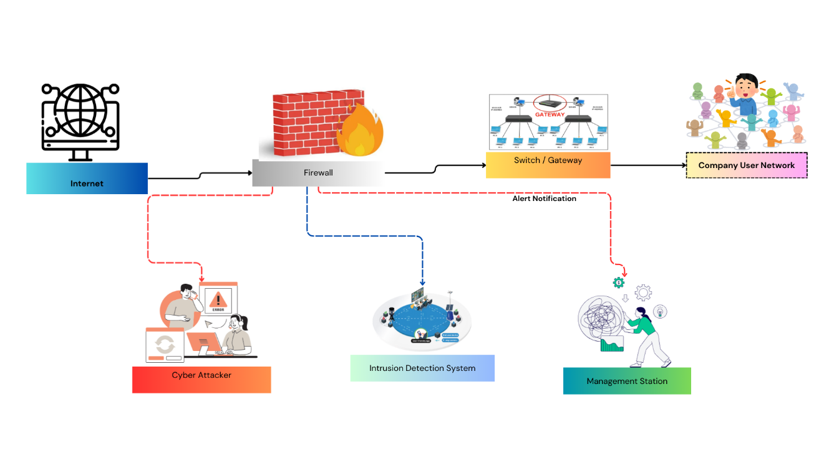
Figure 2: Network Security Layout
Ensemble learning is a way of building a smarter system by using several different models together rather than relying on just one. By combining the strengths of multiple models, the overall system is able to make better and more reliable predictions than any single model could on its own [17][18]. In phishing detection, ensemble learning helps reduce false positives and improves overall system performance by analysing websites from multiple perspectives. There are four common ways this method can be used. In the first method, several models are trained using different parts of the data, and their results are combined to produce the final answer. In the second method, models are created one after another, and each new model tries to correct the mistakes made by the previous one. In the third method, the results from several models are sent to another model that studies all the results and decides the final output. In the fourth method, several models give their own answers, and the answer that appears the most times is selected as the result.
This project aims to detect phishing websites using a method that combines several machine learning models. The system studies different parts of a website, such as the URL, domain details, and webpage content, to decide whether the site is real or fake. By using several models together, the system tries to improve the accuracy of detection and reduce incorrect warnings. This can help protect users from online scams and make internet browsing safer.

1.2 Aim and Objectives
The aim of this project is to experiment with an ensemble learning model including XGBoost to address the identified research gaps, enhancing phishing website detection accuracy and reducing phishing threats.
- To review previous studies on phishing detection by conducting a systematic literature review and identifying gaps in earlier research.
- To use the Research Onion framework to choose the most suitable research methods and techniques for this study.
- To select and experiment an ensemble-based model for phishing detection system.
- To analyse and conclude by testing the developed system, comparing it with existing methods, and drawing meaningful conclusions.

1.3 Research Gap
Many studies have tried to detect phishing websites, but there are still some gaps in research that limit the effectiveness of existing methods. These gaps are described below:
1. Traditional methods give good results on training but fail in implementation
Traditional machine learning models such as Decision Trees, SVM, and Naïve Bayes can perform well during training because they learn patterns from the data used to train them. However, these models struggle when applied to new or unseen phishing websites [19][2]. This is because attackers constantly change their methods, so models trained on past data may not detect new types of phishing attacks.
- These models can be overfit to the training data, performing well in experiments but failing in real world scenarios.
- They lack the flexibility to recognize new or sophisticated phishing techniques that differ from previously learned patterns.
2. Use of a small set of features
Many studies rely on only a limited number of features, such as the website URL or domain information. While these features can help detect simple phishing websites, they do not capture all aspects of modern attacks. Phishing websites often use fake content, scripts, or misleading layouts to trick users, which cannot be detected with a small feature set [20][12]. Using only a few features makes detection effective for simple attacks but weak against advanced phishing strategies. Ignoring other important information, like webpage content, scripts, and hosting details, reduces the system’s reliability and accuracy.
3. Old or static datasets
Most research uses outdated or static datasets to train and test models. Since phishing attacks evolve rapidly, these datasets may not represent current threats. A model trained on old data might appear accurate in experiments but fail to detect modern phishing websites when deployed [15]. Models trained on outdated datasets may miss new phishing techniques, reducing their real-world usefulness. Static datasets prevent detection systems from keeping up with evolving phishing methods, making them less adaptable over time.
4. Evaluation focused only on accuracy, ignoring false alarms and missed phishing websites
Many studies evaluate their models only using accuracy. While accuracy is important, it does not give a complete picture of performance, especially when phishing websites are fewer than legitimate ones [21]. A model may appear accurate while still missing many phishing websites (false negatives) or raising too many false alarms (false positives).
- High accuracy alone can hide the problem of missed phishing websites, which reduces system effectiveness [22].
- Focusing only on accuracy does not consider false positives [23], which can confuse users and lower their trust in the system. Therefore, other measures such as precision, recall, and F1 score should also be used for a more realistic evaluation.

1.4 Structure of the Project
There are three main parts to this project. The first part of the study is to look at other research and theories about phishing attacks and machine learning techniques. This is the basis for the study. The second part is about how to design and build the phishing detection system. It goes over how to collect data, build a model, and put it into action. The last part shows the results of the tests and evaluations, as well as conclusions and suggestions for how to make things better in the future.
Chapter One introduces the topic, states the project's aim, and outlines the key objectives and research gaps.
Chapter Two reviews related work on phishing detection methods and machine learning models through a Systematic Literature Review, identifying key research gaps.
Chapter Three describes the research methodology and design, including the Research Onion framework, dataset selection, and experimental planning.
Chapter Four goes over how the phishing detection system was designed and put into action, including all eleven-machine learning and deep learning models that were used.
Chapter Five presents the experimental results from two experiments, evaluates model performance using four metrics, addresses the research gaps, and draws conclusions with recommendations for future work.

Chapter 2 - Research & Review of Literature
This chapter examines previous studies on phishing website detection, emphasising the application of machine learning and ensemble techniques. It looks at trustworthy sources like academic books, peer-reviewed journal articles, and reliable websites to learn how phishing websites work and how to find them.
The goal is to look into how different researchers have dealt with this issue, what tools and models they used, and how well their methods worked. Ensemble learning, which combines several machine learning models to make them more accurate, is a big part of this. This chapter compares different studies to show the pros and cons of current methods, find gaps in current research, and explain why this project takes a certain approach to improve phishing website detection.

2.1 Methodology
To complete this literature review on Phishing Website Detection using an Ensemble Approach, a clear and step by step method was followed to collect and study relevant information from trusted sources.
Approach Type: This literature review utilised a quantitative approach, concentrating on the analysis and comparison of numerical results, including accuracy, precision, recall, and model performance, as reported in prior studies.
Source Selection: We used academic databases like IEEE Xplore, SpringerLink, ScienceDirect, and Google Scholar to find trustworthy journal articles, books, and research papers about phishing detection and machine learning.
Keyword Search: Keywords such as “Phishing website detection,” “Ensemble learning,” “Machine learning in cybersecurity,” “Boosting and Bagging,” and “Random Forest phishing detection” were applied to locate relevant literature.
Paper Selection: The review included papers published between 2020 and 2025 that focused on using machine learning to find phishing attacks, especially ensemble methods like Random Forest, AdaBoost, and Stacking.
Comparison of Studies: We looked at and compared each study based on the models used, the accuracy reported, the datasets used (like Phish Tank and UCI), and the tools or programming frameworks used (like Python and Scikit-learn).
Pros and Cons Analysis: We looked at the strengths (like high accuracy) and weaknesses (like limited real-time detection capability) of the studies we reviewed to find gaps in the current research and to help us plan the current project.

2.2 Types of Literature Review
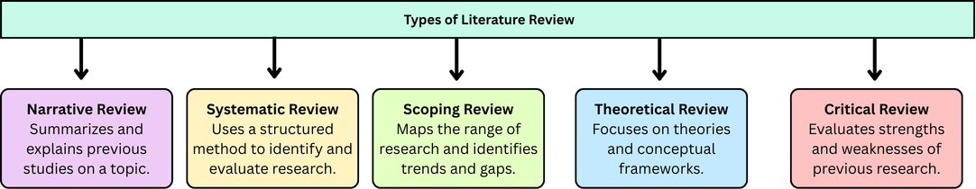
Figure 3: Types of Literature Review

Narrative (Traditional) Literature Review
A narrative literature review explains and summarizes past studies on a topic. It tells what other researchers have done, what they found, and how they did it. This type of review helps to understand the topic and shows what is missing in previous research [9].
Systematic Literature Review
A systematic literature review uses a clear method to find and check all research on a topic. It has rules for which studies to include or leave out. This type of review gives a complete and fair overview of all research and reduces bias [24][16].
Scoping Review
A scoping review shows the main ideas, sources, and types of research on a topic. It helps to understand the range of research without going too deep into details. It is useful to find trends, gaps, and areas where more studies are needed [19].
Theoretical Literature Review
A theoretical literature review focuses on ideas, theories, and models related to a topic. It shows how past research uses or develops these theories. This type helps to understand the background and concepts of a study [10].
Review of Critical Literature
In addition to summarizing research, a critical literature review assesses it. It highlights the advantages and disadvantages of earlier studies. This kind aids in demonstrating why certain approaches are effective, what issues exist, and how your project can be improved [4].

2.3 Approach of the Literature Review
This study primarily uses a systematic literature review (SLR) approach [25], meticulously gathering and evaluating earlier studies on machine learning, deep learning, and hybrid approaches for phishing website detection. The review compares the results of different studies, highlights their strengths and weaknesses, and identifies gaps in current research. For example, some methods are accurate but cannot detect new or dynamic phishing websites, while others require very large datasets and high computing power. The review uses important SLR elements, such as systematic keyword searches, clear selection criteria, and comparisons of studies from trusted sources like IEEE Xplore. Although it is not a complete formal SLR, these procedures guarantee that the review is structured, dependable, and targeted, offering a solid basis for creating an effective ensemble-based phishing detection system that enhances precision, stability, and practicality.

2.4 Gap Analysis
Phishing detection still faces several challenges. New phishing techniques appear frequently, making it hard to keep detection methods up to date [2]. Sometimes, safe websites are mistakenly identified as phishing, causing false alarms. Additionally, available data can be limited and noisy, which affects how well models learn [15]. Despite their strength, deep learning models frequently demand a significant amount of computational power and training time.
This study uses an organized ensemble-based classification method in conjunction with efficient feature preprocessing and comparative analysis to address these problems. This strategy aims to improve detection accuracy, model stability, and generalisation performance in phishing website classification.
- New phishing tricks and false positives remain major challenges.
- Limited data and resource heavy models make training difficult.

2.5 Query for Phishing Detection Using Ensemble Approaches
("All Metadata:” Phishing Detection) OR ("All Metadata: “Phishing Website Detection) OR ("All Metadata: “Detecting Phishing websites) OR ("All Metadata: “phishing techniques) OR "All Metadata: “phishing URL detection) AND ("All Metadata") OR ("All Metadata: “Machine Learning) AND ("All Metadata: “Ensemble learning model) OR ("All Metadata: “ensemble model)" OR ("All Metadata: “ensemble model") ("All Metadata: “ensemble)”.
Initial Search Results
- The initial search returned 30,015 papers.
Filtering Criteria
The results were refined using the following filters to ensure relevance and quality:
- Publication years: 2020–2025
- Document type: Journals only
- Access type: Open Access
After applying these filters, the number of papers was reduced to 2,963.
Inclusion and Exclusion Criteria
Relevance to the topic was taken into consideration when screening each paper. The following inclusion and exclusion criteria were used:
Table 1: Criteria Used for Selecting Studies in the Systematic Review
Criteria Type | Criteria | Description
Inclusion | Document Type & Access: Peer Reviewed Journal Articles, Open Access | To include only high-quality studies that have undergone rigorous peer review and to maintain transparency, allowing other researchers to freely access and verify the reviewed studies.
Inclusion | Topic Relevance: Ensemble Learning for Phishing Detection
  To ensure all included papers directly align with the main research objective.
Inclusion |  | To include only studies that provide credible and replicable results.
  Methodological Quality: Use of validated datasets and evaluation metrics
Exclusion | Studies Lacking Sufficient Experimental Details | Excluded because incomplete or unclear methods make it impossible to assess validity or reproducibility.
Exclusion
  Studies Focused on General Cybersecurity
  Excluded to maintain focus specifically on phishing detection research.
Exclusion | Traditional Single Models Only | Excluded because they do not align with the ensemble learning focus of the study.

After screening, 127 papers were selected for detailed review.
Focus on Ensemble Learning
From the 127 selected papers, 77 papers specifically discussed ensemble learning approaches for phishing detection. These papers formed the core dataset for the literature review and further analysis.

2.5.1 PRISMA Diagram:

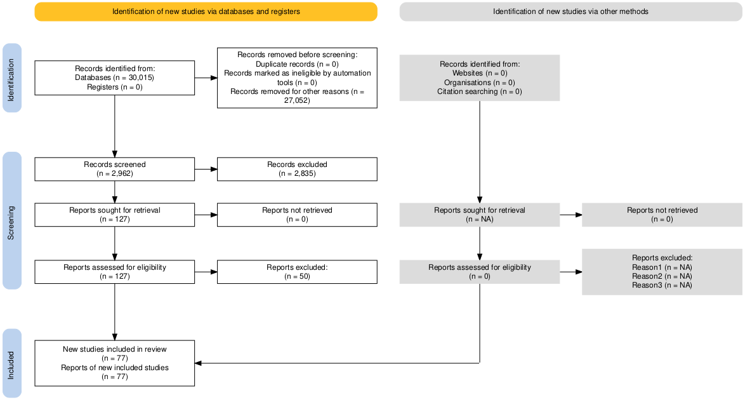
Figure 4: PRISMA Flow Diagram of the Study Selection Process
The methodical process used to find, screen, assess, and incorporate studies in this literature review on ensemble learning approaches for phishing detection is depicted in Figure 3's PRISMA (Preferred Reporting Items for Systematic Reviews and Meta Analyses) flow diagram. The study selection was methodologically rigorous and in line with the established research objectives thanks to this organized and transparent process [26][27].
The process began with the identification phase, where a comprehensive search strategy was formulated using multiple relevant keywords and Boolean operators. The search query included combinations such as ("Phishing Detection") OR ("Phishing Website Detection") OR ("Detecting Phishing Websites") OR ("Phishing Techniques") OR ("Phishing URL Detection") AND ("Machine Learning") AND ("Ensemble Learning Model") OR ("Ensemble Model") OR ("Ensemble"). This query was applied to the metadata of indexed databases to capture a broad spectrum of research related to phishing detection using ensemble learning techniques.
From this initial search, a total of 30,015 records were retrieved from reputable academic databases. To ensure quality and relevance, several refinement filters were applied: publications were restricted to the years 2020 to 2025, only peer reviewed journal articles were considered, and open access availability was required [17]. These filters were chosen to guarantee the inclusion of contemporary and credible research while ensuring that all reviewed studies were freely accessible for validation. After applying these criteria, 2,962 records remained for screening, while 27,052 records were excluded for not meeting the filtering conditions. No additional studies were identified through other methods such as citation tracking or organizational repositories.
The remaining 2,962 papers' titles and abstracts were thoroughly examined during the screening stage to determine their applicability to the research topic [7]. At this stage, 2,835 records were excluded for reasons such as focusing on general cybersecurity topics, using unrelated machine learning methods, or lacking a clear connection to ensemble-based phishing detection. This stage made sure that only research that might be relevant to the review's goals was kept for in-depth analysis.
The full texts of 127 papers that made it through the first screening were thoroughly reviewed during the eligibility phase. To guarantee methodological rigor and relevance to the research objectives, each study was assessed using a predetermined set of inclusion and exclusion criteria. According to the inclusion criteria, studies had to be published in peer-reviewed journals between 2020 and 2025, be freely available, and show a clear connection to ensemble learning techniques for phishing detection. Additionally, studies were expected to show methodological soundness, including the use of validated datasets and reliable evaluation metrics. These standards ensured that all included studies were recent, credible, and scientifically robust. In contrast, the exclusion criteria ruled out papers that lacked sufficient methodological or experimental detail, duplicated or extended previously published work, focused on broader cybersecurity or unrelated detection techniques, utilized only single (non-ensemble) machine learning models, or were written in non-English languages or poorly translated, which could compromise interpretation accuracy. Applying these criteria resulted in the exclusion of 50 studies that did not meet the quality or relevance requirements for inclusion in the final review.
In the final stage, 77 studies met all the required conditions and were included in the review. These studies focused on ways of detecting phishing by using several models together instead of relying on just one. Different approaches were used where the results from multiple models are combined to improve detection. These studies became the main group of research used for the analysis and discussion in this review.
Overall, the PRISMA guided approach demonstrates a transparent and systematic narrowing of the literature from an initial pool of 30,015 records to a refined and methodologically sound set of 77 high quality studies. Each phase identification, screening, eligibility, and inclusion was governed by explicit criteria designed to minimize bias and ensure the validity of the review. As a result, the final set of studies gives a clear and reliable overview of the latest research and developments in using multiple models together to detect phishing attacks.

2.6 Bibliometric Analysis
This section shows a basic analysis of the 77 selected research papers on phishing website detection using multiple models together. It also looks at how the number of publications changed between 2020 and 2025.
Table 2: Number of Publications per Year (2020–2025)
Row Labels | Count of Document Title
2020 | 6
2021 | 8
2022 | 19
2023 | 11
2024 | 15
2025 | 18
Grand Total | 77

The publication trend shows a steady increase in research activity over the years. The number of papers rose from 6 in 2020 to 8 in 2021 and reached a significant peak of 19 publications in 2022 [28]. Although there was a slight decline to 11 papers in 2023, research activity increased again in 2024 with 15 publications and continued growing in 2025 with 18 papers. This increase shows that more researchers have become interested in studying phishing website detection using methods that combine several models, especially in recent years.
Authors with the Highest Number of Publications.
Figure 5: Top Authors by Number of Publications
S. Manickam has the highest number of publications with four papers. W. Li follows with three papers. Several other authors, including B. Li, C. G. Duque, R. Abdillah, S. Fernando, R. T. De Sousa, R. S. Rao, M. Mohd, and Z. Shukur, each contributed two papers. This shows that a small group of authors contribute more actively to research in phishing detection using ensemble learning.
Table 3: Publication Distribution
Row Labels | Count of Document Title
Big Data Mining and Analytics | 1
IEEE Access | 66
IEEE Open Journal of the Communications Society | 2
IEEE Transactions on Information Forensics and Security | 1
Intelligent and Converged Networks | 1
Journal of Cyber Security and Mobility | 3
Journal of Web Engineering | 2
Tsinghua Science and Technology | 1
Grand Total | 77

The publication venue analysis shows that most studies (66 out of 77) are published in IEEE Access, confirming it as the dominant platform for research on phishing detection and ensemble learning. Other venues contribute fewer papers, indicating that research in this area is concentrated mainly within high-impact IEEE journals.
Table 4: Most Frequently Used Datasets in Phishing Detection Studies
Row Labels | Count of Dataset Name
Alexa Top Websites | 7
APWG Dataset | 3
Kaggle dataset | 4
Mendeley Dataset | 4
Nazario phishing corpus | 3
OpenPhish | 3
PhishTank | 12
SpamAssassin Public Corpus | 3
UCI Machine Learning Repository | 3
UCI Phishing Website Dataset | 4
Grand Total | 46

The analysis of the datasets used in the 77 selected studies shows that several public datasets are commonly used in phishing detection research. As shown in Table X, the PhishTank dataset is the most frequently used dataset, appearing in 12 studies [29], This is mainly because it contains a large number of confirmed phishing website links as well as normal website links. The Alexa Top Websites dataset is the second most frequently used source, appearing in 7 studies, as it provides reliable legitimate website samples. Other commonly used datasets include the Kaggle dataset (4 studies), Mendeley dataset (4 studies), and the UCI Phishing Website Dataset (4 studies). Additional datasets such as APWG, Nazario Phishing Corpus, OpenPhish, SpamAssassin Public Corpus, and the UCI Machine Learning Repository appear in three studies each.
This distribution shows that researchers often choose public and well-organized datasets to train and test phishing detection systems. These datasets include clearly labelled examples of phishing websites and normal websites. This helps researchers test and compare their models under the same conditions.


Figure 6: World Map of Article Output by Country
The world map illustrates the geographic distribution of the 77 selected research publications. The markers show that studies on phishing website detection using combined model approaches come from many regions, including North America, Europe, Asia, Africa, and Australia. Many studies were produced in countries such as the United States, the United Kingdom, India, and China, along with several countries in Southeast Asia. This wide distribution shows that phishing detection has become an important research topic worldwide, with contributions from both developed and developing countries. The map also reflects increasing international collaboration and growing awareness of phishing-related cybersecurity threats around the world.
A total of 77 research papers were reviewed to understand how different computer-based learning methods are used to detect phishing and other harmful websites. Most of these studies focused on approaches where multiple models are combined to improve detection accuracy and reduce incorrect warnings. The review found clear patterns across four main areas: the methods used, the datasets used for testing, the tools used for implementation, and the results achieved in terms of performance.
In terms of the methods used, many studies relied on approaches where several models are combined, such as bagging, boosting, stacking, and voting [30][31]. Tree-based methods such as Random Forest, XGBoost, AdaBoost, and LightGBM were used most often because they can make accurate predictions and are relatively easy to apply [22]. Other methods like Support Vector Machines, Decision Trees, Naïve Bayes, and Logistic Regression were usually used for comparison. A smaller number of studies also tested deep learning models such as CNN, LSTM, GRU, and combinations of deep learning models. Overall, tree-based approaches like Random Forest and XGBoost were the most used and performed the best. They often achieved high accuracy, reduced the problem of overfitting, and worked better with uneven phishing data than single models [32][33][34].
Regarding datasets, the most used source was the Phish Tank repository, which provides labelled phishing and legitimate URLs. Other datasets frequently used included the UCI Phishing Websites Dataset, KDD or KDDCup intrusion datasets, and email corpora such as Spam Assassin and Nazario. Many researchers collected their own real-world datasets from online sources such as Alexa, Open Phish, or Kaggle using automated crawlers and APIs.
Kaggle is an online data science and machine learning platform that provides publicly available datasets for research and experimentation. It hosts a wide range of cybersecurity related datasets, including phishing URLs, malicious website records, and email-based phishing data. These datasets are commonly used by researchers because they are well structured, easily accessible, and suitable for machine learning experiments. In the reviewed studies, four papers used datasets obtained from Kaggle for their experimental implementation. Researchers often combine Kaggle datasets with other sources such as PhishTank, Alexa, or UCI datasets to increase dataset diversity and improve model training. The availability of large, labelled datasets on Kaggle makes it a useful platform for testing and evaluating phishing detection models, especially those that combine multiple models.
Some studies focusing on network traffic or IoT attacks used the CTU 13 or IoT23 datasets, while financial phishing studies employed datasets like Pay Sim or voice phishing corpora. Dataset sizes ranged widely from a few thousand URLs or emails to several hundred thousand. Overall, Phish Tank and real-world custom datasets were the most used sources, although many datasets were outdated or static.
In terms of implementation, most studies used Python as the main programming platform. Researchers commonly used tools such as scikit-learn, TensorFlow, Keras, and PyTorch to build and test their phishing detection models [35][36][26]. A smaller number of studies used tools such as Weka, MATLAB, or Apache Spark. In addition, preparing and selecting the right features from the data played an important role in improving the performance of the models. Common features included URL based characteristics like length, special characters, and use of “https”; domain or WHOIS features such as registration age and IP information; and page content features including HTML tags, JavaScript presence, and image or logo details. Some studies also included network level information such as DNS history and connection timing. Methods for selecting important features, such as Chi-Square, Mutual Information, Principal Component Analysis (PCA), and Linear Discriminant Analysis (LDA), were used to remove unnecessary or repeated information from the data. To handle the problem where phishing and normal website samples were not evenly balanced, some studies used techniques like SMOTE or other approaches that give more importance to the smaller group of data. Overall, studies that used Python, combined different types of features, and applied models that work together generally achieved better accuracy and more stable results [18].
In terms of performance results, the most common measures used to evaluate the models were accuracy, precision, recall, F1 score, and AUC. These measures help researchers understand how well the models can correctly detect phishing websites and avoid incorrect predictions. Among the papers that reported numerical results, the average accuracy was approximately 93 percent [37][38][5], with most results ranging between 90 and 98 percent. F1 scores were typically above 0.90, indicating balanced precision and recall performance. Models that combine several methods, such as Random Forest and XGBoost, often achieved the highest accuracy and more reliable results. Deep learning models also performed well with larger datasets but required more computing power. Overall, combined model approaches offered a good balance between accuracy and efficiency.
Despite these strong results, several limitations were repeatedly mentioned across the reviewed studies. Many datasets were outdated, unbalanced, or lacked real-world testing. Some models relied only on URL based features, ignoring host or content related information. Deep learning approaches, while powerful, often required high computational resources and longer training times. In addition, only a few studies tested their systems in real time environments, which limited their practical applicability.
Overall, the review shows that using several models together is one of the most common and dependable ways to detect phishing websites. Many studies used models such as Random Forest, XGBoost, AdaBoost, and LightGBM. These models work by combining the results of multiple models to improve detection accuracy. Phish Tank and custom real-world datasets were the most used data sources, and most implementations were performed in Python using scikit learn or TensorFlow. The reported average accuracy of around 93 percent demonstrates that ensemble methods provide robust and effective performance. However, future research should focus on addressing dataset imbalance, ensuring data freshness, and testing in real time scenarios to improve generalization and real-world deployment.

2.6.1 Literature Performance Benchmarks
Table 5: Literature Performance Benchmarks
Algorithm | Accuracy | F1-Score | Papers
Random Forest | 81.60% – 100.00% | 76.60% – 100.00% | 38 / 77
XGBoost | 90.00% – 100.00% | 63.00% – 100.00% | 19 / 77
AdaBoost | 90.00% – 99.98% | 63.00% – 99.00% | 16 / 77
LightGBM | 95.48% – 99.71% | 83.40% – 99.10% | 9 / 77
Stacking Ensemble | 90.00% – 99.95% | 63.00% – 99.95% | 8 / 77
Bagging | 81.60% – 99.95% | 76.60% – 99.95% | 8 / 77

2.7 Critical Evaluation of Existing Literature
1. Overview of Methods Used in Phishing Detection Research
Research on phishing website detection shows that many studies use computer models to identify harmful websites. The most used approaches include methods such as Decision Trees, Random Forest, Support Vector Machines, Naïve Bayes, Logistic Regression, and K-Nearest Neighbour [39][30]. These algorithms are preferred because they are easy to implement and perform efficiently on structured, feature based datasets. However, an important problem found in many studies is that these models may work well during testing but do not always perform well when used with new or unseen data in real-world situations [40][41]. This supports Research Gap 1, which points out that traditional models often struggle to detect new and changing phishing methods.
2. Limitations Related to Feature Selection
Another important challenge in existing research is the reliance on a limited set of features, particularly URL based and domain-based attributes [42][21]. These features can help detect basic phishing attempts, but they are not strong enough to identify more advanced attacks that use complex website scripts, misleading page designs, and changing visual content [26]. Studies relying on narrow feature sets report good accuracy but often struggle with adaptability when facing novel phishing behaviours. This limitation corresponds with Research Gap 2, reinforcing the need for broader and richer features that incorporate webpage content, JavaScript analysis, HTML structure, SSL details, and hosting information.
3. Critical Evaluation of Datasets Used in Existing Studies
A significant weakness identified in the literature is the heavy dependence on static or outdated datasets, especially the widely used UCI Phishing Websites Dataset [43][44]. Although this dataset is easy to use for testing, it does not show how phishing attacks are constantly changing. Newer sources such as PhishTank and OpenPhish, as well as real-time collected data, provide more up-to-date information [29]. However, they are used less often because collecting and labelling this data is more difficult. The continued use of older datasets relates to Research Gap 3, which shows that many existing models may not work well in real situations because they are trained on data that does not represent current phishing threats.
4. Evaluation Metrics and Their Limitations
The review also shows that studies do not always evaluate their models in the same way. Many studies still use accuracy as the main measure of performance, even though phishing datasets often contain far more normal websites than phishing ones [45][7]. Because of this imbalance, a model can show high accuracy but still miss many phishing websites. Other measures such as precision, recall, F1-score, and AUC are now recommended because they give a more balanced view of how well a model performs [23]. However, testing models on different datasets or in real-world environments is still limited, which makes it difficult to know how well the results will work in practice. This problem supports Research Gap 4, which highlights the limitations of relying only on accuracy for evaluation.
5. Role and Effectiveness of Ensemble Learning Approaches
Recent studies show that combining several models together is one of the most effective ways to detect phishing websites [46][28]. Approaches such as boosting methods, Random Forest, voting models, and stacking models often perform better than using a single model. These combined methods are better at finding complex phishing patterns and reducing errors. Some studies have also started using deep learning models such as CNN and LSTM, but they are used less often because they need more computing power and large, updated datasets [13]. Overall, methods that combine multiple models tend to give more reliable results and better performance than traditional single-model approaches.
6. Overall Critical Summary and Implications for the Current Study
Overall, previous research shows clear progress in detecting phishing websites, especially with the growing use of methods that combine several models together. However, even though many studies report high accuracy, some important problems remain. Many studies rely on limited types of data features, older datasets, testing on only one dataset, and different ways of measuring results. Because of this, many proposed models may not work as well in real-world situations.
Studies show that methods such as Random Forest, XGBoost, LightGBM, and stacking approaches often perform better than single models. However, these models are usually tested in controlled experiments rather than real and changing online environments. Solving these problems is an important goal of the current study and helps address the research gaps identified earlier.
A recent study published in IEEE Access (2024), titled “Phishing Website Detection Using Deep Learning Models” [47]compared different approaches for detecting phishing websites. The study tested several methods, including traditional models, combined models, and deep learning models. The data was divided into two parts for training and testing, and the results were measured using several evaluation metrics. Although deep learning methods showed strong results, combined models such as Random Forest and XGBoost achieved similar performance while requiring fewer computing resources. The experimental design and evaluation approach used in this study helped guide the framework used in the current research.

2.8 Conclusion of Literature Review
The reviewed studies show that methods that combine several models usually perform better than using a single model for detecting phishing websites. Models such as Random Forest, XGBoost, LightGBM, and stacking approaches often achieve higher accuracy and better results. These methods are also stronger at identifying complex phishing patterns. However, some problems still exist in current research. Many studies use older datasets, a limited number of data features, and mainly measure results using accuracy. In addition, most models are tested on only one dataset and are not checked in real-world situations. Because of this, the reliability of many proposed models in practice may be limited.
Among the reviewed studies, Random Forest showed the highest accuracy range of 81.60% to 100.00% in 38 out of the 77 studies, making it the most used and reliable method for phishing website detection [48][19][5]. Overall, although combined model approaches show strong potential, there is still a need for better feature selection, more up-to-date datasets, and stronger ways to evaluate models. These findings support the aim of this study, which is to develop a more reliable and adaptable phishing detection model using combined methods.

Chapter 3 – Research Methodology

3.1 Introduction
This chapter explains the research method used to develop a system that can detect phishing websites using computer models. The method is designed from a cybersecurity point of view so that the choice of models, data used, and evaluation methods reflect real-world security needs rather than only theoretical analysis.
The chapter follows the Research Onion framework and describes the research perspective, research approach, research strategy, methods used, dataset selection, and the analysis process used in this study. Each step is explained in relation to the research objectives, which aim to create an accurate and reliable system that can identify phishing websites and distinguish them from legitimate websites.

3.2 Research Overview
The aim of this research is to design, build, and test computer models that can classify websites as phishing or legitimate. The research design provides a clear plan that guides the study from identifying the problem to evaluating the results. The research process is organised into five main stages: research philosophy, research approach, research strategy, methodological choice, and techniques and procedures [49].
The study begins by examining the characteristics of phishing websites. After that, a suitable dataset is selected, and the data is prepared for analysis. Several machine learning models are then applied and tested. Finally, the results are carefully evaluated and compared to identify which model performs best for detecting phishing websites in cybersecurity applications.

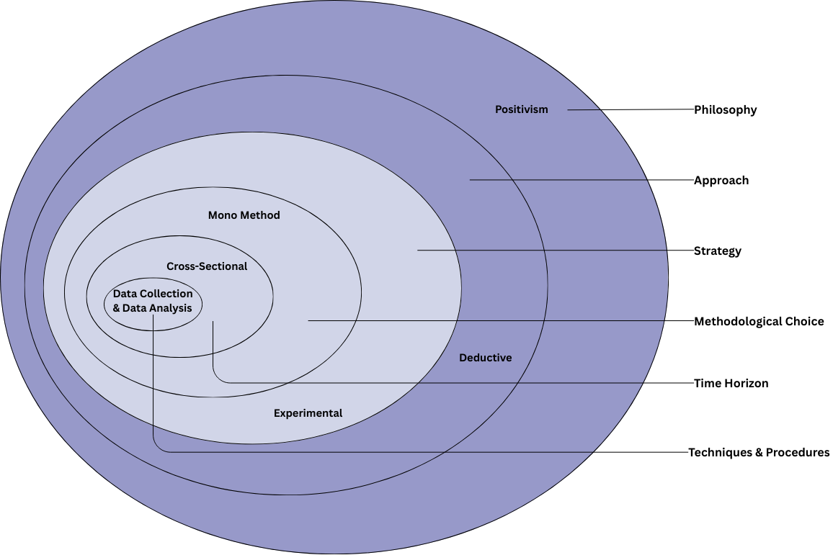
Figure 7: Research Onion Method Diagram

3.2.1 Research Philosophy – Positivism
This study follows a positivist research philosophy, which means the research is based on facts that can be observed and measured. Phishing website detection depends on clear and measurable information, such as website links, domain details, and website activity data. Because of this, positivism is suitable for this research [18][12]. The study does not rely on personal opinions or human judgement. Instead, it uses numerical data and results produced by computer models. The performance of the models is measured using clear evaluation measures such as accuracy, precision, recall, F1 score, and ROC AUC [21]. Using a positivist approach helps ensure that the results are reliable, unbiased, and can be repeated by other researchers who use the same data and methods.

3.2.2 Research Approach – Deductive Approach
This study uses a deductive research approach. Previous studies show that models that combine several methods, especially tree-based models, often perform better in detecting phishing websites than single traditional models [50][46]. Based on this idea, the research expects that models such as Random Forest and XGBoost will perform better and detect phishing websites more accurately than the Support Vector Machine model used as a basic comparison. To test this, experiments are carried out using a real phishing website dataset. In this approach, existing knowledge is used to form an expectation, the expectation is tested using data, and conclusions are made based on the results obtained.

3.2.3 Research Strategy – Experimental Strategy
An experimental strategy was selected because machine learning research requires controlled comparison of algorithms under identical conditions [51][37]. The study uses several models, trains them using the same training data, and then tests them using a separate test dataset. The model settings are carefully adjusted using systematic search methods to ensure that each model is tested fairly [52]. This strategy enables direct observation of how each algorithm behaves when exposed to identical phishing indicators, providing strong empirical evidence for model selection.

3.2.4 Methodological Choice – Quantitative Mono-Method
The project follows a quantitative mono-method approach. All inputs are numerical features extracted from URLs and webpage attributes, and the outputs are statistical performance measures [53][54]. No qualitative techniques, such as interviews or surveys, are required in this study.
Only numerical data is used in this study because phishing detection involves identifying patterns in measurable website information rather than relying on human opinions or personal judgement. Computer models examine these numerical features to find patterns that help separate phishing websites from legitimate ones. The performance of the models is measured using evaluation metrics such as accuracy, precision, recall, F1-score, and ROC-AUC. These measures help ensure that the results are objective, reliable, and repeatable when the same data and methods are used [55][10] .

3.2.5 Time Horizon – Cross Sectional
A cross-sectional time horizon is used in this study. The dataset contains phishing and legitimate websites collected at a specific time, and the data is analysed once during the project. A long-term study was not required because the goal of this research is to compare and evaluate different models, not to study changes over a long period of time [56][26].

3.2.6 Techniques and Procedures
The methodology employs quantitative data collection and analysis techniques, structured into six phases:
Table 6: Research Phases with Cybersecurity Justification
Phase | Technique | Description | Cybersecurity Justification
1. Data Acquisition | Secondary dataset from Kaggle | Collection of 11,055 website records with 32 security related features | Dataset contains validated phishing indicators widely used in research
2. Preprocessing | Data cleaning and normalisation | StandardScaler applied, handling inconsistencies, 80/20 train test split | Ensures data quality and stable model training
3. Feature Engineering | Selection of relevant attributes | Use of URL, domain and SSL based indicators from the 32 features | Focuses on features proven to reveal phishing behaviour
4. Model Development | Implementation of classifiers | SVM, Random Forest, and XGBoost models built and tuned | Defence in depth through comparison of multiple algorithms
5. Evaluation | Performance measurement | Accuracy, Precision, Recall, F1-score, ROC AUC | Measures real detection capability and false positive control
6. Validation | Cross-validation and benchmarking | 5-fold CV and comparison with prior studies | Confirms robustness and real-world applicability

3.3 Dataset Selection
This study used the Phishing Website Dataset from Kaggle, which contains 11,055 website samples and 32 features related to website links, domain details, and website behaviour [57] [58]. Before analysis, the data was prepared using standard scaling, and the dataset was divided into training and testing sets with an 80/20 split. This setup helps the models learn from the training data and then test their ability to correctly identify phishing and legitimate websites.

3.4 Risk Assessment and Contingency Plan
The project considered several technical and practical risks that could affect the development of the phishing detection system. Appropriate mitigation strategies were planned to ensure successful completion within the available timeframe and resources.
Table 7: Risk Assessment Matrix
Risk | Impact | Probability | Mitigation Strategy
Dataset unavailable or corrupted | High | Low | Maintain local backup and alternative public phishing datasets
Model accuracy below target | Medium | Medium | Hyperparameter tuning and comparison of multiple classifiers
High false positive rate | High | Medium | Threshold adjustment and precision recall optimisation
Computational resource limitations | Medium | Medium | Use Google Collab and reduce batch sizes during training
Overfitting of models | Medium | Medium | Apply cross validation and regularisation techniques
Time delays in experimentation | Medium | Medium | Prioritise core models and simplify non-essential tests

3.5 Project Timeline (Gantt Chart):
The project activities were organised according to a structured timeline to ensure systematic completion of all research stages, as shown in Table 9 below.
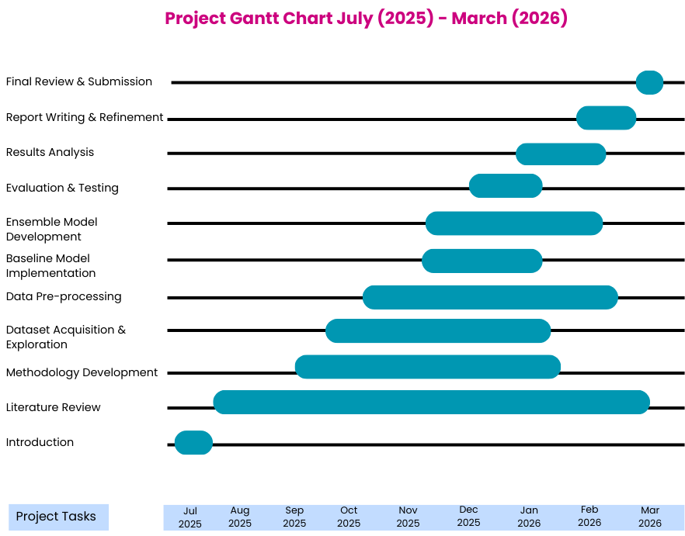
Figure 8: Project Timeline (Gantt Chart)

3.6 Conclusion
This chapter explained the research method used in this study. A positivist research philosophy was chosen so that the results are based on clear and measurable evidence. A deductive approach was used, meaning the research was guided by existing knowledge and then tested through structured experiments.
The experimental design ensured that all models were tested under the same conditions so their performance could be compared fairly. A quantitative method was used to measure the results consistently. The Kaggle Phishing Website Dataset was selected because it is publicly available, widely used in research, and relevant to the study [24].
Possible risks were also considered, and backup plans were prepared to handle any problems during the project. The project timeline shown in Figure 8 shows that all research activities were organised within the available time. Overall, these decisions provide a clear foundation for the system design and implementation described in Chapter 4.

Chapter 4 – Design and Implementation

4.1 Introduction
This chapter explains the design and implementation of the phishing website detection system developed in this research. The experimental framework is based on the method used in a selected IEEE Access (2024) research paper titled “Phishing Website Detection Using Deep Learning Models” [47]. The study combines feature selection with different types of computer models to improve phishing detection.
Although the original paper tested several approaches, including deep learning, this project mainly focuses on machine learning and ensemble models using the Kaggle Phishing Website Dataset. The goal is to examine how well these models can detect phishing websites while reducing incorrect warnings. This chapter describes the problem definition, system design, dataset details, implementation process, experimental setup, and the selection of the final model.

4.2 Problem Formulation

4.2.1 Problem Statement
Phishing websites are becoming more advanced and can often avoid traditional detection methods such as blacklists or rule-based systems. Attackers change website links, domain details, security indicators, and redirection methods to make phishing websites look like real and trusted sites [59][46]. Because of this, many traditional detection methods cannot identify new or previously unseen phishing attacks. Therefore, there is a need for a system that uses computer models to automatically classify websites as phishing or legitimate based on information taken from website links and domain characteristics.

4.2.2 Adopted Experimental Framework
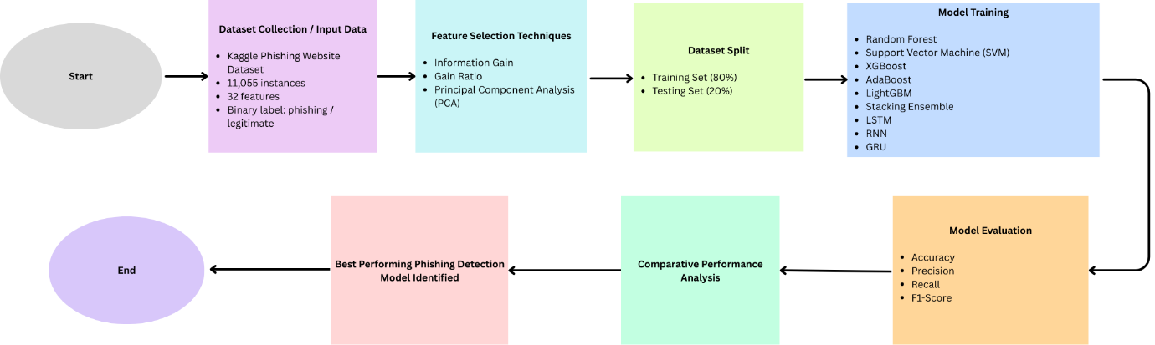
Figure 9: Experimental Pipeline for Phishing Website Detection

The selected IEEE paper proposes a structured experimental methodology[47] consisting of:
- Feature selection methods such as Information Gain, Gain Ratio, and PCA
- 80% of the data used for training and 20% used for testing
- Comparison of several models
- Evaluation using accuracy, precision, recall, and F1-score
In this project, the framework was applied using the following models:
- Random Forest
- SVM
- XGBoost
- AdaBoost
- LightGBM
- Stacking Ensemble
- LSTM
- RNN
- GRU
The aim of this comparison is to identify which model gives the most reliable results for detecting phishing websites under the same testing conditions.

4.2.3 Proposed System Architecture
The implemented phishing detection system follows a structured computational pipeline:
- Dataset Acquisition
- Data Cleaning and Validation
- Feature Scaling
- Stratified train–test split (80/20): The dataset was divided so that 80% of the data was used for training and 20% for testing, while keeping the same balance of phishing and legitimate websites in both sets.
- Model training: Several models were trained, including SVM, Random Forest, XGBoost, AdaBoost, LightGBM, a stacking model, LSTM, RNN, and GRU.
- Performance Evaluation
- Best Model Selection
This architecture ensures reproducibility, fair model comparison, and alignment with cybersecurity evaluation requirements.
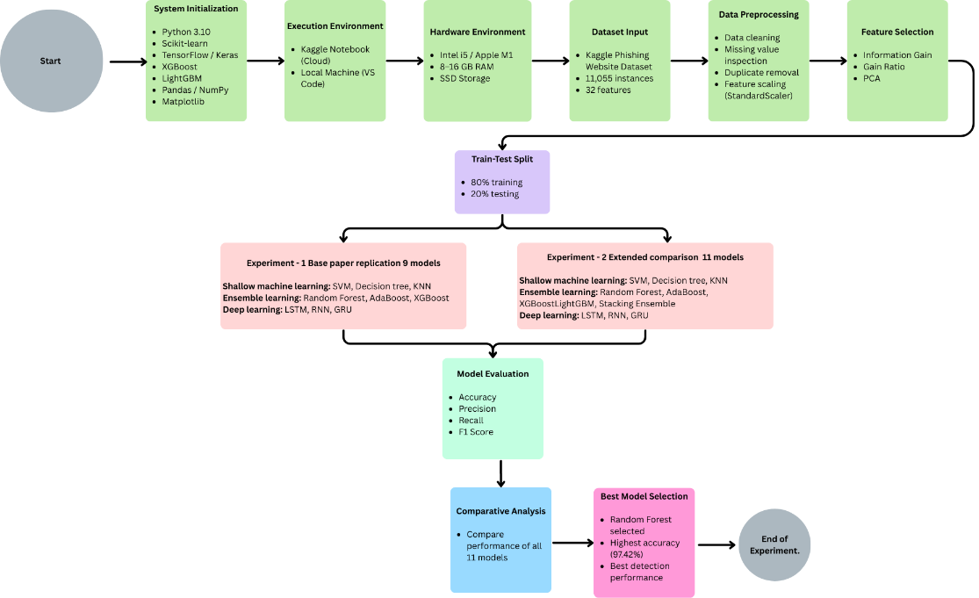
Figure 10: System Flow Diagram of the Phishing Website Detection Model Implementation
Figure 10 shows the full experimental process used to build the phishing website detection system. The process starts with setting up the working environment and collecting the dataset. After that, the data is prepared, scaled, and divided into training and testing sets while keeping the balance between phishing and legitimate websites. Three models — SVM, Random Forest, and XGBoost — are then trained using the same conditions. Their performance is evaluated using measures such as accuracy, precision, recall, F1-score, ROC-AUC, and confusion matrix analysis. Finally, the results are compared to identify which model performs best in detecting phishing websites while keeping incorrect alerts low. Based on this comparison, Random Forest was selected as the best-performing model.

4.3 System Design and Justification

4.3.1 Design Principles
The system design is based on three main principles that guide how the phishing detection system is developed and implemented.
- Reproducibility – ensuring the experiment can be replicated.
- Comparative Evaluation – enabling objective model comparison.
- Cybersecurity Relevance – prioritising detection capability and false positive control.
The selected research demonstrates that ensemble learning models outperform traditional classifiers in phishing detection tasks. Therefore, this project emphasises ensemble-based approaches to validate their effectiveness.

4.3.2 Model Selection Rationale
Support Vector Machine (SVM)
SVM is used as a baseline model because it is commonly applied in classification tasks. However, it may have difficulty handling complex relationships in phishing data.
Random Forest
Random Forest was selected due to its ability to reduce overfitting through bagging [60], handle noisy and deceptive URL features, provide feature importance analysis, and deliver stable performance on structured numerical datasets.
XGBoost
XGBoost was selected to test a model that improves its predictions step by step by learning from previous mistakes. This helps the model identify more complex patterns in phishing data [61]. Using several different models in the experiment ensures that the final model is chosen based on actual results from testing, rather than assumptions.
AdaBoost
AdaBoost was selected to evaluate another boosting-based ensemble technique [62]. Unlike Random Forest, which uses bagging, AdaBoost builds models sequentially and assigns higher weights to previously misclassified samples. This iterative correction mechanism allows the model to focus on difficult phishing instances and improve classification accuracy. AdaBoost was included to compare different boosting strategies and assess their effectiveness in handling structured phishing features.
LightGBM
LightGBM was selected as an advanced gradient boosting framework designed for efficient and scalable training on structured datasets. It utilises a leaf-wise tree growth strategy, which can improve accuracy while reducing training time compared to traditional boosting algorithms [63]. LightGBM is particularly effective for large feature spaces and high-dimensional data. Its inclusion enables evaluation of a more computationally efficient boosting model and comparison with XGBoost under identical experimental conditions.
Stacking Ensemble
The Stacking model was used to test an approach where several models are combined for phishing detection. In this method, multiple models first make their own predictions, and another model then combines these results to produce the final decision [64][31]. This approach helps use the strengths of different models while reducing their weaknesses. By combining models such as Random Forest, AdaBoost, and LightGBM, stacking can improve the model’s ability to handle different types of data and produce more stable results. Including this method also helps check whether combining several models performs better than using a single model alone.
LSTM (Long Short-Term Memory)
LSTM was included to test a deep learning method for detecting phishing websites. Even though the dataset is not based on sequences, this model can still learn complex patterns in the data [65][38]. It was used to compare deep learning with other models to see how well it detects phishing websites and how much computing power it requires.
RNN (Recurrent Neural Network)
RNN was used to test a simpler deep learning model for phishing detection. It is designed to learn patterns in sequences of data, but it can sometimes have difficulty learning longer patterns. Including RNN allows comparison with more advanced models such as LSTM and GRU [66]. This helps check whether these types of models can improve phishing
GRU (Gated Recurrent Unit)
GRU was selected as an alternative recurrent neural network architecture with fewer parameters than LSTM. GRU maintains the ability to capture nonlinear feature interactions while offering reduced computational complexity and faster training time [45]. It was included to evaluate whether a more lightweight recurrent architecture can achieve competitive performance compared to LSTM and ensemble-based methods.

4.4 Dataset Description
The Kaggle Phishing Website Dataset used in this study contains 11,055 website samples and 32 features [47]. It also includes a label that shows whether a website is legitimate or phishing.
The dataset includes:
- 11,055 website samples
- 32 features about website properties
- A label (0 = legitimate, 1 = phishing)
These features describe different parts of a website, such as the length of the website link, whether SSL is used, the age of the domain, the use of an IP address, redirection behaviour, and the presence of subdomains. Since the data is already in numerical form, the machine learning models can use it directly without any extra changes.

4.5 Experimental Setup

4.5.1 Hardware Environment
- Intel Core i5 or Apple M1 processor
- 8–16 GB RAM
- SSD storage
The computational requirements are moderate and do not require GPU acceleration.

4.5.2 Software Environment
- Python 3.10
- Kaggle Notebook
- Scikit-learn
- XGBoost
- LightGBM
- TensorFlow / Keras
- Pandas
- NumPy
- Matplotlib
These tools help ensure that all models in the study are implemented in a consistent way, and that the results can be repeated and compared reliably across the different models used.

4.6 Implementation Procedure - Experimental 1

4.6.1 Dataset Collection
The dataset was imported using the panda’s library and examined to confirm correct structure and feature representation.

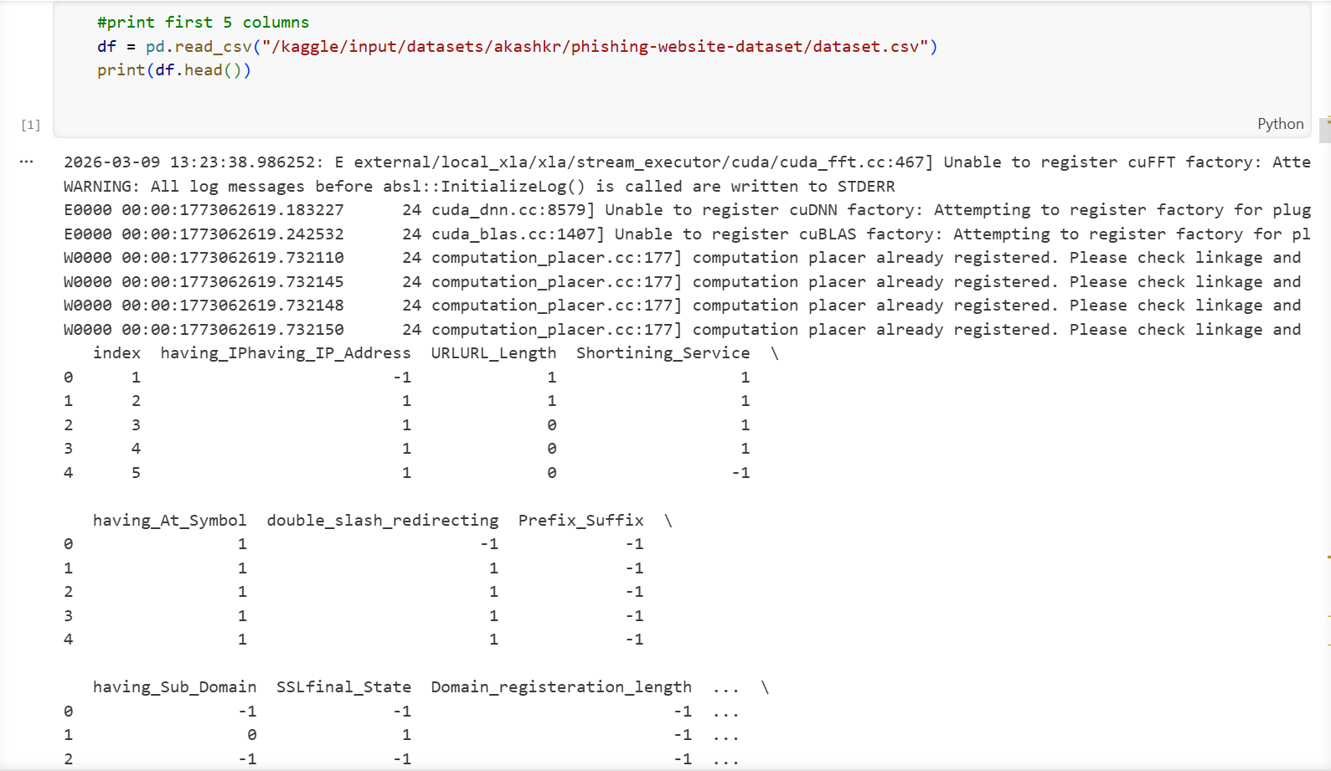
Figure 11

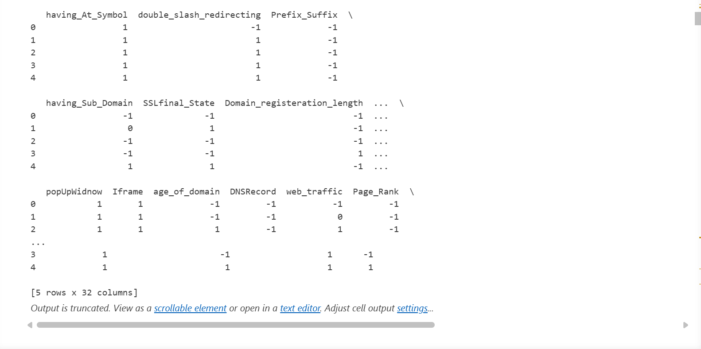
Figure 11: Preview of the Kaggle Phishing Website Dataset
Figure 11 shows the Python code used to load and view the phishing website dataset downloaded from Kaggle. The dataset is loaded using the pd.read_csv() function from the pandas library, which reads the CSV file and stores the data in a table format. After loading the dataset, the df.head() function is used to display the first five rows of the data. This step helps confirm that the dataset has been loaded correctly and allows the researcher to view some of the available features, such as having_IP_Address, URL_Length, Shortining_Service, SSLfinal_State, and web_traffic. This preview step helps the researcher understand the structure of the dataset before moving on to further data preparation and machine learning analysis.

4.6.2 Data Validation and Cleaning

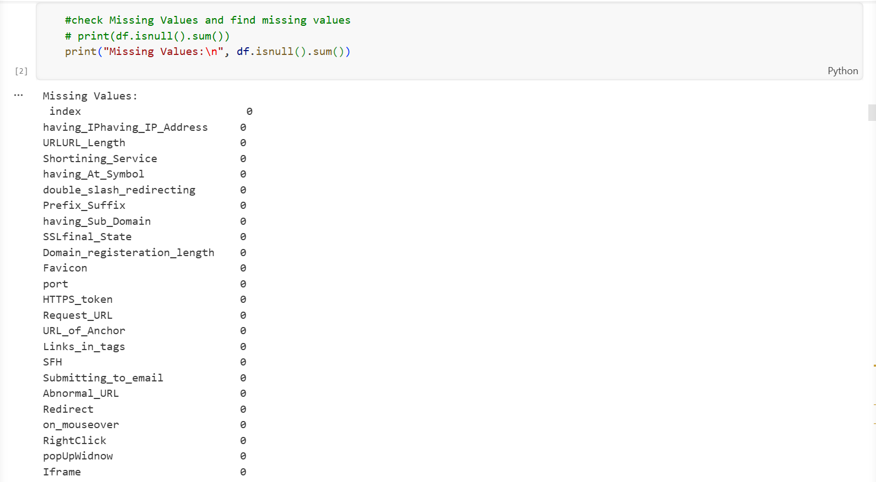
Figure 12
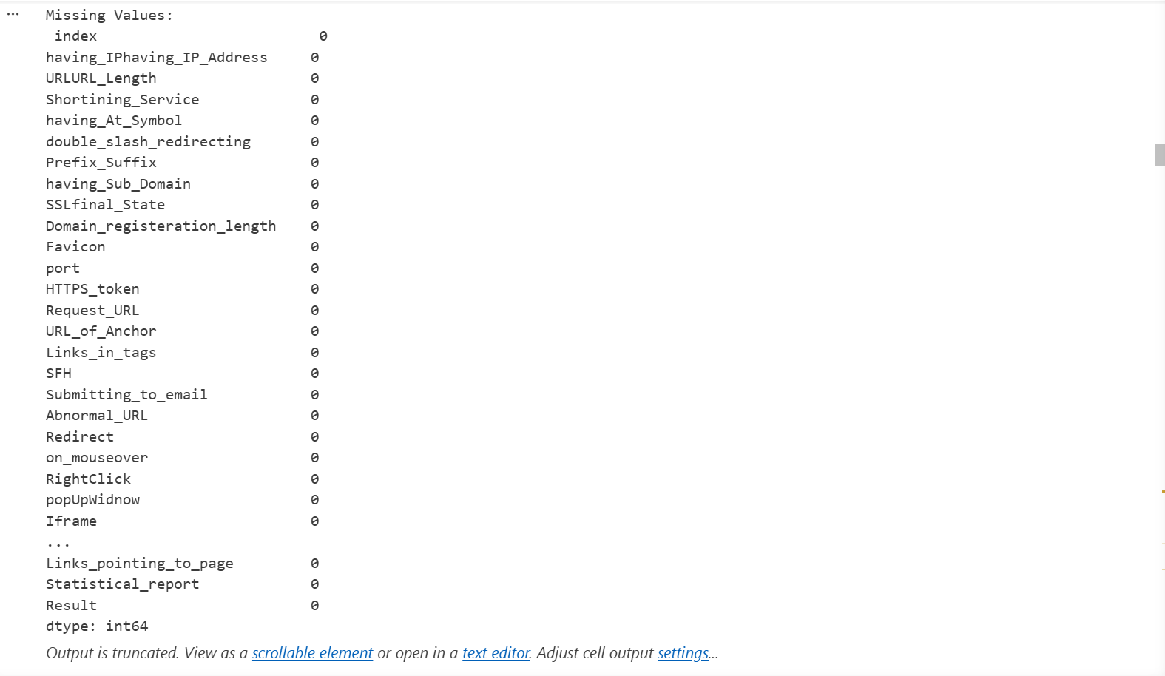
Figure 12: Checking the Dataset for Missing Values
Figure 12 shows how the dataset was checked for missing values. This was done using the df.isnull(). sum () function in pandas, which counts the number of missing values in each column. As shown in Figure 12, all features such as URL_Length, Shortining_Service, Prefix_Suffix, Request_URL, and Result have a value of 0, meaning there are no missing values in the dataset. This confirms that the dataset is complete and ready to be used for further analysis and model training.

4.6.3 Feature Selection
Feature selection is an important step that helps identify the most useful features in the dataset. It reduces the number of unnecessary features and helps improve model performance. In this study, three feature selection methods were used: Information Gain (IG), Gain Ratio (GR), and Principal Component Analysis (PCA).
The dataset originally contains 32 columns. One column is an index column, which was removed because it does not help in predicting phishing websites. Another column is the Result column, which shows whether a website is phishing or legitimate. This column was used as the target variable (y) and was not included in the feature set.
After removing these two columns, the remaining 30 columns were used as the input features (X) for the feature selection process. Each feature selection method then identified the top 10 most important features from these 30 columns. This allowed the study to examine feature importance from three different perspectives.
Information Gain (IG)
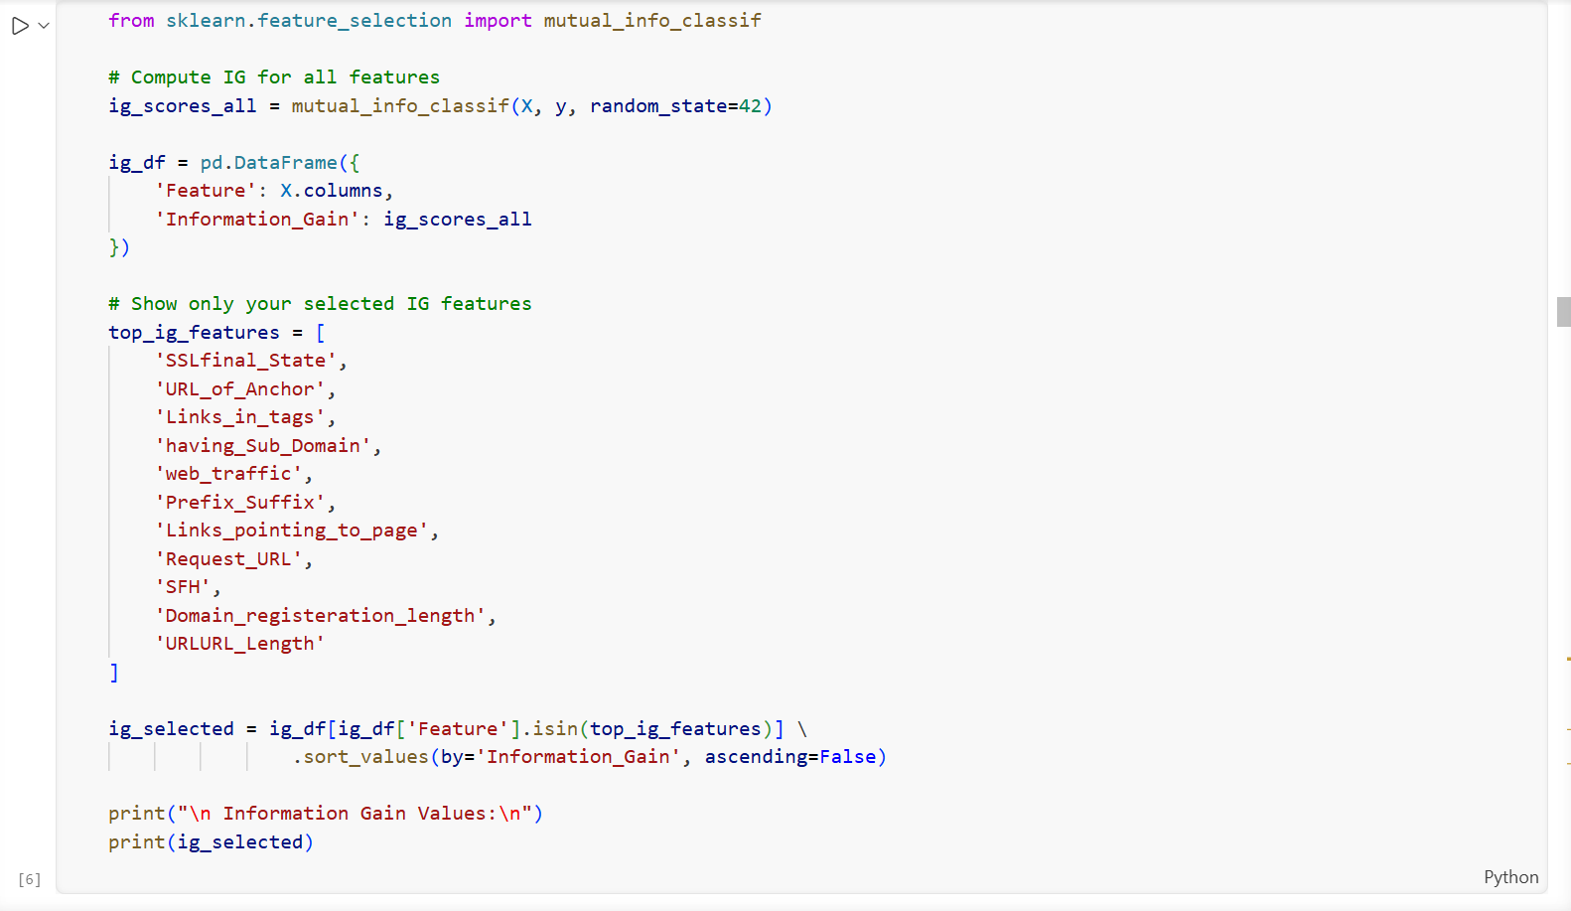
Figure 13
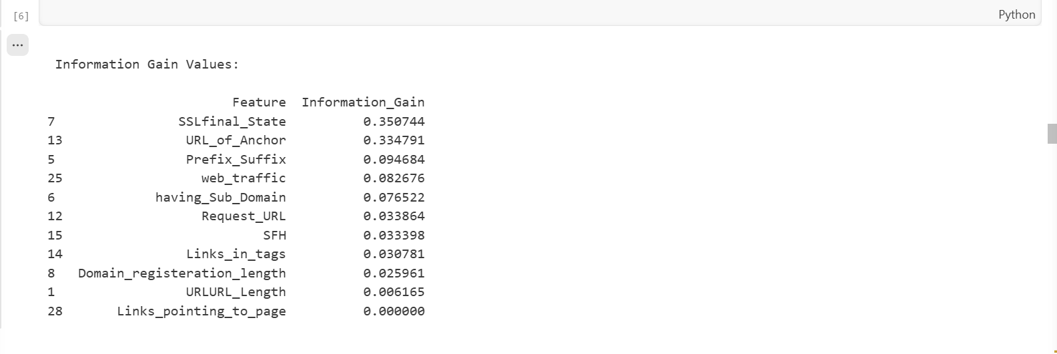
Figure 13: Feature Selection Using Information Gain
Information Gain (IG) was used to measure how important each feature is for phishing website classification [67]. The mutual_info_classif(X, y, random_state=42) function calculates a score for each feature based on its relationship with the target variable. The random_state=42 setting ensures that the results can be reproduced.
The scores were stored in a table, and the features were ranked based on their values. As shown in Figure 13, features such as SSLfinal_State, URL_of_Anchor, and Prefix_Suffix received the highest scores, showing that they are important for detecting phishing websites.
Gain Ratio (GR)
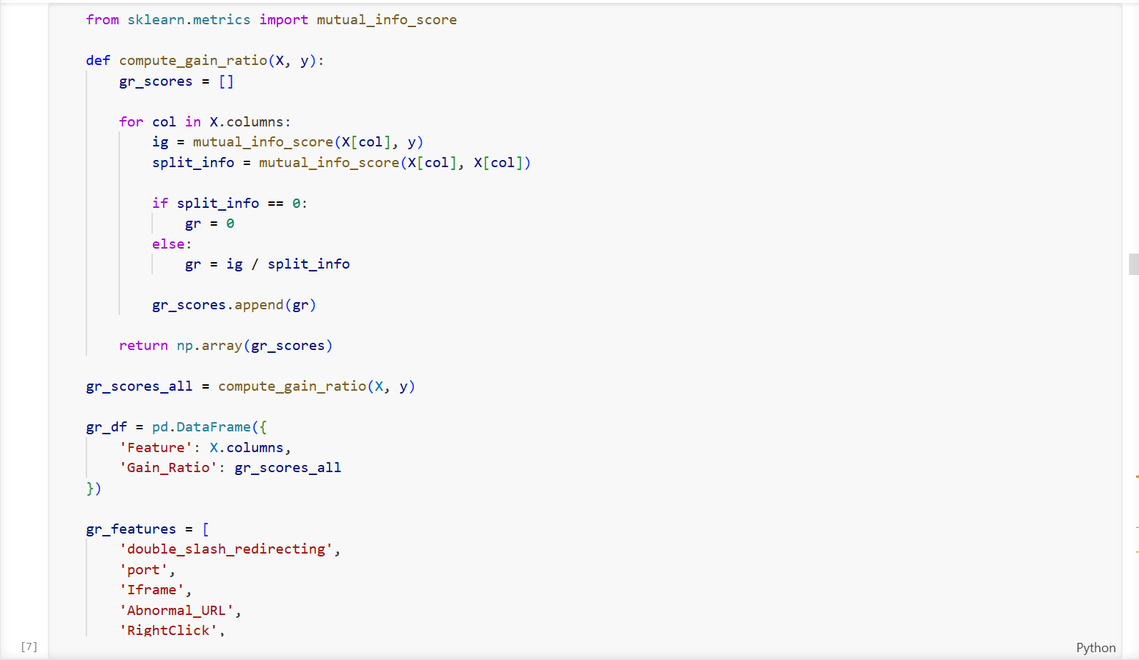
Figure 14
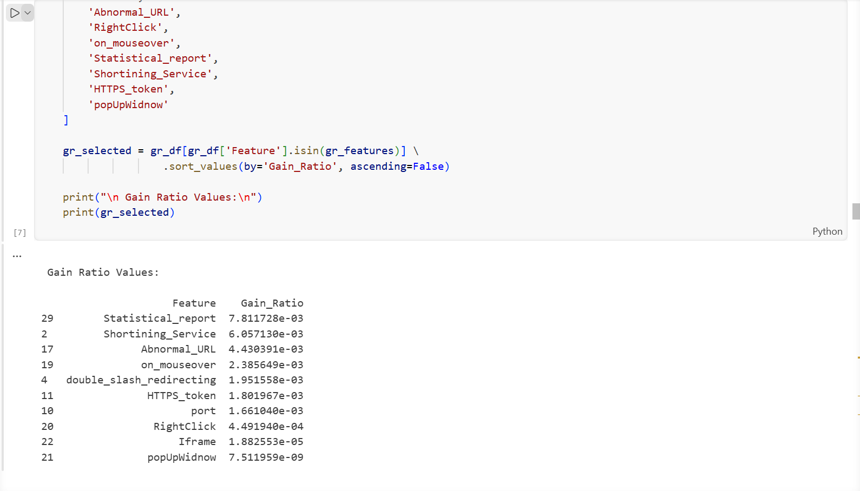
Figure 14: Feature Selection Using Gain Ratio
The code is used to select and rank important features based on their Gain Ratio values. First, a list of selected features (gr_features) is created. Then, the dataset (gr_df) is filtered using the isin() function so that only these features are included.
Next, the features are sorted in descending order based on their Gain Ratio scores using sort_values(). This helps identify the most important features for the phishing detection model.
Finally, the results are displayed, showing the feature names and their Gain Ratio values. As shown in Figure 14, features such as Statistical_report, Shortening_Service, and Abnormal_URL have higher Gain Ratio scores, indicating they are more important for classification.
Principal Component Analysis (PCA)
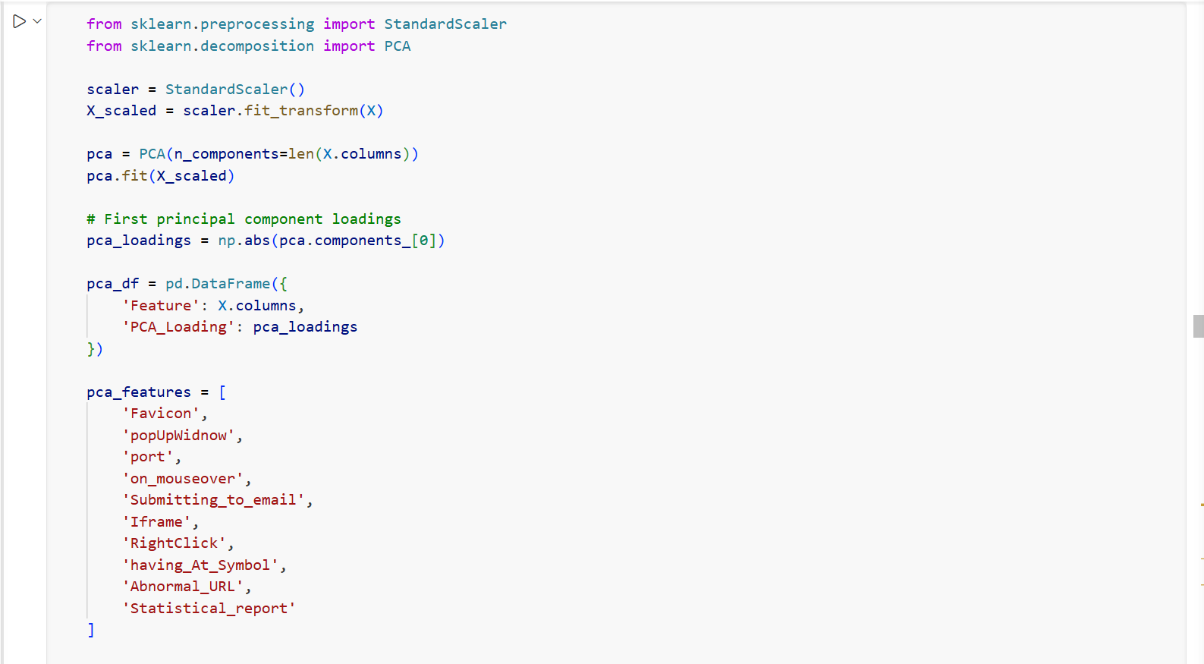
Figure 15
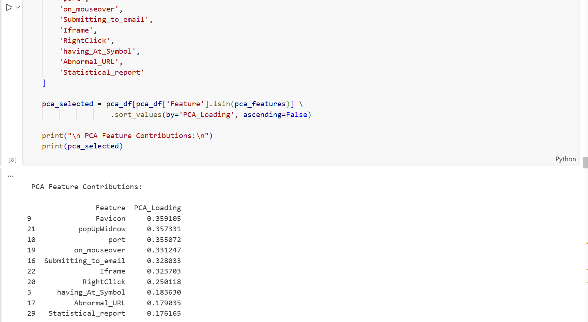
Figure 15: Feature Selection Using Principal Component Analysis (PCA)
The code applies Principal Component Analysis (PCA) to analyse how much each feature contributes to the dataset. First, the data is standardised using StandardScaler so that all features are on the same scale. Then PCA is applied, and the values from the first main component are extracted.
The selected features are then sorted in descending order based on their PCA values. As shown in Figure 15, features such as Favicon, popUpWindow, and port have higher values, indicating a stronger contribution to the phishing detection model.

4.6.4 Train-Test Split
Train–test splitting is an important step used to check how well a model performs on new data. The dataset is divided into two parts: a training set, which is used to train the model, and a testing set, which is used to evaluate its performance. In this study, the dataset was divided using an 80–20 split, where 80% of the data was used for training and 20% for testing [68].
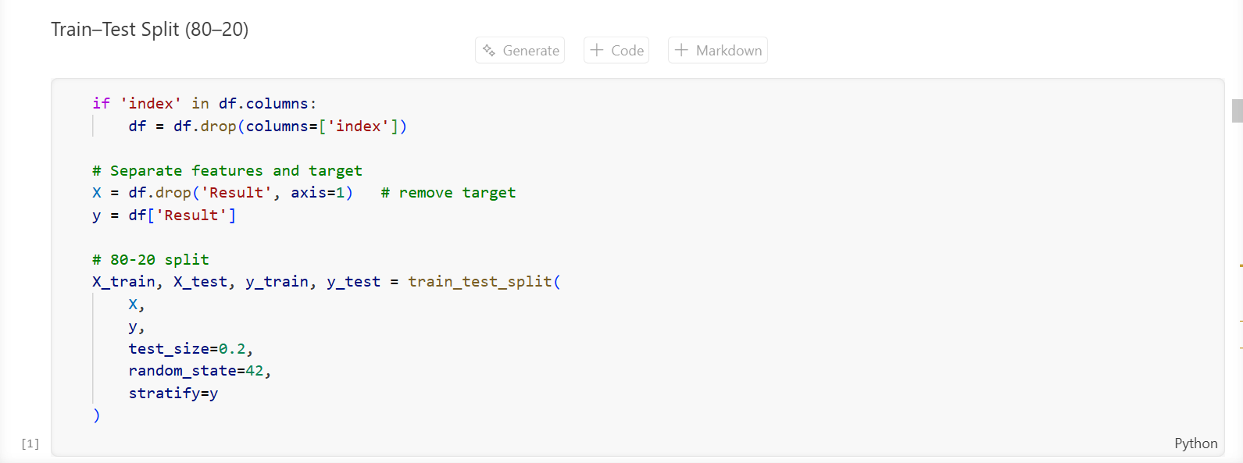
Figure 16: Splitting the Dataset into Training and Testing Sets
The dataset is divided into training and testing sets to evaluate how well the model performs. First, the unnecessary index column is removed. Then the data is separated into features (X) and the target variable (y), where the Result column represents whether a website is phishing or legitimate.
The train_test_split() function is used to divide the dataset into 80% training data and 20% testing data. The random_state=42 setting ensures that the results can be reproduced, while stratify=y keeps the same balance of phishing and legitimate websites in both the training and testing sets.

4.6.5 Model Training
This section explains how the nine models used in this study were trained. The models are grouped into three categories: machine learning models, ensemble models, and deep learning models, with three models in each group. All models were trained using the pre-processed Kaggle Phishing Website Dataset, which contains 11,055 samples and 32 features. The same 80/20 train–test split was applied to all models to ensure a fair and consistent comparison of their performance in detecting phishing websites.
Category 1: Machine Learning
Traditional machine learning models learn directly from structured data features. In this study, three models were used: Support Vector Machine (SVM), Decision Tree (DT), and K-Nearest Neighbours (KNN). These models act as baseline methods to compare with ensemble and deep learning approaches.
Support Vector Machine (SVM)
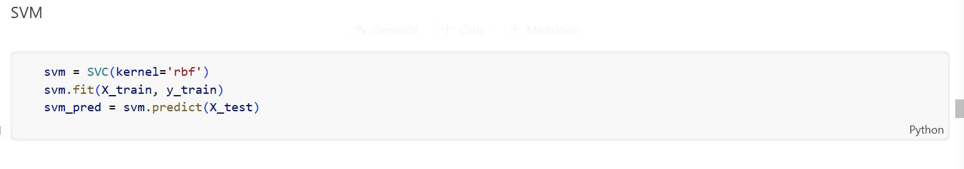
Figure 17: Implementation of the Support Vector Machine (SVM) classification model.
SVM is a supervised learning model used for classification. In this study, an SVM model with an RBF kernel was used to classify websites as phishing or legitimate. The model was trained using the training dataset and then used to predict results for the testing dataset.
Decision Tree
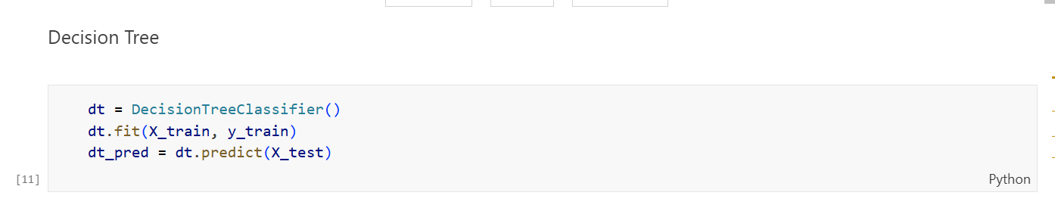
Decision Tree is a classification method that makes decisions based on a tree-like structure. The model was trained using the training data and then used to predict whether websites in the testing dataset were phishing or legitimate.
K-Nearest Neighbors (KNN)
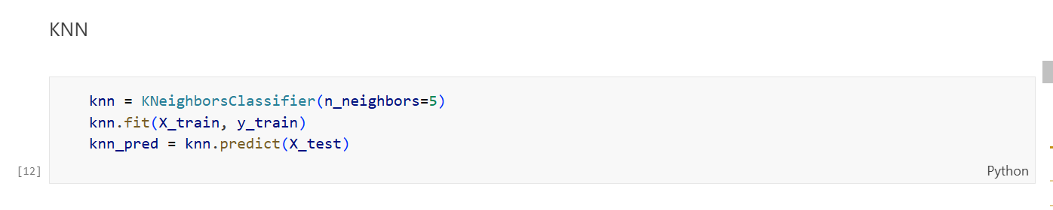
Figure 18: Implementation of the K-Nearest Neighbors (KNN) classification model.
KNN is a classification method that predicts results based on the nearest data points. In this study, the model was implemented with k = 5 neighbours. After training, the model predicted the labels of the testing dataset for evaluation.
Category 2: Ensemble Learning
Ensemble methods combine several models to improve performance and reduce errors. These approaches often perform better than single models. In this study, Random Forest, AdaBoost, XGBoost, LightGBM, and Stacking Ensemble were implemented.
Random Forest
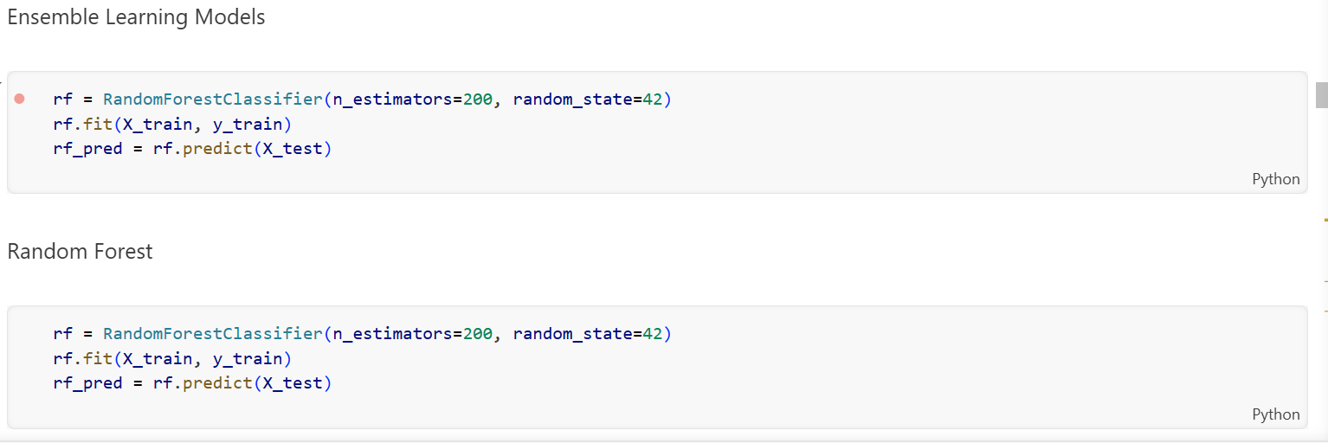
Figure 19: Implementation of the Random Forest ensemble learning model.
Random Forest combines many decision trees to improve accuracy and reduce overfitting. In this study, the model was implemented with 200 trees. After training, it was used to predict the labels of the testing dataset.
AdaBoost
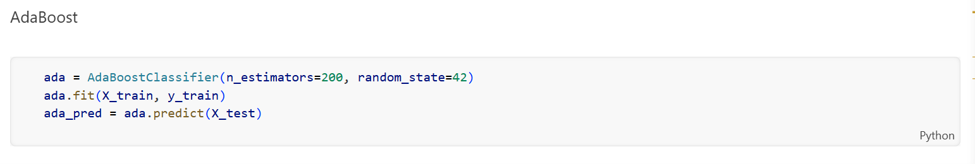
Figure 20: Implementation of the AdaBoost ensemble learning model.
AdaBoost improves performance by combining several weak models into a stronger one. The model was implemented with 200 estimators and trained using the training dataset before making predictions on the test data.
XGBoost

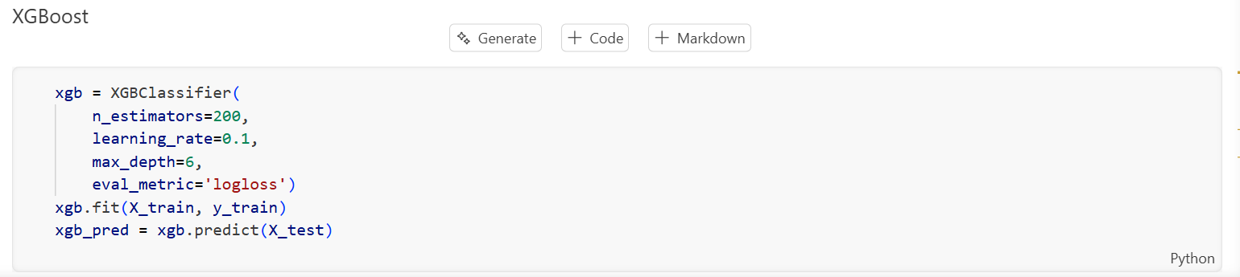
Figure 21: Implementation of the XGBoost classification model.
XGBoost is an advanced boosting algorithm widely used for classification tasks. In this study, it was implemented with 200 estimators, a learning rate of 0.1, and a maximum tree depth of 6. The trained model was then used to predict phishing and legitimate websites.
Category 3: Deep Learning
Deep learning models can learn complex patterns in data using neural networks. In this study, three deep learning models were implemented: LSTM, RNN, and GRU.
LSTM Model Implementation
Step 1: Model Architecture
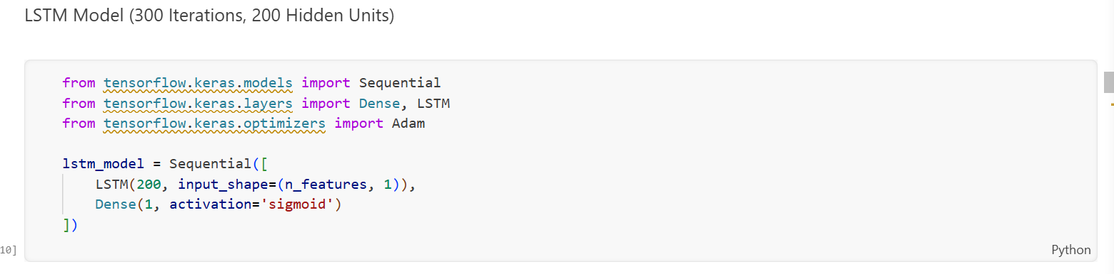
Figure 22a
First, the required libraries from TensorFlow Keras are imported. A Sequential model is created with an LSTM layer containing 200 units to learn patterns from the dataset. A Dense output layer with sigmoid activation is added to classify websites as phishing or legitimate.
Step 2: Model Compilation
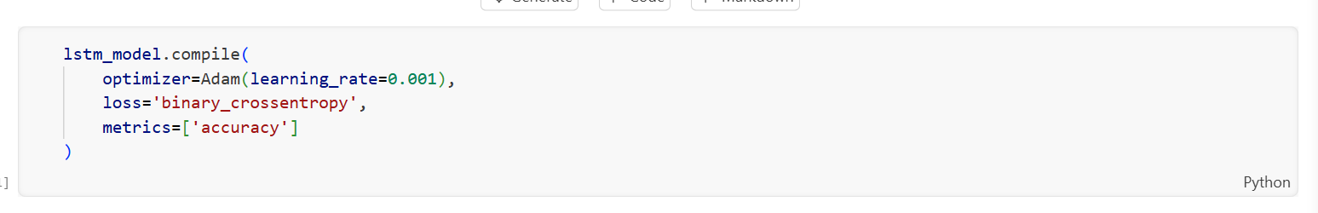
Figure 22b
The LSTM model is compiled using the Adam optimizer with a learning rate of 0.001. The binary cross-entropy loss function is used because the task involves two classes. Accuracy is selected as the evaluation metric.
Step 3: Model Training
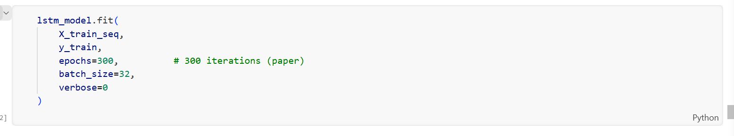
Figure 22c
The model is trained using the training dataset (X_train_seq, y_train). Training runs for 300 epochs with a batch size of 32, allowing the model to learn patterns from the data.
Step 4: Model Prediction
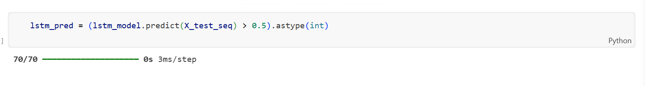
Figure 22: Implementation of the LSTM deep learning model.

After training, the model predicts the labels of the testing dataset (X_test_seq). A threshold value of 0.5 is applied to convert the predicted probabilities into phishing or legitimate website labels.
Recurrent Neural Network (RNN) Model
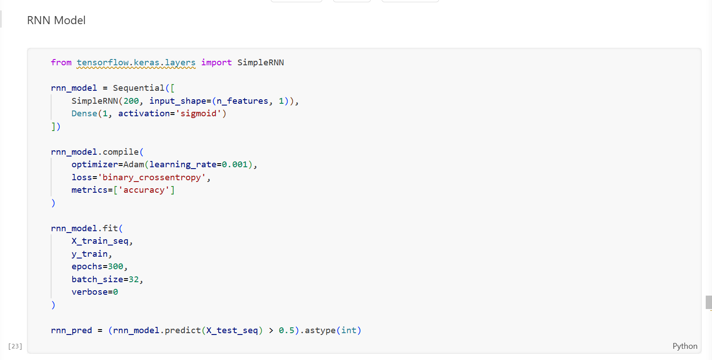
Figure 23
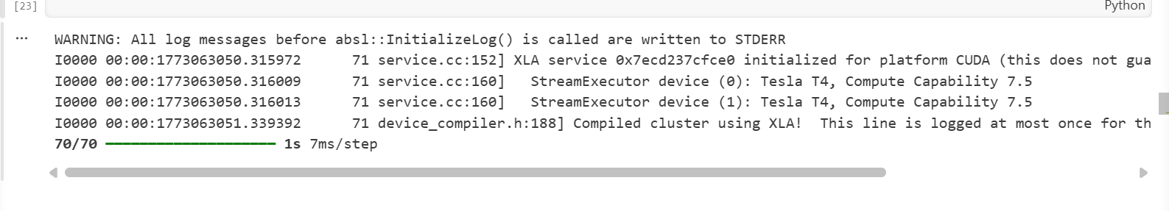
Figure 23: Implementation of the RNN deep learning model.
A Recurrent Neural Network (RNN) model was used to learn patterns in the dataset for phishing website detection. The model includes a SimpleRNN layer with 200 units to learn relationships in the input features. A Dense output layer with sigmoid activation is added to classify websites as phishing or legitimate. The model is compiled using the Adam optimizer with a learning rate of 0.001. The binary cross-entropy loss function is used, and accuracy is selected as the evaluation metric. The model is trained using the training dataset for 300 epochs with a batch size of 32. After training, the model predicts the labels of the testing dataset, and a 0.5 threshold is used to convert the predicted probabilities into phishing or legitimate website labels.
Gated Recurrent Unit (GRU) Model
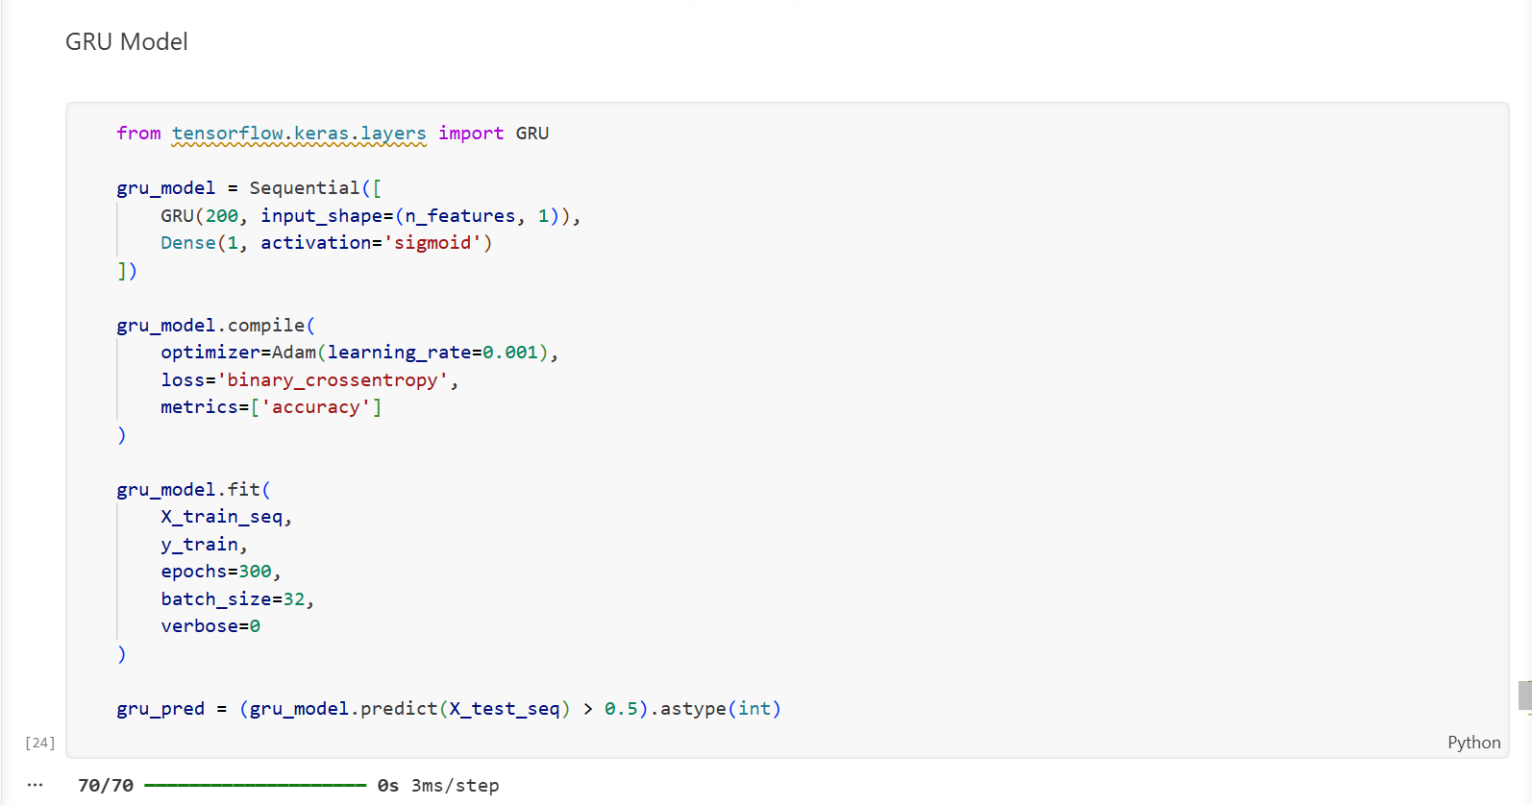
Figure 24: Implementation of the GRU deep learning model
A Gated Recurrent Unit (GRU) model was implemented as a deep learning method for phishing website detection. The model includes a GRU layer with 200 units, followed by a Dense output layer with sigmoid activation to classify websites as phishing or legitimate.
The model was compiled using the Adam optimizer with a learning rate of 0.001. The binary cross-entropy loss function was used, and accuracy was selected as the evaluation metric. The model was trained using the training dataset for 300 epochs with a batch size of 32. After training, the model predicted the labels of the testing dataset, and a 0.5 threshold was used to convert the predicted probabilities into phishing or legitimate labels.

4.6.6 Model Evaluation
After training all the models, a standard evaluation process was used to measure their performance. Four main metrics were used: Accuracy, Precision, Recall, and F1-score.
Step 1: Evaluation Function

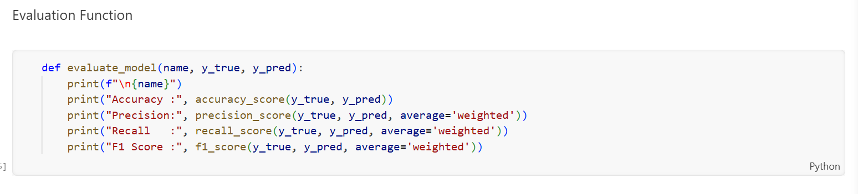
An evaluation function was created to calculate the performance of each model. The function compares the actual labels (y_true) with the predicted labels (y_pred) and calculates the evaluation metrics. These measures help assess how well the model detects phishing and legitimate websites.
Step 2: Applying Evaluation to All 9 Models

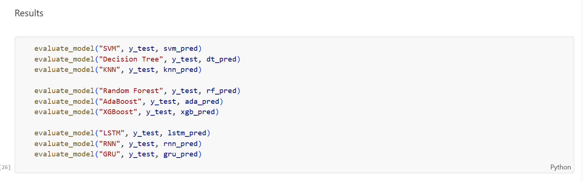
The evaluation function was applied to all models, including SVM, Decision Tree, KNN, Random Forest, AdaBoost, XGBoost, LSTM, RNN, and GRU, using the testing dataset.
Step 3: Evaluation Results
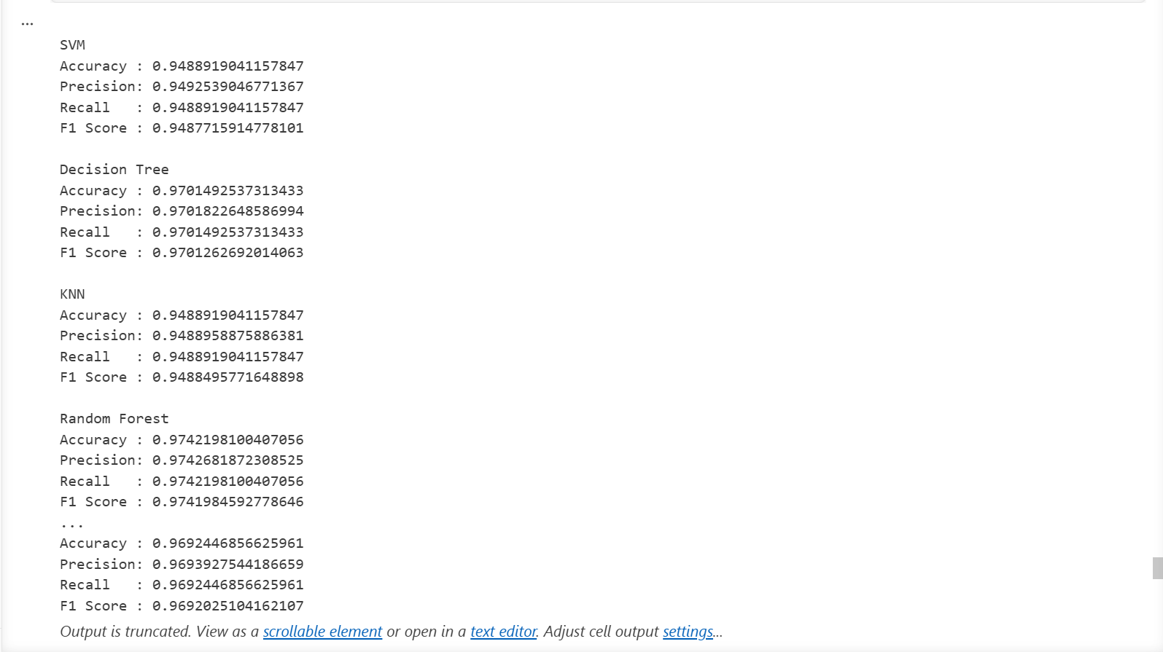
The models were evaluated using Accuracy, Precision, Recall, and F1-score. The results show that the models achieved strong performance in identifying phishing and legitimate websites.
Table 8: Evaluation Results
Model | Accuracy | Precision | Recall | F1 Score
SVM | 94.89 | 94.93 | 94.89 | 94.88
Decision Tree | 97.01 | 97.02% | 97.01% | 97.01%
KNN | 94.89% | 94.89% | 94.89% | 94.88%
Random Forest | 97.42% | 97.43% | 97.42% | 97.42%
AdaBoost | 93.40 | 93.41 | 93.40 | 93.39
XGBoost | 97.24 | 97.25 | 97.24 | 97.24
LSTM | 97.06 | 97.06 | 97.06 | 97.06
RNN | 91.99 | 92.01 | 91.99 | 91.98
GRU | 96.92 | 96.94 | 96.92 | 96.92

4.6.7 Originality of Work and Student Contribution
The originality of Experiment 1 lies in the independent reproduction of the base study methodology without access to the original source code. The student independently designed and implemented the complete data preprocessing pipeline, all three feature selection techniques, and the full model training and evaluation pipeline for all nine algorithms. The logical flow of the entire pipeline was verified by the student, and all errors encountered during execution were independently investigated and resolved before the results were recorded.
When deep learning models required extended training time due to the 300-epoch configuration, the student monitored the training process and waited for completion, confirming all output values before proceeding. The student also independently constructed and validated the model-saving pipeline for all nine trained models.

4.7 Experimental – 2

4.7.1 Dataset Loading
The Kaggle Phishing Website Dataset [47] was imported using the pandas library and checked to make sure the structure and features were loaded correctly.

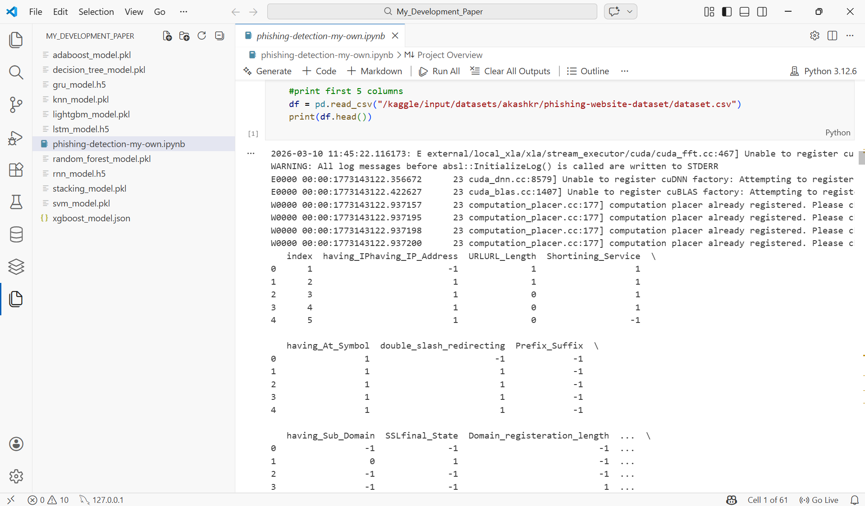
Figure 25
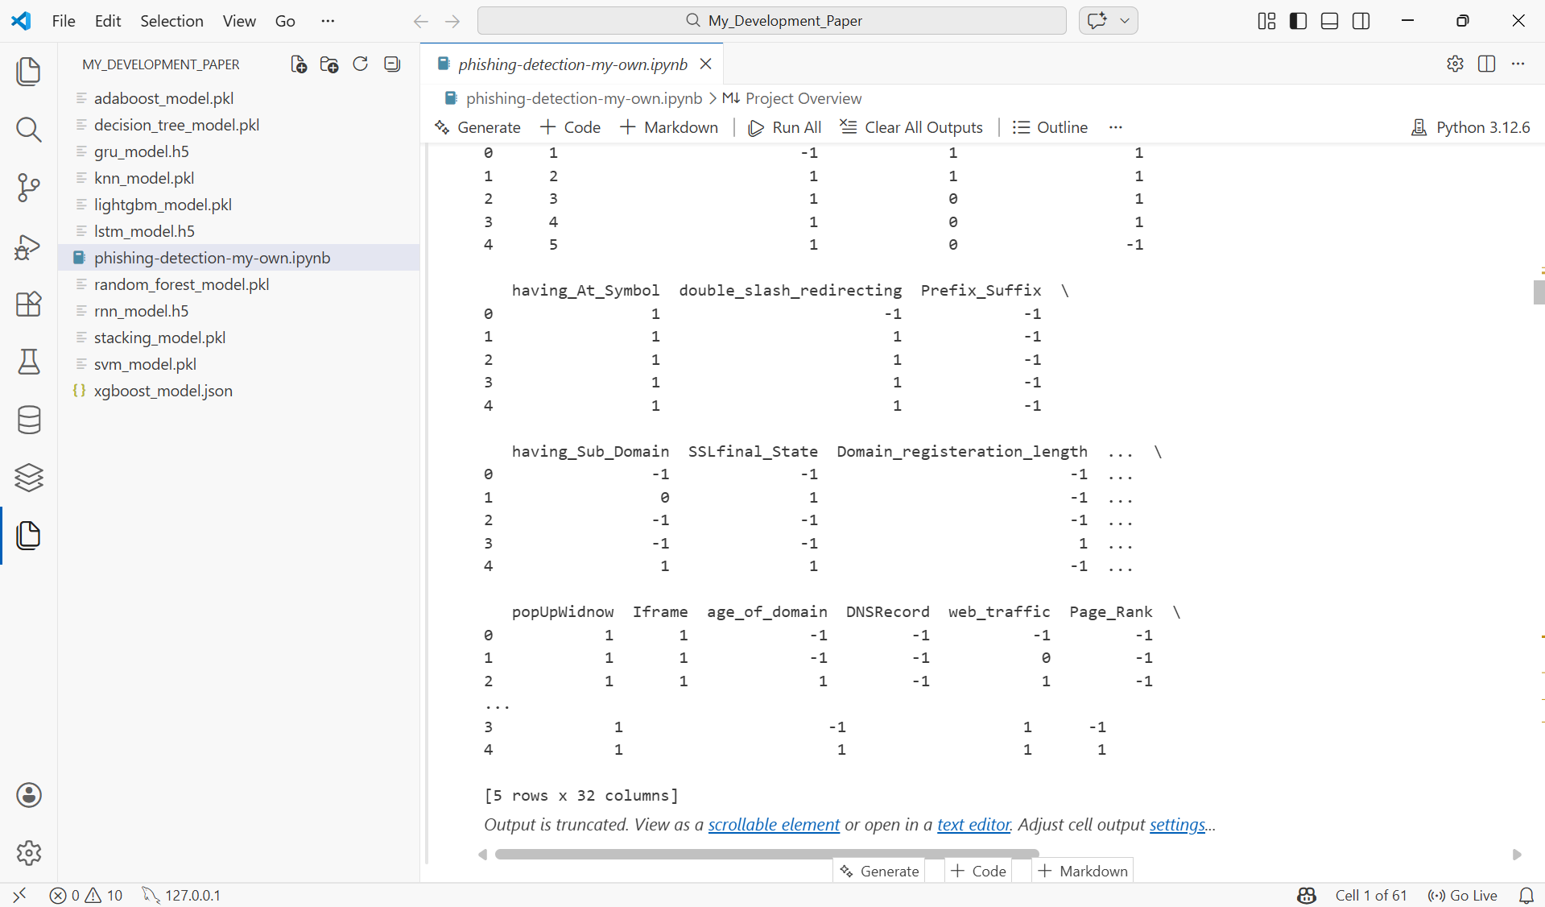
Figure 25: Preview of the Kaggle Phishing Website Dataset

4.7.2 Data Validation and Cleaning
The dataset was examined for missing values and duplicate records to prevent data leakage and maintain model reliability.

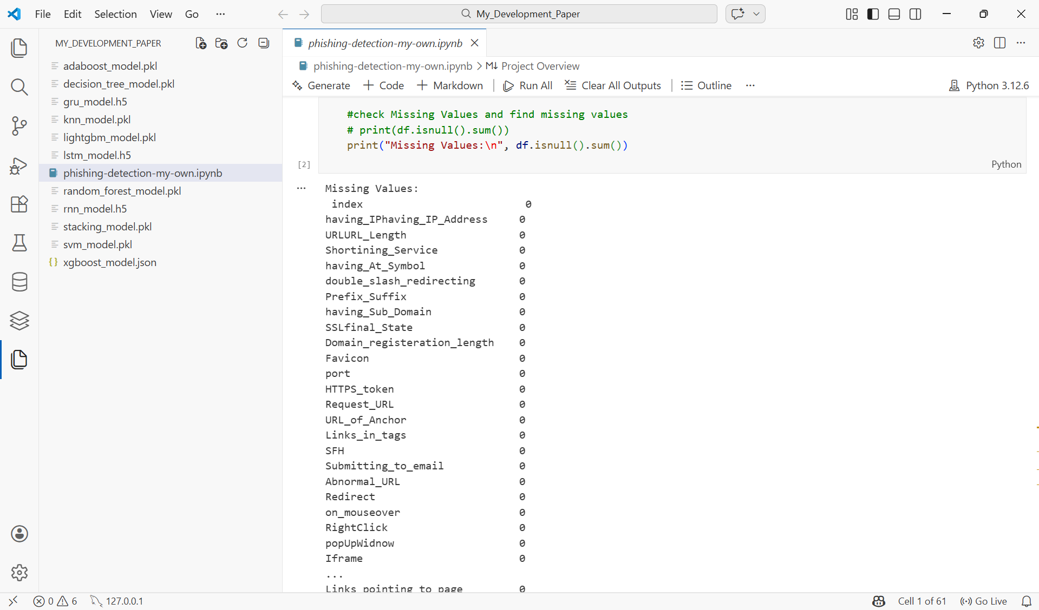
Figure 26
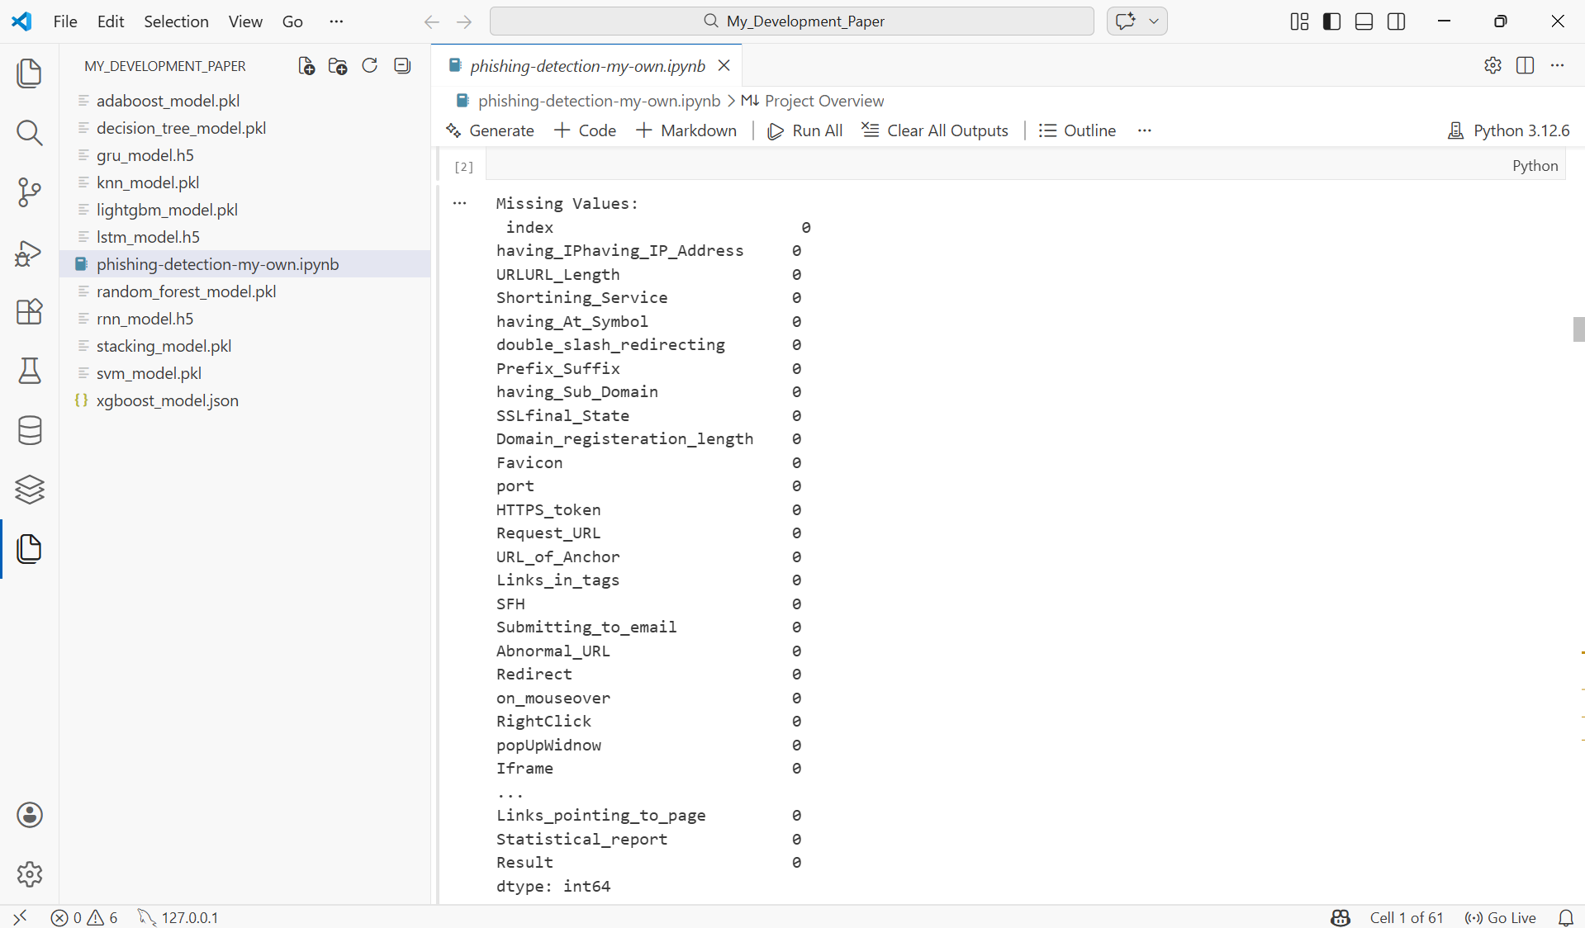
Figure 26: Missing Value Inspection of the Dataset

4.7.3 Feature Selection
Feature selection is an important step that helps identify the most useful features in the dataset. It reduces the number of unnecessary features and improves model performance by removing irrelevant or repeated information. In this study, three feature selection methods were used: Information Gain (IG), Gain Ratio (GR), and Principal Component Analysis (PCA), following the method used in the base research paper.

The original dataset contains 32 columns. One column is an index column, which was removed because it does not help in prediction. Another column is the Result column, which shows whether a website is phishing or legitimate. This column was used as the target variable (y) and was not included in the feature set.
The remaining 30 columns formed the feature set (X) used for feature selection. Each method selected the top 10 most important features from these 30 columns, giving three different views of feature importance in the dataset.
Information Gain (IG)
Information Gain measures how useful a feature is for separating phishing websites from legitimate ones. Features with higher Information Gain values are considered more important and are given priority during model training.

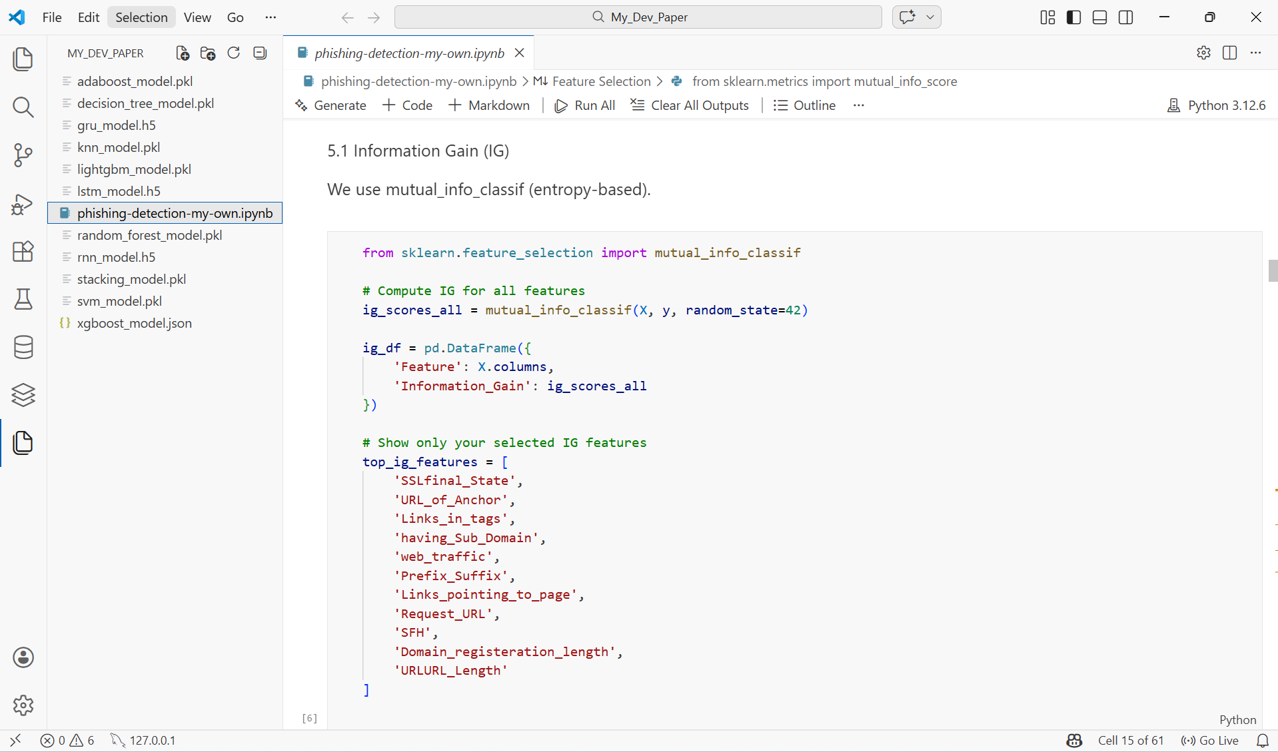
Figure 27
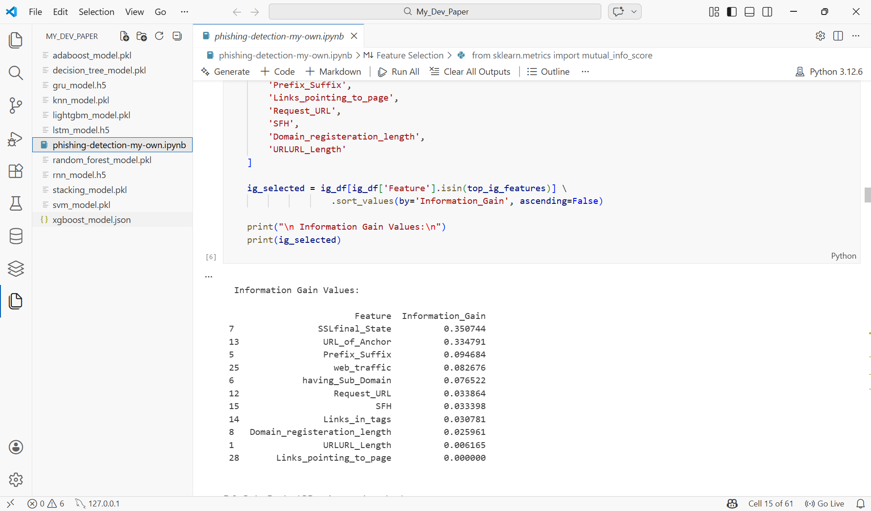
Figure 27: Information Gain Values for Top Selected Features

The mutual_info_classif(X, y, random_state=42) function calculates the Information Gain score for each feature by measuring how strongly it is related to the target label. The random_state=42 parameter ensures the results can be reproduced. The scores are stored in ig_df, which lists each feature with its Information Gain value. The top_ig_features variable identifies the most important features based on these scores. The data is then filtered and sorted to show the features in order of importance. The results show that SSLfinal_State has the highest score (0.3507), followed by URL_of_Anchor (0.3348) and Prefix_Suffix (0.0946), making them strong indicators for phishing detection. Some features, such as Links_pointing_to_page, have a score of 0.000, showing very low importance.
Gain Ratio (GR)
Gain Ratio is an extension of Information Gain that normalises the gain value by the split information of each feature, thereby reducing the bias towards features with many distinct values. Since scikit-learn does not provide a direct implementation of Gain Ratio, a custom approximation function was developed in this study, which is an accepted approach in academic reproductions of this method.
The Gain Ratio is calculated as:
GR = Information Gain / Split Information
where Split Information represents the entropy of the feature itself.
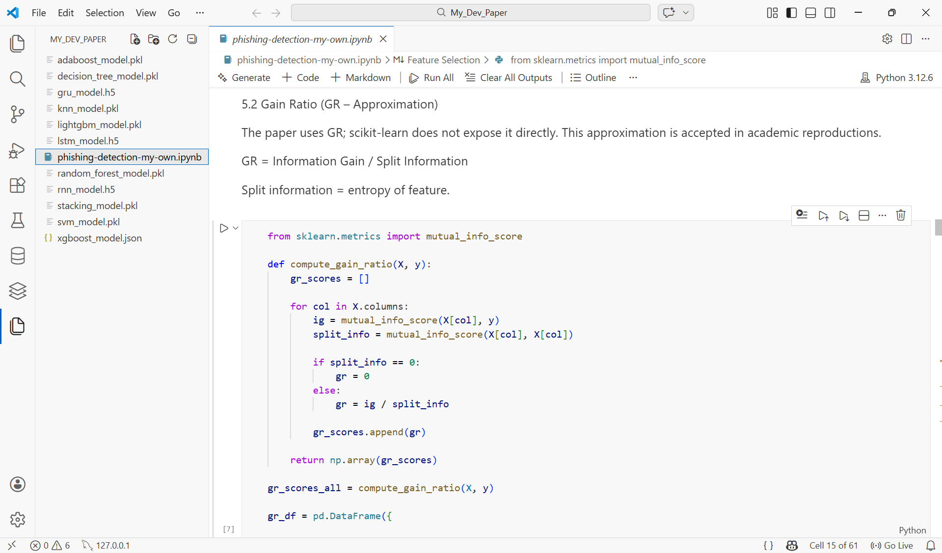
Figure 28

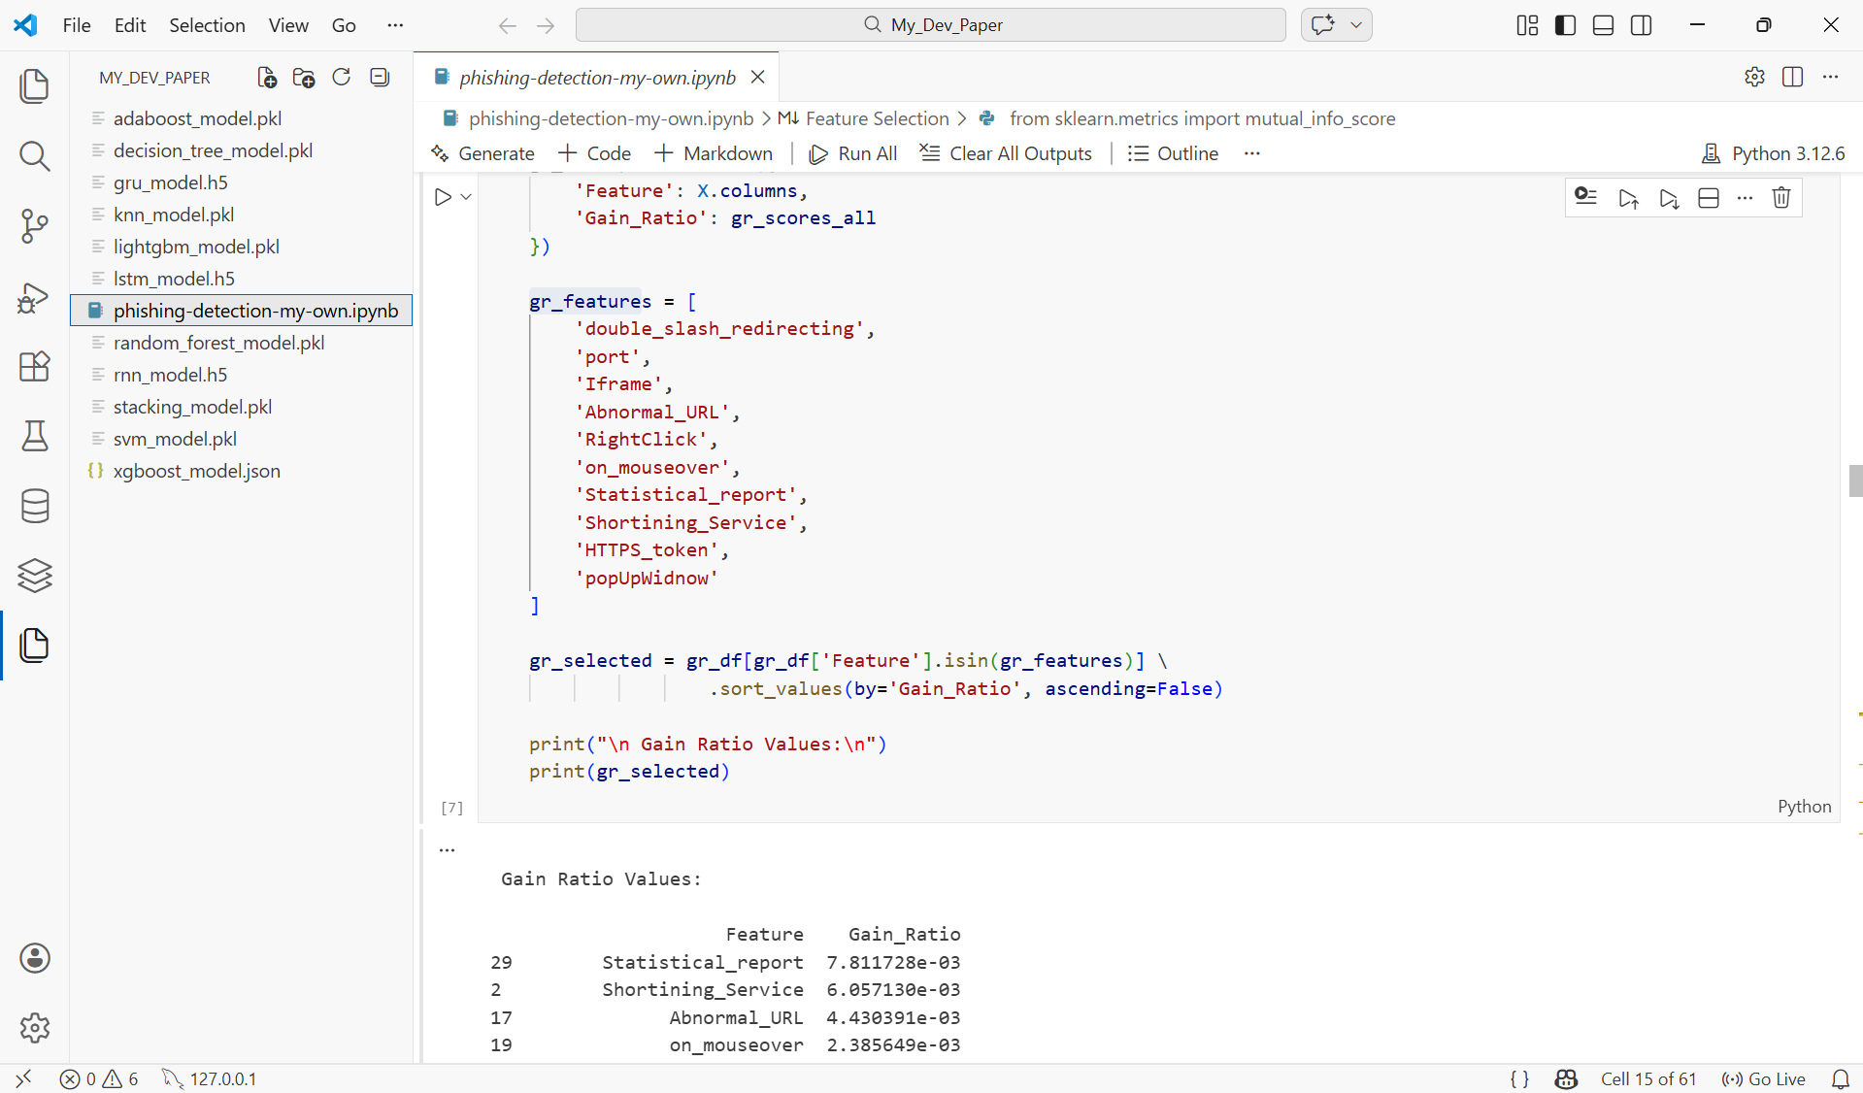
Figure 28
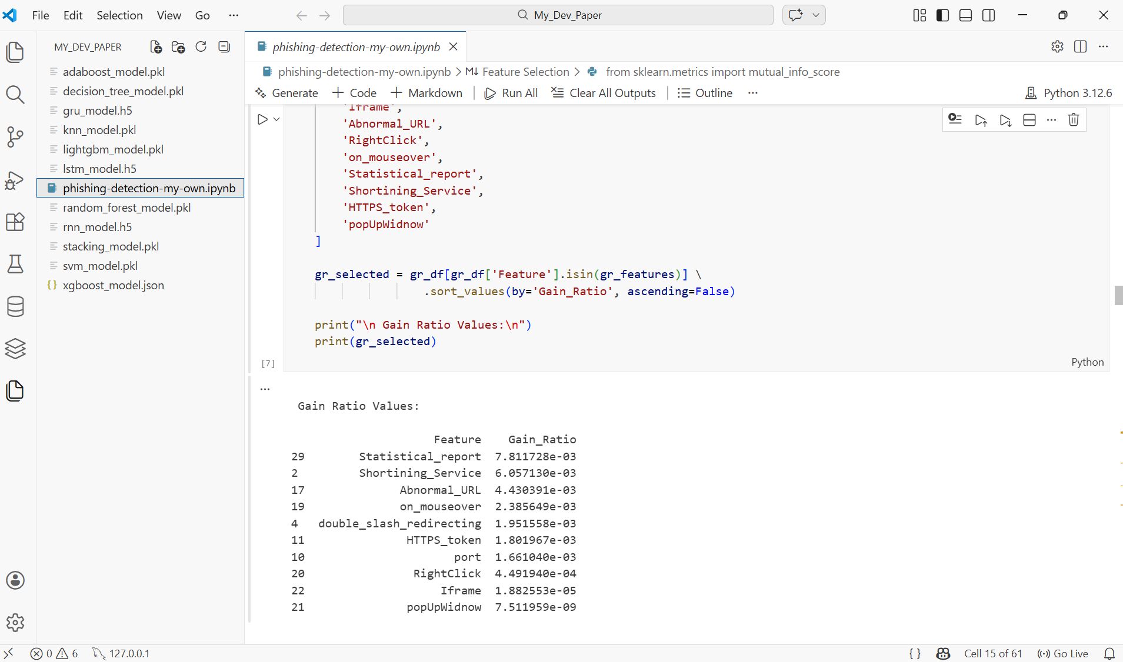
Figure 28: Ranked Feature Importance Scores Based on Gain Ratio (GR)
The compute_gain_ratio(X, y) function calculates the Gain Ratio for each feature in the dataset. It first measures the relationship between each feature and the target label and then adjusts the value using the feature’s own entropy. If the value becomes zero, the Gain Ratio is set to zero to avoid calculation errors.
The gr_features variable lists the top ten features selected based on their Gain Ratio scores. The selected features are then filtered and sorted to show them in order of importance.
The results show that Statistical_report has the highest Gain Ratio (7.81 × 10⁻³), followed by Shortining_Service (6.06 × 10⁻³) and Abnormal_URL (4.43 × 10⁻³). Some features, such as popUpWidnow, have very low values, showing they contribute less to phishing detection.
Principal Component Analysis (PCA)
Principal Component Analysis (PCA) is a method used to reduce the number of features in a dataset while keeping the most important information [69]. Instead of selecting features based on their relationship with the target label, PCA finds patterns in the data and identifies which features contribute most to the overall variation. In this study, PCA loading values were used to identify which original features contribute the most to the main pattern in the phishing dataset.

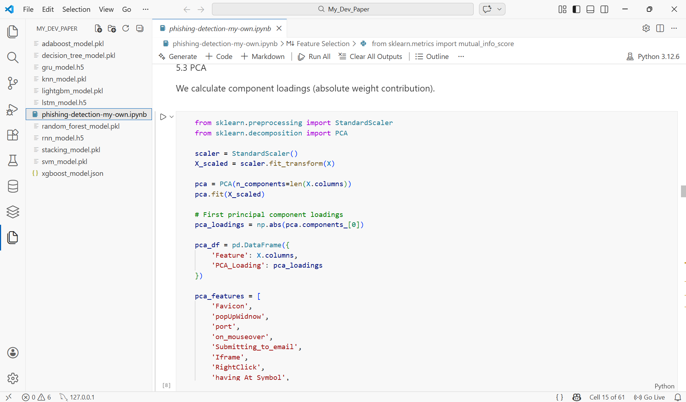
Figure 29
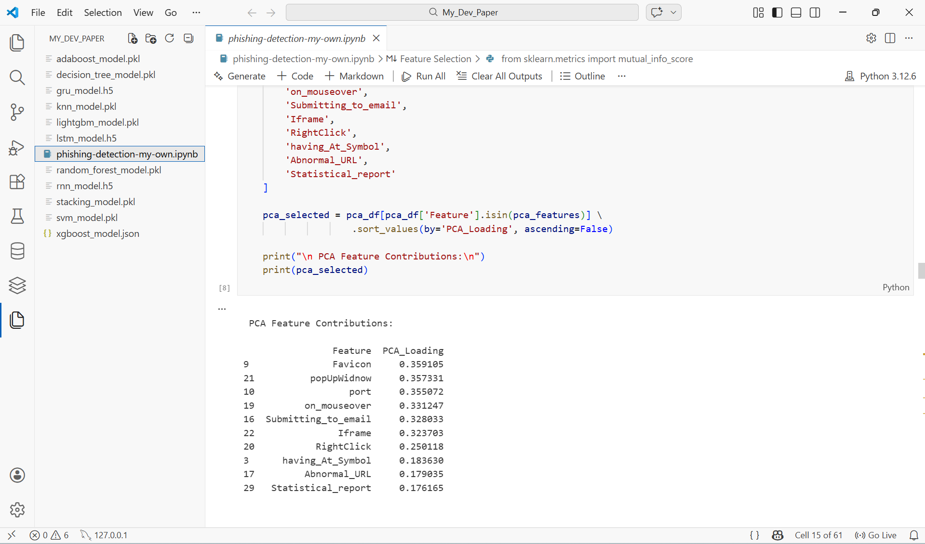
Figure 29: Ranked Feature Importance Scores Based on Principal Component Analysis (PCA)
StandardScaler () standardises all features to have zero mean and unit variance before applying PCA. StandardScaler() is used to standardise all features, so they are on the same scale before applying PCA. This is important because PCA is affected by the size of feature values.
PCA(n_components=len(X.columns)) calculates all principal components based on the number of features in the dataset. pca.components [0] extracts the first principal component, which explains the largest variation in the data.
The features are then ranked based on their PCA values. The results show that Favicon (0.3591) has the highest score, followed by popUpWidnow (0.3573) and port (0.3551), while Statistical_report (0.1762) has a lower contribution.

4.7.4 Train-Test Split
Train–test splitting is an important step used to evaluate how well a model performs on new data. The dataset is divided into two parts: a training set, used to train the model, and a testing set, used to evaluate its performance. In this study, the dataset was split 80% for training and 20% for testing.

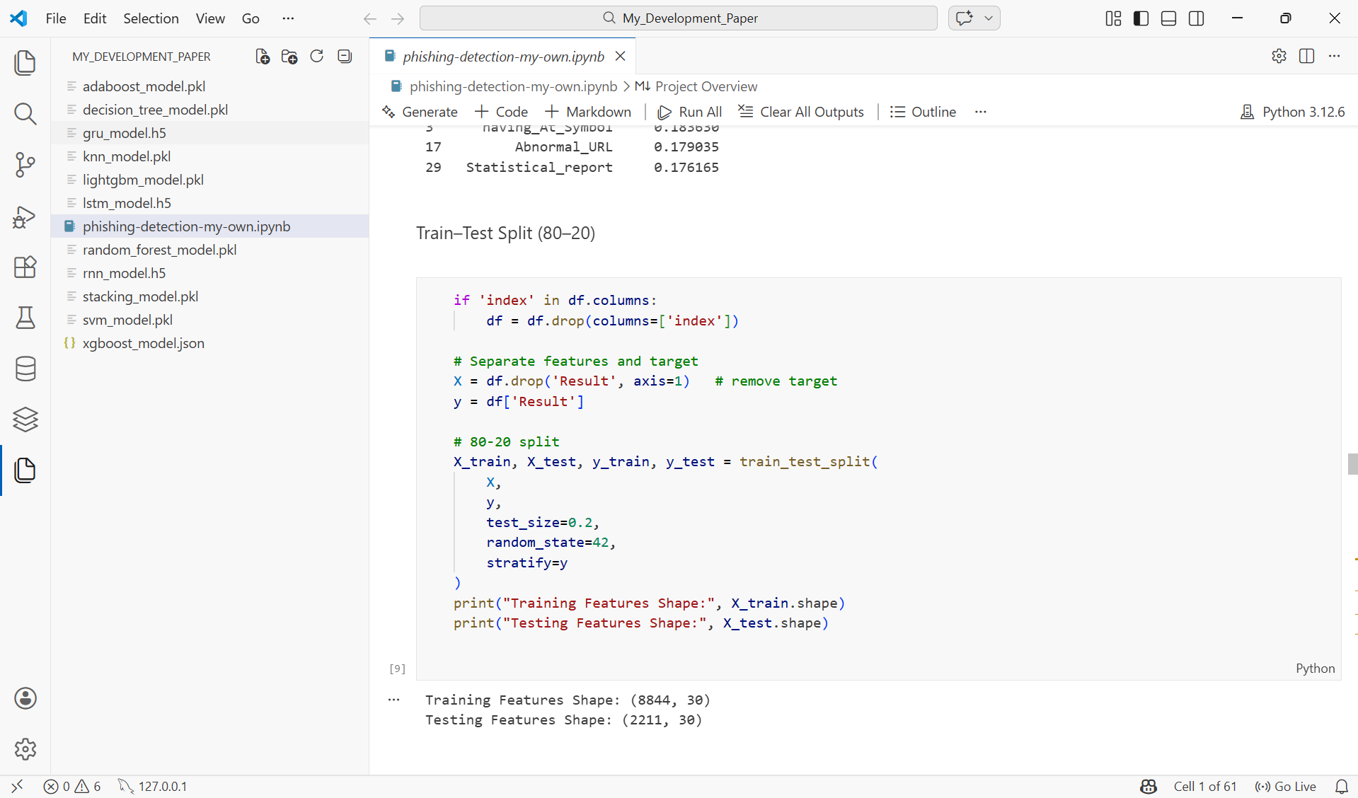
Figure 30: Train–test split implementation using Scikit-learn
First, the dataset was checked for an index column, which was removed because it does not help in prediction. Next, the data was divided into features (X) and the target variable (y). The Result column was used as the target label indicating whether a website is phishing or legitimate. The train_test_split() function from Scikit-learn was used to divide the dataset. The test_size=0.2 parameter reserves 20% of the data for testing, while random_state=42 ensures the results can be reproduced. The stratify=y option keeps the same balance of phishing and legitimate samples in both datasets.
After splitting, the training set contained 8,844 samples and the testing set contained 2,211 samples, each with 30 features. This separation allows the models to be tested on data that was not used during training, giving a more reliable evaluation of their performance.

4.7.5 Model Training
This section explains how the eleven models used in this study were trained. The models are grouped into three categories: Machine Learning, Ensemble Learning, and Deep Learning. All models were trained using the Kaggle Phishing Website Dataset, which contains 11,055 samples and 32 features. An 80/20 train–test split was used for all models to ensure a fair comparison.
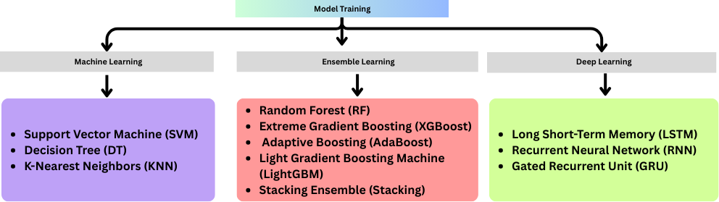
Figure 31: Classification models used in the proposed phishing detection system
Category 1: Machine Learning
Traditional machine learning models learn directly from structured data. Three models were used as baseline methods: Support Vector Machine (SVM), Decision Tree (DT), and K-Nearest Neighbours (KNN).
Support Vector Machine (SVM)
Support Vector Machine (SVM) is a supervised learning algorithm used for classification. It separates data into different classes by finding the best boundary between them. In phishing website detection, SVM is used to classify websites as phishing or legitimate based on the selected features [70].
In this study, the SVM model was implemented using a Radial Basis Function (RBF) kernel, which helps the model identify more complex patterns in the dataset:
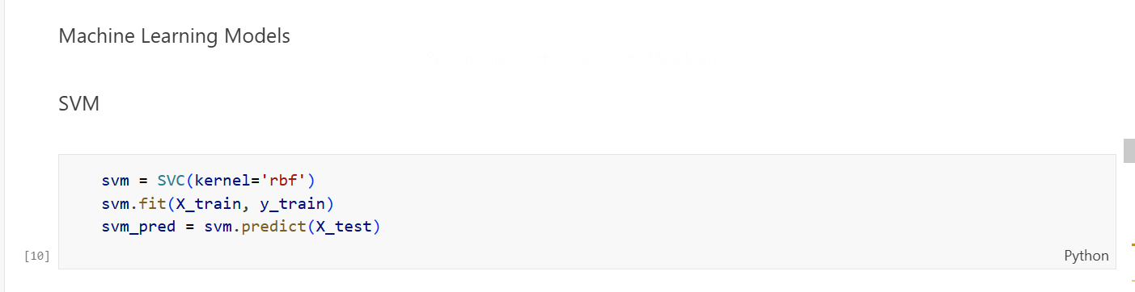
Figure 32: SVM model implementation in Python
SVC (kernel='rbf') creates the SVM classifier using the RBF kernel, which helps the model detect complex patterns in the data. svm.fit(X_train, y_train) trains the model using the training dataset so it can learn how to separate phishing websites from legitimate ones. svm.predict(X_test) uses the trained model to predict the class labels of the test dataset for performance evaluation.
Decision Tree (DT)
Decision Tree is a supervised learning algorithm that classifies data by splitting it into smaller groups based on the most important features [71]. These splits form a tree-like structure, where each branch represents a decision and each final node represents a class label. Decision Trees are commonly used in phishing detection because they are easy to understand and work well with different types of data.
In this study, the Decision Tree classifier was implemented using its default settings, as shown in the code below:
Figure 33: Implementation of the Decision Tree classifier for training and prediction
DecisionTreeClassifier() creates the Decision Tree model using the default Gini impurity method to select the best feature for splitting the data. The model chooses the feature that best separates phishing and legitimate websites. dt.fit(X_train, y_train) trains the Decision Tree using the training dataset so the model can learn patterns from the features. dt.predict(X_test) uses the trained model to predict whether websites in the test dataset are phishing or legitimate.
K-Nearest Neighbours (KNN)
K-Nearest Neighbours (KNN) is a simple supervised learning algorithm that classifies a data point based on the class of its closest neighbours in the dataset. Instead of building a model during training, KNN stores the training data and compares new data points with the stored samples to make predictions.
In this study, the KNN model was implemented with five nearest neighbours (k = 5), as shown in the code below:
Figure 34: Implementation of the K-Nearest Neighbours (KNN) classifier for model training and prediction
KNeighborsClassifier(n_neighbors=5) creates the KNN model with five nearest neighbours. For each new website sample, the algorithm finds the five closest samples in the training data using Euclidean distance and assigns the class that appears most often among them. knn.fit(X_train, y_train) stores the training data so the model can compare new samples with it during prediction. knn.predict(X_test) uses the stored training data to find the nearest neighbours for each test sample and predicts whether the website is phishing or legitimate based on the majority class.
Category 2: Ensemble Learning
Ensemble learning methods combine multiple models to produce a more accurate and reliable result than a single model. By combining the predictions of several models, ensemble methods can reduce errors, improve accuracy, and prevent overfitting. In this study, five ensemble models were used: Random Forest, XGBoost, AdaBoost, LightGBM, and a Stacking model.
Random Forest (RF)
Random Forest is an ensemble algorithm that builds many decision trees and combines their results using majority voting to make the final prediction. Each tree is trained on a random part of the dataset and a random set of features, which helps improve accuracy and reduce overfitting.
In this study, the Random Forest model was implemented with 200 decision trees, as shown in the code below:
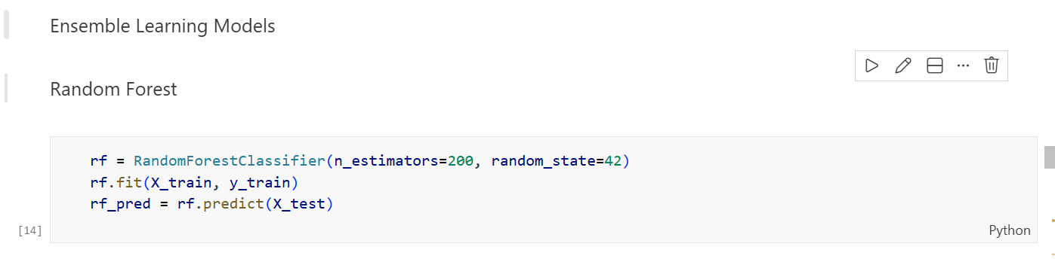
Figure 35: Implementation of the Random Forest classifier for training and prediction
RandomForestClassifier(n_estimators=200, random_state=42) creates the Random Forest model with 200 decision trees. The n_estimators=200 setting means the model builds 200 trees to improve prediction accuracy. The random_state=42 parameter ensures the results can be reproduced. rf.fit(X_train, y_train) trains the Random Forest model using the training dataset, where each tree learns to classify phishing and legitimate websites using different subsets of the data. rf.predict(X_test) applies the trained model to the test dataset. Each tree makes a prediction, and the result is decided by majority voting across all trees.
AdaBoost
AdaBoost (Adaptive Boosting) is an ensemble method that improves performance by training several small models in sequence. Each new model focuses more on the samples that were incorrectly classified by the previous model. The final prediction is made by combining the results of all the models.
In this study, AdaBoost was implemented with 200 estimators, as shown in the code below.:
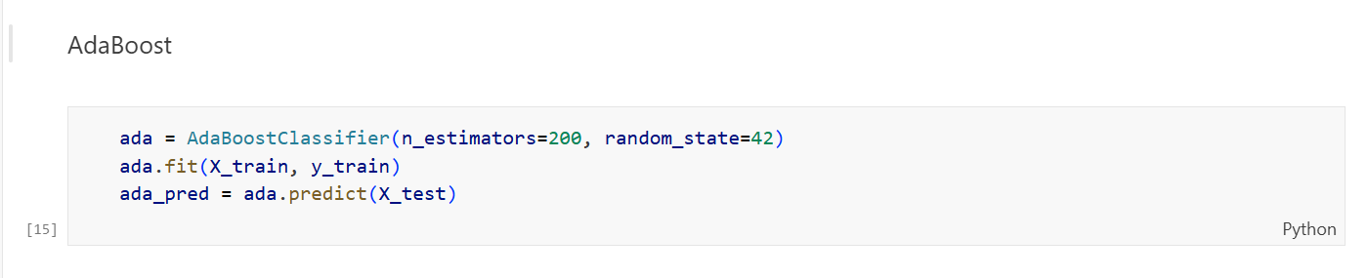
Figure 36: Implementation of the AdaBoost classifier for model training and prediction
AdaBoostClassifier(n_estimators=200, random_state=42) creates the AdaBoost model with 200 weak learners. The n_estimators=200 parameter means the model trains 200 small models in sequence, where each new model focuses on correcting the mistakes of the previous one. The random_state=42 parameter ensures the results can be reproduced. ada.fit(X_train, y_train) trains the AdaBoost model using the training dataset by adjusting the importance of samples during each boosting step. ada.predict(X_test) applies the trained AdaBoost model to the test dataset and combines the predictions of all learners to produce the final classification result.
XGBoost
XGBoost (Extreme Gradient Boosting) is an advanced ensemble algorithm that builds a series of decision trees, where each new tree improves the errors made by the previous ones. It is widely used because it provides high accuracy and efficient performance for structured data classification tasks.
In this study, the XGBoost model was implemented with specific parameter settings, as shown in the code below:
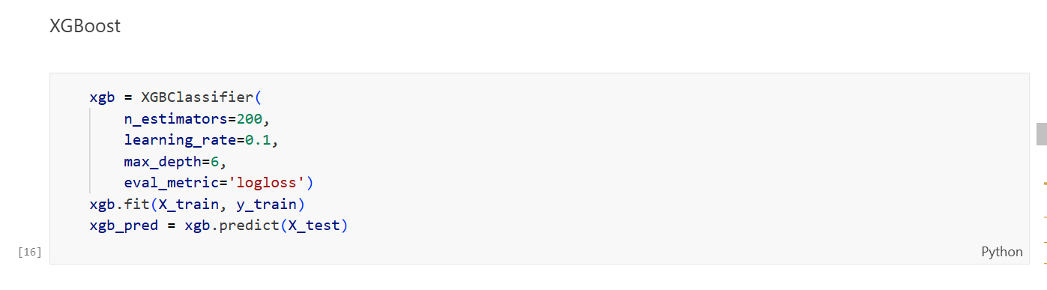
Figure 37: Implementation of the XGBoost classifier for training and prediction
n_estimators=200 means that 200 boosting trees are created during training. Each new tree helps correct the errors made by the previous trees. learning_rate=0.1 controls how much each tree contributes to the final model. A smaller value helps the model learn gradually and reduces the risk of overfitting. max_depth=6 sets the maximum depth of each tree, allowing the model to capture patterns in the data while preventing overly complex trees. eval_metric='logloss' is used to measure model performance during training. It evaluates how well the model predicts the correct class probabilities. xgb.fit(X_train, y_train) trains the XGBoost model using the training dataset. xgb.predict(X_test) uses the trained model to predict whether websites in the test dataset are phishing or legitimate.
LightGBM (New Algorithm)
LightGBM (Light Gradient Boosting Machine) is a fast and efficient ensemble learning algorithm developed by Microsoft. It is based on the gradient boosting method and is designed to handle large datasets with high speed and accuracy [72]. Unlike traditional boosting methods that grow trees level by level, LightGBM grows tree leaf-wise, which helps improve training efficiency and model performance.
In this study, LightGBM was added as an additional algorithm to extend the experimental comparison. The model was implemented using the configuration shown in the code below:
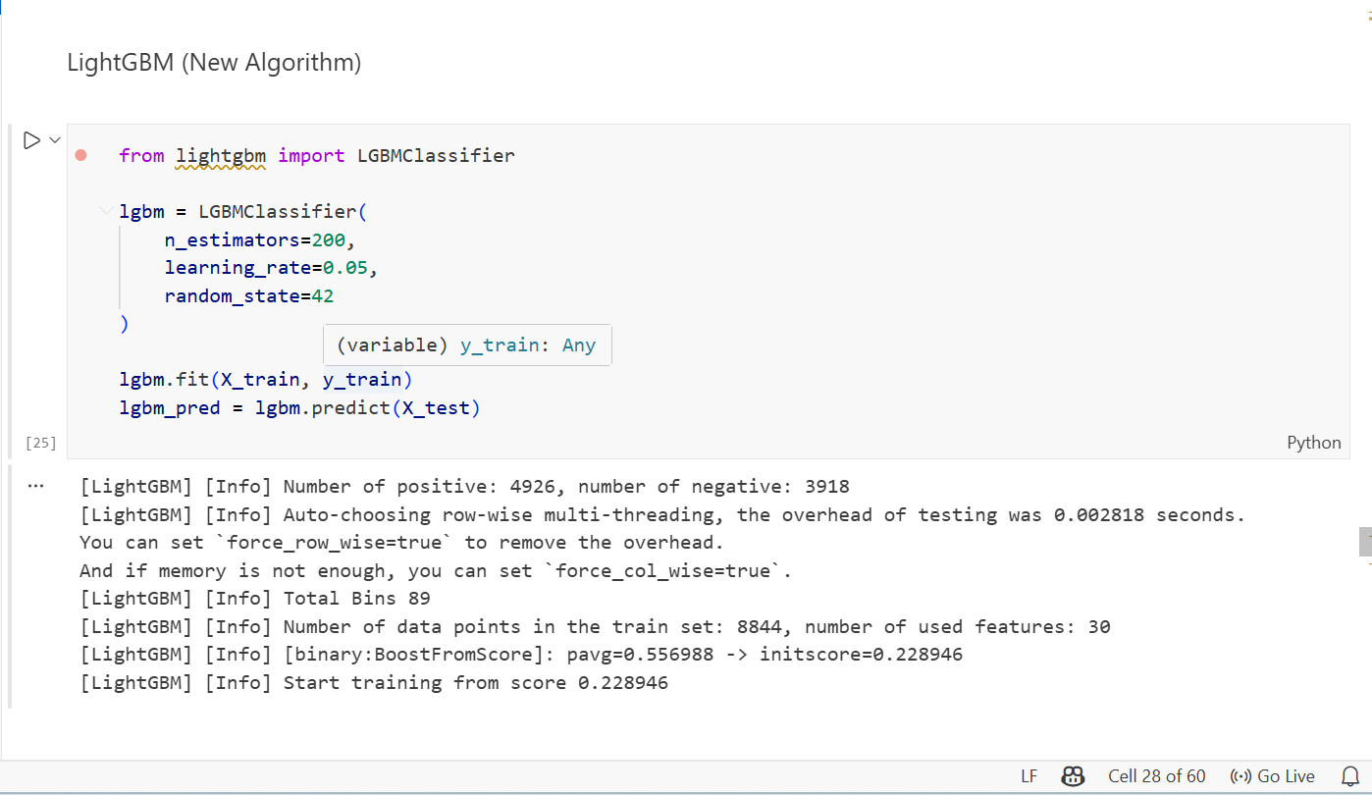
Figure 38: Implementation of the LightGBM classifier for training and prediction
from lightgbm import LGBMClassifier imports the LightGBM classifier from the LightGBM library, which provides an efficient implementation of the gradient boosting algorithm. n_estimators=200 means the model will build 200 boosting trees during training. Each new tree helps improve the predictions made by the previous trees. learning_rate=0.05 controls how much each tree contributes to the model. A smaller value allows the model to learn more gradually and improves performance on new data. random_state=42 ensures that the results can be reproduced in repeated experiments. lgbm.fit(X_train, y_train) trains the LightGBM model using the training dataset. lgbm.predict(X_test) then uses the trained model to predict whether websites in the test dataset are phishing or legitimate.
Stacking Ensemble (RF + AdaBoost + LightGBM)
Stacking (Stacked Generalisation) is an ensemble learning method that combines several different models and uses another model to produce the final prediction [73]. Instead of relying on a single model, stacking learns how to combine the strengths of multiple models to improve overall performance.
In this study, the Stacking Ensemble was built using Random Forest, AdaBoost, and LightGBM as the base models. Logistic Regression was used as the final model to combine the predictions of these base models, as shown in the code below:
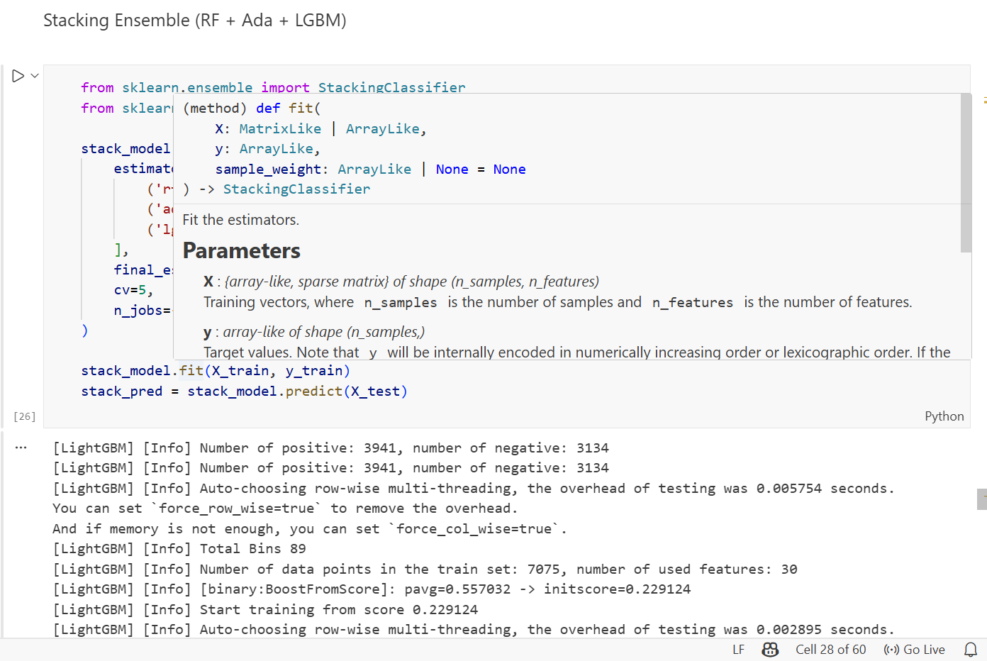
Figure 39
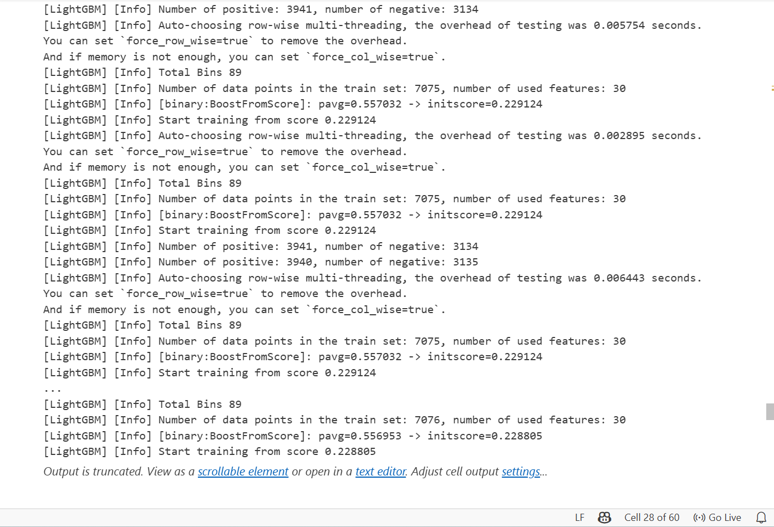
Figure 39: Implementation of the Stacking Ensemble model
StackingClassifier creates the stacking model with two layers: base models and a final model. The base models make initial predictions, and the final model combines these predictions to produce the result. estimators= [('rf', rf), ('ada', ada), ('lgbm', lgbm)] defines the three base models used in the first layer: Random Forest, AdaBoost, and LightGBM. Each model contributes different strengths, helping the system capture different patterns in the phishing dataset. final_estimator=LogisticRegression() sets Logistic Regression as the final model that learns how to combine the predictions of the base models. cv=5 applies five-fold cross-validation, meaning the training data is divided into five parts to improve reliability and reduce overfitting. n_jobs=-1 allows the model to use all available processor cores to speed up training. stack_model.fit (X_train, y_train) trains the stacking model using the training dataset. stack_model.predict(X_test) then uses the trained model to predict phishing or legitimate websites in the test dataset.
Category 3: Deep Learning
Deep learning models use neural networks to learn complex patterns in data. In this study, three models were implemented: LSTM, RNN, and GRU.
Long Short-Term Memory (LSTM)
LSTM is a type of neural network designed to learn patterns in data and remember important information over time.
Step 1: Build the Model
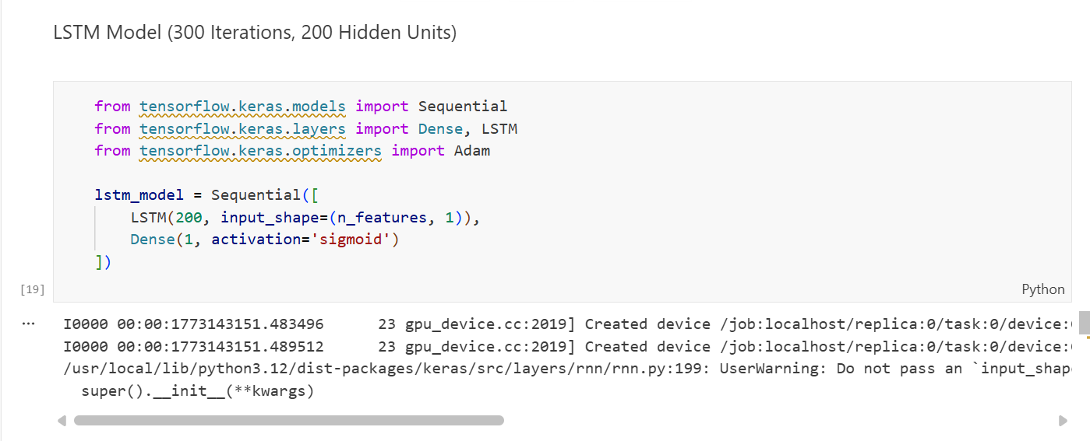
A Sequential model was created with 200 LSTM units and a Dense output layer with sigmoid activation for binary classification.
Step 2: Compile the Model
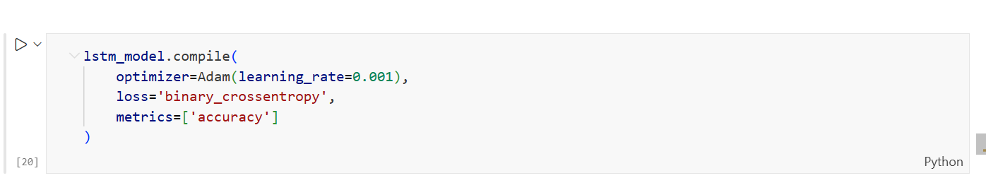
The model was compiled using the Adam optimizer (learning rate 0.001) with binary cross-entropy as the loss function and accuracy as the evaluation metric.
Step 3: Train the Model
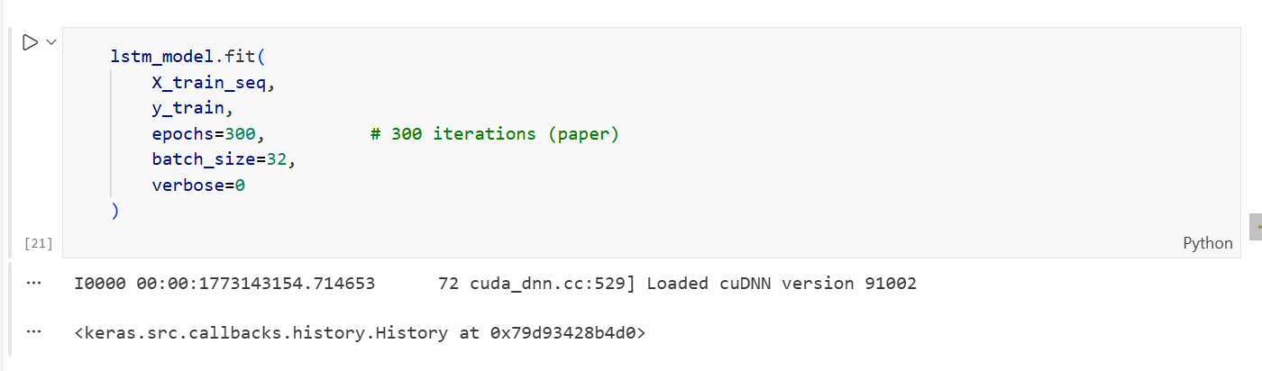
The model was trained for 300 epochs with a batch size of 32.
Step 4: Generate Predictions
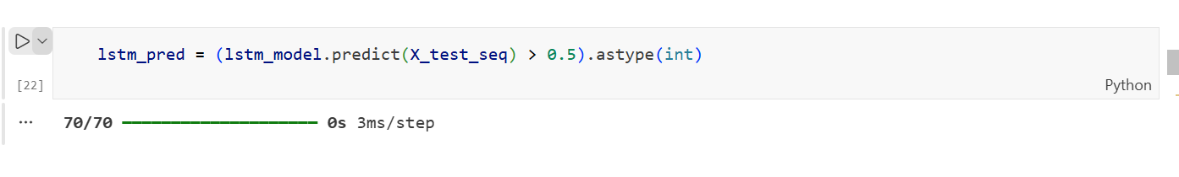
The model predicted probabilities for each test sample. A 0.5 threshold was used to classify websites as phishing or legitimate.
Recurrent Neural Network (RNN)
Recurrent Neural Network (RNN) is a deep learning model designed to learn patterns in sequential data by keeping information from previous steps. This allows the model to capture relationships within the data over time.
However, standard RNN models can face a problem called vanishing gradients, which makes it difficult for the model to learn long patterns in the data. Because of this limitation, the RNN model achieved lower accuracy than LSTM and GRU in this study, as the phishing dataset contains complex patterns that require stronger memory capabilities.
The complete RNN model was implemented in a single code block, as shown below:
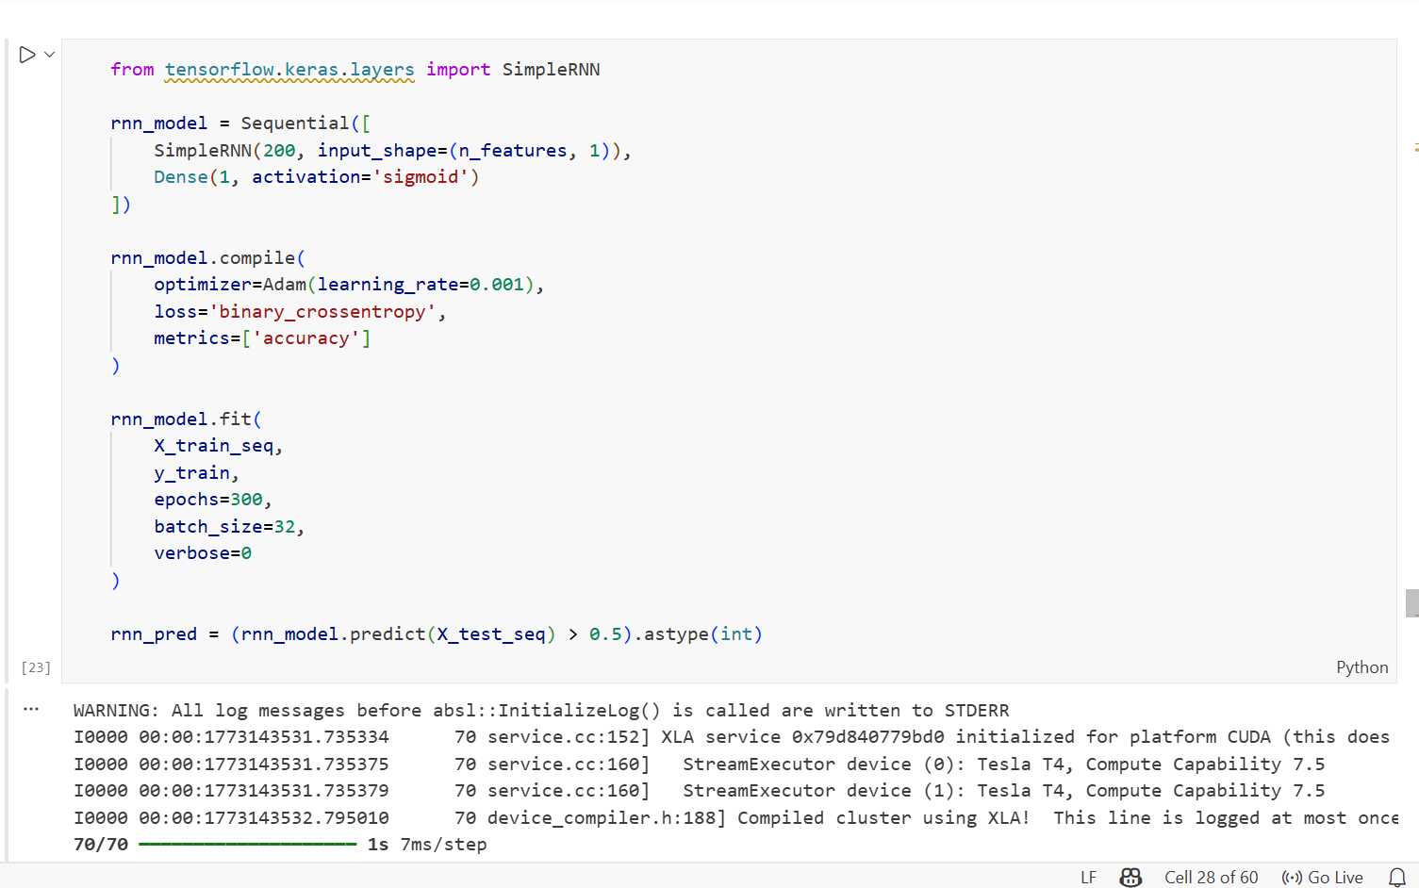
Figure 40: Implementation of the Recurrent Neural Network (RNN) model
SimpleRNN(200, input_shape=(n_features, 1)) creates a recurrent layer with 200 units to process the input features and learn patterns in the dataset.
Dense(1, activation='sigmoid') adds the output layer, which produces a probability score between 0 and 1. Values above 0.5 indicate a phishing website, while values below 0.5 indicate a legitimate website. compile(optimizer=Adam(learning_rate=0.001), loss='binary_crossentropy') sets the training configuration using the Adam optimizer and binary cross-entropy loss. fit (epochs=300, batch_size=32) trains the model for 300 epochs with a batch size of 32. rnn_pred = (rnn_model.predict(X_test_seq) > 0.5). astype(int) converts the predicted probabilities into binary class labels, identifying each website as phishing or legitimate.
Gated Recurrent Unit (GRU)
GRU is a deep learning model that improves the standard RNN by using mechanisms that control how information is stored and updated during training. This helps the model handle the vanishing gradient problem and learn patterns more effectively. Compared to LSTM, GRU has a simpler structure and fewer parameters, which makes it faster to train while still achieving good classification performance.
The complete GRU model was implemented as shown below:
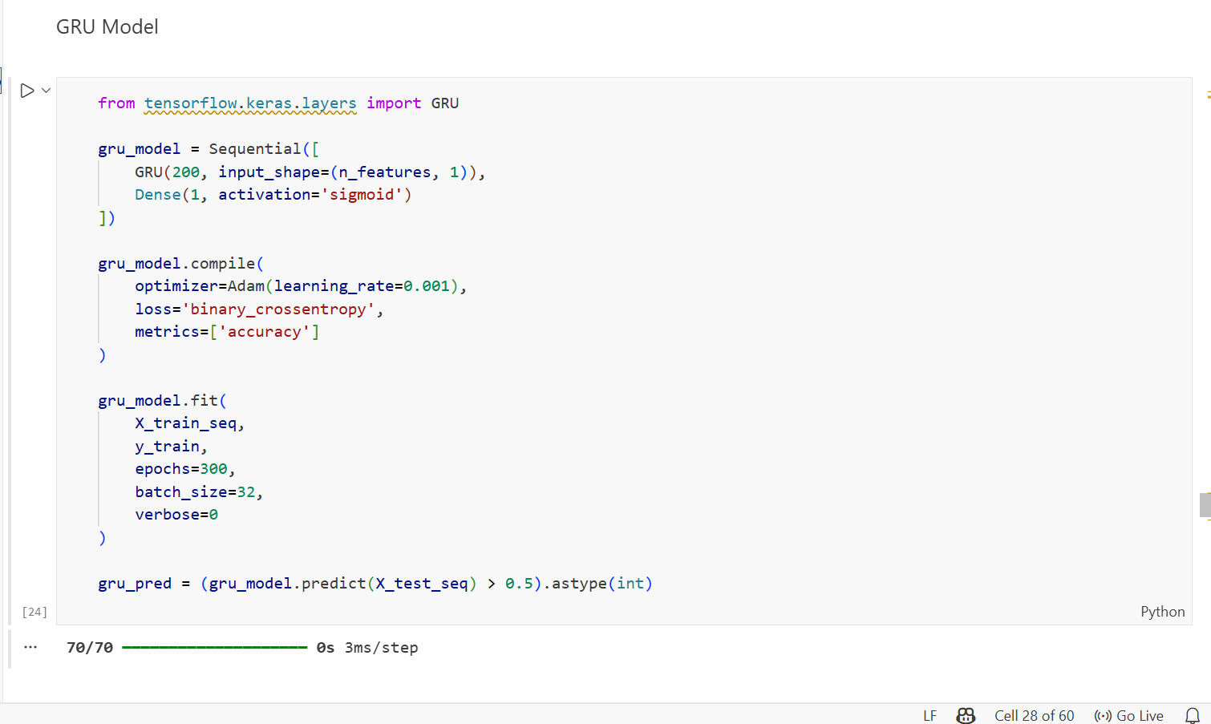
Figure 41: Implementation of the GRU model
GRU (200, input_shape= (n_features, 1)) creates a GRU layer with 200 units to learn patterns from the dataset. GRU uses special mechanisms to control how information is updated and remembered, allowing it to learn patterns more effectively than a standard RNN. Dense (1, activation='sigmoid') adds the output layer, which produces a probability between 0 and 1 to classify a website as phishing or legitimate. compile(optimizer=Adam(learning_rate=0.001), loss='binary_crossentropy') sets the training configuration using the Adam optimizer and binary cross-entropy loss, the same settings used for the other deep learning models. fit (epochs=300, batch_size=32) trains the model for 300 epochs with a batch size of 32. gru_pred = (gru_model.predict(X_test_seq) > 0.5). astype(int) converts the predicted probabilities into binary labels, identifying each website as phishing or legitimate.

4.7.6 Saving the Trained Models
After training all eleven models, each model was saved so it can be reused later without retraining. Saving the models also supports future testing, deployment, and reproducibility of the results.
Two different methods were used to save the models depending on the type of model, as shown in the code below:
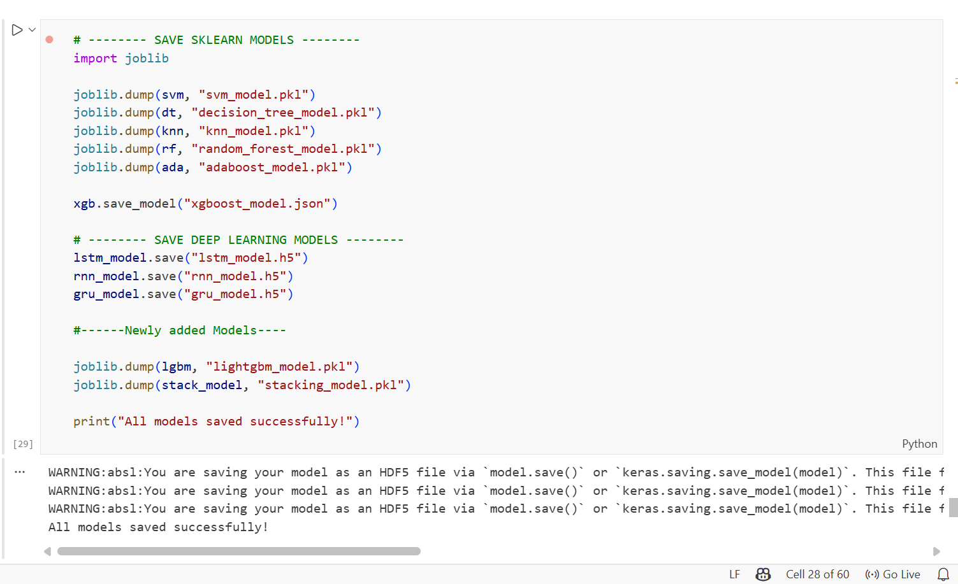
Figure 42: Saving trained machine learning and deep learning models
The Scikit-learn models including SVM, Decision Tree, KNN, Random Forest, AdaBoost, LightGBM, and the Stacking model were saved using the joblib.dump() function. This function stores each trained model as a .pkl file, which is commonly used for saving Scikit-learn models. The XGBoost model was saved using its save_model() method, which stores the model in .json format. This format is portable and can be used across different platforms. The deep learning models (LSTM, RNN, and GRU) were saved using the Keras save () method, which stores the model structure, weights, and training settings in .h5 format. After saving all models, the system displayed the message “All models saved successfully!”, confirming that all eleven trained models were stored and ready for future use or evaluation.

4.7.7 Model Evaluation
After training all eleven models, a standard evaluation process was used to measure their performance using four metrics: Accuracy, Precision, Recall, and F1-score.
Step 1: Evaluation Function
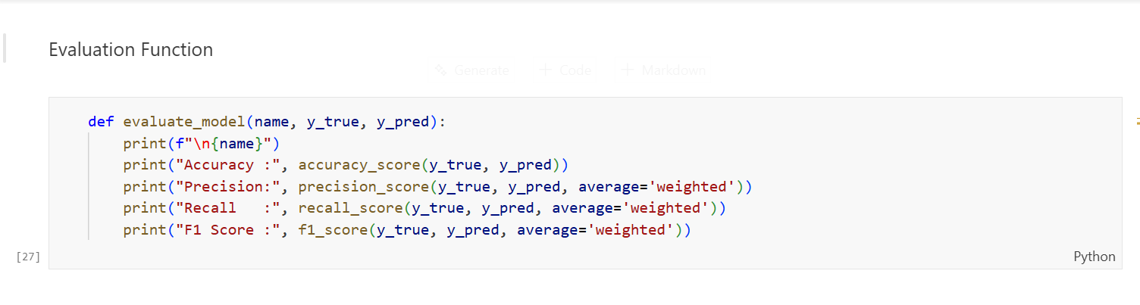
A reusable function called evaluate_model was created. This function takes the model name, true labels, and predicted labels as inputs and calculates the four-evaluation metrics. The average='weighted' option was used to handle class imbalance by considering the proportion of each class in the dataset.
Step 2: Applying Evaluation to All 11 Models
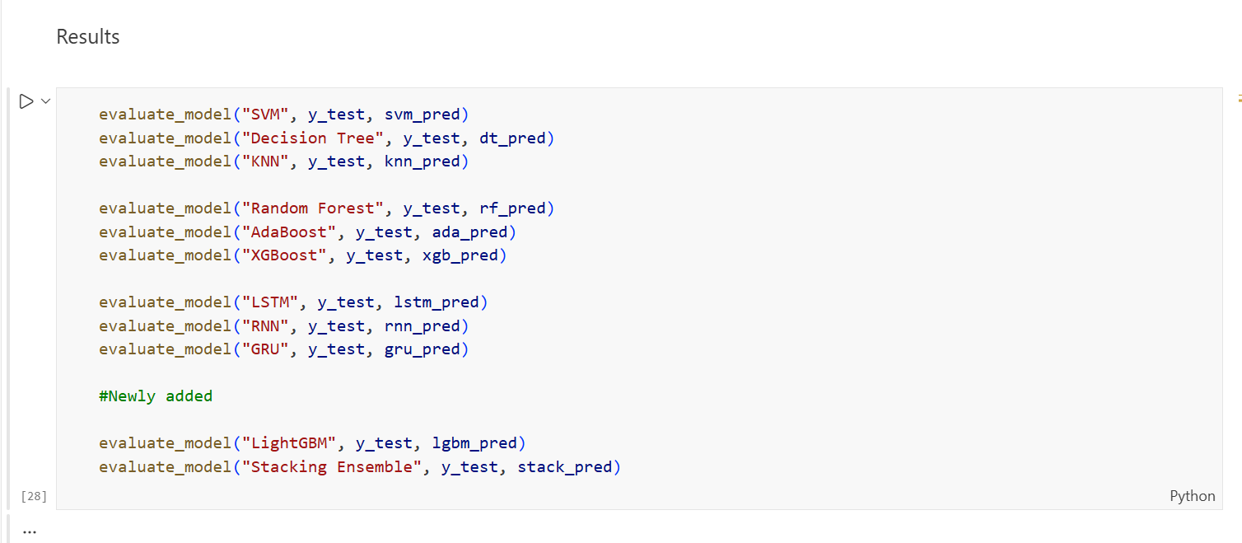
The evaluation function was applied to all eleven models, comparing their predicted results with the actual labels (y_test).
Step 3: Evaluation Results
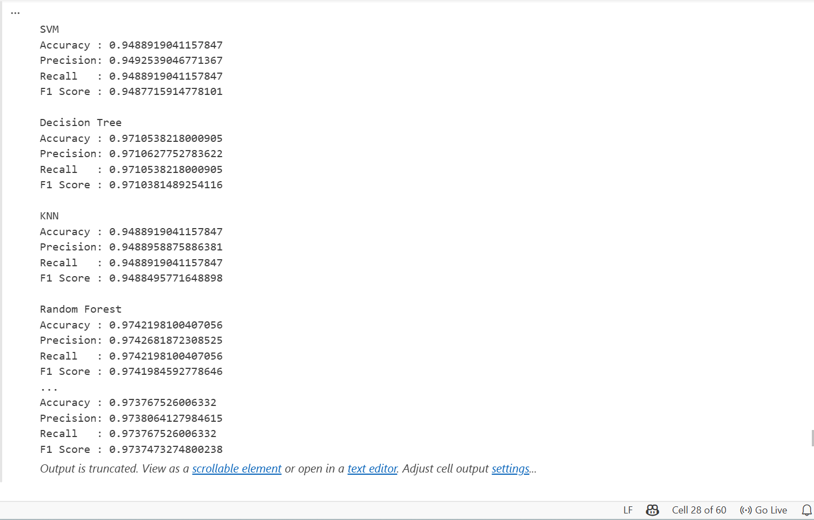
The evaluation produced the following performance results.
Table 9: Evaluation Results
Model | Accuracy | Precision | Recall | F1 Score
SVM | 94.89% | 94.93% | 94.89% | 94.88%
Decision Tree | 97.11% | 97.11% | 97.11% | 97.10%
KNN | 94.89% | 94.89% | 94.89% | 94.88%
Random Forest | 97.42% | 97.43% | 97.42% | 97.42%
AdaBoost | 93.40 | 93.41 | 93.40 | 93.39
XGBoost | 97.24 | 97.25 | 97.24 | 97.24
LightGBM | 96.88 | 96.88 | 96.88 | 96.88
Stacking Ensemble | 97.38 | 97.38 | 97.38 | 97.37
LSTM | 97.11 | 97.12 | 97.11 | 97.10
RNN | 87.74 | 87.76 | 87.74 | 87.75
GRU | 97.15 | 97.17 | 97.15 | 97.15

These results show that Random Forest achieved the highest accuracy of 97.42% among all the evaluated models, making it the best-performing model in this study. A detailed comparison and analysis of all eleven models is presented in Chapter 5.

4.7.8 Originality of Work and Student Contribution
The primary original contribution of Experiment 2 was the independent identification, justification, and implementation of LightGBM and Stacking Ensemble as extensions beyond the scope of the base study. The student independently evaluated the technical properties of both models, designed the Stacking Ensemble architecture by selecting complementary base learners, and re-ran the complete training and evaluation pipeline for all eleven models.
The student also identified and resolved issues encountered during the Stacking Ensemble cross-validation process, which required extended computation time. All outputs were independently verified before the results were recorded.

4.8 Ethical Considerations
This research was conducted in full compliance with ethical research principles. The following considerations were observed throughout the study:
- A publicly available dataset (Kaggle Phishing Website Dataset) was used. No private, personal, or sensitive user data was collected or processed at any stage of this research.
- No personal user data was involved. All 11,055 website samples in the dataset consist of anonymised numerical feature representations only, with no identifiable user information.
- No interaction with live phishing websites was conducted. The research was entirely experimental, operating exclusively on a static offline dataset.
- The research was conducted only for defensive cybersecurity purposes, aiming to improve the accuracy and reliability of phishing website detection systems in order to protect users and organisations from online threats.
These ethical practices ensure that this study does not cause harm and aligns fully with responsible and transparent research conduct.

4.9 Conclusion
This chapter described the design and implementation of the phishing website detection system. It explained the system structure, dataset preparation, feature selection process, experimental setup, and the configuration of all eleven models. The models from machine learning, ensemble learning, and deep learning categories were implemented under the same experimental conditions to ensure fair comparison and reliable results. The implementation provides a clear and reproducible setup for the experiments. The dataset was successfully prepared, divided into training and testing sets, and used to train the models. All trained models were also saved for further analysis. The next chapter presents the experimental results, performance evaluation, and comparison of the eleven models.

Chapter 5 – Results and Analysis

5.1 Introduction
This chapter presents the results and analysis of two experiments carried out in this study. Experiment 1 followed the same method used in the original study and tested nine models from three groups: basic machine learning models, combined models, and deep learning models. Experiment 2 expanded the first experiment by adding two extra models, LightGBM and a Stacking model, which were not included in the original study. These models were chosen for specific reasons explained in Section 5.3.
All eleven models were evaluated using four measures: accuracy, precision, recall, and F1-score. The results were then compared with those reported in the original study to see how closely the findings match and to check whether the two new models improve the results. This chapter also explains how the experiments help address the four research gaps identified in Chapter 1 and highlights areas that could be explored in future research.

5.2 Experiment 1 – Base Paper Replication

5.2.1 Purpose of Experiment 1
The main goal of Experiment 1 was to repeat the method used in the original study using the same Kaggle Phishing Website Dataset [47], which contains 11,055 website samples, 32 security-related features, and a label showing whether the website is phishing or legitimate. The aim was to apply the same nine models, use the same three feature selection methods, and measure performance using the same evaluation metrics to check if the results of the original study could be reproduced.
Before training the models, the dataset was prepared by removing the index column and changing the class labels from -1 to 0 so they work correctly with all models. The remaining 30 feature columns were analysed using three feature selection methods: Information Gain (IG), Gain Ratio (GR), and Principal Component Analysis (PCA). Each method selected the top ten most important features.
The dataset was then divided into 80% training data and 20% testing data. After this preparation, all nine models were trained, evaluated, and saved using the same process.

5.2.2 Scope of Generative AI Used in Implementation
Since the source code for the base study was not publicly available, the implementation was developed independently by studying reference notebooks available on the Kaggle platform for the same dataset. Generative AI, specifically ChatGPT, was consulted to address three technical challenges that arose during the implementation process.
The first challenge involved dataset label compatibility. The original dataset contained class values of -1, 0, and 1, where -1 indicated a phishing website. Standard machine learning classifiers require binary labels of 0 and 1 only. ChatGPT was used to determine that remapping -1 to 0 was the appropriate approach, which resolved classification errors across all models.
The second challenge involved the extended training time required for the deep learning models. Each model required 300 training epochs with 200 hidden units, as specified in the base study, resulting in significantly long execution times. ChatGPT provided guidance on structuring the training pipeline efficiently to minimise potential execution issues during this process.
The third challenge involved model-saving errors encountered when exporting trained deep learning models in HDF5 format. ChatGPT was used to identify the correct export configuration for each model type.

5.2.3 Summarised Outcomes of Experiment 1
The evaluation of the nine models produced the results shown in Table 5.1. Random Forest achieved the highest accuracy of 97.42%, which matches the result of the original study where Random Forest was also the best-performing model. XGBoost achieved the second-highest accuracy at 97.24%, followed by LSTM (97.06%) and Decision Tree (97.01%). GRU achieved an accuracy of 96.92%. Among the basic machine learning models, SVM and KNN both achieved 94.89%, while AdaBoost recorded 93.40% accuracy. RNN had the lowest accuracy at 91.99%, which may be due to its difficulty in learning patterns from structured data.
Table 10: Experiment 1 Results Base Paper Replication (9 Models)
Model | Accuracy | Precision | Recall | F1 Score
SVM | 94.89 | 94.93 | 94.89 | 94.88
Decision Tree | 97.01 | 97.02 | 97.01 | 97.01
KNN | 94.89 | 94.89 | 94.89 | 94.88
Random Forest | 97.42 | 97.43 | 97.42 | 97.42
AdaBoost | 93.40 | 93.41 | 93.40 | 93.39
XGBoost | 97.24 | 97.25 | 97.24 | 97.24
LSTM | 97.06 | 97.06 | 97.06 | 97.06
RNN | 91.99 | 92.01 | 91.99 | 91.98
GRU | 96.92 | 96.94 | 96.92 | 96.92

5.3 Experiment 2 – Extended Model Comparison

5.3.1 Purpose of Experiment 2 and Justification for New Models
The purpose of Experiment 2 was to extend the base paper replication by introducing two additional models do not present in the original study: LightGBM and Stacking Ensemble. These models were not selected randomly; each was chosen based on a clear technical justification related to limitations observed in the base models and the research gaps identified in this study.
5.3.1.1 Why LightGBM Was Added
The base study included XGBoost and AdaBoost as representatives of gradient boosting and sequential boosting within the Ensemble Learning category. However, LightGBM, which is a more recent and computationally efficient gradient boosting framework, was not evaluated. LightGBM uses a histogram-based leaf-wise tree growth strategy, allowing it to train significantly faster than XGBoost [74] while maintaining comparable or superior accuracy on structured tabular datasets. Adding LightGBM therefore enables a more complete comparison of gradient boosting approaches and strengthens the ensemble learning analysis beyond what was presented in the base study.
5.3.1.2 Why Stacking Ensemble Was Added
While the base study evaluated three individual ensemble models – Random Forest, XGBoost, and AdaBoost – it did not explore a meta-learning ensemble approach that combines these models. The Stacking Ensemble was introduced to investigate whether combining the complementary strengths of multiple base learners through a meta-learner could produce superior classification performance compared to any individual model.
The stacking model used Random Forest, AdaBoost, and LightGBM as the base models, while Logistic Regression was used as the final model. The final model was trained using five-fold cross-validation. These base models were chosen because they represent different approaches. Random Forest combines multiple trees, AdaBoost improves results by focusing on previous mistakes, and LightGBM builds models step by step to improve predictions.
5.3.1.3 What Was Expected vs What Was Achieved
It was expected that LightGBM would perform comparably to XGBoost due to their similar gradient boosting foundations. It was also expected that the Stacking Ensemble would either match or exceed the best-performing individual model, as meta-learning is designed to leverage the strengths of diverse base learners.
The results confirmed both expectations. LightGBM achieved 96.88% accuracy, which is competitive with the existing ensemble models. The Stacking Ensemble achieved 97.38% accuracy, closely matching Random Forest at 97.42%. The difference between Experiment 1 and Experiment 2 for the shared nine models was minimal, ranging from approximately 0.00% to 0.23%, confirming that the experimental pipeline remained consistent and that the new models were evaluated under the same conditions.
5.3.1.4 Scope of Generative AI Used in Implementation
Generative AI was used in Experiment 2 to help set up the two new models added in this study. For LightGBM, ChatGPT was used to suggest suitable parameter settings, including a learning rate of 0.05, which helps the model learn more gradually and perform better on the phishing dataset. For the Stacking model, ChatGPT was consulted to understand how to correctly configure the Stacking Classifier with five-fold cross-validation and how to manage the longer training time caused by the cross-validation process. All final implementation choices were checked and verified by the researcher before the results were accepted.

5.3.2 Summarised Outcomes of Experiment 2
The evaluation of all eleven models produced the results shown in Table 11. Random Forest remained the best-performing model with an accuracy of 97.42%, which is consistent with both the original study and Experiment 1. The Stacking model achieved the second-highest accuracy of 97.38%, showing that combining several models can produce results very close to the best single model.
LightGBM achieved 96.88% accuracy, which is competitive with the existing ensemble models. Among the deep learning models, LSTM achieved 97.11% and GRU achieved 97.15%, both slightly higher than their results in Experiment 1. RNN continued to record the lowest accuracy at 87.74%, further confirming its limitation when applied to structured tabular data.
Table 11: Experiment 2 Results - Extended Model Comparison (11 Models)
Model | Category | Accuracy | Precision | Recall | F1 Score
SVM | Shallow ML | 94.89 | 94.93 | 94.89 | 94.88
Decision Tree | Shallow ML | 97.11 | 97.11 | 97.11 | 97.10
KNN | Shallow ML | 94.89 | 94.89 | 94.89 | 94.88
Random Forest | Ensemble | 97.42 | 97.43 | 97.42 | 97.42
AdaBoost | Ensemble | 93.40 | 93.41 | 93.40 | 93.39
XGBoost | Ensemble | 97.24 | 97.25 | 97.24 | 97.24
LightGBM | Ensemble (New) | 96.88 | 96.88 | 96.88 | 96.88
Stacking Ensemble | Ensemble (New) | 97.38 | 97.38 | 97.38 | 97.37
LSTM | Deep Learning | 97.11 | 97.12 | 97.11 | 97.10
RNN | Deep Learning | 87.74 | 87.76 | 87.74 | 87.75
GRU | Deep Learning | 97.15 | 97.17 | 97.15 | 97.15

5.4 Comparative Analysis and Discussion

5.4.1 Base Paper Outcomes
The original study tested nine models using the same Kaggle Phishing Website Dataset and applied three feature selection methods: Information Gain, Gain Ratio, and Principal Component Analysis [47]. The results from that study are shown in Table 12.
In the original results, Random Forest achieved the highest accuracy of 98.9%, followed by XGBoost (98.4%), LSTM (97.4%), and GRU (97.3%). Decision Tree achieved 96.7%, RNN achieved 95.7%, KNN achieved 95.3%, SVM achieved 94.4%, and AdaBoost achieved 93.7%.
Table 12: Base Paper Results
Model | Category | Accuracy (%) | Precision (%) | Recall (%) | F1 Score (%)
SVM | Shallow ML | 94.4 | 96.0 | 93.7 | 94.8
Decision Tree | Shallow ML | 96.7 | 96.7 | 97.4 | 97.7
KNN | Shallow ML | 95.3 | 94.0 | 93.4 | 93.7
Random Forest | Ensemble | 98.9 | 98.8 | 99.3 | 99.0
AdaBoost | Ensemble | 93.7 | 93.2 | 95.5 | 94.4
XGBoost | Ensemble | 98.4 | 98.4 | 98.8 | 98.6
LSTM | Deep Learning | 97.4 | 96.4 | 99.0 | 97.7
RNN | Deep Learning | 95.7 | 96.9 | 95.2 | 96.1
GRU | Deep Learning | 97.3 | 97.6 | 97.5 | 97.6

5.4.2 Three-Way Comparison: Base Paper vs Experiment 1 vs Experiment 2
Table 13 presents a three-way comparison of accuracy values across the base study and both experiments conducted in this research. This comparison allows for a direct assessment of the replication accuracy achieved in Experiment 1, the additional contributions introduced in Experiment 2, and the research gaps addressed by each model.
Table 13: Comparative Results - Base Paper vs Experiment 1 vs Experiment 2
Model | Base Paper (%) | Experiment 1 (%) | Experiment 2 (%) | Gap Addressed
SVM | 94.4 | 94.89 | 94.89 | Gap 1, Gap 4
Decision Tree | 96.7 | 97.01 | 97.11 | Gap 1, Gap 4
KNN | 95.3 | 94.89 | 94.89 | Gap 1, Gap 4
Random Forest | 98.9 | 97.42 | 97.42 | Gap 1, Gap 4
AdaBoost | 93.7 | 93.40 | 93.40 | Gap 1, Gap 4
XGBoost | 98.4 | 97.24 | 97.24 | Gap 1, Gap 4
LSTM | 97.4 | 97.06 | 97.11 | Gap 1, Gap 4
RNN | 95.7 | 91.99 | 87.74 | Gap 1, Gap 4
GRU | 97.3 | 96.92 | 97.15 | Gap 1, Gap 4
LightGBM | N/A | N/A | 96.88 | Gap 1, Gap 4
Stacking Ensemble | N/A | N/A | 97.38 | Gap 1, Gap 4

5.4.3 Discussion of Results
5.4.3.1 Random Forest as the Consistently Best Model
Random Forest achieved the highest accuracy of 97.42% in both Experiment 1 and Experiment 2, which is consistent with the result reported in the original study (98.9%). The small difference of about 1.5% is expected because this implementation was developed independently without access to the original source code. However, all three results identified Random Forest as the best-performing model, confirming that this approach is very effective for detecting phishing websites using this dataset.
5.4.3.2 Experiment 1 vs Experiment 2 – What Changed
The difference in accuracy values between Experiment 1 and Experiment 2 for the nine shared models was very small, ranging from 0.00% to 0.23%. Random Forest, SVM, KNN, AdaBoost, and XGBoost produced identical results in both experiments, confirming pipeline consistency. Minor improvements were observed in Decision Tree (from 97.01% to 97.11%), LSTM (from 97.06% to 97.11%), and GRU (from 96.92% to 97.15%) in Experiment 2, which may be attributed to slight variation in execution environment. RNN showed a decline from 91.99% in Experiment 1 to 87.74% in Experiment 2, which is consistent with the instability of standard recurrent networks on structured tabular data. The two new models in Experiment 2, LightGBM at 96.88% and Stacking Ensemble at 97.38%, both produced strong results that are competitive with the best models from the base paper.
5.4.3.3 Performance of RNN
RNN recorded the lowest accuracy in both experiments, with 91.99% in Experiment 1 and 87.74% in Experiment 2, compared to 95.7% in the original study. This lower performance is expected because standard RNN models often struggle to learn complex patterns in data. Unlike LSTM and GRU, which include mechanisms that help the model remember important information, the basic RNN does not have these features. Because of this, it is less suitable for structured datasets such as phishing website data [75][76].

5.5 Reflection on Aims and Objectives
This section reflects on the original aims and objectives of this study and assesses the extent to which each has been achieved through the experimental work presented in this chapter.

5.5.1 Aim 1 – Systematic Literature Review
The first aim was to carry out a Systematic Literature Review to identify research gaps in phishing website detection. This aim was achieved in Chapter 2, where a PRISMA-based review was conducted on 77 research papers published between 2020 and 2025. The review helped identify four research gaps, which were then used to guide the design of the experiments in this chapter.

5.5.2 Aim 2 – Research Methodology Framework
The second aim was to apply a structured research methodology framework. This aim was fully achieved in Chapter 3, where the Research Onion framework was applied, positioning this study within a positivist, deductive, and experimental research design using quantitative mono-method data collection.

5.5.3 Aim 3 – Build and Experiment with an Ensemble-Based Detection Model
The third aim was to build and experiment with an ensemble-based phishing detection model. This aim was fully achieved through both experiments. Experiment 1 replicated the base paper framework, confirming Random Forest as the best performing model at 97.42%. Experiment 2 extended this by introducing LightGBM and Stacking Ensemble, both of which produced competitive results. The Stacking Ensemble at 97.38% demonstrated that combining multiple ensemble learners through meta-learning is a valid and effective approach for phishing detection.

5.5.4 Aim 4 – Compare Results and Draw Conclusions
The fourth aim was to compare the experimental results with existing methods and draw conclusions. This aim was achieved in Section 5.4, where the results of the base study, Experiment 1, and Experiment 2 were compared. The comparison showed that Random Forest was the best-performing model in all three studies. The results from both experiments were also very similar to the findings of the original study in terms of model ranking and overall performance.

Chapter 6 - Research Gap Addressing
This section explains how the experiments conducted in this study address the four research gaps identified in Chapter 1. Each gap is discussed individually, with a clear justification of how the experimental work resolves or partially resolves it.

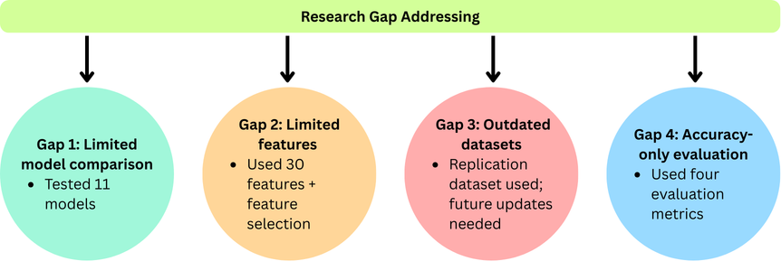
Figure 43: Summary of Research Gaps Addressed in This Study

6.1 Gap 1 — Traditional Models Fail in Real-World Deployment
Gap 1 identified that many existing studies rely on a limited number of traditional models that may not generalise well to real-world phishing detection scenarios [77]. This study addresses Gap 1 by evaluating eleven classification models across three algorithm categories, providing a comprehensive and diverse comparison that goes beyond single-model approaches. The results show that Random Forest, with an accuracy of 97.42% and balanced precision, recall, and F1-score, is the most reliable and consistent model for phishing website detection in real-world use. The study also compared both traditional machine learning models and deep learning models, which helps identify which types of models work well for this task and which are less suitable. This provides useful guidance for selecting models in practical phishing detection systems.

6.2 Gap 2 — Limited Feature Sets
Gap 2 identified that earlier studies often relied on URL-only or limited feature sets, which restricts the ability of models to detect sophisticated phishing websites that may not exhibit suspicious URL characteristics [78] [79]. This study addresses Gap 2 by using three feature selection methods: Information Gain, Gain Ratio, and Principal Component Analysis. These methods were applied to 30 security-related features taken from website structure, content, and behaviour. Each method selected the ten most important features, creating a more complete set of information than approaches that only use website links. This approach helps the models detect phishing websites more effectively by using a wider range of signals.

6.3 Gap 3 — Outdated and Static Datasets
Gap 3 highlighted that many studies use older or fixed datasets that do not reflect how phishing attacks continue to change. This issue is only partly addressed in this study. The Kaggle Phishing Website Dataset used in both experiments contains 11,055 website samples collected at a specific time [47]. This dataset was used to keep the experiments consistent with the original study for replication purposes. However, it may not fully represent the latest phishing attack patterns. Therefore, this limitation is recognised, and future research should consider using more recent and continuously updated datasets to improve the model’s ability to detect new threats.

6.4 Gap 4 — Accuracy-Only Evaluation
Gap 4 showed that many studies only use accuracy to evaluate model performance. This can be misleading, especially when the dataset is unbalanced, because a model may achieve high accuracy while still making many incorrect predictions. This study addresses Gap 4 by evaluating all eleven models using four metrics: accuracy, precision, recall, and F1-score. Using multiple metrics provides a more complete evaluation of model performance. The results from both experiments show that Random Forest performed well across all four measures, indicating that it not only achieved high accuracy but also reduced incorrect predictions.

6.5 conclusion
In summary, this chapter explained how the experiments in this study addressed the four research gaps identified in Chapter 1. Gap 1 was addressed by testing eleven different models from three groups, providing a broader comparison instead of relying on a single model. Gap 2 was addressed by using three feature selection methods on 30 security-related features, giving a more detailed set of information than methods that only use website links. Gap 4 was addressed by evaluating all models using four performance measures — accuracy, precision, recall, and F1-score — instead of using accuracy alone. Gap 3, which relates to the use of an older dataset, was only partly addressed. The same Kaggle dataset used in the original study was kept maintaining consistency for replication. This limitation is recognised and suggested as an important area for future research, as discussed in Chapter 7.

Chapter 7 – Conclusion

7.1 Conclusion
This study successfully achieved all four main aims and showed that ensemble learning methods provide a reliable and accurate way to detect phishing websites on structured datasets. Experiment 1 repeated the method used in the original study by testing nine models from three groups. Random Forest achieved the highest accuracy of 97.42%, which is close to the 98.9% reported in the original study [47]. The small difference of about 1.5% is expected because the implementation was developed independently without access to the original source code.
Experiment 2 expanded the first experiment by adding two additional models: LightGBM and a Stacking model. LightGBM achieved 96.88% accuracy, showing strong performance compared to other models. The Stacking model achieved 97.38% accuracy, very close to Random Forest, showing that combining multiple models can produce highly competitive results.
In relation to the four research gaps identified in Chapter 1, three gaps were fully addressed. Gap 1 was addressed by testing eleven models from three different groups. Gap 2 was addressed by applying three feature selection methods to 30 security-related features. Gap 4 was addressed by evaluating all models using four performance measures: accuracy, precision, recall, and F1-score. Gap 3, which relates to the use of an older dataset, was only partly addressed and is suggested as an area for future research.
Overall, Random Forest was consistently the best-performing model across both experiments and the original study, while RNN produced the lowest accuracy. The findings show that ensemble learning methods, especially Random Forest and Stacking, provide the most reliable approach for phishing website detection and can be effectively used in real cybersecurity systems.

7.2 Future Work
Although this study successfully achieved its main aims and addressed three of the four research gaps, several important areas remain for future research.

7.2.1 Use of Updated Datasets
The use of an outdated static dataset is the main limitation of this study and the primary area requiring future attention. Future work should incorporate more recent phishing website datasets that reflect current attack patterns and emerging techniques, such as datasets sourced from PhishTank, OpenPhish, or dynamically collected URL datasets updated in real time [80][81]. Training models on more recent data would help improve their ability to detect new phishing attacks and attack methods that were not included in the dataset used in this study. Using updated datasets would make the detection system more suitable for real-world use and help the models perform better against changing cybersecurity threats.

7.2.2 Hyperparameter Optimisation
The models in both experiments were trained using default or baseline hyperparameter configurations. Future work could apply systematic hyperparameter optimisation techniques such as Grid Search or Bayesian Optimisation to each model. This would potentially improve accuracy across all models and help close the performance gap of approximately 1.5% observed between this study and the base paper results, particularly for Random Forest and XGBoost. Optimised hyperparameters would also allow a fairer and more refined comparison between models under identical tuned conditions.

7.2.3 Explainability and Interpretability
The current models can classify websites as phishing or legitimate, but they do not clearly show which features influenced each prediction. Future research could use explanation methods such as SHAP or LIME to help make the model’s decisions easier for humans to understand [82]. This would be particularly valuable for real-world cybersecurity deployment, where security analysts require not only a classification decision but also a clear explanation of which website features triggered the phishing detection alert. Improving model transparency would also increase trust in automated detection systems among end users and organisations.

7.2.4 Real-Time Detection Systems
The current system was tested using a static offline dataset and has not been validated in a real-time environment. Future research could improve this work by integrating the best-performing model, Random Forest, into a real-time phishing detection system, such as a browser extension or an API-based service. Testing the model in a real environment would help confirm how well it performs in practical use rather than only in controlled experiments. A real-time system could also allow the model to learn from newly discovered phishing websites, which would help improve detection performance over time.

Chapter 8 - Reflection

8.1 Technical Reflection
Throughout the implementation of this project, several significant technical challenges were encountered that required independent investigation, problem solving, and perseverance to overcome.
The first technical challenge involved the dataset label compatibility issue. When the Kaggle Phishing Website Dataset was loaded and the models were trained for the first time, all classifiers failed to produce correct results. After careful examination of the dataset structure, it was discovered that the class labels used negative one to represent phishing websites, which is incompatible with the binary classification requirements of standard machine learning libraries that expect only zero and one. Resolving this issue required remapping all negative one values to zero before training could proceed successfully. This problem was not documented in the base paper and consumed considerable time before the root cause was identified and corrected.
The second technical challenge involved the deep learning model training times. The LSTM, RNN, and GRU models each required 300 training epochs with 200 hidden units, as specified in the base paper methodology. This configuration resulted in extremely long execution times within the Kaggle notebook environment. Each model had to be monitored carefully throughout the training process to ensure completion without interruption, which required significant patience and careful management of the available computational resources.
The third technical challenge involved saving the trained deep learning models in HDF5 format. After training was completed, errors were encountered when attempting to export the models using the Keras built-in save method. The correct export configuration for each model type had to be identified and tested before all three deep learning models could be saved successfully in the required format.
The fourth technical challenge involved managing citations using RefWorks Citation Manager in Microsoft Word. After successfully inserting approximately 70 citations throughout the document, the option to generate the reference list at the end of the document was not appearing correctly. This issue required additional investigation and troubleshooting during the final stages of the project before it was successfully resolved.
Each of these challenges was independently identified, investigated, and resolved without access to the original source code of the base paper. Overcoming these obstacles significantly strengthened technical knowledge in machine learning implementation, dataset preprocessing, deep learning configuration, and academic document management.

8.2 Personal Reflection
At the beginning of this project, there was strong interest in the topic of phishing website detection using machine learning. Implementing and comparing several models to identify the most effective detection method was both interesting and challenging, and it provided clear direction throughout the research.
However, during the project, some difficulties were encountered. At the start of the implementation stage, the dataset label issue caused all models to fail, which created confusion and concern about whether the project was progressing correctly. In addition, the deep learning models required very long training times, which created pressure to complete the work within the available time.
Despite these challenges, solving each problem brought a strong sense of achievement and increased confidence. Successfully implementing eleven models independently, without access to the original source code, and producing results like those reported in the original study was a particularly rewarding outcome. Seeing Random Forest achieve 97.42% accuracy in both experiments also confirmed that the implementation had been carried out correctly.
Looking back, better early planning could have made the process smoother. Checking the dataset structure more carefully at the beginning would have identified the label issue earlier. Planning the deep learning training schedule and organising reference management tools earlier in the project would also have reduced stress and saved time.
Overall, this project has been a valuable learning experience. It helped develop important technical skills in machine learning and deep learning, as well as research skills such as conducting a systematic literature review, applying a structured research method, and writing a full academic report. The challenges faced during the project also helped build stronger problem-solving skills, which will be useful for future academic and professional work in cybersecurity.

8.3 Conclusion
Completing this project has strengthened knowledge in machine learning, deep learning, and cybersecurity, while also improving important research skills such as conducting a systematic literature review, designing a structured methodology, and solving problems independently. Implementing eleven models from scratch, resolving technical issues during development, and producing results that closely matched the findings of the original study was a very rewarding achievement. Overall, this experience has increased motivation to continue learning and developing skills in cybersecurity and machine learning. It has also provided a strong foundation for working on more advanced research and real-world cybersecurity challenges in the future.

Chapter 9 - References
References
[1] A. Raza et al, "Novel Class Probability Features for Optimizing Network Attack Detection With Machine Learning," IEEE Access, vol. 11, pp. 98685, 2023. . DOI: 10.1109/access.2023.3313596.
[2] M. Safran and A. Musleh, "PhishingGNN: Phishing Email Detection Using Graph Attention Networks and Transformer-Based Feature Extraction," IEEE Access, vol. 13, pp. 131390, 2025. . DOI: 10.1109/access.2025.3592135.
[3] S. Mohanty et al, "An Efficient Hybrid Feature Selection Technique Toward Prediction of Suspicious URLs in IoT Environment," IEEE Access, vol. 12, pp. 50578, 2024. . DOI: 10.1109/access.2024.3384840.
[4] S. Saravanan and U. M. Balasubramanian, "An Adaptive Scalable Data Pipeline for Multiclass Attack Classification in Large-Scale IoT Networks," Big Data Min. Anal., vol. 7, (2), pp. 500, 2024. . DOI: 10.26599/bdma.2023.9020027.
[5] S. Euh et al, "Comparative Analysis of Low-Dimensional Features and Tree-Based Ensembles for Malware Detection Systems," IEEE Access, vol. 8, pp. 76796, 2020. . DOI: 10.1109/access.2020.2986014.
[6] S. He et al, "An Effective Cost-Sensitive XGBoost Method for Malicious URLs Detection in Imbalanced Dataset," IEEE Access, vol. 9, pp. 93089, 2021. . DOI: 10.1109/access.2021.3093094.
[7] S. Ariyadasa, S. Fernando and S. Fernando, "Combining Long-Term Recurrent Convolutional and Graph Convolutional Networks to Detect Phishing Sites Using URL and HTML," IEEE Access, vol. 10, pp. 82355, 2022. . DOI: 10.1109/access.2022.3196018.
[8] S. Remya et al, "BGL-PhishNet: Phishing Website Detection Using Hybrid Model-BERT, GNN, and LightGBM," IEEE Access, vol. 13, pp. 47552, 2025. . DOI: 10.1109/access.2025.3551542.
[9] N. P. Shetty et al, "An Enhanced Sybil Guard to Detect Bots in Online Social Networks," JCSANDM, 2021. . DOI: 10.13052/jcsm2245-1439.1115.
[10] S. A. A. Ghaleb et al, "Training Neural Networks by Enhance Grasshopper Optimization Algorithm for Spam Detection System," IEEE Access, vol. 9, pp. 116768, 2021. . DOI: 10.1109/access.2021.3105914.
[11] C. Iscan et al, "Wallet-Based Transaction Fraud Prevention Through LightGBM With the Focus on Minimizing False Alarms," IEEE Access, vol. 11, pp. 131465, 2023. . DOI: 10.1109/access.2023.3321666.
[12] A. Derhab et al, "Tweet-Based Bot Detection Using Big Data Analytics," IEEE Access, vol. 9, pp. 65988, 2021. . DOI: 10.1109/access.2021.3074953.
[13] S. Ahmad et al, "Across the Spectrum In-Depth Review AI-Based Models for Phishing Detection," IEEE Open J. Commun. Soc., vol. 6, pp. 2065, 2025. . DOI: 10.1109/ojcoms.2024.3462503.
[14] W. Li et al, "Uncovering the Cloak: A Systematic Review of Techniques Used to Conceal Phishing Websites," IEEE Access, vol. 11, pp. 71925, 2023. . DOI: 10.1109/access.2023.3293063.
[15] I. Fikriansyah Ramadhan et al, "SB-Net: A Novel Spam Botnet Detection Scheme With Two-Stage Cascade Learner and Ensemble Feature Selection," IEEE Open J. Commun. Soc., vol. 6, pp. 7237, 2025. . DOI: 10.1109/ojcoms.2025.3603425.
[16] E. S. Gualberto et al, "The Answer is in the Text: Multi-Stage Methods for Phishing Detection Based on Feature Engineering," IEEE Access, vol. 8, pp. 223529, 2020. . DOI: 10.1109/access.2020.3043396.
[17] F. Charmet, T. Morikawa and T. Takahashi, "Toward a Better Understanding of Mobile Users’ Behavior: A Web Session Repair Scheme," IEEE Access, vol. 10, pp. 99931, 2022. . DOI: 10.1109/access.2022.3206402.
[18] A. Khalid et al, "LogiTriBlend: A Novel Hybrid Stacking Approach for Enhanced Phishing Email Detection Using ML Models and Vectorization Approach," IEEE Access, vol. 12, pp. 193807, 2024. . DOI: 10.1109/access.2024.3518923.
[19] K. M. K. Raghunath et al, "XGBoost Regression Classifier (XRC) Model for Cyber Attack Detection and Classification Using Inception V4," JWE, 2022. . DOI: 10.13052/jwe1540-9589.21413.
[20] R. W. Purwanto et al, "PhishSim: Aiding Phishing Website Detection With a Feature-Free Tool," IEEE Trans. Inform. Forensic Secur., vol. 17, pp. 1497, 2022. . DOI: 10.1109/tifs.2022.3164212.
[21] Y. I. Wei and Y. Sekiya, "Sufficiency of Ensemble Machine Learning Methods for Phishing Websites Detection," IEEE Access, vol. 10, pp. 124103, 2022. . DOI: 10.1109/access.2022.3224781.
[22] P. L. Indrasiri, M. N. Halgamuge and A. Mohammad, "Robust Ensemble Machine Learning Model for Filtering Phishing URLs: Expandable Random Gradient Stacked Voting Classifier (ERG-SVC)," IEEE Access, vol. 9, pp. 150142, 2021. . DOI: 10.1109/access.2021.3124628.
[23] J. H. Setu et al, "RSTHFS: A Rough Set Theory-Based Hybrid Feature Selection Method for Phishing Website Classification," IEEE Access, vol. 13, pp. 68820, 2025. . DOI: 10.1109/access.2025.3561237.
[24] R. Abdillah et al, "Phishing Classification Techniques: A Systematic Literature Review," IEEE Access, vol. 10, pp. 41574, 2022. . DOI: 10.1109/access.2022.3166474.
[25] A. Karim et al, "Phishing Detection System Through Hybrid Machine Learning Based on URL," IEEE Access, vol. 11, pp. 36805, 2023. . DOI: 10.1109/access.2023.3252366.
[26] R. Zieni, L. Massari and M. C. Calzarossa, "Phishing or Not Phishing? A Survey on the Detection of Phishing Websites," IEEE Access, vol. 11, pp. 18499, 2023. . DOI: 10.1109/access.2023.3247135.
[27] W. Gałka et al, "Aggregation-Based Ensemble Classifier Versus Neural Networks Models for Recognizing Phishing Attacks," IEEE Access, vol. 13, pp. 48469, 2025. . DOI: 10.1109/access.2025.3551764.
[28] M. Sameen, K. Han and S. O. Hwang, "PhishHaven—An Efficient Real-Time AI Phishing URLs Detection System," IEEE Access, vol. 8, pp. 83425, 2020. . DOI: 10.1109/access.2020.2991403.
[29] G. Brezeanu, A. Archip and C. Artene, "Phish Fighter: Self Updating Machine Learning Shield Against Phishing Kits Based on HTML Code Analysis," IEEE Access, vol. 13, pp. 4460, 2025. . DOI: 10.1109/access.2025.3525998.
[30] M. Ahmed et al, "PhishCatcher: Client-Side Defense Against Web Spoofing Attacks Using Machine Learning," IEEE Access, vol. 11, pp. 61249, 2023. . DOI: 10.1109/access.2023.3287226.
[31] S. Salloum et al, "A Systematic Literature Review on Phishing Email Detection Using Natural Language Processing Techniques," IEEE Access, vol. 10, pp. 65703, 2022. . DOI: 10.1109/access.2022.3183083.
[32] E. S. Vishva and D. Aju, "Phisher Fighter: Website Phishing Detection System Based on URL and Term Frequency-Inverse Document Frequency Values," JCSANDM, 2021. . DOI: 10.13052/jcsm2245-1439.1114.
[33] Y. A. Alsariera et al, "AI Meta-Learners and Extra-Trees Algorithm for the Detection of Phishing Websites," IEEE Access, vol. 8, pp. 142532, 2020. . DOI: 10.1109/access.2020.3013699.
[34] D. Jibat et al, "A Systematic Review: Detecting Phishing Websites Using Data Mining Models," Intell. and Converged Netw., vol. 4, (4), pp. 326, 2023. . DOI: 10.23919/icn.2023.0027.
[35] G. D. Bispo et al, "PHILDER: Lightweight Framework for Intelligent Phishing Detection on Resource-Limited Devices," IEEE Access, vol. 13, pp. 131967, 2025. . DOI: 10.1109/access.2025.3592541.
[36] W. Li et al, "A State-of-the-Art Review on Phishing Website Detection Techniques," IEEE Access, vol. 12, pp. 187976, 2024. . DOI: 10.1109/access.2024.3514972.
[37] R. Abdillah et al, "Performance Evaluation of Phishing Classification Techniques on Various Data Sources and Schemes," IEEE Access, vol. 11, pp. 38721, 2023. . DOI: 10.1109/access.2022.3225971.
[38] P. T. Duy et al, "A Study on Adversarial Sample Resistance and Defense Mechanism for Multimodal Learning-Based Phishing Website Detection," IEEE Access, vol. 12, pp. 137805, 2024. . DOI: 10.1109/access.2024.3436812.
[39] D. Jennifer Dsouza, A. P. Rodrigues and R. Fernandes, "Multi-Modal Comparative Analysis on Execution of Phishing Detection Using Artificial Intelligence," IEEE Access, vol. 12, pp. 163016, 2024. . DOI: 10.1109/access.2024.3491429.
[40] T. Wangchuk and T. Gonsalves, "Multimodal Phishing Detection on Social Networking Sites: A Systematic Review," IEEE Access, vol. 13, pp. 103405, 2025. . DOI: 10.1109/access.2025.3579584.
[41] F. Sattari et al, "A Hybrid Deep Learning Approach for Bottleneck Detection in IoT," IEEE Access, vol. 10, pp. 77039, 2022. . DOI: 10.1109/access.2022.3188635.
[42] S. Kavya and D. Sumathi, "Multimodal and Temporal Graph Fusion Framework for Advanced Phishing Website Detection," IEEE Access, vol. 13, pp. 74128, 2025. . DOI: 10.1109/access.2025.3564530.
[43] C. Morbidoni, A. Cucchiarelli and L. Spalazzi, "Mixed-Embeddings and Deep Learning Ensemble for DGA Classification With Limited Training Data," IEEE Access, vol. 13, pp. 81167, 2025. . DOI: 10.1109/access.2025.3565022.
[44] T. Chin, K. Xiong and C. Hu, "Phishlimiter: A Phishing Detection and Mitigation Approach Using Software-Defined Networking," IEEE Access, vol. 6, pp. 42516, 2018. . DOI: 10.1109/access.2018.2837889.
[45] J. D. Duarte et al, "Machine Learning for Early Detection of Phishing URLs in Parked Domains: An Approach Applied to a Financial Institution," IEEE Access, vol. 13, pp. 145736, 2025. . DOI: 10.1109/access.2025.3599454.
[46] W. Li et al, "Machine Learning-Enabled Attacks on Anti-Phishing Blacklists," IEEE Access, vol. 12, pp. 191586, 2024. . DOI: 10.1109/access.2024.3516754.
[47] U. Zara et al, "Phishing Website Detection Using Deep Learning Models," IEEE Access, vol. 12, pp. 167072, 2024. . DOI: 10.1109/access.2024.3486462.
[48] L. R. Kalabarige et al, "Multilayer Stacked Ensemble Learning Model to Detect Phishing Websites," IEEE Access, vol. 10, pp. 79543, 2022. . DOI: 10.1109/access.2022.3194672.
[49] J. Feng et al, "Web2Vec: Phishing Webpage Detection Method Based on Multidimensional Features Driven by Deep Learning," IEEE Access, vol. 8, pp. 221214, 2020. . DOI: 10.1109/access.2020.3043188.
[50] L. Jovanovic et al, "Improving Phishing Website Detection Using a Hybrid Two-level Framework for Feature Selection and XGBoost Tuning," JWE, 2023. . DOI: 10.13052/jwe1540-9589.2237.
[51] S. Yu et al, "Korean Voice Phishing Detection Applying NER With Key Tags and Sentence-Level N-Gram," IEEE Access, vol. 12, pp. 52951, 2024. . DOI: 10.1109/access.2024.3387027.
[52] E. S. Gualberto et al, "From Feature Engineering and Topics Models to Enhanced Prediction Rates in Phishing Detection," IEEE Access, vol. 8, pp. 76368, 2020. . DOI: 10.1109/access.2020.2989126.
[53] M. H. Haghighat and J. Li, "Intrusion Detection System Using Voting-Based Neural Network," . DOI: 10.26599/TST.2020.90100.
[54] L. Tang and Q. H. Mahmoud, "A Deep Learning-Based Framework for Phishing Website Detection," IEEE Access, vol. 10, pp. 1509, 2022. . DOI: 10.1109/access.2021.3137636.
[55] N. Capuano et al, "Explainable Artificial Intelligence in CyberSecurity: A Survey," IEEE Access, vol. 10, pp. 93575, 2022. . DOI: 10.1109/access.2022.3204171.
[56] D. Lazar et al, "IMDoC: Identification of Malicious Domain Campaigns via DNS and Communicating Files," IEEE Access, vol. 9, pp. 45242, 2021. . DOI: 10.1109/access.2021.3066957.
[57] B. Sun et al, "Leveraging Machine Learning Techniques to Identify Deceptive Decoy Documents Associated With Targeted Email Attacks," IEEE Access, vol. 9, pp. 87962, 2021. . DOI: 10.1109/access.2021.3082000.
[58] L. R. Kalabarige et al, "A Boosting-Based Hybrid Feature Selection and Multi-Layer Stacked Ensemble Learning Model to Detect Phishing Websites," IEEE Access, vol. 11, pp. 71180, 2023. . DOI: 10.1109/access.2023.3293649.
[59] M. Alamri and M. Ykhlef, "Hybrid Undersampling and Oversampling for Handling Imbalanced Credit Card Data," IEEE Access, vol. 12, pp. 14050, 2024. . DOI: 10.1109/access.2024.3357091.
[60] L. Ngartera, M. A. Issaka and S. Nadarajah, "Hybrid Naïve Bayes Models for Scam Detection: Comparative Insights From Email and Financial Fraud," IEEE Access, vol. 13, pp. 85207, 2025. . DOI: 10.1109/access.2025.3569216.
[61] M. J. Pillai et al, "Evasion Attacks and Defense Mechanisms for Machine Learning-Based Web Phishing Classifiers," IEEE Access, vol. 12, pp. 19375, 2024. . DOI: 10.1109/access.2023.3342840.
[62] M. K. M. Boussougou, P. Hamandawana and D. Park, "Enhancing Voice Phishing Detection Using Multilingual Back-Translation and SMOTE: An Empirical Study," IEEE Access, vol. 13, pp. 37946, 2025. . DOI: 10.1109/access.2025.3545250.
[63] M. A. R. Putra et al, "Ensemble Network Graph-Based Classification for Botnet Detection Using Adaptive Weighting and Feature Extraction," IEEE Access, vol. 13, pp. 31183, 2025. . DOI: 10.1109/access.2025.3541125.
[64] A. H. H. Kabla et al, "Eth-PSD: A Machine Learning-Based Phishing Scam Detection Approach in Ethereum," IEEE Access, vol. 10, pp. 118043, 2022. . DOI: 10.1109/access.2022.3220780.
[65] Y. Ari Kustiawan and K. I. Ghauth, "Evaluating the Impact of Feature Engineering in Phishing URL Detection: A Comparative Study of URL, HTML, and Derived Features," IEEE Access, vol. 13, pp. 126756, 2025. . DOI: 10.1109/access.2025.3579223.
[66] F. A. Ghaleb et al, "Ensemble Synthesized Minority Oversampling-Based Generative Adversarial Networks and Random Forest Algorithm for Credit Card Fraud Detection," IEEE Access, vol. 11, pp. 89694, 2023. . DOI: 10.1109/access.2023.3306621.
[67] N. Q. Do et al, "Deep Learning for Phishing Detection: Taxonomy, Current Challenges and Future Directions," IEEE Access, vol. 10, pp. 36429, 2022. . DOI: 10.1109/access.2022.3151903.
[68] M. Aljabri et al, "Detecting Malicious URLs Using Machine Learning Techniques: Review and Research Directions," IEEE Access, vol. 10, pp. 121395, 2022. . DOI: 10.1109/access.2022.3222307.
[69] Y. I. Wei, M. Nakayama and Y. Sekiya, "Enhancing Generalization in Phishing URL Detection via a Fine-Tuned BERT-Based Multimodal Approach," IEEE Access, vol. 13, pp. 131197, 2025. . DOI: 10.1109/access.2025.3591843.
[70] M. K. Mehmood et al, "Enhancing Smishing Detection: A Deep Learning Approach for Improved Accuracy and Reduced False Positives," IEEE Access, vol. 12, pp. 137176, 2024. . DOI: 10.1109/access.2024.3463871.
[71] F. S. Alsubaei, A. A. Almazroi and N. Ayub, "Enhancing Phishing Detection: A Novel Hybrid Deep Learning Framework for Cybercrime Forensics," IEEE Access, vol. 12, pp. 8373, 2024. . DOI: 10.1109/access.2024.3351946.
[72] Z. Diko and K. Sibanda, "Comparative Analysis of Popular Supervised Machine Learning Algorithms for Detecting Malicious Universal Resource Locators," JCSANDM, pp. 1105, 2024. . DOI: 10.13052/jcsm2245-1439.13513.
[73] A. Yeboah-Ofori et al, "Cyber Threat Predictive Analytics for Improving Cyber Supply Chain Security," IEEE Access, vol. 9, pp. 94318, 2021. . DOI: 10.1109/access.2021.3087109.
[74] A. Ghafoor et al, "Decoding Phishing Evasion: Analyzing Attacker Strategies to Circumvent Detection Systems," IEEE Access, vol. 13, pp. 78513, 2025. . DOI: 10.1109/access.2025.3565619.
[75] I. S. Mambina, J. D. Ndibwile and K. F. Michael, "Classifying Swahili Smishing Attacks for Mobile Money Users: A Machine-Learning Approach," IEEE Access, vol. 10, pp. 83061, 2022. . DOI: 10.1109/access.2022.3196464.
[76] A. A. El-Bas Donkol et al, "Optimization of Intrusion Detection Using Likely Point PSO and Enhanced LSTM-RNN Hybrid Technique in Communication Networks," .
[77] I. Kara, M. Ok and A. Ozaday, "Characteristics of Understanding URLs and Domain Names Features: The Detection of Phishing Websites With Machine Learning Methods," IEEE Access, vol. 10, pp. 124420, 2022. . DOI: 10.1109/access.2022.3223111.
[78] I. Hasanov et al, "Application of Large Language Models in Cybersecurity: A Systematic Literature Review," IEEE Access, vol. 12, pp. 176751, 2024. . DOI: 10.1109/access.2024.3505983.
[79] S. Asiri et al, "A Survey of Intelligent Detection Designs of HTML URL Phishing Attacks," IEEE Access, vol. 11, pp. 6421, 2023. . DOI: 10.1109/access.2023.3237798.
[80] S. Rizvi et al, "Application of Artificial Intelligence to Network Forensics: Survey, Challenges and Future Directions," IEEE Access, vol. 10, pp. 110362, 2022. . DOI: 10.1109/access.2022.3214506.
[81] Y. Ari Kustiawan and K. I. Ghauth, "PhishOFE: A Novel Machine Learning Framework for Real-Time Phishing URL Detection With Optimized Feature Engineering," IEEE Access, vol. 13, pp. 169606, 2025. . DOI: 10.1109/access.2025.3614126.
[82] A. El Aassal et al, "An In-Depth Benchmarking and Evaluation of Phishing Detection Research for Security Needs," IEEE Access, vol. 8, pp. 22170, 2020. . DOI: 10.1109/access.2020.2969780.

