University of Wales Trinity Saint David
School of Engineering
2D Diffusion Equation model using the Explicit Finite Difference Method
Michael Corish
2115171
Advanced Manufacturing Operations
27/01/2025
L6 – Computational Methods ACMA6012



Table of Contents

1 Introduction 1
2 The Constitutive Equation of the Problem 2
3 Explicit Finite Difference Form of the Constitutive Equation 3
4 The Initial, Boundary Conditions and Analytical Solution 6
5 Codes Details and Explanations 7
6 Validation of Code 10
7 Sensitivity Analysis 11
7.1 Grid Spacing 11
7.2 Time Step 12
7.3 Thermal Equilibrium Tolerance 13
8 Suggested Improvements and Future Developments 14
9 Conclusion 15
10 References 16
11 Appendix 18

Table of Figures

Figure 1 - Heat equation for the modelled 2D aluminium plate. 2
Figure 2 - Taylor Series of f(x). 3
Figure 3 - Taylor series equation incorporating nearby point function value. 3
Figure 4 - Forward difference approximation. 3
Figure 5 - Backward difference approximation. 3
Figure 6 - Central difference approximation to the 1st derivative. 4
Figure 7 - Central difference approximation to the 2nd derivative. 4
Figure 8 - The grid structure and co-ordinates used to divide the spatial domain of the plate. 4
Figure 9 - Central difference approximation for the 2nd derivatives of the constitutive equation. 4
Figure 10 - Approximation of the 1st derivative using forward difference approximation of the constitutive equation. 5
Figure 11 - The explicit finite difference form of the differential heat equation. 5
Figure 12 - The equation used to determine Fourier's number. 5
Figure 13 - The stability criterion of a 2D shape. 5
Figure 14 - Schematic of initial and boundary conditions for mathematical modelling. 6
Figure 15 - The analytical solution to be used for validation of code results (Chang & Ma, 2001). 6
Figure 16 - Cleaning workspace for code initiation. 7
Figure 17 - Specified material properties. 7
Figure 18 - Spatial consideration 7
Figure 19 - Matrix build and fixed boundary temperatures 8
Figure 20 - Temporal consideration 8
Figure 21 - Explicit Finite Difference Method 8
Figure 22 - Creating a temperature map for time taken to reach thermal equilibrium. 9
Figure 23 - Analytical solution and code validation. 9
Figure 24 - The temperature maps and distribution matrices of the numerical and analytical solutions for code validation. 10
Figure 25 - Grid Spacing Sensitivity Analysis 11
Figure 26 - Time Step Sensitivity Analysis 12
Figure 27 - Thermal Equilibrium Tolerance Sensitivity Analysis 13
Figure 28 - Elements of a FEM 2D model (Gao, et al., 2023). 14

Introduction

The aim of this report is to model the temperature distribution of a rectangular 2-dimensional aluminium plate over time and the time taken to reach thermal equilibrium, through MATLAB coding. These temperature calculations are based on the Explicit Finite Difference Method (EFDM). The developed code alternates from user defined inputs to plate specifics such as material properties, initial east and west boundary and domain temperature conditions. The user inputs required for this code include plate dimensions, grid spacing, time steps and the initial heat source temperature on the north boundary.
This report will provide an in-depth insight into the fundamentals used for model calculations and a detailed review of the developed code used. The main sections are as follows:
- The constitutive equation of the problem: This section will provide background information on what the heat equation is and why it is used. While also, defining all terms used when applied to a 2D geometrical shape.
- Explicit Finite Difference form of the constitutive equation: This area of the report will highlight the full discretisation procedure through using mathematical methods such as the Taylor series, Fourier’s number and the stability criterion.
- The initial boundary conditions and analytical solution: Highlighting the initial conditions for temperature distribution and boundary conditions considered. Also, this section will introduce the analytical solution which will be interpreted against boundary conditions.
- Codes details: Explanation of the sections of developed code.
- Validation of Code: Analyse findings against the analytical solution.
- Sensitivity Analysis: Comparing the codes results under conditional change to understand overall behaviour.
- Model Limitations: Understanding the limitations from numerical methods and the code itself.
- Improvements and Future Development: Investigating the use of alternative numerical methods to provide greater stability and accuracy.

The Constitutive Equation of the Problem

The Heat equation is a parabolic partial differential equation that describes the variation of temperature in a given region over a period of time (Gorguis & Chan, 2008). This equation was introduced by Jean Baptiste Joseph Fourier in 1807. (Narasimhan, 1999) explains the process of heat conduction as the conductive transport and storage of heat in a solid body. The body itself, of finite shape and size, communicates with the external world by exchanging heat across its boundary. This ultimately led to Fourier’s partial differential equation of measuring the rate of temperature change at any location as a function of time.
During model creation for the 2D aluminium plate, the parabolic heat equation (Figure 1) shows the variable T satisfies the given formula. The equation interprets that the plate has uniform material properties such as density $p$, thermal conductivity $k$ and specific heat $c_{p}$. The variable $T\left(x,y,t\right)$ is the temperature of the plate at position $\left(x,y\right)$, where time is specified as $t$. The term $∂$ highlights the partial derivative used to differentiate between two or more variables. In this equation thermal diffusivity $a$ is constant. However, $T\left(x,y,t\right)$ are unknown functions due to position and time variation.
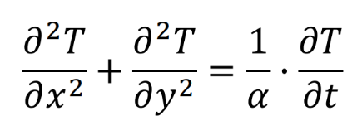

Figure 1 - Heat equation for the modelled 2D aluminium plate.

Explicit Finite Difference Form of the Constitutive Equation

To convert the constitutive equation, in this case the heat equation into an explicit finite difference form, the full discretisation procedure was followed. (Simon & Reza, 2018) describe the process of discretisation as the process of transferring a continuous function into one that is solved only at discrete points or points in time and space, before they can be numerically calculated. (Yew, 2011) highlights that to estimate the rate of change of y with respect to x in such a situation, we can use finite difference formulas to compute approximations of $f\left(x\right)$. It is appropriate to use a forward difference at the left endpoint, a backward difference at the right endpoint, and centred difference formulas for the interior points. To begin, Taylor Series was used to produce difference approximations for the first and second derivative. An advantage of utilising Taylor series is that a differentiable approximate solution is attained, which can then be replaced into the equation and the initial or boundary conditions (Groza & Razzaghi, 2013).
Firstly, the point of $x$ in the function $f\left(x\right)$ was equal to $x_{0}$ , this was taken into consideration and produced the equation displayed below (Figure 2). Although, the Taylor series equation that coincides with the approximated value at point $x_{0}$ and the next nearby point $x_{0}+h$, generating the equation (Figure 3).
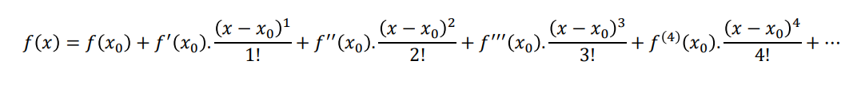
Figure 2 - Taylor Series of f(x).
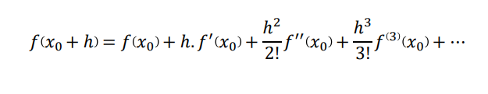

Figure 3 - Taylor series equation incorporating nearby point function value.
Through re-arranging the first derivative of the previous equation (Figure 3), the forward difference approximation can be made in respect to $f^{1}\left(x_{0}\right)$ (Figure 4). The backward difference approximation can also be made from altering the forward approximation from positive to negative (Figure 5). Both approximations become more accurate as $h$ decreases in size, with the error changing in a linear motion.
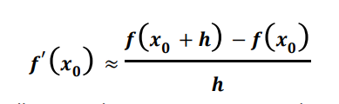

Figure 4 - Forward difference approximation.
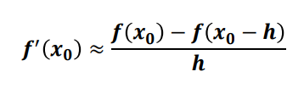

Figure 5 - Backward difference approximation.
Through combining both approximations, the construction of the central difference approximation can be made, which ultimately provides greater accuracy for lesser values of $h.$ By subtracting the forward and backward difference approximations will provide the central difference approximation to the 1st derivative (Figure 6). However, by adding the two approximations, generates the central difference approximation to the 2nd derivative (Figure 7). The next step in the discretisation procedure, required converting the temporal 1st derivative by forward difference approximation and the spatial 2nd derivative by central difference approximation of the heat equation.
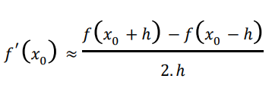

Figure 6 - Central difference approximation to the 1st derivative.
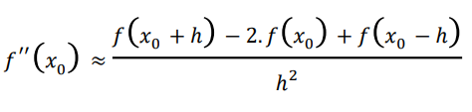

Figure 7 - Central difference approximation to the 2nd derivative.
The spatial discretisation process involves creating a uniformed grid structure with evenly distributed grid points or nodes which are separated by a distance of $h$ (Figure 8). The function $T_{P}^{t}$ represents the temperature at point $P$ at current time, whilst surrounded by directional co-ordinates (N, E, S, W). The temperature at these co-ordinates are displayed as $T_{E}^{t}$ and $T_{w}^{t}$ along the x axis for the central difference approximation of the 2nd derivative. Also, $T_{N}^{t}$ and $T_{S}^{t}$ points used along the y axis for approximation (Figure 9).
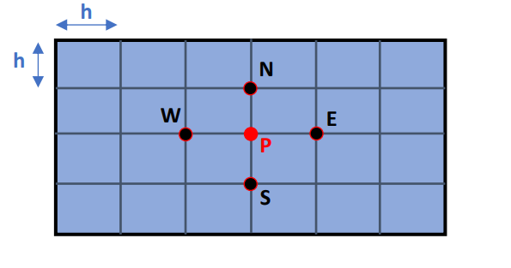

Figure 8 - The grid structure and co-ordinates used to divide the spatial domain of the plate.
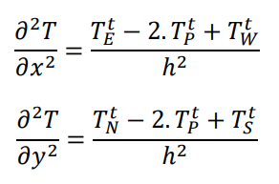

Figure 9 - Central difference approximation for the 2nd derivatives of the constitutive equation.

The process of temporal discretisation comprises of dividing time into time steps represented as $Δt$. While capturing the $P$ location temperature at current time, the temperature at the next time step is also captured as $T_{P}^{t+Δt}$ as part of the 1st derivative forward difference approximation of the heat equation (Figure 10).
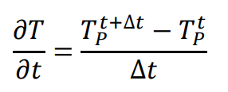

Figure 10 - Approximation of the 1st derivative using forward difference approximation of the constitutive equation.

Deriving the explicit finite difference form of the heat equation from the forward and central difference approximations previously mentioned can be viewed in (Figure 11).
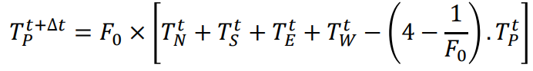

Figure 11 - The explicit finite difference form of the differential heat equation.
The Fourier number ($F_{0})$is introduced into the given equation. The Fourier number is a single dimensionless variable which is expressive of the influence of all three-dimensional quantities on the temperature field (Kunes, 2012). The Fourier number consists of calculating the thermal diffusivity of the plate (α), the user inputted time step ($Δt$) and grid spacing ($h$)(Figure 12). Also, the answer derived from this calculation is essential to determining the fulfilment of the stability criterion (Figure 13). Additionally, there are disadvantages to this method including the limitation on the time step size to be within the stability criterion parameters of 0.25.
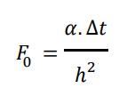

Figure 12 - The equation used to determine Fourier's number.
$$0<F_{0}≤\frac{1}{4}$$
Figure 13 - The stability criterion of a 2D shape.

The Initial, Boundary Conditions and Analytical Solution

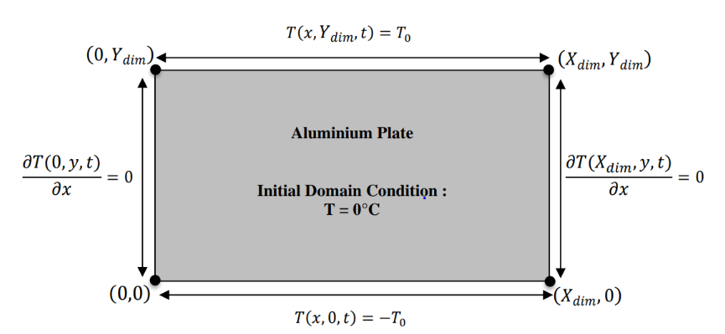
Before creating the computational model, there was an importance to understand the specified initial domain and boundary conditions. The aluminium plate schematic (Figure 14) displays the starting temperature requirements for the computational model. The east and west boundaries are $O^{o}c$, providing perfect insulation for future heat application. The variable $T_{0}$ on the north boundary, highlights the temperature applied to the plate, meaning the boundary will be a user defined applied temperature within the model. Also, south boundary conditions are displayed as $-T_{0}$, signifying that the chosen temperature within the model ( $T_{0}$) will be oppositely applied at the south boundary. Finally, the specified initial domain condition of the plate at $O^{o}c$, representing that no internal heat source will be applied.
Figure 14 - Schematic of initial and boundary conditions for mathematical modelling.
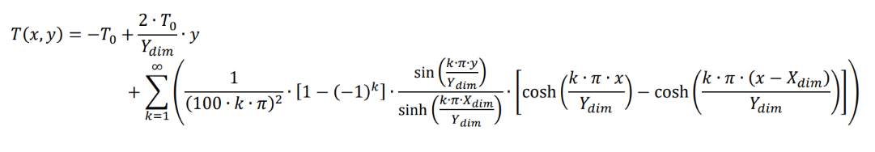
Analysing the computational results for temperature distribution at thermal equilibrium, required an analytical solution for comparison. The analytical solution (Figure 15) will be used to validate code results against the analytical outcome of temperature at thermal equilibrium.
Figure 15 - The analytical solution to be used for validation of code results (Chang & Ma, 2001).

Codes Details and Explanations

For code initiation, the functions clc, clear and close all (Figure 16) were used to clean up the workspace before running the script. Thus, allowing for a clear command window, workspace variable removal and the closing of open figure windows.
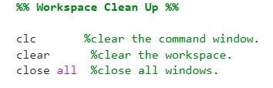

Figure 16 - Cleaning workspace for code initiation.
The following area of code was used to define the given material properties such as density, thermal conductivity and specific heat capacity, to calculate the thermal diffusivity of the aluminium plate (Figure 17).
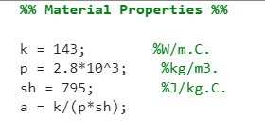

Figure 17 - Specified material properties.
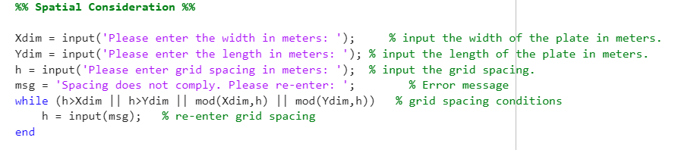
This area of code (Figure 18) requires user inputs for the aluminium plate width (Xdim), length (Ydim) and specifying dimensions of the uniformed grid spacing (h). While considering spatial conditions, an error message (msg) was created to inform the user if the inputted grid spacing was outside of set parameters. These parameters required the grid spacing to be less than specified plate dimensions and divisible into the selected dimensions to provide grid structure. However, the error message allows the user to input a different grid spacing when conditions are not met.

Figure 18 - Spatial consideration
To create the uniformed grid structure there was an importance to calculate and assign the number of columns (NC) and rows (NR) before temperature matrix (T) initialisation. The zeros function was utilised to create the temperature matrix from the calculations carried out previously for NR and NC. Therefore, allowing fixed North and South boundary temperatures to be set through a user inputted value for T0 and computing the opposite temperature to the south boundary as -T0 (Figure 19).

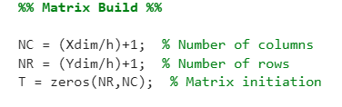
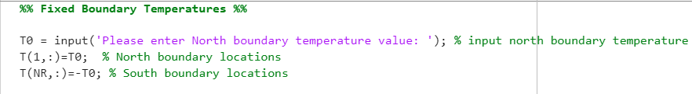
Figure 19 - Matrix build and fixed boundary temperatures
This section of code covers the temporal consideration of the user inputted time step (Ts) (Figure 20), to ensure the time step meets the stability criterion set by the Fourier number (F). Therefore, an error message and maximum value limit was created to guarantee the time step was within set parameters. Also, allowing the user to re-enter if the value was deemed unacceptable.
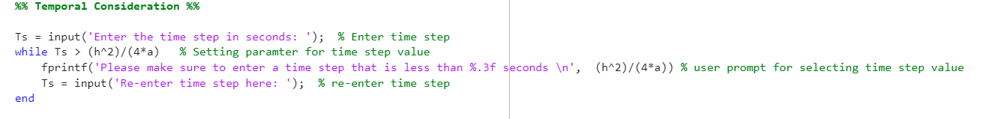
Figure 20 - Temporal consideration
Next, certain conditions were detailed before initialising matrix T2 such as setting the thermal equilibrium tolerance (tol) or otherwise known as Convergence Criterion value to 0.01. Therefore, while E > tol the approximations for temperature at each point of the grid structure will take place until the previous (T) and current approximations (T2) are within the set tolerance. To calculate the temperature within the plate domain the Explicit Finite Difference Equation was computed into the model. Depending on approximation location, the equation was altered to determine the east and west boundary temperatures, while also protecting the insulated boundary conditions through else and if statements (Figure 21).
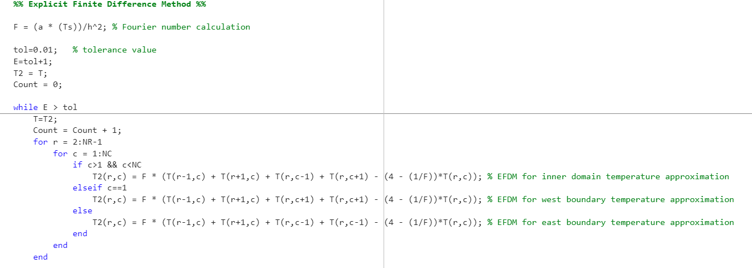
Figure 21 - Explicit Finite Difference Method
To display the change in temperature distribution throughout the aluminium plate until thermal equilibrium was reached, a temperature map was plotted for visual representation (Figure 22).
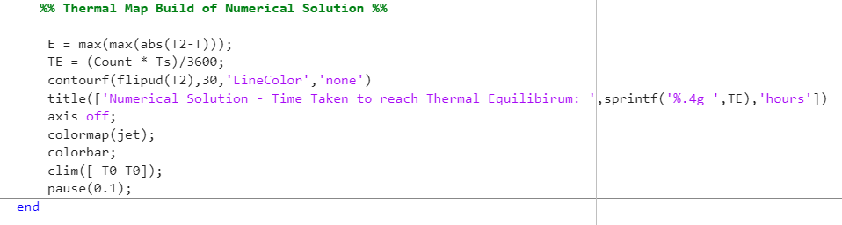
Figure 22 - Creating a temperature map for time taken to reach thermal equilibrium.
Validating the written code required calculating the previously mentioned analytical solution for comparison of temperature distribution at thermal equilibrium. The two outcomes (T2) and (TA) were then displayed in the command window to simplify comparisons. Also, a temperature map was created for the analytical solution to compare against the computational model (Figure 23).
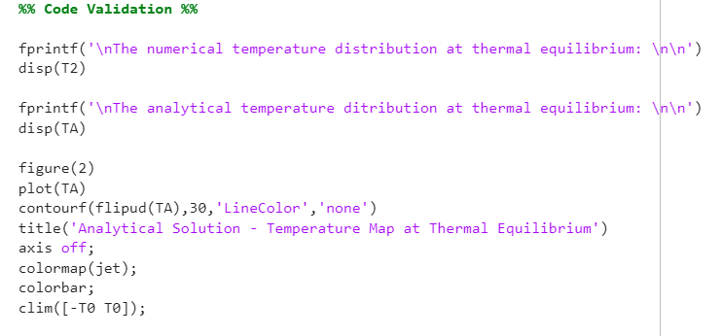
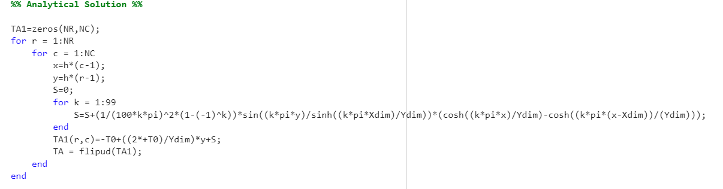

Figure 23 - Analytical solution and code validation.

Validation of Code

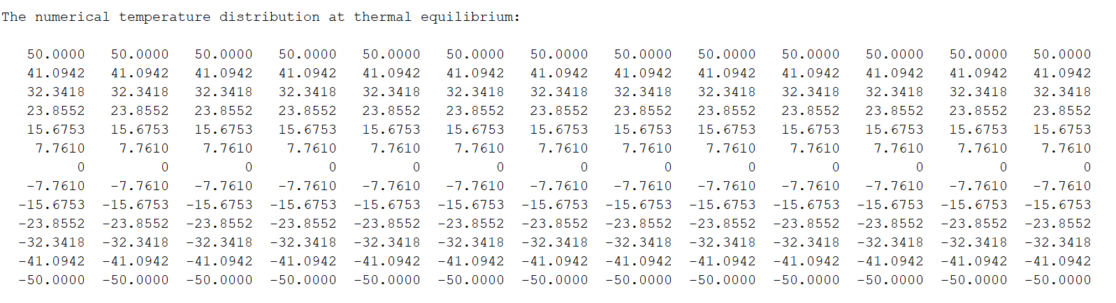
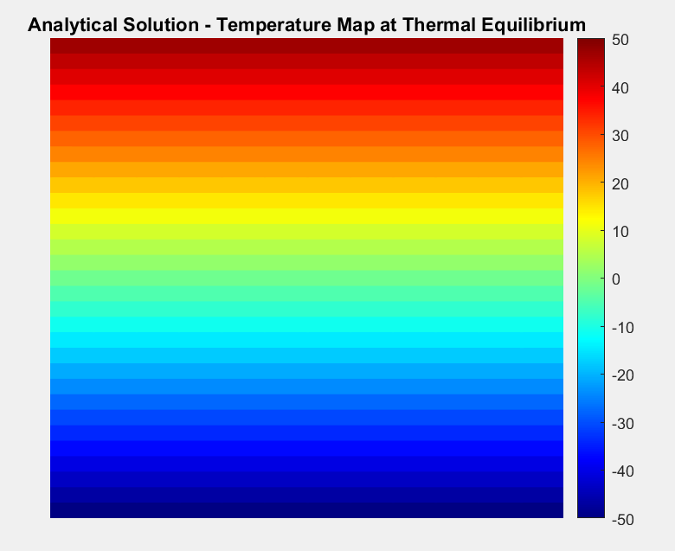
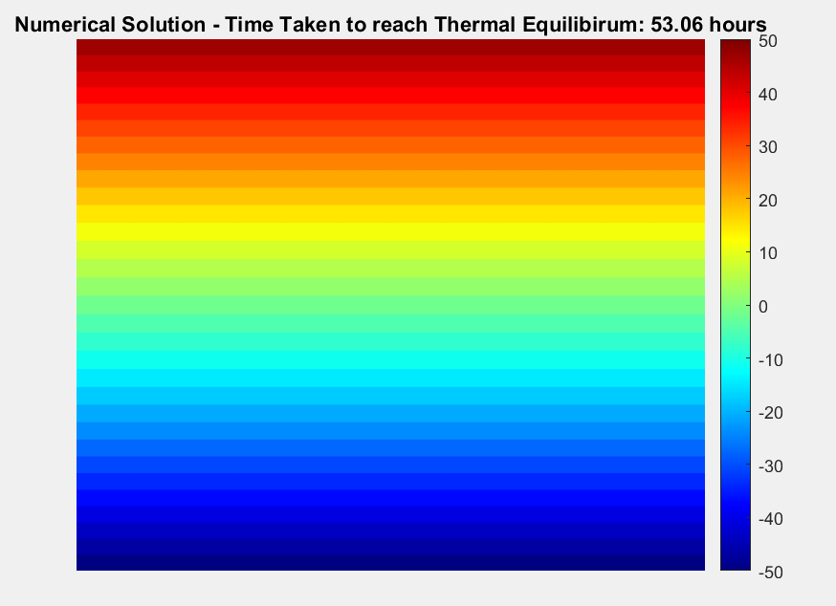
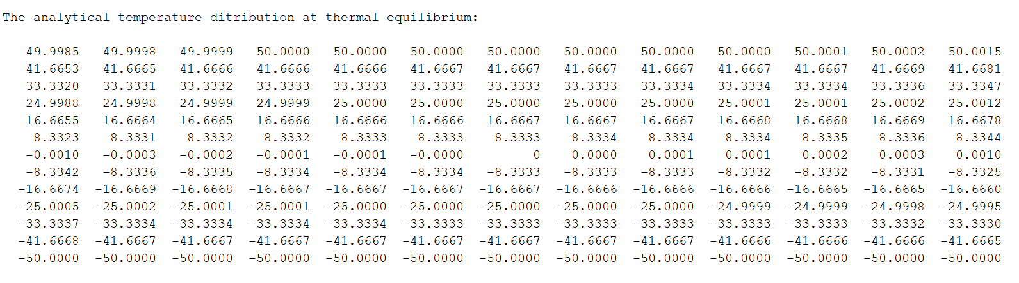
For code validation, temperature maps and matrices were produced to compare outcomes of the numerical computational solution against the analytical solution (Figure 24). From visually comparing these temperature maps, identifying differences between both solutions was difficult. Therefore, proving that the developed code coincides with the analytical form. However, when comparing values of the temperature distribution displayed within the matrix, the temperature values at thermal equilibrium display minimal differences between both solutions. Although, these differences are minimal and expected due to the approximations made using the Explicit Finite Difference Method. Overall, the code performed well on comparison against the analytical solution.

Figure 24 - The temperature maps and distribution matrices of the numerical and analytical solutions for code validation.

Sensitivity Analysis

Performing sensitivity analysis on the developed code with plate dimensions of 12m x 12m, required adjusting inputs such as grid spacing, time step and thermal equilibrium tolerance. By individually varying these parameters, provided feedback on the code’s overall behaviour under conditional change. Also, to provide consistency when carrying out analysis, the north boundary temperature was fixed at 100$°c$, while the south boundary fixed at -100$°c$ for all samples.

Grid Spacing

After reviewing the grid spacing sensitivity graph (Figure 25), the conclusion has been derived that the larger the grid spacing, the greater instability in thermal equilibrium times. Therefore, as grid spacing size decreases, the time taken to reach thermal equilibrium becomes more stable. As grid spacing decreases the truncation error decreases due to the negligibility of the grid spacing value on approximation, therefore on further reduction we converge on the optimum result. Although, running the model at the lowest grid spacing can be time consuming, so on analysis selecting a grid spacing between 0.5m-0.75m would minimise time spent calculating, while also providing a result close to optimum performance. Also, the finite difference method used for calculations has limitations when geometry is considered. The majority of this methods attention has been devoted to the rectangular grid formulation, leading to complications of applying this to curved boundaries (Jensen, 1972). Therefore, other numerical methods may be more appropriate than the finite difference method when being applied to a complex geometry.
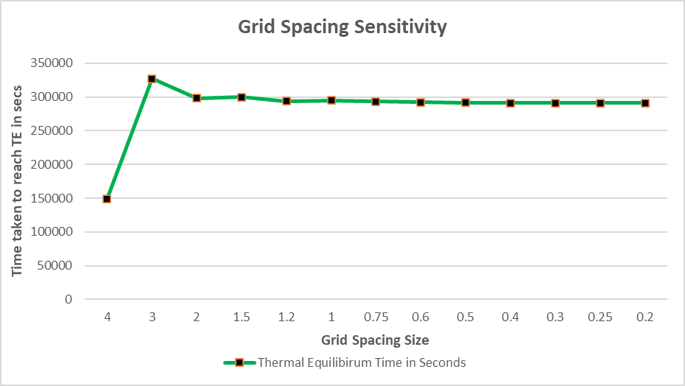

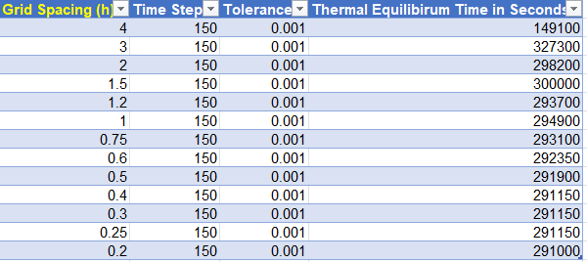

Figure 25 - Grid Spacing Sensitivity Analysis

Time Step

Analysing the relationship between time step size and thermal equilibrium time, the graph (Figure 26) displays the samples collected. The graph shows that there is a relationship between the decrease in time step and the decrease in time taken to reach thermal equilibrium. (Chapra, 2012) explains that truncation error can be reduced by decreasing the step size. The decrease in step size can lead to subtractive cancellation or to an increase in computations. However, decreasing the time step causes an increase in round off error, due to increased computations leading to an accumulation of errors. (Lai & Crassidis, 2008) summarise that decreasing the step size increases the accuracy, but only to an “optimum” point. Any further decrease results in a degradation of the accuracy due to roundoff errors. Hence, a trade-off between truncation and roundoff errors exists. Also, (Neural Concept, 2023) highlights that although explicit schemes are computationally efficient allowing for larger time steps, they may be limited by the Courant-Friedrichs-Lewy (CFL) condition, which imposes constraints on the maximum time step that can be used to solve them. If the time step is chosen too large, the solution may become unstable and produce inaccurate results. On review of the results and taking the balance of errors into account, selecting a mid-range time step size between 400-600 seconds could be most beneficial.
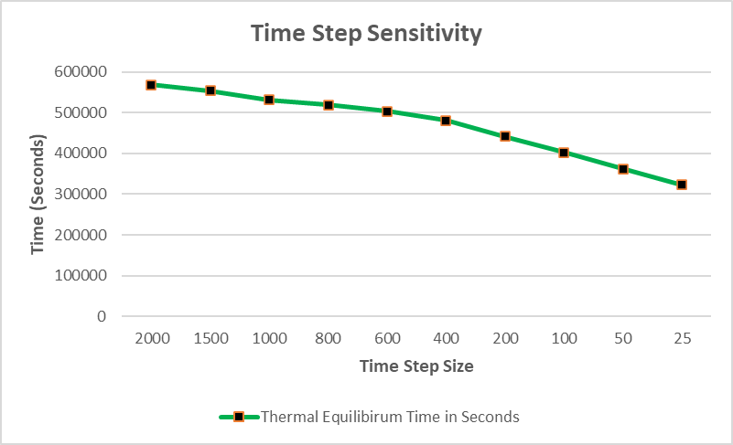

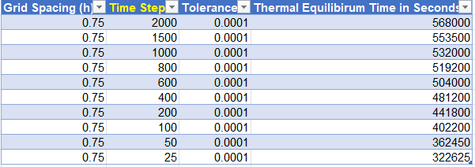

Figure 26 - Time Step Sensitivity Analysis

Thermal Equilibrium Tolerance

The effects of changing the required tolerance condition for reaching thermal equilibrium were captured. From analysing the results, the 0.000001 selection provides greater mathematical results because the temperature difference must be within a minimal tolerance. Although, this increases the amount of time taken to reach thermal equilibrium which ultimately effects practicality. Whereas, using the 0.1 tolerance selection has advantages in practicality but produces less accuracy in terms of results. For the parameters used during this sampling period, 0.001 may be the most suitable tolerance condition due to the balancing between result accuracy and overall time taken to reach thermal equilibrium. However, changing parameters such as grid spacing can ultimately affect the tolerance selection process. Also, the numerical method of subtracting the two temperature maps leads to increased sensitivity, especially with the truncation and round off errors previously highlighted. This is displayed by the large differences in thermal equilibrium times when changing tolerance values (Figure 27).
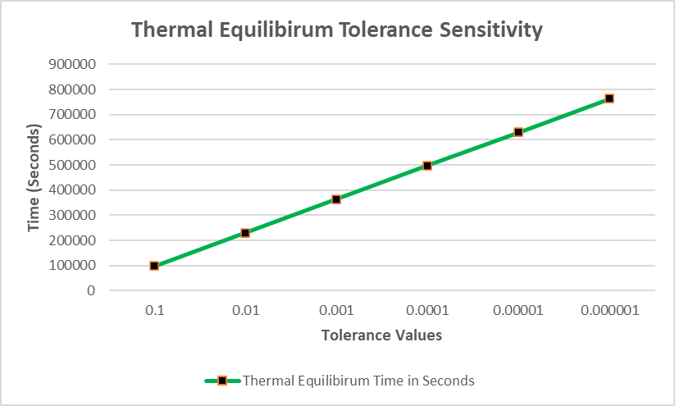

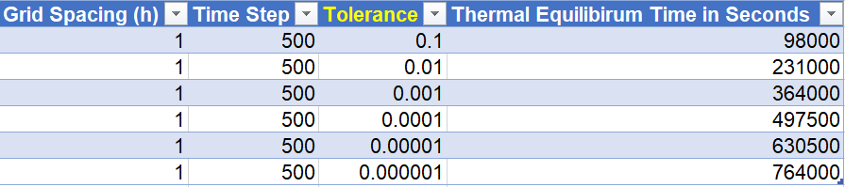

Figure 27 - Thermal Equilibrium Tolerance Sensitivity Analysis

Suggested Improvements and Future Developments

The dependent conditional stability of using the Explicit Finite Difference Method, means that the method requires the correct parameters to be selected for accuracy and stability in results. Although, there are numerical methods that allow for improvements in these outcomes such as the Alternating Direction Implicit (ADI) or Implicit Finite Difference methods. Both methods display unconditional stability, indicating that different parameters can be selected without causing stability or accuracy issues found in the explicit scheme (Niemeyer, 2024). The unconditionally stable implicit scheme requires an increase in linear equation calculations compared to the explicit version. However, (Al-taai & Ali, 2020) believe that using the ADI method simplifies these calculations while also providing unconditional stability.
As previously mentioned, the finite difference method and its uniformed grid structure is commonly used on basic rectangular geometries, which ultimately causes limitations when given a geometry with increased complexity. Firstly, the Finite Element Method (FEM) can achieve high accuracy, particularly with adaptive mesh refinement and higher-order elements. Accuracy depends on factors such as element size, element order, and solution smoothness (Kadam & Dhanke, 2020). This method handles complex geometries and boundary conditions. Also, the Finite Volume Method (FVM) splits computational domains into control volumes otherwise known as cells. These cells can differ in shape and size, although for 2D geometries they are traditionally polygons. This method shows similarities in mathematical discretization with the finite difference method, while having advantages of handling complex geometries and conservation laws in computational heat transfer (Mazumder, 2015). Whereas FEM and FVM discretise the whole domain, Boundary Element Method (BEM) only discretises the boundary of the internal domain. (Sadd, 2005) explains that by avoiding interior discretization, the boundary element method has significant advantages over finite element schemes for infinite or very large domains and for cases in which only boundary information is sought.
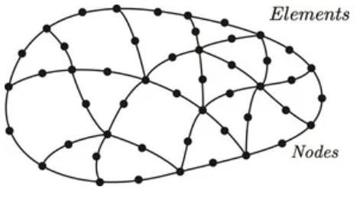

Figure 28 - Elements of a FEM 2D model (Gao, et al., 2023).

Conclusion

The aim of this report was to model temperature distribution over time and calculate the time taken to reach thermal equilibrium using the Explicit Finite Difference Method (EFDM). After review, the developed code produced the computational model required to display these results, while also showing similarities on comparison against the analytical solution. Although, the numerical solution selected (EFDM), may be the simplistic or practical method for modelling heat transfer across a 2D rectangular plate. However, the accuracy and stability of results when inputting a variety of parameters are found to be highly sensitive due to the balance required to minimise errors such as round off and truncation. Through researching the Alternate Direction Implicit method and the ability to provide unconditional stability across a wide range of parameters, which this code requires with differing user inputs, implies that there are more suitable numerical methods than EFDM. Overall, the stated objectives were achieved but further developments would improve the sensitivity of results.

References

Al-taai, E. & Ali, A. A., 2020. Improved Alternating Direction Implicit Method. Baghdad, Purpose-Led Publishing.
Chang, C.-Y. & Ma, C.-C., 2001. Transient thermal conduction analysis of a rectangular plate with multiple insulated cracks by the alternating method. International Journal of Heat and Mass Transfer, 44(13), pp. 2423-2437.
Chapra, S. C., 2012. Applied Numerical Methods with MATLAB for Engineers and Scientists. 3rd ed. New York: McGraw-Hill.
Gao, X.-W.et al., 2023. Overview of Advanced Numerical, Dalian: Aerospace Research Communications.
Gorguis, A. & Chan, W. K. B., 2008. Heat equation and its comparative solutions. Computers & Mathematics with Applications, 55(12), pp. 2973-2980.
Groza, G. & Razzaghi, M., 2013. A Taylor series method for the solution of the linear initial–boundary-value problems for partial differential equations. Computers & Mathematics with Applications, 66(7), pp. 1329-1343.
Jensen, P. S., 1972. Finite difference techniques for variable grids. Computers & Structures, 2(1), pp. 17-29.
Kadam, P. S. & Dhanke, J. A., 2020. Study on Numerical Analysis(Review), Pune: Research Gate.
Kunes, J., 2012. Dimensionless Physical Quantities in Science and Engineering. 2nd ed. Plzen: Elsevier.
Lai, K.-L. & Crassidis, J. L., 2008. Extensions of the first and second complex-step derivative approximations. Journal of Computational and Applied Mathematics, Volume 219, pp. 276-293.
Mazumder, S., 2015. Numerical Methods for Partial Differential Equations Finite Difference and Finite Volume Methods. Ohio: Academic Press.
Narasimhan, T. N., 1999. Fourier's Heat Conduction Equation: History, Influence, and Connections. Journal of Earth and Planetary Sciences, Volume 108, pp. 117-148.
Neural Concept, 2023. Understanding the Importance of the CFL Condition in CFD Simulations. [Online]
Available at: https://www.neuralconcept.com/post/understanding-the-importance-of-the-cfl-condition-in-cfd-simulations#:~:text=The%20CFL%20condition%20is%20derived,is%20the%20spatial%20grid%20spacing
[Accessed 21 01 2025].
Niemeyer, K., 2024. Stability and Stiffness. [Online]
Available at: https://kyleniemeyer.github.io/ME373-book/content/numerical-methods/stability.html
[Accessed 21 01 2025].
Sadd, M. H., 2005. Elasiticty Theory, Applications, and Numerics. In: M. H. Sadd, ed. Formulation and Solution Strategies. s.l.:Academic Press, pp. 83-102.
Simon, N. & Reza, H., 2018. Ocean Modelling for Resource Characterization. In: E. Solutions, ed. Fundamentals of Ocean Renewable Energy. s.l.:Academic Press, pp. 193-235.
Yew, A., 2011. Numerical differentiation: finite differences, Providence: Brown University.

Appendix

%% Workspace Clean Up %%

clc %clear the command window.
clear %clear the workspace.
close all %close all windows.

%% Material Properties %%

k = 143; %W/m.C. % thermal conductivity
p = 2.8*10^3; %kg/m3. % density
sh = 795; %J/kg.C. % Specific heat capacity
a = k/(p*sh); %m^2/s % thermal diffusivity

%% Spatial Consideration %%

Xdim = input('Please enter the width in meters: '); % input the width of the plate in meters.
Ydim = input('Please enter the length in meters: '); % input the length of the plate in meters.
h = input('Please enter grid spacing in meters: '); % input the grid spacing.
msg = 'Spacing does not comply. Please re-enter: '; % Error message
while (h>Xdim || h>Ydim || mod(Xdim,h) || mod(Ydim,h)) % grid spacing conditions
h = input(msg); % re-enter grid spacing
end

%% Matrix Build %%

NC = (Xdim/h)+1; % Number of Columns
NR = (Ydim/h)+1; % Number of rows
T = zeros(NR,NC); % Matrix initiation

%% Fixed Boundary Temperatures %%

T0 = input('Please enter North boundary temperature value: '); % input north boundary temperature
T(1,:)=T0; % North boundary locations
T(NR,:)=-T0; % South boundary locations

%% Temporal Consideration %%

Ts = input('Enter the time step in seconds: '); % Enter time step
while Ts > (h^2)/(4*a) % Setting parameter for time step value
fprintf('Please make sure to enter a time step that is less than %.3f seconds \n', (h^2)/(4*a)) % user prompt for selecting time step value
Ts = input('Re-enter time step here: '); % re-enter time step
end

%% Explicit Finite Difference Method %%

F = (a * (Ts))/h^2; % Fourier number calculation

tol=0.001; % tolerance value
E=tol+1;
T2 = T;
Count = 0;

while E > tol
T=T2;
Count = Count + 1;
for r = 2:NR-1
for c = 1:NC
if c>1 && c<NC
T2(r,c) = F * (T(r-1,c) + T(r+1,c) + T(r,c-1) + T(r,c+1) - (4 - (1/F))*T(r,c)); % EFDM for inner domain temperature approximation
elseif c==1
T2(r,c) = F * (T(r-1,c) + T(r+1,c) + T(r,c+1) + T(r,c+1) - (4 - (1/F))*T(r,c)); % EFDM for west boundary temperature approximation
else
T2(r,c) = F * (T(r-1,c) + T(r+1,c) + T(r,c-1) + T(r,c-1) - (4 - (1/F))*T(r,c)); % EFDM for east boundary temperature approximation
end
end
end

%% Temperature Map Build of Numerical Solution %%

E = max(max(abs(T2-T)));
TE = (Count * Ts)/3600;
contourf(flipud(T2),30,'LineColor','none')
title(['Numerical Solution - Time Taken to reach Thermal Equilibrium: ',sprintf('%.4g ',TE),'hours'])
axis off;
colormap(jet);
colorbar;
clim([-T0 T0]);
pause(0.1);
end

clc

%% User Input Value Display & Time Taken to Reach Thermal Equilibrium %%

fprintf('Parameters\n\nLength = %gm \nWidth = %gm \nGrid spacing = %gm \nTime step = %gs \n',Xdim,Ydim,h,Ts)
fprintf('\nThermal Equilibrium \n\nTime taken to reach thermal equilibrium: %g seconds.',TE*3600)
fprintf('\nTime taken to reach thermal equilibrium: %g minutes.',TE*60)
fprintf('\nTime taken to reach thermal equilibrium: %g hours. \n',TE)

%% Analytical Solution %%

TA1=zeros(NR,NC);
for r = 1:NR
for c = 1:NC
x=h*(c-1);
y=h*(r-1);
S=0;
for k = 1:99
S=S+(1/(100*k*pi)^2*(1-(-1)^k))*sin((k*pi*y)/sinh((k*pi*Xdim)/Ydim))*(cosh((k*pi*x)/Ydim)-cosh((k*pi*(x-Xdim))/(Ydim)));
end
TA1(r,c)=-T0+((2*+T0)/Ydim)*y+S;
TA = flipud(TA1);
end
end

%% Code Validation %%

fprintf('\nThe numerical solution temperature distribution at thermal equilibrium: \n\n') % Numerical solution matrix display
disp(T2)

fprintf('\nThe analytical solution temperature distribution at thermal equilibrium: \n\n') % Analytical solution matrix display
disp(TA)

figure(2) % Analytical solution temperature map build
plot(TA)
contourf(flipud(TA),30,'LineColor','none')
title('Analytical Solution - Temperature Map at Thermal Equilibrium')
axis off;
colormap(jet);
colorbar;
clim([-T0 T0]);

