Name:Margaret Habiba Nkem-Ajoku
Student Number:1809941
Course: Problem Solving and Decision Making
Lecturer:Anupam Mazumdar

Introduction:
Modernisation and globalisation over the past three decades have evolved at an accelerating pace. As a result, businesses and organizations are continuously seeking ways to stay ahead of their competitors. On this premise, contemporary organizations are constantly challenged by increasingly complex tasks and problems.
This essay is therefore tasked with identifying a work-related problem and coming up with p tested solutions. This essay attempts to employ decision making tools and techniques to resolve conflict in the affected organization. Evaluations are conducted based on the solutions proffered. This essay also goes on to showcase the implementation of solutions to steer the organization towards resolving conflict and obtaining optimum output from its employees.
  - Background of the Organization
Caremark Watford (not real name) is a care provider company. The company was founded in 2017 with the sole intent of providing companionship to the elderly as well as vulnerable children and adults. Care provision cuts across providing care to clients with complex needs, palliative care, as well as end of life care to terminally ill clients. Caremark recently included the provision of domestic services to its clientele.
The company has a hierarchical structure in place to ensure governance. At the top of the hierarchy is the owner of the business, who is closely followed by the deputy manager. The deputy manager is the face of the company and is chiefly responsible for sourcing clients. The third position in the organizational chain are two supervisors who ensure care assistants abide with the mantra of the organization which is to promote the independence of its clients as well as ensuring clients are made comfortable in their environment. The supervisors are also tasked with identifying training needs of care assistants on the field, they have the responsibility of ensuring carers attend relevant training before they can return to work.

  - Personal Work Experience
Writers,Kanzel et al (2015) describe conflict as a disagreement between one or more individuals. It is common to experience conflict in the workplace especially in a care setting environment. I work as a care assistant in Caremark and it is common practice to be paired in two’s in order to provide care to clients with complex needs.
In the dispensation of my duties, I have encountered work related conflict with my colleagues at different times. The reasons vary from each person having a different perspective of best practice. As a result, we failed to give priority to the client’s needs which invariably means we failed in our duty of care.
A year ago, I was paired to work with a colleague who had recently joined the company, we were both tasked with the responsibility of assisting a client who needed palliative care. Prior to this visit, the writer of this essay had paid professional visits to the client for a period of three months and understood the client liked to be given medication without interruption being that he was very poorly. On getting to the home of the client my colleague insisted on reading out all the names of the medication and its side effects to the client, she refused to stop even when the client asked her to. The client got upset and asked that we both leave his house. I had intimated my colleague on the client’s preference before we went in for the call, but she insisted on doing what she considered as” best practice”. The client cancelled his contract with the organization as a result.
In giving a fair account of my narrative, I must add that carers are trained to inform clients of the names of medications to be administered, however the 6CS of health and social care postulates that clients should always be treated with dignity and their decisions are to be respected.
The manager called us both to the office afterwards and issued official warning without listening to our narratives. The bottom line as far as management was concerned was the company had lost a client and revenue as a result of our behaviour.

1.3
Literature Review on Conflict
Writers, Dore et al (2015) describe conflict as a state of social discord that is characterised by negative effect. Kim et al ,(2017) affirm that when conflict is unresolved among health care professionals, it can lead to difficult patient care consequences.
They state categorically that conflict may either be individual-In this situation the sources of conflict are internal (self-esteem or self-focus) This conflict poses as a threat to the physical, emotional and mental wellbeing and affects the individual’s ability to perform at work. Kim (2017) goes on to describe the second type of conflict which is interpersonal, as behaviour which shows uncivil behaviour amongst colleagues, for example from low degree of support to destructive behaviours including bullying or humiliation. The consequences of interpersonal conflict are (a) weakened team collaboration and disrespectful working environment.Again,Kim (2017) argues that the root causes of organizational conflict on the other hand spring from ambiguity in scope of practice, professional roles and reporting structure.
Again, writers (Kiltam and Alli,2011) argue conflict arises when individual expectations, goals and interest are incompatible, they also maintain that conflict can be both destructive and constructive. Constructive conflict in their opinion leads to cognitive benefits such as better decision making or judgements of other positions. Team performance is improved, and employees go back their work after conflict has been resolved with better insight which leads to increased performance and positive culture.
Destructive conflict on the other hand tends to disrupt collaboration, communication and problem solving among employees.
The question now arises as to the factors responsible for conflict?
Individual Conflict Factors- Writers, Kim (2017) argues that self-focus is a belief that the reality the person perceives is accurate and indisputable, as a result when the concept of self is perceived to be threatened, it gives room for misrepresentation of the motives of others. Another study shows the depletion of resources (exhaustion and stress) in individuals is likely to increase the risk of judging others motives as lacking in integrity or selfish. Other writers (Krugman et al,2017) maintain that an individual’s state of resource depletion is responsible for the diversion of cognitive and emotional resources from patient care priorities to a point of impairment or reduced concentration.
Interpersonal Factors- Krugman et al (2014) are of the view that communication breakdown is responsible for interpersonal conflict, for example the absence of timely and specific feedback, concise expectations concerning tasks completion or information sharing. Other writers, Haslam and Loughnan (2014) suggest that stigmatising, stereotyping or ignoring the individuality of others also creates interpersonal conflict. Writers (Krugman,2014) posit that individuals may experience a feeling of isolation from teams when treated disrespectfully.
Organizational Conflict Factors-Writers,Bresman and Zilmer (2013) argue that organizational conflict arise from workflow complexity such as procedures, tasks and resources. They further maintain that task-based conflict in hospitals is as a result of ambiguity in policies and workflow coordination.
1.4
Decision Making Tools and Techniques
SWOT
Swot analysis is an analytic method used to evaluate the strength,weaknesses,opportunities and threats involved in an organization, a project, a plan or business activity.Writers,Gurel and Tal (2017) argue that a great number of organizations engage in strategic planning, this strategy is an avenue to help an organization to be productive by guiding the allocation of resources in order to achieve goals. SWOT analysis is a tool used for strategic planning and management in organizations. Gwel and Tat (2017) state that organizations are wholes that interact with their environment and comprise of various sub systems, the process of examining organizations and their environment is referred to as SWOT analysis. It is described as a powerful tool for assessing an organizations deficiencies and capabilities, its market opportunities and the threats to its future. They also maintain that SWOT is an invaluable tool in helping managers identify environmental and organizational factors.
SWOT analysis has both internal and external dimensions. Internal dimensions are associated with strengths and weaknesses whilst external dimensions are threats and opportunities.
Organizational strength- Mirze (2017) defines this as the attribute that adds value to a thing i.e. makes it more advantageous when compared to something else. Organizational strength in other words embodies the characteristics and situations in which an organization is more effective and efficient compared to their competitors.
Organizational weakness- This refers to not having the competency to achieve a task, weakness according to Wigen and Mirze (2017) refers to a situation whereby the current existence and ability of the organization is weaker compared to other competitors and organizations. They argue further that it is important for organizations to know their strength and weaknesses.
Writers (Ulgen and Mizse,2016) further argue that weakness in this context is viewed as a limitation in skills, resources and capabilities that intensely undermines an organizations effective performance. Pearce and Robinson (1991) argue that financial resources, management capabilities, marketing skills and facilities can be sources of weakness. In the writer’s opinion, organizational weaknesses can lead the organization towards inefficiency and ineffectiveness. The writers argue the negative variables should be identified and improved. It is therefore obligatory to address and solve problems that have the potential to cause difficulties and limitations for long term plans and strategies.
Environmental Opportunities-Pearce and Robinson (1991) argue that opportunities in a swot context are a condition or situation appropriate for an activity, as a result it has favourable and positive characteristic. Other writers, (Harison and John 2004) appear to suggest that opportunities are conditions external to the environment, they make it possible for an organization to make the most of its strength and neutralise environmental threats or organizational weaknesses.
Environmental Threats-Ulgen and Mirse (2016) maintain that threats are a condition that negates or prevents the realisation of an activity.It has a characteristic that is negative and should be avoided.Again, Ulgen and Mirse (2010) suggest that threats are all external factors that obstructs the success of the organization and cause unrecoverable damage.

PESTLE
Nitank and Trivedi (2016) argue that pestle is a management technique which is used to identify external risks. Pestle is used to evaluate the impact of political.economic,social,technological,environmental and legal factors on a project.Organizations, usually consider external influences before commencing on a project.The acronym pestle stands for P=Political, E=Economic, S=Social, T=Technological, L=Legal, E=Environmental.
Political-This refers to the extent to which government policies may exert influence on the industry or economy. Government imposed duty or tax may affect the entire generating revenue of an organization. The factors imbibed in a political terrain range from fiscal policies, trade tarrif,tax policies that a government may place levy around the year and this in turn affects the business environment.
Economic- Nitank and Trivedi (2016) suggest that this factor as the name suggests are determinants of the economy’s performance. These economic determinants are capable of impacting an organization and can have long term effects. For instance, a rise in inflation invariably influences the pricing of the company’s goods and services. It also determines the purchasing power of consumers. In the long and short run, the demand and supply chain are also affected. Interest rates, foreign exchange rates, economic growth patterns and inflation rates are described as economic factors.
Social- According to Nitank and Trivedi (2016) sociological factors takes into cognisance all variables that impact the community and market socially. In this context, it is argued that the norms, population dynamics, cultural expectations of the people should be taken into consideration. Determinants like demographics, cultural trends and population analytics are scrutinized in order to gauge and predict outcomes.
Technological-This is related to technological innovations that affect the operations of the market and the industry either favourably or unfavourably. Research, development and automation are indices to take into consideration as they affect technology. It is imperative for organizations and business owners to keep pace with technology if they must remain relevant.
Legal- The factor embraces all legal aspects pertaining to taxation, imports and exports, employment and quotas.Nitank and Trivedi (2016) posit that the above listed factors have internal and external sides. For instance, companies maintain certain policies for themselves and there are certain laws that affect the business environment in certain country’s.As a result, legal analysis takes both angles into consideration and charts out strategies in light of these legislation.
Environmental- These are factors that are determined by the surrounding environment. These include geographical location, global changes in climate,weather,environmental offsets, ground conditions, ground contamination and nearby water services.
Other writers further argue that the emergence of pestle as an analytical tool has yielded dividends such as businesses being able to avoid kickstarting projects that are more likely to fail. Again, they also suggest that businesses can identify opportunities since it shows the path of change within one’s business environment. The application of pestle has helped Organizations to break free from assumptions when they enter new demographic regions or markets, (Nitank and Trivedi,2016).
Porters Five Force
Morenzo (2016) argues that understanding the macro environment is imperative for developing a strategy, however it does not give the wholistic picture. A thorough understanding of an organization or business competitors and the impact they can have on the organization is essential. In order to have vantage,Morenzo (2016) opines that business owners will need to conduct Porters five analysis. The five key factors the model uses to identify and evaluate potential opportunities and risks are- competitive rivalry, threat of new entrants, threat of substitutes, bargaining power of suppliers, bargaining power of buyers.
Pringle and Harrison (2015) posit that Porters model which is grounded in macro economics has been trailed with a lot of criticisms. However, it is still one of the most applied strategic frameworks used today. Porter (1985) maintains that strategy is equal to competition, competition in his view is an intense struggle for profits marked by five distinct forces which are:
Threat of new entrants: Pringle and Huisman (2015) argue that entrants who are new to an industry emerge with a desire and new capacity to gain market share which invariably puts pressure on costs, prices and the rate of investment necessary to compete. If the barrier to entry remains high the threat of new entrants is low. The writers further assert that suppliers are termed to have power when there are a lot of consumers/customers and few suppliers, the goods and services required in this scenario have few substitutes. The suppliers in this situation can dictate premium prices and value themselves. Buyer power on the other hand, are powerful customers who can obtain value by forcing down prices and demanding for better services, as a result supplier in the industry compete more aggressively with each other, this is at the expense of industry profitability.
Threat of substitutes: Pringle and Huisman (2015) argue that when a substitute good is as good as the similar product, then it is said that the threat of the substitute is high. Industry profitability however suffers when the threat of substitutes is high. Porter (1985) maintains however, that industry will need to distance itself from the substitute by enhancing product performance and vigorously marketing otherwise it will suffer in terms of growth potential and profitability.
Industry Rivalry: Price discounting, advertising campaigns and service improvement are the various avenues of rivalry existing amongst competitors. Pringle and Huisman (2015) argue based on Porters postulations, that the potential for a firm to be profitable is negatively associated with increased bargaining power of clients and suppliers, increased competition and lower barriers to entry. Porter (1985) is however of the view that an organization can develop a competitive strategy that is generic in cost or differentiation leadership and can generate superior performance through a coordination of its value chain activities.
2.0 Pointing out the root causes of the identified problem using an analytical tool
2.1 Fishbone Analysis
A writer, Taun (2002) suggests that fishbone analysis is a tool used to analyse business processes and its effectiveness. The fishbone diagram and analysis evaluates the sub causes of a problem and attempts to uncover all the symptoms of the business problem. Other writers (Kanti, 2005) agree that fishbone analysis can be referred to as a cause and effect analysis. The construct of fishbone proposes that the main cause of the problem will be at the head of the diagram whilst the causes take the place of bones, smaller bones invariably are referred to as the resemblance of the sub causes.
Balanced Score Card Institute (2007) maintains that the completion of the diagram shows a comprehendible evaluation of the causes of the main problem and shows the root causes as well. They list people,equipment,materials,environment,management and process as the six classic categories of a fishbone diagram.
For the purpose of this essay, fishbone analysis will be employed using variables that relate with the identified problem.

2.1a
The narrative of the work-related problem embodied in this essay shows that the major issue is both interpersonal and organizational conflict. Organizational conflict is detected from the stance that although Caremark (not real name of the company) is tasked with giving clients optimum care in their home environment it has fallen short by not placing emphasis on best practice amongst its field workers(care assistants). It must be resonated that health care providers are always expected to always take into cognisance the wishes of the client and respect their dignity. It is on this premise that writers (Marleen et al 2016) argue that in recent times the expectations of clients/patients are changing, it then imperative for healthcare practitioners to be more patient centred and patients should be more involved in their care.
To further dissect the root causes of the problem, the essay will apply the classic items of the fishbone diagram which are people, management, process and environment.
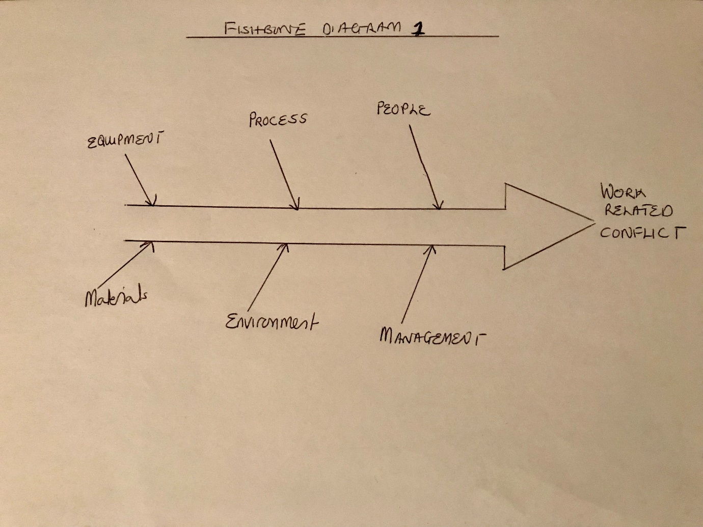
2.1b
Misdirected people
Tarun (2012) maintains that people are the lifeline of an organisation, when they are not properly directed and motivated it will end up in the organization performing abysmally. Ongoing conflict between team members brims from lack of trust and suspicion between team members. The absence of co-ordination in teams and the fact that that job specifications are not properly defined resulted in conflict and the failure of care provision.
2.1c
Inefficient Management
Many writers (Bendesky 2003, Tinsley 2001 and Shulse 2006) maintain that conflict resolution and conflict management are important indices of team performance. They suggest that the absence of a process for managing conflict increases the negative impact of all types of conflict. In the long run the absence of conflict resolution within management leads to a situation where there is lack of fairness, resource efficiency, working relationship and satisfaction of parties.
Inefficiency of management in this situation is revealed in the fact that there is an absence of thorough employee orientation, a lack of exemplary leadership between management and employees.
2.1d Environment
Many questions arise concerning the health and safety of the working environment with regard to workers.Writers,Leman et al (2010) argue that providing an enabling healthy work place environment requires a joint effort with input from management and employees.Other writers, Tarun (2012) posits that work environment needs to be conducive for high level business success.
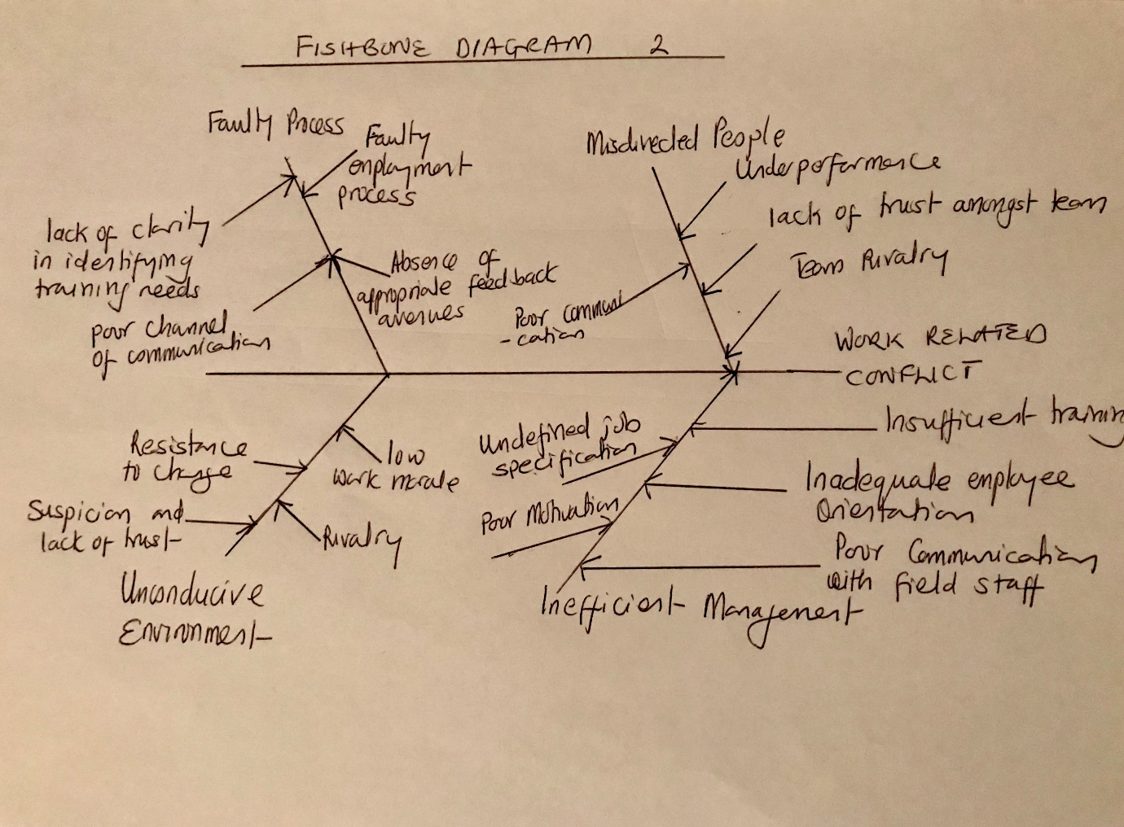

3.0
Solution (A)
Sexton and Orchard (2016) argue that conflict within interprofessional health care systems, when not effectively resolved has been linked to detrimental consequences. However, many studies (McKenzie 2015, Marshall and Robson 2005) show that a lot of benefits accrue from providing conflict resolution training to health professionals. For example, there is a reduction in malpractice suit, improvement in quality healthcare and a safer work environment.
Considering the given circumstances, it will be appropriate for an overhaul of the entire management. The way forward firstly will be the provision of training on conflict resolution for those at the helm of affairs, secondly training on the same subject should be made available for the supervisors and finally the care assistants who are field workers and who have to work in teams will benefit from being exposed to the dynamics of conflict resolution. McKenzie (2015) suggests that acquisition of conflict management skills helps individuals and organizations to build stronger relationships. In the opinion of the writer’s conflict resolution skills are the much-needed tools to move the rocks from the path.
Solution (B)
Caremark (not real name of company) provides orientation for all new employees and hands out the company’s code of conduct handbook to ensure good practice, however the reality on ground leaves nothing to be desired.
Management should make a conscious effort to evaluate the communication skills of its employees, by so doing the organization will be in a better position to identify gaps that need to be addressed by providing training. The narrative of the problem shows that brewing conflict appears to stem from a communication breakdown between all parties.
Furthermore, writers (Geradi 2010, Runde 2014) posit that individuals and with communication skills, when engaged in discord are willing to listen and comprehend an alternative side of an argument. Listening for understanding and sending a message that is brief,clear and timely has been proven necessary in shifting conflict towards reconciliation.
Again, Geradi (2010) and Runde (2014) suggest that training programmes with the intent to educate health care professionals about productive ways to resolve conflict include communication skills training.
3.1
Evaluation of proffered solutions
The writer of this essay maintains solution A will be a more appropriate course for the organization. Reason being conflict is always bound to occur regardless of the communication skills employees may possess.
In the event management is sufficiently trained on conflict resolution, it will place the organization in a vantage position to provide training on effective communication and promote the fundamentals of teamwork. Management will be better equipped to give practical solutions to employees when interpersonal conflict arises between team members.

3.2
Implementation plan
The plan which has been translated into a Gantt chart show the following:
- The first task is for management to enrol on a three-day training on conflict resolution.
- The second task is for supervisors who monitor care assistants on the care field to enrol for a week’s training. The idea is that management will have the required knowledge to support supervisors.
- The last task will be an intensive two weeks training on conflict management,effective communication amongst teams and conflict resolution for care assistants.

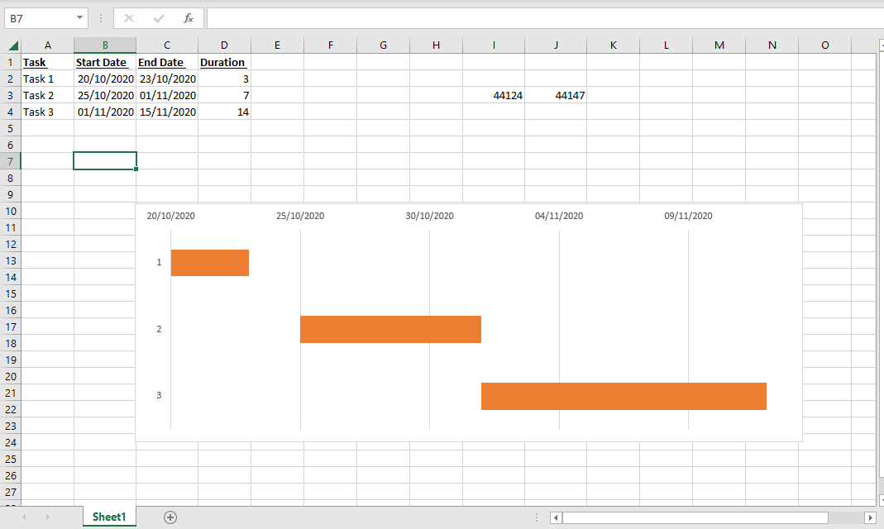

3.3
Communication Plan to Stakeholders
Caremark (not real name) is a company that basically relies on various mediums of communication in order to remain in business. Based on this, I will be transmitting proffered solutions via email to both the general manager and Manager.
Secondly, the writer of this essay will follow up the email with a telephone call to my manager and raise the points highlighted in the email, to discuss and give clarity on the agenda.
Thirdly, I will use twitter to link the organization to funny quotes, links to videos and flash deals that transmit the core message of conflict resolution with the hope that it gets the full attention of stakeholders.

Conclusion
Making decisions and problem solving are key components that play a pivotal role in the success or otherwise of any organization. The narrative of the essay brings to light the dynamics and benefits inherent in the various decision-making tools and techniques, the onus falls on managers and owners of businesses to identify the appropriate problem solving and decision-making technique that best suits the peculiar needs of the businesses they run, It is only then that they can survive and outrun their rivals.

References
Emet, G and Merba , T. (2017) SWOT ANALYSIS:A Theoretical Review, The Journal of International Social Research,Vol.10,Issue 51
Marllen, K., Victor , M and Ana , C. (2016) What is shared decision Making? and what it is not
Nitank, R . and Trivedi , M. (2016) Pestle Technique – A tool to Identify External Risks in Contruction Projects. International Research Journal of Engineering and Technology, Vol 3, Issue 1
https://s3.amazonaws.com/academia.edu.documents/54685520/IRJET-V3I165.pdf?response-content-disposition=inline%3B%20filename%3DPESTLE_TECHNIQUE_A_TOOL_TO_IDENTIFY_EXTE.pdf
https://onlinelibrary.wiley.com/doi/full/10.1111/acem.13065

Pearse, J. and Robinson, R . (1991). Strategic Management, (4th Edition), USA: Irwin, Inc.
Kim, S. , Naike, B and Kim, L (2017) Individual,Interpersonal and Organisational Factors of Healthcare Conflict: A Scoping Review
https://www.tandfonline.com/doi/abs/10.1080/13561820.2016.1272558
Krugman, R., Jones, M., & Lowenstein, S. (2014). Can we learn civility? Reflections on the challenge of changing culture. Academic Medicine, 89 (12), 1586–1588. doi:10.1097/acm.0000000000000429

